Executive Summary
This environmental impact statement/environment effects statement (EIS/EES) presents the findings of the assessment of potential impacts of Marinus Link (the project).
The project is a proposed electricity interconnector of up to 1500 megawatt (MW) between Tasmania and Victoria. It will link Tasmanian renewable energy resources and the National Electricity Market (NEM) via connection in Victoria. This will enable energy trade from a diverse range of generation sources in Tasmania to where it is most needed in Victoria, South Australia, New South Wales and Queensland via the NEM. As a result, the capacity and security of energy will increase across the NEM.
Marinus Link Pty Ltd (MLPL) is the proponent for the project. MLPL was formed in 2018 for the purposes of constructing the project. The Commonwealth, Tasmanian and Victorian governments have agreed to shared ownership of MLPL with the Commonwealth to have a 49%, Victoria a 33.3% and Tasmania a 17.7% shareholding.

Project objectives and benefits
Tasmania has significant renewable energy resource potential, particularly hydroelectric power and wind energy. The potential size of the resource exceeds the Tasmanian electricity demand as well as the capacity of the existing interconnector. The growth in renewable energy generation in mainland states participating in the NEM, together with the reduced use of coal-fired generators, is reducing the availability of dispatchable energy. Dispatchable energy is electricity supply that can be easily turned on and off in response to demand.
The project is proposed to deliver an additional 1500 MW capacity connection between Victoria and Tasmania which will more than triple the continuous capacity currently provided by Basslink (the existing undersea connection across Bass Strait), bringing the total dispatchable energy between Victoria and Tasmania to around 2000 MW.
The project will:

Provide additional trading capacity between Tasmania and mainland Australia to support the transition of the NEM to a lower emissions system, while maintaining a secure and stable power system.
Increase Tasmania’s energy security by providing a second link to the mainland that is geographically separate to Basslink, reducing the impact of a failure. The project will also support development of further renewable energy generation projects in Tasmania by an estimated 33,700 MW, further increasing Tasmania’s energy security.
Support reduction of energy costs through reducing the costs of future generation, energy storage and transmission infrastructure by using existing infrastructure to its full potential; increasing development and availability of relatively low-cost energy capacity; and increase capacity to provide dispatchable energy generated from renewable energy sources.

Provide an estimated $1.47 billion in economic contribution to Tasmania and $1.78 billion in Victoria from the construction and operation of the project.
Support the following jobs during the peak construction period:

- Stage 1: 673 jobs per year in Tasmania and 857 jobs per year in Victoria.
- Stage 2: 643 jobs per year in Tasmania and 818 jobs per year in Victoria.
Increase Tasmania’s telecommunications capacity by 150 times current capacity through construction of a fibre optic cable, bundled with the electricity interconnector.

Project description
The project is a proposed 1500 MW high voltage direct current (HVDC) electricity interconnector between Heybridge in northwest Tasmania and the Latrobe Valley in Victoria. The project will be implemented as two 750 MW stages. Each stage will comprise two power cables and a fibre optic communications cable.
Construction and cabling activities for stage 1 are anticipated to be completed by 2030. Stage 2 activities will follow, with final timing to be determined by market demand. The project timeline is shown in Figure 1.
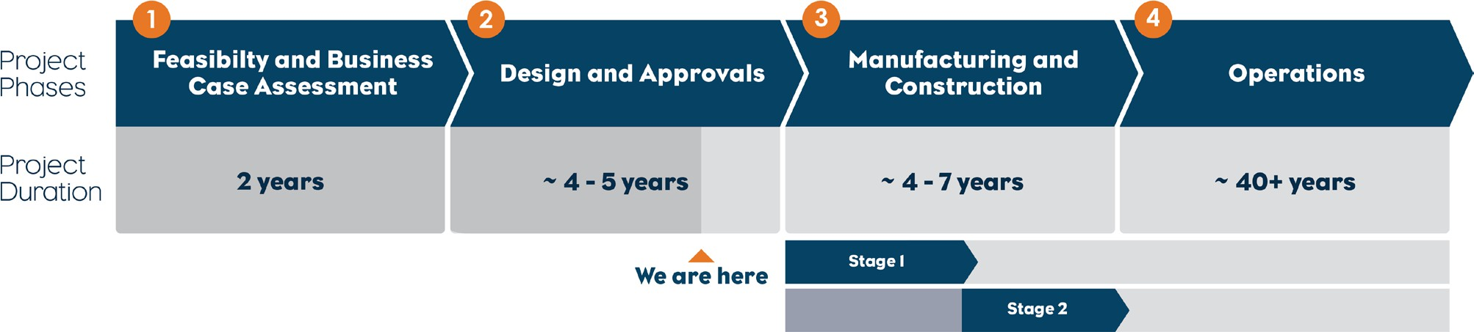

Project alternatives
MLPL completed a comprehensive route and site selection process to identify a project alignment that is technically sound, while minimising impacts to environmental values (including ecological, social and heritage values). MLPL recognises that avoiding environmental impacts is best achieved through careful project design.
Route and site selection criteria where developed based on the identified constraints and opportunities, the technical specifications, and objectives of the project. Potential locations for landfalls, shore crossings, corridors, routes and converter site locations were evaluated against these criteria. The alternatives considered include:
Alternative Victorian land cable routes

Alternative Victorian converter station site at Driffield

Converter station technology to convert HVDC to HVAC and vice versa

Construction methods (overhead versus underground)

Water crossing methods, such as trenchless construction and open trenching.

Alternative of ‘no project’.

Information from the technical analysis confirmed that the preferred route was Burnie to Hazelwood, with landfalls at Heybridge (Tasmania) and Waratah Bay (Victoria), was the least constrained route that met the project objectives. The refinement of the route over 2021 and 2022 has led to the proposed route, which is the subject of this EIS/EES, running from Heybridge, Tasmania to Hazelwood, Victoria.
Technical specialists conducted a wide range of environmental investigations in the terrestrial and marine study areas to refine the proposed project alignment. To support this, MLPL consulted with a wide range of stakeholders to understand values and potential impacts within the project alignment. This process assisted in refining the alignment and was a key input to the EIS/EES.
Impacts have been avoided and minimised through route selection and project design by:

Avoiding marine protected areas including Beagle Marine Park, Boags Marine Park, Wilson’s Promontory Marine Park, Corner Inlet Marine and Coastal Park, Shallow Inlet Marine and Coastal Park.
Avoiding wetlands of international importance (Ramsar wetlands).

Prioritising the avoidance of townships, residential dwellings and farm infrastructure.

Avoiding or minimising impacts to sensitive waterways, native vegetation, road and railway infrastructure through route selection and incorporating trenchless construction methods into the project design.
Avoiding the main recreational and commercial fishing areas of Bass Strait.

Avoiding anomalies identified in the seabed that could be culturally significant as well as more ecologically diverse reef formations.
Incorporating horizontal directional drilling (HDD) for the shore crossings at Heybridge and Waratah Bay to avoid impacts to sensitive dune and intertidal environments.
Bundling and burying cables to reduce electromagnetic field (EMF) emissions, particularly in the marine environment.
Designing connection points in Victoria and Tasmania to minimise additional upgrade requirements to connect to the network.

Survey area and study area
A survey area, containing all the project components, was defined and assessed. The EIS/EES has assessed the defined survey areas for the terrestrial and marine project components.
The terrestrial survey area in Tasmania is defined by the property boundary of the Heybridge converter station site and the location of the shore crossings which extend from the site, under the Bass Highway and

Western Line railway to Bass Strait. Only EPBC Act matters for the Tasmanian survey area are discussed in this EIS/EES.
The marine survey area includes:

A 200 m wide corridor along each project alignment in Commonwealth waters

Approximately 1 km wide for the Tasmanian shore crossing

Approximately 800 m wide for the Victorian shore crossing

A 10 m wide marine construction corridor along each project alignment.

The terrestrial Victorian survey area includes:

a 220 m wide corridor. For some locations the survey area may be wider or narrower and follows property boundaries.
In some instances, major laydown areas are adjacent to the 220 m survey area corridor and in some locations offset from the land project alignment.
A 20 m to 36 m wide terrestrial construction corridor including minor laydown areas.

A study area has also been defined by each technical study, which may be larger or smaller than the survey area. The study area defined by each technical specialist has considered the local, regional, or state context needed to understand the issues and assess the impacts of the project relevant for their discipline. The study area for each technical study is described in each of the technical chapters of EIS/EES Volumes 2 to 4.

Project components
The project’s key components that are located in the survey area, from south to north, are:

High voltage alternating current (HVAC) switching station and HVAC-HVDC converter station at Heybridge in Tasmania.
Shore crossing in Tasmania adjacent to the converter station. The shore crossings will be constructed using HDD under the coastal dunes to approximately 10 metre (m) water depth.
Approximately 255 kilometres (km) of subsea cable across Bass Strait from Heybridge in Tasmania to Waratah Bay in Victoria. The subsea cables for each stage will be laid approximately 2 km apart except near the shore crossings where the stage 1 and 2 cables will come together to enable them to be pulled through the shore crossings.
Shore crossing in Victoria at Waratah Bay approximately 3 km west of Sandy Point. The shore crossings will be constructed using HDD to about 10 m water depth.
Land-sea cable joint where the subsea cables will connect to the land cables in Victoria.

Communications building (Fibre optic cable inspection and test hut) adjacent to Waratah Bay.

Approximately 90 km of underground land cables a minimum of 5 m apart in Victoria, extending from the land-sea joint to the converter station site at Hazelwood.
HVAC switching station and HVAC-HVDC converter station at Hazelwood, adjacent to the existing Hazelwood Terminal Station, where the project will connect to the existing Victorian transmission network.
A transition station at Waratah Bay may also be required if there are different cable manufacturers or substantially different cable technologies adopted for the land and subsea cables. Regardless of whether a transition station is needed, a communications building will be required in the same location.
In developing the final project design, opportunities for further design refinement to avoid impacts may be identified. Figure 2 provides an overview of the project alignment as well as an overview of the project alignment in Victoria (Figure 3) and Tasmania (Figure 4).
The project description (Volume 1, Chapter 6 – Project description), together with the map book showing detail of the project alignment and construction footprint (Attachment 6– Marinus Link EIS/EES Map book), forms the basis of the impact assessments presented in this EIS/EES and has informed the development of Environmental Performance Requirements (EPRs) for the project. The design and construction methodology assed in the EIS/EES is one approach that could be adopted and has been developed to a level where potential impacts can be identified and assessed. The EPRs define the environmental outcomes to be achieved to avoid, minimise and mitigate impacts regardless of the final design and construction methods adopted for the project. The EPRs are provided in each chapter drawing from the technical reports, and are detailed in Volume 5, Chapter 2 – Environmental Management Framework. The final design and construction methods developed to comply with the EPRs and contractual requirements will be determined by preferred contractors.

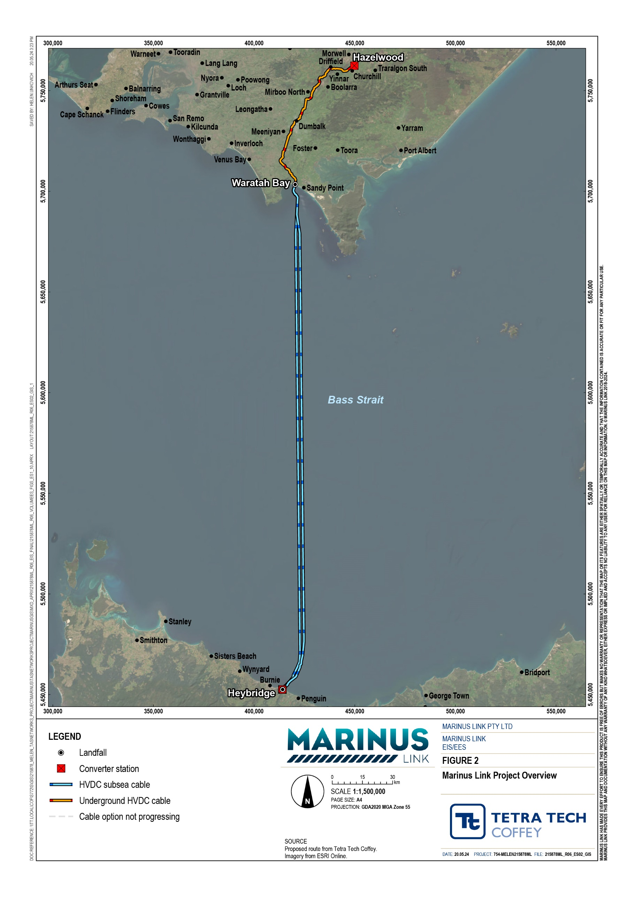

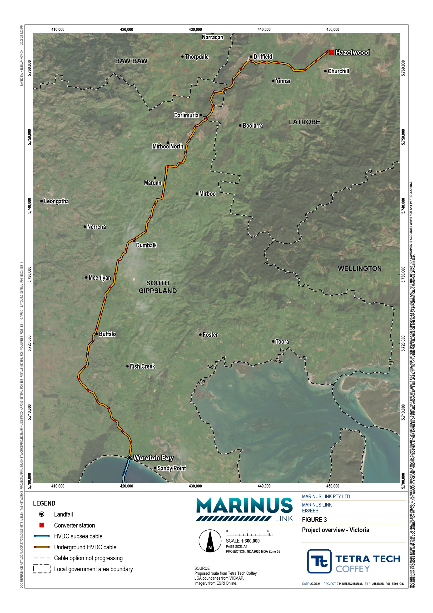

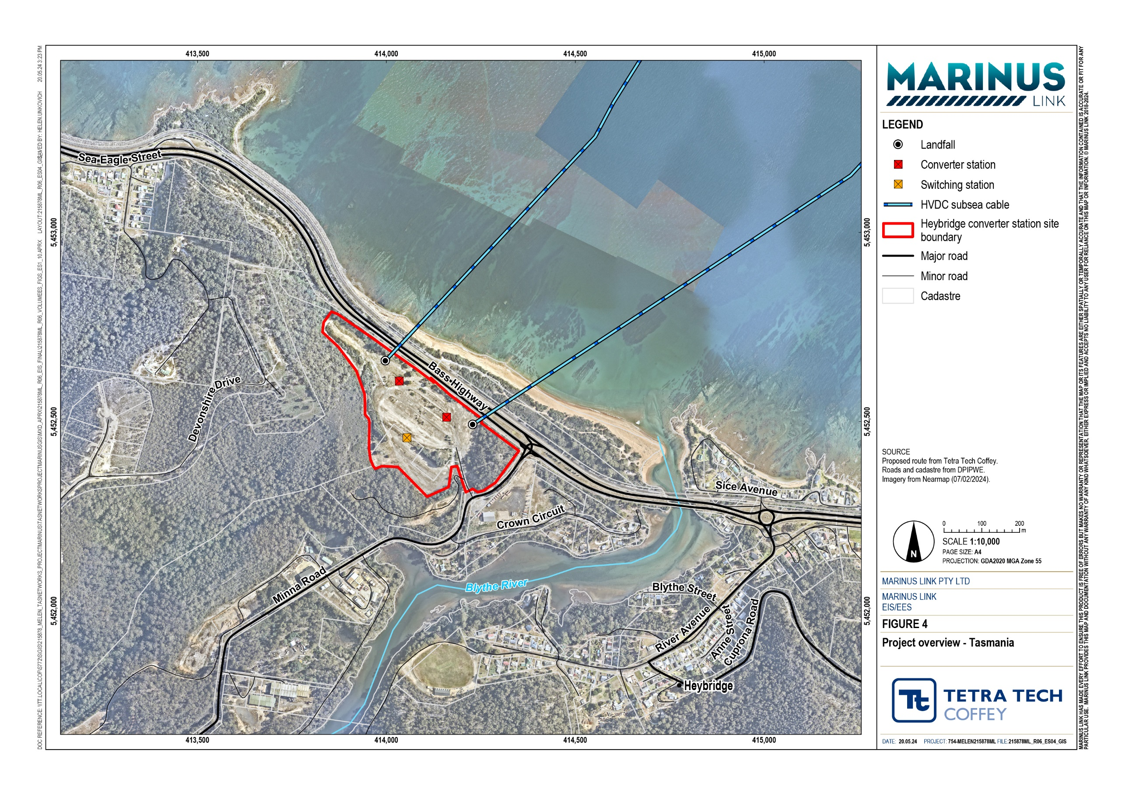

Construction methods

Subsea cables
Installing the subsea cables across Bass Strait requires preparation of the cable route with a pre-lay grapnel run to clear the route of any debris so it is ready for laying of the cable and then burial into the sea floor.
The cable lay vessel used for the installation of each project circuit will need to have two turntables, one for each power cable and a cable drum for the fibre optic cable. The power cables and fibre optic cable for each stage will be bundled and tied together using polypropylene rope and cable ties as the cables are unspooled and lowered over the back of the vessel to the seabed.
A burial vessel will locate, bury and survey the as-laid location of the cable bundles on the seafloor. Geophysical and geotechnical surveys indicate the cable bundles can be buried using water jetting tools to fluidise the sand for the majority of Bass Strait, with small sections of harder substrate requiring mechanical trenching tools or rock mattressing to protect the cable. The subsea cable bundle is picked up from the seafloor and fed over the burial tools to avoid damage as the seabed is fluidised by water jetting. The subsea cable bundle is lowered into the fluidised seabed off the back of the burial tool. The cables will be buried to a depth of between 0.5 m to 1.5 m depending on the substrate. The cable trench will backfill with sand and silt by natural processes. Figure 5 shows the conceptual subsea cable laying and burial.
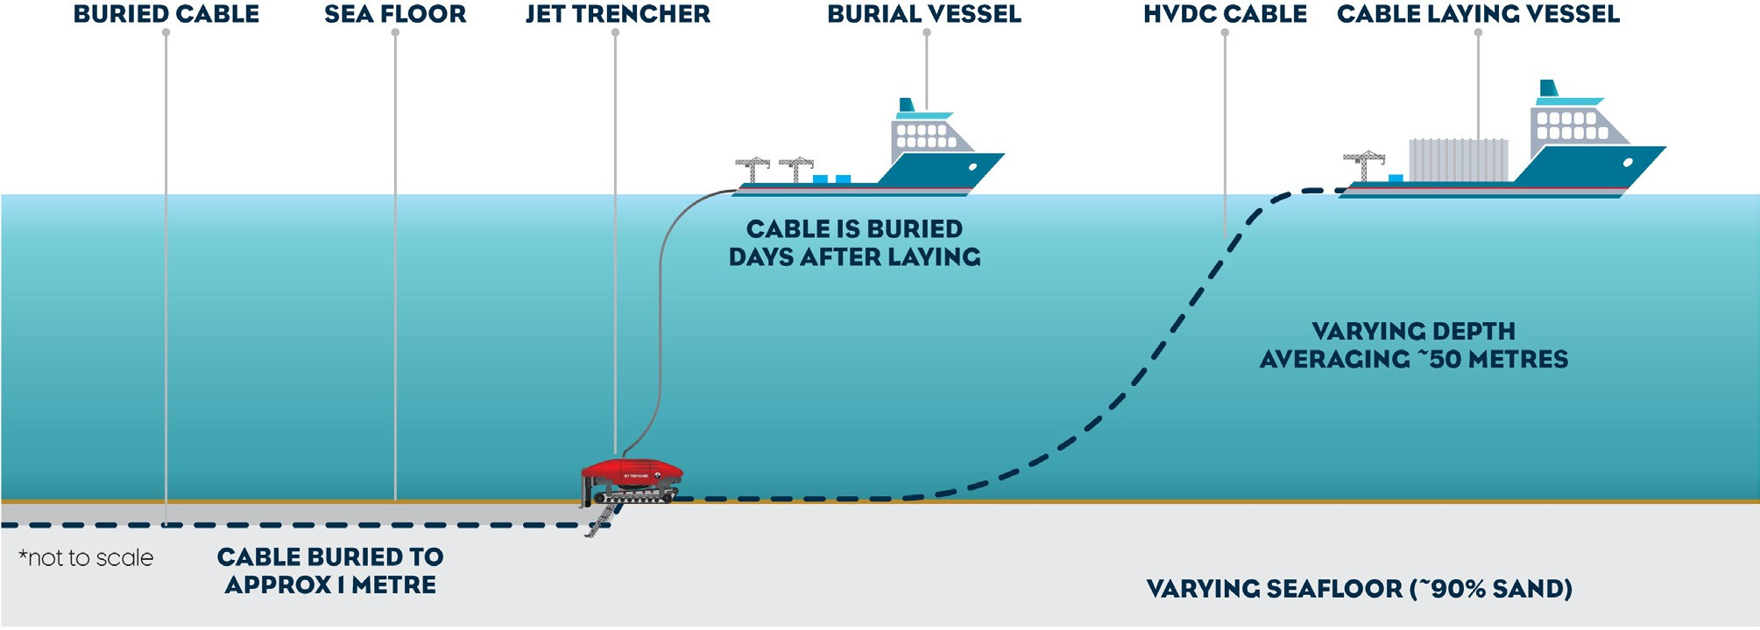

Shore crossings
The shore crossings will be constructed using HDD to avoid impacts to the intertidal area and coastal dunes. HDD involves drilling a borehole under a feature through which a duct is pulled or pushed, depending on the method of installation. Ducts will be installed in each of the six boreholes.
At the shore crossing, the subsea cable bundles will be anchored un-bundled, and each individual cable will be pulled from the end of the duct in an HDD bore. Figure 6 shows the conceptual shore crossing method.

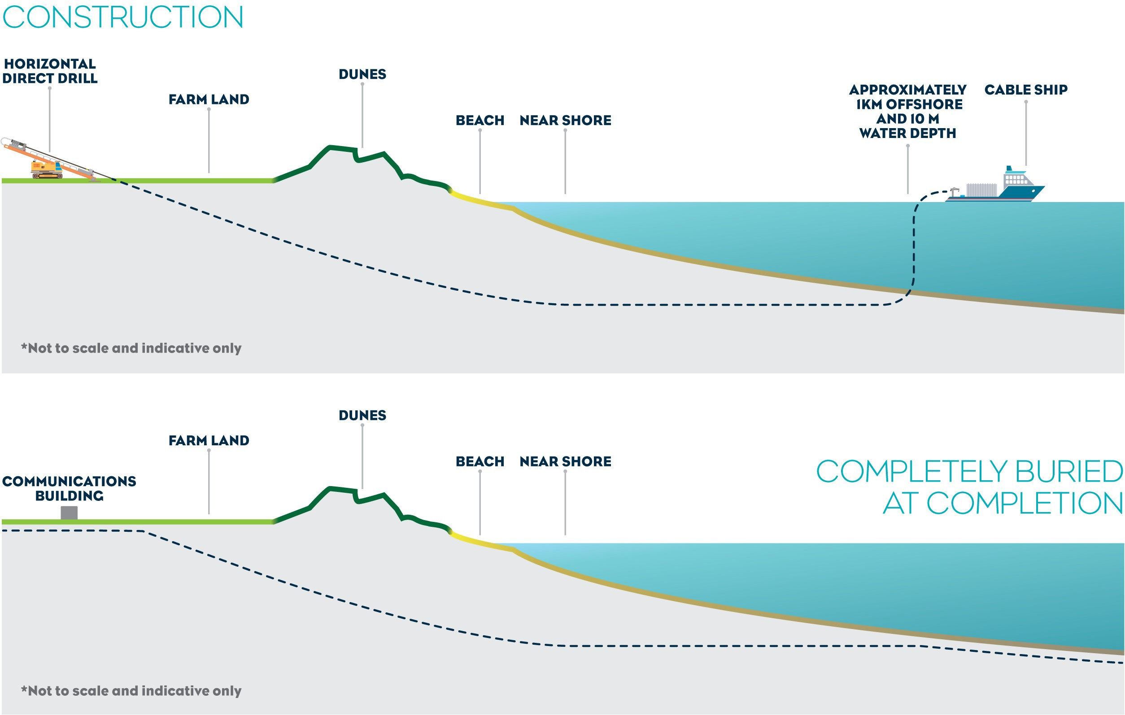

Land cables
Installing land cables from the shore crossing at Waratah Bay to the Hazelwood converter station in Victoria will involve construction of two trenches, haul roads, access tracks, and laydown areas for cable installation and construction of cable joint pits .
The land cable construction corridor will encompass two trenches, haul roads, surface water runoff management structures, topsoil and subsoil stockpiles and major construction laydown areas. A 20 to 36 m wide construction corridor is required for the project alignment, haul road, minor laydown areas and temporary facilities to support construction. Approximately seven larger laydown areas adjacent to the construction corridor may also be required to support construction.
The cables for each circuit will be laid in separate conduits in a horizontal arrangement in a single trench. Conduits will be laid in the trenches and as needed, covered with cable bedding material more commonly known as thermal backfill to assist dissipate heat generated by electricity flowing through the cables or the native soil. Concrete or composite slabs will be placed approximately 0.5 m above the conduits and warning tape 0.7 m below the ground surface (see Figure 7). Following installation of the conduits and thermal backfill (if required) the trench will be backfilled reinstating the soil horizons. Subsoil will be compacted to at least 85% in-situ soil strength. Following installation of the conduits and thermal backfill (if required), the trench will be backfilled reinstating the soil horizons. Following cable pulling and jointing, these workspaces will also be backfilled and reinstated.

The cables will be pulled through the conduits between adjacent cable joint pits. Once the land cable sections have been pulled through the conduits and ducts, they will be joined.
Crossings of waterways and features such as sealed major roads, rail lines, major watercourses, vegetation, and third-party infrastructure will be crossed with trenchless construction methods, such as HDD.
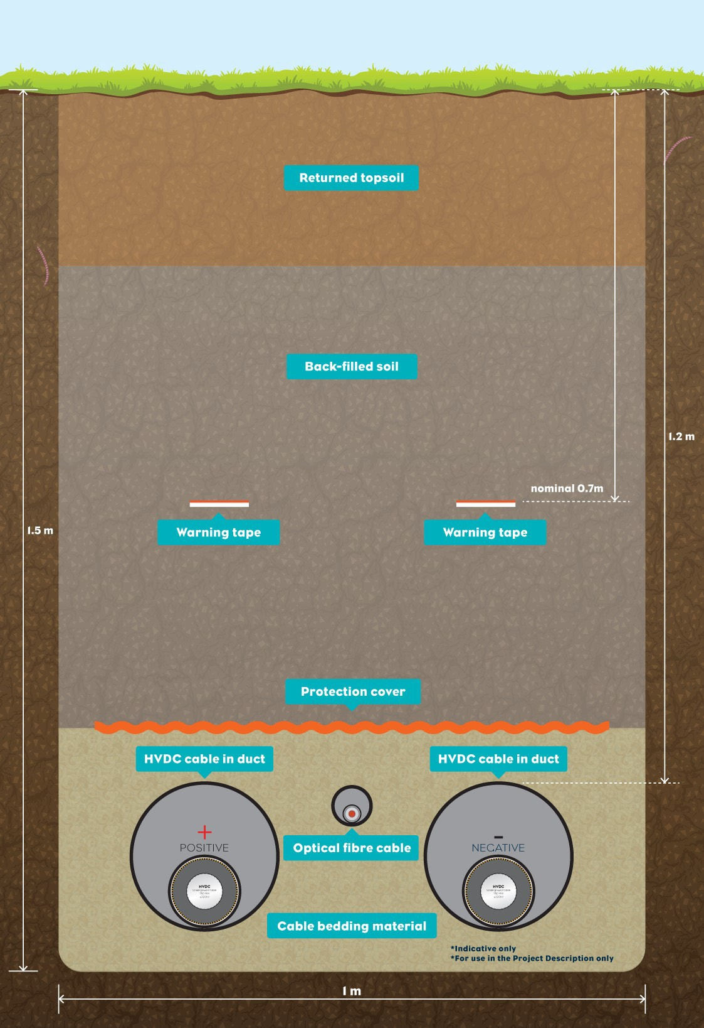

Project assessment and approvals
The project requires assessment and approval under Commonwealth, Victorian and Tasmanian legislation. The EIS/EES has been prepared to address Commonwealth and Victorian requirements. Separate documentation has been prepared to address Tasmanian government requirements. All three governments have agreed to coordinate the assessment processes where possible to:
Support consideration of the impacts of the project across government boundaries.

Streamline the assessment process.

Facilitate consistent environmental and social outcomes.

Figure 8 shows the key legislation applicable this EIS/EES within each jurisdiction. Further information on the primary approvals required to facilitate the construction and operation of the project is provided below.
Figure 9 provides an overview of the key assessment and approval processes.

This section outlines the key legislation relevant to the environmental, land use planning, and heritage assessment and approval of the project in the Commonwealth and Victorian jurisdictions. Further description of the legislation relevant to project approvals is provided in the Volume 1, Chapter 4 – Legislative framework.
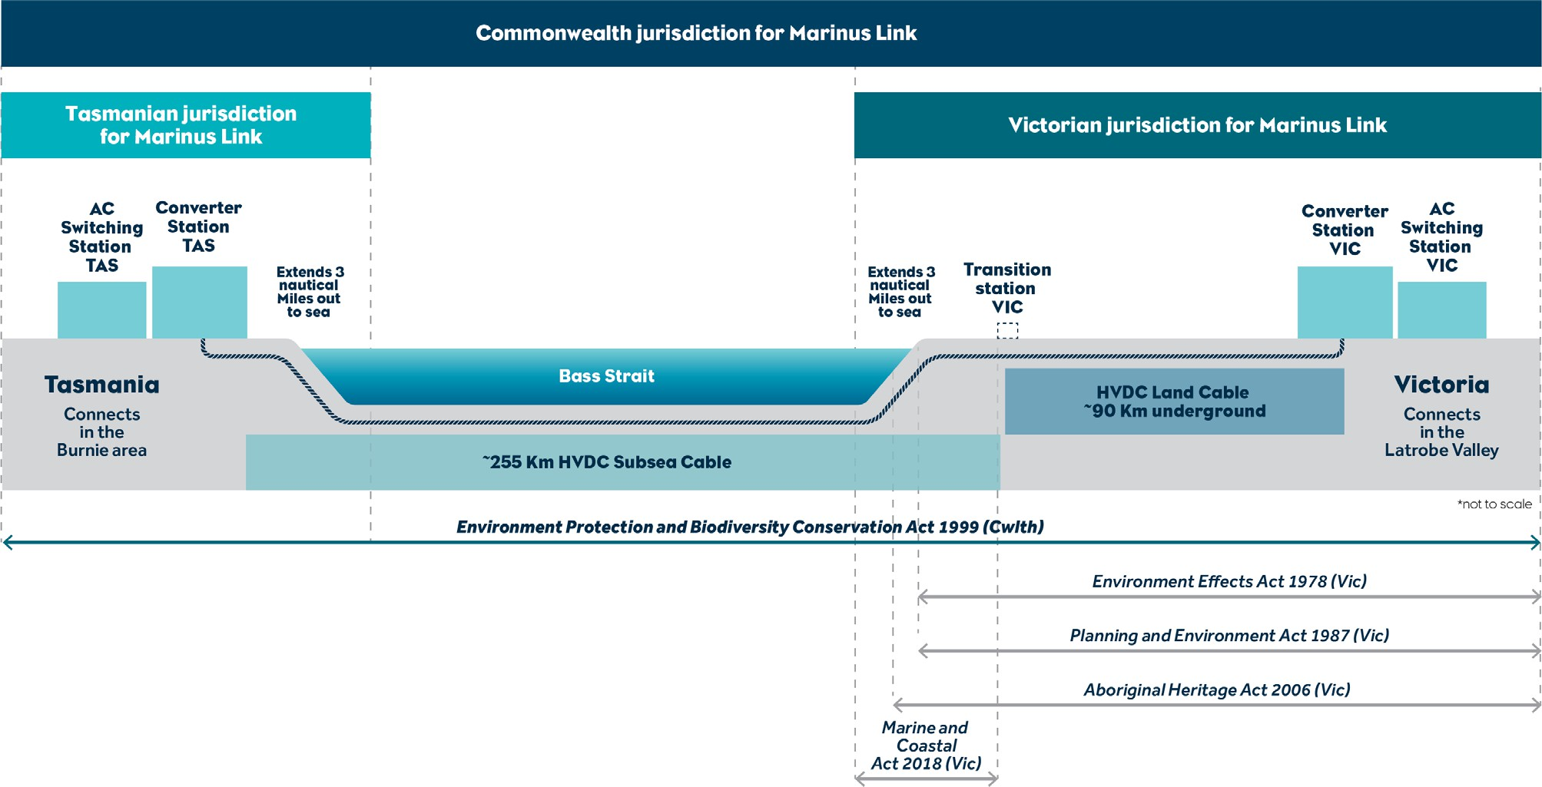

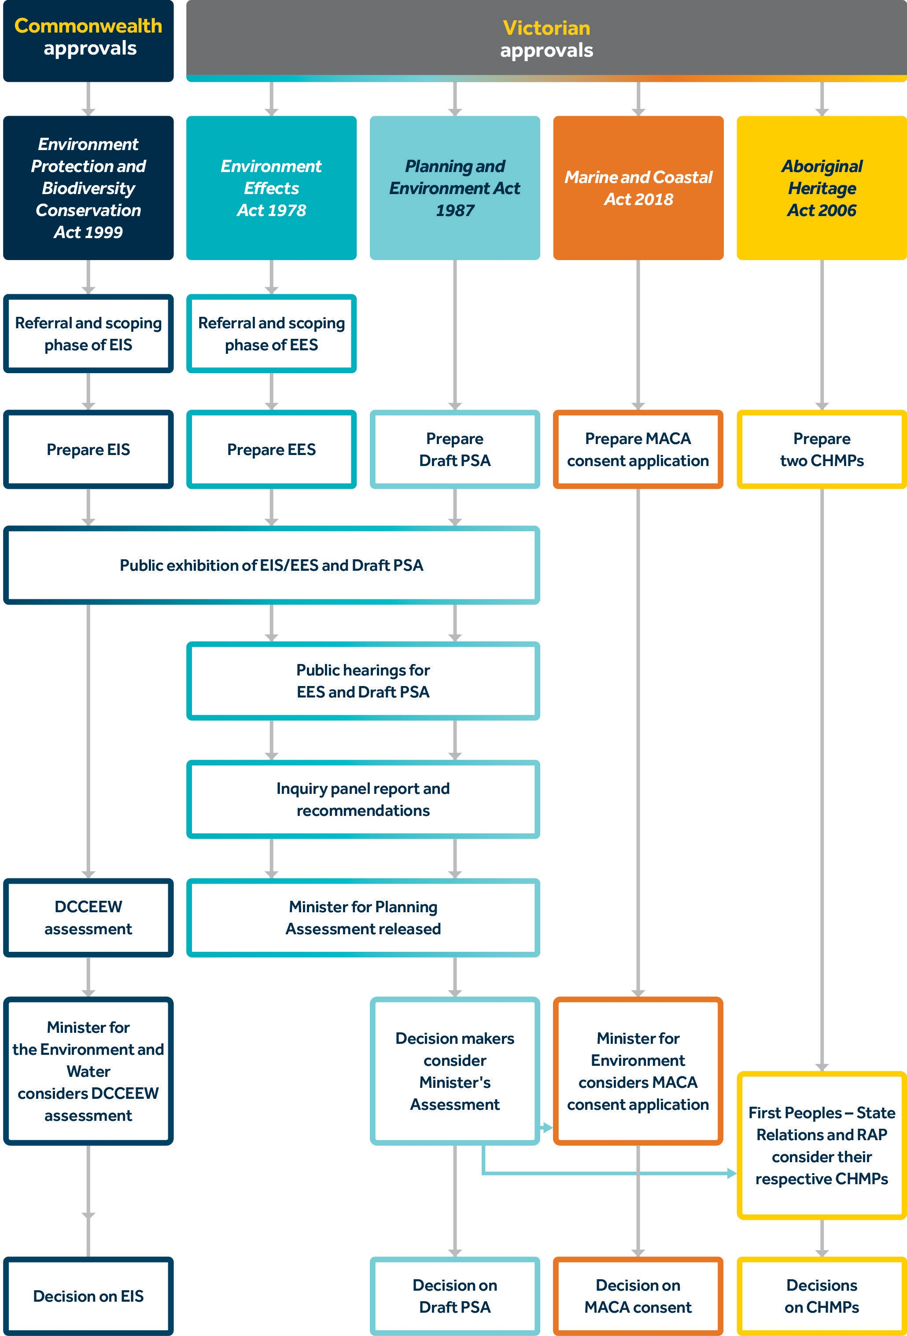

Commonwealth approvals
The EPBC Act applies to projects that may have a significant impact on MNES, such as the project. The EPBC Act is the legislation under which the Commonwealth Government will assess the project for the potential for significant impacts to the following MNES:
Listed threatened species and communities (Sections 18 and 18A of the EPBC Act)

Listed migratory species (Sections 20 and 20A of the EPBC Act)

Commonwealth marine area (Sections 23 and 24A of the EPBC Act)

A transmission and infrastructure licence will also be required from the Commonwealth government under the recently established Offshore Electricity Infrastructure Act 2021 (Cwlth).

Victorian approvals
The EES prepared under the EE Act provides an assessment of the impacts of the project which informs decisions under associated legislation. The key pieces of Victorian legislation under which the project must seek approval are:
Planning and Environment Act 1987 (Vic)

Marine and Coastal Act 2018 (Vic)

Aboriginal Heritage Act 2006 (Vic)

The EE Act is administered by DTP and provides the framework for the assessment of the environmental effects of projects that could have a significant effect on the Victorian environment.
The outcome of an EES is not an approval. Rather it is an assessment by the Minister of Planning about environmental effects of a project and if they are acceptable. Following the completion of a public inquiry that considers public submissions on the EIS/EES, the Minister for Planning will to prepare an assessment of the environmental effects of the project (referred to as the Minister’s assessment). The recommendations in the Minister’s assessment will inform decision-makers issuing the key approvals under relevant Victorian legislation.

The key Victorian approvals are:

Amendment of the Latrobe and South Gippsland Planning Schemes under the Planning and Environment Act 1987 (Vic) (P&E Act) through preparation of a Planning Scheme Amendment (PSA). The P&E Act provides for the draft PSA to be scrutinised by an advisory committee in conjunction with an EES. Following the Minister’s assessment, MLPL anticipates it will request that the Minister for Planning will prepare, adopt and approve a PSA in the proposed form, exempt from the need for further public notice and submission.
Consent under Section 68(3) the Marine and Coastal Act 2018 Act (Vic) (MACA) for consent for the use, development and works on marine and coastal crown land. The MACA consent application will use the information contained in the exhibited EIS/EES. The Minister for Planning’s Assessment will inform a decision by the Minister for Energy, Environment and Climate Change on whether consent under the MACA should be granted.
CHMPs under the Aboriginal Heritage Act 2006 (Vic). Approval under the act must be obtained before commencing any project or action that has the potential to impact Aboriginal cultural heritage in Victoria. A CHMP must be prepared if in EES is required, under the act. A CHMP for the northern section of the Victorian aspect of the project will be assessed by GLaWAC (the RAP in that area). The second CHMP for the southern portion of the Victorian section of the project will be assessed by FPSR, as there is no RAP for the area. The RAP area is shown in Figure 10.
Further permits and licences will need to be obtained prior to the commencement of relevant construction or operational activities. This is likely to include:
Secondary consents required by the proposed draft PSA including the Environmental Management Framework, and the Alignment Plans and Development Plans that will reflect the final design developed to comply with the EPRs. Secondary consents are the approvals obtained after the primary approvals. Secondary consents must be in place prior to commencement of relevant project works.
Transmission and Infrastructure licence under the Offshore Electricity Infrastructure Act 2021 (Cwlth), after an approval decision under the EPBC Act.
Permit under the Wildlife Act 1975 (Vic), prior to any activities that involve the disturbance or control of wildlife from activities, such as the installation of fencing, and wildlife capture, relocation, or hunting efforts.
Permits under the Flora and Fauna Guarantee Act 1988 (Vic) (FFG Act), for the removal of listed threatened species or communities from public or private land.
Licence under the Water Act 1989 (Vic), for works that cross waterways, and for any activities that require water to be sourced from waterways or groundwater.
Permit under the Road Management Act 2017 (Vic), for works near or across roadways, or requiring a modified use of the roadway (e.g., oversized vehicles, road opening, closure, or traffic diversion.

Transmission licence
A licence is required to generate, transmit, supply, or sell electricity in Victoria. On 20 December 2023, Essential Services Commission (ESC) granted MLPL an electricity transmission licence to transmit electricity between Tasmania and Victoria and connect the project infrastructure into the existing transmission network in Victoria. The transmission licence will also enable MLPL to access land in accordance with the Electricity Industry Act 2000 (Vic).
MLPL is committed to seeking voluntary agreements with all landholders where possible, both for investigations and for transmission easements. However, grant of the transmission licence means MLPL can use statutory powers to enter land for certain investigation and works under Section 93 of the Electricity Industry Act 2000 (Vic), subject to compliance with the ESC Land Access Code of Practice (Version 1) (the Code) and payment of compensation. The objectives of the Code are to achieve a balance between the statutory right for licensed electricity transmission companies to access private lands and the rights of landholders. In addition, the Code regulates how electricity companies access private land using powers under Section 93 of the Act (where attempts to enter in agreements have been unsuccessful), establish conditions for access when excising powers under Section 93, regulate the information an electricity transmission company must provide to landholders prior to entering, and regulate ongoing reporting to ESC.
Grant of the transmission licence also opens the possibility for MLPL to seek approval of the Governor in Council to compulsorily acquire transmission easements under Section 86 of the Electricity Industry Act 2000 (Vic), subject to meeting the requirements of the Land Acquisition and Compensation Act 1986 (Vic) including payment of compensation. Despite this, as noted above Marinus Link remains committed to seeking voluntary agreements with all landholders where possible.

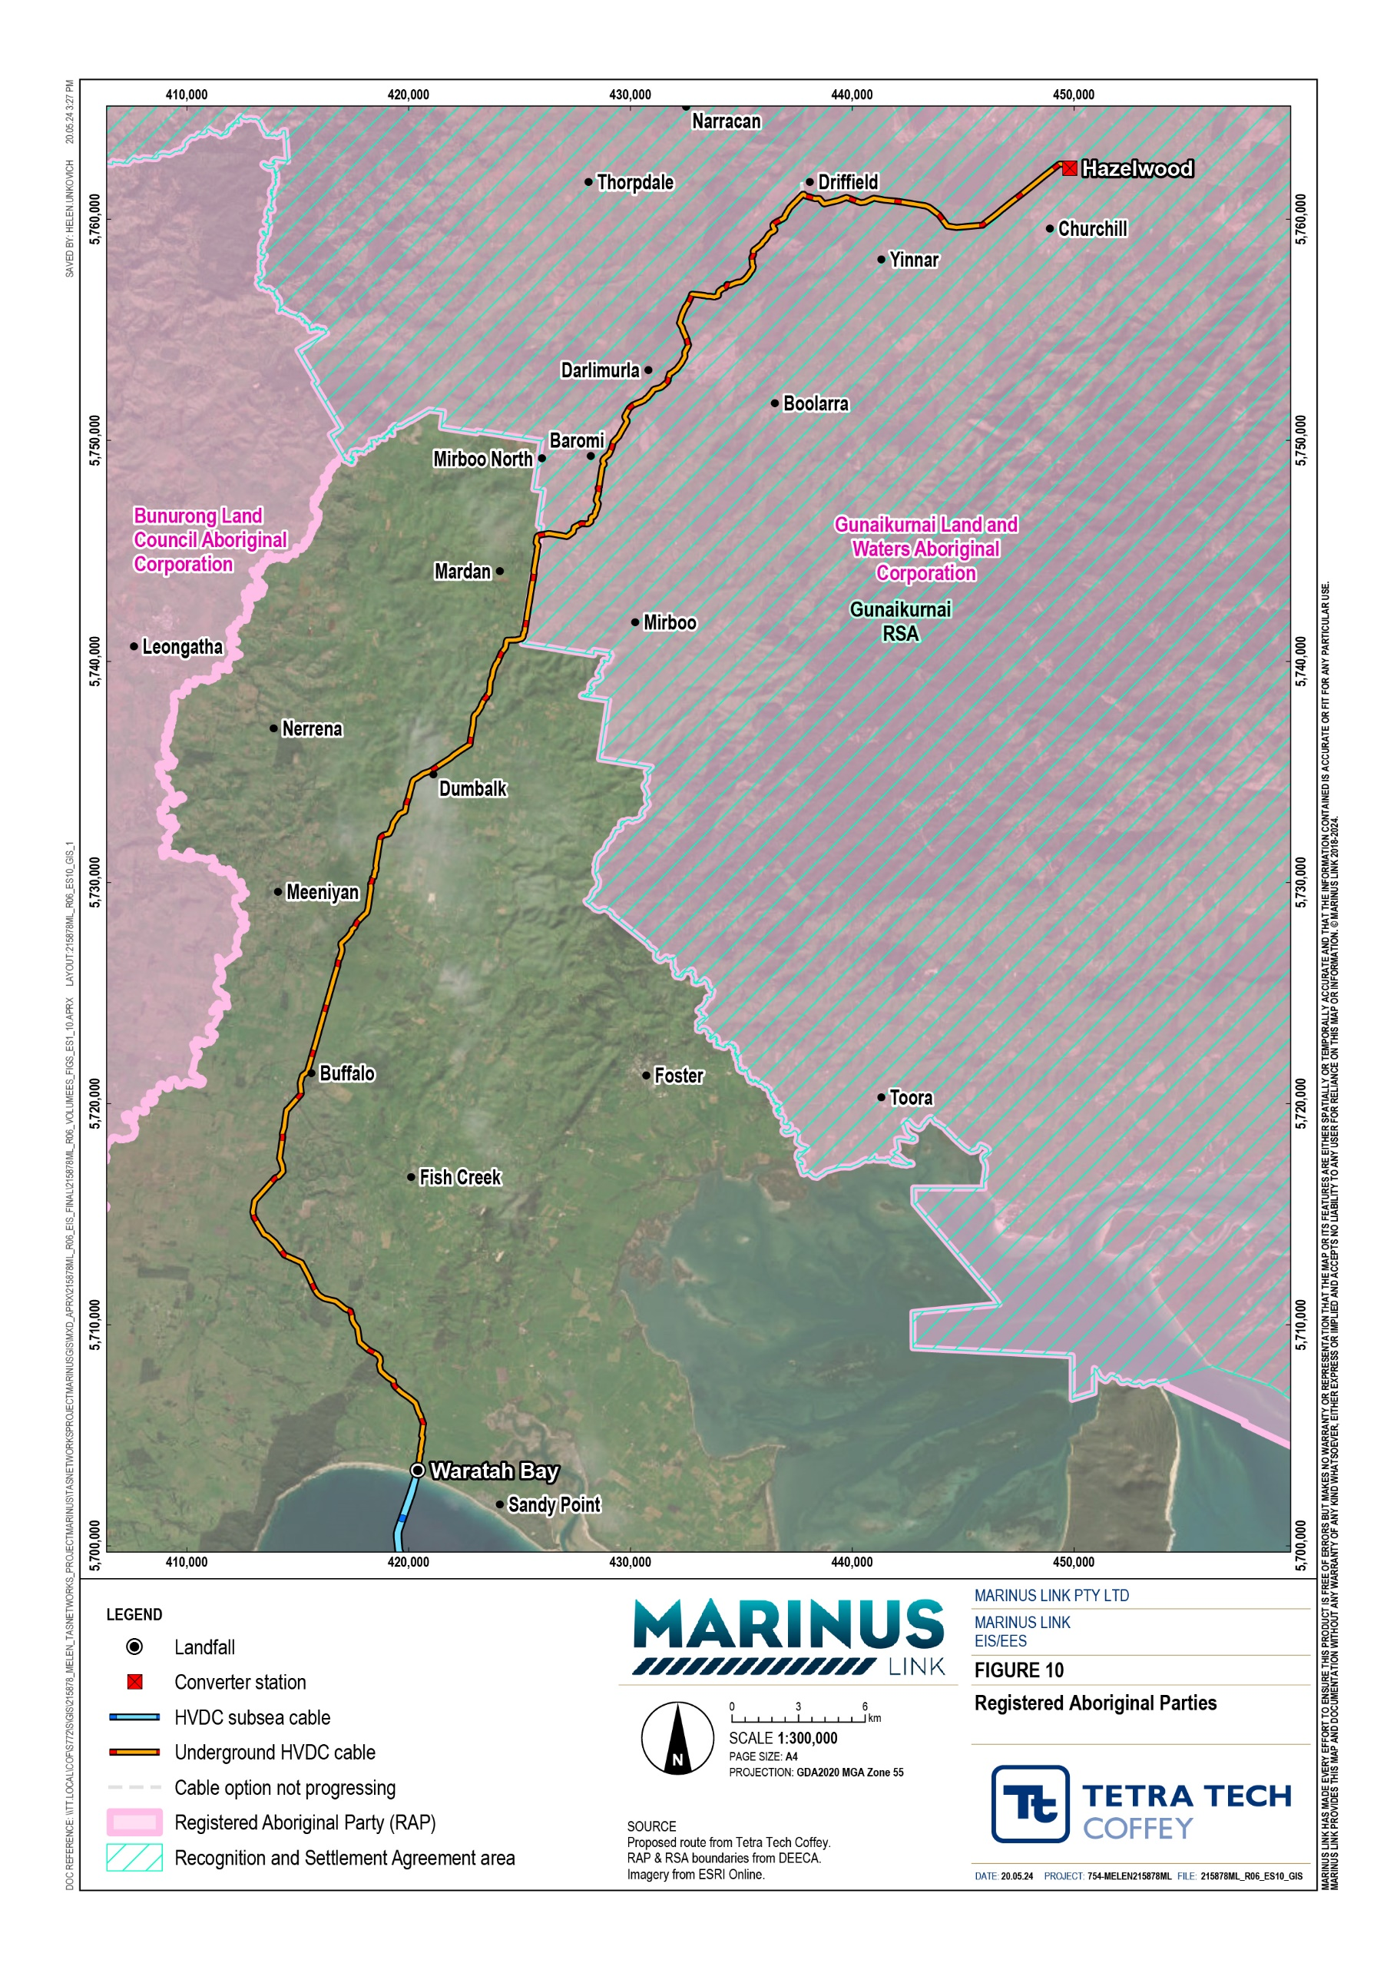

Community consultation
MLPL recognises the importance of building trust and social licence among the community. MLPL have been raising awareness of the project since 2018, providing information and seeking feedback from the community, stakeholders and First Peoples, to inform the project development. MLPL’s approach to engagement requirements is guided the four key pillars illustrated in Figure 11. This approach has also addressed the requirements for engagement for the EIS/EES.
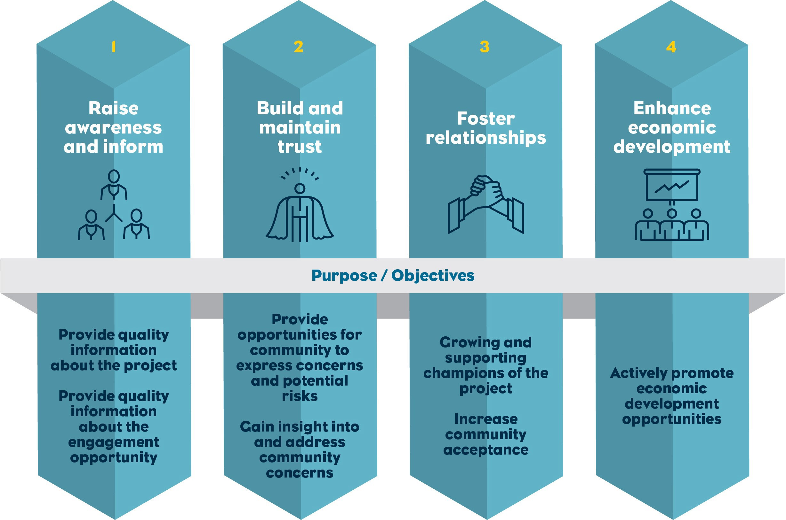

The project’s engagement program consisted of a combination of face-to-face and online forums, supported by digital, print, in-person communication methods were used. Community and stakeholder feedback has informed the proposed route design and construction method. Key changes include:
Project alignment changes to accommodate future land use and farming operations of landholders.

Screening of converter station.

Use of HDD at sensitive locations, such as the shore crossing, major waterways and native vegetation.

Gippsland Stakeholder Liaison Group
MLPL established a Gippsland Stakeholder Liaison Group (GSLG) in late 2021 with representatives from a range of local economic development, educational and environmental organisations, including the Gunaikurnai Land and Waters Aboriginal Corporation (GLaWAC), who provide input into initiatives to maximise the benefits of the project. The GSLG meet regularly and provide a forum for communication and engagement between the MLPL key stakeholders.
Engagement with the broader community and stakeholders has and will continue to inform the design and development of the project. MLPL recognises that issues may emerge over the life of the project and that engagement with stakeholders and the community will be a critical part of effectively identifying and managing issues.

First Peoples engagement
MLPL acknowledges the First Peoples of the Country on which the project is proposed in Victoria, Bass Strait and Tasmania. MLPL has engaged with First Peoples in Victoria and Tasmania throughout the project.
Early in the project, MLPL sought advice from First Peoples State Relations (FPSR) in Victoria regarding the First Peoples groups in the Gippsland region that may have an interest in the project area.
Through engagement with First Peoples group, representatives were identified and nominated by the Boonwurrung Land and Sea Council, Bunurong Land Council Aboriginal Corporation, and Gunaikurnai Land and Waters Aboriginal Corporation (GLaWAC) to take part in the FPAG with MLPL in Victoria. First Peoples feedback through the FPAG has resulted in MLPL integrating commitments into project plans for First Peoples engagement and participation in project construction and operation.
MLPL have continued consultation and discussions with each of the First Peoples groups in Victoria through their First Peoples Engagement Advisors. MLPL have ongoing engagement activities including cultural education sessions for MLPL personnel, progression of cultural values assessments, and general project updates.
In Tasmania, MLPL has engaged with Aboriginal Heritage Tasmania, and commenced engagement with members of the Tasmanian Aboriginal Centre. MLPL has met with truwana Rangers and Community leaders, and is committed to further ongoing meaningful engagement in Tasmania.
Key stakeholders have advised that a state-wide and collaborative engagement approach is more appropriate for First Peoples engagement in Tasmania. MLPL has subsequently discussed a collaborative approach to First Peoples engagement with related major projects and organisations (e.g. Renewables, Climate and Future Industries Tasmania, Hydro Tasmania, North West Transmission Development projects) to plan coordinated engagement that is both culturally appropriate and addresses the needs of the Tasmanian Community.

MLPL is progressing cultural values assessments in consultation with First Peoples and has also completed underwater cultural heritage and submerged landscapes assessments to support the EIS/EES. MLPL is committed to ongoing engagement with First Peoples in Tasmania and Victoria.

Key project impacts
The EIS/EES assesses the potential impacts from construction, operation and decommissioning of the project. The assessment has identified environmental values and potential impacts across the three jurisdictions, addressing the requirements of the EIS guidelines and EES scoping requirements. Two separate Tasmanian EIS documents have been prepared to address the requirements under Tasmanian legislation for the Heybridge converter station and shore crossing.
Avoidance of impacts has been maximised through selection of the route and design of the project. Potential impacts of the project have then been assessed based on the proposed design and construction methods. Where the impact assessment has identified the need to reduce impacts, the project is applying an outcomes-based approach through the preparation of environmental performance requirements (EPRs).
EPRs set out the environmental outcomes that must be achieved through implementing mitigation measures during construction, operation and decommissioning of the project, regardless of the final design adopted.
This performance-based approach encourages innovation by allowing for flexibility in how outcomes are achieved, rather than providing prescriptive measures that must be employed. It allows MLPL and contractors to determine the best way to achieve EPRs and manage impacts, whilst developing and optimising design solutions and construction methods.
In developing EPRs, technical specialists have considered industry standards and guidelines, good practice and the latest approaches to mitigating impacts. Technical specialists have considered possible mitigation measures that are technically and economically feasible measures, good practice, address local conditions and context of the project, and reflect the commitment to sound environmental management techniques.
The project description assessed in the EIS/EES presents a feasible way that the project could be delivered and is the basis of the impact assessments. The final design and construction method may differ from the project description presented in the EIS/EES and will be determined by preferred contractors. Contractors will develop their final designs and construction methods to comply with the project approvals and EPRs following completion of the EIS/EES process, and to address landholder agreements.
To inform the EIS/EES 23 technical studies were completed for the project. The studies provide detailed technical assessments of different environmental and social disciplines required address the EIS guidelines and EES scoping requirements. Studies have:
Assessed existing conditions and identifying relevant values.

Reviewed the project description and identified credible impact pathways – where project activities could result in an impact on the value.
Assessed the potential impacts of activities undertaken for the project on the values.

Where a need is identified to reduce impacts, developed EPRs that define environmental outcomes to be achieved through implementation of mitigation measures that reduce the impacts.
Assessed the residual impacts on values.

Technical studies completed for the following topics have informed the preparation of the EIS/EES:

- Aboriginal and historical cultural heritage
- Agriculture and forestry
- Air Quality
- Benthic ecology
- Bushfire
- Climate change
- Contaminated land and acid sulfate soils
- Economics
- Electromagnetic fields
- Geomorphology and soils
- Greenhouse gas
- Groundwater
- Traffic and transport
- Land use planning
- Landscape and visual
- Marine ecology and resource use
- Noise and vibration
- Surface water
- Social
- Terrestrial ecology
- Underwater cultural heritage and archaeology
- Heybridge social assessment (Tasmania)
- Heybridge terrestrial ecology (Tasmania)

The EIS/EES considers impacts in the survey area under Commonwealth and Victorian legislation. With this the EIS/ESS includes consideration of impacts to the Tasmanian environment covered by Commonwealth legislation. This includes matters of national environmental significance (MNES) and matters considered by the Commonwealth Minister for the Environment and Water when making a decision under the Environment Protection and Biodiversity Act 1999 (Cwlth) (EPBC Act) only. The EIS/EES also covers matters protected by the Underwater Cultural Heritage Act 2018 (Cwlth), such as shipwrecks, in Tasmanian waters.

Construction
The following sections provide a discussion of the technical assessments that had residual high and moderate impacts identified during the construction phase of the project. There are no major residual impacts from construction. All other residual impacts arising from construction will be low, or lesser.
Low or lesser impacts are generally those that are temporary or localised in nature and can be easily managed with standard mitigation measures. This includes impacts on surface water, groundwater, air quality, contaminated land and acid sulfate soils, land use and planning, bushfire, underwater cultural heritage, marine resources, non-indigenous cultural heritage, and landscape and visual amenity. These low impacts are not further discussed in this summary.

Ground stability
The project involves trenching and drilling an underground cable across 90 km of rural Victoria through natural landforms including coastal dues and steep, upland slopes. Ground disturbing activities such as excavation of trenches and horizontal directional drilling have the potential to decrease slope stability or create unstable landforms.
There are 13 locations on the project alignment in Victoria with high residual impacts to land stability and geomorphic properties and 69 with moderate residual impacts. As the area is geomorphologically active and prone to landslides and erosion, the high impacts are due to the uncertainty regarding ground conditions and landform stability at these 13 locations. The moderate impacts are those where the change is potentially medium-term, generally contained within the project area, and require remediation to avoid further degradation. In these areas the impacted geomorphic attributes can be managed with standard mitigation.
These impacts can be managed through engineering design and construction management. Further site investigations and geotechnical assessment will be completed to better understand site conditions including a seismic assessment and further geotechnical testing, assessment of groundwater levels and completion of a landslide risk assessment. The design and construction method for the project will then be refined so that any areas of high landslide risk incorporate measures to reduce the risk to tolerable (in accordance with Australian Geomechanics Society landslide management guidelines). If risks cannot be adequately addressed, the project alignment will be amended.

Terrestrial ecology – Victoria
Avoidance of impacts to ecological values including native vegetation, threatened species and migratory species habitat and threatened ecological communities, was a key objective of the route selection for the project. However, there will be some areas of native vegetation that are required to be cleared for construction of the land cables within Victoria, resulting in impacts on ecological values.
As not all properties have been able to be accessed for detailed ecological surveys, a conservative approach has been taken for some locations to assume presence of threatened species and ecological communities where native vegetation and habitat for threatened species may be present.
Impacts to ecological values will be reduced through the implementation of measures to comply with EPRs, including requirements to:
Complete surveys at locations that could be impacted by the final design to confirm vegetation type and extent, habitat suitability and presence or absence of threatened species.
Develop and implement measures to avoid or minimise impacts on native vegetation and critical habitats as far as reasonably practicable, including realignment of the area of disturbance, reducing the width of the area of disturbance and use of trenchless construction methods.
Preparation and implementation of a biodiversity management plan that includes:

- Measures to manage the risk of introduction and spread of environmental weeds and diseases during construction.
- Pre-clearance inspections by a suitably qualified ecologist prior to habitat removal.
- Work restrictions during nesting and breeding times within 100 m of critical habitat of relevant native fauna species.
The shore crossing will be constructed using HDD, to avoid impacts to the sand dunes and coastline.

Implementation of mitigation measures to achieve these EPRs will reduce impacts to ecological values, as shown in Table 5-1, and the project is unlikely to result in significant impacts to MNES.
The residual impact assessment for terrestrial ecology assumes a fully mitigated scenario. However, MLPL is seeking approval and offsets for a “worst case” scenario of terrestrial ecology impacts, which assumes:
The successful implementation of measures to comply with EPR EC01 to avoid impacts to the EPBC Act listed Gippsland Red Gum (Eucalyptus tereticornis subsp. mediana) Grassy Woodland and Associated Native Grassland TEC including the related FFG Act listed threatened community.
All other impacts as per the pre-mitigated impact assessment.

Based on the above, the worst case scenario for impacts to native vegetation is 21.14 ha (the pre-mitigated total impact of 21.25 ha minus the 0.11 ha area of TEC avoided through EPR EC01).
MLPL is seeking approval and offsets for the worst case scenario to reach a conservative position on the impacts of the project on native vegetation. Where impacts are further avoided through the implementation of measures to comply with terrestrial ecology EPRs, the ultimate areas of native vegetation impacted by the project may reduce, and the offset requirements may change.

Ecological value | Initial impact | Residual impact
Threatened ecological communities | Removal of 0.11 ha of EPBC Act listed Gippsland Red Gum Grassy Woodland and Associated Native Grassland ecological community (critically endangered), resulting in a major impact. | Direct and indirect impacts avoided with implementation of setbacks and use of HDD. Residual impact rating of moderate as impacts can be avoided and community is listed as critically endangered under the EPBC Act.
Waratah Bay woodland flora | Removal of 1.27 ha of suitable habitat for this EPBC Act listed flora species resulting in a major impact. | Through detailed design removal is likely to be reduced to less than 0.28 ha of suitable habitat reducing the impact to moderate.
Threatened Eucalyptus species | Potential impacts to 2.21 ha of Bog gum (critically endangered under the FFG Act), resulting in major impact. | Direct impacts likely to be reduced to 0.28 ha through amendments during detailed design to the area of disturbance. Residual impact is assessed as being high as species is listed as critically endangered under the FFG Act and further survey is required to confirm presence of Bog gum.
River swamp wallaby-grass | Potential impacts to 0.82 ha of suitable  growth and reproduction habitat for the species. Impact rating of high as the | Impacts reduced to moderate with the area impacted  likely to be reduced to 0.39 ha of suitable growth and reproduction habitat impacted through use of HDD

Ecological value | Initial impact | Residual impact
 | species is listed as vulnerable under the EPBC Act. | and amendments to the area of disturbance during detailed design.
Native vegetation | Potential direct impacts to 10.56 ha of native vegetation (including 49 large trees) and indirect impacts of a further  10.69 ha of native vegetation (including 135 large trees), resulting in a moderate impact. | Impacts likely to be reduced to direct impacts to  6.2 ha of native vegetation (including 39 large trees) and indirect impacts to 0.55 ha of native vegetation (including 12 large trees), resulting in a low impact.
Ground dwelling fauna | Potential impacts from noise, light and vibrations as well as impacts to 1.27 ha of foraging and breeding habitat. Impact rating of high due to potential impacts to EPBC Act listed species. | Impacts reduced to moderate as it is likely that habitat impacts will be reduced to 0.28 ha during detailed design and by adopting construction measures to minimise noise, light and vibration impacts.
Shorebirds | Potential impacts to a range of species including the Eastern Curlew (listed as critically endangered under the EPBC Act) from noise, vibration and light emissions at the shore crossing, resulting in a moderate impact. | Impacts to be avoided through use of HDD at Waratah Bay shore crossing and measures to manage works during breeding and nesting periods. Residual impact remains moderate due to the sensitivity of the EPBC Act listed species.

Terrestrial ecology – Tasmania
The terrestrial ecology values of the Heybridge converter station site and shore crossing that are protected by the EPBC Act have been considered in the EIS/EES. The Heybridge site is approximately 10 ha and located adjacent to Bass Strait and has a long history of industrial use. The site has been largely cleared of vegetation and as such no threatened ecological communities or threatened flora species were identified in surveys on the site. As will be done for the Victorian shore crossing, HDD will be used to avoid impacts to the coastal reserve.
There is the potential for three EPBC Act listed fauna species and two migratory species to occur in the study area. The Tasmanian devil and spotted quoll have previously been recorded as roadkill in the area, so may pass through the area. The primary impact would be related to construction traffic movement at dawn and dusk. EPRs have been recommended to minimise traffic movements and reduce speeds to avoid impact to Tasmanian devils and spotted quolls during construction.
The Tasmanian wedge-tailed eagle is known to occur in the area. As there are no nests within 1km of the site, and two nests within 2km of the site, it is unlikely the Tasmanian wedge-tailed eagle will be impacted by construction activities for the project. To avoid impacts, EPRs have been developed to require annual confirmation there are no nests within 500m or a 1 km site line of the project activities.
The white-throated needletail and fork-tailed swift are migratory species which could potentially occur in the survey area. They are not expected to be disturbed by construction activities as they are aerial species and unlikely to utilise vegetation within the survey area.
With the implementation of measures to comply with EPRs, the residual impacts are all low and the project is unlikely to result in significant impacts to MNES.

Traffic and transport
During construction there will be an increase in the number of vehicles using roads in and around the project alignment in Victoria, with construction workers travelling to and from construction areas, and delivery of materials and equipment.
The project will result in short term changes to road conditions, traffic volumes and flows. A theoretical peak project traffic volume may exceed the capacity of some low-capacity local roads. To reduce this potential impact, construction traffic will be scheduled to avoid peak traffic periods where practicable, particularly around schools (including coordination with school bus routes) and during local public events. The principal contractor will also notify and consult with residents and landholders regarding peak works scheduling and any changes in property access arrangements.
Minor road works will be necessary at some locations to allow large construction vehicles to access project construction areas. This may include widening of intersections and clearing of vegetation. Impacts to ecological values have been considered as part of the ecology assessment. Vegetation quality, habitat and arboriculture assessments will be completed of any vegetation to be impacted by these works. Measures will be designed to avoid impacts to native vegetation and critical habitat as far as reasonably practicable.
Safe operation of the road network could be impacted by the project increasing traffic and the poor night time lighting for HDD works. A traffic management plan will be prepared in consultation with road management authorities and include measures to maintain safe operation of the road network during construction.
Potential mitigation measures include:
Reduced speed limits for construction vehicles at certain intersections.
Staggered start and finish times to reduce the number of construction vehicles during peak times. Upgrades of pavement, bridges, intersections and other road infrastructure.
Provision of temporary road lighting at night for intersections used for shore crossing construction activities.
Development and implementation of policies to ensure compliance with safe driving practices such as managing driver fatigue.
Site specific safe driving practices included in inductions for all construction workers. Auditing by an independent road safety auditor.
Several large transformers will need to be delivered to the Hazelwood converter station using a 130 m long, 6 m heigh and 650 tonne transporter. Low hanging powerlines have been identified on the proposed route, which could obstruct the transporter’s movement. The height of these powerlines will be increased prior to delivery of the transformers to avoid impacts to the powerlines and the transporter. A traffic management plan will also be developed specifically for transformer delivery. Measures in the plan are likely to include traffic management personnel to supervise transport and stop traffic where needed to allow for safe passage of the transporter.

Some hazardous goods and materials will need to be transported during construction. The transportation of any hazardous goods or materials will be conducted in accordance with the requirements of the road authority for the type of hazardous good or material.
Following the implementation of measures to comply with EPRs, residual impacts during construction are mostly low or very low. Some moderate residual impacts remain as there will be a change to the road network and its operation during the construction phase on the project. Some of these impacts will occur for the duration of project construction while others will be more short-lived and occurring due to a specific aspect of construction (e.g. the movement of the transformer transporter vehicle).
All residual traffic and transport impacts are moderate and summarised in Table 5-2.

Moderate residual impacts | Potential mitigation measures | Recommended EPR(s)
Local roads over their operating capacity due to construction activities | Consultation with effected parties prior to relevant construction activities Distributing peak event traffic over multiple days | T01
Clearing of land, vegetation, traffic infrastructure and private land to accommodate the access of large construction vehicles (including the transformer transporter) throughout the travel path to construction sites | Conducting local widening works at specific intersections  Constructing access tracks where necessary | T01 T02
Increased traffic, from construction activities, on the road network increasing crash risk | Implement a transport management plan (TMP) | T01
Low hanging power lines on the transformer transporter’s travel route obstructing its movement | Conduct works to raise the height of power lines where necessary | T01
General driver safety | Implement a TMP Survey drivers regularly | T01
Increased crash risk due to poor lighting for HDD at night | Provision of temporary construction lighting | T01
Impacts of the transformer transporter’s movement on safety and traffic delays throughout its travel path | Maintaining traffic management throughout the travel of the transformer transporter | T01 T02
Transportation of hazardous goods and materials | Transportation of hazardous goods and materials will be done in adherence with goods or material specific road  authority requirements | T01

Cultural heritage
Aboriginal people have a unique role as custodians of land and waters and a deep knowledge of environmental values that provides valuable input to the characterisation and understanding of values. There are both tangible and intangible Aboriginal heritage values that may be impacted by the project.
Consultation and engagement has been undertaken with GLaWAC, Bunurong Land Council Aboriginal Corporation and Boonwurrung Land and Sea Council throughout the preparation of the EIS/EES, to inform the assessment of impacts.
Intangible cultural heritage refers to cultural practices, oral traditions and language, skills, techniques and knowledge including dance, stories, crafts, medicines and designs. Aboriginal intangible heritage is communicated from generation to generation and provides communities and individuals with a sense of identity and continuity. Cultural values assessments (CVAs) are being prepared with First Peoples to provide a holistic understanding of the nature, location of tangible and intangible cultural values and how these may be impacted by the project. The CVAs will inform the preparation of the two CHMPs being for the project, as discussed in section 3.2.4. Ground disturbance activities for construction have the potential to impact on tangible Aboriginal cultural heritage values such as artefact scatters, low density artefact distributions (LDAD) and ochre quarries. An initial assessment of tangible cultural heritage values has been completed with a desktop assessment, ground surveys and subsurface testing completed where properties could be accessed. Further subsurface testing will be completed to inform the CHMPs.
Fifteen tangible heritage values have been assessed as having a moderate residual impact from ground disturbance, due to the sensitivity of the value impacted. These values include artefact scatters, LDADs and an ochre quarry. Measures to manage impacts to these sites will be documented in the CHMPs to be approved by GLaWAC and First Peoples - State Relations. Measures may include collection or salvage of artefacts by qualified archaeologists prior to disturbance of the area.

Agriculture and forestry
Agriculture is an important land use in Victoria, with agriculture in Gippsland contributing over $2 billion in gross regional product per year. The land cables in Victoria traverse a range of agricultural activities including beef, dairy, horticulture and organic farming. The project is also located through the Thorpdale plantation operated by HVP in the Strzelecki Ranges and foothills, which is a combination of hardwood and softwood plantations. Construction of the land cables will move across agricultural and forestry properties, with disruptions likely to occur for short periods as the construction moves along the alignment.
The project has the potential to impact on agriculture from construction disturbance reducing land productivity; the need to amend agricultural practices (such as stock movements) during construction; and reduced income due to constraints on farm development plans due to operation of the project. The impacts to forestry during construction will be caused by changes to access, operational conditions and loss of wood stock or flow. With the implementation of measures to comply with EPRs, the impacts on agriculture and forestry during construction will be low for all agriculture types except dairy operations, organic farming and forestry which have some moderate residual impacts.

Property condition surveys will be prepared for each property prior to construction. These surveys will document all key activities on the property including current crops, ground profile, drainage, access arrangements and the type and condition of farm or forestry infrastructure such as fencing, sheds and access roads.
Property management plans will be prepared for each property, informed by the condition report and identify specific measures to avoid or minimise disruption to farming on the property during construction. A key aspect of the plans will be requirements for progressive reinstatement and rehabilitation to minimise impacts to productivity and agricultural practices. Specific controls will also be required for organic farming to avoid impacts to maintaining organic farming certification.
Land and infrastructure will be returned to its previous condition following completion of construction activities. A two-year inspection program will be carried out to confirm that land capability is reinstated after construction.
Property management plans will also be prepared for forestry properties to reduce the impact to plantation coupes, access arrangements and harvesting activities. Property management plans will outline the biosecurity controls required to stop diseases being introduced to the plantations. The final alignment will be refined to minimise loss of wood stock and reduced wood flows from the permanent clearing of trees due to the cable easement. Impacts to forestry operations will be addressed through compensation for loss of wood stock and wood flows.
There are residual impacts to organic farming and dairy farming which are moderate during construction. The residual impacts to dairying are also moderate in operation. Impacts to all other types of agriculture were assessed as being low in construction and operation. The residual impacts to forestry are low in construction and moderate in operation. The moderate residual impacts to agriculture and forestry in construction are summarised in Table 5-3.

Moderate residual impacts | Activity type | Reason for residual impact | Recommended EPR(s)
Reduced productivity or yields from disturbance during construction | Organic farming | Implementation of biosecurity controls to comply with EPR02 will reduce the risk of introducing and spreading animal and plant pathogens, pests and weeds.  Addressing the specific requirements for organic farming will avoid impacting certification.  A moderate residual impact remains because of the specific requirements to maintain organic farming certification and potential sensitivity to construction impacts. | A01, A02, A03, A04, A05
Impact on production during construction caused by need to modify or adopt alternative agricultural practices. | Dairying | Adjusting the standard controls to the specific conditions of each property, managing soils and rehabilitating the property reduces impacts.  A moderate residual impact remains because of the substantial infrastructure and operational requirements of dairying, including the movement of stock morning and night, which could be disrupted during construction. Also due to the staged execution of the project resulting in some properties being disrupted for up to four years. | A01, A02, A03, A04
Reduced farm income due to constraints on farm development plans during  construction. | Dairying |  | A01, A02, A03, A04

Marine ecology
The subsea cables will be constructed approximately 255 km across Bass Strait. Construction activities will include preparation of the cable route to ensure it is clear from debris, laying of the cable and burial into the sea floor. Construction activities required to lay cables have the potential to impact marine species or habitats that support them.
The seabed surrounding the shore crossing HDD exit holes at approximately 10 m water depth is sandy, with sparse seagrass, drift macroalgae, and inferred mixed fauna. The Tasman grass-wrack (Heterozostera tasmanica) seagrass, listed as endangered under the FFG Act, is the only threatened flora species that the project may intersect in the marine environment. The Tasman grass-wrack seagrass is sparsely distributed at the HDD exit hole depth and the total expected impact area of 18 m² for all exit holes effects a very small proportion of the total grass-wrack habitat (0.0002%).
The physical disturbance and changes in water quality generated by the cable trenching and installation activities in nearshore and offshore environment will impact a small area and be short-term. Impacts on benthic flora and fauna will be low, and benthic habitats are expected to recover. The Tasman grass-wrack seagrass, listed as endangered under the FFG Act, is sparsely distributed in patches that the project may intersect. The total potential disturbance area for Tasman grass-wrack from cable trenching and burial is approximately 3,100 m², which is 0.028% of the 11 km² of total habitat for the species in Waratah Bay.
The use of artificial lighting during night-time construction may pose an impact to marine birds, fish and invertebrates. To minimise impacts to marine fauna and avifauna, measures will be implemented to minimise lighting, and directing project vessel lighting inboard and downward (where safe and practicable to do so).
The impact from lighting due to night-time works is expected to be very low to low given the short-term nature of the light source.
Project vessels have the potential to introduce invasive marine species (IMS), non-native marine plants or animals, from other to the Bass Strait through ballast water or hull fouling. Through the implementation of well-established management measures to comply with EPRs and given the limited number of international ships (i.e., a cable laying vessel) that will be involved in the project, the project is expected to have a low risk of introducing or translocating IMS.
Generation of underwater construction noise was the only activity that resulted in a moderate residual marine ecology impact. The noise generating activities from vessel movements and installation of the cable will be short-term and transient in nature. The loudest construction activities associated with the project is the cable lay vessel maintaining location using its thrusters under dynamic positioning control.
Underwater noise can impact on marine species and result in injury; permanent or temporary hearing loss; changes in behaviour including migration, foraging, breeding, resting and navigation habitats or ability; and reduced ability to communicate, echolocate or detect predators.
Different marine species have different levels of tolerance to underwater noise as well as different abilities to avoid noise emissions. A detailed assessment of potential impacts from noise on marine species was completed with low or very low residual impacts assessed for most marine species. However, the predicted

noise levels only exceeded the threshold level for high frequency cetaceans. As such, there is the potential for moderate residual impacts to the pygmy sperm whale (a high frequency cetacean known to occur within Bass Strait, but is not protected under the EPBC Act).
If these whales were to stay within in a very small acoustic disturbance zone for an hour or more there is potential to cause temporary or permanent impacts to hearing. It is very unlikely that a whale would stay within the disturbance zone, given their ability to sense the cable lay vessel’s noise gradient and ability to avoid the ship, so this is a very conservative assessment. Given this, the potential for behavioural impacts due to underwater noise generated during cable lay activities is expected to be low.
A cetacean interaction management plan will be prepared with measures to reduce impacts from underwater noise. These measures will include:
Visual monitoring for cetaceans.

Definition of precaution zones for maintaining a separation distance from cetaceans during cable laying activities and a specified distance for suspension of works when cetaceans approach.

Social – Victoria
A detailed social impact assessment has been completed, assessing the impacts and benefits of the project on people’s community identity, economy and livelihoods, infrastructure and services and people’s productive capacity. The assessment identified five high residual impacts in Victoria through construction and operation, of which are four are positive impacts. There are also 20 moderate residual impacts in construction (five are positive) and 14 low residual impacts (two are positive).
Many of the social impacts identified have been discussed in the discipline specific studies, such as impacts to native vegetation, amenity, and cultural heritage. However, the social impact assessment considers the same impacts in the context of what the community values, resulting in different impact ratings in some cases.
The three high residual impacts during construction, both positive and negative, include:

Increased rental demand during construction in the regional study area would result in a high negative residual impact to the attribute ‘housing affordability and availability’. This is a particular issue because the average income in the regional study area is 28% lower than the state average, which means that households will be more sensitive to rental price increases.
Use of short-term accommodation providers by construction workers would positively impact the attribute ‘industry and business’, as would supporting local businesses by supplying goods and services.
However, there is a potential for tourism accommodation to be constrained due to construction workers using short-term accommodation, which could lead to lower tourist numbers visiting the region. This would affect revenue for regional tourism operators and local businesses such as retail and food services, negatively impacting the ‘industry and business’ attribute, with moderate residual impact.
Construction activities will support local businesses through the goods and services required to support the project’s development contributing to a positive outcome for the community.

Social impacts will be managed through development and implementation of a social impact management plan; workforce and accommodation strategy; community and stakeholder and engagement framework; community benefits sharing scheme; and industry participation plan. Each of these documents will include specific measures to reduce the social impacts of the project and maximise the benefits to the community.
The measures implemented to comply with EPRs for the social impact assessment will also assist in mitigating some potentially negative economic impacts while maximising the potentially positive economic opportunities arising from the project. The economic assessment found there would be positive impacts through the additional gross economic product and taxation revenue generated during construction in both Victoria and Tasmania. The economic modelling also indicated some minor negative impacts to workforce availability across some specific sectors (accommodation, hospitality and retail, health care and social assistance) due to the demand generated by the construction workforce.

Social – Tasmania
Assessment of project impacts in Tasmania identified 11 high residual impacts after mitigation. Seven high residual impacts occur during construction including one positive. Four high residual impacts occur in operation, including two positive. The assessment also identified 13 moderate residual impacts with 12 occurring in construction (five positives), and one in operation. There are also nine low residual impacts including seven for construction (one positive), and two for operation (one positive).
The seven high residual impacts, both negative and positive, include:

Unavoidable construction works undertaken out of normal working hours may generate noise that could be noticeable to neighbouring residents, including the new residential development proposed at Devonshire Drive in the Heybridge Residential Nature Reserve.
Construction may contribute to the demand for construction workers and attract employees away from local businesses. This may reduce the availability of these workers for other industries, and result in increased lead times for other types of construction or workforce shortages for local businesses.
Construction workforce may increase demand for childcare providers, compromising service provision to the existing local and regional community.
Increased rental demand during construction in the regional study area would negatively impact the attribute ‘housing affordability and availability’.
Community members in the study area may experience stress, anxiety or frustration during the construction phase of the project, due to a lack of understanding of the project’s scope, the cumulative impacts of projects in the area and the lack of perceived local benefits.
Community members may experience impacts to physical and mental health due to construction fatigue and ongoing after hours works.
The project’s construction will support local businesses through the goods and services required to support the project’s development contributing to a positive outcome for the community.

Social impacts will be managed through the development of specific measures for the Heybridge community to reduce impacts and realised benefits for the community. The specific measures will be document in a similar suite of documents as will be prepared for the Victorian component of the project.

Noise and vibration
The assessment found that HDD for the shore crossings at Waratah Bay poses the highest risk of impact to sensitive receivers, given the potential for noise emissions over a 12-month intermittent construction window, including night works. These risks will be mitigated to a manageable level of moderate, by implementing measures to be document in a construction noise and vibration management plan developed in consultation with EPA Victoria. With the implementation of measures to comply with EPRs, the residual risk of harm from construction noise and vibration will be medium for night works (unavoidable works) associated with the continuous HDD at the shore crossing.

Operation
The following section provides an overview of the impacts identified during the operation phase of the project. There were no major or high residual negative impacts, and two high positive social impacts identified for the operation of the project in Victoria. There were four high residual social impacts identified during operation of the project in Tasmania.

Victoria and marine environment
An overview of the high positive impacts and the moderate and low residual impacts is provided below.

Operation of the project in Victoria is expected to cause minimal environmental impacts as only minor maintenance activities are required for most of the infrastructure once it is constructed. The cable will be below ground and below the sea floor and only requires direct access for maintenance or repairs. Visual inspections of the land cable alignment will occur approximately once every fortnight using public roads and access tracks. Access to private properties will be minimised to reduce the disturbance to farming and forestry operations. There are few operational vehicles required for the converter station and land cable, and procedures will be in place to manage their potential to spread pests and weeds.
There will be routine inspections of the subsea cable during operation with ROV surveys expected to be scheduled every two years. The potential impacts from the inspections and any cable repairs will be temporary and localised, and assessed as low.
Visual impacts in operation will be limited to the Hazelwood converter station site and the communications building (including the potential transition station). The converter station will be visible within the landscape but will not be a dominant feature from any publicly accessible locations. Vegetation screening will be planted to reduce visual impacts at both locations.

The primary source of noise in operation is the converter station at Hazelwood. The residual risk of noise and vibration impacts during operation will be low with the implementation of measures to comply with EPRs. It is predicted that noise levels generated will be below background levels at sensitive receivers.
During operation, most land uses along the project alignment will be able to resume, however, there will be some restrictions in the 20 m wide easement including no planting of trees, construction of permanent infrastructure or deep excavations in close proximity to the easement, and no cropping to a depth greater than 0.7 m. Overall, operation impacts to agriculture (dairying) and forestry are moderate, however it is anticipated that there will be no long-term impacts that would affect the viability of these industries within the region.
Thirteen Aboriginal cultural heritage values could be moderately impacted during operation. However, as operational activities have less impact pathways and will occur within areas previously disturbed during construction, the likelihood of impacts occurring in operation is significantly reduced.
In addition to creating employment opportunities for the community, there were two high residual positive social impacts identified for operation in Victoria. The project is expected to result in large taxation receipts ($762 million over 25 years (from 2025 to 2050)) for the economic activity generated by the project during operation, which will flow to local, state and the Commonwealth Government to positively impact the ‘economy and livelihood’ of the community in both Victoria and Tasmania. The project may positively affect the health and wellbeing of residents in the study area during operation through the investments during construction in community infrastructure, the potential for downward pressure on the market regarding energy prices, and greater telecommunication security through expansion of the supply-side infrastructure.

Tasmania
Operation of the project in Tasmania is not expected to have a significant impact on MNES and all residual impacts to ecology are low.
During the operational phase only minor maintenance activities will occur at the Heybridge converter station.

The social impact assessment found the project will have similar benefits for the community in Tasmania as it will in Victoria. Once operational, the project is expected to result in large taxation receipts and also provide potential benefits to the health and wellbeing of residents in the study area through investments in community infrastructure during construction.
Similar to Victoria, the project could cause concern in the Tasmanian community about the project’s potential impacts during operation (e.g. EMF, operational noise) which may result in feelings of stress, anxiety and frustration for residents and communities surrounding the converter station. With the implementation of mitigation measures, the noise levels are predicted to meet the target levels.
Once operational, the converter station will be visible from the southern edge of the Bass Highway during operation and from the exit of the tioxide beach foreshore reserve until screening planting is established, which may impact the community’s strong values linked to character and amenity.

Decommissioning
If the project is decommissioned at the end of its 40-year design life, all above-ground infrastructure will be removed, and associated land returned to the previous land use or as agreed with the landholder. The activities will be similar to those required for construction of the project and are not expected to cause significant impacts to environmental values.
The key objective for decommissioning will be to leave a safe, stable and non-polluting environment and avoid or minimise impacts where infrastructure is removed. Remediation of any contamination and reinstatement and rehabilitation of the site will be undertaken to provide a self-supporting landform suitable for the end land use. Conduits for the shore crossings and waterway crossings will be left in situ to avoid the impacts of removal.
Decommissioning activities will be planned and carried out in accordance with regulatory and landholder requirements at the time of decommissioning. A decommissioning management plan for the Victorian, Tasmanian and marine components of the project will be prepared prior to planned end of service and decommissioning of the project with approval sought under the relevant legislation at the time.

Cumulative impacts
Cumulative impacts are those that ‘result from the successive, incremental, and/or combined effects of an action, project or activity when added to other existing, planned and/or reasonably anticipated future ones’ (IFC 2013). To assess the cumulative impacts of the project, other relevant projects that could credibly contribute to cumulative impacts due to the location and timeframe coinciding with Marinus Link were identified. Relevant projects are listed below and shown in Figure 12:

Delburn Wind Farm

Star of the South Offshore Wind Farm

Offshore wind development zone in Gippsland Yolla Infield Well Project BassGas Project
Hazelwood mine rehabilitation project Wooreen Energy Storage System
North West Transmission Developments (NWTD)
Guildford Wind Farm

Robbins Island Renewable Energy Park
Robbins Island Road to Hampshire Transmission Line
Bass Coast Highway upgrades between Cooee and Wynard
Hellyer Wind Farm

Table Cape Luxury Resort Youngmans Road Quarry Port Latta Windfarm
Port of Burnie Shiploader Upgrade

QuayLink – Devonport East Redevelopment

Jim’s Plain Renewable Energy Park

Each technical specialist determined whether there is potential for cumulative impacts to the values being assessed in their study. Cumulative impacts of relevant projects were then assessed based on publicly available information on the relevant projects. Table 5-4 summarises the cumulative impacts identified where additional mitigation (incorporated into EPRs) is required to reduce impacts.

Project | Cumulative impacts | Additional mitigation
Hazelwood mine rehabilitation project | Additional sources of dust emissions from establishment of agricultural hub near the Marinus Link converter station at Hazelwood and project alignment east of Driffield. | Hold regular liaison meetings with other high risk construction sites within 500 m of the site boundary, to ensure plans are co-ordinated and dust and particulate matter emissions are minimised. It is important to understand the interactions of the off-site transport/deliveries which might be using the same strategic road network routes.
Hazelwood mine rehabilitation project, Delburn Wind Farm, Star of the South Offshore Wind Farm and Wooreen Energy Storage System | Demand and competition for skilled labour resources may impact industries requiring similar skill sets.  The project workforce will contribute to the demand for health and emergency service providers, which may compromise the service provided to the existing regional population. | Workforce and accommodation strategy to include mitigation measures to address cumulative impacts.  Social impact management plan to include mitigation measures to address cumulative impacts to health and emergency services.
 | Increase in demand for rental housing during construction with availability already constrained throughout the  region. | Workforce and accommodation strategy to include mitigation measures to address cumulative impacts.
Projects in northern Tasmania | The cumulative impact of the project workforce will contribute to the demand for rental housing in northern Tasmania and exacerbate existing rental availability and affordability issues, which will affect very low and low- income households disproportionally. | Workforce and accommodation strategy to include mitigation measures to address cumulative impacts.
 | The demand and competition for skilled labour resources may impact industries requiring similar skill sets and potentially draw from other industries and local businesses in northern Tasmania. | Social impact management plan to include mitigation measures to address cumulative impacts.
 | The cumulative impact of increased construction workforce on demand for childcare providers, compromising service provision to the existing local and regional community. | Social impact management plan to include mitigation measures to address cumulative impacts.

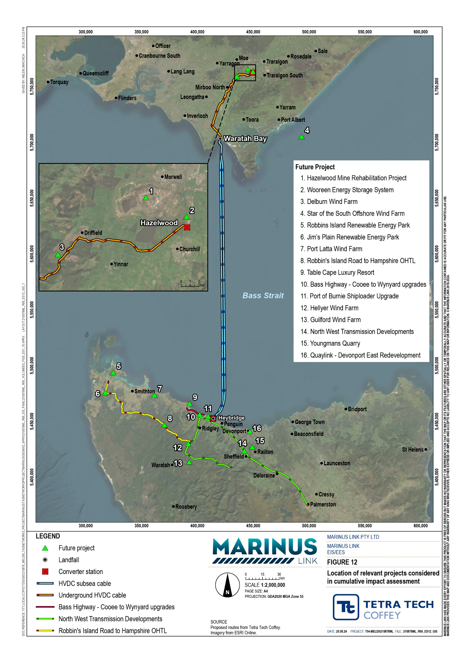

Environmental Management Framework
An Environmental Management Framework has been developed for the project to provide a transparent governance framework for the management of environmental impacts from the project to meet Victorian and Commonwealth environmental statutory requirements, achieve necessary environmental outcomes, protect environmental values and sustain stakeholder confidence.
Key elements of the Environmental Management Framework are:

EPRs that set out the environmental outcomes to be achieved for the project.

Establishment of an Environmental Management System certified to AS/NZS 14001:2016 by MLPL and each principal contractor for the project.
Obtaining necessary secondary consents and approval of documentation such as the final Environmental Management Framework with EPRs.
Obtaining approval from the Victorian Minister for Planning for Alignment Plans and Development Plans (as required in the draft PSA and Incorporated Document). These plans will include the final project alignment, converter station design and transition station design (if required).
Preparation of a range of management plans with an overarching construction environmental management plans (CEMP) for the converter stations (terrestrial) and cables (marine and terrestrial) supported by sub plans (as required in the EPRs).
Preparation and implementation of operations environmental management plans (OEMP) for the converter stations (terrestrial) and cables (marine and terrestrial).
Regular monitoring, review, inspection, auditing and reporting of environmental performance during construction and operation.
Engaging an Independent Environmental Auditor (IEA) to review the CEMPs and sub plans to confirm they are consistent with the Environmental Management Framework and EPRs. The IEA will also audit principal contractors and MLPL during construction and report on environmental performance as well as compliance with project approvals, the CEMP and its subplans.
As the approval holder, MLPL is responsible for compliance with approval requirements and the Environmental Management Framework. Some of these responsibilities will be delegated to principal contractors through a Compliance Management Standard, with implementation audited by the IEA.
The Environmental Management Framework with a full list of EPRs is provided in Volume 5, Chapter 2 - Environmental Management Framework.

Change management
A performance-based approach has been adopted for the project approval and delivery. This approach encourages innovation in development of the design and construction of the project to determine how best to achieve the EPRs to avoid or minimise impacts. Changes to project design may arise due to refinement of design and construction methods by the principal contractors; outcomes of landholder engagement; results of further geotechnical assessments; or unanticipated finds during construction.
Changes to project design will be managed through a clear and transparent process that requires:

Compliance with EPRs.

Agreement with the relevant landholder.

Assessment of changes in environmental impacts and consideration whether there is a material increase in adverse impacts compared with the EIS/EES assessment.
Preparation of a report documenting the reasons for the change and the outcomes of the impact assessment.
Consultation with relevant government agencies if a material change in adverse impacts is identified, to confirm the appropriate environmental impact assessment process and approval requirements for the change.
If it can be demonstrated that there is no material change in adverse effects, seek approval from the Minister for Planning for amendments to Alignment Plans or Design Plans.
Changes to documentation and management plans will be reviewed and approved by MLPL and the IEA, where major changes are proposed. Where required in the Environmental Management Framework or project approvals, regulator approval of changes to documents will also be sought.

Conclusion
The EIS/EES provides a comprehensive assessment of the potential impacts of the project and addresses the requirements of the EIS guidelines and EES scoping requirements.
Avoidance of impacts has been maximised through selection of the route and design of the project. Potential impacts of the project have then been assessed based on the proposed design and construction method.
Where the impact assessment has identified the need to reduce impacts, the project is applying an outcomes-based approach through the preparation of EPRs. EPRs set out the environmental outcomes that must be achieved during construction, operation and decommissioning of the project, regardless of the final design adopted.

This performance-based approach encourages innovation by allowing for flexibility in how outcomes are achieved, rather than providing prescriptive measures that must be employed. It allows MLPL and contractors to determine the best way to achieve EPRs and manage impacts, whilst developing and optimising design solutions and construction methods.
An Environmental Management Framework has been developed to provide a governance framework for the management of environmental impacts that arise from the construction, operation and decommissioning of the project. The Environment Management Framework and the associated EPRs are a suitable approach to managing the environment outcomes for this project and delivering project benefits.

Next steps
The EIS/EES with draft PSA will be on public exhibition for 30 business days so that the community can view the documents and make written submissions. The duration will cover the requirement for 30 business days of exhibition for the EES and 20 business days for the EIS.
The EIS/EES and draft PSA can be accessed at the Marinus Link website: EIS/EES Marinus Link (website- mlpl-dev-001.azurewebsites.net)
Hard copies of components of the EIS/EES and draft PSA, and digital copies of all EIS/EES documents can be viewed at:
Latrobe City Council offices

South Gippsland Shire offices

Marinus Link Traralgon Office

Sandy Point Community Centre

Mirboo North Library

Meeniyan Post Office

Churchill Community Centre

Submissions must be made in writing and can be made between Friday 31 May and 11:59pm on Friday 12 July 2024.
Written submissions on the EIS/EES will be received by Planning Panel Victoria via the Engage Victoria website. Submissions will be received on matters relevant to both the EE Act and EPBC Act.
MLPL has committed to responding to public submissions in both the EIS and EES process, regardless of whether the submission was made through the Commonwealth, Victorian or Tasmanian process.
Information on the hearing process and timetable will be published as it becomes available at: https://engage.vic.gov.au/MarinusLink-IAC
Project information updates will be published on the project website (www.marinuslink.com.au).

