Introduction
Marinus Link (the project) is a proposed electricity and telecommunications interconnector between Tasmania and Victoria. It will enable the flow of electricity in both directions between the two states, delivering low-cost, reliable and clean energy for households and other energy users in Victoria, Tasmania, New South Wales, Australian Capital Territory, Queensland and South Australia via energy retailers.
Tasmania has significant renewable energy resource potential, particularly hydroelectric power and wind energy. The potential size of the resource exceeds the Tasmanian electricity demand as well as the capacity of the existing interconnector. The growth in renewable energy generation in mainland states participating in the National Electricity Market (NEM), together with the reduced use of coal-fired generators, is reducing the availability of dispatchable energy. Dispatchable energy is electricity supply that can easily be turned on and off in response to demand and at short notice.
The project is proposed to provide a second link between the Tasmanian renewable energy resources and other NEM regions via the Victorian electricity grid. This will enable energy trade, from a diverse range of generation sources in Tasmania to where it is most needed in Victoria, New South Wales, Australian Capital Territory, Queensland and South Australia via the NEM. As a result, the capacity and security of energy will increase across the NEM.
The Australian Energy Market Operator (AEMO) has recognised the critical importance of the project, identifying it as an actionable project in both the 2020 Integrated System Plan (ISP) (July 2020) and 2022 ISP (June 2022), and reaffirming it as an urgent actionable project in its 2024 Draft ISP (December 2023).
The ISP provides a roadmap for the efficient development of the NEM over the next 20 years. The 2024 Draft ISP suggests that actionable projects including the project ‘should progress as urgently as possible’ because its early delivery would provide ‘valuable insurance against early coal closures or if the development of generation and storage slows’.
As the project has the potential to impact on environmental and social values, detailed assessment of these potential impacts is required under the Commonwealth Environment Protection and Biodiversity Conservation Act 1999 (Cwlth) (EPBC Act) and the Victorian Environment Effects Act 1978 (Vic) (EE Act), through the preparation of this environmental impact statement/environment effects statement (EIS/EES).

Purpose of this EIS/EES
The purpose of this EIS/EES is to assess the potential impacts of the project in Victoria and on Commonwealth matters in Victoria, Tasmania and the marine environment of Bass Strait. The EIS/EES considers both positive and negative impacts on the environment, including ecological, physical, cultural and social elements. The assessment of impacts covers the design, construction, operation and decommissioning of the project, and will allow the Victorian Minister for Planning under the EE Act and the Commonwealth Minister for the Environment and Water under the EPBC Act to make an assessment or decision regarding its acceptability to proceed.
The project has been assessed through the completion of 23 technical studies across both terrestrial and marine environments. The findings of these technical studies are summarised in this EIS/EES and attached as technical appendices. Through the completion of the technical studies, a set of environmental performance requirements (EPRs) has been developed for the project that will guide the implementation of the project, setting the environmental outcomes to be achieved through the construction, operation and decommissioning.

Project proponent
Marinus Link Pty Ltd (MLPL) is the proponent for the project and is a wholly owned subsidiary of Tasmanian Networks Pty Ltd (TasNetworks). TasNetworks is owned by the State of Tasmania and owns, operates and maintains the electricity network in Tasmania. The proponent details are:
Organisation: Marinus Link Pty Ltd

Postal Address: PO Box 606, Moonah, TAS, 7009 ABN/ACN: 24 167 357 299
In October 2022, the Commonwealth, Victorian and Tasmanian governments signed a Letter of Intent which outlined agreement for the delivery of the project, including a joint ownership model, concessional financing and cost allocation agreement for the project (in addition to arrangements for North West Transmission Developments (NWTD) and Battery of the Nation), based off costs as they were understood, before the project released tenders to the international market.
In March 2024, the Commonwealth, Victorian and Tasmanian governments announced new arrangements which saw the Commonwealth increase its equity share in the project to 49%, and Tasmania’s equity share reduce to approximately 17.7%. Victoria’s equity share remains at 33.3%.
MLPL was formed in 2018 for the purpose of constructing the project. MLPL has no past or present proceedings against it under a Commonwealth, State or Territory law. MLPL benefits from the experience of each of its government owners in planning, delivering, and operating large-scale transmission and nationally- significant projects. MLPL is committed to good industry practice to deliver long term benefits to stakeholders with a focus on compliance with relevant legislative and regulatory requirements.

In December 2023, the Victorian Essential Services Commission issued MLPL with an electricity transmission licence under the Electricity Industry Act 2000 (Vic). The licence is required for MLPL to transmit electricity in Victoria.
Building on the experience of TasNetworks in the delivery of energy transmission projects in Tasmania, MLPL is committed to the sustainable conduct of its activities and has developed a project-specific Environment and Sustainability Policy, which is detailed in Volume 1, Chapter 9 – Sustainability, climate change and greenhouse gas emissions. This policy includes a commitment to minimise impacts on the environment from the project and apply principals of sustainability in its construction, operation and decommissioning.
In addition to the Environment and Sustainability Policy, MLPL has developed and implemented a range of health, safety and community engagement initiatives which include a Safety and Wellbeing Policy, Communications and Engagement Strategy, First Peoples Engagement Plan and Sustainability Framework. These strategies are shaping and guiding internal and external stakeholder communication and engagement activities including those being undertaken with First Peoples groups.
MLPL has dedicated environment and planning, safety and well-being, and communications and engagement teams, supported by expert consultancies. MLPL’s management team and key staff have extensive experience in the delivery of large, complex and multi-jurisdictional projects. MLPL will implement an Environmental Management System (EMS) developed in accordance with International Organisation for Standardisation (ISO) 14001:2015 Environmental management systems to manage compliance with regulatory requirements, approvals and the Environmental Management Framework developed for the project.

Project objectives and benefits
The objective of the project is to support Australia’s transition to renewable energy by providing Victoria with greater market access to Tasmania’s wind and hydro power, as well as proposed pumped hydro long duration energy storage resources. By increasing energy exchange between Victoria and Tasmania, the project is expected to unlock renewable energy generation opportunities and cost-effective energy storage in Tasmania, and support affordable, reliable and clean energy across the NEM.
The project is proposed to deliver an additional 1500 megawatt (MW) capacity connection between Victoria and Tasmania which will more than triple the continuous capacity currently provided by Basslink (the existing undersea connection across Bass Strait), bringing the total dispatchable energy between Victoria and Tasmania to around 2000 MW. The project presents a number of direct and indirect benefits to the NEM and its customers; and the Victorian and Tasmanian economies. These benefits are discussed further in
Volume 1, Chapter 2 – Project rationale, and include:

Stability and security for the NEM by accessing Tasmania’s renewable energy and cost-effective energy storage.

Increased resilience for Tasmanian energy supply, with additional trade capacity and reduced reliance on the single existing interconnector.
Wholesale energy cost reductions in the NEM.

Economic benefits through construction and operations.

Increased telecommunications capacity between Tasmania and mainland Australia.

A Regulatory Investment Test for Transmission (RIT-T) is a public cost benefit analysis test that electricity transmission network service providers must apply to proposals. The RIT-T for the project demonstrates that it will put downward pressure on wholesale electricity prices, and that its benefits to consumers in the NEM will outweigh its costs. The Project Assessment Conclusions Report (PACR) (TasNetworks 2021) is the final step in the RIT-T process, required under the National Electricity Rules, and shows that the project satisfies the RIT-T.
The cost-benefit analysis undertaken for the PACR indicates that the project delivers significant positive net economic benefits to the NEM. Based on the assumed earliest commission date at the time of modelling (2027 for the first 750 MW and 2029 for the second 750 MW), the 1500 MW option is estimated to provide a net economic benefit of between $1.4 billion and $3.65 billion for the life of the project.
Updated modelling completed by Ernst & Young (2023) confirms the above benefits and demonstrates that construction and operation of the project will provide $1.47 billion in economic contribution for Tasmania and
$1.78 billion in economic contribution for Victoria. The project is also predicted to support the following jobs during peak construction:
Stage 1: 673 jobs per year in Tasmania and 857 jobs per year in Victoria.

Stage 2: 643 jobs per year in Tasmania and 818 jobs per year in Victoria.

The construction and operation of the project and associated network augmentation, coupled with induced investment is expected to support jobs across a wide range of industries, education levels and occupations. These include those physically involved in the building and installation process, such as carpenters, plumbers, welders, metal workers and support workers. Indirect jobs in the building and installation process include cost estimators, engineers, financial advisors, technicians, construction managers, surveyors, architects, safety and incident support staff. Core jobs in the operations phase include safety and incident support staff, operations and maintenance managers, plumbers, welders and other maintenance staff, corporate and financial staff and asset managers.
Along with price savings and increased reliability, the project will also facilitate the transition from existing, greenhouse gas (GHG) intensive energy generation, to renewable energy generation. Implementation of the project is expected to support a reduction in GHG emissions by 140 million tonnes of carbon dioxide equivalent (CO2 e) by 2050.
Independent modelling conducted for the PACR (Ernst & Young 2021) supports the development and operation of the project with it providing greater benefits to the NEM than its cost.

Cross-governmental support for the project
The Commonwealth, Victorian, and Tasmanian governments have shown consistent policy support for the project over several years, including in the following ways:
The Australian Energy Ministers recognised the project as a project of national significance in September 2023. The Commonwealth government said it is working closely with Victorian and Tasmanian governments to ensure that work on the project progresses.
The Commonwealth government approved a grant of $75 million in April 2022 to support the completion of the project’s design and approvals phase.
Infrastructure Australia upgraded the project from a ‘Longer-Term Priority Initiative’ to part of a ‘High Priority Initiative’ on its Infrastructure Priority List 2021 (February 2021). In February 2023, Infrastructure Australia named the project as an actionable network investment in the NEM to ensure future connectivity and reliability of the NEM.
Infrastructure Victoria’s Infrastructure Strategy 2021-2051 (December 2021) names the project as a project that can augment critical electricity transmission infrastructure and improve network resilience, noting that the Victorian Government can assist the project by progressing design and approvals.
The Victorian Government’s 2035 Emissions Reduction Target: Driving Real Climate Action (May 2023) lists the acceleration of the project as a key transmission infrastructure project to achieve Victoria’s transition towards renewable energy and to achieve emission reduction targets.
The Tasmanian Department of State Growth has listed the project as one of four major investment projects that will drive investment stimulus, create jobs and reduce power prices.
The Tasmanian Department of State Growth has also committed to progress the project as part of its Tasmanian Renewable Energy Action Plan (December 2020) Priority One actions to double renewable electricity generation by 2040.

Project overview
The project is a proposed 1500 MW high voltage direct current (HVDC) electricity interconnector between Heybridge in northwest Tasmania and the Latrobe Valley in Victoria (Figure 1-01). It will be implemented as two 750 MW circuits to meet transmission network operation requirements in Victorian and Tasmania. Each 750 MW circuit will comprise two power cables and a fibre-optic communications cable bundled together in Bass Strait and laid in a horizontal arrangement on land. The two 750 MW circuits will be installed in two stages.

The key project components for each 750 MW circuit, from south to north, are:

High voltage alternating current (HVAC) switching station and HVAC-HVDC converter station at Heybridge in Tasmania (Figure 1-02).
Shore crossing in Tasmania adjacent to the converter station. The shore crossings will be constructed via horizontal directional drilling (HDD) to about 10 metre (m) water depth.
Approximately 255 kilometres (km) of subsea cable across Bass Strait from Heybridge in Tasmania to Waratah Bay in Victoria (Figure 1-01). The subsea cables for each stage will be laid approximately 2 km apart except near the shore crossings where the stage 1 and stage 2 cables will come together to enable them to be pulled through the shore crossings.
Shore crossing in Victoria at Waratah Bay approximately 3 km west of Sandy Point. The shore crossings will be constructed via HDD to about 10 m water depth.
Land-sea cable joint where the subsea cables will connect to the land cables in Victoria.

Fibre optic cable inspection and test hut (communications building) adjacent to Waratah Bay.

Approximately 90 km of underground land cables a minimum 5 m apart in Victoria, extending from the land-sea joint to the converter station site at Hazelwood (Figure 1-03).
HVAC switching station and HVAC-HVDC converter station at Hazelwood, adjacent to the existing Hazelwood Terminal Station, where the project will connect to the existing Victorian transmission network.
A transition station may be required at Waratah Bay if there are different cable manufacturers or substantially different cable technologies adopted for the land and subsea cables. However, regardless of whether a transition station is needed, a communications building will still be required in the same location.

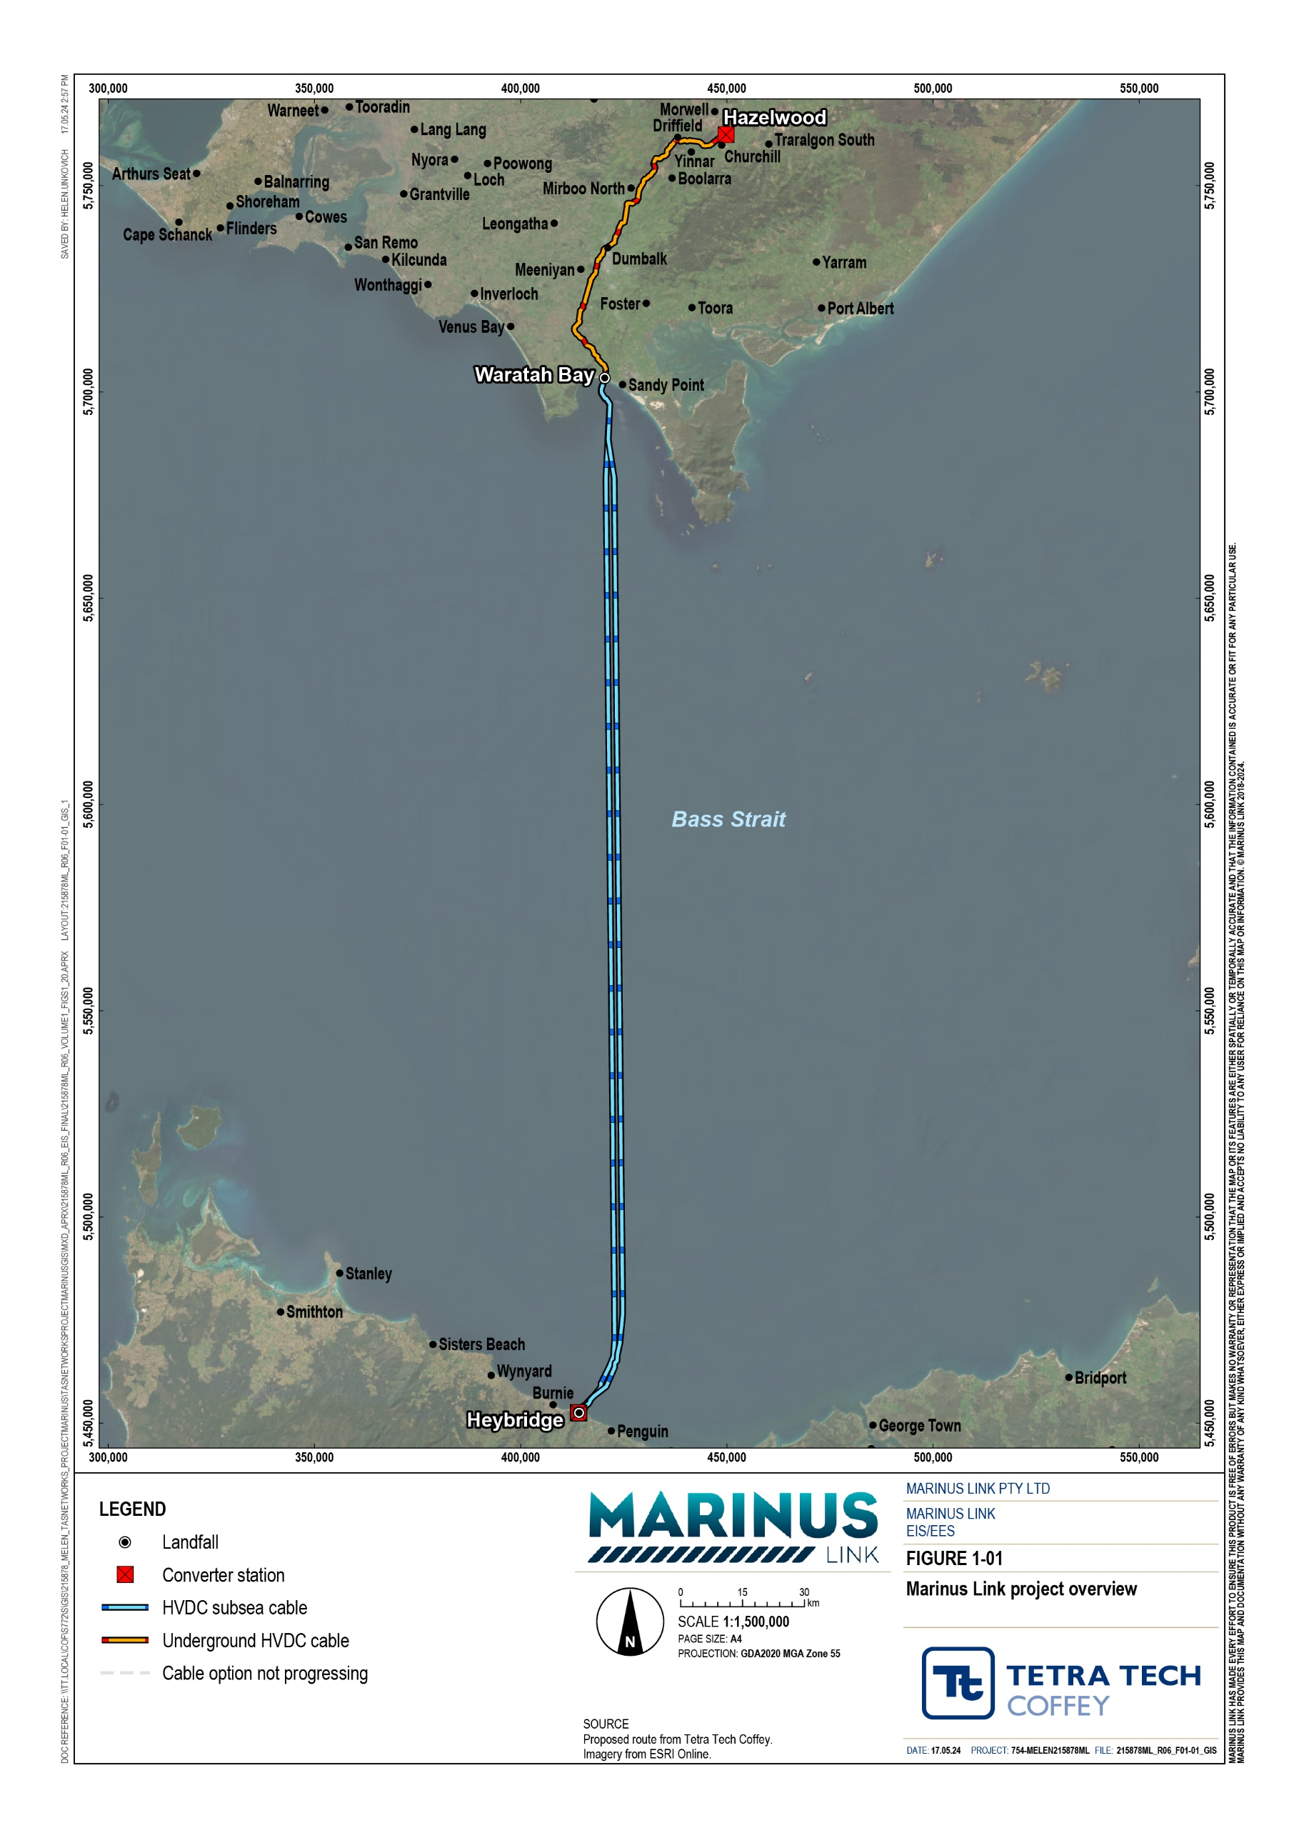

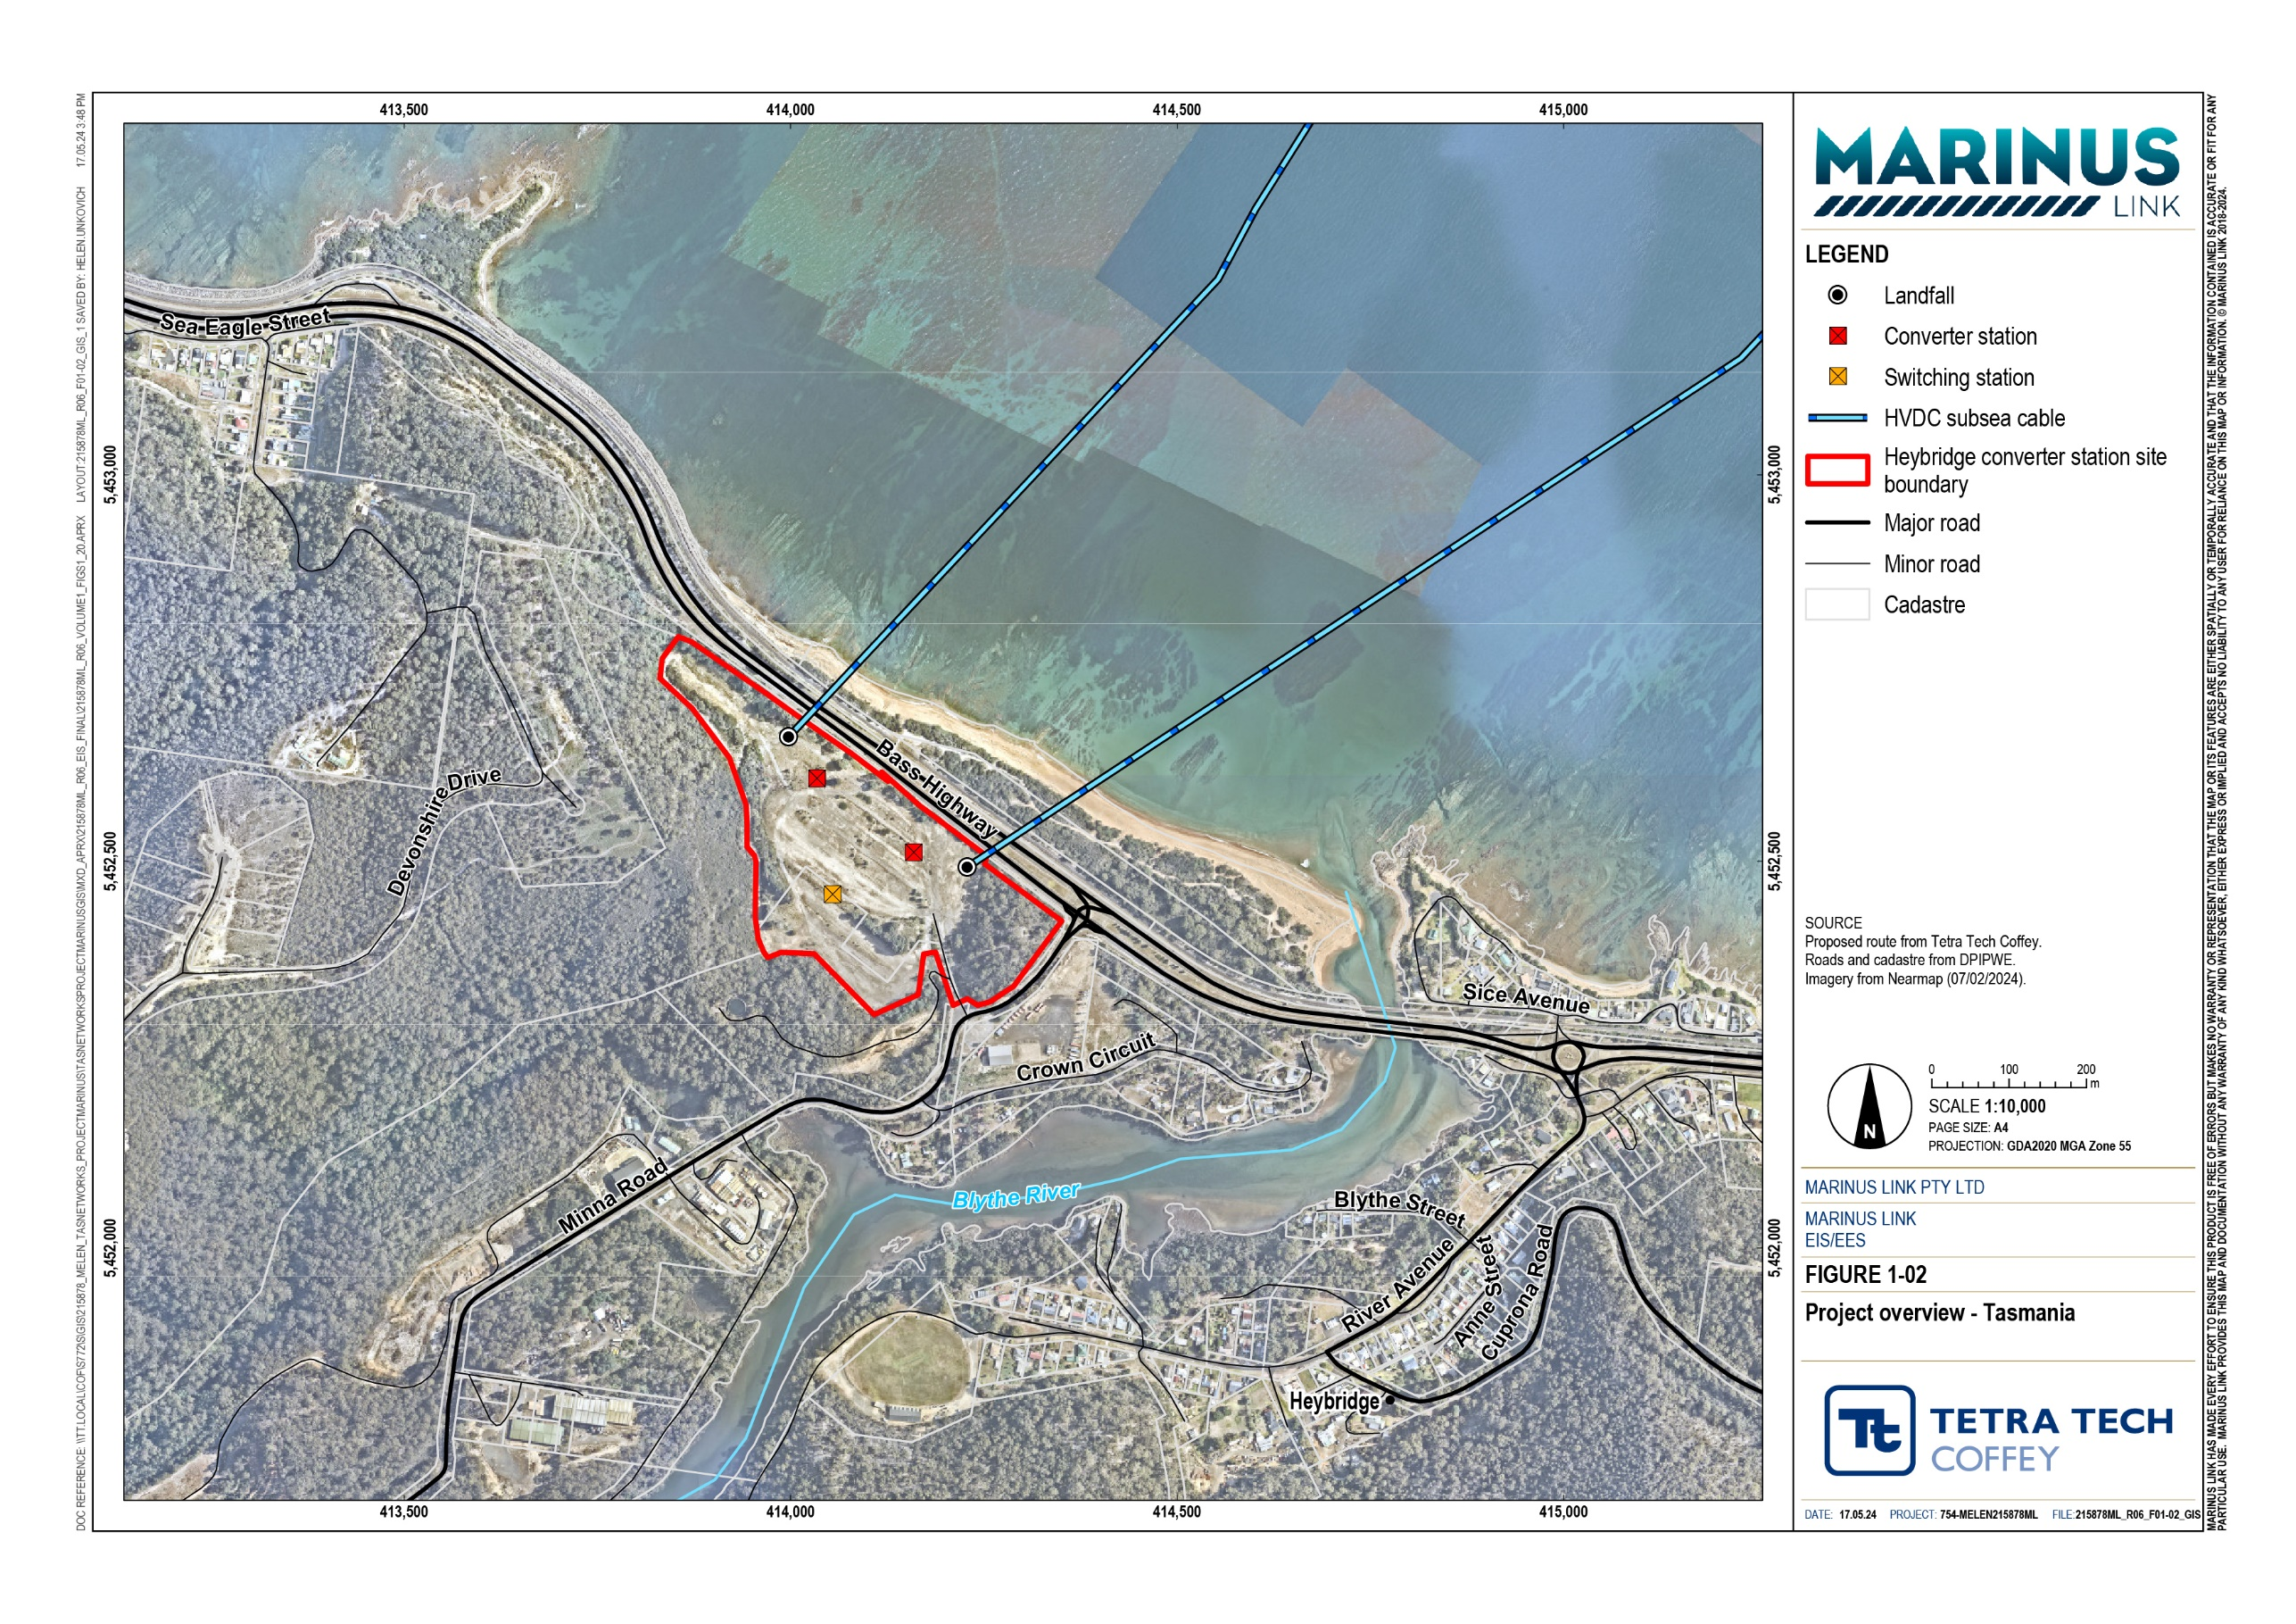

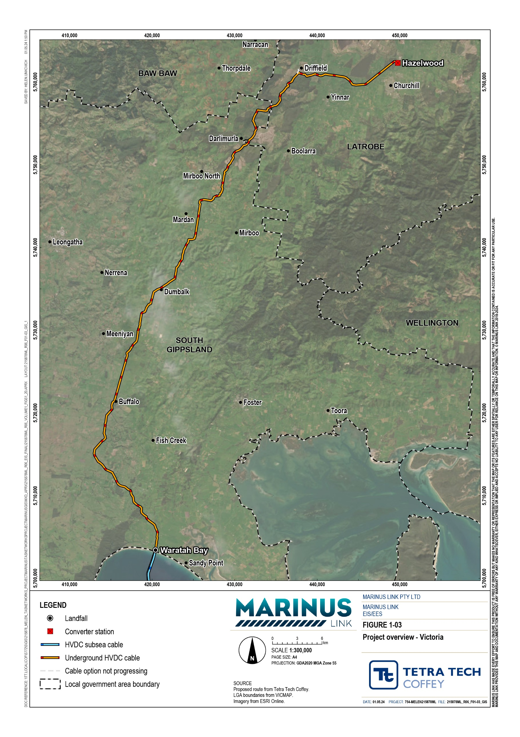

1.5.1 Project timeline
The project is currently progressing through the design and approvals phase. An outline of the project timeline is provided in Figure 1-04 (noting the timelines are subject to approvals, access, weather, construction and market constraints).
If approved, the project will be constructed in two stages. Construction and cabling activities for stage 1 are anticipated to be completed by 2030. Stage 2 activities will follow, with final timing to be determined by market demand.

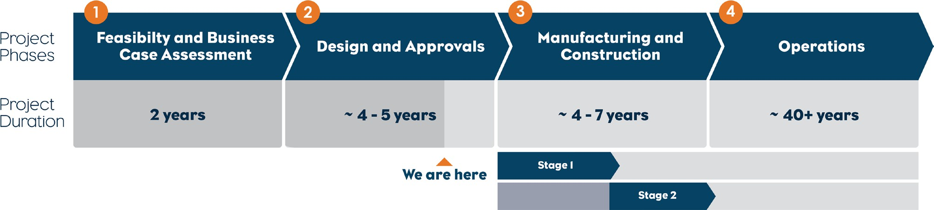

Figure 1-04 Project Timeline

Environmental impact statement / environment effects statement
The project is located within the jurisdictions of the Commonwealth, Victorian and Tasmanian governments. Environmental referrals were submitted to each of these jurisdictions to confirm the assessment and approval requirements for the project.
The project was referred to the Commonwealth Minister for the Environment under the EPBC Act on 5 October 2021. On 4 November 2021, a delegate of the Minister for the Environment determined that the proposed action is a controlled action as it has the potential to have a significant impact on the environment and requires assessment and approval under the EPBC Act before it can proceed. The delegate determined that the appropriate level of assessment under the EPBC Act is an EIS.
The project was referred under the EE Act on 17 September 2021. On 12 December 2021, the Victorian Minister for Planning determined that the project requires an EES under the EE Act, to describe the project’s effects on the environment to inform statutory decision making.

This EIS/EES has been prepared to address the requirements of the Commonwealth and Victorian jurisdictions. For the assessment of the Tasmanian component of the project, only Commonwealth matters within the Tasmanian project area are addressed in this EIS/EES. This includes the Commonwealth requirement to assess shipwrecks under the Underwater Cultural Heritage Act 2018 (Cwlth) in Tasmanian waters. This is addressed in Volume 3 of this EIS/EES. Other matters in Tasmanian waters covered by Tasmanian legislation are assessed in the separate EIS document prepared for the shore crossing.
In July 2022, a delegate of the Director of the Environment Protection Authority Tasmania (EPA Tasmania) determined that the converter station and the shore crossing components of the project be subject to environmental impact assessment by the Board of the Environment Protection Authority (the Board) under the Environmental Management and Pollution Control Act 1994 (Tas) (EMPCA). Therefore, works associated with the converter station at Heybridge will be assessed under s24 of EMPCA, and works for the shore crossing will be assessed under section 27 of EMPCA. MLPL have progressed separate EIS documentation to address the requirements of the EPA Tasmania under the EMPCA.
The three jurisdictions have agreed to coordinate the assessment of the project to:

Support consideration of the impacts of the project across government boundaries.

Streamline the assessment process.

Facilitate consistent environmental and social outcomes.

The Department of Climate Change, Energy, the Environment and Water (Commonwealth) (DCCEEW), Department of Transport and Planning (Victoria) (DTP) and EPA Tasmania have agreed to coordinate the three assessment processes where possible. The approach to coordinate and align environmental assessment processes is rooted in the Commonwealth, Victorian and Tasmanian governments’ recognition of the project as a project of national importance.

Commonwealth EIS guidelines
The project has the potential to have a significant impact on the following matters of national environmental significance (MNES) that are protected under Part 3 of the EPBC Act:
Listed threatened species and communities.

Listed migratory species.

The environment of the Commonwealth marine area.

DCCEEW have published guidelines for the EIS which set out the detailed requirements addressed in this EIS/EES: ‘Guidelines for the Content of a Draft Environmental Impact Statement – Environment Protection and Biodiversity Conservation Act 1999 – Marinus Link underground and subsea electricity interconnector cable (EPBC 2021/9053)’ (EIS guidelines).

Victorian EES scoping requirements
The ‘Scoping Requirements Marinus Link Project Environment Effects Statement’ issued by the Minister for Planning (February 2023) (EES scoping requirements) set out the specific matters to be assessed in this EES for the project. In particular, the EES is required to address:
Effects on biodiversity and ecological values within and near the project area including native vegetation, listed threatened communities and species (flora and fauna) under the Flora and Fauna Guarantee Act 1988 (Vic) (FFG Act) and EPBC Act, such as through clearance, degradation or fragmentation of habitat.
Effects on freshwater and marine environments and related environmental values, including any changes to stream flows, water quality or sedimentation due to waterway crossings or installation of subsea cables.
Effects on Aboriginal cultural heritage values.

Effects on the socioeconomic environment including land use, at local and regional scales.

Effects on existing landscape values.

The EES scoping requirements informed the scope of the technical studies and defined the EES evaluation objectives. The EES evaluation objectives identify the desired outcomes to be achieved and provide a framework for an integrated assessment of the environmental effects of the project. The EES evaluation objectives are provided in Volume 1, Chapter 5 – EIS/EES assessment framework.

Overview of approach to the EIS/EES
DCCEEW, DTP and EPA Tasmania have agreed to coordinate and, where possible, integrate and align their assessment processes. This agreed approach allows the preparation of a consolidated EIS/EES document to address the requirements of both the Commonwealth and Victorian governments (as outlined in
Section 1.1), with two separate EIS documents prepared for the Heybridge converter station and shore crossing to address the requirements of EPA Tasmania. This EIS/EES, together with project information updates to be published following its finalisation and exhibition, will be made available on the project website (www.marinuslink.com.au).
The EIS/EES has been prepared using the proposed project alignment to inform the assessment of potential impacts. A wider survey area has been assessed, as detailed in Volume 1, Chapter 6 – Project description. The final alignment is expected to be within this area and will be determined through detailed design and discussions with affected landholders prior to the commencement of construction.
The assessment of impacts across the whole project alignment, and for both stage 1 and stage 2, have been coordinated and completed at the same time to facilitate a comprehensive assessment of environmental values across the three jurisdictions. Assessments have been completed based on the area of potential impact rather than jurisdiction boundaries. Some studies therefore consider the whole project or the whole of the marine environment.

EPRs have been developed to address the impacts identified in the technical studies. EPRs set the environmental outcomes to be achieved during construction, operation and decommissioning regardless of the final design and construction approach adopted. The EPRs provide a transparent framework for MLPL to enable contractors to bring innovation and the latest approaches to avoiding and managing impacts while providing flexibility in determining the final alignment.

Structure of the EIS/EES
The EIS/EES has been prepared in five volumes:

Volume 1 – Introduction (this volume) provides an introduction with common information on the project, and technical information that spans the whole of project or assessments that are not locationally based.
Volume 2 – Tasmanian terrestrial environment describes the baseline characterisation, impact assessment and EPRs for the Tasmanian terrestrial component of the project (MNES only).
Volume 3 – Marine environment describes the baseline characterisation, impact assessment and EPRs for the marine (nearshore and offshore) component of the project, encompassing Tasmanian waters (MNES only), Commonwealth marine area and Victorian waters.
Volume 4 – Victorian terrestrial environment describes the baseline characterisation, impact assessment and EPRs for the Victorian terrestrial component of the project.
Volume 5 – Synthesis of environmental effects is a series of concluding chapters that draws together the overall assessment of the environmental effects of the project as a whole, as well as a summary for each jurisdiction.
Each volume consists of detailed chapters as illustrated in Figure 1-05. Technical study reports prepared to support this EIS/EES are provided as appendices.

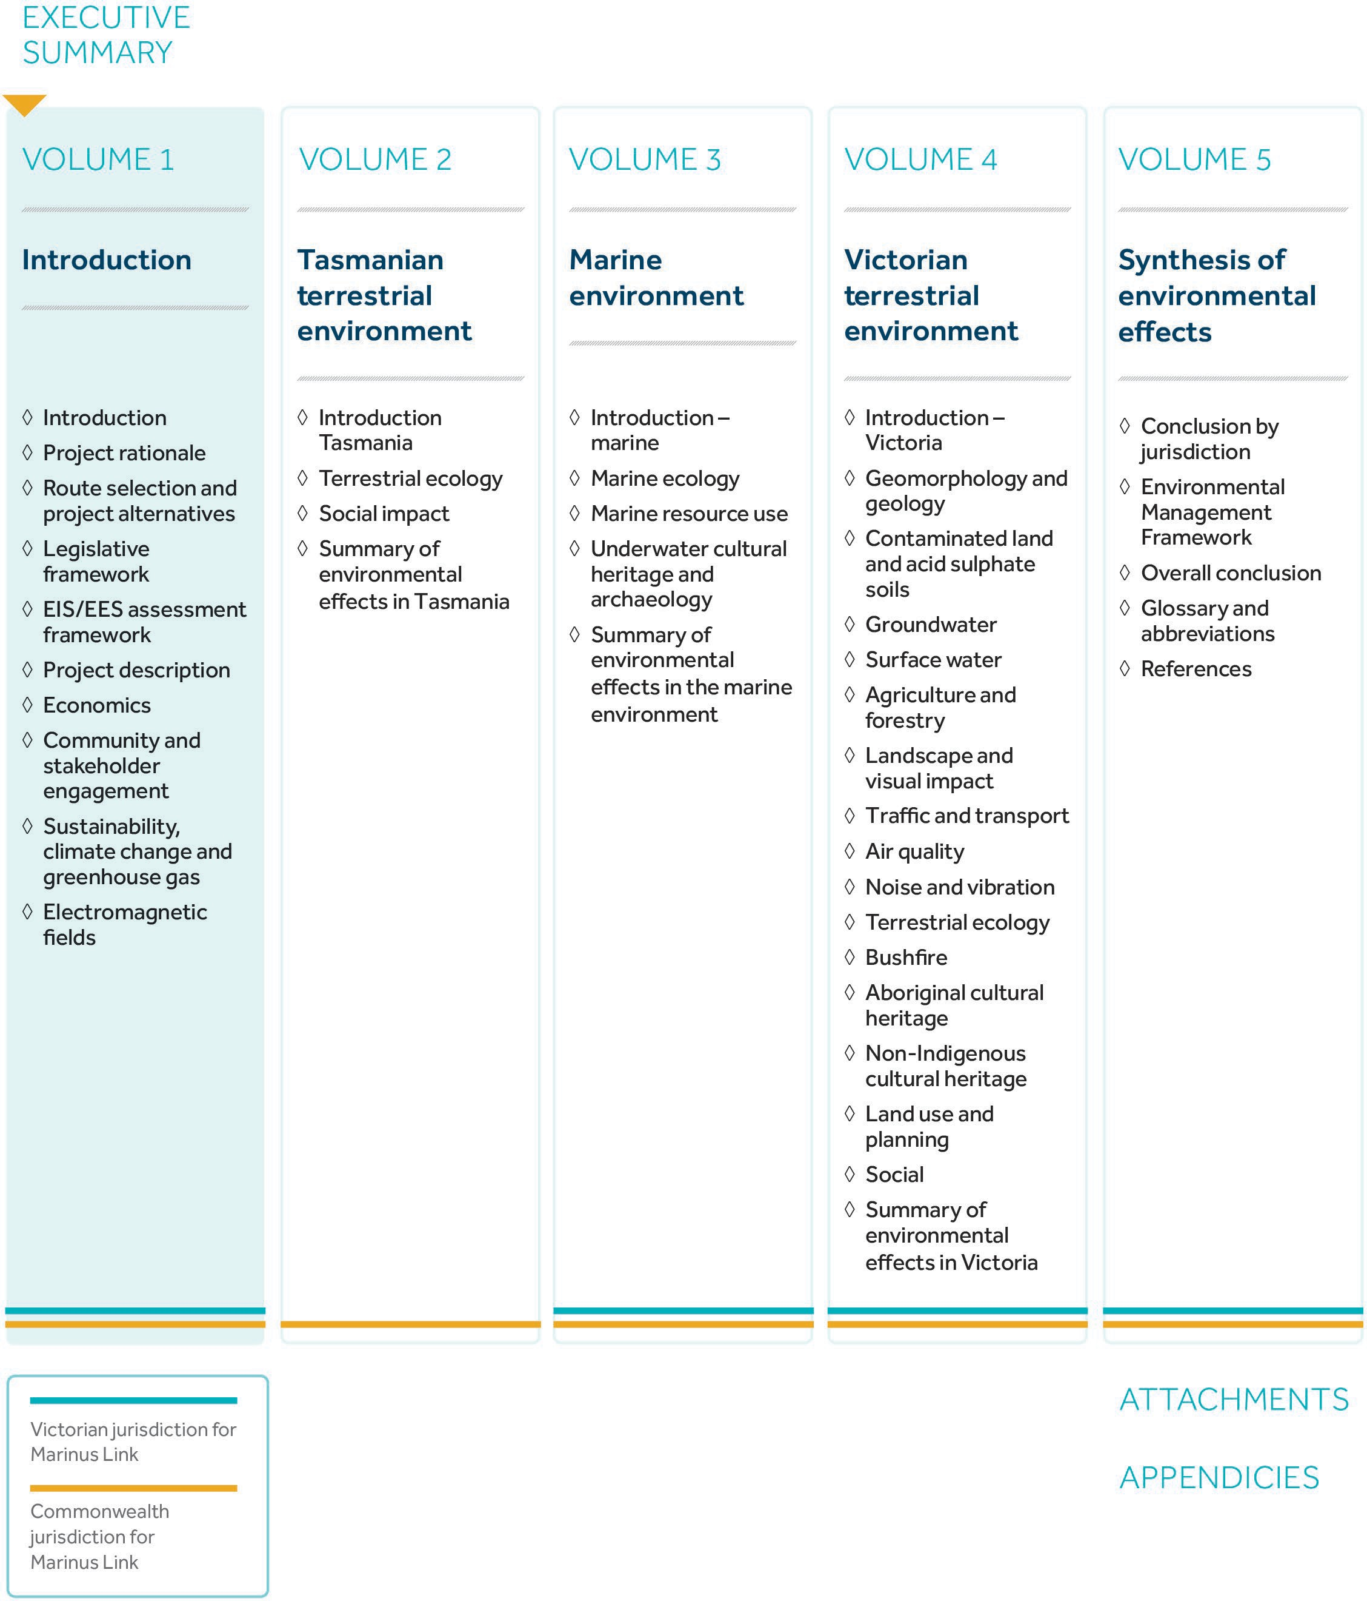

Figure 1-05 Structure of the Marinus Link EIS/EES

