Route selection and project alternatives
The project is the culmination of a comprehensive route and site selection process that has considered technical, environmental, cultural and social constraints. The route and site selection process assessed different options against the project objectives of (MLPL 2021a):
Connecting Tasmanian renewable energy zones, offsetting network investment in Tasmania.

Facilitating export of dispatchable power from Tasmania, to support seasonable reliability across the NEM.
Increasing inter-regional market access.

Increasing energy security.

When commencing this process, MLPL had no pre-determined view on where project infrastructure should be located across Tasmania, Bass Strait and Victoria. Desktop assessments of ecological values, cultural heritage values and geomorphology were completed to inform the route selection process, with detailed consideration of options occurring since 2018. This process reflects the recognition by MLPL that avoidance of impacts to the environment is best achieved through careful selection of the route.
Route selection activities between mid-2018 to late-2020 included:

Identifying what connection is required (start and end points).

Identifying what is proposed to be built (technical specification).

Identifying the physical, biological and socioeconomic values that exist in the area of interest.

Considering the constraints and identifying the opportunities from these values.

Identifying prudent and feasible corridors.

Identifying prudent and feasible routes within the corridors, including:

- Evaluating these routes against route selection criteria and constraints.

- Identifying the least constrained routes.

- Ground-truthing the least constrained routes.

Identifying a preferred route.

Following the announcement of the preferred route in late-2020, refinement of the route progressed through engagement with landholders and the broader community, and consideration of the results of geotechnical investigations and technical study findings. The preferred route continued to be refined through 2021 as engagement and technical studies progressed, culminating in the proposed route and sites subject to this

EIS/EES. The route will continue to be refined in response to landholder discussions and additional information.
This chapter details the route and site selection activities and alternatives considered since mid-2018, as documented in the Route Options Report (MLPL 2021a) prepared for the project.

Identifying what connection is required
Tasmania’s connection to the NEM is currently via Basslink, a 500 MW HVDC interconnector between George Town in Tasmania and Loy Yang in Victoria. Basslink is highly utilised at times, restricting the amount of energy transmission between Tasmania and the NEM. Additional transmission capacity is required to allow storage of surplus renewable energy from the NEM when available, and dispatch of stored energy in times of high demand or low renewable energy output.
Based on economic analysis of potential capacity options (TasNetworks 2021) of 600 MW up to 1500 MW, 1500 MW transmission capacity was identified as delivering the highest net economic benefit. Therefore, the project is a proposed 1500 MW interconnector between the Tasmanian and Victorian electricity grids.
The grid backbone in Tasmania and Victoria is the primary transmission network of the NEM and the strongest part of the energy network (shown in Figure 1-06). These backbone nodes are considered most effective for managing the required energy transfer of up to 1500 MW. Therefore, the route and site selection process for the project started with seeking connection between the grid backbones in Tasmania and Victoria.
The grid backbone in northern Tasmania is the 220 kV double circuit transmission network formed by Sheffield, George Town and Palmerston substations, and the Farrell Substation. The grid backbone along the south coast of Victoria is the 500 kV transmission network formed by Loy Yang, Hazelwood, Cranbourne, Rowville, South Morang, Keilor, Sydenham, Moorabool, Heywood and Portland Alcoa 500 kV substations.
Existing connection locations near the coast were preferred over new infrastructure and locations to reduce the length of land cables. Locations with proximity to existing and proposed renewable energy zones (REZ) also maximise the use of these areas.

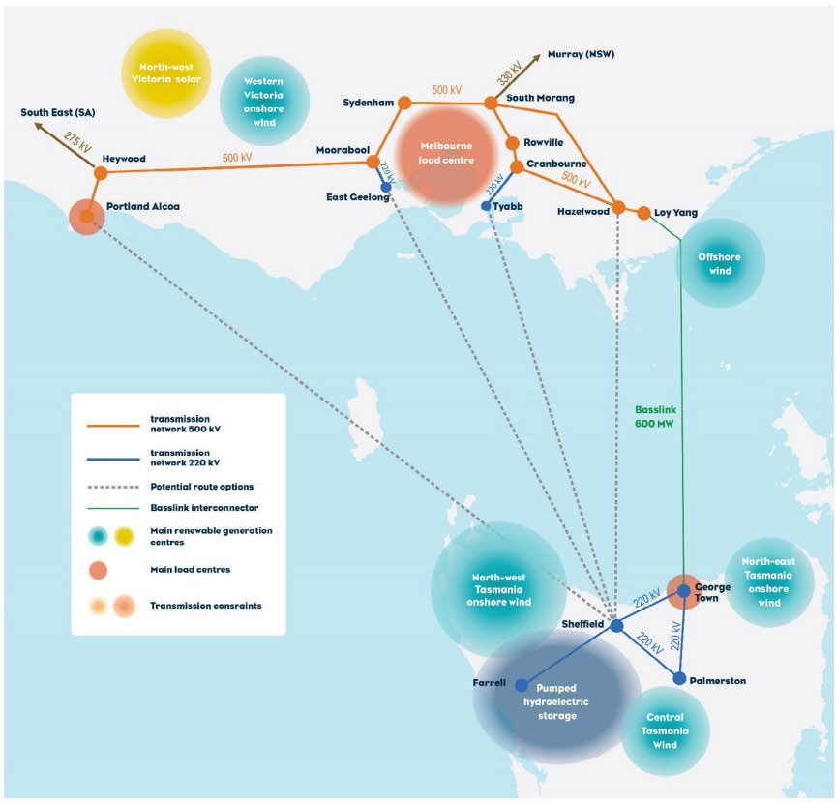

Identifying what is proposed to be built
Electricity can be transmitted as either alternating current (AC) or direct current (DC). Higher losses occur when AC is transmitted over long distances compared to direct current. Because of this, long interconnectors such as the project typically use DC and HVDC to reduce losses.
The project was planned as a 1500 MW HVDC interconnector, connecting the grid backbones in Tasmania and Victoria. Converter stations are required at each end of the link to convert the DC electricity to AC electricity, connecting into the Tasmanian and Victorian electricity grids.
A converter station can be connected via underground cables, overhead transmission lines, or a combination of both. The project’s land cables will be fully underground.
Further detail on the project description for the project, including the design and construction methods, is provided in Volume 1, Chapter 6 – Project description.

Identifying key constraints and values to consider
The selection process for the project corridor, route and converter station site considered the environmental and social context of three areas: Tasmania, Bass Strait and Victoria. This process was supported by desktop ecological, cultural heritage and geotechnical studies, and ground-truthing surveys.

Environmental, physical and social context
The analysis of the environmental, physical and social context of the project area was a key step in route and site selection. It was critical to understand the environment in which any route is proposed, and subsequently the constraints for route and site selection.
Northern Tasmania has undergone substantial native vegetation clearance for agricultural purposes. Remnant vegetation comprises relatively intact tracts of native vegetation, particularly on coastal ranges, along major watercourses and in reserves. Remnant vegetation and waterbodies have the potential to provide important habitat for a range of flora and fauna species including (Eco Logical Australia 2019):
Intact patches of swamp and wet forest communities, which may provide habitat for state listed flora species, and state and nationally listed bird species.
Waterways and waterbodies which could provide habitat for nationally listed species, including Australian grayling, Burnie burrowing crayfish and giant freshwater crayfish.
The dune and beach system comprising native coastal scrub, known to provide habitat for the little penguin.

Scattered native forests and woodland remnants, which could provide habitat for nationally listed species including spotted-tailed quoll, eastern quoll and Tasmanian devil.
The northern Tasmanian coast comprises rocky headlands interspersed with sandy beaches. The rocky headlands and associated rocky platforms transition to rocky reefs and cobbles, interspersed with sand and sediment in nearshore waters. The nearshore rocky platform and reefs provide important habitat values for a diverse range of species. Particularly, these areas provide habitat for benthic algae and other marine plants which are preferred habitat of EPBC Act listed pipefish, sea dragons and sea horses.
Remnant vegetation and threatened species along the Tasmanian northwest coast are protected in Rocky Cape National Park and Narawntapu National Park, and a number of conservation areas. Rocky Cape National Park protects a small part of the northwestern Tasmanian coast, and is known for its natural beaches, sea caves, rock formations and important Aboriginal cultural heritage sites.
The Tasmanian north coast and surrounding waterways have a high potential for Aboriginal cultural heritage including artefacts, artefact scatters, stone quarries, rock shelters, shell middens, fish traps and seal hides. The highest concentration of known fish traps in Tasmania occurs on the north coast between Ulverstone and Burnie.
The natural features and scenic coastline make tourism a major industry in Tasmania. The Spirit of Tasmania ferry operates between Devonport and Melbourne, and the coves and beaches along the north coast are popular tourist destinations.
In addition to the natural features considered, Tasmania’s north coast is important for industry, infrastructure, and recreation, including the following specific features (Figure 1-07):
Trading ports in Devonport and Burnie, and the major fishing port at Stanley.

Iron ore export business, Grange Resources, operating at Port Latta.

Maritime archaeological sites including shipwrecks.

Areas suitable for scallop fishing (i.e., soft silty-sand seabed).

Recreational fishing in proximity to coastal population centres.

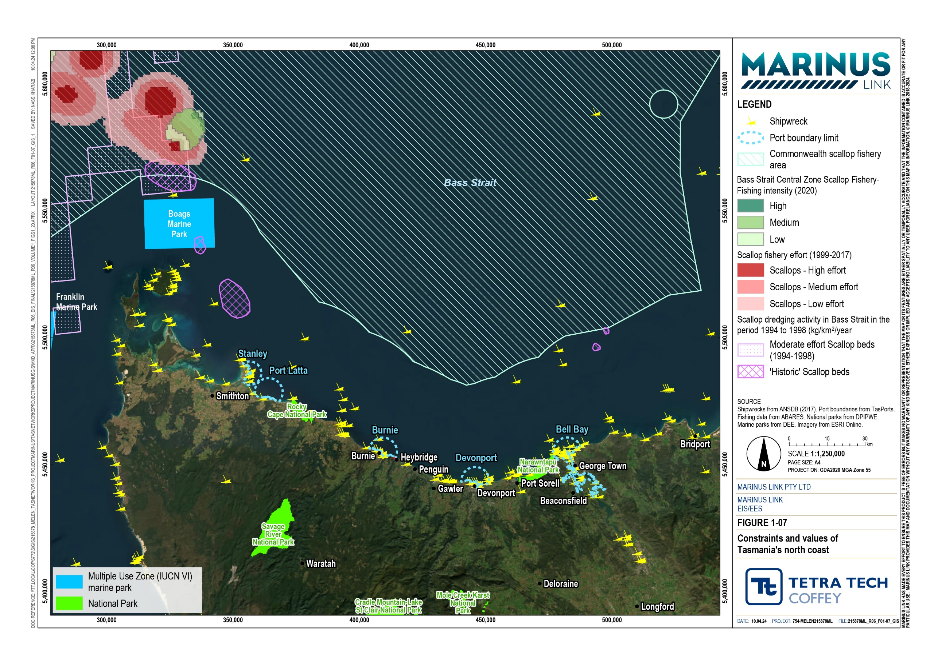

Remnant vegetation in southern Victoria has been largely cleared for agricultural purposes, except for that protected in conservation reserves or on private property, fragmented patches of remnant and planted woodlands, and scattered trees along road reserves, property boundaries and creek lines (Eco Logical Australia 2019). Native vegetation and water bodies in the area provide habitat for many state and nationally significant species. Dune and beach systems along the coast support intact coastal vegetation which provide important habitat for protected species, including threatened waders and migratory shorebirds.
The Strzelecki Ranges are a major feature of Victoria’s southeast coast, extending east from Western Port Bay to east of Traralgon. The ranges comprise the western and eastern sections, with the division between the ranges extending in a line from Morwell to Meeniyan. Elevations range from 300 m to 500 m above sea level, with the highest point being Mt Tassie (730 m). Woody vegetation cover increases from the coastal plains into the Strzelecki Ranges, especially along roadsides, creeks, and gullies, and in hardwood and softwood plantations. In this area, native vegetation exists in large patches and narrow corridors along creek lines and in harvesting buffers, acting as important wildlife corridors and refuges. Native vegetation is protected in the Tara–Bulga National Park.
The Otway Ranges extend east from Port Campbell to Lorne, and to the coast. East of the Otway Ranges, lava flows extend to the coast near Torquay and Breamlea, forming rocky headlands and escarpments.
Expansive coastal plains extend inland from Port Phillip and Western Port bays.

East of Western Port Bay, the coast comprises rocky headlands interspersed with inlets and sandy beaches. Waratah Bay and adjacent Shallow Inlet Marine and Coastal Park lie west of the Wilsons Promontory isthmus, with Corner Inlet and the Nooramunga Marine and Coastal Park to the east. Wilsons Promontory National Park extends into Bass Strait. Parts of its coast and offshore islands are protected by marine national parks. The Ninety Mile Beach extends from McLoughlins Beach at the eastern end of the Nooramunga Marine and Coastal National Park to Lakes Entrance.
Aboriginal cultural heritage, including shell middens, artefacts and scar trees, are known to occur through southern Victoria and coastal areas, as well as areas of non-Aboriginal historical significance.
Native vegetation and other natural and historic features protected in Victoria within national parks, marine national parks and other conservation reserves are shown in Figure 1-08.
Southern Victoria, including the south coast, has largely been developed into rural lifestyle properties, while supporting a range of industries, as follows:
Agriculture including dairy, horticulture, vineyard, and berry farms, among other agricultural enterprises.

Forestry on the northern slopes of the Strzelecki Ranges and in the Otway Ranges.

Tourism including major attractions such as the Great Ocean Road, the Twelve Apostles, Phillip Island and Wilsons Promontory.
Fisheries, with Portland, Port Campbell, San Remo and Port Welshpool being commercial fishing ports.

Oil and gas production at Iona near Port Campbell, Lang Lang near Western Port Bay and Longford in Gippsland.

Portland’s major trading port, which exports wood products and aluminium produced in Alcoa’s Portland aluminium smelter.

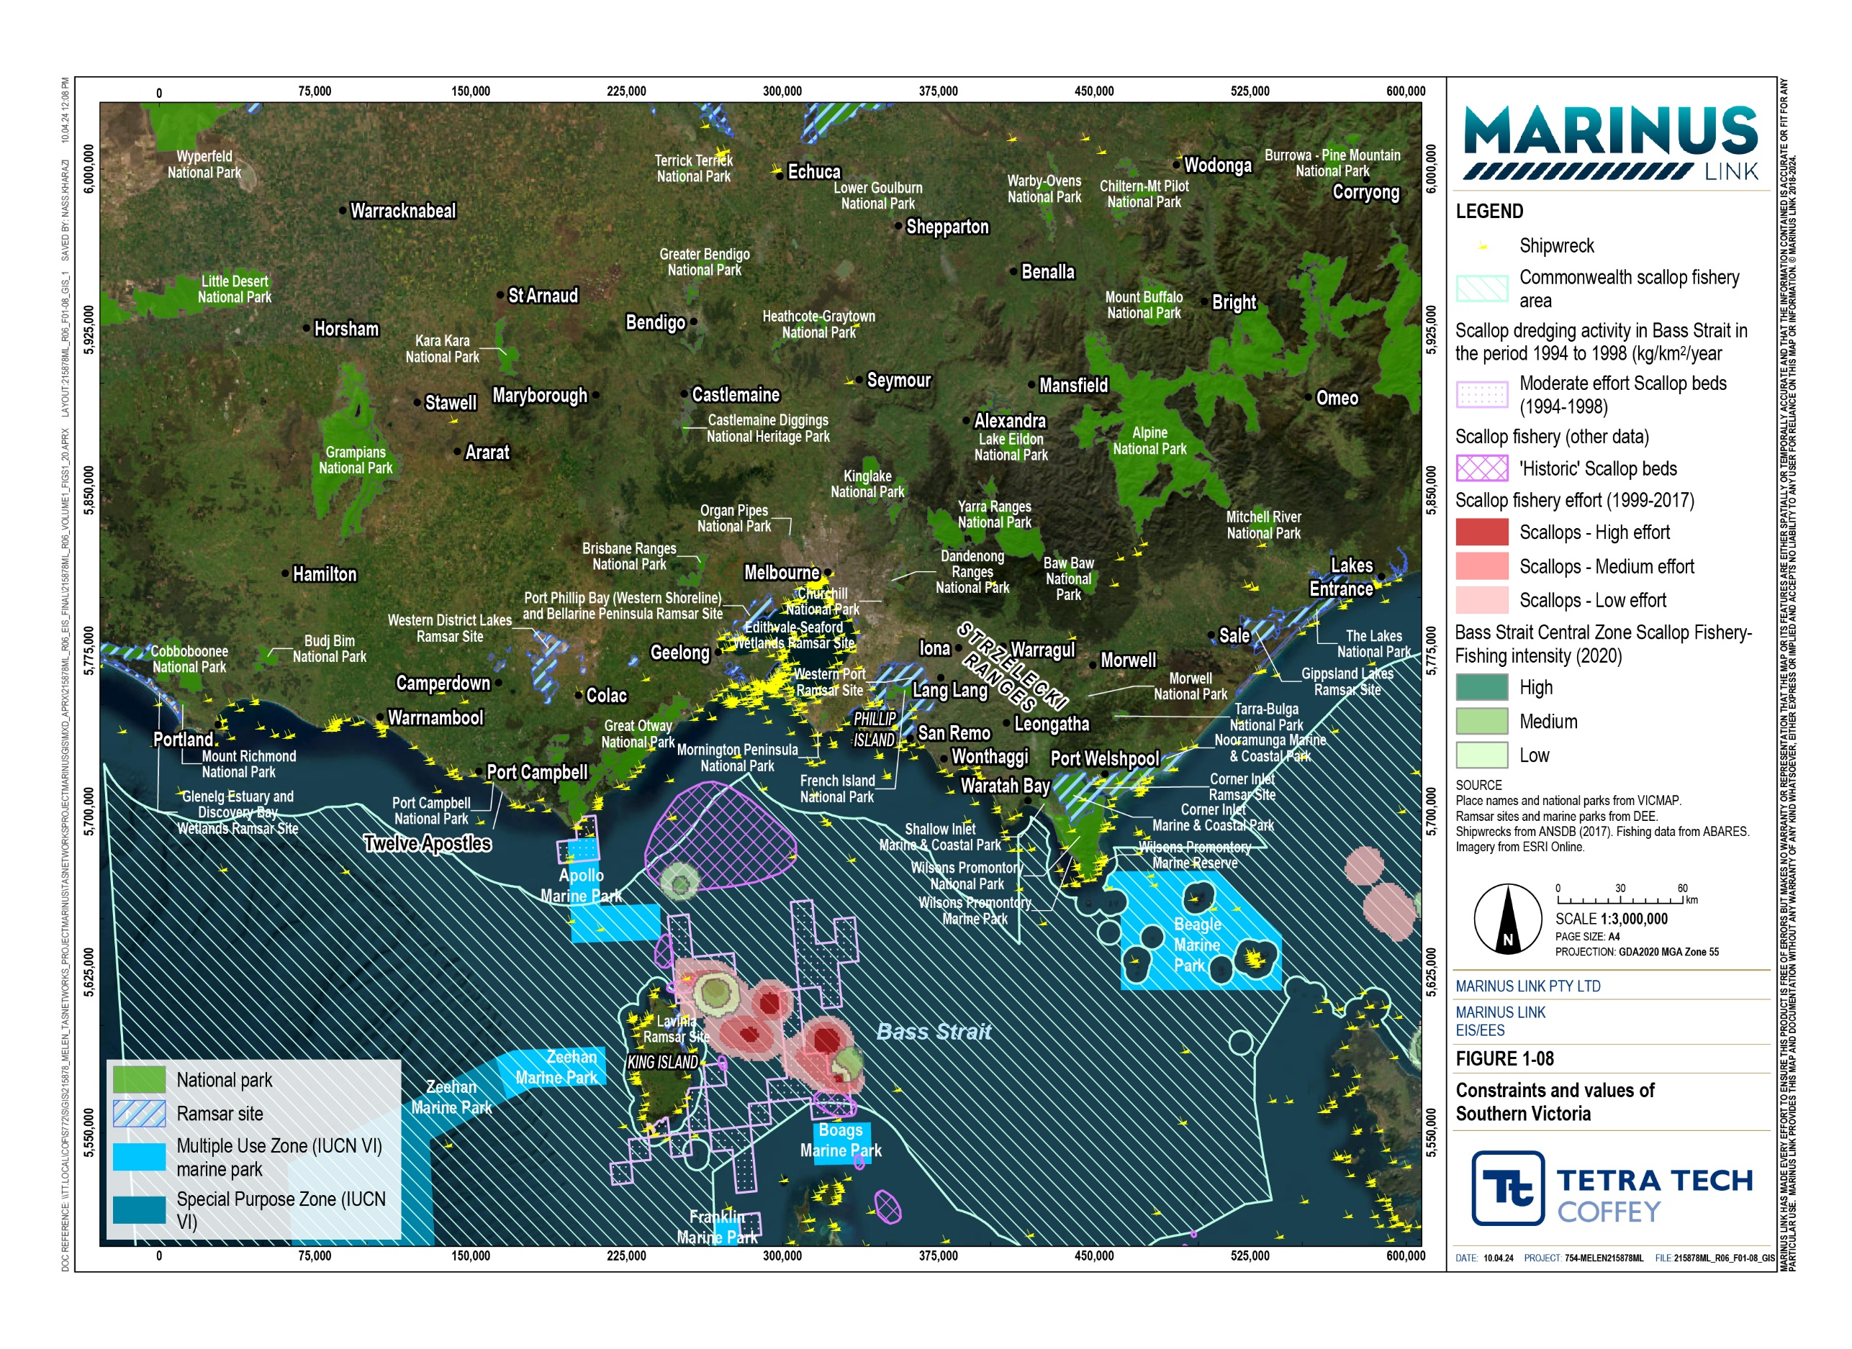

Bass Strait stretches approximately 255 km between the Australian mainland and Tasmania. It is a relatively shallow body of water, with an average depth of approximately 80 m. The seabed is primarily sandy substrate and muddy sediment, with hard substrate found near the islands, which occurs along the eastern and western extents of the strait.
The sandy substrate of the seabed provides habitat for deep water corals and sponges (‘sponge beds’) which support a range of barnacle-like, filter-feeding fauna such as sponges, octocorals and sea squirts.
Ocean surface ecology supported in Bass Strait includes phytoplankton, macroinvertebrates (i.e., jelly fish, comb jellies, salps, arrow squid and calamari) and vertebrates (i.e., fish, sea turtles and marine mammals). It provides important habitat for some whale species including southern right, humpback, blue, sei and fin whales. The area is particularly important for southern right whales, as they use the shallow waters of Bass Strait to calve, specifically around Warrnambool in southwestern Victoria. Humpback whales also frequent Bass Strait, with some passing through during seasonal migrations to and from breeding grounds in eastern Australia.
Bass Strait is an important fishery, particularly scallops, school shark, octopus, crayfish and finfish. Fishing activities are concentrated at the western and eastern sections of Bass Strait, around King and Flinders Islands, and near the Tasmanian and Victorian coasts. Fishing activities in the deeper water of Bass Strait are less intensive due to the soft substrate and lack of habitat features.
A number of marine national parks and marine sanctuaries exist near coastal areas of Bass Strait.

Several other features were considered during the route and site selection process in Bass Strait (shown in Figure 1-09):
Major shipping lanes connecting coastal, regional, and international ports.

Basslink interconnector.

Telecommunication cables, including Telstra cables between Victoria and Tasmania, and Indigo Central cable, which runs through Bass Strait from Western Australia to New South Wales.
Tasmanian Gas Pipeline.

Offshore oil and gas production areas along the southwest and eastern coasts of Victoria as well as the Yolla gas field, located mid-strait.
Defence training areas off the Victorian coast and in eastern Bass Strait, with unexploded ordinances (UXOs) potentially present in the area.
Shipwreck and ship graveyard locations, particularly in the eastern Bass Strait area between Wilsons Promontory and Tasmania’s northeast coast.

Volume 1 – Introduction Page 3-10

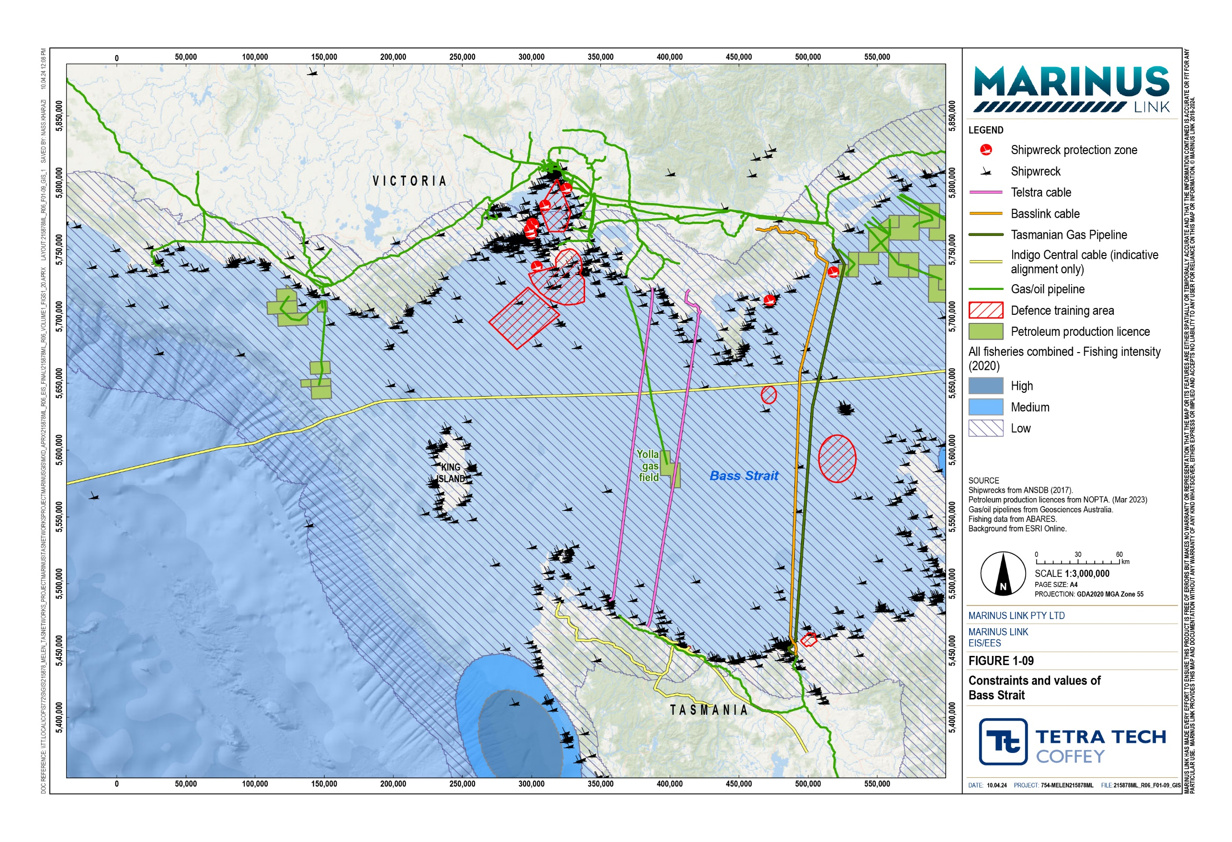

Constraints and opportunities
Following the analysis of the environmental, physical and social context of the project area, constraints and opportunities for onshore and offshore areas were identified to inform the route and site selection criteria. Other considerations were statutory and regulatory requirements; technical considerations; environmental, social, and cultural heritage values; and community expectations.
The constraints were categorised based on the level of constraint in the context of the proposed infrastructure, as follows:
Very High: Areas or land uses where transmission infrastructure may have significant impacts that may be difficult to effectively mitigate. Avoiding these areas is an objective, although may not always be practical to achieve.
High: Areas or land uses where avoidance is prudent, but transmission infrastructure could be sited, and impacts could be mitigated with careful route selection and design, or site-specific management measures, or both.
Moderate: Areas or land uses where transmission infrastructure could be sited, and impacts can be managed with standard mitigation and site-specific measures that address the type and nature of constraint.
Low: Areas or land uses where transmission infrastructure is compatible with existing land uses, or the impacts can be effectively mitigated, or both.
The constraints considered for this project, along with their assigned category, are shown in Table 3-1.

Category | Constraint
Very high | World Heritage Areas
 | National, marine and coastal parks declared under Tasmanian, Commonwealth and Victorian legislation
 | Threatened (critically endangered) species listed under Tasmanian, Commonwealth and Victorian legislation
 | Residential, township and village-zoned land
 | Cemeteries and crematoriums
High | Conservation areas and reserves declared under Tasmanian, Commonwealth and Victorian legislation
 | Threatened (endangered and vulnerable) species listed under Tasmanian, Commonwealth and Victorian legislation
 | Threatened native vegetation and ecological communities listed under Tasmanian, Commonwealth and Victorian legislation
 | Nationally important wetlands and Ramsar wetlands
 | Registered historic cultural heritage properties and places

Category | Constraint
 | Registered maritime archaeology sites (shipwrecks, etc.)
 | Registered Aboriginal cultural heritage places and sensitivity areas
Planning scheme zones and overlays, and land use, including: coastal inundation area
commercial development
environmental management (contamination) landslide hazard area
land subject to inundation
operational airspace and airport environments public conservation and resource area
public park and recreation area priority habitat
salinity management area significant landscape
scenic landscapes, scenic roads and scenic management areas tree preservation and significant vegetation
urban growth
significant agricultural land
 | Airstrips and runways
 | Intensive agriculture, including animal husbandry and vineyards
 | Mining leases
 | Onshore and offshore oil and gas production leases
 | Properties less than 0.4 ha
 | Houses
 | Aquaculture sites
 | Defence training areas
 | Institute for Marine and Antarctic Studies scallop survey sites
 | Marine hazard areas
 | Marine critical habitat sites
 | Australian fur seal colonies
 | Little penguin biologically important areas
 | Sponge garden sites
 | Anchorages
 | Igneous rock, karst limestone and alluvial/swamp deposits

Category | Constraint
Moderate | Unreserved Crown land
 | Waterbodies
 | Threatened (near threatened and rare) species listed under Victorian legislation
 | Threatened (depleted or rare) ecological communities listed under Victorian legislation
 | Seagrass beds or meadows
 | Little penguin biologically important areas (foraging)
 | Waterbodies
Planning scheme zones and overlays, and land use including: bushfire management
low density residential
rural living and rural growth
cropping and irrigated grazing and plantations manufacturing uses
special uses
 | Community facilities
 | Properties between 0.4 ha and 2 ha
 | Actual and potential coastal acid sulphate soil sites
 | Submerged reef
 | Port boundaries
 | Metamorphic rock
Low | Native vegetation not listed for protection
Planning scheme zones and overlays, and land use, including: industrial areas
electricity transmission infrastructure sites
farming land green wedge land
roads
 | Mineral and petroleum exploration licences and permits
 | Sedimentary rock

The main opportunity identified through the site selection process was the potential for co-location of the new infrastructure in existing infrastructure corridors (i.e., existing electricity transmission networks) and unmade road reserves. These opportunities were further investigated to ensure any proposal for co-location of infrastructure was beneficial for the project and avoided adverse impacts on the existing asset.

Route and site selection
Between mid-2018 and late-2020, MLPL completed a detailed route and site selection process, examining a wide range of factors to ensure the ultimate project design and alignment assessed in the EIS/EES met the technical requirements. Factors considered included the unique physical, biological and socioeconomic environments.
The constraints and opportunities associated with the existing environment were identified at the beginning of the site selection process through review of relevant publicly available information and desktop studies.
The identified constraints and opportunities, along with the technical specifications and objectives of the project, were the basis for the route and site selection criteria. Potential landfalls, shore crossings, corridors, routes and converter site locations were evaluated against these criteria.
The route and site selection process is shown in Figure 1-10 and involved the following key steps:

- Several prudent and feasible corridors were identified, considering the project objectives, suitable grid connection points and grid capacity, having regard to the identified values and constraints.
- These corridors, along with the site selection criteria, were then used to evaluate suitable landfall locations and converter station sites to select prudent and feasible routes.
- The prudent and feasible routes were then compared against each other, using the route and site selection criteria, to identify the routes considered to be least constrained.
- Detailed desktop studies were then undertaken on the two least constrained routes to determine the significance of the impacts of each route, and to ultimately select a preferred route.
- The route was refined using recommendations from ground-truthing, technical analysis, and engineering and constructability reviews.

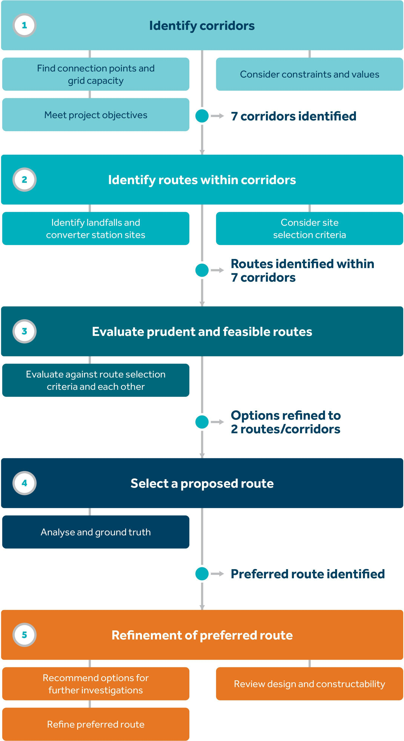

Identifying corridors
An important starting point for route and site selection was identifying the corridors with suitable connection points and grid capacity. Potential corridors were considered prudent and feasible where they satisfied the project objectives and where there were no critical constraints. The corridor selection process is summarised in the sections below.
Potential connection points were identified in Tasmania and Victoria primarily based on their proximity to the coast and capacity to support the additional energy transmission. In Tasmania, Sheffield Substation was identified with these prerequisites, however, was determined to be remote from the North West Tasmania REZ. Alternative connection points in North West Tasmania are Burnie Substation, Port Latta Substation and Smithton Substation. These connection points were determined to better meet the project objectives, noting that transmission network augmentation would be required.
Potential connection points in Victoria that are near the coast were modelled by AEMO (AEMO 2018) to have capacity for the additional energy transmission. These points included Portland, Moorabool, Cranbourne and Hazelwood terminal stations.
Based on the identified potential connection points and grid capacity, several prudent and feasible corridors which meet the project objectives were identified, as outlined in Table 3-2.

Identified Corridor | Benefits
Port Latta – Portland | Port Latta is closest to North West Tasmania REZ, and proposed renewable energy parks.  Capacity at Portland may become available due to the expected closure of Alcoa’s Portland aluminium smelter.  Portland is close to South Australia, enabling interregional trading in the NEM.
Port Latta – East Geelong | Port Latta is closest to the North West Tasmania REZ and proposed renewable energy parks. East Geelong is adjacent to the Greater Geelong and western Melbourne demand centres.
Burnie – East Geelong | Burnie Substation is connected via 220 kV overhead transmission line to Sheffield Substation and close to the North West Tasmania REZ.  Burnie Substation is part of proposed planned upgrades associated with the NWTD to support connection of renewable energy generation and the project.  East Geelong is adjacent to the Greater Geelong and western Melbourne demand centres.
Burnie – Moorabool | Burnie Substation is connected via 220 kV overhead transmission line to Sheffield Substation and close to the North West Tasmania REZ.  Burnie Substation is part of planned upgrades associated with the NWTD to support connection of renewable energy generation and the project.  Moorabool Terminal Station is located on the 500 kV grid backbone, currently unconstrained and close to the Greater Geelong and western Melbourne demand centres.
Burnie – Hazelwood | Burnie Substation is connected via 220 kV overhead transmission line to Sheffield Substation and close to the North West Tasmania REZ.  Burnie Substation is part of planned upgrades associated with the NWTD to support connection of renewable energy generation and the project.  Hazelwood Terminal Station is one of the strongest nodes in the Victorian transmission network. The 500 kV overhead transmission lines from Hazelwood Terminal Station to Melbourne have 11,000 MW capacity but are operated at lower capacity to provide the required network reliability.  The retirement and closure of Hazelwood Power Station has freed 1600 MW of capacity on these overhead transmission lines.  Forecast retirement of Yallourn W Power Station will free another 1400 MW of capacity.
Sheffield – Cranbourne | Sheffield Substation is the strongest node in the Tasmanian grid backbone and is close to the North East Tasmania REZ, Tasmanian Midlands REZ and connected to the North West Tasmania REZ by a 220 kV overhead transmission lines.  Cranbourne is currently unconstrained and not expected to become constrained due to the closure of Latrobe Valley coal-fired power stations.  Cranbourne is close to the south eastern Melbourne demand centre.
Sheffield – Hazelwood | Sheffield Substation is the strongest node in the Tasmanian grid backbone and is close to the North East Tasmania REZ, Tasmanian Midlands REZ and connected to the North West Tasmania REZ by 220 kV overhead transmission lines.  Hazelwood Terminal Station is one of the strongest nodes in the Victorian transmission network. The 500 kV overhead transmission lines from Hazelwood Terminal Station to Melbourne have 11,000 MW capacity but are operated at lower capacity to provide the required network reliability.  The retirement and closure of Hazelwood Power Station has freed 1600 MW of capacity on these overhead transmission lines.  Forecast retirement of Yallourn W Power Station will free another 1400 MW of capacity.
Source: Adapted from Marinus Link Route Options Report (MLPL 2021a)

The seven prudent and feasible corridors identified are shown on Figure 1-11.

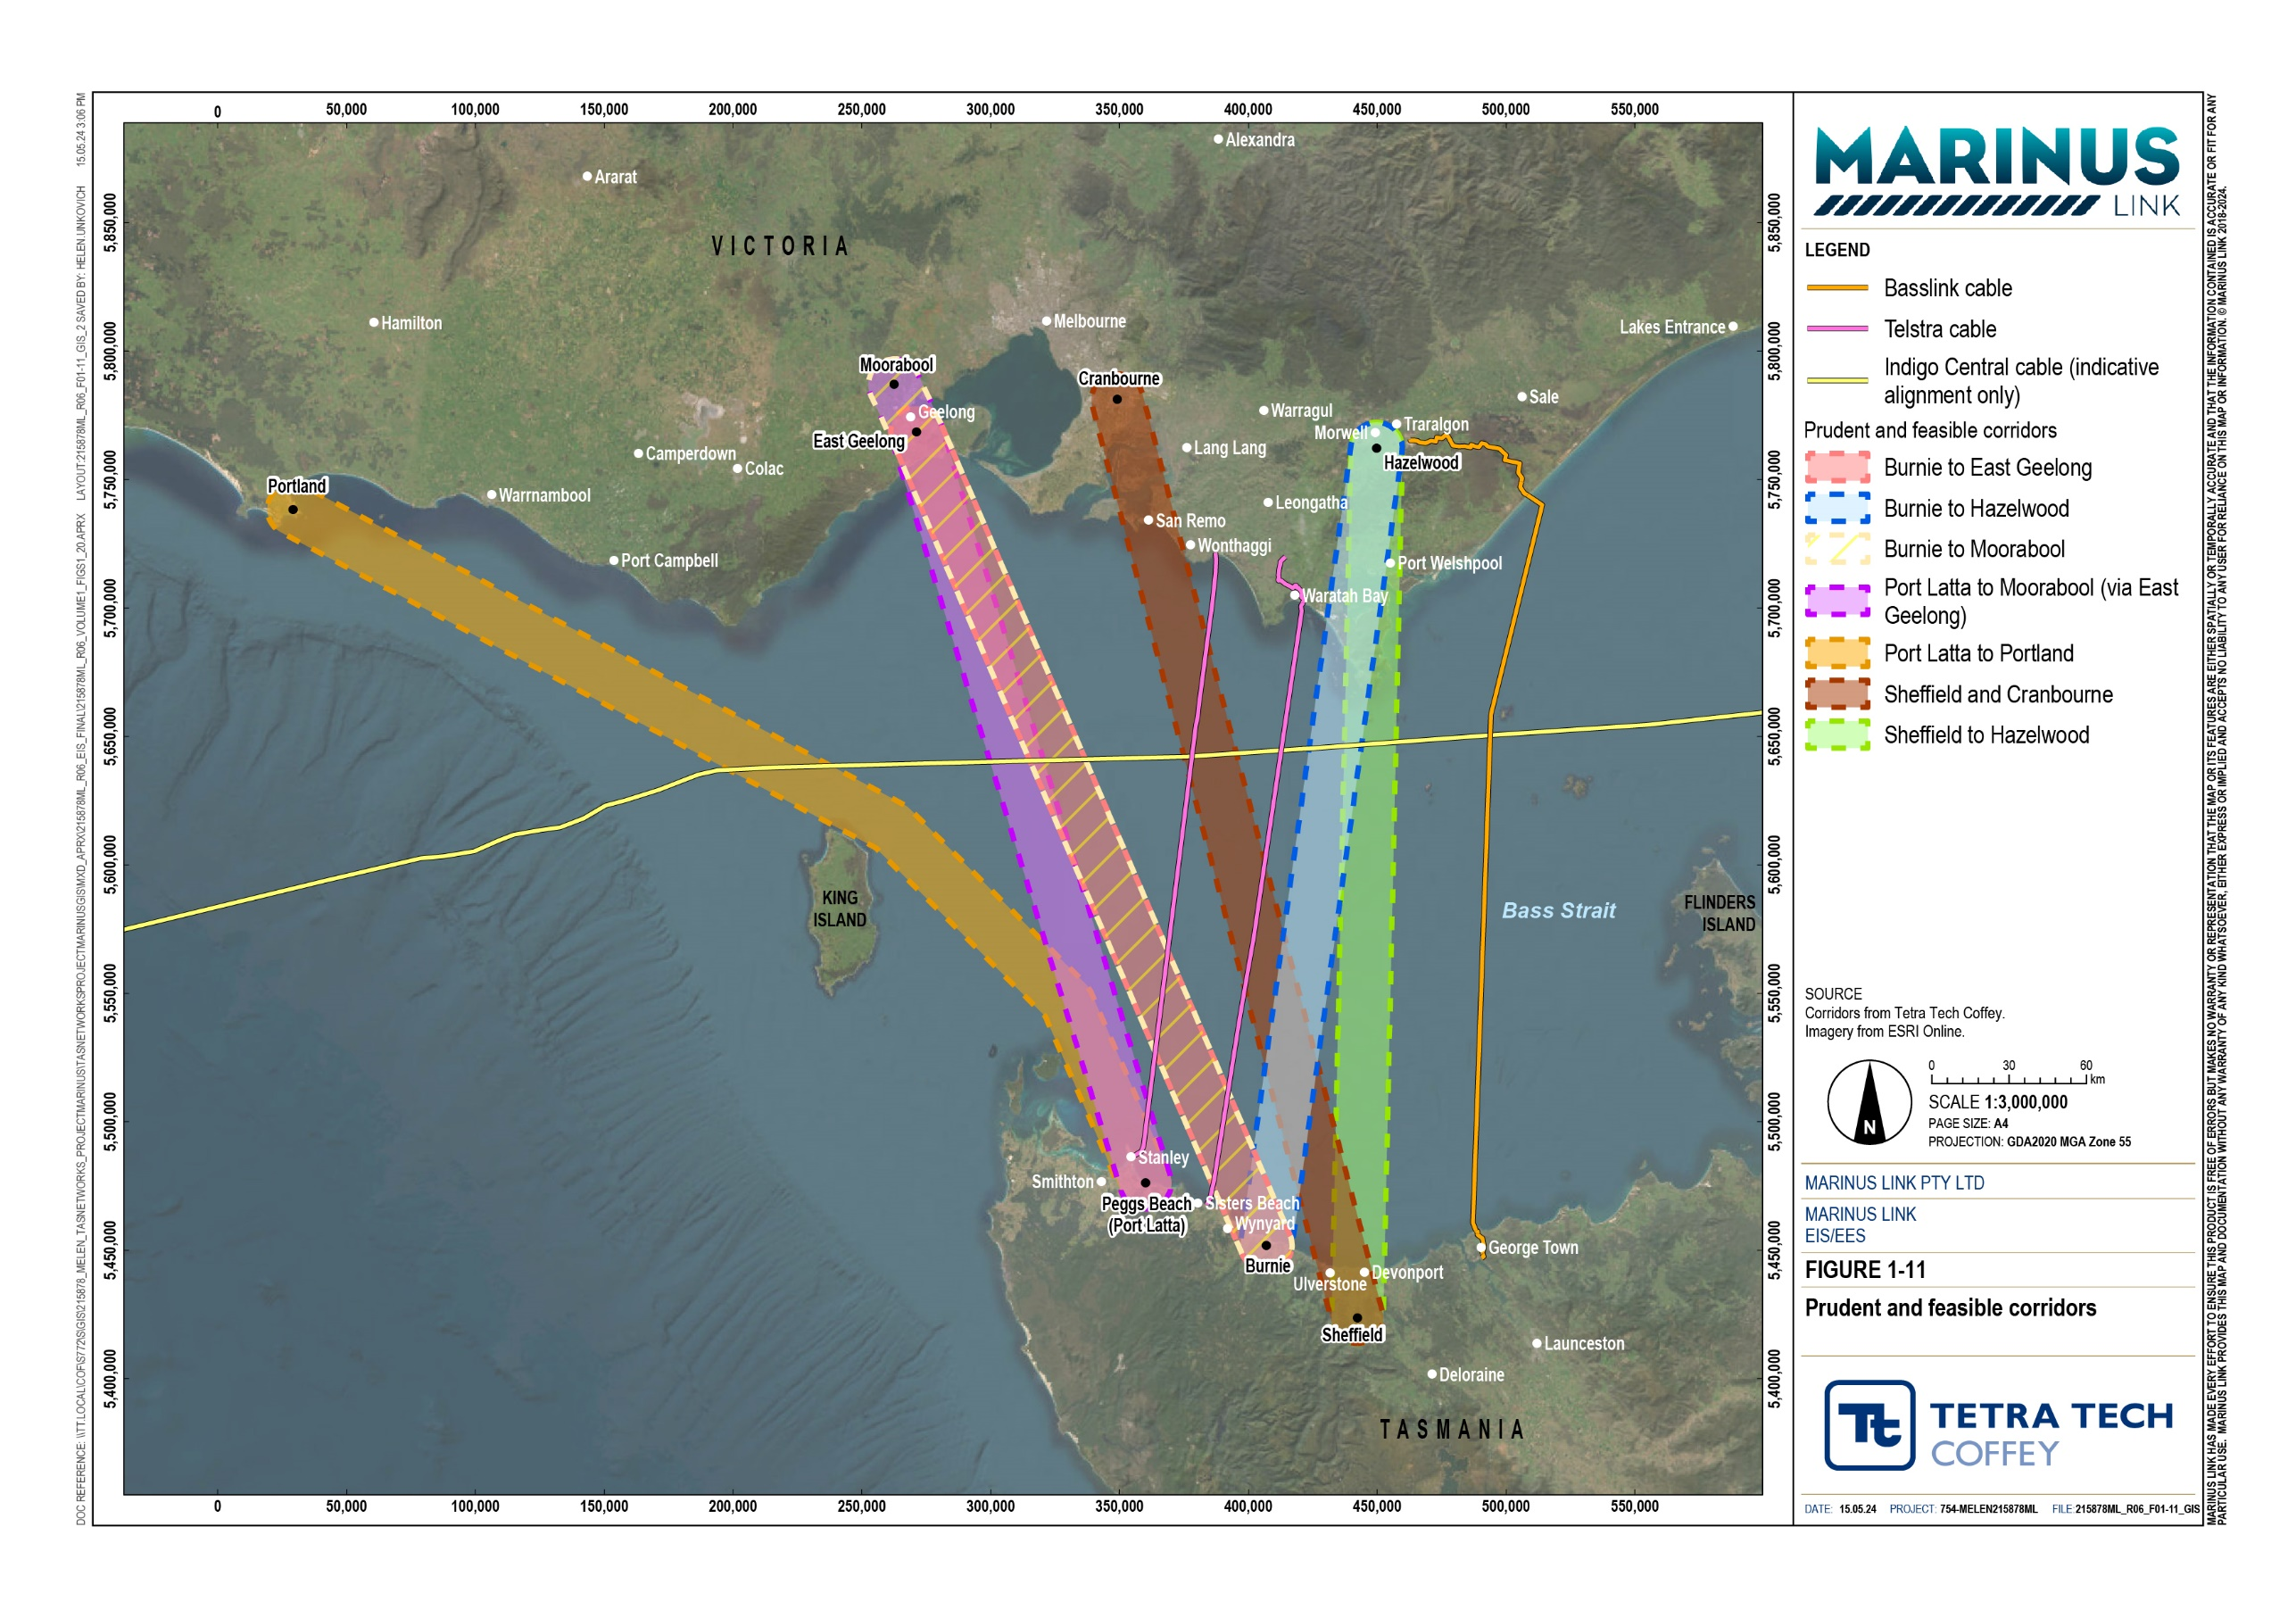

Colocation of the project transmission infrastructure along the Basslink interconnector was considered as an opportunity but not pursued due the inherent risk to energy security in Tasmania. By separating the project and Basslink geographically, there is less chance of damage to the two transmission circuits in one event (i.e., from a ship anchor in marine environment, bushfire in terrestrial environment etc.). Separate locations increase energy security, one of the primary objectives of the project.
Other project objectives and technical requirements that would not be met through collocating the project and Basslink include the following:
The project objective of offsetting network investment by locating the interconnector near the North West Tasmania REZ would not be feasible using the Basslink corridor.
Capacity constraints may exist in the grid backbone between Basslink’s Victorian connection site (Loy Yang) and Hazelwood Terminal Station.
Additional transmission capacity at Basslink’s Tasmanian connection site (George Town) would require significant upgrades to the Tasmanian transmission network.

Identifying and evaluating route options
The seven corridors identified through the corridor selection process (Table 3-2) were further investigated to identify potential prudent and feasible routes within those corridors. The objective of the route and site selection assessment was to identify the shortest, technically feasible route between connection points that minimises environmental, land use and cultural heritage impacts.
Route and site selection was guided by criteria developed based on technical requirements, such as meeting project objectives, engineering considerations and constructability, as well as the constraints and opportunities identified for the project.
The route and site selection criteria adopted for the project are listed in Table 3-3.

Criterion | Considerations
Cost | capital expenditure (construction costs)  optimise overall route length and trade-off between onshore and offshore operating expenditure (maintenance and transmission energy loss costs)
Available land for converter stations | sufficient space for facilities and potential buffers stable landforms  suitable terrain, geology and geotechnical conditions  good access

Criterion Considerations

Onshore (and landfall) constructability
ease of access
disruption to existing access, services and businesses potential for relocation of existing services
workspace including stringing for horizontal directional drills or horizontal bores potential for contaminated land
potential for UXO
landform, geology and soil conditions including exposure to hard and/or fractured strata, and slope failure
watercourse crossings geotechnical considerations

Offshore constructability
nearshore water depth
nearshore littoral currents (and drift) velocity of currents
subsea infrastructure crossings
potential for shipwrecks and other obstructions potential for UXO
disruption to existing access, services and businesses
constraints on port operation (channels and anchorages)
seabed conditions (exposure to hard and/or fractured strata) seabed mobility (sand waves or other mobile bedforms)

Third party interference
exposure to dragged anchors exposure to excavation or deep ripping
exposure to piling or other intrusive activities

Avoid incompatible land/seabed uses
anchorages
ammunition disposal grounds cemeteries and crematoriums Defence training areas
ship graveyards shipping lanes
fishing activities that impact the seabed (trawling, scallop dredging)

Avoid or minimise other subsea infrastructure crossings
submarine telecommunication cables subsea electricity interconnectors subsea oil and gas pipelines
outfall pipelines

Avoid colocation with incompatible linear infrastructure
steel pipelines, fences and other metallic structures parallel to the interconnector which increase potential for induced current in steel infrastructure and fault current affecting the steel infrastructure

Transmission network security
geographic diversity to avoid single contingency events

Capacity to facilitate renewable generation connections
connection point proximity to wind, solar and pumped hydro storage projects

Expansion potential
capacity to accommodate future interconnectors, i.e., sufficient space to install a future interconnector including at shore crossings and on land cable routes

Criterion | Considerations
Opportunity for third party benefit / contribution | proximity to renewable energy zones
Land tenure | freehold, Crown land, reserves  land holdings (small private and commercial properties)
Occupation | Proximity to houses or sensitive businesses (noise from converter station sites, amenity impacts). The objective is to maximise the distance between the proposed infrastructure and sensitive receivers, noting that other constraints may limit such opportunities.
Planning (zones and overlays) | zones, including residential, rural, agriculture, transport/access routes, etc.  overlays (as applicable) including environmental significance, significant landscapes, erosion management, landslip hazard and contaminated land
Land Use | intensively farmed land with substantial infrastructure including berry farms, piggeries, poultry farms, vineyards, etc.
Native vegetation | TASVEG (digital map of Tasmania’s vegetation)  ecological vegetation classes (digital map of Victorian ecological communities)
Threatened ecological communities | native vegetation communities listed under Commonwealth, Victorian and Tasmanian legislation
Threatened species | records of threatened flora and fauna species listed under Commonwealth, Victorian and Tasmanian legislation
Sensitive ecosystems | seagrass beds and meadows  wader and migratory species foraging and nesting habitat wetlands/groundwater dependent ecosystems
Registered historical cultural heritage properties and places | historical cultural heritage sites listed under Commonwealth, Victorian and Tasmanian legislation
Registered Aboriginal cultural heritage places and sensitivity areas | Aboriginal cultural heritage sites listed under Commonwealth, Victorian and Tasmanian legislation  areas mapped as having high potential for Aboriginal cultural heritage
Marine archaeology (shipwrecks) | shipwrecks listed under Commonwealth, Victorian and Tasmanian legislation
Fisheries | aquaculture sites  Institute for Marine and Antarctic Studies scallop survey sites
Disposal site/potential contamination | ammunition disposal grounds ship graveyards  outfall pipeline deposits
Source: Marinus Link Route Options Report (MLPL 2021a)

Route options within the potential corridors were identified to meet the route and site selection criteria. Route selection required identifying feasible landfalls and converter station sites first. Prudent and feasible routes were then identified between converter station sites and landfalls in both Victoria and Tasmania, and across Bass Strait.
Suitable landfalls were identified in consideration of the distance to the connection point and the site selection criteria. Converter station sites were then identified for each corridor. Further details of landfall sites and converter station sites considered are provided in the Route Options Report (MLPL 2021a).
The identified landfalls and converter station sites, along with the site selection criteria were then used to identify prudent and feasible routes across Bass Strait (i.e., between landfalls) and between the landfalls and converter station sites in Tasmania and Victoria.
To achieve the shortest route possible between landfalls, route selection aimed to cross Bass Strait in a straight line. This was mostly possible, except small deviations where identified constraints needed to be avoided, including defence training areas and ammunition disposal grounds; oil and gas infrastructure; shipwrecks and graveyards; steep seabed slopes and sensitive benthic communities.
While the identified corridors avoided the majority of the main fishing areas at the eastern and western margins of Bass Strait as well as scallop fishing areas in soft substrate, fisheries between Stanley and King Island (existing and proposed) also required route deviations.
Routes were selected to preference the deep muds and silts of central Bass Strait where possible, avoiding the more ecologically diverse nearshore reefs, sea mounts and rock platforms.
On land, the route between landfall and converter station was determined largely based on terrain, as well as the route selection criteria. Routes which run at right angles to slopes were preferred to avoid lateral forces on the land cables and to minimise land disturbance through construction and from potential landslip. Route selection also aimed to follow property and road reserve boundary fences where possible to minimise land use disturbance.
Once the prudent and feasible routes within each corridor were identified, they were evaluated against the route and site selection criteria to determine the routes that were least constrained. The evaluation used information gathered through desktop studies and ground-truthing, which involved onsite observations, as well as a marine geophysical reconnaissance survey.
Each route was compared against the route and site selection criteria using a ‘traffic light system’. The routes were assigned a colour against each criterion which indicated the level of constraint relative to other evaluated routes, as shown in Table 3-4 of the Route Options Report (MLPL 2021a).

Criterion | Port Latta–Portland | Port Latta–East Geelong | Burnie–East Geelong | Burnie–Moorabool | Burnie–Hazelwood | Sheffield–Cranbourne | Sheffield–Hazelwood
Length (km) | 446 | 321 | 359 | 391 | 346 | 395 | 376
Cost
Availability of land for converter stations
Onshore (and landfall) constructability – Tasmania
Onshore (and landfall) constructability – Victoria
Offshore constructability
Third-party interference
Incompatible land/seabed uses
Subsea infrastructure crossings
Colocation with incompatible linear infrastructure
Transmission network security and capacity
Capacity to facilitate renewable generation connections
Expansion potential
Opportunity for third party benefit/contribution
Land tenure
Occupation
Planning (zones and overlays)
High quality agricultural land
Native vegetation
Threatened ecological communities
Threatened species
Sensitive ecosystems
Registered historical cultural heritage properties and places
Registered Aboriginal cultural heritage places and sensitivity areas
Maritime archaeology (shipwrecks)
Fisheries
Disposal sites/potential contamination
Source: Marinus Link Route Options Report (MLPL 2021a)

The outcome of the analysis indicated that Burnie-Hazelwood and Sheffield-Hazelwood were the least constrained routes. A summary of the justification for the selection of the preferred route is included in Table 3-5 for each route option analysed.

Route | Constraint | Opportunity
Port Latta – Portland | Longest and most costly route.  Would pass close to and potentially impact important fisheries.  Would cross Otway Basin gas fields and production infrastructure. | Closer to Tasmania’s North West REZ.  Facilitate inter-regional trading with South Australia and Victoria.
Port Latta – East Geelong  Burnie – East Geelong | East Geelong area would require significant upgrades to existing transmission lines at substantial cost.  Highly constrained by urban development which requires routes to follow existing roads and reserves.  Approach to landfalls on Victorian south- west coast would be in proximity to (or through) defence training areas and ship graveyards.  Would pass close to and potentially impact important fisheries. | East Geelong is close to demand centres.
Burnie – Moorabool | Highly constrained by urban development which requires routes to follow existing roads and reserves.  Approach to landfalls on Victorian south- west coast would be close (or through) to defence training areas and ship graveyards.  Would pass close to and potentially impact important fisheries. | Moorabool is close to demand centres.
Burnie – Hazelwood  Sheffield – Hazelwood | Long onshore cable sections in Victoria which means a higher number of affected landholdings and potential constructability issues.  Long onshore cable sections increase exposure to native vegetation, threatened ecological communities, Aboriginal cultural heritage and high- quality agricultural land. | Limited subsea infrastructure crossings. most direct route across Bass Strait  (shortest marine section).  Good proximity to both Tasmanian REZ and proposed renewable generation projects.  Strong connection at Hazelwood to existing 500 kV Victorian transmission network, with sufficient capacity for interconnection.  Good geographic diversity to support power system stability and supply redundancy.  Limited exposure to incompatible land or seabed issues.
Sheffield – Cranborne | Area is highly constrained by urban development, infrastructure, small landholdings, the Koo Wee Rup swamp drains and associated ecological values, and asparagus growing areas near Koo Wee Rup. | Cranborne is electrically unconstrained and close to demand centres.
Source: Adapted from Marinus Link Route Options Report (MLPL 2021a)

The preferred routes resulting from the route and site selection evaluation, Burnie – Hazelwood and Sheffield – Hazelwood, were subject to further technical analysis to assess the feasibility and arrive at a single preferred route.
The technical analysis included detailed desktop studies, along with onsite ground-truthing by ecologists, geomorphologists and cultural heritage consultants.
The ground-truthing exercises included assessing the accuracy of the desktop information through onsite observations from publicly accessible areas, including the following:
Benthic habitat

- An assessment of the seabed and benthic habitat types at the landfall sites was undertaken by a marine ecologist which showed good correlation between the desktop information collected and the observed habitats. No biological assemblages or species particularly sensitive to disturbance were identified. The assessment confirmed Waratah Bay as the preferred landfall due to it being predominantly sandy substrate, gently sloping seabed and partially protected from prevailing winds and sea conditions.
Marine geophysical survey

- A marine geophysical reconnaissance survey was also undertaken to confirm seabed bathymetry and composition along the routes. The survey confirmed that central Bass Strait substrate is predominantly silty sand/sandy silt, becoming sand interspersed with cobbles and complex outcropping in the Tasmanian nearshore area.
Aboriginal and cultural heritage

- Engagement was undertaken with the relevant Aboriginal elders and other First Peoples, whose land is crossed by the preferred onshore route options.
- In Victoria, Aboriginal elders and other First Peoples inspected the proposed routes and did not identify any significant sites or places. The representatives advised that Aboriginal cultural heritage would exist as artefacts scatters, shell middens and story lines, particularly at the coast but also along and near inland watercourses (MLPL 2021a).
- In Tasmania, an Aboriginal heritage officer and archaeologist found no significant sites nor places on or near the areas to be potentially impacted by the project (MLPL 2021a).
Economic analysis

- Additional economic analysis was completed on the two preferred routes which showed the best option was connection in the Burnie area. This location supports efficient energy flow between the project and renewable energy generators and storage resources in Tasmania. TasNetworks, in its role as jurisdictional planner, prepared the North West Transmission Strategic Plan. The plan proposed reinforcing the North West Tasmania transmission network by creating a rectangle (a second backbone) comprising new 220 kV double circuit transmission lines connecting Burnie and

Sheffield substations with proposed new switching stations as Hampshire Hills and Staverton. The proposed project is known as the NWTD. The NWTD supports the connection of the project in the Burnie area.
Information from the technical analysis confirmed that the preferred route was Burnie-Hazelwood with landfalls at Heybridge (Tasmania) and Waratah Bay (Victoria) as the least constrained route that met the project objectives. The environmental impacts of this route and associated sites could be effectively minimised and managed through detailed refinement of the route, construction method and environmental management strategies and measures.
In late-2020, MLPL released the preferred Burnie-Hazelwood route to the public. Over the following two years, the preferred Burnie to Hazelwood conceptual route has been reviewed and refined to address issues and recommendations identified through the technical investigations and through engagement with impacted landholders. The original route was also subject to detailed engineering and constructability review which informed the final route and site selection.
Route refinement in Victoria, between Waratah Bay and Hazelwood, was largely based on terrain and geomorphic characteristics, particularly in crossing the Hoddle and Strzelecki ranges. These areas have deep valleys and steep slopes which pose engineering and constructability constraints. Constraints associated with existing infrastructure (i.e., roads, third-party infrastructure) were further investigated, and opportunities for colocation were incorporated where practicable.
MLPL sought to provide information and obtain feedback from the community and landholders on the preferred route and applied principles from the International Association for Public Participation’s (IAP2) spectrum of public participation by:
Informing the community and landholders of the proposed location of the route.

Consulting on the proposed route.

Involving l landholders in the micro siting of the route to avoid impacts to properties.

First Peoples were also consulted early in the route selection process, providing input to opportunities and constraints of the proposed route. Importantly, outcomes of this consultation indicated that there were no significant sites nor places in proximity of the preferred route.
Engagement with Victorian landholders has resulted in the proposed route being refined, where reasonable and feasible, to address their concerns. In some instances, route refinement has involved several meetings as landholders become more informed about what is proposed and how the interconnector will be constructed and operated. Further information from landholders about current, proposed and future farming activities and plans has informed route refinement. Route refinement on properties has sought to address landholder concerns about impacts on:
Soil properties and drainage

Prime pasture paddocks and cropping land

Plantation coupes and harvesting activities

Drier land used by stock in winter

Existing and planned shelter belts

Farm infrastructure, including access to milking sheds and stock handling facilities

Springs and stock and irrigation water supply

Internal laneways and stockyards

Farm plans, including future stock underpasses, stock handling facilities, fodder storage and access

Proposed house and farm shed sites.

Across Bass Strait, the route was refined at the Tasmanian and Victorian coasts to avoid seabed features such as low-profile reefs and seamounts, and sponge beds in deeper waters.

The proposed route
The refinement of the route over 2021 and 2022 has led to the proposed route, which is the subject of this EIS/EES, running from Heybridge, Tasmania to Hazelwood, Victoria (Figure 1-12).
In Tasmania, a converter station is proposed to be located at Heybridge near Burnie (Figure 1-13). The converter station will facilitate connection of the project to the North West Tasmania transmission network.
Approximately 255 km of subsea HVDC cables will be laid across Bass Strait. The cable bundles for each circuit will transition from approximately 300 m apart at the HDD exit in the nearshore area to 2 km apart in offshore waters.
In Victoria, the shore crossing is proposed to be located at Waratah Bay with the route crossing the Waratah Bay–Shallow Inlet Coastal Reserve. The nearshore approach to the Victorian coast and Waratah Bay shore crossing avoids the rocky platforms and patch reefs that extend east into the bay from Cape Liptrap and west into the bay from Wilsons Promontory National Park. The route was initially designed to avoid crossing the Telstra Bass Strait 1 telecommunications cable which lands in Waratah Bay but later revised to cross the cable to address onshore land use issues.
From the land-sea joint located behind the coastal reserve, the land cable will extend underground for approximately 90 km to the converter station adjacent to Hazelwood Terminal Station (Figure 1-14).
Further detail regarding the final route design is provided in Volume 1, Chapter 6 – Project description.

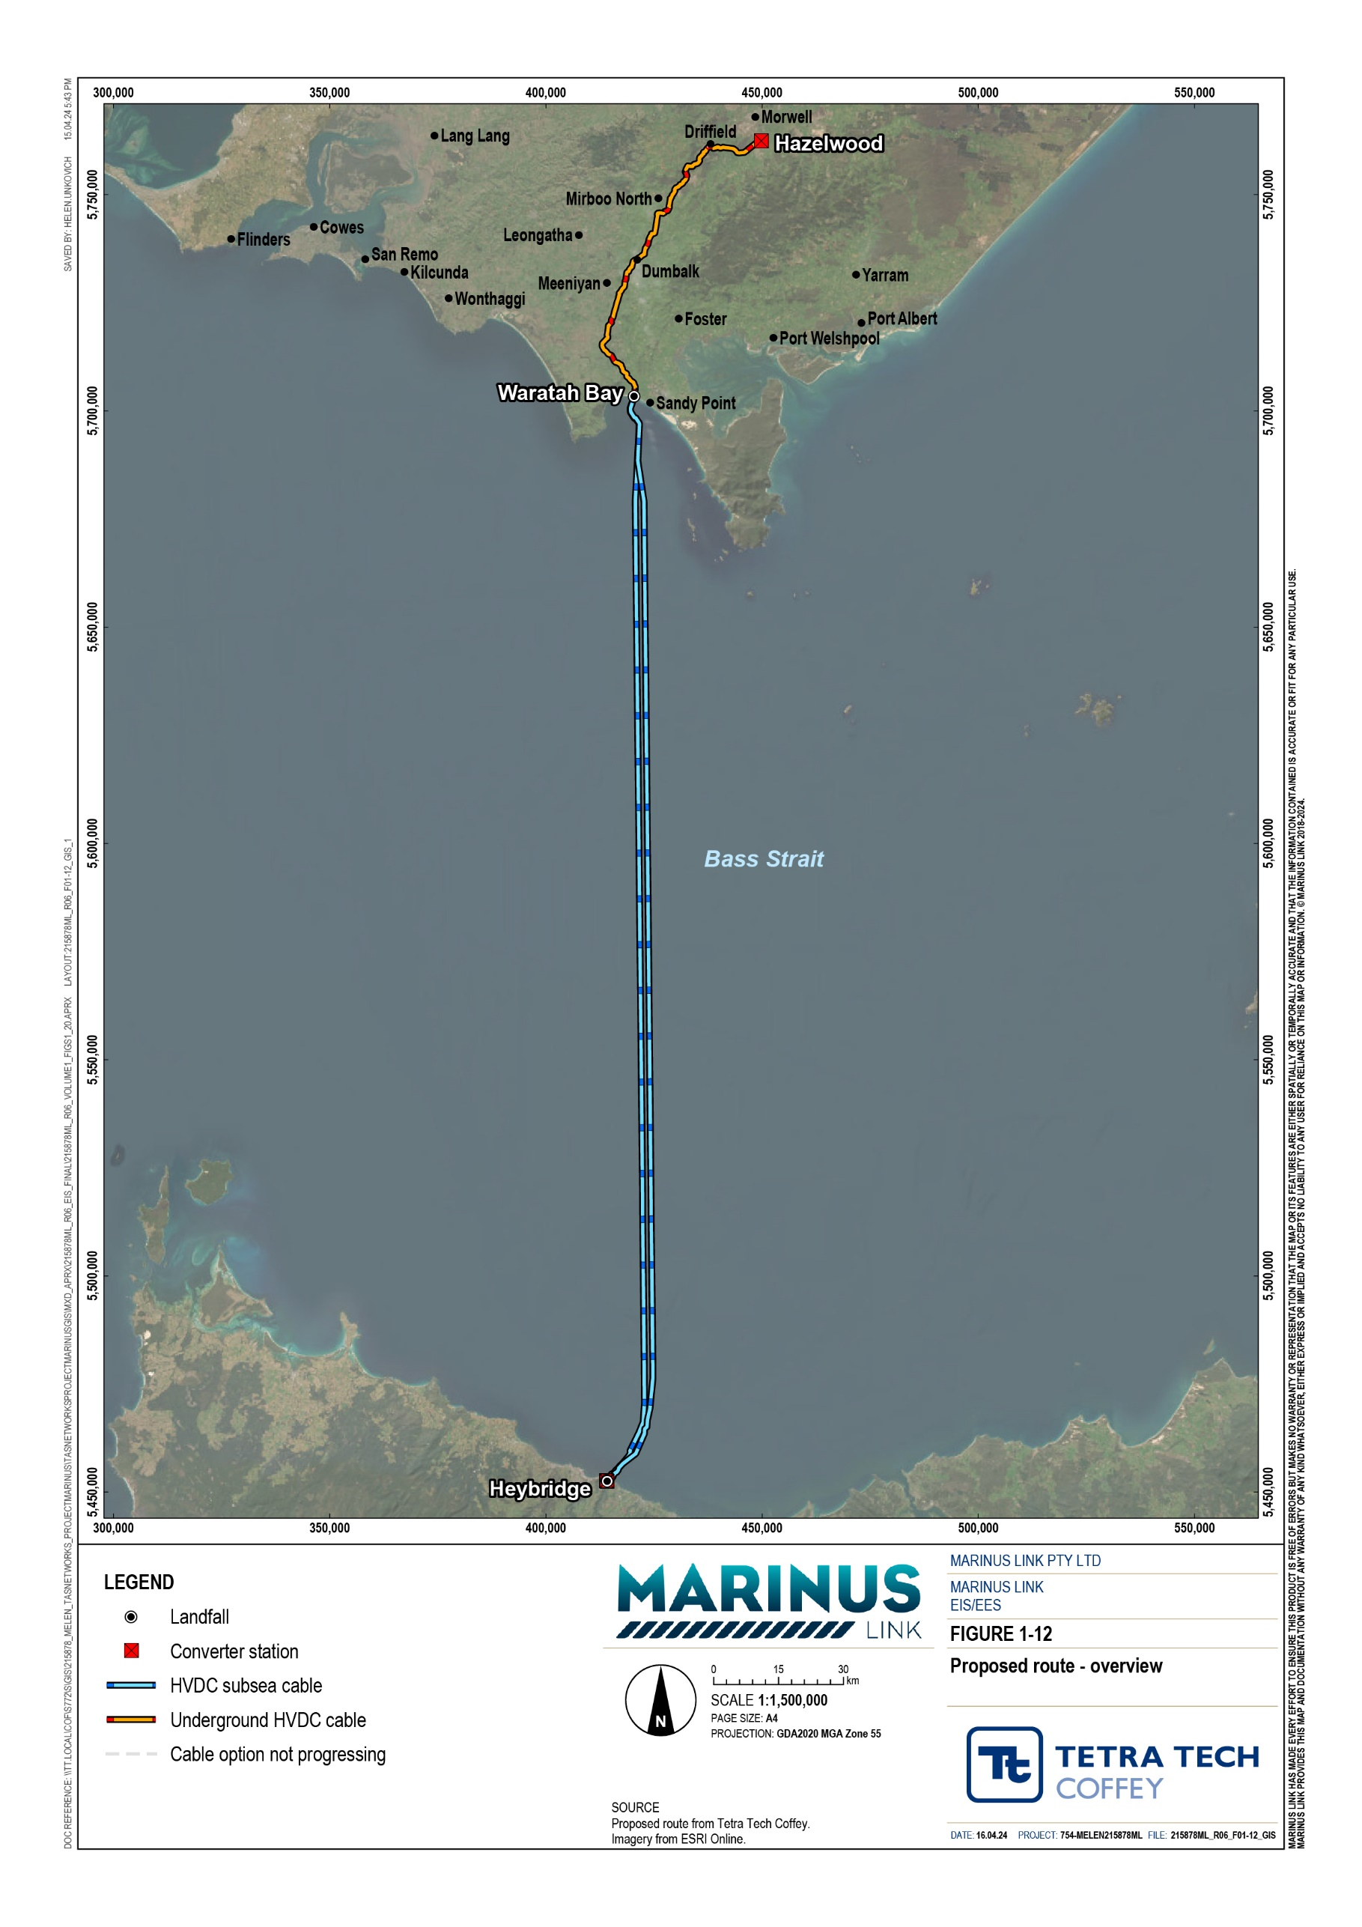

DOC REFERENCE: \\Tz

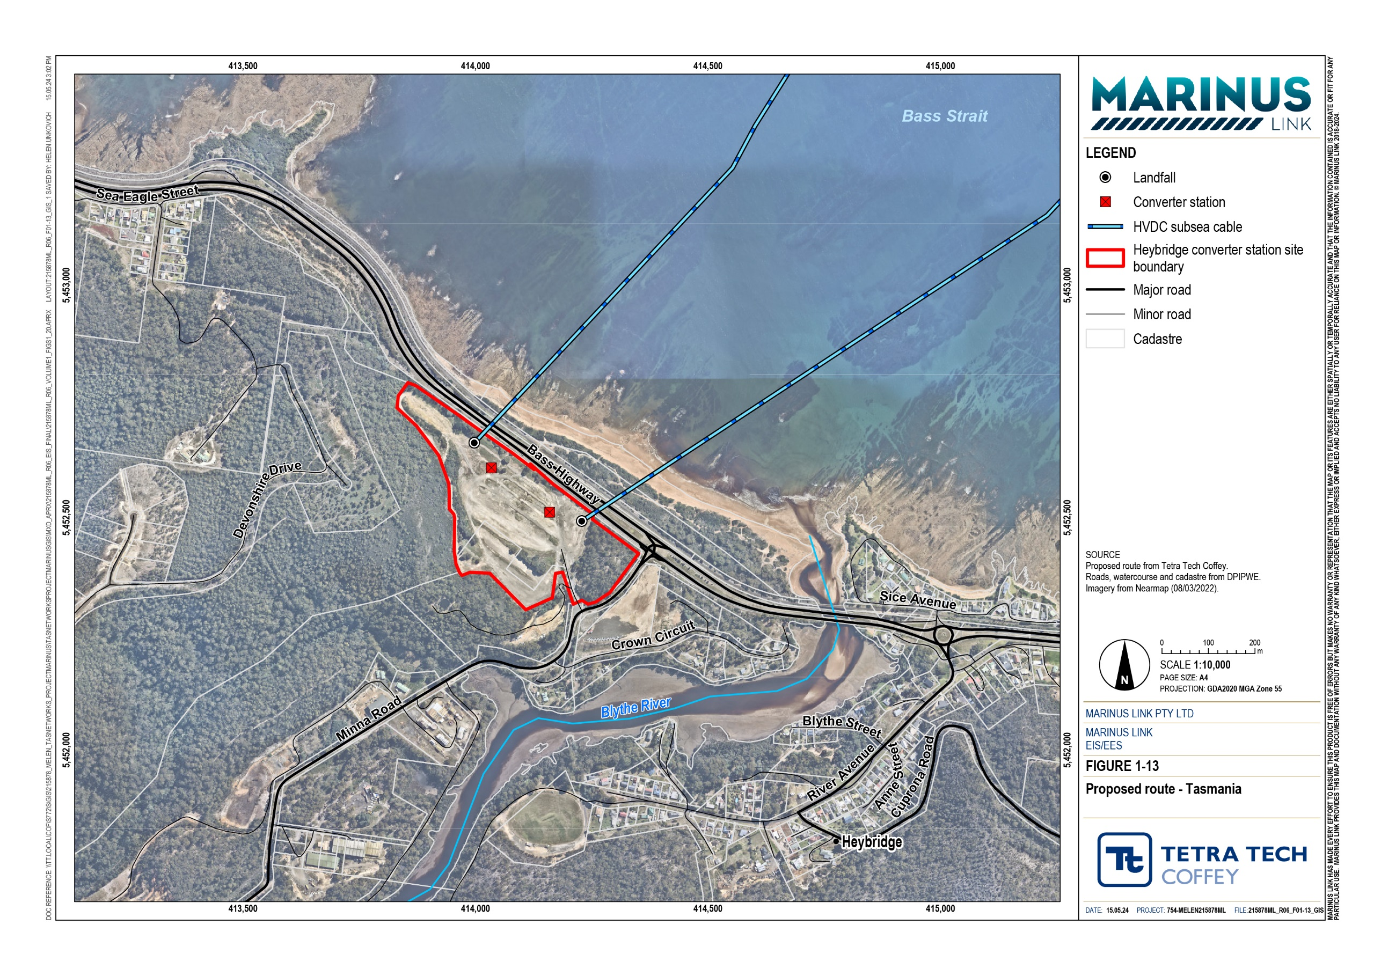
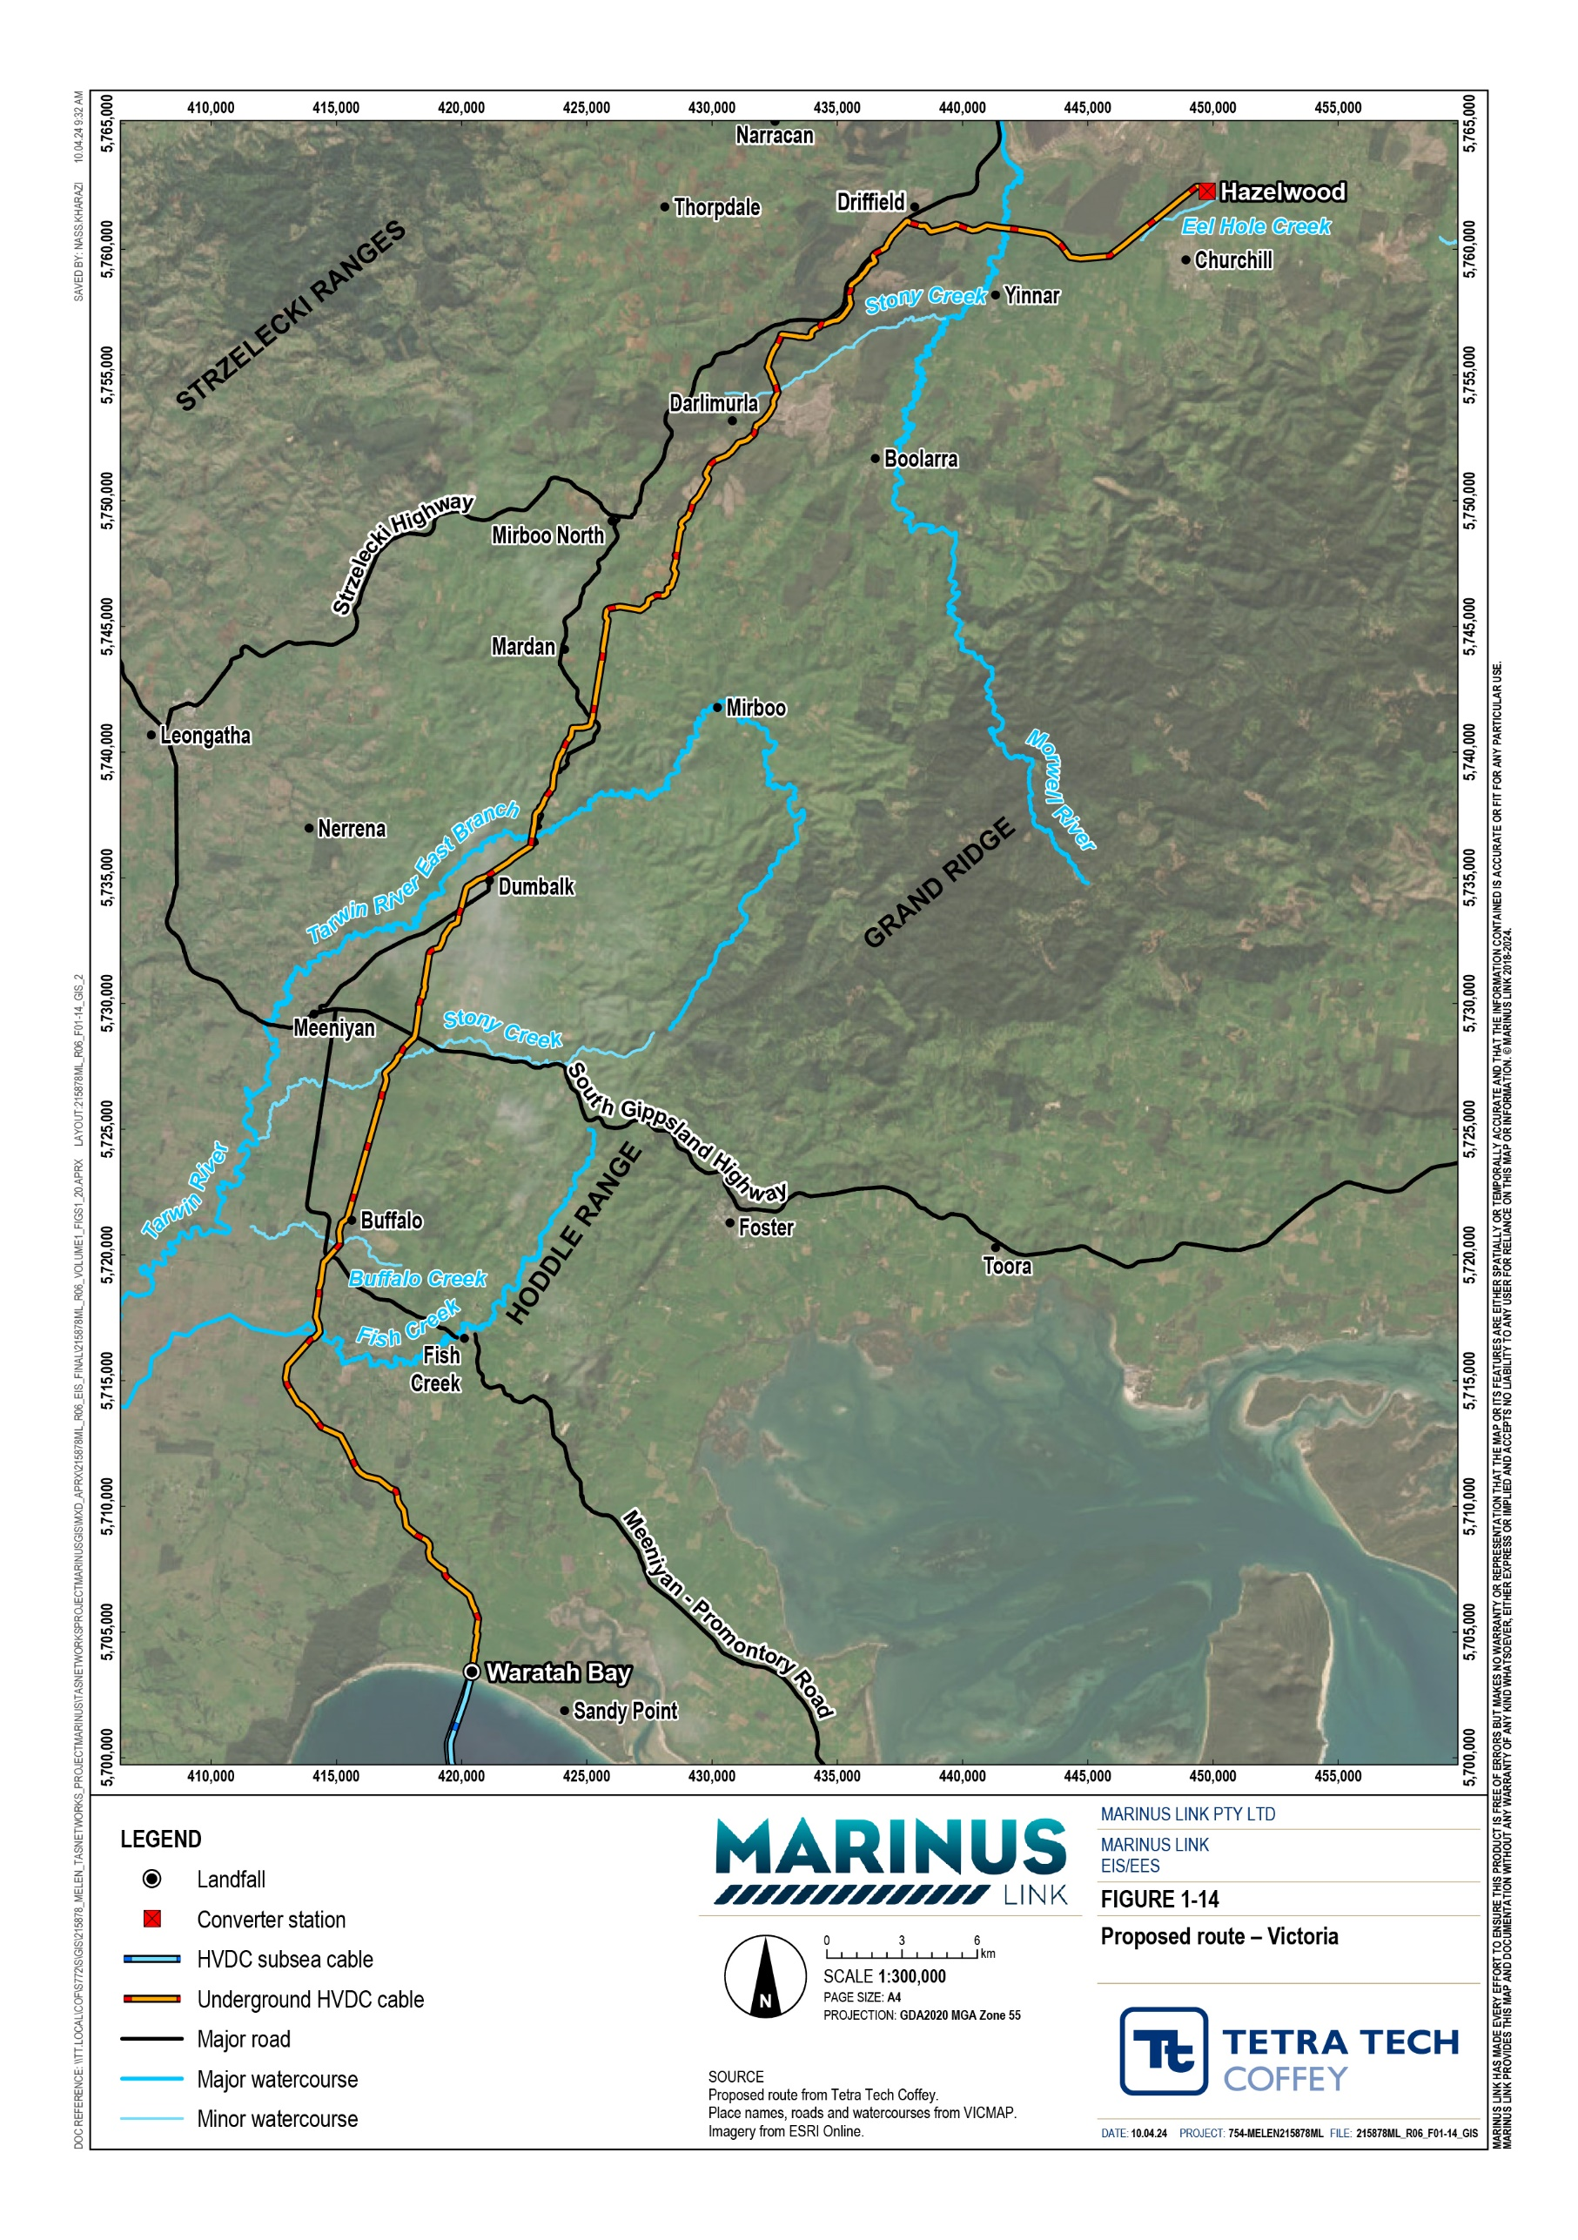

Project alternatives
The detailed route and site selection process facilitated the assessment of multiple project alternative alignments and siting for project infrastructure. Options considered include:
Alternative Victorian land cable routes

Alternative Victorian converter station site

Converter station technology

Construction methods (overhead versus underground)

Methods for crossing assets and features

Alternative of ‘no project’.

Alternative Victorian land cable routes
A key objective of the route selection approach for the land cable in Victoria was to avoid, where practicable, the heavily dissected hills and creeks of the Strzelecki Ranges, predominantly encountered north of Foster in the headwaters of the Tarwin River. The most feasible option for routes was a corridor to the west of the Hoddle Range, up the Tarwin River valley, across the undulating plateau of the Strzelecki Ranges that extends from Mardan to Mirboo North, and down the ranges to Driffield and Hazelwood.
Six key alternative routes, along with variations in the Tarwin River (East Branch) valley and Strzelecki Ranges, were investigated as part of the route selection process. The aim was to reduce the route’s exposure to steep slopes and unstable landforms, impacts on properties and farming practices, impacts on plantation operations, and impacts on watercourses and remnant vegetation.
The options included using sections of the road network through highly constrained areas, following the Tarwin River valley to its watershed on the Grand Ridge. While roads provide opportunities for routes, they introduce further constraints including variable fill material affecting cable design and performance, road formation cut and fill ratio, potentially affecting trench stability, other infrastructure including water mains, telecommunication cables, cattle underpasses and bridges, property and emergency vehicle access during construction, and space for the cable joint pits.
Overall, the project alignment presents the least constrained route option investigated. The alternative routes investigated (Figure 1-15) and reasons for them being adopted or discounted are detailed in the following sections.

North of South Gippsland Highway, an alternative route along the eastern side of the Tarwin River (East Branch) valley was investigated. The route generally followed the Dumbalk East–Stony Creek Road to Dumbalk North, where it continued up the Tarwin River (East Branch) valley to Mirboo. Passing west of Mirboo, the alternative route ran west of Mirboo Road to Limonite. At Limonite, the route followed the Old Foster Road to Boolarra–Mirboo North Road before descending the Grand Ridge along ridges through farmland and plantations to Darlimurla, where it joined the proposed route. Subsequent to this alternative route being identified, a variation on this route was proposed by Mirboo North landholders s. The variation involved following Limonite Road to Boolarra and then Monash Way and Tramway Road to Hazelwood Terminal Station.
The alternative route up the Tarwin River (East Branch) valley is highly constrained from Mirboo to Boolarra– Mirboo North Road, particularly from Limonite to Boolarra–Mirboo North Road where the route runs in Old Foster Road. The road is on top of a narrow steep-sided ridge leaving no opportunity to locate the route on either side of the road. Constructing the route in this section would require extended road closures due to the narrow formation of Old Foster Road.
Limonite Road is highly constrained between Limonite and Boolarra, where it is adjacent to O’Grady Creek. The creek valley is steep sided in this section with evidence of slope movement. The responsible road authority has placed warning signs (‘Rough surface road subject to movement’) at each end of a 600 m section of the road in this area. Routes adjacent to the road are technically challenging and potentially infeasible due to the steep slopes and landslip hazard in this area.
Limited workspace, exposure to steep-side slopes, and land and roads subject to movement, were the reasons that this alternative route (Tarwin River valley) and its variation (Limonite Road) were discounted from further investigation.
The proposed route generally follows Loves Lane (Meeniyan–Mirboo North Road) up the southern slopes of the Strzelecki Ranges, north of Dumbalk. The ridge which the road follows is challenging in places with steep slopes and potential landslip hazards. Two alternative routes were investigated in this area, one along Loves Lane and one via Campbells Road.
Loves Lane was discounted, as a constructability and engineering review concluded this route was not feasible due to the significant disruption to traffic and farm and business access, shallow rock visible in road batters, and extent of fill material in the road formation.
Campbells Road runs along the ridge north of Loves Lane and was investigated as an alternative route up the southern slopes of the ranges. This alternative route generally follows Farmers Road north before crossing the Tarwin River (East Branch) to follow the steep ridge to Meeniyan–Mirboo North Road at the top of the southern slopes.
This alternative route was discounted due to the steep slopes, potential landslip hazards and limited workspace near Campbell Road’s intersection with Meeniyan–Mirboo North Road.

A geomorphic assessment of the proposed route that ran south of Mirboo North confirmed the land north of Berrys Creek was susceptible to slumping and slope failure. An alternative route in more stable terrain up the southern side of Berrys Creek valley was identified and adopted in this section. The proposed route was further revised to the south to reduce impacts on horticultural land adjacent to Nicholls Road.
Boolarra–Mirboo North Road runs along the Grand Ridge east of Mirboo North. Terrain either side of the road varies from undulating to steep, with evidence of landslides. The proposed route runs adjacent to Fullertons Road and along a natural terrace east of Old Darlimurla Road.
Old Darlimurla Road was investigated as an alternative route north of the Grand Ridge. The road is narrow and bordered by mature eucalypt trees. Laying cables under the road would cause significant disruption to adjacent rural residential properties and potentially result in the loss of the trees due to construction activities encroaching the tree protection zones. For these reasons, this alternative route was discounted.
Little Morwell River runs in a narrow valley with steep slopes on the northern side of the valley. Darlimurla Road was investigated as an alternative route in this area. This alternative route was discounted as:
The road is narrow and construction activities would cause significant traffic disruption for local residents and the plantation owner.
The bridge over Little Morwell River is narrow with space either side, constrained by steep banks and rural residential properties.
The route across the Morwell River floodplain initially followed the Hazelwood to Cranbourne 500 kV OHTLs. This route would have resulted in cable joint pits in the floodplain and subject to inundation. To avoid cable joint pits in areas subject to inundation, the route was moved downstream to where the floodplain narrows to approximately 400 m. This enabled the cable joint pits to be sited on the floodplain terraces above the 1-in- 100-year flood extent.

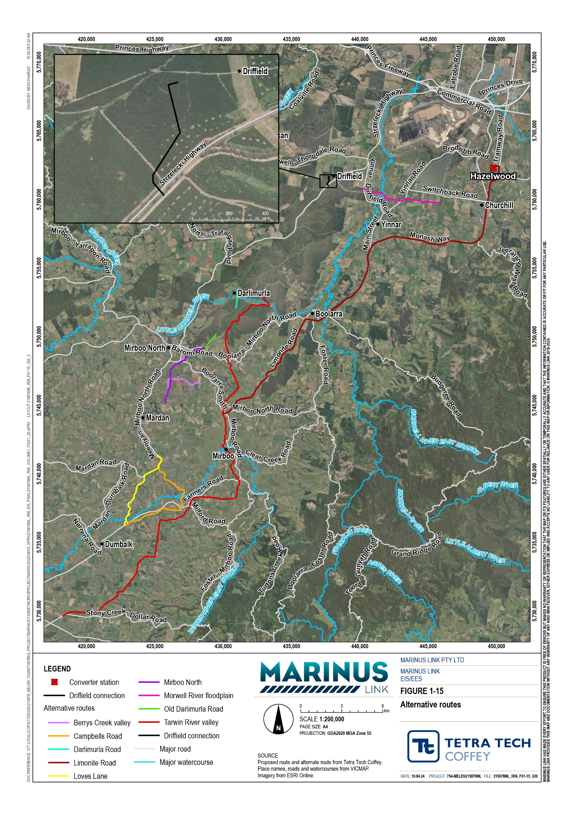

Alternative Victorian converter station site
Two converter station site options were considered in Victoria, at Driffield and Hazelwood. The technical studies prepared to support this EIS/EES have assessed both converter station sites in Victoria along with the site in Heybridge in Tasmania. In Victoria, Hazelwood has since been confirmed as the preferred location for the converter station. Several factors were considered in deciding between the two sites, including:
Proximity to the existing power transmission network.

Sufficient space for buildings and equipment.

Site access requirements for overdimensional loads.

Potential environmental impacts during construction and operation.

Terrain at Driffield limits the available space, with the Hazelwood site having space for expansion. Less bulk earthworks are required at the Hazelwood site compared to the Driffield site. Burrowing and spiny crayfish are present in the Strzelecki Ranges with burrows observed at the Driffield converter station site. Trapping at the site identified the common lowland burrowing crayfish (Engaeus quadrimanus) but the low capture rate does not preclude the threatened Narracan burrowing crayfish (Engaeus phyllocercus) and South Gippsland spiny crayfish (Euastacus neodiversus) being present.
The Driffield converter station site would have a significant impact on plantations due to the area required for the facility. Unlike the land cable route, which has been designed to minimise impacts on plantations by use of strategic firebreaks and existing plantation access tracks, development of the site would have resulted in the permanent loss of valuable timber resource affecting wood stocks and wood flow. For these reasons, the Hazelwood converter station site is less constrained and preferred.

Converter station technology
Two technologies are available to convert HVDC to HVAC and vice versa. They are:

Line commutated converters which use thyristors to convert HVDC to HVAC and vice versa.

Voltage source converters which use transistors to convert HVDC to HVAC and vice versa.

Basslink uses line commutated converter technology which has been used for over 50 years. This technology requires the polarity of the circuit to be changed to transfer the direction of power flow. This process takes time and requires the link to be brought to zero volts before changing the polarity.
In contrast, voltage source converter technology is more flexible. Voltage source converters change the direction of power flow by reversing the direction of the current. The change can be done instantaneously. Other advantages of voltage source converters are that they can:
Operate with lower system strength, which is important for inverter-connected renewable energy generation, such as wind farms.

Support continuous power flow during power flow reversals, i.e., when changing power flows out of and into Tasmania.
Support continuous provision of frequency control ancillary services to manage the variability of renewable energy generation.
Provide substantial reactive support to AC systems, which the project will be connected to.

Offer black start capability, i.e., the ability to restart the power system after a blackout event.

For these reasons, voltage source converter technology was chosen for the project.

Underground versus overhead
Transmission lines can transmit electricity by HVDC or HVAC. In either case it is possible to construct either overhead transmission lines (OHTL) or underground cables. Consideration was given to the use of HVDC or HVAC and underground cables or OHTL in the development of the project.
HVDC is a more efficient way to transmit electricity over long distances, reducing losses. HVAC provides greater flexibility for connection to generators and electricity users.
Underground cables have lower visual impacts and provide greater protection from extreme weather conditions such as lightning and strong winds, which can damage infrastructure. OHTLs are usually cheaper to build (depending on the design) and can be easier to access for maintenance and repair.
For the Bass Strait crossing, underground HVDC is required as:

The construction of OHTLs across Bass Strait would be very technically challenging and result in higher impacts to vessel movements and use of Bass Strait during operation.
HVDC has materially higher performance efficiency than HVAC, therefore the amount of energy lost in transmission is reduced.
No connection to generators or users is required for the Bass Strait crossing meaning a key benefit of HVAC is not needed for the project.
In Victoria, either HVDC or HVAC, and either OHTLs, or underground cables, or a combination of these, could be used to transmit power from the shore crossing to the Hazelwood converter station. Underground HVDC cables were identified as the preferred option as:
It is more efficient to connect the project to the existing grid than for energy generators and users to connect directly to the project. Because of this it is possible to utilise HVDC from the shore crossing to the connection to the grid in the Latrobe Valley. This is a more efficient method to transmit electricity and reduces the amount of electricity lost in transmission.
If HVAC was to be used in Victoria, a converter station would be required nearer to the Victorian coastline to convert the HVDC subsea cable to HVAC, as well as an OHTL to the existing grid in the Latrobe Valley. This would require a bigger building with nosier equipment by the coastline as well as large OHTLs, increasing impacts on amenity. A number of options for location of a converters station

closer to the coast were considered including near Mirboo North (to avoid crossing the Grand Ridge overhead), in the Tarwin River valley (to avoid crossing the Strzelecki Ranges underground), and near the Fish Creek–Walkerville Road inland of Waratah Bay. These options were not preferred due to the increased visual impacts in a significant landscape, proximity to communities and potential impacts on tourism, including the Wilsons Promontory tourist route through Meeniyan and Fish Creek.
The option to install HVDC cables underground in parts and overhead in parts was also explored.
However, this split approach would cost more than installing the HVDC line underground in its entirety. It is also technically difficult with the voltage source converter technology selected for the project.

Method for crossing other assets and features
A range of methods were considered for crossing of waterways, roads, existing infrastructure and other areas of sensitivity such as native vegetation. From the outset, the preferred method of construction of the shore crossing has been HDD due to the sensitivity of the coastal environment and interface with the marine environment, where methods such as trenching are not viable to 10 m water depth.
Watercourse crossing methods were determined based on the risk that construction activities pose to watercourse form, behaviour, flow and associated aquatic ecology values. Crossing all watercourses using trenchless construction methods (e.g., horizontal directional drilling or HDD) is costly and not practicable where the impacts of open trenching can be effectively managed.
Ephemeral watercourses and drainage lines typically have poorly defined channels, no riparian vegetation, and degraded aquatic ecosystems. Bed and banks can be effectively reinstated and rehabilitated to maintain watercourse form, behaviour, flow and protect upstream and downstream values. For this reason, trenching is proposed for ephemeral watercourses and drainage lines, with trenching occurring in periods of no or low flow.
Permanent major watercourses will be crossed using trenchless construction methods, typically HDD. Watercourses proposed to be crossed using HDD are Fish Creek, Buffalo Creek, Stony Creek, Tarwin River East Branch, Tarwin River tributaries, Morwell River and Eel Hole Creek. Desktop geomorphology and geotechnical investigations indicate HDD is technically feasible for these crossings.
Should detailed geotechnical investigations find trenchless construction methods are not technically feasible, an open cut construction method would be applied.
For crossing of other features such as roads and existing infrastructure, trenchless construction methods and trenching have been considered. HDD has been assumed as the method to be used for areas where trenchless methods are recommended to reduce impacts on values and assets. This is discussed further in Volume 1, Chapter 6 – Project description.
Construction methods will continue to be refined based on site conditions and available technology. The final methods chosen will comply with the requirements established for the project.

No Marinus Link
The project has been recognised by Commonwealth and state government ministers as a project of national significance (Bowen 2022) as it supports Australia’s transition to cleaner energy and provides a critical piece of national transmission infrastructure.
The rationale for the project is outlined in Volume 1, Chapter 2 – Project rationale. The consequences of the project not proceeding are that the following benefits would not be realised:
Energy transition: The additional transmission capacity provided by the project would allow for higher amounts of renewable energy in the NEM, while providing firming capacity to replace the current stabilising function of coal fired generation.
Improving Tasmania’s energy security: The project will enable the continued trading, transmission and distribution of electricity within the NEM. It will also reduce the risk of a single interconnector failure across Bass Strait and complement existing interconnector infrastructure within the wider NEM. The project is also expected to induce development of further renewable energy generation projects in Tasmania, offering additional energy security to Tasmania and the NEM.
Wholesale energy cost reductions: The project will reduce energy costs through:

      - Reducing capital costs of future generation, energy storage and existing infrastructure through using existing infrastructure to its' full potential.
      - Increasing availability of low-cost renewable energy capacity.

      - Reducing reliance on gas generation to provide dispatchable energy.

Economic benefits: The project is predicted to provide economic contribution of $1.47 billion for Tasmania and $1.78 billion for Victoria (Ernst & Young 2023). The project will also support the generation of indirect and direct jobs across a wide range of industries, education levels and occupations. The project is predicted to support the following jobs during peak construction:
      - Stage 1: 673 jobs per year in Tasmania and 857 jobs per year in Victoria.

      - Stage 2: 643 jobs per year in Tasmania and 818 jobs per year in Victoria.

Telecommunications capacity: The project will increase Tasmania’s current optical fibre capacity by 150 times.

