Legislative framework
The project requires assessment and approval under Commonwealth, Victorian and Tasmanian legislation. Approvals will cover the construction, operation and decommissioning of the project. The EPBC Act governs the environmental assessment process within the Commonwealth’s jurisdiction, and the requirement for an EIS. The EE Act governs the environmental assessment process within Victoria, and the requirement for an EES. This EIS/EES has been prepared to address Commonwealth and Victorian legislation. The approach taken to develop and deliver the EIS/EES is discussed in Volume 1, Chapter 5 – EIS/EES assessment framework.
This chapter identifies the legislation relevant to the environmental, land use planning, and heritage assessment and approval of the project. Figure 1-16 outlines the key legislation and the relevant jurisdictions that are applicable to this EIS/EES.
The assessment and approval processes under Tasmanian legislation have been addressed in separate documentation as discussed in Volume 1, Chapter 1 – Introduction.

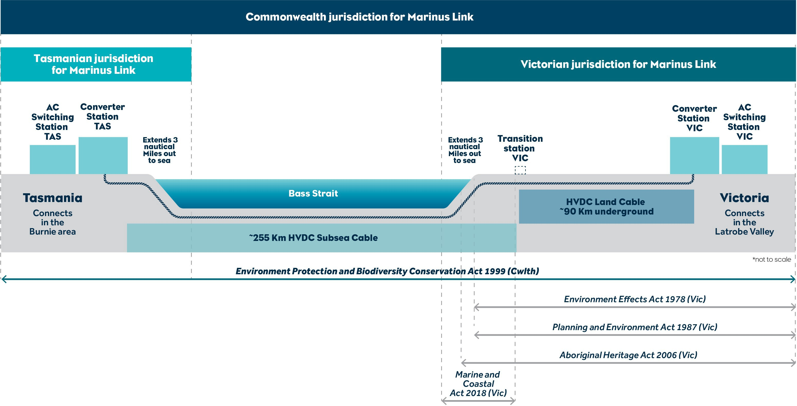

Key legislation
The following section outlines the key legislation under which the project will seek primary approval.

Environment Protection and Biodiversity Conservation Act 1999 (Cwlth)
The EPBC Act applies to projects, such as Marinus Link, that may have a significant impact on MNES. Key steps in the EPBC Act assessment process are described below.

An EPBC Act referral was submitted for the project on 28 September 2021 (2018/9053 – Marinus Link Underground and subsea electricity interconnector cable). The referral was made available for public comment between 5 October 2021 and 19 October 2021. Following this, a referral decision was received from a delegate for the former Minister for the Environment on 4 November 2021, determining that the project is a controlled action with the potential for significant impacts on the following MNES:
Listed threatened species and communities (sections 18 and 18A of the EPBC Act).

Listed migratory species (sections 20 and 20A of the EPBC Act).

Commonwealth marine area (sections 23 and 24A of the EPBC Act).
Following the referral decision, a delegate for the Minister for the Environment and Water provided draft EIS guidelines. The draft EIS guidelines were made available for public comment from 24 August 2022 to
14 September 2022. The final EIS guidelines were issued on 18 October 2022 by a delegate for the Minister.
The EIS guidelines describe the matters that are to be addressed in this draft EIS, as required under section 101A of the EPBC Act.

This EIS/EES has been prepared to address the requirements of the EIS guidelines and is the draft EIS published for public comment for the purposes of section 103 of the EPBC Act. The draft EIS was reviewed for adequacy by assessment officers at DCCEEW, and then updated by the proponent, before being approved for publication for public comment. Under the EPBC Act, the EIS must be publicly available for comment for a minimum of 20 business days. It is proposed that this publication period will be scheduled to coincide with public exhibition of the EES under the EE Act.

Following completion of the public comment period, comments will be reviewed and addressed, and the draft EIS will be finalised, taking account of comments as required in section 104 of the EPBC Act. A summary of the comments and how they have been addressed will also be prepared and published with the final EIS.

Following finalisation of the EIS, DCCEEW will prepare a recommendation report for consideration by the Minister for the Environment and Water. This report will recommend whether the action should be approved and, if so, any conditions that should be attached to the approval. Following receipt of the recommendation report, the Minister may invite comments from other relevant Commonwealth Ministers. The Minister may also request additional information to inform the decision making.
In deciding whether to approve the project, the Minister or their delegate must consider the requirements of Section 136 of the EPBC Act, including:
Matters relevant to the relevant controlling provisions for the project:

- Listed threatened species and communities.

- Listed migratory species.

- Commonwealth marine areas.

Economic and social matters.

Conclusions on these matters are outlined in Volume 5, Chapter 1 – Conclusion by jurisdiction. In considering these matters, the Minister or their delegate must take into account:
The principles of ecologically sustainable development;

The finalised EIS;

Recommendation report; and

Any relevant comments given to the Minister by other Ministers.

In deciding whether to approve the project, the Minister or their delegate must consider the requirements of Section 139 of the EPBC Act relating to threatened species and endangered communities.
Under Section 139(1) of the EPBC Act, the Minister must not act inconsistently with:

Australia’s obligations under the Convention on Biological Diversity (the Biodiversity Convention)

Australia’s obligations under The Convention on Conservation of Nature in the South Pacific (the Apia Convention).
Australia’s obligations under Convention on International Trade in Endangered Species of Wild Fauna and Flora.
Any applicable Recovery Plan or Threat Abatement Plan.

Under Section 139(2) of the EPBC Act, the Minister or their delegate must have regard to any approved Conservation Advice for the species or community.
Under Section 140 of the EPBC Act, the Minister or their delegate may consider whether the proponent is suitable to be granted an approval based on the proponent’s history in relation to environmental matters.

In deciding whether to approve the project in relation to a listed migratory species, the Minister or their delegate must not act inconsistently with the following conventions or agreements (as relevant):
Convention on the Conservation of Migratory Species of Wild Animals (the Bonn Convention)

China–Australia Migratory Bird Agreement

Japan–Australia Migratory Bird Agreement

An international agreement approved by the Minister, under subsection 209(4) of the EPBC Act.

Environment Effects Act 1978 (Vic)
The EE Act is administered by the DTP and provides the framework for the assessment of the environmental effects of projects that are capable of having a significant effect on the environment in Victoria.
Similar to an EIS, an EES is a multidisciplinary environmental impact assessment report that describes the potential impacts (positive and negative) of the project. The EES is required under the EE Act and informs the Victorian Minister for Planning’s assessment of the project’s environmental effects in Victoria.
A referral for the project (2021R-04) was referred to the Minister for Planning on 17 September 2021, for a decision on whether an EES is required. A referral decision was received from the Minister on 12 December 2021. The Minister determined that an EES is required for the project due to the project’s potential for a range of significant effects that require assessment. In particular, the Minister identified that the EES needs to address:
effects on biodiversity and ecological values within and near the project area including native vegetation, listed threatened communities and species (flora and fauna) under the Flora and Fauna Guarantee Act 1988 and Environment Protection and Biodiversity Conservation Act 1999, such as through clearance, degradation or fragmentation of habitat;
effects on freshwater and marine environments and related environmental values, including any changes to stream flows, water quality or sedimentation due to waterway crossings or installation of subsea cables;
effects on Aboriginal cultural heritage values;

effects on the socioeconomic environment including land use, at local and regional scales; and

effects on existing landscape values.
Draft EES scoping requirements were prepared by DTP and exhibited for public comment between
24 August 2022 and 19 September 2022. The draft EES scoping requirements were then revised after considering public submissions. The final EES scoping requirements were approved by the Minister for

Planning in February 2023. The EES scoping requirements define the matters that are to be addressed in this EES.
DTP convened a technical reference group (TRG) consisting of representatives of relevant Victorian and Commonwealth government agencies, Registered Aboriginal Parties, as well as the Tasmanian Environment Protection Authority. The TRG is made up of members from relevant Commonwealth and state government entities:
DCCEEW Heritage Victoria

Department of Energy, Environment and Climate Action (DEECA)
DTP
Latrobe City Council

Transport Safety Victoria (formerly Maritime Safety Victoria)

Environment Protection Authority Victoria (EPA Victoria)
EPA Tasmania

First People-State Relations (FPSR)

Gunaikurnai Land and Waters Aboriginal Corporation (GLaWAC)
Regional Roads Victoria

South Gippsland Shire Council

Victorian Fisheries Authority (VFA)

West Gippsland Catchment Management Authority (WGCMA).

The TRG advised DTP and MLPL on the scoping and adequacy of technical assessments and draft EES chapters, as well as coordination of the EES process with other state assessment and approval processes.
The TRG has met 14 times between April 2022 and July 2023.
The Minister for Planning has authorised the EES for public exhibition. Volumes 1, 3, 4, and 5 of this EIS/EES (which relate to Victorian matters) will be exhibited for a minimum of 30 business days (noting these volumes also contain aspects addressing the Commonwealth EIS guidelines). During this time any interested party may make a written submission on the EES. MLPL will review submissions and prepare a response to issues raised.

The Minister has directed that an inquiry will be required, as per item ‘(x)’ of the procedures and requirements that apply to the project EES process (Appendix A to the EES scoping requirements) which is that ‘an inquiry will be appointed under the Environment Effects Act 1978 to consider environmental effects of the proposal’. The Minister will appoint an advisory committee to conduct an inquiry, and issue terms of reference, setting out the matters to be considered. The inquiry is likely to include formal hearings to allow MLPL to present on the project and for submitters to present on their submissions.
Following completion of the inquiry, the advisory committee will issue an assessment report for consideration by the Minister for Planning.
The final step in the EES process is for the Minister to prepare an assessment of the environmental effects of the project (Minister’s assessment). The outcome of an EES is not an approval. Rather it is an assessment by the Minister of Planning about environmental effects of a project and if they are acceptable. The recommendations in the Minister’s assessment will inform decision-makers under other relevant Victorian legislation, discussed further below.

Planning and Environment Act 1987 (Vic)
The Planning and Environment Act 1987 (Vic) (P&E Act) governs the use and development of land in Victoria. The P&E Act sets out processes for preparing planning permits, planning schemes (for municipal and other declared districts), and planning scheme amendments (PSA) to the Victoria Planning Provisions and planning schemes.
Various aspects of the project trigger planning approvals under the Latrobe and South Gippsland Planning Schemes. This includes approval for the use and development of land for a utility installation, as well as for earthworks, road construction, fencing, creation of easements, removal/destruction/lopping of vegetation, and for works proximate to major pipeline infrastructure, the Principal Road Network and waterways.
A PSA is the preferred planning approval pathway for the project as it provides a simplified, efficient, and consistent approval process, by removing the need to apply for multiple individual permits, whilst still meeting the requirements set out by the P&E Act. The Minister for Planning has agreed to the preparation of a draft PSA for the Victorian components of the project, and for it to be exhibited with the EIS/EES required for the project. The P&E Act provides the framework in which a PSA is to be prepared, assessed and adopted by the Victorian Minister for Planning, as the planning authority. The PSA is referred to as a draft until it is approved by the Minister.

Draft PSA GC217 to both the Latrobe and South Gippsland Planning Schemes, including an Incorporated Document, has been prepared for the project and will be exhibited alongside this EIS/EES. The draft PSA outlines the proposed amendments to the Latrobe and Gippsland planning schemes. More specifically, the amendment:
Introduces Clause 45.12 ‘Specific Controls Overlay’ (SCO) to the South Gippsland Planning Scheme, and new Schedule 3 (SCO3) in the Latrobe Planning Scheme and South Gippsland Planning Scheme, to give effect to the specific control contained in the Marinus Link Incorporated Document, August 2023.
Amends the schedule to Clause 72.01 ‘Responsible Authority for This Planning Scheme’ of the Latrobe and South Gippsland Planning Schemes to make the Minister for Planning the Responsible Authority for the administration and enforcement of the planning schemes relevant to the use and development of land for the project and the Marinus Link Incorporated Document, August 2023.
Amends the schedule to Clause 72.03 ‘What does this Scheme consist of’ to insert reference to the new planning scheme maps.
Amends the Schedule to Clause 72.04 ‘Documents incorporated in this Planning Scheme’ of the Latrobe and South Gippsland Planning Schemes to include the Marinus Link Incorporated Document,
August 2023.

Amends Clause 74.01 of the South Gippsland Planning Scheme to include the Specific Controls Overlay with a short description.
Amends Planning Scheme Map No. 92SCO, and insert new Planning Scheme Map nos. 90SCO, 91SCO, 105SCO, 106SCO, and 116SCO in the Latrobe Planning Scheme and inserts new Planning Scheme Map nos. 8SCO, 9SCO, 18SCO, 26SCO and 35SCO in the South Gippsland Planning Scheme, to identify the land to which SCO3 applies.
The proposed Incorporated Document, like a planning permit, outlines the land to which the proposed controls apply, confirms the aspects of the project which can be undertaken without further approval under the Planning Scheme, and includes a number of conditions on which the use and development permitted by the Incorporated Document must be undertaken. This type of planning control has frequently been used on major infrastructure projects and provides a straightforward legal and administrative tool to regulate and control the development of the project. Compliance with the Incorporated Document, following adoption and approval of the PSA, will be required by the P&E Act. Under the Incorporated Document, Ministerial approval would be required for:
Alignment Plans and Development Plans

The Environmental Management Framework, which includes the EPRs.

Further information on these arrangements is provided in Volume 5, Chapter 2 – Environmental Management Framework and the draft planning scheme amendment which is included as an attachment to this EIS/EES.

Whilst the draft PSA will be exhibited with the EIS/EES, it is not formal exhibition of the PSA within the meaning of the P&E Act. The exhibition of the draft PSA with the EIS/EES however, provides the opportunity for persons to understand the changes to the planning schemes required to facilitate the project, and to comment on the draft PSA along with the EIS/EES if desired.
The Minister will assess the PSA, including the Incorporated Document, against the planning provisions and schemes, P&E Act and associated Ministerial Directions. Following the Minister’s assessment, MLPL anticipates it will request that the Minister for Planning approve the PSA in the proposed form, exempt from the need for further public notice given that submissions on the draft PSA would have been considered as part of the EES inquiry process under the EE Act. Following the consideration of submissions through an inquiry, the Minister for Planning will determine whether to use their powers under section 20(4) of the P&E Act, to exempt the project from further exhibition. A subsequent decision whether to approve the PSA under the P&E Act is informed by the Minister’s assessment of the EES.

Marine and Coastal Act 2018 (Vic)
The Marine and Coastal Act 2018 Act (Vic) (MACA) manages the use and development of the coastal and marine environments including the seabed, and outlines the processes for obtaining consent to develop, or undertake works on marine and coastal Crown land. The MACA applies to land from the outer limit of Victorian waters (at 3 nautical miles (NM)) to 200 m inland of the high watermark.
An application for consent for the use, development and works on marine and coastal crown land, will be made under Section 68 of MACA. The Minister’s assessment of the EES will inform the decision whether to provide consent under MACA by the Victorian Minister for Environment.
Consent under the MACA was issued in February 2020 for marine geophysical and geotechnical investigations for the project.

Aboriginal Heritage Act 2006 (Vic)
A key objective of the Aboriginal Heritage Act 2006 (Vic) (AHA) is to recognise, protect, and conserve Aboriginal cultural heritage. The AHA applies to cultural heritage values in Victoria and its waters (to the 3 NM state limit). Under the AHA, a Cultural Heritage Management Plan (CHMP) must be prepared if an EES is required. Approval under the AHA must be obtained before commencing any project or action that has the potential to impact Aboriginal cultural heritage in Victoria.
Two CHMP’s are being prepared to address management and protection of Aboriginal cultural heritage in the project area. A CHMP for the northern section of the Victorian section of the project (Figure 1-17) will be assessed by GLaWAC (the Registered Aboriginal Party (RAP) in that area). A CHMP for the southern portion of the Victorian section of the project will be assessed by FPSR. Notices of intent for the CHMPs have been submitted to these parties.

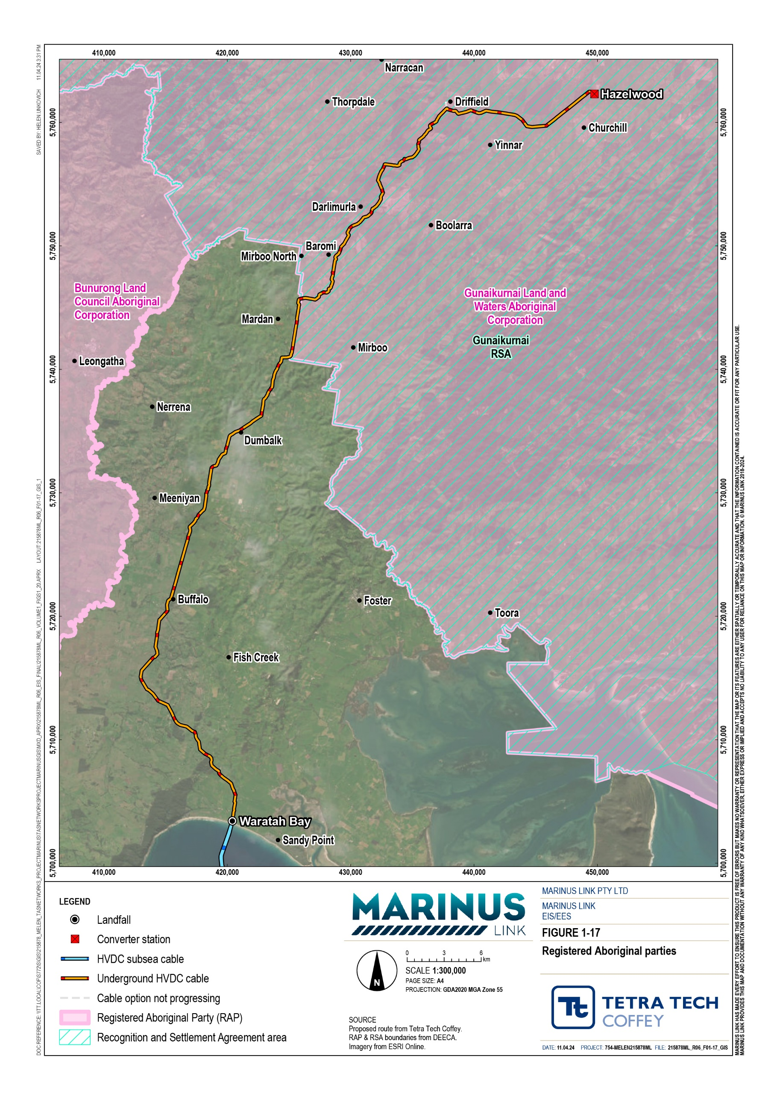

Other relevant legislation
The following section outlines the other Commonwealth and Victorian legislation relevant to the project.

Commonwealth
The objective of the Offshore Electricity Infrastructure Act 2021 (Cwlth) (OEI Act) is to provide an effective regulatory framework for the construction, operation and decommission of offshore renewable energy infrastructure and offshore electricity transmission infrastructure. The OEI Act outlines how and where these infrastructure projects can operate. The OEI Act applies to Commonwealth waters between Tasmanian and Victorian coastal waters.
Offshore renewable energy infrastructure projects will require a licence to operate under the OEI Act. The type of infrastructure will dictate the licence required. A transmission and infrastructure licence is required for the installation and operation of the undersea interconnectors. MLPL will need to obtain a transmission and infrastructure licence, and will also need to need to submit a management plan to the Offshore Infrastructure Regulator, detailing the offshore infrastructure activities that are proposed and how it meets the criteria set out in the OEI Act.
The objective of the Underwater Cultural Heritage Act 2019 (Cwlth) (UCH Act) is to protect Australia’s underwater cultural heritage sites and artefacts. The UCH Act defines a set of criteria that is used to determine what sites and artefacts are protected under the act.
The UCH Act operates within Commonwealth waters and shipwrecks within state waters. First Peoples’ sites and artefacts within the state waters are protected under state cultural heritage legislation (see Aboriginal Heritage Act 2006 (Vic)). Project activities with the potential to damage underwater cultural heritage sites and artefacts need to consider and comply with the requirements of the UCH Act.
The UCH Act has some overlap with the Aboriginal and Torres Strait Islander Heritage Protection Act 1984 (Cwlth) (ATSIHP Act), as both acts protect First Peoples’ cultural heritage values within Commonwealth waters; however, the UCH Act is broader to cover non-Indigenous marine cultural heritage, and the ATSIHP Act extends its cover to terrestrial cultural heritage.

The objective of the ATSIHP Act is to preserve and protect Aboriginal and Torres Strait Islander cultural heritage areas and objects of significance from injury and desecration. The ATSIHP Act enables immediate and direct action for protection of threatened areas and objects by a declaration from the Commonwealth Minister for the Environment and Water (or from authorised officers). The ATSIHP Act applies to Aboriginal and Torres Strait Island cultural heritage values in Commonwealth land and waters. The ATSIHP Act may override state legislation if the Minister deems the state legislation to be insufficient to protect the threatened areas or objects.
MLPL is not required to seek permit nor approval under the ATSIHP Act. However, it may still be applicable to the project, as the ATSIHP Act provides the opportunity for an Aboriginal person or relevant tradition owner group to initiate a temporary project cessation through application to the Minister. This temporary cessation is to allow the Minister an opportunity to assess the potential risk posed to cultural heritage areas and objects, and to determine whether they are sufficiently protected.
MLPL has engaged with First Peoples to identify and avoid impacts to cultural heritage areas and objects of significance, meaning that application of the ATSIHP Act is not required.
The Native Title Act 1993 (Vic) (Native Title Act) establishes the right of Aboriginal people to the ownership and title of their ancestral lands (native title). The Native Title Act outlines the process for Aboriginal people to claim the native title of land and recognises and protects their right to do so.
GLaWAC native title interests have been recognised for lands in Central and East Gippsland under a determination of the Federal Court of Australia. These include the section of the project area between Mirboo North and Hazelwood.
An unregistered native title claim by the Boonwurrung People is yet to be determined in relation to the section of the project area between Waratah Bay and Mirboo North, in which there is no RAP. First Peoples’ groups including Bunurong Land Council Aboriginal Corporation (BLCAC), Boonwurrung Land and Sea Council (BLSC) and GLaWAC have asserted traditional ownership interests in this area.
The Sea Installations Act 1987 (Cwlth) (Sea Installations Act) ensures that sea installations are operated safely (with regard to people, ships and aircraft in the vicinity) and in a way that protects the environment and applies appropriate laws relating to sea installations. The Sea Installations Act applies from the 3 NM state limit to the limits of Australian waters.
There is no approval or permitting processes under the Sea Installations Act (since the 2014 amendment). However, a number of provisions, including maritime safety standards, will still apply during operation of the project. These will be addressed through the development of an operations environmental management plan (OEMP).

An objective of the Climate Change Act 2022 (Cwlth) (Climate Change Act) is to outline Australia’s GHG emission reduction targets. Approval of the project is not required under the Climate Change Act. However, consideration of the targets presented under the Climate Change Act help to contextualise the projects benefits and justification (discussed further in Volume 1, Chapter 9 – Sustainability, climate change and greenhouse gas emissions) and is required under the EIS assessment guidelines.

Victorian
Other Victorian legislation, relevant to the project, is described below.
The Heritage Act 2017 (Vic) (Heritage Act) provides the framework for identifying and protecting sites and artefacts of historic and European heritage value in Victoria. The Heritage Act establishes the Victorian Heritage Register, a database of known historic and European heritage sites and artefacts.
Following the completion of desktop and field surveys it is considered unlikely that the project’s activities will result in the disturbance to European or historic heritage sites or artefacts. However, a management plan will be developed for the unexpected finding of these items or sites protected by the Heritage Act.
If discovered, a permit will be required prior to commencing any works that may disturb, damage or modify any of these items or sites that are protected under law.
The objective of the Environment Protection Act 2017 (Vic) (EP Act) is to protect human health and the environment from pollution and waste in Victoria. The EP Act outlines the legislative framework that establishes the powers, responsibilities and processes of EPA Victoria, as well as the general environmental duty (GED) of all Victorians.
Approval of the project is not required under the EP Act; however, there are many components of the legislation and subordinate documents that inform the assessment of impacts. This includes the GED and environment reference standard. These requirements are discussed in more detail in the relevant chapters of the EIS/EES.
The Wildlife Act 1975 (Vic) provides a framework for the protection, conservation and sustainable management and use of wildlife in Victoria.
Under the Act, the disturbance or control of wildlife from activities, such as the installation of fencing, and wildlife capture, relocation, or hunting efforts, will require an Authority to Control Wildlife permit. These requirements will apply during construction of the project.

The FFG Act provides the legislative framework for biodiversity conservation in Victoria. The FFG Act outlines the processes that have the potential to threaten biodiversity in Victoria, and lists the threatened species and communities of flora and fauna, along with their characterisation (expressing their degree of vulnerability). The FFG Act covers terrestrial, aquatic, and marine species within Victorian jurisdiction.
Potential project impacts on the FFG Act listed threatened species and communities have been assessed in the preparation of this EIS/EES. A permit will be required during construction to take or remove any of the FFG Act listed threatened species or communities from public or private land. This may occur due to construction activities or their effects, including vegetation clearance or ground disturbance.
The objectives of the FFG Act will need to be considered whilst the Minister completes their assessment of Volumes 1, 3, 4, and 5 of this EIS/EES.
The Water Act 1989 (Vic) provides the legislative framework for managing water resources in Victoria. Under the Act, a person must apply to the appropriate catchment management authority for a permit to complete works on or near waterways, or license to take and use water from a waterway or groundwater source.
The project will likely need to obtain a Works on Water Ways permit from WGCMA for works that cross or are within 30 m of a waterway, and a Licence to Take and Use water from waterways or groundwater. These will be sought from WGCMA under delegation from the Minister, prior to commencement of relevant construction activities.
The Road Management Act 2004 (Vic) (Road Management Act) establishes the management system for public roads in Victoria. The purpose of the Road Management Act is to promote a safe, responsible and efficient use of the road networks in Victoria. Under the Act, a permit is required for any road opening, closure, or traffic diversion. The project will likely require road opening, closure, or traffic diversion and, therefore, will require a permit during construction.
The Climate Change Act 2017 (Vic) provides the legislative guidance to manage climate risks. This Act establishes state targets and systems for tracking and achieving climate related objectives.
No approval or permitting is required under the Act. However, the assessment under the EE Act requires the consideration of this Act, which has a focus on potential impacts in relation to climate change, including:
Predictions of energy use and greenhouse gas emissions associated with the project.

Risks associated with projected climate change and resilience to these risks, including consideration of the Act’s principals of risk management and standards for risk assessment, e.g., AS/NZS
ISO 31000:2009.

The Traditional Owner Settlement Act 2010 (Vic) makes it possible for the Victorian Government to recognise traditional owners and their associated rights in Crown land. A settlement under the Act may be reached between traditional owners and the Victorian government.
In 2010, the Victorian government entered into a Recognition and Settlement Agreement with GLaWAC, under the Act, for the project area between Mirboo North and Hazelwood (see Figure 1-17).
An unregistered native title claim by the Boonwurrung People, for the section of the survey area between Waratah Bay and Mirboo North (in which there is no RAP), is yet to be determined.

Transmission licence
A licence is required to generate, transmit, supply, or sell electricity in Victoria. On 20 December 2023, Essential Services Commission (ESC) granted MLPL an electricity transmission licence to transmit electricity between Tasmania and Victoria and connect the project infrastructure into the existing transmission network in Victoria. The transmission licence will also enable MLPL to access land in accordance with the Electricity Industry Act 2000 (Vic).
MLPL is committed to seeking voluntary agreements with all landholders where possible, both for investigations and for transmission easements. However, grant of the transmission licence means MLPL can use statutory powers to enter land for certain investigation and works under section 93 of the Electricity Industry Act 2000 (Vic), subject to compliance with the ESC Land Access Code of Practice (Version 1) and payment of compensation. The objectives of the Code are to achieve a balance between the statutory right for licensed electricity transmission companies to access private lands and the rights of landholders. In addition, the Code regulates how electricity companies access private land using powers under Section 93 of the Act (where attempts to enter in agreements have been unsuccessful), establish conditions for access when excising powers under Section 93, regulate the information an electricity transmission company must provide to landholders prior to entering, and regulate ongoing reporting to ESC.
Grant of the transmission licence also opens the possibility for MLPL to seek approval of the Governor in Council to compulsorily acquire transmission easements under Section 86 of the Electricity Industry Act 2000 (Vic), subject to meeting the requirements of the Land Acquisition and Compensation Act 1986 (Vic) including payment of compensation. Despite this, as noted above MLPL remains committed to seeking voluntary agreements with all landholders where possible.

Land tenure
Land within the project area is subject to the following acts related to land tenure:

Native Title Act 1993 (Cwlth) (described above)

Traditional Owner Settlement Act 2010 (Vic) (described above)

Land Act 1958 (Vic)

Crown Land (Reserves) Act 1978 (Vic)

Victorian Plantations Corporation Act 1993 (Vic)

The project will need to comply with requirements under each of these Acts.

Summary of requirements
In summary, an EIS and EES are required under the EPBC Act and EE Act respectively. A combined EIS/EES has been prepared for the project. This is discussed further in Volume 1, Chapter 5 – EIS/EES assessment framework. The Commonwealth Minister for the Environment and Water will be responsible for deciding whether to approve of the project under the EPBC Act. The Victorian Minister for Planning will provide an assessment of the environmental effects of the project under the EE Act. This assessment will inform other decisions, such as the PSA under the P&E Act.
Further permits and licences will need to be obtained prior to commencement of relevant construction or operational activities. This is likely to include:
Secondary consents required by the proposed draft PSA including the Environmental Management Framework, and the Alignment Plans and Development Plans that will reflect the final design developed to comply with the EPRs .
Transmission and Infrastructure licence under the OEI Act.

Permit under the Wildlife Act 1975 (Vic), prior to any activities that involve the disturbance or control of wildlife from activities, such as the installation of fencing, and wildlife capture, relocation, or hunting efforts.
Permit under the FFG Act, for the removal of listed threatened species or communities from public or private land.
Licence under the Water Act 1989 (Vic), for works that cross waterways, and for any activities that require water to be sourced from waterways or groundwater.
Permit under the Road Management Act 2017 (Vic), for works near or across roadways, or requiring a modified use of the roadway (e.g., oversized vehicles, road opening, closure, or traffic diversion).

