EIS/EES Assessment framework
This chapter outlines the assessment framework adopted for this EIS/EES to achieve a consistent approach across all technical studies for the evaluation of the project. It describes the different methods used for the assessment of impacts and the approach that the project is taking to mitigate these impacts through the development of EPRs.

Assessment framework overview
Relevant Commonwealth, Victorian and Tasmanian agencies have produced guidelines to guide the assessment of project impacts and to inform project approval decisions. This EIS/EES presents the assessment against the guidelines issued under Commonwealth and Victorian jurisdictions. Separate documentation is being prepared for the Tasmanian Government to assess the project. Volume 1, Chapter 4 – Legislative framework describes the legislation relevant for the assessment and approval of the project in Commonwealth and Victorian jurisdictions.
The assessment framework has considered the relevant legislation and assessment guidelines consisting of EIS guidelines for Commonwealth matters and EES scoping requirements for Victoria, as well as methods for the different technical disciplines to assess the impacts of the project. The scope of the impact assessments includes the construction, operation, and decommissioning phases of the project.
The key components of the assessment framework are:

Legislation, policy, and guidelines

Commonwealth and Victorian assessment guidelines

Technical specialist methods to assess impacts and recommend EPRs.

The assessment framework is show in Figure 1-18.

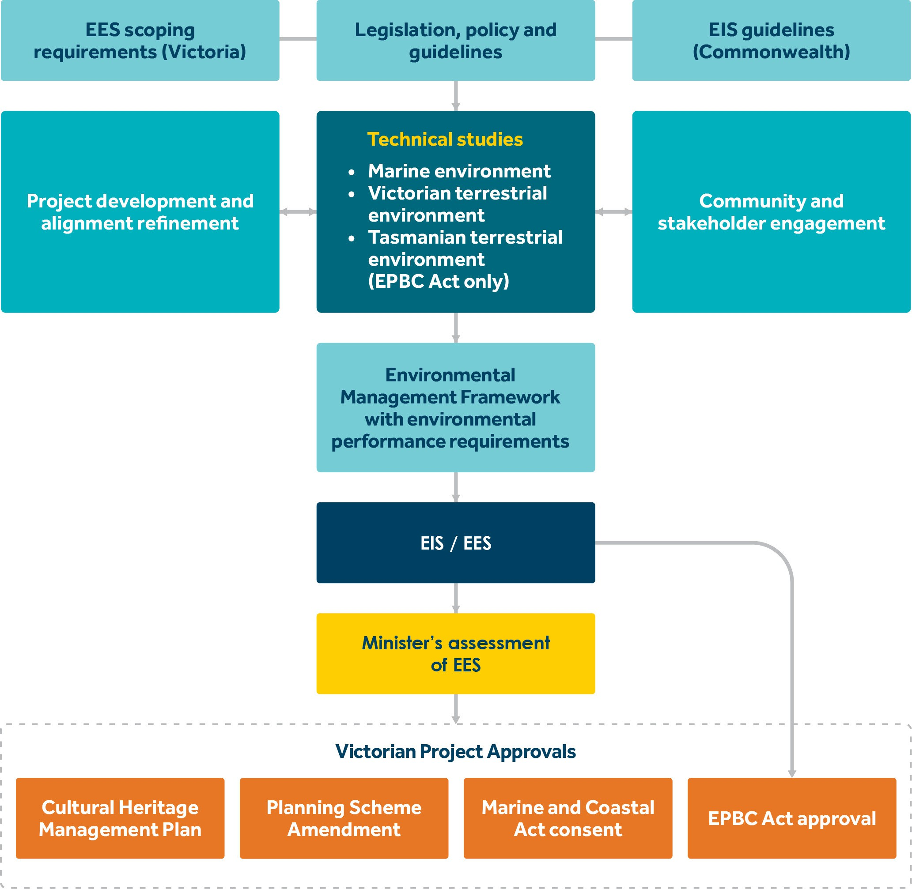

Figure 1-18 EIS/ESS overall assessment framework

Performance based approach
Avoidance of impacts has been maximised through selection of the route and design of the project. Potential impacts of the project have then been assessed. Where the impact assessment has identified the need to reduce impacts, the project is applying an outcomes-based approach to environmental mitigation through the preparation of EPRs. EPRs set out the environmental outcomes that must be achieved during construction, operation and decommissioning of the project, regardless of the final design adopted.
This performance-based approach encourages innovation by allowing for flexibility in how outcomes are achieved, rather than providing prescriptive measures that must be employed. It allows MLPL and contractors to determine the best way to achieve EPRs and manage impacts, whilst developing and optimising design solutions and construction methods.

In developing EPRs, technical specialists have considered industry standards and guidelines, good practice and the latest approaches to mitigating impacts. Technical specialists have considered possible mitigation measures that are technically and economically feasible measures, good practice, address local conditions and context of the project, and reflect the commitment to sound environmental management techniques.
EPRs have been developed by each technical specialist and are documented in each technical appendix. The EPRs for all studies are also a key part of Volume 5, Chapter 2 - Environmental Management Framework of this EIS/EES.

Assessment guidelines
The EIS/EES assessment framework responds to the requirements of the assessment guidelines for the project. This section provides an overview of the guidelines and Attachments 1 and 2 provide a full list of the requirements of the assessment guidelines and where they have been addressed in the EIS/EES.

Commonwealth
The delegate for the Minister for the Environment issued Guidelines for the content of a draft Environmental Impact Statement Environment Protection and Biodiversity Conservation Act 1999 Marinus Link underground and subsea electricity interconnector cable (EPBC 2021/9053) (EIS guidelines).
The EIS guidelines apply to the project in the Commonwealth marine area, Victoria and Tasmania with regards to MNES. The guidelines require that the level of analysis and detail in the EIS reflects the level of significance of potential environmental impacts.
The EIS must include assessment of:

physical seabed disturbance

underwater disturbance impacts

vessels disturbance impacts

terrestrial disturbance impacts

impacts on underwater cultural heritage

impact on users of the marine environment

routine vessel discharge and unplanned spills

introduction of invasive species

consequential and facilitated impacts

economic and social impacts

cumulative impacts.

The EIS must also:

Provide information on proposed EPRs, and any specific avoidance, management, and mitigation measures for impacts of the project on MNES.
Include an Environmental Management Framework that sets out the framework for management, mitigation, and monitoring of impacts including requirements for environmental auditing as it applies to the EPBC Act.
Outline an offset strategy to compensate for any the residual significant impacts of the project on MNES (where required) that meets the requirements in the EPBC Act 1999 Environmental Offsets Policy October 2012 (EPBC Act Offset Policy).
Describe how First Peoples have been engaged through the assessment of the project against the EIS guidelines and a process of ongoing consultation through the life of the project.
Describe how consultation with affected parties and communities has been undertaken in relation to the proposed action.
Assess compliance of the action with principles of ecological sustainable development (ESD) as set out in the EPBC Act, and the objects of the Act.
Provide details of the environmental record of the person proposing to take the action.

Outline other requirements for approvals or conditions that apply or that the proponent reasonably believes are likely to apply to the proposed action.

Victoria
The DTP issued the Scoping Requirements Marinus Link Project Environment Effects Statement as approved by the Minister for Planning (EES scoping requirements). The EES scoping requirements set out the proposed specific matters to be investigated and documented in the EES and the evaluation objectives for these matters.
As stated in the EES scoping requirements, evaluation objectives outline the desired outcomes to be achieved in the context of key legislative and statutory policies, as well as the principles and objectives of ecologically sustainable development, environment protection, net community benefit and healing Country.
In accordance with the Ministerial Guidelines (DSE 2006), the evaluation objectives provide a framework to guide an integrated assessment of environmental effects and for evaluating the overall implications of the project.
Table 5-1 sets out the EES evaluation objectives, relevant legislation, chapters, attachments, and technical appendices in this EIS/EES that addresses the objectives.

Table 5-1 EES evaluation objectives and technical studies

EES evaluation objective | Key Victorian legislation | Relevant EIS/EES chapter, attachments, and technical appendices
Biodiversity and ecological values Avoid, and where avoidance is not possible, minimise adverse effects on  terrestrial, aquatic and marine biodiversity  and ecology, including native vegetation, listed threatened species and ecological communities, other protected species and habitat for these species, and to address offset requirements consistent with state policies. | Flora and Fauna Guarantee Act 1988 (Vic)  Planning and Environment Act 1987 (Vic)  Environment Protection Act 2017 (Vic)  Marine and Coastal Act 2018 (Vic) Pollution of Waters by Oil and  Noxious Substances Act 1986 (Vic)  Water Act 1989 (Vic) | Volume 3, Chapter 3  Volume 4, Chapter 11  Volume 5, Chapters 1, 2 Technical appendices  G, H and V
Marine and catchment values  Avoid and, where avoidance is not possible, minimise adverse effects on land and water (including groundwater, surface water, waterway, wetland, and marine) quality, movement and availability. | Marine and Coastal Act 2018 (Vic) Pollution of Waters by Oil and  Noxious Substances Act 1986 (Vic)  Water Act 1989 (Vic)  Environment Protection Act 2017 (Vic) | Volume 3, Chapters 2, 3  Volume 4, Chapters 2,  3, 4, 5  Volume 5, Chapters 1, 2 Technical appendices H,  N, O, P, Q
Cultural heritage  Protect, avoid and where avoidance is not possible, minimise adverse effects on historic heritage values, and tangible and intangible Aboriginal cultural heritage values, in partnership with First Peoples. | Heritage Act 2017 (Vic)  Aboriginal Heritage Act 2006 (Vic) | Volume 3, Chapter 4  Volume 4, Chapter 13,  14  Volume 5, Chapters 1, 2 Technical appendices I,  J
Agriculture, land use and socio economic  Avoid and, where avoidance is not possible, minimise adverse effects on agriculture, forestry and other land uses, social fabric of communities, and local infrastructure, businesses and tourism. | Planning and Environment Act 1987 (Vic) | Volume 1, Chapter 7  Volume 3, Chapter 3  Volume 4, Chapters 6,  15, 16  Volume 5, Chapters 1, 2 Technical appendices B,  H, K, S, U
Amenity, health, safety and transport  Avoid and, where avoidance is not possible, minimise adverse effects on community amenity, health and safety, regarding noise, vibration, air quality including dust, the transport network, greenhouse gas emissions, fire risk and electromagnetic fields. | Planning and Environment Act 1987 (Vic)  Environment Protection Act 2017 (Vic)  Climate Change Act 2017 (Vic) | Volume 1, Chapters 9,  10  Volume 4, Chapters 8,  9, 10, 12  Volume 5, Chapters 1, 2 Technical appendices A,  D, L, M, T, W
Landscape and visual  Avoid and, where avoidance is not  possible, minimise potential adverse effects on landscape and visual amenity. | Planning and Environment Act 1987 (Vic) | Volume 4, Chapter 7  Volume 5, Chapter 1, 2 Technical Appendix R

Coordination of assessments
The Commonwealth, Victorian and Tasmanian governments have agreed to coordinate the assessment of the project. While there are three separate assessment processes under separate legislation, many of the steps within the process can be aligned and coordinated to facilitate:
Consistency in environmental outcomes.

Comprehensive assessment of environmental values across jurisdictional boundaries.

Clear and consistent information for the community and stakeholders to understand the potential impacts of the project.
The coordinated assessment has and will be implemented through administrative means to align key steps in the assessment processes. This includes coordination of the preparation, exhibition and finalising of scoping requirements/assessment guidelines; cross jurisdictional participation in the TRG and review of draft technical studies; the public exhibition of this EIS/EES; and the assessment of the project and preparation of approval conditions (should the project be approved).
Where projects in Victoria require assessment under both the EPBC Act and EE Act, the bilateral agreement made in 2014 under section 45 of the EPBC Act between the Commonwealth and Victorian governments for environment assessments could normally apply. However, as the project is not wholly located within the jurisdiction of Victoria, the bilateral agreement cannot apply for this project.
Typically, when the bilateral agreement does not apply, separate documents are prepared for an EIS and EES. For this project however, the Commonwealth and Victorian governments have agreed to the preparation of a single EIS/EES to address the specific requirements of both the Commonwealth government and Victorian government legislation and assessment processes.

Impact assessment methods
Technical studies have been completed to address the EIS assessment guidelines, the EES scoping requirements, and demonstrate how the EES evaluation objectives have been met. Four different impact assessment methods have been used to assess direct and indirect impacts, depending on the technical discipline, environmental, cultural and social context, and statutory requirements. These methods are:
significance assessment

risk assessment

compliance assessment

discipline specific methods.

These methods are further described in this section and illustrated in Figure 1-19.

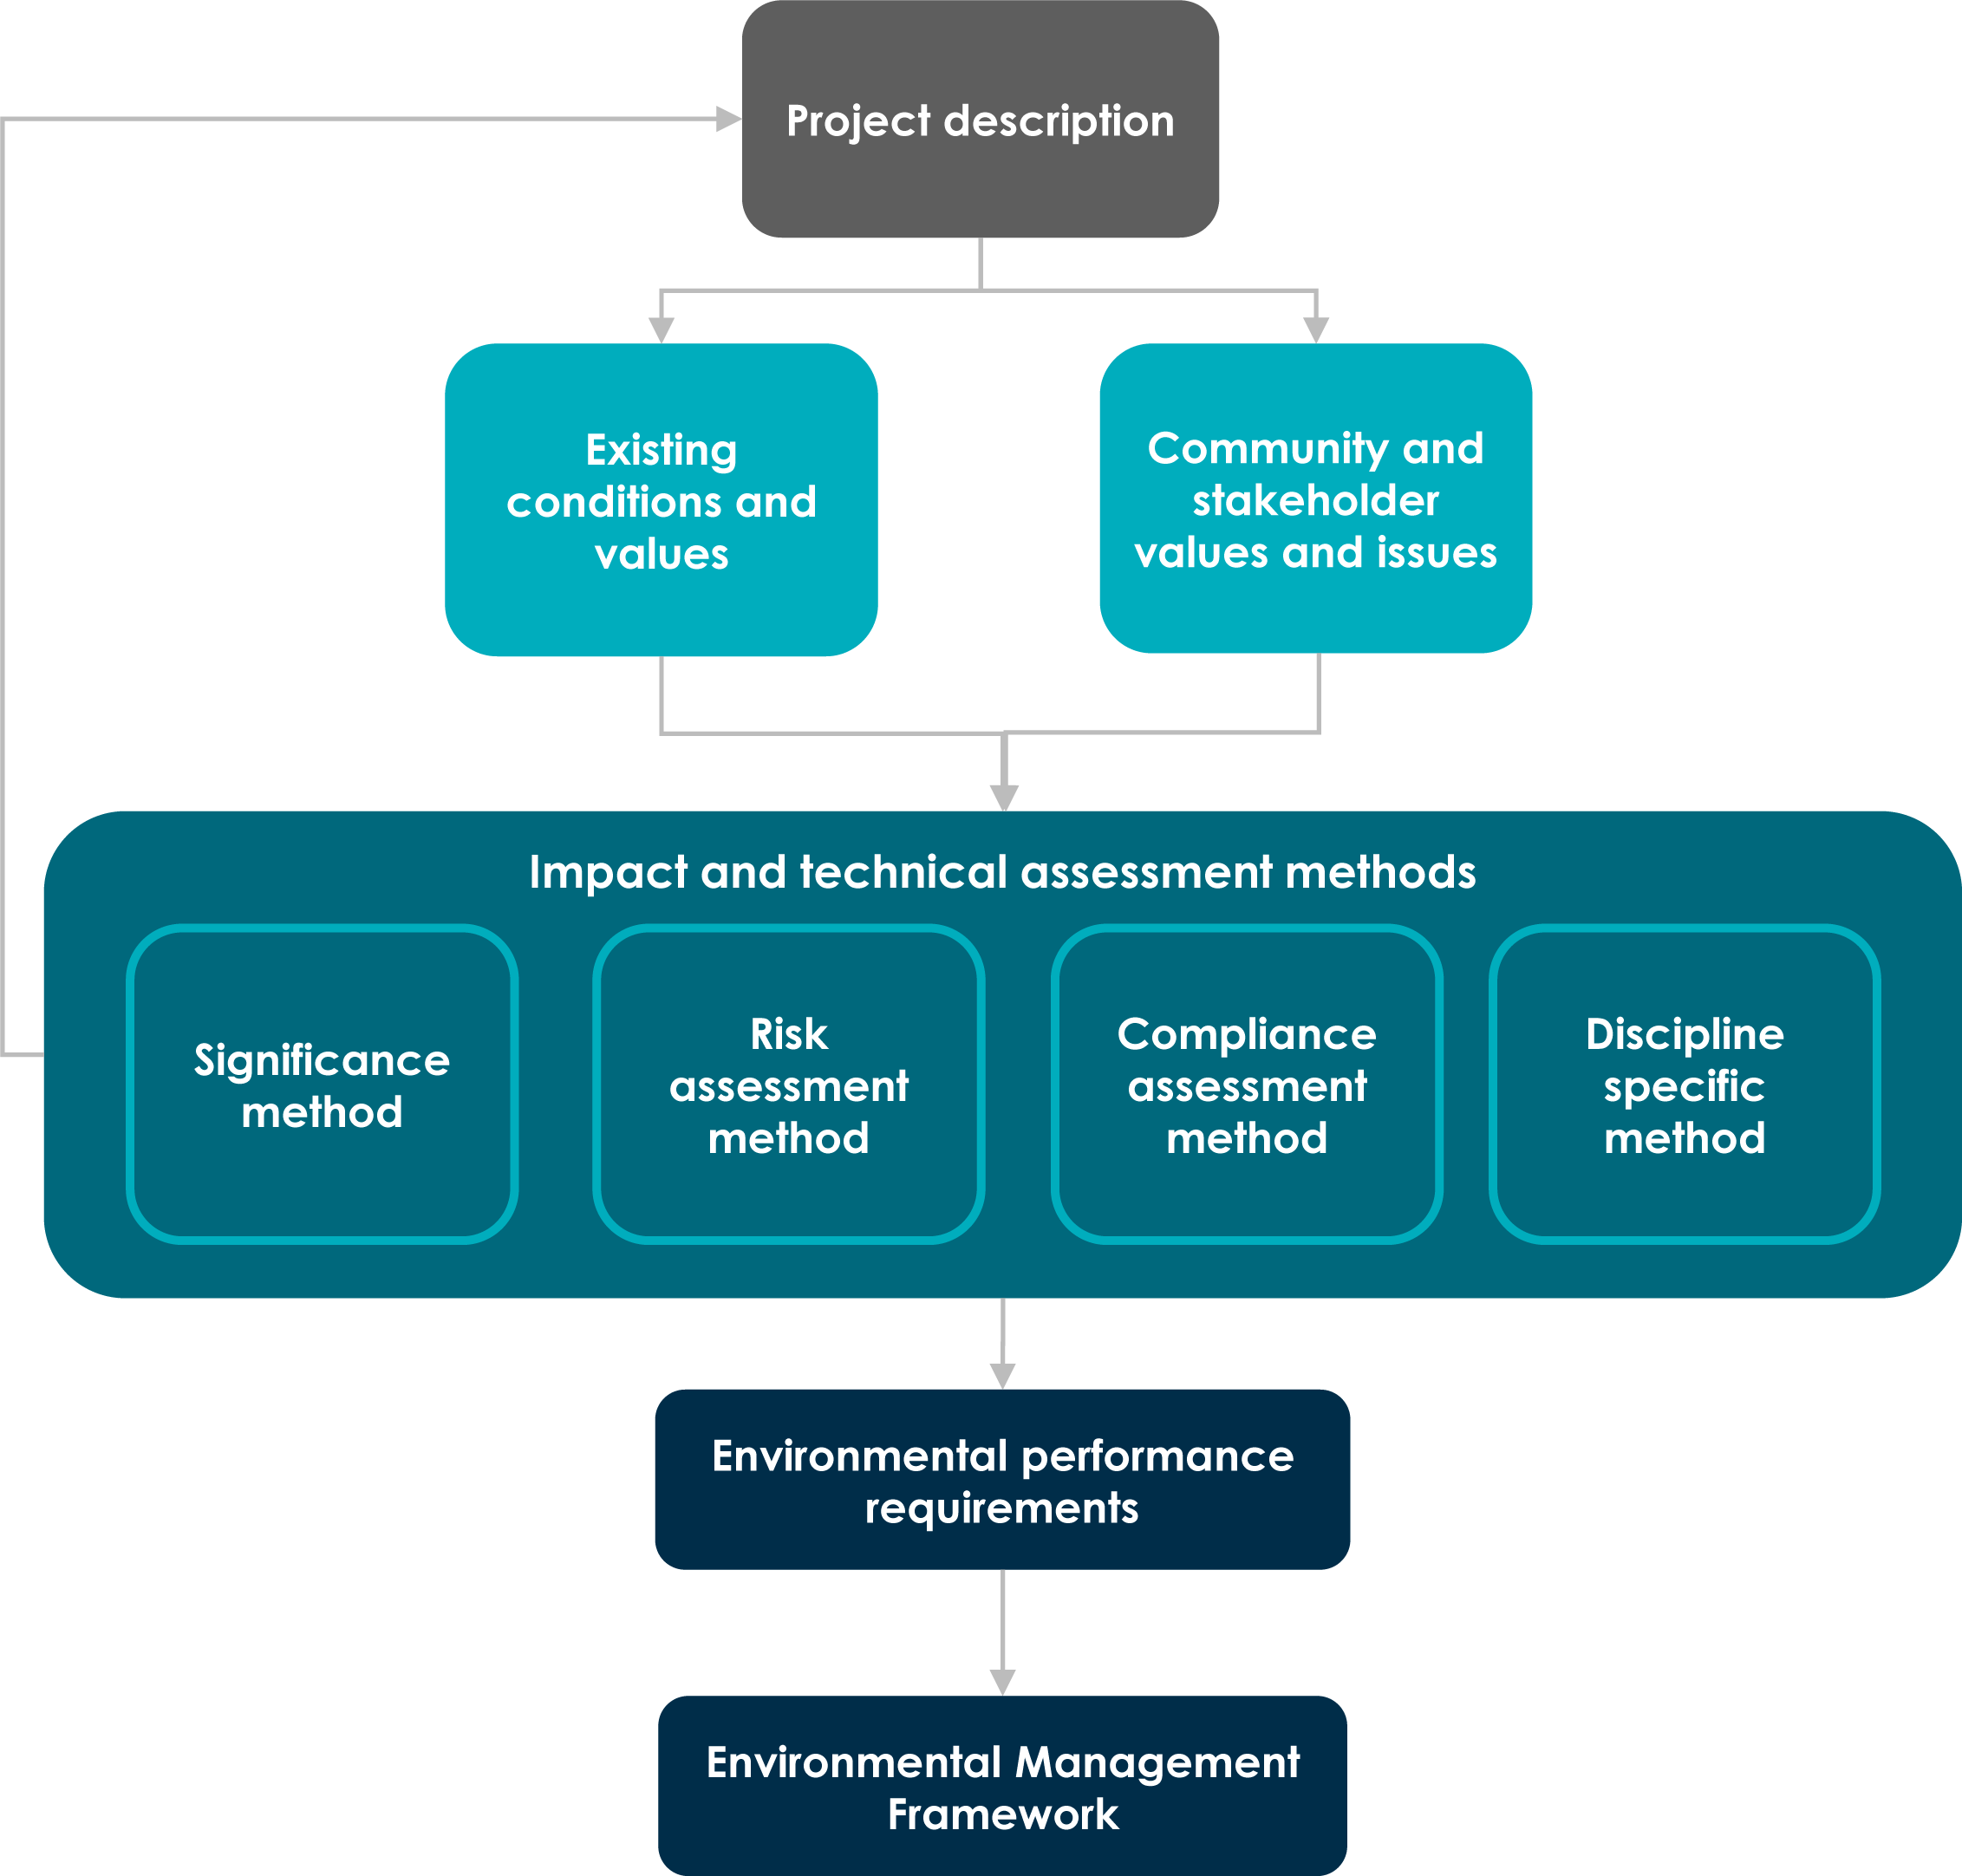

Figure 1-19 Impact assessment approach for technical studies

A significance assessment evaluates the sensitivity of a value to change and the magnitude of an impact on the value. This method assumes an impact will occur (i.e., a hazard, event or mechanism and pathway exist and are credible) with mitigation focussing on reducing the magnitude of an impact.
A risk assessment considers the likelihood of environmental harm occurring (i.e., the likelihood of an event, mechanism or pathway existing and, when considered together with the hazard, resulting in harm to the environment) and the consequences of this harm, considering the sensitivity of the value to change, to determine the risk of environmental harm.
The benefit of using the significance method is that it requires an explicit assessment of the sensitivity of the value which is useful where there is uncertainty about the sensitivity of a value or how it will respond to a change. Sensitivity assessment is implicit in risk assessment and often not considered or properly assessed. A risk assessment is beneficial when there is more certainty about the sensitivity of values and how they will respond to change, and where there is an ability to manage the likelihood of environmental harm occurring, for example by avoiding the event or pathway.
Significance assessment should not be confused with the Significant impact guidelines – Matters of National Environment Significance (Department of the Environment 2013) or Burra Charter (Australia ICOMOS 2013) which prescribe how these matters will be assessed to determine significance.
The compliance assessment method is adopted where the study approach relies on compliance with a statutory guideline or policy, e.g., water and air quality guidelines.
Some studies adopt discipline specific methods where they are standards or technical guidelines. Examples are greenhouse gas estimates and bushfire assessments, which are done in accordance with national reporting standards and guidelines, emanating from inquiries and reviews into bushfire disasters.
The method used in each technical study was determined by the technical specialists considering the context, environmental values, proposed activities, statutory requirements and guidelines.
The key steps for the impact assessments were:

Assessing existing conditions and identifying relevant values.

Reviewing the project description and identifying credible impact pathways – where project activities could result in an impact on the value.
Assessing the potential impacts of activities undertaken for the project on the values.

Where a need is identified to reduce impacts, developing EPRs that define environmental outcomes to be achieved through implementation of mitigation measures that reduce the impacts.
Assessing the residual impacts on values.

Further explanation of each method and when and how they are applied in the technical studies is provided below.

An important consideration for impact assessment is scale and context. The project is being assessed with the preparation of an EIS/EES because of its potential for significant impact on matters protected by the EPBC Act and potential for a range of significant effects to the environment in Victoria. This is reflected in the impact assessment criteria developed for each technical study.

Values
The basis of an impact assessment is the identifying the values potentially affected by a project. Values encompass the qualities, characteristics and conditions of the physical, biological, social, cultural and economic environments. This forms the basis of the characterisation of the existing environment. The characterisation of existing environment may include future predicted conditions in some circumstances, for example predicted climate change scenarios which may affect certain values.
A value is:

A quality or physical characteristic of the environment that is important to ecological health; public benefit (or amenity), safety or health.
A quality of the environment identified and declared to be a value under environmental legislation.

Values can also be identified based on statutory guidelines or policy, and, where these are not provided, defined based on previous experience, accepted practice and/or input from key stakeholders. First Peoples have a unique role as custodians of land and waters and a deep knowledge of environmental values that provides valuable input to the characterisation and understanding of values.
Changes due to the construction, operation or decommissioning of the project that affect these values are the impacts assessed in this EIS/EES. Impacts can be both positive and negative, and the technical studies have considered if both could occur.

Impact pathways
For harm to values to occur, a credible impact pathway must exist between the project activity and the value. Where the impact pathway is incomplete, harm cannot occur. To determine the impact pathway the following must be identified through review of the project description:
Hazardous activities – project activities that could cause harm or damage (an impact) to an identified value.
Mechanism – the event that enables or triggers the hazard to cause harm or damage to an identified value, such as physical disturbance or extraction of water.
Pathway – the physical route from the hazard to the value, such as through the ground, air or water.

Once the impact pathway has been identified, the impact can be assessed.

A risk is a hazardous event, situation or activity that poses a threat to a value. A risk assessment considers the likelihood and the consequence of the hazardous event occurring.
An impact is the effect of an action or hazardous event. An impact assessment considers the mitigation measures required to avoid, minimise, offset or manage an impact together with the sensitivity of the value and the magnitude of the impact.

Impact assessment
Four different impact assessment methods have been applied to inform this EIS/EES to consider both positive and negative impacts. The appropriate method has been determined by each technical specialist based on the characteristics of the aspect of the environment being assessed and the level of certainty or likelihood about an impact occurring.
Table 5-2 sets out the impact assessment method applied for each technical study. Further details of how the method has been applied and why it is appropriate for the technical study is provided in the respective appendices to this EIS/EES.

Table 5-2 Application of assessment method by technical studies

Technical study | Jurisdiction | Assessment method
Aboriginal and historic cultural heritage | Victoria | Significance
Agriculture | Victoria | Significance
Air quality | Victoria | Risk
Bushfire | Victoria | Discipline specific
Climate change | Commonwealth and Victoria | Discipline specific
Greenhouse gas emissions | Commonwealth and Victoria | Discipline specific
Contaminated land and acid sulfate soils | Victoria | Risk
Economics | Commonwealth and Victoria | Discipline specific
Electromagnetic fields | Commonwealth and Victoria | Compliance
Geomorphology and geology | Victoria | Significance
Groundwater | Victoria | Significance
Surface Water | Victoria | Risk
Landscape and visual impact assessment | Victoria | Discipline specific
Land use and planning | Victoria | Compliance and significance
Marine benthic ecology | Commonwealth, Victoria and Tasmania | Baseline assessment only
Marine ecology and resource use | Commonwealth, Victoria and Tasmania | Significance
Noise and vibration | Victoria | Risk
Social impact assessment | Victoria and Tasmania | Significance
Terrestrial ecology | Commonwealth, Victoria and Tasmania | Significance
Traffic and transport | Victoria | Significance and risk
Underwater cultural heritage and archaeology impact assessment | Commonwealth, Victoria and Tasmania | Significance

This method considers the significance of an impact on the value by evaluating the magnitude of an impact and the sensitivity of the value to change. This approach assumes the impact will occur due to the actions taken for the project (i.e., a hazard, event or mechanism and pathway exist and are credible) and mitigation focuses on reducing the magnitude of an impact. The significance method is beneficial as it requires an explicit assessment of the sensitivity of the value which is useful where there is uncertainty about the sensitivity of a value or how it will respond to a change. It is the primary method of impact assessment used for the project. The key steps of the significance impact assessment approach are set out in Figure 1-20.
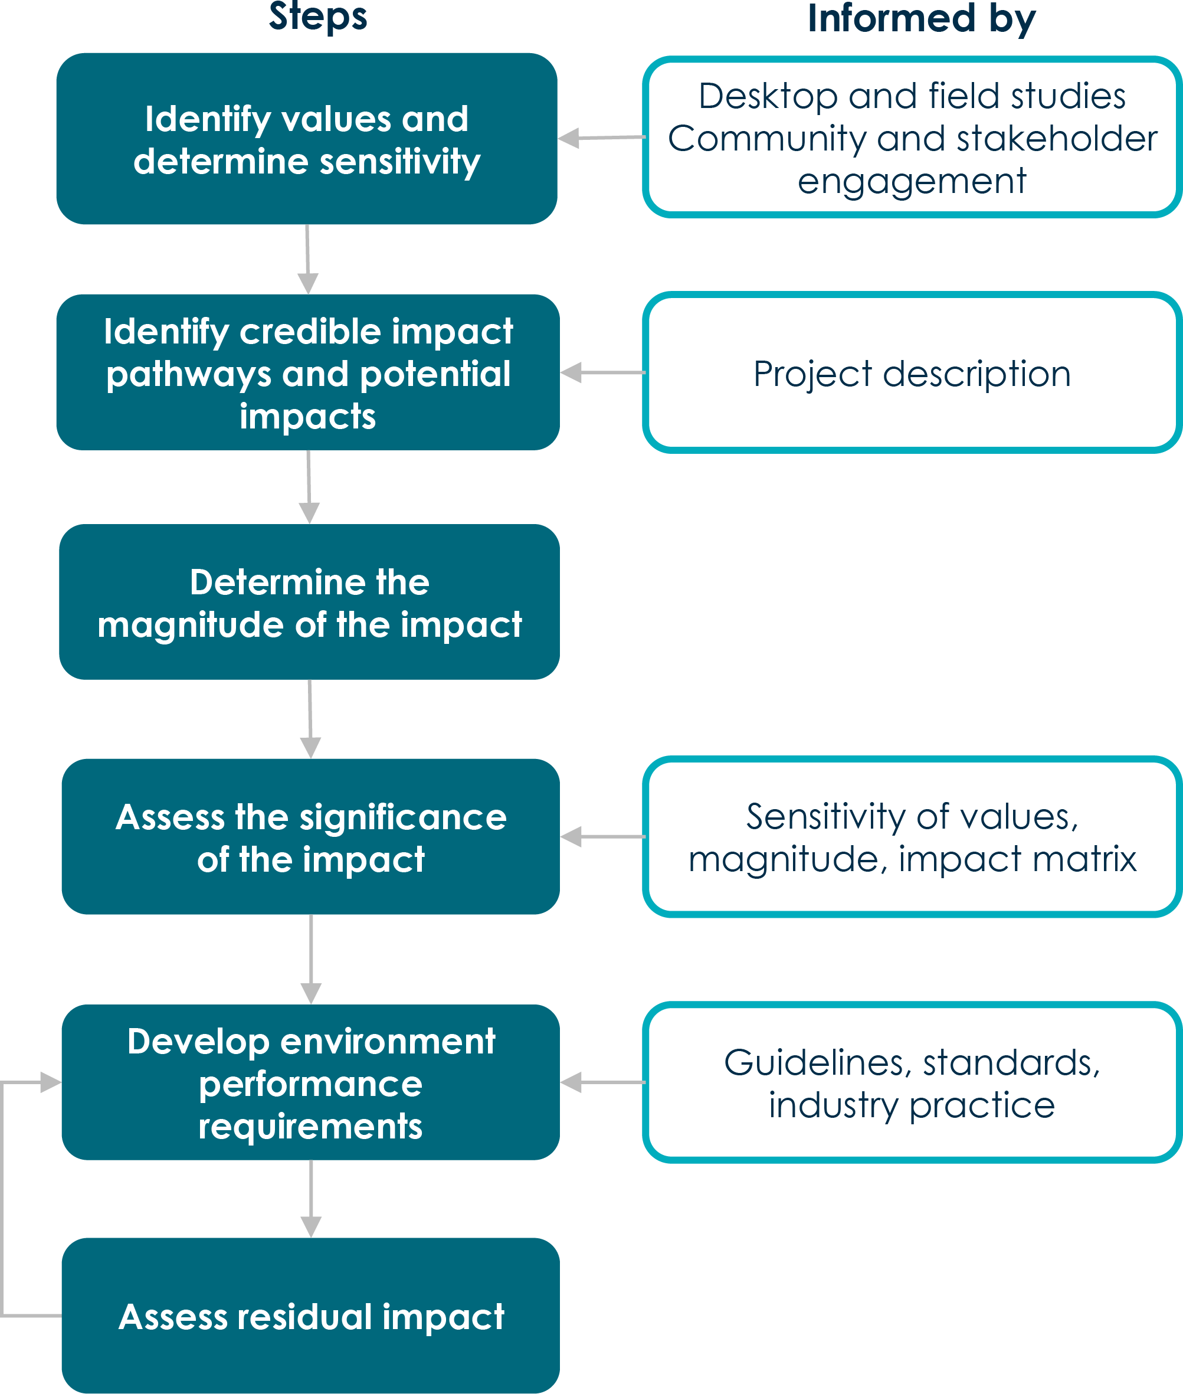

Figure 1-20 Steps of the significance assessment method

The sensitivity of a value is determined with respect to its protection status, intactness, uniqueness or rarity, resilience to change, replacement potential and community value. These contributing factors are described below.
Protection status is assigned to a value by governments (including statutory and regulatory authorities) or recognised international organisations (e.g., United Nations Educational, Scientific and Cultural Organization) through legislation, regulations and international conventions.
Intactness is an assessment of how intact a value is. It is a measure (with respect to its characteristics or properties) of its existing condition, particularly its representativeness.
Uniqueness or rarity of a value is an assessment of its occurrence, abundance and distribution within and beyond its reference area (e.g., bioregion/biosphere).
Resilience to change is determined by the extent to which a value can cope with change including that posed by threatening processes. This factor is an assessment of the ability of a value to adapt to change without adversely affecting its conservation status, intactness, uniqueness or rarity.
Replacement potential is the potential for a representative or equivalent example of the environmental value to be found to replace any losses.
Community value is the community infrastructure, assets, places and values of importance and concern to the community in which a project is proposed to be located. This factor also considers what is currently provided for the community (e.g.: road capacity, community facilities, open space areas, etc.) and how it could be affected by a project.
The model criteria for determining sensitivity are set out in Table 5-3. These criteria were amended to be specific for each of the technical studies.
Table 5-3 Model sensitivity criteria

Sensitivity level | Criteria
Extremely sensitive | The value is listed on a recognised or statutory state, national or international register, or is protected under legislation, regulations or guidelines as being of very high significance (e.g., critically endangered).
 | The value is intact and retains its intrinsic value.
 | It is unique. It is isolated to the affected system/area which is poorly represented in the broader region, territory, country or the world.
 | It is fragile and predominantly unaffected by existing threatening processes. Small changes would lead to substantial changes to the prescribed value.
 | It is not widely distributed throughout the system/area and consequently would be difficult or impossible to replace.

Sensitivity level | Criteria
Very sensitive | The value is listed on a recognised or statutory state, national or international register, or is protected under legislation, regulations or guidelines as being of high significance (e.g., endangered).
 | The value is relatively intact and retains most of its intrinsic value.
 | It is locally unique to the environment or community in which it occurs, with few regionally available alternatives.
 | It is predominantly unaffected by existing threatening processes. Small changes would lead to changes to the prescribed value.
 | It is not widely distributed throughout the system/area and consequently recovery potential would be limited.
Sensitive | The value is listed on a recognised or statutory state, national or international register, or is protected under legislation, regulations or guidelines as being of moderate significance (e.g., vulnerable).
 | The environmental value is in a moderate to good condition despite it being exposed to threatening processes. It retains many of its intrinsic characteristics and structural elements.
 | It is relatively well represented in the systems/areas in which it occurs, but its abundance and distribution are limited by threatening processes.
 | Threatening processes have reduced the environmental or social value’s resilience to change. Consequently, changes resulting from project activities may lead to degradation of the prescribed value.
 | Replacement of unavoidable losses is possible due to its abundance and distribution.
Not very sensitive | The value is not listed on a recognised or statutory state, national or international register, or is protected under legislation, regulations or guidelines as being of significance.
 | It is in a poor to moderate condition as a result of existing threatening processes which have degraded its intrinsic value.
 | It is not unique or rare and numerous representative examples exist throughout the system/area.
 | It is less widely distributed throughout the host systems/areas.
 | There is slight detectable response to change of the value but can quickly recover.
 | The abundance and wide distribution of the value ensures replacement of unavoidable losses is assured.
Not sensitive | The value is not listed on any recognised or statutory register. It is not recognised locally by relevant suitably qualified experts or organisations e.g., historical societies.
 | It is in a poor condition as a result of existing threatening processes which have degraded its intrinsic value.
 | It is not unique or rare and representative examples exist abundantly throughout the system/area.
 | It is abundant and widely distributed throughout the host systems/areas.
 | There is no detectable response to change, or change does not result in further degradation of the value.

The magnitude of an impact on a value is assessed by considering:

Geographical extent – assessment of the spatial extent of the impact where the extent is defined as site, local, regional or widespread (meaning state-wide or national or international).
Duration of the impact – the timescale of the effect i.e., if it is short, medium or long term.

Severity of the impact – assessment of the scale or degree of change from the existing condition, as a result of the impact. This could be positive or negative.
The magnitude of impact was assessed for all credible impact pathways i.e., where a project activity may lead to an impact on a value.
The initial magnitude assessment considered any existing mitigations measures and project commitments as described in Volume 1, Chapter 6 – Project description. Additional mitigation measures that could be implemented to comply with EPRs have then be considered in determining the residual impact.
The model criteria for determining severe, high, moderate and low impacts are set out in Table 5-4. These criteria were amended to be specific for each of the technical studies.
Table 5-4 Model magnitude criteria
An impact that causes permanent changes to the physical, ecological, or social environment and irreversible harm to values or consequences of the impact are unknown and management controls are untested.
Causes major public outrage, sustained widespread community complaints.
Prosecution by regulatory authorities. Avoidance through appropriate design responses is required to address the impact.
Severe
Criteria
Magnitude level
Major An impact that is widespread, long lasting and results in substantial change to the value either temporary or permanent.
Can only be partially rehabilitated or uncertain if it can successfully be rehabilitated. Causes major public outrage, possible prosecution by regulatory authorities.
Appropriate design responses are required to address the impact.
Receives widespread local community complaints and lasting effects on the social fabric of a community.
Moderate
An impact that extends beyond the operational area to the surrounding area but is contained within the region where the project is being developed.
The impacts are short term and result in changes that can be ameliorated with specific management controls.
May receive local community complaint.
Minor A localised impact that is short term and could be effectively mitigated through standard management controls.
Remediation work and follow-up required.
Negligible
A localised impact that is temporary and does not extend beyond operational area. Either unlikely to be detectable or could be effectively mitigated through standard management controls.
Full recovery expected.

The significance level of an impact is determined by the sensitivity of the value and the magnitude of the change it will experience. Table 5-5 shows how, using the criteria described above, the significance level of impacts is determined having regard to the sensitivity of the value and the magnitude of the expected change.
Table 5-6 outlines the model significance criteria that are amended to be specific for each technical study.

Table 5-5 Assessment of impact

Magnitude of impact | Extremely sensitive | Very sensitive | Sensitivity of value  Sensitive | Not very sensitive | Not sensitive
Severe Major Moderate Minor  Negligible | Major | Major | Major | High | Moderate
 | Major | Major | High | Moderate | Low
 | High | High | Moderate | Low | Low
 | Moderate | Moderate | Low | Low | Very low
 | Moderate | Low | Low | Very low | Very low

Table 5-6 Model impact significance criteria
Occurs when impacts will potentially cause irreversible or widespread harm to a value that is irreplaceable because of its uniqueness or rarity. Avoidance through appropriate design responses is the only effective mitigation.
Major impact
Significance of impact Description
High impact Occurs when the proposed activities are likely to exacerbate threatening processes affecting the intrinsic characteristics and structural elements of the value. While replacement of unavoidable losses is possible, avoidance through appropriate design responses is preferred to preserve its intactness or conservation status.
Moderate impact
Occurs where, although reasonably resilient to change, the value would be further degraded due to the scale of the impacts or its susceptibility to further change. The abundance of the value ensures it is adequately represented in the region, and that replacement, if required, is achievable.
Low impact Occurs where a value is of local importance and temporary and transient changes will not adversely affect its viability provided standard environmental controls and management measures are implemented.
Very low impact
A degraded (very low sensitivity) value exposed to minor changes (negligible magnitude impact) will not result in any noticeable change in its intrinsic value and hence the proposed activities will have negligible or no effects. This typically occurs where the activities occur in industrial or highly disturbed areas.

A risk assessment considers the likelihood of environmental harm occurring from an event and the consequence of this harm considering the sensitivity of the value to change. This method involves assessing the likelihood of an event, mechanism or pathway existing and, when considered together with the hazard, resulting in harm to the environment. The relationship between likelihood and consequence provides the level of risk of harm to the value, considering all reasonably practicable measures to reduce the likelihood and consequence of the risk.
A risk assessment is beneficial when there is more certainty about the sensitivity of values and how they will respond to change, and where there is an ability to manage the likelihood of environmental harm occurring.
The principles of risk management described in AS ISO 31000:2018 Risk management – guidelines have been adopted for technical studies adopting a risk assessment method. This involves the following steps:
Establish the context – set the context for the risk assessment by identifying the values.

Identify potential risks and issues – review potential risks and identify possible causes of changes to the values.
Likelihood analysis – assess the likelihood of a change to values occurring, prior to implementation of risk controls and measures.
Consequence analysis – assess the consequences (impact) of identified risks prior to implementation of standard risk reduction controls and measures.
Assess the risk of harm – consider the consequence and likelihood of harm and use the risk assessment matrix.
Risk reduction – identify the risk controls and environmental performance requirements, including additional site or value-specific controls and measures where required (mitigation measures to avoid, minimise, offset or manage risks) to reduce the residual risk of environmental harm.
Analyse residual risk – analyse the residual risk of harm to values following implementation of the risk controls and measures.
Figure 1-21 summarises the steps of the risk assessment approach. The residual risk of harm is the level of remaining risk of harm to the environment following the implementation of industry standard measures or possible mitigation measures to comply with EPRs. The assessment assumes mitigation measures have been effectively implemented to comply with EPRs.

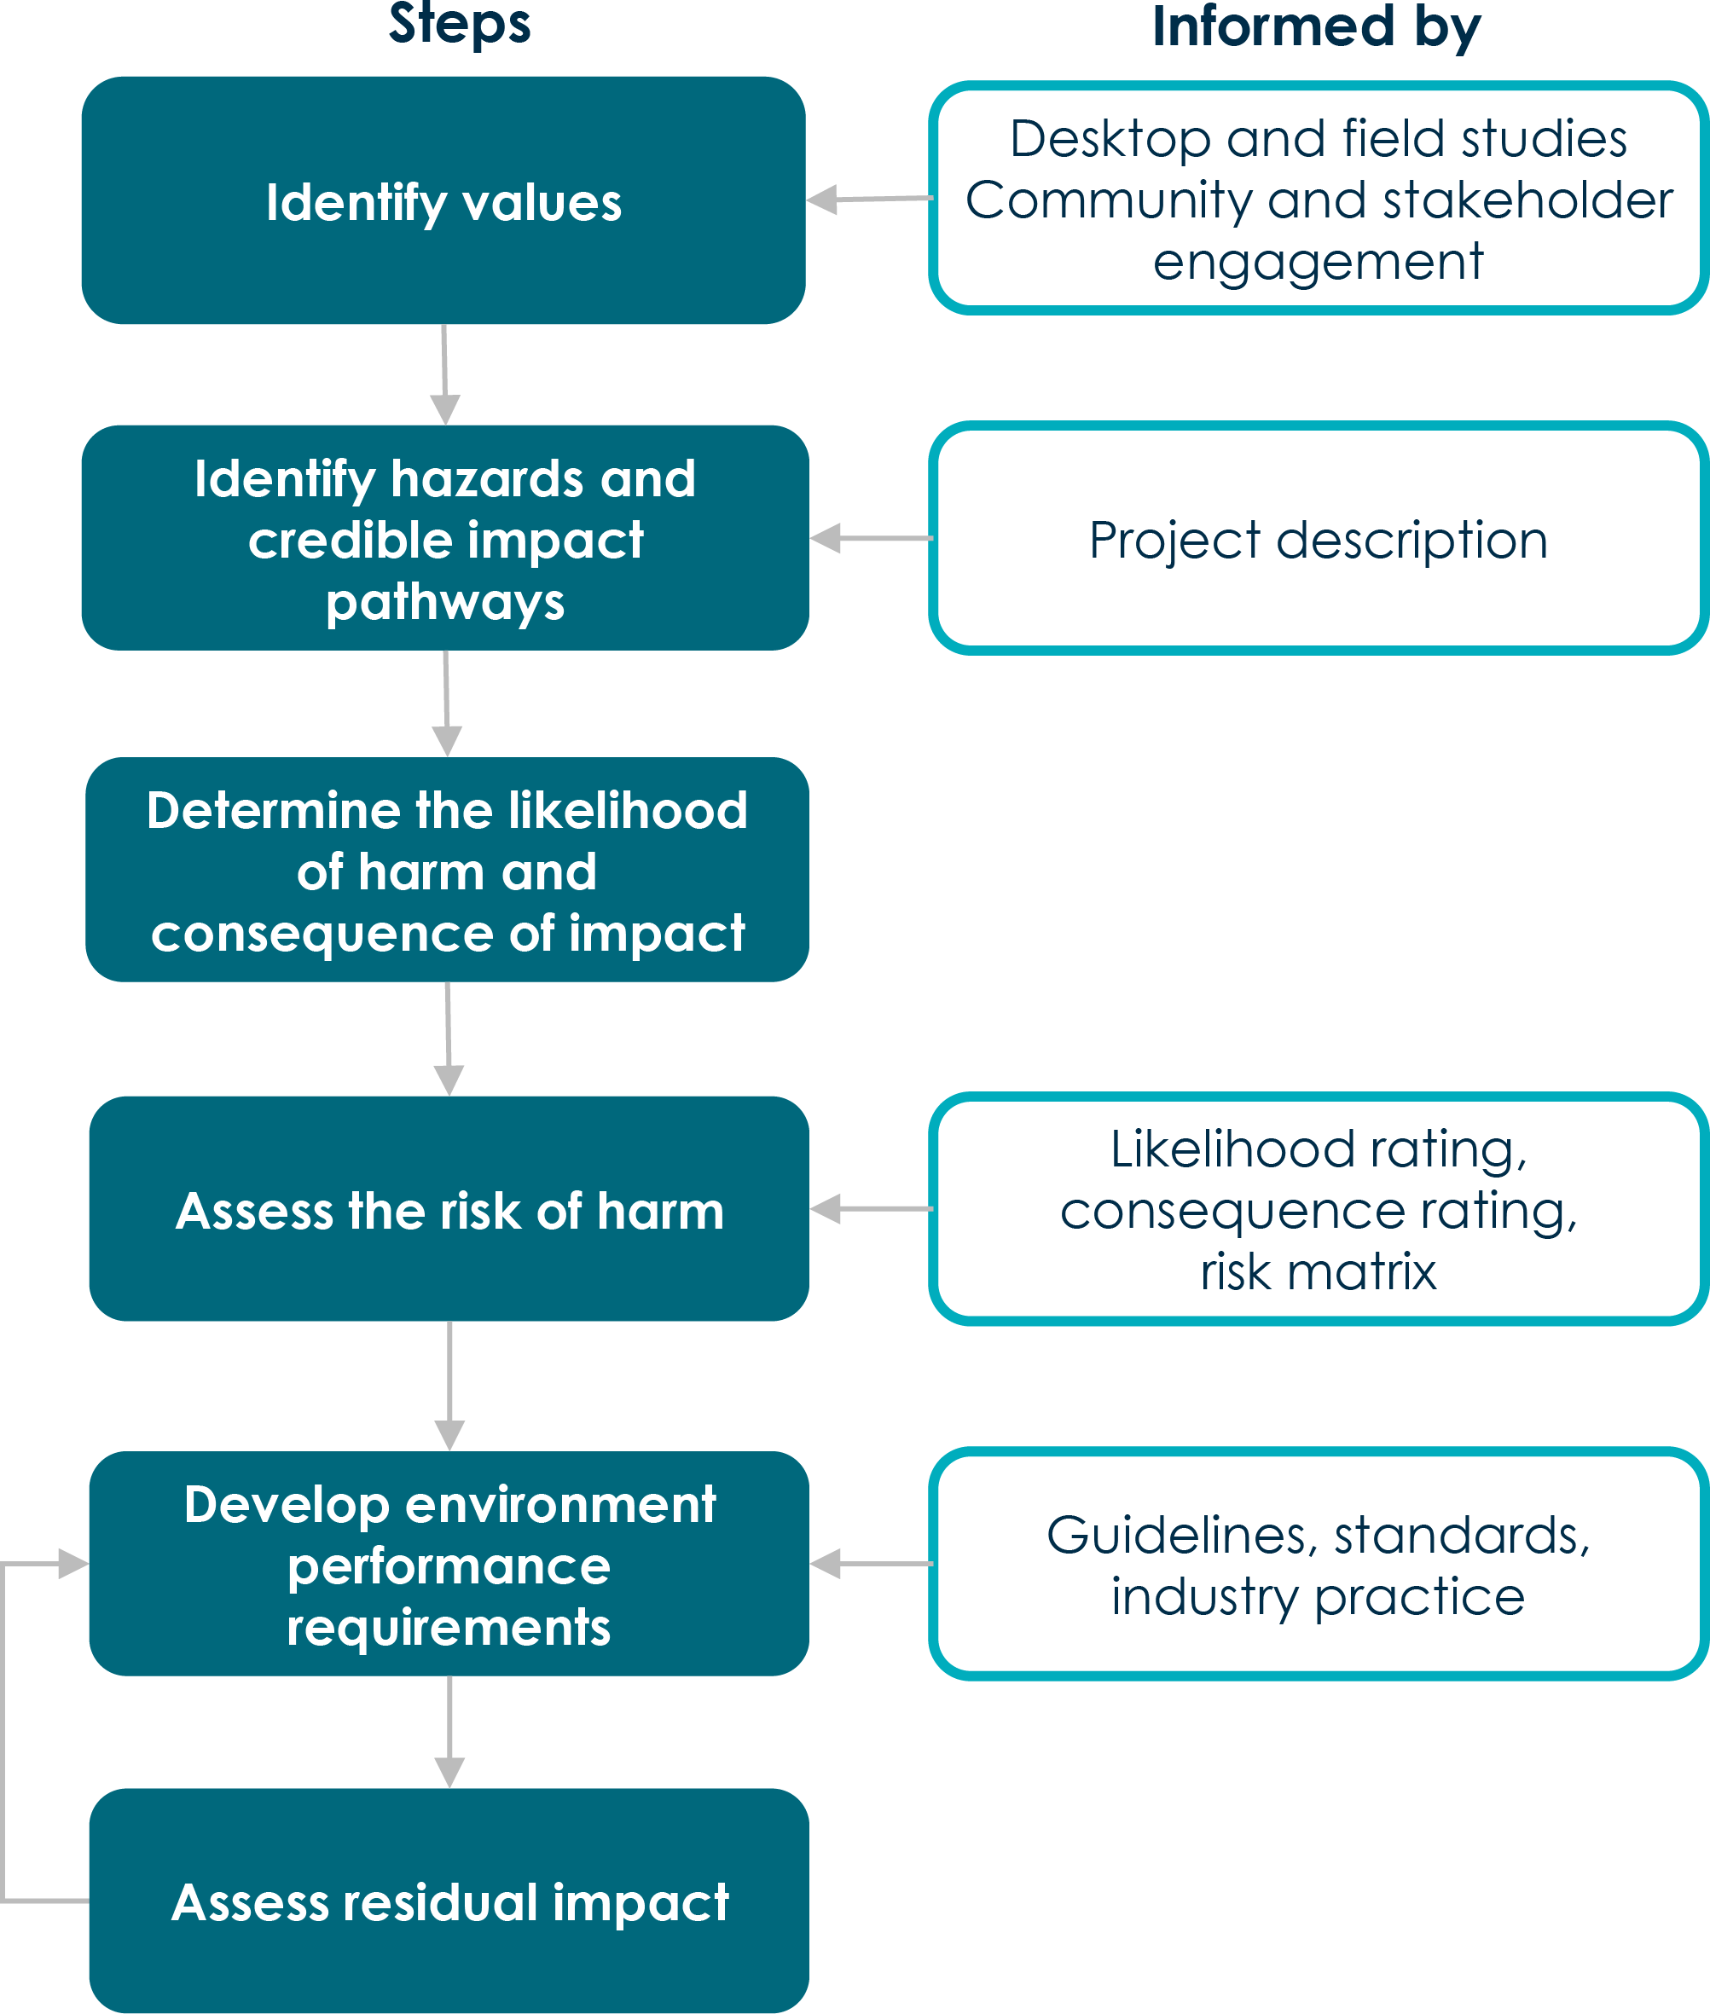

Figure 1-21 Steps of the risk assessment method

The assessment of risk of harm to identified values (prior to implementation of proposed standard mitigation measures to avoid, minimise, offset and manage impacts) was conducted by examining the likelihood of harm occurring and the potential consequences (i.e., a measure of severity of environmental impact) should the harm occur.
Qualitative risk assessment was used to assess the likelihood of harm to the relevant values from construction, operation and maintenance, and decommissioning activities.
Model qualitative criteria developed for the likelihood of potential risks are set in out in Table 5-7. These criteria are amended to be specific for each of the technical studies.
Table 5-7 Qualitative criteria for likelihood
A hazard, event and pathway exist, and harm has occurred in similar environments and circumstances elsewhere and is expected to occur more than once over the duration of the project activity, project phase or project life.
Almost certain
Likelihood description
Criteria
Likely A hazard, event and pathway exist, and harm has occurred in similar environments and circumstances elsewhere and is likely to occur at least once over the duration of the project activity, project phase or project life.
Possible
A hazard, event and pathway exist, and harm has occurred in similar environments and circumstances elsewhere and may occur over the duration of the project activity, project phase or project life.
Unlikely A hazard, event and pathway exist, and harm has occurred in similar environments and circumstances elsewhere but is unlikely to occur over the duration of the project activity, project phase or project life.
Rare
A hazard, event and pathway are theoretically possible on this project and has occurred once elsewhere, but not anticipated over the duration of the project activity, project phase or project life.
Source: Adapted from AS ISO 3100:2018.

Following the assessment of likelihood of harm occurring, the potential consequences (i.e., a measure of severity of impact), should the harm occur, were considered.
Qualitative risk assessment was used to assess the consequence of impacts on the environment deemed likely to occur from construction, operation and decommissioning activities.
Model qualitative criteria developed for the consequence of potential risks are set in out in Table 5-8. The consequence criteria are amended to be specific for each technical study. Statutory, nationally or internationally accepted guidelines have been incorporated into the consequence criteria where available.

Table 5-8 Qualitative criteria for consequence
An effect that causes permanent changes to the environment and irreversible harm to physical, ecological, or social environmental values, or consequences of the impact are unknown and management controls are untested.
Causes major public outrage, sustained widespread community complaints. Prosecution by regulatory authorities.
Avoidance through appropriate design responses is required to address the impact.
Severe
Criteria Consequence description
Major An effect that is widespread, long lasting and results in substantial change to the value either temporary or permanent.
Can only be partially rehabilitated or uncertain if it can successfully be rehabilitated. Appropriate design responses are required to address the impact.
Causes major public outrage, possible prosecution by regulatory authorities. Receives widespread local community complaints.
Moderate
An effect that extends beyond the operational area to the surrounding area but is contained within the region where the project is being developed.
The harm is short term and result in changes that can be ameliorated with specific management controls.
Minor A localised effect that is short term and could be effectively mitigated through standard management controls.
Remediation work and follow-up required.
Negligible
A localised effect that is temporary and does not extend beyond operational area. Either unlikely to be detectable or could be effectively mitigated through standard management controls.
Full recovery expected.
Source: Adapted from AS ISO 3100:2018.

The risk of harm was determined by combining likelihood and consequence using the matrix in Table 5-9. The initial risk was determined with consideration of controls and commitments inherent in the design and project description. The residual risk was then assessed considering the application of industry standard measures or possible mitigation measures that could be applied to comply with EPRs.
The risk assessment guides the identification and development of mitigation measures to avoid, minimise, offset and manage risks. Higher identified risks require specific controls or management, whereas lower risks can be managed using standard controls.
Table 5-9 Risk evaluation matrix

 |  |  |  | Likelihood
 |  | Rare | Unlikely | Possible | Likely | Almost certain
 | Negligible | Very low | Very low | Very low | Low | Moderate
Consequence | Minor | Very low | Low | Low | Moderate | Moderate
 | Moderate | Low | Low | Moderate | High | High
 | Major | Low | Moderate | High | Very high | Very high
 | Severe | Moderate | High | Very high | Very high | Very high
Source: Adapted from AS ISO 3100:2018

This approach considered whether impacts from the project will comply with the requirements of a statutory guideline or policy.
Where statutory guidelines are provided (e.g., Victorian Planning Provisions), the assessment of significance and magnitude, or likelihood and consequence, is not required. In this instance, an assessment of compliance for the project against statutory guidelines has been undertaken. The results of modelling or other predictive techniques were also used to indicate whether published limits will or will not be exceeded (i.e., the assessment is binary and not subjective).
Statutory guidelines set out in regulatory documents are designed to protect the relevant values. The guidelines include an implicit assessment of the vulnerability of the value through the setting of limits or thresholds.
There are some technical disciplines that adopted discipline specific methods to assess impacts, estimate emissions or conditions for the project. This includes technical disciplines such as greenhouse gas emissions, electromagnetic fields, climate change, landscape and visual, and bushfire risk. In some instances, these methods were implemented along with the significance assessment.

Cumulative impacts
The EIS guidelines and EES scoping requirements both include requirements for the assessment of cumulative impacts. Further requirements are also set out in the Ministerial Guidelines (DSE 2006).
The approach applied to assess cumulative impacts had two key steps. The first was to identify other relevant projects that could contribute to a cumulative impact with the project. The second was to assess the impacts of these projects on relevant values.
The International Finance Corporation (IFC) guidelines on cumulative impacts have been adopted to identify possible projects that could cause a cumulative impact. The IFC guidelines (IFC 2013) define cumulative impacts as those that ‘result from the successive, incremental, and/or combined effects of an action, project, or activity when added to other existing, planned, and/or reasonably anticipated future ones.’
The approach for identifying projects for assessment of cumulative impacts considered:

Temporal boundary: the timing of the relative construction, operation and decommissioning of other existing developments and/or approved developments that coincides (partially or entirely) with the project program.
Spatial boundary: the location, scale and nature of the other approved or committed projects that are expected to occur in the same area of influence as the project. The area of influence is defined at the spatial extent of the impacts a project is expected to have. The area of influence was the study area for each technical discipline.

Proposed and reasonably foreseeable projects were identified based on their potential to credibly contribute to cumulative impacts, due the location and timeframe coinciding with the project. Identifying relevant projects was based on publicly available information that confirms a project is substantially progressed and committed, with information being available about potential impacts. Projects were included as relevant if:
Construction has commenced.

They have been approved, with construction yet to commence.

Assessment documentation has been submitted and is being considered by a decision maker.

Assessment documentation is currently being prepared and information is publicly available.

Projects where preparation of assessment documentation has not commenced have not been considered in the assessment of cumulative impacts. This is because of the high level of uncertainty associated with these potential future projects and the lack of information to assess potential future impacts. This included a number of potential offshore wind farms off the coast of Victoria as well as upgrades to the Bass Highway between Deloraine and Devonport.
Each technical study has considered the list of relevant projects and made a determination as to whether there is potential for positive or negative cumulative impacts to the values being assessed in the study. Cumulative impacts of relevant projects have then been assessed based on publicly available information on the relevant projects.
The studies have adopted methods specific for their disciplines and used publicly available information where it is suitable to undertake a meaningful assessment of impacts. Where relevant, the cumulative impacts of these projects and the project are discussed in the technical appendices and chapters of this EIS/EES.
The identified relevant projects, based on information available at the time of preparation of the EIS/EES, (November 2022) are described in Table 5-10. Project locations relative to the project are shown in Figure 1- 22.
This approach is consistent with the requirements of the EIS guidelines, EES scoping requirements and associated guidance.

Table 5-10 Relevant projects for Marinus Link cumulative impact assessment

Project name | Description | Status at time of preparation of EIS/EES
Delburn Wind Farm | A 33-turbine windfarm across approximately 4,778 ha located in the Strzelecki Ranges, south of the Latrobe Valley, within the Hancock Victorian Plantations pine timber plantation at Delburn.  The project alignment intersects the southern part of the Delburn Wind Farm project area at Pleasant Valley Road and has an interface of approximately 12 km to Driffield. | Current status: Approved in March 2022. Construction: Commence in 2022.  Operation: Commence in 2025.

Star of the South Offshore | A 2,200 MW offshore wind farm with up to 200 turbines off the Gippsland coast and | Current status: Preparation of assessment documentation.
Wind Farm (SOTS) | an and a transmission corridor of up to 75km to connect to the grid turbines are located off the Gippsland coast near McLoughlins Beach and Woodside Beach approximately 70 km east of the project shore crossing. The transmission line for SOTS largely follows the Bass Link cable and connects at either Loy Yang or Hazelwood terminal station. | Construction: Commence in 2025. Operation: Commence in 2030.
Offshore wind | Offshore wind development zone in Gippsland including a number of projects such | Current status: Awaiting feasibility licences and commencing
development zone in | as Greater Gippsland Offshore Wind Project (BlueFloat Energy), Seadragon Project | impact assessments
Gippsland | (Floatation Energy), Greater Eastern Offshore Wind (Corio Generation) and Great Southern Offshore Wind Farm (Macquarie). | Construction: Unknown Operation: Unknown
Hazelwood mine | Rehabilitation of former Hazelwood mine and power station involving | Current status: Preparation of assessment documentation.
rehabilitation project | decommissioning of remaining buildings, roads and infrastructure, earthworks to reprofile steep slopes, reinstating some water courses to a more natural alignment, and flooding the mine. | Construction: Commence in 2025 and be completed in 2029.
Wooreen Energy Storage | Four-hour utility scale battery of up to 350 MW capacity. Located at Jeeralang gas- | Current status: Application lodged for assessment in March
System | fired power station in Hazelwood North in close proximity to Hazelwood and the project converter station. | 2023.  Construction: expected to commence from mid-2024 with operation to commence in 2026  Operation: Commence end of 2026.
NWTD | Upgrades to transmission lines in northwest Tasmania to facilitate connection of renewable energy generation projects to the NEM. The NWTD will connect to the project substation at Heybridge. | Current status: Preparation of assessment documentation. Construction: Commence in 2025.  Operation: Commence in 2028 to 2029.
Guildford Windfarm | Onshore windfarm of up to 80 turbines with a capacity of 450 MW. | Current status: Preparation of assessment documentation. Construction: Commence in 2024.  Operation: Commence in 2026.

Project name | Description | Status at time of preparation of EIS/EES
Robbins Island Renewable Energy Park | Onshore windfarm of up to 122 wind turbines with a capacity of 900 MW. | Current status: Assessment Construction: Commence in 2023. Operation: Commence in 2025
Jim’s Plain Renewable | 40 MW solar farm and onshore windfarm of up to 31 wind turbines with a capacity of | Current status: Approved.
Energy Park | 200 MW. | Construction: Commence in 2023. Operation: Commence in 2024.
Robbins Island Road to | 220 kV transmission line to connect the Robbins Island windfarm and Jim’s Plain | Current status: Preparation of assessment documentation.
Hampshire Transmission Line | windfarm to the Tasmanian grid. | Construction: Commence in 2023. Operation: Unknown.
Bass Highway upgrades between Cooee and Wynard | Realignment of approximately 3.2 km of Bass Highway. | Current status: Construction commenced. Operation: Commence in 2025.
Hellyer Windfarm | Onshore windfarm of up to 12 wind turbines with a capacity of 50 MW. | Current status: Preparation of assessment documentation.
 |  | Construction: Unknown. Operation: Unknown.
Table Cape Luxury Resort | Luxury accommodation. | Current status: Approved. Construction: Unknown. Operation: Unknown.
Youngmans Road Quarry | Limestone quarry development with average annual production of 72,000 tonnes of limestone. | Current status: Approved. Construction: Unknown.
 |  | Operation: Unknown.
Port Latta Windfarm | Onshore windfarm of up to 7 wind turbines with a capacity of 25 MW. | Current status: Approved Construction: Unknown. Operation: Unknown.
Port of Burnie Shiploader | Minerals shiploader and storage expansion at TasRail’s existing Bulk Minerals | Current status: Construction commenced.
Upgrade | Export Facility. | Operation: Commence in 2023.
QuayLink – Devonport | Port terminal upgrade project to support TasPorts in increasing capacity of both | Current status: Construction commenced.
East Redevelopment | freight and passenger ferry services across Bass Strait. | Operation: Commence in 2027.

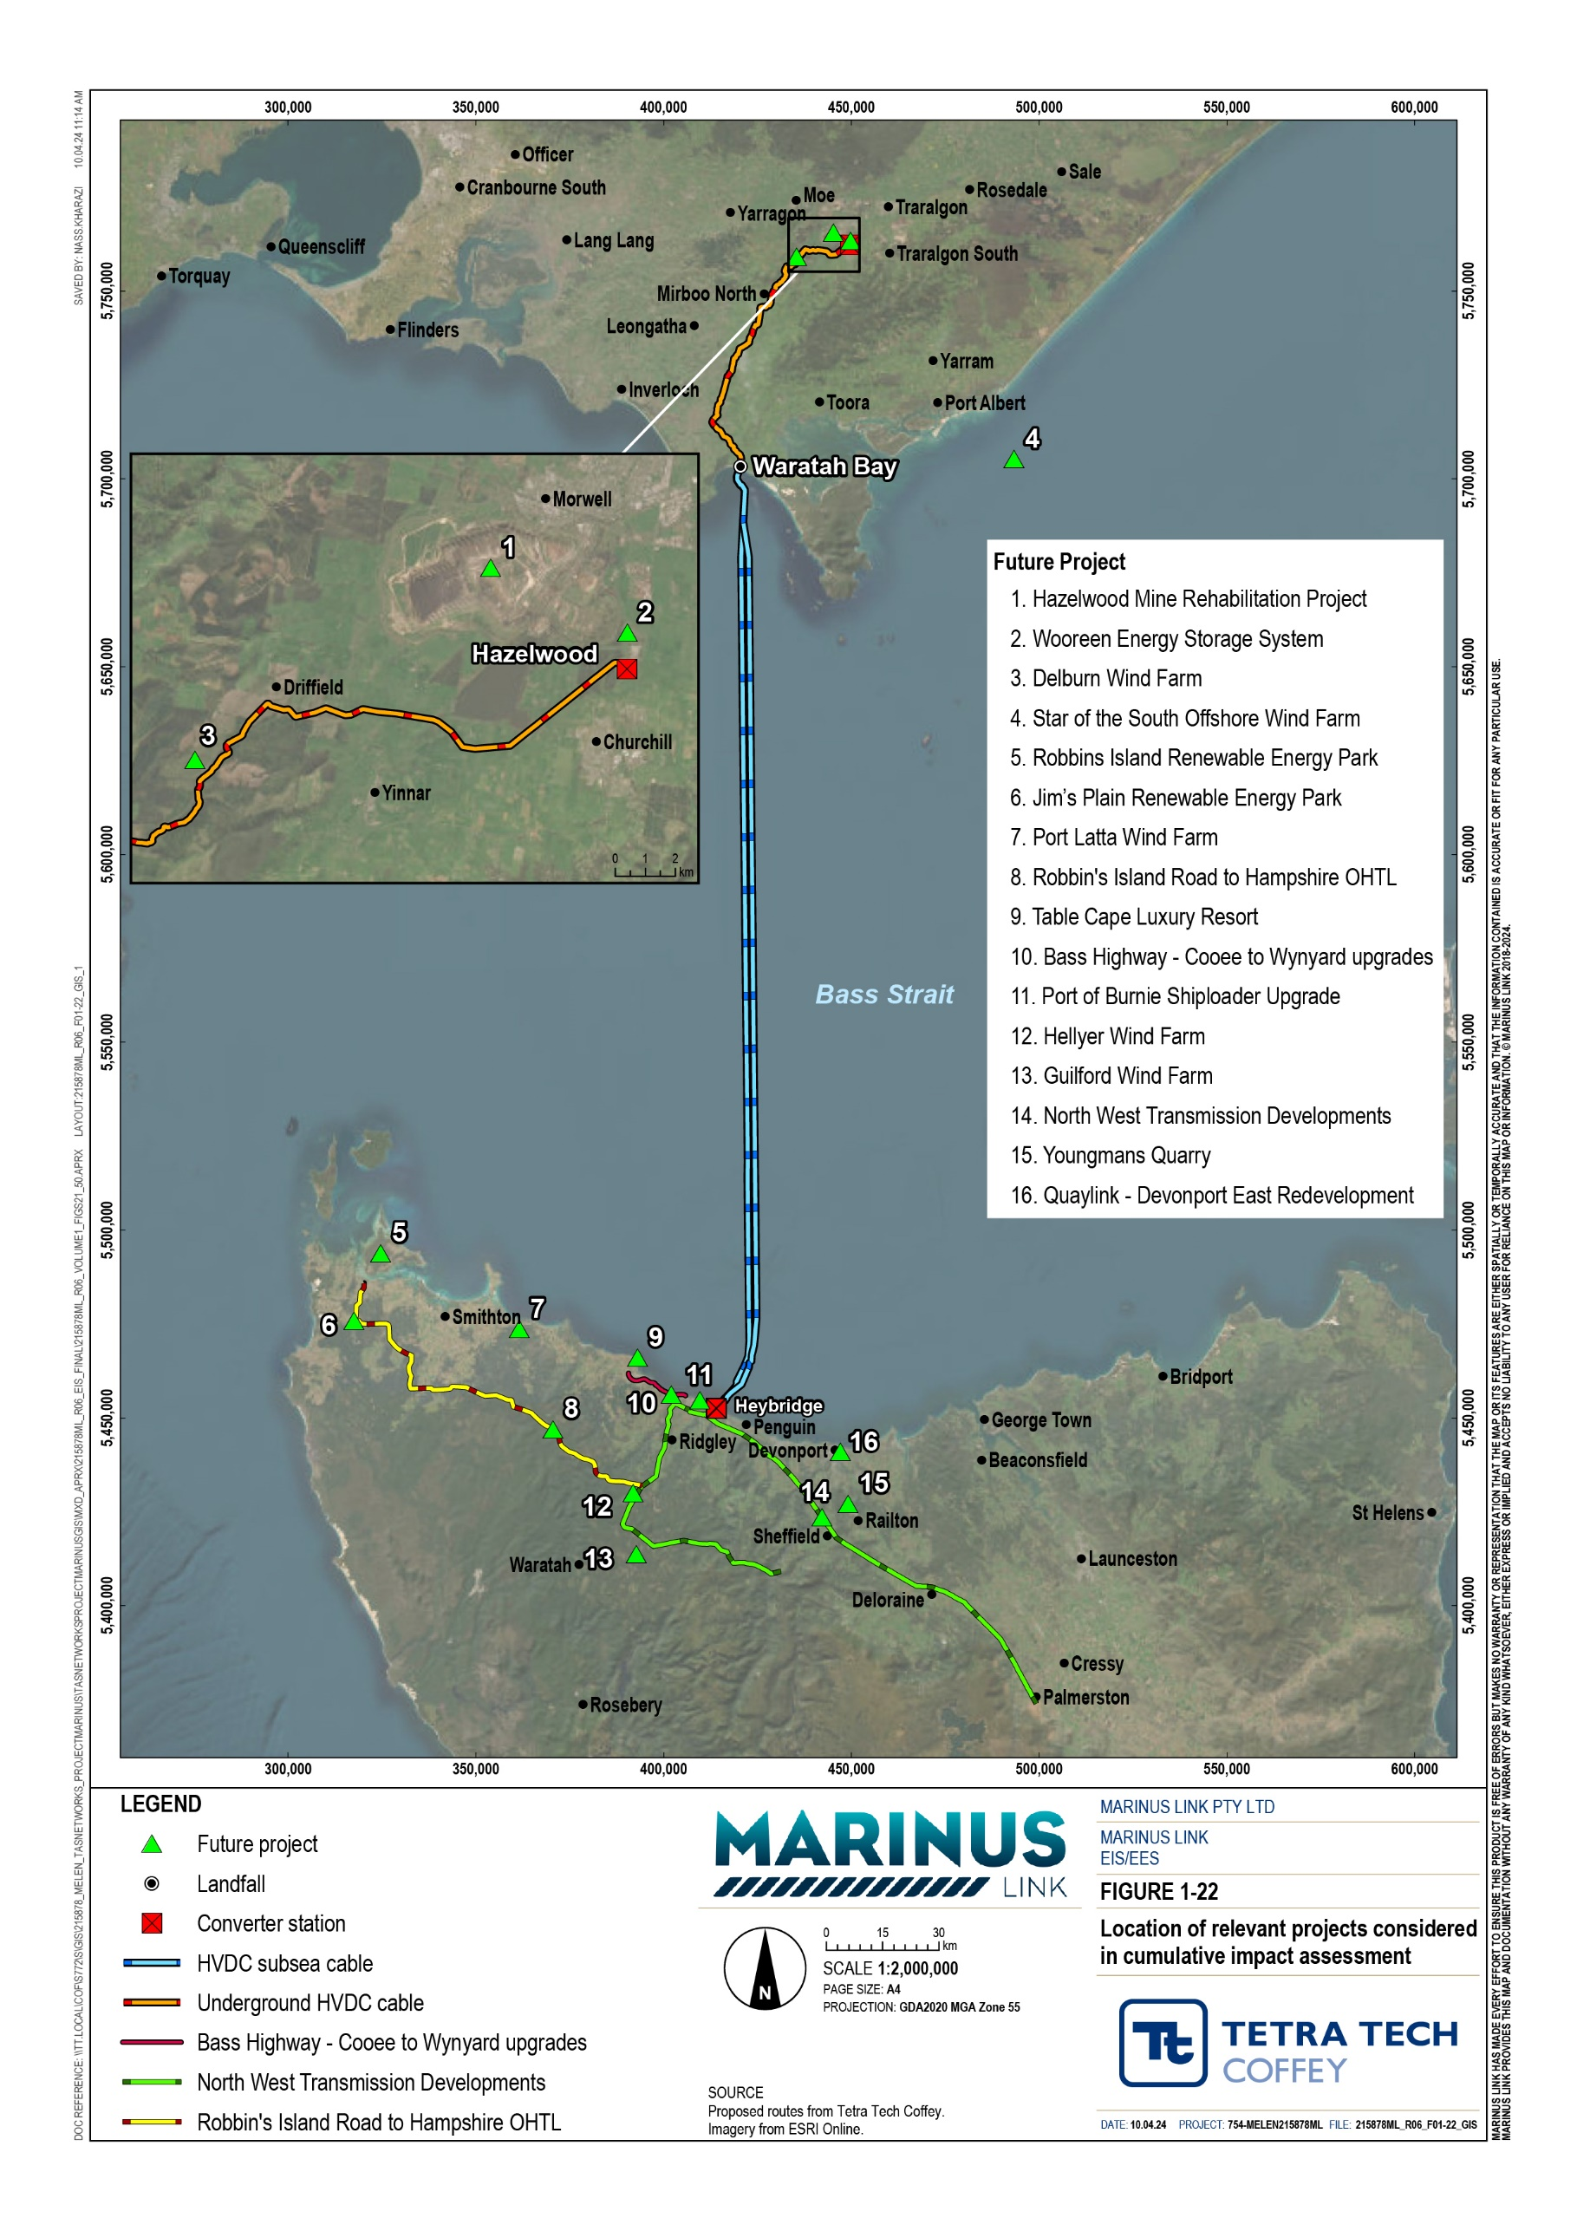

Environmental Management Framework
An Environmental Management Framework has been prepared for the project and is provided in Volume 5, Chapter 2 – Environmental Management Framework. It provides a transparent governance framework for the management of environmental impacts from the project to meet statutory requirements, achieve necessary environmental outcomes, protect environmental values and sustain stakeholder confidence.
The Environmental Management Framework forms a key part of the governance framework for the project and outlines:
Organisational and contractor roles and responsibilities

Requirements for environmental documentation

Approach for evaluating compliance through monitoring, reporting, and auditing

EPRs.

Compliance with the Environmental Management Framework and EPRs will be supported by an Independent Environmental Advisor and audited by an Independent Environmental Auditor.

Community, stakeholder and First Peoples engagement
MLPL have been engaging the community and stakeholder since 2019 on the progress of the project. The engagement has informed refinement of the project alignment and understanding of the key issues and concerns of the community and stakeholders. Engagement outcomes informed the scope of technical studies and continued to inform these studies through the preparation of the EIS/EES. Ongoing engagement with TRG members has also enabled the EIS/EES to address all relevant issues and any revised legislation, guidelines and policies.
MLPL established a Gippsland Stakeholder Liaison Group (GSLG) in late 2021 with an independent chair. The GSLG has representatives from a range of local organisations who provide input into initiatives to maximise the benefits of the project, including local economic development plans and the project’s local community benefit sharing approach.
MLPL have also established a First Peoples Advisory Group (FPAG) with representatives from the Boonwurrung Land and Sea Council, Bunurong Land Council Aboriginal Corporation and GLaWAC. The group enables First Peoples, as custodians of land and waters, to share their deep knowledge of environmental values and contribute to the project.
MLPL’s FPAG facilitates ongoing conversations about the potential impacts, partnerships and opportunities presented by the project for First Peoples in Gippsland. It also provides MLPL with information and advice regarding issues pertinent to First Peoples living in Gippsland, including matters related to the environmental approvals process.

Volume 1, Chapter 8 – Community and stakeholder engagement provides details of the stakeholder and community engagement that has informed the EIS/EES and project development.

Scope of technical studies
Detailed technical studies have been prepared to address the EIS guidelines and EES scoping requirements. The findings of these studies have informed this EIS/EES. A list of the technical studies, an outline of the scope of the studies and studies that informed the assessments is provided in Table 5-11.
Table 5-11 Scope of technical studies

EIS/EES  Appendix | Technical study | Study scope | Contributing studies
A | Marine benthic ecology | Survey and document baseline benthic ecological characteristic, and seabed conditions and constraints in Bass Strait to inform the marine ecology and resource use technical study. | N/A
B | Marine ecology and resource use | Impacts on marine ecology including migratory species, benthic ecology and water quality.  Impacts on marine resources including commercial and recreational fishing vessel movements. | Marine benthic ecology Electromagnetic fields
C | Underwater cultural heritage and archaeology (MERU) | Impacts on maritime cultural heritage and submerged heritage. | Aboriginal and historical cultural heritage
D | Electromagnetic fields (EMF) | Impacts to marine and terrestrial environments from electromagnetic fields in operation of the project. | N/A
E | Economics | State, regional and local impacts and benefits from the project. | Agriculture and forestry Land use and planning Social
F | Aboriginal and historical cultural heritage | Impacts to Aboriginal cultural heritage and historical values due to disturbance or removal of Aboriginal cultural heritage places and materials. | Geomorphology and geology  Underwater cultural heritage and archaeology
G | Agriculture and forestry | Impacts to agricultural and forestry practices and productivity. | Land use and planning EMF  Traffic and transport
H | Air quality | Impacts to ambient air quality and sensitive receptors due. | Traffic and transport
I | Bushfire | Impacts to and from the project due to bushfire risk. | Terrestrial ecology Climate change  Land use and planning
J | Climate change | Assess climate change scenarios that could affect the project. | Air quality

EIS/EES  Appendix | Technical study | Study scope | Contributing studies
K | Greenhouse gas emissions | Estimate the greenhouse gas emissions generated from the project. | Traffic and transport Terrestrial ecology
L | Contaminated land and acid sulfate soils | Impacts due to the disturbance of contaminated land or acid sulfate soils. | Land use and planning Geomorphology and  geology
M | Geomorphology and geology | Impacts to landforms and the project due to geology, soil and land stability conditions. | Land use and planning Groundwater  Contaminated land and acid sulfate soils
N | Groundwater | Impacts to groundwater levels, flow and quality. | Terrestrial ecology Geomorphology and  geology  Surface water  Contaminated land and acid sulfate soils  Climate change
O | Surface water | Impacts to overland flows, flooding conditions, water quality and geomorphology of waterways . | Contaminated land and acid sulfate soils  Geomorphology and geology  Groundwater  Terrestrial ecology Climate change
P | Landscape and visual | Impacts to landscape character and views along the project alignment. | Land use and planning Social
Q | Land use and planning | Impacts on existing land use along the project alignment. | Air quality  Aboriginal and historical cultural heritage  Agriculture and forestry Landscape and visual Noise and vibration  Traffic and transport Terrestrial ecology
R | Noise and vibration | Impacts to sensitive receptors due to noise generated from the project. | Traffic and transport

EIS/EES  Appendix | Technical study | Study scope | Contributing studies
S | Social | Impacts and benefits to the community identity and values, including amenity, livelihood, access to services, community infrastructure and productive capacity of the project. | EMF  Agriculture and forestry Economics  Air quality  Noise and vibration Marine ecology and  resource use  Aboriginal and historical cultural heritage  Terrestrial ecology Traffic and transport  Landscape and visual Land use and planning
T | Terrestrial ecology | Impacts to terrestrial and aquatic ecology including listed threatened species under state and commonwealth legislation. | Contaminated land and acid sulfate soils  Groundwater  Noise and Vibration Surface water
U | Traffic and transport | Impacts to regional and local traffic conditions and infrastructure to due transport of oversized project specific equipment in construction and traffic generated from the project. | N/A

