Project description
This chapter provides a description of the design, construction, operation, and decommissioning of the project based on a concept design and supporting information. The design and construction methodology is one approach that could be adopted and has been developed to a level where potential impacts can be identified.
The project description, together with the map book showing detail of the project alignment and construction footprint (Attachment 6– Marinus Link EIS/EES Map book), forms the basis of the impact assessments presented in this EIS/EES and has informed the development of EPRs for the project. The EPRs define the environmental outcomes to be achieved to avoid and mitigate impacts regardless of the final design of the project. The EPRs are detailed in Volume 5, Chapter 2 – Environmental Management Framework. The final design and construction methods developed to respond to the EPRs, and contractual requirements will be determined by preferred contractors, as described in Section 6.2.1.

Project overview
The project is a proposed 1500 MW HVDC electricity interconnector between northwest Tasmania and the Latrobe Valley in Victoria. It starts at Heybridge in northwest Tasmania, extends north 255 km across Bass Strait, and makes landfall in Victoria at Waratah Bay. The project then consists of 90 km underground infrastructure from Waratah Bay, through Gippsland to Hazelwood in the Latrobe Valley, Victoria.
The project will be implemented as two 750 MW circuits rather than a single 1500 MW circuit to meet transmission network operation (availability and reliability) requirements in Tasmania and Victoria.
Figure 1-23 provides an overview of the project location and Figure 1-24 shows the Tasmanian components of the project. Figure 1-25 below and Figure 1-30 in Section 6.2.2 show the key Victorian components of the project.
Table 6-1 provides the coordinates for the Heybridge and Hazelwood converter stations, land cable start and end points, as well as joint bay locations along the alignment that provide an indication of the alignment pathway. Coordinates are provided in GDA2020 MGA Zone 55.

Table 6-1 Coordinates of the project alignment

Project location | Easting | Northing
Heybridge Converter Station | 414083 | 5452491
Sea Cable Tasmania side | 414928 | 5453191
Sea Cable midway point | 422656 | 5587136
Sea Cable Victoria side | 420111 | 5702366
Land cable start point | 420408 | 5703403
JP5A | 419227 | 5707515
JP10A | 415730 | 5711653
JP15A | 413620 | 5716234
JP20 | 415139 | 5720658
JP25 | 416707 | 5725914
JP30A | 418578 | 5731101
JP35A | 421437 | 5735339
JP40A | 423941 | 5739891
JP45A | 425815 | 5745135
JP50A | 428599 | 5747929
JP55 | 431376 | 5752404
JP60 | 433205 | 5756566
JP65A | 436956 | 5760091
JP70 | 442091 | 5760802
JP75 | 446700 | 5760391
Land cable end point | 449533 | 5762482
Hazelwood Converter Station | 449946 | 5762410

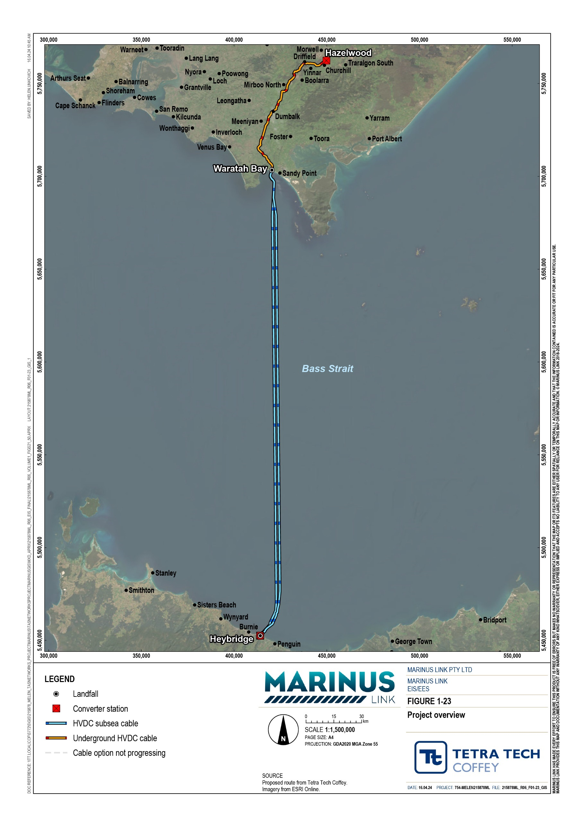

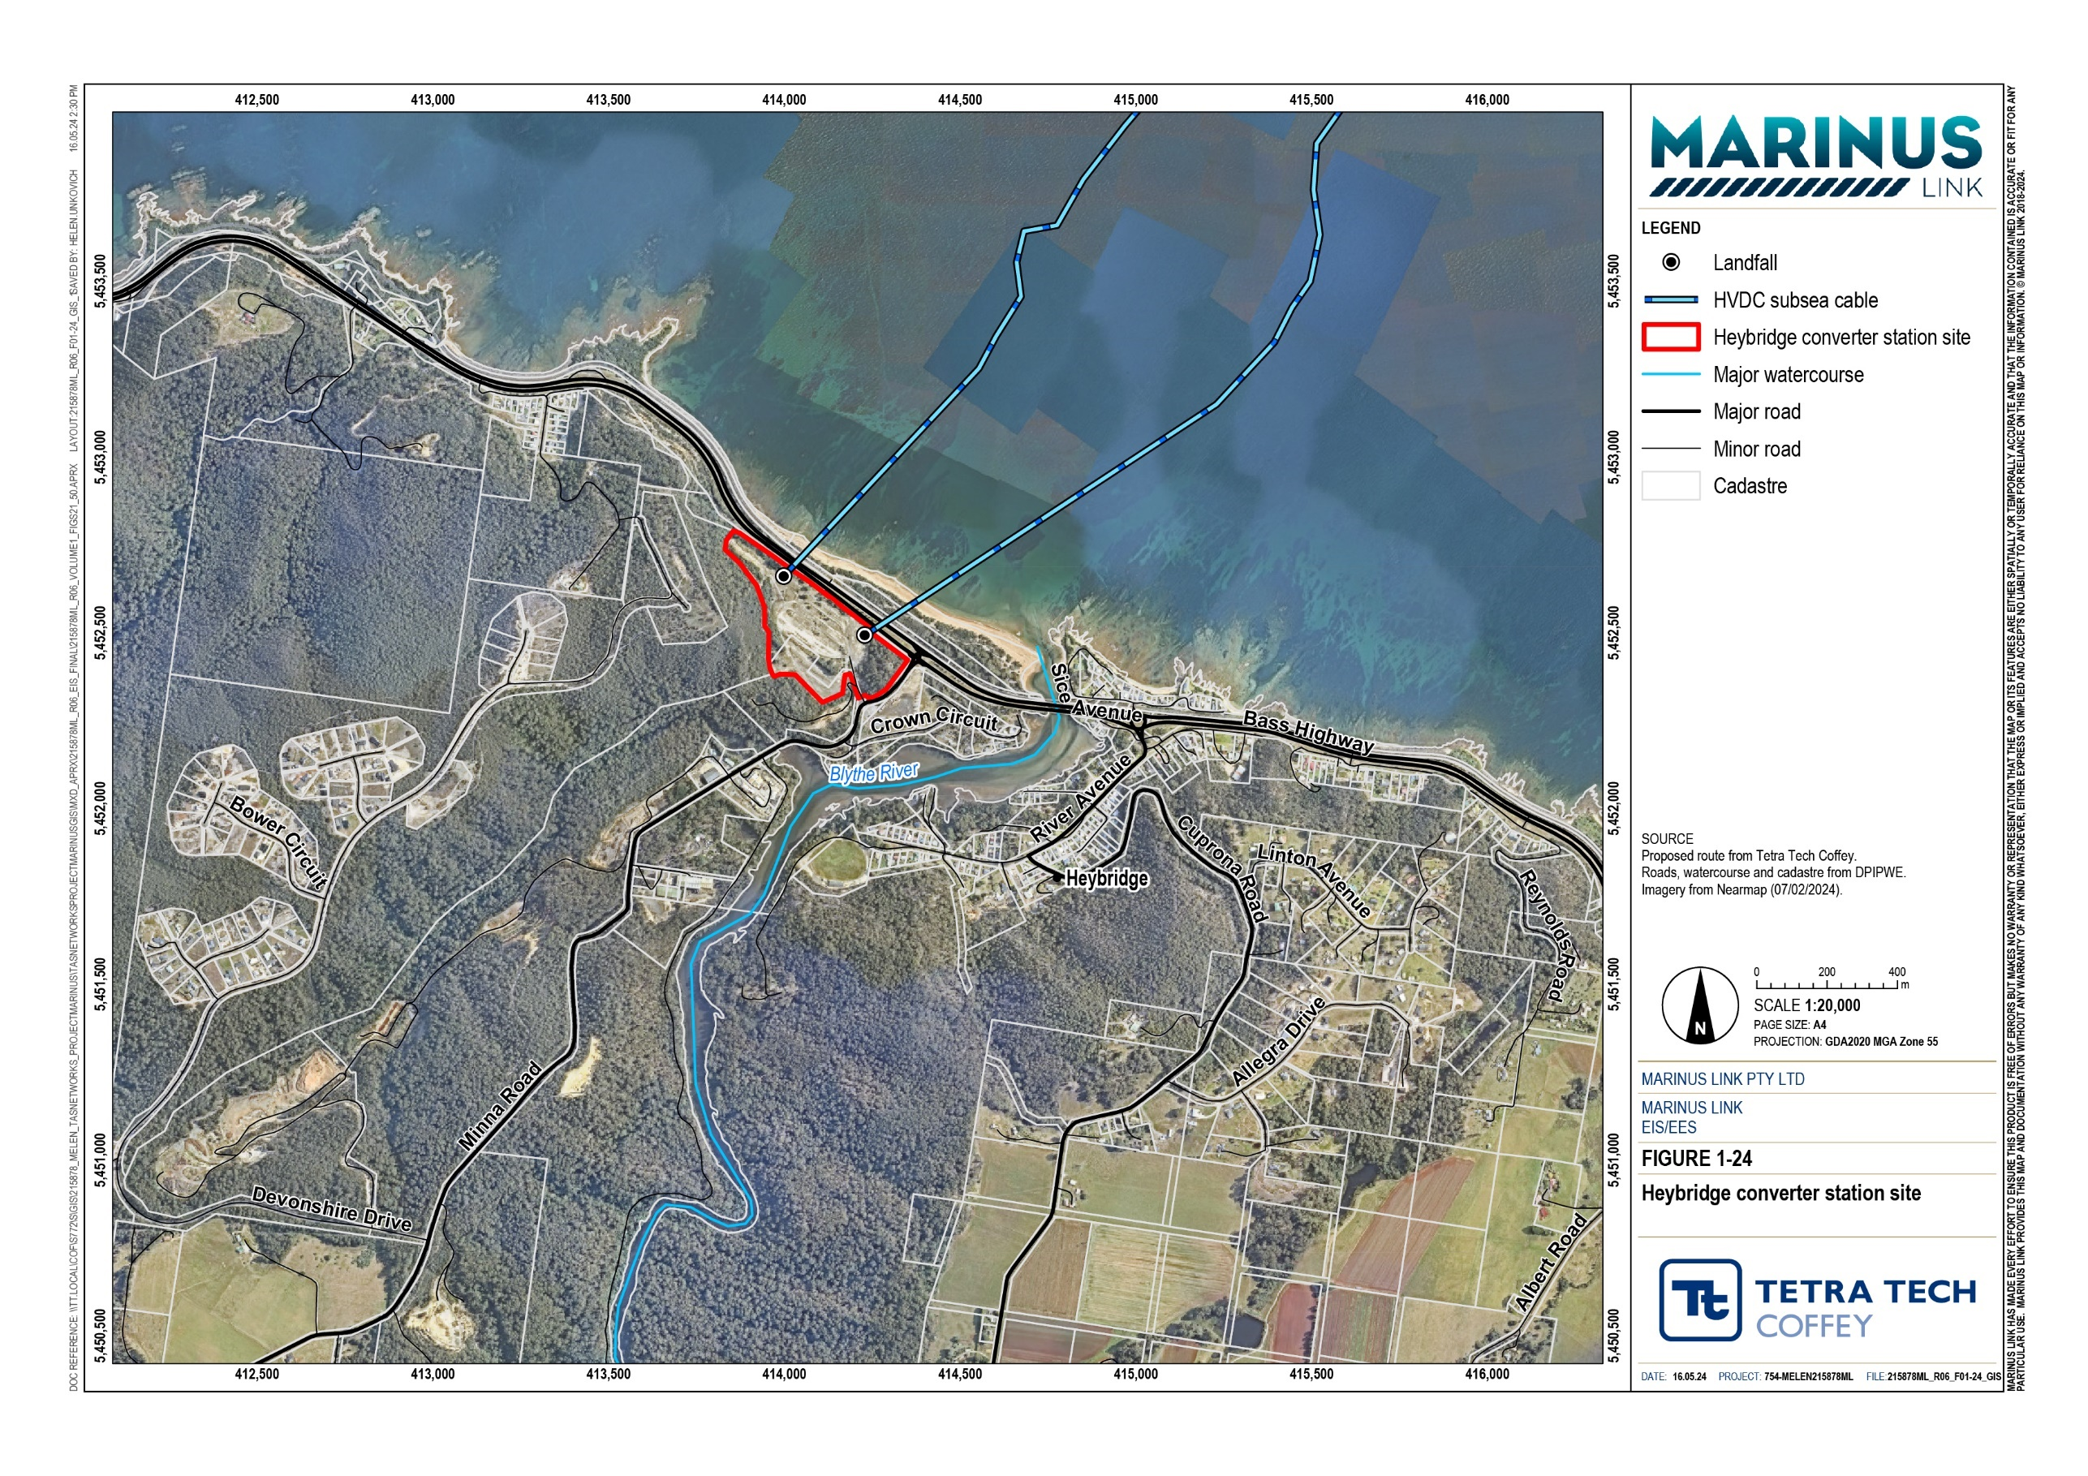
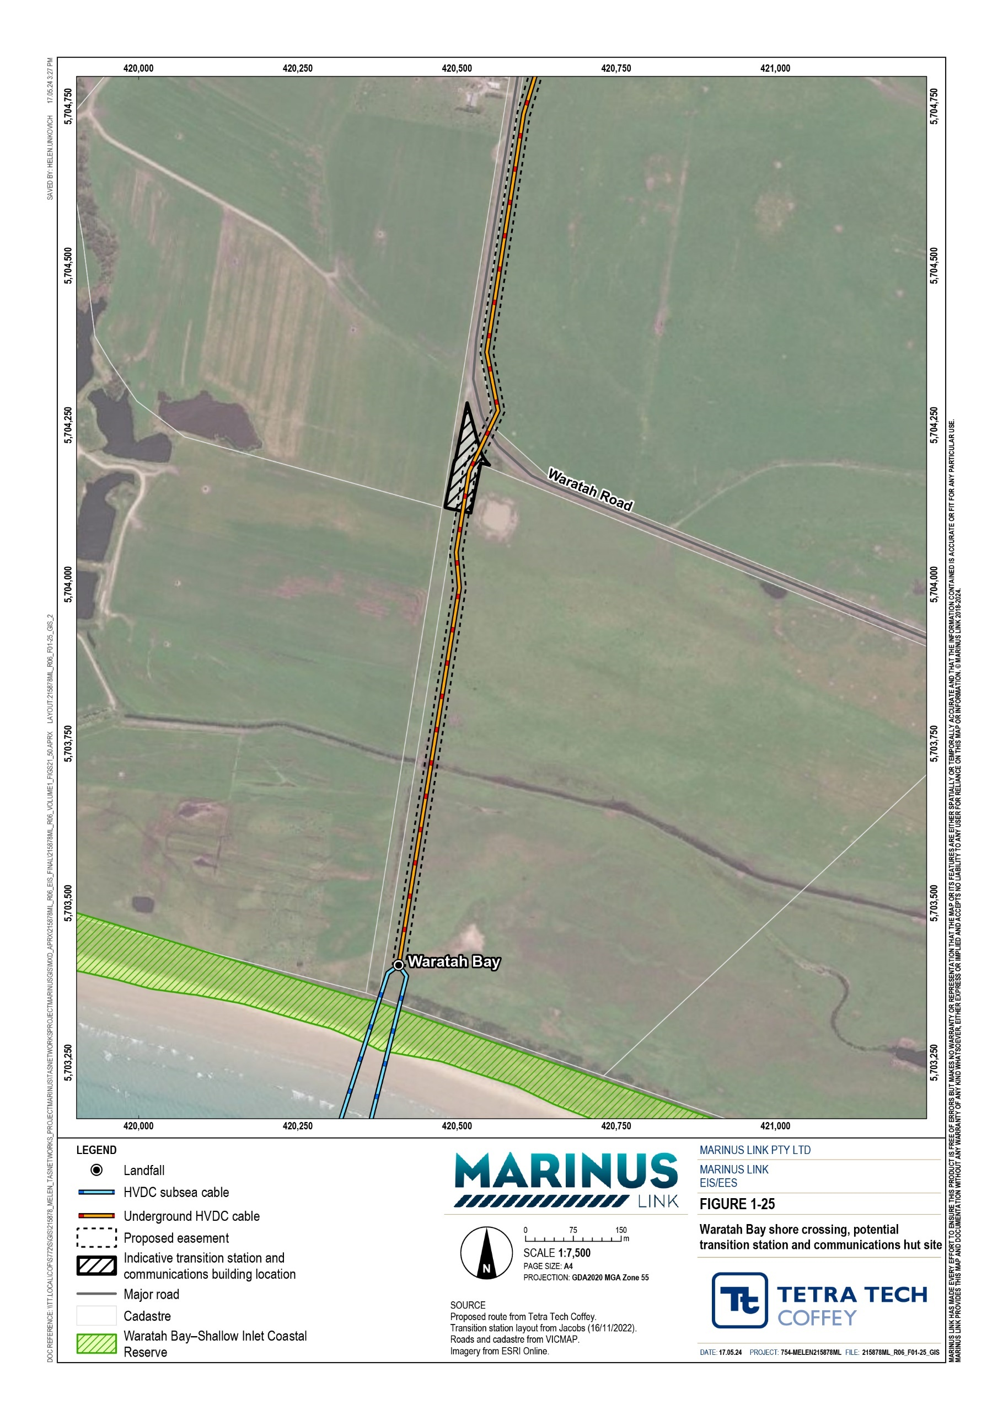

Project components
The project comprises of two 750 MW (1500 MW total capacity) symmetrical monopoles using ±320 kV cross-linked polyethylene (XLPE) insulated cables and voltage source converter (VSC) technology.
Each 750 MW monopole is referred to as a circuit and will comprise two power cables and a fibre-optic communications cable bundled together in Bass Strait and laid in a horizontal arrangement through the shore crossings and on land. Each 750 MW circuit comprises two HVDC power cables and a fibre-optic cable.
The key project components from south to north are:

HVAC switching station and HVAC-HVDC converter stations (two converter stations so there is one for each circuit) at Heybridge in Tasmania, where the project will connect to the northwest Tasmania 220 kV transmission network.
Shore crossing in Tasmania adjacent to the converter station.

Subsea cables across Bass Strait from Heybridge in Tasmania to Waratah Bay in Victoria. Shore crossing at Waratah Bay approximately 3 km west of Sandy Point.
Land-sea joint where the subsea cables will connect to the land cables in Victoria.

Communications building (fibre optic cable inspection and test hut) adjacent to Waratah Bay (Figure 1-25).
Land cables in Victoria from the land-sea joint to the converter station site adjacent to Hazelwood terminal station in the Latrobe Valley.
HVAC switching station and HVAC-HVDC converter stations (two converter stations so there is one for each circuit) at Hazelwood and extension of Hazelwood terminal station, in Victoria, where the project will connect to the existing Victorian 500 kV transmission network.
The switching stations and converter stations infrastructure for both circuits are collectively referred to as the converter station for each of the Heybridge and Hazelwood sites.
A transition station may be required at Waratah Bay if there are different cable manufacturers or substantially different cable technologies adopted for the land and subsea cables. However, regardless of whether a transition station is needed, a communications building (housing fibre optic terminal station) will still be required in the same location.
The key components of the project are shown in Figure 1-26.

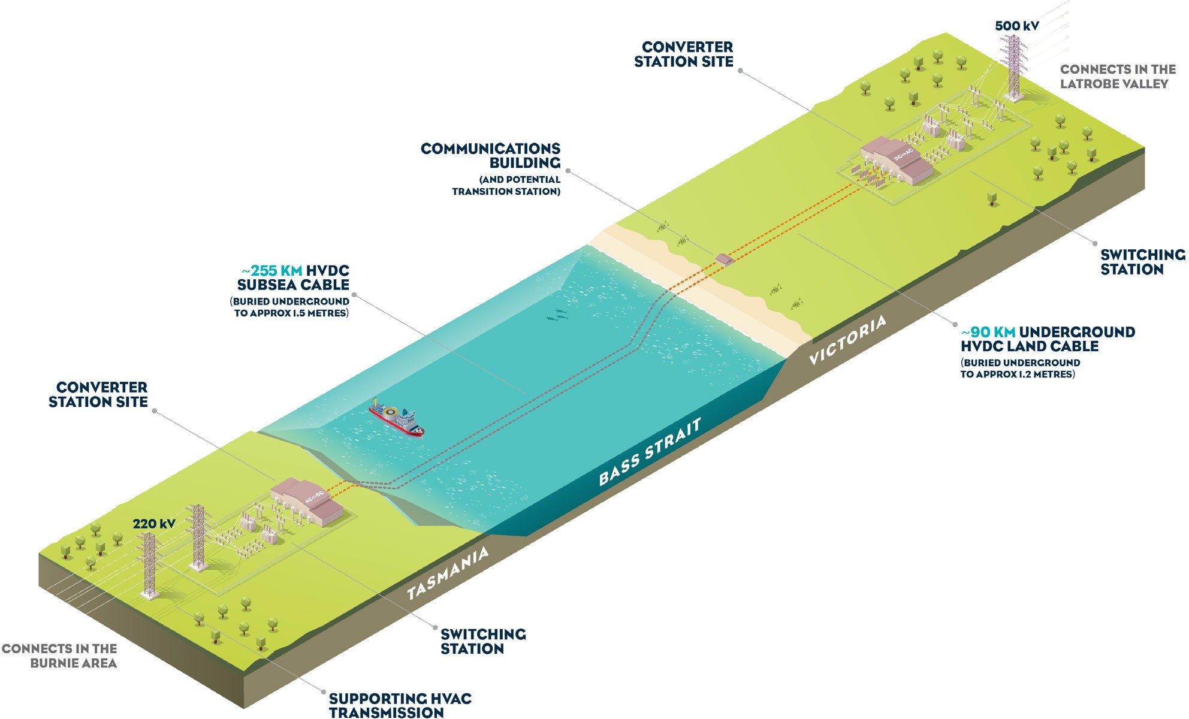

Figure 1-26 Project components

Project stages
The project will be delivered in two stages. Each stage will deliver one complete 750 MW HVDC circuit between Tasmania and Victoria. Civil works, trenching and installation of cable conduits and joint pits for both stages will be completed in stage 1. This will minimise the extent of works associated with stage 2 and provide for the efficient delivery of the second circuit at a time determined by market demand.
Stage 1 will involve:

Site establishment including laydown areas and constructing foundations for the converter stations, communications building and transition station for both circuits.
All civil works, trenching and installation of cable conduits, and installation of cable joint pits for both circuits.
Access tracks and haul roads to access the cable route, HDD locations and joint pits.

Installation of the first HVDC converter at Heybridge and Hazelwood.

Laying of the stage 1 land based and subsea cables.

Testing and commissioning.

Site reinstatement and rehabilitation.

Stage 2 will involve:

Installation of the second HVDC converter at Heybridge and Hazelwood.

Laying of the stage 2 land based and subsea cables, using conduits and joint pits installed as part of stage 1 works.
Testing and commissioning.

Any remaining site rehabilitation.

The indicative construction program is provided in Section 6.3.9.

Survey area and area of disturbance
The following sections outline the defined survey area and area of disturbance (AoD) for the project.
The survey area defines the area within which all project components will be located. The EIS/EES has assessed defined survey areas for the terrestrial and marine project components.
The terrestrial survey area in Tasmania is defined by the property boundary of the Heybridge converter station site and the location of the shore crossings which extend from the site, under the Bass Highway and Western Line railway to Bass Strait. Only EPBC Act matters for the Tasmanian survey area are discussed in this EIS/EES.
The marine survey area includes:

A 200 m wide corridor along each project alignment in Commonwealth waters

Approximately 1 km wide for the Tasmanian shore crossing

Approximately 800 m wide for the Victorian shore crossing

A 10 m wide marine construction corridor along each project alignment.

The terrestrial Victorian survey area includes:

A 220 m wide corridor. However, in some locations the survey area may be wider or narrower to follow property boundaries.
In some instances, major laydown areas are adjacent to the 220 m survey area corridor and in some locations offset from the land project alignment.
A 20 m to 36 m wide terrestrial construction corridor including minor laydown areas.

The terrestrial survey area also forms the basis of the SCO proposed with the draft PSA as shown in Attachment 3 –Planning Scheme Amendment.

A study area has also been defined by each technical study, which may be larger or smaller than the survey area. The study area defined by each technical specialist has considered the local, regional, or state context needed to understand the issues and assess the impacts of the project relevant for their discipline. The study area for each technical study is described in each of the technical chapters of EIS/EES Volumes 2 to 4.
Figure 1-27 shows the survey areas at the Tasmanian and Victorian shore crossings, and the marine survey area. Figure 1-28 shows the Victorian terrestrial survey area.
Key construction components such as location of access tracks and laydown areas are provided in the EIS/EES map book (Attachment 6– Marinus Link EIS/EES Map book).
The AoD for the project falls within the marine and terrestrial survey areas and is the area required for the construction of the key components of the project. It includes:
the 10 m wide marine construction corridor

the 20 m to 36 m terrestrial construction corridor

laydown areas

haul roads and access tracks

areas to be occupied by above ground components of the project including the converter station, communications building and possible transition station.
Impacts to vegetation have been avoided wherever possible when choosing the route alignment and defining the AoD. Areas where HDD will avoid surface impacts are excluded from the AoD.
The total indicative AoD for the project is approximately 852 ha. In the onshore environment, the total indicative AoD is approximately 345 ha and in the offshore environment, it is approximately 507 ha.
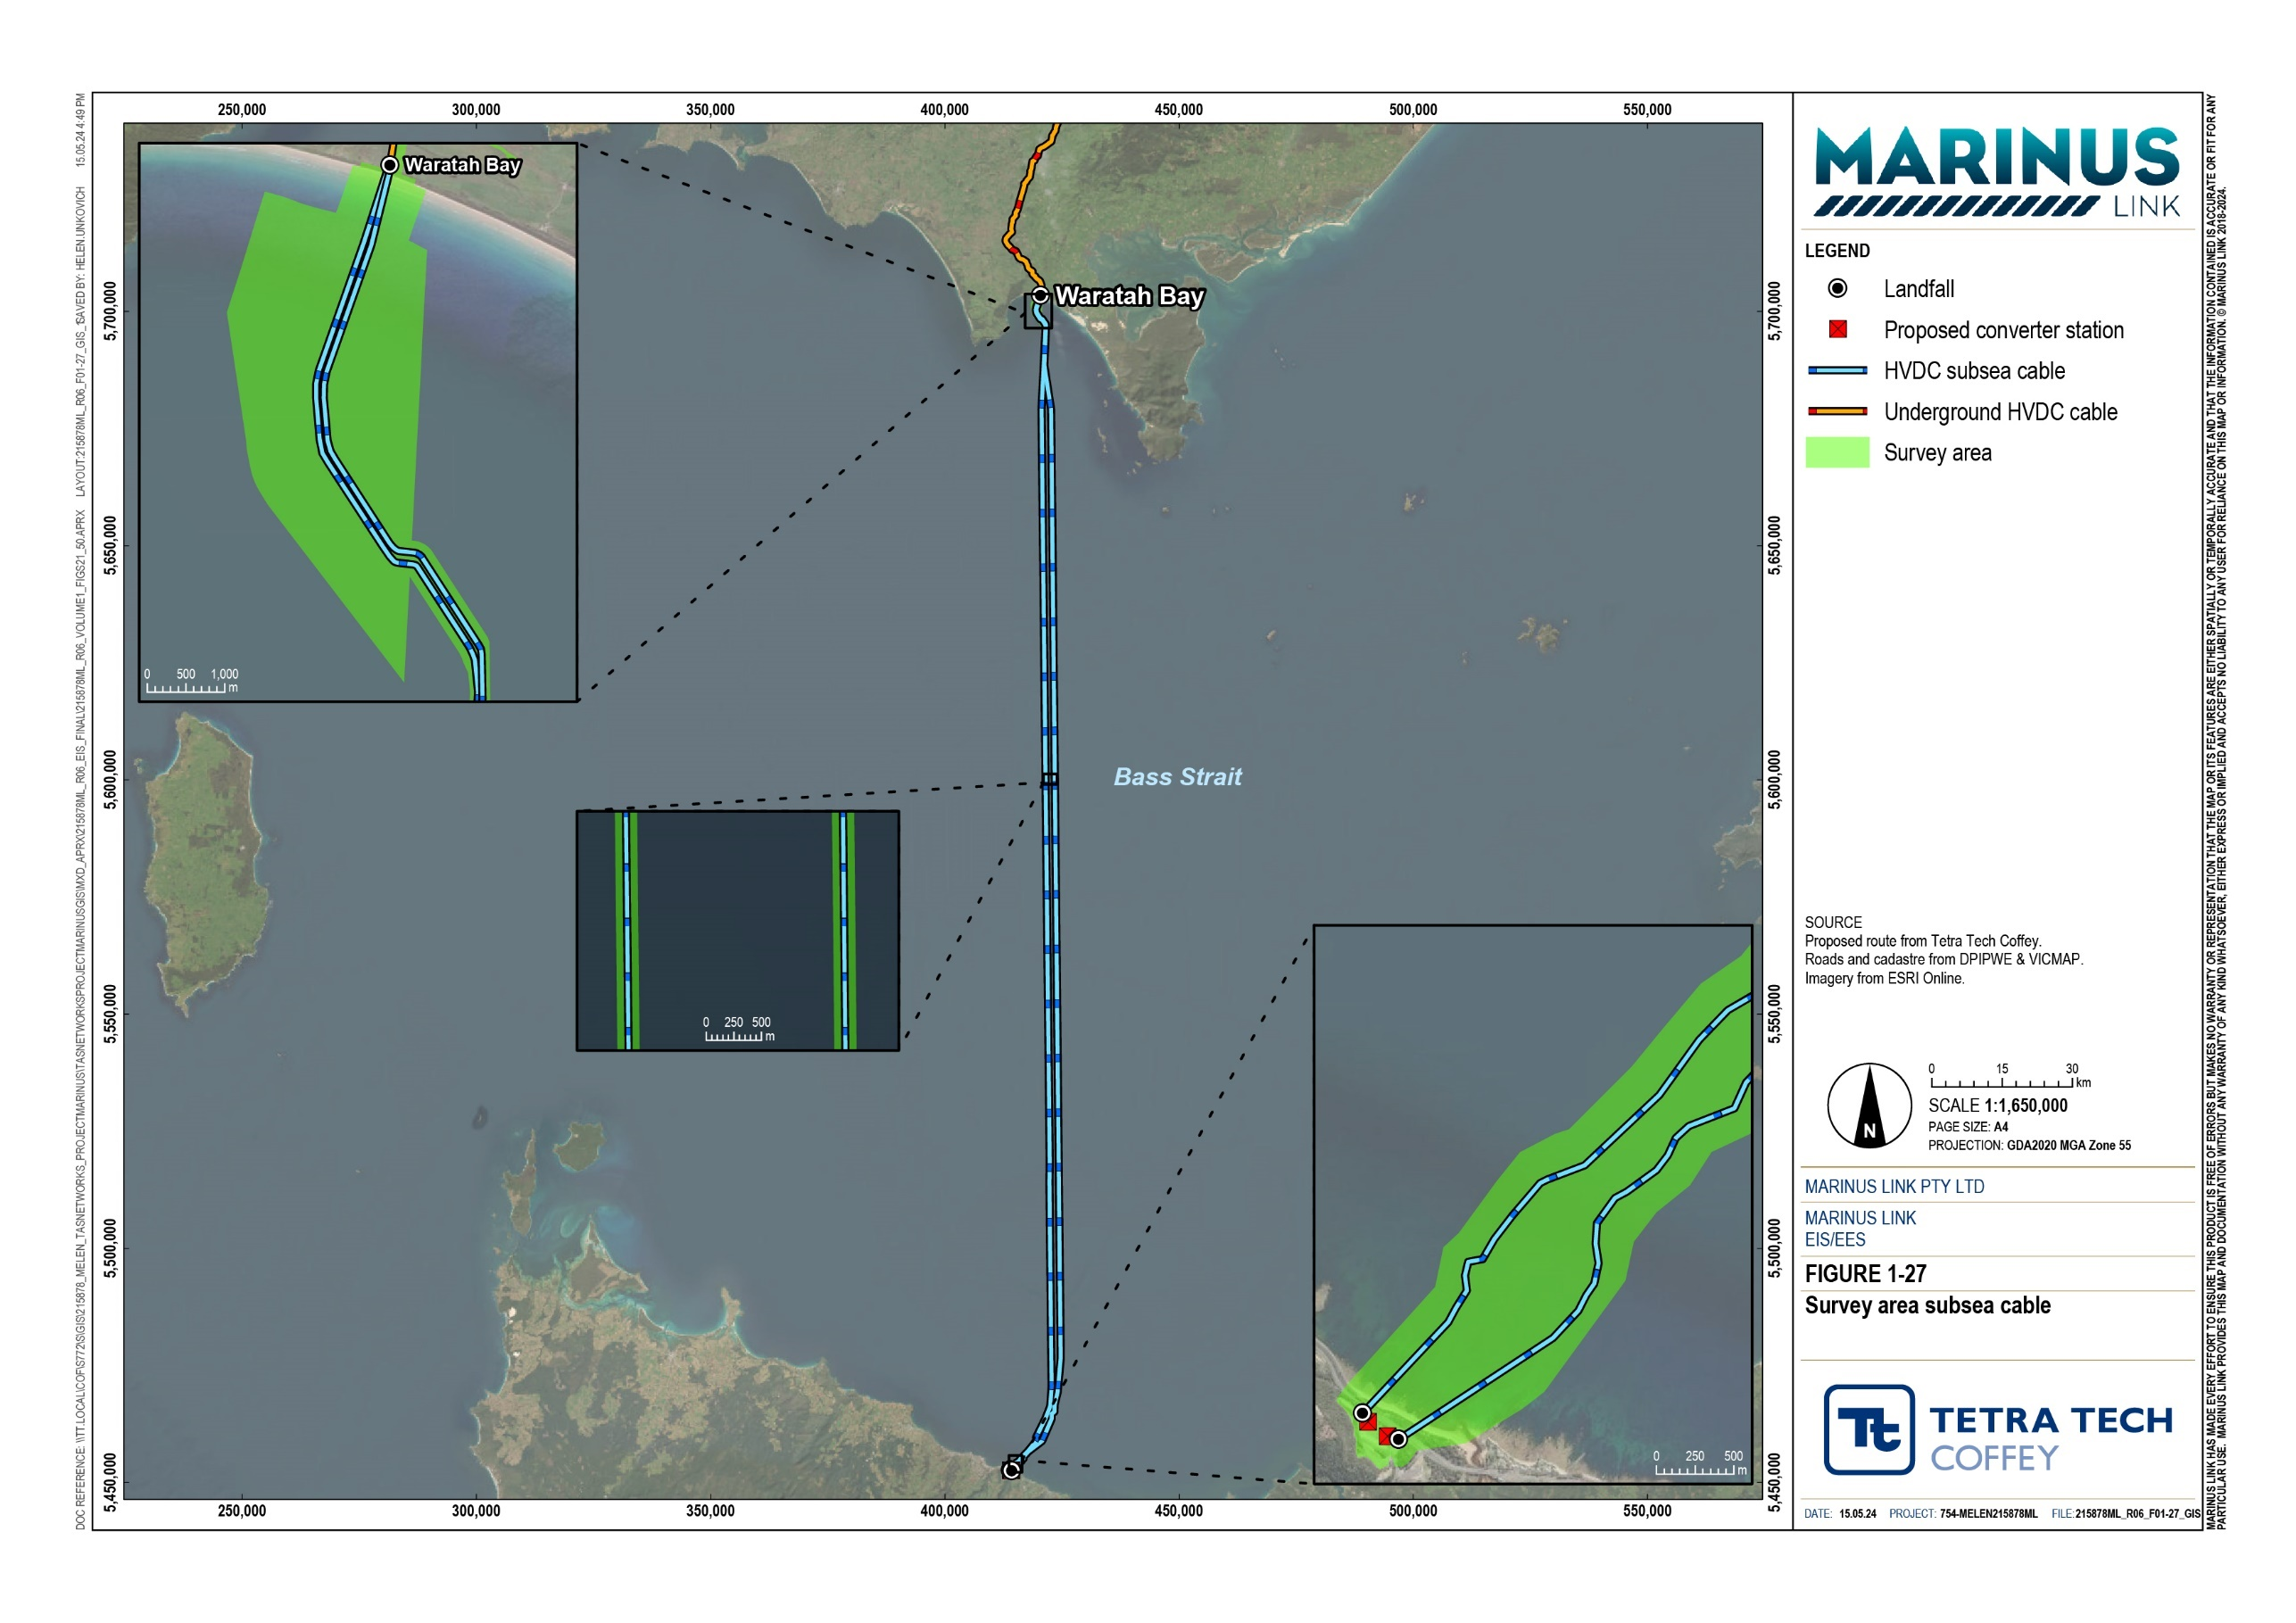
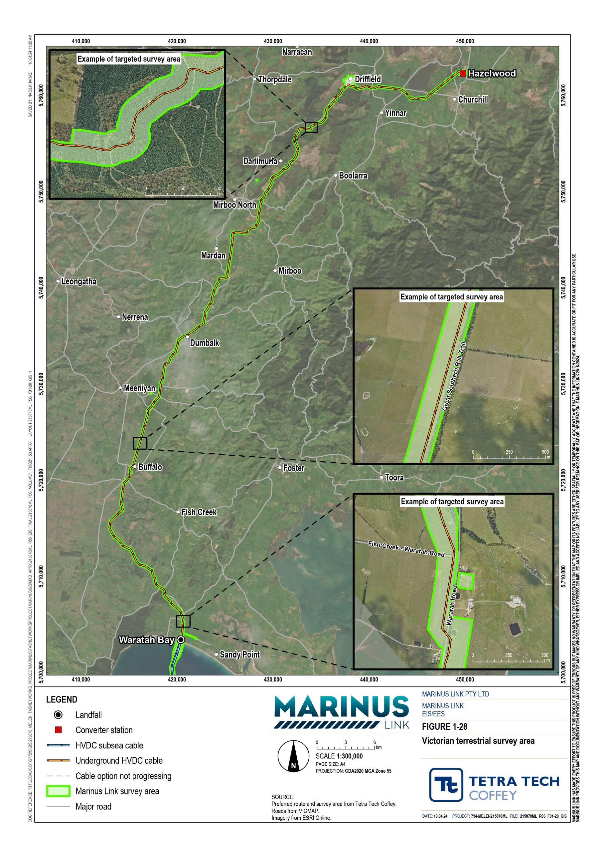

Design
This section describes the design of the project that has formed the basis of the impact assessment for the EIS/EES.

Status of project design
This project description presents a feasible way that the project could be delivered and is the basis of the impact assessment presented in this EIS/EES. The final design and construction method may differ from this project description and will be determined by preferred contractors. Contractors will develop their final designs and construction methods to comply with the project approvals and EPRs following completion of the EIS/EES process, and to address landholder agreements.

Converter stations
The converter station layout, general arrangement and key components will be similar for the Heybridge and Hazelwood converter stations.
Both converter stations will generally comprise of the following key components and equipment:

HVAC 220 kV switching station with gas insulated switchgear (GIS). Sulfur hexafluoride (SF6) gas will be used in the switchgear, and SF6 components will be designed to meet International Electrotechnical Commission (IEC) standards as a ‘closed pressure system’ (reference IEC 62271-1 / AS IEC 62271.1). A building will enclose the GIS equipment.
HVAC 220 kV filter banks.

HVAC 220/320 kV transformers and coolers. The transformers will be housed in bunds designed in accordance with applicable Australian standards.
Two main buildings with approximate dimensions of 70 m wide, 90 m long and 27 m high, comprising three halls including:
- HVAC phase reactor hall containing valve reactors.

- Valve hall containing the converter modules and valves.

- HVDC hall with HVDC reactors and HVDC land cable terminations.

A two-storey service and control building containing system control, protection and data acquisition equipment, station services such as uninterrupted power systems (UPS) systems with batteries, fire suppression systems, control room and amenities.
Spare parts buildings and workshop.

Telecoms building for control systems and commercial telecoms.

Firefighting systems including a fire water tank of approximately 1,000,000 litres (L).

Stormwater drainage system including bunded areas and gross pollutant traps or triple interceptor traps which will be periodically pumped out by a licensed wastewater disposal contractor.
Septic tank for greywater and sewerage.

Security fencing approximately 3.25 m high made from weldmesh, with barbed wire on the top section. Closed circuit television (CCTV) and automated security lighting to monitor and illuminate the converter station respectively.
Two 1500 kilovolt-ampere diesel generators with above ground fuel storage of 5000 L (sufficient for eight hours at full load, 2500 L diesel per converter).

Building materials for the roof and walls will be a standard sheet steel construction. Alternatives may include insulating panels or pre-cast concrete tilt panels if required for acoustic attenuation.
The Tasmanian converter station is located at Heybridge, near Burnie, and the site and its components including the two HVAC–HVDC converters and switching station are referred to as the Heybridge converter station. An indicative layout for the Heybridge converter station is provided in Figure 1-29.
The Heybridge converter station design also includes:

Overhead steel lattice gantries at Heybridge converter stations, on which the HVAC 220 kV transmission lines (connection to Tasmanian transmission network) will terminate.
Subsea cables connecting directly into the Heybridge converter station site, which are connected to the HVAC switching station that facilitates the project connecting to the Tasmanian 220 kV transmission network.
Stormwater drainage system to manage discharge of clean surface water runoff and overflow from the traps to a form of water sensitive urban design (e.g., swale drain), before discharge to the ocean via the existing site drainage culvert.
Access to the Heybridge converter station from Minna Road, off the Bass Highway.

Internal sealed access roads.

Buildings and infrastructure designed to be protected from inundation in a 1 in 200 year rainfall event.
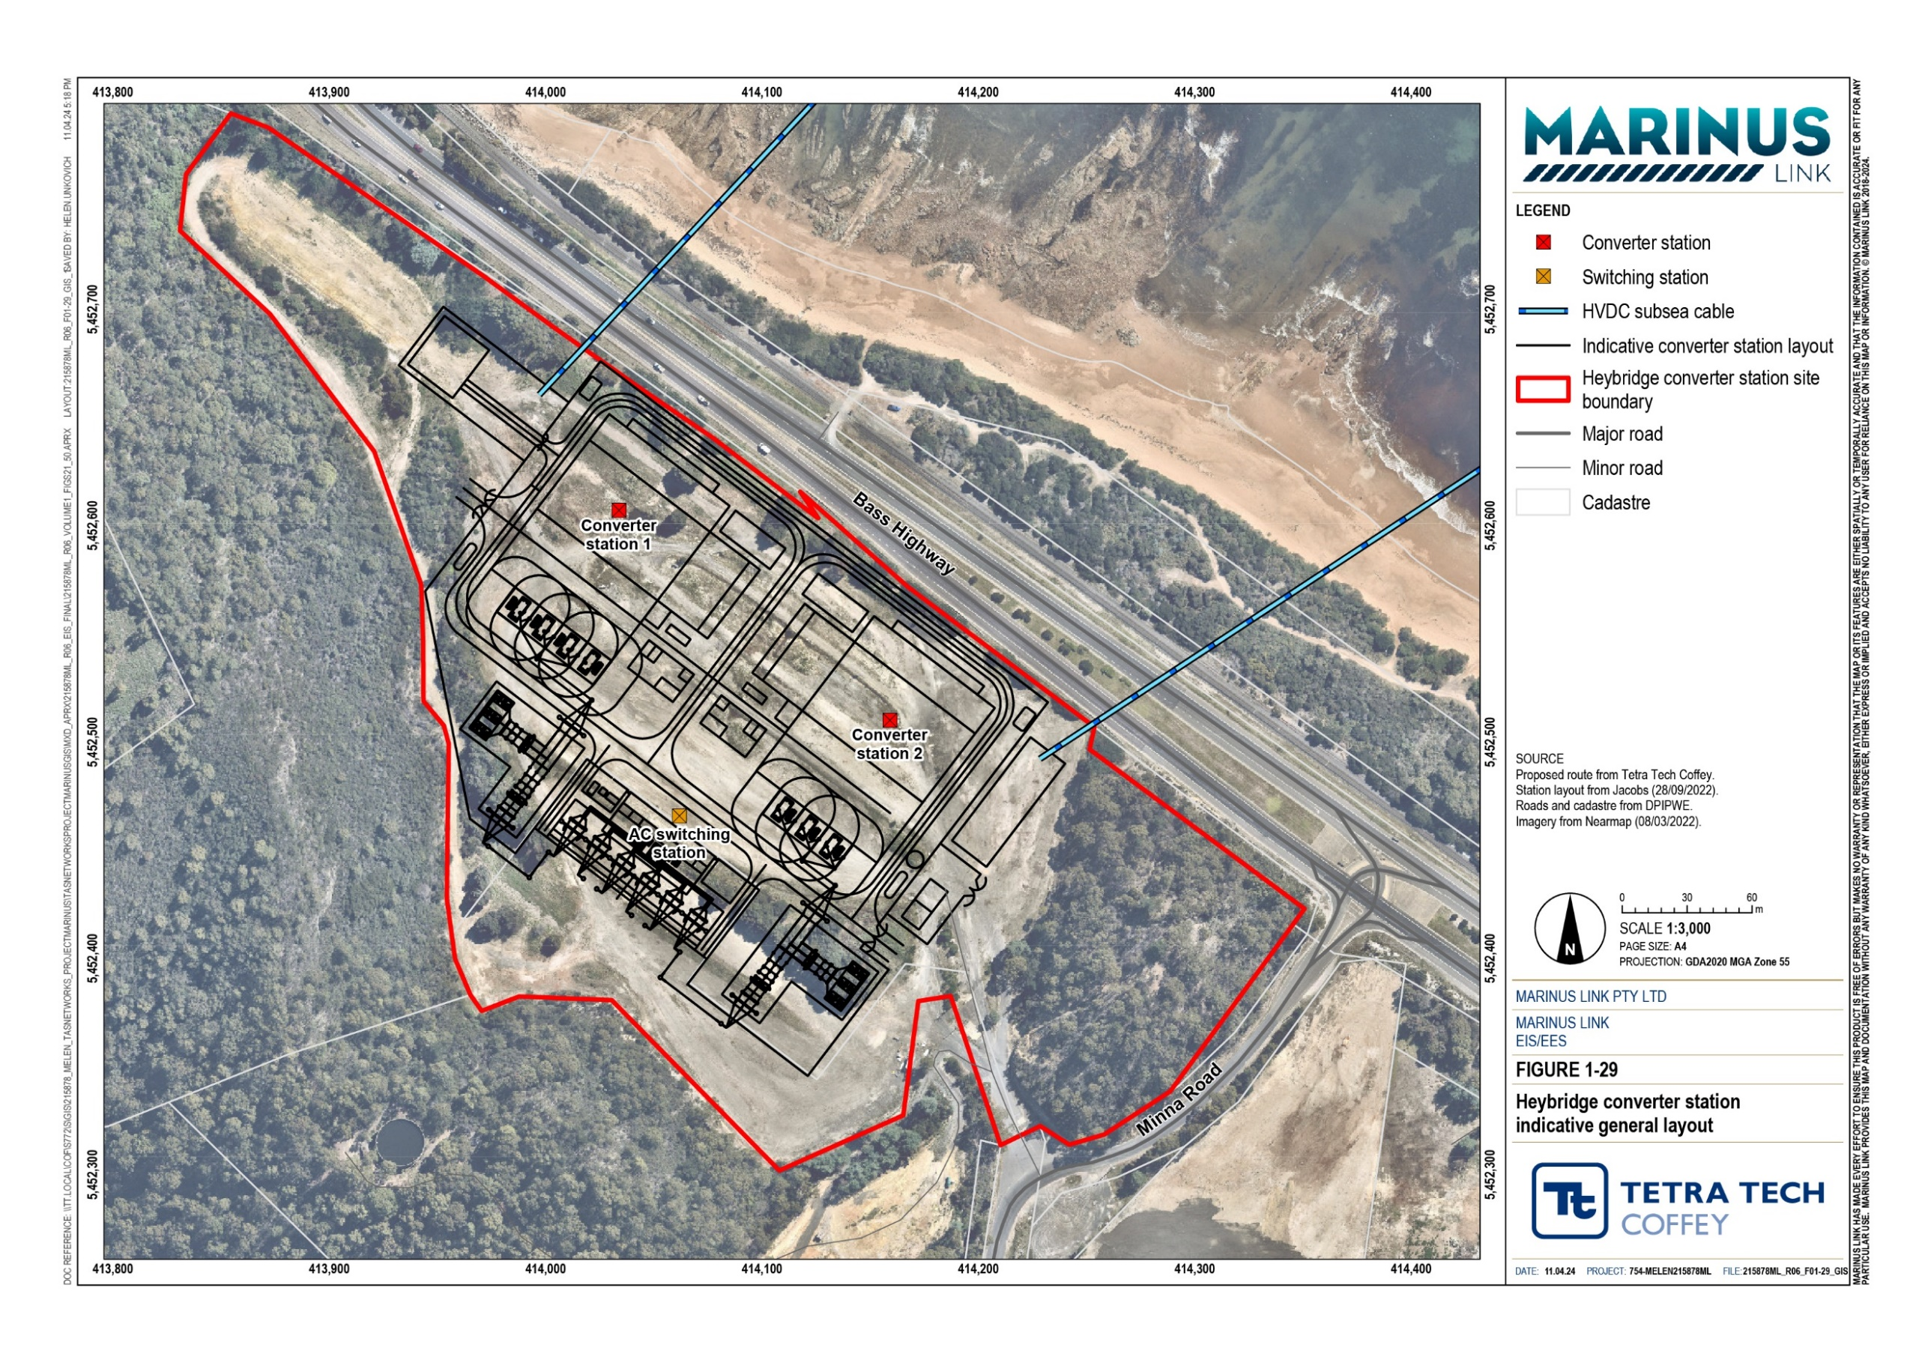

The Victorian converter station will be located adjacent to Hazelwood terminal station in the Latrobe Valley. It will connect directly to the 500 kV yard of Hazelwood terminal station. This connection will be achieved by an extension of the existing Hazelwood terminal station.
The Hazelwood converter station site is in farmland adjacent to the southern boundary of the Hazelwood terminal station and Tramway Road. The converter site and all components located on the site are referred to as the Hazelwood converter station. The converter station layout, general arrangement and key components will be similar to the Heybridge converter station except for:
The site will have an internal two-lane sealed access road that is 8 m wide with pathways each side.

Access will be from Tramway Road.

Buildings and infrastructure for the converter station will be designed to a level to be protected from inundation in a 1 in 100 year rainfall event.
An indicative general site layout for Hazelwood converter station site is shown in Figure 1-30.

Volume 1 – Introduction Page 6-15

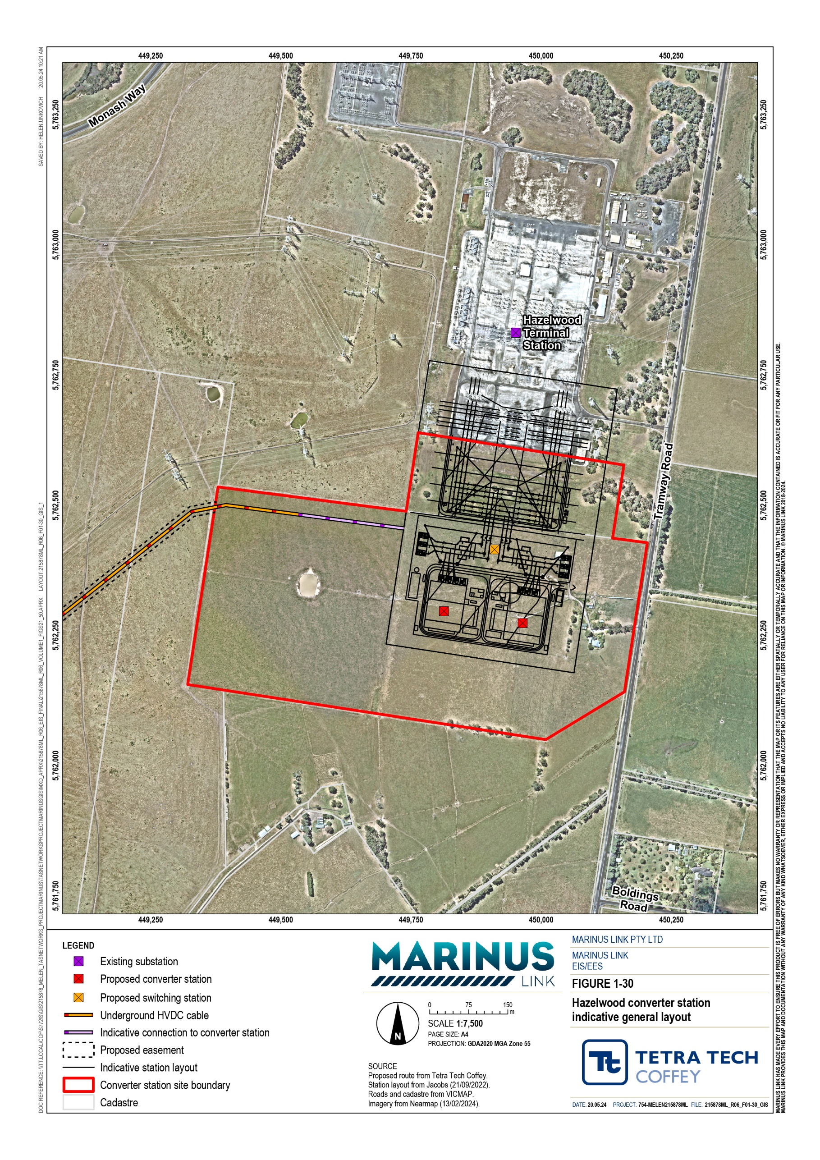

Land cables
The two land cables will extend approximately 90 km from Waratah Bay to the Hazelwood converter station site in Victoria. Both cables will be located within one 20 m wide easement. Community consultation, project constructability and environmental and social values have been considered in the design and location of the land cable. A detailed discussion on project alignment options and selection of the preferred alignment is provided in Volume 1, Chapter 3 – Route selection and project alternatives.
Land cables are not required in Tasmania, as the subsea cables will directly connect to the converter stations with the shore crossing being within the site boundary of the Heybridge converter station.
The key design elements for land cables and joint bays include:

Cables located a minimum of 5 m apart and buried to at least 1.5 m.

Joint bays installed every 800 to 1200 m and marked with poles.

Joint bays 12 to 14 m long by 2.5 m wide and 2.5 m deep, buried 0.5 m below the surface.

The cable joint bays for each circuit will be located side-by-side wherever possible or staggered along the alignment if necessary. They will be located adjacent to boundary fences or other features to reduce land use impacts where practicable. The project alignment will be marked at paddock and property boundaries.

Subsea cables and shore crossings
Subsea cables will extend north across Bass Strait for approximately 255 km from the Tasmanian shore crossing to the Victorian shore crossing. The subsea project alignment runs along longitude 146°05’ across Bass Strait. The alignment deviates from this longitude in approximately 60 m water depth off the Tasmania coast and near Tongue Point, Wilsons Promontory National Park on the Victorian coast to align with the landfall and shore crossing points.
The subsea cables for each stage will be laid in a bundle comprising three cables: two power cables (one operating at positive polarity and the other at negative polarity) and a fibre-optic cable. The cable bundles will transition from being approximately 300 m apart at the HDD nearshore exit at the Tasmanian coast to being laid approximately 2 km apart in offshore waters across Bass Strait. In the Victorian nearshore area, the separation between bundles will reduce to approximately 100 m apart, and at the HDD exit point the cables will be anchored, un-bundled and pulled through six ducts drilled under the coastal reserve. There will be three ducts for the shore crossing of each circuit.
The subsea cables are expected to be manufactured in approximately 125 km lengths. One offshore subsea cable joint for each stage will therefore be required in Bass Strait.

Transition station and communications building
The project description allows for a transition station near the Victorian coast at Waratah Bay. This transition station will only be required if the subsea and land cables are supplied by different cable manufacturers or substantially different cable technologies are selected. The transition station will also provide an additional access point facilitating fault finding in case of a cable failure.
If the same supplier provides the land and subsea cables, a transition station may not be required in Victoria. A transition station is not required in Tasmania.
Regardless of whether a transition station is needed, a communications building is required in Victoria. A separate land-sea cable joint will also be required closer to the coastline as the cable changes from the subsea to the land cable.
The transition station and communications building will be adjacent to and accessed from Waratah Road and the unmade government road as shown in Figure 1-25. They will be in a compound approximately 75 m by 50 m. The transition station will comprise of GIS subsea–land cable joints housed in 40-foot shipping containers approximately 3 m high and a communications building. The GIS joints will contain SF6 gas. The indicative general layout for the transition station is shown in Figure 1-37 in Section 6.3.5.
Stormwater runoff from the site will be directed to existing drainage lines. The transition station site is above the 1 in 100 year flood level but subject to standing water following heavy rain. The transition station will however be designed to a level to be protected from inundation in a 1 in 200 year rainfall event.
The communications building will be a standalone building, approximately the size of a shipping container. The communications building will be connected to the Telstra’s Bass Strait 1 (BS1) communications building by a fibre-optic cable running in the road reserve or private property south of Waratah Road.
The communications building will include power, light, heating, cooling, ventilation, air condition, fire detection and suppression, back-up generator, and UPS to ensure the proper functioning of the fibre-optic telecommunication equipment.
For security, the site will be fenced and protected including guard rails to protect the site from vehicles travelling on Waratah Road, CCTV and automated security lighting will be required.
Landscaping and screen planting will be established consistent with the facility design and recommendations from the landscape and visual technical study (Technical Appendix R: Landscape and visual).

Third-party infrastructure and service relocation
The subsea cables and land cables both cross third-party infrastructure. The subsea cables cross submarine fibre-optic cables, for which the crossing method is explained in Section 6.3.4.
Services crossed by the Victorian land cables include:

Telstra fibre-optic and copper cables

South Gippsland Water water supply pipelines

Gippsland Water water supply pipelines and trunk sewer mains

APA Group high pressure gas pipelines

AusNet high voltage electricity transmission and distribution lines

Farm water supply pipelines and pump electricity supply cables.

The crossing design and method will be agreed with the asset owner to ensure construction and operation and maintenance activities do not affect operation, maintenance or replacement of the third-party infrastructure. The design will also consider the operation and maintenance requirements for the land cables. Third-party infrastructure crossings are typically perpendicular to reduce the length of land cable and third- party infrastructure in contact.

Construction
This section describes the typical construction activities for each component of project described in Section
6.2. Construction of the project will occur in different sections at the same time along the project alignment and as the above ground components are constructed in Hazelwood and Waratah Bay.
The project will be constructed in two stages as described in Section 6.1.2. Each stage will have three cables bundled together in Bass Strait and laid in a single trench on land. The trench, conduits, joint pits, and HDD ducts for both 750 MW circuits will be installed, and land reinstated as part of stage 1 to reduce disturbance to properties, land use and farming activities. This also provides flexibility for the timing of stage 2.
During the construction phase, there will be multiple principal contractors and sub-contractors involved in the delivery of the different project components. There is expected to be four work fronts, comprising of trench construction and cable laying activities.

Converter stations
The key components and equipment for the Heybridge and Hazelwood converter stations are outlined in Section 6.2.2. Construction of the converter stations involves the activities outlined in Table 6-2. Construction activities will be similar between both converter stations sites, tailored to the conditions of each site.

Table 6-2 Converter station construction activities

Construction phase | Activities
Site preparation / establishment | Surveying and vegetation clearing.  Construction site offices and amenities, and laydown areas.
Civil and building works | Bulk earthworks to construct the converter station bench.  Transport engineered fill and aggregate to the site for the bench and hardstand if required depending on the results from the geotechnical investigations.  Remediation or disposal of contaminated soils disturbed during bulk earthworks in accordance with relevant regulatory requirements.  Constructing site access and internal roads.  Structural steelwork for buildings and electrical apparatus and infrastructure. Construction of the converter halls (comprising phase reactor, valve and  HVDC reactor halls), control and auxiliaries building and GIS building  foundations, cable trenches and foundations for electrical apparatus and transformer bays.  Construction of a stormwater drainage system. Installation of fire water tank.  Installation of HVDC converter equipment and associated apparatus.  Delivery and installation of HVAC switchgear and auxiliary transformers. Installation of electrical, mechanical and firefighting systems.  Installation of automated security lighting.
Commissioning and testing | Commissioning the converter station and switching station.  Testing of electrical, mechanical, lighting and firefighting systems.

The Heybridge converter station will require an elevated bench, constructed to provide a stable base for the Heybridge converter station and situate it above the 1 in 200 year flood level. The site will have a gentle slope (reduced level (RL) 9.35 m to RL 6.8 m) towards the northern boundary.
There is also potential for some low level contaminated material or asbestos to be found on the Heybridge site. Contaminated soil will be excavated and managed in accordance with relevant regulatory requirements.
To meet the design requirements of the Hazelwood converter station site, earthworks during construction will level the site and provide a stable base for the Hazelwood converter station situated above the 1 in 100 year flood level.

Shore crossings
The shore crossing will be constructed using HDD to avoid impacts to the intertidal area and coastal dunes. The shore crossing for both ends of the project will be constructed to approximately 10 m water depth, be about 10 m below ground when crossing the coast and expected to extend between 800 m and 1200 m offshore.

HDD involves drilling a borehole under a feature through which a duct is pulled or pushed, depending on the method of installation. HDD is a means of drilling a borehole along a predetermined alignment that can have both horizontal and vertical curves. The borehole direction or curvature is controlled by a combination of sensors located along the borehole alignment at the surface that monitor the drill head’s position and pressure applied through varying drilling fluid volumes and flow rates.
Ducts will be installed in each of the six boreholes. The nominal diameter of the high-density polyethylene (HDPE) ducts is 250 mm overall or outside diameter (OD). The subsea cables are approximately 130 mm to 140 mm in diameter.
The following activities are typically required for a shore crossing HDD:

Construction of access to HDD drill (entry) pad.

Preparation of hardstand.

Installation of erosion and sediment controls around perimeter of workspace.

Digging of entry pits.

Delivery and set up HDD drill rig and associated equipment, including closed system HDD drill mud/fluid cycle equipment.
Drilling pilot hole from entry pit under the feature along the design catenary.

Reaming of the borehole to required diameter (approximately 320 mm) by pulling reamer back through borehole. The reamed hole is typically 1.25 times the diameter of the duct to be installed.
Welding of HDPE or steel duct lengths together to form the duct that will be pulled through the borehole (also known as stringing).
Pulling ducts through the boreholes and setting in place using bentonite (if required).

Pushing out ducts to the HDD exit point to allow an HDPE extension to be fitted to the HVDC cable duct and HDPE sub-ducts to be installed in the metallic return and fibre optic cable duct.
Burying of the HDPE extension and sub-ducts after cable installation (as required).

Cleaning of ducts and fitting of a messenger wire. The wire will be secured to an inspection gauge, which will be left positioned at the end of the duct, and the end will be capped, and a marker buoy attached.
Capping of shore crossing ducts after completion. Backfilling of drill entry pit.

Removal of all equipment and drill cuttings.

Exposure of ducts when the cable-landing operation is about to commence.

Removal of hardstand and reinstatement of entry pads following trenching and pulling land cables through the ducts.
Rehabilitation of entry pads and temporary access tracks.

It is anticipated that HDD and duct installation for the shore crossing of both circuits will take approximately eight to 12 months. Each HDD will be drilled continuously up to 24 hours per day, up to 7 days per week to ensure borehole stability. There may be instances where drilling stops and starts, depending on construction needs. Ducts for both stages will be installed during stage 1 works to avoid two separate drilling campaigns.
The shore crossings will comprise six HDDs, one for each cable (two power and one fibre optic per stage) with three drilled from each of the two drill pads. The HDD drill pads will be temporary and only required for construction purposes. Full restoration will occur after the land cables are installed and joined to the subsea cables.
The cable bundles will be un-bundled near the borehole exits and each individual cable will be pulled through a duct in the HDD bore under the shore to the HDD drill pad. The boreholes will diverge slightly to ensure adequate separation at the nearshore exit.
At the shore crossing, the subsea cable bundles will be anchored un-bundled, and each individual cable will be pulled from the end of the duct in an HDD bore.
Figure 1-31 shows the conceptual shore crossing method.

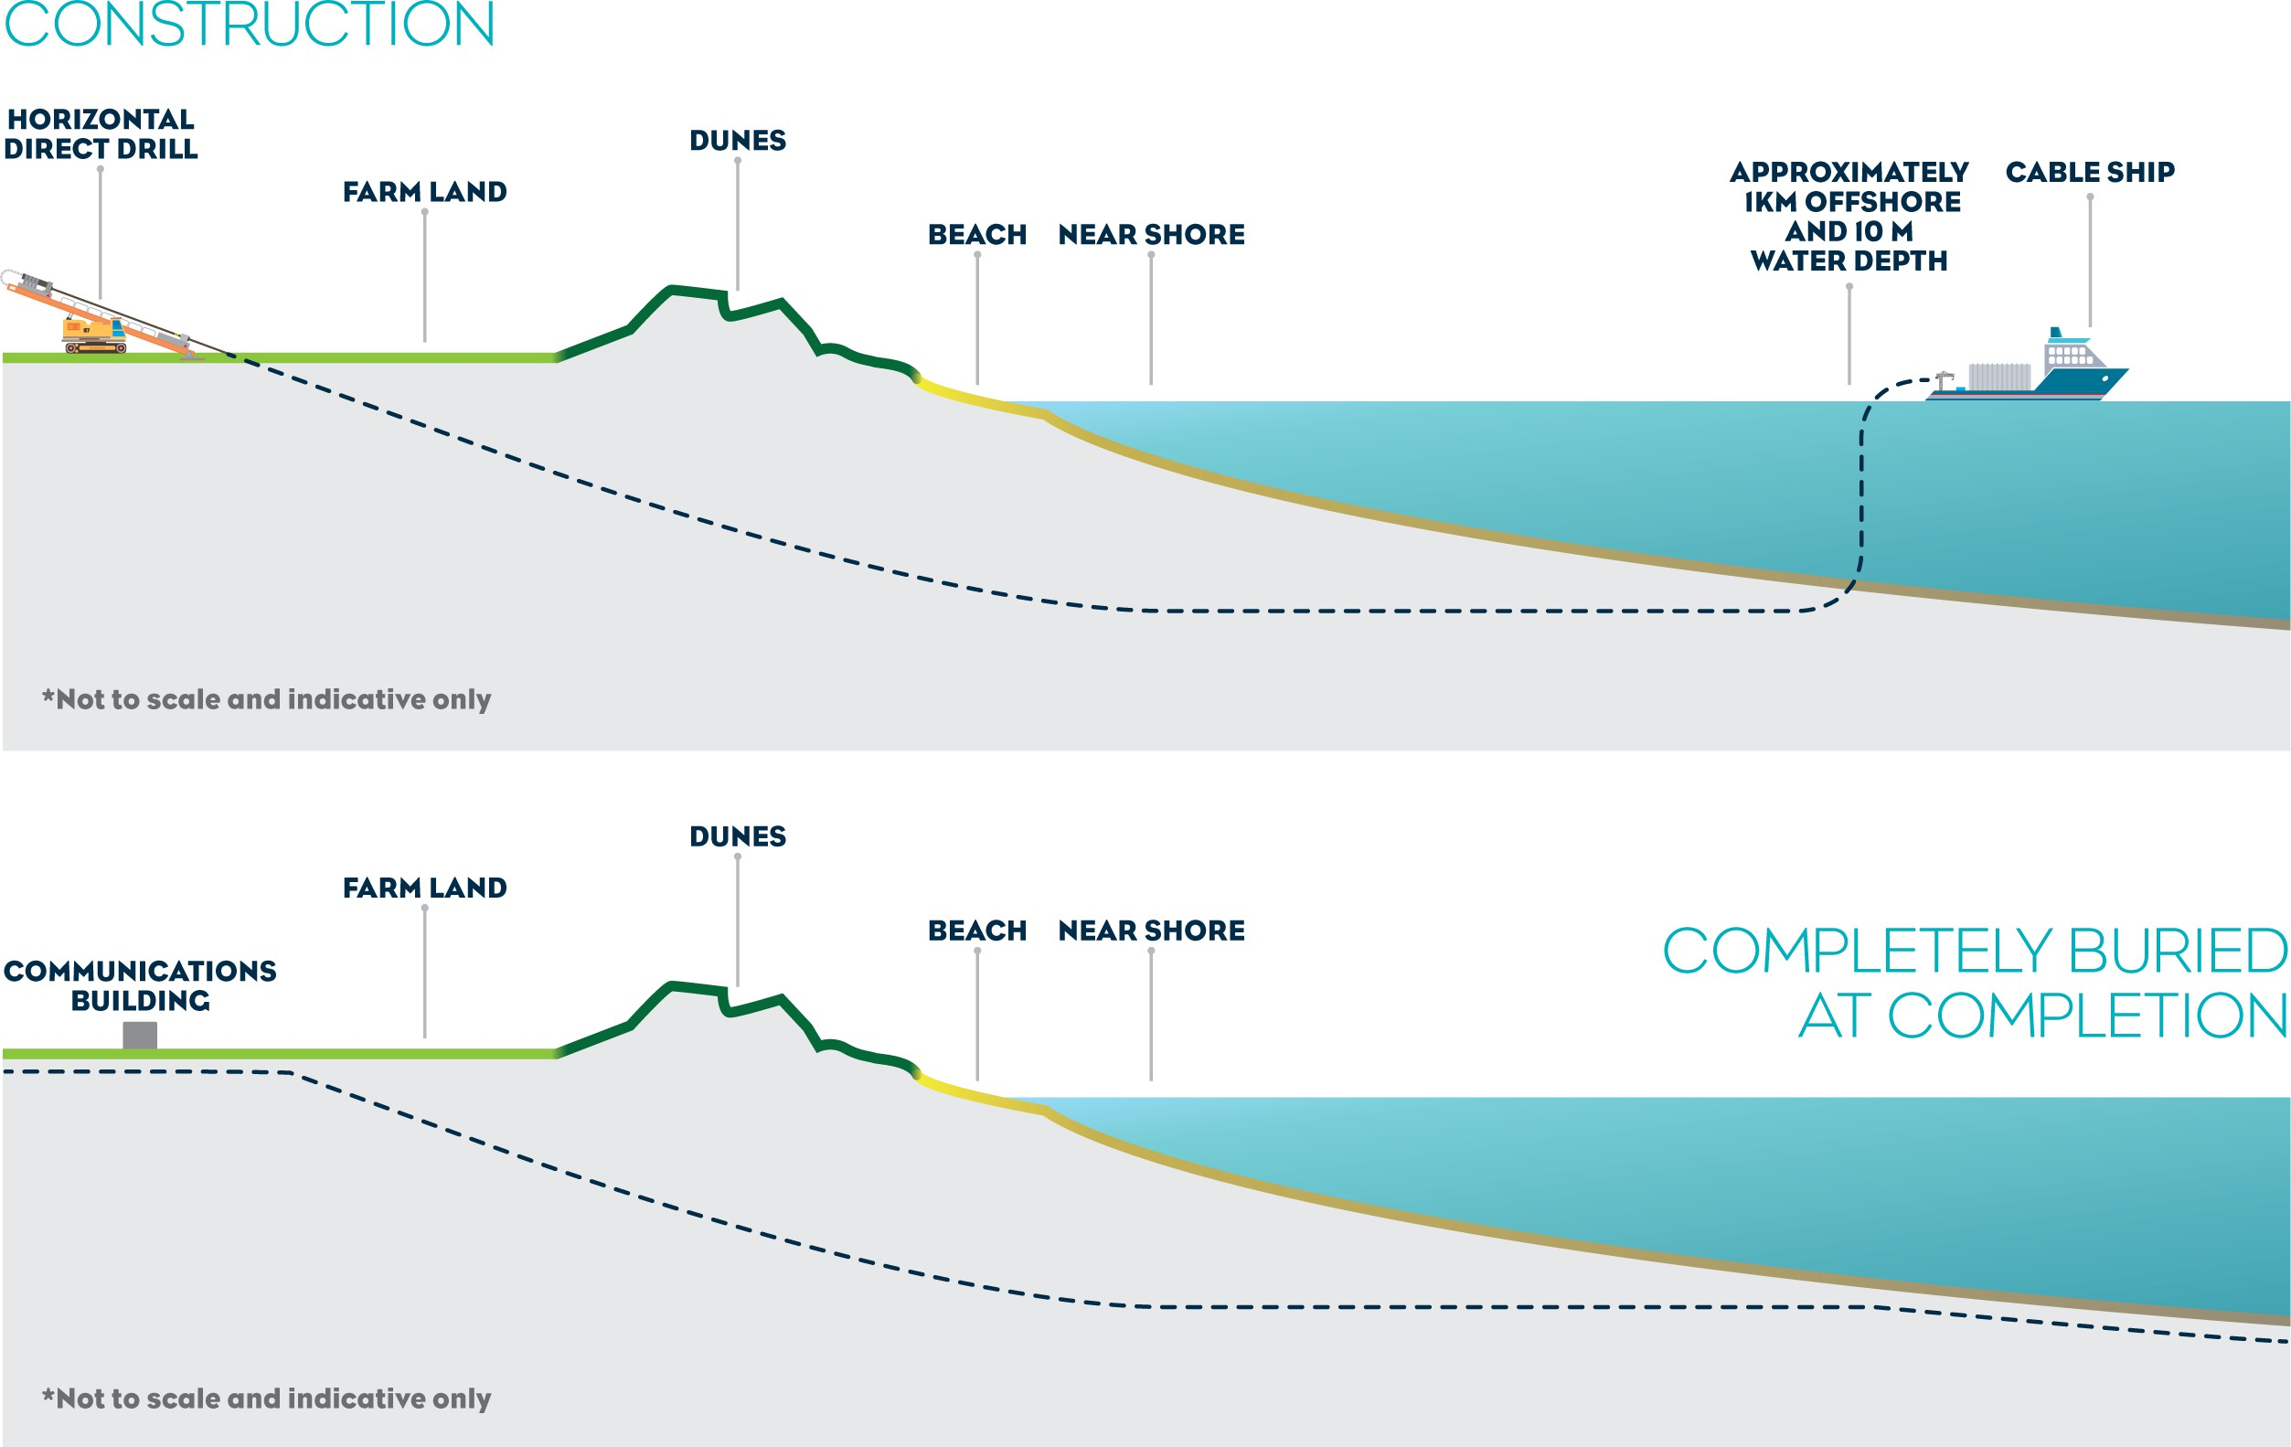

Figure 1-31 Indicative illustration of the shore crossing method at Waratah Bay

The Tasmanian shore crossing will begin from within to Heybridge converter station site as shown in Figure 1-24. The shore crossing is west of the Blythe River mouth.
In Tasmania the drilling for both stage 1 and stage 2 cables will be launched from different ends (western and eastern) of the Heybridge converter station site. This is primarily due to the paleochannels restricting the locations of the stage 1 and stage 2 alignments. The paleochannels are former rivers that are now under the sea.
The locations are also influenced by the proximity of the converter station to the cable entries at Heybridge, and landing the cables in separate locations at each end of the site allows for a more suitable design interface between the cables and the converters.
The Tasmanian shore crossing will comprise six HDDs, one for each cable (two power and one fibre optic) with three drilled from each of the pads located adjacent to each converter station. The drill pads for the HDD will be located adjacent to each of the converters, either end of the converter station. Each drill pad will consist of a large hardstand area that will accommodate the HDD equipment and three entry pits of approximately 4 m by 4 m.
The crossings will be drilled under the Bass Highway and Western Line which are adjacent to the proposed Heybridge converter station site. The HDD will extend approximately 1 km offshore along the subsea project alignment through competent rock to the paleochannels. The subsea cables will be pulled from the cable lay vessel to the converter station HDD drill pads.
The HDD exit points will align with the paleochannels in the rock platform that extends offshore from the beach. The paleochannels are mostly sand filled. The former tioxide plant outfall disused pipeline occupies the western paleochannel and will need to be crossed. The method for crossing the outfall pipeline will be determined by the preferred contractor.
In Victoria, the shore crossing is in Waratah Bay, approximately 3 km west of Sandy Point. The shore crossing will comprise six HDDs, as required for the Tasmanian shore crossing, drilled from a single drill pad. The HDD drill pad will be in farmland as close to the coastal reserve as possible (without being within the coastal reserve). The HDD drill pad will be approximately 100 m by 100 m. Figure 1-32 shows the layout of the HDD drill pad.
The subsea cables and land cables will be joined close to the Victorian coast, as subsea cables are designed for a lower ambient temperature and lower thermal resistivity, and are not suitable for onshore installation over long distances. The land-sea cable joint will be installed at the HDD drill pad site adjacent to the Waratah Bay–Shallow Inlet Coastal Reserve.
Waratah Bay beach will not be closed during construction, unless required to manage public safety concerns at the time, in which case disruption will be short term and temporary.

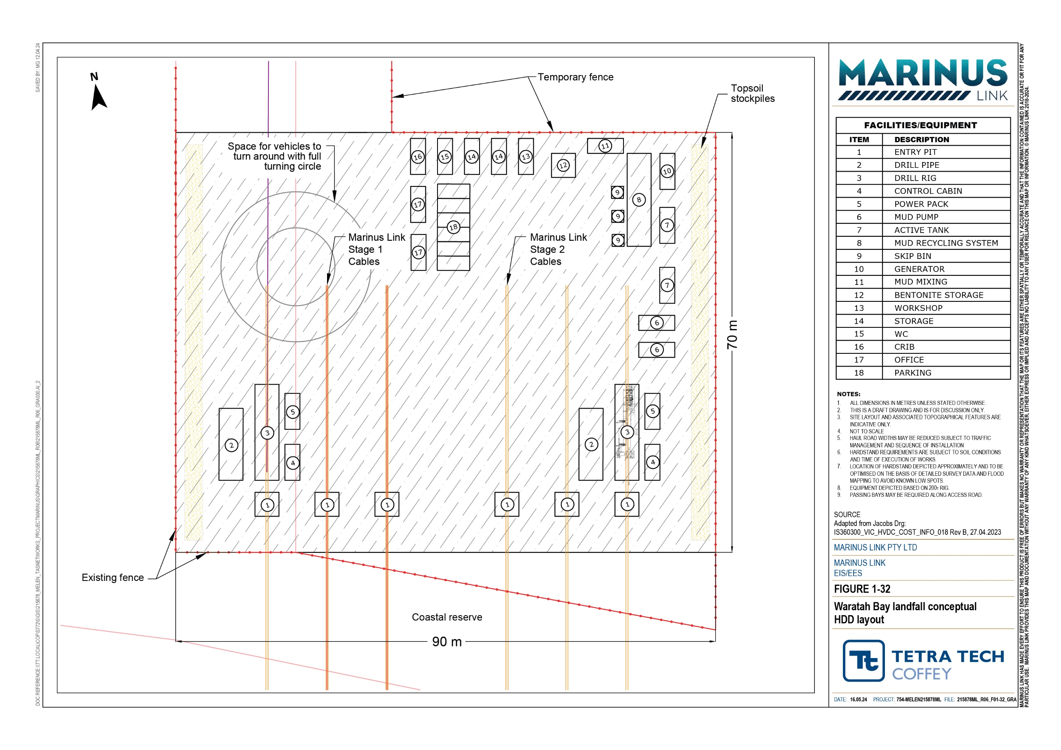

Land cables
Installing land cables from the shore crossing at Waratah Bay to the Hazelwood converter station in Victoria will involve construction of two trenches, haul roads, access tracks, and laydown areas for cable installation and construction of cable joint pits (see Figure 1-33).
It will also require management of removed vegetation, topsoil and excavated soils. Once the civil works are completed, the cable lengths will be pulled through the conduits and joined at each joint pit. The installation of land cables may progress at multiple locations simultaneously across the project alignment. As these activities progress along the project alignment, each construction location is referred to as a work front.
Construction of the land cable will involve construction activities on private land. Land access will be managed through access licences or construction leases with landholders.
The construction corridor for both circuits will be up to 36 m wide and narrower where space is constrained, or sensitive areas must be avoided. The cables for each circuit will be laid in separate conduits in a horizontal arrangement in a single trench. The trenches for each circuit will be a minimum of 5 m apart depending on the position of the haul roads in the construction corridor and the width of the construction corridor. Trenching is expected to progress between 100 m to 300 m (depending on ground conditions) in a 10-hour working day with a minimum of 10 days required to trench between adjacent cable joint pits.
Conduits will be laid in the trenches and covered with cable bedding material more commonly known as thermal backfill to assist dissipate heat generated by electricity flowing through the cables or the native soil. The need for thermal backfill may vary along the route depending upon the thermal properties of the native soil. Thermal backfill is a weak sand-cement mix that provides a consistent material with uniform heat dissipating properties. Concrete or composite slabs will be placed approximately 0.5 m above the conduits and warning tape 0.7 m below the ground surface (see Figure 1-34). Following installation of the conduits and thermal backfill (if required) the trench will be backfilled reinstating the soil horizons. Subsoil will be compacted to at least 85% in-situ soil strength.
Following installation of the conduits and thermal backfill (if required), the trench will be backfilled reinstating the soil horizons. Following cable pulling and jointing, these workspaces will also be backfilled and reinstated. Unless required (e.g., for stage 2 construction) by or agreed with the landholder, temporary haul roads and access tracks will be removed.
Cable joint pits will be spaced 800 m to 1200 m apart (approximately 90 cable joint pits) based on the nominal cable lengths and considering the topography, road and watercourse crossings and farming practices. The cable lengths will be joined at cable joint pits, which will be buried at least 0.5 m below the surface. The cable joint pits will be excavated, and suitable drainage installed to prevent water or moisture ingress during the works. The cable joint pits will be constructed in-situ or pre-fabricated using precast concrete modules and brought to site for installation.
The cables will be pulled through the conduits between adjacent cable joint pits. The cable joint pits and conduits between cable joint pits for both stages will be installed and laid in stage 1 to reduce impacts on properties and farming activities.

Volume 1 – Introduction Page 6-25

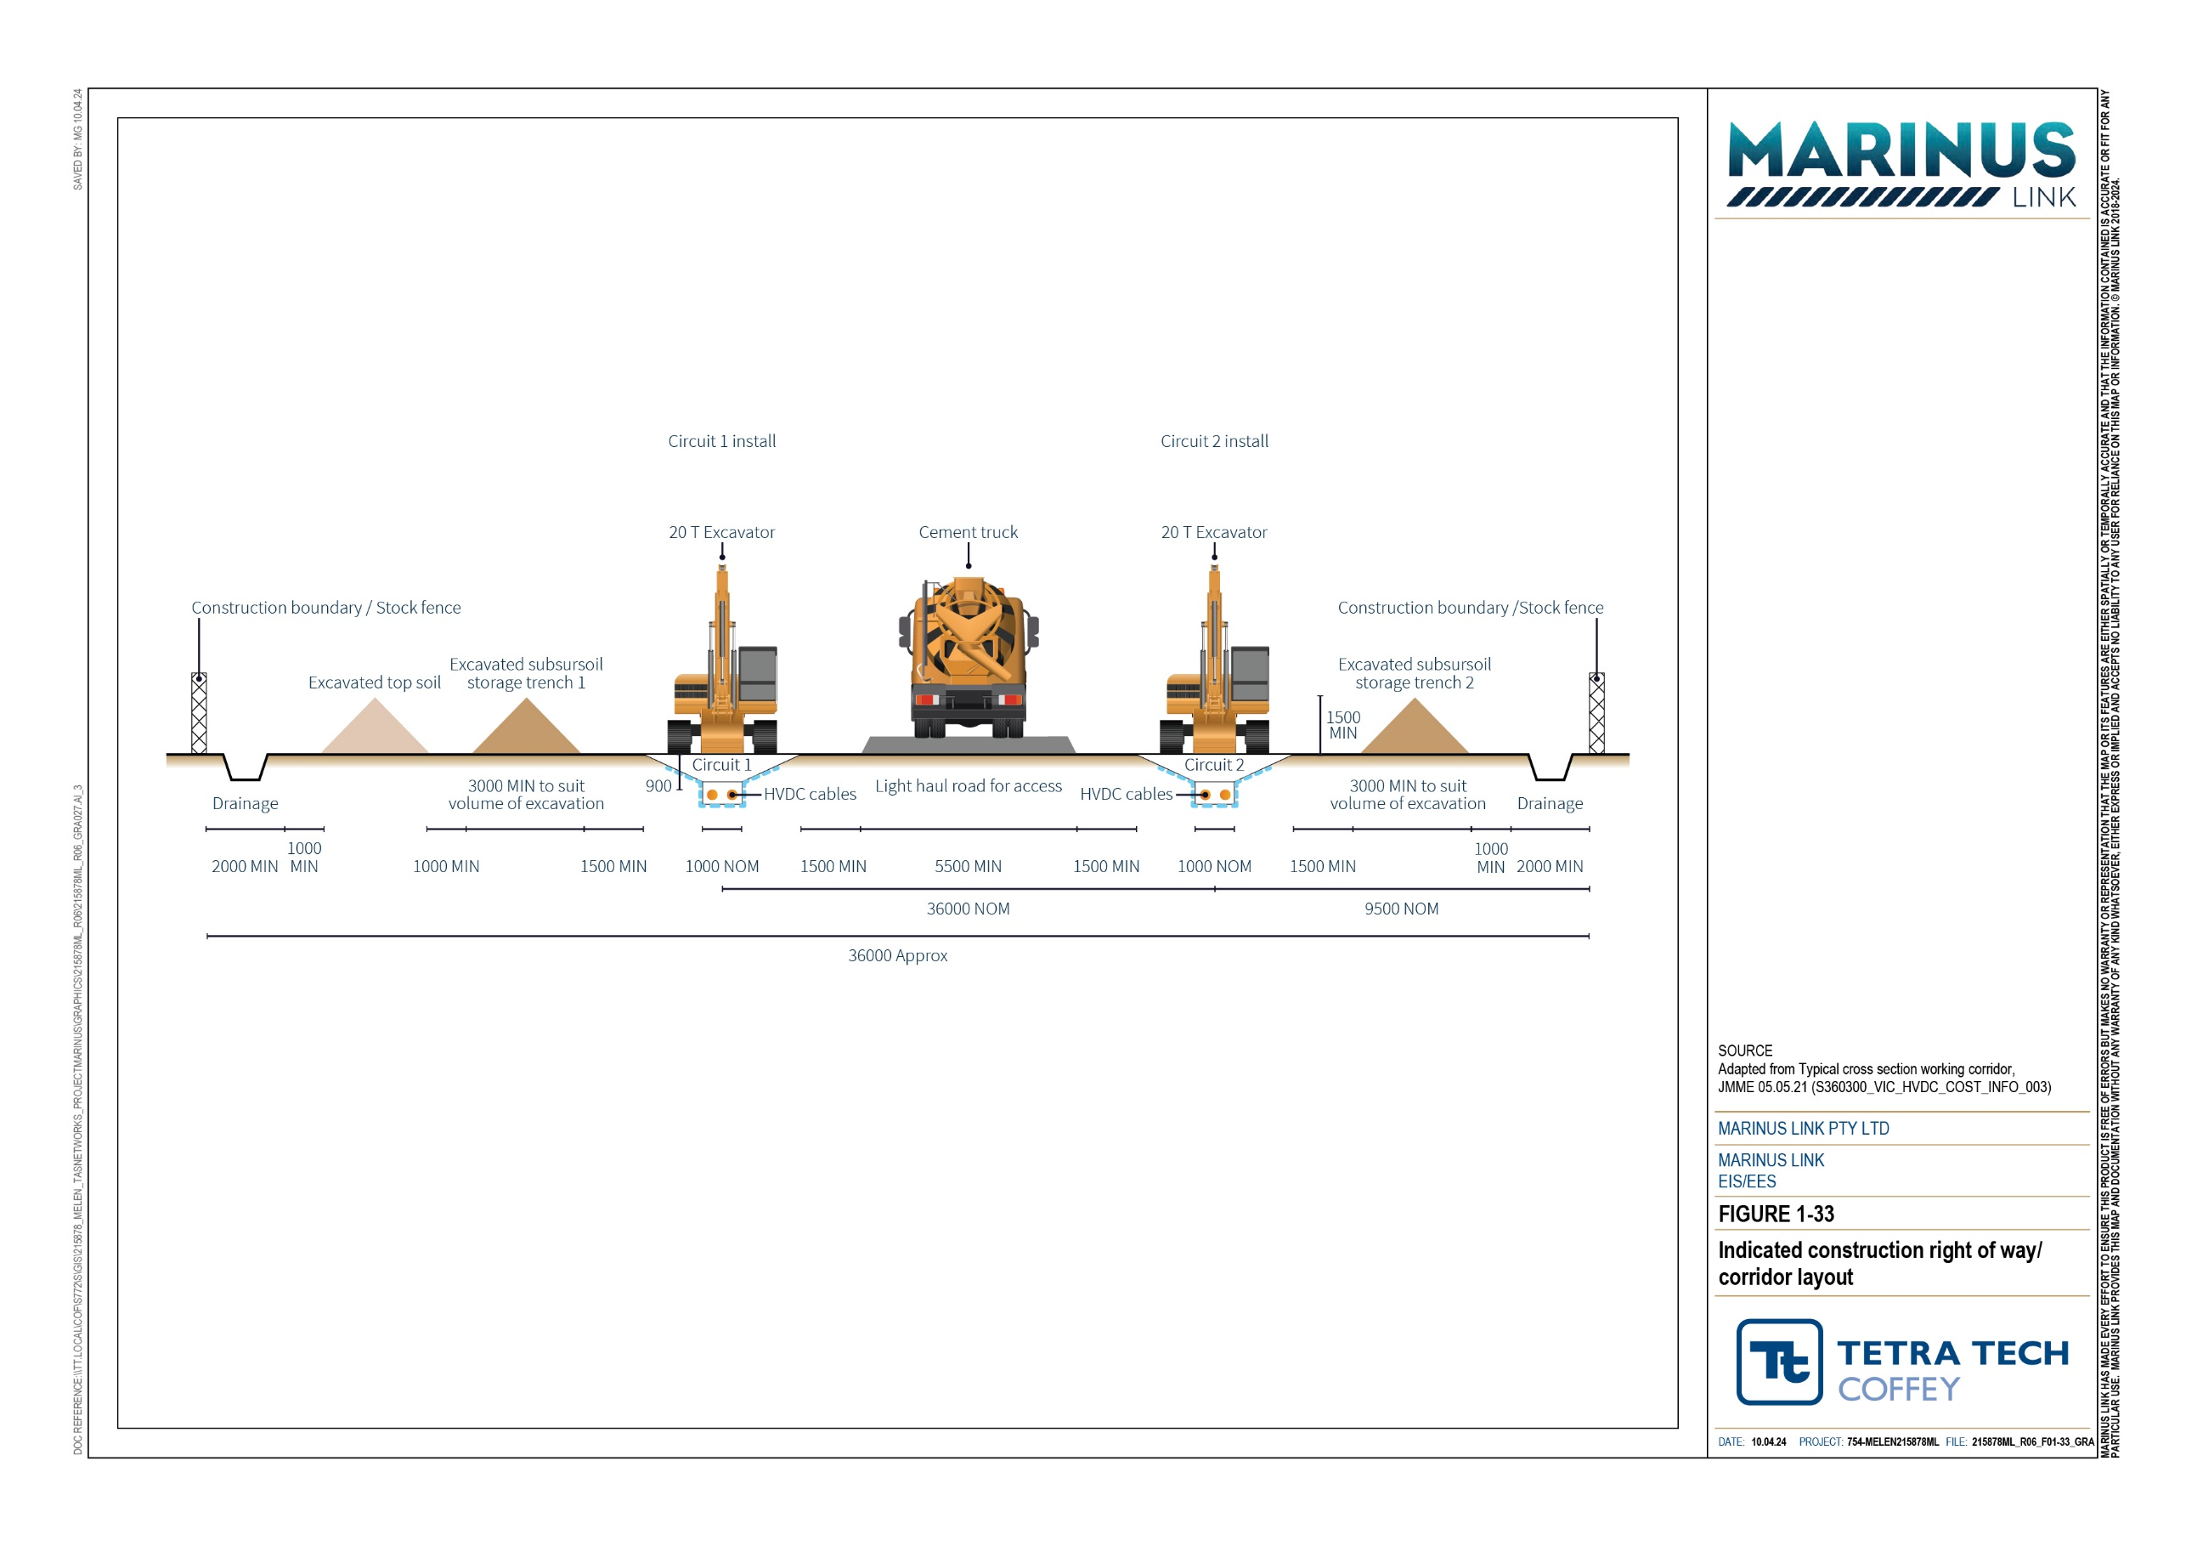

MARINUS LINK HAS MADE EVERY EFFORT TO ENSURE THIS PRODUCT IS FREE OF ERRORS BUT MAKES NO WARRANTY OR REPRESENTATION THAT THE MAP OR ITS FEATURES ARE EITHER SPATIALLY OR TEMPORALLY ACCURATE AND THAT THE INFORMATION CONTAINED IS ACCURATE OR FIT FOR ANY PARTICULAR USE. MARINUS LINK PROVIDES THIS MAP AND DOCUMENTATION WITHOUT ANY WARRANTY OF ANY KIND WHATSOEVER, EITHER EXPRESS OR IMPLIED AND ACCEPTS NO LIABILITY TO ANY USER FOR RELIANCE ON THIS MAP OR INFORMATION. © MARINUS LINK 2018-2024.

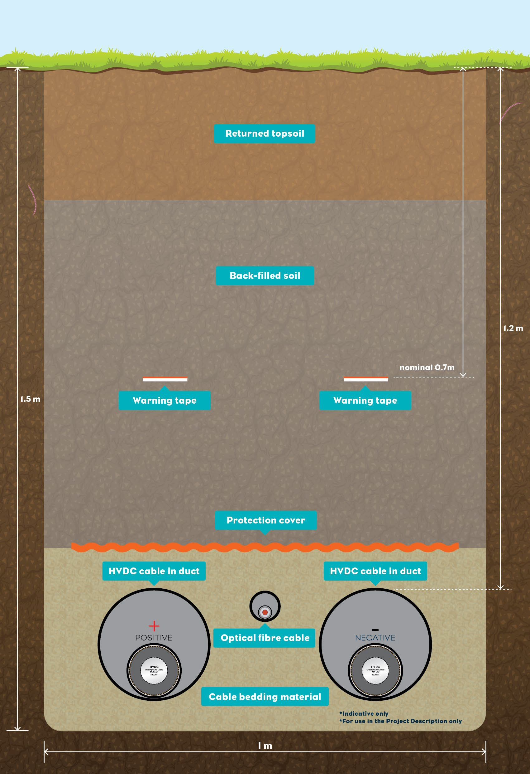
Figure 1-34 Illustration of how the land cable will be installed in the trench

Construction activities are proposed to be undertaken within the identified AoD (see Section 6.1.3) with access to the construction corridor via existing roads as much as possible and, subject to landholder approval, existing access tracks within private land. New access tracks or haul roads will be required to be constructed or existing tracks upgraded where existing access is not suitable.
The key construction activities for installation land cables and joint pits are outlined in Table 6-3. The key activities for trenchless construction are outlined in Section 6.3.2.
Table 6-3 Key activities for land cable installation

Construction phase | Key activities
Site preparation / establishment | Preconstruction surveys.  Preconstruction condition assessments of properties and heavy construction vehicles transport routes.  Establishing weed and pathogen washdown facilities, and any other required environmental controls.  Installing stock proof fencing, where required, and agreed with the landholder. Clearing vegetation and stockpiling.  Topsoil stripping and stockpiling.  Establishment of laydown areas including site offices and amenities.  Establishing site access locations including constructing site entries and access gates, access roads, and access tracks to the construction corridor.
Civil works | Excavation of trenches and stockpiling of subsoil separate from topsoil.  Dewatering trenches or joint pits where construction is below the groundwater level.  Installing the working floor in the trench comprised on a controlled material either sand, gravel, crushed rock or cement bound sand or rock.  Installation of conduits and thermal backfill into trenches. Imported thermal backfill will be required where the native soil does not have the required heat dissipating properties.  Backfilling trenches with thermal backfill (bedding material) or subsoil and topsoil to reinstate soil horizons and reinstatement of the construction corridor except at cable joint pits and where equipment (e.g., caterpuller) required to assist cable installation is required.  Remediation of any soil contamination.  Construction (in-situ) or installation (pre-cast modules) of cable joint pits. Backfilling and reinstatement of cable joint pit workspaces.  Landscaping and screening plantings for the converter station, communications building and potential transition station.  HDD crossing of features, as described in Section 6.3.2 and in the section below.
Cabling works | Transporting cable drums to joint pits.  Pulling of land cables through the conduits between adjacent cable joint pits. Cable jointing.

In some instances, cable pulling and joining activities will occur sometime after the installation of the cable joint pits. This may be the case at particular locations in stage 1, depending on the overall construction program for that stage, and would occur for cable joint pits installed as part of stage 1 works to accommodate the later pulling of the stage 2 circuit. In these locations, the cable joints pits will be backfilled with sand or other appropriate material to provide a safe work environment and prevent erosion or drainage issues, where required. This will be done on a case-by-case basis. All cable joint pit locations during the works will be fenced off to the general public and landholders due to health and safety concerns until the works have been completed.
Cable drums are expected to be transported to every second cable joint pit in most instances. Topography and access will inform the cable drum pulling locations as land cables will typically be lowered down steep slopes, not pulled up steep slopes as the stresses on the cables may exceed the design pulling tension.
Cable pulling at cable joint pits will be undertaken in two stages – one for each of the 750 MW circuits. The land cables will be pulled through the conduits and ducts between cable joint pits under tension to avoid damage.
Cable pulling is expected to start approximately 8 months to 12 months after the trenching and installation of conduits start, however this will be highly dependent on manufacturing timing. Each cable section pull (800 m to 1200 m) will typically take up to five days.
Once the land cable sections have been pulled through the conduits and ducts, they will be joined. Cables are joined in a positive pressure and dehumidified atmosphere enclosure to avoid dust and moisture in the joint (which increases the risk of failures when in operation). A temporary shipping container-sized “jointing hut” will be installed over each cable joint pit to provide a sterile workspace for the jointing works.
Set up at each joint pit has been assumed to take between three and five days with jointing works expected to take between five and eight days at each joint pit.
Where thermal backfill is required, there will be excess subsoil. This excess soil will be classified according to EPA Publication 1828.2 and reused on the property (in accordance with the waste hierarchy) or disposed to a licenced facility if required. If there is no property reuse options, the soil will be disposed of to a lawful facility in accordance with EPA Victoria requirements.
The project alignment crosses 82 waterways, 15 are initially proposed to be crossed with HDD, while the remaining 67 waterways will be crossed by open cut trench construction method.
Crossing of features such as sealed major roads, rail lines, major watercourses, vegetation, and third-party infrastructure will be done by HDD. The proposed HDD locations are shown in Attachment 6 – Marinus Link EIS/EES Map Book.
HDD has been assumed as the trenchless construction method most likely to be used for the project and is the basis for the EIS/EES impact assessments. This assumption was informed by the ground conditions along the alignment and that HDD is often more suited to longer distances.

The assumed HDD locations are between 100 m and 300m in length along the alignment. Each HDD is estimated to take up to two weeks plus mobilising and demobilising. Waratah Bay shore crossing (described in Section 6.3.2), and Morwell River crossing HDD crossings will need to be continuous works for 24-hours per day, 7 days per week to ensure borehole stability.
The method for HDD is broadly described in Section 6.3.2. The difference however for the land cable crossing of features is that there will also be exit pits and pads requiring construction and rehabilitation. HDD involves drilling a borehole under a feature through which a duct is pulled or pushed depending on the method of installation. The ability to use HDD, as well as the length of time required for drilling, depends on geology and other land conditions. Further geotechnical and environmental investigations will inform the approach to HDD at specific locations or other trenchless construction methods selected.
An HDD failure or frac-out can occur at the drill entry and exit pits but most commonly occurs along the borehole alignment. Frac-out is caused by excessive drilling fluid pressure escaping from the borehole through fissures or weaknesses in the substrate. It can result in sedimentation and increased turbidity in watercourses, covering vegetation in drilling fluid, and can cause localised subsidence resulting from collapsed geological strata.
Prior to the commencement of HDD, site establishment will include the HDD pad and drill rig site, the establishment of temporary laydown areas, site office and amenities. HDD requires the establishment of workspaces on both sides of the feature crossing. These areas will be fenced, and designed to provide noise attenuation, as required. Ground preparation of two HDD drill pads and establishment of a hardstand is required to stabilise the HDD equipment, including the HDD drilling rig. The HDD drill rig will be installed and anchored onsite. The HDD pad and drill rig site for crossing of features along the project alignment will typically occupy an area approximately 80 m by 100 m. The HDD exit hole will typically occupy an area approximately 20 m by 40 m. In addition, an area for stringing the duct prior to it being pulled or pushed through the borehole is required. Typically, the duct is strung out from the HDD exit point along the construction right of way. However, this is not always possible and temporary workspace up to the width of the construction right of way and the length of the duct string will be negotiated with the affected landholder.
Inert drilling fluids such as bentonite, are typically used in HDD. Although non-toxic, such products have very fine particles and can elevate turbidity or coat and mask aquatic and terrestrial plants if a frac-out occurs.
Drilling fluids are managed in a closed system. The drilling fluid recirculating system at the HDD drill site extracts drill cuttings for disposal at the site during rehabilitation or for transportation offsite, depending on their properties. Prior to the commencement of HDD, temporary pits will be established onsite to capture drilling mud.
Excavated soils or water will be reused on site, where practicable. However, if excavated soils or water present a contamination risk, they will be managed in accordance appropriately (see Section 6.6.1).

Following construction, the HDD sites will be reinstated and include the following:

Removing plant and machinery, and temporary buildings not required for stage 2.

Removing and disposing (see Section 6.6.1) of hardstand and any temporary concrete foundations.

Restoring disturbed land (not required for stage 2) to its pre-existing condition, at a minimum.

Treating of weed infestations.
Major laydown areas have been assessed at approximately 13 km intervals, while minor laydown areas may be located at every second cable joint pit along the project alignment for the duration of construction of stages 1 and 2. The laydown areas will accommodate materials, spare parts, workforce parking, a site office and amenities and will be a nominal 100 m by 120 m. The laydown areas assessed in the EIS/EES are indicative and could change subject to the outcomes of further landholder consultation.
Construction of the laydown areas and works to establish access, site facilities and the cable joint bays will be undertaken as a rolling program of works during the initial 24 months of construction. The laydown areas, cable joint bay construction areas with amenities and haul roads will remain in place until both stages of land cable installation are complete. Topsoil from the laydown area will be stockpiled so it can be reused in rehabilitation of laydown area. If a landholder chooses to retain the laydown area, the topsoil will be re-used within the construction corridor if possible.
Access tracks will be required in construction and operation. Access tracks will typically be 3 m to 4 m wide however an area of up to 10 m wide may be required for construction or upgrade works to make access tracks suitable for construction vehicles. The preference will be to use or upgrade existing farm and plantation access tracks and roads where practicable and with landholder consent.
Tracks will be required to the cable joint pits, HDD drill pads, and laydown areas. From these locations construction vehicles will use the haul road in the construction corridor to access the construction work sites.
Some access tracks and fences may be retained between stage 1 and stage 2 construction works to access joint pits. Landholder requirements will determine whether a track is permanent or temporary. Unless agreed with the landholder to retain access tracks, all constructed access tracks will be removed.
A haul road will be constructed between the trenches within the construction corridor to support trenching, installation of the conduits and thermal backfill, and cable installation (unless an existing road already exists elsewhere within or close to the proposed easement). The haul road will also be removed unless agreed with the landholder to retain the road.

Dewatering may be required when excavating trenches, cable joint pits and HDD entry and exit pits to manage groundwater ingress or any surface flows that enter the excavations. Dewatering may be required to keep cable joint pits dry during cable installation and jointing activities. Where dewatering may encounter contaminated water, it will be pumped out and held for testing. Contaminated water will be managed and disposed of in accordance with the requirements of the Environment Protection Act 2017 (Vic).
In general, dewatering will involve:

Working methods and systems to limit groundwater inflow to excavations and groundwater drawdown.

Installing, operating and maintaining pumps, plant, pipework, sub drains, sump pumps and other equipment necessary to remove water from open excavations.
Removing groundwater in a way that will not cause damage to the permanent project works or to third party property.
Removing or backfilling temporary sub-drains and sumps so they are watertight once they are no longer required.

Subsea cables
Installing the subsea cables across Bass Strait requires preparation of the cable route to ensure it is clear from debris, laying of the cable and then burial into the sea floor. This section describes the process for installing the subsea cables.
Prior to laying the subsea cables, a pre-lay survey will be completed by a remotely operated vehicle (ROV) to confirm the exact location of the route. A pre-lay grapnel run will follow and remove the debris from the project alignment. The grapnel will cut and collect any seabed debris on the project alignment such as discarded fishing nets, anchor chains, out of service cables, etc, to prevent these from damaging or impeding the works.
The cable lay vessel used for the installation of each project circuit will need to have two turntables, one for each power cable and a cable drum for the fibre optic cable. The power cables and fibre optic cable for each stage will be bundled and tied together using polypropylene rope and cable ties as the cables are unspooled and lowered over the back of the vessel to the seabed.
The subsea cable will arrive in Bass Strait already loaded on a cable lay vessel. The cable lay vessel will transport the cable lengths from the factory in either northern Europe or Japan to Port of Melbourne in Victoria, or Port of Burnie or Port of Devonport in Tasmania. The cable lay vessel will mobilise from those ports to the shore crossings to land the cables and commence cable laying. The subsea cables will be laid in

two campaigns, with the cable lay vessel re-supplied either from the factory or with cable from a cable transport vessel in a port.
Once the cable bundle is laid on the seafloor several smaller vessels (typically locally owned commercial and charter or fishing vessels) will be deployed as guard vessels to ensure that no damage is done by third parties while the cable is exposed on the seabed. The cable laying process is illustrated in Figure 1-35 and Figure 1-36.
A burial vessel will locate, bury and survey the as-laid location of the cable bundles on the seafloor. Geophysical and geotechnical surveys indicate the cable bundles will be buried using water jetting tools to fluidise the sand for the majority of Bass Strait, with small sections of harder substrate requiring mechanical trenching tools or rock mattressing to protect the cable. The subsea cable bundle is picked up from the seafloor and fed over the burial tools to avoid damage as the seabed is fluidised by water jetting. The subsea cable bundle is lowered into the fluidised seabed off the back of the burial tool. The cables will be buried to a depth of between 0.5 m to 1.5 m depending on the substrate. The cable trench will backfill with sand and silt by natural processes. Rock mattresses or armouring, concrete mattresses or cast-iron shells may be required in Tasmanian nearshore waters and in the paleochannels to protect the cables where they are laid on hard substrate.
Cable protection will be undertaken as a separate campaign. For offshore works it is expected that at any one time there will be in operation one cable lay vessel, one burial vessel, and five guard vessels. A large work vessel will be required for constructing the Indigo Central and Telstra BS1 fibre-optic cable crossings.
While cable laying and burial will take place over 12 months, the cable lay and burial vessels operating in Bass Strait overnight and requiring navigational lighting will be active for approximately two to three months (not continuously) for each circuit.
After burial activities have been completed, a remotely operated vehicle (ROV) survey will be completed to confirm the cable has been buried correctly.

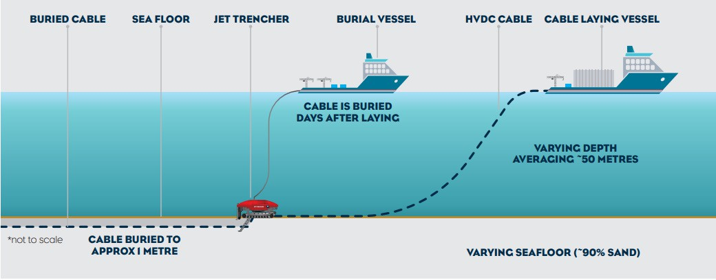
Figure 1-35 Subsea cable laying and burial

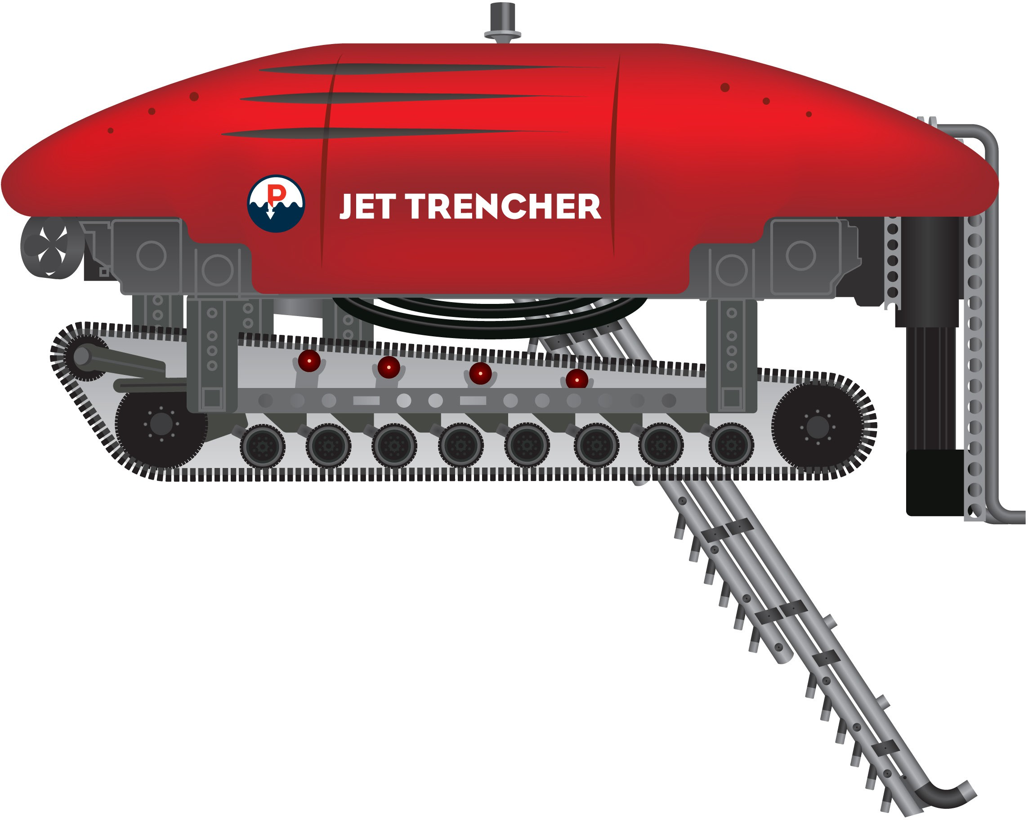
Figure 1-36 Jetting trencher

The subsea cables will cross Indigo Central fibre-optic cable mid-Bass Strait and Telstra BS1 fibre-optic cable in Waratah Bay approximately 5 km offshore in 20 m to 22 m water depth. The cable crossings will be constructed in accordance with United Nations Convention on the Law of the Sea and International Cable Protection Committee guidelines which require submarine cable asset owner agreement on the crossing method. Typically, rock or concrete mattresses will be placed over the existing cable and the subsea cable bundles laid on the mattresses. The subsea cables will be protected by placement of rock mattresses or armouring. Submarine cable crossings are perpendicular to minimise the length of cable affected by the crossing.

Transition station and communications building
If required, construction of the transition station located off Waratah Road in Victoria will include:

Civil works including the access road, transition station bench, foundations and hardstand area.

Installation of containers and communications building (Figure 1-37).

Installation of GIS joints and ancillary equipment.

Joining land and subsea cables.

Testing and commissioning.

An engineered site bench of approximately 3,750 m² will be required to provide a stable base for the transition station. Approximately 750 mm of soil (including 350 mm of topsoil) will need to be excavated to reach suitable ground on which the bench will be constructed. Some of the excavated material will be reused on site for landscaping, however some may need to be transported and managed offsite in compliance with the waste management hierarchy and GED.
If only the communications building is needed for this site, the following construction activities will be required:
Civil works including the access road, transition station bench, foundations and hardstand area.

Installation containers and communications building.

Testing and commissioning.
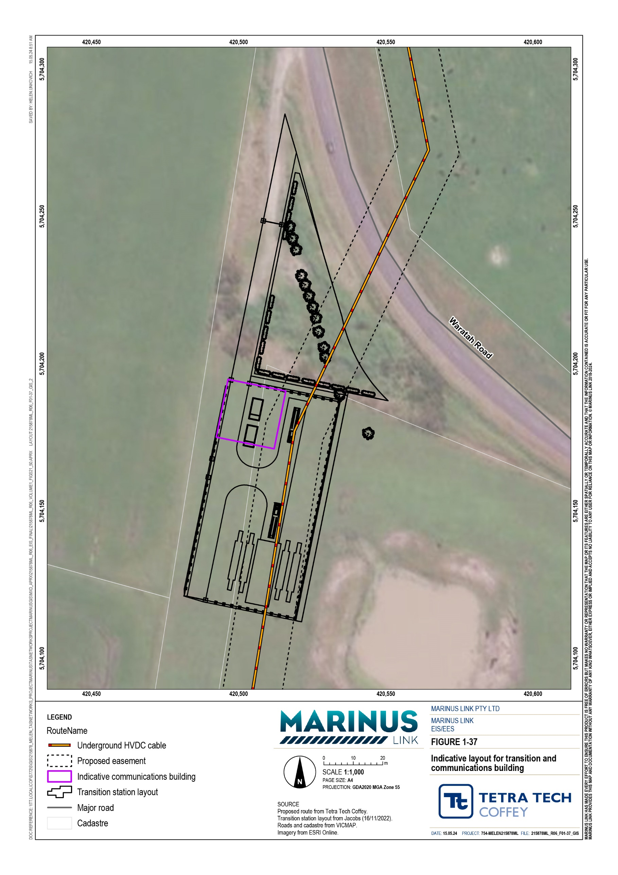

Construction vehicles
Construction will require the movement of equipment, plant, materials, and workforce personnel.

The potential types of equipment, plant and vehicles required for project construction, which have been considered in the impact assessments, include:
Converter stations: Heavy rigid, flatbed and light trucks, semi-trailers, excavators, graders, backhoe diggers, concrete trucks, 100 t and 200 t mobile cranes, elevated work platforms, air compressors and portable generators.
Transformer transport: Construction of the converter station will require the delivery of several large transformers. This will require a bespoke vehicle arrangement which will be approximately 130 m long, 6 m in height and will weigh approximately 650 t, as shown in Figure 1-38.
Shore crossing: HDD drill rig, heavy rigid, flatbed and light trucks, light vehicles and excavators.

Cable joint pit construction: Excavators, mobile crane, concrete trucks, heavy rigid and flatbed trucks, and light vehicles.
Land cable construction: Excavators, heavy rigid and flatbed trucks, light vehicles, cable drum transport, and HDD drill rigs.
Cable jointing: Heavy rigid trucks, a mobile crane, light vehicles, excavator.

Backfilling of trenches and cable joint pits: Excavator, front end loader, grader, flatbed trucks and light vehicles.
Construction vehicles will be stationed at major or minor laydown areas.
At the Heybridge converter station site traffic movements are likely to generate a total of 420 total vehicle movements per day, including heavy, construction light vehicles and employee vehicle movements.
It is assumed that all construction related heavy vehicle traffic volumes will be arriving to the construction sites from either Burnie (west of the site), Devonport or Launceston (east of the site). These paths of travel will both primarily use the Bass Highway, turning into the site at the Minna Road intersection.
Construction of the Victorian shore crossing is likely to generate 74 vehicle movements per day. The transition station daily vehicle movements are likely to be 106 vehicles, Hazelwood converter station may generate 420 vehicle movements per day, with 216 daily traffic movements at laydown areas. The remainder of the project alignment works are expected to generate traffic movements of 103 vehicles per day.

Volume 1 – Introduction Page 6-37
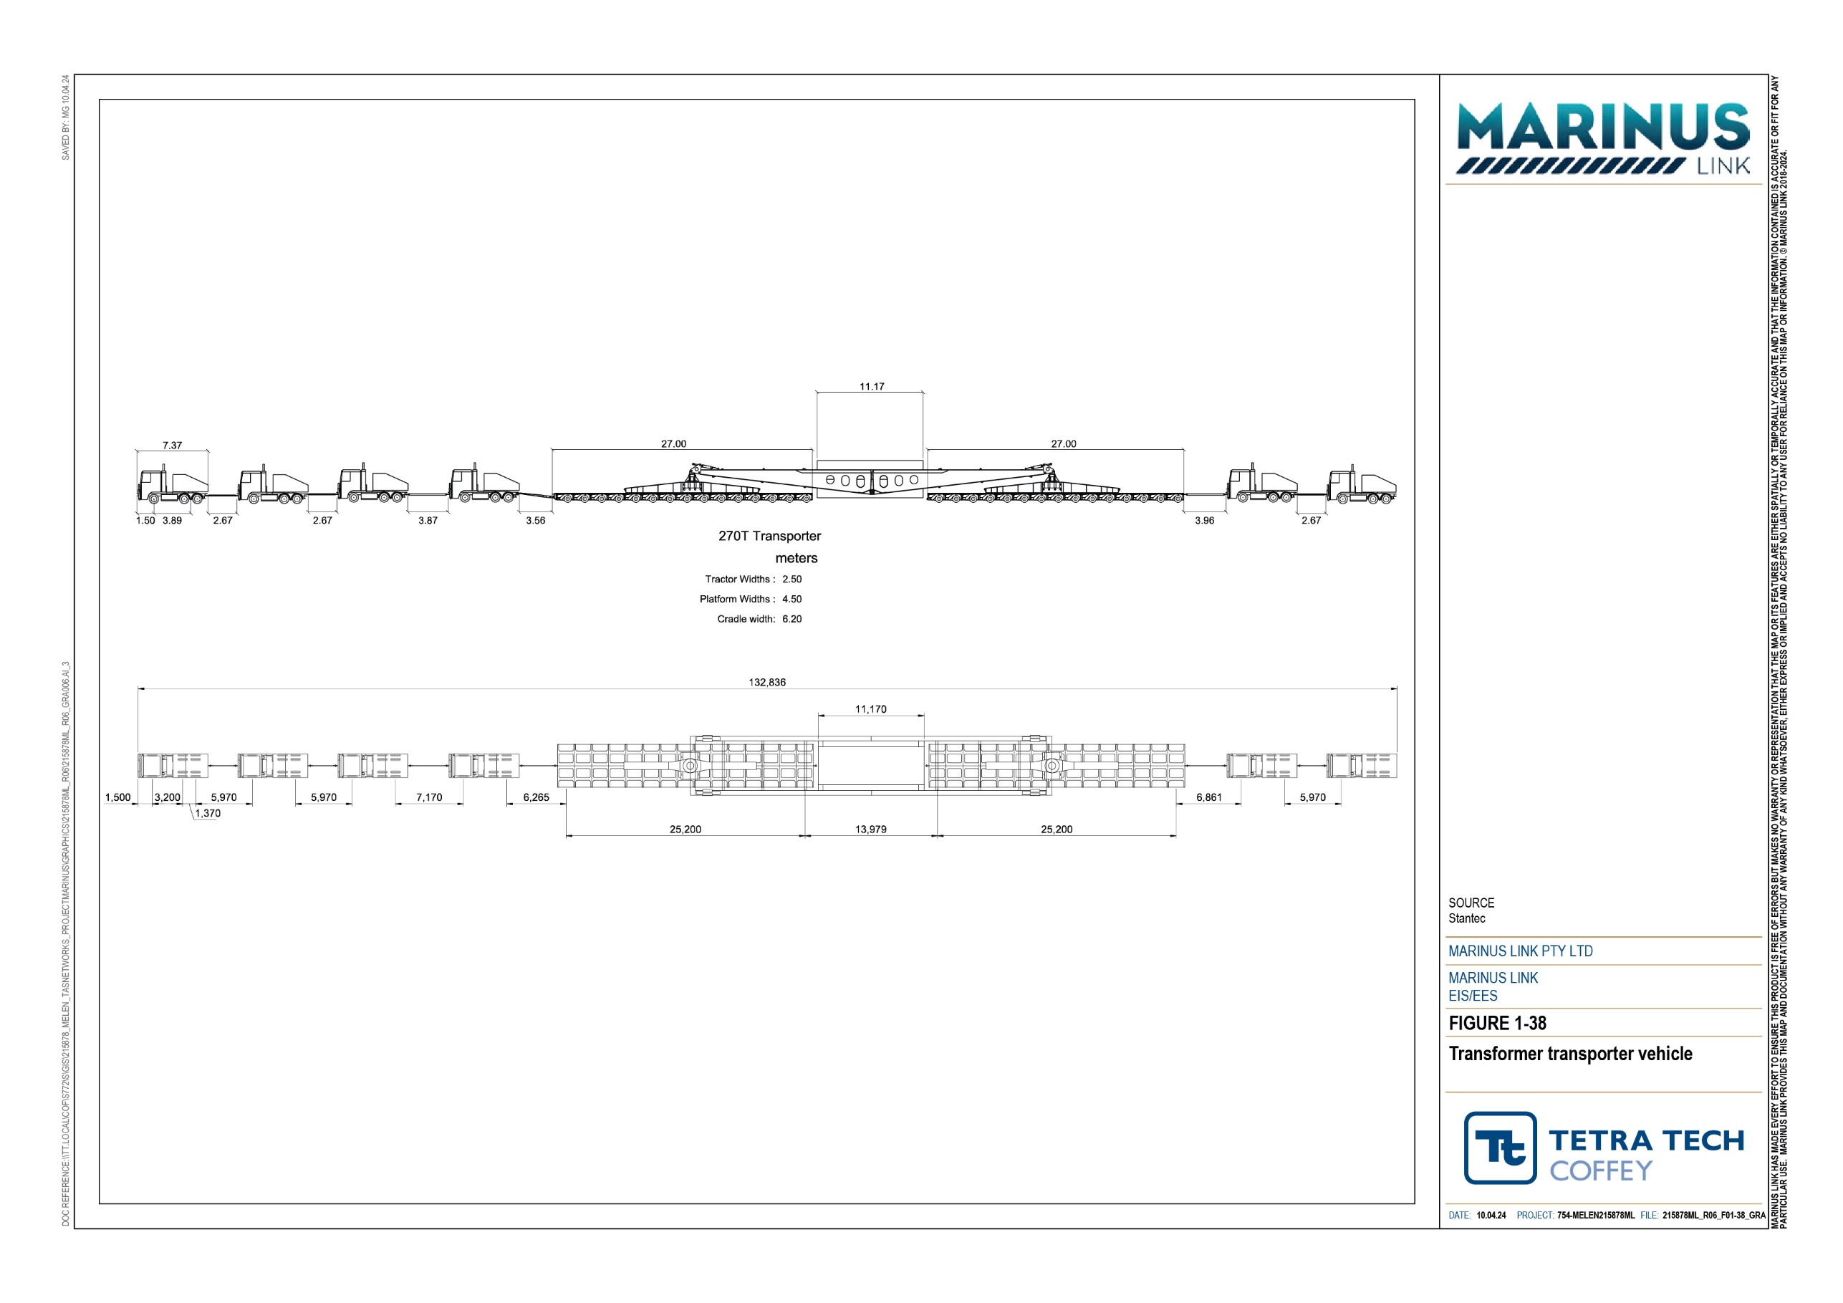

Reinstatement and rehabilitation
Workspaces including the construction corridor, access tracks, HDD drill pads, waterway crossings and laydown areas will be reinstated and rehabilitated following completion of construction. Reinstatement and rehabilitation will ensure the land is returned to pre-existing use or a condition consistent with the proposed land use, and will be determined in consultation with landholders. Reinstatement includes replacing any structures, fences, services, landforms and anything else removed during construction. Rehabilitation includes activities to enable land capability and capacity to be returned to pre-construction conditions so that existing land uses can resume. Reinstatement and rehabilitation activities are described in Table 6-4.
Table 6-4 Reinstatement and rehabilitation activities

Construction phase | Activities
Reinstatement | Removing any temporary structures, haul roads, access tracks, hardstand, buildings or services established for construction.  Watercourse crossings reinstatement including reconstructing channel form and banks, and stabilising watercourse bed and banks using appropriate methods such as rock armouring, geotextile fabric and plantings.  Road formations, pavements and road infrastructure, which have been used for heavy construction vehicles, reinstated to conditions consistent with preconstruction standards or as agreed with the road authority.  Reinstating fences, services and any other infrastructure removed to enable construction.  Reinstating surface contours, drainage lines and stormwater drains.
Rehabilitation | Rehabilitation of land to the same gradient, drainage and condition. Rehabilitation of soil condition and soil horizons.  Revegetation with species agreed with the landholder.  Monitoring for erosion, sedimentation, subsidence and weeds.

Reinstatement will include all land being returned to pre-existing conditions when not required for a subsequent stage.
Access roads to and between joint pits will be retained until the stage 2 circuit is installed where agreed with landholders. Where access for stage 2 is not required, the access track will be removed at the end of stage 1 unless agreed with the landholder it is to be retained. Where access is required for stage 2, access tracks and construction pads are assumed to be maintained until works are completed.
Reinstatement activities typically take five to ten days between each cable joint pit and two to five days at each cable joint pit.
Construction working corridor fences will be removed once vegetation and land use has been established and in agreement with the landholder. Rehabilitation of agricultural land and replanted vegetation will be monitored as part of the regular easement inspections, and in accordance with the rehabilitation strategy (refer to Section 6.4.4).

Successful rehabilitation of agricultural properties will be indicated by two grazings by stock or two crop cycles and no evidence of slumping or erosion in agreement with the landholder. Re-vegetated areas will also be inspected at the same intervals to confirm vegetation has established and is largely weed free.
Unsuccessful rehabilitation will be remediated. Each property will have a property management plan that will set out the rehabilitation requirements agreed with the landholder.
Native species will be used in revegetation and plantings, particularly in areas where habitat is removed, and that are suited to the landscape.
Impacts to waterway crossings will also be minimised through the reinstatement of construction areas together with the management of any site runoff to reduce the risk of erosion. Revegetation and reinstatement of the beds and banks of waterways and drainage lines will be managed in accordance with West Gippsland Catchment Management Authority requirements.

Construction workforce and hours
The construction workforce will require a variety of skills for the civil construction and electrical installations. This section describes the workforce and working hours required for construction of the project.
The contractors engaged for construction of the converter stations, shore crossings, transition station and land cable will determine the final workforce numbers and composition required to meet the program. This section outlines the estimated workforce numbers that have been considered in the impact assessment.
Workers for the construction of each converter station are expected to peak at approximately 180 persons per day. The workforce will be made up of local, intrastate, interstate and international personnel depending on the complexity of the work and the requirement for specialist skills and equipment.
For the Heybridge converter station, over the 36 month duration of construction it is anticipated that local workers from north west Tasmania may make up approximately 45% of construction workforce, with 30% from elsewhere within Tasmania. Interstate resources coming from other locations within Australia may make up approximately 17% of the workforce with the balance international. Non-local Tasmania workers are expected to seek short-term accommodation in major townships in north west Tasmania including Burnie
and Ulverstone.

For Hazelwood converter station works over the 44 month construction period, it is anticipated 87% of the workforce is anticipated to be local or state-based workers (e.g., 45% local and 42% state) with 5% from interstate. It has been assumed that approximately 47% of the workforce will require accommodation local to site in close by townships such as Morwell, Traralgon, Leongatha, Meeniyan and Foster.
The land cable construction will require up to 125 full time equivalent staff over 36 months for civil works. There would then be another 50 workers for 18 months for cable pulling and jointing. It has been assumed for that land cable construction will involve multiple moving work fronts along the project so the workforce will be spread out along the project alignment.

For the construction of the subsea cable specialised cable laying crews will be required. Subsea cable lay vessels are typically owned by the cable manufacturers or specialist partners, and they work all over the world shipping and laying cables mainly for offshore wind farms and interconnectors. The crew are specialised and largely employed directly by the vessel owners, supplemented with some casual crew including a few roles for locally sourced crew.
The cable lay vessel will be manned by a crew working 24 hour, 7 days per week in shifts. There is typically a marine crew of approximately 20 people, who are responsible for the operation of the vessel. The cable management crew of 60 to 70 people will control the cable installation. The marine crew live aboard permanently (on rotation), and the cable management crew fly in and out to ports local to the project and will join the vessel for up to 30 days at a time. Crew rotation is managed through port calls and the off going crew will either fly home or stay in the region for their leave break.
Construction activities will generally occur during the normal working hours defined in EPA Publication 1834 Civil construction, building and demolition guide being Monday to Friday 0700 – 1800 hrs and Saturday 0700 – 1300 hours, excluding public holidays. Unavoidable works may be required outside these working hours.
Extended working hours resulting from unavoidable works could relate to:

Works that need to be undertaken without a break in program, such as concrete pouring.

Delivery of essential, oversized plant or equipment.

Time sensitive maintenance or repair of public infrastructure.

Emergency works required due to unforeseen circumstances.

Protection and control commissioning work within the switching station.

Construction works that will require 24 hour, 7 day activities include subsea cable installation and shore crossing HDD and Morwell River crossing. These activities need to be continuous to ensure the integrity of cable laying and boreholes respectively.

Indicative construction program
The indicative construction period for the project is two stages over four to seven years. Impact assessments for this EIS/EES have been based on an indicative construction program set out in Figure 1-39 in which construction of stage 1 (including the civil works and conduits for both cables) is anticipated to be completed by end 2028 and operational by end 2029, with the further cable laying for stage 2 assumed to be completed by end 2029 and operational by end 2030. The planning controls and EPRs apply to both Stages to ensure that impacts of the project are appropriately managed, including full rehabilitation of affected land. The actual timeframe for delivery of stage 2 will be determined by market demand.
The land cable civil works construction and installation for one circuit will take approximately 26 months. Installation of the second circuit will take approximately 18 months.

It is expected the Heybridge converter station construction will take to be up to 36 months for each stage, including approximately 12 months of HDD drilling for the shore crossing for both circuits. The Hazelwood converter station is expected to take up to 44 months to construct. The shore crossings in both Tasmanian and Victoria is expected to take 12 months to complete.
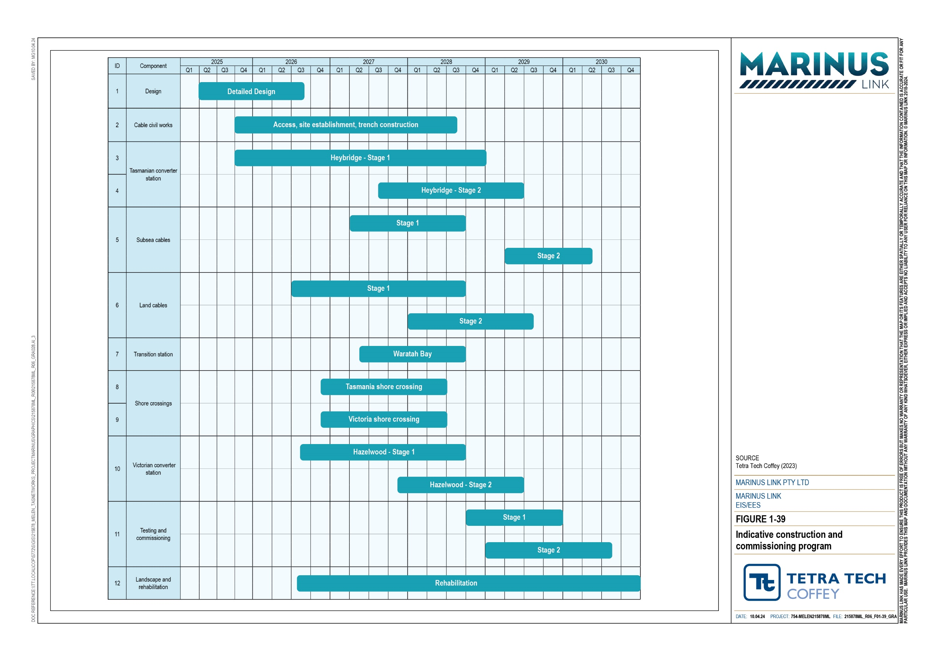

Operation and maintenance
Operation and maintenance activities commence following commissioning of the project and the interconnector entering service. The activities will continue for the life of the project to ensure its safe and reliable operation.
The project will operate 24 hours per day, 365 days per year over an anticipated minimum 40-year operating life.
Operation and maintenance activities will typically include:

Routine inspections of the land cable easement for potential operation and maintenance issues, including:
- unauthorised activities and structures

- land stability

- rehabilitation issues including weed infestations resulting from construction activities

- cover at watercourse crossings.

Periodic inspection of the subsea project alignments by ROV.

Remote monitoring of shipping activity near the subsea cables for potential anchoring issues.

Servicing, testing and repair of the subsea and land cables, transition station and converter stations and ancillary equipment including scheduled minor and major outages.
Reinstatement and rehabilitation of any temporary workspaces required to repair the subsea or land cable.
Maintenance of permanent access tracks.

Table 6-5 provides further details of the maintenance schedule for the project.

Table 6-5 Marinus Link maintenance schedule

Activity area | Asset area | Schedule
Non-outage scheduled maintenance | Converter stations | Quarterly
Outage scheduled maintenance | Stage 1 and stage 2 circuits | Year one then every two years
Mid-life refurbishment | Stage 1 and stage 2 circuits | Years 10, 20 and 30
Cable surveys and works | Cable stores | Every two years
 | Cables | Seabed surveys in year two, year four and then every six years.  Remedial work every six years or as required

Easement conditions on property titles will set out restrictions on activities on the easement. Most farming and cropping activities can continue although no buildings or trees will be allowed within the easement.
Cable joint pits will be marked with poles and the project alignment will be marked at paddock and property boundaries.

Converter stations
Operation and maintenance vehicles entering and exiting the converter station site will be between two and five light vehicles per day for operation staff. Planned outages which occur up to twice a year will involve 15 to 20 personnel working normal working hours for up to two weeks.
During the operational and maintenance phase workers will be undertaking tasks such as waste collection, routine maintenance, inspecting equipment, alarm response, outage coordination and planning, and training.
The switchgear in the converter stations contains SF6 and is maintained every four to six years. Maintenance typically does not require internal access to gas compartments ensuring the SF6 remains within the closed pressure system. Test instruments to identify SF6 gas leaks during will be used. Gas compartment monitoring will identify leaks that develop in service by a drop in pressure in operation.
While ‘non-active’ gas compartments (i.e., those containing no switching devices or moving parts) will generally not be accessed over the lifetime of the installation, ‘active’ compartments may be subject to internal inspection after 20 to 25 years in service. This necessitates recovery of SF6 gas using a closed system to avoid leaks. Any unplanned repair work requiring internal access to the gas compartments will follow the same SF6 gas recovery procedures.
Fuel and energy will be consumed in the converter stations during operation and maintenance. Fuel and energy usage at both converter station sites is summarised in Table 6-6 and has informed Technical Appendix D: Greenhouse gas emissions.
Operational greenhouse gas emissions will come from two main sources: the routine operation of the stand-by diesel generator sets and SF6 gas leaks from the high voltage switchgear. Power consumed in operating the converter and transitions stations will contribute to indirect greenhouse gas emissions.
For the SF6, the Energy Network Australia guideline is to assume 0.5 % leakage per year and 1 kg of SF6 being equivalent to 22.8 t of CO2.

Table 6-6 Converter stations fuel and energy usage

Heybridge converter station | Hazelwood converter station
Two 1.5 Mega Volt Amps gensets with 2500 L of fuel storage | Two 1.5 Mega Volt Amps gensets with 2500 L of fuel storage each

Converter station SF6 switchgear comprising four main circuit breakers at 100 kg each.
Converter station switchgear comprising four main circuit breakers at 105 kg of SF6 each giving a total volume of 420 kg.

220 kV GIS with between 3000 kg and 5000 kg of SF6
The 500 kV AC yard will have 10 circuit breakers with 105 kg of SF6 gas each giving a total volume of 1050 kg.

Power consumption for operation of buildings on site, approximately 700 kW average based on 24 hours per day, 7 days per week operation over 365 days.
Power consumption for operation of buildings on site, approximately 700 kW average based on 24/7 operation over 365 days per year.

Energy used for the operation of the converter station is Energy used for the operation of the converter station will assumed to be 80% from Tasmanian renewable energy be from a fossil fuel source in Victoria.
sources and 20% from fossil fuel sources in Victoria.

Subsea cable
Cable monitoring systems will be installed to assist identify the location of cable faults. Seabed inspection using a ROV will occur periodically. It is not expected that exclusion zones will be established over the subsea cable in operation.

Transition station and communications building
The transition station at Waratah Bay will not be manned. During normal operations, the site will be monitored remotely. Regular inspections of buildings for weeds, pests and drainage will be done and maintenance activities carried out.
The communications building will also be monitored remotely and regularly inspected. In the event mains supply is lost, the UPS will provide power for up to six hours, after which the backup generator will start and provide supply for up to four days to the communications building. The generator will start automatically when the UPS system runs low on energy. Generator fuel tank levels will be monitored remotely.

Land cables
The land cables will require very little maintenance. Routine maintenance will be required at cable joint pits and associated link boxes with sheath tests conducted every five years. For these tests, there would be two workers using hand held equipment and a standard four wheel drive (4WD) vehicle for access.
Route visual inspections of the project alignment will also be undertaken fortnightly from a vehicle either on public roads or access tracks. The purpose of these inspections will be to ensure that no unauthorised activities are occurring on the easement. The inspections will also include checks for weeds and pests and changes in landforms or ground conditions. Inspections may also include inspection of adjacent land for evidence of instability.

Additional inspections of the project alignment will be completed following major weather events such as earthquakes, major storms or rainfall events and fires, or if requested by the landholder. Inspections will check slope stability and for any changes in landform or ground conditions.
Rehabilitation of agricultural land and replanted vegetation will be monitored as part of the regular easement inspections, and in accordance with the rehabilitation strategy, at three-month intervals for two years post construction to ensure rehabilitation and re-vegetation success.
A 20-m-wide easement will protect the land cables and provide space for future cable replacement and/or additional transmission capacity (subject to future approval). The easement will facilitate ongoing access for maintenance or other operations purposes. No restrictions will be placed on the size of agricultural vehicles that can travel over the land cable easement. Cable joint bays may have some restrictions depending on their location and will be assessed on a case-by-case basis.

Decommissioning
The operational lifespan of the project is a minimum of 40 years. At this time the project will be either decommissioned or upgraded to extend its operational lifespan.
Requirements at the time will determine the scope of decommissioning activities and impacts. Table 6-7 provides an outline of the key decommissioning activities at the end of the operational life of the project. The key objective of decommissioning is to leave a safe, stable and non-polluting environment, and minimise impacts during the removal of infrastructure.
Decommissioning will be planned and carried out in accordance with regulatory and landholder requirements at the time. Decommissioning plans for onshore and offshore infrastructure will be prepared in accordance with approvals conditions prior to planned end of service and decommissioning of the project. The decommissioning plans will outline how activities will be undertaken and potential impacts managed as outlined in EPRs EM04 and EM05 included in the Environmental Management Framework for the project (Volume 5, Chapter 2 – Environmental Management Framework).

Table 6-7 Decommissioning activities
Above ground buildings and structures. Land cable joint pits.
Concrete cable joint pits would be broken down to at least one metre below ground level and buried in-situ or excavated and removed.
Rock mattresses and subsea cable armouring.
Removal and demolition
Possible decommissioning activities
Remediation Remediation of any contamination.
Recovery
Land cables.
Subsea cables recovery by water jetting.
Leave in situ Conduits install by HDD and shore crossing ducts. Cable joint pits below one metre of ground level.
Any below ground infrastructure where it is found to be a lower environmental and landholder impact.
Waste management
Land cables to metal recyclers for recovery of component materials. Implementation of waste management hierarchy principles, avoid, minimise, reuse, recycle and appropriately dispose.
Waste management practices will accord with applicable legislation at the time.

Reinstatement and rehabilitation

Waste
Reinstatement of land surface once infrastructure is removed.
Rehabilitation of the site to provide a self-supporting landform suitable for the end land use.
The land returned to the previous land use or as agreed with the landholder.

Waste generated in construction, operation and decommissioning will be managed in accordance with the waste management hierarchy and applicable legislation.
The principles for waste management to be adopted in all stages of the project are: avoid generating waste
minimise waste segregate waste
reuse materials or equipment recycle materials or equipment
appropriately dispose waste in accordance with regulatory requirements.

Waste in Victoria will be managed in accordance with relevant legislation including:
Environmental Protection Act 2017 (Vic) and GED
Environment Protection Regulations 2021 (Vic)
Occupational Health and Safety Act 2004 (Vic)
Environmental Management and Pollution Control Act 1994 (Tas)
Environmental Management and Pollution Control (Waste Management) Regulations 2010 (Tas).

Permissions may also be sought from EPA where applicable for waste storage and disposal. Waste in the marine environment will be managed in accordance with:
Convention for Prevention of Pollution from Ships (MARPOL)

Protection of the Sea (Prevention of Pollution from Ships) Act 1983 (Cwlth)

Hazardous Waste (Regulation of Exports and Imports) Act 1989 (Cwlth).

Waste will be classified and managed in accordance with regulatory requirements in Victoria including domestic waste, industrial waste and controlled or priority waste. The EP Act provides a framework for the management of waste in Victoria. Waste arising from commercial, industrial or trade activities or from laboratories, is required to be classified. EPA publication 1968.1 Guide to classifying industrial waste provides guidance on the process for classifying industrial waste under the EP Act and Environment Protection Regulations 2021.
The project will maintain an inventory of all waste generated and managed on project sites, including the type of waste, the volumes, the disposal method and disposal location and/or contractor managing the disposal. The project will use EPA Victoria’s Waste Tracker to ensure reportable priority waste (hazardous waste) is appropriately managed, transported and lawfully disposed.

Construction waste
Waste will be generated in the construction of the converter stations, transition station, communications building and installation of land cables and joint pits. Waste streams are expected to include:
excavated material

concrete formwork materials

treated timber and plastic conductor drums and lagging

packaging material (plastic wrapping, paper, cardboard, crates and boxes)

bare copper used for earthing grids

metal off-cuts and unused metal sections

low voltage cable waste

domestic general waste

drill cuttings, mud or fluid

green waste

water from dewatering activities

Liquid waste from toilets and other amenities will be collected and stored in tanks associated with those facilities, for removal by a licensed contractor to wastewater treatment facilities. Alternatively, where possible, amenities will be connected to existing utilities.

During HDD drilling mud or fluids and cuttings are mixed, used and recycled in a closed system designed to avoid spills and seepage to the water table and adjacent watercourses. The drilling mud will be recycled and reused. The drilling fluid cycle comprises the HDD rig, a return sump and the solids control unit. Any drilling residue will be collected in containers for disposal to an approved site.
Contamination testing will be undertaken on the drill cuttings, which will be stored in a bunded area on site and then managed in line with GED depending on the results of the contamination testing and classification of waste. If the drill cuttings are of suitable quality and structural properties, they will be reused on site.
Material extracted from the pits will be set to one side and used to refill the pit after completion of the drilling. The cuttings will be stored in a bunded controlled area, under plastic sheeting. The material is proposed to be stored on site for up to six months.
No emission of SF6 is expect when charging of the GIS switchgear at the Heybridge and Hazelwood converter stations and transition station is done. SF6 switchgear is charged and removed using a closed system that limits the potential for wastage. Recognised and established industry procedures will be used to limit the loss of SF6 to be <0.5 % of the filling volume.

Operation and maintenance waste
Waste generated in operation, and maintenance will be managed in accordance with the waste management hierarchy and applicable legislation.
During operation, the following waste may be generated from operation and maintenance activities at the converter stations:
Oil (equivalent to 90,000 L) in each transformer (six in operation per site). Oil leaks are expected to be negligible, and any oil removed will be recycled.
Lead acid batteries for the emergency power system at the converter stations will need to be replaced every 10 years. There are two 125 V DC battery banks which consist of 58 lead acid cells. Lithium batteries with a 20 to 25-year life are being progressively used by the electricity transmission industry, however it is uncertain if they will be adopted for this project.
Approximately five rat bait stations will be required to be replaced every six months.

Approximately 20 L of herbicide for weed control will be used every three months.

Packaging from spare parts and consumables.

General waste from staff on site.

Emission of SF6 from the Heybridge converter station, transition station and Hazelwood converter station in operation are estimated to be:
Heybridge converter station could emit 2 kg of SF6 from circuit breakers annually.

Heybridge switching station contains a 220 kV GIS that could emit 20 kg of SF6 annually.

DC GIS transition station could emit approximately 8 kg of SF6 annually.

Hazelwood terminal station extension could emit approximately 7.35 kg of SF6 annually.

