Community and stakeholder engagement
Community and stakeholder engagement includes different forms of contact, collaboration, and information shared between MLPL and other organisations or individuals. It has helped to identify issues and informed the impact assessments prepared for the EIS/EES. This chapter is based on the report provided in Attachment 4: Consultation report and describes the engagement approach that has been undertaken by MLPL.
This chapter outlines the engagement carried out during the development of the EIS/EES and the ongoing engagement proposed to be undertaken by MLPL, subject to receipt of project approvals.
Community and stakeholder views are a key consideration of the Commonwealth and Victorian governments in the environmental assessment and approval processes. The Commonwealth EIS guidelines set out the following requirements relating to community and stakeholder engagement.
Section 9: Economic and Social Matters.

Section 10: Consultation.

Refer to Attachment 1: Guidelines for the Content of a Draft Environmental Impact Statement for the EIS guidelines.
The Victorian EES scoping requirements set out that consultation with the community, stakeholders and First Peoples must inform the development of the project and technical studies prepared for the EES. The scoping requirements also specify that the proponent is responsible for preparing and implementing a Victorian Consultation Plan (Consultation Plan). The Consultation Plan sets out the engagement approach required to inform the EIS/EES for areas onshore and offshore within state waters up to 3 NM offshore. The Consultation Plan was reviewed and amended in consultation with the TRG and DTP. The Consultation Plan was developed to:
Provide appropriate opportunities for input and feedback from different stakeholders on the project and EIS/EES investigations, and inform them of these opportunities.
Provide an outline of a program for community stakeholder engagement and communications for the construction and operational phases of the project.
Support and enable culturally appropriate, informed and meaningful engagement with First Peoples, including ongoing engagement.
Refer to Attachment 2: Scoping Requirements Marinus Link Environment Effects Statement for the EES scoping requirements.

This chapter outlines the approach to engagement. The outcomes from this engagement and the project response to the feedback is provided in:
Volume 2 Tasmania, Chapter 1 – Introduction

Volume 3 Marine, Chapter 1 – Introduction

Volume 4 Victoria, Chapter 1 – Introduction.

Engagement approach
MLPL has been raising awareness of the project since 2018, providing information and seeking feedback from the community, stakeholders and First Peoples. The project has adopted a best-practice approach to meet the engagement requirements for the EIS guidelines and EES scoping requirements. This approach involves establishing and implementing an effective process for providing project information to seek feedback and incorporate the feedback into the development and delivery of the project.
The project’s proposed communication and engagement activities are detailed in the Consultation Plan, available at: https://www.marinuslink.com.au/wp-content/uploads/2023/04/Marinus-Link-EIS-EES- Consultation-Plan.pdf.
Volume 2, Chapter 1 – Introduction, Volume 3, Chapter 1 – Introduction and Volume 4, Chapter 1 – Introduction describes the stakeholders identified in the marine environment and Victoria (respectively), engagement activities completed for the project and the key outcomes from the engagement.

Engagement principles
The four key pillars guiding MLPL’s communication and engagement with community members and stakeholders outlined in Figure 1-40, include:
Raise awareness and inform.

Build and maintain trust.

Foster relationships.

Enhance economic development.

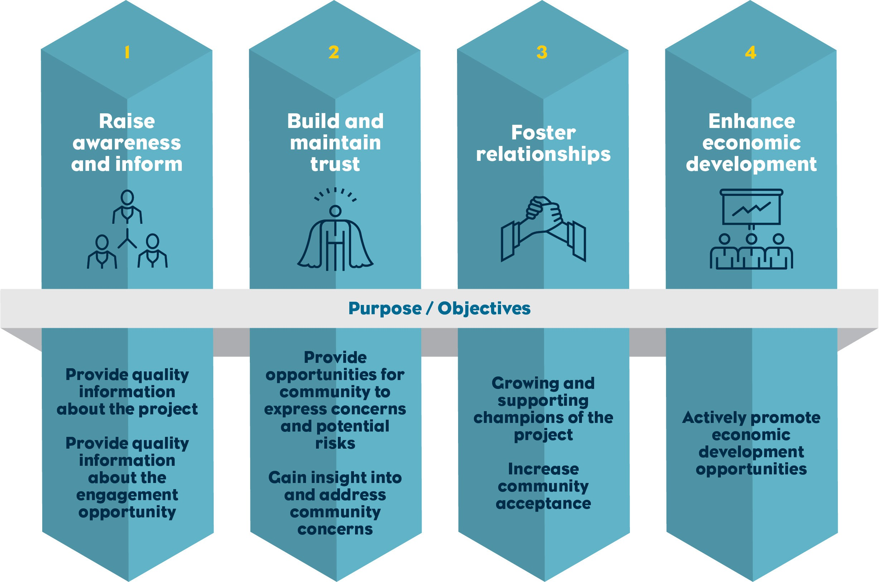
Figure 1-40 Communication and engagement pillars

Engagement goals
The overarching goals of the project’s community, stakeholder and First Peoples engagement has been to inform project development. The engagement goals include:
Informing the community and stakeholders about potential impacts from the project.

Creating multiple opportunities for the community and stakeholders to provide feedback about the project and potential impacts.
Identifying issues and opportunities important to the community and stakeholders, which can be used to inform construction and mitigate impact.
Ensuring the project can meet the requirements under relevant laws and regulations.

The engagement has also informed the technical studies and addressed the requirements of the EIS/EES processes.

Engagement
The IAP2 developed the IAP2 spectrum framework to describe and assess the level of public participation in decision-making processes. The project utilised this framework to guide the approach and level of engagement required throughout EIS/EES process. The IAP2 spectrum consists of five levels of public participation, which align with the five formal phases of the project’s engagement program described in Figure 1-41.
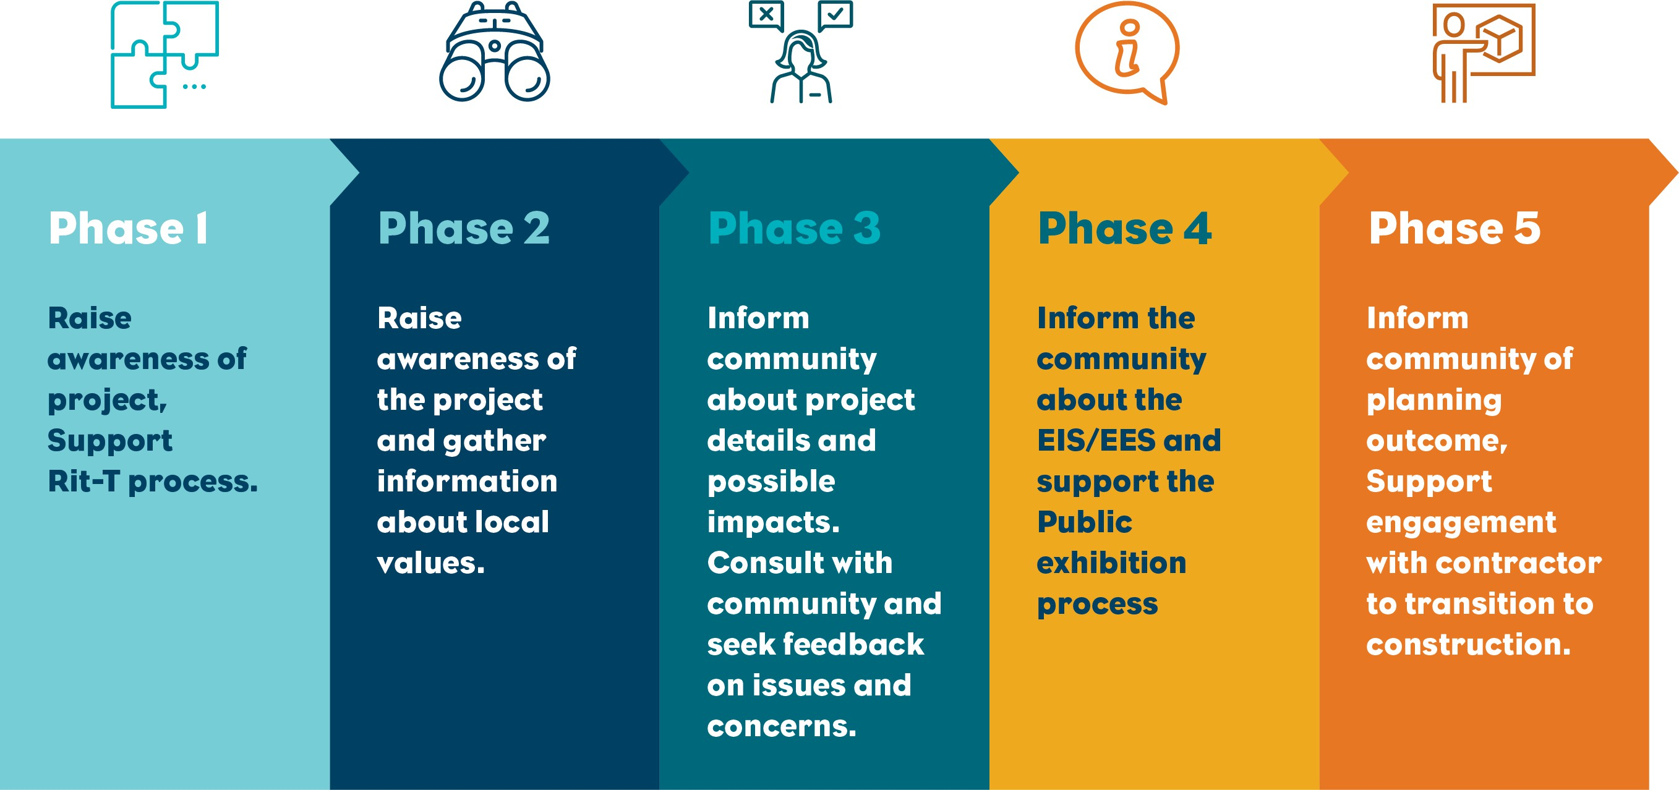
Figure 1-41 Consultation phases

Phase 1
Phase 1 took place between July 2018 and December 2019, prior to the preparation for the assessment. The objectives of this phase of engagement was to raise awareness of the project and support the Feasibility Study, Business Case Assessment, and RIT-T.

Phase 2
Phase 2 engagement activities took place between early 2020 to early 2022. The on-ground engagements in Victoria were delayed due to regional bushfire events and the global COVID-19 pandemic. MLPL commenced engaging with Gippsland landholders in November 2020, which involved consultation around the proposed route. Engagement with the broader community commenced in early 2021 and involved raising awareness of the project and capturing feedback on the proposed route through activities including a public webinar.

Phase 3
Phase 3 began with the preparation of the EIS/EES in August 2022 and has focused on key themes, topics and interests raised through the development of the technical studies. The purpose of Phase 3 engagement activities were to inform the community about project details and possible impacts. MLPL engaged broadly across both Victoria and Tasmania, consulting with stakeholders including landholders, community, interest groups and First Peoples to seek feedback on the project, including the findings of technical studies and possible management approaches.

Phase 4
Phase 4 engagement will commence with the public exhibition of the EIS/EES in early 2024.

Public exhibition will provide members of the community the opportunity to learn more about the project’s potential impacts and mitigation measures and provide feedback in the form of a comment through a formal submission process.
The purpose of Phase 4 engagement activities will be informing community members of the key EIS/EES findings and provide stakeholders and the community the opportunity to provide feedback on EIS/EES.

Phase 5
Phase 5 will commence with the publication of the Victorian Minister for Planning’s Assessment and
EPBC Act decision. MLPL will continue to engage with the community and stakeholders on the outcomes of the assessment and approvals process and throughout the construction, operation and decommissioning phases of the project.

Communication tools
MLPL utilised a variety of communication tools and materials to support the engagement program, including:

Marinus Link website.

Marinus Link social media pages.

Newsletters or community updates in hard-copy and digital format.

Fact sheets in hard-copy and digital format.

Maps, for in-person sessions and use on the Marinus Link website.

Engagement reports and GSLG meeting minutes, published on the project’s website.

Webinars with recordings uploaded to the Marinus Link website.

Stakeholders
MLPL is engaging with stakeholders to inform them of the potential impacts of the project. A summary of the key project stakeholders is provided below. Further details of engagement activities with these stakeholders and the community are provided in Volume 3, Chapter 1- Introduction and Volume 4, Chapter 1 - Introduction.

Gippsland Stakeholder Liaison Group
The GSLG was formed in November 2021 to facilitate ongoing conversations between key stakeholders and MLPL. The GSLG meets regularly with MLPL to discuss the environmental assessment and approvals process. The GSLG is a forum for representatives of organisation and community groups to raise concerns, provide feedback and provide input on how to maximise the benefits for the project for the community.
Members of the GSLG are listed in Table 8-1.

Table 8-1 GSLG stakeholders

Gippsland Stakeholder Liaison Group stakeholders
South Gippsland Shire Council | WGCMA
Gunaikurnai Land and Waters Aboriginal Corporation | Gippsland Trades and Labour Council
TAFE Gippsland | Federation University
Committee for Gippsland | Growing Regional Opportunities for Work (Gippsland)
Latrobe Valley Authority

Tasmanian stakeholders
A range of engagement activities have been completed with Tasmania stakeholders. Stakeholders include:

Department of Premier and Cabinet TasPorts

Department of State Growth Burnie City Council

Department of Natural Resources and Environment
Tasmania Parks and Wildlife Services

Environment Protection Authority Tasmania Marine and Safety Tasmania
Central Coast Council Cradle Coast Authority Rotary Club of Burnie Business North West
Launceston Chamber of Commerce

First Peoples
MLPL acknowledges the First Peoples of the Country on which the project is proposed in Victoria, Bass Strait and Tasmania. In Victoria, MLPL has engaged with the three First Peoples groups:
GLaWAC

BLSC

BLCAC.

In mid-2022 MLPL hired First Peoples Engagement Advisors to lead engagement with the three First Peoples groups listed above. These roles are embedded within the engagement team and support a range of activities including the formation and management of a FPAG.
Through connections with each First Peoples group, representatives were identified and nominated by each group to take part in the FPAG with MLPL, which met formally four times between late 2022 and mid-2023 to discuss the project’s impacts, challenges and opportunities. The FPAG also provided advice on MLPL’s cultural heritage assessment and inputs into key strategies and plans for the project. Meaningful and open discussions were held on topics such as cultural heritage values on land and across Bass Strait, community benefits, workforce participation, and Native Title.
The FPAG ceased meetings in mid-2023 following consultation with the First Peoples groups, and in light of current legal proceedings relating to Native Title. While the FPAG has not continued, MLPL through their First Peoples Engagement Advisors have continued consultation and discussions with the three First Peoples groups separately, with ongoing engagement activities including cultural education sessions for MLPL personnel, progression of cultural values assessments, and general project updates.
First Peoples in Victoria and Tasmania will continue to be consulted through delivery of the project. Consultation has informed the development of the social impact assessments (Technical Appendix F: Heybridge social assessment and Technical Appendix U: Social), CHMPs and cultural values assessments (CVAs) (in Victoria), and the Marinus Link Sustainability Framework. First Peoples are being directly engaged to inform in the development of the community benefits scheme and industry participation target setting.
In Victoria, MLPL has committed to ongoing engagement with First Peoples in the preparation CVAs, which will provide a greater understanding of intangible Aboriginal cultural values in the study area and will inform the CHMPs being prepared for the project. Three CVAs will be developed for the project, one with each of the First Peoples groups. MLPL’s commitment to completing the CVAs is documented in the EPRs relating to cultural heritage (see Volume 5, Chapter 5 – Environmental Management Framework). Development of the CVAs has commenced with each of the three First Peoples groups, with a focus on facilitating open and meaningful discussion with the groups. Engagement for the CVAs is being progressed on the terms of each First Peoples group, based on availability and capacity of key Community members. Further information on the CVA is provided in Volume 4, Chapter 13 – Aboriginal cultural heritage.

In Tasmania MLPL has engaged with Aboriginal Heritage Tasmania, and commenced engagement with members of the Tasmanian Aboriginal Centre. MLPL has met with truwana Rangers and Community leaders, and is committed to further ongoing meaningful engagement in Tasmania.

In 2023, MLPL had proposed to establish a Tasmanian equivalent of the FPAG. However, upon advice from Aboriginal Heritage Tasmania and stakeholders from within the Tasmanian Aboriginal community, it was agreed that a different approach to First Peoples engagement in Tasmania was more suitable. MLPL has subsequently discussed a collaborative approach to First Peoples engagement with related major projects and organisations (e.g., Renewables, Climate and Future Industries Tasmania (RECFIT), Hydro Tasmania, NWTD projects) to plan coordinated engagement that is both culturally appropriate and addresses the needs of the Tasmanian Community. MLPL has committed to developing and implementing a strategy that commits to an ongoing relationship and partnership with First Peoples for the development and delivery of the project. Further details are provided in Volume 5, Chapter 5 – Environmental Management Framework.

Landholders
MLPL commenced engagement with affected landholders in November 2020. Each landholder has an allocated land access agent who is their main point of contact for the project. Land agents have assisted landholders to understand the project’s potential impacts on their land. MLPL has engaged regularly with landholders via face to face and virtual meetings, letters, phone calls and emails. Landholders have been provided with a landholder information pack and land and access easement acquisition factsheet. Both documents are available on the Marinus Link website – https://www.marinuslink.com.au/landholder- engagement/.

Maritime stakeholders
As the project crosses the entirety of Bass Strait, there are a range of maritime stakeholders that MLPL has engaged with regarding the project. A list of stakeholders is provided in Table 8-2. Further details of engagement activities with maritime stakeholders are provided in Volume 3, Chapter 1 – Introduction.
MLPL is continuing to implement a Stakeholder Engagement Plan which includes the program of engagement and consultation for these key stakeholders.

Table 8-2 Maritime stakeholders

Category | Stakeholders
Fisheries | South East Trawl Fishing Industry Association (SETFIA) Seafood Industry Australia  Commonwealth Fisheries Association Southern Shark Industry Alliance  Victorian Rock Lobster Association Seafood Industry Victoria  Tasmanian Seafood Industry Council  Scallop Fishermen’s Association of Tasmania  Tasmanian Rock Lobster Fishermen’s Association Small Pelagic Fishery Resource Assessment Group Tasmanian Abalone Council  Tasmanian Game Fishing Association Sports Fishing Club of Tasmania  Tasmanian Rock Lobster Fishermen’s Association TARFish Tasmania
Government | Department of Defence  National Offshore Petroleum Safety and Environmental Management Authority Australian Maritime Safety Authority  Maritime and Safety Tasmania Burnie Ports  Transport Safety Victoria (formerly Maritime Safety Victoria) Victorian Fisheries Authority
Industry | ExxonMobil  Hibiscus Petroleum Beach Energy  Telstra Optus

Technical reference group
DTP convened an inter-agency TRG to advise MLPL and DTP on:

Applicable policies, strategies and statutory provisions.

EES scoping requirements issued by the Victorian Minister for Planning.

The design and adequacy of EIS/EES technical studies.

The proponent’s public information and stakeholder consultation program for the EIS/EES process.

Responses to issues arising from the EIS/EES investigations.

The technical adequacy and completeness of draft EIS/EES documentation.

Coordination of statutory processes.

Government organisation and First Peoples represented on the TRG were:

DCCEEW (Commonwealth)

DEECA (Victoria)

DTP (Victoria)

EPA Victoria

EPA Tasmania

First People State Relations (Victoria)

GLaWAC

Heritage Victoria

Latrobe City Council

Maritime Safety Victoria

Regional Roads Victoria

South Gippsland Shire Council

Victorian Fisheries Authority

WGCMA.

Ongoing engagement
Feedback and project milestones have and will continue to inform the ongoing engagement activities. Phase 4 and 5 (discussed in Section 8.1.3) will commence after public exhibition and the Victorian Minister for Planning’s assessment of the EIS/EES and EPBC Act approval decision, respectively. MLPL recognises that issues may emerge over the life of the project and that engagement with stakeholders and the community will be a critical part of effectively identifying and managing issues.
Engagement with stakeholders and the community will play a crucial role in the construction, operation and decommissioning of the project. It will inform the final design and the development of measures to avoid and minimise impacts as part of project approvals and EPRs compliance.
MLPL will support the successful contractors with engagement and communication during construction and provide a framework to achieve consistent communication and engagement across the project. MLPL will develop a project-wide Community and Stakeholder Engagement Framework that will outline how each principal contractor will coordinate their communications and provide consistent information to stakeholders, community and directly-affected landholders.

