Sustainability, climate change and greenhouse gas emissions
This chapter outlines MLPL’s sustainability program, identifies potential changes in climate that could impact the project and estimates the amount of greenhouse gas emissions generated by the project.

Sustainability
MLPL adopted its first sustainability framework in 2023. The framework is designed to direct MLPL's sustainability efforts and drive commitment to continuous improvement over the life of the project to ensure MLPL creates value for people, energy customers, and shareholders, and leaves a positive legacy for communities and the environment.
This section addresses the following sections of the EIS guidelines:

Section 2.2: Relevant legislative and policy context

Section 11: Environmental Record of Person Proposing to take the Action

The EIS guidelines also require the EIS/EES to address the principles of ecologically sustainable development (ESD), which are addressed throughout the EIS/EES. A summary of how these principles have been addressed by the project is provided in Volume 5, Chapter 1 – Conclusion by jurisdiction. Refer to Attachment 1: Guidelines for the Content of a Draft Environmental Impact Statement for the EIS guidelines.
The EES scoping requirements set out the following requirement relevant to sustainability:

Project description and rationale: description of the project's components (supported by visuals and diagrams), including the approach to incorporate sustainability principles and practices into project development and delivery.
Refer to Attachment 2: Scoping requirements Marinus Link Environment Effects Statement for the EES scoping requirements.

Project context
The project sits within the context of Australia’s transition to clean energy and the increasing market and policy focus on sustainable environmental and business practices, where requirements are only expected to increase. The project is complex and multi-jurisdictional, traversing three jurisdictions and is therefore required to meet Commonwealth Government, Victorian Government and Tasmanian Government expectations.

International sustainability policy
Strategic sustainability practices and reporting are increasingly expected by markets and governments internationally, with mandatory reporting regimes being introduced by policy makers in many regions over the next few years. The following international standards informed the development of MLPL's Sustainability Framework:
United Nations Framework Convention on Climate Change – Paris Agreement December 2015

Australian Government Nationally Determined Contribution under the UNFCCC Communication 2022

United Nations Sustainable Development Goals: The 2030 Agenda for Sustainable Development

United Nations Declaration on the Rights of Indigenous Peoples 2017

International Finance Corporation: Performance Standards on Environmental and Social Sustainability 2012.

Australian sustainability policy and requirements
Within Australia there is no legislative requirement for sustainability reporting, however, projects and organisations are required to meet standards laid out in relevant law and policies across state and Commonwealth jurisdictions. Accordingly, the environmental, social, economic, and governance requirements of the Commonwealth, Victorian and Tasmanian jurisdictions have informed the development of the sustainability objectives, priorities, and targets for the project. These include:
The Energy Charter (Australia)

Infrastructure Sustainability Council IS Rating Scheme (Australia)

National Greenhouse Energy Reporting Scheme (Australia)

National Electricity Rules and National Electricity Objective (Australia)

Social Procurement Framework (Victoria)

Tasmanian Jobs and Growth North and Northwest (Tasmania).

Coupled with mounting political pressure both domestically and abroad, it is anticipated Australia’s approach to sustainable development will rapidly mature in the next five years. On 12 December 2022, the Treasurer publicly committed to climate risk disclosure by Commonwealth Government entities that are comparable to the private sector, outlining that climate risk disclosure will be mandatory for the private sector, implemented in tranches, from 2024 to 2025. To ensure the Commonwealth Government is leading by example and there is competitive neutrality between the public and private sectors, climate risk disclosure will also be required for comparable Commonwealth Government entities. Much of the detail is yet to be defined – including how soon it will apply to entities like MLPL – however, this development signals that entities like MLPL should be preparing themselves for a mandatory sustainability reporting regime coming into effect in Australia in the near future.

Energy and transmission trends globally
The international energy and transmission market is among the more consistent sectors for clear environmental, social, and governance (ESG) or sustainability strategies supported by measurable commitments or key performance indicators (KPIs). With energy playing such a significant role in climate management strategies, this sector is prioritising transparent sustainability governance, including:
Board responsibility and oversight of their sustainability progress.

Annual reporting against KPIs, occasionally verified through assurance audits by third parties.

Use of the Global Reporting Initiative Standards to guide sustainability reporting.

Adherence to frameworks like the United Nations Sustainable Development Goals (SDGs), the Task Force on Climate-related Financial Disclosures (TCFD), and the ISO Standards, commonly ISO 14001 for environmental management.
Comprehensive materiality assessments with internal and external stakeholders.

Within the energy sector, organisations taking a sustainability-oriented approach have provided more comprehensive coverage of the material issues associated with their projects than those taking an ESG approach.
Locally, the energy and transmission industry adhere to frameworks like the Energy Charter, Global Real Estate Sustainability Benchmark for Infrastructure Assets, and the TCFD, and aligns to the law and policies relating to the particular state and nationally. However, the energy and transmission industry is not as proactively transparent about what their ESG targets are and how well they are meeting them.

Domestic energy project trends
At an energy project level, there is a noticeable lack of reporting on sustainability initiatives; however, this is beginning to change as sustainability ratings tools, such as the Infrastructure Sustainability Council’s rating scheme, are gaining popularity particularly in Victoria and New South Wales.

Marinus Link Sustainability Framework
Marinus Link has developed a sustainability framework to clarify the vision and objectives of the project regarding sustainability, to understand strengths and weaknesses in this area, and to ensure progress, transparency, and accountability by tracking performance against the objectives. It is aligned with, and informed by, Marinus Link’s Environment and Sustainability Policy (see Section 9.1.4).

Development of the framework involved:

Materiality assessment

Theory of change

Alignment with the United Nations SDGs

Creation of sustainability targets

Development of well-defined governance practices.

The outcome is a framework centred around three key objectives to deliver: a Healthy Planet, Community Prosperity, and a reputation as a Trusted Organisation. These objectives are supported by nine priorities, and sustainability targets will be developed for the different phases of the project, underpinned by defined actions and outcomes. A Sustainability Strategy will be developed to outline how the framework will be implemented.
Clear governance procedures will be set out in MLPL's Sustainability Strategy that will be developed to ensure the delivery of the sustainability objectives, priorities and targets. The objectives, priorities, and targets will also be informed by the policy documents listed in Section 9.1.1. These include regular internal and external monitoring and review processes to ensure performance and continuous improvement. The sustainability framework is available at: https://www.marinuslink.com.au/sustainability/.
MLPL will develop a Compliance Management Standard which will include requirements for the principal contractor to develop and implement a Sustainability Management Plan in accordance with the Marinus Link Sustainability Framework. Requirements to comply with the Marinus Link Sustainability Framework have also been included in relevant environmental performance requirements such as for reducing greenhouse gas emissions through:
Use of low emission fuels

Maintenance of equipment and vehicles

Minimising vegetation clearance

Purchase of green energy

Procurement of energy efficient machinery

Use of low carbon emission concrete

Use of recycled materials.

Further details are provided in Volume 5, Chapter 2 – Environmental Management Framework. An overview of the Marinus Link Sustainability Framework is shown in Figure 1-42.

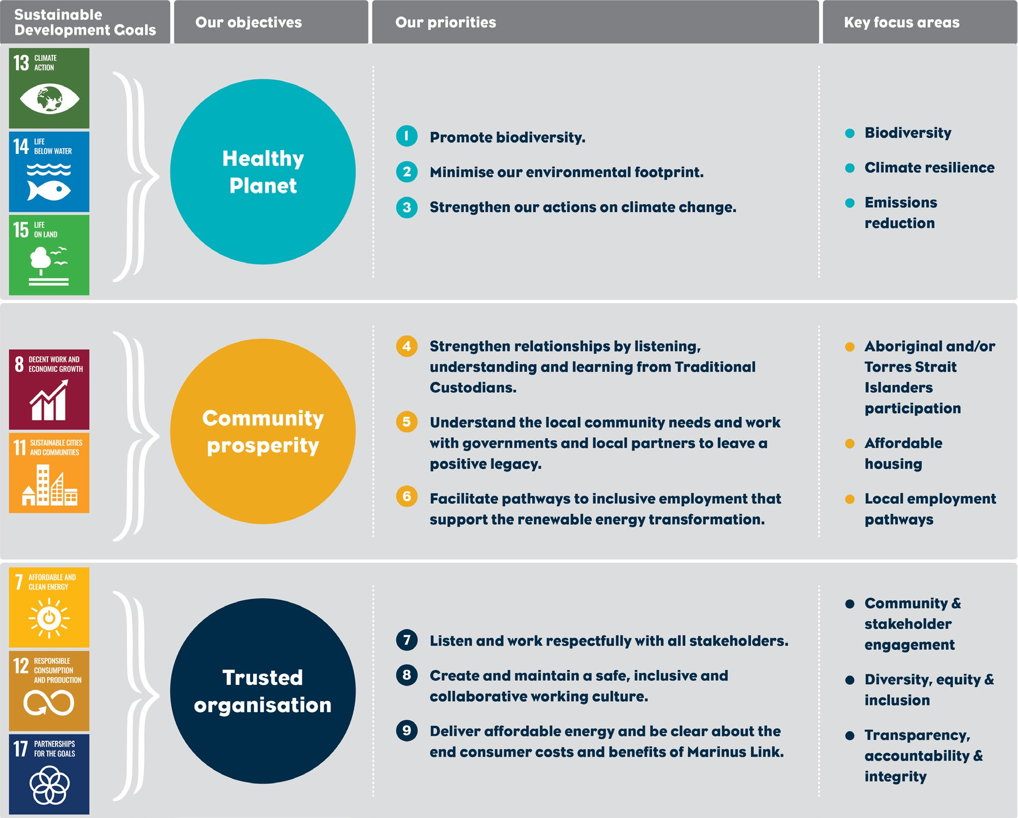

Figure 1-42 Marinus Link Sustainability Framework

Marinus Link sustainability targets
MLPL's sustainability targets will form a key component of the sustainability framework, providing the goals against which MLPL will track its performance and improve over time. The targets will be developed considering relevant Commonwealth and state legislation and policy (listed in Section 9.1.1), stakeholder views, and the specific circumstances of Marinus Link as a business and as a project – including MLPL's sustainability maturity, industry and geopolitical context, and project delivery timeframe. The result will be MLPL's first ever set of sustainability targets which will be mapped against MLPL's three core sustainability objectives of 'Healthy Planet', 'Community Prosperity' and 'Trusted Organisation'. The targets will be designed to be reviewed annually to ensure they remain robust, reasonable, and fit-for-purpose. Updated targets will be provided on the Marinus Link website.

MLPL Environment and sustainability policy
MLPL has an environment and sustainability policy that provides overarching objectives for the project in relation to environmental and sustainability matters. The policy is provided in Figure 1-43.

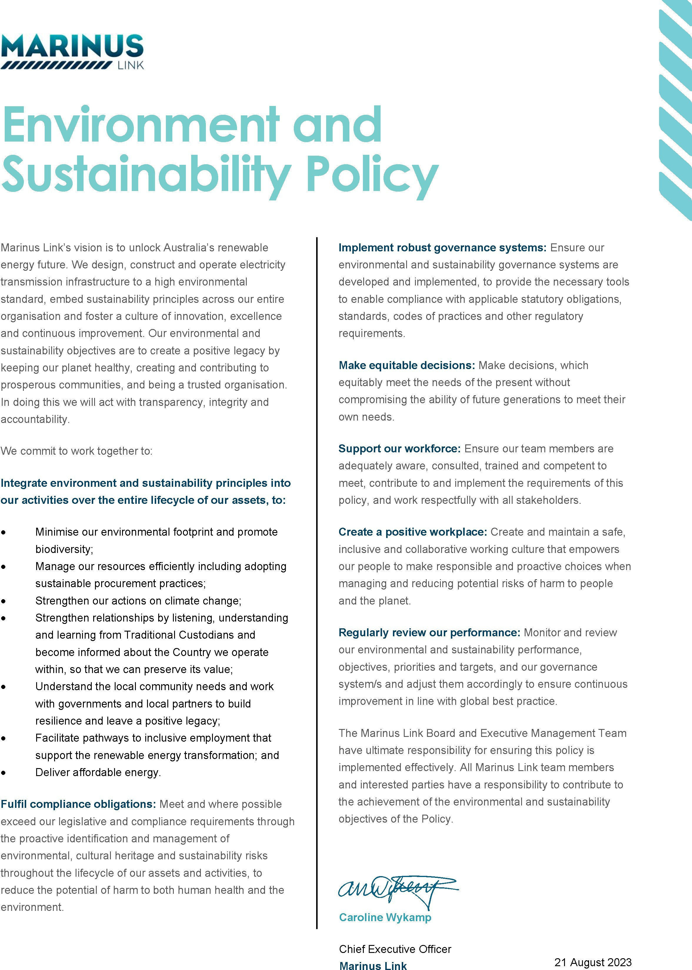

Figure 1-43 MLPL Environment and Sustainability Policy

Climate change
This section provides an overview of the climate change assessment completed for the project and is based on the technical studies provided in Technical Appendix C: Climate change. This section considers climate change for the whole of the project, across the Commonwealth, Victorian and Tasmanian jurisdictions.
Climate change is a consequence of global warming, which is the accumulation of heat in the atmosphere and the oceans due to the increase concentration of greenhouse gases in the atmosphere. Climate is the long-term pattern of weather in a region and weather is the state of the atmosphere at a point in time.
Consideration of climate change in the design, construction, and operation of a project will enable the project to be resilient to the risks presented by climate change and extreme weather. This includes an increased frequency and/or intensity of some weather and climate extremes (extreme rainfall, droughts, storms, fire weather).
This section will address Section 5.11: Cumulative Impacts of the EIS guidelines. Refer to Attachment 1: Guidelines for the Content of a Draft Environmental Impact Statement for the EIS guidelines.
The EES scoping requirements set out the following requirement relevant to climate change:

Project description and rationale: risks associated with projected climate change and resilience to these risks including consideration of the Climate Change Act 2017’s principles of risk management and standards for risk assessment e.g. AS/NZS 3100:2009.
Refer to Attachment 2: Scoping requirements Marinus Link Environment Effects Statement for the EES scoping requirements.
Climate change predictions have also been considered in scenario modelling of groundwater (Technical Appendix P: Groundwater) and surface water (Technical Appendix Q: Surface water) conditions, and assessment of bushfire risks (Technical Appendix M: Bushfire). Scientific information on the effects of climate change on ecosystems and listed species that was available has also been considered in Technical Appendix V: Terrestrial ecology and Technical Appendix H: Marine ecology and resource use.

Method
The key steps taken to assess the climate change factors that could affect the project were: Considering the climate factors of the broader region where the project is located.
Conducting a desktop review of existing climate conditions including temperature, humidity, rainfall, wind speed, bushfire history, soil parameters and sea conditions. The assessment included review of historic databases and data from relevant Bureau of Meteorology (BoM) monitoring sites in Tasmania and Victoria.
Reviewing climate projections for Tasmania and Victoria using datasets from the previous Coupled Model Intercomparison Project Phase 5 (CMIP5) models and the current Coupled Model Intercomparison Project Phase 6 (CMIP6) models to consider future climate scenarios. This includes any updates from the State of the Climate 2020 (CSIRO and BoM 2020) and the Sixth IPCC Assessment Report (AR6) (IPCC 2021).
Assessing potential risks to the project associated with climate change by following the approach adopted by the Electricity Sector Climate Information (ESCI) project. The approach applies:
      - AS/NZS ISO 31000:2018 Risk management;
      - AS 5334-2013 Climate change adaptation for settlements and infrastructure; and
      - Intergovernmental Panel on Climate Change (IPCC) 2013 Managing the risks of extreme events and disasters to advance climate change adaptation.
Assessment of climate change impacts and adaption techniques for infrastructure developments based on climate change adaptation principles.
Developing EPRs in response to the assessment to set the required environmental outcomes for the project. Refer to Volume 5, Chapter 2 – Environmental Management Framework for the complete list of EPRs.
The method is further detailed in Technical Appendix C: Climate change.

Legislative context
The key legislation and policies that informed the climate change assessment are outlined in Table 9-1. Other legislation that informs the project assessment and approvals are described in Volume 1, Chapter 4 – Legislative framework.

Table 9-1 Key legislation and strategies relevant to the climate change assessment

Name | Relevance to the assessment
Climate Change Act 2022  (Cwlth) | The Act does not impose direct obligations on companies, but signals sector- based reforms to achieve greenhouse gas emissions reductions to achieve Australia’s 2030 and 2050 greenhouse gas emissions reduction targets under the Paris Agreement.
National Climate Resilience and Adaptation Strategy  (DAWE 2021). | The strategy provides a national framework and defines the roles and responsibilities for state and local government and businesses on climate adaptation and research.
Climate Change Act 2017 (Vic) | Under the Climate Change Act, the Victorian Government is required to publish five yearly adaptation action plans (AAP) across 7 key systems, including:  built environment  education and training  health and human services natural environment  primary production transport  water cycle.  The Built Environment AAP includes strategies for ensuring the resilience of electricity infrastructure to climate change.
Climate Change Strategy (Vic) | The strategy provides a roadmap to net-zero emissions by 2050. The strategy includes objectives for improving the ability of the built environment and infrastructure to withstand and recover from the impacts of climate change, and actively managing biodiversity, ecosystems, and natural resources to improve resilience to climate change.
Gippsland Regional Climate Change Adaptation Strategy (Vic) | The Draft Gippsland Regional Climate Change Adaptation Strategy (DELWP 2021) focuses on actions that will allow the community, business,  industry, and environment to adapt to the changing climate. It includes strategic actions for the built environment with adaptation planning being informed by assessment of key infrastructure vulnerability, and through contributing to the resilience of the regional economy.
Climate Change (State Action) Act 2008 (Tas) | The Act requires industry and businesses, in collaboration with the Tasmanian government, to develop sector-based emissions reduction and resilience plans, and prepare a climate change action plan, every five years.  The recently formed ReCFIT provides whole of government advice for climate adaptation including providing tailored information to business and industry to minimise climate risks through informed decisions. Progress against the recently concluded Climate Change Action Plan 2017-2021 (TCCO 2021) has been assessed and the follow up action plan is currently under development.

Assumptions and limitations
The key assumptions and limitations for the climate change assessment include:

Weather patterns in the project areas were assumed to be similar to the nearest BoM monitoring stations, including, Burnie NTC AWS (1992-2022), Burnie (Park Grove) (2009- 2022), and Wynyard Airport (1947-current). Weather data for the Victorian sites was derived from Corner Inlet (Yanakie) (2013-2022), Morwell (Latrobe Valley Airport) (1984-2022) and Wonthaggi (1911-2022).
Based on data collected for the project, it is understood the ambient soil temperature for the project is 18°C. An ambient soil temperature of 18°C was used for the climate change assessment. For the purpose of the EMF assessment (see Volume 1, Chapter 10 – Electromagnetic fields), a conservative assessment has been completed using an assumed ambient soil temp of 25°C, to inform design standards for the cable.

Existing climate conditions
Current climate conditions have been assessed for the project area in southern Victoria and northern Tasmania to classify the weather patterns including temperature, wind and rainfall. The climate of the region is characterised by mild summers and cold winters with no dry season. It regularly experiences cold fronts and troughs from the west and low pressure systems from the north. The elevation along the project alignment varies from 0 m at the shore crossings at Heybridge and Waratah Bay, to a peak of 276 m along the land cable.
Weather patterns were characterised using BoM monitoring sites that were considered to be broadly representative of the current conditions across the project. Table 9-2 lists the BoM monitoring sites and recorded parameters.
Table 9-2 BoM monitoring sites summary

BoM monitoring site | Site number | Distance from the project | Parameters
Burnie NTC AWS | 091344 | 5.6 km NW | Temperature and meteorological data
Burnie (Park Grove) | 091355 | 8.4 km W | Rainfall
Wynyard Airport | 091107 | 22.4 km NW | Rainfall, temperature, solar exposure, and climate statistics
Corner Inlet (Yanakie) | 085301 | 7.9 km E | Rainfall, temperature, and meteorological data
Morwell (Latrobe Valley Airport) | 085280 | 9.3 km N | Rainfall, temperature, meteorological data, and climate statistics
Wonthaggi | 086127 | 36 km W | Climate statistics

Temperature
The BoM data summarised in Table 9-3 shows that the highest and lowest temperatures are experienced in Victoria and that the temperature variation is greater in southern Victoria than in northern Tasmania where the project is located.
In southern Victoria, the lowest temperatures recorded range between 1.7ºC in summer and -4.8ºC in winter. The highest temperatures range between 46.3ºC in summer and 21.5 ºC in winter.
In northern Tasmania, lowest temperatures recorded for Burnie in summer is 7.1°C, and 2.1°C in winter. The highest temperature in summer is 31.5°C and 18.6°C in winter.
Table 9-3 Maximum and minimum daily temperatures recorded at Burnie NTC AWS, Morwell (Latrobe Valley Airport), and Corner Inlet (Yanakie)
Maximum temperature (°C) Minimum temperature (°C)

Burnie NTC Morwell Corner Inlet Burnie NTC Morwell Corner Inlet AWS (Latrobe Valley (Yanakie, AWS (Latrobe Valley (Yanakie,
(Tasmania) Airport, Victoria) (Tasmania) Airport, Victoria)
Season Victoria) Victoria)
Autumn | 26.6 | 40.4 | 36.6 | 3.5 | -2.8 | -0.3
Spring | 25.8 | 38.6 | 36.8 | 3 | -2.6 | 0.6
Summer | 31.5 | 46.3 | 43.7 | 7.1 | 1.7 | 3.2
Winter | 18.6 | 26.8 | 21.5 | 2.1 | -4.8 | -3

Rainfall
Average, maximum and minimum seasonal rainfall records from BoM sites were reviewed for Burnie (Park Grove, Tasmania), Morwell (Latrobe Valley Airport, Victoria) and Corner Inlet (Yanakie, Victoria). The rainfall at these sites is used to characterise the rainfall of the project area in Tasmania and Victoria.
Seasonal rainfall at these sites is characteristic of the southern oceanic climate with no clear dry season and rainfall distributed across the year. The annual rainfall statistics are summarised in Table 9-4 and show that the Tasmanian converter station site is wetter on average than the Victorian converter station site. The Tasmanian converter station site had a maximum annual total of almost 500 mm higher than Victoria, however it also had a lower minimum rainfall.
The mean total rainfall peaks during winter months at Burnie and Corner Inlet, and is lowest during summer. While at Morwell, the mean total rainfall peaks during spring and winter and is marginally lower during summer.

Table 9-4 Annual rainfall statistics for Burnie (Park Grove), Morwell (Latrobe Valley Airport) and Corner Inlet (Yanakie)
Rainfall statistics during data period
Location | Station | Annual average total | Maximum annual total | Minimum annual total
Tasmania | Burnie (Park Grove) | 876 mm | 1411 mm | 221 mm
Victoria | Morwell (Latrobe Valley Airport | 711 mm | 947 mm | 384 mm
Victoria | Yanakie (Corner Inlet Yanakie) | 725 mm | 966 mm | 319 mm

Wind speed
Wind speed data from the BoM monitoring locations were also reviewed for the project. There is daily and seasonal variation in wind speed at all locations. In summary:
Winds in Burnie on the coast of Tasmania are moderate to strong with an average speed of 4.36 m/s and the winds predominantly occur from the southwest to northwest.
Winds in Morwell, which is at the northern end of the project alignment in Victoria, are also moderate to strong with an average speed of 3.74 m/s. Winds predominantly occur from a western and north-easterly direction.
Winds at Corner Inlet on the coast in Victoria are generally strong with an average speed of 4.63 m/s and predominantly occur from the southwest to the north-west.

Soil temperature
The upper limit of the average soil temperature along the project alignment is 18ºC at 1 m depth. The average soil temperature is higher at the Hazelwood, when compared to the Heybridge converter station site in Tasmania.

Sea conditions
Sea levels were reviewed for Tasmania and Victoria coastlines near where the project is located. The maximum, minimum and mean levels recorded at Burnie and Stony Point are shown in Table 9-5.
Table 9-5 Minimum, maximum, and mean sea level (m) at Burnie and Stony Point

Statistic | Burnie (Tasmania) | Stony Point (Victoria)
Minimum | -0.234 m | -0.284 m
Maximum | 4.133 m | 3.670 m
Mean | 1.943 m | 1.744 m

The annual average sea surface temperature was assessed at 25 locations between Heybridge, Tasmania and Waratah Bay, Victoria. Surface water temperatures ranged between 15.0 ºC near Tasmania and 15.8 ºC near Victoria. The annual average sea temperature declines with depth, with the lowest temperature recorded at the maximum depth of Bass Strait, around 92 m below sea level. Average sea temperatures are
2.5 to 3 ºC warmer in January and 2.5 ºC cooler in July. Sea temperatures at depth are relatively stable across the year.

Bushfire zones
The project is located in areas that have a history of bushfires and are identified as bushfire prone areas in the Tasmanian and Victorian planning schemes. Bushfires have occurred in the Driffield area along the project alignment as well as in the area around the Heybridge site, but not directly on the converter station site.
A bushfire assessment has been conducted for the project and the Victorian assessment is discussed in Volume 4, Chapter 12 – Bushfire.

Climate change projections
Climate projections have been assessed for the project area based on temperature, rain, wind, sea level, temperature and soil temperature meteorology publications. The climate change assessment (Technical Appendix C: Climate change) determined the following projections by considering the CMIP5 models, with relevant updates from The State of Environment report produced by BoM and CSIRO (2020), and the IPCC Assessment Report (2021). The climate change projections in the following sections extend to 2090 which is beyond the design life of the project (40 years). This timeframe is included for reference to cover the scenario that the project is upgraded to extend its operational lifespan.

Temperature
Higher temperatures and extreme temperature days are occurring more frequently across Australia with the effects of climate. This is evident through the maximum temperatures in Australia exceeding 39 ºC on 33 days in 2019 compared to 24 days between 1960 to 1980 that exceeded 39 ºC.
Between 1910 and 2013 the mean temperatures in northern Tasmania and southern Victoria rose between
0.8 ºC and 1 ºC. The maximum projected median summer temperatures in the project area are projected to increase by 0.9 ºC by 2030 and by 3.3 ºC by 2090.

Rainfall
The average annual rainfall across southern Australia has been decreasing since the mid 1970’s with a 12% reduction recorded in rainfall April to October. There was a prolonged dry period that occurred in the late 1990’s and 2000’s, which was known as the millennium drought.

Effects of El Nino, La Nina, the Indian Ocean Dipole and southern annual mode are all expected to continue to result in above or below average rainfall in southern Australia. The effects combined with an increase in heat energy in the climate is expected to result in more moisture being held in the atmosphere. Heavy rainfall events of increased intensity are then likely to occur, leading to flash flooding. These events can be particularly extreme when soil infiltration is limited after long dry periods or when the soil is saturated.
Projections for northern Tasmania and southern Victoria are for a 2% reduction in annual rainfall by 2030 and 5% by 2090, when compared to the rainfall recorded between 1986 to 2005.The reduced rainfall is expected to be greatest during spring and summer.

Windspeed
Changes in average wind speed for the project area are predicted to be minimal with a 0.4% increase by 2030, and 0.3% by 2090. This indicates that for the duration of the project there will be little to no change in the median wind speed.

Soil conditions
Soil moisture is affected by temperatures, humidity and rainfall. A decrease in soil moisture is predicted across all seasons. The greatest decline in soil moisture in southern Victoria is predicted in winter and spring, and in Tasmania during summer and autumn.
At a depth of 1m, soil temperatures are expected to increase with increased air temperatures. However monthly average soil temperature predicted to only slightly increase above 20°C by 2080 at Hazelwood, which is the warmest location along the alignment.

Sea conditions
Sea temperature and levels in Australian waters are generally increasing. The highest level of sea temperature warming in Australia has occurred around south-eastern Australia and Tasmania and sea level rise in south-eastern Australia is above the global average.
The sea temperature in Bass Strait has increased by 0.16°C to 0.2°C per decade between 1950 and 2019.

Sea levels in Australian waters have been measured since 1880 to be increasing with the majority of sea level rise occurring in the last 50 years. By 2030 the sea level is predicted to rise between 0.08 and 0.18 m at both Burnie, Tasmania and 0.08 and 0.17 m at Stony Point in Victoria.

Extreme weather events
The extreme weather events that could occur as a result of climate change and affect the project include:

Rainfall – Whilst total rainfall is declining in the region, it is projected that the intensity of rainfall events may increase by 21% by 2080.
Coastal conditions –the mean significant wave height is projected to increase in Bass Strait by the end of the 21st century. There may however be a decrease in wave height in near shore regions due to projected decreases in wind speeds.
Bushfire – The frequency of fire weather is increasing across Australia; it is projected that fire risk in Tasmania and southern Victoria could increase by 30% by 2090.

Climate change risks
The following changes to climate due to global warming are relevant to the project:

Increased frequency of extreme heat days

Increased frequency and intensity of storm events

Increased frequency and intensity of bushfires and fire storms

Increased frequency and scale of flooding

Increased frequency and intensity of droughts

Soil expansion, contraction, mass movement and change in thermal conductivity

Coastal erosion and inundation

The principal contractor is required to address these climate change risks in the detailed design of the project through contractual requirements set by MLPL.

Construction
Potential impacts during the construction of the project due to climate change may include:

Heat waves or increased average temperatures that exceed industry guidelines for construction workers and works continuity, leading to delays.
Sparks or hot surfaces on construction equipment potentially igniting dry vegetation and creating a fire risk.
Increased soil erosion due to heavy rainfall onto saturated or dry soils leading to large movements of sediments into waterways.
Coastal erosion due to rising sea levels impacting infrastructure and power transmission.

These risks will be managed through measures implemented in construction that specifically consider the impacts of climate change in relation to temperatures, flooding management, erosion and emergency management (EPR CC01). A risk assessment will also be completed by the contractors to identify climate change risks and management measures relevant for their scope of work.

Operation
The potential impacts to the project in operation due to climate change will be considered and addressed in the design of the infrastructure. The impacts could affect continuous supply of power and supply capacity due to the frequency and intensity of severe weather events. The weather events such as extreme heat or winds could exceed the normal design standards adopted for the infrastructure and lead to power outages.
As part of the design process, scenario planning and a risk assessment will be undertaken to assess design parameters and engineering properties to build in redundancy and incorporated mitigation measures to manage extreme weather events and the effects of climate change to the extent reasonably possible (EPR CC01). The design process will adopt industry standards to address climate change effects such as those outlined in AS/NZS 1170.2:2021 structural design actions.
Operational management plans will also include measures to address extreme weather events in operation such as bushfires, floods and extreme heat days.

Decommissioning
The operational life span of the project is 40 years, after which the project will either be decommissioned or upgraded to extend its operational life span. There will be greater certainty of the effects of climate change when planning for decommissioning or extension commences. These effects will be considered in accordance with the regulatory requirements of the time and will be incorporated into a Decommissioning Plan.

Environmental performance requirements
EPRs set out the environmental outcomes that must be achieved during all phases of the project. In developing these EPRs, industry standards and guidelines, good practice and the latest approaches to managing impacts were considered.
The following EPRs have been set for the project on climate change as shown in Table 9-6. All EPRs are provided in Volume 5, Chapter 2 - Environmental Management Framework.

Table 9-6 EPRs

EPR ID | EPR
CC01 | Implement measures to address the impacts of climate change on the project  Design the project to address potential impacts from climate change across the life of the project, considering:  Increased ambient temperatures/soil temperatures/sea temperatures and their potential impact on the operation of high voltage infrastructure.  Sea level rise and coastal erosion and its potential impact on accessibility, and function of coastal infrastructure.  The design must be informed by a risk assessment completed to identify climate change risks and management measures based on:  AS/NZS ISO 31000:2018 Risk management – Principles and guidelines  AS 5334-2013 Climate change adaptation for settlements and infrastructure – A risk-based approach  IPCC 2012 Managing the risks of extreme events and disasters to advance climate change adaptation  Include measures in the CEMP and OEMP (as relevant) to address:  Extreme or chronic weather events such as bushfires, heavy rainfall events and extreme wind speeds and their potential impact on safety of employees, accessibility, and operation of infrastructure.

Conclusion
The projected weather changes that could affect the project over its lifespan include increased daily temperatures, increase frequency and intensity of storm events, and an overall reduction in total rainfall. There could also be environmental changes that affect the project such as sea level rise and storm surges.
The design development will include scenario planning and a risk assessment to assess the design parameters and engineering properties required to provide redundancy in the design and incorporate mitigation measures to manage extreme weather events and the effects of climate change to the extent reasonably possible (EPR CC01). The design process will also adopt industry standards to address climate change effects such as those outlined in AS/NZS 1170.2:2021 structural design actions.

Greenhouse gas emissions
This section provides a summary of the GHG emissions associated with the construction and operation of the project. This section is based on the impact assessment provided in Technical Appendix D: Greenhouse gas. This section considers greenhouse gas emissions for the whole of the project, across the Commonwealth, Victorian and Tasmanian jurisdictions.
GHG emissions are gases that have the ability to absorb heat and emits, where their heat emittance causes increased warmth of the surfaces receiving their radiance. Gases such as CO2, methane (CH4), nitrous oxide (N2O) and SF6 are the primary gases contributing to the effect of climate change and global warming due to their high ability to absorb and emit heat radiation. The accumulation of GHG emissions warms the atmosphere and sea surfaces leading to significant long-term changes in climatic conditions.
Whilst construction and operation of the project will result in GHG emissions, a key outcome of the project is to facilitate increased use of renewable energy and improve the efficiency of both Tasmania’s and Victoria’s electricity grid, reducing GHG emissions.
The EIS guidelines do not include any requirements relating to the assessment of GHG emissions.

The EES scoping requirements set out the following EES requirements relevant to greenhouse gas emissions:
Project description and rationale: predictions of energy use and greenhouse gas emissions associated with the project.
Amenity, health, safety, and transport: Avoid and, where avoidance is not possible, minimise adverse effects on community amenity, health and safety, with regard to noise, vibration, air quality including dust, the transport network, greenhouse gas emissions, fire risk and electromagnetic fields.
Other aspects covered in the above EES evaluation objective are addressed in the following EIS/EES chapters:
Volume 1, Chapter 10 – Electromagnetic fields

Volume 4, Chapter 3 – Contaminated land and acid sulfate soils

Volume 4, Chapter 8 – Traffic and transport

Volume 4, Chapter 9 – Air quality

Volume 4, Chapter 10 – Noise and vibration

Volume 4, Chapter 12 – Bushfire

Refer to Attachment 2: Scoping Requirements Marinus Link Environment Effects Statement for the EES scoping requirements.

Method
The project’s GHG emissions were assessed in accordance with relevant environmental regulations and policies, including:
The National Greenhouse Accounts, October 2020 (Department of the Industry, Science, Energy and Resources 2020)
National Greenhouse and Energy Reporting (Measurement) Determination 2008 (NGER)

The Greenhouse Gas Protocol (WRI/WBCSD 2004).

The project’s GHG emissions were quantified based on project emissions estimates and according to the National Greenhouse and Energy Reporting scheme (NGER), which classifies GHG emissions as either scope 1, scope 2 or scope 3 emissions:
Scope 1 emissions are identified as the GHG emissions caused directly from the project such as fuel use for construction vehicles.
Scope 2 emissions are the indirect GHG emissions resulting from electricity and energy usage for the projects (e.g., in construction compounds and during operation for lighting), as well as loss of energy from transmission from generator to end user.
Scope 3 emissions are the indirect emissions that are generated because of the project but not directly by project activities. Scope 3 emissions include the emissions from vehicles transporting materials to the project site and embedded emissions in the materials used for construction (e.g., steel and concrete).

Legislative context
The assessment addressed key legislative requirements relevant to GHG emissions from the Commonwealth Victorian and Tasmanian governments. The key legislation, policies and guidelines that informed the assessment of greenhouse gas impacts is outlined in Table 9-7.

Table 9-7 Key legislation and regulations relevant to GHG emissions

Relevant legislation | Relevance
Climate Change Act 2022 (Cwlth) | The Climate Change Act 2022 establishes the 2030 reduction target
Climate Change (Consequential Amendments) Act 2022 (Cwlth) | The Climate Change (Consequential Amendments) Act embeds the Australia’s GHG emissions reduction targets into fourteen Commonwealth Acts, including the Clean Energy Regulator Act 2011, Infrastructure Australia Act 2008, National Greenhouse and Energy Reporting Act 2007, and the Renewable Energy (Electricity) Act 2000.
National Greenhouse and Energy Reporting Act 2007 (Cwlth) | The National Greenhouse and Energy Reporting Act mandates reporting of GHG emissions and energy consumption by corporations or facilities that exceed specified threshold for energy production, energy use or GHG emissions. NGER obligations excludes reporting on scope 3 emissions.
Climate Change Act 2017 (Vic) | The Climate Change Act aims to provide a legal framework for the government to take proactive measures, set emissions reduction targets, and implement strategies to transition towards a low emissions economy. This includes Australia’s commitments to reduce GHG emissions by 43% by 2030 and to net zero by 2050.
Environment Protection Act 2017  Environment Protection regulations (Vic) | The Environment Protection Act includes the general environmental duty (GED), which places a duty on all Victorians and Victorian businesses who engage in an activity that may cause harm to human health or the environment from pollution or waste to eliminate those risks, or if not possible to do so, to reduce those risks so far as reasonably practicable.  GHGs are expressly defined as waste in the EP Act, and as such the minimisation of harm from GHG emissions is required to comply with the GED
Climate Change Act 2008 (Tas) | The Climate Change Act outlines the Tasmanian Government’s framework for action on climate change, including a GHG reduction target of at least 60% below 1990 levels by 2050.

Assumptions and limitations
The assessment of GHG emissions is based on the information provided in Volume 1, Chapter 6 – Project description using calculators and requirements set by Australian energy regulators.
The calculations include consideration of emissions from land use, land use change and forestry (LULUCF). LULUCF emissions are not included in NGER reporting requirements but are included in the assessment for completeness. LULUCF emissions can be negative (land clearing) or positive (carbon sequestration).

Existing conditions
A summary of annual 2020 GHG emissions in Australia, Victoria and Tasmania is presented in Table 9-8.

Table 9-8 Annual GHG emissions for Australia, Tasmania and Victoria

Inventory total | Australia | Tasmania |  | Victoria
 | Emissions (Million tonnes of carbon dioxide equivalent (Mt CO2-e)) | Emissions (Mt CO2-e) | Contribution to national emissions | Emissions (Mt CO2-e) | Contribution to national emissions
Including LULUCF | 498 | -3.7 | -0.7% | 83 | 17%
Excluding LULUCF | 537 | 7.9 | 1.5% | 104 | 19%

Greenhouse gas emissions
Scope 1 emissions for the project (direct emissions) will be generated by:

Construction:

      - Diesel emissions from vehicles and equipment used to construct the land cable, SF6 emissions from the switching stations and diesel emissions from backup generators.
      - Marine fuel emissions from the cable lay and burial vessel.
      - Clearing of land for construction.
Operation:

      - Leakage of SF6 from the switching stations.

Scope 2 emissions (indirect emissions) for the project will be generated by:

Construction:

      - Energy use during construction activities e.g., for lighting.
Operation:

      - Loss of energy in transmission along the project.
      - Electricity use for lighting and security.

Scope 3 emissions for the project will be generated by:

Construction:

      - Transportation of equipment and materials to the project site.
      - Embodied energy in materials used for construction (e.g., steel, concrete, cables).

A summary of indicative Scope 1 and 2 emissions from the project are provided in Table 9-9. Scope 3 emissions estimates are summarised in Table 9-10. Maximum emissions from the project are expected during operation, due to the loss of energy in transmission along Marinus Link.
Table 9-9 Indicative Scope 1 and 2 emissions (tCO2-e)

Scope |  | 2025 | 2026 | 2027 | 2028 | 2029 | 2030 | Ongoing
Scope 1 | Diesel consumption (vehicles) | 345 | 597 | 755 | 46 | - | - | 52
Diesel consumption - - - - - - 29
(backup generators)
 | Sea Cable - 154 77 77 - - -
 | SF6 leakage - - - - - - 878
 | Land disturbance 10,109 10,109 10,109 10,109 10,109 - 0

Scope 2 | Electricity (use) (GJ) | 45 | 89 | 89 | 89 | 89 | 15 | 6,518
 | Electricity loss (transmission) | - | - | - | - | - | - | 227,651

TOTAL | Total (excl LULUCF) | 390 | 841 | 922 | 213 | 89 | 15 | 235,128
 | Total (incl LULUCF) | 10,499 | 10,950 | 11,031 | 10,322 | 10,198 | 15 | 235,128
Note: Emissions (tCO¬2-e) have been rounded to nearest whole number.

Table 9-10 | Scope 3 GHG emissions (tCO2-e)
Component |  | Emissions
Aggregate |  | 1,806
Concrete |  | 25,579
Steel |  | 125,806
Transport |  | 9,462
Diesel |  | 261
Electricity |  | 12
Total |  | 162,926
9.3.6 | Project benefits

The project’s broader objective is to facilitate the transition from existing, GHG intensive energy generation, to renewable energy generation. Implementation of the project is expected to support a reduction in GHG emissions by 140 million t CO2-e by 2050.

Environmental performance requirements
EPRs have been developed through consideration of the industry standards and guidelines, good practice to identify approaches to reduce total emissions are proposed for the project (Table 9-11). All EPRs are provided in Volume 5, Chapter 2 – Environmental Management Framework.
Table 9-11 EPRs
GHG01 Minimise greenhouse gas emissions in construction

Prior to commencement of project works, identify opportunities to reduce Scope 1 and Scope 2 greenhouse gas emissions (as defined in the NGER Act), so far as reasonably practicable. Measures must be consistent with the Marinus Link Sustainability Framework and include consideration of:
Use of low emission fuels
Maintenance of equipment and vehicles Minimising vegetation clearance Purchase of green energy
Procurement of energy efficient machinery Use of low carbon emission concrete
Use of recycled materials
The design must include measures to avoid SF6 leakage so far as reasonably practicable.
Scope 1 and Scope 2 GHG emissions during construction must be reported annually on the Marinus Link website.
EPR ID EPR
GHG02 Report on GHG emissions in operation

Prior to commencement of operation, identify opportunities to reduce operational Scope 1 and Scope 2 greenhouse gas emissions (as defined in the NGER Act) so far as reasonably practicable. Measures must be consistent with the Marinus Link Sustainability Framework and include consideration of:
Management and maintenance of SF¬6 insulated equipment in accordance with Australian Standard IEC 62271.4: 2015 – high-voltage switchgear and controlgear – Part 4: Handling procedures for sulphur hexafluoride (SF¬6) and its mixtures and the Energy Network Australia Industry Guideline for SF6 Management (Document 022-2008) and prevention of release of SF¬6 by using a closed cycle during installation, maintenance and decommissioning of equipment where practicable.
Use of low emission fuels.
Maintenance of equipment and vehicles. Purchase of green energy.
Procurement of energy efficient machinery.
Scope 1 and Scope 2 emissions from operation must be reported annually on the Marinus Link website.

The complete list of EPRs for the project is provided in Volume 5, Chapter 2 – Environmental Management Framework.

Conclusion
Construction and operational activities for the project will result in Scope 1 and 2 GHG emissions. Emissions are associated with fuel consumption, clearing of land and the embodied energy in materials used in construction. The main contributor to emissions from the project is clearing of land in construction and loss of electricity in transmission during operation.
A key objective of the project is facilitating transition to renewable energy generation, which will reduce state and national GHG emissions, with the project expected to result in a reduction of GHG emissions of
140 million t CO2-e by 2050.

