Electromagnetic fields
This chapter provides an assessment of the potential impacts of EMF generated by the project on people, plants and animals, technology, and water quality. It is based on the impact assessment provided in Technical Appendix A: Electromagnetic fields.
Modelling of EMF levels has been conducted for the land cables from the Waratah Bay shore crossing to the Hazelwood converter station in Victoria and for the subsea cables from the Heybridge converter station in Tasmania to the Waratah Bay shore crossing in Victoria. Impacts on sensitive receivers including MNES have been assessed along the full alignment, however, impacts on marine plants and animals are addressed in Technical Appendix H: Marine ecology and resource use to avoid overlap between the EMF and marine ecology impact assessments.
EMF covers both the electric and the magnetic fields generated by the project. The converter stations at Heybridge in Tasmania and Hazelwood in Victoria will convert the transmitted electricity from AC to DC at one end of the interconnector and from DC back to AC at the other end of the interconnector. The main sources of EMF in the converter stations and associated switchyards will be from AC. The electricity in the underground and subsea cables will be DC, which is often used for long distance electricity transmission to minimise electricity losses.
The distinction between AC and DC is important in the impact assessment because there are different EMF exposure reference levels for AC and DC electricity. AC fields are constantly varying in line with the operating frequency of 50 Hertz. DC fields are generally static and only change slowly with changes in the voltage and or current in the system. AC fields therefore have a much greater potential to interact with the surroundings.
This assessment also considers the potential impacts of electromagnetic interference (EMI) from the converter stations as the subsea and land cables do not produce any high frequency fields that generate EMI.
The potential impact of low frequency EMF on human health has been researched since the 1970’s when EMF was first highlighted as a potential concern. Numerous studies have been conducted with no conclusive evidence to suggest that low frequency EMF is harmful to human health. The WHO recommends a policy of ‘prudent avoidance’ which is reflected in the international standards that set out EMF exposure limits.
The EIS guidelines set out the following requirements relating to EMF:

Section 5.3 Underwater disturbance (noise, heat, vibrations, and electromagnetic fields) impacts.

Refer to Attachment 1: Checklist - Guidelines for the Content of a Draft Environmental Impact Statement for the EIS Guidelines.

The EES scoping requirements set out the following evaluation objective relevant to EMF:

Amenity, health, safety and transport - Avoid and, where avoidance is not possible, minimise adverse effects on community amenity, health and safety, with regard to noise, vibration, air quality including dust, the transport network, greenhouse gas emissions, fire risk and electromagnetic fields.
The EES scoping requirements also set out an evaluation objective for biodiversity and ecological values that is relevant to assessment of EMF in the marine environment. The aspects of that evaluation objective are addressed in Technical Appendix H: Marine ecology and resource use.
Other aspects covered in the above EES evaluation objective are addressed in the following EIS/EES chapters:
Volume 1, Chapter 9 – Sustainability, climate change and greenhouse gas emissions.

Volume 4, Chapter 8 – Traffic and transport.

Volume 4, Chapter 9 – Air quality.

Volume 4, Chapter 10 – Noise and vibration.

Volume 4, Chapter 12 – Bushfire.

Refer to Attachment 2: Checklist – Scoping Requirements Marinus Link Environment Effects Statement for the EES scoping requirements.

Method
The method used to assess the potential impacts of EMF (including EMI) generated by the project is the compliance method, which is detailed further in EIS/EES Volume 1, Chapter 5 – EIS/EES Assessment framework. The key steps to assess EMF included:
Defining a study area for the EMF impact assessment.

Characterising existing conditions for EMF, including:

- Conducting a desktop assessment of background EMF levels.

- Conducting a desktop survey to identify sensitive receivers by reviewing online aerial photography and publicly available information about residential, commercial or industrial building usage.
- Reviewing relevant guidelines and standards to identify EMF reference levels for all sensitive receivers.
Using computer modelling to calculate EMF, EMI and heat levels generated by the project.

Conducting an impact assessment:

  - Comparing EMF levels generated by the project against the reference levels for sensitive receivers.
  - Comparing heat levels generated by the cables against a reference temperature, beyond which soils will start to dry out.
  - Comparing EMI generated at the converter stations against the applicable reference level.

Where reference levels were exceeded, identifying potential mitigation measures to reduce impacts.

Defining EPRs to be achieved.

Assessing residual impacts after implementation of potential mitigation measures that comply with EPRs.

Conducting cumulative impact assessment of other projects proposed in the same location and timeframe as the project.

Study area
The study area is a 1 km wide corridor (500 m either side of each cable) between the converter stations at Heybridge in Tasmania and the converter stations at Hazelwood in Victoria, including the land cables, the shore crossings and the subsea cables. The study area includes the Heybridge and Hazelwood convertor stations and surrounding area.
The study area is 500 m either side of the cable because EMF and EMI are not likely to be distinguishable from background levels at distances greater than 500 m.

Guidelines and standards
Guidelines and standards informing the assessment of impacts for EMF are presented in Table 10-1.

Table 10-1 Guidelines and standards relevant to the EMF assessment

Guidelines | Relevance to assessment
International Commission on Non-Ionising Radiation Protection (ICNIRP) - Guidelines for limiting exposure to time-varying electric and magnetic fields (1 Hz-100 kHz) 2010 | ICNIRP 2010 specifies EMF reference levels for the human body.
ICNIRP - Guidelines for limiting exposure to electric fields induced by movement of the human body in a static magnetic field and by time-varying magnetic fields below 1 Hz 2014 | ICNIRP 2014 specifies EMF reference levels for the human body.
Institute of Electrical and Electronics Engineers  - Standard C95.1- Safety Levels with Respect to Human Exposure to Electric, Magnetic, and Electromagnetic Fields, 0Hz to 300GHz 2019 | Standard C95.1 specifies EMF reference levels for the human body.
European Standard EN 45502-2-1 - Active implantable medical devices - Particular requirements for active implantable medical devices intended to treat bradyarrhythmia (cardiac pacemakers) 2003 | EN 45502-2-1 specifies EMF reference levels for implanted pacemakers.
European Standard EN 45502-2-2 - Active implantable medical devices - Part 2-2: Particular requirements for active implantable medical devices intended to treat tachyarrhythmia (includes implantable defibrillators) | EN 45502-2-2 specifies EMF reference levels for defibrillators.
Australian Standard/New Zealand Standard (AS/NZS) 61000.6.1:2006 | AS/NZS 61000.6.1 specifies EMF reference levels for residential, commercial and light-industrial environments.
AS 2344:2016 | AS 2344 specifies EMI reference levels for powerlines and high voltage equipment. This standard was used to assess EMI produced by converter station outdoor equipment.
AS/NZS 7000:2016 | AS/NZS 7000 specifies limits for EMI produced by overhead transmission lines. In lieu of EMI guidelines for substations and switchyards, the assessment has used AS/NZS 7000 to assess corona discharge from electrical infrastructure (e.g., busbars and  conductor terminations) connecting existing substations or switchyards to the converter stations.

Assumptions and limitations
The EMF assessment has been conducted based on the following assumptions and limitations:

The cable voltage is ±320 kV.

The cables will be laid in bundles with each bundle approximately 2 km apart in Bass Strait. The bundles will come together at the shore crossings in Victoria and Tasmania. The pole cables will be side-by-side and touch and the fibre optic cable will sit in the valley formed by the touching pole cables.
For EMF modelling purposes the cables are assumed to be in a horizontal or vertical plane with the fibre optic cable between the pole cables. This is a worst case and is not planned.
Modelling of EMF levels has been conducted for both the land cables and the subsea cables, with potential impacts on marine plants and animals are addressed in Technical Appendix H: Marine ecology and resource use.
Impacts on workers inside the converter stations are not considered because these are regulated under occupational health and safety standards.
The design assumptions for ambient soil temperature are 18°C for the submarine section and 25°C for the land section.

Existing conditions
EMF are invisible forces that surround us. They are like sound waves and ultraviolet (UV) light in that we can’t see them, but we know they are there and can measure them with special equipment.
Electric fields are measured in kilovolts per metre (kV/m) and magnetic fields are measured in microTesla (μT). Where magnetic fields are very low, the unit of measurement is nanotesla (nT), where 1 nT is equal to
0.001 μT. For the purposes of this chapter, except where stated otherwise, electric and magnetic fields are considered together.
Figure 1.44 shows the electromagnetic spectrum, where low frequency EMF are generally harmless and high frequency EMF can be harmful. For example, X-rays and radiation (high frequency EMF) are used in medicine, but overexposure can affect our health.
EMF occur naturally and there are background EMF levels that we experience every day. EMF are also generated by electrical equipment, as shown in Figure 1-44.
Understanding background EMF levels is important because it helps scientists and regulators determine how much EMF exposure is safe for people, animals, plants etc., and at which level it becomes harmful. These levels are called the reference levels for sensitive receivers and were used in the impact assessment.

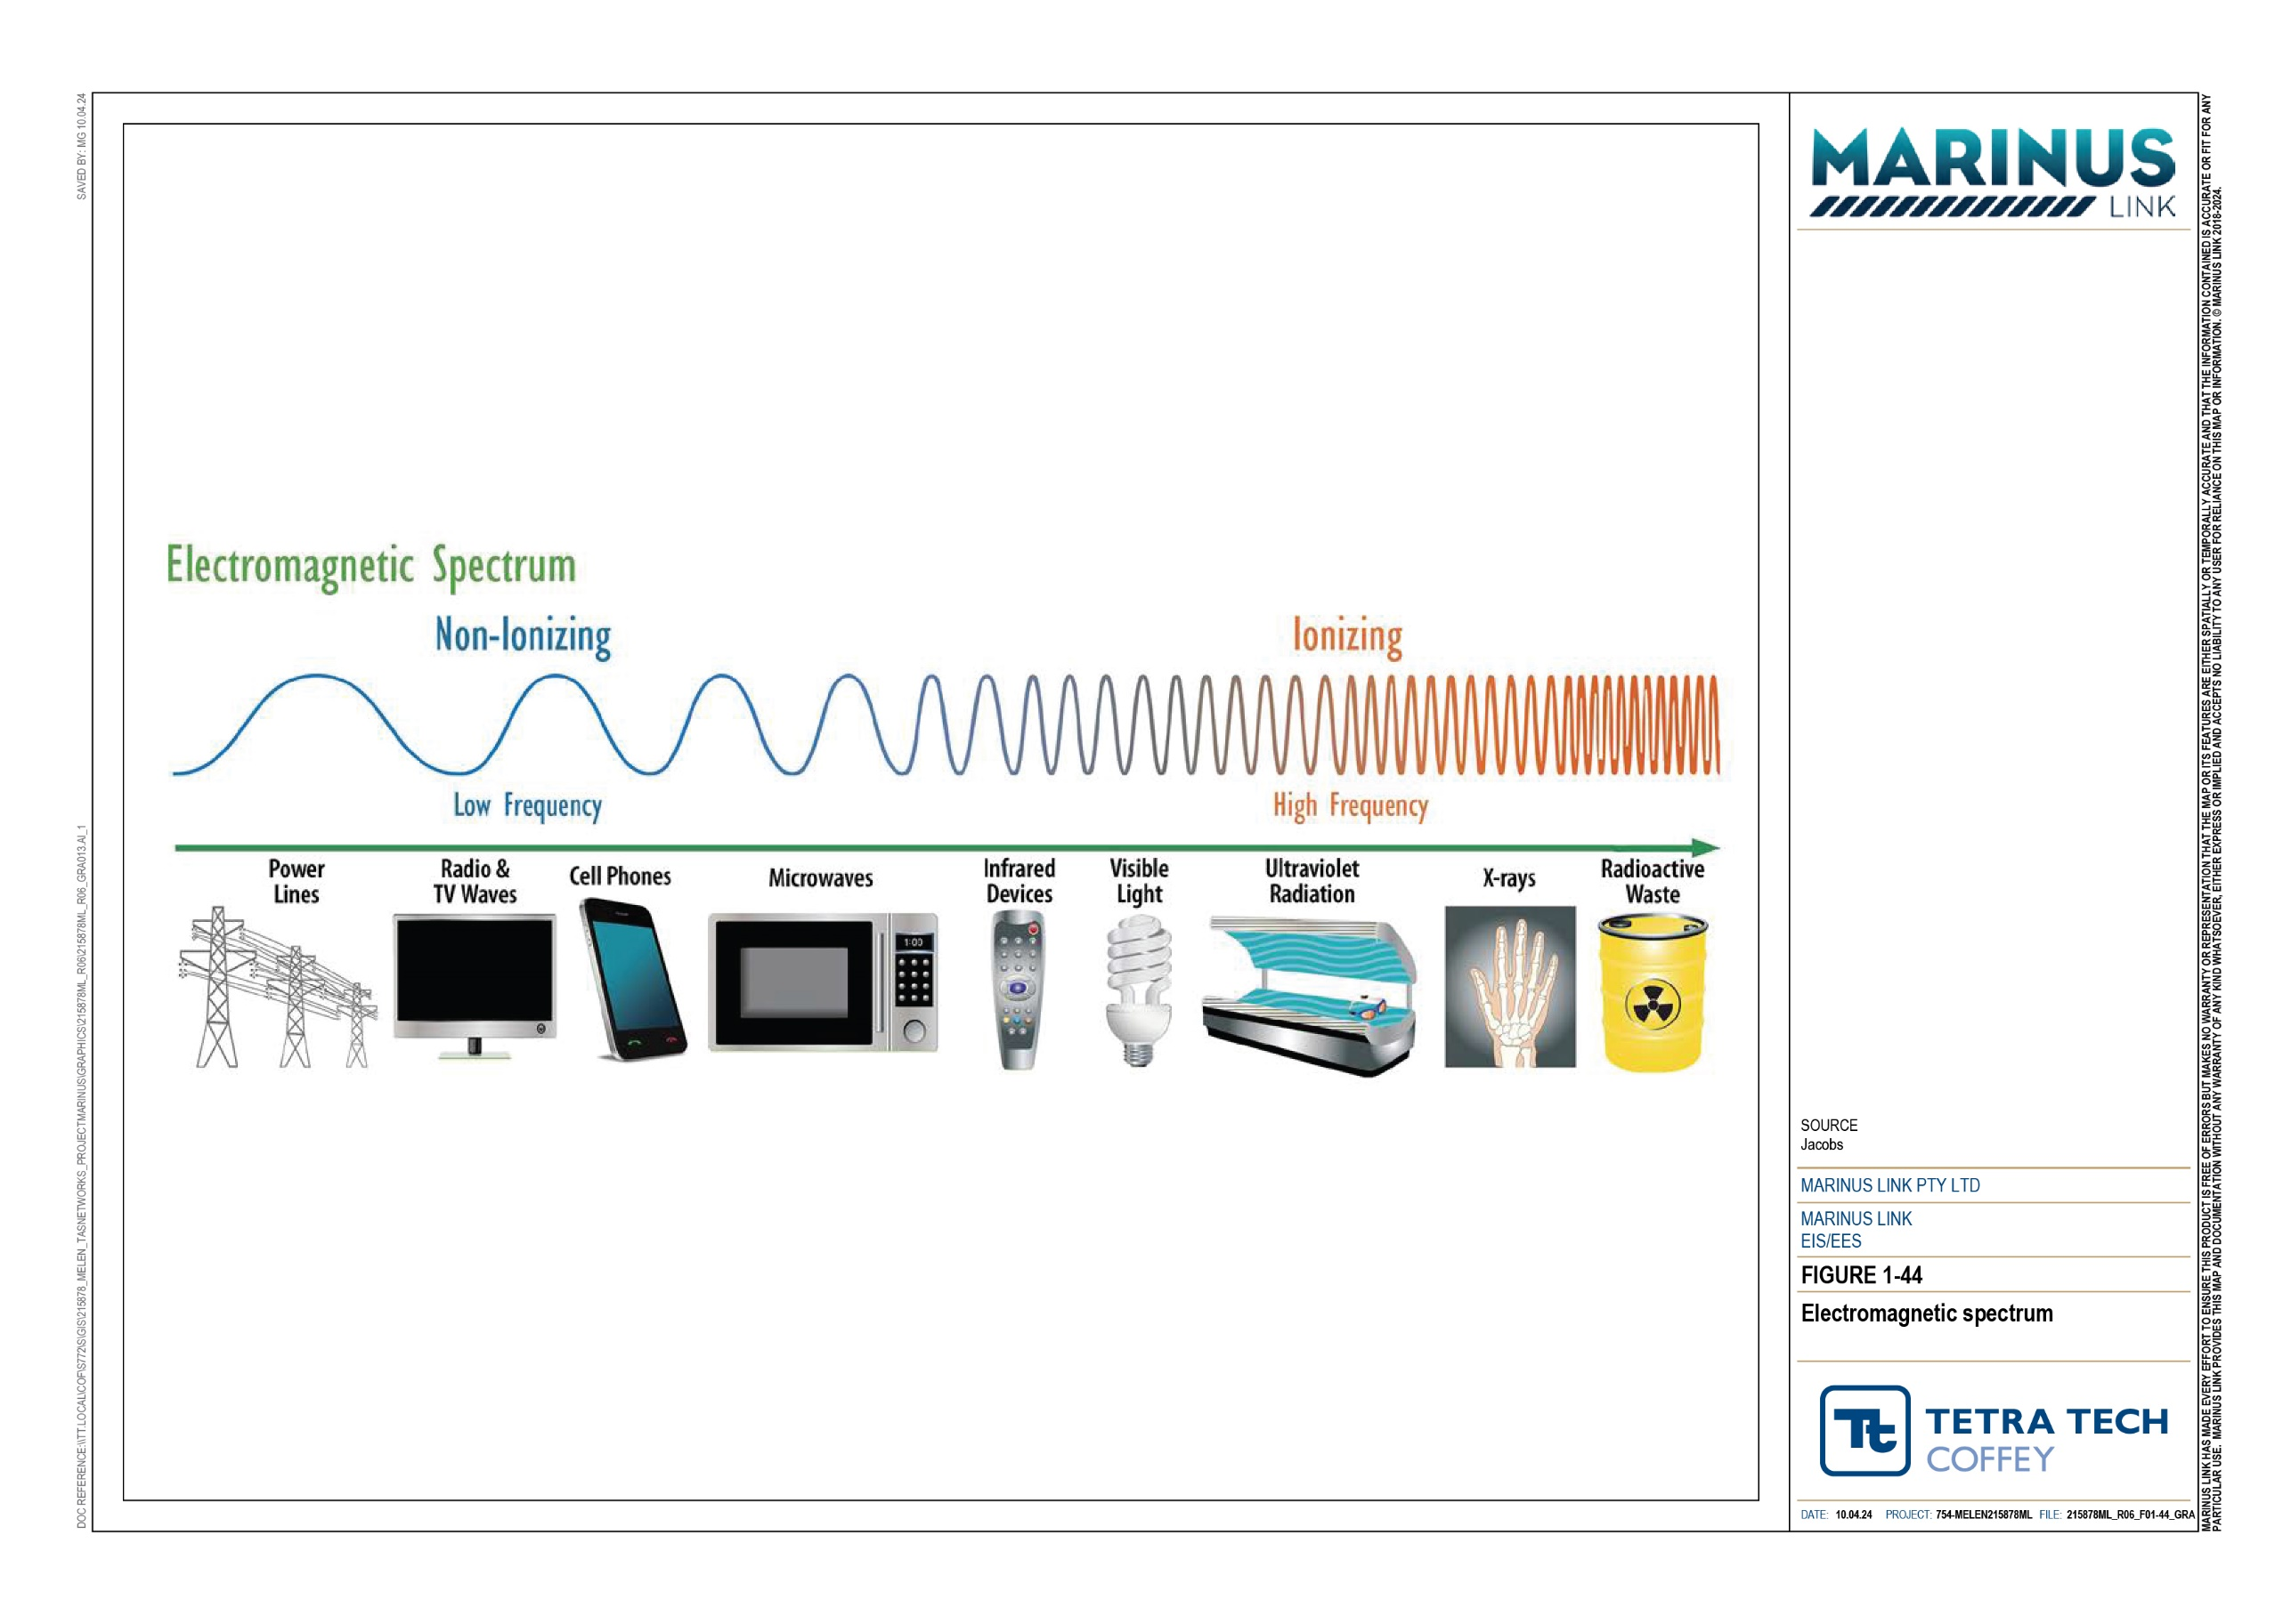

Background EMF levels
Naturally occurring EMF occur in the onshore and offshore study area. In Bass Strait, Tasmania and Victoria, the background EMF comprises the earth’s magnetic field and EMF generated by all electricity infrastructure and telecommunication cables. The earth’s magnetic field is generated by four sources:
The core field, resulting from the movement of molten iron in the centre of the earth.

The rock field, resulting from the presence of magnetic rocks in the earth’s crust.

The atmospheric field, resulting from solar radiation and winds.

The oceanic field, resulting from the movement of ocean currents through the earth’s magnetic field.

The atmospheric and oceanic fields are referred to for completeness, but they contribute very little to background EMF levels. The main source is the core field, which is strongest at the north and south poles. This means that Bass Strait, Tasmania and Victoria naturally have relatively high background EMF levels because they are close to the south pole. Also, the rocks underneath Bass Strait, Tasmania and Victoria are volcanic and contain magnetic iron (the rock field), which increases the EMF levels resulting from the core field.
As shown in Figure 1-45, the total background EMF in the offshore study area varies considerably, with the average approximately 60 µT. As shown in Figure 1-46, the total background EMF in the onshore study area is less variable, with the average onshore background EMF approximately 60 µT. The variation in background EMF in Figure 1-45 and Figure 1-46 is largely due to geological differences, with some rocks having higher magnetic content than others.

Volume 1 – Introduction Page 10-7

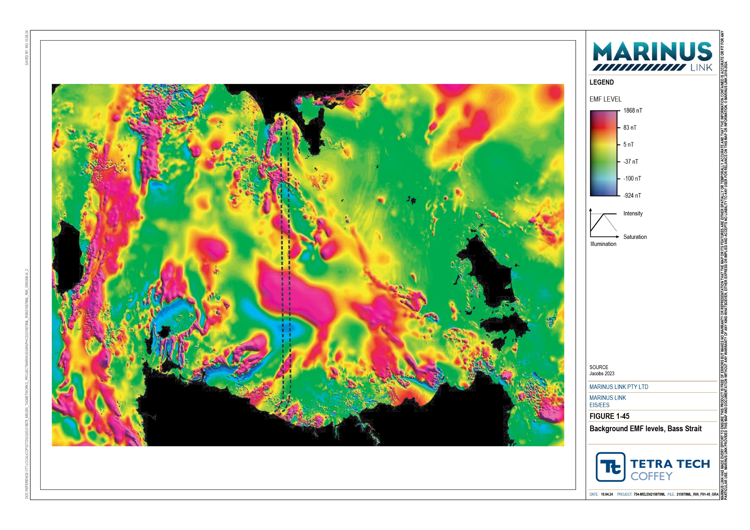
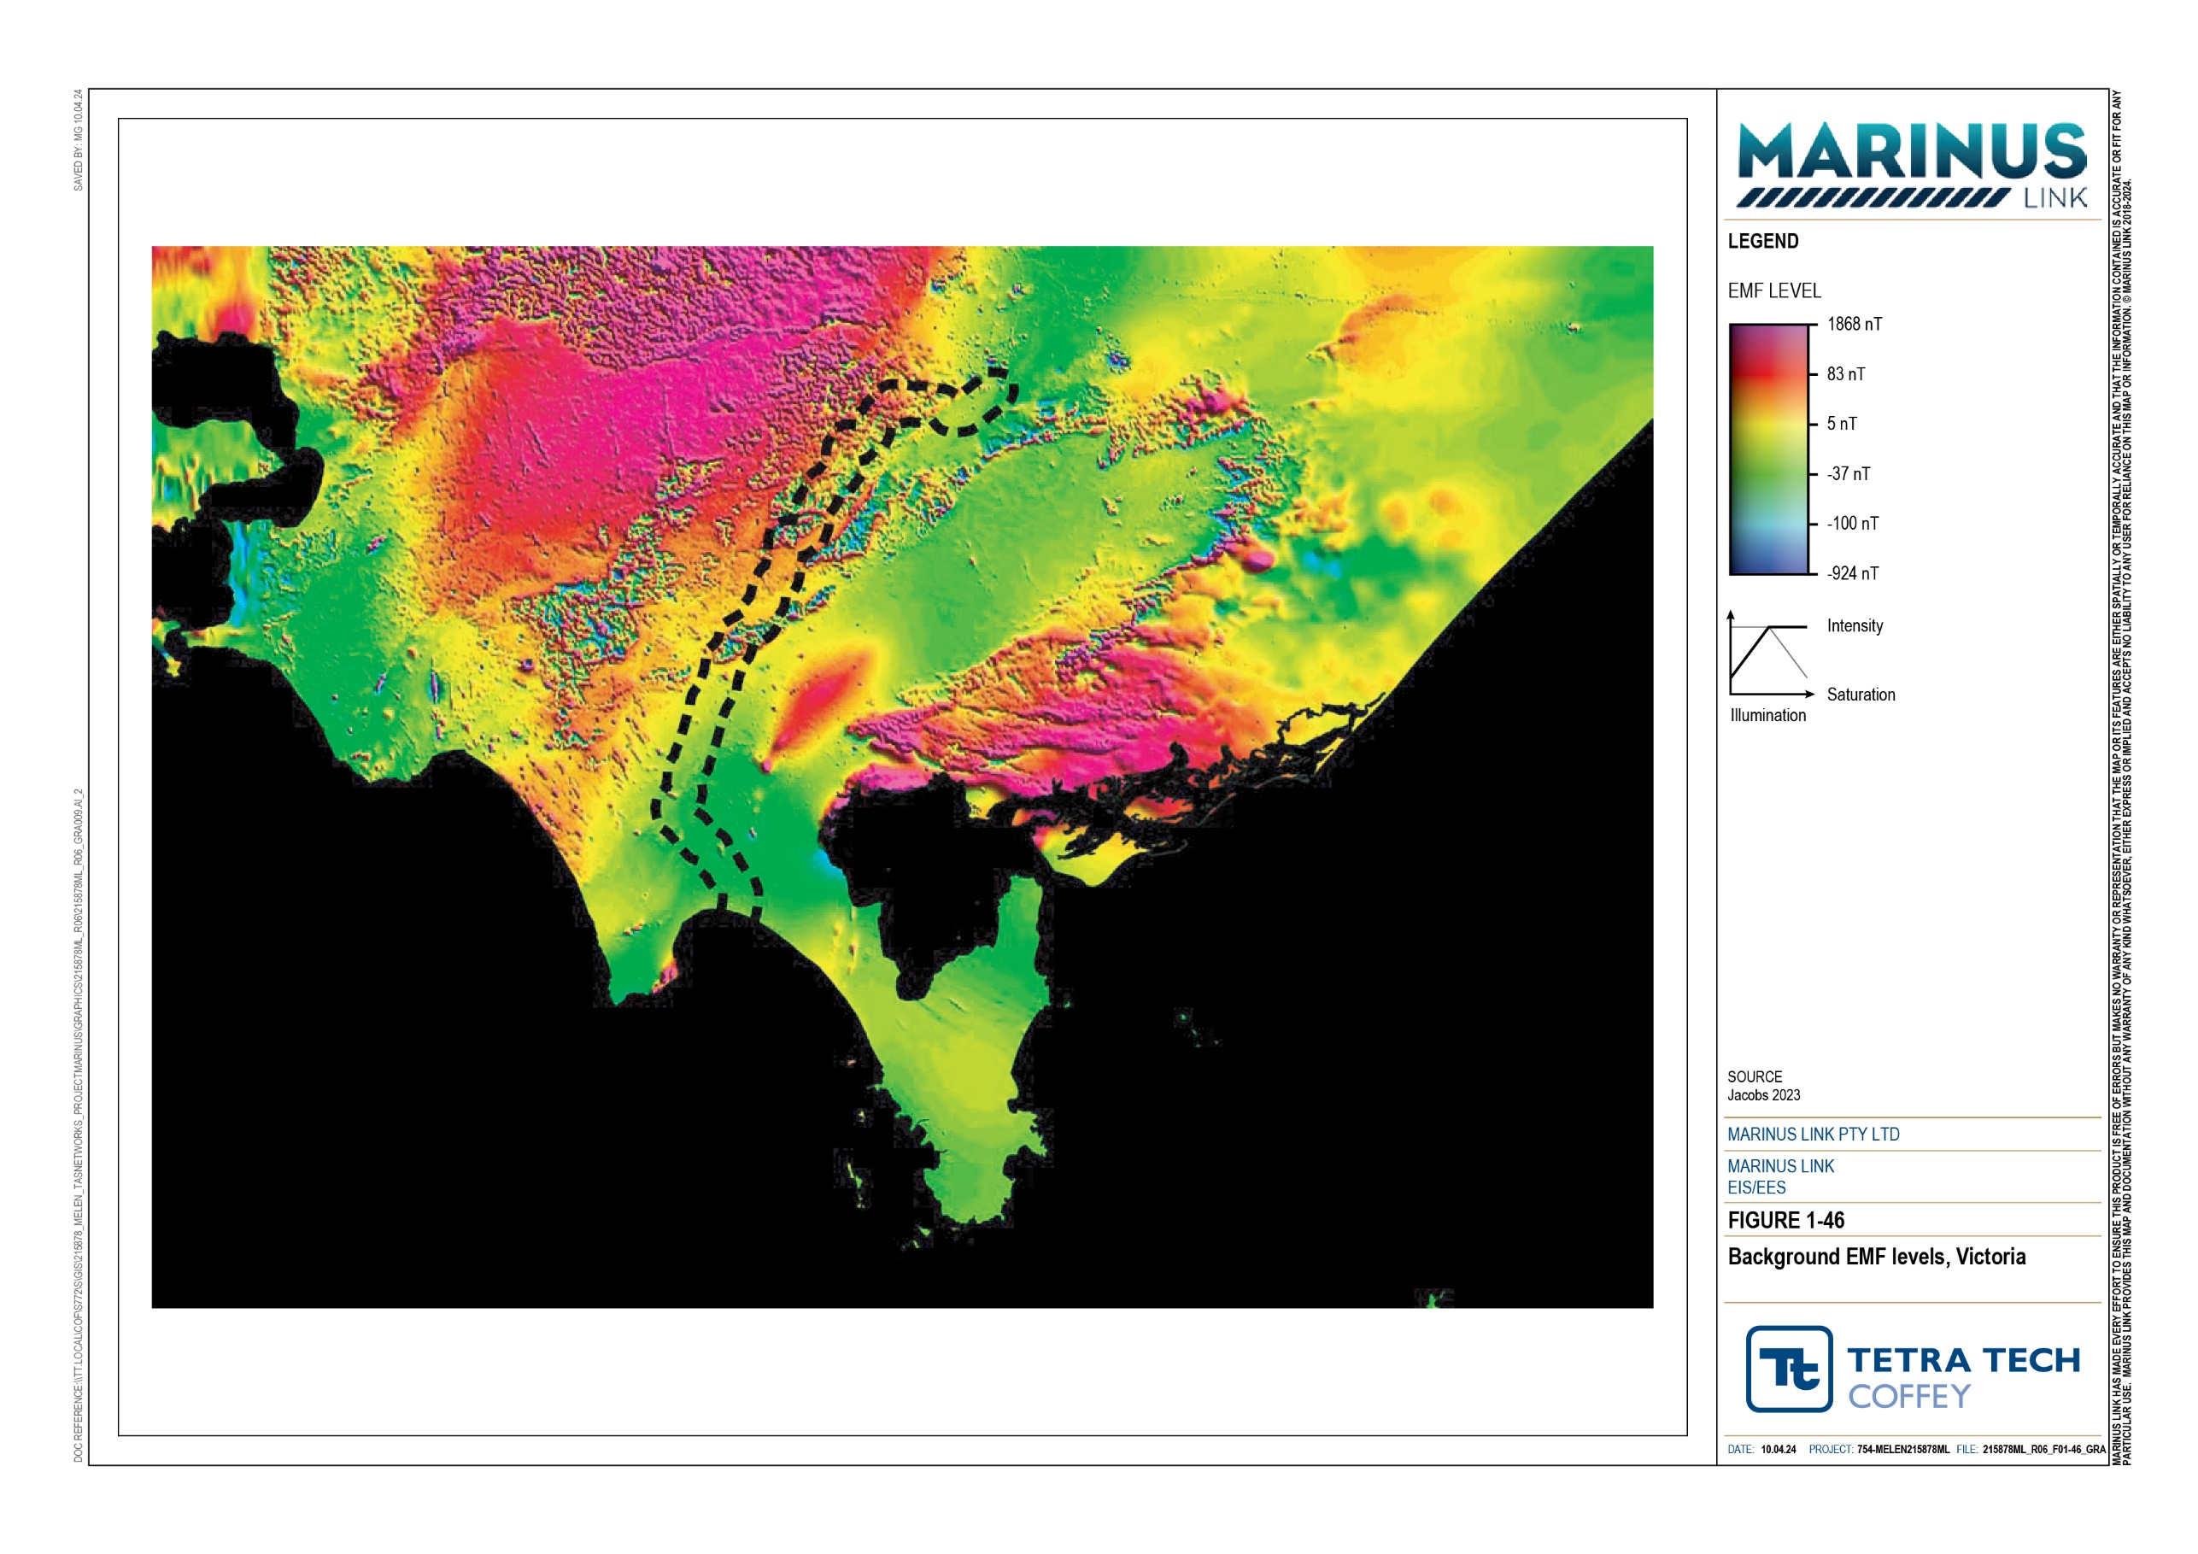

Background soil and water temperatures
EMF and cable heating are often considered together as they are key factors in cable design and choice of installation methods. EMF do not actually cause heating.
The buried cables will contain a copper or aluminium conductor, just like the strand of copper inside the wiring in homes. Electricity flows through this conductor in the form of a stream of electrons bouncing around but all moving in the same direction. When one of these electrons bumps into one of the atoms which makes up the conductor, it transfers some of its kinetic (moving) energy to that atom in the form of heat. This results in heating of the conductors, then the cable itself and eventually the surrounding soil or water. The more energy that is transmitted by the cables, the more heat that is generated.
It is important to know what the ambient or background soil and water temperatures are to be able to calculate the temperatures after cable installation, and whether these could have impacts on sensitive receivers. Assumed background soil and water temperature at key locations along the route are presented in Table 10-2.
Table 10-2 Assumed background soil and water temperatures

Location | Temperature (°C)
Heybridge (soil at 1 m depth) | 25
Hazelwood (soil at 1 m depth) | 25
Bass Strait (seawater close to seabed) | 18

Sensitive receivers
Sensitive receivers are people, animals and plants, technology and water quality which might be negatively impacted by exposure to EMF generated by the project. A desktop assessment was conducted to identify sensitive receivers present in the study area, and which EMF reference levels apply to each receiver. The sensitive receivers are described below and listed in Table 10-3 along with safe exposure reference levels.

Table 10-3 Sensitive receivers and EMF/temperature reference levels

Sensitive receiver | Source of EMF | Electric fields:  AC reference level | Electric fields:  DC reference level | Magnetic fields: AC reference level | Magnetic fields:  DC reference level | Source
People | Converter stations and cables | 5 kV/m | 5 kV/m | 200 µT | 400,000 µT | ICNIRP reference levels

Active implantable medical devices | Converter stations and cables | 5 kV/m | 5 kV/m | 200 µT | 500 µT | ICNIRP reference levels
Electrical equipment | Converter stations and cables | Undefined | Undefined | 3.8 µT | Undefined | AS/NZS 61000-6-1 – reference level for electrical & electronic equipment in a residential, commercial or light industrial environment
Livestock | Converter stations and cables | 5 kV/m | 5 kV/m | 200 µT | 400,000 µT | Conservative assumed values from desktop assessment, Technical Appendix A: Electromagnetic fields
RFID tags | Converter stations and cables | Undefined | Undefined | 3,000,000 µT | 3,000,000 µT | Technical Appendix A: Electromagnetic fields
Beehives | Converter stations and cables | 4.1 kV/m | Undefined | 100 µT | 2 µT | Technical Appendix A: Electromagnetic fields
Crops and orchards | Converter stations and cables | 5 kV/m | 5 kV/m | Undefined | Undefined | Technical Appendix A: Electromagnetic fields
Farm machinery guidance equipment | Converter stations and cables | Undefined | Undefined | Undefined | Undefined | Technical Appendix A: Electromagnetic fields
Terrestrial fauna | Converter stations and cables | 5 kV/m | 5 kV/m | 200 µT | 400,000 µT | Technical Appendix A: Electromagnetic fields
Marine fauna | Cables | Not applicable | N/A | N/A | N/A | Technical Appendix H: Marine ecology and resource use
Marine vessel navigation systems | Cables | N/A | N/A | N/A | Undefined | N/A
Water quality | Cables | N/A | N/A | N/A | N/A | The temperature reference level is 50°C

People
While exposure to very high levels of EMF over long periods can cause physical harm to people, EMF emitted by the project will be within World Health Organisation and International Commission on Non-ionising Radiation Protection (ICNIRP) reference levels for the protection of human health. Occupational exposure levels in certain parts of the converter stations have the potential to be relatively high, however control measures (design and operation and maintenance procedures) will be implemented to ensure worker (employee and contractor) exposure remains within the guideline values including specific measures for those with implanted medical devices.

Plants and animals
Livestock, beehives, crops and orchards, terrestrial fauna and marine fauna are susceptible to EMF. Like for people, overexposure to EMF can affect animals behaviour and cause physical harm. For example, many animals use the earth’s magnetic field to navigate, and an increase in EMF beyond a given level can disturb and confuse them. Honey bees are particularly sensitive to DC EMF and small fluctuations of >2 µT can disturb navigation.
AC EMF can negatively impact crops, certain plants and animals. The AC EMF levels expected to be emitted from the converter stations will be lower than the levels emitted which can affect plants and animals.
Therefore, AC EMF is not discussed further in this chapter.

Cable heating may cause drying out of the soils surrounding the cable trench, which might negatively impact plant health.
Potential impacts on marine plants and animals are addressed in Technical Appendix H: Marine ecology and resource use.

Technology
Active implantable medical devices, electrical and electronic equipment, radio-frequency identification (RFID) tags, farm machinery guidance equipment and marine vessel navigation systems are susceptible to EMF. Each type of technology has an EMF tolerance level, above which they may malfunction. For example, when moving a compass too close to a magnet, the needle will not point north because the magnet interferes with the earth’s magnetic field. Active implantable medical devices include pacemakers and cochlear impacts. In the case of pacemakers, excessive exposure to EMF can change the electrical signals that regulate the wearer’s heartbeat.
Farm equipment may use global positioning systems (GPS) or differential GPS (DGPS) for navigation. Electric fields are screened by the metallic sheath in the subsea and land cables. Magnetic fields are not screened and extend beyond the cables. GPS or DGPS equipment sensitive to magnetic fields could be affected if close to the cables. GPS or DGPS signals are unlikely to be affected due to the high frequencies at which they operate.
Magnetic fields generated by the subsea cables can affect magnetic compasses in shallow water. Large commercial vessels use gyrocompasses that sense the axis of the earth rather than its magnetic field and so

are unaffected. Smaller, recreational vessels that use magnetic compasses may be affected if in shallow water and within 10 m of the cables. GPS navigation systems, which are used almost universally by large and small vessels are unaffected by magnetic fields generated by the subsea cables.
Very sensitive receivers (including electron microscopes that might be found in hospitals or universities) are distinct from sensitive receivers, are particularly sensitive to EMF and have very low exposure tolerances (e.g., 0.03 to 0.3 µT, which is around 10 to 100 times more sensitive than honey bees). The desktop assessment did not identify any such equipment within the study area and so very sensitive receivers are not considered any further.

Water quality
Heat generated by the subsea cables may warm the surrounding sediment and seawater. Elevated soil and water temperatures can affect plant growth and benthic assemblages or communities. Increasing the seawater temperature may also increase conductivity. Increasing conductivity near a magnetic field (subsea cable) increases the induced electric field in the seawater, which may impact marine animals.

Construction impacts
Impacts during the construction phase are negligible because EMF are only generated while electrical current is flowing, which requires the converter stations and cables to be operational.
Any radiocommunications and electrical equipment used during construction will have the appropriate certification, indicating that they are safe to use, and that no radio frequency interference is expected.

Operation impacts
Operation of the interconnector will generate EMF and EMI. EMF will be generated by the AC and DC electrical apparatus including switching stations and converter stations, and DC land and subsea cables. Impacts during the operation phase have been assessed using the outputs of computer modelling, compared with applicable reference levels. The converter stations, subsea cables and land cables were each modelled separately.
EMI will be generated by the electrical apparatus within the converter stations. Impacts during the operation phase have been assessed using the outputs of computer modelling, compared with applicable reference levels.
A cable heating assessment was carried out to assess potential impacts on background soil and water temperatures from heat generated by resistance in the land and subsea cables.
The results of the modelling and cable heating assessment are presented below. In all cases, results are presented only for potentially affected sensitive receivers. For example, livestock are considered in the land cables impact assessment because the land cables are likely to go through paddocks where livestock are kept.

Heybridge converter station
The main source of EMF is the AC electrical equipment to be installed at the Heybridge converter station site. This equipment is designed to convert the DC electricity in the subsea cables into AC electricity for transmission within Tasmania or vice versa when electricity is being exported from Tasmania to Victoria.
The converter station will also include DC equipment. The DC equipment in the converter stations and associated outdoor installations was not modelled because the equipment generating high EMF will be positioned away from the converter station perimeter fence avoiding impacts on nearby sensitive receivers. The highest levels of DC magnetic fields at the converter station perimeter fence line are directly above the subsea cables which extend into the converter station. EMF generated by the subsea cables is covered in the subsea cable modelling and impact assessment (Section 10.4.3).

The AC electrical equipment was modelled using the HIFREQ computer model. As shown in Table 10-4, the calculated EMF are below the reference levels for applicable sensitive receivers at the converter station perimeter fence.

Table 10-4 Results of modelling - Heybridge converter station

Sensitive receiver | Electric fields:  AC reference level | Maximum calculated value | Magnetic fields: AC reference level | Maximum calculated value
People | 5 kV/m | 3.5 kV/m | 200 µT | 14.2 µT
Active implantable medical devices (e.g., pacemakers and cochlear implants) | 5 kV/m | 3.5 kV/m | 200 µT | 14.2 µT
Livestock | 5 kV/m | 3.5 kV/m | 200 µT | 14.2 µT
Beehives | 4.1 kV/m | 3.5 kV/m | 100 µT | 14.2 µT
Terrestrial fauna | 5 kV/m | 3.5 kV/m | 200 µT | 14.2 µT

At normal operating voltage, the modelled EMI level of the electrical apparatus in the converter station and associated switchyards is 12 to 14 kilovolts per cm (kV/cm), which is less than the 16 kV/cm reference level specified for acceptable transmission line corona performance in AS/NZS 7000:2016 (see Technical Appendix A: Electromagnetic fields).

Hazelwood converter station
The main source of EMF is the AC electrical equipment to be installed at the Hazelwood converter station site. This equipment is designed to convert the DC electricity in the land cables into AC electricity for transmission within Victoria or to convert AC electricity to DC electricity for export to Tasmania.
The converter station will also include DC equipment. The DC equipment in the converter stations and associated outdoor installations was not modelled because the equipment generating high EMF will be

positioned away from the converter station perimeter fence avoiding impacts on nearby sensitive receivers. The highest levels of DC magnetic fields at the converter station perimeter fence line are directly above the land cables. EMF generated by the land cables is covered in the land cable modelling and impact assessment (Section 10.4.4).
The AC electrical equipment was modelled using the HIFREQ computer model. As shown in Table 10-5, the calculated EMF are below the reference levels for applicable sensitive receivers at the perimeter fence.
Table 10-5 Results of modelling - Hazelwood converter station

Sensitive receiver | Electric fields:  AC reference level | Maximum calculated value | Magnetic fields: AC reference level | Maximum calculated value
People | 5 kV/m | 3.2 kV/m | 200 µT | 10.7 µT
Active implantable medical devices (e.g., pacemakers and cochlear implants) | 5 kV/m | 3.2 kV/m | 200 µT | 10.7 µT
Livestock | 5 kV/m | 3.2 kV/m | 200 µT | 10.7 µT
Beehives | 4.1 kV/m | 3.2 kV/m | 100 µT | 10.7 µT
Terrestrial fauna | 5 kV/m | 3.2 kV/m | 200 µT | 10.7 µT

At normal operating voltage, the modelled EMI level of the electrical apparatus is less than 16 kV/cm, which is the reference level specified for acceptable transmission line corona performance in AS/NZS 7000:2016 (see Technical Appendix A: Electromagnetic fields).

Subsea cables
The DC subsea cables to be installed through Bass Strait will generate magnetic fields. Electric fields are screened by the metallic sheath in the cables. Seawater passing through the magnetic fields generated by electricity flowing through the cables will generate a weak electric field. Technical Appendix H: Marine ecology and resource use discusses and assesses the potential impacts of these weak electric fields.
Magnetic fields generated by the DC subsea cables were modelled at three locations – at the Heybridge shore crossing, through Bass Strait and at the Waratah Bay shore crossing. The modelling assumed the subsea cables were at the target burial depth of 1 m. As shown in Table 10-6, the calculated EMF are below the reference levels for applicable sensitive receivers at all locations.
The highest EMF levels are at the shore crossings where the subsea cables are unbundled to be installed in separate ducts under the nearshore waters, beach and coastal dunes. The cables will be up to 50 m apart at the offshore end of the shore crossing ducts and closer at onshore end of the ducts. Figure 1-47 shows the calculated EMF levels (in µT) at the Heybridge shore crossing and Figure 1-48 shows the calculated EMF levels (in µT) at the Waratah Bay shore crossing.

Through Bass Strait, the cables are bundled together, meaning the cables in each of the two links (one link is two power cables plus one fibre optic cable) are laid close together. Because the electrical current in the two power cables runs in opposite directions, EMF are substantially cancelled considerably reducing the EMF levels.
Impacts on marine plants and animals are addressed in Technical Appendix H: Marine ecology and resource use.
Impacts on vessel navigation systems using compasses are expected to be negligible. As summarised in Section 10.2.3, magnetic fields generated by the subsea cables will not impact the gyrocompasses or GPS systems used by commercial vessels, and only magnetic compasses within 10 m of the cables. Visual navigation near the coast minimises impacts to navigational safety caused by EMF disrupting the accuracy of compass readings.

Table 10-6 Results of modelling - subsea cables

Sensitive receiver | Modelled location | Magnetic fields: DC reference level | Maximum calculated value
People | Heybridge shore crossing | 400,000 µT | 193 µT
 | Bass Strait (horizontal alignment) | 400,000 µT | 24 µT
 | Waratah Bay shore crossing | 400,000 µT | 194 µT
Active implantable medical devices (e.g., pacemakers and cochlear implants) | Heybridge shore crossing | 500 µT | 193 µT
 | Bass Strait (horizontal alignment) | 500 µT | 24 µT
 | Waratah Bay shore crossing | 500 µT | 194 µT

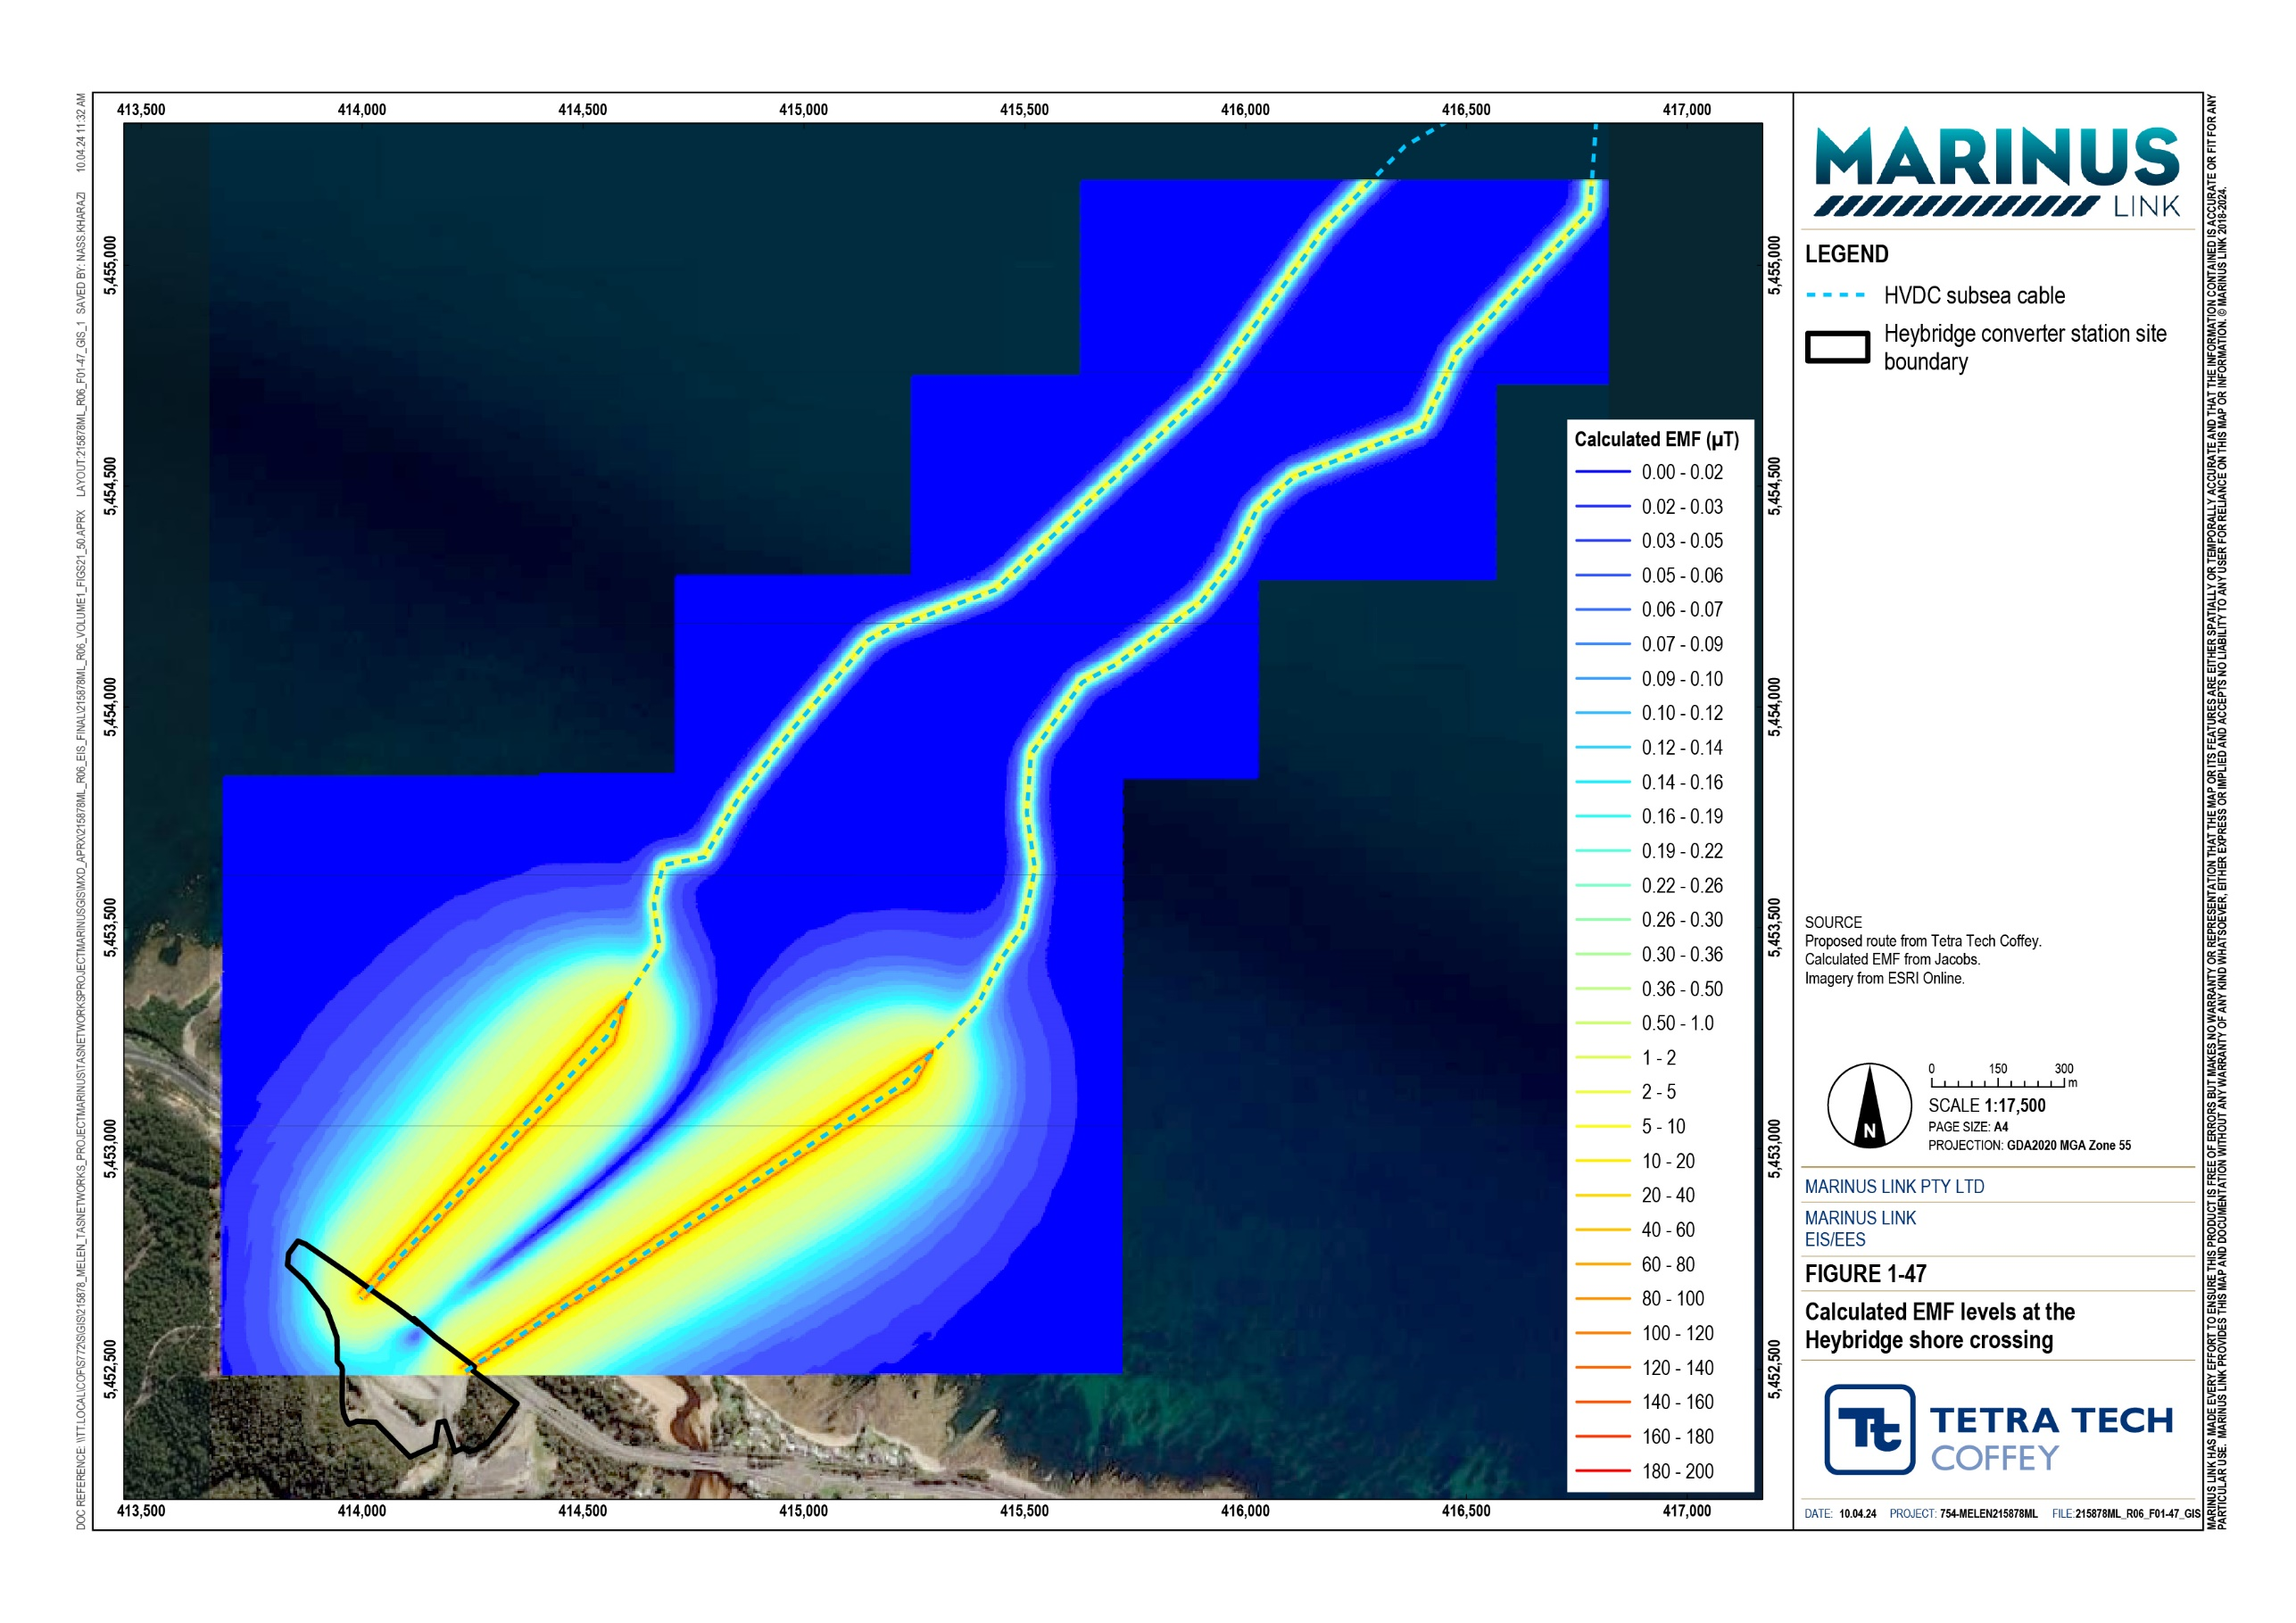
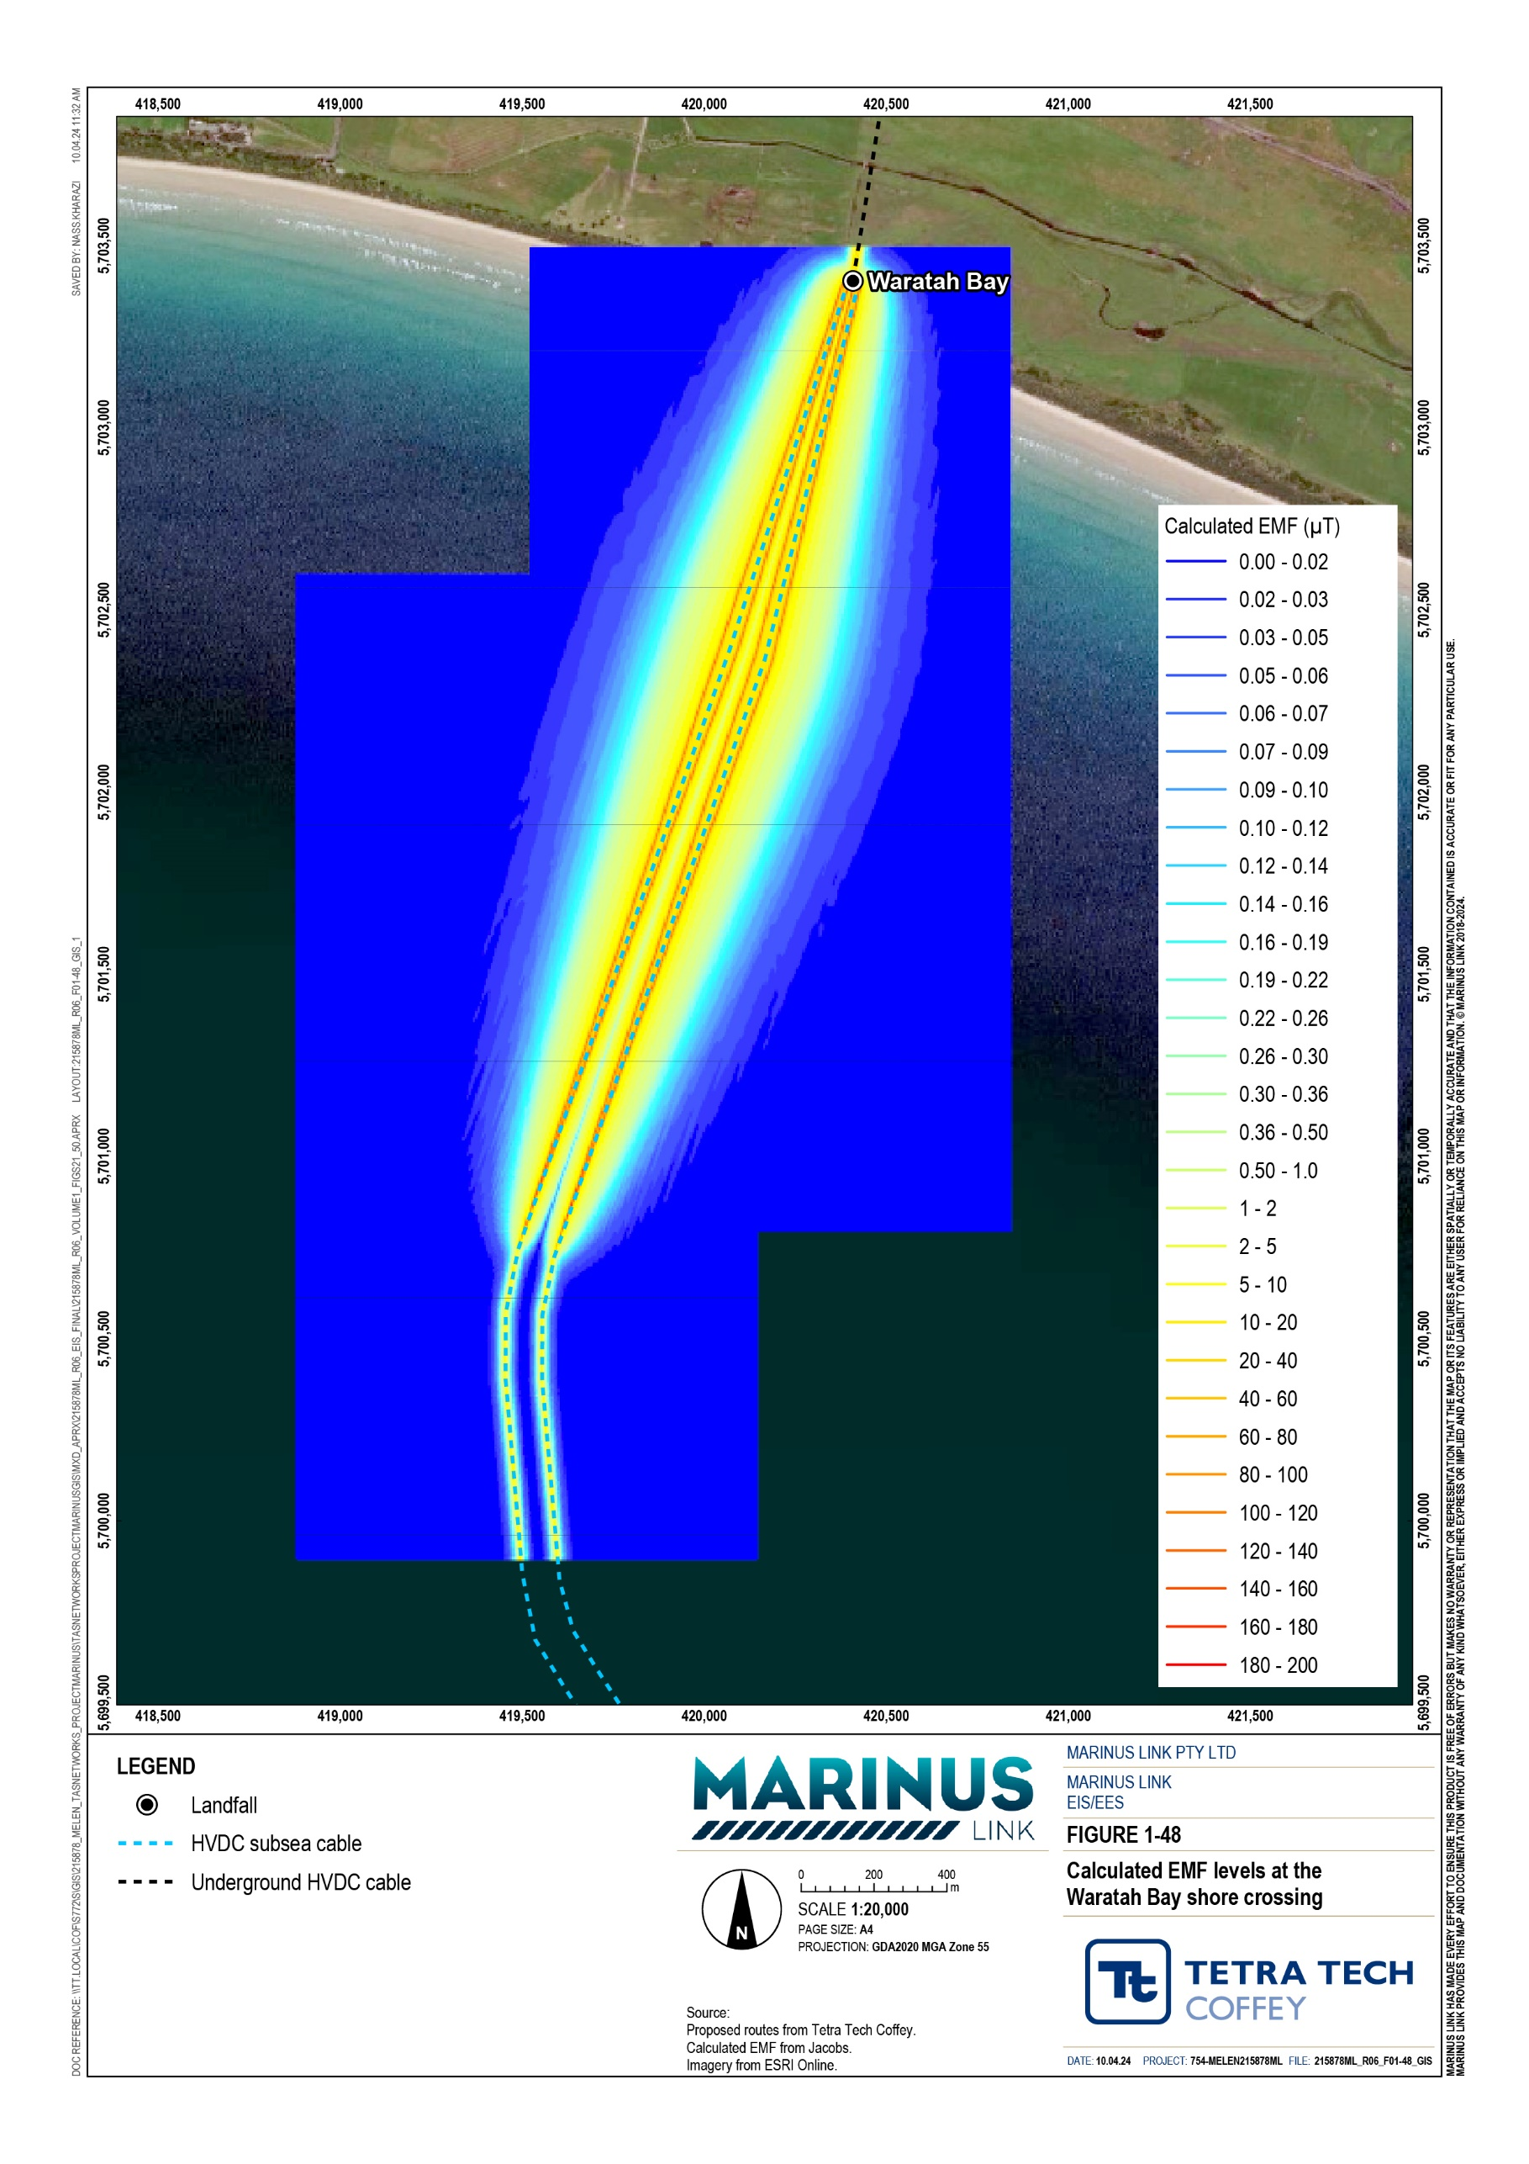

Land cables
The DC land cables to be installed between the shore crossing at Waratah Bay and the converter station at Hazelwood will generate magnetic fields. Electric fields are screened by the metallic sheath in the cables.

Magnetic field levels generated by the DC land cables were modelled for four cable spacings (0.5 m, 1 m, 2 m and 4 m). The design spacing is 0.5 m between the two power cables within one link, but this might increase up to 4 m where cables are installed in HDD ducts under roads and watercourses. EMF levels for the worst case (4 m) spacing are presented in Table 10-7.

Table 10-7 Results of modelling – land cables

Sensitive receiver | Magnetic fields: DC reference level | Maximum calculated value at 4 m spacing
People | 400,000 µT | 124 µT
Active implantable medical devices (e.g., pacemakers and cochlear implants) | 500 µT | 124 µT
RFID tags | 3,000,000 µT | 124 µT
Livestock | 400,000 µT | 124 µT
Beehives | 2 µT | 124 µT
Terrestrial fauna | 400,000 µT | 124 µT

As shown in Table 10-7, the calculated EMF are below the reference levels for applicable sensitive receivers except beehives. The land cables could impact on the behaviour of honey bees because directly above the buried cables, and within 5 m of the cable trench, the calculated field levels are above 2 µT. No beekeeping sites are known within 5 m of the proposed cable route, but should any be identified, alternative sites will be discussed and agreed with the beekeeper. EPRs require the location of beehives to be documented, and for MLPL to work with landholders to implement reasonably practicable measures to address potential impacts (EPRs EMF01, EMF02).

Cable heating assessment
The increase in seabed and soil temperature caused by heat generated by the subsea and land cables respectively was modelled for six locations along the proposed route. Three depths (the minimum burial depth of 1 m, plus 0.5 m and 0.1 m below seabed or ground level) and three operating scenarios (normal operating temperature, plus 70°C and 90°C operating temperatures which are the maximum operating temperatures) were modelled. The results of the cable heating assessment are presented in Table 10-8.

Background soil temperature assumed on land is 25°C (see Table 10-2). At 50°C, soil will start to dry out, meaning that an increase in soil temperature of over 25°C above background will cause drying out of soils around the cables. A temperature increase of more than 3°C in the root zone for pasture grasses
(0.1 m depth) can cause drying out of the soil around the roots, and negatively impact the health of the plants.
Table 10-8 shows that soil temperature increases at 0.1 m depth under normal and 70°C cable operating temperatures are all less than 3°C. One section (Smallmans Road–Darlimurla Road), indicates a modelled soil temperature increase of +3°C under a 90°C cable operating temperature scenario. The design requires cables to be buried with thermal backfill (a weak sand-cement mix) which facilitates efficient heat dissipation and minimises soil heating. As such, negligible impacts are expected on plant life around the land cables.
At the locations where soil temperature increases by more than 25°C at 1.0 m depth, deeper excavation and thicker thermal backfill may be required to keep soil temperature increases to less than 25°C.
As indicated in Table 10-2, the background seawater temperature just above the seabed in Bass Strait is 18°C. The maximum increase in soil temperature just below the seabed is 1°C (Table 10-8). The large volume of seawater and strong ocean currents which have a cooling effect are expected to dissipate this warming. Negligible impacts on seabed or seawater temperatures are expected.

Table 10-8 Results of cable heating assessment

Operation condition Increase in soil temperature above Ambient for various cable sections
 | Heybridge converter station | Subsea section | Waratah Bay – Smallmans Rd | Smallmans Rd – Darlimurla Rd | Darlimurla Rd – Strzelecki Hwy | Strzelecki Hwy – Hazelwood
Steady state current  1.0 m depth | +8°C | +7°C | +8°C | +20°C | +8°C | +14°C
Conductor temp 70°C  1.0 m depth | +11°C | +22°C | +11°C | +25°C | +11°C | +17°C
Conductor temp 90°C 1.0 m depth | +15°C | +30°C | +15°C | +35°C | +15°C | +25°C
Steady state current  0.5 m depth | +3°C | +2°C | +3°C | +9°C | +3°C | +6°C
Conductor temp 70°C  0.5 m depth | +5°C | +9°C | +5°C | +12°C | +5°C | +8°C
Conductor temp 90°C  0.5 m depth | +6.5°C | +12°C | +6.5°C | +16°C | +6.5°C | +11°C
Steady state current  0.1 m depth | +0°C | +0°C | +0°C | +1°C | +0°C | +1°C
Conductor temp 70°C  0.1 m depth | +1°C | +0°C | +1°C | +2°C | +1°C | +1.5°C
Conductor temp 90°C  0.1 m depth | +1.5°C | +1°C | +1.5°C | <3°C | +1.5°C | +2°C

Decommissioning impacts
The operation phase is the only phase relevant to the impact assessment, as once no current is flowing through the cables no EMF will be generated.

Environmental performance requirements
EPRs set out the environmental outcomes that must be achieved during all phases of the project. In developing these EPRs, industry standards and guidelines, good practice and the latest approaches to managing impacts were considered. Project specific management measures, relevant legislation and policy requirements informed these EPRs.
The proposed EMF related EPRs are summarised in Table 10-9.

Table 10-9 EPRs

EPR ID | EPR
EMF01 | Design the project to reduce EMF/EMI emissions  Design and construct the project to reduce electric and magnetic fields (EMF) and electromagnetic interference (EMI) for the project alignment onshore to below the reference levels or as low as reasonably practicable to avoid and minimise impacts. The applicable reference levels are defined in EIS/EES Technical Appendix A: Electromagnetic Fields Section 7 of the EMI impact assessment prepared for the EIS/EES.  The design must be informed by a project wide EMF and EMI assessment for all the proposed infrastructure, identifying existing sensitive receptors and committed future developments within the study area. The assessment must be documented in a management plan that includes, but is not limited to:  Outcomes of the project wide EMF and EMI assessment and details of the areas assessed.  The location of all sensitive receptors including beehives within 5 m of the infrastructure. The location of beehives must also be documented in the property management plans (EPR A02).  Where at-receiver mitigation works to sensitive equipment are required to avoid or minimise adverse impacts.  A pre- and post-construction testing strategy to verify design calculations, impacts on sensitive equipment and the efficacy of any specified mitigation measures.  Remedial action to be undertaken if EMF and EMI limits are not met during the construction, testing, and commissioning.  The EMF and EMI management plan must be prepared to inform the design and commissioning of the project.  EMF and EMI emissions of the subsea cable are addressed in EPR MERU 12.
EMF02 | Investigate and resolve complaints regarding EMF and EMI during operation  As part of the OEMP, develop a protocol for investigating and resolving complaints regarding EMF and EMI during operation. The protocol must outline requirements for working with landholders to assess  impacts on sensitive equipment and implement reasonably practicable measures to address impacts.

Residual impacts
The method used in this impact assessment requires mitigation measures to be considered where modelling indicates the project EMF levels may exceed applicable reference levels. As detailed in Section 10.4, project operations result in one exceedance.
The 2 µT reference level for beehives is exceeded by operation of the land cables in Victoria. Mitigation proposed for this is relocating any beehives located within 5 m of the cable. This exceedance is expected to be resolved by applying the above provided mitigation measures, resulting in an assessed negligible residual impact.

Cumulative impacts
Cumulative impacts with other projects occurring at the same place and at the same time were considered.

For the subsea cables, the operational Basslink, as well as two proposed offshore wind farms (Bass Offshore Wind Energy and Great Southern) were considered, as these are the closest sources of existing and proposed EMF to the project.
Cumulative impacts with other subsea cables are not significant unless they are within 50 m of the project. Basslink and the proposed offshore windfarms are more than 50 km from the project at the time of the assessment. None of the offshore wind farms proposed on the Gippsland coast or in Bass Strait are close enough to the project to cause cumulative impacts.
Cumulative impacts with other DC land cables are not significant unless they are within 10 m of one another. Most other projects, including the proposed Delburn wind farm and existing or proposed power lines will have AC cables. Running DC and AC cables close to one another results in only negligible cumulative impacts, in part because humans and animals are less affected by DC fields than AC fields.

Conclusion
EMF are invisible forces that surround us. They occur naturally, forming the background EMF levels that we experience every day, and are generated by electrical equipment including by the project.
Sensitive receivers considered in this impact assessment are people, active implantable medical devices, electrical equipment, livestock, RFID tags, beehives, crops and orchards, farm equipment, terrestrial fauna, marine vessel navigation systems and water quality. Impacts on marine plants and animals are addressed in Technical Appendix H: Marine ecology and resource use to avoid.
Project operation is expected to generate EMF levels which are below all applicable reference levels for sensitive receivers, with one exception. Operation will result in exceedance of the 2 µT reference level for beehives. The mitigation measure proposed to address this is to relocate any beehives located within 5 m of the cable. Residual impacts are expected to be negligible.

The potential residual impacts of EMF generated by the project on people, plants and animals, technology, and water quality was assessed as negligible.
The EIS guidelines regarding underwater disturbance have been met because details of the EMF to be generated have been modelled and heat generation from the operation of the subsea cable has been modelled in the cable heating assessment. The further aspects of the EIS guidelines regarding underwater disturbance due to noise, heat and vibration (e.g., impacts on MNES) are addressed in Technical Appendix H: Marine ecology and resource use.
Because adverse effects on community amenity, health and safety with regard to electromagnetic fields are expected to be avoided (and where avoidance is not possible, minimised) through the implementation of mitigation measures to achieve EPRs, the project is predicted to meet the EMF component of the EES evaluation objective to ‘avoid and, where avoidance is not possible, minimise adverse effects on community amenity, health and safety, with regard to noise, vibration, air quality including dust, the transport network, greenhouse gas emissions, fire risk and electromagnetic fields’.

