Introduction
This volume of the environmental impact statement/environment effects statement (EIS/EES) provides a summary of the assessment of the impacts of Marinus Link (the project) on the terrestrial environment to address Commonwealth requirements in Tasmania. This includes matters of national environmental significance (MNES) and other matters considered by the Minister for the Environment and Water when making a decision under the Environment Protection and Biodiversity Act 1999 (Cwlth) (EPBC Act).
For the Tasmanian terrestrial environment, these matters include ecology (threatened species and communities, and migratory species) and social considerations. Tasmanian legislative requirements are assessed in separate EIS documentation prepared for the converter station site and shore crossing.
The assessment of MNES in Tasmanian coastal waters is addressed in Volume 3 of this EIS/EES and the supporting technical studies. Other matters in Tasmanian coastal waters covered by Tasmanian legislation are addressed in the separate EIS document prepared for the shore crossing.

Tasmanian project overview
The project is a proposed 1500 megawatt (MW) high voltage direct current (HVDC) electricity interconnector between Heybridge in northwest Tasmania and the Latrobe Valley in Victoria. In Tasmania, a converter station is proposed to be located at Heybridge near Burnie (Figure 2-01). The converter station will facilitate the connection of the project to the Tasmanian transmission network. There will be two subsea cable landfalls at Heybridge with the cables extending from the converter station across the Bass Strait to Waratah Bay in Victoria.
The shore crossings will be constructed using horizontal directional drilling (HDD) from the converter station to about 10 m water depth where the cables will then be trenched (where geotechnical conditions permit). A detailed project description is provided in Volume 1, Chapter 6 – Project description of this EIS/EES. Six HDDs will be drilled from two drill pads (three HDDs at each drill pad), with one drill pad located at either end of the converter station site. It is expected to take approximately 12 months for the HDD drilling of the shore crossing. Subsea cables laying and protection will take place over approximately 12 months.
The area that has been the focus of this impact assessment in Tasmania is defined by the property boundary of the Heybridge converter station site and the location of the shore crossings which extend from the site, under the Bass Highway and Western Line railway to Bass Strait. This area is referred to as the ‘survey area’ as defined in Volume 1, Chapter 6 – Project description. The survey area is shown in Figure 2-02.

Volume 2 – Tasmanian terrestrial environment Page 1-1

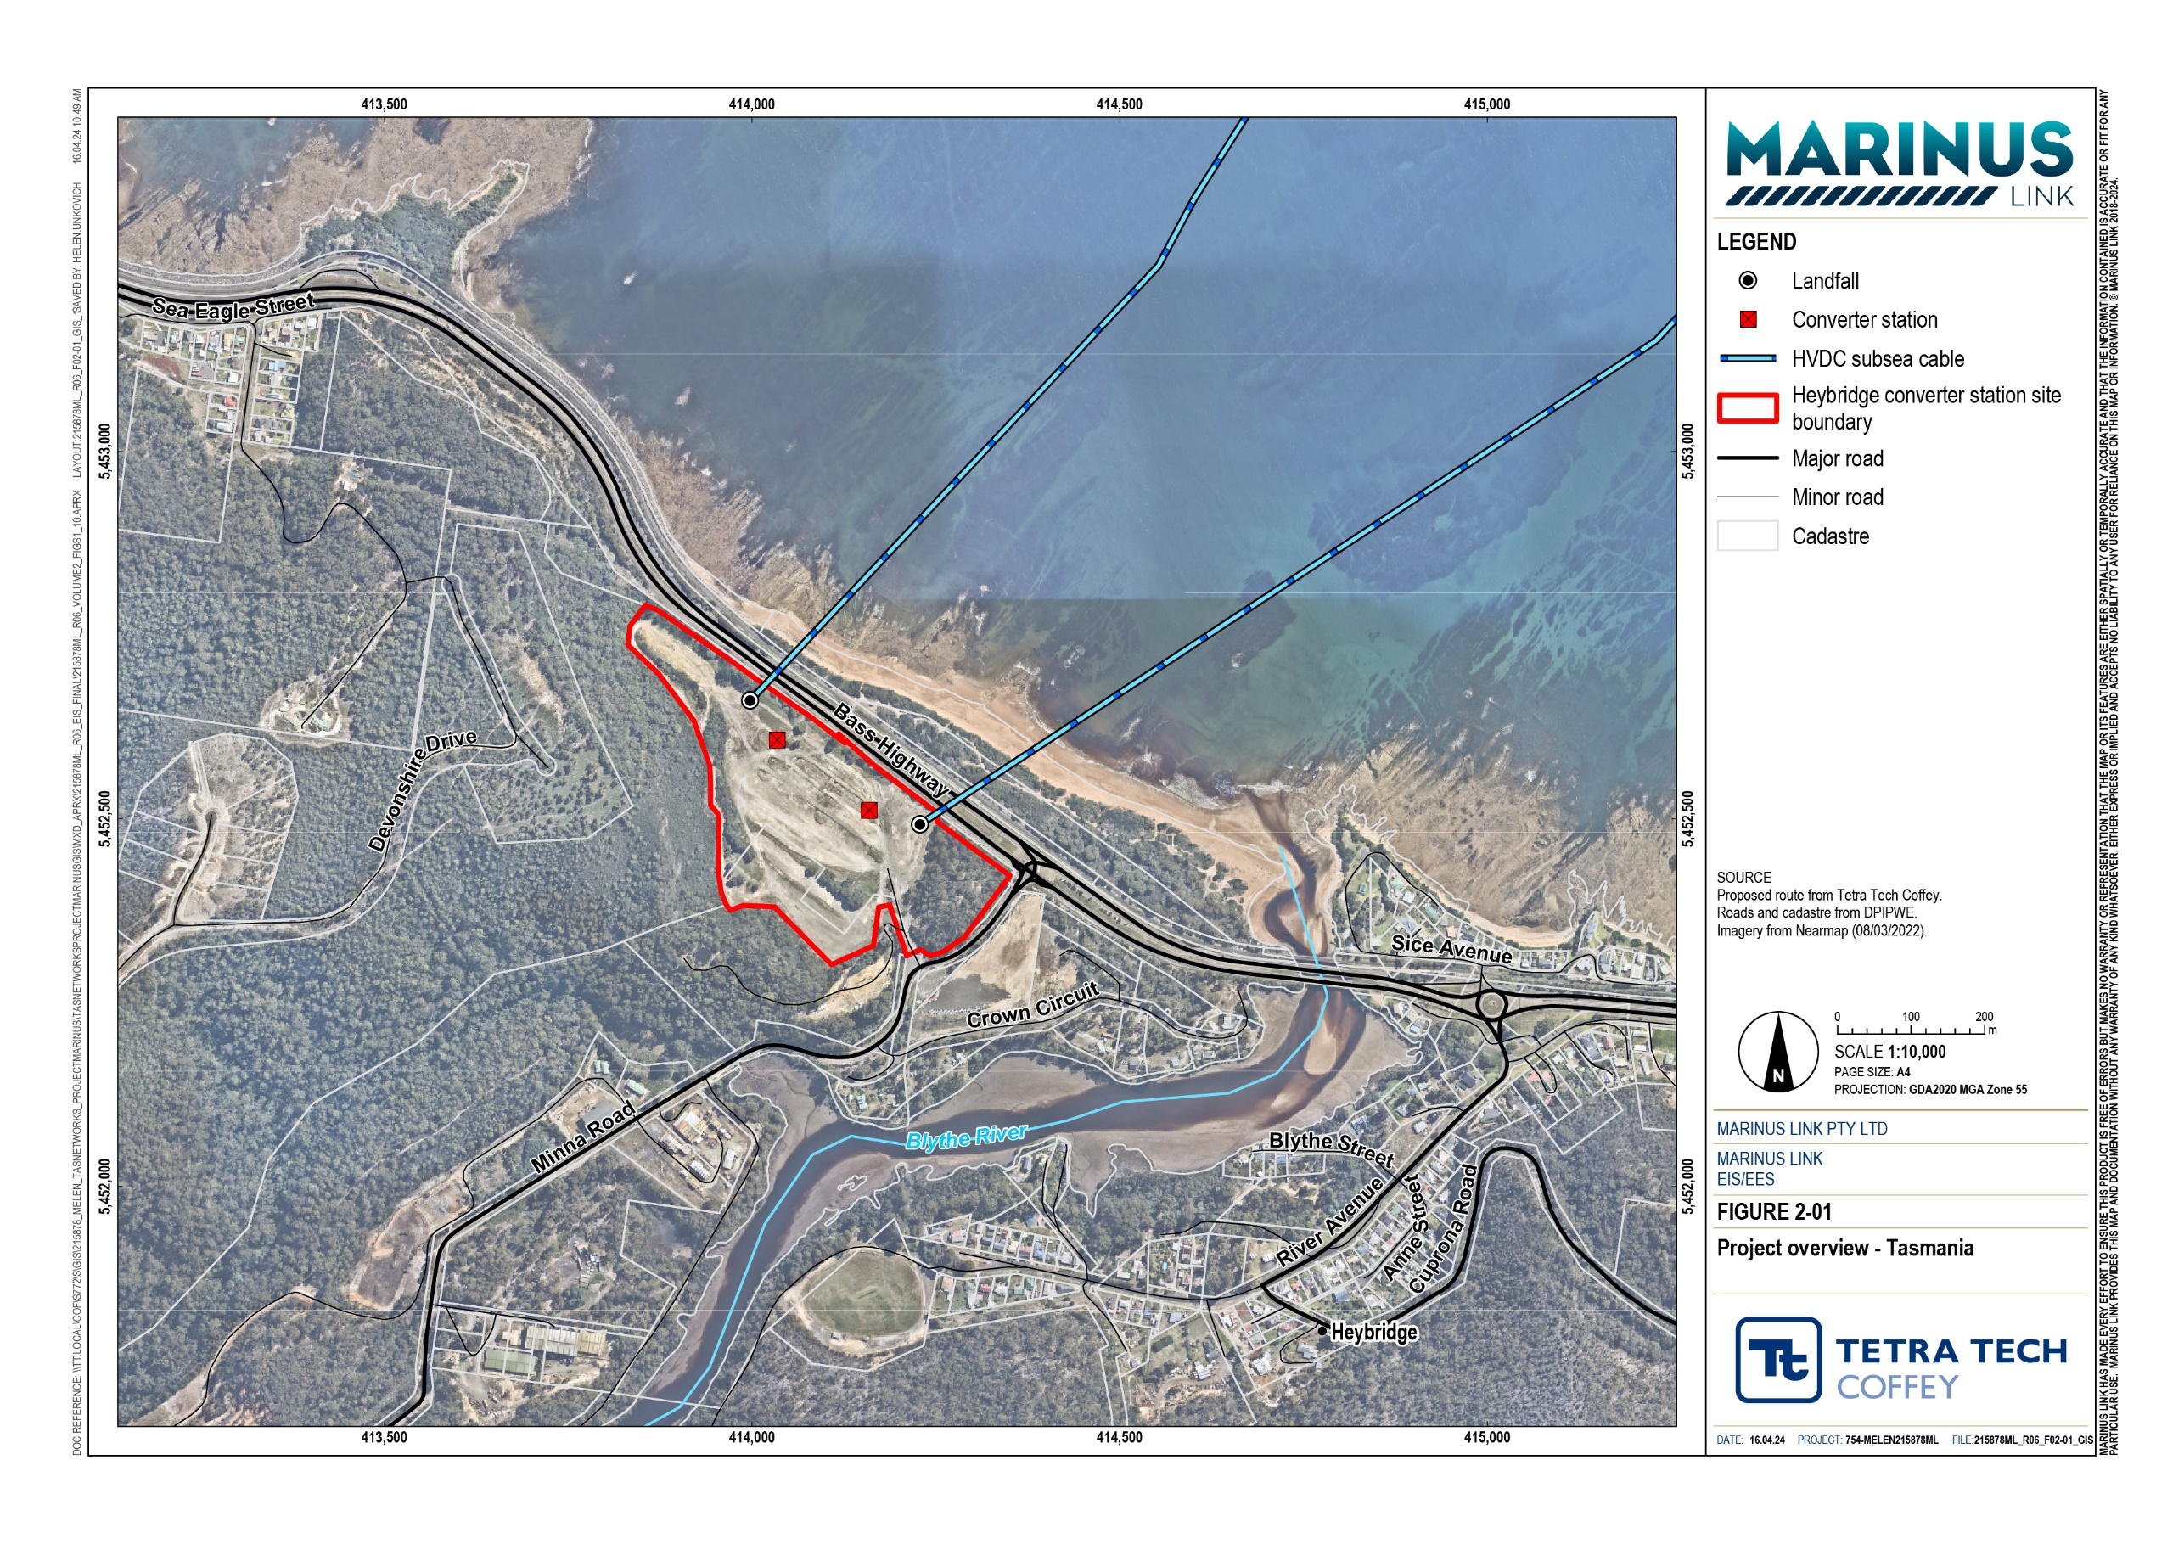

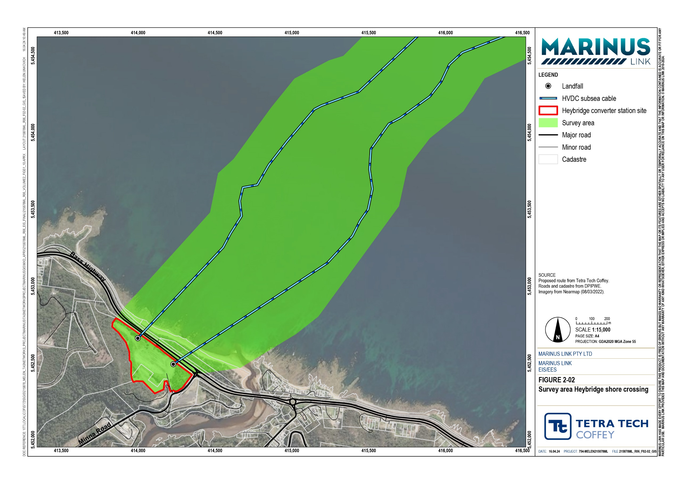

Stakeholder engagement
Marinus Link Pty Ltd (MLPL) is engaging with stakeholders to inform them of the potential impacts of the project and seek feedback. This section summarises the key engagement activities undertaken with stakeholders in Tasmania.
A summary of the key project stakeholders and the approach to engagement is provided in Volume 1, Chapter 8 – Community and stakeholder engagement. The project’s engagement program consisted of a combination of face-to-face meetings and online forums, supported by digital and print materials.

Engagement activities
Between September 2022 and October 2023, the project engaged with Tasmanian stakeholders to support the delivery of the project. The purpose of the engagement activities was to inform stakeholders about the potential impacts of the project and to seek feedback on key concerns or values. Table 1-1 provides a summary of the key engagement activities.
Table 1-1 Key engagement activities (September 2022 to October 2023)

Timing | Activities
September 2022 | Community newsletter  Sulphur Creek drop-in information session (near Heybridge) Burnie Farmers Market pop-up information stall
October 2022 | Burnie Show and Agri Expo pop-up information stall Meeting with Burnie City Council  Meeting with Central Coast Council
November 2022 | ICT Conference Hobart pop-up information stall Rotary Club of Burnie presentation  NWTD Meet the projects presentation Meeting with Burnie City Council  Meetings with Business North West and Launceston Chamber of Commerce
December 2022 | Community newsletter  Burnie Farmers Market pop-up information stall Launceston industry and stakeholder breakfast Regional Development Australia presentation
March 2023 | Tasmanian Aboriginal community meetings Tasmania Aboriginal Centre meetings  Aboriginal Heritage Tasmania meetings Community newsletter  Devonport industry and stakeholder breakfast Burnie drop-in information sessions
April 2023 | Community and stakeholder webinar  Meeting with Aboriginal Heritage Tasmania

Timing | Activities
June 2023 | Burnie City Council presentation  Presentation to First Peoples groups
July 2023 | Heybridge drop-in information session with NWTD counterparts
September 2023 | MLPL and Burnie City Council Community Partnership Program launch
October 2023 | Community newsletter  Burnie Show and Agri Expo pop-up information stall

In Tasmania MLPL has engaged with Aboriginal Heritage Tasmania, and commenced engagement with members of the Tasmanian Aboriginal Centre. MLPL has met with truwana Rangers and Community leaders, and is committed to further ongoing meaningful engagement in Tasmania.
Key stakeholders have advised that a state-wide and collaborative engagement approach is more appropriate for First Peoples engagement in Tasmania. MLPL has subsequently discussed a collaborative approach to First Peoples engagement with related major projects and organisations (e.g. Renewables, Climate and Future Industries Tasmania, Hydro Tasmania, North West Transmission Developments (NWTD) to plan coordinated engagement that is both culturally appropriate and addresses the needs of the Tasmanian Community.
Engagement with the community and key stakeholders will continue throughout the development, construction and operation of the project when Phase 4 and Phase 5 of the engagement approach are implemented.

Engagement outcomes and responses
Key environmental, social, and cultural heritage interests and concerns raised during engagement activities, and the project responses are presented in Table 1-2. The feedback has informed the project development and the technical studies completed to support the EIS/EES and the two separate Tasmanian EISs.
A key outcome of the technical studies are the environmental performance requirements (EPRs) that define the environmental outcomes that must be achieved during the design, construction, operation, and decommissioning phases of the project (Volume 5, Chapter 2 – Environmental Management Framework). The EPRs are designed to confirm the project is delivered and operated in accordance with the expectations of stakeholders, addressing key environmental, social and cultural heritage interests and concerns raised by stakeholders.

Table 1-2 Interests or concerns raised by stakeholders (2022 to 2023)

Interests or concerns raised by stakeholders | MLPL response
Concerns about noise and vibration impacts to amenity, such as:  Noise and vibration impacts during construction and operation of the Heybridge converter station.  Noise impacts from the land and shore crossing HDD operations. | The majority of construction activities will take place during the day, night works will be avoided where possible.  Out of hours works will be limited to unavoidable activities and those activities which cannot be stopped once they have started, such as HDD or pouring concrete.  The project will prepare a Construction Noise and Vibration Management Plan, as part of the construction environmental management plan (CEMP), in consultation with EPA Tasmania. The plan will detail how impacts will be managed.  Noise monitoring will occur during any out of hours works to verify noise levels do not exceed relevant thresholds.
Concerns about impacts to traffic, such as:  Cumulative impacts of the increased volume of heavy vehicle traffic on Minna Road and Bass Highway intersection. | MLPL acknowledges the importance of an efficient and safe traffic movement throughout the local area.  The project will develop tailored traffic management plans, prepared as part of the overall CEMP, to mitigate disruption to traffic movement and manage safety during construction.  A road transport plan will be designed to allow for different traffic levels and conditions, upgrading roads and crossings where required, and ensuring that pedestrian and vehicle access is reinstated in line with road design standards.  Local roads will be avoided where possible during construction.  Road closures will be avoided, but access may be limited during peak construction times.  Engagement with local authorities is being undertaken, and will continue throughout the different project phases, to manage potential traffic impacts associated with oversized deliveries of converter station equipment to the proposal site.  Potential traffic and transport impacts during construction have been considered in the traffic and transport technical study.
Concerns about the visual impact of the proposal on the local community | During the design of the converter station buildings, strategies and design outcomes will be developed to reduce the visual prominence in views from the Bass Highway and include vegetative screening.
Concerns about ecological impacts, including the removal of vegetation | Significant ecological impacts are not expected, with the proposal site already cleared of vegetation prior to the development of the proposal.
Significant interest in job opportunities, including the type of jobs, where to find out more, how to express interest, and when they will become available. | MLPL is engaging with government agencies and tertiary education providers to identify skill gaps and opportunities.  The project is committed to maximising local content and will prepare an industry participation plan to outline the approach that contractors will need to take to verify that fair and reasonable opportunities are provided to local businesses.  MLPL developed an internal register for interested workers and directed potential candidates to register at all engagement sessions. This list will be provided to the successful contractor.  MLPL is registered on the ICN Gateway. Interested businesses were directed to that portal at all engagement sessions.
Concern about housing availability and affordability and how this will be impacted by the project’s  construction workforce. | MLPL is developing a workforce accommodation plan to mitigate impacts to local housing and accommodation during construction.

Structure of the EIS/EES
The EIS/EES consists of five volumes:

Volume 1 – Introduction provides an introduction with common information on the project, and technical information that spans the whole of project or assessments that are not locationally based.
Volume 2 – Tasmanian terrestrial environment (this volume) describes the existing conditions, impact assessment and EPRs for the Tasmanian terrestrial component of the project. This volume only considers MNES and matters considered by the Minister for the Environment and Water when making a decision under the EPBC Act.
Volume 3 – Marine environment describes the existing conditions, impact assessment and EPRs for the marine (nearshore and offshore) component of the project. This volume addresses matters in the Commonwealth marine area, Victorian coastal waters and Tasmanian coastal waters (MNES only).
Volume 4 – Victorian terrestrial environment describes the existing conditions, impact assessment and EPRs for the Victorian terrestrial component of the project. This volume addresses Commonwealth and Victorian government requirements.
Volume 5 – Synthesis of environmental effects is a series of concluding chapters that draws together the overall assessment of the environmental effects of the project as a whole and provides a summary of impacts for each jurisdiction.
Each volume consists of detailed chapters as illustrated in Figure 2-03. Technical study reports have been prepared to support this EIS/EES and are provided as appendices.

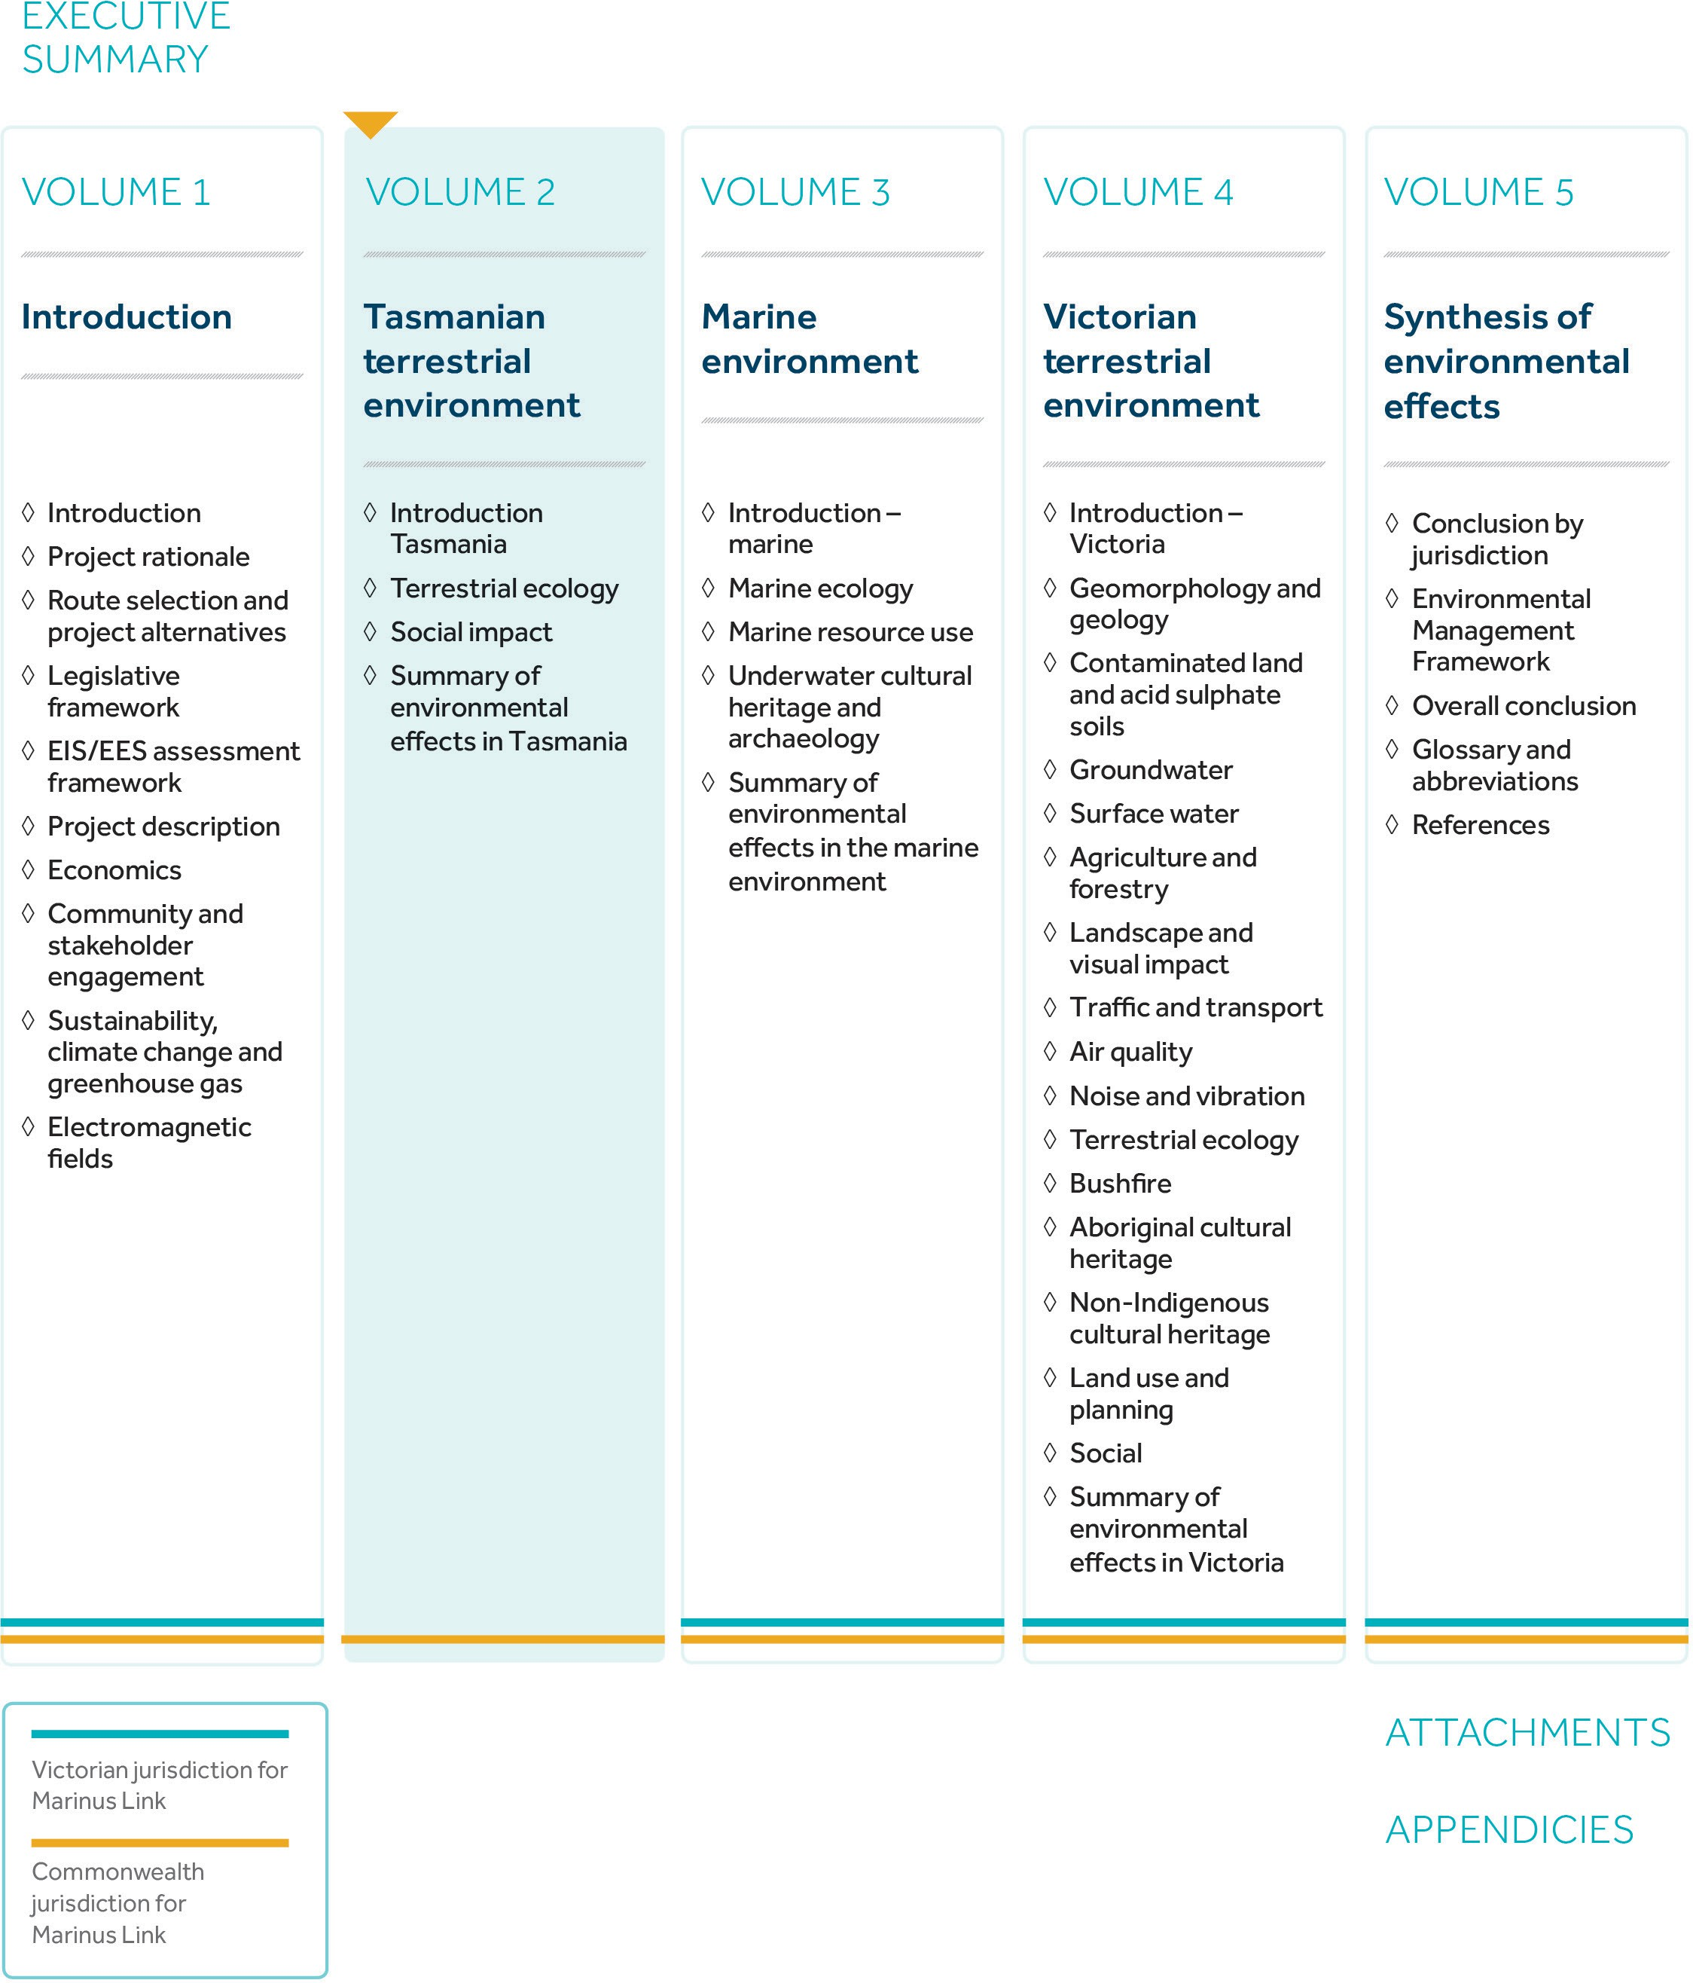
Figure 2-03 Structure of the Marinus Link EIS/EES

