Terrestrial ecology
This chapter provides an assessment of the terrestrial ecology impacts associated with the construction, operation, and decommissioning of the project in the Tasmanian project area. This chapter is based on the assessment provided in Technical Appendix E: Heybridge terrestrial ecology assessment and addresses Commonwealth matters only. MLPL has progressed separate EIS documentation to addresses the requirements of EPA Tasmania under Tasmanian legislation.
Terrestrial ecology values include native vegetation and associated habitats, threatened species, migratory species and threatened ecological communities recognised under state or national legislation. Impacts to these values could occur during construction from activities such as the clearing of vegetation, and movement of people and machinery spreading weeds or other pest species.
This chapter addresses the following sections of the EIS guidelines:

Section 4.2: Description of the existing environment

Section 4.3: Description of the protected matters

Section 5: Relevant impacts

Section 5.5: Terrestrial impacts

Section 5.10: Consequential and facilitated impacts

Section 5.11: Cumulative impacts

Section 6: Proposed avoidance and mitigation measures

Section 7: Offsets.

Refer to Attachment 1: Checklist – Guidelines for the content of a draft Environmental Impact Statement for the EIS guidelines.
The terrestrial ecology assessment considered the potential effects of the project on terrestrial ecological values in the Tasmanian project area. It also recommended EPRs to mitigate impacts.
This assessment considers the potential impacts of the project on MNES in the Tasmanian project area.

Assessment method
This assessment was informed by the significance assessment approach described in Volume 1,
Chapter 5 – EIS/EES assessment framework. The key steps in assessing the terrestrial ecology values and impacts included:
Defining a study area and survey area for the terrestrial ecology assessment.

Completing a desktop assessment to identify the ecological values that may occur in the study area and their likelihood of occurrence, including review of:
- Biological databases, spatial datasets and aerial imagery including the Commonwealth Department of Climate Change, Energy, the Environment and Water’s Protected Matters Search Tool (PMST), and the Tasmanian Department of Natural Resources and Environment Natural Values Atlas (NVA).
- Publicly available reports, guidelines, standards and scientific literature.

Conducting field surveys, involving vegetation quality and habitat condition assessments, and targeted surveys for threatened flora and fauna species. An eagle nest survey was conducted across the region, including an area within a 2 kilometres (km) radius of the converter station site for the NWTD. The eagle nest survey was completed in accordance with the Technical Note No. 1 for Eagle Nest Searching (FPA 2015) and Survey Guidelines for Australia’s Threatened Birds (DSEWPC 2010). Field surveys within the converter station and shore crossing survey areas that informed the terrestrial impact assessment as relevant to MNES involved:
- Verifying and mapping of vegetation communities.

- Searching for threatened flora species.

- Recording characteristic flora species and their cover abundance where required to determine the vegetation community.
- Identifying and assessing potential habitat for threatened fauna species. This included recording important fauna habitat components and indirect evidence of threatened fauna presence when encountered.
- Searching for Tasmanian devil and Spotted-tail quoll dens in accordance with the Survey Guidelines for Australia’s Threatened Mammals (DSEWPC 2011b).
Identifying and assessing potential impacts on terrestrial ecology values during construction, operation and decommissioning of the project using the significance assessment method (see
Volume 1, Chapter 5 – EIS/EES assessment framework).

Identifying potential cumulative impacts on terrestrial ecology values within the study area.

Developing EPRs in response to the impact assessment to reduce the identified impacts where necessary.
Assessing residual impacts after implementing measures to comply with the EPRs.

Considering the need for offsets where the project is likely to have a residual significant impact.

A detailed method (including field survey methods) is provided in Technical Appendix E: Heybridge terrestrial ecology assessment.

Study area
The terrestrial ecology study area comprises the area required to characterise ecological values and provide context for the assessment of impacts. For terrestrial ecology, this includes the following:
Survey areas:

      - Converter station survey area: an approximately 10 hectare (ha) area defined by the property boundary of the Heybridge converter station site.
      - Shore crossing survey area: a 6.5 ha area extending from the Heybridge converter station site, under the Bass Highway and Western Line railway, and across the shore to Bass Strait.
Study areas:

      - A 5 km radius around the survey areas used to identify which ecological values are likely to occur based on the PMST and NVA.
      - The eagle nest survey completed for the NWTD considered a 2 km radius study area around the Heybridge converter station site.
The terrestrial ecology survey areas and the eagle nest study areas are shown on Figure 2-04.

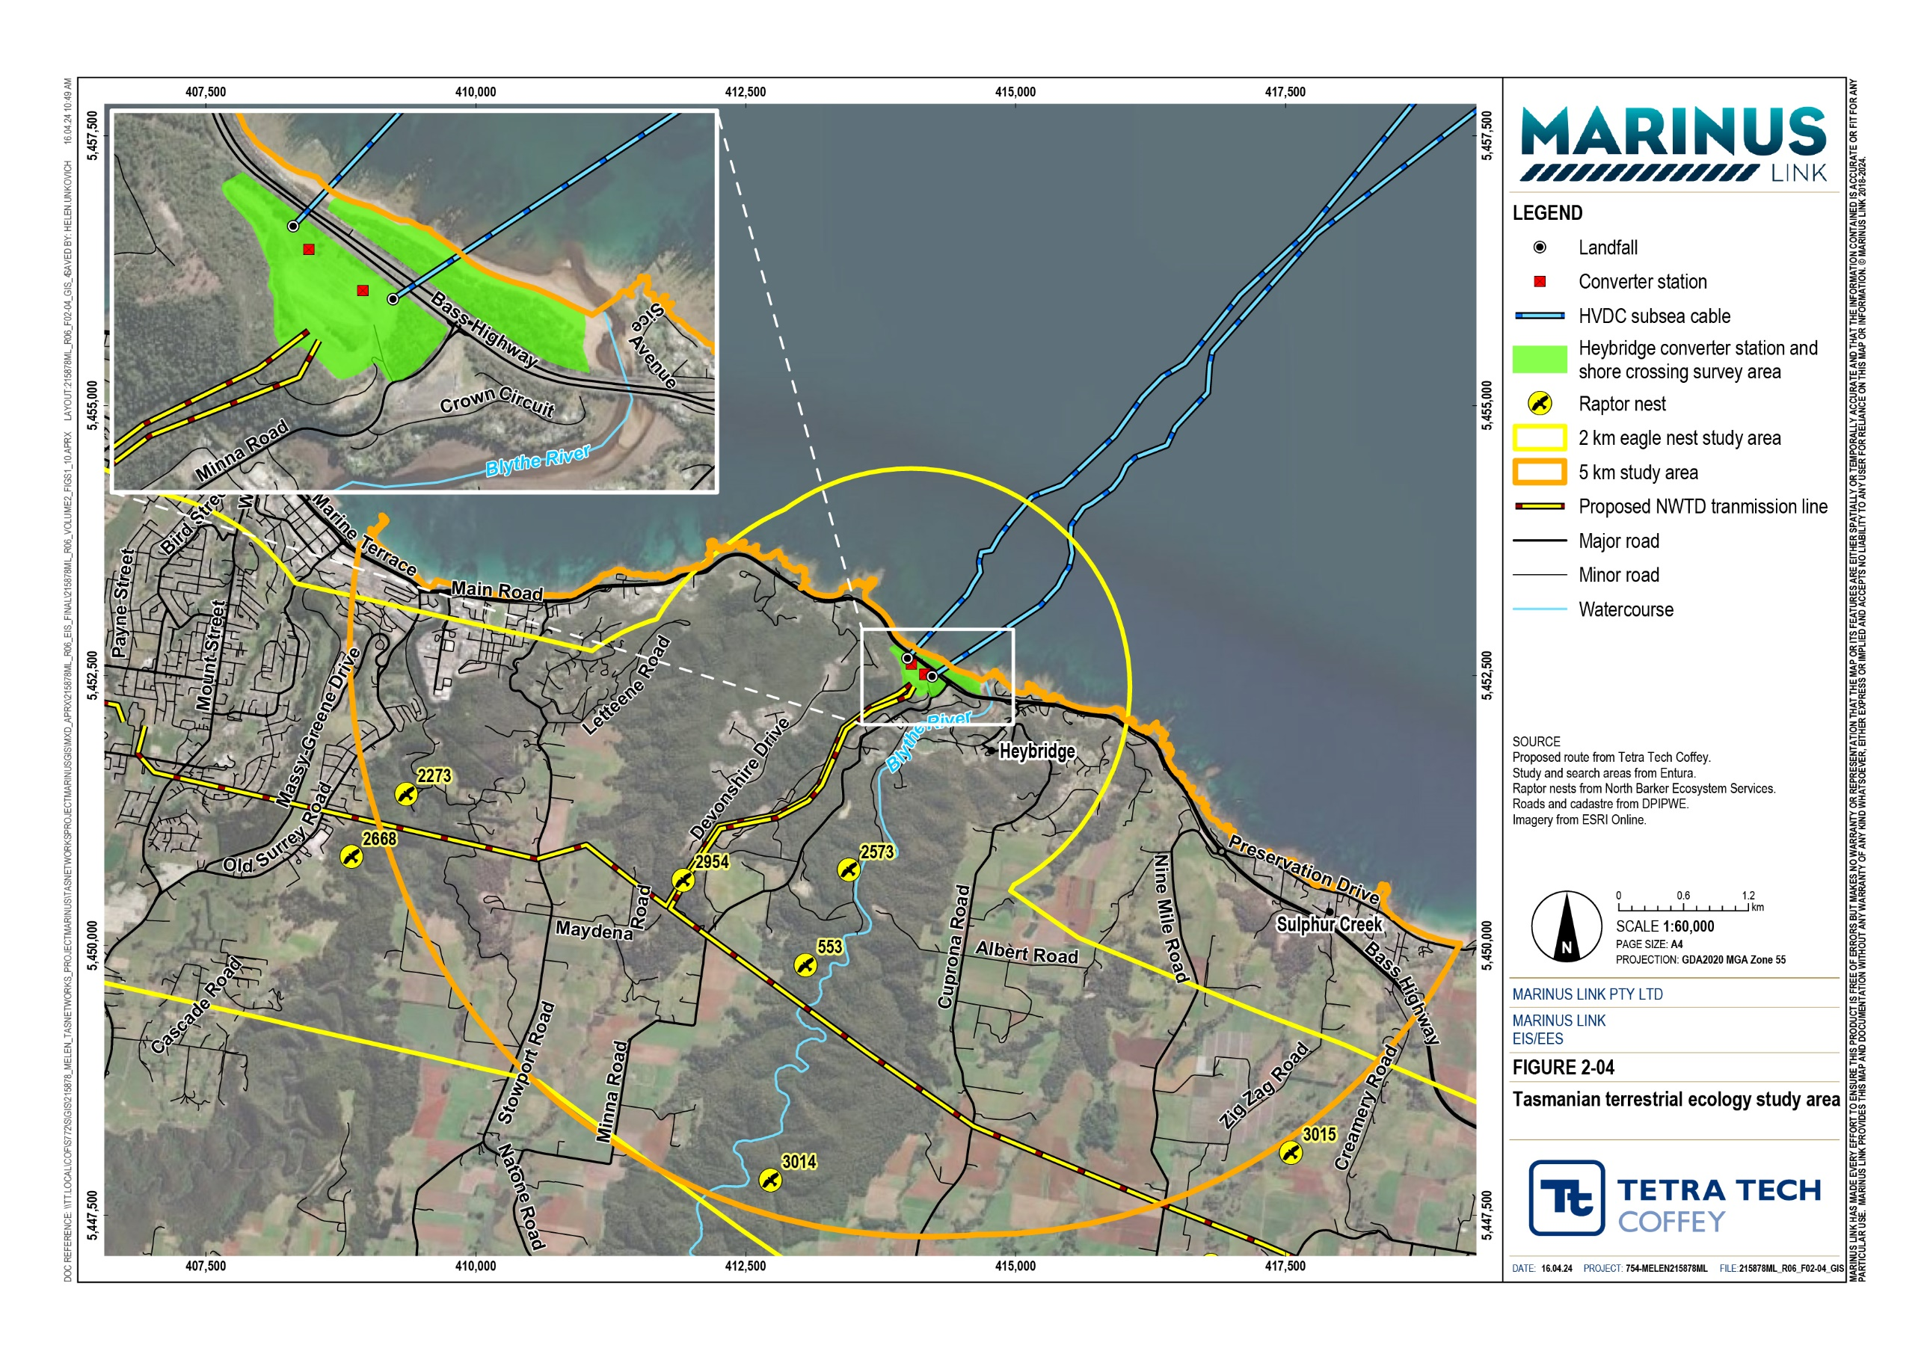

Legislative context
Table 2-1 outlines the key legislation, policies and guidelines that informed the terrestrial ecology assessment as relevant to MNES.

Title | Relevance to the assessment
Environment Protection and Biodiversity Conservation Act 1999 (EPBC Act) (Cwlth) | The EPBC Act is Australia’s key national environmental law. The EPBC Act identifies nine MNES, including listed nationally and internationally important flora, fauna and ecological communities. The project requires assessment and approval under the EPBC Act for projects with potential to impact threatened species and communities, migratory species and Commonwealth marine areas.
Significant Impact Guidelines 1.1 (Cwlth) | EPBC Act policy statement that provides guidance for determining whether the project is likely to have a significant impact on a protected matter.
Recovery plans (Cwlth) | Prepared for a specific species, group of species or ecological community, recovery plans set the research and management actions required to stop the decline of, and support the recovery of, species or ecological community. Recovery plans have been considered for relevant species where they have been prepared. Under the EPBC Act, in deciding whether or not to approve the project, the Minister for the Environment and Water must not act inconsistently with a recovery plan.
Conservation advice (Cwlth) | Conservation advice can be developed in tandem or separately to recovery plans to identify actions required to support conservation and recovery of a species or ecological community. Under the EPBC Act, in deciding whether or not to approve the project, the  Minister for the Environment and Water must have regard to any approved conservation advice for relevant species or ecological communities.

Assumptions and limitations
The key assumptions and limitations for the terrestrial ecology assessment include:

Unidentified flora species: Varying flower times and seasonality affects the identification of some flora species during field surveys; however, no listed threatened annual flora species were identified as potentially occurring in the study area.
Potential occurrence of species or communities: The assessment focuses on species or communities known to occur (the species/ecological community has been recorded on the NVA or by field surveys) or that may occur (the species/ecological community has been recorded on the NVA and suitable species habitat exists or could exist). Species that are unlikely to occur or absent have not been assessed for impacts; a complete list of these species is provided in Technical Appendix E: Heybridge terrestrial ecology assessment.

Existing conditions
This section describes the existing conditions and values of terrestrial ecology in the study area. The assessment considered the following MNES:
Threatened ecological communities

Threatened flora

Threatened fauna

Migratory species.

The converter station survey area is a 10.8 ha area comprised of predominantly modified land (9.3 ha). This modified land includes cleared land (8.2 ha), tree plantings (0.6 ha) and weeds (0.5 ha). A small area
(1.5 ha) of native vegetation, Eucalyptus amygdalina coastal forest and woodland, is located on the southeastern corner of the Heybridge converter station site.
The shore crossing survey area is a 6.5 ha area, comprised of native forest (2 ha), native scrub (3 ha) and sandy beach (1.5 ha). The native vegetation communities on the shore crossing site include E. viminalis–
E. globulus coastal forest and woodland and Coastal scrub.

Vegetation communities in the survey areas are shown in Figure 2-05

Threatened ecological communities
Two EPBC Act listed threatened ecological communities were identified as potentially occurring within the study area:
Tasmanian Forests and Woodlands dominated by black gum or Brookers gum (Eucalyptus ovata / E. brookeriana) (listed as critically endangered under the EPBC Act).
Tasmanian white gum (E. viminalis) wet forest (listed as critically endangered under the EPBC Act).

Neither community was recorded within the survey area during field surveys.

Threatened flora species
Three EPBC Act listed threatened flora species were identified during the desktop baseline assessment as potentially occurring within the survey area: tailed spider orchid (listed as vulnerable under the EPBC Act), hoary sunray (listed as endangered under the EPBC Act), and swamp fireweed (listed as vulnerable under the EPBC Act). However, a review of the current range and habitat requirements for these species found that they were not likely to occur due to the absence of suitable habitat within survey area, and none were identified during field surveys.

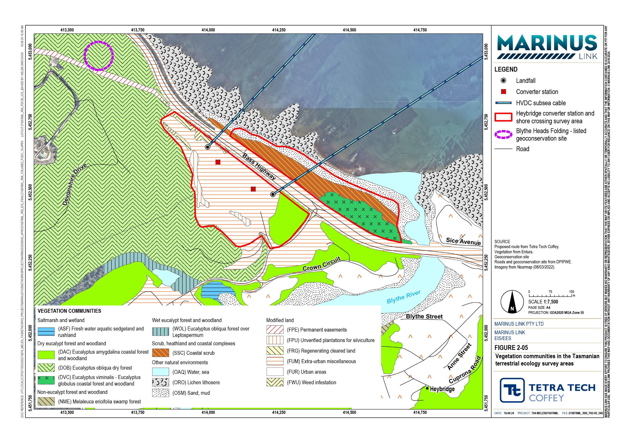

Threatened and migratory fauna species
Four EPBC Act listed threatened fauna species and one migratory species were identified as potentially occurring within the study area:
Tasmanian devil (Sarcophilus harrisii) (listed as endangered under the EPBC Act)

Spotted-tail quoll (Dasyurus maculatus subsp. maculatus) (listed as vulnerable under the EPBC Act)

Tasmanian wedge-tailed eagle (Aquila audax subsp. fleayi) (listed as endangered under the EPBC Act)

White throated needletail (Hirundapus caudacutus) (listed as vulnerable under the EPBC Act)

Fork-tailed swift (Apus pacificus) (listed as migratory under the EPBC Act).

None of these species have been recorded within the survey area and based on the habitat values within the survey area, are not considered likely to occur.
Under the EPBC Act, the Tasmanian devil is listed as endangered, and the Spotted-tail quoll is listed as vulnerable. Both species have previously been recorded near the Heybridge converter station as roadkill. Records of roadkill nearby include two Tasmanian devils (one on Minna Road and one on Bass Highway) and one Spotted-tail quoll (on Minna Road).
Within the survey area there is no suitable denning habitat, limited habitat for prey species and foraging, and little evidence of presence of these species (no scats identified). Populations of Tasmanian devils and Spotted-tail quolls in the area are low but individuals may pass over or be present in the vicinity of the site.
The Tasmanian wedge-tailed eagle is listed as endangered under the EPBC Act and is known to occur within 2 km of the survey area. There are no known wedge-tailed eagle nests within 1 km of the converter station or shore crossing. Two eagle nests have previously been recorded within 2 km of the survey area:
Nest 2573: This is wedge-tailed eagle nest is located 1.7 km south of the survey area. The wedge-tailed eagle may occasionally overfly the survey area.
Nest 1323: This was either a wedge-tailed eagle or white-bellied sea eagle nest located 1.6 km west of the converter station site; however, it has not been sighted in recent surveys and is considered to be absent.
The white-throated needletail is a migratory species listed as vulnerable under the EPBC Act. The species was identified as potentially occurring within the study area, however there are no NVA records within the study area. The white-throated needletail is an aerial species that may fly over coastal areas (including the site) during summer. It roosts in dense vegetation with widely spaced trees, such as open forest and rainforest.
The fork-tailed swift is listed as migratory under the EPBC Act and was identified as potentially occurring within the survey area, however there are no NVA records within the study area. The fork-tailed swift is an aerial species that rarely comes to land and is not expected to use the site; however, it may fly over the site during summer.

Summary of terrestrial ecology values
Based on the assessment of existing terrestrial ecology conditions through desktop review and field surveys, the following ecological values are relevant for the impact assessment as detailed in Technical Appendix E: Heybridge terrestrial ecology assessment:
Tasmanian devil

Spotted-tail quoll

Tasmanian wedge-tailed eagle

White-throated needletail

Fork-tailed swift.

These species are all considered to have a high sensitivity rating for the impact assessment as they are protected under the EPBC Act.

Construction impacts
Construction activities associated with the Heybridge converter station and shore crossing (as outlined in Volume 1, Chapter 6 – Project description) that may impact ecological values include vegetation and habitat clearing, and construction-related traffic movements. Construction activities, including construction-related traffic movements, will occur over a two-year period at the Heybridge converter station and shore crossing, between 2025 and 2027.
As HDD will be used for the shore crossing, no vegetation clearance is required in the coastal area between the Heybridge converter station site and the shoreline. Some clearance of modified vegetation, including tree plantings and weeds, will occur within the converter station site; however, no native vegetation is proposed to be cleared.
Heavy vehicles and worker travel to and from worksites will occur predominantly at 7 a.m. and 4 p.m., six days a week. This is expected to be during daylight hours between October and March, and at or just after dawn and at or just before dusk between April and September. Roads proposed to be used by the project are Bass Highway and a 200 m stretch of Minna Road between Bass Highway and the Heybridge converter station site. Night traffic, defined as traffic between 5 p.m. and 7 a.m., is expected to increase by 165% on Minna Road and 3.2% on Bass Highway. As HDD requires continuous drilling (i.e., 24 hours a day, seven days a week), there may be some traffic at nights associated with shift work. This is assumed to be minor, consisting of ten vehicle movements each at 7 a.m. and 7 p.m.
Potential impacts to terrestrial ecology values from these activities are discussed further below.

As part of the terrestrial ecology assessment in Technical Appendix E: Heybridge terrestrial ecology assessment, an assessment of impacts has been completed against criteria from the Significant Impact Guidelines 1.1 (DoE 2013) for each of the potentially impacted listed threatened fauna species. The findings are discussed below.

Tasmanian devil and Spotted-tail quoll
EPBC Act listed mammals, the Tasmanian devil and the Spotted-tail quoll, may occasionally pass through or occur in the vicinity of the converter station site and shore crossing survey area. The Tasmanian devil is listed as endangered under the EPBC Act and has an approved conservation advice. The approved conservation advice (DEWHA 2009) identifies the species’ key threats as:
Devil facial tumour disease

motor vehicles

habitat loss, disturbance and modification

predation by foxes.

There is no approved conservation advice for the Spotted-tail quoll (Tasmanian population).

As outlined in Section 2.2.3, there are no records or observations of these species utilising the survey area and no suitable denning habitat within the survey area or surrounding areas. However, as there have been a small number of roadkill records for both species on Minna Road and Bass Highway, project-related traffic is considered a possible impact pathway for the species.
In particular, Minna Road, between the Bass Highway intersection and the entrance to the Heybridge converter station site, presents a potential impact pathway to these species due to the significant increase in night-time traffic volumes anticipated from project-related traffic.
The primary potential impacts from the project on the Tasmanian devil and the Spotted-tail quoll are related to construction traffic movements on Minna Road, between one hour before dusk and one hour after dawn. The majority of project-related traffic (heavy vehicle and worker movements) will be between 7 a.m. and
4 p.m. Some of these movements will be considered night-time movements occurring in periods one hour after sunrise or one hour before sunset. For the majority of the year, these times are considered daylight hours. However, there will be some days of the year where sunrise occurs after 6 a.m. and sunset occurs before 5 p.m., which will result in project traffic movements occurring within the one-hour window threshold of dawn and dusk, resulting in potential impacts to these species.
As the section of Minna Road to be used by project traffic is short, it is anticipated that heavy vehicles will not be travelling at high speed. Given the nature of construction traffic and low populations of Tasmanian devils and Spotted-tail quolls in the area, roadkill impacts on the Tasmanian devil and Spotted-tail quoll associated with construction traffic on Minna Road are considered to be of minor magnitude, resulting in a moderate impact. With the application of measures to comply with EPRs, the magnitude of impacts is reduced to negligible magnitude, resulting in a low impact.
As night traffic on Bass Highway is only expected to increase marginally, roadkill impacts on the Tasmanian devil and Spotted-tail quoll associated with construction traffic on Bass Highway are considered to be of negligible magnitude to the species and therefore a low impact.
An assessment against EPBC Act significant impact criteria concluded that the project is not likely to interfere with the recovery of this species and is not likely to result in a significant impact.

Tasmanian wedge-tailed eagle
As there are no known nests located within 1 km of construction activities associated with the Heybridge converter station and shore crossing, the Tasmanian wedge-tailed eagle is unlikely to be impacted by construction activities for the project. Construction impacts on the wedge-tailed eagle are assessed to be of negligible magnitude and low impact.
To avoid impacts to raptors, the EPRs require recent data (within one year of construction commencing) to confirm there are no nests within a distance of 500 m, or within 1 km line-of-sight of construction activities. If no recent data (within one year) is available, further nest surveys are required to confirm there are no nests. If a new nest is identified, project activities must be avoided during breeding season (within a distance of 500 m, or within 1 km line-of-sight of the nest), as per the Threatened Tasmanian Eagles Recovery Plan
2006-2010. If project activities are required within a distance of 500 m, or within 1 km line-of-sight of the nest, construction is to be deferred until outside of the breeding season.
An assessment against EPBC Act significant impact criteria concluded that the project is not likely to interfere with the recovery of this species and is not likely to result in a significant impact.

White-throated needletail and fork-tailed swift
The white-throated needletail and fork-tailed swift are not expected to be disturbed by construction activities as they are aerial species and unlikely to utilise vegetation within the survey area. Therefore, construction impacts on these species are assessed to be of negligible magnitude and low impact.
An assessment against EPBC Act significant impact criteria concluded that the project is not likely to interfere with the recovery of these species and is not likely to result in a significant impact.

Operation impacts
Once constructed, the project will operate 24 hours per day, 365 days per year over an anticipated minimum 40-year operational lifespan. Operation and maintenance activities include:
Periodic inspection of the subsea project alignments by remotely operated vehicles.

Remote monitoring of shipping activity near the subsea cables for potential anchoring issues.

Servicing, testing and repair of the subsea cables and converter station equipment and infrastructure including scheduled minor and major outages.
Potential impacts on Tasmanian devil and Spotted-tail quoll during operation relate to roadkill from road traffic movements associated with operation and maintenance activities during dusk and dawn. As traffic movements are likely to be minimal during operation, the Tasmanian devil and Spotted-tail quoll are unlikely to be significantly impacted by the operation of the project.
Based on current nest locations, the Tasmanian wedge-tailed eagle is unlikely to be impacted by the operation of project. If a new nest is constructed or identified within 500 m distance or 1 km line-of-sight of

the project, there is the potential for the Tasmanian wedge-tailed eagle to be impacted by maintenance activities (e.g., long term increase in site activity that includes use of crane/s for lifting or replacing large components or equipment) during operations. To avoid impacts to raptors, major activities within a distance of 500 m, or within 1 km line of sight of active eagle nests must be avoided during breeding season. If an active nest is identified within a distance of 500 m, or within 1 km line of sight, the EPRs require major activities to be deferred until outside of the breeding season.
The white-throated needletail and fork-tailed swift are unlikely to be impacted by operation of the project. Operation impacts on all species are assessed to be of negligible magnitude and low significance.

Decommissioning impacts
The operational lifespan of the project is a minimum 40 years. At this time the project will be either decommissioned or upgraded to extend its operational lifespan.
Decommissioning will be planned and carried out in accordance with regulatory requirements at the time. A decommissioning plan in accordance with approvals conditions will be prepared prior to planned end of service and decommissioning of the project.
Requirements at the time will determine the scope of decommissioning activities and impacts. The key objective of decommissioning is to leave a safe, stable and non-polluting environment.
In the event that the project is decommissioned, all above-ground infrastructure will be removed, the site rehabilitated.
Decommissioning activities required to meet the objective will include, as a minimum, removal of above ground buildings and structures. Remediation of any contamination and reinstatement and rehabilitation of the site will be undertaken to provide a self-supporting landform suitable for the end land use.
Decommissioning and demolition of project infrastructure will implement the waste management hierarchy principles being avoid, minimise, reuse, recycle and appropriately dispose. Waste management will accord with applicable legislation at the time.
Decommissioning activities may include recovery of land and subsea cables. The conduits and shore crossing ducts will be left in-situ as removal will cause significant environmental impact. Subsea cables will be recovered by water jetting or removal of rock mattresses or armouring to free the cables from the seabed.
A decommissioning plan will be prepared to outline how activities will be undertaken and potential impacts managed.

Environmental performance requirements
EPRs set out the environmental outcomes that must be achieved during all phases of the project. In developing these EPRs, industry standards and guidelines, good practice and the latest approaches to managing impacts were considered. Project specific management measures, relevant legislation and policy requirements informed these EPRs (Table 2-2).
While the project will not directly impact on native vegetation values, EPRs have been developed to preserve any existing native vegetation, avoid clearing of native vegetation, and to prevent the introduction or spread of weeds, pests and pathogens which could impact on other terrestrial ecology values in the area.

EPR ID | EPR
EC01 Tas* | Minimise vegetation removal and implement and implement vegetation protection measures  To inform the project design, develop and implement measures to avoid and otherwise minimise to the extent practicable impacts on native vegetation. The design must avoid the eucalyptus woodland vegetation in the northeast corner of the site.  Prior to commencement of project works, develop a vegetation management plan to avoid and otherwise minimise impacts to vegetation, covering as a minimum:  - Identification of areas of important flora and fauna habitat to be protected during construction.  - Fencing protected areas and no-go zones to prevent access during construction.  - Pre-construction site assessment to confirm that vegetation and trees to be retained have been adequately protected from impact.  - Vegetation clearing controls and protection measures.  - Implementation of appropriate measures to manage the risk of spread and introduction of weeds and pathogens during construction.  - Procedures if unexpected threatened species are identified.  The vegetation management plan must be a sub plan of the CEMP and implemented during construction.
EC02 Tas | Implement measures to protect fauna  Prior to commencement of project works, develop a fauna management plan to avoid and otherwise minimise impacts to fauna, covering as a minimum:  Protection measures for Tasmanian devils and Spotted-tail quolls with a focus on construction traffic and awareness regarding roadkill included in site inductions.  Recording and reporting process for incidents of vehicle strikes and/or roadkill of Tasmanian devils and Spotted-tail quolls on Minna Road between intersection with Bass Highway and the entry to site, where vehicles associated with the project will travel. Reporting of roadkill of Tasmanian devils and Spotted-tail quolls to the Department of Natural Resources and Environment Tasmania. Removing mortalities off the road within a specified distance of site to reduce attracting carnivorous fauna.  Utilisation of night lighting to a minimum amount required to safely operate the site and to reduce light pollution and adverse effects to fauna species.  Management procedures to avoid animals entering trenches or being recovered from trenches and excavated areas.  Preclearance surveys of construction areas for threatened fauna species prior to vegetation removal and undertaken by a suitably qualified ecologist.  The fauna management plan must be a sub plan of the CEMP and implemented during construction.

EPR ID | EPR
EC03 Tas | Implement measures to protect raptors  Prior to commencement of project works confirm that there are no nests within a distance of 500 m of the site boundary, or within 1 km line-of-sight prior to construction using data collected within one year of construction commencing.  Undertake further nest survey if there is no current (within one year) survey of nest presence and to avoid impacts to raptors outside of the breeding season, as per the Threatened Tasmanian Eagles Recovery Plan 2006-2010 and the Environment Protection Authority’s Guide to Eagle Nest Searching and Nest Activity Checks.  If a nest is observed within a distance of 500 m of the site boundary, or within1 km line-of-sight prior to construction the following will be required:  Avoid project activities within a distance of 500 m, or within 1 km line of sight of active eagle nests during breeding season in accordance with guidelines outlined in the FPA Fauna Technical Note No. 1.  Construction to be deferred until outside of the breeding season if a nest within a distance of 500 m, or within 1 km line of sight is determined to be active as per FPA Fauna Technical Note No.  1. All nests are to be treated as active during the breeding season until determined as inactive by a suitable qualified person.
EC04 Tas* | Operational implementation of vegetation protection measures  As part of the OEMP, develop a vegetation management plan for operations to avoid and otherwise minimise impacts that covers:  Demarcation of areas of important flora and fauna habitat to be protected during normal maintenance and operations.  Implementation of appropriate measures to manage the risk of spread and introduction of weeds and pathogens during normal maintenance and operations.  The vegetation management plan must be a sub plan to the OEMP and implemented in operation.
EC05 Tas | Operational implementation of measures to protect raptors  As part of the OEMP, develop a nest management strategy to avoid impacts to raptors during major operational and maintenance activities (e.g. long-term increase in site activity that includes use of crane/s for lifting and replacing large components and equipment)  Prior to major operational and maintenance activities, confirm that there are no nests within a distance of 500 m of the site boundary or within1 km line-of-sight prior to activities, using data collected within one year prior to the commencement of construction.  Undertake a further nest survey if there is no recent (within one year) survey data of nest presence outside of the breeding season, as per the Threatened Tasmanian Eagles Recovery Plan 2006-2010 and the Environment Protection Authority’s Guide to Eagle Nest Searching and Nest Activity Checks.  If a nest is observed within a distance of 500 m or within 1 km line-of-sight prior to major operational/maintenance activities the following will be required:  Avoid major activities within a distance of 500 m or within 1 km line of sight of active eagle nests during breeding season in accordance with guidelines outlined in the FPA Fauna Technical Note No. 1  Defer major activities until outside of the breeding season if a nest within a distance of 500 m, or within 1 km line of sight is determined to be active as per FPA Fauna Technical Note No. 1. All nests are to be treated as active during the breeding season until determined as inactive by a suitable qualified person.
*These EPRs are not relevant to management of impacts on EPBC Act listed species and are not discussed in this chapter.

In addition to the terrestrial ecology EPRs above, other EPRs that would reduce the potential for impacts on terrestrial ecology values, include:
Tasmania - Traffic and transport (Stantec 2024).

EPRs from other technical studies for the Tasmanian component of the project are included in separate EIS documentation to address the requirements of the EPA Tasmania.

Residual impacts
Residual impacts are those remaining after the implementation of measures to comply with EPRs.

The pre-mitigated impact on Tasmanian devils and Spotted-tail quolls is assessed as moderate. Impacts on these species, primarily roadkill impacts associated with construction traffic, will be managed through implementation of measures to comply with EPR EC02 Tas. This may involve the implementation of mitigation measures such as reducing night-time traffic on Minna Road through scheduling and use of workforce buses, monitoring the 200 m stretch of Minna Road for roadkill and removing any carrion, reducing construction traffic speed limits, and educating drivers on fauna collision procedures. With the implementation of measures to comply with EPR EC02 Tas, the impact on the Tasmanian devil and Spotted- tail quoll during construction will be reduced from moderate to low.
While the pre-mitigated impact on the wedge-tailed eagle is low, construction and operational EPRs have been included to address any potential new nests identified prior to construction works. If new nests are identified prior to construction, measures to comply with EPR EC03 Tas during construction and EPR EC05 Tas during operation will be implemented. The residual impact on the wedge-tailed eagle remains low.
No EPRs are required or proposed to manage potential impacts on the fork-tailed swift or white-throated needletail during construction or operation of the project. The residual impact on these species remains low.
The residual impacts are summarised in Table 2-3. With the implementation of measures to comply with EPRs, the project is unlikely to result in a significant impact on MNES.

Affected value | Sensitivity | Initial impact  Magnitude | Significance | Recommended EPRs | Sensitivity | Residual impact  Magnitude Significance
Construction
Tasmanian devil and Spotted-tail quoll | High | Minor | Moderate | EPR EC02 | High | Negligible Low

Tasmanian wedge-tailed eagle | High | Negligible | Low | EPR EC03 | High | Negligible | Low
White-throated needletail and fork-tailed swift | High | Negligible | Low | None required | High | Negligible | Low
Operation
Tasmanian wedge-tailed eagle | High | Negligible | Low | EPR EC05 | High | Negligible | Low
White-throated needletail and fork-tailed swift | High | Negligible | Low | None required | High | Negligible | Low

Cumulative impacts
The potential for cumulative impacts to terrestrial ecology is limited to Tasmanian devils and Spotted-tail quolls, from the project and the NWTD project as construction activities from the two projects may occur in proximity to each other and in similar timeframes. Given the risk of roadkill to these species from increased traffic movements there is the potential for cumulative impacts to from the combined construction vehicle movements for the two projects.
There is potential for Tasmanian devils and Spotted-tail quolls species to pass over and be in the vicinity of the Heybridge converter station site and shore crossing survey area, but the species has not been observed and there is no suitable denning habitat in the vicinity.
As outlined in the Tasmanian Survey Guidelines and Management Advice for Development Proposals that May Impact on the Tasmanian Devil (Natural and Cultural Heritage Division 2015), there is an increased risk of roadkill mortality when twilight and night-time traffic is expected to increase more than 10% above the typical rate of traffic. The terrestrial ecology assessment (Technical Appendix E: Heybridge terrestrial ecology assessment) has considered a 10% increase in traffic one hour before sunset to one hour after sunrise as the potential trigger for increase in roadkill impacts on Tasmanian devils and Spotted-tail quolls.
Both projects will result in an increase in vehicle traffic during construction, and twilight and night traffic movements on Minna Road and Bass Highway will likely increase by at least 10% at times due to Marinus Link and NWTD construction. There is therefore a possibility of roadkill from twilight and night-time traffic movements from construction of both the project and the NWTD on these roads.
With the application of standard management measures, the NWTD is unlikely to result in a significant impact or decrease in population of these species. Given the limited extent of roads where the project may contribute to roadkill, and with the application of measures to comply with EPRs, the project is unlikely to contribute to a significant decrease in the population of Tasmanian devil and Spotted-tail quolls in Tasmania when combined with the impacts from the NWTD.
Based on publicly available information, no other projects were identified that could result in a cumulative impact.

Offsets
The project is not likely to have a significant impact on MNES in Tasmania, and no Commonwealth offset requirements are triggered.

Conclusion
The terrestrial ecology impact assessment identified and assessed potential impacts on terrestrial ecology values from project activities. For Tasmania, this EIS/EES considers Commonwealth matters only. Separate impact assessment has been completed for Tasmanian state-listed ecology values.
Commonwealth matters likely to be impacted by project activities are limited to threatened fauna species and terrestrial migratory species, as no threatened vegetation communities or threatened flora species were identified as likely to occur within the survey area. The assessment identified initial impacts ranging from low impact to moderate impact resulting from construction activities. The most significant of these relate to the Tasmanian devil and Spotted-tail quoll relating to roadkill from project traffic on Minna Road. Following successful implementation of EPRs, residual impacts on all ecological values are low and there is no significant impact on MNES.

