Introduction
Marinus Link (the project) has the potential to impact environmental and social values, and detailed assessment of these potential impacts is required under Commonwealth and state legislation.
This volume of the environmental impact statement/environment effects statement (EIS/EES) outlines the assessment of the impacts of the project on the marine environment to address the Commonwealth and Victorian legislative requirements. This includes the assessment of matters of national environmental significance (MNES) in Tasmanian coastal waters, as well as Commonwealth requirements in Tasmanian waters covered by the Underwater Cultural Heritage Act 2018 (Cwlth), such as shipwrecks. Tasmanian legislative requirements in respect of Tasmanian coastal waters are assessed in the separate EIS documentation prepared for the shore crossing.
This chapter provides an overview of the project scope in the marine environment; a summary of maritime stakeholder engagement activities and how feedback has been incorporated into the EIS/EES; and an overview of the structure of the EIS/EES and the matters addressed in Volume 3.

Marine project overview
The project is a proposed 1500 megawatt (MW) high voltage direct current (HVDC) electricity interconnector between Heybridge in northwest Tasmania and the Latrobe Valley in Victoria.
Approximately 255 kilometres (km) of subsea HVDC cable will be bundled together and laid across Bass Strait (Figure 3-01). Further detail on the construction, operation and decommissioning of the subsea cable is provided in Volume 1, Chapter 6 – Project description. The cable bundles for each circuit will transition from approximately 300 m apart at the horizontal directional drilling (HDD) (offshore) exit to 2 km apart in offshore waters.
The marine survey areas are shown in Figure 3-02, and include:

A 200 m wide corridor for each cable bundle in Commonwealth waters.

Approximately 1 km wide for the Tasmanian shore crossing.

Approximately 800 m wide for the Victorian shore crossing.

Volume 3 – Marine environment Page 1-1

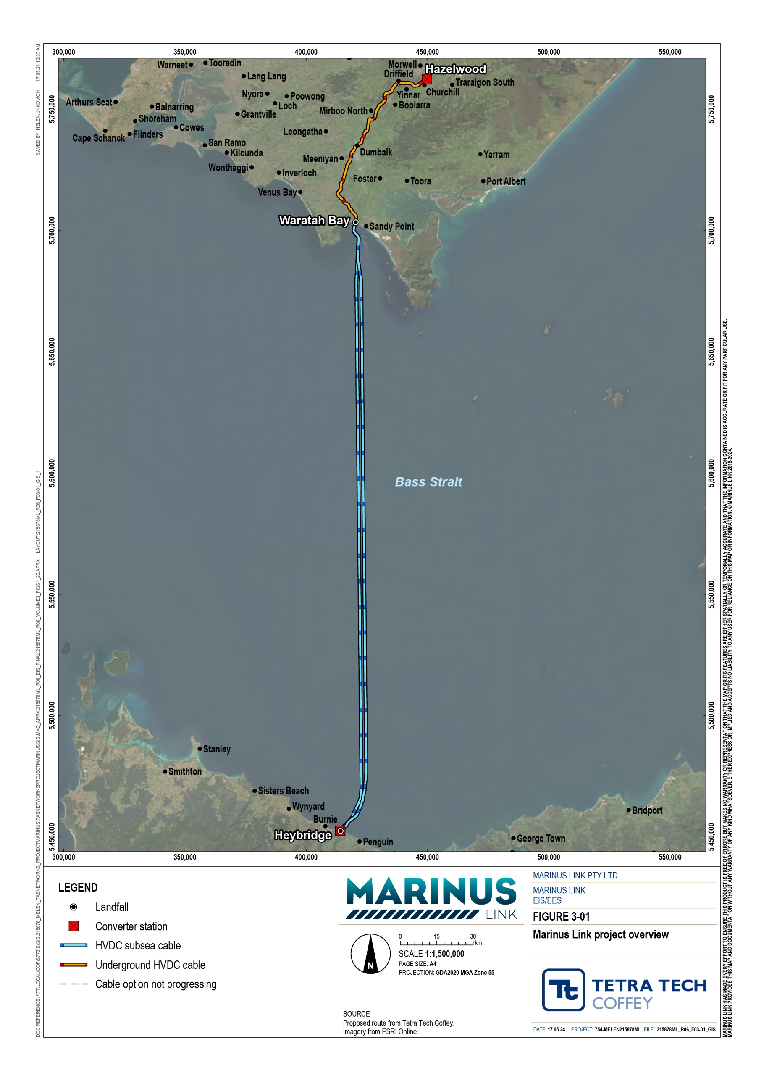

.

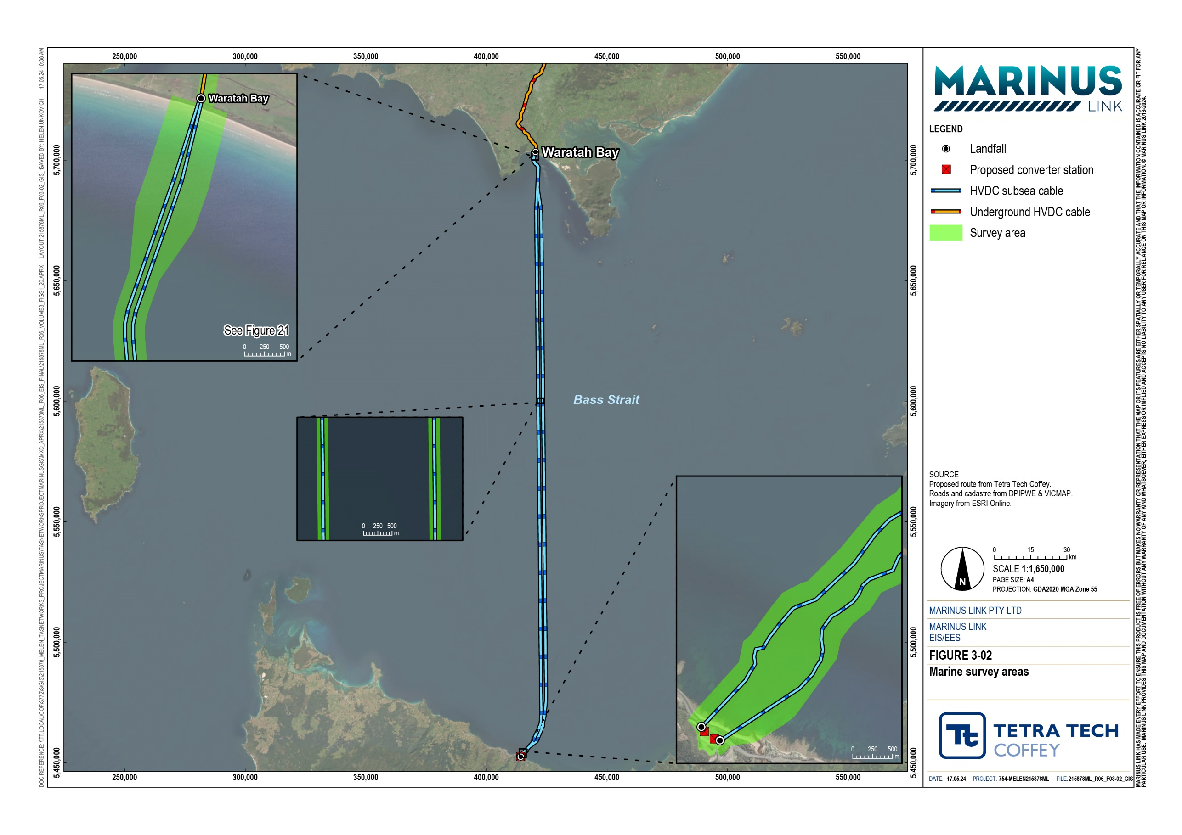

Stakeholder engagement
Marinus Link Pty Ltd (MLPL) has engaged with stakeholders about the potential impacts of the project and seeking feedback. This section summarises the key engagement activities undertaken with maritime stakeholders.
A summary of the key project stakeholders and the approach to engagement is provided in Volume 1, Chapter 8 – Community and stakeholder engagement.

Engagement activities
The engagement strategy consists of five phases, as shown in Figure 3-03. Engagement activities for the EIS/EES were mainly during phase 3. Phase 4 will commence with public exhibition of the EIS/EES.

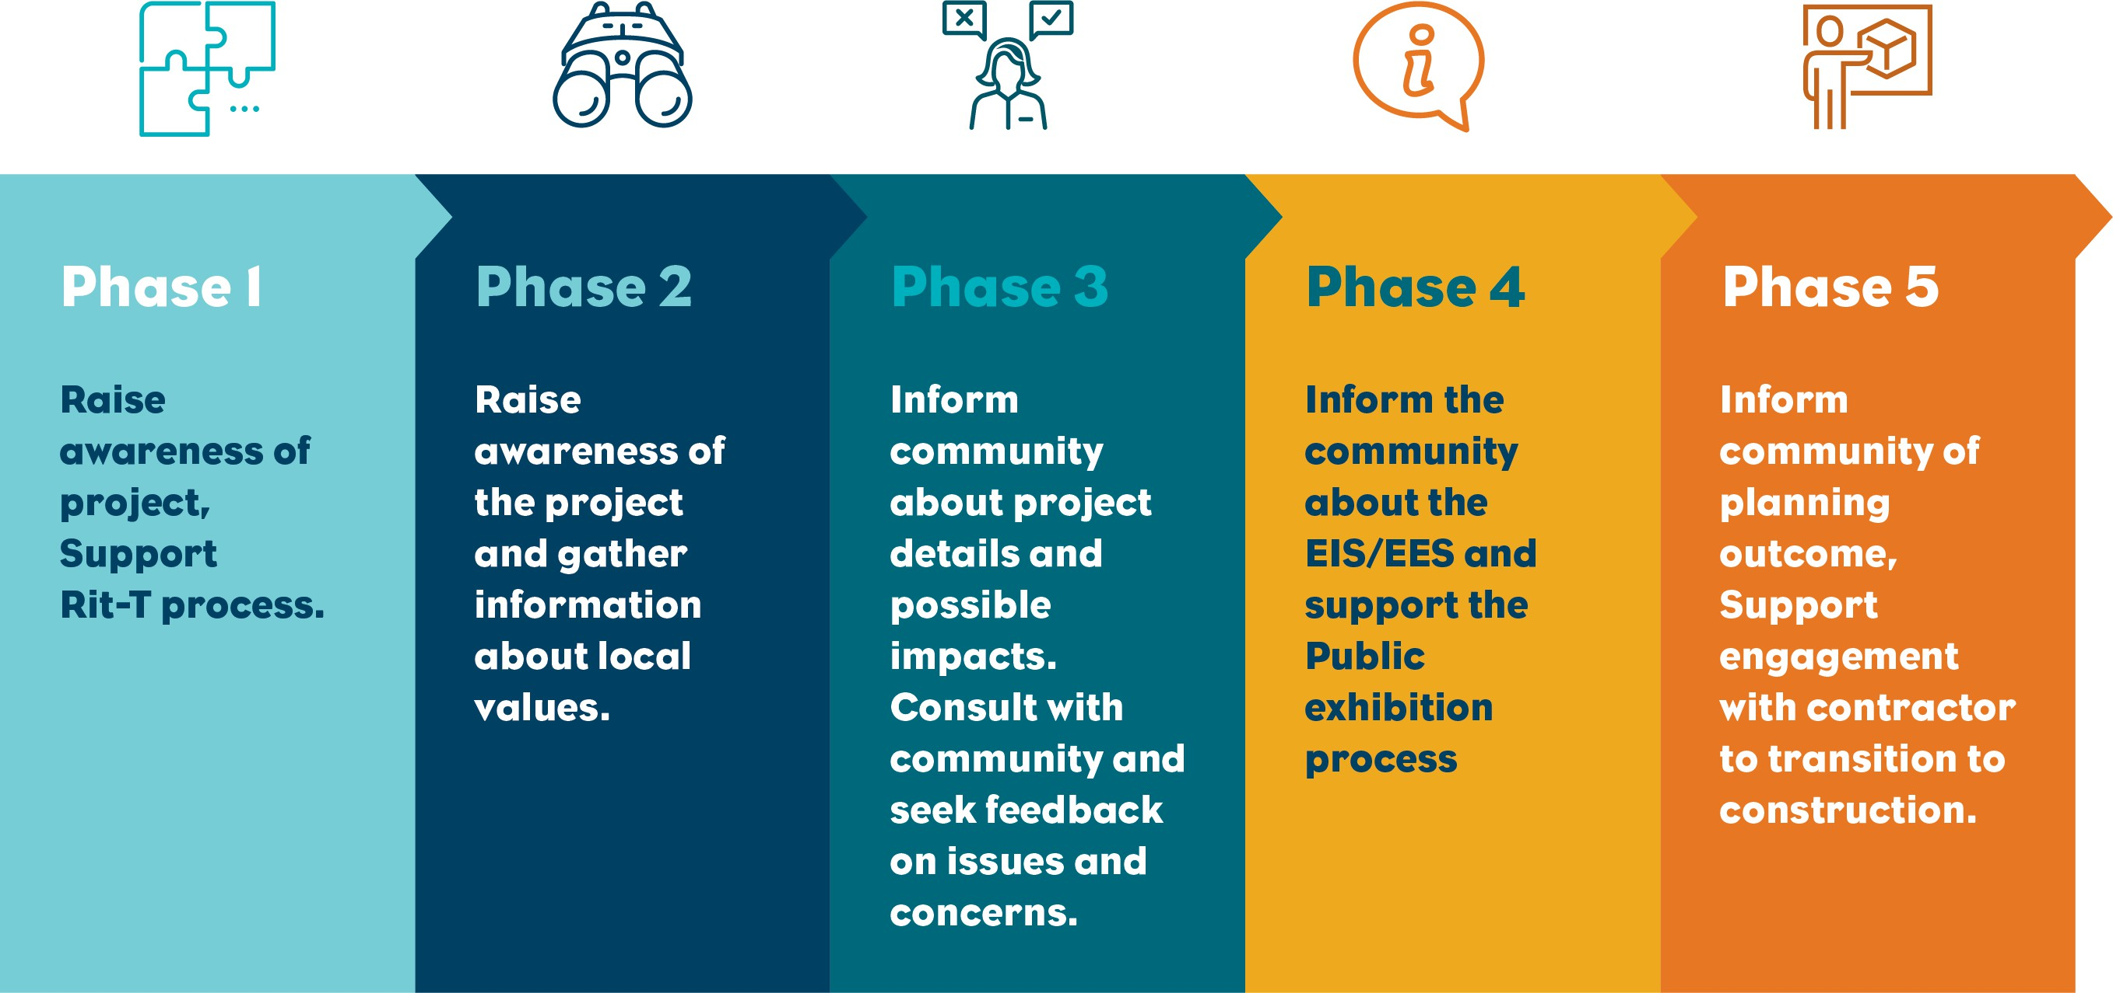
Figure 3-03 Consultation phases

Phase 1 of engagement occurred over an 18-month period between July 2018 and December 2019, with a focus on raising awareness of the project supporting the project’s Regulatory Investment Test for Transmission (RIT-T) process.
Direct engagement with Bass Strait marine and maritime industry stakeholders began in July 2021 (in phase 2) with invitations for a one-on-one project introduction. During this time, nine project introduction meetings were held online and in-person with stakeholders including the Tasmanian Seafood Industry Council (TSIC), Marine and Safety Tasmania (MAST), Burnie Ports, Transport Safety Victoria (formerly Maritime Safety Victoria), Victorian Fisheries Authority, Telstra (Infraco, asset managers), Indigo cable (Singtel, Optus), and South East Trawl Fishing Industry Association (SETFIA).
Email correspondence with stakeholders was progressed in late 2021 and throughout 2022 relating to planned (and now completed) marine surveys.

During preparation of the EIS/EES through 2022 and 2023, a range of engagement activities have been completed to inform Bass Strait stakeholders about the project and potential associated environmental and heritage impacts. The SETFIA was engaged by MLPL to identify the commercial fishing sectors in the project area. The engagement sought general information about these fisheries and the impacts that the project may have on them. The engagement was undertaken with Commonwealth, Victorian and Tasmanian managed fisheries.

Engagement outcomes and responses
The key interest and concerns raised through the engagement with maritime stakeholders is summarised in Table 1-1. The feedback has informed the project development and technical studies completed to support the EIS/EES.
Table 1-1 Interests and concerns raised by the maritime stakeholders

Theme | Issues raised | MLPL response
Commercial and recreational fishing | Requests for ongoing engagement with fishery stakeholders to help identify potential impacts. | The importance of engaging with key fishery stakeholders has been acknowledged throughout the development of the project and will continue during project construction.  MLPL will engage with commercial and recreational fishers on the project activities, schedule, locations and durations will be developed and implemented. This plan will outline notifications to be provided to marine users. Further detailed on this plan is outlined in Volume 3, Chapter 3 – Marine resource use and Volume 5, Chapter 2 – Environmental Management Framework.
 | Guidance for fishing methods near the subsea cable alignment. | The final proposed subsea cable alignment was selected based on a range of criteria, including the avoidance of major fishing grounds to minimise impacts on the fishing industry. Engagement with key fishery stakeholders will continue to guide the ongoing management of fishing activities within the location of the undersea cable alignment, including preferred fishing methods.
 | Concern about disturbance of the seabed impacting on marine water quality. | The proposed construction methodology for laying the subsea cable alignment is expected to cause minimal physical disturbance to the seabed.
Concerns around loss of MLPL presented to SETFIA and its members about possible fishing ground and exclusion project impacts. Continued engagement will be ongoing and zones during the cable laying will consider equipment or infrastructure upgrades for fishers, process. opportunities for fishing vessels to be used during construction,
along with guidelines on fishing near cables and how to approach potential snagging or striking incidents.
Maritime safety | Concerns relating to navigation safety during construction. | The proposed subsea cable alignment avoids key fishing grounds, scallop farms, shipping routes and anchorage points. MLPL will provide advance notice of any construction activities to marine users. MLPL will explore opportunities to engage local vessels to support construction activities, like guarding  activities.

Theme | Issues raised | MLPL response
Third party asset owners in Bass strait | Requirement to protect assets from damage during construction and operation | Ongoing engagement and collaboration with directly impacted asset owners to establish cable crossing agreements.
Underwater cultural heritage | Potential impacts to underwater cultural heritage | MLPL is progressing Cultural Values Assessments in consultation with First Peoples and has also completed underwater cultural heritage and submerged landscapes assessments to support the EIS/EES. MLPL is committed to ongoing engagement with First Peoples in Tasmania and in  Victoria through the First People’s Advisory Group and other direct engagement in Tasmania.

Structure of the EIS/EES
The EIS/EES consists of five volumes:

Volume 1 – Introduction provides an introduction with common information on the project, and technical information that spans the whole of project or assessments that are not locationally based.
Volume 2 – Tasmanian terrestrial environment describes the existing conditions, impact assessment and environmental performance requirements (EPRs) for the Tasmanian terrestrial component of the project. This volume considers matters of national environmental significance (MNES) and matters considered by the Commonwealth Minister for the Environment and Water when making a decision under the Environment Protection and Biodiversity Act 1999 (Cwlth) (EPBC Act) only.
Volume 3 – Marine environment (this volume) describes the existing conditions, impact assessment and EPRs for the marine (nearshore and offshore) component of the project. This volume addresses matters in the Commonwealth marine area, Victorian coastal waters and Tasmanian coastal waters (MNES only).
Volume 4 – Victorian terrestrial environment describes the existing conditions, impact assessment and EPRs for the Victorian terrestrial component of the project. This volume addresses Commonwealth and Victorian government requirements.
Volume 5 – Synthesis of environmental effects is a series of concluding chapters that draws together the overall assessment of the environmental effects of the project as a whole and provides a summary of impacts for each jurisdiction.
Each volume consists of detailed chapters as illustrated in Figure 3-04. Technical studies that were prepared to support this EIS/EES are provided as appendices.

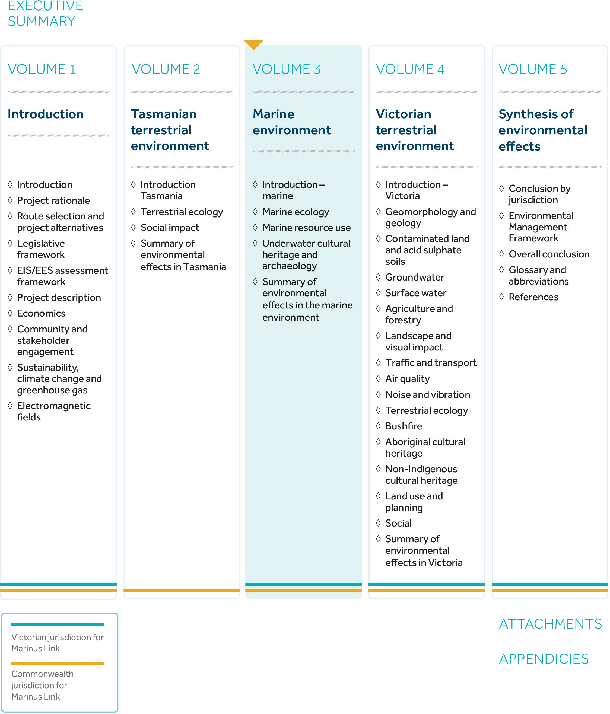

Figure 3-04 Structure of the Marinus Link EIS/EES

