Marine ecology
This chapter provides an assessment of the potential impacts on marine ecological values from the construction, operation and decommissioning of the project. This chapter is based on the assessment provided in Technical Appendix H: Marine ecology and resource use, and the baseline assessment presented in Technical Appendix G: Benthic ecology.
Marine ecology refers to the flora, fauna and ecosystems of the oceanic environment. The project’s subsea cables will traverse seabed habitats and benthic biological communities occurring in nearshore and offshore environments in Bass Strait.
The EIS guidelines set out the following requirements related to marine ecology:

Section 4.2: Description of the existing environment

Section 4.3: Description of the protected matters

Section 5: Relevant impacts

Section 5.1: General impacts

Section 5.2: Physical seabed disturbance impacts

Section 5.3: Underwater disturbance (noise, heat, vibrations, and electromagnetic fields) impacts

Section 5.4: Vessel disturbance impacts

Section 5.8: Routine vessel discharges and unplanned spills impacts

Section 5.9: Introduced invasive species impacts

Section 5.11: Cumulative impacts.

Refer to Attachment 1: Guidelines for the Content of a Draft Environmental Impact Statement for the EIS guidelines.
The EES scoping requirements set out the following EES evaluation objective relevant to marine ecology:

Marine and catchment values – Avoid and, where avoidance is not possible, minimise adverse effects on land and water (including groundwater, surface water, waterway, wetland, and marine) quality, movement and availability.
Refer to Attachment 2: Scoping Requirements Marinus Link Environment Effects Statement for the EES scoping requirements.
The marine ecology assessment considered the potential impacts from the project to marine ecology, including relevant MNES. Potential impacts were also assessed for threatened species, ecological communities and risks from marine invasive species. The assessment also recommends EPRs to avoid and reduce potential impacts.

This chapter addresses the impacts to marine ecology in the Commonwealth marine area and Victorian coastal waters. It also addresses impacts to MNES that occur in the marine environment in Tasmania, Victorian and Commonwealth waters. Impacts assessed under Tasmanian legislation are covered in separate EIS document prepared for the shore crossing.
Other aspects covered in the above EES evaluation objective that are not related to marine ecology are addressed in the following EIS/EES chapters:
Volume 1, Chapter 10 – Electromagnetic fields (for terrestrial aspects)

Volume 4, Chapter 3 – Contaminated land and acid sulfate soils

Volume 4, Chapter 4 – Groundwater

Volume 4, Chapter 5 – Surface water

Volume 4, Chapter 11 – Terrestrial ecology.

Method
The assessment used the significance assessment and risk assessment methods described in Volume 1, Chapter 5 – EIS/EES assessment framework. A likelihood of occurrence was used to identify EPBC Act and FFG Act listed species, as well as non-listed species potentially occurring within study area. The EPBC Act Protected Matters Search Tool (PMST) was the primary database used to identify relevant species, other databases are listed below.
The key steps taken in assessing the impacts to marine ecology include:

Defining a study area for the marine ecology impact assessment (Section 2.1.1).

Conducting a desktop review to assess the existing:
- Physical environment including climatic conditions, oceanography, water quality, sediment characteristics and coastal processes.
- Marine biological environment including bioregional settings, marine seabed habitats, marine pelagic habitats, and sensitive marine ecological communities.
- Marine ecological values and their sensitivity to impact.

The desktop review included review of publicly available data and literature sources to assess existing condition and biological environments including:
- Southern Australian Sea Turtles (SAST) Project
- PMST (see Figure 3-06 for the area used for the protected matters search)
- Atlas of Living Australia
- Victorian Biodiversity Atlas
- Victorian State Wide Integrated Flora and Fauna Teams
- National Conservation Values Atlas

- Species Profile and Threats Database (SPRAT)
- Tasmanian Natural Values Atlas
- BirdLife International
- Relevant literature regarding marine fauna species and their preferred habitats and foraging areas (refer to Technical Appendix H: Marine ecology and resource use for a full list of literature).
Reviewing supporting marine assessments relevant to marine ecology, including the following attachments to Technical Appendix H: Marine ecology and resource use:
- Attachment D: Supplementary Information – Underwater noise assessment
- Attachment F: Commercial fisheries data
- Attachment G: Underwater noise modelling
- Attachment H: Additional EMF modelling for Marine ecology and resource use scope
- Attachment I: Maritime traffic assessment.
Reviewing Technical Appendix G: Benthic ecology, which included underwater video surveys of the benthic environment along the cable routes.
Assessing marine noise based on underwater noise modelling and assessment of acoustic threshold criteria for hearing and physiological impacts to noise-sensitive fauna, as well as published behavioural distance thresholds.
Reviewing the marine engineering and geophysical surveys conducted by MLPL that characterises the existing physical seabed properties within the project area.
Identifying and assessing the potential impacts on marine ecological values during construction, operation and decommissioning of the project.
Assessing the risk of marine fauna vessel collisions and invasive marine species (IMS).

Identifying potential cumulative impacts on marine ecological values.

Developing EPRs in response to the impact assessment to set the required environmental outcomes for the project. The assessment of residual impacts presented in this chapter assumes implementation of measures to comply with the EPRs. Refer to Volume 5, Chapter 2 – Environmental Management Framework for a full list of EPRs.
Assessing residual impacts after implementation of measures to comply with the EPRs.

The assessment acknowledges all marine based activities must comply with Australian Maritime Safety Authority (AMSA) requirements, as compliance with these measures are a legal requirement.
The introduction and establishment of IMS has been assessed by the risk assessment method. This is because the impact is not certain to occur as the likelihood of occurrence can be mitigated.
Further details of the method are provided in Technical Appendix H: Marine ecology and resource use.

Study area
The study area considers the total area needed to sufficiently characterise and assess potential impacts to marine ecology from the project. The study area for this assessment comprises the nearshore and offshore environments (Figure 3-05). The nearshore environment (also referred to as state waters) is the area between the shoreline and the three nautical mile (NM) state limit in Victoria and Tasmania. The offshore environment is defined as the Commonwealth waters outside of nearshore environment excluding continental shelves to the west and east of the strait (Figure 3-06).

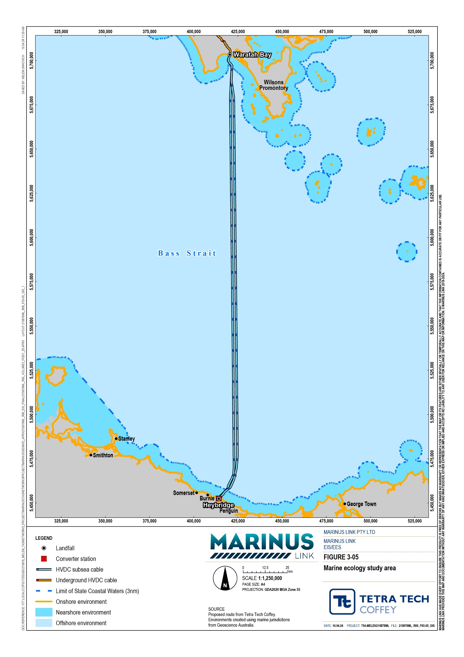
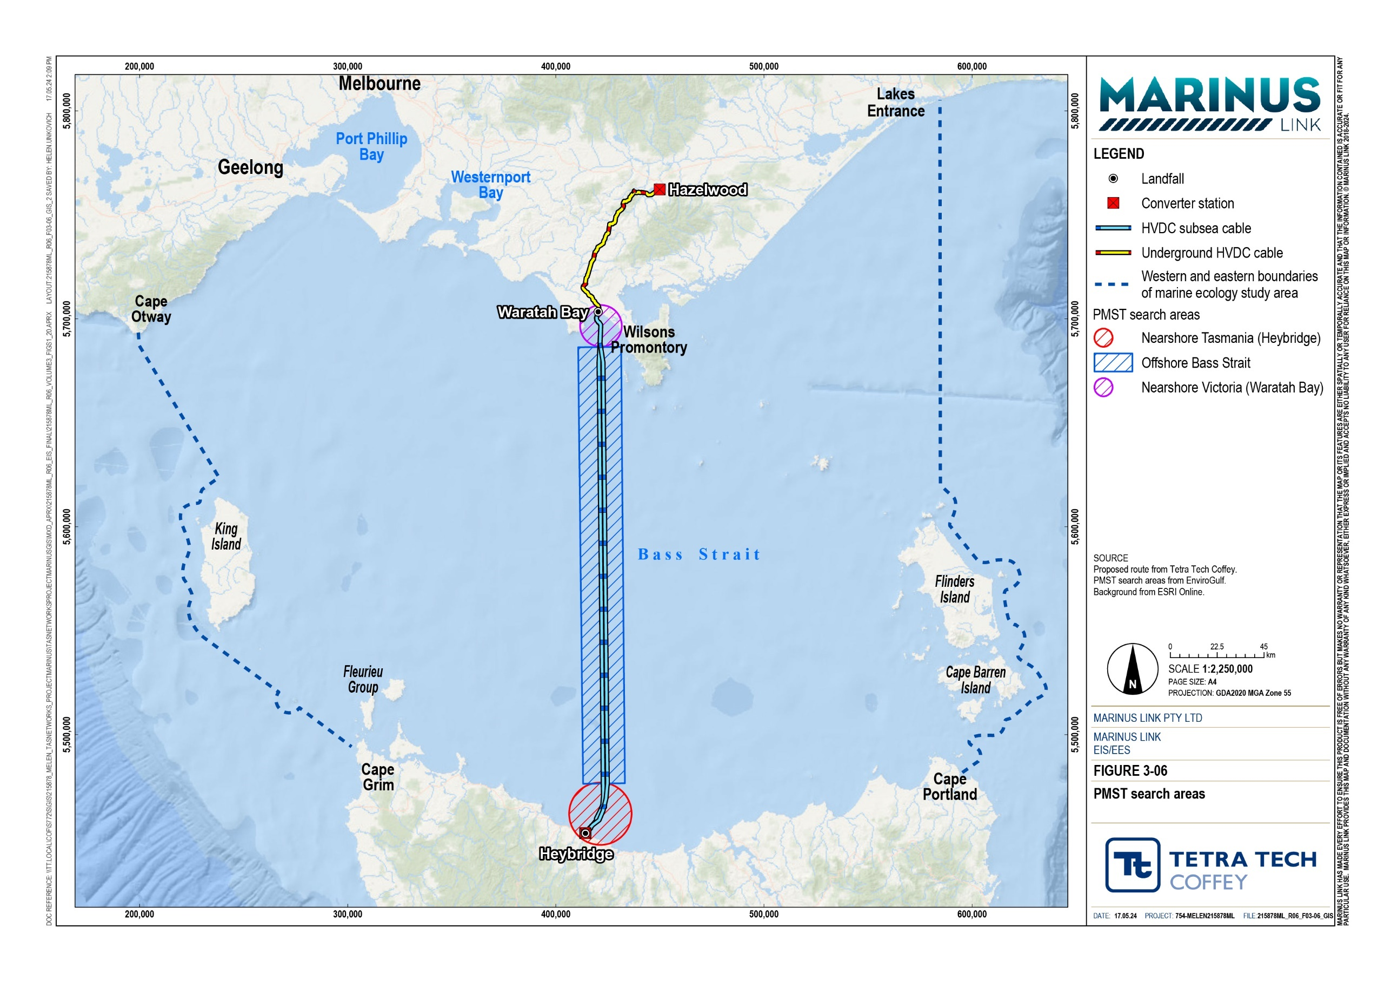

Legislative context
The legislation, supporting policy, standards and guidelines that relate to the assessment of marine ecology impacts are provided in Table 2-1.
Table 2-1 Legislation, policy and guidelines relevant to the marine ecology assessment

Title | Relevance to the assessment
Australian Maritime Safety Authority Act 1990 (Cwlth) | This Act establishes AMSA as a regulatory body, responsible for ensuring the appropriate certification and registration of ships in Australian waters. AMSA issues Marine orders directing marine traffic within Bass Strait and reducing the risk of collisions.  The project’s vessels will need to comply with Marine orders issued by AMSA, directing the project’s vessels and outlining temporary exclusion zones. Marine Orders administered by AMSA include, but are not limited to:  - AMSA Marine Orders Part 30 (Prevention of Collisions)  - AMSA Marine Orders Part 59 (Offshore Support Vessel Operations)  AMSA is responsible for responding to and controlling pollution events from marine vessels in Commonwealth waters. The project’s vessels will need to comply with the requirements of AMSA's National Plan for Maritime Emergencies (NATPLAN).
Biosecurity Act 2015  (Cwlth) | This Act establishes the regulatory framework for the management of risk associated with the introduction of pests and diseases via vessels entering Commonwealth waters. The Act is administered by AMSA and has a particular focus on the management of IMS associated with transported ballast water and hull fouling.  Under the Act, the project will need to manage the risk of IMS by managing vessels ballast water in accordance with the Australian Ballast Water Management Requirements and conducting anti-fouling procedures in accordance with the Anti- fouling and In-water Cleaning Guidelines. This is discussed further in relevant EPRs, in Section 2.6, Environmental performance requirements.
Environment Protection and Biodiversity Conservation Act 1999 (Cwlth) (EPBC Act) | The EPBC Act is Australia’s key national environmental law. The project requires assessment and approval under the EPBC Act for potential impacts to threatened species and communities, migratory species and Commonwealth marine area.
Navigation Act 2012  (Cwlth) (Navigation Act) | This Act is administered by AMSA and promotes maritime safety in navigation and marine pollution prevention, giving effect to relevant international safety and navigation conventions in Commonwealth waters, including the convention on the International Regulations for Preventing Collisions at Sea 1972 (COLREGs).  The project’s vessels will need to comply with requirements of this Act, including safe navigation and pilotage practices, implementation of navigation aids, and the appropriate pollution prevention certificates.
Offshore Electricity Infrastructure Act 2021 (Cwlth) | This Act outlines requirements for potential future conflict management between intersecting infrastructure projects, to manage cumulative impacts.
Protection of the Sea (Prevention of Pollution from Ships) Act 1983 (Cwlth) (PSPPS Act) | This Act is administered by AMSA and gives effect to the International Convention for the Prevention of Pollution from Ships (MARPOL 73/78), mandating controls and equipment standards for construction and operational discharges at sea (Annexes I-VI of MARPOL 73/78).  The project’s vessels will need to comply with these standards, including reporting of marine pollution incidents.

Title | Relevance to the assessment
Marine and Coastal Act 2018 (Vic) (Marine and Coastal Act) | The project will require consent under the Marine and Coastal Act for any proposed use, development or works that are on marine and coastal Crown land.  Marine and Coastal Policy 2020 was prepared under the Marine and Coastal Act and provides direction to decision makers including local councils and landholders on a range of issues relating to the planning, management and sustainable use of coastal and marine environments; including the impacts of climate change, population growth and ageing coastal structures.  The policy applies to the planning and management of all private and public land and waters between the outer limits of the Victorian coastal waters (3 NM from the high-water mark) and five kilometres inland of the high water mark, including 200 metres below the surface of that land.
Environment Protection Act 2017 (Vic) (EP Act) | The EP Act provides the framework for assessing the potential impacts of pollution and waste on human health and the environment. The subordinate legislation and guidance for the EP Act that have informed this assessment include the Environment Reference Standard (ERS) 2021 and the GED.  The GED outlines the duty that applies to any organisation or person undertaking an activity that may give rise to risk of harm to the environment and human health from pollution event or waste to minimise those risk so far as reasonably practicable. This would apply to marine vessels and construction activities.
Flora and Fauna Guarantee  Act 1988 (Vic) (FFG Act) | The FFG Act regulates the protection and management of biodiversity including the conservation of threatened species and communities and the management of potentially threatening processes in Victoria. For example, permits are required to take, remove, or disturb listed or protected flora species, listed communities and fish on public land.
Significant Impact Guidelines 1.1 (Cwlth) | EPBC Act policy statement that provides guidance for determining whether the project is likely to have a significant impact on a protect matter. Relevant to this chapter are guidelines for listed threatened species and ecological communities, listed migratory species and the Commonwealth marine environment.
Australian Standard / New Zealand Standard (AS/NZS) 4282:2019 –  Control of the obtrusive effects of outdoor lighting | This guideline outlines measures to manage the obtrusive effects of outdoor lighting on living organisms.
National Light Pollution Guidelines for Wildlife | This guideline outlines the framework for managing the effects of artificial light on fauna. This guideline has been adopted for assessing the impacts of artificial light, used in construction activities on EPBC Act listed species and state protected species.
EPBC Act Policy Statement 2.1 Interaction between offshore seismic exploration and whales: Industry guidelines | While the guidelines are for seismic noise sources, the policy includes information on acoustic thresholds and precautionary exclusion zones that have been used in the development of underwater noise management measures.
EPBC Act Policy Statement 3.21 – Industry guidelines for avoiding, assessing and mitigating impacts on EPBC Act listed  migratory shorebird species | This policy statement outlines industry guidelines for assessing, avoiding and mitigating impacts on EPBC Act listed migratory shorebird species. These guidelines will be adopted in cases where the species is found in the project area and assessed to be potentially impacted.

Title | Relevance to the assessment
The International Convention for the Control and Management of Ships’ Ballast Water and Sediments, 2004 (BWM Convention) | This BWM Convention outlines the ballast water management requirements of vessels in international waters must be managed. This will apply to vessels that are involved with the project and arrive through international waters.
International Cable Protection Committee (ICPC) guidelines | Recommendations published by the ICPC to assist the cable and pipeline industries to adopt a harmonised approach in relation to crossings.  The project will consider these guidelines in relation to the subsea cable crossing other infrastructure.
Recovery plans under the EPBC Act | Sets the research and management actions required to stop the decline of, and support the recovery of, listed species and threatened ecological communities. Recovery plans have been considered for relevant species where they have been prepared. Under the EPBC Act, in deciding whether or not to approve the project, the Minister for the Environment and Water must not act inconsistently with a recovery plan. Applicable recovery plans include:  - Recovery Plan for Marine Turtles in Australia (DoEE 2017c)  - National Recovery Plan for threatened Albatrosses and Giant Petrels 2011 – 2016 (DSEWPaC 2011c)  - Recovery Plan for the White Shark (Carcharodon carcharias)  (DSEWPaC 2013a)  - Conservation Management Plan for the Blue Whale 2015-2025. A Recovery Plan under the Environment Protection and Biodiversity Conservation Act 1999 (DoE 2015a)  - Conservation Management Plan for the Southern Right Whale  (DSEWPaC 2012)  - Sub-Antarctic Fur Seal and Southern Elephant Seal Recovery Plan  (DEH 2004)  - Recovery Plan for the Australian Sea Lion (Neophoca cinerea)  (DSEWPaC 2013b)  - National Recovery Plan for the Orange-bellied Parrot (DELWP 2016)  - National Recovery Plan for the Swift Parrot (Saunders and Tzaros, 2011)
A guide to boating and swimming around whales, dolphins and seals (Vic) (DELWP 2022) | This is guidance under the Wildlife (Marine Mammal) Regulations 2019 which are laws to protect seals, dolphins and whales in Victoria. This guidance document outlines distances to keep from seals, dolphins and whales. This guide will need to be followed by project-related vessels.
Environmental and wildlife regulations (Marine Safety Victoria 2022) | These regulations outline the laws protecting the marine environment and its wildlife. The projects activities will need to be undertaken and designed to have compliance with these regulations.
Environment Reference Standard 2021 | Under the EP Act, the Environment Reference Standard outlines environmental values, indicators, and objectives to be adopted in assessing and reporting environmental conditions in Victorian Waters.
Australian Biofouling Management Requirements (DAWE 2022) | Provides guidance on biosecurity best practice for international vessels while in Australian territorial seas. This is relevant to the management of IMS from international vessels used in the construction of the project.

Assumptions and limitations
The key assumptions and limitations for the marine ecology assessment include:

The assessment has assumed all marine vessels and marine based activities will comply with AMSA requirements.
The assessment is based on the observations of the physical environment and biological communities observed in the 2019 and 2021 seabed surveys (Technical Appendix G: Benthic ecology), geophysical data collected in 2019, 2020 and 2023, and regional data collected. Species not observed in the seabed surveys, but listed as present according to regional data, were assumed to be present and included in the assessment.
The benthic ecology surveys did not capture the 2022 project realignment in Waratah Bay. However, based on review of the geophysical data it shows that the sea floor is the same sandy seabed with some rocky outcrops as the previous alignment. With this it is expected that the marine benthic communities are similar to those observed in the surveys of the original alignment, which is 2 km to the east.
The assessment is based on a desktop review of relevant data and literature sources (detailed in Section 2.1), including studies of ecological impacts arising from other subsea cable projects. No targeted surveys for marine fauna, birds or pelagic marine species were completed for this assessment as the available data and literature sources were considered sufficient for purpose of the assessment.
The specifications (i.e., type, size and capacity) of vessels used in the construction, operation and decommissioning phases of the project were derived from literature review of similar subsea interconnector projects or operations.
The specifications (i.e., type, noise emissions) of equipment for underwater noise source levels for construction activities (e.g., jet trenching or targeted rock pillow placement) were derived from a review of construction equipment typically used in subsea cable installation and burial.
The study has focussed on electromagnetic fields from DC. While there may be an AC magnetic field component, it was not modelled. However, it is assumed that similar to DC fields, AC fields will be localised and rapidly diminishing, based on the results of modelling undertaken by Hutchison et al.2018 (cited in Technical Appendix H: Marine ecology and resource use) which assessed the magnetic field emissions for existing subsea cables (Cross Sound Cable and the Neptune Cable).

Existing physical environment
The project alignment across Bass Strait between Heybridge, Tasmania and Waratah Bay, Victoria is approximately 255 km. Bass Strait has numerous islands, and deep ocean drop-offs at its eastern and western borders. This section describes the physical environment features that influence the marine fauna and flora of Bass Strait. This includes currents and waves, bathymetry, coastal processes, water quality, background noise, and magnetic and electric fields.

Currents and waves
Surface water from the Great Australian Bight moves eastwards into Bass Strait in winter, where it transforms under atmospheric conditions to what is known as Bass Strait water. The water reaches the Bass Strait eastern shelf break where a northward current then directs the water towards Victoria. The force of each of these water masses is influenced by the climate.
Bass Strait is high-energy environment, with median significant wave height range from approximately 1 m in the southern parts to 1 to 2 m in the northern and central parts of Bass Strait. Currents from the Pacific and Southern oceans merge in Bass Strait and fine-grained seabed sediments in shallow water may be transported and resuspended due to the turbulent wave climate.

Bathymetry
Figure 3-07 shows the water depth along the project alignment. The depth of central Bass Strait is relatively flat, along the project alignment, with an average depth of 75 m and maximum depth of 80.6 m. The seabed begins to ascend from a depth of 70 m to the Victorian shore.
Figure 3-08 shows the bathymetry in nearshore Victoria. The bathymetry shows the revised (i.e., current) final 7 km section of the Waratah Bay alignment traverses the same seabed types as the original alignment, for which benthic underwater video characterisation was conducted. Figure 3-08 shows the bathymetry of the Waratah Bay seabed.
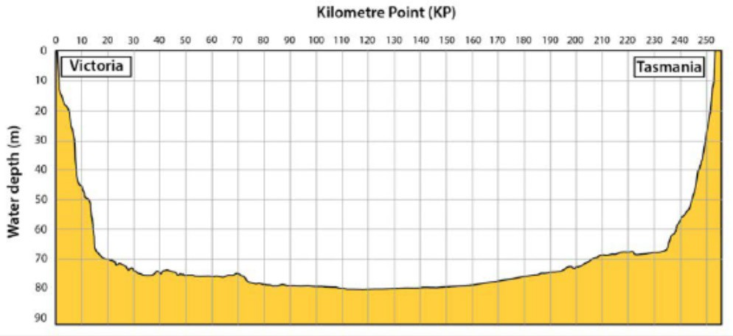
Figure 3-07 Water depths along the project alignment in Bass Strait

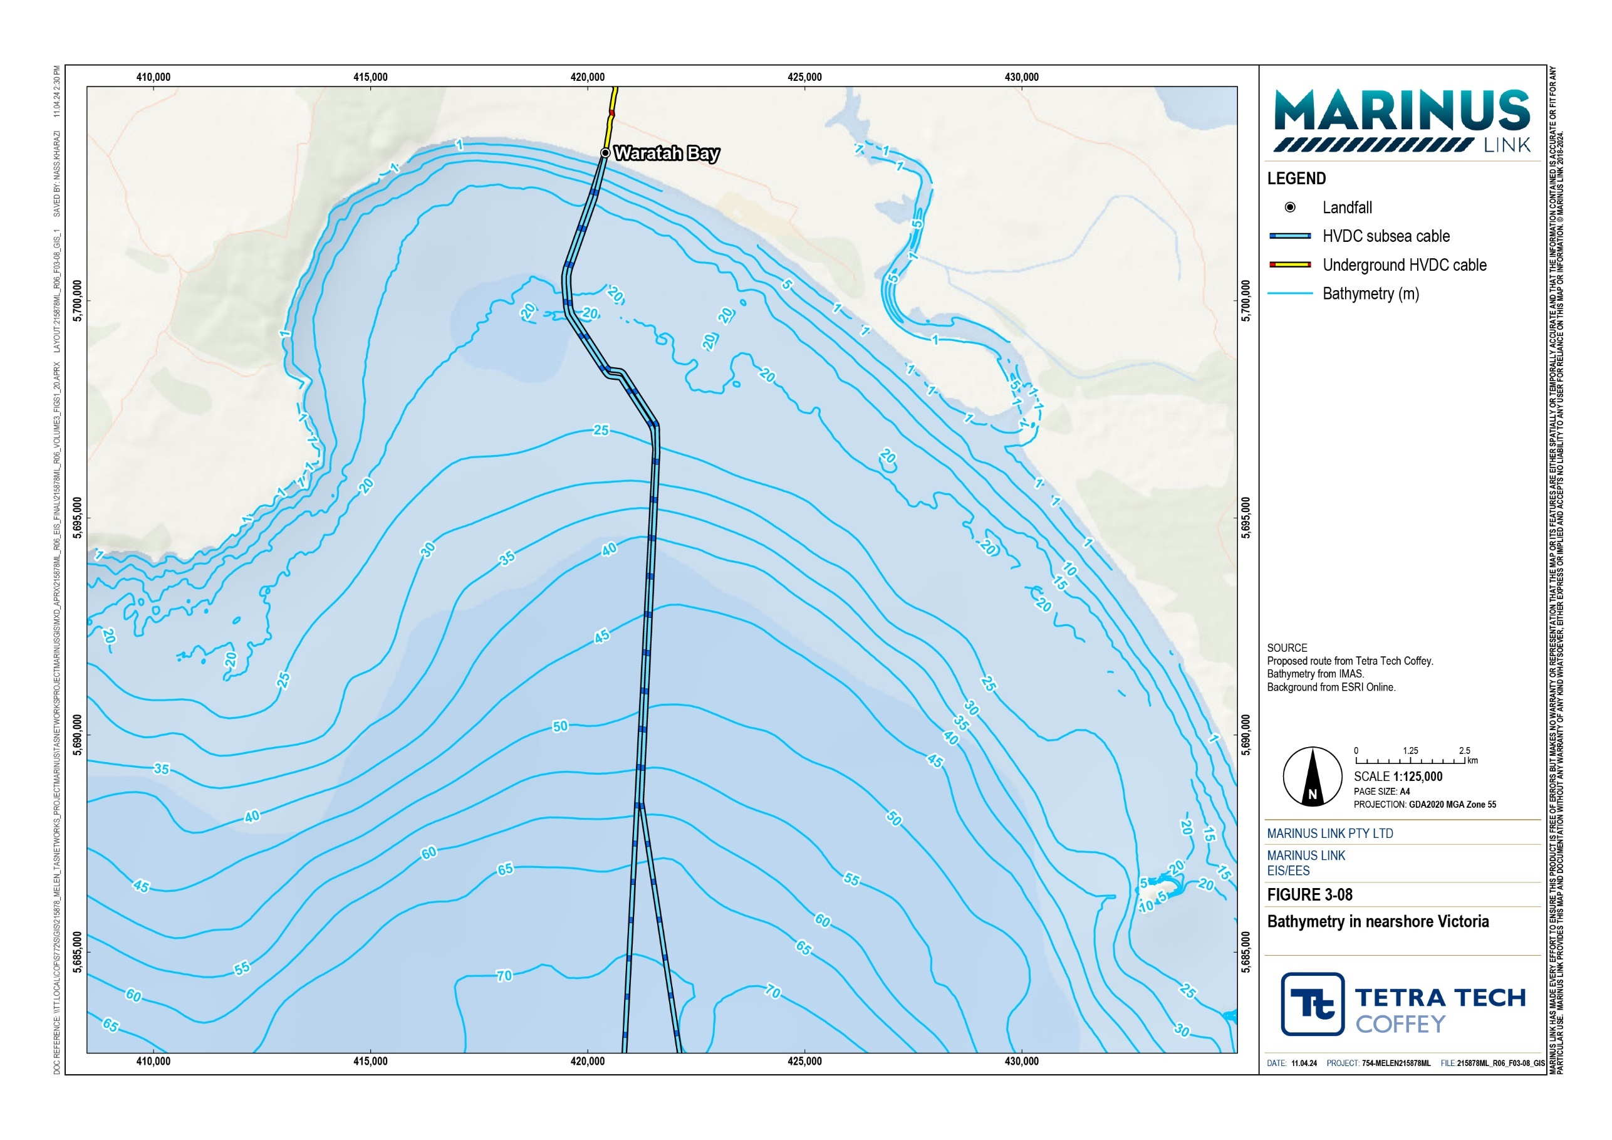

Seabed sediments and zones
The Bass Strait offshore seabed comprises predominantly of fine sands and coarse to very coarse silts. The dominant seabed types in offshore Bass Strait are described in Table 2-2. The seabed sediments are expected to be uncontaminated and of good quality. A literature review did not identify any sources of sediment contamination along the Waratah Bay coastline or across the Bass Strait offshore route. The nearshore seabed in Waratah Bay largely comprises coarse and fine sands.
Table 2-2 Offshore seabed zones and dominant seabed types

Offshore seabed | Water depth | Segment length | Dominant seabed type
Zone 1 | 25 m to 65 m | 9.5 km | Sand with ripples
Zone 2 | 65 m to 79 m | 73 km | Silty sand
Transition | 79 m to 80 m | 37 km | Transition from silty sand to sandy silt
Zone 3 | 80 m to 62 m | 112 km | Silt/clay
Zone 4 | 62 m to 10 m | 12.5 km | Sand with ripples and rock

Coastal processes
Waratah Bay primarily consists of sandy beaches and dune systems, with patches of rock shoreline and rock headlands towards the southwestern section of the bay. The subsea cable landfall will primarily intercept with sandy substrate.
Review of historical aerial imagery indicates that the shoreline at the proposed landfall in Waratah Bay has not changed over the preceding 36 year period from 1986 to 2022. As the coastline has been stable at the shore crossing location, modelling of coastal processes at the Waratah Bay is not considered further.
The stability of the coastline at Waratah Bay is not expected to change due to climate change in a way that interacts with the cables over the 40 year life of the project.

Water quality
Water quality data was sourced from the publicly accessible dataset collected by the Spirit of Tasmania passenger ferry as it traverses Bass Strait. This data was assumed to be representative of water quality in central Bass Strait and the Victorian nearshore environment. Table 2-3 outlines the seasonal variation in key water quality parameters. This includes temperature measured in degrees Celsius (°C), turbidity measured in nephelometric turbidity units (NTU), salinity measured in practical salinity units (PSU), and chlorophyll-a (a form of chlorophyll used in oxygenic photosynthesis) measured in milligrams per cubic metre (mg/m³).

Higher turbidity and chlorophyll-a concentrations, and lower salinity concentrations and temperatures were recorded in the surface water at both locations, during winter. Higher turbidity means the water has low clarity, which may be attributed to suspended sediments. The average surface salinity for nearshore Victoria is 34.70 PSU, whilst the average surface salinity for offshore Bass Strait is 34.60 PSU.
Chlorophyll-a concentrations provide an indicator of phytoplankton abundance. The average surface chlorophyll-a concentration for nearshore Victoria is 0.34 mg/m³, whilst the average surface chlorophyll concentrations for offshore Bass Strait is 0.35 mg/m³. The surface chlorophyll-a concentrations are considered very low and are characteristic of the generally low phytoplankton biomass and productivity levels of nearshore and offshore Bass Strait.
Both locations appeared to have a similar degree of seasonal variation, however, the water temperature increase in summer was slightly higher in nearshore Victoria.
Table 2-3 Average water quality for offshore Bass Strait and nearshore Victoria (2020 to 2021)

Location | Season | Temperature (°C) | Turbidity (NTU) | Salinity (PSU) | Chlorophyll a (mg/m³)
Offshore Bass Strait | Winter | 14.28 | 1.19 | 33.76 | 0.40
 | Summer | 16.91 | 0.44 | 35.44 | 0.30
Nearshore Victoria | Winter | 14.35 | 1.06 | 33.95 | 0.38
 | Summer | 18.20 | 0.49 | 35.45 | 0.30
Winter: 1 June 2020 to 31 August 2021; Summer: 1 December 2020 to 28 February 2021
Source: MV Spirit of Tasmania I data from AODN 2019 as cited in Technical Appendix H: Marine ecology and resource use

Underwater noise
The unit of measurement used in the assessment of underwater noise is the sound exposure level, expressed as dB re 1 µParms. This is the level of noise that is received relative to specific pressure (1 µPa) and distance from the source (1 m) over a given duration (adjusted to 1-hour for the purpose of this assessment). It reads as the decibel value of the mean of the square root pressure at 1 metre from the noise source.
The ambient noise levels of nearshore Waratah Bay and offshore Bass Strait were derived from literature review of comparable locations in nearshore and offshores areas, both in Australia and overseas.
Attachment D of Technical Appendix H: Marine ecology and resource use provides a list of the literature sources and reported ambient underwater noise levels. There are no existing field measurements of these locations.
The average background noise level in nearshore Waratah Bay is expected to be 105 dB re 1 µParms, and range between 90 dB and 145 dB re 1 µParms. It is expected to be in the higher end of the range during summer months, when there is greater watercraft activity. The average background noise level in central Bass Strait was determined to be 95 dB re 1 µParms, with a range between 90 dB and 110 dB re 1 µParms.

Magnetic fields
Magnetic fields are quantified by magnetic flux density, magnetic induction, or magnetic field strength and are measured in Tesla (T). nT (nano Tesla) is one billionth of a Tesla.
The background magnetic fields within the study area comprise of multiple sources, both natural and anthropogenic. Natural magnetic fields are generated by the earth’s magnetic fields and do not vary greatly in the short term but may vary in the order of hundreds of years. Figure 3-09 shows the natural magnetic anomalies of Bass Strait. The anomalies are produced by deep geological features that are at least 10 km below the seabed.
The geomagnetic field along the project alignment varies from 61,334 nT at Heybridge to 60,281 nT at Waratah Bay, as shown in Table 2-4. The average geomagnetic field across the project alignment through Bass Strait, varies by an average of +4.2 nT per km from south to north. Geomagnetic fields also change naturally at a rate of +120 nT/year, depending on geographic location. This is considered relatively constant over an ecological timeframe.
Table 2-4 Geomagnetic field component along the project alignment

Component | Tasmanian shore crossing | Central Bass Strait | Victorian shore crossing | Average variation from Tasmania to Victoria (per km)
Total magnetic field (nT) | 61,335 | 60,826 | 60,281 | 4.2
Source: NOAA, 2023, cited in Technical Appendix H: Marine ecology and resource use

Electric fields
Natural electric fields exist in marine waters and normally range from 0.005 µV/cm to 0.5 µV/cm¹. Movement of conductive seawater through geomagnetic fields, such as tidal flows, currents, and marine fauna movement, may also produce weaker electric fields in the degree of tens or hundreds of nV/cm (1 nV/cm equates to 0.001 µV/cm). Natural electric and magnetic fields are also discussed in Volume 1, Chapter 10 – Electromagnetic fields.
Living organisms generate biogenic electric fields due to respiratory and cardiac activity and muscle contractions. These fields vary depending on the taxonomic group, position and activity of the organism, ranging between 2 µV/cm and 100 µV/cm at a very close distance. These weak electric fields can be detected by most elasmobranchs, such as sharks, rays, skates and magneto-sensitive fauna.
Localised electric fields are generated by anthropogenic features such as vessel movement and subsea infrastructure; i.e., oil and gas pipelines and interconnectors. Electric fields generated by vessel movement, however, are weaker than background electric fields and are not significant to the marine ecosystem.

¹ µV/cm or micro Volt per centimetre standard international (SI) unit of measurement for electric field strength.
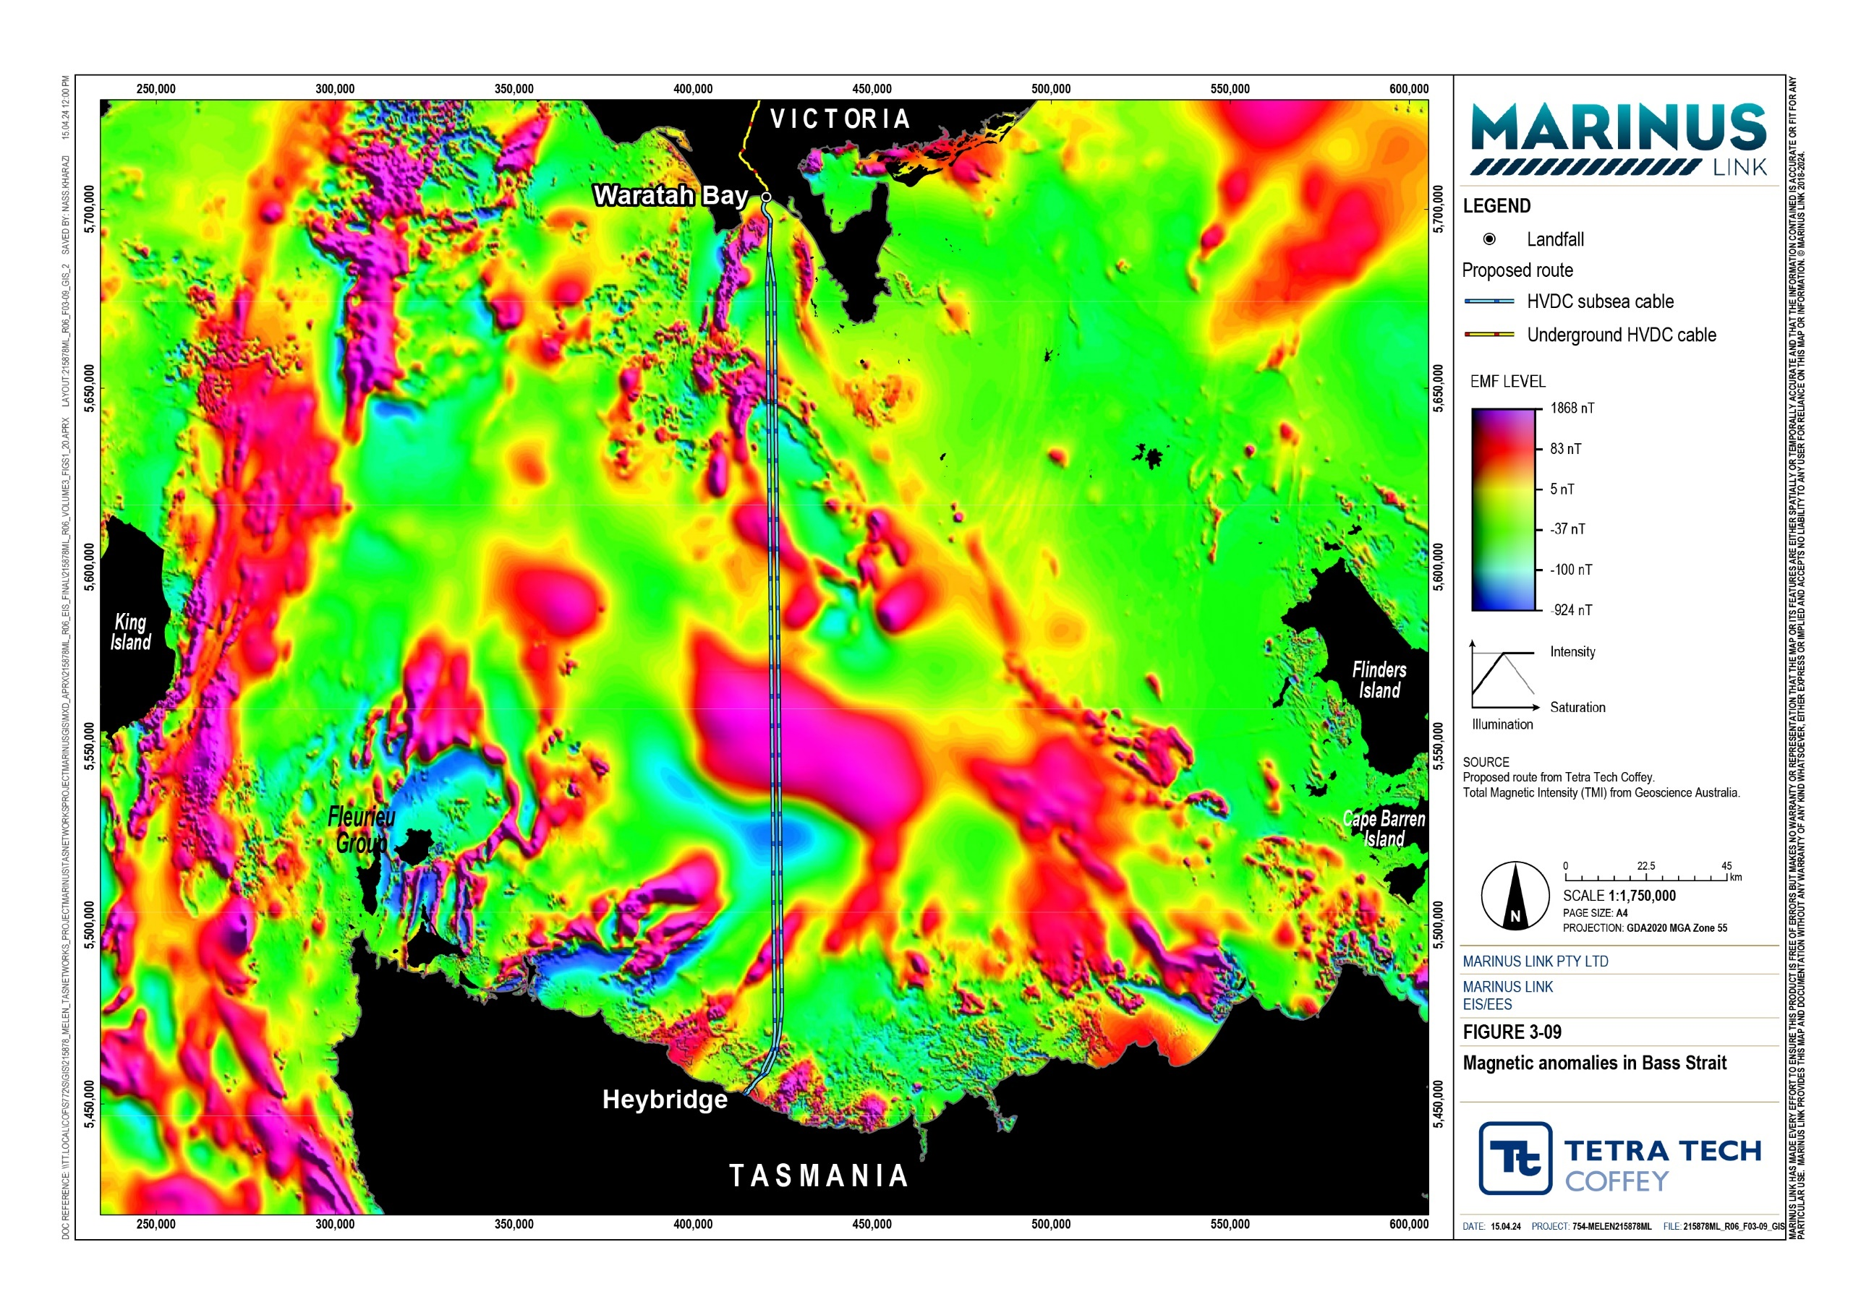

Existing biological environment
The biological environment refers to the marine fauna, flora and habitats that are known to exist. The marine habitats in the study area include:
Soft seabed habitats (i.e., sands, silts, and shell) characterised by sparse and less dense populations of benthic flora and fauna and infauna.
Hard seabed habitats comprised (i.e., rocky reefs, rock platform) characterised by invertebrates (sponges, ascidians, scallops) and macroalgae populations.
Water column habitats comprised of waters less than 200 m deep, characterised by phytoplankton.

Benthic environment
The marine benthic habitats of the study area are described in this section. The benthic habitat along the project alignment is predominantly soft-sediment, fine and mobile sandy seabed.
The benthic environment in offshore Bass Strait comprises coarse sand and rock closer to the Tasmanian state waters boundary, but is predominantly soft-sediment seabed, varying in primary composition of sand or silt, with sparse patches of flora and evidence of epibiota activity, particularly sea sponges, eunicid worm tube stalks, and mounds (see Figure 3-10). There is one zone (Zone 3; see Table 2-5) where the route passes through an area where mesophotic ‘sponge bed’ communities are anticipated to be present.
Table 2-5 provides a summary of the benthic characteristics of five offshore benthic community zones identified.
Table 2-5 Offshore benthic community zones

Zone | Water depth | Benthic characteristics
Zone 1 | 25 to 65 m | Sand with ripples, mixed macroalgae, sparse epibenthic macroinvertebrates, burrowing polychaete worms, sediment infauna, unidentifiable low growth, possibly encrusting or colonial invertebrates.
Zone 2 | 65 to 79 m | Silty sand with sparse benthic communities, individual sponges or small patches of mixed invertebrates and branching soft corals over mostly bare seabed.
Transition | 79 to 80 m | Characterised by a transition from sand to finer silt with silt/clay layers. Colonial eunicid worm tubes stalks protrude as sparsely distributed. Relatively flat section of seabed with dimples from burrowing biota.
Zone 3 | 80 to 62 m | Silt/clay with mesophotic ‘sponge coral’ communities anticipated to occur between 65 to 75 m depths. Abundant mounds of burrowing infauna. Sparse distribution of macroinvertebrates (encrusted worm tubes, slender branched soft corals, occasional commercial and doughboy scallops).
Zone 4 | 62 to 10 m | Sand/rock. Stalked bryozoans, doughboy and commercial scallops, and eleven arm sea stars. Green macroalgae sparsely distributed.

The benthic environment in nearshore Waratah Bay is predominantly fine sandy seabed with small patches of cobble and isolated patches of low-profile reef. The seabed is generally bare of epibiota, except for sparsely distributed seagrass and macroalgae, and sparse evidence of epifauna (see Figure 3-11). The Tasman grass-wrack (Heterozostera tasmanica) seagrass was observed mostly as low to moderate density between 10 m and 15 m water depth, and as individuals or sparse patches at 8 to 10 m water depth and 15 to 31 m water depth. Tasman grass-wrack is listed as endangered under the FFG Act. This is the only threatened flora species identified within the study area.
Table 2-6 provides a summary of the benthic characteristics of four Waratah Bay benthic community zones identified.
Table 2-6 Waratah Bay benthic community zones

Zone | Water depth | Benthic characteristics
Zone 1 | 5 to 15 m | Sand and rock reef with low to moderate density seagrass, drift macroalgae and mixed infauna
Zone 2 | 15 to 20 m | Sand with sparsely distributed seagrass and mixed infauna
Zone 3 | 15 to 20 m | Sand, rock reef and cobble with mixed macroalgae, sparsely distributed seagrass and benthic macroinvertebrates
Zone 4 | 20 to 25 m | Sand with mixed infauna and drift macroalgae

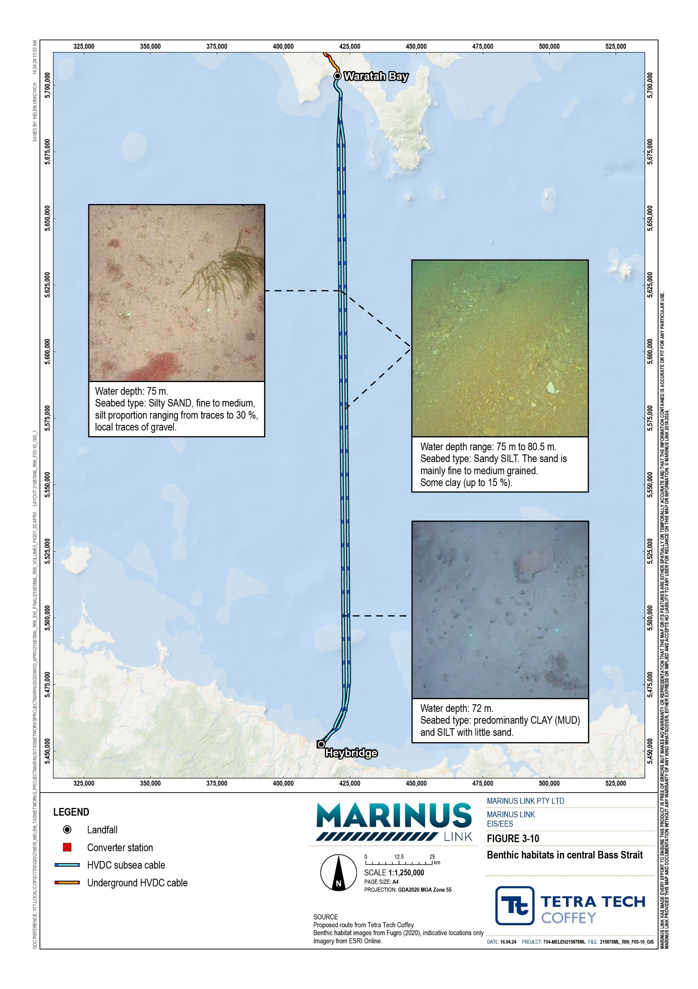

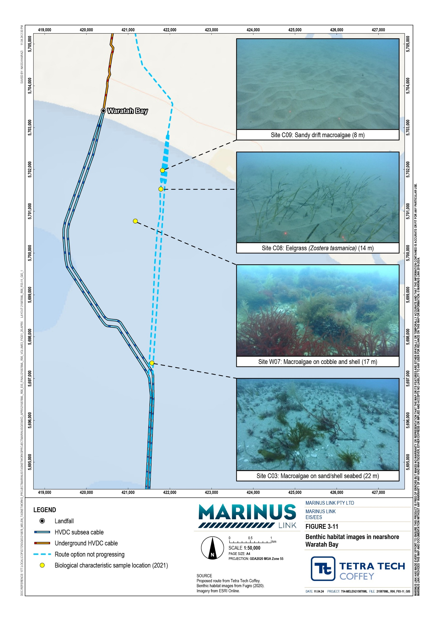

Marine protected areas
Marine protected areas encompass marine parks, reserves and areas managed to conserve marine biodiversity. The subsea alignment does not cross Commonwealth marine reserves, the nearest Commonwealth marine reserve is the Beagle Commonwealth Marine Reserve, located 31.5 km east of the project’s proposed alignment.
The nearest Victorian marine reserve is the Wilsons Promontory Marine Reserve, which is 12 km to the east of western subsea bundled cables alignment and is the closest conservation area to the project alignment. The Glennie Group, made up of the Great Glennie, Dannevig and McHugh islands, lies within the marine reserve and has significant habitats including breeding areas for marine birds and Australian fur seals, which forage within the surrounding waters.
Marine protected areas in the nearshore environment are shown in Figure 3-12.

Biologically important areas
Biologically important areas (BIAs) are spatially defined areas and times where aggregates of marine species protected under the EPBC Act are known to breed, forage, rest or migrate. The project alignment will intersect the following BIAs:
Southern right whale (Eubalaena australis) (Section 2.3.4)

Pygmy blue whale (Balaenoptera musculus brevicauda) (Section 2.3.4)

Short-tailed shearwater (Puffinus tenuirostris) (Section 2.3.7)

Shy albatross (Thalassarche cauta) (Section 2.3.7)

Great white shark (Carcharodon carcharias) (Section 2.3.8).

Volume 3 – Marine environment Page 2-21

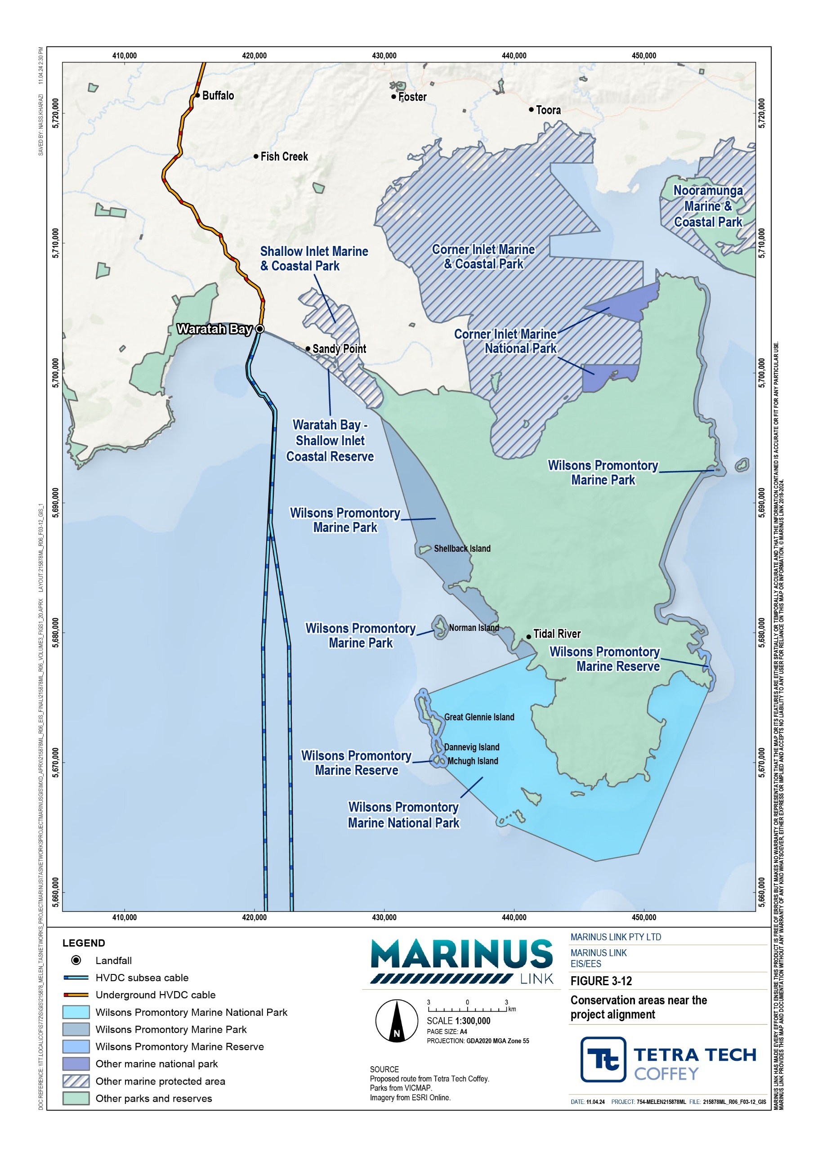

Cetaceans
There are 21 species of cetaceans (whales, dolphins and porpoises) included in the assessment. These species are made up by two groups, consisting of 10 species of baleen whales (Mysticeti) and 11 species of toothed whales (Odontoceti).
Ten of these species are listed as migratory under the EPBC Act, including:

Humpback whale (Megaptera novaeangliae)

Southern right whale (Eubalaena australis)

Sei whale (Balaenoptera borealis)

Antarctic blue whale (Balaenoptera borealis dia)

Pygmy blue whale (Balaenoptera musculus brevicauda)

Fin whale (Balaenoptera physalus)

Pygmy right whale (Caperea marginata)

Killer whale, or orca (Orcinus orca)

Dusky dolphin (Lagenorhynchus obscurus)

Spotted bottlenose dolphin, also known as Indo-Pacific bottlenose (Tursiops aduncus).

Table 2-7 presents the PMST results and conservation status under legislative and international conservation lists, including the International Union for Conservation of Nature Red List of Threatened Species (IUCN), EPBC Act, and FFG Act.
The likelihood of occurrence of these cetaceans has been determined based on review of species observation and distribution data from The Atlas of Living Australia, and The Tasmanian Natural Values Atlas, and is presented in Table 2-7.
Table 2-7 Summary of conservation status, PMST search data and likelihood of occurrence

Species | Conservation status |  |  | Occurrence in PMST search areas | Determined likelihood of occurrence
 | IUCN | EPBC  Act | FFG  Act | Victoria / offshore / Tasmania | Victoria / offshore / Tasmania
Baleen whales (Mysticeti)
Humpback whale (Megaptera novaeangliae) | LC | Mi | EN | Species known | Very likely
Southern right whale (Eubalaena australis) | LC | EN,  Mi | EN | Species known | Very likely
Sei whale (Balaenoptera borealis) | EN | VU,  Mi | - | Foraging likely | Rare

Species | Conservation status |  |  | Occurrence in PMST search areas | Determined likelihood of occurrence
 | IUCN | EPBC  Act | FFG  Act | Victoria / offshore / Tasmania | Victoria / offshore / Tasmania
Antarctic blue whale (Balaenoptera musculus intermedia) | EN | EN,  Mi | EN | Species likely | Remote
Pygmy blue whale (Balaenoptera musculus brevicauda) | EN | EN,  Mi | EN | Species likely | Possible
Fin whale (Balaenoptera physalus) | VU | VU | - | Foraging likely | Rare
Pygmy right whale (Caperea marginata) | LC | Mi | - | Foraging may occur | Rare
Antarctic minke whale (Balaenoptera bonaerensis) | NT | - | - | - | Remote
Common minke whale (Balaenoptera acutorostrata) | LC | - | - | Species may occur | Possible
Dwarf minke whale (Balaenoptera acutorostrata subsp.) | - | - | - | - | Rare
Toothed whales (Odontoceti)
Killer whale (or orca) (Orcinus orca) | DD | Mi | - | Species likely | Rare (Vic: Likely)
False killer whale (Pseudorca crassidens) | NT | - | - | Species likely (Vic: not listed) | Rare
Short-finned pilot whale (Globicephala macrorhynchus) | LC | - | - | Species may occur (Vic: not listed) | Rare (Tas: Remote)
Long-finned pilot whale (Globicephala melas) | LC | - | - | - | Likely
Dusky dolphin (Lagenorhynchus obscurus) | LC | Mi | - | Species may occur | Rare
Common dolphin (Delphinus delphis) | LC | - | - | Species may occur | Very likely
Risso's dolphin (Grampus griseus) | LC | - | - | Species may occur | Rare
Spotted bottlenose dolphin / Indo- Pacific bottlenose (Tursiops aduncus) | NT | - | - | Species likely (Tas: not listed) | Rare (Tas: Remote)
Common bottlenose dolphin (Tursiops truncatus) | LC | Mi | - | Species may occur | Very likely
Burrunan dolphin (Tursiops australis) | - | - | - | - | Rare
Sperm whales  (Physeter macrocephalus) | VU | - | - | - | Likely (Tas: Rare)

DD: Data Deficient, EN: Endangered, LC: Least Concern, Mi: Migratory, NT: Near Threatened, VU: Vulnerable, -: Not listed

The project alignment will intercept the BIAs of the southern right whale (Eubalaena australis), humpback whale (Megaptera novaeangliae) and Pygmy blue whale (Balaenoptera musculus brevicauda).
The Conservation Management Plan for the Blue Whale (DoE 2015), issued under the EPBC Act, outlines a framework for conserving and managing blue whale population, including the sub-species, pygmy blue whale and Antarctic blue whale and includes the following objectives:
Maintaining and improving management protection of blue whales

Addressing anthropogenic noise

Understanding impacts of climate change on blue whale population

Minimising vessel collisions

Measuring and monitoring population recovery

Describing population distribution and defining biologically important habitat.

The Conservation Management Plan for the Southern Right Whale (DSEWPC 2012), issued under the EPBC Act, outlines a framework for conserving and managing the recovery of southern right whale populations in Australia and includes the following objectives:
Demonstrate that the number of southern right whales occurring off southwest Australia (nominally southwest Australian population) is increasing at or near the maximum biological rate.
Demonstrate that the number of southern right whales occurring off southeast Australia (nominally southeast Australian population) is showing signs of increase.
The nature and degree of difference between the southeastern and southwestern Australian populations of southern right whales is clearly understood.
Current levels of legal and management protection for southern right whales are maintained or improved and an appropriate adaptive management regime is in place.
Anthropogenic threats are demonstrably minimised.

Threatened whales
The southern right whale, Antarctic blue whale, and pygmy blue whale are classified as endangered under the EPBC Act and FFG Act. The humpback whale and southern humpback whale subspecies are not listed as threatened under the EPBC Act, but are endangered, and critically endangered under the FFG Act, respectively. The sei whale and fin whale are classified as vulnerable under the EPBC Act, but not listed as threatened under the FFG Act.
The following sections summarise the likelihood of occurrence and BIAs of threatened whale populations located in and around the study area.

Humpback whale
The migratory humpback whale, classified as endangered under the FFG Act, is very likely to occur within offshore Bass Strait, and the Victorian and Tasmanian nearshore areas, particularly during the humpback’s northern migration to tropical waters of eastern Australia for breeding, from May through to July, and southern migration, from October through to December, although this is not their primary migration pathway. There is no commonwealth conservation advice for the humpback whale, given its removal from the EPBC Act’s list of threatened species in early 2022. For the purposes of this assessment, humpback whales are considered at a species level, not as a breeding group.
The International Whaling Commission recognises seven breeding groups of humpback whales in the southern hemisphere. Group D is from the western Australian coast, and there are two Group E subgroups: E1 from the eastern Australian coast, and E2 that visits Australian waters adjacent to Norfolk Island. Group D is considered unlikely to be present in Bass Strait, and Group E2 is completely absent from Bass Strait waters, and therefore, these breeding groups are not discussed further.
Eastern humpback whale E1 subpopulations congregate in BIAs to display important behaviours, including calving, resting, and feeding areas. The primary calving areas used by this whale are within warm nearshore and coastal waters off Mackay, Queensland. Humpback whales remain in the warmer waters on the eastern Queensland coast from late autumn to late spring. Following this, migration occurs between late winter to late spring. Humpback whales rest in sheltered embayments along the east coast during their southern migration. The nearest resting area is Twofold Bay, approximately 460 km from the project alignment. Some of these whales are known to pass westward through Bass Strait, resting in embayments such as Corner Inlet, on their way to feeding areas in the Southern Ocean.
Humpback whales have also been sighted twice in Waratah Bay. In addition to the Southern Ocean feeding grounds, the humpback whale has been observed feeding along the east and south east coast of mainland Australia and Tasmania. The majority of the whales migrate northward for winter along the east coast of Tasmania, and some migrate along the west coast of Tasmania and pass eastward through Bass Strait, which intercepts the project alignment.

Southern right whale
The endangered migratory southern right whale is very likely to occur in offshore Bass Strait, and the Victorian and Tasmanian nearshore areas, particularly between June and September, after which they migrate to feeding grounds in the Southern Ocean between December and April.
The southern right whale congregates in BIAs to display important behaviours, including resting, breeding and calving. The migration and resting areas include the coastal waters of Victoria to the 3 NM limit, with extension out at the Phillip Island, Western Port, and Wilsons Promontory areas.

The breeding area is on the central east coast of Tasmania and extends to the continental shelf. Calving typically takes place in areas with a water depth of 10 m, between May and October. Calving areas in Victorian waters include Logans Beach near Warrnambool, located 330 km from the project alignment, and intermittently Port Campbell, Port Fairy, and Portland, in southwest Victorian waters, the closest being
270 km from the project alignment. Connecting habitat areas are classified as within the Tasmanian 3 NM limit around Tasmania and its largest islands, being King Island, and the Furneaux Group.
Feeding areas of the south east Australian subpopulation of southern right whales are not known; however, historical whale capture data suggests it may be in the highly productive area of the Southern Tropical Convergence at latitudes between 39° S and 42° S, during summer months. Southern right whales migrate from their summer feeding grounds to the warmer coastal waters, and are seasonally present along the southeast Australian coast from April to November. Some southern right whales migrate north along the east coast of Tasmania before continuing in a northeasterly direction along the east coast of Victoria and New South Wales. Others migrate north along the west coast of Tasmania and continue in a westerly direction along the coastline of South Australia and Western Australia.

Pygmy blue whale
The endangered migratory pygmy blue whale has a possible likelihood of occurrence in offshore Bass Strait, and the Victorian and Tasmanian nearshore areas, particularly between November and May when they feed on krill (Nyctiphanes australis) that swarm on the surface, attracted by the upwelling of cool nutrient-rich water from the Bonney Upwelling. There are two known subpopulations of the pygmy blue whale, including the South Eastern Indian Ocean (SEIO) and the South West Pacific Ocean (SWPO) subpopulations. The SEIO subpopulation is known to migrate from the south west waters of Western Australia in early to mid- Autumn to Indonesian waters for Winter and returning by late December. The SWPO subpopulation has mainly been recorded in New Zealand waters, with northern migration to Tongan and Samoan waters. These species are known to overlap in Bass Strait waters; whilst the SEIO subpopulation has a larger presence in Bass Strait, primarily occurring in western and central Bass Strait, the SWPO subpopulation boundary extends to the eastern side of Bass Strait and therefore will have a lower presence in the project area.
Passive whale call monitoring studies have recorded pygmy blue whale calls in the warmer south west Victorian waters, presumably to feed and breed in the Bonney Upwelling area, to the west of the study area, with a peak presence in late autumn and early winter months.
The project alignment intercepts the possible foraging area BIA for the pygmy blue whale. The Conservation Management Plan for the Blue Whale 2015-2025 (DoE 2015a.), issued under Section 269A(2) of the EPBC Act, identifies known and likely areas used by the pygmy blue whale. This includes a high use foraging area along the southeast South Australian and southwest Victorian coastlines, a known foraging area to the east between Cape Otway and Cape Patterson, and a possible foraging area covering most of the central and eastern portion of Bass Strait, and Tasmanian coastline. The project will transect the possible foraging area of the pygmy blue whale.

Non-threatened whales
The common bottlenose dolphin was the only non-threatened migratory whale species determined a likelihood of occurrence of possible or greater.
In addition, the common minke, sperm and long-finned pilot whales, and common dolphin are cetaceans that were determined to have a likelihood of occurrence of possible or greater.
The pygmy sperm whale (Kogia breviceps) is the only high frequency cetacean likely to occur in offshore Bass Strait, which has a habitat preference for the continental shelf edge and deep slope, though they are known to pass through Bass Strait. This species has a remote likelihood of occurring in Waratah Bay nearshore waters.
These species are not listed as threatened under the EPBC Act or FFG Act. There is no conservation advice for these species.

Pinnipeds
There are six species of pinnipeds that are known to occur or may occur in Bass Strait:

Eared seals (Otariidae pinnipeds):

- Australian fur seal (Arctocephalus pusillus doriferus)

- long-nosed fur seal (Arctocephalus forsteri)

- sub-Antarctic seal (Arctocephalus tropicalis).

Earless seals (Phocidae pinnipeds):

- Australian sea lion (Neophoca cinerea)

- southern elephant seal (Mirounga leonina)

- leopard seal (Hydrurga leptonyx).

The sub-Antarctic seal, Australian sea lion and southern elephant seal are EPBC Act listed marine species. The PMST search results and conservation status are presented in Table 2-8.
The likelihood of occurrence of these pinnipeds has been determined, based on review of species observation and distribution data from The Atlas of Living Australia, and The Tasmanian Natural Values Atlas, and is presented in Table 2-8.

Table 2-8 Conservation status, PMST search data and likelihood of occurrence of pinnipeds

Species | Conservation status |  |  | Occurrence in PMST search areas | Determined likelihood of occurrence
 | IUCN | EPBC  Act | FFG  Act | Victoria / offshore / Tasmania | Victoria / offshore / Tasmania
Otariidae (eared seals)
Australian fur seal (Arctocephalus pusillus doriferus) | LC | - | - | Species or species habitat may be present  (Vic: Species or species habitat likely) | Very likely
Long-nosed fur seal (Arctocephalus forsteri) | LC | - | VU | Species or species habitat may be present | Rare
Sub-Antarctic seal (Arctocephalus tropicalis) | LC | EN | - | - | Remote
Phocidae (earless seals)
Australian sea-lion (Neophoca cinerea) | EN | EN | EN | - | Rare (Vic: Remote)
Southern elephant seal (Mirounga leonina) | LC | VU | - | - | Possible (Vic: Remote)
Leopard seal (Hydrurga leptonyx) | LC | - | - | - | Possible
EN: Endangered, LC: Least Concern, VU: Vulnerable, -: Not listed

The project alignment will not intercept any known BIAs of pinnipeds; however, it will intercept foraging areas of the Australian fur seals from Kanowna Island and will most likely intercept foraging areas actively used by other species.

Sea turtles
There are five species of turtle that are known to occur in Bass Strait. These turtles are EPBC Act listed migratory marine species, and include:
Loggerhead turtle (Caretta caretta)

Green turtle (Chelonia mydas)

Leatherback turtle (Dermochelys coriacea)

Olive ridley turtle (Lepidochelys olivacea)

Hawksbill turtle (Eretmochelys imbricata).

The likelihood of occurrence of these sea turtles has been determined, based on review of species observation and distribution data from The Atlas of Living Australia, and The Tasmanian Natural Values Atlas. Table 2-9 outlines the conservation status and the likelihood of presence and behaviours of these turtle species identified in the PMST search.

The leatherback turtle was the only species with a likelihood of occurrence of possible or greater. The leatherback turtle is listed as endangered, and critically endangered, under the EPBC Act and FFG Act, respectively. The leatherback turtle is the most observed turtle in Bass Strait, being likely to occur in the Victorian nearshore and offshore waters and the southern waters of Australia, including Bass Strait, are considered a foraging site for the leatherback turtle where they feed on megaloplankton. The leatherback turtle is mostly pelagic, occurring in tropical, sub-tropical and temperate waters globally, with breeding grounds in New Guinea and Indonesia, and mainly migrating through Bass Strait during summer months.
The olive ridley and hawksbill turtles have been recorded to occur irregularly outside their normal range in Victorian water of Bass Strait.
Table 2-9 Conservation status, PMST search data and likelihood of occurrence of sea turtles

Species | Conservation status |  |  | Occurrence in PMST search areas | Determined likelihood of occurrence
 | IUCN | EPBC  Act | FFG  Act | Victoria / offshore / Tasmania | Victoria / offshore / Tasmania
Loggerhead turtle (Caretta caretta) | VU | EN, Mi | - | Vic: Foraging, feeding or related behaviour /  Offshore: Species or species habitat known to occur  Tas: Not listed | Rare (Tas: Remote)
Green turtle (Chelonia mydas) | EN | VU, Mi | - | Species or species habitat may be present | Rare (Tas: Remote)
Leatherback / leathery turtle (Dermochelys coriacea) | VU | EN, Mi | CR | Vic: Foraging, feeding or related behaviour /  Offshore: Species or species habitat known to occur  Tas: Not listed | Likely (Tas: Possible)
Olive ridley sea turtle (Lepidochelys olivacea) | VU | EN, Mi | - | - | Remote
Hawksbill turtle (Eretmochelys imbricata) | CR | VU, Mi | - | - | Remote
CR: Critically Endangered, EN: Endangered, VU: Vulnerable, Mi: Migratory, -: Not listed

There are no BIAs identified for these species in southeast Australia, according to the National Conservation Values Atlas; however, the project is expected to intercept their migratory pathways and potential foraging areas.
The Recovery Plan for Marine Turtles in Australia (DoEE 2017c) presents conservation information for sea turtles in Australia and includes the following objectives:
Maintaining and improving current management protection for marine turtles.

Ensuring management of marine turtles is supported.

Minimising anthropogenic threats to marine turtle populations.

Determining turtle populations trends at index beaches and key foraging grounds.

Marine birds
There are a number of marine bird species that are known to inhabit or directly rely upon the habitats of Bass Strait or nearshore Waratah Bay. These are mainly pelagic seabirds that forage over Bass Strait, including nearshore and offshore waters, and may be impacted by the project. Marine birds are considered in this assessment if they are species of conservation significance under the EPBC Act or FFG Act, or are EPBC Act listed marine species.

Important Bird Areas
Important bird areas (IBA) are internationally recognised areas that are significant to bird conservation. There are three Victorian IBAs within the study area, including the Corner Inlet Marine and Coastal Park, Gippsland Lakes, and Shallow Inlet. The Corner Inlet Marine and Coastal Park, and Gippsland Lakes, are outside of the project area of direct influence, due to the landform separation and distance to the project alignment. Some bird species that use the Corner Inlet Marine and Coastal Park may forage along the foreshore of Waratah Bay.
The Shallow Inlet IBA is within 5 km of the project alignment and includes a variety of suitable coastal habitats for shorebirds, supporting 180 species of birds. Of these, there are 19 Japan-Australia Migratory Birds Agreement (JAMBA) listed species and 16 China-Australia Migratory Birds Agreement (CAMBA) listed species. The Shallow Inlet IBA regularly supports significant numbers of Pacific golden plover (Pluvialis fulva) and hooded plover (Thinornis rubricollis), in addition to over 1% of the flyway populations of five species of migratory shorebird. These include the double-banded plover (Charadrius bicinctus), red-necked stint (Calidris ruficollis), sanderling (Calidris alba), curlew sandpiper (Calidris ferruginea) and eastern curlew (Numenius madagascariensis).
The Curtis Island, Egg Island, and Three Sisters IBAs are within the vicinity of the project alignment. However, the Egg Island and Three Sisters IBAs are 34 km and 12.7 km from the project alignment and therefore, are not considered further in the assessment. The Curtis Island IBA is part of the Curtis Group, located 47 km from the project alignment, supporting little penguins, fairy prions, pacific gulls, sooty catchers, and over 1% of the short-tailed shearwaters global population, of which are protected within the Curtis Island Nature Reserve. Due to the distance from the project, this IBA is also not considered in the assessment.

Migratory marine bird species
The conservation status, and migratory, breeding or foraging behaviour of marine birds identified within the PMST search area are presented in Table 2-10. These include pelagic seabirds that forage over the open waters of Bass Strait.
There were 5 endangered and 18 vulnerable species of marine bird, classified under the EPBC Act, identified within the PMST search areas (see Table 2-10).

Table 2-10 Conservation status, PMST search data and likelihood of occurrence of marine birds

Species | Conservation status |  |  | Occurrence in PMST Search areas | Migratory listed (under  EPBC) | Determined likelihood of occurrence
 | IUCN | EPBC  Act | FFG  Act | Victoria / offshore / Tasmania |  | Victoria / offshore / Tasmania
Procellariiformes (albatrosses and petrels)
Antipodean albatross (Diomedea antipodensis) | EN | VU | - | Foraging likely | Yes | Very likely
Gibson's albatross (Diomedea antipodensis gibsoni) | EN | VU | - | Foraging likely | No | Likely to occur
Southern royal albatross (Diomedea epomophora) | VU | VU | CR | Foraging likely | Yes | Likely to occur
Wandering albatross (Diomedea exulans) | VU | VU | CR | Foraging likely | Yes | Likely to occur
Northern royal albatross (Diomedea sanfordi) | EN | EN | - | Foraging likely | Yes | Likely to occur
White-bellied storm- petrel  (Fregetta grallaria grallaria) | LC | VU | - | Likely to occur | No | Likely to occur
Blue petrel (Halobaena caerulea) | LC | VU | - | May occur | No | May occur within area
Southern giant petrel (Macronectes giganteus) | LC | EN | EN | Foraging likely (Vic: May occur) | Yes | May occur within area
Northern giant petrel (Macronectes halli) | LC | VU | EN | May occur | Yes | May occur within area
Sooty albatross (Phoebetria fusca) | LC | VU | CR | Likely to occur | Yes | Likely to occur
Gould's petrel (Pterodroma leucoptera leucoptera) | VU | EN | - | May occur | No | May occur within area
Soft-plumaged petrel (Pterodroma mollis) | LC | VU | - | May occur | No | May occur within area
Buller's albatross (Thalassarche bulleri) | NT | VU | EN | May occur | Yes | May occur within area
Northern Buller's albatross (Thalassarche bulleri platei) | NT | VU | – | May occur | No | May occur within area
Shy albatross (Thalassarche cauta) | NT | EN | EN | Foraging likely | Yes | Very likely
Indian yellow-nosed albatross (Thalassarche carteri) | EN | VN | - | Likely to occur | Yes | Likely to occur

Species | Conservation status |  |  | Occurrence in PMST Search areas | Migratory listed (under  EPBC) | Determined likelihood of occurrence
 | IUCN | EPBC  Act | FFG  Act | Victoria / offshore / Tasmania |  | Victoria / offshore / Tasmania
Grey-headed albatross (Thalassarche chrysostoma) | EN | EN | EN | May occur | Yes | May occur within area
Campbell albatross (Thalassarche impavida) | VU | VU | - | Foraging likely | Yes | Likely to occur
Black-browed albatross (Thalassarche melanophris) | LC | VU | - | Foraging likely (Vic: May occur) | Yes | Likely to occur
Salvin's albatross (Thalassarche salvini) | VU | VU | - | Foraging likely | Yes | Likely to occur
White-capped albatross (Thalassarche steadi) | NT | VU | - | Foraging likely | Yes | Likely to occur
Other listed migratory species
Charadriiformes (gulls, terns, skuas)
Australian fairy tern  (Sternula nereis nereis) | VU | VU | - | Known to occur (Offshore: Foraging likely) | No | Remote
Great skua (Stercorarius(Catharacta) skua) | LC | - - May occur Yes |  |  |  | May occur within area
Little tern (western Pacific)  (Sternula albifrons sinensis) | LC | - - May occur Yes |  |  |  | May occur in
 |  |  |  | (Offshore: Not listed) |  | nearshore
Little tern (Sternula albifrons) | LC | - | CR May occur Yes |  |  | May occur in
 |  |  |  | (Offshore: Not listed) |  | nearshore
Crested tern (Thalasseus bergii) | LC | - | - | Not listed Yes (Vic: Breeding known) |  | Known to occur in Vic nearshore
Caspian Tern (Hydroprogne caspia) | LC | - | VU | Not listed Yes (Vic: Breeding known) |  | Known to occur in Vic nearshore
Sooty Tern (Onychoprion fuscata) | LC | - | - | Not listed Yes (Vic: Breeding known) |  | Known to occur in Vic nearshore
White-bellied sea-eagle  (Haliaeetus leucogaster) | LC | - | EN | Vic: Species known to Yes occur  Offshore: Not listed Tas: Breeding known to occur |  | Known to occur in Vic nearshore

Species | Conservation status |  |  | Occurrence in PMST Search areas | Migratory listed (under  EPBC) | Determined likelihood of occurrence
 | IUCN | EPBC  Act | FFG  Act | Victoria / offshore / Tasmania |  | Victoria / offshore / Tasmania
Other listed marine species
Procellariiformes (shearwaters, prions and skuas)
Flesh-footed shearwater (Ardenna carneipes) | NT | - | - | Foraging likely | Yes | Likely to occur
Sooty shearwater (Ardenna griseus ) | NT | - | - | May occur | Yes | May occur
Southern fairy prion (Pachyptila turtur subantarctica) | EN | VU | - | Known to occur | No | Known to occur
Sphenisciformes (penguins)
Little penguin LC |  | - | - | Species known & | No | Known to occur
(Eudyptula minor) foraging likely
CR: Critically Endangered, EN: Endangered, LC: Least-concern species, NT: Near Threatened, VU: Vulnerable - denotes Not listed. ‘Not present’ denotes the species was not deemed present according to the PMST search for a given area.

There are 11 species of marine birds that have BIAs within the study area. This includes the yellow-nosed albatross, white-faced storm petrel, common diving petrel, short-tailed shearwater, and Australasian gannet, in addition to the six species listed in Table 2-10.
The shy albatross has been selected to represent the other species of albatross for the purpose of the assessment. This is because it is the only endemic albatross to have known breeding site in Bass Strait and has very large foraging areas that cover most or the whole of the South east Marine Region. Albatrosses are typically highly mobile and have very large foraging areas outside of breeding seasons; however, the shy albatross typically feeds within 300 km of its colony.
There are five EPBC Act listed migratory marine species with breeding BIAs in Bass Strait:

Shy albatross (Thalassarche cauta)

Short-tailed shearwater (Ardenna tenuirostris; formerly Puffinus tenuirostris)

Australasian gannet (Morus serrator)

Common diving petrel (Pelecanoides urinatrix)

Little penguin (Eudyptula minor).

The shy albatross is listed as endangered, migratory and marine. While the other four species are not listed as threatened or migratory but are listed as marine. The only Commonwealth approved conservation advice or listing advice is for the shy albatross, which is managed under the National Recovery Plan for threatened Albatrosses and Giant Petrels 2011-2016 (DSEWPC 2011).

Table 2-11 provides the BIAs of these species that are associated with breeding. This table has omitted BIAs that are outside the projects area of direct influence (50 km from the project alignment) and have not been considered further for the purpose of the assessment. Table 2-12 presents a summary of foraging BIAs in Bass Strait. All BIAs are presented in Technical Appendix H: Marine ecology and resource use.
Table 2-11 Marine bird breeding BIAs within 50 km of the project alignment

Distance to alignment (km) |  | Shy albatross | Short-tailed shearwater | Australasian gannet | Common diving petrel | Little penguin
Waratah Bay and Wilsons Promontory:
Shellback Island | 11 | - | B | - | B | B
Norman Island | 11 | - | B | - | B | B
Great Glennie Island | 10 | - | B | - | B | B
Dannevig Island | 11 | - | B | - | B | B
Citadel Island | 11 | - | B | - | B | B
McHugh Island | 12 | - | B | - | B | B
Kanowna Island | 17 | - | B | - | B | B
Anser Island | 18 | - | B | - | B | B
Wattle Island | 22 | - | B | - | B | B
Rabbit Rock | 34 | - | B | - | - | B
Rabbit Island | 36 | - | B | - | - | B
Northern Bass Strait (islands):
Rodondo Island | 24 | - | B | - | - | -
Wright and Egg islands | 34 | - | - | - | - | -
West Moncoeur Island | 35 | - | B | - | - | -
East Moncoeur Island | 37 | - | B | - | - | -
Cone Islet | 47 | - | B | - | - | -
Curtis Island | 47 | - | B | - | B | B
B: Breeding BIA

Table 2-12 Marine bird foraging BIAs in Bass Strait

EPBC Act status |  | Foraging BIA
Wandering albatross | VU | Bass Strait excluding 3 NM state limits
Buller’s Albatross | VU | Bass Strait excluding 3 NM state limits
Shy Albatross | EN | Bass Strait including 3 NM state limits
Campbell Albatross | VU | Bass Strait excluding 3 NM state limits
Black-browed Albatross | VU | Bass Strait excluding 3 NM state limits
Indian, Yellow-nosed Albatross | - | Bass Strait excluding 3 NM state limits
White-faced Storm Petrel | - | Bass Strait including 3 NM state limits
Common Diving Petrel | - | Bass Strait including 3 NM state limits
Short-tailed Shearwater | - | Bass Strait including 3 NM state limits
Australasian Gannet | - | Port Phillip Bay/Black Pyramid Rock
Little Penguin | - | Bass Strait (numerous sites)

The shy albatross’ breeding BIAs include Albatross Island, and Councillor Island (King Island), which are 121 km and 164 km from the project alignment, respectively. The Australasian gannet has four BIAs – the closest being Port Phillip Bay in Victoria, and Black Pyramid Rock in Tasmania, which are approximately 150 km from the project alignment. The breeding BIAs of the shy albatross and Australasian gannet are not within the project’s direct area of influence and have not been considered further in the assessment.
The short-tailed shearwater has 22 breeding BIAs within 50 km of the project alignment, largest of which is at Great Glennie Island in Victoria, and Curtis Island in Tasmania.
The common diving petrel has 12 breeding BIAs within 50 km of the project alignment. These are made up of Curtis Island, that resides in Tasmanian jurisdiction and 11 islands in the vicinity of Wilsons Promontory and Waratah Bay.
The foraging BIA of the Australasian gannet includes Port Phillip Bay with a buffer area extending approximately 35 km out from the mouth of the bay, and a buffer zone over Black Pyramid Rock (30 km radius) and its nearshore waters, which are approximately 130 km and 120 km from the project alignment, respectively.
The little penguin has a 17 breeding BIAs within 50 km of the project alignment, including 11 in islands in the vicinity of Waratah Bay and Wilsons Promontory, and six beach or islands in Tasmanian jurisdiction. Little penguins come ashore to moult at the end of their breeding seasons.
The little penguins diet consists of a variety of clupeid, with its nearest foraging BIA in Tasmania including Egg Island, Sisters Island, and the Curtis Group ranging from 28 km to 40 km from the project alignment. All other foraging areas of the little penguins are over 50 km form the project alignment. This includes the

nearest foraging BIA in Victoria, which is the buffer zone around Phillip Island (approximately 10 km radius), which is 134 km from the project alignment.
The shy albatross’ diet consists mostly of fish and cephalopods, while the common diving petrels is mostly marine crustaceans particularly euphausiids and copepods. The foraging BIA of the shy albatross, short- tailed shearwater, and common diving petrel includes the whole of Bass Strait. Therefore, movement of project related vessels travelling through Port Phillip Bay will transect foraging BIAs of these species.
The likelihood of occurrence of these marine birds shown in Table 2-11 has been determined based on review of species observation and distribution data from The Atlas of Living Australia and The Tasmanian Natural Values Atlas. The shy albatross is likely to occur in the Victoria nearshore and offshore, and Tasmanian offshore study area. While the short-tailed shearwater, Australasian gannet, and little penguin are very likely to occur. The common diving petrel is very likely to occur in the Victorian nearshore and offshore but has a possible likelihood of occurring in the Tasmanian offshore.

Shore and wetland bird species
The conservation status, presence and likelihood of occurrence of some of the more common shore and wetland birds is provided in Table 2-13. Most of the bird species listed will be restricted to the wetlands of Shallow Inlet in Waratah Bay away from the project’s area of disturbance (see Figure 3-12), but some may occur in the foreshore, in the vicinity of the area of disturbance. The Victorian and Tasmanian shore bird species primarily consist of plovers, terns, sandpipers, snipes, godwits and knots.
Table 2-13 Conservation status, and likelihood of occurrence of shore and wetland birds.

Common name | Conservation status |  |  | Occurrence in PMST search areas* | Determined likelihood of occurrence
 | IUCN | EPBC  Act | FFG  Act | Victoria / Tasmania | Victoria / Tasmania
Shore and/or wetland birds listed as critically endangered under EPBC Act (Cwlth)
Regent Honeyeater (Anthochaera 2-37hrygia) | CR | CR | CR | Vic: Somewhat likely  Tas: Not listed
Curlew Sandpiper (Calidris ferruginea) | NT | CR | CR | Vic: Known  Tas: May occur | Likely
Great Knot  (Calidris tenuirostris) | EN | CR | CR | Known (roosting) | Rare
Eastern Curlew  (Numenius madagascariensis) | EN | CR | CR | Vic: Known  Tas: Likely | Likely
Swift Parrot (Lathamus discolor) | CR | CR | CR | Vic: Known  Tas: Known (breeding) | Likely
Orange-bellied parrot (Neophema chrysogaster) | CR | CR | CR | Vic: Likely (migratory)  Tas: Not listed | Remote

Common name | Conservation status |  |  | Occurrence in PMST search areas* | Determined likelihood of occurrence
 | IUCN | EPBC  Act | FFG  Act | Victoria / Tasmania | Victoria / Tasmania
Shore and/or wetland birds listed as endangered under the EPBC Act (Cwlth)
Australasian Bittern (Botaurus poiciloptilus) | VU | EN | CR | Likely | Likely
Mongolian Plover (Charadrius mongolus) | VU | EN | EN | Vic: Known (roosting)  Tas: Not listed | Likely
Red Knot (Calidris canutus) | NT | EN | EN | Vic: Known  Tas: Likely | Likely
Grey Falcon (Falco hypoleucos) | VU | EN | VU | Vic: May occur  Tas: Not listed | Possible
Australian fairy tern  (Sternula nereis nereis) | - | EN | - | Vic: Likely  Tas: Known | Likely
Listed migratory species
Fork-tailed Swift (Apus pacificus) | LC | - | - | Vic: Not listed  Tas: Likely | -
Flesh-footed Shearwater (Ardenna carneipes) | NT | - | - | Vic: Not listed  Tas: Foraging | -
Sooty Shearwater (Ardenna grisea) | NT | - | - | Vic: Not listed  Tas: May occur | -
Nunivak Bar-tailed Godwit (Limosa lapponica baueri) | NT | VU | VU | Known | Likely
Fairy Prion (Pachyptila turtur subantarctica) | LC | VU | - | Known | Possible
Australian Painted Snipe (Rostratula australis) | EN | VU | CR | Vic: Likely  Tas: Not listed | Possible
Little Tern (Sternula albifrons) | LC | VU | CR | Vic: Not listed  Tas: May occur | -
Eastern Hooded Plover (Thinornis cucullatus cucullatus) | VU | VU | VU | Known | Likely
Non-threatened migratory wetland species
Common Sandpiper (Actitis hypoleucos) | LC | - | VU | Vic: May occur  Tas: Known | Very likely
Ruddy Turnstone (Arenaria interpres) | LC | - | EN | Vic: Known (roosting)  Tas: Not listed | Likely
Sanderling (Calidris alba) | LC | - | - | Vic: Known (roosting)  Tas: Not listed | Very likely
Pectoral Sandpiper (Calidris melanotos) | LC | - | - | Vic: May occur  Tas: Not listed | Possible

Common name | Conservation status |  |  | Occurrence in PMST search areas* | Determined likelihood of occurrence
 | IUCN | EPBC  Act | FFG  Act | Victoria / Tasmania | Victoria / Tasmania
Sharp-tailed Sandpiper (Calidris acuminata) | VU | - | - | Vic: Not listed  Tas: May occur | -
Red-necked Stint (Calidris ruficollis) | NT | - | - | Vic: May occur  Tas: Not listed | -
Double-banded Plover (Charadrius bicinctus) | NT | - | - | Vic: Known (roosting)  Tas: Not listed | -
Latham's Snipe (Gallinago hardwickii) | NT | - | - | Known | -
Swinhoe's Snipe (Gallinago megala) | LC | - | - | Vic: Likely (roosting)  Tas: Not listed | -
Pin-tailed Snipe (Gallinago stenura) | LC | - | - | Vic: Known (roosting)  Tas: Not listed | Likely
Bar-tailed Godwit (Limosa lapponica) | NT | - | VU | Vic: Known (roosting)  Tas: Not listed | Likely
Little Curlew (Numenius minutus) | LC | - | - | Vic: Likely (roosting)  Tas: Not listed | Possible
Whimbrel  (Numenius phaeopus) | LC | - | - | Vic: Likely (roosting)  Tas: Not listed | Possible
Osprey  (Pandion haliaetus) | LC | - | - | Vic: May occur  Tas: Not listed | Possible
Pacific Golden Plover (Pluvialis fulva) | LC | - | - | Vic: Known (roosting)  Tas: Not listed | Likely
Greater Crested Tern (Thalasseus bergii) | LC | - | - | Vic: Known (breeding)  Tas: Not listed | Likely
Grey-tailed tattler (Tringa brevipes) | NT | - | CR | Vic: Known (roosting)  Tas: Not present | Likely
Common Greenshank (Tringa nebularia) | LC | - | EN | Vic: Known  Tas: Not present | Likely
Marsh Sandpiper (Tringa stagnatilis) | LC | - | EN | Vic: Known (roosting)  Tas: Not present | Likely
CR: Critically Endangered; EN: Endangered, LC: Least Concern, NT: Near Threatened, VU: Vulnerable. Dash indicates no listed status. ‘Not present’ denotes species not present according to the PMST search.
* Terrestrial birds included in the PMST search results (due to the search buffer) have been omitted.

There are five bird species that are classified as critically endangered under the EPBC Act, including three that are likely to occur and two that have a rare or remote likelihood of occurrence.
There are two species that are very likely to occur within the project area and 17 species that are likely to occur within the project area. There is one relevant species that is protected under the Threatened Species Action Plan 2015-16: 20 birds by 2020 (DoE 2015b). This is the eastern hooded plover (Thinornis cucullatus cucullatus), which is classified as vulnerable and may occur along the Victorian foreshore.

Marine fishes
Over 500 species of fish are estimated to reside within Bass Strait waters. A focus has been given to migratory and other protected or sensitive fish species for the purpose of the assessment, given the large number of species.

Migratory species
The PMST search indicated that seven threatened and/or migratory species are known to occur in the search areas, these include:
White shark (Carcharodon carcharias)

School shark (Galeorhinus galeus)

Porbeagle, mackerel shark (Lamna nasus)

Shortfin mako, mako shark (Isurus oxyrinchus)

Australian grayling (Prototroctes maraena)

Southern Bluefin Tuna (Thunnus maccoyii)

Blue warehou (Seriolella brama).

The white shark and Australian grayling are listed as vulnerable under the EPBC Act and endangered under the FFG Act, whilst the mackerel and mako sharks are not listed. The mako shark is listed as endangered under the IUCN Red List of Threatened Species and the other three species are listed as vulnerable (see Table 2-14).
The PMST search report (provided in attachments to Technical Appendix H: Marine ecology and resource use) lists the presence and types of significant behaviours these species of migratory fishes.
The likelihood of occurrence of these migratory fishes has been determined, based on review of species observation and distribution data from The Atlas of Living Australia, and The Tasmanian Natural Values Atlas, and is presented in Table 2-14.
The mako shark has a possible likelihood of occurrence in the Victorian nearshore and offshore, and rare in the Tasmanian offshore, based on the number of observations and their preference for oceanic and offshore waters. This is likely to be during summer, based on observations of mako shark migrating through and residing in Bass Strait and the Great Australian Bight and migrating to the Coral Sea in the winter and spring. They migrate from Australian waters to beyond the economic exclusion zone, into international waters. Their diet comprises of other sharks, cephalopods, bill fish and small cetaceans.
The white shark is considered very likely to occur in the Victorian nearshore and offshore environment, with numbers being highest from November to December, and likely to occur in the Tasmanian offshore. The white shark diet includes a variety of fish, other sharks and rays, cephalopods, and crustacean, and shifts to also include marine mammals as they mature. They migrate seasonally northward along the eastern Australian coast in autumn and winter, returning to the southern coast by early summer. The waters to the

east of Wilson Promontory, including the Corner Inlet and Ninety Mile Beach coastal area, present a major nursery environment for juvenile white sharks, aggregating primarily from December to June.
Table 2-14 Summary of conservation status and likelihood of occurrence of migratory marine fishes within the PMST search area

Conservation status |  |  |  | Occurrence in PMST search areas | Determined likelihood of occurrence
 | IUCN | EPBC  Act | FFG  Act | Victoria / offshore / Tasmania | Victoria / offshore / Tasmania
White shark (Carcharodon carcharias) | VU | VU | EN | Foraging known to occur (Tas: Species known to occur) | Very likely (Tas: Likely)
School shark  (Galeorhinus galeus) | - | CD | - | Species or species habitat likely to occur | Likely
Porbeagle, mackerel shark (Lamna nasus) | VU | - | - | Species or species habitat likely to occur | Remote
Shortfin mako, mako shark (Isurus oxyrinchus) | EN | - | - | Species or species habitat may be present (Vic: Not listed) | Possible (Tas: Rare)
Australian grayling (Prototroctes maraena) | VU | VU | EN | Vic: Species may occur Offshore: Species not listed Tas: Species likely to occur | Rare
Southern Bluefin tuna (Thunnus maccoyii) | - | CD | - | Species or species habitat likely to occur | Likely
Blue warehou (Seriolella brama) | - | CD | - | Species likely to occur (Vic: Species or species habitat known to occur) | Very likely (Tas: Likely)
CD: Conservation dependent, CR: Critically Endangered, EN: Endangered, LC: Least-concern species, NT: Near Threatened, VU: Vulnerable - indicates Not listed.

The project alignment will transect two BIAs of the white shark, including the distributional BIA that covers from the Victorian shoreline to the 50 m bathymetric contour, and through 18 km of the BIA centred over Kanowna Island. This is a foraging area for the white shark, given the abundance of Australian fur seals, long-nosed fur seals and little penguins located on Kanowna Island. There are additional BIAs within the study area that are centred on Victorian and Tasmanian islands, all with areas extending in to Commonwealth waters; however, these are outside the project’s area of disturbance.
There are no known BIAs for the mackerel shark, mako shark and Australian grayling in the project area.

The mako shark is protected under the Convention of Migratory Species (Bonn Convention), to which Australia is a signatory. The Recovery Plan for the White Shark (Carcharodon carcharias) (DSEWPC 2013a) sets out research and management actions to stop the decline of and support recovery of this species.

Other protected species
Syngnathidae (pipefishes, seadragons, and seahorses) are listed marine species under the EPBC Act. There are 28 species of syngnathidae that are known to occur within the PMST search area. All species may occur within the Victorian nearshore and offshore Bass Strait search areas, except for the brushtail pipefish and Mollison’s pipefish which are only listed as occurring in the Victorian nearshore (refer to Technical
Appendix H: Marine ecology and resource use, for the complete list). Syngnathids habitats include seagrass, macroalgae, reefs and other hard bottom habitats. The likelihood of occurrence of syngnathid fishes in nearshore Victoria, and offshore Bass Strait is rare, given the majority of the habitat traversed by the project alignment is medium to fine-grained soft sediments, which is not a suitable type of habitat for these species.

Common species
A variety of pelagic, demersal nearshore, demersal mid-shelf species of fish, including pilchards, anchovies, garfish, flathead, salmon, whiting, snapper, and reef sharks are known to occur within the study area. The full list of these species is provided in Technical Appendix H: Marine ecology and resource use and are not discussed further in this chapter due to their lack of conservation status, and significance in the impact assessment.

Marine invertebrates
Bass Strait is host to a diverse range of pelagic and benthic invertebrates, with the most abundant groups consisting of several polychaete families, pycnogonids, peracarid crustaceans, opisthobranch molluscs, bryozoans, and brachiopods. Bass Strait is primarily comprised of soft seabed habitats, which are dominated by crustaceans and polychaete worms, many of which are unknown species.

Threatened marine invertebrates
The PMST search reports did not identify any threatened marine invertebrates. Review of the Atlas of Living Australia shows these are more commonly found in embayments, including Port Phillip Bay, Western Port and Corner Inlet, while there are few sightings along the open south east Victorian coastline. The nearest threatened species sightings are two of the brittle star (Clarkcoma australis) in Corner Inlet (see Figure 3-12). This was located 25 km from the project nearshore alignment and separated by land, and therefore, outside the project’s area of direct influence and not considered further. The brittle star is not endemic to Victoria and have a very limited distribution, typically residing in seagrass. All other sightings of threatened species were approximately 30 km to 110 km from the project alignment. Table 2-15 presents the conservation status and likelihood of occurrence of threatened marine invertebrates, based on the Atlas of Living Australia, although they do not appear in the PMST search reports. The sea cucumber 5251 (Apsolidium densum) is the only one of these species that is endemic to Victoria.

Table 2-15 Likelihood of occurrence of threatened marine invertebrates known to occur in Victorian waters

Species | Conservation status |  | Likelihood of occurrence in Victorian nearshore and offshore
 | EPBC Act | FFG Act
Sea cucumber (Apsolidium falconerae) | - | CR | Rare
Sea cucumber 5251 (Apsolidium densum) | - | - | Rare
Sea cucumber 5052 (Apsolidium handrecki) | - | - | Rare
Sea cucumber (Pentocnus bursatus) | - | - | Rare
Sea cucumber (Thyone nigra) | - | - | Rare
Sea cucumber (Rowedota shepherdi) | - | - | Rare
Brittle star (Amphiura trisacantha) | - | EN | Rare
Brittle star (Clarkcoma australis) | - | CR | Rare
Stalked hydroid (Ralpharia coccinea) | - | - | Rare
Brackish jellyfish (Australomedusa baylii) | - | EN | Rare
Sea slug (Platydoris galbana) | - | EN | Rare
Marine opisthobranch (Rhodope rousei) | - | CR | Rare
Chiton 5254 (Bassethullia glypta) | - | CR | Rare
Ghost shrimp (Pseudocalliax tooradin) | EN | - | Rare
Southern hooded shrimp (Athanopsis australis) | - | EN | Rare
EN: Endangered, CR: Critically endangered, VU: Vulnerable, -: Not listed

Summary of PMST results
Table 2-16 presents a summary of the EPBC Act PMST search results.

Table 2-16 Summary of EPBC Act (Cwlth) PMST results

Category | Offshore waters (Bass Strait) | Victorian nearshore (Waratah Bay) | Tasmanian nearshore (Heybridge)
Matters of National Environmental Significance (MNES):
World Heritage Properties | - | - | -
National Heritage Places | - | - | -
Wetlands of International Importance | - | 1 | -
Great Barrier Reef Marine Park | N/A | N/A | N/A
Commonwealth marine area | 2 | 1 | 2
Listed threatened ecological communities | - | 3 | 4
Listed threatened species | 39 | 78 | 58
Listed migratory species | 38 | 61 | 42
Other matters protected by the EPBC Act:
Listed marine species | 66 | 101 | 72
Whales and other cetaceans | 15 | 13 | 14
Critical habitats | - | - | -
Australian Marine Parks | - | - | -
EPBC Act extra information:
State and Territory reserves | - | 4 | 8
IMS | - | - | -
Nationally Important Wetlands | - | 1 | -
Key ecological features (marine) | - | - | -
BIAs | 15 | 14 | 14
Bioregional assessments | - | 1 | -

Pelagic environment
The primary type of plankton in the shallow nearshore and offshore waters of Bass Strait is phytoplankton. Based on chlorophyll-a concentrations of less than 0.5 mg/m³ (presented in Table 2-3), phytoplankton biomass and productivity are generally low in Bass Strait. However, phytoplankton blooms have been observed in historical aerial imagery, and is possible if conditions are favourable, e.g., seasonal upwellings causing an inflow of nutrient-rich water.
Generally low primary productivity of phytoplankton dictates that the secondary productivity of other plankton species, including zooplankton and megaloplankton is correspondingly low.
A literature review of the impacts of existing underwater infrastructure on these plankton species and micronekton, found no significant impacts to benthic and pelagic habitats and ecological communities, and therefore, have not been considered further in the assessment.

Invasive marine species
There are 21 IMS that have been identified within the study area. The primary IMS known to occur in nearshore Waratah Bay are the European shore crab (Carcinus maenas), Northern Pacific seastar (Asterias amurensis), New Zealand screw shell (Maoricolpus roseu), and Pacific Oyster (Crassostrea gigas).
The European shore crab is an established marine pest of national significance that has been observed in Waratah Bay. Observations of the other IMS are at over 10 km from the project alignment, and out of the projects area of disturbance. Impacts of the European shore crab are not totally known, due to its long history in Victorian waters and a lack of baseline information. Some international and Tasmanian based studies have linked the European shore crab to a dramatic decline in commercial shellfish, native crabs, bivalve molluscs, and other native invertebrates.
The IMS species with their distance of the nearest observation from the project, and the assessed likelihood of their occurrence within the project area are presented in Table 2-17. Table 2-17 was compiled with information from the National Introduced Marine Pest Information System (NIMPIS), Atlas of Living Australia and Tasmanian Natural Values Atlas.

Table 2-17 IMS likelihood of occurrence and distance from project

Species | Victorian nearshore and offshore |  | Tasmanian waters (3 nm limit)
 | Distance from project alignment (km) | Likelihood of occurrence | Distance from project alignment (km) | Likelihood of occurrence
Invasive marine flora
Wakame (kelp) (Undaria pinnatifida) | 80.5 | Remote | 29 | Possible
Devil's tongue weed (Grateloupia turuturu) | 153 | Remote | 63 | Remote
Deadman's fingers (Codium fragile subsp. fragile) | 82 | Remote | >230 | Remote
Invasive marine fishes
Trident goby (Tridentiger trigonocephalus) | 124 | Remote | - | Remote
Yellowfin goby (Acanthogobius flavimanus) | 30.3 | Possible | - | Remote
Streaked goby (Acentrogobius pflaumi) | 144 | Remote | - | Remote
Invasive marine invertebrates
Asian date mussel (Arcuatula senhousia) | 5.5 | Possible | 5.7 | Possible
Pacific oyster (Magallana gigas) | 80 | Rare | 5.7 | Possible
Beautiful trough-shell (Raeta pulchella) | 166 | Remote | >230 | Remote
European clam (Varicorbula gibba) | 5.2 | Possible | 5.7 | Possible
New Zealand screw shell (Maoricolpus roseus) | 19.5 | Rare | 0.3 | Very likely
East Asian bivalve (Theora lubrica) | 4 | Possible | 63 | Possible
Leathery sea squirt (Styela clava) | 117 | Remote | >230 | Remote
Solitary ascidian (Ascidiella aspersa) | 130 | Remote | 30 | Possible
Solitary ascidian (Styela plicata) | 91.5 | Remote | >230 | Remote
Northern Pacific seastar (Asterias amurensis) | 18.1 | Possible | 63 | Possible
Rough sea star (Astrostole scabra) | 20.4 | Possible | 7.2 | Possible
European shore crab (Carcinus maenas) | 5.5 | Very likely | 5.7 | Possible
Asian shore crab (Hemigrapsus sanguineus) | 113 | Remote | – | Remote
Fan worm (Euchone limnicola) | 115 | Remote | 5.7 | Possible
European fan worm (Sabella spallanzanii) | 103 | Remote | 30 | Possible

The yellowfin goby, Asian date mussel, European clam, East Asian bivalve, Northern Pacific sea star, and rough sea star have a possible likelihood of occurrence in the Victorian nearshore and offshore, while the remaining IMS have a remote to rare likelihood of occurring in the Victorian nearshore and offshore.
Wakame (kelp), Pacific oyster, European clam, East Asian bivalve, Northern Pacific sea star, rough sea star, European shore crab, fan worm, and European fan work, have been identified in the NIMPIS as occurring in Bass Strait waters and assessed to have a possible likelihood of occurrence in the Tasmanian offshore waters of Bass Strait. The New Zealand screw shell has been identified within proximity to the Tasmanian nearshore project alignment and is considered very likely to occur in the Tasmanian offshore waters.

Summary of values
Based on the assessment of the existing marine environment, the environmental values associated with the physical and biological environment include:
Nearshore seabed habitat that supports benthic communities and marine fauna

Offshore seabed habitat that supports benthic communities and marine fauna

Marine fauna that occur in and around the study area, including:

- cetaceans

- pinnipeds

- sea turtles

- marine birds

- marine fishes

- marine invertebrates.

Nearshore and offshore habitats vulnerable to IMS.

Construction impacts
Construction activities will occur at the shore crossing and along the project alignment. Potential sources of impacts to marine ecology include:
Physical disturbance from:
- directional drilling of the shore crossing
- pre-lay grapnel run and cable placement
- cable installation and burial
- cable infrastructure and hard substrate crossings.

Underwater noise generated during construction.

Night-time artificial lighting.

Introduction or translocation of IMS through ballast water and hull fouling management.

Collision of marine fauna with construction vessels.

Shore crossing
The shore crossing will comprise of six directionally drilled holes (three for each circuit) with temporary exit holes at 10 m water depth. This will not impact the backshore, foreshore, or intertidal zone at the beach due to the depth of the crossing at approximately 10 m beneath the surface. No impacts to beach stability or coastal processes are anticipated.
Drilling fluids will be extracted from the HDD holes approximately 5 m before breakthrough to the seabed. A small amount (approximately 2.35 m³) of drilling fluid from the final 5 m of drilling will escape the HDD holes to the nearshore environment. The fluid is likely to comprise 95% water and 5% bentonite clay, a non-toxic, natural clay-based mineral, with a particle size less than 0.63 µm.
The potential impacts on values include:

Physical disturbance of nearshore seabed habitat and benthic communities at the directional drill site.

Changes to water quality through the dispersion of drilling fluid particulates that escape from the HDD hole at breach.
The drilling fluid that escapes at HDD sites is expected to settle within an area of approximately 3 m² from each exit hole which will be approximately 50 m apart and drilled sequentially. Each HDD exit hole will temporarily increase turbidity and total suspended solids (TSS) in the water column. This disturbance and reduced water quality may temporarily impact nearshore benthic communities. The seabed surrounding the exit holes at 10 m water depth are sandy, with sparse seagrass, drift macroalgae, and inferred mixed fauna.
The residual impact of HDD on nearshore seabed habitats is very low and nearshore water quality is low. This is based on the low sensitivity of the sandy seabed habitat and very low sensitivity of the water quality. The low sensitivity rating is based on the frequent sediment mobilisation that naturally occurs in the nearshore environment. The impact magnitude was rated a low given the small volume of drilling fluid, small area impacted and short-term nature of the impact.
The Tasman grass-wrack (Heterozostera tasmanica) seagrass, listed as endangered under the FFG Act, is the only threatened flora species that the project may intersect. This species is mostly present between 10 m and 15 m water depth in Waratah Bay, and extending 4 km west and 8 km east of the project alignment covering an area of 11 km². The Tasman grass seagrass is sparsely distributed at the HDD exit hole depth and the total expected impact area of 18 m² for all exit holes effects a very small proportion of the total grass- wrack habitat (0.0002%). The proposed HDD exit point is near its maximum feasible distance from shore as the HDD drill pad will be situated behind the coastal dunes to avoid impacts to these features. Consequently, the HDD exit point cannot be extended beyond the location of the Tasman grass-wrack.
The potential impacts to this threatened seagrass species are anticipated not to be significant due to the small area impacts and wide distribution of the species. The area of Tasman grass-wrack that the project may intersect is outside the boundary of the Victorian Planning Scheme, however it is within the Victorian

jurisdiction. Therefore, if required, a permit for removal or disturbance of Tasman grass-wrack seagrass would be obtained under the FFG Act. No offsets are proposed at this stage for the Tasman grass-wrack and MLPL will work with DEECA to address FFG Act permit conditions, if required.
The residual impact of HDD on nearshore benthic communities is low. This is based on high sensitivity of the benthic communities, given the likely presence of the endangered Tasman grass-wrack seagrass, but a negligible impact magnitude, due to the very small extent of the habitat that may be lost or degraded, or impacted by reduced water quality, from drilling fluids. The recovery of benthic habitats is expected to be rapid due to their adaptation to the high-energy hydrodynamic environment of nearshore Waratah Bay.
The impacts associated with HDD of the shore crossing will be reduced by removing excess drilling fluids and managing drill pressure prior to seabed breakthrough (EPR MERU01).

Pre-lay grapnel run and cable placement on seabed
Pre-lay grapnel runs will be conducted prior to the cable placement on the seabed to remove debris that could impact the cable lay and installation activities. The pre-lay grapnel runs will clear the project alignment of debris on the seafloor such as discarded chains, fishing gear and nets. Potential impacts of the pre-lay grapnel runs and cables’ placement include:
Physical disturbance to benthic habitats situated at the pre-lay grapnel runs and cables’ placement site.

Physical impacts on flora and fauna within the pre-lay grapnel runs and cables’ placement site.

The pre-lay grapnel runs will tow a 50 cm wide grapnel, commencing in the Tasmanian nearshore environment, following the project alignment through Bass Strait to the HDD exit hole at 10 m depth in Waratah Bay. The grapnel will be confined to a maximum disturbance depth of 1.2 m (actual disturbance depth is often shallower than 1.2 m, typically between 0.4 m and 0.8 m) and width of 0.5 m.
Following the pre-lay grapnel runs, the cable will be placed on the seabed by a cable lay vessel. The cable placement impact area in nearshore Victoria is estimated to be 2,070 m² for each alignment (total of
4,140 m² for both of the subsea bundled cables) based on the alignment length of 7,400 m in the Victoria nearshore zone and disturbance width of 0.28 m per alignment. This area makes up approximately 0.003% of the equivalent unimpacted seabed area (about 88 km²) between the 10 m and 27 m (3 NM Victoria state waters limit) water depths (i.e., from the HDD exit hole at 10 m depth to the edge of the nearshore zone at 27 m).
The impact to the seabed from the pre-lay grapnel run and placement of the cables will occur within the area of disturbance of the subsequent cable trenching and burial (Section 2.4.3), which is a larger and deeper impact extent than pre-lay grapnel disturbance. As such, the impacts from the pre-lay grapnel run and cable placement on the seabed to benthic communities and the nearshore seabed habitat is not assessed further.
The impact assessment focusses on cable trenching and burial, as its area of disturbance encompasses the area of disturbance of grapnel run and cable placement. This approach to exclude the pre-lay grapnel run and cable placement from the impact assessment is consistent with assessments conducted for other projects with subsea infrastructure, including Basslink, Swepol Link Interconnector, Ichthys Gas

Development Project, Hawaiky Submarine Cable, NorthConnect UK, and Ocean Wind 1 Offshore Windfarm, where these projects also focused on the impacts of the largest scale disturbance activity over their respective alignments.

Cable trenching and burial
After the cable placement on the seabed, a tracked wet jetting trenching machine will travel along the project alignment to bury it. The jet trencher has two high and low pressure water jet nozzles that will temporarily suspend and fluidise the sand, allowing the cable to sink under its own weight and be buried as the seabed sediment settles. The potential impacts of wet jetting include:
Physical disturbance to benthic habitats, flora and fauna at the cable trenching site.

Water quality changes in lower water column due to increased concentration in TSS and turbidity through the dispersion of sediment along the cable trenching site.
The impacted area of the cable trenching site comprises an approximate 1.67 m wide surface trench, and two 0.6 m wide wet jetting tracks (Figure 3-13). The tracks will compress the seabed by 5 cm to 10 cm, depending on the compressibility of the seabed.
Cable trenching is proposed to be done with wet jetting and sediment fluidisation. This will allow the cable to sink under its own weight so that the top of surface of the cable will be nominally 1 m below the seabed.

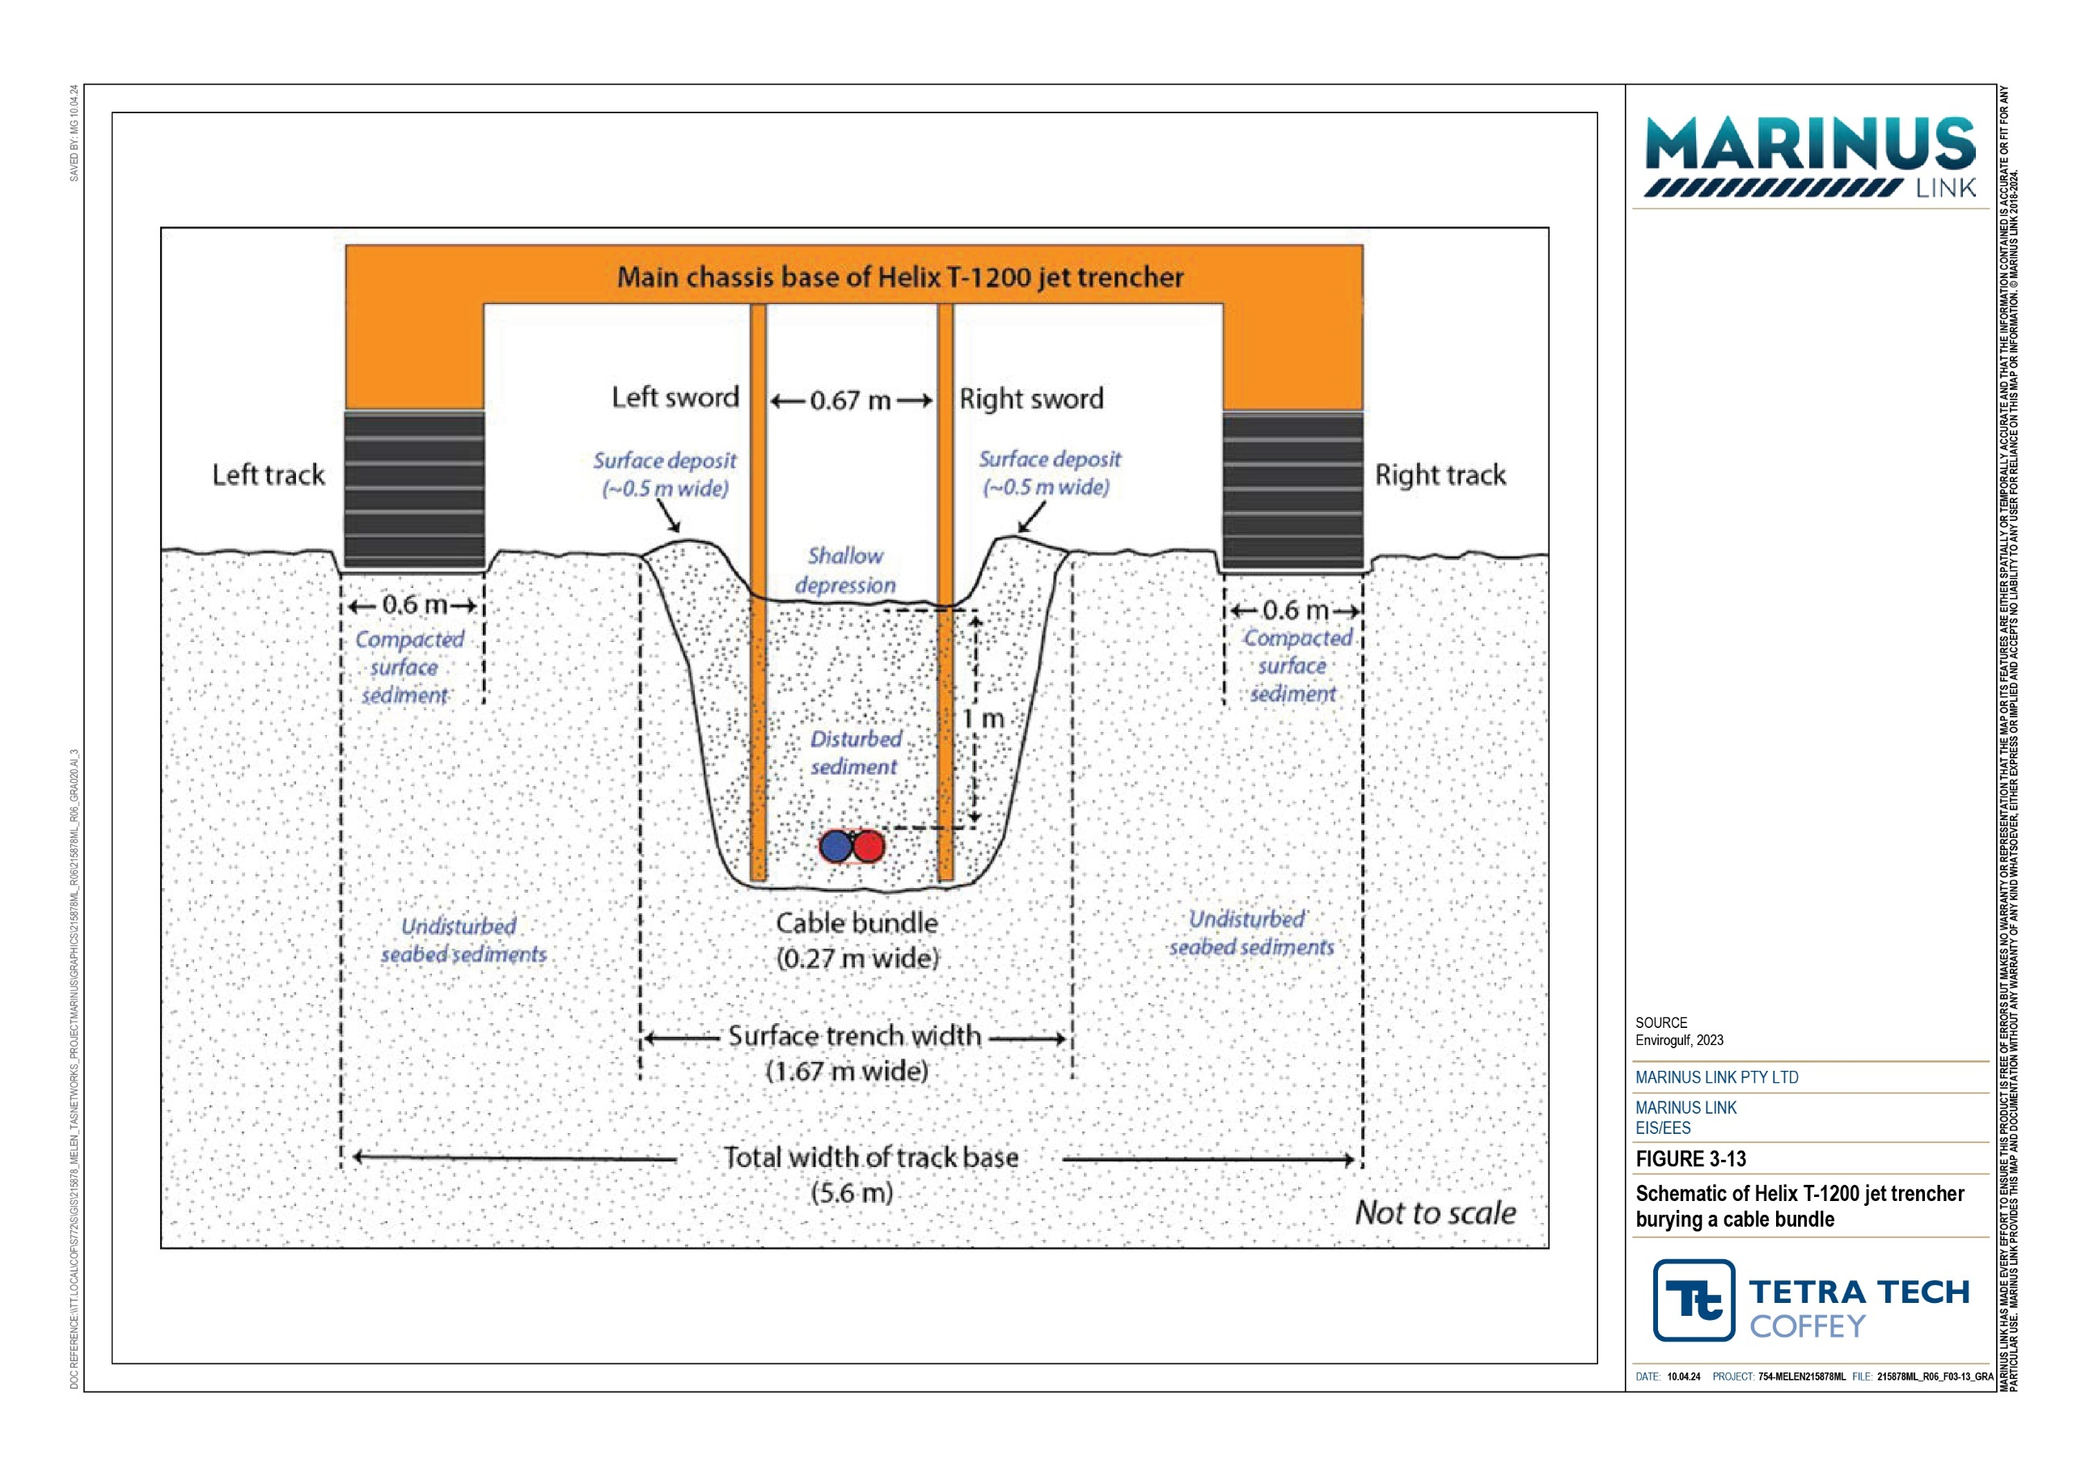

Nearshore environment
The total impacted seabed area in the Victorian nearshore environment from the cable trenching and burial operation for each of the subsea bundled cables is anticipated to be approximately 21,240 m². This is derived from the sum of the total compaction area from the wet jetting tracks and the total wet jetting impact area. This area of disturbance in nearshore Waratah Bay represents approximately 0.02% of the 88 km² seabed habitat surface area in Waratah Bay, between the 10 and 27 m water depth (3 NM state water limit).
The trenching works in nearshore Victoria is anticipated to take approximately 15 hours, based on the jet trenchers movement rate through sand of 400 meters per hour (m/h).
The seabed habitat of nearshore Victoria has a very low sensitivity, given the area is frequently exposed to turbulent coastal forces and marine sediment transport and suspension, and is a common and wide spread seabed type. The water quality of nearshore Victoria is of high sensitivity.
The impact magnitude of both the physical disturbance of the seabed, and impacts to water quality, in nearshore Victoria is negligible due to the relatively small area that is anticipated to be impacted, and the short duration of impacts. Therefore, the physical disturbance to the seabed and the consequential reduced water quality from wet jet trenching is considered to have a low residual impact. A low residual impact is also predicted for impacts to benthic invertebrates and fish.
Physical disturbance to benthic habitats can be reduced through localised realignments of the cable
informed by completing a pre-lay survey prior to cable installation (EPR MERU03) activities including the pre- lay grapnel run, cable laying and subsequent jet trenching. A shallow water eductor tool (nozzle) may be used for cable burial in very shallow waters.
The Tasman grass-wrack seagrass is listed as endangered under the FFG Act and is the only threatened flora species that the project may intersect. This species is sparsely distributed in patches of low to moderate densities. There is a potential for some individuals to be impacted by trenching activity; however, the loss of several individuals will not impact the overall viability of this species as the area of impact will be small compared to the widespread distribution of this species, which includes the Victorian coastline to the west of South Australia and the north and east coasts of Tasmania. The total potential disturbance area for Tasman grass-wrack from cable trenching and burial is approximately 3,100 m², which is 0.028% of the 11 km² of total habitat for the species in Waratah Bay.
The area of Tasman grass-wrack that the project may intersect is outside the boundaries of the Victorian Planning Scheme, however it is within the Victorian jurisdiction. Therefore, if required, a permit for removal or disturbance of Tasman grass-wrack seagrass would be obtained under the FFG Act. No offsets are proposed at this stage for the Tasman grass-wrack and MLPL will work with DEECA to address FFG Act permit conditions, if required.
The turbidity plumes generated by the trenching will likely consist of medium to fine-grained sediment particles, resulting in a slight increase in turbidity and TSS. Jet trenching fluidises the seabed sediments rather than remove it, so the activity displaces less sediment than traditional trenching. A conservative estimate is that TSS and turbidity returns to background levels of less than 2 mg/L and less than 5 NTU, respectively, within several kilometres down-current. Oslo and Paris Conventions (OSPAR) of 2012

considers wet jetting or remote operated jet trenching as having the lowest environmental impacts on water quality.
There were no potential sources of sediment contamination identified in offshore Bass Strait or nearshore Victoria. Therefore, no contamination is anticipated to be disturbed or spread by the suspension of sediments through the wet jetting method.

Offshore environment
The total area of seabed impacted by wet jetting in offshore Bass Strait is approximately 0.7 km². This represents a very small area compared to the similar adjacent seabed in Bass Strait. The trenching works in offshore Bass Strait is anticipated to take up to approximately 1,240 hours. This is based on the range of the jet trenchers movement rate through sand and finer sediments ranging between 400 m/h and 800 m/h across the 255 km Bass Strait route.
Zones 1 and 4 are relatively close to shore on either side of Bass Strait (Section 2.2.3), have a shallow depth and are exposed to more coastal forces, such as wave action and currents, resulting in coarser grain size in shallower waters and finer material in the deeper waters of central Bass Strait. Seabed habitats (sand) in zones 1 and 4 are anticipated to recover within about six months, due to the increased coastal forces. This is based on observations from the Bass Strait seabed recovery after the cable trenching for Basslink.
Seabed habitats in Zone 2 (silty sand) and Zone 3 (silt/clay) are anticipated to recover within a few months to a year, due to the low bottom water velocities and consequential low sediment transport and accumulation. This is based on the recovery rate of seabed trawl scars observed from other projects and as slight trenching depressions are less significant than trawl scars. Drift algae, debris, and benthic macroinvertebrates are however anticipated to accumulate within the shallow depression left by the trenching, and will result in a localised increase in biological diversity and productivity, as was observed for Basslink.
Zone 3 is the most likely to experience effects to water quality from the physical disturbance of the seabed sediment. This is due to the high proportion of fine silt and clay, which has higher susceptibility to be suspended, and the presence of mesophotic sponge coral communities. Particles will suspend into the bottom water column and be distributed down current, reducing water quality and potentially impacting benthic ecology.
The seabed of offshore Bass Strait has a low sensitivity as it is a common and widespread seabed type, but has slightly less forces acting upon it. The exception is Zone 3 in offshore Bass Strait, where the known habitat of mesophotic sponge coral communities occur within the depth range of 65 to 75 m (see
Section 2.3.1). This area has an increased sensitivity of moderate.

The lower water column in offshore Bass Strait has a low sensitivity, due to the sparseness of benthic ecology that could be impacted by reduced water quality.
The impact magnitude of both the physical disturbance of the seabed, and impacts to water quality, in offshore Bass Strait is negligible due to the relatively small section that is expected to be impacted, and the short period in which it is impacted. Therefore, the physical disturbance to the seabed and the consequential

reduced water quality from wet jet trenching is considered to have a very low impact in offshore Bass Strait, with the exception of Zone 3, which has a low residual impact.

Cable infrastructure and hard substrate crossings
Existing seabed infrastructure and hard substrates that the project alignment crosses pose a challenge for the installation of the cable as this does not allow for the cable to reach its nominal depth of 1 m below the sea surface. The crossing of existing seabed infrastructure and shallow hard substrate will involve the laying of rock fill or rock mattresses to achieve the nominal depth to minimise the chance of the cable being damaged from anchor hook-up or seabed trawling gear. The potential impacts of this include:
Changes to seabed habitats due to introduction of hard rock substrate.

Changes to water quality, such as increased concentration in TSS and turbidity due to placement of hard rock substrate.
Disturbance to existing soft sediment benthic communities, due to placement of hard rock substrate.

The 2020 geophysical survey identified several locations where the cable could not be buried to its nominal depth of 1 m due to shallow, underlying substrate. These locations were able to be avoided by micro realignment of the cable.
The cable will cross the Alcatel Submarine Networks (ASN) Indigo Central telecommunications cable in offshore Bass Strait, and the Telstra Bass Strait 1 (BS1) telecommunications cable at two points in Waratah Bay. Potential impacts due to the construction of these infrastructure crossings and any potential damage to the existing subsea cables will be avoided or managed with the implementation of a Cable Crossing Management Plan (EPR MERU05). The Cable Crossing Management Plan will be informed by engagement with the asset owners to establish the exact positioning of their assets, requirements for how the crossing should be designed and a pre-lay seabed survey. The Cable Crossing Management Plan will also be informed by the International Cable Protection Committee (ICPC) guidelines that outline the approach that parties should take to reach a mutual agreement regarding subsea infrastructure crossings.
The residual impacts on seabed habitats and benthic communities of offshore Bass Strait due to crossing the ASN Indigo Central telecommunications cable are very low. This is based on the low sensitivity of the sandy seabed and benthic communities as they are common and widespread, combined with a negligible magnitude of impact as a relatively small area of seabed habitat will be impacted. The rock fill or rock mattress installed for crossing of the Indigo Central telecommunications cable represents a total area of about 300 m² for the two alignments. This is a relatively small area compared to the expanse of surrounding sandy seabed. In addition, the presence of rock structure may provide beneficial habitat and substrate for some benthic fauna and flora.
The residual impacts on the seabed habitats and benthic communities of nearshore Waratah Bay due to crossing the BS1 telecommunications cable are very low. This is based on the very low sensitivity of the sandy seabed due to the sparseness of any habitat features, and negligible magnitude of impact as the area of seabed habitat impacted is relatively small. The crossing location will be in deep water and outside the

depth range where the FFG listed Tasman grass-wrack seagrass is found. Similar to above, the addition of rock structure at the crossing may provide beneficial benthic habitat.
The residual impacts on the water quality in the lower water column of offshore Bass Strait and nearshore Waratah Bay due to the above-mentioned cable crossings are low. This is based on the moderate sensitivity of the lower water column water quality and the short-term increase in turbidity and TSS. The rock placement work (i.e., source of sediment dispersal and suspension) will be typically less than a day and turbidity will rapidly disperse and dilute. This results in a negligible magnitude of impact, given the temporary impacts to water quality are expected to return to background levels within several kilometres down-current.
The cable will also cross the discharge pipeline from the former Tioxide Australia Plant that was located on the Heybridge converter station site. Trace metal contamination was found in the seabed sediments within Tasmanian waters, which may also extend beyond the 3 NM state waters limit. Crossing the pipeline could release contaminated sediments into the water column and adjacent environments affecting benthic biological communities. The contaminants of concern are arsenic and nickel. With the implementation of measures to comply with EPR MERU 04 the residual impacts from mobilisation of metals would be low. This is based on a water quality sensitivity of high based on the available water quality data in nearshore Tasmania, and a magnitude of impact of negligible.
The negligible magnitude of impact is based on the short duration of wet jetting at any one point along the project alignment and the brief and localised area where benthic communities will be exposed to dissolved metal concentrations prior to mixing and being diluted with seawater. It is expected that due to the short term and transient disturbance of contaminated sediments, any brief exposure of elevated dissolved metal concentrations to marine fauna will not result in chronic toxicity or bioaccumulation.

Underwater noise
The primary sources of noise from the project are during construction. The project activities that are the main source of sound and their expected noise levels include:
Cable lay vessel maintaining station under dynamic positioning and laying cable, which has an underwater noise source level of 185 dB re 1 µParms at 1 m.
Nearshore cable pulling and lay operations, which have an underwater noise source level of 145 dB re 1 µParms at 1 m while the boats are idling, and up to 165 re 1 µParms at 1 m while the boats are manoeuvring floated cables.
Cable installation in soft seabed sediments using a jet trencher, which has an underwater noise source level of 150 dB re 1 µParms at 1 m with trencher in burial mode, and up to 175 dB re 1 µParms at 1 m while the trencher’s host vessel is moving at 0.5 knots.
The highest noise level generated by the project is the cable lay vessel maintaining station under dynamic positioning and laying cable, which was conservatively used in the impact assessment as a worst-case scenario of underwater noise emissions. The noise generating activities of vessel movement, rock placement and trenching are all non-impulsive noises.

Potential impacts on marine fauna through increased underwater non-impulsive noise include:

Marine fauna mortality.

Permanent threshold shift (PTS), i.e., physical injury and permanent hearing loss.

Temporary threshold shift (TTS), i.e., temporary hearing loss.

Behavioural disturbance impacts, such as displacement or interference with migration, foraging, breeding, resting, and navigation habits or ability. Noting foraging impacts may also be secondary due to disturbance of prey species.
Auditory masking impact such as reduced ability to communicate, echolocate or detect predators.
Masking is the increase in the hearing thresholds for one sound due to the presence of another sound. For masking to occur, the underwater noise must be loud enough, have similar frequency content to the hearing sensitivity of a low frequency cetacean, and happen concurrently with low frequency cetacean calls or songs.
Species groups have different tolerances to noise, due to their varying sensitivities and abilities to avoid a noise emission and were considered in the following groups:
Low frequency hearing cetaceans, i.e., baleen whales, including humpback whale, southern right whale, blue whale, sei whale, fin whale, and minke whale.
Mid frequency hearing cetaceans, including:

- Dolphins, such as bottlenose and common dolphins.

- Whales, such as sperm, false killer, long finned pilot, killer and strap-toothed whales.

High frequency hearing cetaceans, including:

- Whales, such as pygmy sperm whale and pygmy right whale.

- Dolphins, such as the dusky dolphin.

Pinnipeds, such as the leopard, Australian fur and long-nosed fur seals.

Sea turtles, such as the loggerhead, green, olive ridley and leatherback turtles.

Marine birds.

Fishes, grouped into the following hearing groups:

- Group 1: Fish that do not have a swim bladder, only detect particle motion, and have a poor sensitivity for sound.
- Group 2: Fish that have a swim bladder, detect particle motion and pressure, but no additional accessories or organs to enhance their hearing ability.
- Group 3: Fish that have a structure that mechanically connects to their inner ear and only detect particle motion, providing a greater hearing sensitivity.
- Group 4: Fish that have a swim bladder connected to their inner ear.

- Bony fishes (Osteichthyes): includes those with or without swim bladders.

- Cartilaginous fishes (Chondrichthyes): includes sharks, skates, rays and chimaeras.

Macroinvertebrates, including:

- Pelagic macroinvertebrates, such as molluscs, cephalopods (squid and calamari) and sea slugs; jellyfishes
- Benthic macroinvertebrates, including decapod crustaceans, such as lobsters and crabs, and molluscs such as scallops, abalone and octopuses.

Noise thresholds for marine fauna
The underwater noise assessment adopted a range of peer-reviewed acoustic threshold criteria from a literature review. The threshold criteria sources are described in Technical Appendix H: Marine ecology and resource use.
Table 2-18 presents the adopted noise threshold levels for marine fauna groups. The table presents the noise level thresholds for hearing and physiological damage and behavioural disturbance. There are no identified threshold criteria for auditory masking or vibration.
Figure 3-14 illustrates the general relationship between distance and PTS, TTS, behavioural disturbance onset thresholds, and audible zones.
The upper and lower behavioural disturbance thresholds are associated with disruptive and subtle behavioural effects, respectively. For example, the upper limit is associated with interference in migration, movement, foraging, breeding, and sound avoidance. The lower limit is associated with minor changes in locomotion speed, direction speed and dive profile but not avoidance.
Bony fish groups 1 to 4 have been used to categorise fishes for the assessment of PTS and TTS onset and mortality impacts. Group 3 fish, which have relatively higher hearing sensitivity, were used to assess behavioural and masking impacts.
Table 2-18 Noise threshold levels for marine fauna groups

Marine fauna group | Hearing and physiological damage thresholds* |  | Behavioural disturbance thresholds**
 | PTS  (dB re 1 µPa²·s) | TTS  (dB re 1 µPa²·s) | Lower limit  (dB re 1 μPa rms) | Upper limit  (dB re 1 μPa rms)
Low frequency cetaceans | 199 | 179 | 130 | 160
Mid frequency cetaceans | 198 | 178 | 130 | 160
High frequency cetaceans | 173 | 153 | 130 | 160
Phocidae pinnipeds (earless or true seals) | 201 | 181 | 120 | 160
Otariidae pinnipeds (eared seals) | 219 | 199 | 1,520 | 160
Sea turtles | 204 | 189 | - | 175

Marine fauna group | Hearing and physiological damage thresholds* |  | Behavioural disturbance thresholds**
 | PTS  (dB re 1 µPa²·s) | TTS  (dB re 1 µPa²·s) | Lower limit  (dB re 1 μPa rms) | Upper limit  (dB re 1 μPa rms)
Little penguins | - | - | - | 150
Bony fishes | - | 189 | - | -
Group 3 fishes | - | - | - | 150
Cephalopod | - | - | - | 150
- No appropriate threshold criteria exist.
* Hearing and physiological damage thresholds are based on sound exposure levels (SELs) cumulated over one hour.
** Behaviour disturbance thresholds are based on received sound pressure levels (SPLs). dB re 1 µPa²·s unit of measurement is explained in Section 2.2.6.

Predicted noise levels
Attachment G of Technical Appendix H: Marine ecology and resource use outlines the underwater noise modelling results that have been used to calculate the propagation distances to acoustic threshold criteria for noise-sensitive marine fauna. The underwater noise modelling allowed calculation of the radial distances from the noise source that will result in acoustic damage, acoustic disturbance and behavioural impact.
Figure 3-14 shows these radial distances in graphical form, where the middle of the red circle represents the source of the noise (e.g., the position of the operating trencher). Each subsequent ring (orange, yellow, green, pale blue and dark blue) represents both an increase in distance from the noise source, as well as a decreasing level of impact. Physical injury (the worst possible impact) occurs closest to the noise source (in the red area), because this is where the noise would be the loudest. The noise being audible but not provoking a behavioural response occurs furthest away from the noise source (in the dark blue area) because this is where it is quietest.
Table 2-19 presents the predicted radial distances at which noise levels from the adopted sound source with sound pressure level of 185 dB re 1 µParms at 1 m reduce to meet the adopted noise thresholds; i.e., within these radial distances impacts may occur. Figure 3-15 shows the PTS and TTS hearing damage threshold zones for cetacean and pinnipeds.

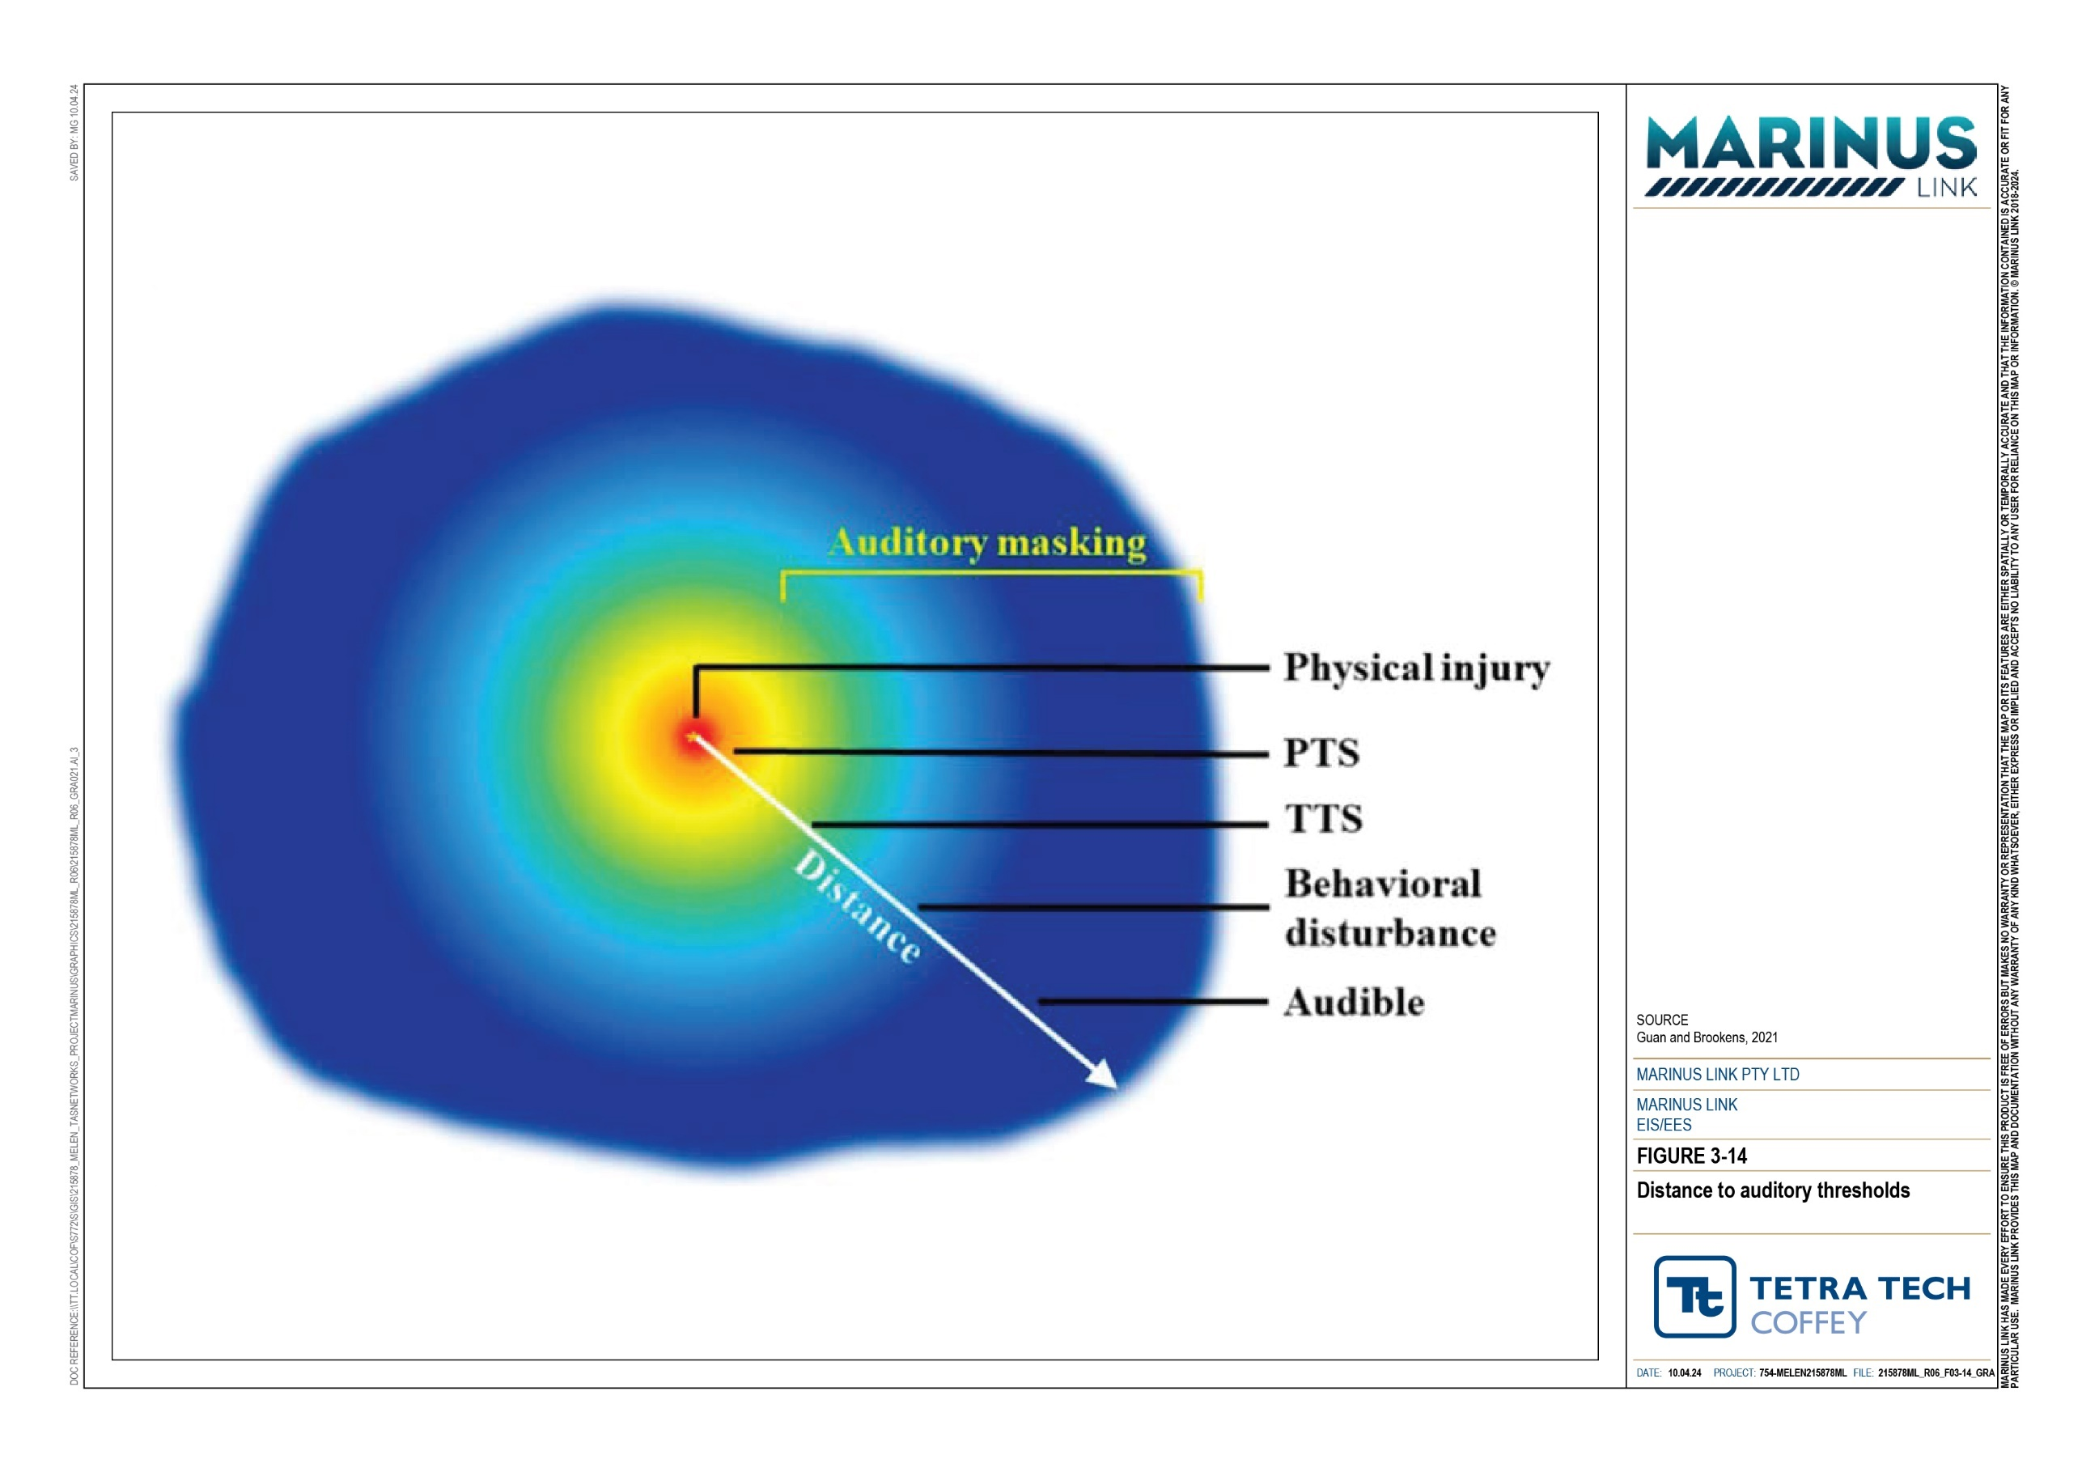

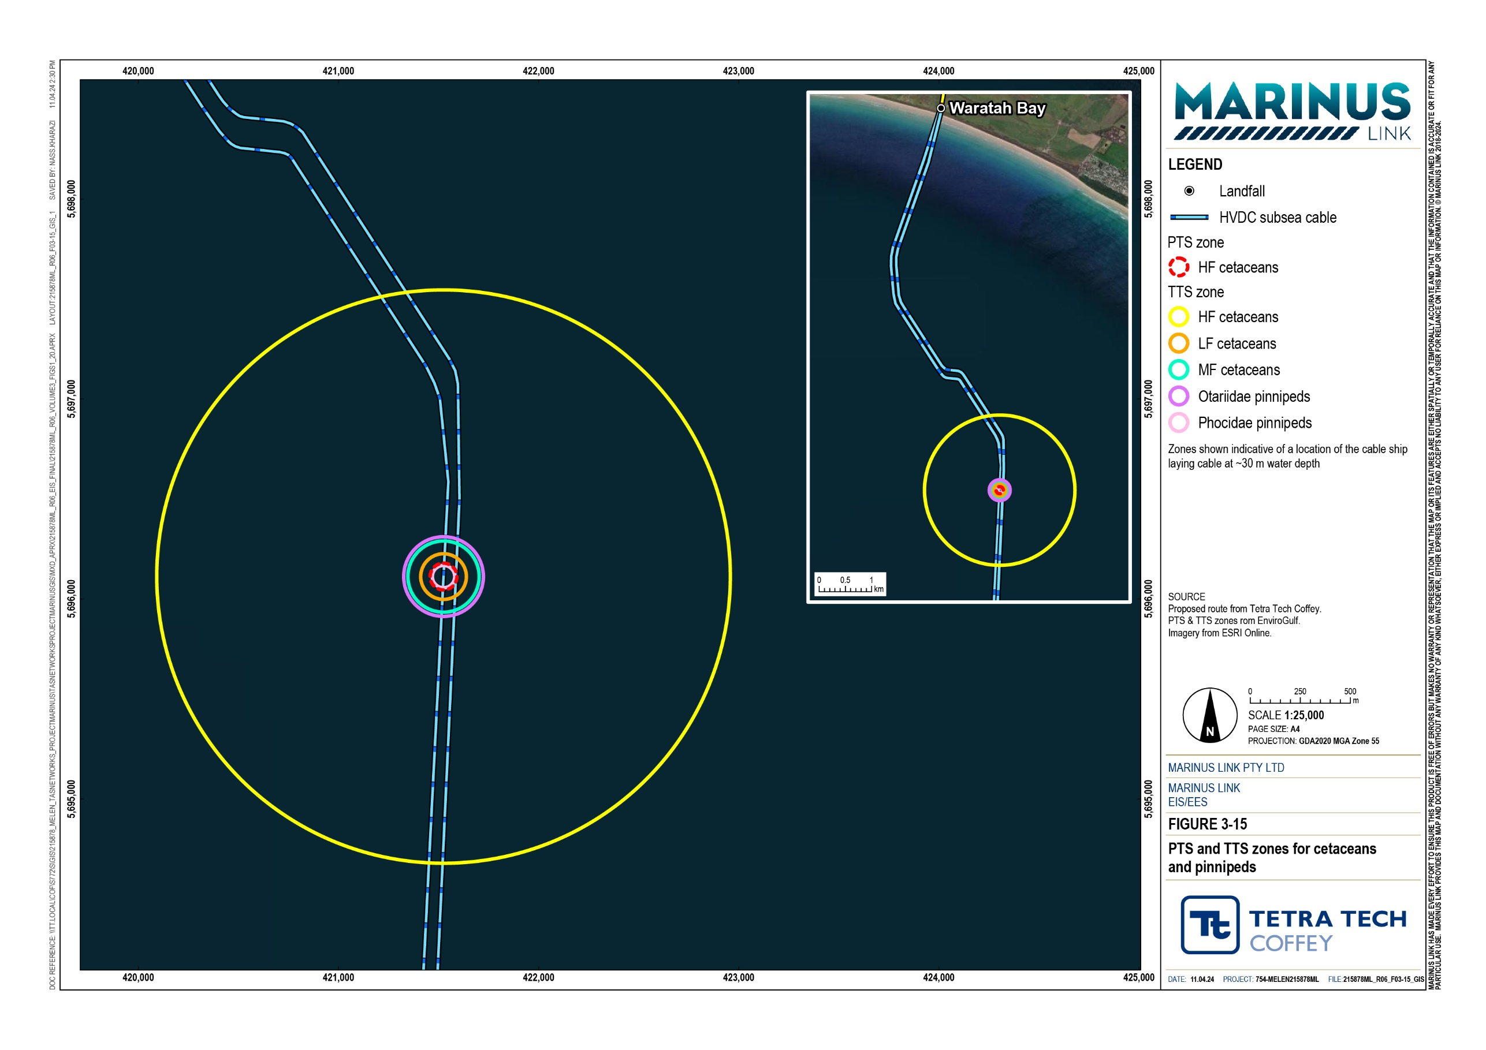

Table 2-19 Calculated distances from noise source to adopted noise threshold levels for marine fauna groups

Marine fauna group | Zone of physiological damage and hearing lossª |  | Zone of behavioural change^{b}
 | Radial distance of PTS onset (m) | Radial distance of TTS onset (m) | Distance to lower threshold for subtle behaviour change (m) | Distance to upper threshold for disruptive behaviour (m)
Low frequency cetaceans | DNE | 114 | 4,641 | 46.4
Mid frequency cetaceans | DNE | 43 | 4,641 | 46.4
High frequency cetaceans | 67 | 1,433 | 4,641 | 46.4
Phocidae pinnipeds (earless or true seals) | DNE | 56 | 4,641 | 46.4
Otariidae pinnipeds (eared seals) | DNE | 4 | 4,641 | 46.4
Sea turtles | DNE | DNE | 215 | 4.6
Little penguins | - | - | - | 215
Group 3 bony fishes | - | 201 | - | 215
Cephalopods | - | - | - | 215
- No appropriate threshold criteria exist. DNE Does not exceed threshold level.
a Zones based on cumulative sound exposure levels measured over one-hour duration.
b Zones based on root mean square (rms) sound pressure level.

Permanent threshold shift
A PTS could result in physical injury or permanent hearing loss in marine fauna. As shown in Table 2-19, the PTS noise thresholds for most fauna groups are not exceeded at any distance from the vessel noise source. The exception is the PTS noise threshold for high frequency cetaceans, which extends 67 m from the noise source. This represents a small area within which high frequency cetaceans could experience auditory injury or permanent hearing loss (from noise sound level exceeding 173 dB re 1 µPa²·s) if they remain within the area 67 m from the noise source for an hour or more.
The high frequency cetaceans have a low sensitivity because they are well represented across a wide distribution in Bass Strait and can avoid noise sources. The only likely high frequency cetacean to be present is the pygmy sperm whale (Kogia breviceps). The impact magnitude is high because the PTS onset threshold is exceeded and could result in permanent injury or damage to the hearing of a high frequency cetacean; however, this assumes that the animal remains within the 67 m distance from the noise source for at least an hour. This is an unlikely scenario given the cetacean’s capacity to sense the noise gradient and avoid the area where the noise exceeds the threshold. The residual impact of moderate is therefore very conservative. If a high frequency cetacean’s response to sensing the noise gradient is to leave the area, the

PTS onset distance will be less than 1 metre from the cable lay vessel. In this case the impact is low, which is a more realistic assessment.
Given the moderate residual impact to high frequency cetaceans and no PTS impacts to other fauna groups are predicted, no mortality impacts are expected. The marine fauna groups are also unlikely to attempt to approach the vessel thrusters as they will avoid the noise source, and in the case of sea turtles, are unable to approach the thrusters due to their velocity. Therefore, any PTS or mortality of these marine fauna groups is not anticipated and not assessed further.

Temporary threshold shift
A TTS could result in temporary hearing loss in marine fauna. Table 2-19 shows a range of distances within which the TTS noise threshold is exceeded for cetaceans, pinnipeds and bony fishes.
These fauna groups all have low sensitivity to noise impacts as they are widely distributed in Bass Strait and can sense and move away from noise. The impact magnitude is moderate because criteria for temporary hearing loss (TTS threshold onset) are exceeded, but effects are reversible within a few days. The distances within which the thresholds are exceeded are all small in comparison to the expansive habitats in Bass Strait. Further, the animals must spend an hour within these threshold exceedance distances from the cable lay vessel, which is unlikely as they could hear the noise and move away. The residual impact to these fauna groups is therefore low.

Behavioural impacts
Table 2-19 shows that for cetaceans and pinnipeds, the lower and upper limits for behavioural disturbance are exceeded at 46 m and 4,641 m from the cable lay vessel noise source.
Cetaceans (low, mid and high frequency) all have low sensitivity to noise due to their widespread distribution and ability to navigate around or away from noise sources. Behavioural impacts due to underwater noise during cable lay activities will be low magnitude because of the relatively small distance where the upper disturbance threshold is exceeded (up to 46.4 m from the construction vessel) and the short term nature of the impact. The exception is in the nearshore zone in Waratah Bay where the cable pulling takes place, the noise impact will be longer term in the location (about ten days) and the impact magnitude therefore is moderate. Behavioural impacts due to underwater noise have a residual impact of low for the low frequency, mid frequency and high frequency cetaceans.
Pinnipeds are considered to have low sensitivity to noise given their wide distribution in Bass Strait and ability to avoid noise. Magnitude of the impact due to behavioural disturbance is moderate based on the predicted level being reached at a distance of 60 m from the construction vessel noise source, and pinnipeds are expected to move away from the vessel. The impact will be short term in any given area as the construction vessel moves along the route. The residual impact is low.
Disruptive behavioural responses from sea turtles may occur above the threshold of 175 dB re 1 μParms, which is predicted to be reached at 4.6 m from the construction vessel noise source. Sea turtles are considered very unlikely to approach within 4.6 m of the vessel, which is proximal to the vessel ’s thrusters.

Given the low sensitivity of sea turtles and low magnitude based on the very small distance of 4.6 m where the noise threshold is exceeded, the residual impact of noise behaviour disruption to sea turtles is low.
No noise impacts are predicted for diving seabirds as they only submerged for a few seconds, representing very short-term exposure to underwater noise. Therefore, only little penguins are assessed, due to their longer presence beneath the water’s surface.
The little penguin is considered to have a low sensitivity due to their wide distribution in Bass Strait and their ability to move away from noise. Noise behavioural disturbance to the little penguin is low magnitude given that passage through the 215 m radius threshold area will be very short-term. The residual impact is low.
Noise disturbance residual impacts to Group 3 fish are also predicted to be low due to the short term and temporary disruption within the predicted 215 m threshold zone.

Auditory masking
There are no threshold or acoustic criteria for assessing auditory masking impacts on any of the fauna groups that rely on sound to navigate and orientate.
Low frequency cetaceans have been observed amplifying calls to account for increased background levels. The peak frequency of mid frequency cetacean communications is outside the frequency range of the vessels thrusters in dynamic positioning mode, resulting in a weak auditory masking effect, unless very close to the noise source. High frequency cetaceans communicating frequency range largely does not overlap with the frequency of the noise generated by the thrusters. In the case of the pygmy sperm whale, there is no overlap at all.
Pinniped communication frequencies largely overlap with the frequency of the cable lay vessel; however, this will have transient and localised effects. Sea turtles are uncommon and typically only present as solitary individuals, reducing their need to communicate. Literature review found that the little penguins vocal frequency range is expected to overlap completely with the frequency range of the vessel and does not have an ability to communicate outside this range; however, this impact will be very brief, based on the vessels transient speed and the swim speed of the little penguin.
Auditory, acoustic and communication masking impacts is determined to be low residual impact for all fauna groups. This is based on the low sensitivity of the fauna groups, given their wide distribution in Bass Strait. For all fauna groups, except bony fish, it is also based on the low magnitude of impact, given the cable lay vessel’s noise will be transient through Bass Strait causing only minor cessation of vocal behaviour. Bony fish have a residual impact of low and impact magnitude of moderate, due to the temporarily reduced ability of soniferous fishes to navigate and detect predators.
Minimal masking effect is anticipated for cetaceans unless they are close to the noise source. Marine mammals and the little penguin are well-adapted to accounting for the natural and variable noisy ocean environment, and likely to be tolerant to some increase in masking due to human activity.

Impacts to marine invertebrates
The approach to assessing noise impacts to marine invertebrates is different than the other fauna groups. The worst case noise source level of 185 dB re 1 µParms at 1 m has not been used because:
Marine macroinvertebrates lack sensory organs to perceive sound pressure, but some can sense hydrostatic disturbance.
Almost all marine invertebrates do not have gas-filled chambers or organs that could enable them to detect sound pressure changes.
There are no particle motion threshold criteria for assessing vibration effects.

However, given the importance of the arrow squid (Nototodarus gouldi) and southern calamari (Sepioteuthis australis) to fisheries in Bass Strait, cephalopods were assessed for underwater noise impacts based on their ability to detect low frequency sounds, vibrations and particle motion. In terms of behaviour threshold criteria, the National Marine Fisheries Service acoustic threshold of 150 dB re 1 μParms for onset of behavioural effects in Group 3 fishes was adopted, although this is likely a conservative threshold for cephalopods as they do not have a swim bladder connected to the inner ear like Group 3 fishes.
Cephalopods have a very low sensitivity to noise given their lack of swim bladder or internal gas-filled chambers. The impact magnitude is low as cephalopods are expected to temporarily avoid the noise source before returning to the area once the cable lay vessel (and noise) slowly moves away. The residual impact to cephalopods (including arrow squid and southern calamari) due to underwater noise disturbance is therefore very low.
Benthic macroinvertebrates could be impacted by seabed vibrations generated by jet trenching.
However, the jet trencher will move at about 400 m/hour in sandy seabed meaning that vibration effects will be highly localised and short term at any one point along the project alignment. No mortalities or sublethal physiological impacts to benthic macroinvertebrates are predicted due to vibrations. Larger and more mobile species (e.g., crabs, prawns and rock lobsters) may temporarily move out of the way from the jet trencher. Sessile (relatively immobile) benthic macroinvertebrates will not be displaced.
Given the impacts are, at most, very low for marine invertebrates, no noise management EPRs are proposed specifically for this fauna group.

Artificial lighting
The primary source of artificial lighting during construction is from the cable lay vessel and the two guard vessels that will accompany cable lay operations during night-time. The vessels deck and stern areas will need to be lit sufficiently for the bundling, tying, and laying of the cables. The mobile cable laying operations in offshore Bass Strait are expected to be 24 hours per day, 7 days per week. The vessel will be stationary using its thrusters under dynamic positioning for cable pulling in nearshore Waratah Bay and this is expected to only occur during daylight hours, with minimum maritime navigation lighting requirements being met at night-time. Therefore, impacts of artificial lighting are only expected to occur in offshore Bass Strait. Whilst cable laying will take place over 12 months, the cable lay and burial vessels operating in Bass Strait overnight and requiring navigational lighting will be active for approximately two to three months (not continuously) for each circuit.
The birds most susceptible to artificial lighting impacts are seabirds, shorebirds and nocturnal migratory terrestrial birds. Representative birds used in the impact assessment are albatross, petrel and little penguin.
Potential impacts on birds from artificial lighting during night-time construction activities are anticipated to primarily be at dusk or dawn and include:
Injury or death due to collision with vessels from the attraction to illumination sources outside of daylight hours.
Impacts to migration and flight paths of nocturnal birds, due to exposure to light during night-time.

Impacts to resting, foraging and habitual roosting sites, or temporary refuge sites.

Potential impacts on near-sea surface marine fauna from artificial lighting during night-time construction activities include:
Direct attraction to illumination sources outside daylight hours by invertebrates, such as zooplankton and micronekton, and fishes and cephalopods. Fishes and cephalopods may also be attracted to the abundance of invertebrate, and larger predatory fish may be attracted by the abundance of smaller fish.
Potential impacts to birds and marine fauna may be minimised by the implementation of EPR MERU10 that includes measures associated with:
Minimising lighting, including number of lights, intensity (and colour), and duration, but maintaining enough to maintain crew safety and compliance with maritime navigation requirements.
Minimising light spill by directing lighting inboard and downward, and avoiding general area ‘floodlighting’.
Routinely inspecting for birds that may have been attracted by lit areas of the vessels.

These measures will be implemented in compliance with applicable guidelines including, Australia’s National Light Pollution Guidelines for Wildlife, Australian Standard AS/NZS 4282:2019 Outdoor lighting obtrusive effects, and EPBC Act Policy Statement 3.21 – Industry Guidelines for avoiding, assessing and mitigating impacts on EPBC Act listed migratory shorebird species.

The magnitude of impact of artificial lighting on all marine birds and near-sea surface marine fauna is negligible given the impacts are short-term due to the transience of the cable lay operations. The residual impacts of artificial lighting on marine birds in offshore Bass Strait are low. This is based on the high sensitivity of marine bird species, due to the potential for threatened bird species to be impacted, and the negligible magnitude of impact.
Potential impacts of artificial lighting on marine mammals are not anticipated as there are minimal known direct effects. Turtle hatchlings may be impacted by artificial lighting; however, based on the distribution of turtle species and the likelihood of hatchlings in central offshore Bass Strait, impacts of artificial lighting on turtles are not anticipated. Squid are known to be directly attracted to artificial lighting, and secondarily by preying on species of zooplankton, micronekton and small fishes that might be attracted to the lighting.
However, no species of squid are threatened and no direct negative impacts of artificially lighting are anticipated. Therefore, impacts of artificial lighting on marine mammals, turtles, and squid are not assessed further.
Artificial lighting may impact the diel vertical migration behaviour of zooplankton and micronekton and has been assessed. The residual impacts of artificial lighting on diel vertical migration of marine invertebrates in offshore Bass Strait is low. This is based on the high sensitivity because of the presence of light-sensitive invertebrates that undertake this vertical migration, and negligible magnitude of impact based on short term and transient exposure to the light.
The residual impacts of artificial lighting on marine fishes are low in offshore Bass Strait. This is based on the moderate sensitivity of marine fish, due to a limited group of fish being attracted to night-time lighting, and negligible magnitude of impact because of a localised zone of water being illuminated compared to the available habitat of the fish.

Invasive marine species
The introduction of IMS has the potential to introduce pathogens that may infect native fauna. Introduced IMS also have the potential to establish new habitats and outcompete local species for space and resources as well as prey on local species.
The primary potential source of IMS introduction or translocation between ports and different areas of Bass Strait by project vessels is through ballast water or hull fouling. Ballast water refers to the water that a vessel collects or releases from its ballast to counteract weight fluctuations. For example, when a vessel unloads its cargo at a port it will take on water to make up for the lost weight, so that it maintains its stability in the water, and in doing so can collect and release different species. Hull fouling refers to the growth of marine flora and fauna that is attached to the submerged surfaces of a vessel.
Additionally, the targeted rock and rock mattress placement that is to be employed for hard substrate and third-party infrastructure crossings may provide suitable habitats for native or IMS to colonise. Most of the project will be buried in the soft-sediment seabed and will not increase the suitability for colonisation, with only the BS1 and ASN Indigo Central telecommunications cables to be crossed by rock placement (see Section 2.4.4).

IMS risks will be mitigated through the implementation of measures to comply with EPR MERU11, which is to develop and implement a plan to avoid introduction of IMS. This includes requirements for each project vessel (including domestic and international vessels) to comply with a range of Australian and international ballast water, antifouling and biosecurity measures.
Vessels arriving from European and East Asian countries are considered to have the highest potential for introducing IMS capable of establishing populations in the temperate waters of Bass Strait. Therefore, international vessels with European or East Asian origins will be required to completely replace their ballast water at the equator. It is unlikely any potential IMS will survive when released in the warmer waters of the equator, and any potential IMS in the ballast water from the equator is unlikely to survive in the cooler waters of Bass Strait.
The overall risk of introduction of IMS due to vessel movements is assessed to be low given the range of well-established management measures to be implemented and the limited number of international ships (i.e., a cable laying vessel) that will be involved in the project in the context of a much larger number of international vessels using Bass Strait waters.
Given the low presence and diversity of existing IMS in Bass Strait and very small amount of hard rock substrate that is to be installed at third-party infrastructure crossing locations, it is predicted that any native benthic fauna will outcompete any potentially introduced IMS if it occurs on the rock substrate. With the measures outlined above for IMS management, the risk of IMS establishment on hard rock substrate at infrastructure crossings is low.

Marine fauna collision
Project vessel movements have the potential to collide with marine fauna causing injury or death. The highest risk will be during construction as more vessel movements will occur during this phase. Vessel collision can be a risk to slow-moving marine megafauna such as large cetaceans and sea turtles. Faster moving and agile fauna such as seals, sea lions, little penguin, fish, squid and smaller cetaceans (e.g., dolphins) are less susceptible to collision strike as they can more readily evade approaching vessels.
The assessment focusses on the risks to large cetaceans and sea turtles, given they are the most vulnerable to vessel collision. It is assumed that cetaceans and sea turtles known to be present, or that could be present in the project area, are potentially impacted. This is because the cable construction cannot be scheduled around movements (i.e., migration) of fauna through Bass Strait. Construction of the subsea cables will occur when cable-lay vessels are available. These vessels are specialised and there are limited numbers available globally, so construction timing is subject to vessel availability. When cable laying commences it's a continuous operation until cable-lay is complete. Additionally, many species move through Bass Strait waters in different areas and at different times. Therefore, it is conservatively assumed that the species are present during construction.

The assessment focusses on the following vessel movement scenarios:

Slow-moving cable lay ship during the cable lay.

Slow-moving offshore support vessel (OSV) and tethered subsea remotely operated vehicle (ROV) trencher during cable installation and burial.
Fast-moving construction vessels transiting between port and the construction areas (e.g., OSVs for pre- lay grapnel runs, construction of concrete mattresses, small boats to manoeuvre floated cables to the HDD ducts, guard vessels).
To understand the risks of vessel-cetacean collision, a review of literature on recorded cetacean strikes was conducted. Peel et al. (2016), cited in Technical Appendix H: Marine ecology and resource use, summarised vessel-cetacean strikes recorded in Australia between 1997 and 2015. The study reported humpback whales were the most frequent strike (41 recorded strikes), followed by southern right whales (10 strikes). This equates to an annual average strike rate of 2.3 for humpback whale and 0.56 for southern right whale. The study reported three cetacean vessel strikes in Bass Strait waters between 1986 and 2015, equating to an annual average strike rate of 0.11. This information indicates that existing risks of vessel-cetacean collisions are very low in the context of about 50 daily transits across Bass Strait. The project will have typically three vessels operating in any one day during construction, which represents between 2 to 6% of the total daily transits of other maritime traffic during construction.
The risk of vessel-cetacean collision due to the slow-moving project vessels is very low. This is due to the low speeds of up to about 1.5 knots (1.8 to 2.8 km/h) for these vessels being unlikely to cause mortality or serious injury to cetaceans. Cetaceans will likely be able to sense the noise from the slow-moving vessels and move out of the way. The risk will be managed by EPR MERU08, which will involve the implementation of a cetacean interaction management plan. The plan will include measures for visual monitoring of cetacean presence and maintaining precaution zones, in which works should be suspended if a cetacean approaches, during vessel movements. There is a degree of confidence in this assessment, given the existing very low numbers of recorded vessel collisions in Bass Strait.
The risk of vessel-cetacean collision due to fast-moving construction vessels is slightly higher due to the faster moving speeds (typically between 12 to 18 knots). The risk is considered to be low in the context of the small number of vessel movements in addition to existing maritime traffic, with which cetacean collisions are rare.
No literature data was available for vessel-sea turtle strikes in Bass Strait. However, in Bass Strait, population densities of migrating turtles are low, sea turtle BIAs are absent, and there is low prevalence of high value foraging habitat. Similar to cetaceans, sea turtles will likely sense the slow-moving construction vessels’ noise and move out of the way. The risk will be managed by EPR MERU09, which involves implementing a plan for managing interactions with sea turtles. This includes visual monitoring of sea turtle presence near construction vessels and maintaining a minimum separation distance for vessels of 50 m from sea turtles. If a sea turtle is spotted within this 50 m buffer zone, vessels must reduce speed and shift the engine to neutral, not engaging the engines until sea turtles are clear of the area. The risk of collision with slow-moving construction vessels is considered to be very low. There is a slightly higher risk associated with

the fast-moving vessels (12 to 18 knots) as turtles would have less time to move out of the way. The risk of turtle collision with fast-moving vessels is considered to be low.
During project operation and decommissioning, the risk of vessel collision with large cetaceans and sea turtles is expected to be lower than those assessed above given the lower amount of vessel movements.

Operation impacts
Operational activities such as cable inspection surveys or repairs are considered minor in relation to the large number of vessels that typically operate in Bass Strait and are not assessed further. However, the cable will produce magnetic, electrical and thermal fields while it is in operation. The effects of these are discussed below.
The project has no proposed direct discharges of treated or untreated wastewater to the marine environment during operation.

Magnetic fields
Magnetic fields are generated by the interaction between the copper conductors and steel armouring of the cables with the Earth’s magnetic fields, even when the cable is not in operation. However, these magnetic fields are very weak in comparison to the magnetic fields generated while the cable is energised, during the operations phase. Therefore, impacts associated with magnetic fields generated by the project are only assessed for the operation phase of the project.
Modelling data (see Technical Appendix H: Marine ecology and resource use, Attachment E) shows that the magnetic fields from the project’s two bundled cables will not interact because the magnetic field of each cable is localised and the cables are separated by up to 2 km for a majority of the project alignment.
Modelling in central Bass Strait shows the total magnetic flux at the seabed above the cable is predicted to be 34.98 µT above the background of 60.87 µT. The modelling shows the magnetic flux increase is 0.105 µT at the water’s surface – 82 m above the seabed (Figure 3-16).
Modelling in nearshore Victoria shows the magnetic field at the seabed above the cable is predicted to be
35.233 µT above the background 60.35 µT. The modelling shows an incremental increase of 0.018 µT/m at the water’s surface – 50 m above the seabed.
The primary magnetic field impact to marine fauna is the disruption to the navigation or orientation of magneto-sensitive fauna that use geomagnetic fields for orientation and navigation through local or long migrations. This includes species of cetaceans, pinnipeds, sea turtles, bony fishes, cartilaginous fishes and marine invertebrates. Live stranding of cetaceans may be an indirect impact of disorientation.
There are no thresholds for magnetic field level exposure to magneto-sensitive cetaceans, pinnipeds, sea turtles, marine invertebrates and fishes. However, some studies that have investigated behavioural responses to magnetic fields have been considered in the assessment.

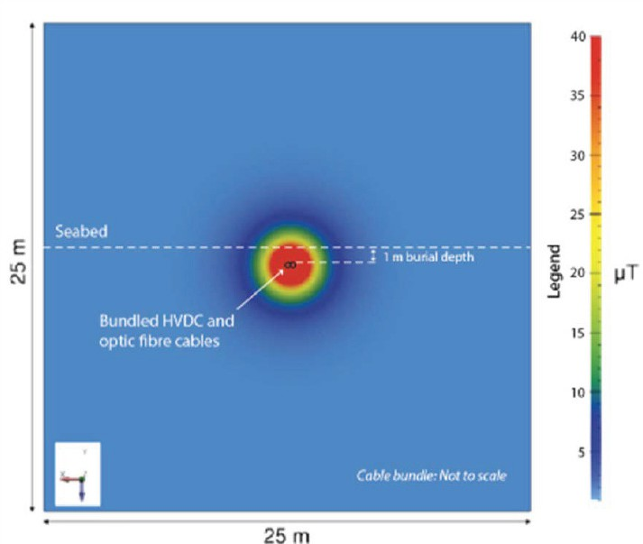
Figure 3-16 Cross section of magnetic field around buried western subsea cable operating at 750 MW

Cetaceans
Some species of cetaceans that undertake long-distance migrations, such as fin whales and northern right whales are magneto-sensory. Some studies suggest there is a correlation between live-stranding occurrences and the relative shape of magnetic field anomalies of approximately 30 nT to 50 nT, with some fin whales being observed following the linear contours of a geomagnetic gradient and avoiding gradients. However, literature review of live-stranding data found there was no evidence of a correlation between live- strandings and operation of subsea HVDC cables in the Baltic Sea, New Zealand, or Bass Strait.
This assessment adopts the humpback whale as the representative cetacean for magnetic field impacts. This because this species is magneto-sensitive and its migration habitats are relatively well studied.
Magnetic anomalies may be caused by natural variations of magnetic material in the Earth’s crust and seafloor sediments. Migratory cetaceans that transit Bass Strait will also rely on other sensory cues, such as sight, smell and sound, to assist their orientation and navigation. Studies of migratory effects on cetaceans as a result of magnetic fields from subsea cables, including Basslink and other HVDC cables overseas, shows that cetacean migration is not affected by the magnetic fields. Basslink has been in operation since 2006 and humpback whales regularly migrate through Bass Strait across that operational HVDC cable, with no public records of live strandings caused by the operating cable. The near water surface magnetic fields

generated above the project’s cables are predicted to be very low and expected to be 18.7 nT and 5.1 nT above background levels in central Bass Strait and nearshore Waratah Bay, respectively. Overall, the cables’ magnetic fields are very unlikely to create a barrier to humpback whale migration through Bass Strait.
Humpback whales are predicted to sense the gradient of magnetic fields from the project cables as they pass through Bass Strait. The sense will be at a maximum when they cross the cables with the magnetic gradient diminishing as they move away from the cables. The sensitivity of humpback whales is low given their increasing population levels and their ability to continue migration patterns across operating HVDC cables, sensing magnetic fields as additional magnetic anomalies. The magnitude is negligible given the very low predicted increases in magnetic fields above background levels, and the temporary sensing of the magnetic anomaly by the whale as it passes over the cables. The residual impact is therefore considered to be very low.

Pinnipeds
Literature review indicates pinnipeds do not possess magneto-sensory capabilities; however, some literature indicates that the elephant seals may have a weak capability of sensing magnetic fields and use this to support their navigation over long distance migrations, whilst primarily relying on extrinsic factors (e.g., physical landmarks, bathymetric features, currents and elevated coastal underwater noise sources).
The residual impacts of magnetic fields on otariid pinnipeds are very low. This is based on their very low sensitivity, as they do not possess magneto-sensory capabilities, and the negligible magnitude of impact due to the low incremental magnetic field level near the seafloor surface.
The residual impacts of magnetic fields on phocid pinnipeds, in particular, the elephant seal, are low. This is based on their moderate sensitivity, as they are assumed to have a weak magneto-sensory system, and the negligible magnitude of impact, given their limited use of this sense in the relatively shallow waters of Bass Strait and their brief and transitory exposure to magnetic fields as they migrate.

Sea turtles
Sea turtles primarily use geomagnetic fields of the Earth to orient their migrations over long distances; however, they will also rely on sight, sound, and smell when orienting on a small scale. Experiments have shown sea turtles may experience disorientation when exposed to magnetic fields. Adult and sub-adult sea turtles that are expected to migrate through Bass Strait, swimming near the sea surface, are not expected to be disturbed by magnetic fields generated by the cable, as the magnitude of these magnetic fields is very low at the surface.
The residual impacts of magnetic fields on sea turtles are low. This is based on the high sensitivity, given their conservation status and their magneto-sensory system, and the negligible magnitude of impact because of their common and widespread distribution, ability to navigate using other senses, and the low incremental magnetic field level near the surface.

Marine fishes
Magneto-sensitive bony fish species use magnetic fields to assist navigation and orientation over long distances. Studies from the Baltic Cable between Sweden and Germany observed no disruption in the navigation of eels that passed over the subsea cable. This cable generated a magnetic field 5.7 times greater than that expected from the project.
Electro-sensory cartilaginous fish species, such as sharks, rays and skates, have the ability to detect magnetic fields, due to the induced electric fields they create while swimming through magnetic fields (impacts from electrical fields are discussed in the following section). Literature review shows these cartilaginous fish use this for navigation through their local environments, in support of other sensory cues. Additionally, studies of the Skagerrak HVDC link in the North Sea found no significant effects from magnetic fields on these fish species. Benthic cartilaginous fishes will experience a slightly greater anomaly than pelagic or surface-swimming sharks; however, both exposures are relatively low. It is anticipated that magneto-sensitive bony and cartilaginous fish that pass through the cables magnetic field will detect it as a brief anomaly and continue their migration.
The residual impacts of magnetic fields on magneto-sensitive bony fish species that migrate through Bass Strait, such as the short and long finned eels are low. This is based on the moderate sensitivity, given their magneto-sense use for navigation, and the negligible magnitude of impact given the cables magnetic fields reduce to background geomagnetic levels within approximately 10 m of the sea floor, and their exposure will be transitory based on their swimming speed.
The residual impacts of magnetic fields on electro-sensitive cartilaginous fish species, such as sharks, skates and rays are low. This is based on the high sensitivity because of their magneto-sense use for navigation and the conservation status of some of the species, and the negligible magnitude of impact, given their exposure will be relatively low and transitory. No magnetic field impacts are predicted for pelagic or surface-swimming sharks due to the magnetic field being similar to background levels in the upper water column.

Marine invertebrates
Literature review indicates that the only marine invertebrate that may possess magneto-sensory capabilities are migratory decapods, such as spiny lobsters. The southern rock lobster (Jasus edwardsii) resides in the study area; however, it is known to remain within a 5 km area and therefore, is considered unlikely that it is magneto-sensory, and is more likely to rely on other sensory cues. Additionally, the southern rock lobster inhabits high-profile reefs and rocky outcrops which is avoided by the project alignment. Literature review found a lack of effect on marine invertebrates from magnetic fields from Basslink and other subsea cables generating higher magnetic levels than the project cables.
The impacts of magnetic fields on marine invertebrates are very low. This is based on the low and very low sensitivities of decapods and benthic macro invertebrates, respectively because they lack magneto-sensory capabilities. The negligible magnitude of impact is due to the lack of migratory decapods in the study area, and the low incremental magnetic fields expected at the seabed.

Mitigation measures for these magnetic effects will be incorporated into the design and construction phases by bundling the cables together, separating each circuit, and burying the cables. This results in a high degree of magnetic field cancellation, lowering magnetic field interaction and reducing the magnetic field omitted at the seabed surface and overlying water column. This is outlined in EPR MERU 12. No other mitigation measures are proposed to reduce magnetic field impacts on marine ecological values.
Some marine birds have magneto-sensory capabilities; however, they are unlikely to use this while diving underwater as the projects magnetic fields are expected to be at or near background levels, and therefore, impacts to marine birds due to magnetic fields are not assessed further.

Electric fields
The project cables’ armouring is grounded to earth to prevent the direct generation of electric fields; however, a static electric field will be generated by the seawater flowing vertically through the cables magnetic field, resulting in a horizontal electric field. The intensity of the electric field will correlate with the intensity of the magnetic field, which is proportional to the electric current of the cables, and inversely proportional to their radial distance. Through the implementation of EPR MERU12, the subsea cables will be installed and buried in a manner that reduces the electromagnetic fields.
There are no strictly marine mammals such as whales or dolphins, or marine birds, that have electro-sensory systems, which allow them to detect electric fields. Principal electrosensitive marine fauna include cartilaginous fishes such as elasmobranchs, including sharks, skates, rays, and chimaeras, and Agnatha, such as sea lampreys, which use this for navigation, detecting other fauna, and for mating and predation.
The generation of electric fields along the project alignment may lead to:

Interference of marine fauna’s electro-sensory systems that are used for navigation and detecting other fauna.
Interference on migration of electrosensitive elasmobranchs.

Impacts to electrosensitive benthic macroinvertebrates.

Effects to the behavioural, physiological, and anatomical responses of elasmobranchs, such as modified heart rate and direction of attacks on prey.
Modelling predicted that sea water flow at a velocity of 0.1 m/s and 0.2 m/s generates electric fields between
5.6 µV/m and 11.6 µV/m, respectively. These levels are low and similar to that of the natural background electric field levels in vicinity of the project alignment in Bass Strait. However, it is expected that elasmobranchs will be able to detect these variances as they have been proven to be sensitive to levels as low as 0.005 µV/cm, and 0.01 µV/cm, for the blue shark and scalloped hammerhead shark, respectively.
Electro-sensory systems of elasmobranchs are primarily used for detecting prey that are partially or completely buried in the soft seabed sediment, such as flatheads and flounders. It is expected that a shark may detect an electrical field and not exhibit an overt reaction unless a species dependent behavioural response threshold is surpassed, meaning that the response of the shark is not a reflex or fixed action response. A behavioural response such as turning away, accelerated swimming, or biting at the seabed may

occur in the near proximity to the subsea cable where the electric field is strongest. However, it is expected that repetitive exposure and no reward from biting will result in diminished subsequent responses, and recognition of this electric field anomaly, and therefore, does not represent an adverse impact.
Literature review also found that Basslink and several other subsea cables through Cook Strait, New Zealand, were observed to induce electric fields that were not disruptive to the natural survivability of elasmobranchs in the area.
The residual impacts to benthic elasmobranchs are assessed to be very low. This is based on a low sensitivity as there are no listed threatened benthic elasmobranchs in the study area, and a negligible impact magnitude given the increased electric fields above background are localised to about 10 m from the cable. The electric field strengths will be at insufficient strength to cause displacement of benthic elasmobranchs.

Thermal fields
The subsea cable will generate heat while in operation. This heat will dissipate through seabed and water surrounding the cable, creating a heat gradient or what is commonly known as thermal field. Cables that have been directly laid on the seabed and are immediately in contact with sea water will dissipate the heat quickly, confining the heat to the surface of the cable. This negligible heat increase from unburied cable has not been assessed further because the project cables will be primarily buried or armoured with rock.
Potential impacts that may be caused by the generation of thermal fields along the project alignment include:

Increased temperature of bottom water.

Thermal effects on benthic flora species composition, population density, and productivity.

Indirect impacts on fauna that rely upon the benthic flora that may be impacted by thermal effects.

Mitigation measures for these effects will be incorporated into the design, manufacture, and installation of the subsea cable, such as ensuring that the conductors surface temperatures are within the 70°C and 90°C range, at their specified power transmission, and the burial of the cable to the nominal depth of 1 m. This will also be beneficial for cable stability and longevity. These measures are outlined in EPR MERU12.
The seabed sediment that surrounds the buried cable will not dissipate the heat as quickly and a thermal field may be present up to several tens of centimetres away. Modelling was conducted to determine the predicted seabed temperature, with the cable operating at varying capacities (steady-state, 70°C and 90°C) and varying burial depths (0.1 m, 0.5 m and the nominal 1.0 m) (Technical Appendix A: Electromagnetic fields). The cable sheath can reach temperatures of 70°C, while the cable conductor can reach temperatures of 90°C.
The modelling found that the ambient temperature raised was extremely localised, within 0.5 m of the cable, and did not result in an increased temperature at a 0.1 m burial depth (see Table 2-20). The majority of marine benthic fauna, such as polychaete worms and molluscs, live within the top 5 cm to 10 cm. The increased thermal field will not be distinguishable at the seabed surface and will not have any adverse impacts on benthic flora or fauna in this upper zone. Literature review also found no evidence of significant influence on marine fauna due to thermal fields caused by operational subsea cables, including Basslink.

Table 2-20 Project HVDC cable heating assessment results

Cable depth below seabed (m) | Operating condition | Predicted temperature increase of sediment* (°C) | Predicted temperature of sediment (°C)
0.1 | Steady state current | +0 | 18
 | Conductor at 70°C | +0 | 18
 | Conductor at 90°C | +0 | 18
0.5 | Steady state current | +2 | 20
 | Conductor at 70°C | +9 | 27
 | Conductor at 90°C | +12 | 30
1.0 | Steady state current | +7 | 25
 | Conductor at 70°C | +22 | 40
 | Conductor at 90°C | +30 | 48
* Above ambient 18°C

The conductor is expected to increase the temperature of the sediment and sediment pore water in the localised vicinity of the cable by up to 30°C, reaching temperatures up to 48°C. This impact zone is extremely small; however, is likely to result in mortality of deep-sediment infauna such as nematode worms. There may also be increased metabolism and productivity of these infauna species at the slightly more temperate sediment at the outer edge of the thermal field. Literature review indicates that an increase up to 10°C may double metabolism. This potentially stimulated productivity in deep-sediment infauna is relatively small, given the extremely low productivity of this zone, and is not assessed further.
Overall, the benthic fauna affected by thermal fields are assessed to be of low sensitivity due to low diversity and sparse distribution across the project alignment. The impact magnitude is considered negligible given that the benthic faunal communities are widespread across Bass Strait. The residual impact is therefore assessed as very low.

Inspection and maintenance impacts
During operations there will be routine subsea cable inspection and maintenance performed. Seabed ROV inspection surveys are scheduled to occur in year two, year four and then every six years over the 40 year operational life. Remedial and maintenance work on the cables will be performed as required.
This section assesses potential impacts from the routine subsea cable ROV inspections as well as a scenario where a major subsea cable fault repair is undertaken.
ROV inspections will be conducted by a slow moving OSV (i.e., typically moving at about 4.5 knots). This type of vessel will have an underwater noise source level of about 175 dB re 1 Pa at 1 m at 4.5 knots (Technical Appendix H: Marine ecology and resource use, Attachment D).

The primary impacts due to ROV inspection relate to vessel collision risk with marine fauna and underwater noise effects on marine fauna. As there will be less vessel movements during routine inspection compared to during construction, the risks of fauna collision will be lower during inspection and maintenance than during construction. The collision risks during construction ranged from low to very low (see Section 2.4.8), so the risks during ROV inspection will also be within this range.
As the underwater noise source level for an OSV used for the ROV inspections will be lower than the worst case sound level (185 re 1 Pa at 1 m for the cable lay vessel) used in the assessment of construction impacts (which ranged from very low to moderate), underwater noise impacts will be lesser than those assessed for construction. Given that the subsea cable inspection will be infrequent and short term (i.e., eight events over 40 years, each for a duration of several days), underwater noise impacts during subsea cable ROV inspection will range from very low to low.
The extent of repair for a major fault is difficult to predict; however, the likely scenario would include:

Mobilising a cable repair ship and an ROV for cutting and retrieving the faulty section of cable.

Retrieving and cutting the faulty section of cable.

Splicing of a new section of cable onboard the cable repair ship.

Install and bury the new cable section using an OSV with tethered ROV trencher.

Potential impacts during a major fault repair include underwater noise impacts to marine fauna, seabed disturbance resulting in impacts to benthic habitats and decreased water quality due to temporarily suspended sediments.
The cable repair ship will likely be smaller than the cable lay ship as it may only need to carry 2 to 3 km of new cable. The cable repair ship used for Basslink, CS Ile de Re, has an underwater noise source level of 180 dB re 1 Pa at 1 m (Technical Appendix H: Marine ecology and resource use, Attachment D), which is lower than the worst case sound level used for the assessment of construction underwater noise impacts (see Section 2.4.5). Similarly, the ROV trencher (150 dB re 1 µPa at 1 m) and OSV (175 dB re 1 µPa at 1 m) used during the repairs have lower sound levels than the worst case cable lay ship sound level. Therefore, underwater noise impacts are expected to be below the very low to moderate range assessed for construction.
The seabed disturbance from retrieval and re-burial of the cable will result in impacts no greater than those assessed Section 2.4.3 for cable laying and burial impacts. This is because the disturbance during cable repair will be confined to a localised section of the alignment. Impacts to benthic habitats and communities and bottom water quality will be within the range assessed for construction, being very low to low.

Environmental performance requirements
EPRs set out the environmental outcomes that must be achieved during all phases of the project. In developing these EPRs, industry standards and guidelines, good practice and the latest approaches to managing impacts were considered. Project specific management measures, relevant legislation and policy requirements informed these EPRs.
Table 2-21 outlines the EPRs for avoiding and managing impacts to marine ecology.

Table 2-21 EPRs

EPR ID | EPR
MERU01 | Monitor HDD activities for the shore crossing to avoid or minimise impacts to the marine environment  Prior to commencement of marine construction develop procedures for:  Monitoring HDD activities and drilling fluid pressures to minimise release of drilling fluid to the marine environment.  Extracting cuttings and drilling fluids from the HDD pilot boreholes for the shore crossing prior to breaking through to the sea floor.  These procedures must be documented in a sub plan to the CEMP and implemented during construction.
MERU02 | Placement of final subsea project alignment to avoid or minimise impacts on benthic habitats  The subsea project alignment, should be located, to the extent reasonably practicable:  Within the sand-filled palaeochannels and gutters in nearshore Tasmania and within the sandy seabed of Waratah Bay, in nearshore Victoria.  Away from nearshore areas of higher biological productivity (e.g., low- and high-profile reefs). To avoid obstacles such as rocks and relocated to areas of soft-sediment seabed.  The final subsea project alignment must be informed by geophysical surveys and geotechnical investigations, and seabed sampling.
MERU03 | Undertake a pre-lay survey prior to subsea cable installation to minimise seabed disturbance  Prior to commencement of subsea cable installation, undertake a pre-lay survey to inform the final subsea project alignment so that it is clear of obstacles to the extent reasonably practicable, including low-profile reefs.
MERU04 | Minimise impacts from disturbing contaminated sediments around the disused tioxide pipeline  Prior to commencement of marine construction that could disturb contaminated sediments associated with the disused tioxide pipeline of the former tioxide factory at Heybridge, Tasmania, measures must be developed and documented in a sub-plan the CEMP to manage the release of contaminated sediments during construction activities (e.g., wet jetting operations) in the paleochannels and gutters in the Tasmanian nearshore and offshore waters. These measures should also manage the release of surface sediment contaminants if the tioxide pipeline, currently exposed and resting on the seabed, is to be removed, cut or collapsed during construction.
MERU05 | Develop and implement a cable crossing management plan  Prior to commencement of marine construction, develop a cable crossing management plan with measures to avoid impacts on existing third-party subsea cables during construction. The cable crossing management plan must:  Be developed through consultation with the owner of the Bass Strait 1 cable crossed by the project.

EPR ID | EPR
Be developed through consultation with the owner of the Indigo Central cable crossed by the project.
Describe the approach and key requirements for safe cable crossing.
Includes an engineering solution for the crossing with relevant infrastructure owners.
Includes requirements for informing the Australian Maritime Safety Authority (AMSA) of the location, timing and duration of cable crossing works.
Be informed by guidelines published by the International Cable Protection Committee to assist the cable industry to adopt a harmonised approach in relation to crossings (ICPC 2023b).
Document the crossing point locations for the subsea cables, and the distances that the jet trencher will stop before crossing existing third-party subsea cable.
Outline the notification protocols for informing Bass Strait 1 and Indigo Central cable owners of the final design and construction approach.
The plan must be implemented during construction.
MERU06 | Develop and implement a marine communication plan  Prior to commencement of marine construction, develop and implement a marine communication plan that includes:  Identification of relevant stakeholders.  Protocol for notifying the AMSA of the proposed locations, timing and duration of proposed marine construction activities.  The approach for compliance with AMSA Marine Orders Part 30 (Prevention of Collisions), AMSA Marine Orders Part 59 (Offshore Support Vessel Operations) and the convention on the International Regulations for Preventing Collisions at Sea, 1972 (COLREGs).  Protocol for informing the Australian Hydrographic Office of the locations, dates, times and duration of proposed marine construction activities.  A plan to engage with commercial and recreational fisheries on the project activities, schedule, locations and durations.  The approach for using guard vessels to enforce the temporary exclusion zone during cable laying across Bass Strait and at the shore crossings.  The approach for informing recreational users of marine activities, in accordance with the Community and Stakeholder Engagement Plan (EPR S03).  This plan must be implemented during construction.
MERU07 | Develop and implement a marine fauna management plan  Prior to commencement of marine construction, develop a marine fauna management plan to avoid or minimise impacts to marine fauna. The management plan should outline the approach to:  Managing interactions with marine fauna where there is not a specific species management plan required under EPR MERU08 and MERU09.  Reporting and collation of information about siting of and interactions with marine fauna, including those covered by species specific management plans.  Protocols for incident management and reporting.  Protocols for managing injured seabird or coastal bird if discovered on a lit vessel. Include species specific management plans as sub-plans.  The measures in the plan must be consistent with the objectives of relevant EPBC Act recovery plans including:  Recovery Plan for Marine Turtles in Australia (DoEE 2017c)  National Recovery Plan for threatened Albatrosses and Giant Petrels 2011-2016 (DSEWPaC 2011c)  Recovery Plan for the White Shark (Carcharodon carcharias) (DSEWPaC 2013a)  Sub-Antarctic Fur Seal and Southern Elephant Seal Recovery Plan (DEH 2004)  Recovery Plan for the Australian Sea Lion (Neophoca cinerea) (DSEWPaC 2013b) The marine fauna management plan must be implemented during construction.

EPR ID | EPR
MERU08 | Develop and implement a cetacean interaction management plan  Prior to commencement of marine construction, develop cetacean interaction management plan to avoid or minimise impacts to cetaceans during construction. The cetacean interaction management plan must:  Be developed in accordance with relevant guidelines including:  - EPBC Act Policy Statement 2.1 – Interaction between Offshore Seismic Exploration and Whales: Industry Guidelines (DEWHA 2008e)  - Wildlife (Marine Mammals) Regulations 2019  - A guide to boating and swimming around whales, dolphins and seals (DELWP 2022)  - Wildlife Management. Whale and dolphin viewing guidelines (DNRE 2019)  Define the area for visual monitoring for cetaceans that is appropriate for cable laying works.  Define precaution zones for maintaining a separation distance of cable laying works from cetacean and the distance at which works should be suspended when cetaceans approach.  Outline vessel-cetacean strike avoidance measures to minimise the potential for collision. Include a procedure for marine mammal observations which may include the role of Marine  Mammal Observers (MMOs) on construction vessels at or around active construction locations.  The measures under the plan should be consistent with the goals of the EPBC Act Conservation Management Plan for the Blue Whale (DoE 2015a) and Conservation Management Plan for the Southern Right Whale (DSEWPaC 2012).  The cetacean interaction management plan should be a sub-plan to the marine fauna management plan (EPR MERU07) and be implemented during construction.
MERU09 | Develop and implement a plan for managing interactions with sea turtles  Prior to commencement of marine construction, develop a sea turtle interaction management plan for managing interactions with sea turtles to avoid or minimise impacts during construction. The plan must:  Define the area for visual monitoring.  Document the approach to vessel based visual monitoring with a minimum visual monitoring buffer zone of 200 m.  Define exclusion and buffer zones for maintaining a separation distance of vessels from sea turtles, including the requirement for transiting vessels to maintain a minimum separation distance of 50 m from sea turtles.  Outline vessel-sea turtle strike avoidance measures to minimise the potential for collision with sea turtles, including if sea turtles are sighted within the 50 m separation distance, vessels must reduce speed and shift the engine to neutral, not engaging the engines until sea turtles are clear of the area.  Consider all construction vessels including guard vessels, small boats manoeuvring floated cables, crew transit vessels and dive boats. A plan is not required for slow moving vessels laying cable, towing gear or subsea machines.  The sea turtle interaction management plan should be a sub-plan to the marine fauna management plan (EPR MERU07) and be implemented during construction.
MERU10 | Develop and implement measures to minimise impacts on marine fauna and avifauna due to lighting  Prior to commencement of marine construction, develop measures to minimise impacts on marine fauna due to artificial lighting for construction and operation. The measures must consider the following:  Australia’s National Light Pollution Guidelines for Wildlife (DoEE 2020), to manage the effect of artificial light on marine turtles, seabirds, and migratory shorebirds that are listed under the EPBC Act, species that are part of a listed ecological community, and species protected under state or territory legislation for which artificial light has been demonstrated to affect behaviour, survivorship, or reproduction.  Australian Standard AS/NZS 4282:2019 Control of the obtrusive effects of outdoor lighting and recognise the impact of artificial light on living organisms.  EPBC Act Policy Statement 3.21 - Industry Guidelines for avoiding, assessing and mitigating impacts on EPBC Act listed migratory shorebird species (DoEE 2017a).  The measures must:  - Minimise lighting where practicable and where safety is not compromised, minimise the number of lights, the intensity of lights, and the amount of time lights are turned on.

EPR ID | EPR
- Direct lighting to where it is needed and avoid general area floodlighting.
- Limit area and deck lighting to the amount and intensity necessary to maintain deck crew safety.
- Direct lighting inboard and downward (where possible) to reduce the potential for seabird attraction.
- Avoid direct lighting of the sea surface and minimise indirect lighting on the sea surface to the extent practicable.
- Include routine inspection of lighted areas of the cable lay vessel and other night-time operating vessels for birds that may have been attracted.
The measures must be addressed in the marine fauna management plan (EPR MERU07) and be implemented during construction
MERU11 | Develop and implement a plan to avoid the introduction of invasive marine species  Prior to commencement of marine construction, develop a ballast water management plan and biofouling management requirements for each marine vessel to avoid the introduction of marine pests via ballast water and biofouling of the vessels hull and semi-enclosed spaces.  Compliance with ballast water management requirements  During construction and operation vessel owners must comply with the:  Australian Ballast Water Management Requirements (DAFF 2020)  Biosecurity Act 2015 (Cwlth)  International Convention for the Control and Management of Ships’ Ballast Water and Sediments, 2004 (BWM Convention 2004)  Australian Anti-fouling and in-water cleaning guidelines (DoA, DoE 2015)  Ballast Water Management Requirements (DAFF 2020)  Maritime and Aircraft Reporting System (MARS) and the Vessel Compliance Scheme (VCS):  - Prepare and submit a Pre-arrival Report (PAR) for answering the ballast water questionnaire from DAFF.  - Non-First Point of Entry (NFP) application v16.  - Ballast Water (BW) report v108.  International marine traffic must have a ballast water management plan for water and sediments that includes:  A ballast water record book.  An International Ballast Water Management certificate where ships are 400 gross tonnes and above in accordance with the BWM Convention and specifies which standard the ship is complying with, as well as the date of expiry of the Certificate.  Vessels with a ballast water management system must carry a type approval certificate specific to the type of ballast water management system installed  Complete and accurate record of all ballast water movements.  Detailed information regarding vessel maintenance history for treating biofouling.  Compliance with biofouling management requirements  During construction and operation vessel owners must comply with the:  Biosecurity Amendment (Biofouling Management) Regulations 2021 (Cwlth) that require operators of all vessels to provide information on biofouling management practices prior to arriving in Australia.  Australian Biofouling Management Requirements (‘ABFMR’) (DAWE 2022) via:  - Biofouling Management Plan  - Biofouling Record Book.  - Alternatively, clean all biofouling within 30 days prior to arriving in Australia and submit a cleaning report to DAFF.  Australian National Antifouling and In-water Cleaning Guidelines (DoA, DoE 2015).  The ballast water management plans and biofouling management requirements must be implemented during construction and operation.

EPR ID | EPR
MERU12 | Adopting a HVDC cable design that minimises the electromagnetic fields and heat emitted from the subsea and land cable  The cable and construction method must be designed to install and bury subsea cables in a manner that reduces the EMF emitted from the subsea cables at the seabed and overlying the water column. The cable design and installation must include:  Cable burial up to 1.5 metres.  Bundling the HVDC cables in each subsea circuit to cancel out or greatly reduce EMF. Separating each subsea circuit to reduce interaction of electromagnetic fields.
MERU13 | Notification of the final subsea project alignment  At the completion of marine construction, MLPL must inform the Australian Hydrographic Office and the Victorian Department of Energy, Environment and Climate Action of the locations and coordinates of the final subsea project alignment to enable the Australian Hydrographic Office to publish Notices to Mariners to inform maritime users of the presence of seabed power cables and mark them on navigation charts.

Residual impacts
Residual impacts are those remaining after the application of measures to comply with EPRs. The residual impacts to marine ecology values during construction and operation are summarised in Table 2-22.

Construction
HDD activities will be monitored to reduce the likelihood of releasing drilling fluid into the environment and adjust the drilling if deemed necessary (EPR MERU01). The physical disturbance and changes in water quality generated by construction in the nearshore and offshore environment will impact a small area and be short-term in nature. Physical disturbance and impacts on the flora and fauna will be negligible, and recovery of the benthic habitats is expected to be rapid. The project will reduce physical disturbance to nearshore and offshores habitats in the design phase by assessing the pre-lay survey prior to subsea cable (EPR MERU03) and undertaking localised realignments to avoid habitats (EPR MERU02). The residual impacts to the seabed and lower water column range from very low for nearshore seabed habitat disturbance to low for nearshore water quality impacts, nearshore benthic communities and Tasman grass-wrack seagrass disturbance (see Table 2-22 for further detail).
The noise generating activities associated with the project will be short-term and transient in nature. The project is not expected to result in mortalities of noise-sensitive marine fauna. The loudest construction activity associated with the project is the cable lay vessel maintaining location using its thrusters under dynamic positioning control. The PTS for low and mid frequency cetaceans, and phocids are only reached within 1 m to 2 m of the cable lay vessel’s thrusters, and 8 m for bony fishes. The implementation of species- specific management plans (EPRs MERU06, MERU07, MERU08) will avoid or minimise impacts to marine fauna through defining precaution zones for maintaining a separation distance of cable laying works and outlining strike avoidance measures. The marine fauna management plans will include underwater noise management and fauna collision management measures consistent with the EPBC Act Conservation

Management Plan for the Blue Whale (DoE 2015a) and the EPBC Act Conservation Management Plan for the Southern right whale (DSEWPaC 2012).
The residual impacts are very low for noise and vibration impacts on invertebrates, offshore behavioural disturbance in high, mid and low frequency cetaceans, acoustic behaviour impacts in sea turtles, behaviour impacts in little penguins, and auditory masking in cetaceans, otariid pinnipeds, sea turtles and little penguins. Residual impacts are moderate for PTS onset impacts in high frequency cetaceans (see Table
2-22 for further detail of residual impacts).

The residual risk of construction vessels colliding with large cetaceans and sea turtles is low for fast moving vessels and very low for slow-moving vessels. This is due to the small increase in vessel movements relative to existing maritime traffic, as well as the species being likely to sense slow-moving construction vessels’ noise and avoid them. The risk of collision will be mitigated by implementing measures under EPRs MERU08 and MERU09. Potential measures for cetaceans include employing minimum approach distances and best practices as outlined in Commonwealth, Victorian and Tasmanian guidelines, as well as maintaining caution and observation zones while monitoring for large cetaceans ahead of transiting vessels. These measures are in line with relevant conservation and recovery plans for potentially occurring cetaceans.
Potential measures for sea turtles include maintaining caution and observation zones while monitoring for sea turtles ahead of transiting vessels. The recommended caution zone is 50 m and if a sea turtle occurs within this zone, vessels must reduce speed and shift the engine to neutral. These measures are in line with the recovery plan for sea turtles.
Artificial lighting associated with the project will be short-term due to the transient nature of the cable laying operations and limited night-time works in more sensitive nearshore areas. The project will implement measures to reduce lighting where practicable, and safe to do so, to minimise impacts on marine fauna and avifauna (MERU10). Residual impacts range from very low for petrels to low for albatrosses, shorebirds, marine birds, marine fish and marine invertebrates (see Table 2-22 for further detail).
Through the implementation of a plan to avoid the introduction of IMS, and a ballast water management plan (MERU11), the project is expected to have a low risk of introducing or translocating IMS.

Operation
Through the adoption of modern HVDC cable design that minimises electromagnetic fields (MERU12), residual impacts range from very low for cetaceans, otariid pinnipeds, marine invertebrates and crustaceans, to low for sea turtles, phocid pinnipeds and bony and cartilaginous fish (see Table 2-22 for further detail).
Through the adoption of a modern HVDC cable design, the heat generated by the operational cable is expected to be highly localised (within 0.5 m) and is not expected to impact most benthic flora or fauna, which occur in the upper surface of the sediments and on the seabed. Residual thermal field impacts are considered to be very low.

Table 2-22 Summary of residual construction and operation impacts on marine ecology values

Physical disturbance from directional drilling of the shore crossing

Value and impact | Recommended | Justification for residual ratings | Sensitivity | Magnitude | Residual | Phase
 | EPRs |  |  |  | impact

Nearshore seabed habitat disturbance | MERU01 MERU02 MERU03 | The area of impacts to seabed habitats is small and will be further minimised through detailed design. | Low | Negligible | Very low | Design
Nearshore water quality impacts | MERU01 MERU02 MERU03 | Changes in increased concentration in TSS and turbidity will be short-term in nature.  HDD monitoring will be undertaken to avoid dispersion of drilling fluid. | Moderate | Negligible | Low | Construction
Nearshore benthic communities and Tasman grass-wrack seagrass disturbance | MERU01 MERU02  MERU03 | Construction activities will impact a small area, characterised by a wide distribution of common species. The recovery of benthic communities is expected to be rapid due to their adaptation to the high-energy hydrodynamic environment. | High | Negligible | Low | Construction

Pre-lay surveys, cable trenching and burial disturbance
Nearshore seabed habitat disturbance | MERU02 | Refining the subsea cables alignment will minimise impacts to seabed habitats. | Very low | Negligible | Very low | Design

Nearshore water quality impacts | MERU02 | Changes in increased concentration in TSS and turbidity will be short-term in nature.  HDD monitoring will be undertaken to avoid dispersion of drilling | High | Negligible | Low | Construction
 |  | fluid.
Nearshore benthic invertebrates and fishes disturbance | MERU02 | Construction activities will impact a small area, characterised by a wide distribution of common species. The recovery of benthic communities is expected to be rapid due to their adaptation to the high-energy hydrodynamic environment. | Very low | Negligible | Very low | Construction
Offshore seabed habitat impacts | MERU02 | Refining the subsea cable alignment will minimise impacts to seabed habitats. | Low | Negligible | Very low | Construction

Value and impact | Recommended EPRs | Justification for residual ratings | Sensitivity | Magnitude | Residual impact | Phase
Offshore bottom water quality impacts | MERU02 | Changes in increased concentration in TSS and turbidity will be short-term in nature. | Low | Negligible | Very low | Construction

Offshore seabed fauna | MERU02 | Changes in increased concentration in TSS and turbidity will be | Moderate | Negligible | Low | Construction
and infauna |  | short-term in nature.

Cable infrastructure and hard substrate crossings
Seabed habitat and | MERU02 | Refining the subsea cable alignment will minimise impacts to | Very low | Negligible | Very low | Construction
benthic community | MERU05 | seabed habitats.
degradation
(nearshore)

Water quality impacts (nearshore) | MERU02 MERU05 | Refining the subsea cable alignment will minimise impacts to seabed habitats. | Moderate | Negligible | Low | Construction
Soft-sediment seabed habitat degradation (offshore) | MERU02 | Refining the subsea cable alignment will minimise impacts to seabed habitats. | Low | Negligible | Very low | Construction
Water quality impacts (offshore) | MERU02 MERU05 | Refining the subsea cable alignment will minimise impacts to seabed habitats. | Moderate | Negligible | Low | Construction

Underwater noise
High frequency cetacean PTS onset impacts | MERU07 | The pygmy sperm whale is the only high frequency cetacean that is likely to occur in Bass Strait and has a preference for continental shelf and deep slope habitats. | Low | High | Moderate | Construction

Cetacean, pinniped and bony fish TTS onset impacts
MERU07 TTS onset threshold will be short-term and impact a localised area. Low Moderate Low Construction

Value and impact | Recommended EPRs | Justification for residual ratings | Sensitivity | Magnitude | Residual impact | Phase
Macroinvertebrates | MERU07 | Noise and vibration impacts will be highly localised and very short | Very low | Negligible | Very low | Construction
noise and vibration |  | term in duration at any one point along the project alignment. No
impacts |  | mortalities or sublethal physiological impacts to benthic
 |  | macroinvertebrates are predicted due to vibrations.

High, mid and low frequency cetacean behavioural disturbance impacts (offshore) | MERU07 | The frequency hearing range of high frequency cetaceans is above the frequency of the noise generated by the cable lay vessel and is unlikely to be disturbed | Low | Low | Low | Construction
High, mid and low frequency cetacean behavioural disturbance impacts (nearshore) | MERU07 | The frequency hearing range of high frequency cetaceans is above the frequency of the noise generated by the cable lay vessel and is unlikely to be disturbed | Low | Moderate | Low | Construction
Pinnipeds behavioural disturbance impacts | MERU08 | Migrating or fast moving pinnipeds are expected to detour around the cable lay vessel while it transits Bass Strait. | Low | Moderate | Low | Construction
Sea turtle acoustic behaviour impacts | MERU09 | Given the weak responsiveness of turtles to sound pressure, behavioural disturbance levels are only exceeded at a 4.6 m radius from the thrusters of the cable lay vessel.  The project will undertake visual monitoring and exclusion zones for maintaining distance between the construction vessels to avoid noise impacts. | Low | Low | Low | Construction
Little penguins behaviour impacts | MERU08 | Little penguins are widely distributed in Bass Strait and can move away from noise | Low | Low | Low | Construction
Group 3 pelagic fish behaviour impacts | MERU08 | Temporary changes are expected to the speed, direction or swimming depths of Group 3 pelagic fish. | Moderate | Low | Low | Construction

Value and impact | Recommended EPRs | Justification for residual ratings | Sensitivity | Magnitude | Residual impact | Phase
Group 3 benthic fish behaviour impacts | MERU08 | Temporary changes are expected to the speed, direction or swimming depths of Group 3 benthic fish | Moderate | Negligible | Low | Construction
Cetacean auditory masking impacts | MERU07 | The peak frequency of low frequency cetacean communications is outside the frequency range of the vessels thrusters in dynamic positioning mode, resulting in a weak auditory masking effect. | Low | Low | Low | Construction
Otariid pinnipeds auditory masking impacts | MERU08 | Otariid pinnipeds communicating frequency range largely does not overlap with the frequency of the noise generated by the thrusters | Low | Low | Low | Construction
Sea turtle acoustic auditory masking impacts | MERU09 | Sea turtles are uncommon and typically only present as solitary individuals, reducing their need to communicate | Low | Low | Low | Construction
Little Penguins acoustic masking impacts | MERU08 | Vocal frequency range is expected to overlap with the frequency range of the vessel and does not have an ability to communicate outside this range. This impact will be short-term and transient in nature. | Low | Low | Low | Construction

Artificial lighting impacts
Night-time light- | MERU10 | The project will minimise lighting where practical and safe to do so, | High | Negligible | Low | Construction
sensitive albatrosses, |  | and direct lighting inboard and downward (where possible) to
shorebirds, marine |  | reduce the potential for seabird attraction
birds

Night-time light- sensitive petrels | MERU10 | The project will minimise lighting where practical and safe to do so, and direct lighting inboard and downward (where possible) to reduce the potential for seabird attraction | Low | Negligible | Very low | Construction
Marine fish behaviour | MERU10 | The project will minimise lighting where practical and safe to do so, and avoid direct lighting of the sea surface and minimise indirect | Moderate | Negligible | Low | Construction
 |  | lighting on the sea surface

Value and impact
Recommended EPRs
Justification for residual ratings
Sensitivity Magnitude
Residual Phase impact

Near-surface marine invertebrates migration
MERU10 The project will minimise lighting where practical and safe to do so, and avoid direct lighting of the sea surface and minimise indirect lighting on the sea surface
High Negligible Low Construction

Invasive marine species
Risk of introduction and establishment of IMS | MERU11 | Range of well-established management measures to be implemented and the limited number of international vessels (i.e., a cable laying vessel) that will be involved in the project in the context of a much larger number of international vessels using Bass Strait waters.  Very small amount of hard rock substrate that is to be installed at third-party infrastructure crossing locations, it is predicted that any native benthic fauna will outcompete any potentially introduced IMS if it occurs on the rock substrate | NA | NA | Low Risk | Construction Operation Decommissioning
Marine fauna collision

Cetaceans and sea turtle strike risk from cable lay vessels | Construction vessels move at slow speed and will not be in high risk areas such as foraging and feeding areas. | Likelihood  = Rare | Consequence  = Negligible | Very low risk | Construction
Cetaceans and sea turtle strike risk from fast moving transit | There is a low density of background shipping in the project area and not a high number of construction vessels expected. Impacts can be managed with standard mitigation and management | Likelihood  = Unlikely | Consequence  = Minor | Low risk | Construction
vessel | measures.
Magnetic fields
Impacts on cetaceans MERU12 | The project adopts a HVDC cable design that minimises the generation of magnetic fields | Low | Negligible | Very low | Operation
Impacts on sea turtles MERU12 | The project adopts a HVDC cable design that minimises the generation of magnetic fields | High | Negligible | Low | Operation

Value and impact | Recommended EPRs | Justification for residual ratings | Sensitivity | Magnitude | Residual impact | Phase
Impacts on otariid pinnipeds | MERU12 | The project adopts a HVDC cable design that minimises the generation of magnetic fields | Very Low | Negligible | Very Low | Operation
Impacts on phocid pinnipeds | MERU12 | The project adopts a HVDC cable design that minimises the generation of magnetic fields | Moderate | Negligible | Low | Operation
Impacts on bony fishes | MERU12 | The project adopts a HVDC cable design that minimises the generation of magnetic fields | Moderate | Negligible | Low | Operation
Impacts on cartilaginous fishes | MERU12 | The project adopts a HVDC cable design that minimises the generation of magnetic fields | High | Negligible | Low | Operation
Impacts on marine invertebrates | MERU12 | The project adopts a HVDC cable design that minimises the generation of magnetic fields. | Very low | Negligible | Very low | Operation
Impacts on crustaceans | MERU12 | The project adopts a HVDC cable design that minimises the generation of magnetic fields | Low | Negligible | Very low | Operation
Electric fields
Impacts on benthic elasmobranchs | MERU12 | The project adopts a HVDC cable design that minimises the generation of electric fields | Low | Negligible | Very low | Operation

Thermal fields
Impacts on benthic fauna | MERU12 | The project adopts a HVDC cable design that minimises the generation of heat | Low | Negligible | Very low | Operation

Decommissioning
The operational lifespan of the project is a minimum 40 years. At this time the project will be either decommissioned or upgraded to extend its operational lifespan. Requirements at the time will determine the scope of decommissioning activities and impacts. The key objective of decommissioning will be to leave a safe, stable and non-polluting environment, and minimise impacts during the removal of infrastructure.
A draft marine decommissioning management plan will be prepared before the end of project life, which will account for any legislative changes, updated industry codes or guidelines at the time. The marine decommissioning management plan will include an assessment of the impacts of the two decommissioning options of leaving the cables in-situ or removing them. The assessment will consider aspects including:
relevant national and international regulations
how each option affects the exiting natural environment at the time obstructing surface navigation and fishing activities
sediment mobility
management of decommissioned cables
technical and socioeconomic benefits and feasibility of cable removal.

The requirements of the marine decommissioning management plan are outlined in EPR EM06 which is documented in Volume 5, Chapter 2 – Environmental Management Framework.
Decommissioning of project infrastructure will implement the waste management hierarchy principles of avoid, minimise, reuse, recycle and appropriately dispose. Waste management will be in accordance with applicable legislation at the time.
Retaining the cables in situ is not expected to generate seabed disturbance, sedimentation or water quality impacts. The chemical composition of the cables is relatively benign and possess a low likelihood of direct chemical contamination to sediment or water. Previous studies discussed in the Technical Appendix H: Marine ecology and resource use considered the release of dissolved heavy metals from buried cables and considered the quantities to be released to be insufficient to have significant impacts. The absence of decommissioning vessels and seabed cable recovery equipment means that underwater noise impacts will also be avoided.
The removal of the subsea cables will involve a vessel pulling the cable from the seafloor and disposal of the cable at an appropriate land-based facility. The physical disturbance associated with the removal of the subsea cable is expected to be less than the impact associated with installation due to the absence of wet jetting for shallow buried cables and the use of smaller vessels compared to the cable laying vessel.
Therefore, the nature, extent and magnitude of underwater impacts are expected to be no greater than those associated with construction. A decommissioning management plan will be prepared to outline how activities will be undertaken and potential marine ecology impacts managed. Overall, the residual impacts from subsea cable removal are expected to be no greater than construction impacts, ranging from very low to low.

Cumulative impacts
The proposed and reasonably foreseeable projects in Bass Strait that could result in cumulative impact with the project are:
Star of the South Offshore Wind Project (SOTS).
Greater Eastern Offshore Wind Project (Corio Generation). Greater Gippsland Offshore Wind Project (BlueFloat Energy) Seadragon Wind Project (Flotation Energy).
Great Southern Wind Farm (Corio Energy).
Yolla Infield Well Project BassGas Project (Beach Energy).

Table 2-23 presents the distances from Marinus Link and potential start of operations of these projects (where information is recorded).
Table 2-23 Reasonably foreseeable marine-based projects in Bass Strait

Project | Distance to Marinus Link (closest point) (km) | Start of operation
Star of the South Offshore Wind Project | 82 | Not recorded
Greater Eastern Offshore Wind Project | 78 | 2030
Greater Gippsland Offshore Wind Project | 130 | 2030
Seadragon Wind Project | 160 | Not recorded
Great Southern Wind Farm | Not recorded, although the one designated | Not recorded
 | offshore wind block (Figure 3-17) is traversed by Marinus Link
Yolla Infield Well Project BassGas Project | 25.5 | Not recorded

The project alignment will traverse the Gippsland area declared under the Offshore Electricity Infrastructure Act 2021 (Cwlth), including areas where proponents have applied for feasibility license permits. Figure 3-17 shows the locations of the zones for prospective offshore infrastructure projects including offshore wind farms and oil and gas projects. Offshore wind zones are areas declared by the Commonwealth Minister for Climate Change and Energy as being suitable for offshore renewable energy generation projects. Locations of offshore wind lease areas are approximate and have been based on interpolation of published small-scale maps. The project intersects the westernmost of these offshore wind blocks.
Cumulative impacts during the construction and operation of the project are assessed in the following sections. It is envisaged that the Yolla Infield Well and the Great Southern Windfarm projects construction would occur after construction of the project is completed in 2030. This is based on the Yolla Infield Well and the Great Southern Windfarm projects being in early feasibility study phase in 2023 and a typical duration of about ten years between early feasibility studies to project commissioning. Therefore, no cumulative impact is expected with those projects and Marinus Link construction.

Cumulative impacts during construction
The primary source for cumulative impact between the project and the other foreseeable future projects is via underwater noise from project vessels. This could result in a cumulative increase in noise levels in Bass Strait due to the combination of noise from the project construction vessels and vessels associated with foreseeable future projects in addition to the existing ‘background’ maritime traffic.
Given the large distances between Marinus Link and the other projects, cumulative noise increases that exceed thresholds for hearing and physiological damage are predicted to not occur. The largest zone for noise TTS threshold exceedance is 1,433 m (see Section 2.4.5), which is a much smaller distance than the separation between Marinus Link and the other projects. Similarly, the zone for lower threshold for subtle behaviour disturbance (4,641 m) is well within the distances between the projects, and therefore no cumulative behaviour disturbance impacts are predicted. Third-party vessels that transit across the project alignment during construction would pass construction vessels briefly, resulting in a short term cumulative noise increase to the local area. Implementation of temporary exclusion zones during the project construction will limit cumulative vessel noise as it limits vessel movements in the vicinity of construction.
Low frequency noise generated by the project, other foreseeable projects, and background maritime traffic can travel for hundreds of kilometres, which would add to the background underwater noise levels in Bass Strait. This low frequency noise has the potential to mask communication calls between low frequency hearing cetaceans. Given that some 18,644 vessels use Bass Strait each year (about 50 per day) (Technical Appendix H: Marine ecology and resource use, Attachment I), it is considered that the project’s construction vessels (up to three operating on a given day), along with vessels from the foreseeable projects, would contribute a minor proportion of the total cumulative low frequency noise in Bass Strait. The contribution of low frequency noise during construction of the project will be temporary, being several weeks duration. The cumulative pathway of underwater noise during operation of the project would be short term with infrequent vessel movements required (i.e., six inspection and maintenance events over the 40 year project life, each lasting several days).
While there may be temporary overlapping periods where cumulative low frequency vessel noise may add to masking effects of low frequency cetaceans, there is evidence that some cetaceans can adapt their vocalisations (e.g., by changing intensity or frequency) so that their calls are less likely to be masked. The predicted cumulative impact of cetacean call masking due to low frequency noise is low. This is based on a moderate magnitude as the impact extends potentially across hundreds of kilometres but is temporary and low in the context on background underwater noise sources. This is also based on a low sensitivity as low frequency cetaceans are widespread and abundant across Bass Strait and will have some existing resilience to underwater noise due to existing marine traffic.

Cumulative impacts during operation
Cumulative underwater noise during the operation of the project will be much lower than during construction and will be infrequent. The main noise source during operation will be occasional ROV inspections of the subsea cable, which may coincide with construction of windfarm facilities in the offshore wind block traversed by the project. While there is potential for ROV and support vessel noise to overlap with noise from construction vessels associated with future offshore windfarm construction in the declared offshore wind block, any coincidental overlapping noise would be very short term and infrequent. Therefore, cumulative underwater noise impacts during operations would be very low.
The electromagnetic fields emitted from the operating the project will be separated from the existing Telstra and Alcatel Indigo fibre optic cables (Figure 3-17) by up to one metre due to the rock mattress crossings.
Long length fibre optic cables have only typically weak magnetic field, below the background geomagnetic field. It is expected that there would be little electromagnetic field interaction between the operating the project and the two fibre optic cable crossings and no cumulative impacts to magnetosensitive fauna are predicted.
If the Great Southern Wind Farm is constructed, there would be subsea electricity cables in the vicinity of the project. Although the locations are not known at this time, there will be a requirement for a buffer between that project and the project. This impact assessment (see Section 2.5) predicted impacts between very low and low for impacts to magnetosensitive marine fauna due to the operating cables. This level of impact would also be expected for the Great Southern Wind Farm project, which would also be required to manage cumulative marine environmental impacts. Overall, no significant interaction between the operating cables of the two projects is predicted and no cumulative impacts with the Great Southern Wind Farm project are anticipated.
The export power cables from offshore wind farms, if constructed, in the declared offshore wind block would unlikely cross the project alignment as there would likely be a minimum 1 km separation requirement, consistent with the SOTS project’s 1 km buffer either side of Basslink. Cables from projects in the designated block should be able to be oriented parallel with the project alignment, to the shoreline, without the need to cross it. Therefore, no cumulative electromagnetic field impacts are predicted in the designated offshore wind block.

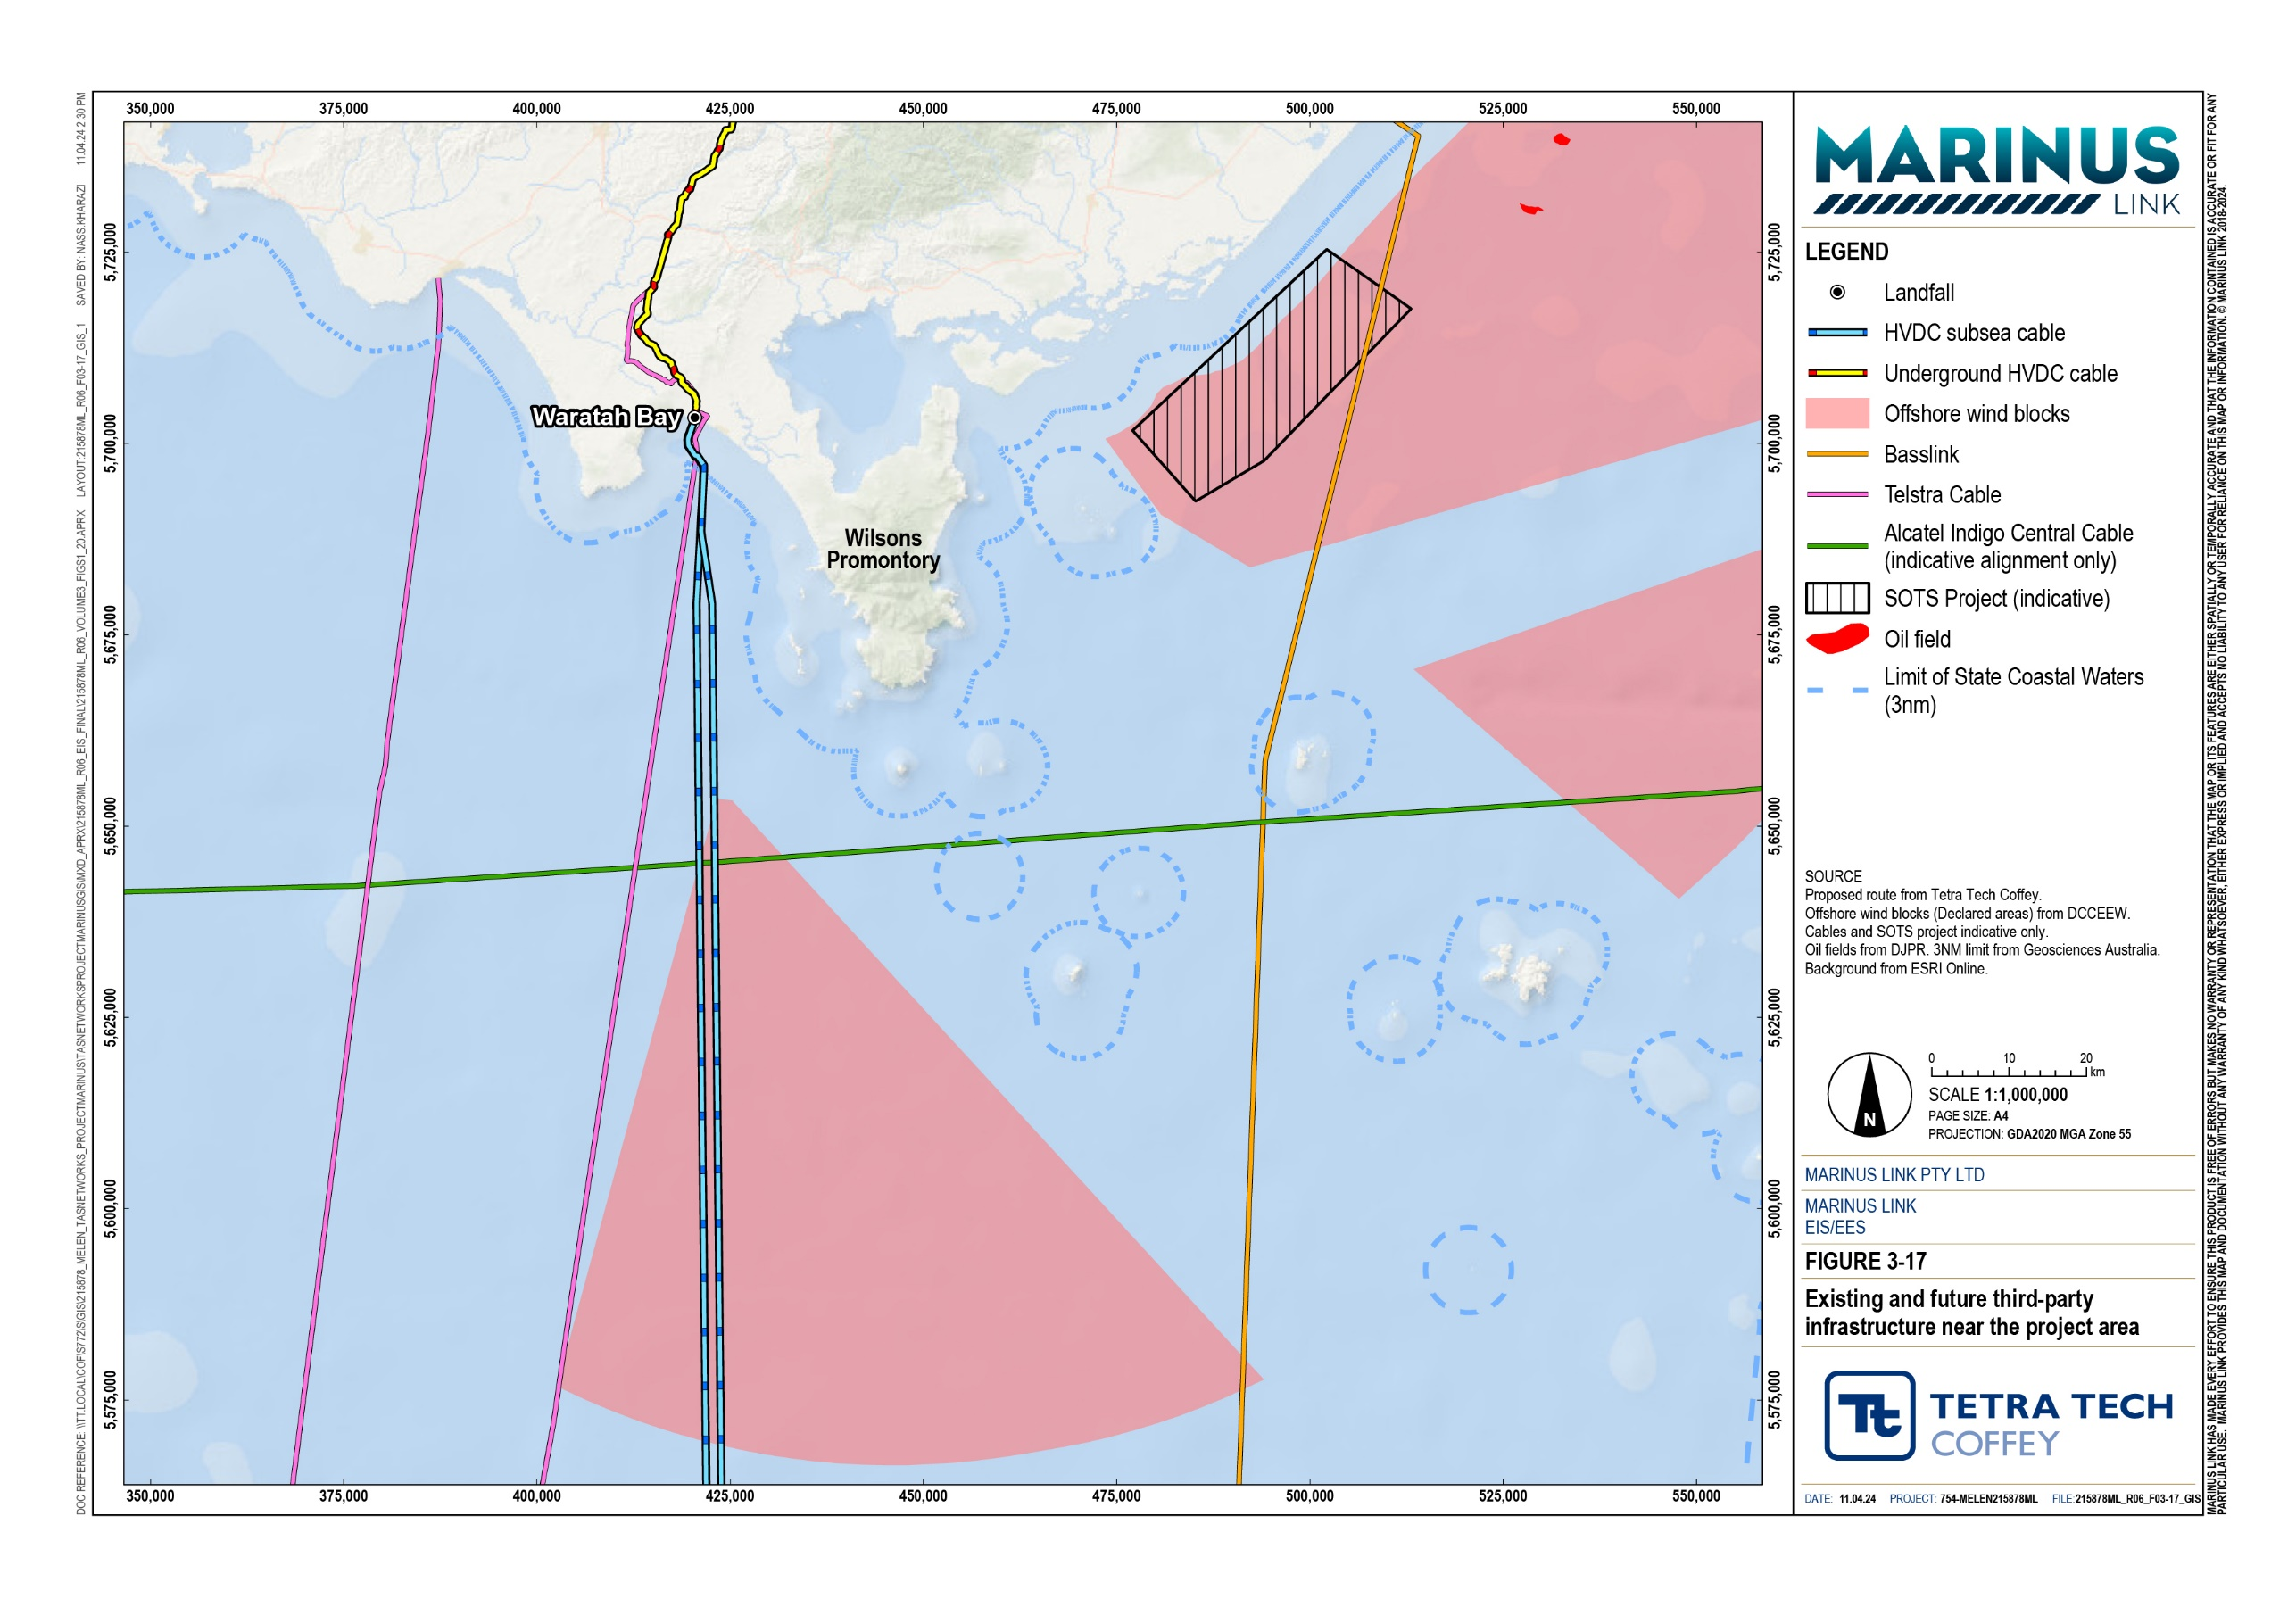

Conclusion
The assessment identified marine fauna, flora, and benthic community values along the project alignment. Fauna broadly included cetaceans, pinnipeds, sea turtles, marine birds and marine invertebrates, which included some migratory and threatened species. Benthic ecological communities and flora included marine invertebrates and seagrasses, which were sparsely present. The seabed across the project alignment is relatively low in biodiversity as the route mostly follows sands and muds and avoids outcropping structures and reef.
The assessment determined the following construction impacts have the potential to impact the marine ecological values:
Physical disturbance from directional drilling of the shore crossing.

Physical disturbance from cable installation and burial.

Impacts to fauna from underwater noise generated during construction.

Impacts to fauna from night-time artificial lighting.

Impacts to native marine fauna and flora due to the introduction or translocation of IMS through ballast water and hull fouling management.
Collisions with marine fauna during vessel movements.

The assessment found that standard management and mitigation measures implemented to comply with EPRs for each of these construction impacts will result in low to very low residual impact to marine fauna, flora, and benthic communities. This is primarily due to the predominantly low to negligible magnitudes of impact, given the localised and temporary nature of construction impacts, as well as the predominantly low sensitivity of values, given they mostly have a wide distribution in Bass Strait.
The only impact assessed to have a moderate residual impact was the PTS onset impacts on high frequency cetaceans, due to their very high sensitivity to underwater noise that may be generated by the project’s construction activities. However, this assessment was conservative as it assumes the high frequency cetacean stays in the area where impact could occur for 1 hour, which is considered unlikely given the high frequency cetaceans are likely to avoid the noise on its approach.
The assessment determined the magnetic, electric and thermal fields that are generated during cable operation, have the potential to impact the marine fauna. The assessment found that implementation of standard management measures to comply with EPRs resulted in low to very low residual impacts to marine fauna, flora, and benthic communities. This is primarily due to the implementation of EPR MERU12 for the cable design, which limits the magnetic, electric, and thermal fields generated by bundling, burying each circuit, and installing them separately to reduce cumulative effect between cables. This resulted in a negligible magnitude of impact for each of the impacts associated with these fields.

Many of the potential impacts have been substantially reduced through the planning and design of the project. For example, avoidance of biologically diverse beach and reef marine environments through route selection, and the adoption of HDD at the shore crossings.
The residual impacts from subsea cable removal (if this option is selected for decommissioning) will relate to temporary seabed disturbance. The impacts are expected to be within the range of construction impacts, ranging from very low to low and managed under a decommissioning management plan.
Overall, the assessment determined the impacts associated with construction, operation and decommissioning of the project will be manageable, given the implementation of standard management and mitigation measures to comply with EPRs. A high level of confidence has been given to the assessment conclusion that no significant long-term impacts, such as impacts to threatened species under the EPBC Act or FFG Act, are anticipated from the construction or operation of the project. This is based on observations made from similar projects that observed no significant impacts, including Basslink and Swepol Link (Sweden to Poland interconnector). Therefore, achievement of the following EES objectives relevant to marine ecology is expected:
Terrestrial, aquatic and marine biodiversity and ecology, including native vegetation, listed threatened species and ecological communities – Avoid, and where avoidance is not possible, minimise adverse effects on terrestrial, aquatic and marine biodiversity and ecology, including native vegetation, listed threatened species and ecological communities, other protected species and habitat for these species, and to address offset requirements consistent with state policies.
Water (including groundwater, Hydrology, waterway, wetland, and marine) quality, movement and availability – Avoid and, where avoidance is not possible, minimise adverse effects on water (including groundwater, Hydrology, waterway, wetland, and marine) quality, movement and availability.

