Marine Resource Use
This chapter provides an assessment of the potential impacts on marine resources from the construction, operation and decommissioning of the project. The chapter is based on the information provided in Technical Appendix H: Marine ecology and resource use.
The subsea cables will extend across Bass Strait, from Heybridge in Tasmania to Waratah Bay in Victoria. The alignment will cross major and minor shipping routes, commercial fishing grounds, recreational areas and existing subsea infrastructure.
The EIS guidelines set out the following requirements related to marine resources: Section 4.2: Description of the existing environment
Section 4.3.2: Commonwealth Marine Area

Section 5.1: General impacts

Section 5.7: Impacts on users of the marine environment

Refer to Attachment 1: Guidelines for the Content of a Draft Environmental Impact Statement for the EIS guidelines.
The EES scoping requirements set out the following EES evaluation objective relevant to marine resource use:
Marine and catchment values – Avoid and, where avoidance is not possible, minimise adverse effects on land and water (including groundwater, surface water, waterway, wetland, and marine) quality, movement and availability.
Refer to Attachment 2: Scoping Requirements Marinus Link Environment Effects Statement for the full list of EES scoping requirements.
The assessment considered the potential impacts to marine resources occurring in the onshore, nearshore and offshore marine environments in the Victorian and Commonwealth waters. Marine resources include commercial fisheries, recreational fishing, other marine recreational activities, vessel navigation systems, shipping traffic, and other subsea infrastructure. The marine resources assessment considers the potential impacts from the project. It also recommends EPRs to mitigate impacts.
Other aspects covered in the above EES evaluation objective not related to marine resources are addressed in the following EIS/EES chapters:
Volume 3, Chapter 2 – Marine ecology

Volume 4, Chapter 2 – Geomorphology and geology

Volume 4, Chapter 3 – Contaminated land and acid sulfate soils

Volume 4, Chapter 4 – Groundwater

Volume 4, Chapter 5 – Surface water

Volume 4, Chapter 11 – Terrestrial ecology

Method
Informed by the significance assessment method described in Volume 1, Chapter 5 – EIS/EES assessment framework, the key steps taken in assessing the impacts to the marine resources identified in the study area, include:
Defining a study area for the marine resource impact assessment.

Conducting a desktop review to identify the existing marine resources in the study area by accessing publicly available data sources, including literature from the following industry bodies and authorities:
- Australian Maritime and Safety Authority (AMSA)
- Australian Fisheries Management Authority (AFMA)

- Southern and Eastern Scalefish and Shark Fishery (SESSF)

- SETFIA

- Bass Strait Central Zone Scallop Fishery (BSCZSF)

- Tasmanian Seafood Industry Council

- Seafood Industry Australia.

Reviewing supporting marine assessments relevant to marine resources, that are attached to Technical Appendix H: Marine ecology and resource use, including:
- Attachment D Supplementary Information: Underwater noise assessment, EGC 2023

- Attachment F: Commercial fisheries data, SETFIA 2022

- Attachment H: Additional EMF memo, Jacobs 2022

Reviewing Commonwealth and Victorian managed commercial fisheries activities to identify active fisheries.
Identifying and assessing the potential impacts on marine resources during construction and operation of the project using the significance assessment method.
Identifying potential cumulative impacts on marine resources within the study area.

Developing EPRs in response to the impact assessment to reduce the identified impacts where necessary. Assessing residual impacts with the implementation of measures to comply with the EPRs. Refer to Volume 5, Chapter 2 – Environmental Management Framework for a full list of EPRs.
The assessment acknowledges that all marine based activities must comply with AMSA requirements, who are the national regulatory body for maritime safety and protection of the marine environment. As compliance with maritime safety requirements is legal requirement it is assumed that existing maritime users are

complying with AMSA requirements. Therefore, only residual impacts have been assessed for impacts to marine vessel activity due to the project.
The assessment of existing marine ecology and the potential impacts on marine ecological values are addressed in Volume 3, Chapter 2 – Marine ecology.

Study area
The study area considers the total area needed to sufficiently characterise and assess potential impacts to marine resources from the project. The study area for this assessment considers activities occurring in the following segments of the marine environments:
The onshore environment, including the beach environment.

The nearshore environment, comprising state waters up to 3 NM of the shore environment, excluding continental shelves to the west and east of the strait.
The offshore environment, comprising Commonwealth waters beyond the Victorian 3 NM limit.

The assessment of the project also considered the impacts to shipping and fishing activities in the following study areas:
A 4 km wide area (2 km either side of the project alignment centreline) for impacts to navigation, shipping traffic recreational fishing and recreational activities.
A 16 km wide area (8 km either side of the project alignment centreline) to assess impacts to commercial fishing activities.
The study area is shown in Figure 3-18.

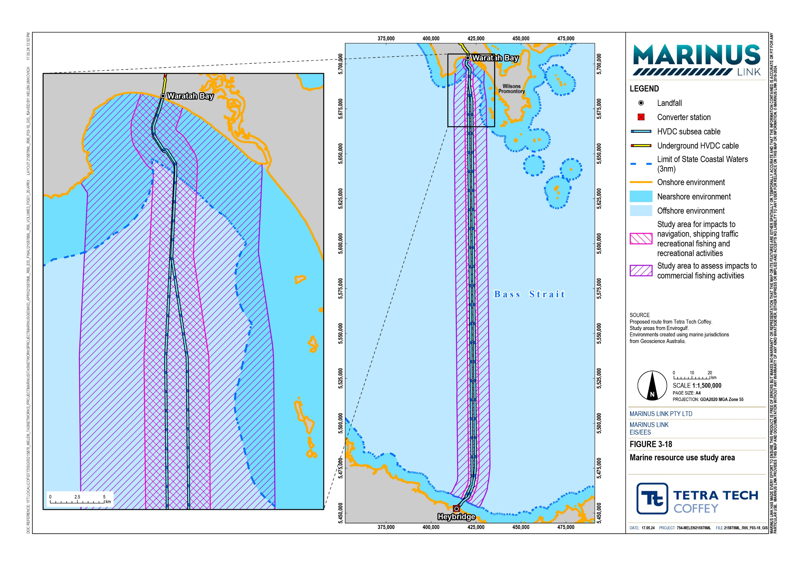

Legislative context
The legislation, supporting policy, guidance and standards that relate to the assessment of impacts on marine resources are provided in Table 3-1.
Table 3-1 Legislation and guidelines relevant to marine resources assessment

Title | Relevance to the assessment
Australian Maritime Safety Authority Act 1990 (Cwlth) (AMSA Act) | The AMSA Act establishes AMSA as a regulatory body, responsible for ensuring the appropriate certification and registration of ships in Australian waters. AMSA issues Marine Orders directing marine traffic within Bass Strait and reducing the risk of collisions. All vessels are required to comply with Marine Orders issued by AMSA. Marine Orders administered by AMSA include, but are not limited to:  - AMSA Marine Orders Part 30 (Prevention of Collisions)  - AMSA Marine Orders Part 59 (Offshore Support Vessel Operations)
Navigation Act 2012  (Cwlth) (Navigation Act) | The Navigation Act is administered by AMSA and promotes maritime safety in navigation, giving effect to relevant international safety and navigation conventions in Commonwealth waters, including the convention on the International Regulations for Preventing Collisions at Sea 1972 (COLREGs).  All vessels are required to comply with requirements of this act, including safe navigation and pilotage practices, implementation of navigation aids.
Offshore Electricity Infrastructure Act 2021 (Cwlth) | This Act provides a framework for regulating offshore renewable energy generation and electricity transmission infrastructure, including proposed offshore electricity infrastructure areas in Bass Strait that may be intersected by the project.
Offshore Electricity Infrastructure Regulations 2022 (Cwlth) | These regulations provide the licensing scheme for offshore renewable energy generation and electricity transmission infrastructure.
Fisheries Act 2015 (Vic) (Fisheries Act) | The Fisheries Act provides a framework for the regulating, managing, and conserving Victoria’s marine fisheries. The purpose of the Act is to manage state fisheries in a sustainable and responsible manner.
Fisheries Regulations 2019 (Vic) | The Fisheries Regulations facilitate the licensing of recreational and commercial fishing in Victoria. Keys aspects of the regulations include fisheries and the fisheries licence classes, set controls on each type of fishing and outline measures for the Victorian Fisheries Authority to monitor and enforce the management controls.
International Cable Protection Committee (ICPC) guidelines | Guidelines developed to ensure the protection, security, and safe interaction of international subsea cables with seabed and ocean users.
Marine and Coastal Act 2018 (Vic) (MACA) | MACA provides a framework for planning and managing the marine and coastal environment. This Act aims to protect Victoria’s coastline and improve capacity to address the protect Victoria’s coastline and improve our ability to address the long- term challenges of climate change, population growth and ageing coastal structures.  Marine and Coastal Policy 2020 provides direction to decision makers including local councils and landholders on a range of issues relating to the planning, management and sustainable use of coastal and marine environment, including the impacts of climate change, population growth and ageing coastal structures.  The policy applies to the planning and management of all private and public land and waters between the outer limits of the Victorian coastal waters (3 NM from the high- water mark) and five kilometres inland of the high-water mark, including 200 metres below the surface of that land. Technical Appendix S: Land use and planning details  the project’s consistency with the Marine and Coastal Policy 2020.

Assumptions and limitations
The key assumptions and limitations for the marine resources assessment include:

The assessment has assumed all marine vessels and marine based activities will comply with AMSA requirements.
Annual shipping traffic density figures were based on data from 25 March 2019, and annual shipping traffic density up to this date, to capture data not showing the effects of the pandemic on shipping traffic.
Offshore recreational sports fishing vessels targeting tuna, swordfish, yellowtail kingfish and other pelagic fish species (i.e., mako, thresher, gummy, seven gill and blue shark) were not considered in this assessment as they are uncommon in nearshore Bass Strait and Victorian waters.
The study only considered the magnetic fields associated with the operational phase of the project for the effect on vessel navigation. While weak magnetic fields may arise during the construction and decommissioning phases of the project, they are considered negligible and were not assessed further.
The assessment has assumed the project will not require an exclusion zone for vessels over the subsea cables during operation, as the cable will be buried to a nominal depth of 1 m (0.5 m to 1.5 m), preventing damage from anchors and trawling gears. Volume 1, Chapter 6 – Project Description provides further detail on cable laying and burial.
The assessment of cumulative impacts (Section 3.8 Cumulative impacts) was completed in December 2023. At this time, applications had been made for feasibility licences in the Gippsland
declared offshore wind area, however the Commonwealth Minister for Climate Change and Energy had not decided on the licence applications for the proposed offshore wind area in Bass Strait.

Existing conditions
This section describes the existing marine resources along the project alignment within Bass Strait, including:
maritime traffic and navigation systems

commercial fisheries

recreational fishing

recreational boating and other uses

existing subsea infrastructure and offshore industries.

Maritime traffic
Shipping lanes provide designated routes for commercial vessels, recreational vessels and passenger ferries. Maritime traffic traversing Bass Strait comprise of commercial cargo ships, bulk carriers, oil and gas industry vessels, commercial fishing vessels and passenger ferries, including the Spirit of Tasmania I and II. Many of these vessels port in Port Phillip Bay, where the main ports in Victoria are located, including Port of Melbourne, Port of Geelong and Williamstown dockyards. There are a number of smaller ports and harbours situated along the southeast coast of Victoria (i.e., Port Franklin, Port Welshpool, Port Albert and Lakes Entrance), used primarily by fishing vessels.
The project intersects several shipping routes, including:

A traffic separation scheme that divides shipping lanes for eastbound and westbound vessels.

A prominent shipping route connecting Melbourne and Devonport.

Smaller shipping routes, including routes connecting Devonport to Geelong and Devonport to Port Franklin.
Figure 3-19 shows the cumulative marine traffic density in Bass Strait.
Ships and vessels rely on several systems to navigate a designated route, including:

Automatic Identification System (AIS): Real-time network of transmitters and receivers that enable vessel movements to be tracked, recorded and broadcasted.
Global Positioning System (GPS): Satellite-based navigation system used to determine real-time information regarding a vessel’s position, speed, and course.
Long-range Identification and Tracking (LRIT): Automatically transmits the tracking information of a vessel at regular intervals to designated LRIT Data Centres, which will monitor ship movements.
Magnetic compass: Provides a vessel’s bearing relative to the Earth's magnetic field.

Gyrocompass: Provides a vessel's bearing by sensing the Earth’s axis rather than the Earth’s magnetic field.
Vessels may use one, or a combination of the above for navigations purposes
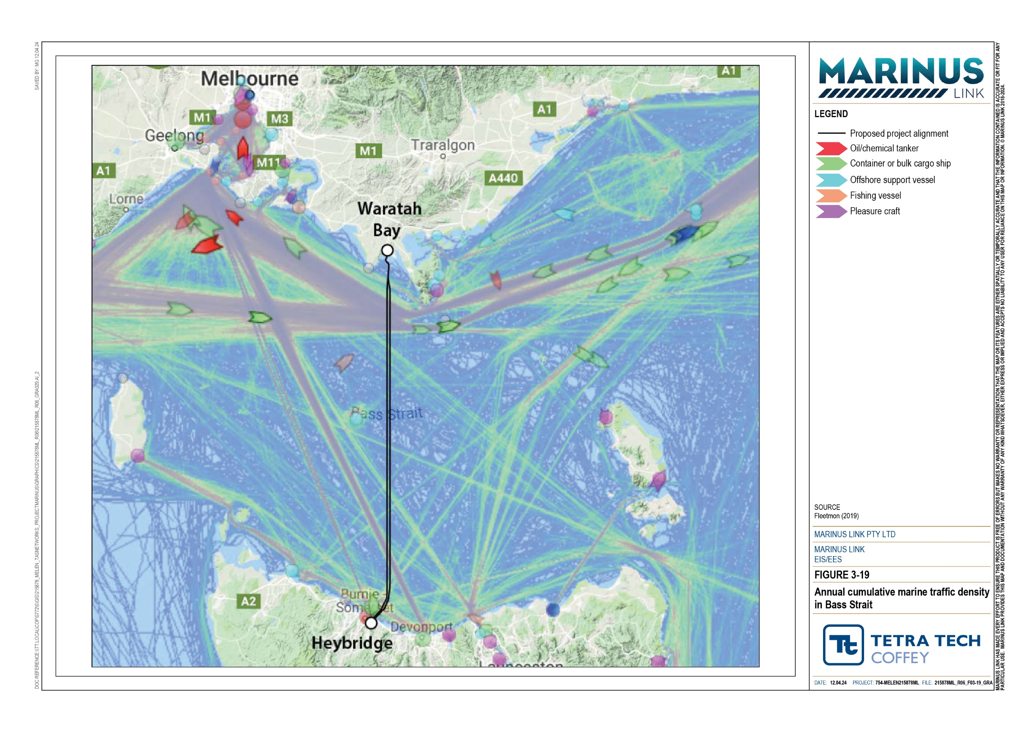

Commercial fisheries
The commercial fisheries in Bass Strait are represented by a variety of fishery industry bodies including Seafood Industry Victoria (SIV), Tasmanian Seafood Industry Council and the Tasmanian Rock Lobster Fishermen’s Association (TRLFA). These bodies represent different subsets of the commercial fishing industry, advocating for their interests, offering resources and promoting the sustainable growth of the commercial fishing industry.
There are 21 Commonwealth and Victorian managed commercial fisheries permitted to work in Bass Strait. Of these 21 Commonwealth and Victorian managed commercial fisheries, only eight fisheries have actively fished in the study area in the last 10 years and were considered in this assessment.
There are four Commonwealth managed commercial fisheries in the study area, comprising of SESSF Commonwealth Trawl sector, SESSF/ Shark Gillnet and Shark Hook and Trap (GHAT) sectors, Southern Squid Jig Fishery and the BSCZSF. The Commonwealth managed fisheries target a variety of marine species including the tiger flathead, silver trevally, Gould’s squid and various species of shark and scallop. Table 3-2 summarises the target species and fishing techniques used in the study area. Locations of the Commonwealth and Victorian managed commercial fisheries in the study area are shown in Technical Appendix H: Marine ecology and resource use, and Attachment F: Commercial fisheries data of Technical Appendix H.
There are four Victorian managed commercial fisheries in the study area, comprising of Abalone and Sea Urchin Fishery, Ocean General Fishery, Rock Lobster (Eastern Zone) Fishery and Wrasse (Ocean) Fishery. The Victorian managed fisheries target a variety of marine species including the southern rock lobster, Eastern Australian salmon, sardines and various species of abalone, wrasses, bait fishes. Table 3-3 summarises the target species and fishing techniques used in the study area.
Table 3-2 Summary of target species in Commonwealth managed fisheries

Commonwealth managed fisheries | Fishing technique | Target species
SESSF Commonwealth Trawl sector | Otter-board trawls (mid-water or pelagic trawling) | Gummy shark, school shark, silver trevally, redfish, jackass morwong, blue grenadier, tiger flathead
 | Otter-board trawls (demersal or bottom-trawling) | Gummy shark, school shark, silver trevally, redfish. jackass morwong, tiger flathead
 | Danish seine | Tiger flathead, eastern school whiting
SESSF/GHAT Shark Gillnet and Shark Hook sectors | Demersal gillnet, gillnets, fish traps, automatic longlines | Gummy shark and byproduct fishes (i.e., school shark, elephant fish, saw sharks)
 | Demersal longline, shark hook | Gummy shark, deepwater blue eye trevalla, pink ling
Southern Squid Jig Fishery | Squid jig | Gould’s squid
BSCZSF | Bottom-towed scallop dredge harvester | Commercial scallop, doughboy scallop
Attachment F: Commercial fisheries data of Technical Appendix H.

Table 3-3 Summary of target species in Victorian managed fisheries

Victorian managed fisheries | Fishing technique | Target species
Abalone and Sea Urchin Fishery | Diving and restricted to rocky substrates of near shore areas | Greenlip abalone, blacklip abalone

Ocean General Fishery Demersal longline; demersal gillnet;
squid jig; minor line; and purse seine
Eastern Australian salmon, sardines, pilchards and various bait fish species

Rock Lobster (Eastern Zone) Baited lobster pots Fishery
Southern rock lobster and bycatches of octopuses and leatherjackets
Wrasse (Ocean) Fishery Demersal longline; minor line Bluethroat wrasses, senator wrasses,
southern Maori wrasses, spotted wrasses
Attachment F: Commercial fisheries data of Technical Appendix H.

Recreational fishing
Recreational fishing includes fishing for leisure and competitions. This activity is undertaken from the beaches or on boats in nearshore waters of southern Victoria. Most of the recreational fishing in the vicinity of the project occurs east of Wilsons Promontory in Corner Inlet due to its proximity to the larger population centres of Port Franklin and Port Welshpool. Fishing occurs to a lesser extent in Waratah Bay as there are no large population centres along the coastline, and only the smaller coastal towns of Waratah Bay, Walkerville and Sandy Point located nearby.
A literature review found that recreational fishing in Waratah Bay targeted Australian salmon, gummy shark, dusky flathead, Australasian snapper, King George whiting and sand flathead. Southern calamari are also caught in Waratah Bay.
Larger recreational fishing boats target big game and deep-sea fish in the offshore waters of Bass Strait. These larger recreational boats have home bases in both Victoria (i.e., Queenscliff and Sorrento) and Tasmania (i.e., Launceston, Port Sorrell and Wynyard). These boats are known to target game fish such as the shortfin mako shark, common thresher sharks, various shark species, broadbill swordfish, stripped Marlin and various species of tuna.
Figure 3-20 shows major centres near recreational fishing sports and home bases of larger recreational boats.

Recreational boating and other uses
Other recreational uses of Bass Strait include recreational boating and other nearshore and onshore activities.
Recreational boating activities include power boats, jet skis, yachts, kayaking, and sea-going canoes. These activities occur in the nearshore environments intersected by the study area. There are boat ramps located at Shallow Inlet, Walkerville North, Walkerville South and Waratah Bay Village.

When the ocean conditions are favourable, recreational boating between Waratah Bay and Shallow Inlet Marine Park and Coastal Reserve will occur for recreational activities and fishing. Recreational activities spread around Waratah Bay are expected to be more prominent in summer months, associated with tourism.
Other recreational boating activities comprise of onshore activities (i.e., walks in or near the beach), swimming, surfing, snorkelling, scuba diving and sea kayaking. Key locations for other recreational activities include Shallow Inlet Marine and Coastal Park, and Wilsons Promontory National Park.
Figure 3-20 shows the locations used by recreational boaters and locations of other key recreational activities.

Existing subsea infrastructure and offshore industries
The assessment considered existing subsea infrastructure, including the following existing cables within the study area:
Basslink HVDC bundled cable

Telstra’s Bass Strait 1 telecommunications cable

Alcatel’s Indigo Central telecommunications cable.

For repairing or maintaining existing infrastructure, vessels may be utilised for maintenance.

The subsea project alignment will not transverse existing offshore oil and gas exploration infrastructure, therefore the project is not expected to interact with existing offshore oil and gas resources. The assessment identified future oil and gas projects within the east Gippsland oil and gas area, appropriately 170 km away from the project area, therefore the project is not expected to interact with proposed offshore oil and gas resources.
The subsea project alignment will traverse the Gippsland area declared under the Offshore Electricity Infrastructure Act 2021 (Cwlth) as being suitable for offshore wind energy. Proponents have submitted feasibility licence applications for the declared area, which are currently being assessed by the Commonwealth Minister for Climate Change and Energy. No feasibility licences or other licences under the act have been granted at the time of preparing this EIS/EES. However, it is anticipated the subsea project alignment may intersect one or more areas subject to feasibility licences for projects to be developed in the future. The offshore wind projects are discussed further in Section 3.8.
Existing subsea infrastructure and the offshore wind energy zones are shown in Figure 3-21.
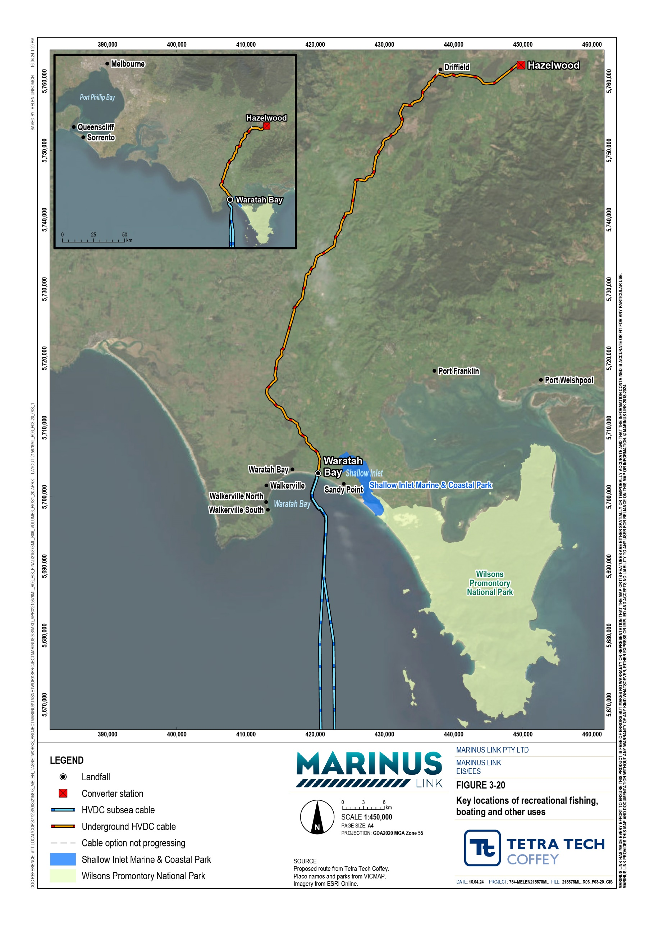

DATE: 16.04.24 PROJECT: 754-MELEN215878ML FILE: 215878ML_R06_F03-20_GIS

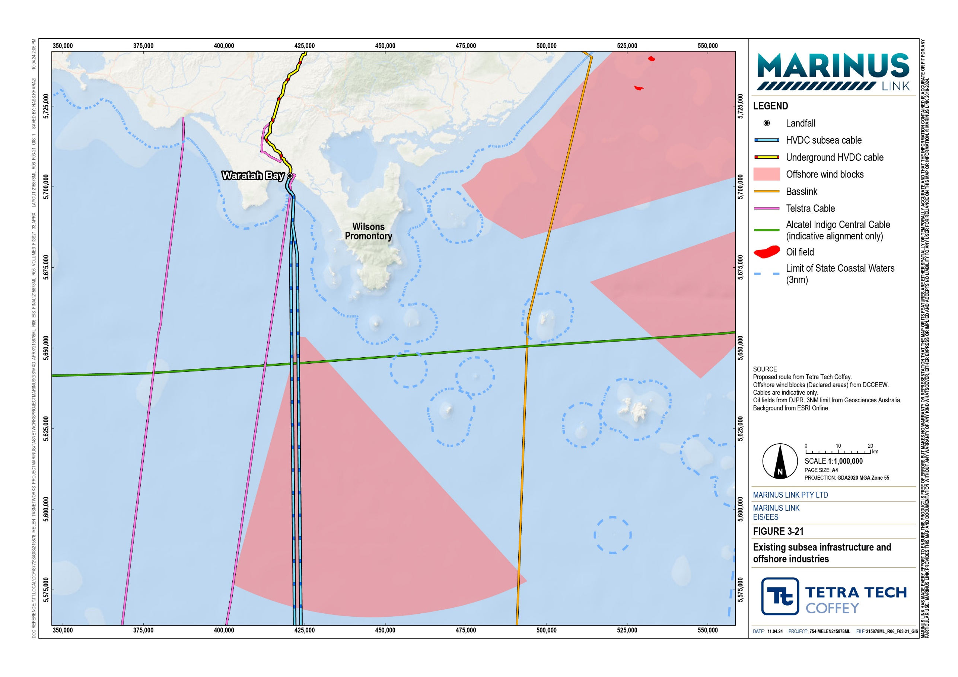

Summary of values
Potential impacts were determined based on the identified resources uses which may be affected by project construction, operation and decommissioning activities. The marine activities and uses in the study area are summarised in Table 3-4. Marine ecology values, including flora, fauna and marine habitat are described in Volume 3, Chapter 2 – Marine ecology.
Table 3-4 Summary of marine activities and uses

Maritime traffic | Commonwealth and Victorian managed fisheries | Other recreational users | Existing subsea infrastructure and offshore industries
commercial cargo ships bulks carriers  commercial fishing vessels  passenger ferries  oil and gas industry vessels | Abalone and Sea Urchin Fishery  Ocean General Fishery  Rock Lobster (Eastern Zone) Fishery  Wrasse (Ocean) Fishery  SESSF Commonwealth Trawl sector  SESSF/ GHAT Shark Gillnet and Shark Hook sectors  Southern Squid Jig Fishery Bass Strait Central Zone  Scallop Fishery | boaters  jets skiers kayakers canoeists snorkers  scuba divers hikers  recreational fishers, including fishers undertaking fishing for leisure and competitions | telecommunication cables  oil and gas industry infrastructure

Construction impacts
Construction activities associated with the subsea cable will encompass the onshore, nearshore and offshore environments. Potential sources of impacts to the marine environment and associated marine resources include:
Disrupting access to maritime traffic routes, commercial fishing and recreational fishing from the presence of a temporary and moving exclusion around subsea cable placement.
Disrupting access to recreational users to the onshore and nearshore environments the from directional drilling of the shore crossing

Temporary exclusion zones and shore crossing
Construction activities in the nearshore and onshore environment will require the presence of temporary exclusion zones, including:
A moving exclusion zone of 1.5 km long by 1 km wide surrounding the cable lay vessel during subsea cable installation and burial as it crosses Bass Strait.
An exclusion zone of 3.2 km long by 1 km wide in nearshore Waratah Bay surrounding the cable lay vessel during exiting of the HDD shore crossing to the seafloor and subsea cable installation.

The shore crossing will involve six horizontally directionally drilled holes that will exit the sea floor at 10 m water depth. This will not impact the foreshore, or intertidal zone at the beach as the drilled hole will be approximately 10 m beneath the surface.

Maritime traffic
The cable lay vessel will traverse minor and major maritime shipping lanes in Bass Strait and Waratah Bay. It will be accompanied by guard vessels to maintain the exclusion zone and alert approaching vessels of the cable laying. The presence of this moving exclusion zone and associated guard vessels will temporarily obstruct access to areas where cable laying is occurring.
Transport ships and ferries regularly travel across marine transport routes between Melbourne, Geelong and Devonport ports, which will cross the subsea project alignment. While subsea cable laying is occurring, non- project related vessels will be required to detour around the exclusion zone.
There are few existing restrictions on the movement of vessels offshore in Bass Strait, therefore this detour will likely result in a minor deviation of a vessel’s planned course. MLPL will be required to notify AMSA and the AHO of location, timing and duration of cable crossing works so that all maritime users are aware of the exclusion zone (EPR MERU06). Engagement will also be undertaken with owners of other existing infrastructure along the alignment and the restricted access that will occur during cable laying (EPR MERU05).
With the appropriate notifications in place and short duration of the moving exclusion zone, the detour around the exclusion zone will likely represent a minor nuisance to non-project related vessels, and the residual impact has been assessed as very low. This rating is based on shipping traffic having a low sensitivity due to ships already adhering to AMSA requirements to avoid collisions and regularly undertaking navigation course changes. The magnitude of impact will be minor given as the navigation deviations will be small and short term.

Commercial fisheries
The 1.5 km long by 1 km wide moving exclusion zone around the cable lay vessel and near shore construction activities for the shore crossing, may temporarily restrict access to commercial fishing grounds. There may also be impacts to commercial fishery habitats and resources, which are discussed in Volume 3, Chapter 2 – Marine ecology.
Most of the alignment across Bass Strait is soft and sandy seabed. The main fishing activities occurring in this environment is scallop dredging and demersal hook and line and bottom-set longlining targeting gummy sharks and other demersal fish species. These fishing grounds in Bass Strait are extensive and have no significant restrictions on vessel movement. Fishing vessels will therefore have the capability to navigate around the cable lay vessel’s exclusion zone and still access fishing grounds.

MLPL will advise commercial fishery associations (listed in Table 3-2 and Table 3-3) of the construction activities, including proposed locations, dates, times and expected duration, in compliance with AMSA and AHO requirements (EPR MERU05, EPR MERU06).
With the appropriate notifications in place and short duration of the moving exclusion zone, detouring around the exclusion zone and fishing in alternative areas will likely represent a minor nuisance to fishing vessels, and the residual impact has been assessed as very low. This rating is based on the capacity of fishing vessels to manoeuvre around the moving exclusion zone and readily access alternative areas within the fishing grounds. The magnitude of impact will be negligible, given the navigation deviations will be small and short term, while the size of the exclusion zone is small relative to the commercial fishing areas.
While the disturbance of the seabed through cable laying could lead to direct and indirect impacts to fishery resources and habitats, the assessment found the residual impacts were low for both fish habitats and food sources. This rating is based on the high sensitivity due to the high value recreational fishers attached to commercial fish stocks. However, the magnitude of impact was found to be negligible, given seabed disturbance impacts to seabed habitats and biological communities are localised, short-term and recoverable, while the size of the exclusion zone is small relative to the commercial fishing areas. The project impacts on commercial fishery resources and their habitat are discussed in Volume 3, Chapter 2 – Marine ecology.

Recreational fishing and boating
Construction activities in the nearshore environment will require a temporary 3.2 km long by 1 km wide temporary exclusion zone in Waratah Bay, temporarily obstructing access to the nearshore recreational fishing areas. The exclusion zone will be established around the cable lay vessel stationed near shore, at a water depth of about 15 m. This will be for the HDD shore crossing construction exiting the sea floor and pulling the cable from the cable lay vessel through the HDD marine exit holes that will be located in a water depth of 10 m.
The cable lay vessel’s presence will necessitate boats departing from Waratah Bay and heading towards popular recreational fishing spots such as Cape Liptrap, Shallow Inlet, and Wilsons Promontory to seek alternative routes that avoid the designated exclusion zone.
MLPL will advise commercial and recreational fisheries of the construction activities, including proposed locations, dates, times and expected duration, in compliance with AMSA and AHO requirements (EPR MERU06). During nearshore construction activities, recreational fisherman will be able to access alternative nearshore areas while nearshore construction activities are occurring. There will be not exclusion zone on the beach at Waratah Bay and it will still be accessible for recreational fishing.

The residual impacts to recreational fishing and boating are assessed to be low. This rating is based on both recreational fishers and boaters having a moderate sensitivity due to value recreational fishers attach to nearshore fishing areas, and the nuisance of longer transits to avoid the temporary exclusion zones. The magnitude of the impact to recreational fishers by boat will be negligible, given fishers can access alternative areas in the adjacent nearshore area. While the magnitude of the impact to recreational boaters will be low as the navigation deviations around the exclusion zone will be small and short term.
While the disturbance of the seabed through cable laying could lead to direct and indirect impacts to fishery resources and habitats, the assessment found the residual impacts were low to very low for both fish habitats and food sources. This rating is based on the high sensitivity due to the value recreational fishers attach to shoreline and nearshore fish stocks. The magnitude of impact was found to be negligible, given all seabed disturbance impacts to seabed habitats and biological communities are localised, short-term and recoverable. The project impacts on recreational fishery resources and their habitat are discussed in
Volume 3, Chapter 2 – Marine ecology.

Marine tourism and recreation
Marine based tourism in the nearshore and offshore environment is primarily associated with recreational fishing and recreational boating. Other marine recreational uses include breach walks, diving, surfing, sea kayaking and wind surfing.
Construction of the shore crossing will involve long trajectory HDD boreholes out to about 10 m water depth, utilising a trenchless technique that avoids any disturbance to the backshore, foreshore, or intertidal zone of the beach, as the HDD borehole and ducts are situated deep underground. This process will not impact coastal processes or the sand beaches and shorelines in these areas, and therefore is not expected to be any impacts on beach activities.
The presence of a temporary exclusion zone at approximately 10 m to 15 m depth will prevent swimmers, surfers and kayaks accessing the nearshore area encompassed by this exclusion zone. During nearshore construction, recreational users will be able to access areas of the beach outside of the exclusion zone, therefore the residual impacts are considered low to very low. This rating is based on the high sensitivity due to value recreational users place on the nearshore and offshore environment, and the nuisance of longer transits to avoid the temporary exclusion zones. The magnitude of the impact is negligible given navigation deviations around the exclusion zone will be small and short term, and recreational activities can occur in adjacent nearshore and offshore areas.

Existing infrastructure
The project’s subsea cables will cross the Alcatel Submarine Networks (ASN) Indigo Central and Telstra’s Bass Strait 1 subsea telecommunication cables. The project does not cross the Basslink cable.
To avoid potential damage to the existing ASN Indigo Central and Telstra cables, the project will consider the location and nature of the existing third-party infrastructure. MLPL will develop a cable crossing management plan, in consultation with the owners of existing third-party subsea cables or pipelines to ensure construction can be undertaken without impacting existing infrastructure (EPR MERU05).
MLPL’s cable crossing management plan (EPR MERU05) will consider the International Cable Protection Committee (ICPC) guidelines, intended to safeguard subsea cables and the marine environment. The ICPC guidelines include the following obligations:
Avoid conduct that prejudices the repair of other cables or pipelines (article 112.2).

Indemnify damage to any first laid cable or pipeline that is crossed (article 115).

Indemnify mariners or vessel owners who, through no fault of their own foul a cable, but sacrifice their gear to avoid damage to the cable (article 114).
Following the implementation of the cable crossing management plan and (EPR MERU05) and marine communication plan (EPR MERU06) the project is not expected to impact existing infrastructure.

Operation impacts
There will be limited impacts in operation as infrastructure will be located entirely below the sea floor. This section describes the potential impacts during operation to vessel’s navigation systems.
There are no permanent exclusion zones proposed around the subsea cable, given the cable will be buried to a nominal depth of 1 m (0.5 m to 1.5 m). Therefore, operational activities will not restrict maritime traffic and fisheries operating in the area.

Navigation
When power flows through the HVDC cables during operation, magnetic fields will be produced. When cables are not operating there is a weaker magnetic field due to the earth’s existing magnetic field interacting with the copper and steel in the HVDC cables.
Magnetic fields can interfere with the accuracy of some navigation systems of commercial and recreational boats. The project has adopted a modern HVDC cable design (described in Volume 1, Chapter 6 – Project Description), minimising the electromagnetic fields (EMF) and heat emitted from the subsea and land cable (EPR MERU012). However, the project will still generate EMF once the HVDC cable are energised, during operation.

Modelling (Attachment H: Additional EMF memo of Technical Appendix H: Marine ecology and resource use) found the EMF generated by the project are at or near background levels both at and above the sea surface. The existing electromagnetic conditions are discussed in Volume 3, Chapter 2 – Marine ecology.
The magnetic field generated by the energised HVDC cable may interfere with accuracy of magnetic compass readings. Although GPS navigation systems or gyrocompasses are the primary navigation tool used by larger vessels, smaller vessels may utilise magnetic compasses. The level of disturbance will depend on the amount of power being generated by the project (i.e., higher level of disturbance associated with the generation of 750 MW, compared to 375 MW), and the depth of the sea water (i.e., higher level of disturbance associated with shallower waters, compared to deeper waters).
The closer a magnetic compass is to the energised HVDC, the higher the level of disturbance. However, to have a significant impact, the magnetic compass will need to be located within 10 m of the subsea cable. This scenario will only impact smaller vessels when travelling very close to the subsea cable, in shallow water that is less than 10 m deep.
Overall, the residual impact on magnetic compass for all non-project related vessels is considered low. This is based on a moderate sensitivity of vessels’ navigation as it will only affect smaller vessels in very shallow water. The magnitude is low as the impact will be short term when the cable is crossed.
The modelling and impacts associated with EMF generated by the project, are discussed further in
Volume 1, Chapter 10 – Electromagnetic fields. The impacts associated with EMF generated by the project on marine ecology are detailed in Volume 3, Chapter 2 – Marine ecology.
Following the placement of the subsea cable, MLPL will notify the AHO of the cable coordinates for publication on navigation charts to inform maritime users of the location of the subsea cables (EPR MERU13).

Decommissioning impacts
The operational lifespan of the project is a minimum 40 years. At this time the project will be either decommissioned or upgraded to extend its operational lifespan.
Decommissioning will be planned and carried out in accordance with regulatory requirements at the time. A decommissioning management plan in accordance with approvals conditions will be prepared prior to planned end of service and decommissioning of the project.
Requirements at the time will determine the scope of decommissioning activities and impacts. The key objective of decommissioning is to leave a safe, stable and non-polluting environment, and minimise impacts during the removal of infrastructure.
Decommissioning of project infrastructure will implement the waste management hierarchy principles of avoid, minimise, reuse, recycle and appropriately dispose. Waste management will be in accordance with applicable legislation at the time.

Decommissioning activities may include recovery of subsea cables and removal of rock armouring or mattresses. Alternatively, the subsea cables may be left in situ. The conduits and shore crossing ducts would be left in-situ as removal would potentially cause significant environmental impact.
A decommissioning management plan will be prepared to outline how activities will be undertaken and potential impacts managed.

Environmental performance requirements
EPRs set out the environmental outcomes that must be achieved during all phases of the project. In managing impacts were considered. Project specific management measures, relevant legislation and policy requirements informed these EPRs.
The EPRs relevant to managing impacts to marine resources were developed as part of assessment presented in Technical Appendix H: Marine ecology and resource use assessment. The following table only includes EPRs from this report that are relevant to marine resources. The marine ecology EPRs are presented in Volume 3, Chapter 2 – Marine Ecology.
The EPRs required to manage construction phase impacts are listed below in Table 3-5.

Table 3-5 EPRs
MERU05 Develop and implement a cable crossing management plan
Prior to commencement of marine construction, develop a cable crossing management plan with measures to avoid impacts on existing third-party subsea cables during construction. The cable crossing management plan must:
Be developed through consultation with the owner of the Bass Strait 1 cable crossed by the project. Be developed through consultation with the owner of the Indigo Central cable crossed by the project. Describe the approach and key requirements for safe cable crossing.
Includes an engineering solution for the crossing with relevant infrastructure owners.
Includes requirements for informing the Australian Maritime Safety Authority (AMSA) of the location, timing and duration of cable crossing works.
Be informed by guidelines published by the International Cable Protection Committee (ICPC) to assist the cable industry to adopt a harmonised approach in relation to crossings (ICPC, 2023b).
Document the crossing point locations for the subsea cables, and the distances that the jet trencher will stop before crossing existing third-party subsea cable.
Outline the notification protocols for informing Bass Strait 1 and Indigo Central cable owners of the final design and construction approach.
The plan must be implemented during construction.
EPR ID EPR
MERU06 Develop and implement a marine communication plan
Prior to commencement of marine construction, develop and implement a marine communication plan that includes:
Identification of relevant stakeholders.
Protocol for notifying the AMSA of the proposed locations, timing and duration of proposed marine construction activities.
The approach for compliance with AMSA Marine Orders Part 30 (Prevention of Collisions), AMSA Marine Orders Part 59 (Offshore Support Vessel Operations) and the convention on the International Regulations for Preventing Collisions at Sea, 1972 (COLREGs).
Protocol for informing the Australian Hydrographic Office of the locations, dates, times and duration of proposed marine construction activities.
A plan to engage with commercial and recreational fisheries on the project activities, schedule, locations and durations.
The approach for using guard vessels to enforce the temporary exclusion zone during cable laying across Bass Strait and at the shore crossings.
The approach for informing recreational users of marine activities, in accordance with the Community and Stakeholder Engagement Plan (EPR S3).
This plan must be implemented during construction.
MERU12 Adopting a HVDC cable design that minimises the electromagnetic fields and heat emitted from the subsea and land cable
The cable and construction method must be designed to install and bury subsea cables in a manner that reduces the EMF emitted from the subsea cables at the seabed and overlying the water column. The cable design and installation must include:
Cable burial up to 1.5 metres.
Bundling the HVDC cables in each subsea circuit to cancel out or greatly reduce EMF. Separating each subsea circuit to reduce interaction of electromagnetic fields.
MERU13 Notification of the final subsea project alignment
At the completion of marine construction, MLPL must inform the Australian Hydrographic Office and the Victorian Department of Energy, Environment and Climate Action of the locations and coordinates of the final subsea project alignment to enable the Australian Hydrographic Office to publish Notices to Mariners to inform maritime users of the presence of seabed power cables and mark them on navigation charts.

Residual impacts
Residual impacts are those that will occur after the application of measures to comply with EPRs. The residual impacts to marine resources during construction and operation are rated as low to very low. A summary of residual impacts is provided in Table 3-6.

Construction
The presence of an exclusion zone around the subsea cable may temporarily obstruct access to commercial shipping grounds, commercial and recreational fishing zones and areas used for other recreational purposes MLPL will engage with recreational fisheries and boarder community regarding locations, dates, times and duration of proposed marine construction activities (EPR MERU06). Given the temporary nature and limited extent of the exclusion zones, the impacts are likely to represent a minor nuisance to marine resource users and subsequently the residual impact will be very low.
The implementation of a cable crossing management plan to manage impacts on existing third-party subsea cables during construction will include the need to consult with owners of third-party infrastructure regarding mutually acceptable engineering solutions and notice of proposed subsea construction work This will reduce the magnitude of impacts and subsequent residual impacts to existing infrastructure (EPR MERU05).

Operation
The generation of EMF from the energised cable will not impact the use of GPS navigation systems, however, it may impact the accuracy of magnetic compasses in smaller recreational vessels in very close proximity to the subsea cable (within 10 m). Through the adoption of modern HVDC cable design that minimises the EMF (EPR MERU12) and notifying ASMA and AHO of the final cable locations, vessels can avoid being close to the subsea cable (within 10 m) (EPR MERU13), reducing the residual impacts on marine resources to low.

Table 3-6 Summary of construction and operation impacts on marine resource use

Activity | Recommended EPRs | Justification of residual rating | Sensitivity | Magnitude | Residual impact
Construction
Temporary exclusion zones and fisheries impacts | MERU05 | Commercial fisheries will be notified of the marine constructions activities and can make adjustments to their proposed fishing activities, as required, while exclusion zones are in place. | Low | Negligible | Very low

Navigation and marine | MERU05, | Relevant stakeholders will be notified of the marine constructions activities and can | Low | Negligible | Very low
traffic exclusion zone impacts | MERU06 | make adjustments to their proposed route, as required.
Recreational fishing temporary exclusion zones | MERU05 | Recreational fishers will be notified of the marine constructions activities and can make adjustments to their proposed fishing activities, as required, while temporary exclusion zones are in place. | Moderate | Negligible | Low
Recreational fishing boat transit impacts | MERU05 | Recreational boaters will be notified of the marine constructions activities and can make adjustments to their proposed route, as required. | Moderate | Negligible | Low
Nearshore recreational | MERU05 | Recreational fishers will be notified of the marine constructions activities and can | High | Negligible | Low
fishing targeted fish |  | fish in alternative nearshore fishing grounds.
Navigation and marine traffic exclusion zone | MERU13 | Notifying AHO of the location of the final project alignments to enable maritime users to consider the subsea cables when planning their voyage. | Low | Negligible | Very low
impacts

Operation
Magnetic compass deviation | MERU12 | The project adopts a HVDC cable design that minimises the generation of magnetic fields. | Moderate | Negligible | Very low

Cumulative impacts
There are no other projects identified as being proposed in close proximity of Bass Strait or Victorian waters where the project is proposed, and at the time construction is proposed. While there are other third-party assets that will be crossed by the project, the asset owners will be notified in advance of construction activities (EPR MERU05) to avoid works occurring at the same time. The implementation of a marine communication plan (EPR06) will require the identification of relevant stakeholders prior to the commencement of construction, and development of a plan to engage with these stakeholders on project activities, schedule, works locations and durations.
Very low magnetic fields are generated around existing operating subsea telecommunication cables (e.g., Telstra’s Basslink 1 cable and Alcatel’s Indigo Central cable). It is expected there will be little interaction between the magnetic fields of the project and these existing assets.
The subsea cables will be separated from these other cables by a concrete mattress. The assessment of the electromagnetic fields prepared for the marine ecology and resource use assessment also found that the HVDC cable magnetic fields will mask those of the underlying telecommunication cables. Subsequently no cumulative impacts are predicted to occur.
Figure 3-21 shows the project alignment will traverse the Gippsland area declared under the Offshore Electricity Infrastructure Act 2021 (Cwlth), including areas where proponents have applied for feasibility license permits. Although the details for the precise location of the offshore windfarms are not yet known, the proposed offshore windfarm projects will be required to maintain a 1 km exclusion zone around the subsea cables, as is the case for the Basslink cable.

Conclusion
The assessment identified potential impacts to existing marine resources in the project area due to project activities. The resources include shipping traffic, commercial fisheries, recreational fishing and boating, other recreational activities and vessel navigation systems.
The key impacts associated with the construction phase of the project include:

The temporary 1.5 km long by 1 km wide exclusion zone surrounding the cable lay vessel during subsea cable installation and burial causes disruption to marine based activities including:
- Maritime traffic using transit routes that intersect with the project alignment.

- Commercial fisheries that are located on the project alignment.

The temporary 3.2 km long by 1 km wide exclusion zone in nearshore Waratah Bay surrounding the cable lay vessel during subsea cable installation and associated construction activities disrupting recreational fishing and other marine uses.

The key impacts associated with the operation phase of the project are potential disruptions to the accuracy of magnetic compasses in smaller recreational vessels in very close proximity to the subsea cable (within 10 m).
MLPL will notify relevant maritime authorities, organisations and owners of third-party seabed infrastructure of the nature and timing of the construction and maintenance activities (EPR MERU05, EPR MERU06), enabling maritime users avoid the activities. The final location of the subsea cables will be provided to relevant maritime authorities, organisations and community groups to ensure maritime users can be informed when planning their journey, and in the event a magnetic compass is used, they can seek alternative navigation strategies (EPR MERU13). Navigation charts will also show where anchoring is not permitted to avoid the cable (EPR MERU 13).
EPRs were developed to address the identified impacts to marine resources. With the implementation of measures to comply with EPRs, the overall residual impact to marine resources and users will be low to very low during construction and operation. Therefore, achievement of the following EES objective relevant to marine resource use is expected:
Marine and catchment values –Avoid and, where avoidance is not possible, minimise adverse effects on land and water (including groundwater, surface water, waterway, wetland, and marine) quality, movement and availability.

