Underwater cultural heritage
This chapter provides an assessment of the underwater cultural heritage impacts associated with the construction, operation and decommissioning of the project. This chapter is based on the impact assessment provided in Technical Appendix I: Underwater cultural heritage and archaeology.
Underwater cultural heritage includes any cultural heritage values submerged in the ocean. Cultural heritage in this chapter includes physical artefacts that are significant in the context of maritime (i.e., non-Aboriginal) or Aboriginal heritage. The project will involve activities to construct, operate and potentially decommission subsea cables across Bass Strait. Impacts to underwater cultural heritage could occur when these activities coincide with archaeologically significant sites and objects on or under the seabed.
This chapter addresses impacts to tangible cultural heritage only, as addressed in Technical Appendix I: Underwater cultural heritage and archaeology. Intangible cultural heritage, such as submerged landscapes, is being considered through a separate cultural values assessment (CVA), in partnership with the relevant First Peoples groups, that will inform the Cultural Heritage Management Plans (CHMPs) for the project. The CVAs and any ongoing engagement with First Peoples will inform the management plan for underwater cultural heritage, as required by the EPRs. As these programs are ongoing, this chapter does not incorporate the outcomes of the CVA.
The EIS guidelines set out the following requirements related to underwater cultural heritage:

Section 4.2: Description of the existing environment

Section 5.1: General impacts

Section 5.6: Impacts on underwater cultural heritage

Section 6: Proposed avoidance and mitigation measures

Refer to Attachment 1: Guidelines for the Content of a Draft Environmental Impact Statement for the EIS guidelines.
The EES scoping requirements set out the following EES evaluation objective relevant to underwater cultural heritage:
Cultural heritage – Protect, avoid and where avoidance is not possible, minimise adverse effects on historic heritage values, and tangible and intangible Aboriginal cultural heritage values, in partnership with Traditional Owners.
Refer to Attachment 2: Scoping Requirements Marinus Link Environment Effects Statement for the EES scoping requirements.
The underwater cultural heritage assessment considers the potential impacts of the project on underwater cultural heritage including but not limited to shipwrecks, vessel discard, geophysical anomalies and submerged cultural landforms.

This chapter addresses the impacts to underwater cultural heritage in Victorian and Commonwealth waters. It also addresses underwater cultural heritage values protected by the Underwater Cultural Heritage
Act 2018 (Cwlth) in Tasmanian waters. Values protected by Tasmanian legislation are addressed in the separate EIS document prepared for the shore crossing.
Other aspects covered in the above EES evaluation objective are addressed in the following EIS/EES chapters regarding the Victorian terrestrial components of the project:
Volume 4, Chapter 13 – Aboriginal cultural heritage

Volume 4, Chapter 14 – Non-indigenous cultural heritage.

Method
The potential impacts to underwater cultural heritage (Aboriginal and maritime heritage) have been assessed by the technical specialist. Technical Appendix I: Underwater cultural heritage and archaeology provides further detail on the methods used.
The key steps in the methods included the following:
Definition of a study area and a survey area for underwater cultural heritage.

Desktop review of literature and databases, including:
- Australasian Underwater Cultural Heritage Database (AUCHD)
- Australian Hydrographic Service – Sea Dumping in Australia (AHS SD)
- Victorian Heritage Database (VHD)

Review of geophysical survey data (Side scan sonar (SSS), multibeam sonar bathymetry (MBES), sub- bottom profiling and magnetometer), by a qualified maritime archaeologist, from along the project alignments to locate potential underwater heritage features. The assessment used this data to locate the unverified geophysical anomalies in Section 4.2.5 and inform the submerged heritage predictive model in Section 4.1.3.
Consulting the Australia ICOMOS Burra Charter for Places of Cultural Significance 2013 to inform the assessment of maritime and Aboriginal cultural heritage significance.
Predictive modelling of potential submerged terrestrial Aboriginal heritage using geophysical data.

Impact assessment based on the significance method as described in Volume 1, Chapter 5 – EIS/EES assessment framework but modified for the maritime cultural heritage assessment. The methods are briefly described in Section 4.1.4.
Developing EPRs in response to the impact assessment to set the required environmental outcomes for the project. The assessment of residual impacts presented in this chapter assume implementation of measures to comply with the EPRs. Refer to Volume 5, Chapter 2 – Environmental Management Framework for the full list of EPRs.

Study area
The study area is the area required to characterise the existing maritime and submerged heritage values, and their sensitivities. The technical specialist defined a suitable study area to give context for the assessment of impacts to these values.
The underwater cultural heritage study area comprises a 5 km area either side of the project alignments. For the offshore section of the project, the study area also included the 2 km between the alignments (i.e.,12 km wide study area). The study area is shown in Figure 3-22.
Three sections of the study area have been defined:

Offshore: Central section of Bass Strait (between the Victorian and Tasmanian nearshore sections).

      - The total corridor width is 12 km. This includes the 2 km gap between the project alignments and 5 km either side of the project alignments.
Victorian nearshore: North section of Bass Strait (between the Victorian shore at highest astronomical tide and 3 NM from shore).
      - The total corridor width is 10 km (5 km either side of route centreline)

Tasmanian nearshore: South section of Bass Strait (between the Tasmanian shore at highest astronomical tide and 3 NM from shore).
      - The total corridor width is 10 km (5 km either side of route centreline).

The study area for the impact assessment incorporates the geophysical survey areas, dive survey sites and sites identified in database searches. The study area allows for the level of uncertainty in the database for sea dumping sites and shipwreck site coordinates.
The geophysical surveys and dive surveys were undertaken in the area where the project could be located and was smaller than the survey area defined by the technical specialist for the impact assessment. In the offshore section, this area is 2.2 km (100 m either side of the project alignments, which are approximately 2 km apart). The Victorian nearshore geophysical survey area was approximately 2.5 km wide at the coast, reducing to approximately 350 m before the cable separation point offshore. The Tasmanian nearshore survey area was approximately 1 km wide.
Dive surveys were undertaken for a superseded Victorian nearshore project alignment, so most of the geophysical anomalies inspected are no longer in the vicinity of the current project alignment. Two geophysical anomalies remain on the current project alignment, but the dive surveys found them to not be cultural heritage features. These dive surveys targeted maritime heritage and not Aboriginal heritage. See Annex A of Technical Appendix I: Underwater cultural heritage and archaeology for further details on these surveys.
Dive surveys of seven geophysical anomalies were undertaken in the Tasmanian nearshore section of the study area. These were found to not be features of cultural heritage value. See Annex B of Technical Appendix I: Underwater cultural heritage and archaeology for further details on these surveys.
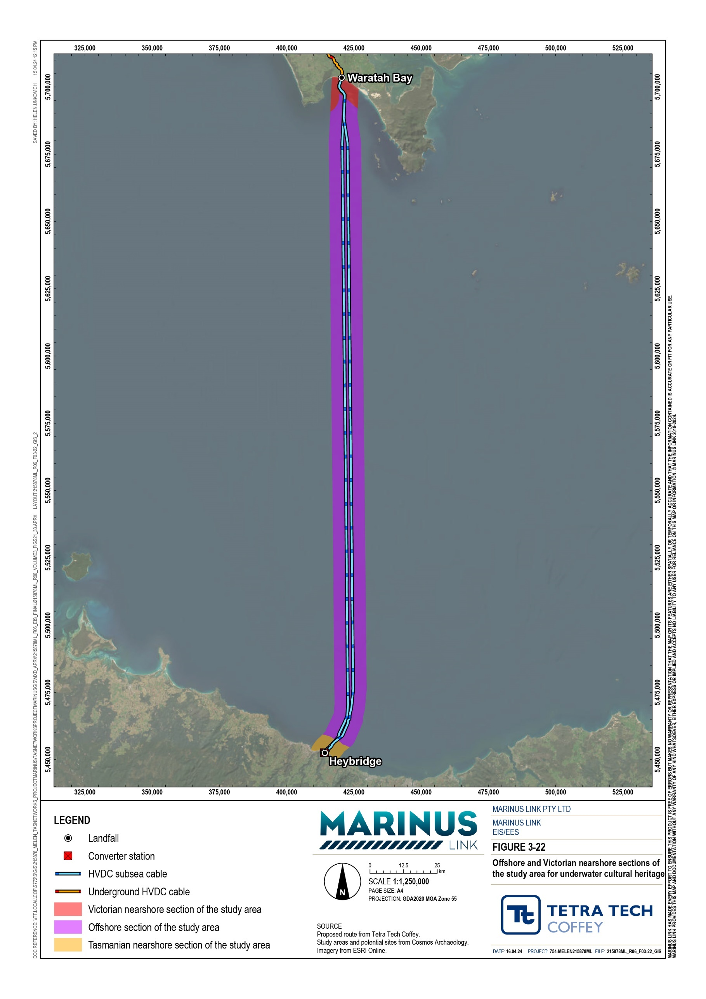

Key legislation
Table 4-1 below summarises the key legislation considered for underwater cultural heritage. For the full extent of legislation relevant to the project refer to Volume 1, Chapter 4 – Legislative framework.

Title | Relevance to the assessment
Underwater Cultural Heritage Act 2018 (Cwlth) | Sets the terms for the identification, protection and conservation of Australia’s underwater cultural heritage in the commonwealth marine area, and shipwrecks in State waters that have been submerged for 75 years or more.  Historic shipwrecks and aircraft wrecks (and certain associated articles) that have been in the water for at least 75 years are automatically protected under this Act if located in Commonwealth waters. Shipwrecks that have been in the water for at least 75 years and are located in state waters can also be protected. Shipwrecks that have been in Commonwealth or state waters less than 75 years can be designated as protected if the minister is satisfied that the sites or artefacts are significant. With regards to aircraft wrecks that have been in the water less than 75 years, only those located in Commonwealth waters can be designated as protected if the minister. Articles such as archaeological sites and artefacts may be protected by the minister if they meet certain criteria under the Act.  Submerged aboriginal artefact sites can be protected under the Act if the minister is satisfied that the associated articles are significant.
Aboriginal Heritage Act 2006 (Vic) | This Act provides for protection of Aboriginal cultural heritage in Victoria.  The project must obtain two CHMPs as part of the EIS/EES and obtain necessary permits to authorise activities that may impact Aboriginal cultural heritage.
Heritage Act 2017 (Vic) | This Act provides for protection of all items of cultural heritage significance in Victoria.  This includes historical archaeological sites and artefacts, cultural landscapes and places, shipwrecks and other significant objects.  The project activities must not knowingly disturb, damage or displace any object or site of cultural heritage significance. Some of these actions may be permissible with a permit. The project must report any shipwrecks or shipwreck artefacts discovered within 7 days of discovery. The project must report all other types of underwater archaeological sites within 30 days of discovery.

Submerged heritage predictive modelling
This section provides an overview of the modelling used to predict existing conditions for Aboriginal cultural heritage. A modelling approach was used because any Aboriginal cultural heritage artefacts present would be submerged and buried by thousands of years of sediment build up.
Since the arrival of humans into Australia approximately 65,000 years ago, rivers and lakes would have provided useful resources for people. At least 2 million square kilometres of Australian landscape (including Bass Strait) have since been inundated by rising sea levels, submerging these ancient landscapes and any. associated cultural heritage features and values.
As the full extent and depth of these submerged landscapes cannot be inspected, submerged terrestrial archaeologists develop predictive models to assess the likelihood that these submerged landscapes, and associated landforms, have Aboriginal cultural heritage features and values.

The terms ‘landscapes’ and ‘landforms’ are used in this chapter and are distinct terms. Landscapes are broad spatial areas that encompass various landforms, whereas landforms are singular geomorphic features within a landscape.
The technical specialist developed a predictive submerged terrestrial landscapes model to assess landforms with potential cultural heritage value in the study area. The submerged terrestrial landforms predictive modelling included the following steps:
Step A – Using geophysical and geotechnical survey data (SSS, MBES, sub-bottom profiling, magnetometer and radiocarbon analysis of seabed cores) to assess seabed geomorphology, subsurface geology and infer the age of landform formations and whether their age aligns with human presence.
Step B – Identifying previous seabed disturbance within the identified landscapes. The extent of disturbances to sites within the study area can eliminate some sites from needing further investigation.
Step C – Reconstructing submerged landscapes with suitable geomorphic and age criteria for containing heritage sites using data and outcomes from step A. This step establishes the characteristics of submerged landscapes that can be predictive of human behaviour patterns.
Step D – Establishing the context between terrestrial site types, associated landforms and local environments. This step uses terrestrial analogues in the region to indicate the likely site types associated with submerged landforms.
Step E – Assessing the predicted frequency of cultural material present within a defined landform or feature.
Step F – Establishing submerged landform site type associations. The amount and type of cultural material typically found in the terrestrial analogues can be used to predict the amount and type present in submerged landforms.
Step G – Predicting what sites might have survived being submerged.

Step H – Assessing the likelihood of site or cultural material presence and its condition within a submerged landform or feature. This step combines the frequency of cultural material from step E with the exposure measure, from step G, to predict the likelihood of a site holding cultural objects in a meaningful condition (i.e., the feature has not been modified beyond recognition).
Technical Appendix I: Underwater cultural heritage and archaeology provides further detail on this predictive modelling method.

Underwater heritage impact assessment method
The underwater cultural heritage impact assessment used the significance assessment method and modified it for use in the underwater cultural heritage assessment by including the probability of impact on an underwater cultural heritage site or item. Technical Appendix I: Underwater cultural heritage and archaeology includes the full description of the significance assessment method, as modified for underwater cultural heritage.

The three components of the method include:

Magnitude (or scale) of impact on an underwater cultural heritage site or item.

Significance (or consequence) of the impact on the cultural heritage values of a site or item. This is determined by the magnitude of the impact and cultural heritage sensitivity of the item.
Probability of impact on an underwater cultural heritage site or item.

The outcome of the assessment is a level of significance of impact rating and a probability of impact percentage.

Assumptions and limitations
The underwater cultural heritage assessment was based on the following key assumptions and limitations:

Side scan sonar (SSS) and multibeam echo sounder (MBES) data did not include the portion of the study area closest to shore as survey vessels could not safely access these shallow portions. To address this gap, the technical specialists included data from dive surveys and magnetometer surveys to collectively cover all sections of the study area, except for the new shore crossing alignment. This is not expected to be a material limitation as any cultural heritage artefacts in these portions will not be impacted by cable laying activities. HDD will occur in this area with no disturbance of the seabed.
The geophysical data obtained for the Victorian nearshore section of the study area did not cover the final approximately 380 m from the shoreline. This is not an issue for the purpose of this assessment as the cable HDD exit point from the shore crossing is expected to be 800 to 1,200 m from the shoreline, meaning any features within the 380 m from shore will not be impacted.
The geophysical survey method for the Victorian nearshore section of the study area did not adopt the same method as was used for the offshore and Tasmania section. While the confidence of the findings of the method adopted for the Victorian nearshore section is reduced, the method is sufficient to assess the likelihood of underwater cultural heritage occurring along or near the project alignment.
Due to safety, no diving was conducted for the offshore section of the study area. Diving was only conducted in the Victorian and Tasmanian nearshore sections of the study area up to a depth of 30 m. Any geophysical anomalies that have not been visually inspected remain potential maritime heritage values until visually inspected. This can be mitigated by realigning the project alignment to avoid geophysical anomalies, or inspection by ROV to identify the nature of geophysical anomalies.
Determining the significance of Aboriginal cultural heritage requires consultation with the relevant First Peoples communities. At the time of writing, consultation with First Peoples has not been completed to a point that it can be integrated into this assessment. To address this, ongoing consultation and further assessment of the submerged landforms is required under the EPRs.

Maritime heritage existing environment
This section describes the existing environment for maritime cultural heritage in the study area. This includes a description of the historical use of Bass Strait and the artefacts that could be present on the ocean floor such as shipwrecks, vessel discards, defence dumping sites and geophysical anomalies. The assessment in Technical Appendix I: Underwater cultural heritage and archaeology includes a description and assessment of potential maritime heritage artefacts in Tasmanian waters. This chapter only addresses underwater cultural heritage values in Tasmanian waters that are protected under the Underwater Cultural Heritage
Act 2018 (Cwlth). This is only relevant to shipwrecks in Tasmanian waters that have been submerged for at least 75 years, which could be declared as protected under this Act. Other underwater cultural heritage values protected under Tasmanian legislation are not addressed here.

Historical activities and context
Bass Strait has a high number of shipwrecks. Some reasons for this are:

Bass Strait’s notoriously rough waters and hazards in the form of islands, shoals and reefs.

There is a formal vessel disposal area 150 km to the northwest of the study area.

In 1940, during World War II, German naval forces laid mines in and around Bass Strait that are known to have sunk at least two vessels.
Waratah Bay is listed on the National Trust, is of state significance and is listed on the Victorian Heritage Register. It housed limestone mining and shipping activities from the late 1800s to around World War I, with shipments sent to Melbourne, more locally and to Sydney.
Review of the above and further historical context of the study area identified the following activities that occur presently or historically across Bass Strait:
human occupation in the late Pleistocene until post-glacial sea-level rise

development of ports and harbours following colonisation

fishing, sealing and whaling

intrastate and interstate shipping

international shipping

sea dumping of ammunition, boats, chemicals and a wide variety of potentially culturally relevant materials.
Due to these historic activities, shipwrecks and sea dumping, sites of potential maritime cultural heritage significance could be present across Bass Strait.

Shipwrecks
While geophysical data and underwater diving did not reveal any shipwrecks or dumped boats within the study area, review of AUCHD, VHD and other available historical resources identified 16 shipwrecks that could be in the offshore section of the study area, six shipwrecks that could be in the nearshore Victorian nearshore section of the study area and eight shipwrecks that could be in the Tasmanian nearshore section of the study area. The uncertainty is attributed to the vague descriptions of shipwreck locations in these historical resources. It is possible that further unreported shipwrecks exist in the study area, particularly in the offshore section of the study area, as it is less often accessed by recreational vessels and diving, reducing the chance of incidental encounters with maritime archaeological sites.
Of the 16 shipwrecks that could be in the offshore section of the study area, two may be within 5 km of the project alignments. Due to the low accuracy of recorded positions and the potential for wreckage to drift, a
9.5 km accuracy range has been assigned to these sites. Figure 3-23 shows the 9.5 km ranges within which two shipwrecks may occur within the project alignments. Only these two are depicted in Figure 3-23 because the remaining 14 are either reported as distant from the project alignments or have no location listed beyond ‘Bass Strait’.
One location of sinking (S.S Kanowna) was given as 22 km southwest of Cleft Island (Figure 3-23) and was likely found by a dive team in 2005. However, no coordinates were reported, and the discovery remains unrecognised by Heritage Victoria. There are no reports of the second wreck being found.
In the Victorian nearshore section of the study area, review of heritage databases identified six maritime archaeological sites (all shipwrecks) that may be located within 5 km of the project alignment centreline. The review of the AUCHD revealed that none of the wrecks have been reported as found and all list the same coordinates, implying ‘placeholder’ locations. Figure 3-24 shows the potential shipwreck locations in Waratah Bay, with one narrower field indicating a ship known to have wrecked near Shallow Inlet.
In the Tasmanian nearshore section of the study area, the heritage database review identified eight shipwrecks with a location range that reaches within 5 km of the project alignment centreline. One of these eight is listed as wrecked in 1959, so does not qualify for protection under the Underwater Cultural Heritage Act 2018 (Cwlth). The AUCHD revealed that none of the wrecks have been reported as found and that the shipwrecks’ locations have low and variable levels of accuracy. The potential location range for one shipwreck overlaps the project alignment, so this shipwreck or associated wreckage could be in the vicinity of the area of disturbance.
The location ranges of the other shipwrecks do not overlap with the project alignment, however wreckage associated with these shipwrecks could have floated into the area of disturbance. A review of the geophysical data and subsequent dive surveys in the Tasmanian nearshore section of the study area did not reveal any shipwreck sites or wreckage at the alignment. There is still a possibility that wreckage from a shipwreck that was not detected by the surveys may have floated into the study area. Figure 3-25 shows the potential location ranges of the eight identified shipwrecks in reference to the project alignment and study area.

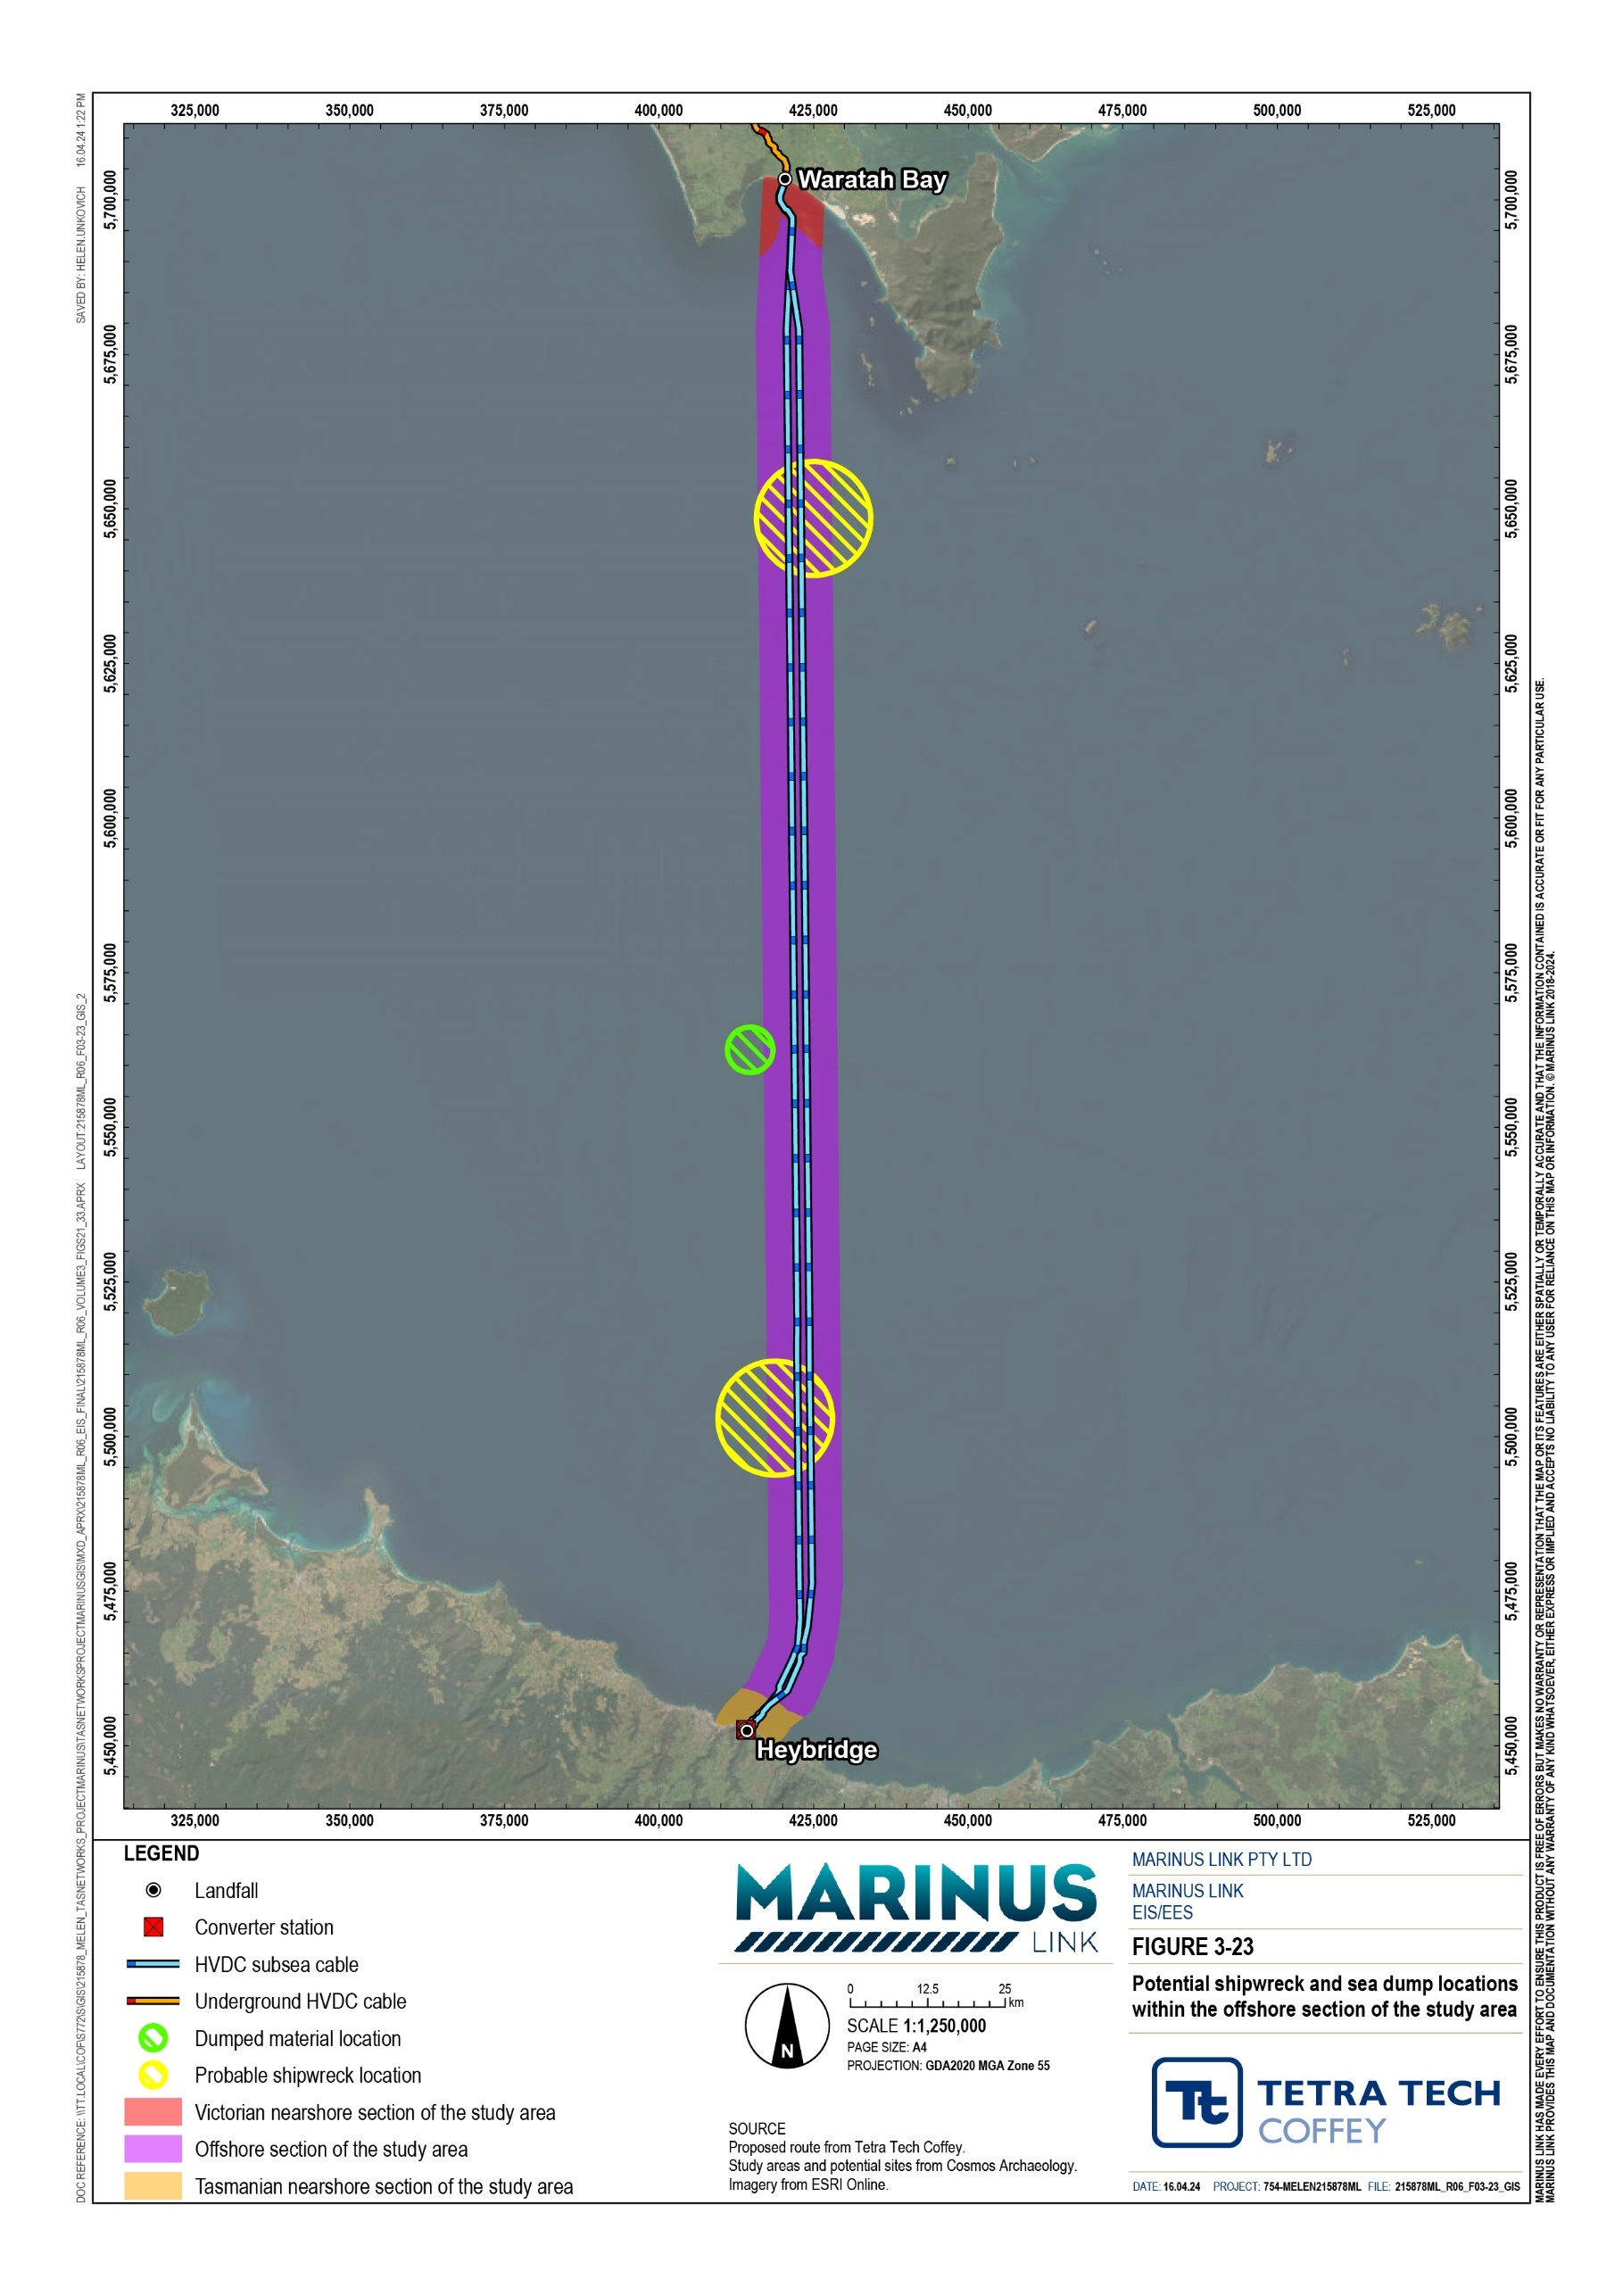
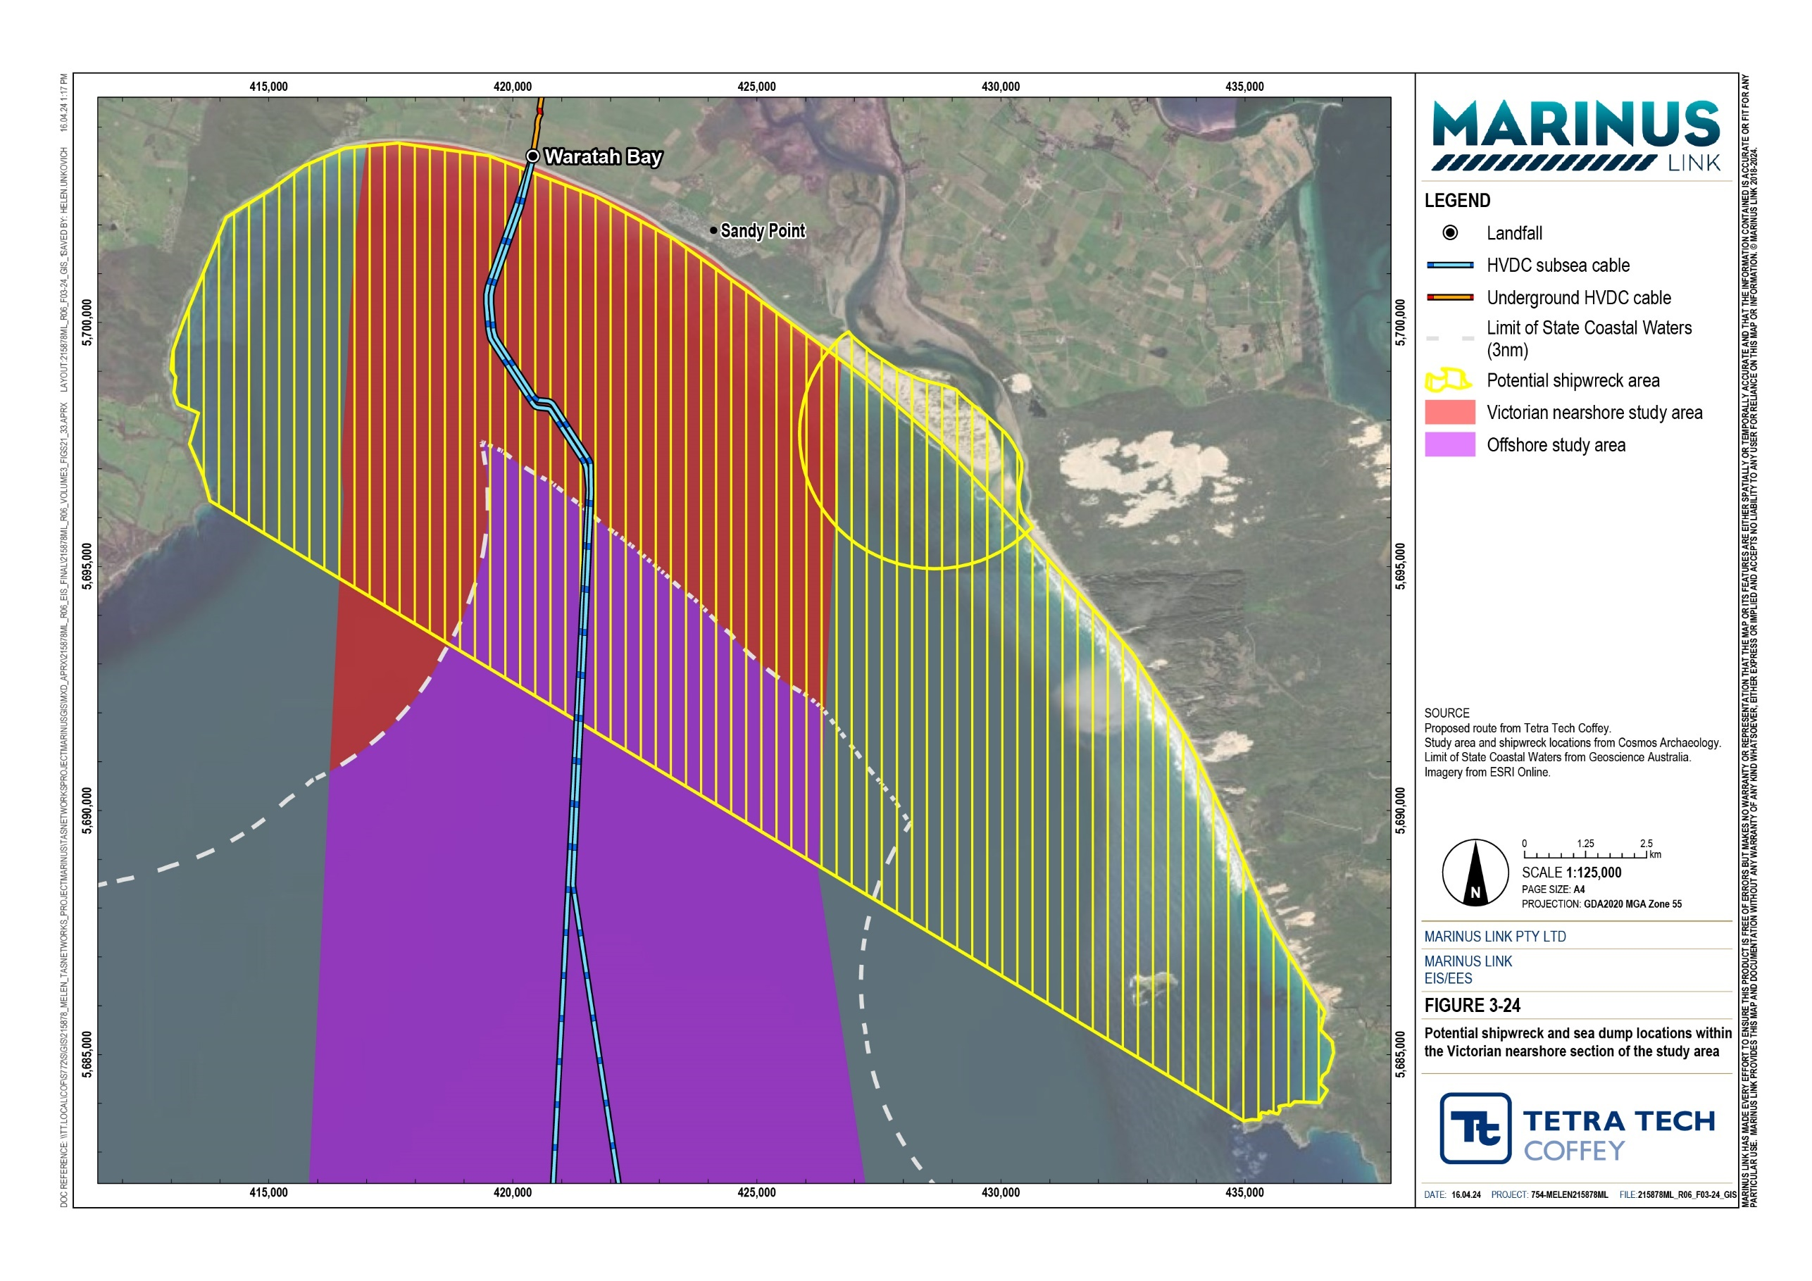

FILE:215878ML_R06_F03-25_GIS

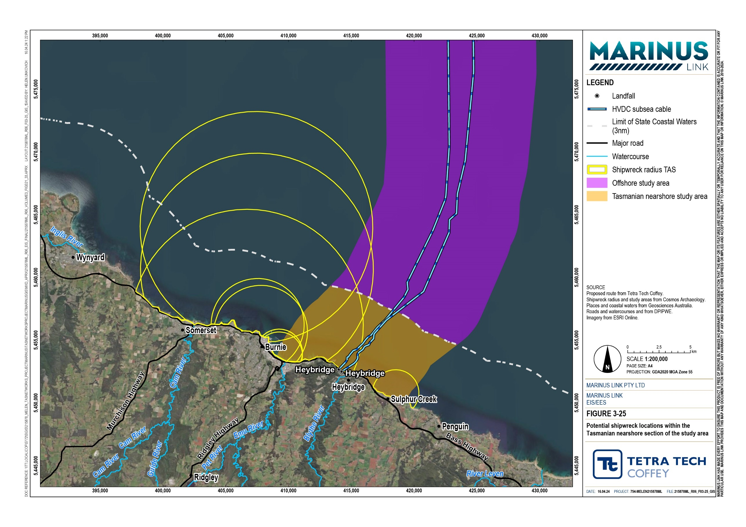

Dumping sites
There are two ammunition dumps listed in the AHO that may be within the offshore section of the study area and intersected by the project alignment. Such dump sites could cover an area up to a few kilometres. These listed sites have identical locations (Figure 3-23), date and description, possibly indicating that it is the same dump listed twice.
Geophysical and dive surveys conducted for the project identified no dumping sites. While it is unlikely that dumping sites are in the study area, this cannot be discounted due to the uncertainty of their recorded locations and the limitations of the present study.

Vessel discard
Vessel discard can be accidental or deliberate, and usually consists of single items that may occur in scatters. Items may include personal objects, food and drink containers, ships’ fittings and equipment, and fishing and boating equipment. These are unlikely to be of high historical significance as they would likely be of modern origin and be damaged. Such discards are more likely in the nearshore environments where vessels were more commonly moored. However, discards are still unlikely in Waratah Bay as there are no historic port facilities.

Unverified geophysical anomalies
Geophysical anomalies are features, identified from geophysical surveys, that are distinct from the surrounding seabed. These are surface anomalies and are generally associated with maritime heritage rather than Aboriginal heritage (submerged Aboriginal heritage is generally buried by millennia of sediment). Any anomalies not visually inspected, due to safety or time constraints, are unverified and remain potentially culturally significant until visually inspected.
Remote sensing data, collected by Fugro and XOCEAN (as cited in Technical Appendix I: Underwater cultural heritage and archaeology), assisted in identifying geophysical anomalies in the three sections of the study area and in reviewing their potential for cultural significance. Reviews, conducted by qualified maritime archaeologists, categorised the anomalies as follows:
priority A – potentially culturally significant and within 50 m of the project alignment

priority B – potentially culturally significant but beyond 50 m of the project alignment

priority C – most likely natural in origin rather than cultural

priority X – lowest priority, including known non-culturally significant features

Pre cable lay surveys via ROV will occur allowing for visual inspection of the anomalies closest to the project alignment. Review of the geophysical data identified 72 geophysical anomalies within the offshore section of the study area (Figure 3-26), seven of which were priority A. No anomalies in the offshore section of the study area could be directly inspected through dive surveys, due to their depths.
In the Victorian nearshore section of the study area, geophysical data identified seven geophysical anomalies (Figure 3.27). One is within 200 m of the project alignment, which is assumed to be a natural anomaly (not cultural heritage). The other six are over 200 m from the project alignment. None of the anomalies have been visually inspected as they are beyond the area of disturbance of project activities.
In the Tasmanian nearshore section of the study area, seven geophysical anomalies (four priority A and three priority B) were inspected during dive surveys and found to not be cultural heritage values. The geophysical surveys identified a further six priority C anomalies (Figure 3-28). As these six are expected to be natural features, they were not visually inspected and are not further assessed in this chapter.
Table 4-2 outlines the anomalies identified in the offshore and Victorian nearshore sections of the study area. For further details on the geophysical anomalies and corresponding surveys, see Technical Appendix I: Underwater cultural heritage and archaeology.

Study area | Priority A | Priority B | Priority C | Priority X | Visual inspections
Offshore | 7 | 25 | 26 | 14 | None due to water depths >30 m
Victorian nearshore | 0 | 3 | 4 | 0 | Ten priority A and B anomalies were inspected by dive surveys, primarily on the old project alignment. Two of these 10 anomalies are on the new alignment. However, the inspected anomalies were found to not be cultural heritage features.
Tasmanian nearshore | 4 | 3 | 6 | 23 | Seven priority A and B anomalies were inspected by dive surveys and were found to not be cultural heritage features.

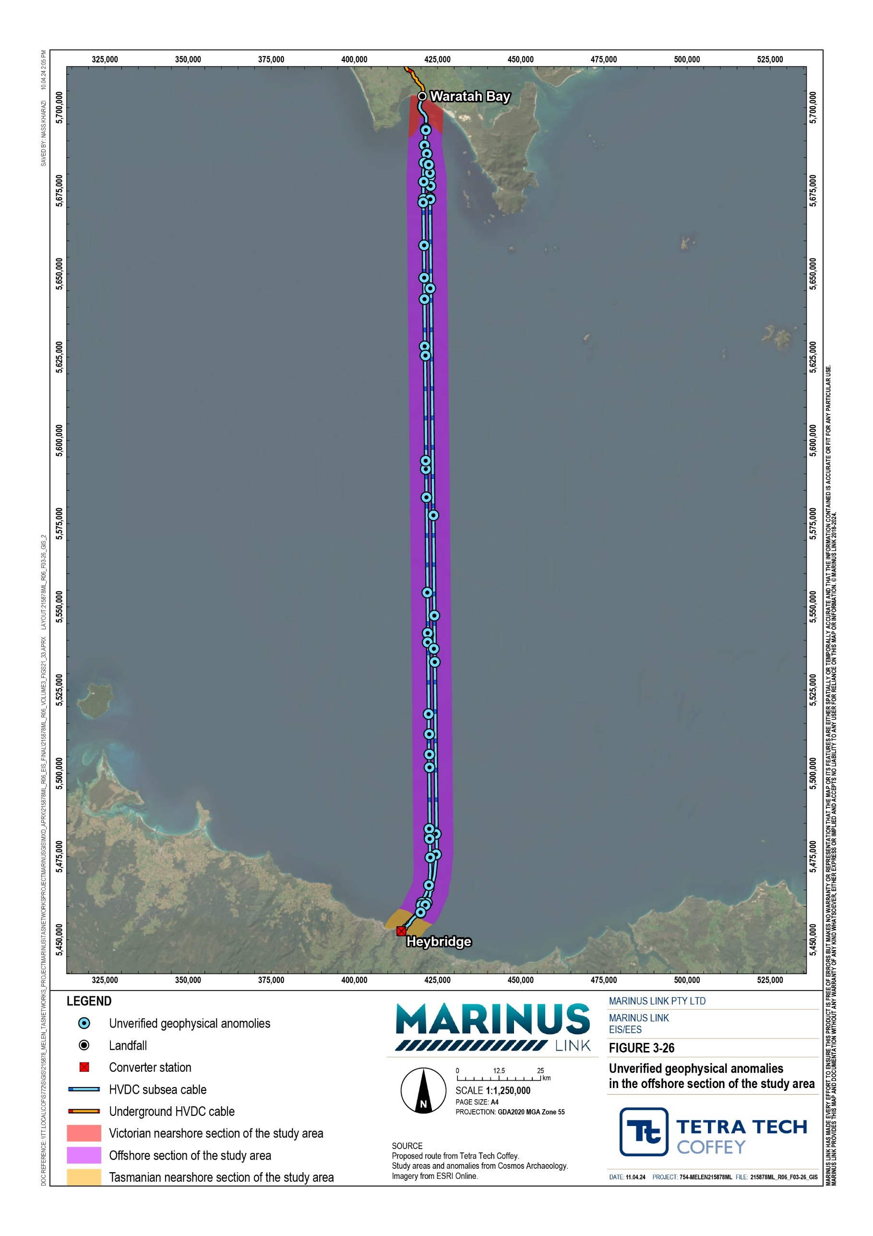
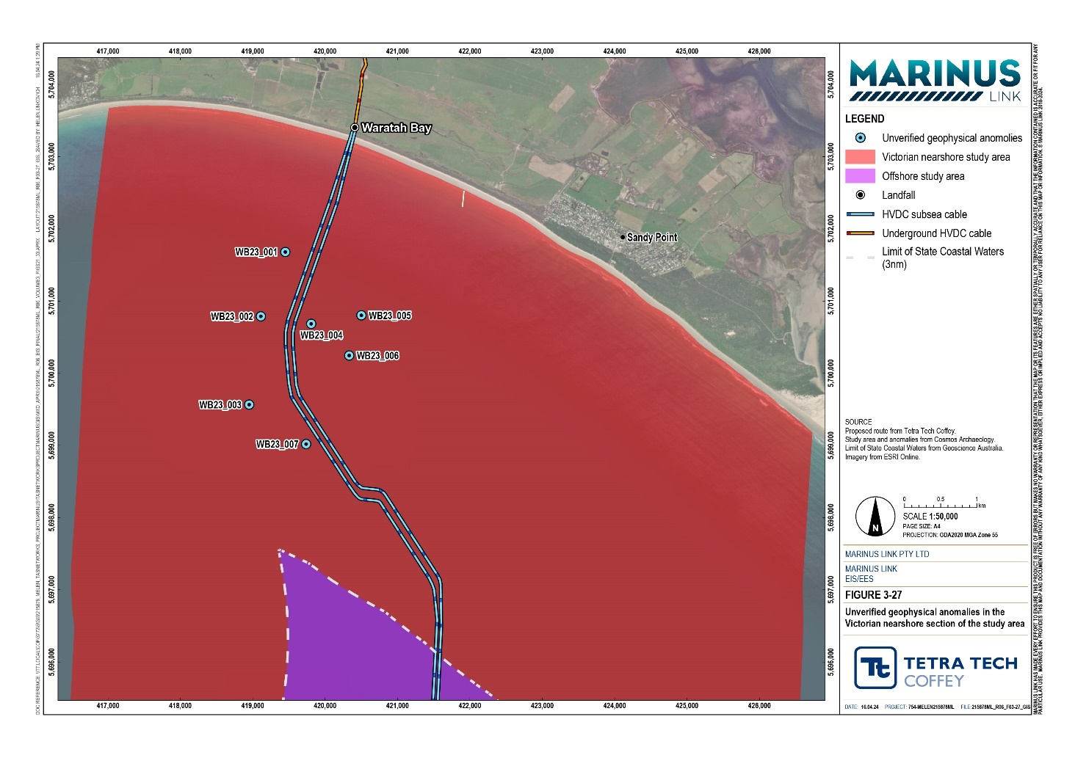
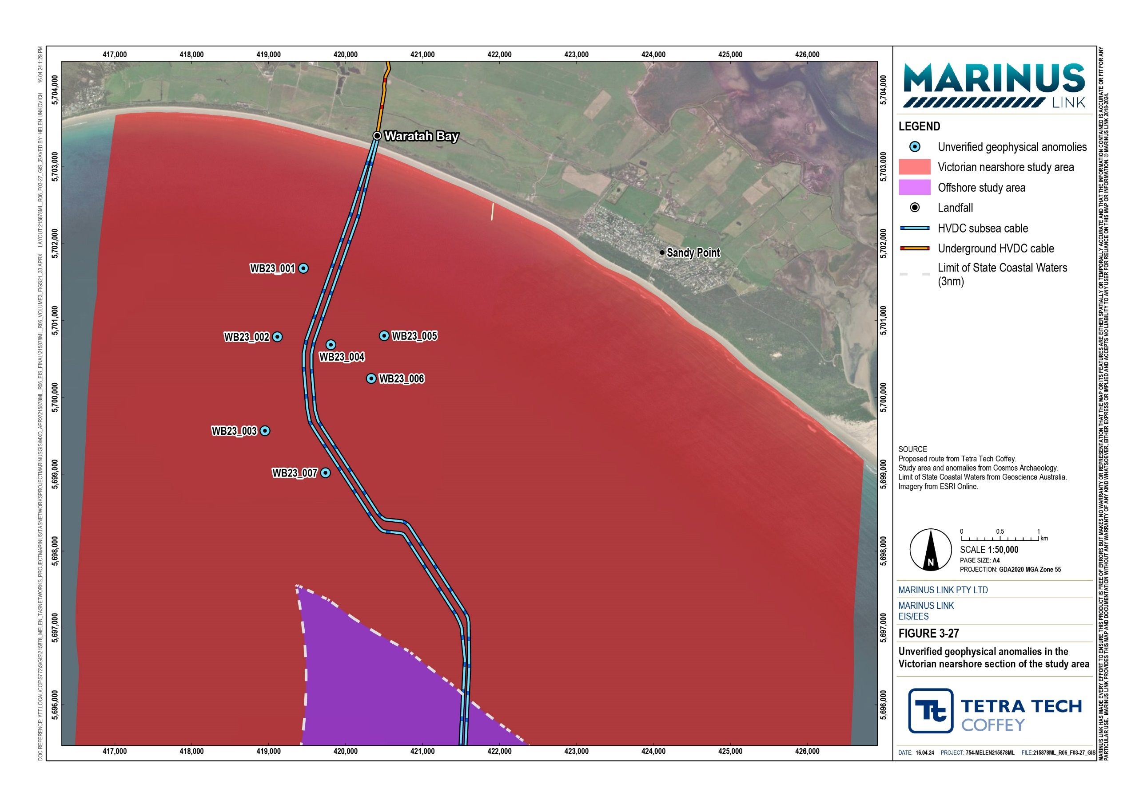
\

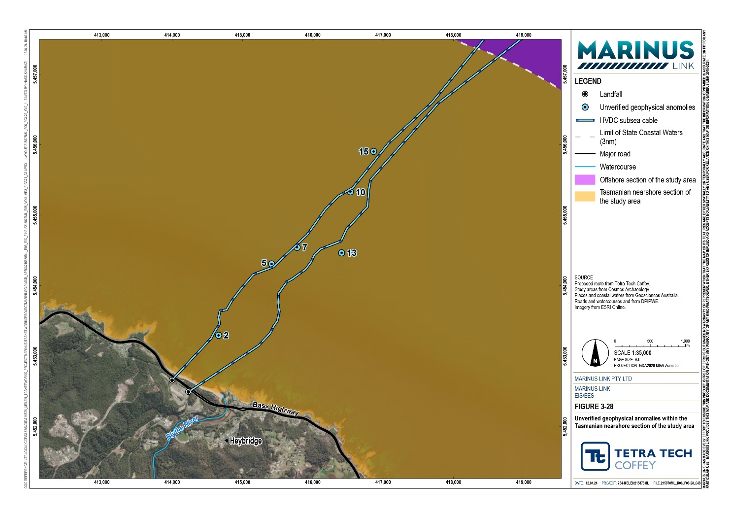
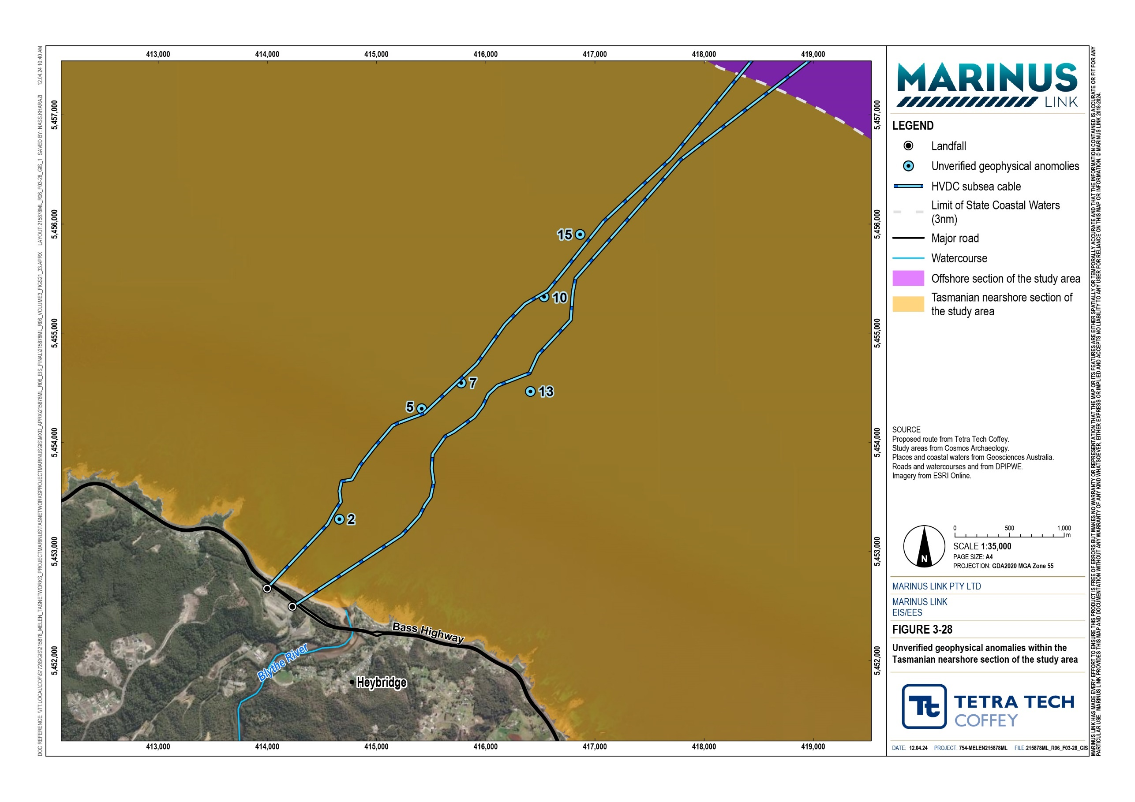

Aboriginal heritage existing environment
This section describes the existing environment for Aboriginal cultural heritage in the study area, as detailed in Technical Appendix I: Underwater cultural heritage and archaeology. The technical appendix considered the potential for submerged cultural landforms in all of the marine study area. Whilst the assessment identified a submerged entrenched stream/gully landform through the review of geophysical data in nearshore Tasmania, it is not discussed in this chapter. This chapter only discusses the existing conditions and impact assessment relevant to Commonwealth and Victorian legislation.

Geological history and human occupation context
The first Aboriginal people arrived in Australia about 65,000 years ago. Human presence in Tasmania dates to around 35,000 years ago at a time when low sea levels led to the formation of the Bassian Plain, allowing terrestrial emigration from the mainland. Today the Bassian Plain is submerged by the waters of Bass Strait. Between 25,000 to 16,000 years ago lower temperatures reduced the habitability of the Tasmanian uplands, possibly forcing people onto the Bassian Plain. Archaeological evidence indicates increasing human presence on the Bassian Plain around 23,000 years ago.
Current understanding of early human behaviour indicates that the first Aboriginal people would have preferentially occupied coastal environments, in part due to the familiarity of the resources provided and travel routes over water. Consequently, submerged landscapes that were coastal at some point following human arrival in Australia are more likely to hold sites of Aboriginal cultural heritage significance.
Resources available to people occupying the Bassian Plan would have included igneous deposits for preparation of tools, as well as groundwater springs and water holes.
Archaeologist Sandra Bowdler (cited in Technical Appendix I: Underwater cultural heritage and archaeology) conducted a review of Aboriginal archaeology in Bass Strait, as documented in Technical Appendix I: Underwater cultural heritage and archaeology. This details the relationship of Aboriginal peoples with the now inundated landscape. Bowdler describes Bass Strait prior to inundation as a lowland plain (Bassian Plain) inhabited by a nation adapted to an exposed, resource-limited land. The seasonal and ephemeral nature of the lake within this plain likely influenced this nation’s behaviour. Figure 3-29 shows the evolution of the Bassian Plain to submergence from 20,000 to 11,000 years ago.
From around 16,000 years ago, rapid sea level rise and intensifying drought conditions characterised the Bassian Plain. The sea rise forced inhabitants to abandon culturally significant sites and places that may have spanned over 1,000 generations. Remaining occupation was reserved to coastal regions and eventually just the islands of the Bass Strait, however archaeological records imply inhabitants also abandoned these islands between 10,000 to 4,000 years ago, likely due to climatic reasons.
With this context, this chapter considers submerged terrestrial landforms that may have Aboriginal cultural heritage significance and may be intersected by the project.

Volume 3 – Marine environment Page 4-18

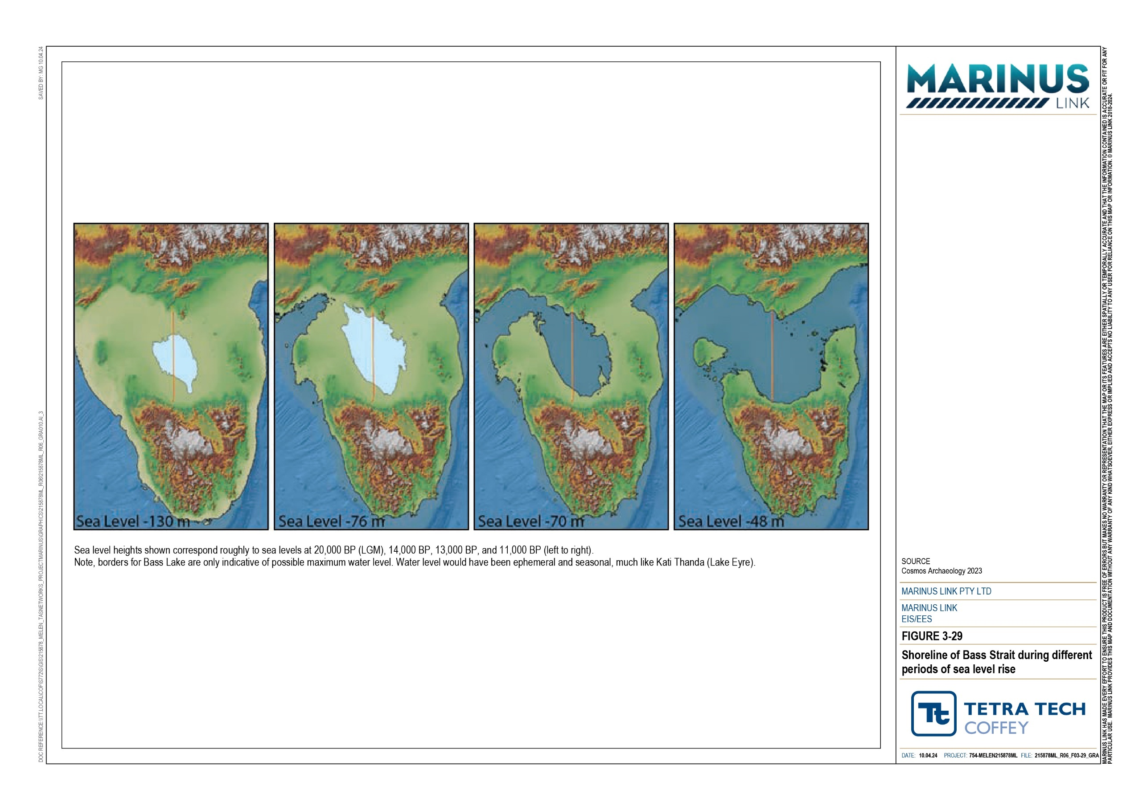

Submerged cultural landscapes
This section outlines the results of the predictive modelling assessment of submerged cultural landscapes and their potential to hold Aboriginal cultural heritage values.
The geophysical data that was used to inform the predictive model identified two types of cultural landform features near the project alignment in the offshore section of the study area. The locations of these features in the offshore section of the study area and their position, relative to the project alignment, are displayed in Figure 3-30.
Multibeam bathymetry showed evidence of submerged beach ridge formations in the southern portion of the offshore section of the study area within 20 km of the Tasmanian coast, as depicted in Figure 3-31. Ridges are present at depths ranging from 45 m to 70 m and exhibit the distinctive geometry of a former shoreline.
In the northern portion of the offshore section of the study area, sub-bottom profile data revealed a 3 m deep channel buried beneath the seabed. This is indicative of a former estuarine channel. The geometry of the feature indicates it was a meandering channel on a broad, flat coastal plain. The channel is up to 400 m wide and about 76 m below current sea level. The channel is approximately 27 km from the Victorian coast as shown in Figure 3-30. Figure 3-32 shows the sub-bottom profiler data that identifies the submerged estuarine channel, along with a terrestrial analogue of Shallow Inlet.
In the Victorian nearshore section of the study area, geophysical data identified a beach ridge strandplain approximately 3 km from the shoreline (Figure 3-30). This landform is between 17 to 22 m deep and approximately 1.5 km wide. The last time sea level was at this elevation for long enough to produce such a landform was around 80,000 years ago, indicating it formed prior to human occupation and therefore would have been inland, rather than coastal, when humans were in this region.
To indicate the age of sediments at different depths in the beach ridge formations, three borehole cores were taken in the southern portion of the offshore section of the study area and assessed by radiocarbon dating. Figure 3-33 shows the locations of the cores sampling. All cores were tested using multisensory core logging and x-ray imaging, as well as C14 radiocarbon dating of the unearthed organic components.
The upper metre of all cores represents the 10,000 years to 11,000 years of marine sediment deposition following sea level transgression. Radiocarbon dating of the organic components showed their ages align with historic sea level elevation. The layer immediately underlying the contemporary upper metre, observed in two of the three cores, is basalt cobbles.

One of the cores withdrew sediment from below the cobble layer. This sediment was indicative of a still water environment with little biological activity. A layer between the lower sediment and the basalt cobble exhibits characteristics that indicate the presence of marine burrowing organisms, indicating the incursion of marine water. The assessment that the sedimentary layers originated from a non-marine environment is supported by the radiocarbon dating of woody and charcoal materials. Tests showed these materials are around
13,000 years old and the associated sedimentary layers originate from a terrestrial depositional environment (i.e., likely a lagoon or lake system). Since sea level transgression occurred 10,000 years to 11,000 years ago, the age of the woody and charcoal material indicates that a lake would have been present when the area was inhabited by Aboriginal people.
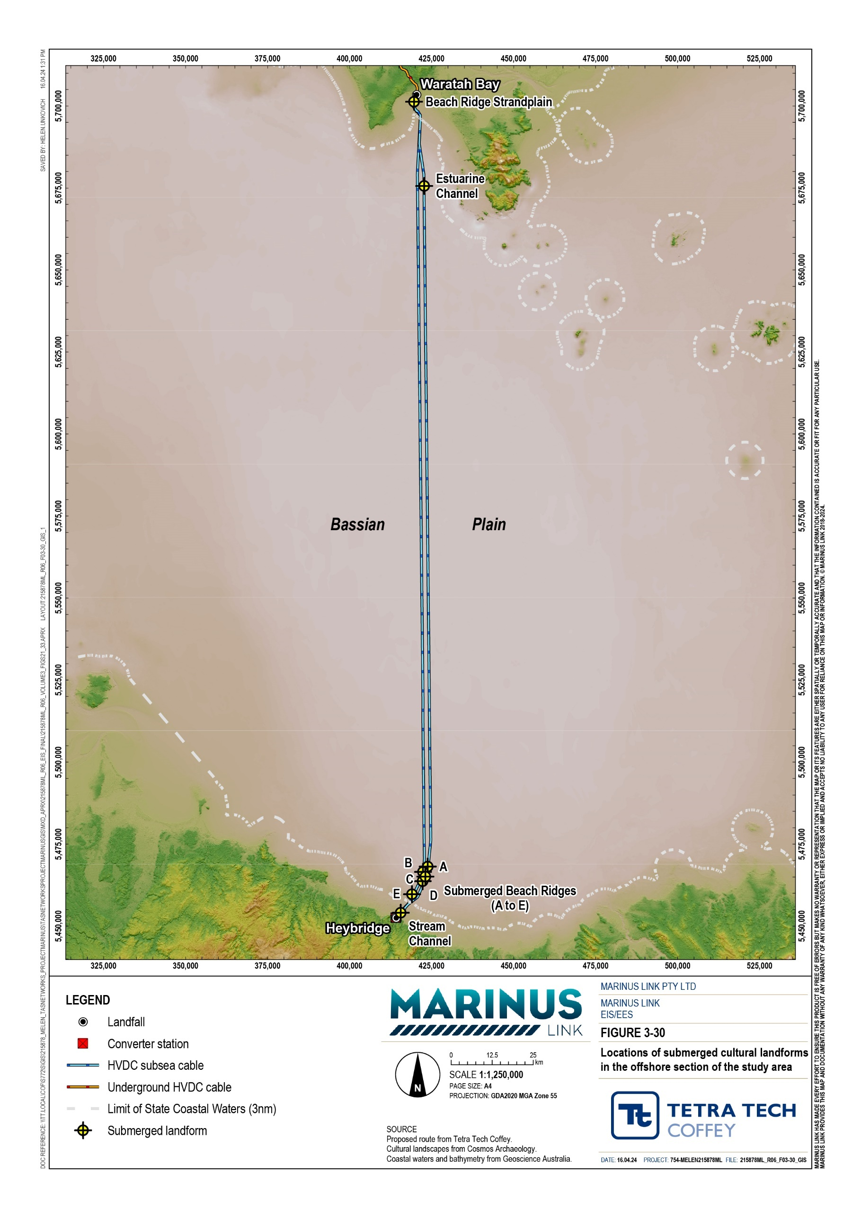

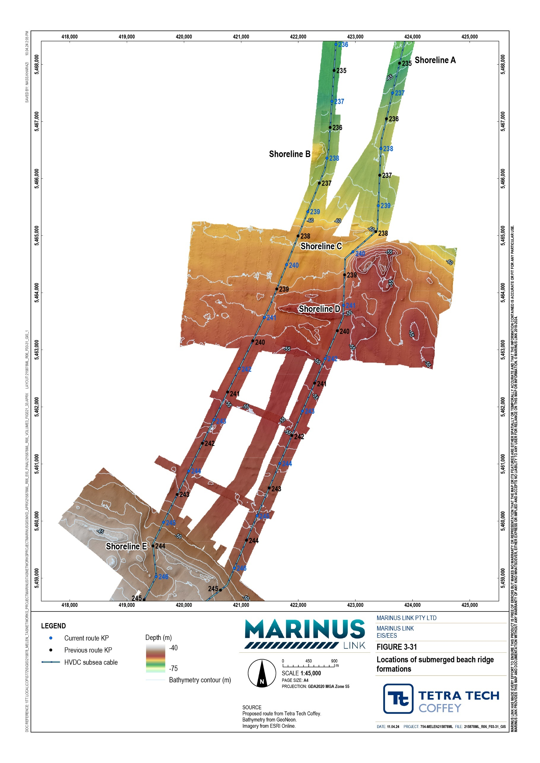
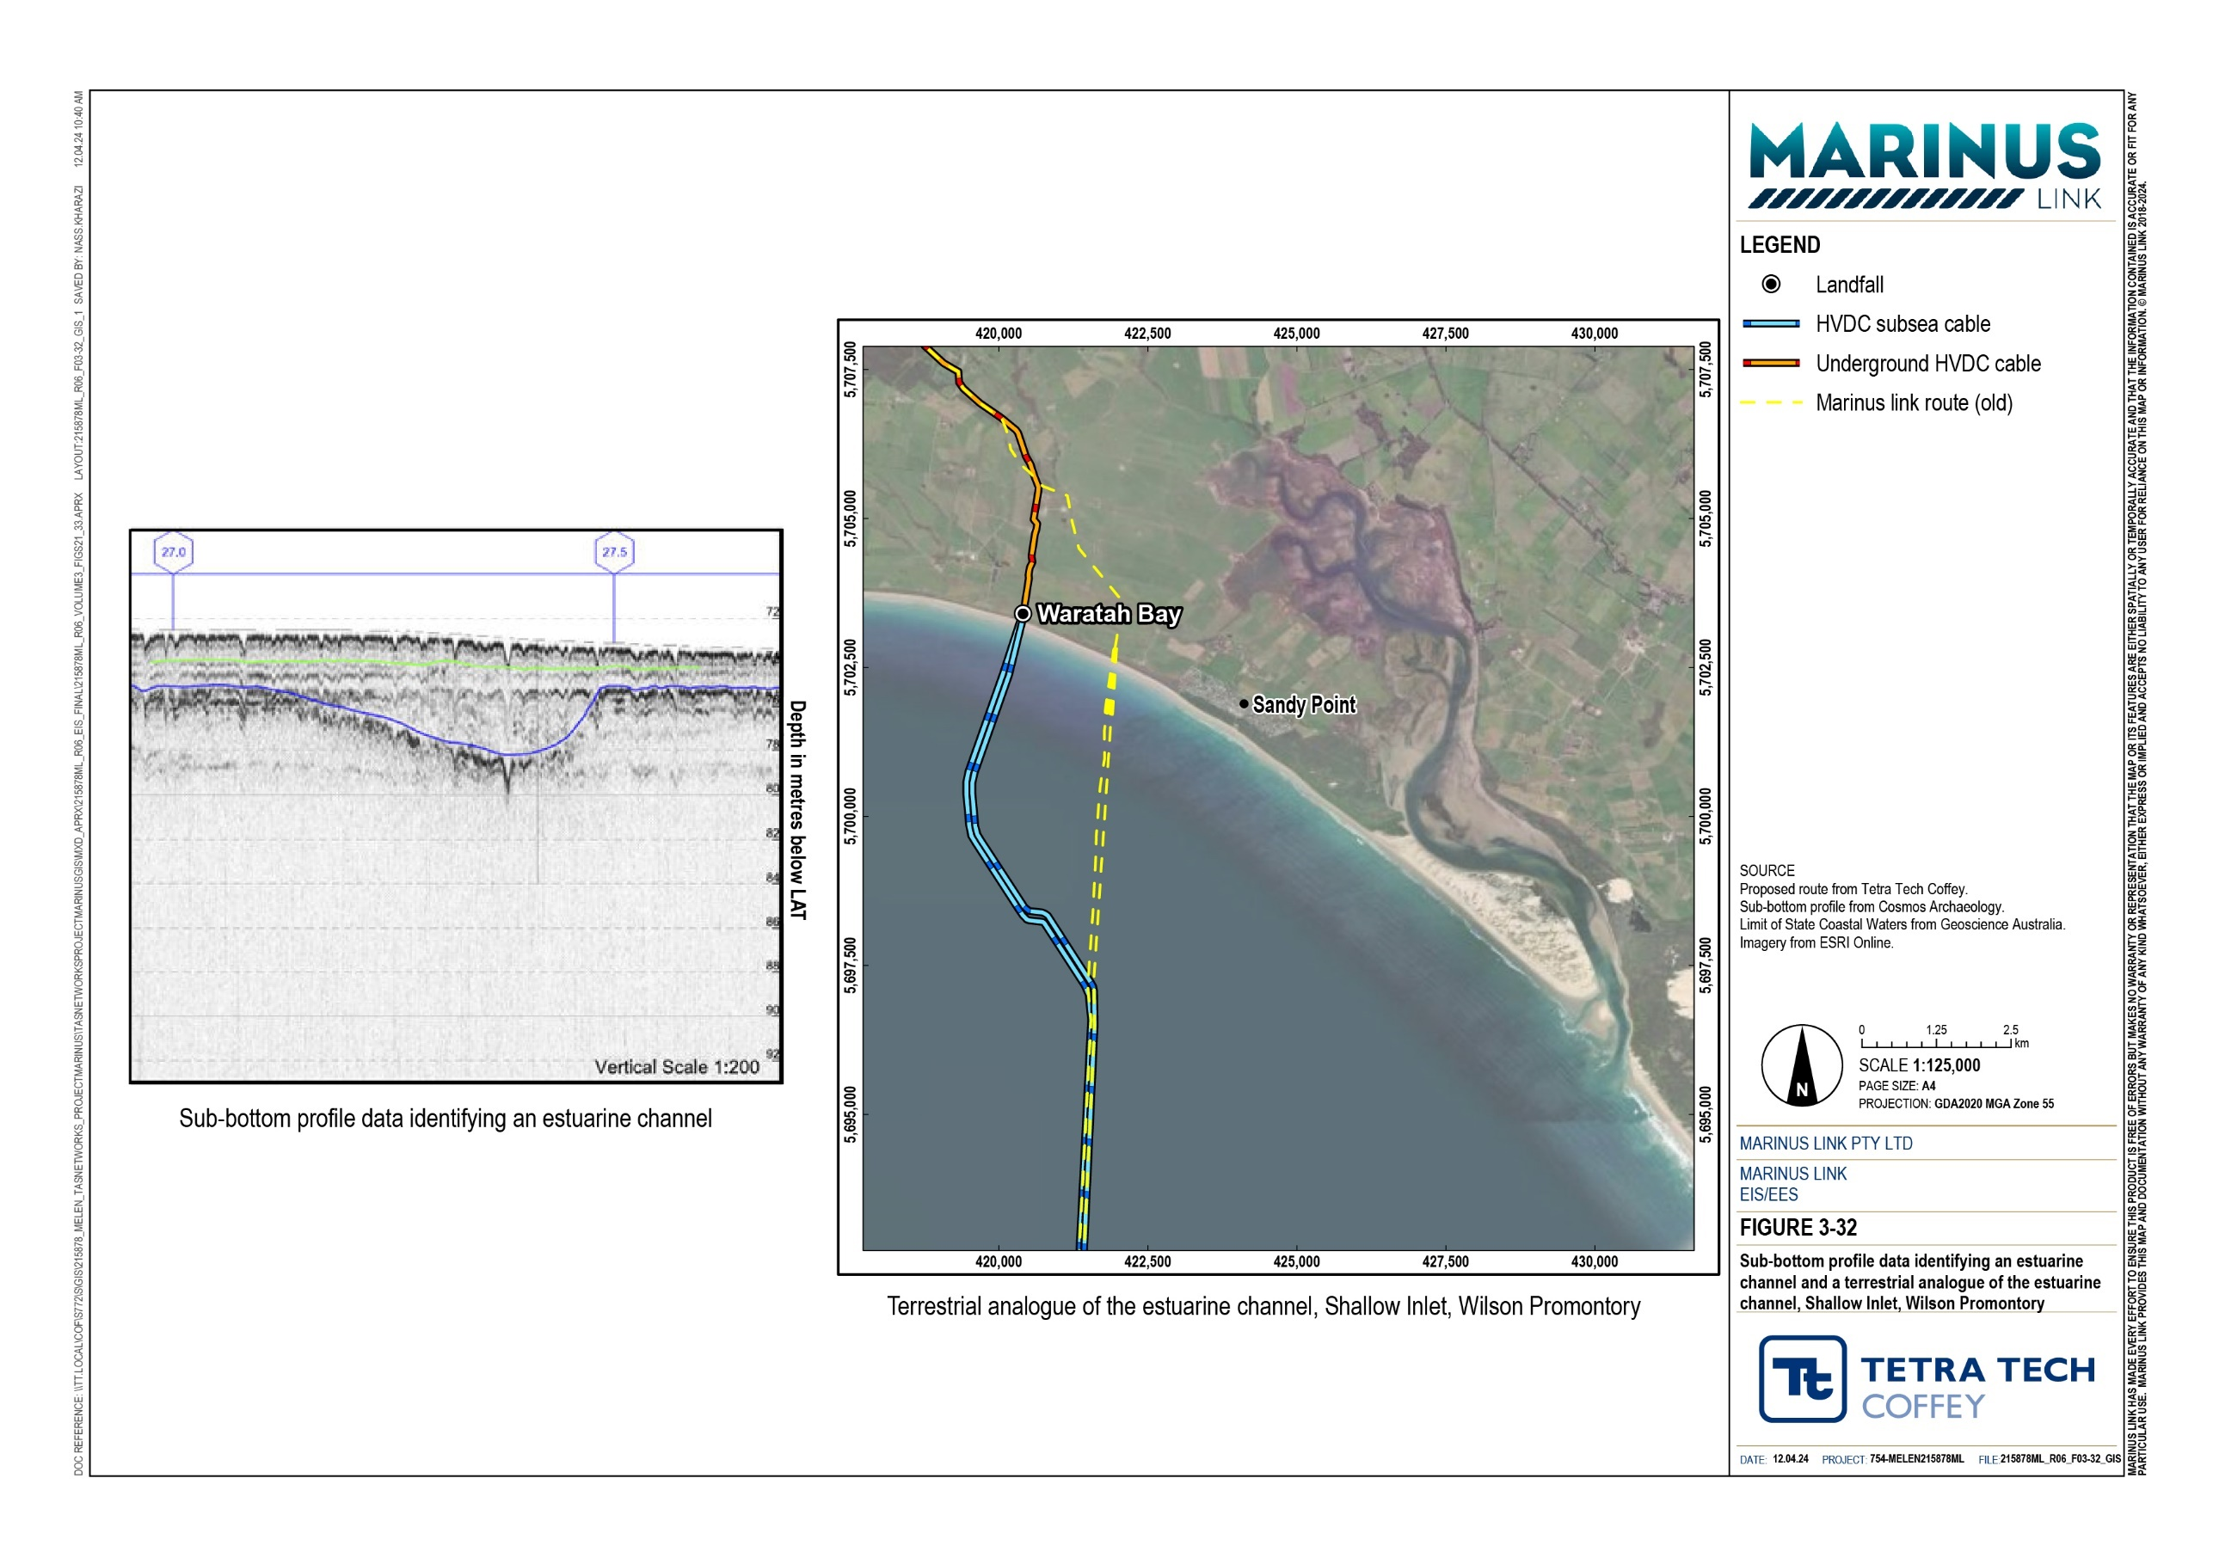
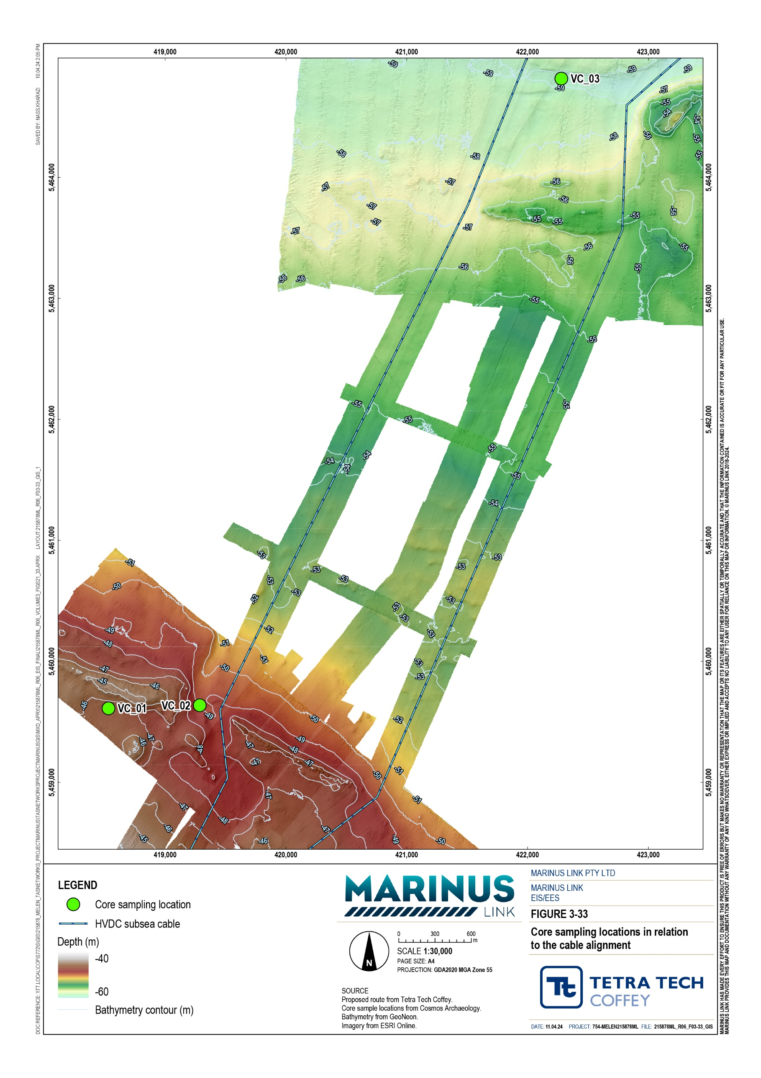

Table 4-3 summarises the findings of the submerged heritage predictive modelling, including the three landform types identified and the archaeological site types likely to be associated with those landforms. Analogous contemporary terrestrial landforms, that have been surveyed for archaeological remains, are used to predict these associations. Table 4-3 also presents the expected condition of the site types and the likelihood of sites being in a condition where archaeological value is recognisable. Refer to Technical Appendix I: Underwater cultural heritage and archaeology for the full description of how the assessment established the submerged heritage predictive model.

Submerged landform | Associated site type  (Step D and F) | Frequency of site type (Step E) | Site integrity (Step G) | Likelihood of presence (Step H)
Estuarine channel | Artefact scatter –  Site type is based on terrestrial analogues from Bobundara Swamp, NSW | From the landform analogues (Step D and Step F), a score from 0 (nil) to 5 (common) is attributed, reflecting the predicted frequency of archaeological features.  Artefact scatter frequency score is 2 (rare) meaning that between 0.1 to 1% of estuarine channel sites are expected to contain artefact scatters. | Site integrity combines a site’s durability and its exposure to hydrodynamic processes resulting in a score from 0 (high integrity) to 5 (low integrity).  Artefact scatter site integrity score is 3 due to expected exposure to predominantly low energy waves, erosion and inundation energy. The site durability is predicted to be low due to the fragility and transportability of the artefacts and lithics. | Subtracts the scores attained in Step G from that of Step E. A score from <1 (very low confidence) to 5 (very high confidence) is attributed reflecting the likelihood of presence in a meaningful condition.  Artefact scatter likelihood of presence score is <1 (very low confidence) meaning there is extremely low likelihood of the presence of material that has survived inundation and ocean conditions with a recognisable degree of archaeological integrity.

Submerged landform | Associated site type  (Step D and F) | Frequency of site type (Step E) | Site integrity (Step G) | Likelihood of presence (Step H)
Beach ridges | Middens & Artefact scatter –  Site types are based on terrestrial analogues (beach- barrier landforms) from coastal dunes between Kilcunda and Cape Patterson, Victoria. | From the landform analogues (Step D and Step F), a score from 0 (nil) to 5 (common) is attributed, reflecting the predicted frequency of archaeological features.  Middens frequency score is 5 (common) meaning that >50% of beach ridge sites are expected to contain middens.  Artefact scatter frequency score is 4 (frequent) meaning that 10 to 50% of beach ridge sites are expected to contain artefact scatters. | Site integrity combines a site’s durability and its exposure to hydrodynamic processes resulting in a score from 0 (high integrity) to 5 (low integrity).  Middens site integrity score is 3 due to expected exposure to predominantly low energy waves, erosion and inundation energy. The site durability is predicted to be low as archaeological material is likely to be moved from the context that makes them archaeologically significant.  Artefact scatter site integrity score is 2 due to expected exposure to predominantly low energy waves, erosion and inundation energy. The site durability is predicted to be moderate as this landform has likely solidified over time. | Subtracts the scores attained in Step G from that of Step E. A score from 0 (least possible) to 5 (very high confidence) is attributed reflecting the likelihood of presence in a meaningful condition.  Middens likelihood of presence score is 2 (low confidence) meaning there is very low likelihood of the presence of material that has survived inundation and ocean conditions with a recognisable degree of archaeological integrity.  Artefact scatter likelihood of presence score is 2 (low confidence) meaning there is very low likelihood of the presence of material that has survived inundation and ocean conditions with a recognisable degree of archaeological integrity.
Beach ridge strandplain | Artefact scatter – Site type is based on two strandplain analogues at Ninety Mile Beach and Waratah Bay  (3.5 km landward of the newly identified beach ridge strandplain), Gippsland. | From the landform analogues (Step D and Step F), a score from 0 (nil) to 5 (common) is attributed, reflecting the predicted frequency of archaeological features.  Artefact scatter frequency score is 2 (rare) meaning that between 0.1 to 1% of strandplain sites are expected to contain artefact scatters. | Site integrity combines a site’s durability and its exposure to hydrodynamic processes resulting in a score from 0 (high integrity) to 5 (low integrity).  Artefact scatter site integrity score is 4 due to expected exposure to high energy waves, erosion and inundation energy. The site durability is predicted to be low as strandplain inundation would have washed away any artefacts held in the topsoil. | Subtracts the scores attained in Step G from that of Step E. A score from 0 (least possible) to 5 (very high confidence) is attributed reflecting the likelihood of presence in a meaningful condition.  Artefact scatter likelihood of presence score is <1 (very low confidence) meaning there is very low likelihood of the presence of material that has survived inundation and ocean conditions with a recognisable degree of archaeological integrity.

In summary, the submerged cultural landform assessment of potential existing Aboriginal cultural heritage is as follows:
There is the least possible confidence that artefact scatters will be present with a recognisable degree of archaeological integrity in the estuarine channel landform.
There is very low confidence that middens or artefact scatters will be present with a recognisable degree of archaeological integrity in the assessed beach ridges. The increase in confidence attributed to the beach ridges is due to the higher score for frequency of site type (Step E) for these formations.
There is very low confidence that artefact scatters will be present with a recognisable degree of archaeological integrity in the assessed beach ridge strandplain. The decrease in confidence relative to the other landforms is attributed to the lower site integrity score (Step G).

Summary of cultural heritage values and sensitivities
The assessment found no examples of maritime heritage sites in the Victorian nearshore or offshore sections of the study area and no examples of underwater cultural heritage protected under Commonwealth legislation were found in the Tasmanian nearshore section of the study area. However, the presence of maritime heritage sites cannot be discounted, as no section of the study area has been surveyed comprehensively due to the factors discussed in Section 4.2.
Consequently, three types of maritime heritage sites are assessed for the Victorian nearshore or offshore section of the study area. Shipwrecks, or associated wreckage and geophysical anomalies, are assessed for the Tasmanian nearshore section of the study area. The assessed potential values for maritime heritage in the Victorian nearshore and offshore section of the study area include:
shipwrecks

sea dumping sites and vessel discard

geophysical anomalies.

The submerged heritage predictive modelling process, outlined in Section 4.1.3, identified three submerged landform features, in Victorian or Commonwealth waters, that have the potential to hold Aboriginal cultural heritage artefacts. As these features have not been visually inspected for the presence of Aboriginal cultural heritage artefacts, the predicted sites outlined in Section 4.3.2 are assessed. The landform features that are the assessed values for underwater Aboriginal cultural heritage are as follows:
estuarine channel

beach ridge landforms

beach ridge strandplain.

As described in Section 4.3.2, these values are submerged landforms for which terrestrial landform analogues with comparable characteristics are known to hold Aboriginal cultural heritage artefacts. Assessment of these values is an assessment of the potential cultural artefacts they may hold.

Cultural heritage significance
All occurrences of cultural heritage have a level of significance that is usually a product of the object or site’s rarity, cultural value at local to international levels and physical condition. As the condition of sites and objects within the study area cannot be assessed without visual inspection or excavation, the significance of these sites will be assessed without reference to their physical condition.
The assessment used the criteria outlined by the Australian ICOMOS Charter for the Conservation of Places of Cultural Significance 1999 to predict the significance of potential Aboriginal and maritime cultural artefacts. This is the standard employed by most heritage practitioners in Australia. The heritage significance assessment also considered relevant Commonwealth and Victorian criteria.
The predicted heritage significance of potential sites in the study area are outlined in Table 4-4. Details of the assessment of heritage significance is provided in Technical Appendix I: Underwater cultural heritage and archaeology.

Site types | Heritage significance | Heritage significance level
Shipwrecks | Considers the representativeness, rarity and value at local, regional, state, national and international levels.  Significance usually considers physical condition, but as this assessment deals | Medium to high – shipwrecks discoveries are rare in Bass Strait and any new discoveries would contribute to our understanding of 19th and 20th century waterborne activities and traditions
Sea dumping sites | with potential sites, this aspect has been discounted. | Low – sea dumping sites can vary in content and are common across Australia
Vessel discard |  | Low – vessel discard can consist of rubbish and is common across Bass Strait
Consultation with First Peoples is ongoing and will inform the social, historical, spiritual and aesthetic significance of Aboriginal cultural heritage artefacts, in addition to the predicted occurrence of sites. It is expected that any surviving sites discovered would have high scientific and historical significance as they would be the first of their kind in south-eastern Australia.
The predicted heritage significance of potential site types associated with the identified submerged landforms are outlined in Table 4-5.

Submerged landforms | Site type association | Scientific/archaeological significance | Heritage significance level
Estuarine channel | Artefact scatter | The significance of these site types is generally equivalent to those on land but would likely have enhanced values on the basis that they are associated with an older inundated | High
Beach ridge | Artefact scatter | Pleistocene landscape. | High
 | Midden |  | High
Beach ridge strandplain | Artefact scatter |  | High

Cultural heritage sensitivity
Cultural heritage sensitivity is a product of cultural heritage potential (likelihood of presence) and cultural heritage significance. The cultural heritage potential of Aboriginal cultural heritage and submerged landforms is determined through the method described in step H of Section 4.1.3.

Construction impacts
Construction of the project may impact on cultural heritage values in the study area. Impacts to both maritime and Aboriginal cultural artefacts could relate to cable installation activities and apply to the offshore section of the study area. Impacts to the Victorian nearshore section of the study area will be largely avoided by HDD crossing of the shoreline. The key impacts relate to the following activities:
a pre-lay grapnel run

cable installation activities

rock armour and mattresses

anchoring

HDD.

Due to the uncertainty surrounding the cultural heritage significance of the various sites assessed, the highest significance level of the potential sites assessed in Technical Appendix I: Underwater cultural heritage and archaeology is adopted. As cultural heritage significance informs the sensitivity rating, impact magnitude and impact level, the highest assessed rating of each of these factors is discussed in this chapter. This conservative approach assesses a worst feasible scenario.

The impact assessment in Technical Appendix I: Underwater cultural heritage and archaeology includes potential maritime heritage artefacts in Tasmanian waters. As this chapter only addresses underwater cultural heritage values in Tasmanian waters that are protected under the Underwater Cultural Heritage Act 2018 (Cwlth), only shipwrecks are included in this impact assessment.
The impact assessment method also includes a probability of impact factor. The inclusion of probability is necessary as the assessment of underwater cultural heritage is reliant on the interpretation of geotechnical and geophysical data. The limitations of these data collection methods mean that the presence or absence of underwater cultural heritage sites cannot be stated with certainty.
The terms used to describe the probability of impact, which are used in this chapter, include:

Certain (100%)

Highly probable (85 to 99 %)

Probable (50 to 84%)

Improbable (25 to 49%)

Highly improbable (1 to 14%)

Almost impossible (< 1%).

Refer to Technical Appendix I: Underwater cultural heritage and archaeology for the full description of how the assessment considers impact probability.

Pre-lay grapnel run
Project construction will include a series of a pre-lay grapnel run that involve towing a grapnel along the seabed at the project alignments, down to 0.5 m below the seabed. The purpose of this is to clear the project alignment of obstacles such as ghost nets and boulders, that may interfere with the cable bundles either during or post-installation.
The grapnel run will damage or dislocate any maritime heritage along its path (down to 0.5 m below the seabed) and reduce the heritage significance of these objects. The impact was assessed to be highly probable.
Most of the potential maritime heritage values assessed in the study area are considered unlikely to be present along the project alignment and therefore unlikely to be impacted by the grapnel run. The exception is the five geophysical anomalies identified within 10 m of the project alignment which are considered highly probable to be impacted. The impact assessment of a pre-lay grapnel run on the various potential maritime heritage values in the offshore section of the study area is summarised in Table 4-6.

The impacts to shipwrecks are assessed as moderate prior to mitigation if an intact shipwreck, of high heritage significance, is found in the path of the grapnel run. The assessed probability is almost impossible as the assessment found no indication that a shipwreck is near the project alignment, which is consistent for all impacts to shipwrecks. Developing and implementing an underwater cultural heritage management plan (UCHMP) for the project (EPR UCH04) will mitigate potential impacts to shipwrecks.
The impacts to vessel discards are assessed as very low prior to mitigation if discards are found in the path of the grapnel run and are of low heritage significance. The assessed probability is highly improbable as discards are more common when ships are moored, and most of the study area is not appropriate for mooring. This assessment of impact probability is consistent for all impacts to discards. Developing and implementing a UCHMP (EPR UCH04) will mitigate the impacts to vessel discards.
The impacts to geophysical anomalies prior to mitigation are assessed as moderate if they are objects or sites of high cultural significance. The assessed impact probability is highly probable for the anomalies within 10 m of the project alignment and improbable for the anomalies located 10 m to 50 m from the project alignment due to their respective proximities to the grapnel run. The mitigation measures for all known or newly identified anomalies are to realign the project alignment to avoid them by the buffer distances listed in Table 4-6 (at least 10 m), or if this is not feasible, to assess the anomalies for the cultural heritage value using an ROV (EPR UCH02). An ROV survey of a geophysical anomaly will determine its cultural heritage value, and allow suitable mitigation measures to be developed and implemented. The ROV survey will also confirm whether anomalies within 10 m of the alignment can be avoided. Necessary mitigation could range from archival survey to archaeological excavation, as determined by a qualified maritime archaeologist.

Site type | Sensitivity | Impact magnitude | Impact level | Impact probability | Mitigation measures
Potential shipwreck | Very sensitive | Moderate | Moderate | Almost impossible | Develop and implement a UCHMP (EPR UCH04)

Potential discard | Sensitive | Minor | Very low | Highly improbable | Develop and implement a UCHMP (EPR UCH04)
Geophysical anomalies within 10 m of the | Very sensitive | Moderate | Moderate | Highly probable | The impact could be negated by realigning the project alignment to avoid these anomalies. The following buffers are recommended:
project alignment (ID: anomaly 25, 39: 10 m
25, 39, 44, 61, 67) anomaly 44, 61, 67: 25 m
If realignment is not feasible, the anomalies should be assessed for their cultural heritage value using an ROV. Assessment of ROV footage by a qualified maritime archaeologist will determine what level of mitigation is appropriate (EPR UCH02)

Geophysical anomalies within 10 m to 50 m of the project alignment (ID: 1, 2, 13, 16, 32, 35,
41, 57, 64, 71)
Very sensitive Moderate Moderate Improbable The impact could be negated by realigning the project alignment to avoid these
anomalies. It is recommended that each anomaly be given a buffer of 25 m.
If realignment is not feasible, the anomalies should be assessed for their cultural heritage value using an ROV. Assessment of ROV footage by a qualified maritime archaeologist will determine what level of mitigation is appropriate (EPR UCH02)

The impact pathway of a grapnel run on maritime heritage in the Victorian and Tasmanian nearshore sections of the study area is largely the same as in the offshore section discussed in the previous section.
Vessel discards and potential shipwrecks in the Victorian section of the study area is assessed to have the same impacts as for vessel discards and potential shipwrecks in the offshore section, except that the impact probability to shipwrecks is slightly higher (highly improbable). This is due to the reduced confidence in the geophysical data obtained in the surveys of the Victorian nearshore section of the study area. Potential shipwrecks in the Tasmanian section of the study area are assessed to have the same impacts as for potential shipwrecks in the offshore section.
Unverified geophysical anomalies in the Victorian nearshore section of the study area are more than 100 m from the project alignment and therefore will not be impacted by the pre-lay grapnel run.
The impact of a pre-lay grapnel run on the various potential maritime heritage values is summarised for the Victorian and Tasmanian nearshore sections of the study area in Table 4-7 and Table 4-8, respectively.

Site type | Sensitivity | Impact magnitude | Impact level | Impact probability | Mitigation measures
Victorian nearshore
Potential shipwreck | Very sensitive | Moderate | Moderate | Highly improbable | Develop and implement a UCHMP (EPR UCH04)
Potential vessel discard | Sensitive | Minor | Very low | Highly improbable | Develop and implement a UCHMP (EPR UCH04)

Site type | Heritage sensitivity | Impact magnitude | Impact level | Impact probability | Mitigation measures
Tasmanian nearshore
Potential shipwreck | Very sensitive | Moderate | Moderate | Almost impossible | Develop and implement a UCHMP (EPR UCH04)
The grapnel run will only dig into the seabed up to 0.5 m deep. This is not deep enough to impact the two submerged landforms in the offshore section of the study area, which are around 2 m below the seabed. Therefore, the potential grapnel run impacts to Aboriginal cultural heritage artefacts in the offshore section of the study area are considered negligible.

The pre-lay grapnel run will avoid hard rock, including in the beach ridge strandplain, and it is therefore almost impossible that an impact to Aboriginal cultural heritage artefacts at this landform will occur. If an impact were to occur, the impact would be very low as artefacts would likely have been very highly degraded by long term exposure to oceanic forces and the archaeological integrity of any remaining artefacts will have been significantly reduced.
The impact of a pre-lay grapnel run on potential Aboriginal cultural heritage values in the beach ridge strandplain is summarised in Table 4-9.

Submerged landform / associated site type | Sensitivity | Impact magnitude | Impact level | Impact probability | Mitigation measures
Beach ridge strandplain / artefact scatter | Sensitive | Negligible | Very low | Almost impossible | N/A

Cable trenching
Laying of the cable is expected to use the jet trenching method. This involves high-pressure water displacing seafloor sediment to create a trench up 1.5 m deep and 1 m to 2 m wide. The cable bundle will then sink into the trench by its own weight, which is approximately 50 kg – 100 kg / metre. The displaced sediment will bury the cable bundle through natural tidal and sand movements.
The jet trenching and subsequent cable laying may damage or dislocate buried maritime heritage sites or artefacts. It may also expose sites and artefacts that were previously protected by layers of sediment to mechanical, biological and chemical damage.
Cable trenching in all sections of the study area has been assessed to have the same impact and impact probability on potential maritime heritage values as the pre-lay grapnel run in the same section of the study area. The impact ratings are summarised in Table 4-6, Table 4-7 and Table 4-8.
The distinction between the impacts of the cable trenching and pre-lay grapnel run is that cable trenching has a deeper and wider impact footprint. Cable trenching will also occur after the pre-lay grapnel run has cleared any obstacles from the project alignment.

The jet trenching impact depth of 1.5 m below the seabed is shallower than the estuarine channel submerged landform, which is around 2 m. Consequently, the probability of Aboriginal cultural heritage artefacts in this landform being damaged is almost impossible. It is possible that sites or artefacts are not as deep as the geophysical data suggest. In this case a very low impact could occur. No specific mitigation measures will be required.
Potential Aboriginal cultural heritage artefacts in the beach ridge submerged landform in the southern part of the offshore section of the study area have a higher probability of being impacted as these formations may be closer to the seabed than the 1.5 m impact depth of jet trenching. The assessment found that the impact probability is highly improbable and the pre mitigation level of impact is low.
Table 4-10 outlines the impact of cable trenching on potential Aboriginal cultural heritage artefacts in the identified submerged landforms prior to applying mitigation measures.

Submerged landform / associated site type | Sensitivity | Impact magnitude | Impact level | Impact probability | Mitigation measures
Estuarine channel / artefact scatter | Sensitive | Negligible | Very low | Almost impossible | N/A
Beach ridges / artefact scatter and midden | Very sensitive | Minor | Low | Highly improbable | Obtain high resolution video and multibeam sonar to more accurately model and position the submerged landform.  Implement a sampling strategy at sites where the project alignment intersects the beach ridges (EPR UCH03)
The potential impact of cable trenching to the beach ridge strandplain in the Victorian nearshore section of the study area is assessed to be the same as for the pre-lay grapnel run in Section 4.5.1. The impact ratings are summarised in Table 4-9.

Rock armour and concrete mattresses
In locations where jet trenching is not able to achieve an acceptable depth of coverage for the cable, rock armour or concrete mattresses will be employed to protect the cable. Rock armour or mattresses will be used where the seafloor is too solid to be displaced by jet trenching and where the project alignment crosses third- party seabed infrastructure in Bass Strait, such as Telstra’s telecommunication cables. This method of cable laying will provide sites (if present) more protection from hydrodynamic processes.

The potential impacts to all site types in each section of the study area are very low because the impact magnitude in each case was negligible, as the rock armour and mattressing only impacts the upper surface of the seabed where a grapnel run and trenching would have already disturbed any artefacts present. The only exception is the unverified geophysical anomalies in the Victorian nearshore section of the study area, which are assessed as no impact due to their distance from the project alignment. The probability of impact for each value in each section of the study area is the same as for a grapnel run and cable trenching, as the impacts of rock armour and mattresses will be isolated to the project alignment.
No specific mitigation measures will be required.

Table 4-11, Table 4-12 and Table 4-13 outline the impact assessment for rock armour and concrete mattresses on the potential maritime heritage sites in the offshore, Victorian nearshore and Tasmanian nearshore sections of the study area, respectively.

Site type | Heritage sensitivity | Impact magnitude | Impact level | Impact probability
Offshore
Potential shipwreck | Very sensitive | Negligible | Very low | Almost impossible
Potential discard | Sensitive | Negligible | Very low | Highly improbable
Geophysical anomalies within 10 m of the project alignment (ID: 25, 39, 44, 61, 67) | Very sensitive | Negligible | Very low | Highly probable
Geophysical anomalies within 10 m to 50 m of the project alignment (ID: 1, 2, 13, 16, 32,  35, 41, 57, 64, 71) | Very sensitive | Negligible | Very low | Improbable

Site type | Heritage sensitivity | Impact magnitude | Impact level | Impact probability
Victorian nearshore
Potential shipwreck | Very sensitive | Negligible | Very low | Highly improbable
Potential discard | Sensitive | Negligible | Very low | Highly improbable
Geophysical anomalies | Very sensitive | No impact | No impact | No impact

Site type | Heritage sensitivity | Impact magnitude | Impact level | Impact probability
Tasmanian nearshore
Potential shipwreck | Very sensitive | Negligible | Very low | Almost impossible

The impact to beach ridges will be very low and there will be no impact to the estuarine channel.

The impact to potential Aboriginal cultural heritage artefacts at beach ridges is very low because the impact magnitude is negligible. This is because the depth of the impact could only impact cultural heritage at the upper depth of the beach ridges and this section will already have been impacted by the grapnel run.
There will be no impact to the estuarine channel because it is deeper than the expected extent of works for installing rock armour and concrete mattresses at this submerged landform.
No mitigation measures will be required.

Table 4-14 outlines the impact of rock armour and concrete mattresses on potential Aboriginal cultural heritage artefacts in the identified submerged landforms.

Submerged landform / associated site type | Sensitivity | Impact magnitude | Impact level | Impact probability
Estuarine channel / artefact scatter | Not very sensitive | N/A | N/A | N/A
Beach ridges / artefact scatter and midden | Very sensitive | Negligible | Very low | Highly improbable

The potential impact of rock armour and concrete mattresses to the beach ridge strandplain in the Victorian nearshore section of the study area is assessed to be the same as for the pre-lay grapnel run in
Section 4.5.1. The impact ratings are summarised in Table 4-9.

Anchoring
Construction vessels may need to anchor in the study area to complete works. If an anchor is dropped onto a cultural heritage site, this could damage and dislocate the site, and any artefacts present.

The potential impacts of anchoring will have a very small footprint. Due to this, and there being no identified shipwrecks in the vicinity of the project alignment, it is assessed to be almost impossible that anchoring will affect such a site in the study area. In the offshore section of the study area potential impacts to vessel discards are assessed to be almost impossible, and highly improbable in the Victorian nearshore section. The slightly higher chance in the Victorian section is due to vessel discards being more likely to occur when vessels are anchored, and anchoring is more common close to shore.
Geophysical anomalies are known to be in the vicinity of the project alignment in the offshore section of the study area and the assessed impact probability is highly improbable. In the Victorian nearshore section of the study area, no geophysical anomalies are within 100 m of the project alignment, however, project vessels may still anchor this distance from the alignment, so the assessed probability is also highly improbable. For each section of the study area, this assessment conservatively assumes that the impacted geophysical anomaly is a cultural heritage site or object.
Loose objects such as discards will likely be moved rather than damaged. Consequently, the impact of anchoring on vessel discards is assessed as very low. Should an impact occur to a fixed site such as a shipwreck or a fixed geophysical anomaly, the impact could be as high as moderate depending on the heritage significance of the site.
Anchoring in each section of the study area has largely the same impact ratings as for the pre-lay grapnel run except for impact probabilities. This distinction is due to the smaller impact footprint of anchoring and the current path of the grapnel run being proximal to geophysical anomalies in the offshore section of the study area. The impact ratings for the offshore, and Victorian and Tasmanian nearshore sections of the study area are summarised in Table 4-15, Table 4-16 and Table 4-17.

Site type | Sensitivity | Impact magnitude | Impact level | Impact probability | Mitigation measures
Offshore
Potential shipwreck | Very sensitive | Moderate | Moderate | Almost impossible | Develop and implement a UCHMP (EPR UCH04)
Potential discard | Sensitive | Minor | Very low | Almost impossible | Develop and implement a UCHMP (EPR UCH04)
Geophysical anomalies within 10 m of the project alignment (ID: 25, 39, 44, | Very sensitive | Moderate | Moderate | Highly improbable | The impact could be negated by realigning the project alignment to avoid these anomalies. The following buffers are recommended:
61, 67) |  |  |  |  | anomaly 25, 39: 10 m
 |  |  |  |  | anomaly 44, 61, 67: 25 m
 |  |  |  |  | If realignment is not feasible, the anomalies should be assessed for their cultural heritage value using an ROV. Assessment of ROV footage by a qualified maritime archaeologist will determine what level of mitigation is appropriate (EPR UCH02)
Geophysical anomalies within 10 m to 50 m of the project alignment (ID: 1, 2,  13, 16, 32, 35, 41, 57, 64, 71) | Very sensitive | Moderate | Moderate | Highly improbable | The impact could be negated by realigning the project alignment to avoid these anomalies. It is recommended that each anomaly be given a buffer of 25 m.
 |  |  |  |  | If realignment is not feasible, the anomalies should be assessed for their
 |  |  |  |  | cultural heritage value using an ROV. Assessment of ROV footage by a qualified maritime archaeologist will determine what level of mitigation is appropriate (EPR UCH02)

Site type | Sensitivity | Impact magnitude | Impact level | Impact probability | Mitigation measures
Victorian nearshore
Potential shipwreck | Very sensitive | Moderate | Moderate | Almost impossible | Develop and implement a UCHMP (EPR UCH04)
Potential vessel discard | Sensitive | Minor | Very low | Highly improbable | Develop and implement a UCHMP (EPR UCH04)

Site type | Heritage sensitivity | Impact magnitude | Impact level | Impact probability | Mitigation measures
Tasmanian nearshore
Potential shipwreck | Very sensitive | Moderate | Moderate | Almost impossible | Develop and implement a UCHMP (EPR UCH04)

Due to the depth of the estuarine channel submerged landform, relative to the shallow impact of anchoring, no impact is predicted to potential Aboriginal cultural heritage artefacts at this landform.
The beach ridge submerged landforms are closer to the seabed and could be impacted by anchoring. The assessed probability is highly improbable to occur during anchoring. The impact of anchoring on potential Aboriginal cultural heritage artefacts will be low, and is the same as for cable trenching, as summarised in Table 4-10. The mitigation measures applied for cable trenching will also apply to anchoring (see Table
4-10).
It is highly unlikely that anchoring will occur on the beach ridge strandplain as the surface is unsuitable for holding anchors. Consequently, the probability of impact is almost impossible. If an impact were to occur it would be negligible as the archaeological integrity of any remaining Aboriginal cultural heritage artefacts is expected to be significantly reduced.
The impact ratings of anchoring in the Victorian nearshore section of the study area are the same as for the pre-lay grapnel run and are summarised in Table 4-9.

Horizontal directional drilling
Impacts to cultural heritage sites or artefacts could occur at the HDD exit point in the seabed of the Victorian section of the study area.
No maritime heritage is recorded in the Victorian and Tasmanian nearshore sections of the study area, so it is assessed to be almost impossible that HDD impacts maritime heritage sites or artefacts. If an unmitigated impact were to occur, the impact will be low for potential shipwrecks and very low for potential vessel discards. Unverified geophysical anomalies in the Victorian nearshore section are over 100 m from the alignment and are assessed to have no impact from HDD. The impact assessment of HDD on the potential maritime heritage site types is included in Table 4-18 and
Table 4-19 for the Victorian and Tasmanian nearshore sections of the study area, respectively.

Site | Sensitivity | Magnitude | Significance | Probability
Victorian nearshore
Potential shipwrecks | Very sensitive | Minor | Low | Almost impossible
Potential discard | Sensitive | Negligible | Very low | Almost impossible

Site | Sensitivity | Magnitude | Significance | Probability
Tasmanian nearshore
Potential shipwrecks | Very sensitive | Minor | Low | Almost impossible

The beach ridge strandplain located in the Victorian nearshore section of the study area is not in the vicinity of the HDD exit point. As such, the assessment found no potential impacts could occur to this feature and potential associated artefact scatters from HDD.

Operation impacts
Cable monitoring systems will be installed to assist in identifying the location of cable faults. Periodic non- impacting seabed inspection using a ROV will occur.
The only assessed impact from project operation is potential scouring at the toes of rock armour or concrete mattresses.
It is possible that rock armour or concrete mattresses that have been installed to protect the cable, in locations where it could not be buried, could cause seabed scouring and may expose and destabilise a maritime cultural heritage site. The impact probability was assessed as:
almost impossible for potential shipwrecks (offshore, Vic and Tas)

highly improbable for potential discard (offshore and Vic)

highly probable for geophysical anomalies within 10 m of the project alignment (offshore)

improbable for geophysical anomalies between 10 m to 50 m from the project alignment (offshore)

The geophysical anomalies identified in the Victorian nearshore section of the study area are over 100 m from the project alignment and therefore will not be impacted by scouring.
The assessed impact for potential shipwrecks in the whole study area, and for offshore geophysical anomalies, is low. For potential vessel discards, in the whole study area, the assessed impact is very low. The impact levels are relatively low for scouring because rock mattresses or armouring will only be used where harder seabeds prevent jet trenching and where there is less soft sediment or sand that could cause scouring. The impact level for potential vessel discard is very low because this site is less culturally sensitive.
Mitigation measures will only be applied to known and newly identified geophysical anomalies within 10 m of the project alignment in the offshore section of the study area. Measures may include minor realignment of the project alignment and applying buffers to avoid the anomalies, or where this is not feasible, visual assessment of the anomalies using an ROV. Review of the ROV footage will then allow a qualified maritime archaeologist to determine what mitigation measures are suitable.
Table 4-20, Table 4-21 and Table 4-22 outline the scouring impact of rock armour and concrete mattresses on the potential maritime heritage sites in the offshore, Victorian nearshore and Tasmanian nearshore sections of the study area, respectively.

Site type | Heritage sensitivity | Impact magnitude | Impact level | Impact probability | Mitigation measures
Offshore
Potential shipwreck | Very sensitive | Minor | Low | Almost impossible | N/A
Potential discard | Sensitive | Minor | Very low | Highly improbable | N/A
Geophysical anomalies within 10 m of the project alignment (ID: 25, 39, 44,  61, 67) | Very sensitive | Minor | Low | Highly probable | The impact could be negated by realigning the project alignment to avoid these anomalies. The following buffers are recommended:  anomalies 25, 39: 10 m  anomalies 44, 61, 67: 25 m  If realignment is not feasible, the anomalies should be assessed for their
 |  |  |  |  | cultural heritage value using an ROV. Assessment of ROV footage by a qualified maritime archaeologist will determine what level of mitigation is appropriate (EPR UCH02)
Geophysical anomalies within 10 m to 50 m of the project alignment (ID: 1, 2,  13, 16, 32, 35, 41, 57, 64, 71) | Very sensitive | Minor | Low | Improbable | N/A

Site | Sensitivity | Magnitude | Significance | Probability
Victorian nearshore
Potential shipwrecks | Very sensitive | Minor | Low | Almost impossible
Potential discard | Sensitive | Minor | Very low | Highly improbable

Site | Sensitivity | Magnitude | Significance | Probability
Tasmanian nearshore
Potential shipwrecks | Very sensitive | Minor | Low | Almost impossible

It is possible that rock armour or concrete mattresses could cause seabed scouring that may expose and destabilise Aboriginal cultural heritage artefacts.
The estuarine channel landform is characterised by a loose sediment seabed so it is highly improbable that rock armour or concrete mattresses will be used. If this approach is used, the impact will be very low as the magnitude of impact will be negligible.
The assessment expects that the beach ridge landform has hardened since submersion and will be resistant to scouring. Consequently, the projected impact is very low.
Table 4-23 outlines the scouring impact of rock armour and concrete mattresses on the potential Aboriginal cultural heritage artefacts.

Submerged landform / associated site type | Sensitivity | Impact magnitude | Impact level | Impact probability | Mitigation measures
Estuarine channel / artefact scatter | Not very sensitive | Negligible | Very low | Highly improbable | N/A
Beach ridges / artefact scatter and midden | Very sensitive | Negligible | Very low | Highly improbable | N/A
The beach ridge strandplain identified in the Victorian nearshore section of the study area is hard and rocky, and anticipated to be resistant to scouring. Therefore, no scouring impact to potential Aboriginal cultural heritage artefacts in this landform are anticipated.

Decommissioning impacts
The operational lifespan of the project is a minimum 40 years. At this time the project will be either decommissioned or upgraded to extend its operational lifespan. Requirements at the time will determine the scope of decommissioning activities and impacts. The key objective of decommissioning will be to leave a safe, stable and non-polluting environment, and minimise impacts during the removal of infrastructure.
A draft decommissioning management plan will be prepared before the end of project life, which will take account of any legislative changes, updated industry codes or guidelines at that time. The requirements of the decommissioning management plan are outlined in EPR EM06 which is documented in Volume 5, Chapter 2 – Environmental Management Framework.
Decommissioning of project infrastructure will implement the waste management hierarchy principles of avoid, minimise, reuse, recycle and appropriately dispose. Waste management will be in accordance with applicable legislation at the time.
Retaining the cables in situ would avoid most potential impacts to underwater cultural heritage values. However, scouring may occur where rock armour and concrete mattresses are installed. As discussed in Section 4.6, scouring impacts are not likely, and if they do occur, are expected to be low.
The removal of the subsea cables will involve a vessel pulling the cable from the seafloor and disposal of the cable at an appropriate land-based facility. The physical disturbance associated with the removal of the subsea cable is expected to be less than the impact associated with installation due to the absence of wet jetting for shallow buried cables and the use of smaller vessels compared to the cable laying vessel.
The nature, extent and magnitude of underwater cultural heritage impacts will be no greater than those associated with construction. A decommissioning management plan will be prepared to outline how activities will be undertaken and potential impacts managed.

Environmental performance requirements
EPRs set out the environmental outcomes that must be achieved during all phases of the project. In developing these EPRs, industry standards and guidelines, good practice and the latest approaches to managing impacts were considered. Project specific management measures, relevant legislation and policy requirements informed these EPRs as shown in Table 4-24.

EPR ID | EPRs
UCH01 | Undertake a magnetometer survey for the final Victorian shore crossing project alignment and additional geophysical surveys if the alignment is revised to be outside the study area  Prior to commencement of marine construction, undertake a magnetometer survey of the project alignment to assess the potential for maritime heritage sites for the final Victorian shore crossing.  If the alignment is revised to a location outside the areas where geophysical surveys have been completed, undertake geophysical surveys for the revised section to the same standard as the rest of the alignment, prior to commencement of construction. Identified anomalies that cannot be avoided are to be assessed and managed as per EPR UCH02.  Any additional geophysical survey must be done to the same standard, that is, the same data acquisition parameters, interpretation and presentation as the surveys completed by MLPL in 2019 and 2020 in the development of the subsea project alignment. That data must be reviewed by a suitably qualified maritime archaeologist with experience in maritime heritage and submerged Aboriginal heritage.  The outcomes of these surveys must inform the development of the management plan for underwater cultural heritage (EPR UCH04).
UCH02 | Avoid impacting unverified seabed anomalies identified in the marine geophysical survey  Prior to commencement of marine construction, refine the subsea project alignment to ensure unverified seabed anomalies are avoided and apply a buffer of 10 to 50 m depending on the nature of the anomalies (Refer to Table 12-1 of EIS/EES Technical Appendix I for recommended buffer distances from identified anomalies). The buffer must be determined in consultation with a qualified maritime archaeologist. Where anomalies cannot be avoided by more than 10 m, further investigations should be undertaken to assess their cultural heritage values.  These further investigations should include:  Visual inspections by diving in waters less than 30 m or a remotely operate vehicle in deeper water.  The assessment of the maritime heritage values of an anomaly must be undertaken by a qualified maritime archaeologist.  If culturally significant anomalies cannot be avoided, appropriate mitigation measures should be developed and implemented. Mitigation could take the form of a detailed survey and/or archaeological excavation which may require a permit.  The outcomes of these investigations must inform the development of the management plan for underwater cultural heritage (EPR UCH04).
UCH03 | Minimise potential impacts to the submerged beach ridge landforms  Prior to commencement of marine construction, obtain sufficiently detailed information about the submerged beach ridge formations, which occur at the locations shown in Figure 9-2 and Table 9-3 of EIS/EES Technical Appendix I, to assist in refinement of design to minimise potential impact to cultural heritage values associated with the landscape prior to inundation.  The sufficiently detailed information includes obtaining high resolution video and multi-beam data along the route where it crosses the beach ridges.  By the completion of construction, have a 3D model prepared using the detailed information collected prior to construction to contribute to the interpretation of these formations as they could have appeared prior to sea level rise. This will be provided to the relevant First Peoples groups.  If construction requires trenching through the beach ridge landform, the impacts must be assessed and minimised during construction, and mitigation measures implemented where required.  These measures must be overseen by a qualified maritime archaeologist and inform the development of the management plan for underwater cultural heritage (EPR UCH04).

EPR ID | EPRs
UCH04 | Manage impacts and unexpected finds by developing and implementing a management plan for underwater cultural heritage  Prior to commencement of marine construction, develop an underwater cultural heritage management plan detailing measures to avoid and minimise impacts on underwater cultural heritage and archaeology for both First Peoples and maritime heritage. The plan must be prepared by an experienced and qualified maritime archaeologist, informed by all available data collected for the alignment and be informed by engagement with First Peoples (EPR EM08).  The plan must include:  An unexpected finds protocol.  Artefact and site recognition guide.  Artefact and site recording standards that conform to relevant State and Commonwealth requirements.  Detailed maps of no anchoring zones.  Inductions prepared for contractors and criteria for when different inductions are required to address separate work activities.  The required approach and frequency for site/sea floor inspections before, during construction and after construction (if required) where anomalies can’t be avoided with a 10 m buffer or if significant sites are identified along the alignment.  The plan must be implemented during construction.

Residual impacts
Residual impacts on underwater cultural heritage have been assessed by considering the effective implementation of the potential mitigation measures to comply with proposed EPRs, outlined in Section 4.8. All residual impacts to underwater cultural heritage will be low, very low or not applicable and those discussed in this section apply to project construction.
The residual impacts to geophysical anomalies from a pre-lay grapnel run, cable trenching or scouring in the offshore section of the study area will not occur if the cable is realigned and the recommended buffer distances are applied to avoid the anomalies. The impact is low if the cable is not realigned but anomalies are visually surveyed with an ROV and found not to be a sensitive heritage site. A survey of the geophysical anomalies will allow their cultural heritage value to be assessed and mitigation measures be developed and implemented. Residual impacts from anchoring will also be reduced by these measures and the impact will be highly improbable.
The residual impact to potential shipwrecks and potential discards from a pre-lay grapnel run, cable trenching, scouring and anchoring in the offshore, and Victorian and Tasmanian sections of the study area is low if a UCHMP is developed and implemented.
A summary of the impacts to maritime heritage, with associated potential mitigation measures and recommended EPRs, is in Table 4-25.

Residual impact | Potential mitigation measure | Recommended EPR(s) | Predicted residual impact
A pre-lay grapnel run, cable trenching, scouring and anchoring potentially damaging potential maritime heritage sites and artefacts at offshore geophysical anomalies  within 10 m of the project alignment (ID: 25, 39, 44, 61, 67). | The impact could be negated by realigning the project alignment to avoid these anomalies. The following buffers are recommended:  anomaly 25, 39: 10 m  anomaly 44, 61, 67: 25 m | UCH02 | No impact
 |  |  | Low
 | If realignment is not feasible, the anomalies should be assessed for their cultural heritage value using an ROV. Assessment of ROV footage by a qualified maritime archaeologist will determine what level of mitigation is appropriate.
A pre-lay grapnel run, cable trenching and anchoring potentially damaging potential maritime heritage sites and artefacts at geophysical anomalies in the offshore section of the study area within 10 m to 50 m of the project alignment (ID: 1, 2, 13, 16, 32, 35,  41, 57, 64, 71). | The impact could be negated by realigning the project alignment to avoid these anomalies. It is recommended that each anomaly be given a buffer of 25 m. | UCH02 | No impact
 | If realignment is not feasible, the anomalies should be assessed for their cultural heritage value using an ROV. Assessment of ROV footage by a qualified maritime archaeologist will determine what level of mitigation is appropriate. |  | Low
A pre-lay grapnel run, cable trenching and anchoring potentially damaging potential shipwrecks and vessel discards in the offshore, and Victorian and Tasmanian nearshore sections of the study area. | Develop and implement a UCHMP | UCH04 | Low
The residual impact to potential Aboriginal cultural heritage artefacts in the identified beach ridge submerged landforms is very low subject to modelling and positioning of the landforms being completed prior to construction.
The residual impact to potential Aboriginal cultural heritage artefacts in the identified estuarine channel is very low. No mitigation measures are proposed as project activities are not expected to impact this landform and the impact magnitude is negligible.
The residual impact to potential Aboriginal cultural heritage artefacts in the identified beach ridge strandplain is very low. No mitigation measures are proposed as project activities are expected to avoid this landform and the impact magnitude is negligible.
A summary of the impacts to potential Aboriginal cultural heritage artefacts, with associated potential mitigation measures and recommended EPRs, is in Table 4-26.

Residual impact | Potential mitigation measure | Recommended EPR(s) | Predicted residual impact
Cable trenching, pre-lay grapnel, and anchoring potentially damaging potential Aboriginal cultural heritage artefacts in the beach ridge submerged landforms | Obtain high resolution video and multibeam sonar to more accurately model and position the submerged landform.  Realign the project alignment to avoid the beach ridge landforms where possible.  Implement a sampling strategy at sites where the project alignment intersects the beach ridges | UCH03 | Very low
Cable trenching, pre-lay grapnel and anchoring potentially damaging potential Aboriginal cultural heritage artefacts in the estuarine channel submerged landform | N/A | N/A | Very low
Cable trenching, pre-lay grapnel and anchoring potentially damaging potential Aboriginal cultural heritage artefacts in the beach ridge strandplain submerged landform | N/A | N/A | Very low

Cumulative impacts
The project alignment will traverse the Gippsland area declared under the Offshore Electricity Infrastructure Act 2021 (Cwlth), including areas where proponents have applied for feasibility license permits.
Consequently, projects constructed concurrently with Marinus Link have the potential to cause a cumulative impact on the environment. The most advanced of these, Star of the South Offshore Wind Project (SOTS), is planned to commence construction in 2025, with a substantially larger area of disturbance than the project. Details on the impacts of SOTS and other projects in the vicinity of Marinus Link are not presently available, so assessment of underwater heritage cumulative impacts is not yet possible. However, these projects will be required to avoid and manage impacts to a similar low level as for Marinus Link and will be reasonably well separated from the Marinus Link cables.
As potential residual impacts from the project will be avoided or reduced to manageable levels (i.e. resulting in very low to low impact), this assessment found that no cumulative impacts on underwater cultural heritage from Marinus Link and other future projects are expected.

Conclusion
The underwater cultural heritage assessment identified and assessed existing conditions, impacts and associated risks to maritime heritage with the associated values of:
shipwrecks

dumping sites and vessel discard

geophysical anomalies.

The assessment identified no examples of maritime heritage in the study area. Five unverified geophysical anomalies are within 10 m of the project alignment and 10 are between 10 m to 50 m from the project alignment in the offshore section of the study area. Impacts to unverified anomalies could be mitigated either through cable realignment or visual inspection via ROV, in line with the recommended EPRs. No cultural heritage features protected under the Underwater Cultural Heritage Act 2018 (Cwlth) (i.e., shipwrecks) in Tasmanian waters were identified by geophysical surveys and dive surveys. All identified geophysical anomalies in the Victorian nearshore section of the study area are beyond 100 m from the project alignment and therefore will not be impacted by cable-laying activities.
While no shipwrecks, dumping sites or vessel discards were located during surveys, their presence cannot be entirely discounted. The potential impact to these values will be mitigated by developing and implementing a UCHMP in line with the recommended EPRs.
The assessment also considered impacts to potential submerged Aboriginal cultural heritage artefacts in the following submerged landforms:
estuarine channel

beach ridge landforms

beach ridge strandplain.

No examples of Aboriginal cultural heritage artefacts have been found in the study area. It is expected that any artefacts, if present, will be buried by layers of sediment in the submerged landforms. Project activities could disturb the layers of sediment, potentially exposing and damaging buried artefacts. However, the assessment found such impacts in the offshore section of the study area to be, at worst, highly improbable, given the depth of the submerged landforms compared to the shallow impact of project activities.
In the Victorian nearshore section of the study area, it is highly unlikely that any Aboriginal cultural heritage artefacts remain in the beach ridge strandplain, and the archaeological integrity of any remaining artefacts will have been significantly reduced. Further, the rocky nature of the landform will be resistant to scouring if rock armour and concrete mattresses are used. Consequently, impacts to Aboriginal cultural heritage artefacts in this section are assessed as almost impossible and very low impact.

Potential impacts could be mitigated by measures to comply with EPRs including:

Realigning the project alignment to avoid the landforms if possible.

Obtaining high resolution video and multibeam sonar to more accurately model and characterise the submerged landform to inform mitigation measures to be adopted.
Implementing a sampling strategy at sites where the project alignment intersects the beach ridges.

The residual impacts following mitigation measures being applied to comply with EPRs are as follows:

Maritime heritage

- Low impact from a pre-lay grapnel run, cable trenching, scouring or anchoring potentially damaging potential maritime heritage sites and artefacts in the offshore section of the study area at geophysical anomalies:
  - Anomalies within 10 m of the project alignment (ID: 25, 39, 44, 61, 67) (EPR UCH02).

  - Anomalies within 10 m to 50 m of the project alignment (ID: 1, 2, 13, 16, 32, 35, 41, 57, 64, 71) (EPR UCH02).
- Low impact from anchoring potentially damaging geophysical anomalies in the Victorian nearshore section of the study area (EPR UCH02).
- Low impact from a pre-lay grapnel run, cable trenching or anchoring potentially damaging potential shipwrecks or vessel discards in the offshore, and Victorian and Tasmanian nearshore sections of the study area (EPR UCH04).
Aboriginal heritage

- Very low impact from a pre-lay grapnel run, cable trenching and scouring potentially damaging potential Aboriginal cultural heritage artefacts in the estuarine channel submerged landform (EPR UCH03).
- Very low impact from cable laying and anchoring potentially damaging potential Aboriginal cultural heritage artefacts in the beach ridge submerged landforms (EPR UCH03).
- Very low impact from cable laying and anchoring potentially damaging potential Aboriginal cultural heritage artefacts in the beach ridge strandplain.
The focus of the underwater cultural heritage EPRs to mitigate these impacts during construction are:

EPR UCH01: Undertake a magnetometer survey for the final Victorian shore crossing project alignment and additional geophysical surveys if the alignment is revised to be outside the study area
- Requires the project to complete a marine geophysical survey to the standard of the surveys completed by MLPL during route development, that will be reviewed by a maritime archaeologist to identify potential heritage features on the sea floor and advise suitable mitigation measures.

EPR UCH02: Avoid impacting unverified seabed anomalies identified in the marine geophysical survey

- Requires the project to refine the project alignment to avoid anomalies with a buffer to be determined by a qualified maritime archaeologist. For any anomalies that cannot be avoided, the project should conduct further investigation, including visual inspections, to assess their cultural heritage value.
EPR UCH03: Minimise potential impacts to the submerged beach ridge landforms

- Requires the project to further assess the beach ridge formations by creating a 3D model of the area to inform the development of measures that minimise impacts. The measures should be supervised by a qualified maritime archaeologist.
EPR UCH04: Manage impacts and unexpected finds by developing and implementing a management plan for underwater cultural heritage
- Requires the project to engage a suitably qualified maritime archaeologist to develop and implement a UCHMP, in consultation with First Peoples, that manages and reduces impacts to unexpected finds and potential heritage sites.
The EIS guidelines and EES evaluation objective have informed the assessment and development of the EPRs summarised above (the full set of EPRs is described in Volume 5, Chapter 2 – Environmental Management Framework. Following the application of these EPRs, the residual impacts are as low as reasonably practicable.

