Introduction
Marinus Link (the project) has the potential to impact environmental and social values, and detailed assessment of these potential impacts is required under Commonwealth and state legislation.
This volume of the environmental impact statement/environment effects statement (EIS/EES) outlines the assessment of project impacts on the Victorian terrestrial environment to address Commonwealth and Victorian legislative requirements.
This chapter provides an overview of the project scope in Victoria; a summary of stakeholder engagement activities in Victoria and how feedback has been incorporated into the EIS/EES and an overview of the structure of the EIS/EES and the matters addressed in Volume 4.

Victorian project overview
The project is a proposed 1500 megawatt (MW) high voltage direct current (HVDC) electricity interconnector between Heybridge in northwest Tasmania and the Latrobe Valley in Victoria (Figure 4-01).
In Victoria, the shore crossing is proposed to be located at Waratah Bay with the route crossing through the Waratah Bay–Shallow Inlet Coastal Reserve. A transition station at Waratah Bay may be required if there are different cable manufacturers or substantially different cable technologies adopted for the land and subsea cables. Regardless of whether a transition station is needed, a communications building will be required in the same location.
From the land-sea joint located behind the coastal dunes, the land cable will extend underground for approximately 90 kilometres (km) to the Hazelwood converter station (Figure 4-02). From Waratah Bay the cable will run northwest to the Tarwin River Valley and then travel north to the Strzelecki Ranges. The route crosses the ranges between Dumbalk and Mirboo North before turns northeast into the Latrobe Valley towards Hazelwood. The Victorian converter station will be located at Hazelwood, adjacent to the existing terminal station. Further detail is provided in Volume 1, Chapter 6 - Project description.
The Victorian terrestrial survey area is a 220 metre (m) wide corridor which accommodates a 20 to 36 m wide construction corridor and minor laydown areas. In some locations the survey area is wider or narrower and follows property boundaries. In some instances, major laydown areas are adjacent to the 220 m terrestrial survey area corridor and in some locations offset from the land cable route.
The EIS/EES map book (Attachment 6– Marinus Link EIS/EES Map book) provides further details of the location of the survey area, area of disturbance (AoD) for construction, indicative laydown areas and proposed horizontal directional drilling (HDD) locations.

Volume 4 – Victorian terrestrial environment Page 1-1

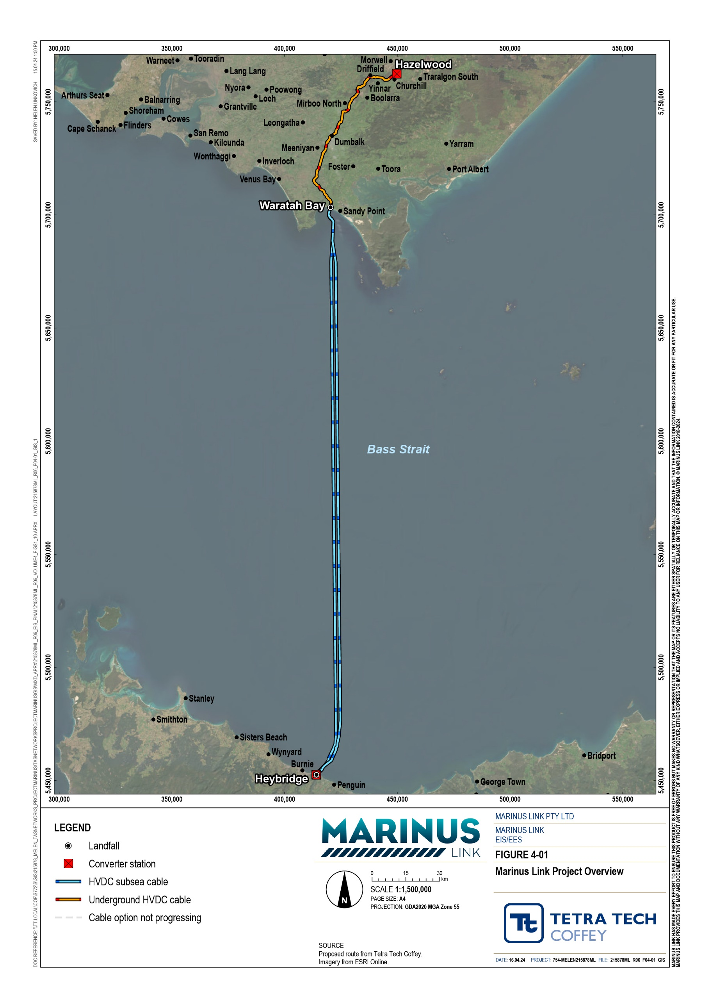

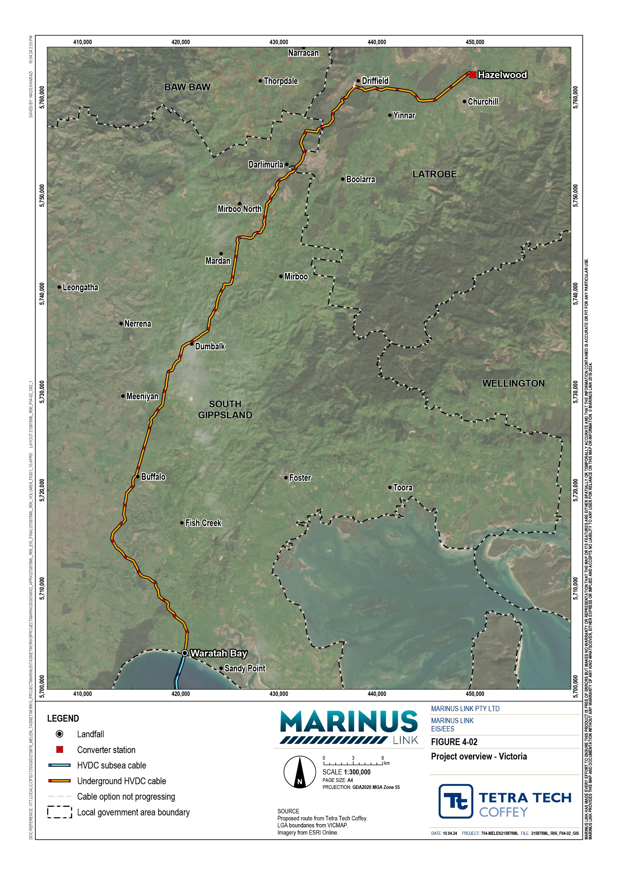

Stakeholder engagement
Marinus Link Pty Ltd (MLPL) has engaged with stakeholders about the potential impacts of the project and sought feedback. This section summarises the key engagement activities undertaken with the relevant stakeholders in Victoria, as outlined in the EES Consultation Plan.
The project’s engagement program consisted of a combination of face-to-face and online forums, supported by digital, print and in-person communication methods. A summary of the key project stakeholders and the approach to engagement is provided in Volume 1, Chapter 8 – Community and stakeholder engagement.

Engagement activities
The project’s engagement strategy consists of five phases, as shown in Figure 4-03. Engagement activities for the EIS/EES were mainly during phase 3. Phase 4 will commence with public exhibition of the EIS/EES.
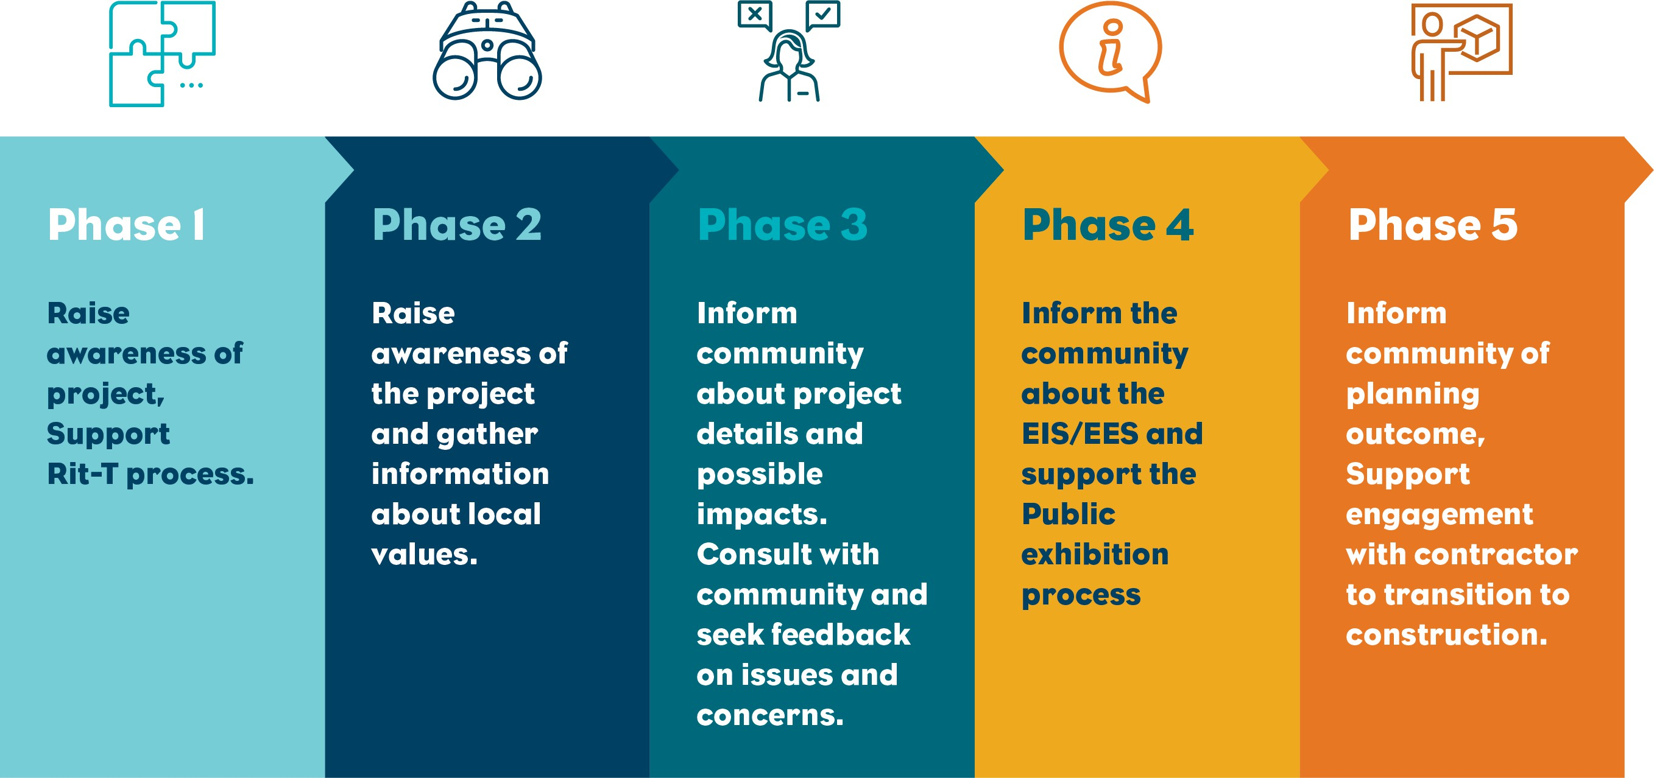

A total of 38 key stakeholder engagement meetings or briefings were held between August 2022 and April 2023 at meetings, events and conferences, virtually or face-to-face across Latrobe City Council and
South Gippsland Shire Council. A total of 1,069 stakeholders were engaged across 46 industry events and stakeholder briefings. MLPL met 15 times with the Technical Reference Group (TRG), four times with Gippsland Stakeholder Liaison Group (GSLG), and four times with First Peoples Advisory Group (FPAG) during Phase 3 of the engagement program.
Key stakeholders, including advisory groups, were also driven along the proposed route a total of eight times, to discuss the route alignment, local conditions, construction methods, and the assessment and approval process. Key stakeholders were also encouraged to attend and participate in general engagement activities, including pop-up events, markets, and drop-in sessions.

Early in the project, MLPL sought advice from First Peoples State Relations (FPSR) regarding the First Peoples groups in the Gippsland region that may have an interest in the project area, with a focus on the shared country in the southern portion of the project alignment. Three First Peoples groups were identified:
Boonwurrung Land and Sea Council (BLSC)

Bunurong Land Council Aboriginal Corporation (BLCAC)

Gunaikurnai Land and Waters Aboriginal Corporation (GLaWAC).

Through connections with each First Peoples group, representatives were identified and nominated by each group to take part in the FPAG with MLPL. The FPAG met four times between October 2022 and May 2023 to discuss the project’s impacts, challenges and opportunities, and to provide feedback on the project.
Table 1-1 summarises the key interests and concerns raised by the FPAG from these meetings.

The FPAG ceased meetings in mid-2023 following consultation with the First Peoples groups, and in light of current legal proceedings relating to Native Title. While the FPAG has not continued, MLPL through their First Peoples Engagement Advisors have continued consultation and discussions with the three First Peoples groups separately, with ongoing engagement activities including cultural education sessions for MLPL personnel, progression of cultural values assessments, and general project updates.
Assessment of the project’s impacts on tangible heritage are described in Volume 4, Chapter 13 – Aboriginal cultural heritage.

Interests or concerns raised by the FPAG | MLPL response
Long-term jobs and careers for their communities and opportunities for higher- skilled careers. | MLPL is developing an industry participation plan that will consider immediate job opportunities for First Peoples and opportunities to upskill communities.
More information is required on construction timeframes and workforce requirements. | MLPL has provided expected project timeframes and job requirements to the FPAG.
First Peoples participation should focus on local opportunities in Gippsland more than the rest of Australia. | MLPL will consider local opportunities as part of the industry participation plan.
The project should consider funding scholarships to support long-term opportunities outside project. | MLPL will consider scholarships and training opportunities as part of the community benefits sharing scheme (CBSS).
Communication must consider the preferences of First Peoples and the project should consider ways of informing First Peoples outside the advisory group. | MLPL established the FPAG as an ongoing forum to engage with First Peoples in Gippsland and seek feedback on how to best engage with First Peoples.  The MLPL Community and Stakeholder Engagement Framework will outline the approach for communication preferences and channels for reaching First Peoples.
The project should consider a Memorandum of Understanding (MOU) for First Peoples participation. | The FPAG terms of reference outlines the ongoing commitment to First Peoples involvement in the project. Through the FPAG, MLPL will establish guiding principles for First Peoples participation and compensation for engagement through the FPAG.

Interests or concerns raised by the FPAG | MLPL response
The project should consider cultural awareness training for contractors and subcontractors. | MLPL is implementing cultural awareness training internally. A similar program will be implemented with contractors and sub- contractors.
Social impact assessment (SIA) input needs to consider integrity, confidentiality and understanding. | MLPL provided an opt-in option for First Peoples to input into the SIA and set up separate SIA meetings.
Request to input into the Sustainability Framework Action Plan. | MLPL will provide opportunities for the FPAG to input into the Sustainability Framework Strategy.
Interest in underwater cultural heritage findings. | MLPL have engaged with First Peoples on the findings of the underwater cultural heritage assessment. Further engagement will be undertaken with individual First Peoples organisations in Victora and Tasmania through the cultural values assessment (CVA), to further discuss the underwater cultural heritage and archaeology assessment and opportunities for further research.
Request to provide input into the CVA. | MLPL are working with the three First Peoples groups to prepare a CVA for each group. The CVAs will discuss values both onshore and offshore.

The focus of landholder engagement has been to obtain access to properties for survey activities, understand how properties are managed, inform changes to the alignment to reduce impacts (see Volume 1, Chapter 3 – Route selection and project alternatives), and develop individual property management plans.
MLPL continues to engage with landholders on detailed alignment changes and individual property management plans.
Additional consultation with landholders was undertaken to inform the agriculture and forestry, and social impact assessments (see Volume 4, Chapter 6 – Agriculture and forestry; Volume 4, Chapter 16 – Social).
Eight drop-in sessions were held at locations along the project alignment between March and April 2023 to share information and seek feedback on the early findings of technical studies, potential project impacts, and possible mitigation measures. Land agents were present to support the sessions, while subject matter experts (SMEs) presented information on key topics. MLPL SMEs presented information at the drop-in sessions on:

The cable, alignment, route options and converter stations.
Geotechnical surveys, the shore crossing and construction.
Environmental approvals and requirements.
First Peoples, community engagement and how to provide feedback.
Safety.

External SMEs presented information at the drop-in sessions on:

Noise and vibration

Traffic and transport

Ecology

Agriculture

Marine benthic ecology.

Online community and stakeholder engagement consisted of four webinars, an online feedback survey and virtual meetings and briefings (discussed in Section 1.2.1 and summarised in Table 1-2). Two webinars were held in August 2022, to support the release of EIS guidelines and EES scoping requirements. An additional two webinars were held in April 2023, to provide information regarding the project’s potential impacts and proposed mitigation measures. Three of the webinars were recorded and made available on the project website.
The Marinus Link website provides ongoing updates regarding project developments, key findings, updates, news and community feedback. There were a total of 113 participants at the virtual or recorded webinars. An online survey was created in March 2023 and remained open until late 2023. The Marinus Link website has facilitated online engagement with over 59,000 visitors to the end of 2023.
Face-to-face community and stakeholder engagement consisted of 13 pop-up events and market attendance, in addition to the face-to-face meetings, briefings, and drop-in sessions (discussed in Section 1.2.1). A total of 3,967 conversations were held during face-to-face community and stakeholder engagement.
Landholders were encouraged to attend and participate in drop-in sessions by invitation via letterbox drops. Direct invitations were provided to 96 landholders along the route. Members of the community were also encouraged to attend the community drop-in sessions and webinars through newspaper advertisements, newsletters, social media posts, stakeholder e-mails, and e-updates. Newsletters, community updates, advertisements, and social media posts provided project updates, news, survey outcomes, details on upcoming engagement activities, and feedback methods.

Platform | Quantity
Project website engagement | 59,000 site visits
Webinars | 113 participants
Face-to-face meetings | 3,967 conversations
Drop-in sessions | 134 attendees

Promotional material included in newspaper advertisements reached 6+ million people, while paid or organic social media posts reached more than 23,000 people (Table 1-3).
The material created to communicate project updates and information about the EIS/EES process is summarised in Table 1-4.

Promotion material | Quantity | Accessibility
Newspapers advertisements in local, state and regional newspapers | 12 digital and 14 printed | Print and online
Printed newsletters were delivered to households in the project area | 7,933 newsletters | Print
Digital newsletters e-mailed to local and key stakeholders, government, and industry stakeholders | 309 stakeholder emails | Online
Paid or organic social media posts | 16 posts | Online
Project e-updates | 585 people registered | Online

Communications material | Quantity | Accessibility
Maps of the proposed project alignment | 15 | Available in-person and online
Fact sheets to support understanding of technical studies and land access and acquisition | 22 | Available in-person and online
Engagement reports and meeting minutes from Gippsland Community Liaison Group (GSLG) meetings | 1 – Engagement report (July 2018 – December 2022)  6 – Community updates in Victoria  7 – GCLG documents, comprising of 5 meeting minutes, site visit notes and a summary report | Available online
Recorded webinars | 2 | Available online
Summary report | 1 | Available online
Regulatory investment test for transmission | 1 | Available online

Fact sheets were provided in hard-copy and digital format, to support the understanding of technical aspects of the project, such as potential impacts and mitigation measures from technical studies, landholder information packs, and land access and easement acquisition. Maps were utilised for in-person sessions and featured on the Marinus Link website to show community members and stakeholders the proposed route in relation to their property or area of interest. The maps showed the proposed route, local roads, vegetation, houses, survey corridor, HDD locations, laydown areas and major haulage routes. Engagement reports and GSLG meeting minutes were published on the project’s website, providing a summary of feedback, key

issues and how this feedback has informed project outcomes. Webinar recordings were uploaded to the project website, providing information about the project and the EIS/EES process.
Communication channels, such as e-mail (team@marinuslink.com.au), hotline (1300 765 275), mail address (Marinus Link Pty Ltd PO Box 606 Moonah Tasmania 7009), and land agents’ relationships with landholders, were established to allow members of the community and stakeholders to reach out to MLPL to discuss issues or the project, outside of the engagement activities mentioned above. During Phase 3 engagement, 20 emails, and 12 phone calls were received, and numerous landholder discussions took place.

Project changes in response to feedback
Community and stakeholder feedback has informed the proposed route design and construction methods. Key changes include:
Project alignment changes to accommodate future land use and farming operations of landholders.

Screening of the converter station.

Use of HDD at sensitive locations, such as the shore crossing and key waterways.

Community and stakeholder feedback has also informed the technical studies prepared for the EIS/EES and development of environment performance requirements (EPRs), by helping to identify potential issues and opportunities. The feedback will also be used by MLPL to develop a CBSS and inform planning of construction works to reduce impacts to agricultural activities.
First Peoples feedback through the FPAG has resulted in MLPL integrating commitments into project plans for First Peoples engagement and participation in project construction and operation. First Peoples have also provided input to the Sustainability Framework Strategy and CBSS.

Engagement outcomes and responses
Key environmental, social, and cultural heritage interests and concerns raised during Phase 3 engagement, and the project responses are presented in Table 1-5, Table 1-6, and Table 1-7, respectively. Relevant EIS/EES chapters are indicated where additional technical information is available.
The feedback has informed the project development and the technical studies prepared for the EIS/EES. A key outcome of the technical studies are the EPRs that define the environmental outcomes that must be achieved during the design, construction, operation, and decommissioning phases of the project (the full list of EPRs is provided in Volume 5, Chapter 2 – Environmental Management Framework). The EPRs are designed to confirm the project is delivered and operated in accordance with the expectations of stakeholders, addressing key environmental, social and cultural heritage interests and concerns raised by stakeholders.

Interests or concerns raised | Project response | Relevant EIS/EES chapters
Ecology
Concerns about ecological impacts along the | MLPL is committed to minimising vegetation removal, disturbance to vegetation and | Volume 3, Chapter 2 –
route, such as: | fauna , habitat fragmentation and loss. | Marine ecology
Vegetation removal. | EPRs have been identified to minimise potential ecological impacts as a result of project | Volume 4, Chapter 11 –
Environmental and coastal impacts to Waratah Bay, such as potential impacts to Hooded Plovers on Waratah Bay Beach. | activities.  HDD will be used, where practicable, for areas of substantial native vegetation, to minimise vegetation loss. | Terrestrial ecology
Impacts from HDD beneath the sand dunes, and the subsea construction approach. | The shore crossing alignment was selected to minimise interface with key marine and onshore habitat areas.
 | HDD at the shore crossing will minimise environmental impacts to the dunes, beach and
 | flora and fauna in the shore crossing area.
 | The project will prepare biodiversity management plans, as part of the overall construction environmental management plan (CEMP).
Concerns about bushfire management given the | The risks of bushfire have been assessed in detail for the project. | Volume 4, Chapter 12 –
project’s interface with timber plantations. | The project will prepare and implement a bushfire emergency management plan (BEMP). | Bushfire
Groundwater and surface water
Concerns about groundwater and surface water | MLPL acknowledges ground and surface water are important water sources for both | Volume 4, Chapter 3 –
impacts along the route, such as: | people and the surrounding environment. | Contaminated land and

Flooding impacts to the project, given previous flooding on the Yinnar / Morwell River flood plains.
Impacts to natural springs water quality and large underground aquifers in the area.
Impacts to surface water and groundwater have been assessed as part of the EIS/EES. EPRs include requirements for protection of groundwater and surface water values,
including minimising flood risk from project infrastructure.
acid sulfate soils
Volume 4, Chapter 4 – Groundwater
Volume 4, Chapter 5– Surface water

Concerns about the project’s constructability in low lying areas and impacts of waterlogged soils during the wet season.
EPRs include requirements for construction contractors to prepare detailed management plans that include measures to manage ground disturbance.
Volume 4, Chapter 2 – Geomorphology and geology

Interests or concerns raised | Project response | Relevant EIS/EES chapters
Marine and fisheries
Concerns about marine impacts from benthic | The shore crossing location was selected to minimise interface with key marine and | Volume3, Chapter 2 –
sampling and construction, such as: | onshore habitat areas. | Marine ecology
Impacts to water quality. | The proposed methodology for laying the subsea cables is expected to cause minimal | Volume3, Chapter 3 –
Impacts to marine ecology, such as whales in | physical disturbance to the seabed. | Marine resource use
Waratah Bay. | EPRs include requirements for construction contractors to prepare detailed management | Volume 4, Chapter 11 –
Disturbance of the seabed. | plans that include measures to manage impacts to water quality and marine ecology. | Terrestrial ecology
Concerns about the impact of electromagnetic | A detailed assessment of marine EMF impacts has been completed to inform the | Volume1, Chapter 10 –
fields (EMF) on marine life during operation. | EIS/EES. | Electromagnetic fields
 | Cables have been bundled to reduce EMF emissions.
 | EMF emissions will be within relevant guidelines and are comparable with that of the existing Basslink cables.
Concerns about impacts to marine resource use, | The subsea project alignment will avoid major fishing grounds and subsequently | Volume 3, Chapter 2 –
such as: | minimise impacts to the fishing industry. | Marine ecology
Impacted fishing methods near the subsea | MLPL will continue to engage with key fishery stakeholders throughout the project | Volume 3, Chapter 3 –
cable. | lifecycle. | Marine resource use
Impacts on the Victorian Recreational Code of Conduct during construction.  Impacts to navigation safety during | MLPL will work with the Australian Maritime Safety Authority (AMSA), Marine and Safety Tasmania and other fishery stakeholders to broadcast safety information prior to construction activities taking place.
construction.
Construction impacts and amenity
Concerns about noise and vibration impacts to | Noise modelling undertaken by the project indicates that noise levels generated by the | Volume 4, Chapter 10 –
amenity, such as: | converter station will not exceed background levels. | Noise and vibration
Noise and vibration impacts from the converter station during construction and | The majority of construction activities will take place during the day, night works will be avoided where possible.

operation, particularly in light of the decommissioning of Hazelwood Power Station and associated reduction to local noise.
Noise impacts from the land and shore crossing HDD operations.
Out of hours work will be limited to unavoidable activities and those activities which cannot be stopped once they have started, such as HDD or pouring concrete.
EPRs require preparation of a construction noise and vibration management plan (CNVMP) in consultation with the Environment Protection Authority Victoria (EPA Victoria). The CNVMP will detail how impacts will be managed.

Interests or concerns raised | Project response | Relevant EIS/EES chapters
Concerns about the visual impact of the converter | The preferred converter station site is located adjacent to the Hazelwood Transfer | Volume 4, Chapter 7 –
station at Hazelwood. | Station and existing transmission infrastructure. | Landscape and visual
 | Landscaping is proposed to screen the converter station and reduce impacts to visual
 | amenity.

Concerns about dust and air quality impacts from heavy vehicles.
The majority of residents in the vicinity of the project alignment are more than 300 m from the works area, therefore dust is not expected to present any risks to human health.
Measures to comply with EPRs will be implemented to reduce impacts to the environment and nearby properties. This includes preparation of a construction dust management plan (CDMP), detailing how dust emissions will be reduced and managed.
Volume 4, Chapter 9 – Air quality

Concerns or interest about the proposed construction method, such as:
Trenching and impacts to the environment HDD and impacts to noise
Some construction impacts will be expected for local communities. Measures to manage and mitigate potential construction impacts will be detailed in relevant management plans. Community feedback will be used to inform measures to comply with EPRs, wherever possible.
The cables will be installed using open trenching, wherever possible. HDD will be used where the project alignment needs to cross rivers, environmentally sensitive areas, railways, roads or utility services.
Volume 1, Chapter 6 – Project description

Concerns about impacts to traffic, such as:
Cumulative impacts from the increased volume of heavy vehicle traffic on Tramway Road, Hazelwood, due to the construction and operation of the converter station, and other industrial infrastructure and businesses in that area.
Increase of traffic and heavy vehicles in townships and along local roads, as well as impacts of detour routes and other traffic management measures.
MLPL acknowledges the importance of an efficient and safe traffic movement throughout the local area.
Measures to mitigate disruption to traffic movement and manage safety during construction will be prepared in consultation with road authorities and documented in a traffic management plan (TMP). The EPRs include a requirement to maintain transport capacity and performance for all travel modes in peak travel demand periods.
Volume 4, Chapter 8 – Traffic and transport

Agriculture
Relevant EIS/EES chapters
Project response
Interests or concerns raised

Concerns about impacts to local farmers’ during construction and operation, such as:
Biosecurity.
Organic certification. Agricultural production.
MLPL engaged with organic certification bodies in Victoria and broader agricultural industry to seek feedback on and input into the project’s proposed construction method and mitigation.
MLPL will develop individual property management plans for directly impacted landholders along the project alignment, to verify:
- All directly impacted landholders understand their current and future land uses, and micro- siting requirements, to reduce impacts to production.
- Organic certification is not impacted for all directly impacted landholder.
- Landholders’ biosecurity requirements, including hygiene requirements, location of access points and parking areas. Biosecurity requirements must be adhered to as a condition of property access during all phases of the project.
Volume 4, Chapter 6 – Agriculture

Concerns about potential impacts to agricultural production during operation, due to the heat and EMF of underground cables.
Community benefits and impacts
Where possible, MLPL has sited the cable toward the back of properties away from cropping areas.
Any impact to long-term crop growing will be considered as part of the easement compensation process.
The project is not expected to generate EMF above levels that already exist in the local environment, as the cable sheath and underground location of the cables will limit the amount of EMF produced.
The EMF levels from standard wiring in farm sheds will likely be higher than EMF levels generated by the project.
Volume1, Chapter 10 – Electromagnetic fields
Volume 4, Chapter 6 – Agriculture

Interest to know more about community benefit opportunities and sharing of ideas including:
Forest conservation. Biodiversity corridors.
Increased electricity supply.
Other renewable energy and offshore wind projects.
MLPL is engaging with key local stakeholders on potential opportunities for community benefit sharing.
  - MLPL will develop a CBSS that will seek to be equitable, rewarding and meet local needs. MLPL is not involved with other renewable energy or offshore wind projects.
Other renewable energy projects do not connect to the project.
Volume 1, Chapter 7 – Economics
Volume 4, Chapter 16 – Social

Interests or concerns raised | Project response | Relevant EIS/EES chapters
Concerns about the impacts to long term | A workforce and accommodation strategy will be prepared with measures to mitigate impacts to | Volume 4, Chapter 16 –
housing and holiday accommodation | local housing and accommodation during construction. | Social
during construction. |  | Volume 1, Chapter 7 –
 |  | Economics
Land access

Concerns about the impacts to property land-use and the process for development of individual property management plans, easement creation, and compensation, amounts, and the process for voluntary vs. compulsory acquisition of easements.
MLPL is working closely with all directly impacted landholders to understand their current and future land uses.
MLPL acknowledges that every property is unique and is committed to working with impacted landholders to develop and agree on individual property management plans to the satisfaction of all parties.
Compensation is calculated on a case-by-case basis. MLPL will follow legislation under the Land Acquisition and Compensation Act 1986 (Vic) and the Victorian Government guidelines for additional compensation.
MLPL is developing its easement compensation framework and will negotiate outcomes with individual landholders.
Volume 1, Chapter 3 – Route selection and project alternatives

Concerns about future easement ownership, access by other projects or infrastructure, and re-instatement process on private properties of the easement post construction.
Easements will be reinstated to as good or better condition wherever possible, in line with individual property management plans.
MLPL is working with landholders who wish to keep access roads and fencing installed by the project.
Volume 1, Chapter 3 – Route selection and project alternatives

Landholders were interested in potential improvements to the communication and engagement process in the coming months, including frequency and detailed information on compensation.
MLPL is committed to working closely with all impacted landholders throughout the project lifecycle and has dedicated land agents in place to manage direct communications.
MLPL is developing its easement compensation framework and will negotiate outcomes with individual landholders from late 2023.
The project will use feedback about communication and engagement processes to refine the approach going forward.
Volume 5, Chapter 2 - Environmental Management Framework

Concern about how landholder information would be recorded, protected and handed over.
MLPL has a dedicated Land Agent team that manages the recording of information provided by landholders.
MLPL is covered by and complies with TasNetwork's Privacy Policy and its associated obligations under The Privacy Act 1988 (Cwlth) and the Personal Information Protection Act 2004 (Tas).
Volume 5, Chapter 2 – Environmental Management Framework

Project information and benefits
Relevant EIS/EES chapters
Project response
Interests or concerns raised

Significant interest in job opportunities, including the type of jobs, where to find out more, how to express interest, and when they will become available.
MLPL is engaging with government agencies and tertiary education providers to identify skill gaps and opportunities.
MLPL is committed to maximising local content and will prepare an industry participation plan to outline the approach that contractors will need to take to verify that fair and reasonable opportunities are provided to local businesses.
MLPL developed an internal register for interested workers and directed potential candidates to register at all engagement sessions. This list will be provided to the successful contractor.
MLPL is registered on the ICN Gateway. Interested businesses were directed to that portal at all engagement sessions.
Volume 1, Chapter 7 – Economics
Volume 4, Chapter 16 – Social

Concern about access to information within the project’s technical studies.
Project design and construction
MLPL has updated the website for content access.
Stakeholders and the community will have access to the technical studies during the public exhibition period.
A range of hard copy and digital communication materials were developed to share early findings from the technical studies.
Volume 1, Chapter 8 – Community and stakeholder engagement

Concerns about the proposed route alignment design, re-alignment, impacts to neighbouring properties, and constructability, including interface with existing infrastructure and topography challenges.
MLPL completed a rigorous route options analysis, which determined the proposed route as the most feasible and least impactful option.
Micro-siting along the route will be further refined during ongoing investigations and landholder negotiations.
Volume 1, Chapter 3 – Route selection and project alternatives

Concerns about the potential closure of Waratah Bay beach during construction.
Waratah Bay Beach is not expected be closed to beach users during construction, however temporary, short term closures may be required to mitigate risks to public safety.
Volume 3, Chapter 3 – Marine resource use

Concerns about the process to remediate any damage caused during construction to public and private properties.
Construction contractors will be required to reinstate and remediate all construction areas, including haulage routes as required in consultation with landholders.
Property condition surveys will be completed prior to and after construction to inform reinstatement and remediation requirements.
Volume 5, Chapter 2 - Environmental Management Framework

Concerns about community safety from the underground land cables due to electromagnetic fields.
MLPL recognises there is community interest in the potential health effects from exposure to EMF. The on-land component of the project is not expected to generate EMF above guideline levels.
Volume1, Chapter 10 – Electromagnetic fields

Cultural heritage
Relevant EIS/ESS chapters
Project response
Interests or concerns raised

Concern that MLPL wasn’t engaging with First Peoples or undertaking adequate Aboriginal Cultural Heritage investigations.
MLPL recognises and respects the history, culture and stories that First Peoples bring to our communities and acknowledge that they have a profound spiritual connection to the lands and waters on which the project is proposed to be built.
MLPL has dedicated Aboriginal Engagement Advisors to direct and deliver engagement with regional First Peoples groups.
The project is undertaking site walkovers with First Peoples to inform the development of the Cultural Heritage Management Plans (CHMPs).
MLPL has established a FPAG comprising:
- GLaWAC
- BLCAC
- BLSC Aboriginal Corporation
Ongoing engagement with FPAG are guided by FPAG terms of reference.
Volume 4, Chapter 13 – Aboriginal cultural heritage

Structure of the EIS/EES
The EIS/EES consists of five volumes:

Volume 1 – Introduction describes the scope of the project in Victoria and provides a summary of stakeholder engagement activities in Victoria and how issues raised have been addressed.
Volume 2 – Tasmanian terrestrial environment describes the existing conditions, impact assessment and EPRs for the Tasmanian terrestrial component of the project. This volume considers matters of national environmental significance (MNES) and matters considered by the Commonwealth Minister for the Environment and Water when making a decision under the Environment Protection and Biodiversity Act 1999 (Cwlth) (EPBC Act) only.
Volume 3 – Marine environment describes the existing conditions, impact assessment and EPRs for the marine (nearshore and offshore) component of the project. This volume addresses matters in the Commonwealth marine area, Victorian coastal waters and Tasmanian coastal waters (MNES only).
Volume 4 – Victorian terrestrial environment (this volume) describes the existing conditions, impact assessment and EPRs for the Victorian terrestrial component of the project. This volume addresses Commonwealth and Victorian government requirements.
Volume 5 – Synthesis of environmental effects is a series of concluding chapters that draws together the overall assessment of the environmental effects of the project as a whole and provides a summary of impacts for each jurisdiction.
Each volume consists of detailed chapters as illustrated in Figure 4-04. Technical studies prepared to support this EIS/EES are provided as appendices.

