Geomorphology and geology
This chapter provides an assessment of the potential impacts on geomorphology and geology associated with the construction, operation and decommissioning of the project. This chapter is based on the impact assessment provided in Appendix O: Geomorphology and geology.
Geomorphology is the study of the Earth’s physical features, the processes that shape them and their change over time. The project involves trenching and drilling an underground cable across 90 km of rural Victoria, through natural landforms including coastal dunes and steep, upland slopes. It is important to assess the potential impacts of the project on these landforms.
There are no requirements in the EIS/EES guidelines directly relevant to geomorphology and geology. Refer to Attachment 1: Checklist – Guidelines for the Content of a Draft Environmental Impact Statement for the EIS Guidelines.
The EES scoping requirements set out the following evaluation objective relevant to geomorphology and geology:
Marine and catchment values – Avoid and, where avoidance is not possible, minimise adverse effects on land and water (including groundwater, surface water, waterway, wetland, and marine) quality, movement and availability.
The geomorphology and geology assessment has addressed the component of this evaluation objective focused on minimising adverse effects on land movement.
Refer to Attachment 2: Checklist – Scoping Requirements Marinus Link Environment Effects Statement for the EES scoping requirements.
The geomorphology and geology impact assessment considers the potential impacts of the project on the landforms on and through which the project will be located. It also recommends EPRs to mitigate impacts where required.
Other aspects referred to in the above EES evaluation objective will be addressed in the following EIS/EES chapters:
Volume 3, Chapter 2 – Marine ecology

Volume 4, Chapter 4 – Groundwater

Volume 4, Chapter 5 – Surface water.

Method
The method used to assess the potential impacts of the project on geomorphology and geology is the significance method, which is detailed further in Volume 1, Chapter 5 – EIS/EES assessment framework. Key steps included:
Defining a study area.

Characterising existing conditions, including:

- Using and combining several data sources to divide the 90 km route into 187 trench sectors.

- Identifying geomorphic attributes to determine the sensitivity of each sector.

Conducting an impact assessment, considering the sensitivity of identified geomorphic attributes and the magnitude of potential impacts to determine the level of impacts.
Developing EPRs in response to the impact assessment to reduce the identified impacts where necessary.
Assessing residual impacts after considering implementation of EPRs.

Study area
The study area comprises 187 trench sectors of unique geomorphological characteristics, situated along the project alignment,(within the 220 m wide project survey area (as defined in Volume 1, Chapter 5 – EIS/EES assessment framework), between the shore crossing at Waratah Bay and the converter station at Hazelwood in Victoria. Comprehensive detail about each of the trench sectors is provided in Appendix A of Technical Appendix O: Geomorphology and geology. The 187 trench sectors comprise the following:
Waratah Bay shore crossing: 3 sectors.

Underground cable route:183 sectors.

Hazelwood converter station site: 1 sector.

Assumptions and limitations
The geomorphology and geology assessment has been conducted based on the following assumptions and limitations:
The geomorphology and geology impact assessment is a desktop assessment, supplemented by the results of a limited site inspection, conducted from public roads and other public access areas in 2019. This is a limitation as much of the route across private land has not been sighted.
The assessment primarily used Light Detection and Ranging (LiDAR) from 2021 and high-resolution aerial photography, supplemented by LiDAR from 2007 at Waratah Bay and Google Earth imagery where 2021 or 2007 LiDAR was not available.

The results of geotechnical investigations have been incorporated into the geomorphology and geology impact assessment where the work undertaken by the geotechnical contractor coincided with the geomorphology and geology study area.

Existing conditions
This section briefly describes the existing geomorphological and geological conditions in the study area.

The approximately 90 km long project alignment between Waratah Bay and Hazelwood is a geomorphically active landscape, prone to change through landslides and erosion. Multiple factors combine to create a dynamic landscape which has experienced slope instability and several landslides in the recent past and may experience more.
Landform stability is the aspect of geomorphology of greatest relevance to the project. The factors that combine to create the landscape and influence its stability are introduced below.

Vegetation cover
In 1750, the study area was heavily forested from Waratah Bay to as far north as Churchill (Figure 4-05). Forests and woodlands serve three important functions which tend to stabilise landforms. Deep root systems hold the soil together, the canopy protects the soil from heavy rainfall events which facilitate erosion, and the trees in their entirety provide a wind break, protecting the soil from high winds which also facilitate erosion.
Vegetation cover may have been impacted by fire; through managed fire by Aboriginal communities (expected to be near the coast and plains) or through uncontrolled fire from human and non-human sources during European occupation.
Forest clearance for grazing, mining and timber harvesting during European occupation has completely changed the vegetation cover (see Figure 4-05), with significant removal of vegetation cover exposing soils and altering surface hydrology.

Geology and regolith
Regolith is essentially the surface geology, referring to material overlying solid bedrock (including soil); it is essentially bedrock which has been weathered and broken down into unconsolidated, loose material in-situ, and/or unconsolidated, loose material that has been transported and deposited on solid bedrock and in-situ weathered material. The study area has continuous regolith cover that varies in thickness, generally depending on the underlying geology. Regolith cover contributes towards slope instability because having soils with, for example, different water retention capacity next to one another can result in increased water run-off along that boundary.
At the shore crossing at Waratah Bay, surface geology is primarily coastal, alluvial (loose material deposited by running water) and lacustrine (lake) deposits of unconsolidated dune sand, swamp sediments and organic material, river terraces sands, silts and clay. Between Waratah North and the Tarwin Lower area, surface

geology is generally sediments of the Haunted Hills Formation, which comprises poorly consolidated gravels, sands, and clays deposited by flooding streams, slope colluvium (loose material that has eroded from slopes) and alluvial fans.
The widespread basement geology from the Tarwin Lower area to the Mirboo North area is generally sedimentary rocks of the Strzelecki Group, which comprises sandstone, siltstone, and conglomerate. The Strzelecki Group is overlain in some areas by Thorpdale Volcanic Group basalt lava flows, usually on hill tops, plateaus and valley sides. Thorpdale Volcanic Group material comprises basalt, tuff, and interbedded sandstone and silcrete, and is often covered by alluvial and colluvial sediments.
North of the Mirboo North area, surface geology is mainly Thorpdale Volcanic Group material. The volcanic material is generally covered by colluvial and alluvial sediments and is interbedded with and underlying Latrobe Valley Group sediments. Between the Driffield and Hazelwood areas, surface geology is unconsolidated sediments (sand, organic material, silts, and clay) associated with the Morwell River floodplain and terraces, alluvial, river terraces and lacustrine deposits, and the Haunted Hills Formation.
Figure 4-06 shows the geology across the geomorphology study area.

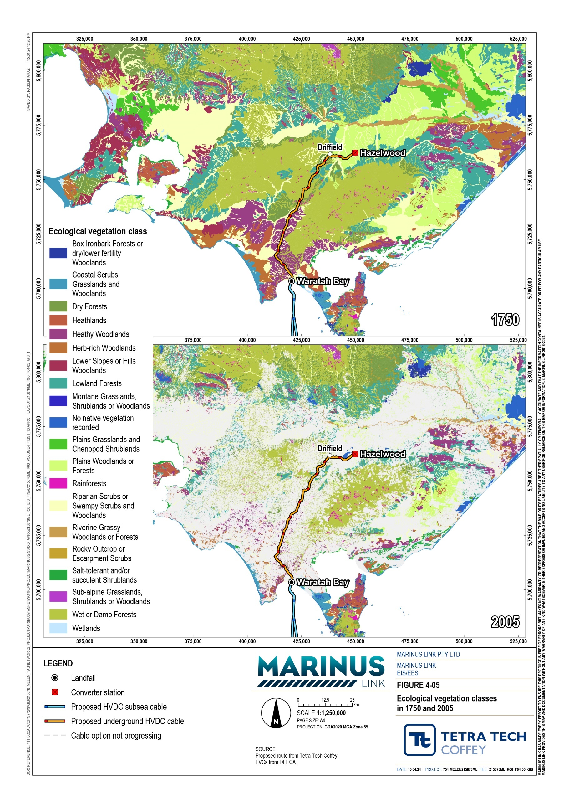
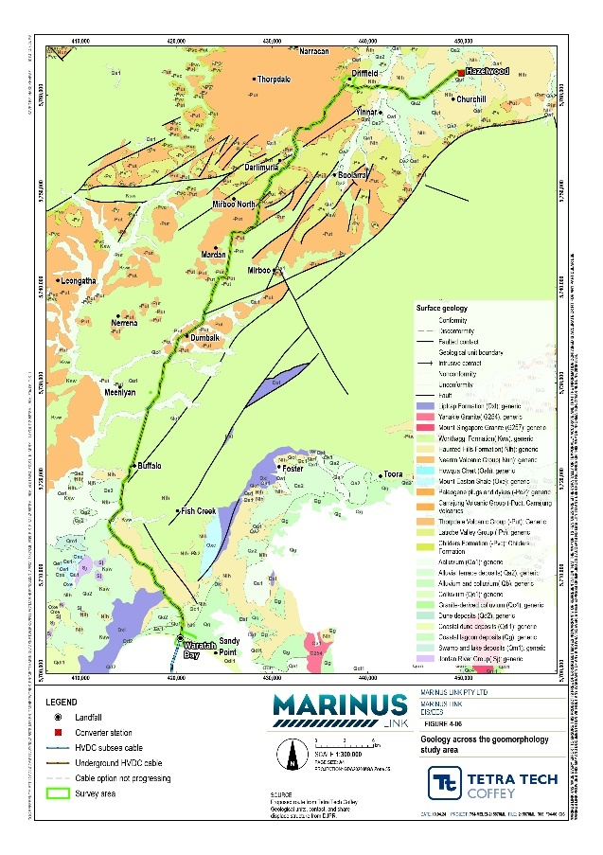
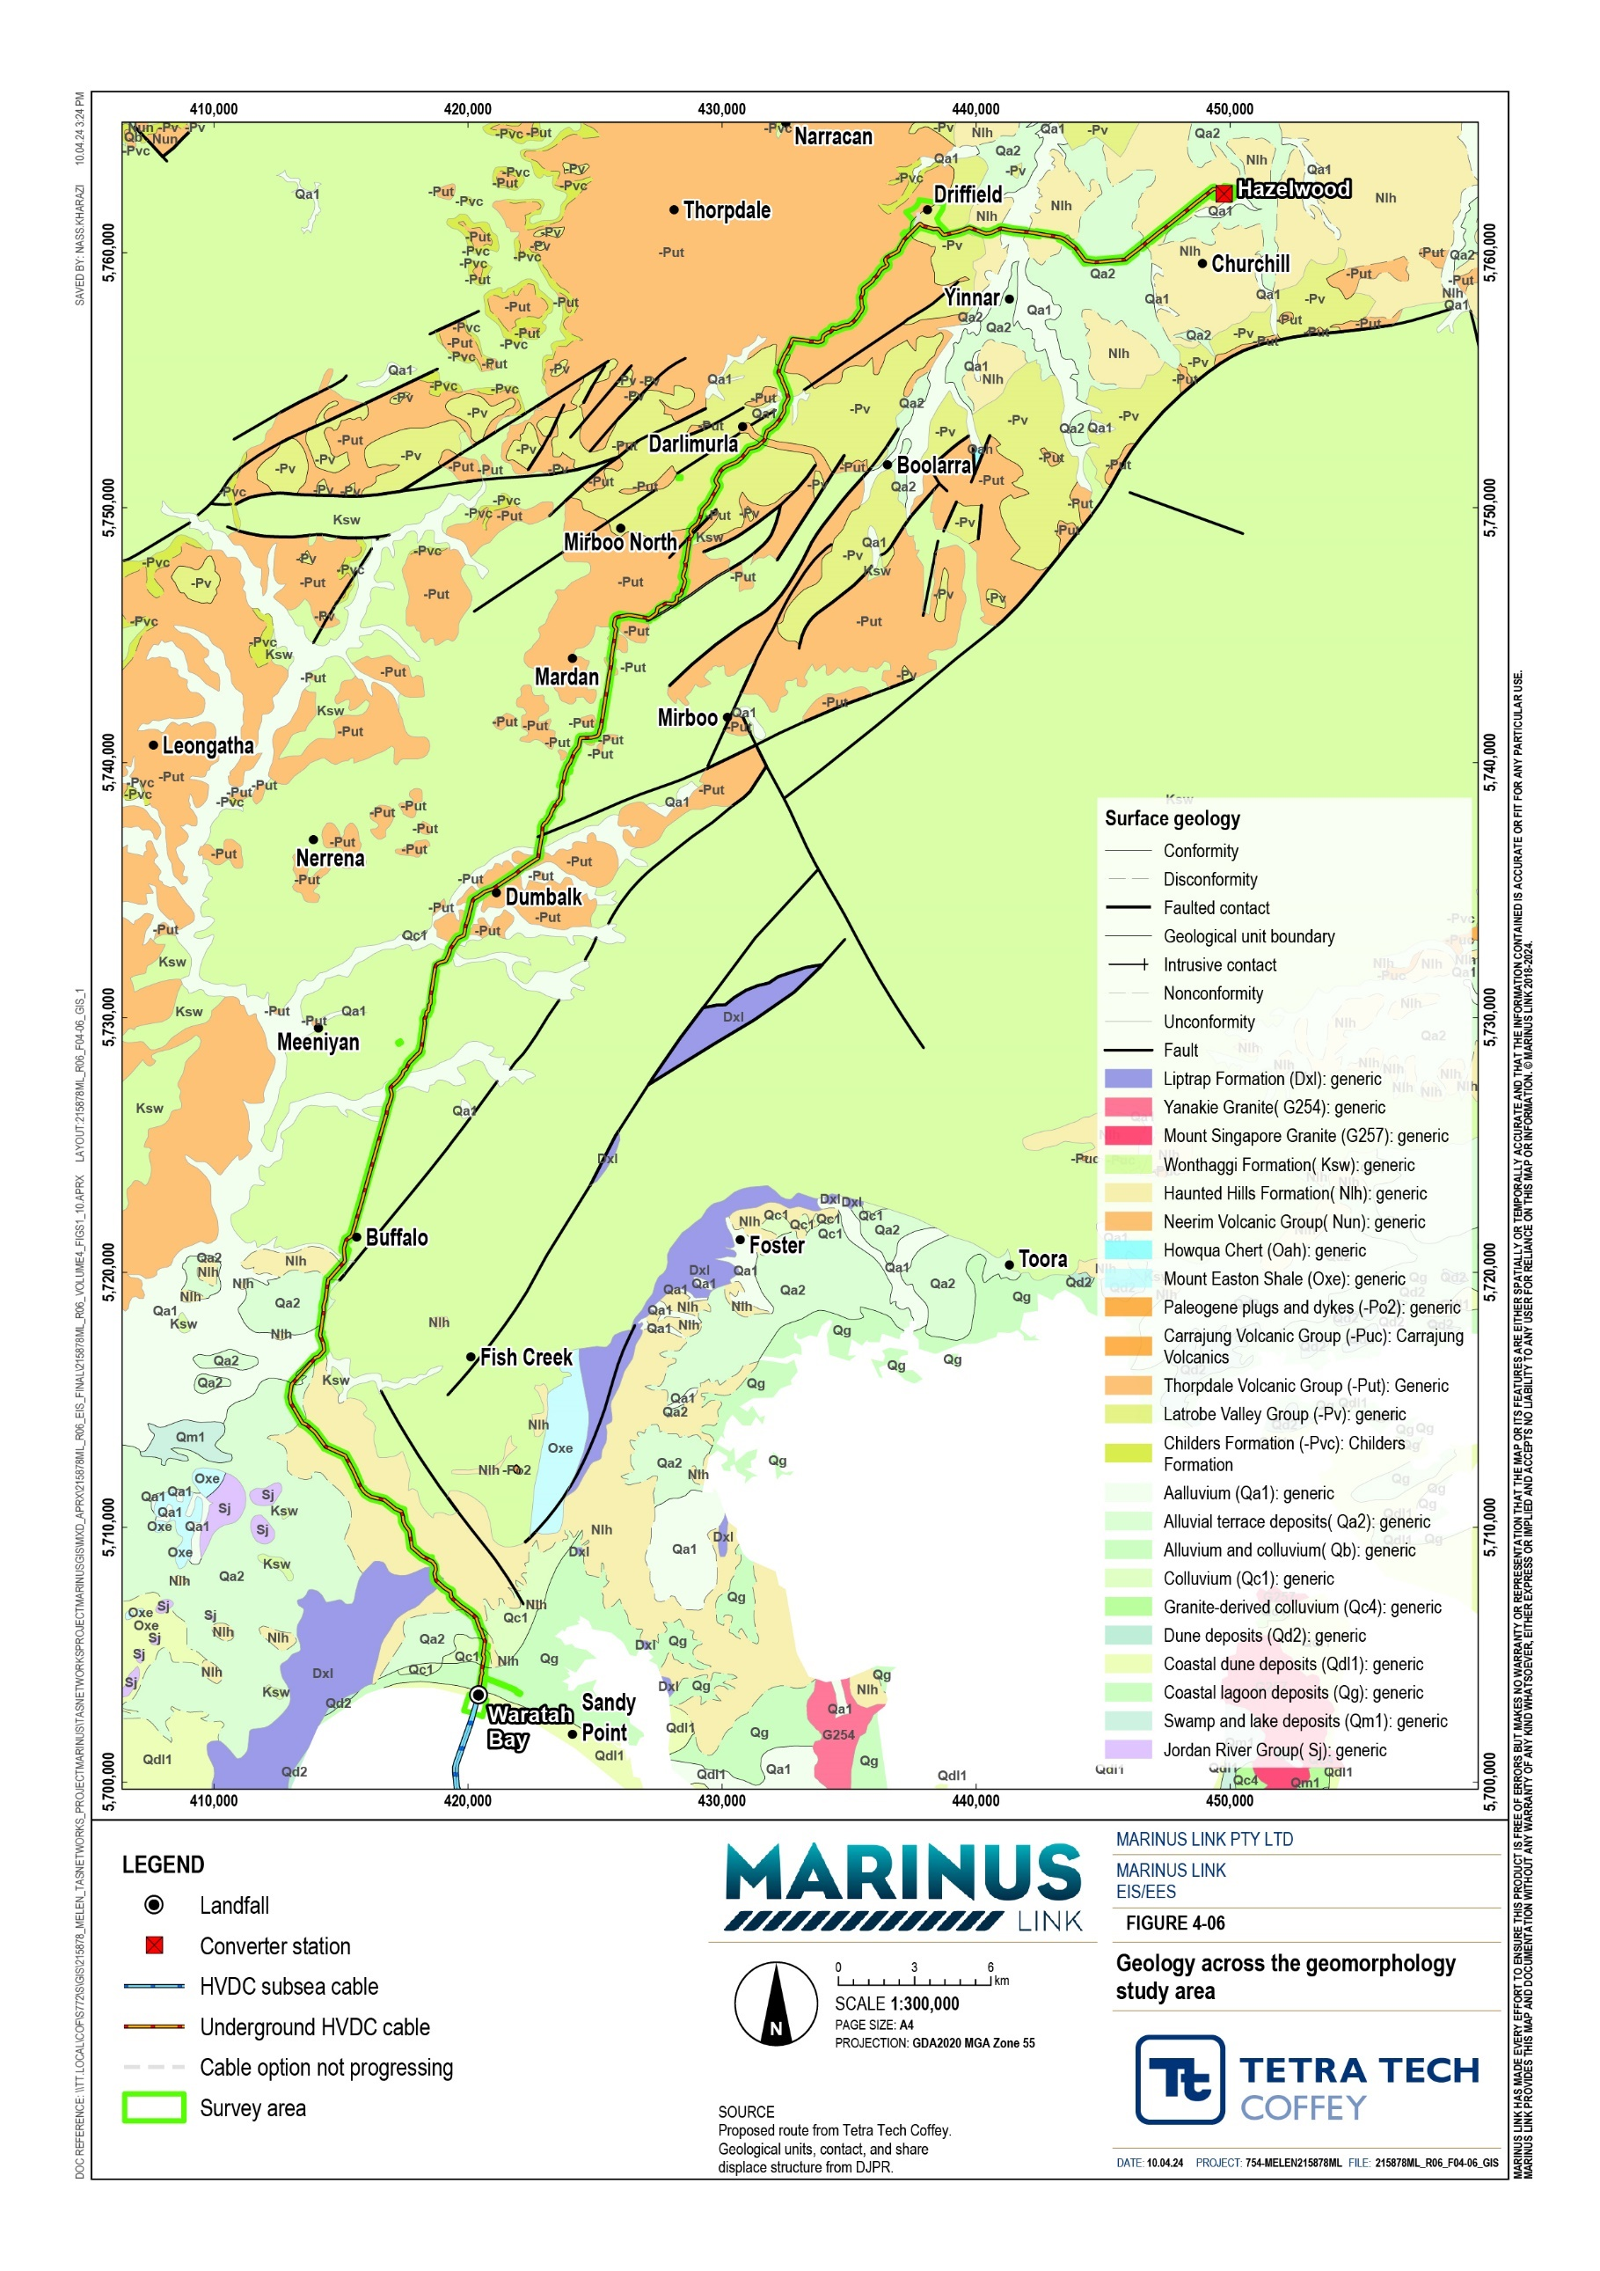

Geomorphology and geomorphic processes
The geomorphology of the study area varies, crossing gently undulating low elevation terrain, areas of elevated hillslopes dissected by drainage lines and rivers and streams and associated floodplains and valleys. Many slopes across the study area show evidence of slope instability and landslides, particularly where weathered basalt and thick colluvium are present. Slope movement is further facilitated by the presence of several watercourses which transport material downstream (Figure 4-07). Mass movement (including landslides) is facilitated where younger, volcanic basalts are located on top of older, more erodible rock. An example of this occurs at the Tarwin and Narracan fault blocks (Figure 4-08).
The geomorphology of the shore crossing in Waratah Bay is characterised by steeply undulating coastal dunes and a flat tidal channel. North of the dunes to Waratah North, the study area crosses low-relief historic coastal terraces and sand ridges, and areas with small channels.
The Waratah North to the Tarwin River East Branch area is characterised by undulating slopes, slopes of colluvial and alluvial terraces, and slopes weakly dissected by streams and tributaries of Fish Creek, Tarwin River, Stony Creek. These slopes are susceptible to slope wash, landslides, and channel incision.
From the Tarwin River East Branch to Driffield, the geomorphology of the study area is characterised by undulating hilly terrain and plateaus, showing evidence of landslides on steep valley slopes, slope wash. Between Driffield and Hazelwood, the study area crosses the Morwell River floodplain, paleochannels and river terraces, which may be subject to flooding or overbank flows, erosion and channel migration.

Seismicity
Seismicity is a measure of how prone an area is to earthquakes. Earthquakes and smaller tremors may trigger slope movement (landslides). Figure 4-09 shows the location of earthquakes across Victoria between 1970 and 2014, the study area is seismically active.

Climate
The study area has relatively high rainfall. This results in water being added to steep slopes through infiltration into the soil, further facilitating slope movement.

Volume 4 – Victorian terrestrial environment Page 2-7
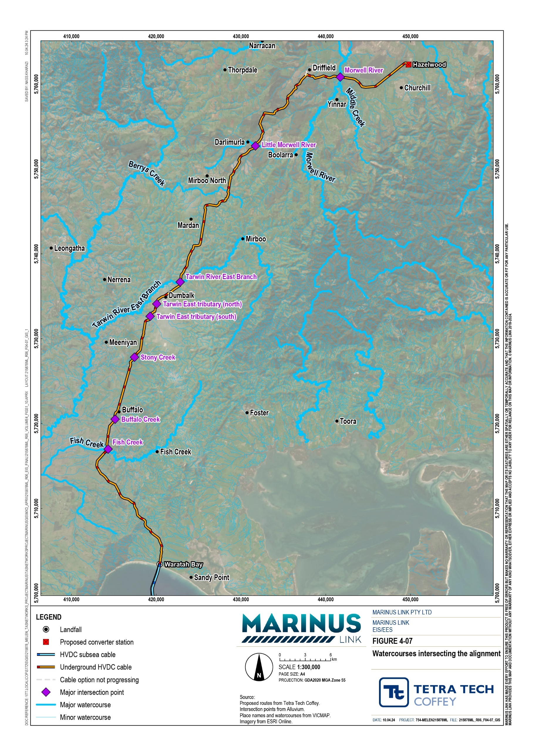

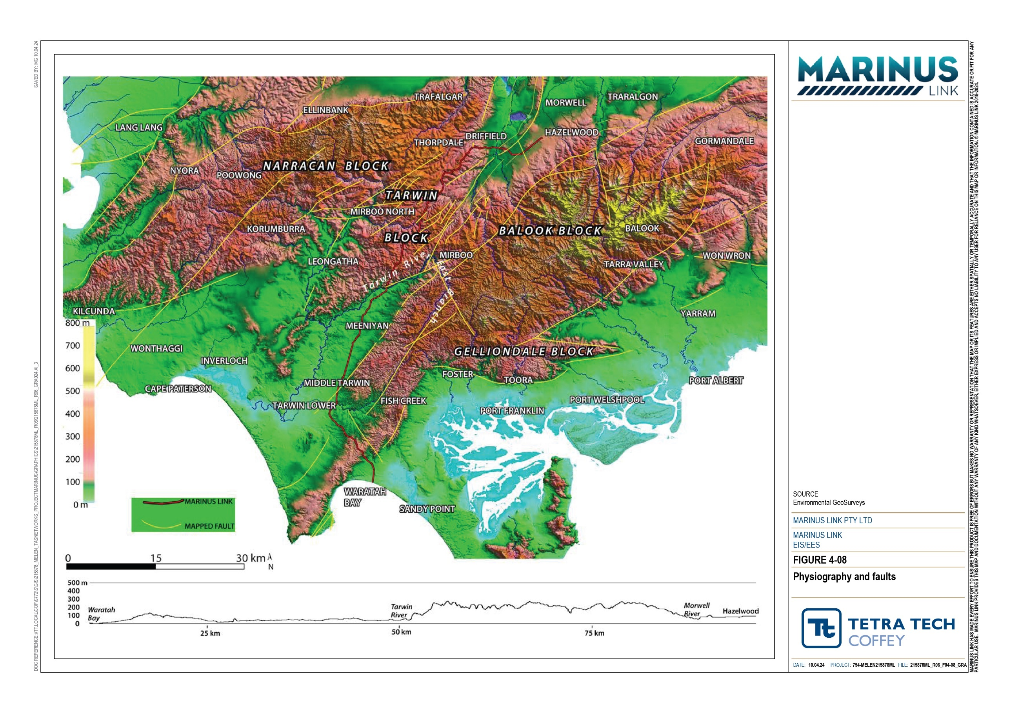

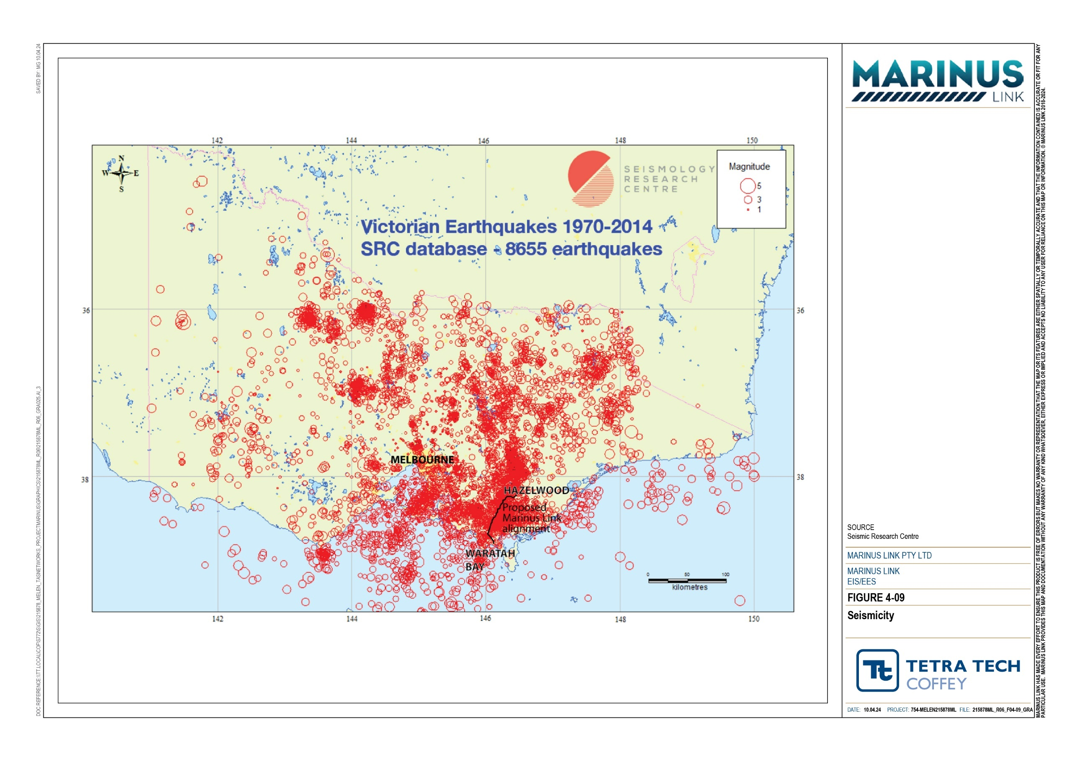

Geomorphic attributes
A geomorphic attribute is a physical property of a landform or a geomorphic process that defines the shape and stability of the landscape. There are nine geomorphic attributes identified across the study area, as listed in Table 2-1. Single attributes or groups of these attributes then define the spatial extent of discrete geomorphic units or ‘trench sectors’. A change in geomorphic attributes determines the boundary of a trench sector.

Table 2-1 Geomorphic attributes

Geomorphic attribute | Definition
Relief and slope | Relief is the difference in elevation between two points and is a measure of how high a given piece of land is. Slope is a measure of how steep the land is.
Landform stability | Landform stability refers to how resistant a landform is to change. In this context, the stability of slopes (e.g., whether they will be subject to a landslide) is particularly relevant.
Erosivity | Erosivity means how resistant a rock or a landform is to erosion.
Hydrology | Hydrology refers to how a given piece of land drains after a rainfall event, for example whether it becomes waterlogged or not.
Flood potential | Flood potential means how likely it is that a given piece of land will be flooded by a river or creek.
Regolith | Regolith in this context means the depth to bedrock, the thickness of the regolith and how broken down it is.
Soils | Soils means the surface layer of soil overlying the regolith. Soil composition is particularly relevant. High clay content for example is associated with good water retention, but also increased likelihood of shrinking and swelling.
Acid sulfate soil (ASS) | ASS refers to the existing presence of ASS, or the potential for these to develop.
Geoheritage | Geoheritage means natural geoscience features which are worth preserving. An example might be a particular cave system.

Trench sectors
The alignment has been divided into 187 trench sectors (192 total assessed, minus the five trench sectors associated with the Driffield converter station site option that is not being progressed), where each of the nine geomorphic attributes combine to create a unique section of landscape. Some trench sectors are a few metres long, whilst other extend for several kilometres. The landscape of the region is complex, with a high density of stream crossings, which has resulted in the high number of trench sectors being identified.
The trench sectors form the basis of the impact assessment. The trench sector and their sensitivity and shown in Figure 4-10.

The overall sensitivity of each trench sector was determined through assigning a sensitivity rating for each of the geomorphic attributes in that sector and combining these ratings. A sector may have geomorphic attributes that range in sensitivity, so the overall sensitivity needs to consider all geomorphic attributes.
As an example, for the geomorphic attribute ‘hydrology’:

Sensitive means moderate slopes with potential flow paths to defined watercourses.

Very sensitive means steep slopes with long periods of waterlogging.

Extremely sensitive means a landscape which has declared watercourses and drainage lines (e.g., there is a river on it).
All trench sectors have overall sensitivity ratings of sensitive to extremely sensitive; 101 of the trench sectors are sensitive, 68 are very sensitive and 18 are extremely sensitive. Extremely sensitive and very sensitive trench sectors occur in a range of geologic settings, however extremely sensitive sectors are generally those located in areas where there are existing landslides or slope instability.
The full list of sensitivity criteria for each geomorphic attribute for the trench sectors is presented in Table 4-3 in Technical Appendix O: Geomorphology and geology. The sensitivities of each of the 187 trench sectors are listed in Appendix A of Technical Appendix O: Geomorphology and geology.

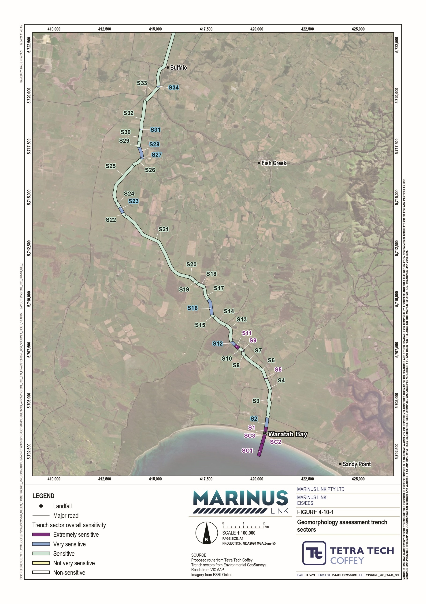
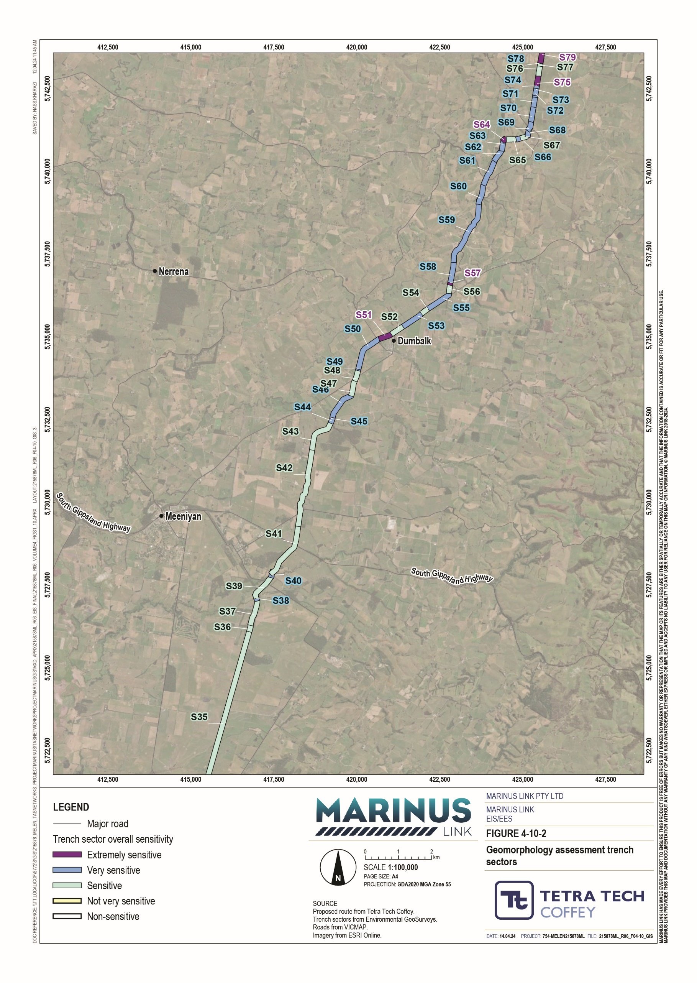

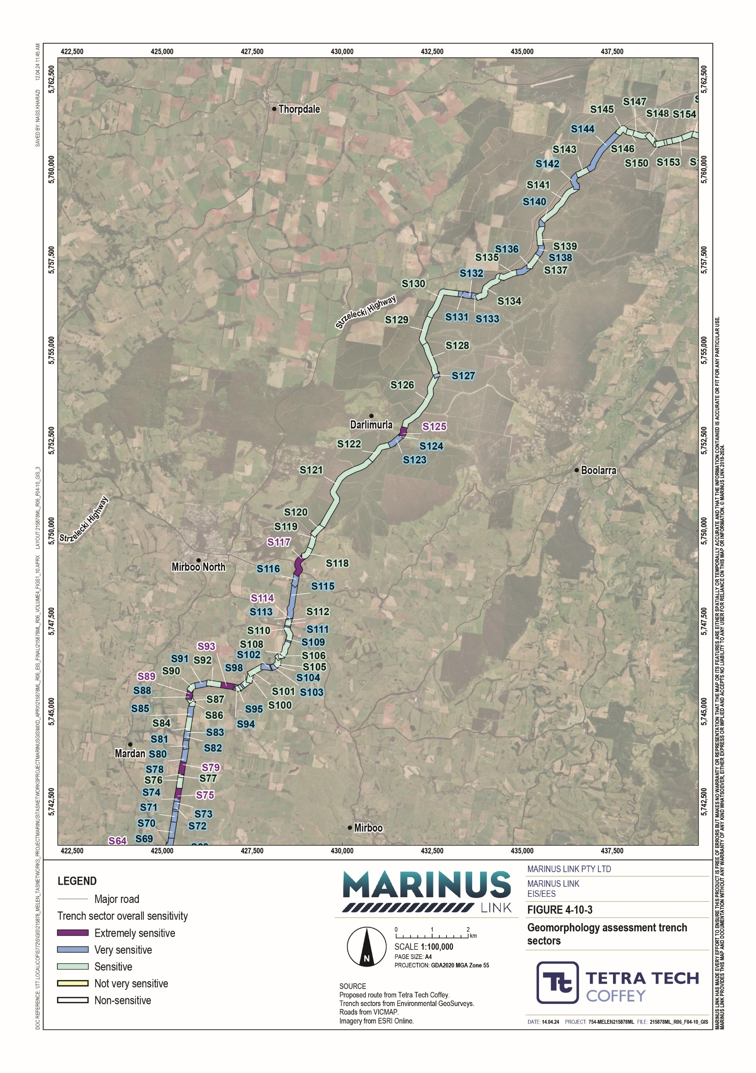
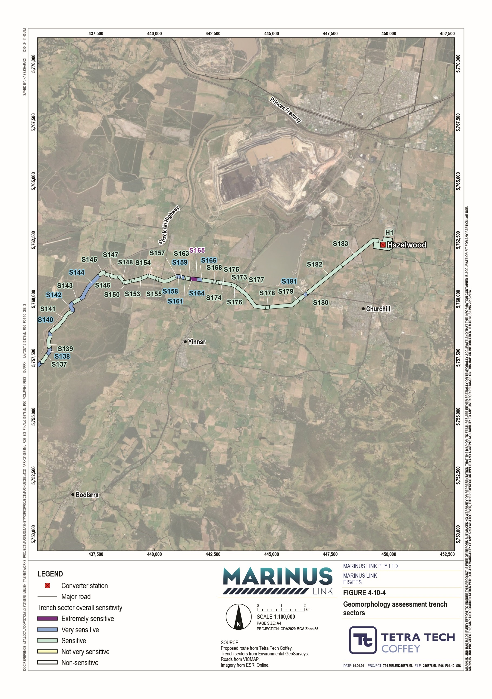

Construction impacts
The key project activities that could result in impacts on geomorphology and geology are:

Vegetation clearance. Where vegetation is cleared to ground level (i.e., no ground cover is retained), soils may become exposed to erosion and surface water infiltration.
Ground disturbance, including ground level earthworks (such as trenching, cut, fill, compaction and covering (e.g., with concrete)); and below ground earthworks (such as HDD). Ground disturbance may:
- expose soils to erosion;

- destabilise landforms;

- expose excavated surfaces to surface water infiltration;

- facilitate erosion and sedimentation of watercourses or drainage lines. This can lead to channel avulsion and instability of watercourse forms;
- cause watercourse / drainage line diversion or infill with consequential erosion, scour, sedimentation, and depleted groundwater resources;
- expose actual and potential acid sulfate soils (PASS).

Construction of access tracks has not been assessed as it is assumed they will not involve geomorphically sensitive activities such as topsoil stripping, installing drains, excavations or trenching.
Impacts can occur individually in response to one activity, or in combination in response to more than one activity. Potential impacts on geomorphic attributes of trench sectors that may arise from project construction are:
Decreased slope stability. All slopes have an angle at which they are generally stable. Increasing that angle through construction works can result in overstep slopes which are more prone to slumping and landslides.
Creation of unstable landforms. Decreasing the ground level by removing material with an excavator or increasing it by importing fill can change the way that an area of land responds to water, including rainfall. Immediate changes in ground level can result due to subsidence (sink holes) which can occur if HDD is not carried out correctly.
Changed surface flow condition (run-on and runoff) and infiltration. Changing ground response to rainfall may occur following changes in surface materials, through vegetation or hard-standing (e.g., concrete pads for the converter station). Vegetation clearance exposes the soil surface to a greater volume of rainwater, which can increase the amount of water absorbed into the soil, and the rate at which the soil is saturated. Covering the soil with concrete does the opposite; rainfall cannot be absorbed into the soil and will flow over and eventually off the concrete pad, depending on the nature of the drainage which is installed.

Changed groundwater dynamics. Increasing the groundwater level results in wetter slopes which are more prone to slumping and landslides. Surface water infiltration following soil exposure can contribute to increased groundwater loading, which may lead slumping and / or slope failure of landforms.
Changed channel dynamics or watercourse form. Increasing erosion in upland areas results in more sediment being washed into watercourses and carried downstream. This results in increased deposition of sediment in downstream areas, which accumulates over time and eventually causes watercourse diversion.
Lost or degraded soil structure and other physical properties. Ground disturbance in areas where ASS might exist can result in potential ASS being exposed to oxygen, resulting in the chemical reaction which creates sulfuric acid. The (sulfuric) acid can be mobilised into the environment and cause pollution.
Of the 187 trench sectors, 184 have a moderate or higher unmitigated impact (before the implementation of measures to comply EPRs), 36 of which have a major impact. Unmitigated impacts are almost all moderate or higher because of the susceptibility of the landforms to become unstable based on the geomorphic attributes of the trench sectors, the nature of construction activities proposed (particularly excavations associated with open trenching and HDD) and how construction will interact with the landforms, and uncertain geology in some locations.
Further details of construction impacts are provided in Section 2.7.

Operation impacts
They key activities with the potential to cause impacts on geomorphology and geology are generally restricted to the construction phase. However, the timespan over which impacts could occur (e.g., increasing slope saturation to point of failure) may extend into operations because geomorphological processes often take a long time. These impacts are considered within the construction impact assessment.
No further impacts on geology and geomorphology are expected to occur during operation of the project.

Decommissioning impacts
The current operational lifespan of the project is a minimum 40 years. At this time the project will be either decommissioned or upgraded to extend its operational lifespan.
Requirements at the time will determine the scope of decommissioning activities and impacts. The key objective of decommissioning will be to leave a safe, stable and non-polluting environment, and minimise impacts during the removal of infrastructure.
In the event that the project is decommissioned, all above- ground infrastructure will be removed, and associated land returned to the previous land use or as agreed with the landholder. All underground

infrastructure will be decommissioned in accordance with the requirements of the time. This may include removal of infrastructure or some components remaining underground where safe to do so.
Should removal of project infrastructure be required at the end of its operational life, the nature, extent and magnitude of impacts would no greater than those associated with construction. A decommissioning management plan will be prepared to outline how activities would be undertaken and potential impacts managed.
Technical Appendix O: Geomorphology and geology assumes that the cable conduits will remain in ground and did not further consider decommissioning impacts.

Environmental performance requirements
EPRs set out the environmental outcomes that must be achieved during all phases of the project. In developing these EPRs, industry standards and guidelines, good practice and the latest approaches to managing impacts were considered. Project specific management measures, relevant legislation and policy requirements informed these EPRs.
The EPRs that will be implemented to manage potential impacts to geomorphology and geology are listed in Table 2-2.
EPR GM02 requires areas identified as high landslide risk in the impact assessment to be addressed through design controls to achieve a tolerable level of risk. A tolerable level of risk (referenced in EPR GM02) is defined as a risk within a range that society can live with to secure certain net benefits. It is a range of risk regarded as non-negligible and needing to be kept under review and reduced further if possible (ASG 2007c). In determining whether the risk level at each location is tolerable, a number of factors are considered, including:
The size of the affected area

The occurrence of coherent rock material or boulders

The slope angles, relief and runout potential

The potential for impacts to people and risk of loss of life

The nature and extent of damage or destruction to built structures and other infrastructure

The disruption to rural agricultural activities that could occur and whether it is for restricted time periods or if some soil damage may be irrecoverable.

Table 2-2 EPRs

EPR ID | EPR
GM01 | Assess ground conditions and landslide risks to inform design and construction methods  Prior to commencement of project works, complete surveys and site assessments along the project alignment, converter station, shore crossing and transition station to assess ground conditions to inform the design and site specific construction methods for the project components including above ground infrastructure, buildings, access roads, underground cables, joint bays, and laydown areas.  The surveys and site assessments must be undertaken by a suitably qualified person and include, but not limited to:  Seismic assessment to assess seismic hazards.  Geotechnical testing to confirm geological conditions. Groundwater levels.  Landslide risk assessment.
GM02 | Develop designs that minimise construction induced ground movement  Prior to commencement of project works, develop a design for below and above ground infrastructure that:  Addresses areas of high landslide risk identified in EPR GM01 and implement design measures to reduce landslip risks to tolerable levels in accordance with Australian Geomechanics Society landslide management guidelines:  - Landslide Risk Management Concepts and Guidelines (AGS 2000)  - Guideline for Landslide Susceptibility, Hazard and Risk Zoning for Land Use Planning (AGS 2007)  - Commentary on Guideline for Landslide Susceptibility, Hazard and Risk Zoning for Land Use Planning (AGS 2007)  - Practice Note Guidelines for Landslide Risk Management (AGS 2007)  - Commentary on Practice Note Guidelines for Landslide Risk Management (AGS 2007)  - The Australian GeoGuides for Slope Management and Maintenance (AGS 2007)  Includes measures to stabilise construction areas using appropriate engineering techniques in particular where cuts and fills are required.  Responds to local soil and groundwater conditions including the potential for reactive soils such as in weathered volcanics and alluvial sediments and other clay rich soils.  Considers induced settlement through subsidence resulting from groundwater drawdown through construction.  Allows for ground movements (both lateral and vertical) within the design of cable joints and couplings, and any surface infrastructure.  Where landslide risks cannot be addressed through design controls, the project alignment must be amended to reduce landslide risks to a tolerable level.
GM03 | Develop designs that minimise ground disturbance due to vegetation removal and disturbance of acid sulfate soils  Prior to commencement of project works, develop designs for below and above ground infrastructure that: Are informed by investigations required in EPR GM01.  Includes measures to ensure ground disturbance is kept to a minimum following vegetation clearance.  Minimises disturbance of ASS as outlined in EPR CL03.
GM04 | Undertake construction excavations in accordance with Australian Standards and informed by geotechnical investigations  Prior to commencement of project works, develop methods that:  Are in accordance with AS 3798-2007 Guidelines on earthworks for commercial and residential developments, and the Best Practice Erosion and Sediment Control Guidelines (IECA 2008).  Ensure all trenches are backfilled with suitable engineering materials to an appropriate design compaction standard to ensure long term trench and slope stability.  Include cut and fill batter angles that are commensurate with long term engineering designs.

EPR ID | EPR
Include measures for treating exposed faces in a manner to limit erosion and promote longer term vegetation growth.
Minimise the duration of open trenches in landscapes susceptible to movement.
Utilise excavation equipment that is suitable for the geological conditions and able to efficiently construct the proposed trench profile.
Include a program for inspections of excavations during construction.
These measures must be documented in a sub plan to the CEMP and implemented during construction.
GM05 | Develop and implement methods for trenchless construction (HDD) that have considered ground conditions  Prior to commencement of project works, develop measures where trenchless construction methods will be implemented that addresses site conditions as determined through the assessments completed to comply with EPR GM01.  These methods must be specific to the location, geology, terrain and surrounding landscape stability. These measures must be documented in a sub plan to the CEMP and implemented during construction.
GM06 | Develop and implement methods to provide trench stability during construction  Prior to commencement of project works, develop measures that provide trench stability and consider factors such as, but not limited to:  Measures that support the stability of the surrounding landscape to maintain lateral support.  Measures to support trench walls and prevent collapse in all ground conditions including unconsolidated and soft soils such as a result of presence of marine deposits, alluvial sediments and weathered, saturated basalts.  Methods to manage trench dewatering, where it is required, to avoid and/or minimise scouring and erosion.  Avoiding surface water from entering the trench during and after construction, and if not possible to avoid, install appropriate drainage with managed outlets.  Minimise the duration that trenches are kept open.  These measures must be documented in a sub plan to the CEMP and implemented during construction.
GM07 | Develop and implement methods to provide slope stability during trenching  Prior to commencement of project works, develop measures that ensure stability on slopes and consider factors such as, but not limited to:  Avoid and minimise water being dammed in trenches which could then induce saturated slopes and initiate instability.  Avoid placement of spoil from trenches next to a trench on moderate to steep slopes to reduce impact on slope instability.  Implement measures so that the trench and the slope above is fully supported and the upslope is not undermined and initiates failures.  Minimise the duration that trenches are kept open.  Wherever possible, sequence trenching to work down the slope rather than up the slope to avoid undermining moderate to steep slopes from below.  Includes measures to ensure slope stability above and below the trench following vegetation clearance. These measures must be documented in a sub plan to the CEMP and implemented during construction.
GM08 Develop and implement a site drainage plan to minimise site run off and avoid and/or minimise impacts to ground and slope stability
Prior to commencement of project works, develop measures to avoid and minimise impacts to ground and slope stability. The plan must document measures and where they will be applied to address:
The provision of drainage for any area of disturbed ground and construction of level areas.
Existing gullies or areas susceptible to gullying by avoiding the concentration of water flows into susceptible areas.
Avoid creating closed depressions so as to avoid ponding of runoff.

EPR ID | EPR
GM09 | Develop and implement a watercourse crossing plan to avoid and/or minimise impacts to existing fluvial geomorphology  Prior to commencement of project works, develop a plan for watercourse crossings that documents the measures and where they will be applied to avoid and minimise impacts to fluvial geomorphology. The plan should address:  Management of trenching across watercourses to avoid major damming and channel incision of watercourses.  Adopting trenchless construction methods for all significant watercourses.  These measures must be documented in a sub plan to the CEMP and implemented during construction.
In addition to the geomorphology and geology EPRs, the other EPRs that will reduce the potential impacts to geomorphology and geology caused by the project are related to:
Contaminated land and acid sulfate soils (Volume 4, Chapter 3 – Contaminated land and acid sulfate soils)
Groundwater (Volume 4, Chapter 4 – Groundwater)

Surface water (Volume 4, Chapter 5 – Surface water)

The complete list of EPRs for the project is provided in Volume 5, Chapter 2 – Environmental Management Framework.

Residual impacts
Impacts to land stability and geomorphic properties can be managed through engineering design and construction management. The EPRs developed for this assessment centre around carrying out key project activities in such a way that the magnitude of potential impacts on each trench sector, and therefore ground movement, is reduced. They result in a reduced residual impact for most trench sectors.
Potential impacts across all sectors will be managed through implementation of a combination of EPRs, depending on site-specific ground conditions and proposed design and construction method. EPRs GM01, GM02 and GM03 will be implemented during the design phase of the project. The remaining EPRs will be implemented during the construction phase, and relate to construction methods and requirements.
EPR GM01 requires ground conditions and landslide risks to be assessed to inform design and construction methods. Ground conditions, including soil type, depth, and moisture content, among others, are a significant factor in determining how a proposed cable installation activity will affect the stability of the surrounding landscape. EPR GM01 seeks to confirm that the design responds to the ground conditions.
Minimising construction-induced ground movement in accordance with EPR GM02 involves developing designs that stabilise construction areas, allow ground movements and consider settlement associated with construction-induced groundwater drawdown. EPR GM02 also requires the design of the project to address landslip risks identified in EPR GM01 to a tolerable level of risk.

EPR GM03 involves designing the project to minimise ground disturbance following vegetation removal and disturbance of ASS and PASS. This aims to minimise unnecessary ground disturbance and exposure or activation of ASS.
Excavating the cable trenches also has the potential to cause land instability. EPR GM04 requires excavation to be carried out in accordance with AS 3798-2007 Guidelines on earthworks for commercial and residential developments, and informed by geotechnical investigations. This EPR has been developed to confirm that trenches are designed and excavated in a manner that results in long-term stability. EPR GM04 also requires that a program is developed for inspection of excavations during construction.
Similarly, EPR GM05 relates to developing methods for trenchless construction that addresses specific site conditions, such as ensuring the shore crossing HDD method is suitable for the underlying geology and any potential instability. In addition, stability of open trenches during construction will be managed in accordance with EPR GM06, which involves consideration for how project activities (e.g., spoil stockpile placement or project traffic movements) and existing infrastructure may interact with and cause loading on the open trench, and managing water flows into the trench (groundwater or surface water in-flows).
Measures will be developed and implemented to avoid impacts to ground and slope stability, relating to methods that confirm slope stability (EPR GM07) and a site drainage plan that minimise site run off and interaction between water and potentially unstable slopes (EPR GM08). Potential impacts on the geomorphology of watercourses crossed by the project will be managed through the implementation of a watercourse crossing plan (EPR GM09).
The locations of unmitigated and residual impacts are shown in Figure 4-11. Unmitigated impacts are shown by the line on the left and residual impacts are shown by the line on the right. Table 2-3 provides a breakdown of the number of trench sectors where impacts will reduce.
Table 2-3 Summary of unmitigated and residual impacts on trench sectors

Unmitigated impacts ratings | Total number of trench sectors for each impact level | Number of trench sectors for each residual impact level after applying EPRs
 |  | Low | Moderate | High | Major
Low | 3 | 3 | 0 | 0 | 0
Moderate | 114 | 99 | 15 | 0 | 0
High | 34 | 3 | 27 | 4 | 0
Major | 36 | 0 | 27 | 9 | 0
Total | 187 | 105 | 69 | 13 | 0

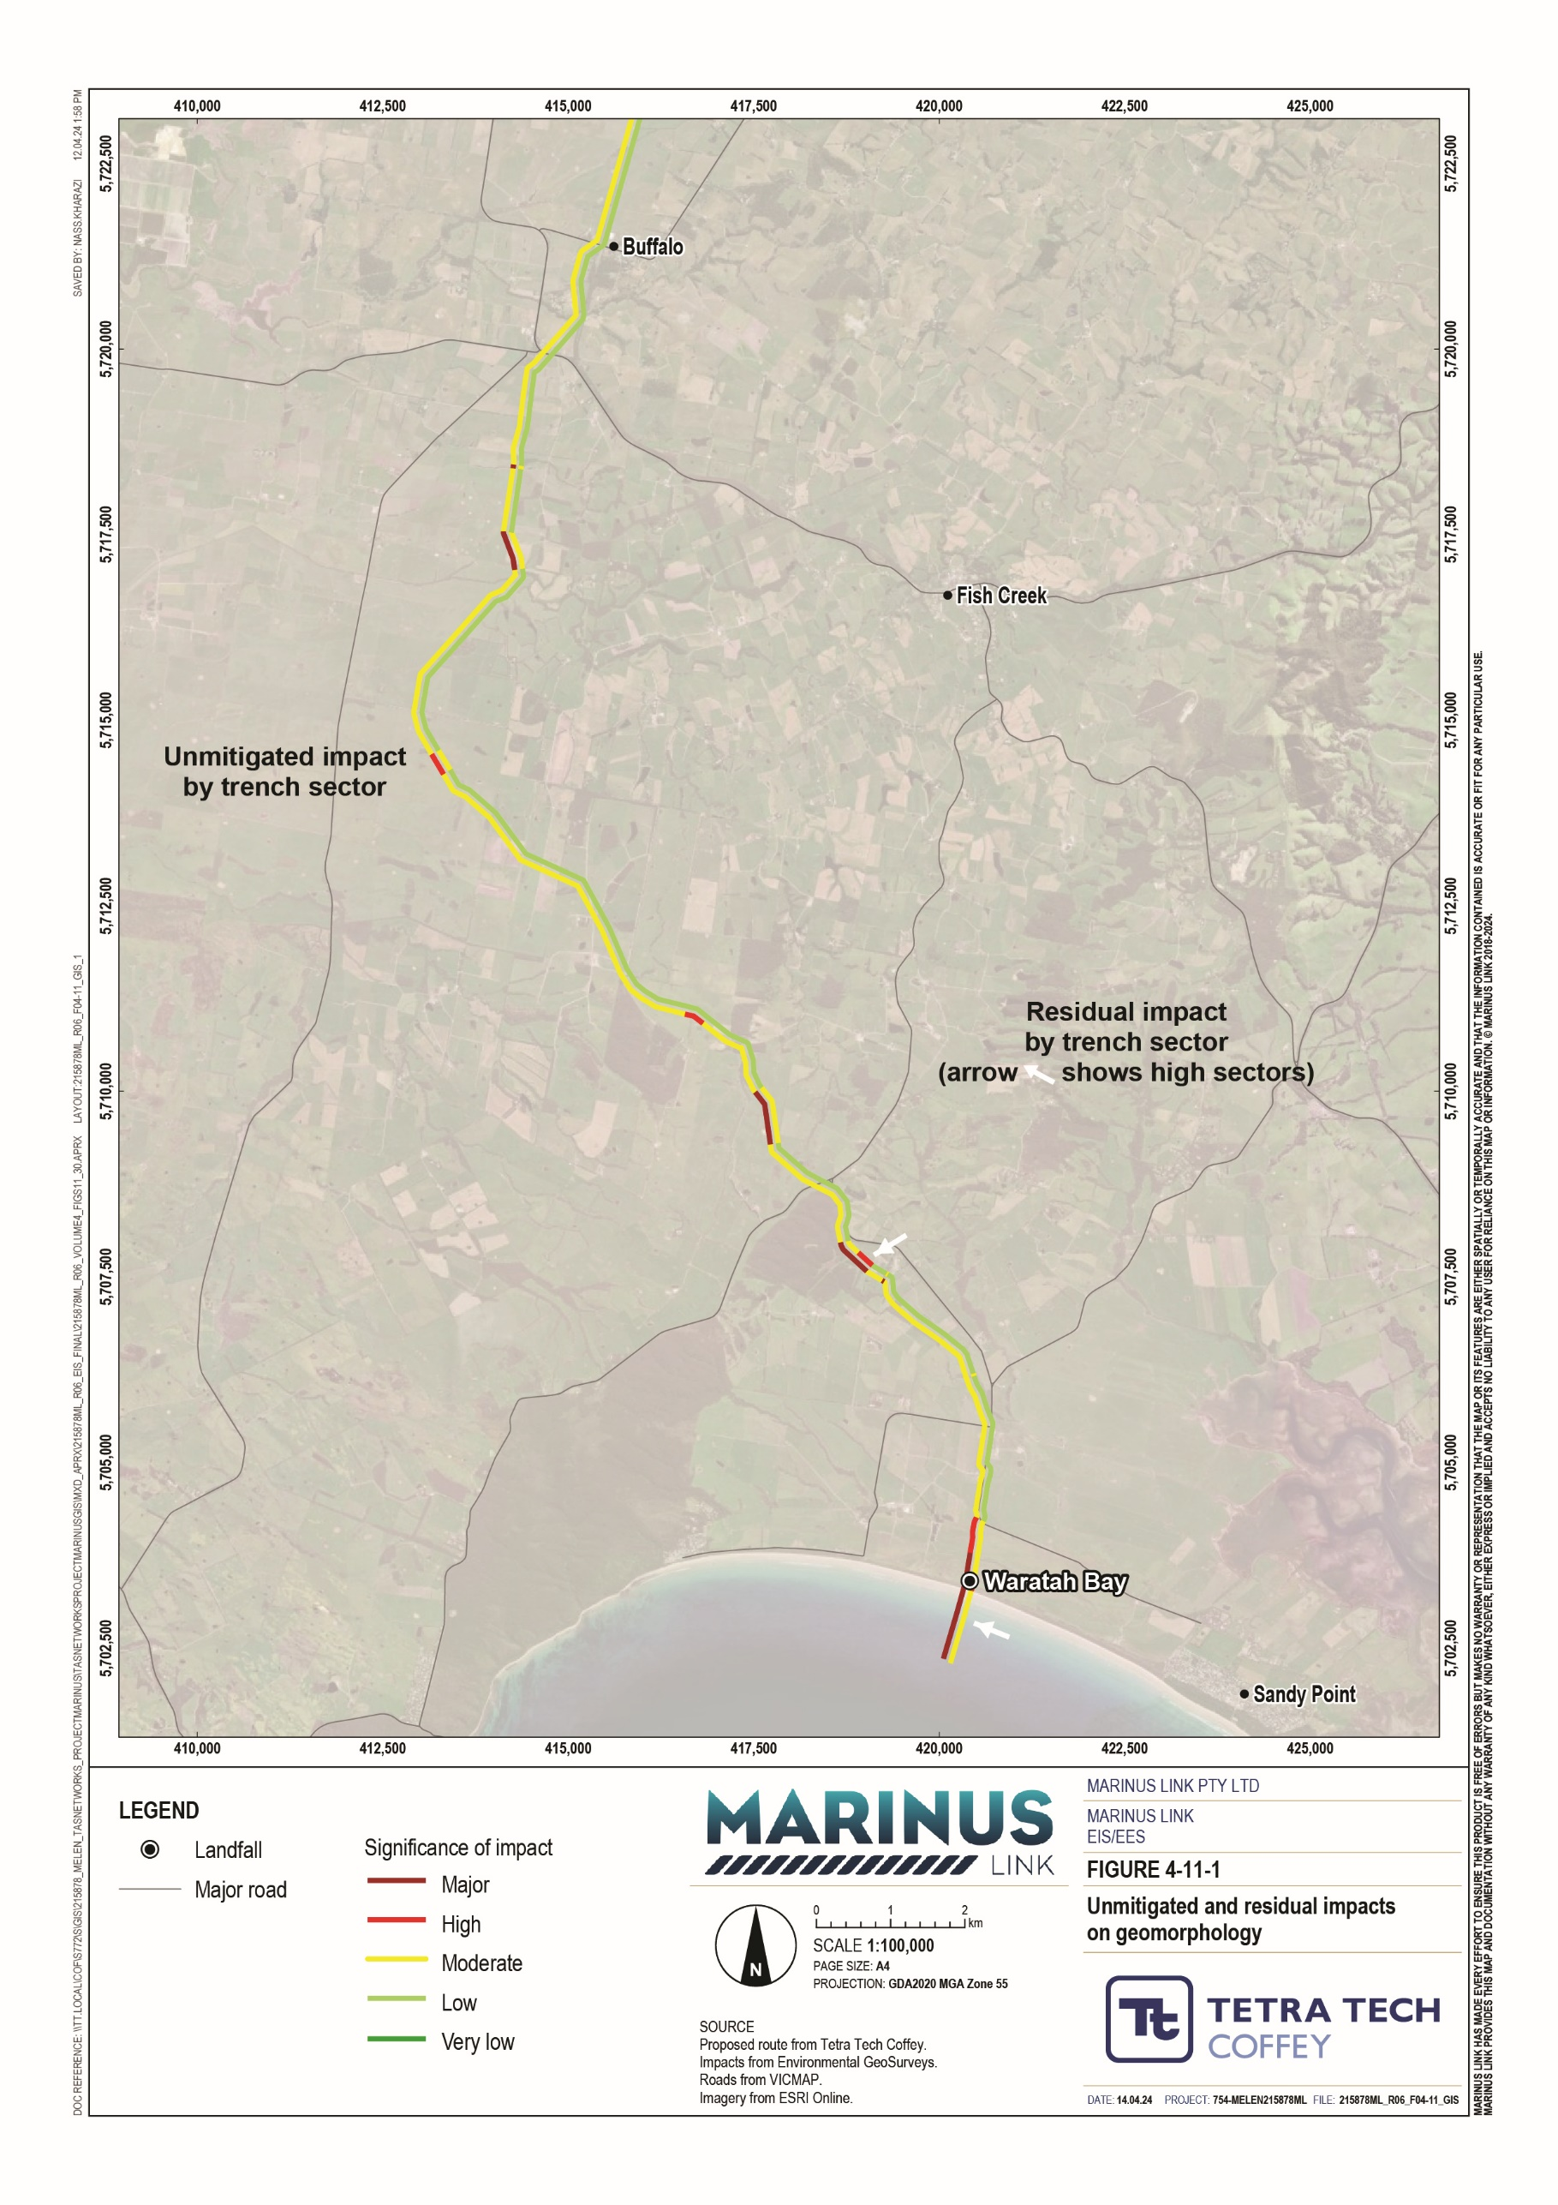

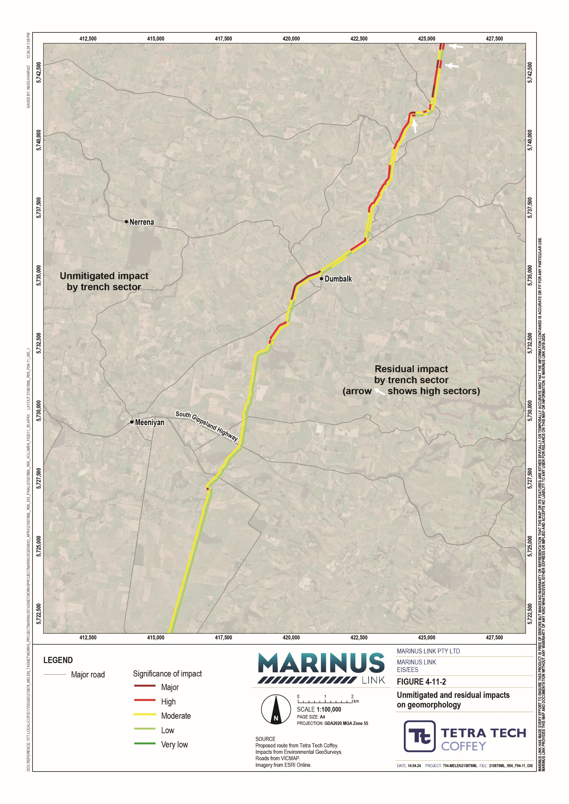

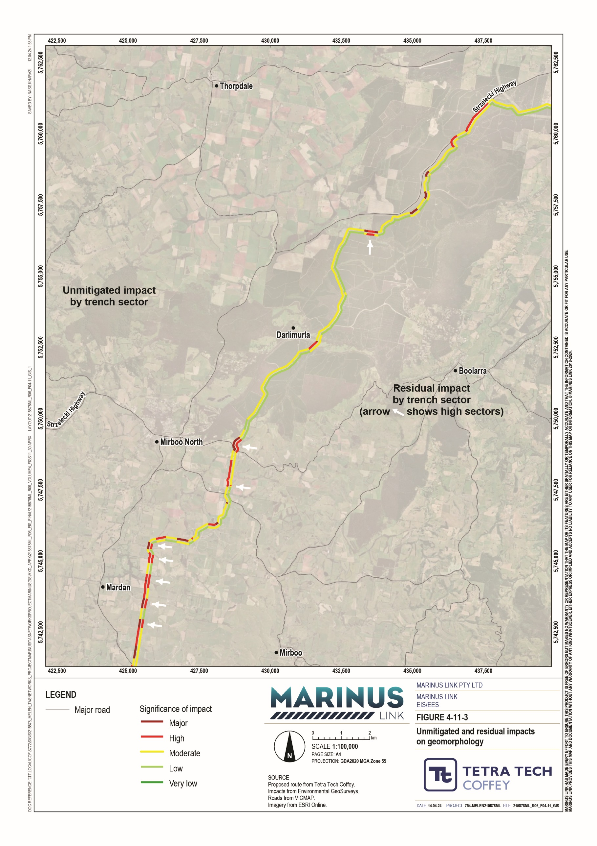

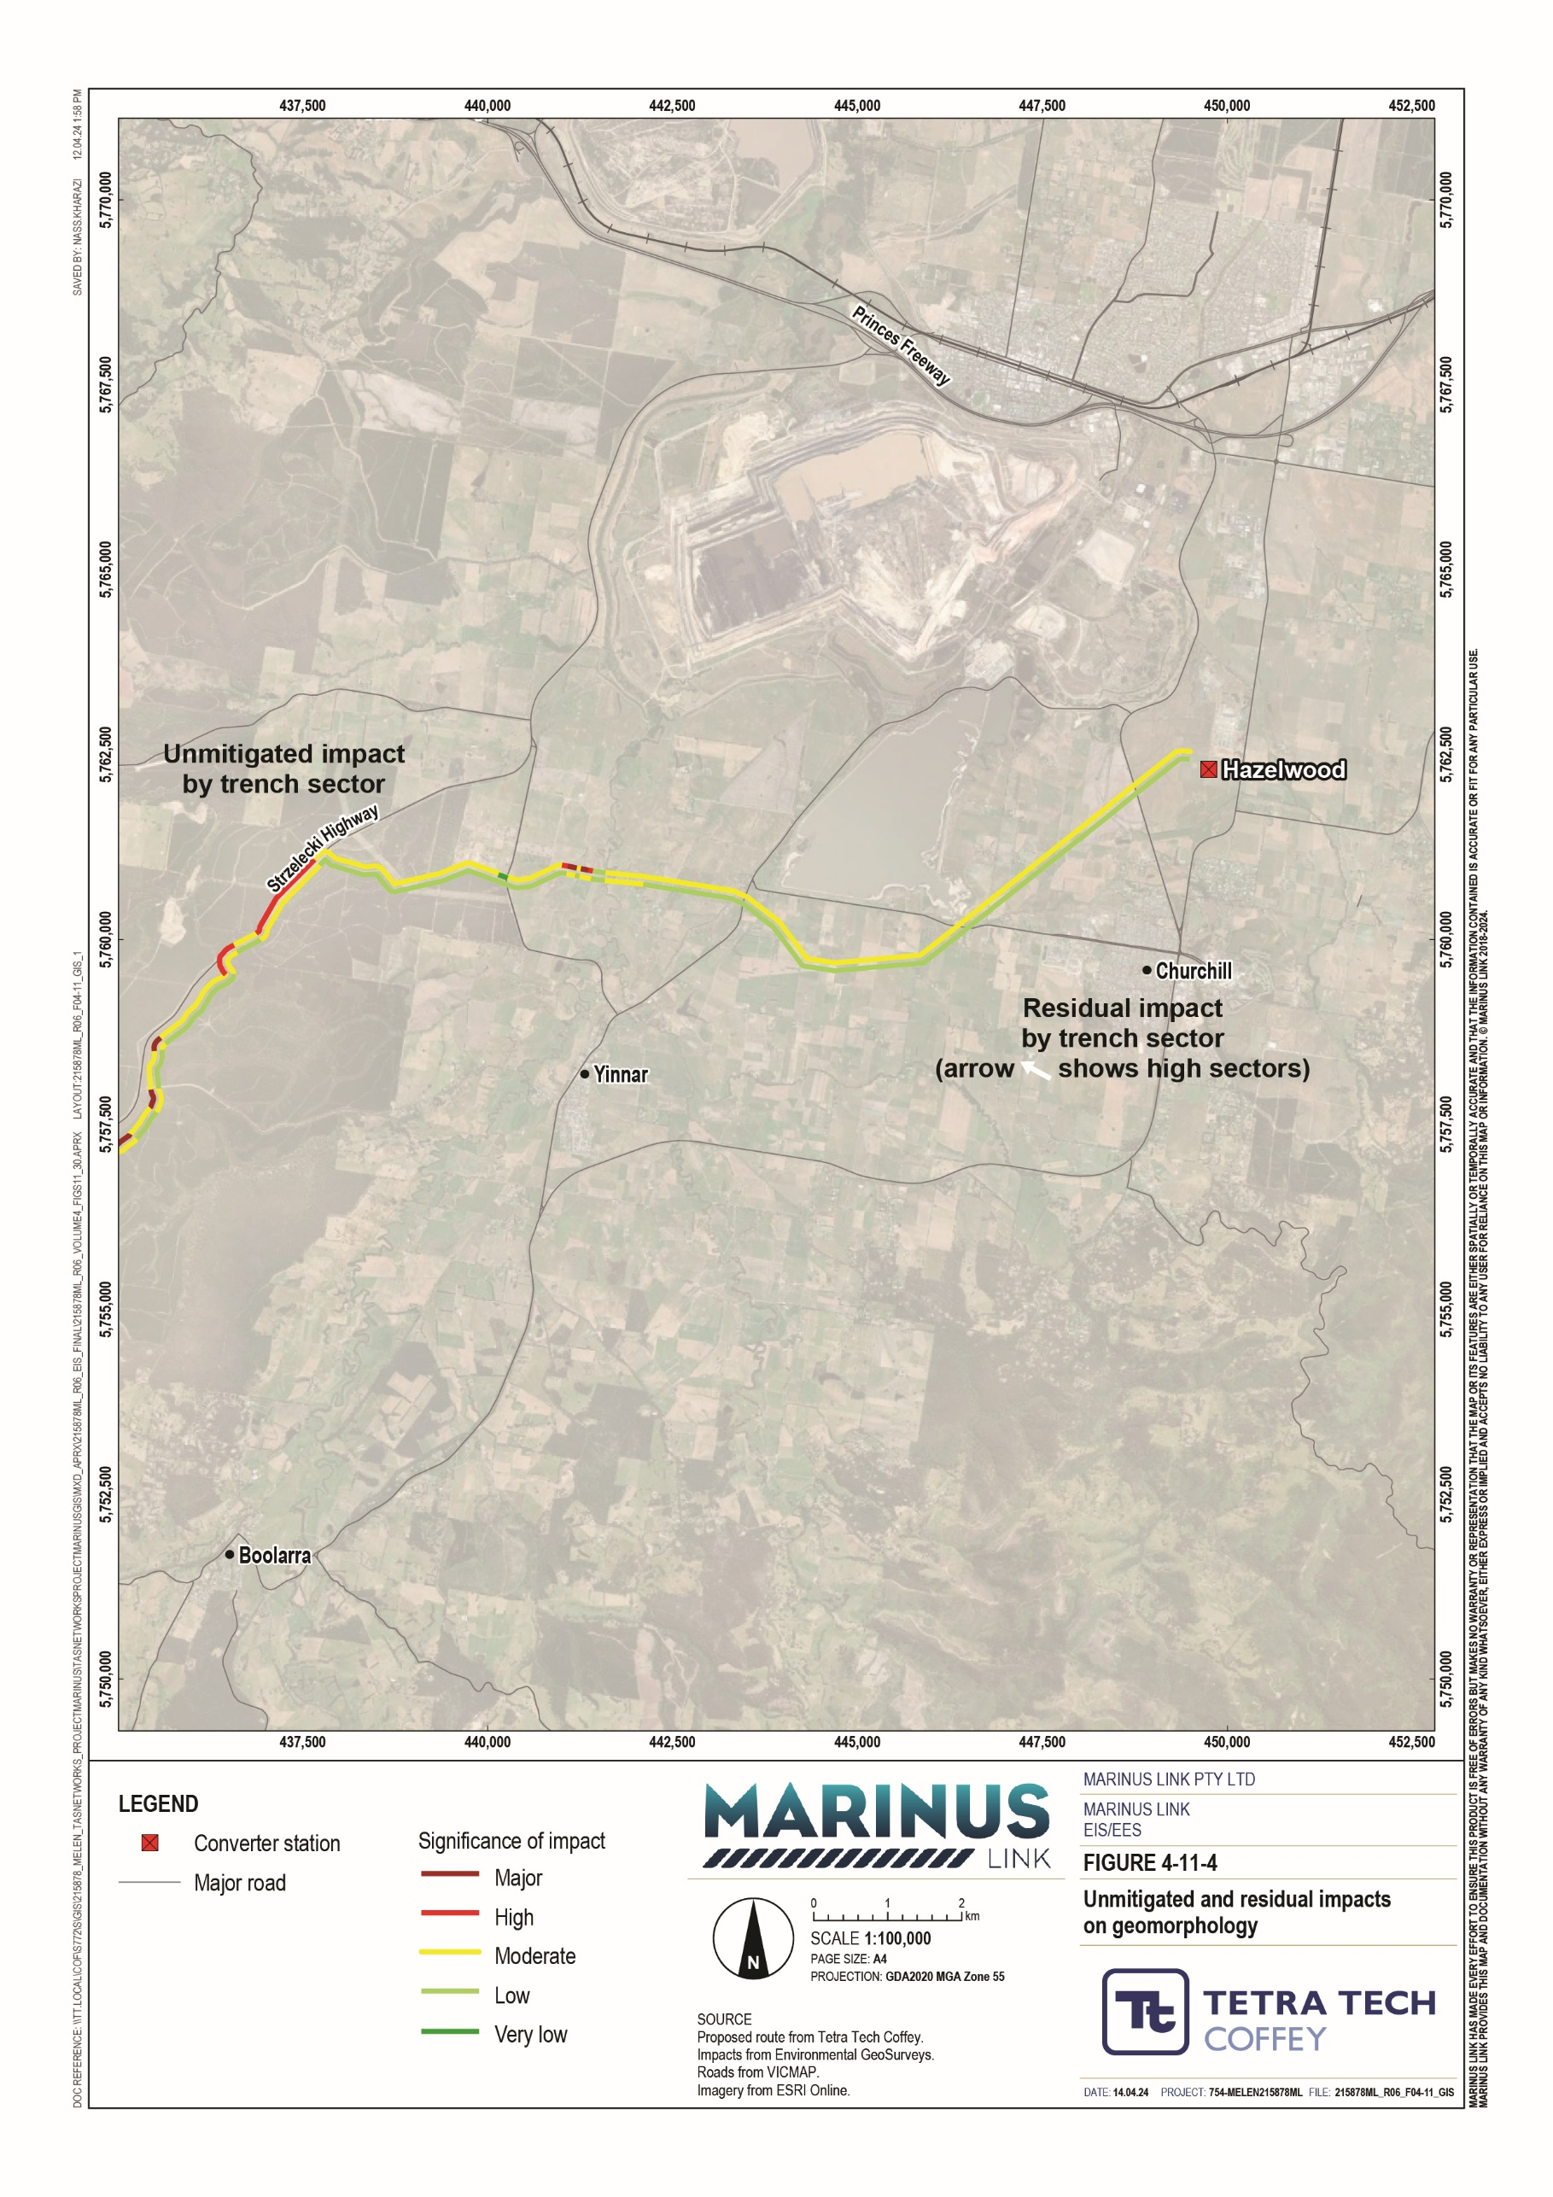

Of the 70 trench sectors with a high or major unmitigated impact, 57 reduced to moderate or low. Of the remaining 13 sectors, 9 reduced from major to high, and four remained high. Table 2-4 provides further discussion regarding trench sectors with a high or major unmitigated impact that reduced to moderate or low following implementation of key EPRs.
A low residual impact means the area of impact is localised (within the project operational area) and effectively remediated with standard mitigation. Whilst a moderate impact means the area of impact due to a change in landform or landform processes is geographically limited and has a magnitude of impact that forms a tolerable risk (see Section 2.6 for a description of a tolerable risk).
Relevant EPRs for the group of trench sectors are outlined, however details regarding specific EPRs to implemented at each site are provided in Appendix A of Technical Appendix O: Geomorphology and geology. Table 2-5 provides further discussion regarding trench sectors with a high or major unmitigated impact that remained at or are reduced to high following implementation of EPRs.

Trench sectors with a high residual impact are also shown on Figure 4-11 as the red trench sectors with white arrows pointing at them. A high residual impact means that a change may be long-term or permanent for some geomorphic attributes and the effects extend beyond the project operational area. Substantial remediation is required to reinstate some affected geomorphic attributes and supported environmental values. Table 2-5 outlines the EPRs that address the 13 sections with high residual impacts.
Although there are 13 trench sectors with a high residual impact, EPR GM01 includes a requirement for further site investigation and testing at these locations. Designs will be developed to address ground conditions and maintain land stability, with the aim of preventing the project from causing geomorphological impacts such as a landslide or subsidence. If the design is not able to address landslide risks as described, the project alignment must be revised, and measures to comply with EPRs re-applied at the revised location/s, to reduce landslide risks to a tolerable level.

Table 2-4 Trench sectors with high or major pre-mitigation impacts reduced to moderate or low residual impacts

Trench sectors Pre- mitigated impact
Justification of residual rating Recommended
EPRs
Residual impact

SC1, SC2 Major Characterised by unconsolidated, saturated substrate within a subtidal area. These conditions require appropriate construction design and methods and HDD methods to be in place, in accordance with key EPRs GM01 and GM05.
GM01, GM05 Moderate

S1, S78 Major Characterised by soft soils and PASS. Appropriate acid sulfate soil management will be implemented in accordance with EPR GM03, including consideration of construction timing to avoid adverse weather.
GM01, GM02, GM03, GM04, GM06, GM07, GM08, GM09
Moderate

S2
High
Characterised by potential regolith instability and soft/unconsolidated soils, with potential waterlogging. In addition to design EPRs, appropriate construction methods in accordance with key EPRs GM04, GM06, GM07 and GM08 are required to provide ground, slope, and trench stability, including consideration of construction timing to avoid adverse weather
GM01, GM02, GM04, GM06, GM07, GM08
Moderate

S23, S98 High Characterised by channels, with susceptibility to flooding, waterlogging and channel-slope instability. In addition to design EPRs, appropriate construction methods in accordance with key EPRs GM04, GM06, GM07 and GM08, including consideration of construction timing to avoid adverse weather and
GM01, GM02, GM03, GM04, GM06, GM07,
Moderate

S9, S94 Major
implementation of a watercourse crossing plan (EPR GM09) is required.
GM08, GM09

S20
High
Characterised by generally moderately inclined slopes with potential instability, uncertain ground
conditions and regolith. Appropriate site management to accommodate actual conditions encountered at
S55, S59, S61, S62, S63, S66, S68, S71, S73, S74, S91, S95, S102, S123, S142
High
time of construction in accordance with key EPRs including GM04, GM06, GM07, GM08.
GM01, GM02, GM03, GM04, GM05, GM06, GM07, GM08, GM09
Low

Moderate
S12, S51, S93
Major

Trench sectors | Pre- mitigated impact | Justification of residual rating | Recommended EPRs | Residual impact
S158 | High | Characterised by dissected or steep terrain composed of mostly volcanic or alluvial material. In addition to design EPRs, these sectors require appropriate site management of spoil and stockpiles to confirm slope | GM01, GM02, GM03, GM04, | Low

S80, S115, S144, S162
High
stability is maintained in accordance with key EPRs GM04, GM06, GM07.
GM06, GM07, GM08, GM09

Moderate

S16 Major
S86
High
Characterised by evidence of groundwater discharge, seepage or outflows. In addition to design EPRs,
GM01, GM02,
appropriate construction methods in accordance with key EPRs GM04, GM06, GM07 and GM08, including GM03, GM04,
S28, S70, S104, S136, S138
Major
consideration of timing of construction to avoid adverse ground conditions
GM06, GM07, GM08, GM09
Low

Moderate

S44, S46, S72, S103, S113, S161
High Generally located adjacent to or crossing active channels or floodplains. In addition to design EPRs, these sectors require appropriate management through a site drainage plan and watercourse crossing plan in
GM01, GM02, GM03, GM04,
Moderate

accordance with EPRs GM08 and GM09, including timing of construction to avoid potential episodes of GM05, GM06,

S31, S38, S50, S88, S93, S109, S124, S131, S133, S140, S159
Major
high stream flow to minimise impacts on watercourses. Many of these sectors may also require HDD in accordance with EPR GM05.
GM07, GM08, GM09

H1
Major
Characterised by a broad, low hill and low rises, with potential slope instability. In addition to design EPRs, this sector would need to be constructed in accordance with GM04, GM06, GM07, GM08 to manage potential ground, slope and trench instability.
GM01, GM02, GM03, GM04, GM06, GM07, GM08
Moderate

Table 2-5 Trench sectors with pre-mitigation impacts of high or major reduced to high residual impacts

Trench sector | Pre- mitigation impact | Description | Recommended EPRs | Residual impact
SC3 | Major | Traverses an inherently unstable dune landform (120-m-long area of steep coastal dunes), where unconsolidated sediment is prone to erosion. Uncertain sub-surface geology and characteristics require implementation of EPRs GM01 and GM05 to design and undertake HDD to minimise impacts (such as subsidence/sinkholes) at the site. | GM01, GM05 | High

S11 | Major | Characterised by complex terrain with an existing landslide extending approximately 250 m, two watercourse channels, | GM01, GM02, | High
 |  | and uncertainty as to surficial geology and spatial extent and type of slope movements in valley floor and western | GM04, GM06,
 |  | slopes. | GM07, GM08
 |  | In addition to design EPRs, including geotechnical and landslide investigations, this sector requires appropriate
 |  | construction methods in accordance with key EPRs GM04, GM06, GM07, GM08 to confirm ground, slope, and trench
 |  | stability.
S64 | Major | Traverses steep south-facing slope and apparent landslide, crossing boundary between deeply weathered Thorpdale | GM01, GM02, | High
 |  | Volcanics and weathered Strzelecki Group sedimentary rocks. In addition to design EPRs, including geotechnical and | GM04, GM06,
 |  | landslide investigations, this sector requires appropriate construction methods in accordance with key EPRs GM04, | GM07, GM08
 |  | GM06, GM07, GM08 to confirm ground, slope, and trench stability.
S75 | Major | Traverses west-facing slope, with existing landslides observed from aerial imagery. In addition to design EPRs, including geotechnical and landslide investigations, this sector requires appropriate construction methods in accordance with key | GM01, GM02, GM04, GM06, | High
 |  | EPRs GM04, GM06, GM07, GM08 to confirm ground, slope, and trench stability. | GM07, GM08
S79 | Major | Crosses two active stream channels. Possible landslides and other slope instability at lower deeply weathered Thorpdale Volcanics and weathered Strzelecki Group sedimentary rocks. In addition to design EPRs, including geotechnical and | GM01, GM02, GM04, GM06, | High
 |  | landslide investigations, this sector requires appropriate construction methods in accordance with key EPRs GM04, | GM07, GM08,
 |  | GM06, GM07, GM08 to confirm ground, slope, and trench stability, and EPR GM09 to avoid impacts at watercourse | GM09
 |  | crossings.
S81 | High | Located in steep slopes in weathered Strzelecki Group sedimentary rocks and possible landslide. In addition to design EPRs, including geotechnical and landslide investigations, this sector requires appropriate construction methods in | GM01, GM02, GM04, GM06, | High
 |  | accordance with key EPRs GM04, GM06, GM07, GM08 to confirm ground, slope, and trench stability. | GM07, GM08
S82 | Major | Crosses an active channel at base of steep slopes of adjacent trench sectors (S81 and S83). In addition to design EPRs, | GM01, GM02, | High
 |  | including geotechnical and landslide investigations, this sector requires appropriate construction methods in accordance | GM04, GM06,
 |  | with key EPRs GM04, GM06, GM07, GM08 to confirm ground, slope, and trench stability, and EPR GM09 to avoid | GM07, GM08,
 |  | impacts at watercourse crossings. | GM09

Trench sector | Pre- mitigation impact | Description | Recommended EPRs | Residual impact
S83 | High | Located in an existing landslide and steep slopes. Capping of deeply weathered Thorpdale Volcanics at ridge crests indicates deep regolith of weathered Strzelecki Group sedimentary rocks. In addition to design EPRs, including geotechnical and landslide investigations, this sector requires appropriate construction methods in accordance with key EPRs GM04, GM06, GM07, GM08 to confirm ground, slope, and trench stability. | GM01, GM02, GM04, GM06, GM07, GM08 | High
S85 | High | Located in an existing landslide in deep regolith of weathered Strzelecki Group sedimentary rocks below deeply weathered Thorpdale Volcanics and sub-volcanic sediments of low strength. In addition to design EPRs, including geotechnical and landslide investigations, this sector requires appropriate construction methods in accordance with key EPRs GM04, GM06, GM07, GM08 to confirm ground, slope, and trench stability, and EPR GM09 to avoid impacts at watercourse crossings. | GM01, GM03, GM02, GM04, GM06, GM07, GM08, GM09 | High
S89 | Major | Located in an existing landslide in deeply weathered Thorpdale Volcanics. In addition to design EPRs, including geotechnical and landslide investigations, this sector requires appropriate construction methods in accordance with key EPRs GM04, GM06, GM07, GM08 to confirm ground, slope, and trench stability. | GM01, GM02, GM04, GM06, GM07, GM08 | High
S114 | Major | Located in very steep slope/escarpment and landslide in deeply weathered Thorpdale Volcanics. In addition to design EPRs, including geotechnical and landslide investigations, this sector requires appropriate construction methods in accordance with key EPRs GM04, GM06, GM07, GM08 to confirm ground, slope, and trench stability. | GM01, GM02, GM03, GM04, GM06, GM07, GM08 | High
S117 | Major | Characterised by complex geology and regolith. Uncertain geological boundaries given existing small scale geological mapping. Significant landslide features overlying volcanic basalts in the Tarwin River uplands that require assessment. In addition to design EPRs, including geotechnical and landslide investigations, this sector requires appropriate construction methods in accordance with key EPRs GM04, GM06, GM07, GM08 to confirm ground, slope, and trench stability. | GM01, GM02, GM04, GM06, GM07, GM08 | High
S132 | High | Located in a possible landslide in deeply weathered Thorpdale Volcanics and uncertain regolith on steep slope. In addition to design EPRs, including geotechnical and landslide investigations, this sector requires appropriate construction methods in accordance with key EPRs GM04, GM06, GM07, GM08 to confirm ground, slope, and trench stability. | GM01, GM02, GM03, GM04, GM06, GM07, GM08 | High

Conclusion
The 90 km long project alignment between Waratah Bay and Hazelwood is a geomorphically active landscape, prone to change through landslides and erosion.
The geomorphology attributes which characterise the landscape include, relief and slope, landform stability, erosivity, hydrology, flood potential, regolith, soils, ASS, and geoheritage.
There are 187 trench sectors which form the basis of the impact assessment. The trench sectors were each assigned a sensitivity based on the sensitivity of each geomorphic attribute in that sector. Approximately half the sectors were sensitive and the other half either very or extremely sensitive.
Before the implementation of EPRs, just over 37% of the 187 trench sectors had either a major or high impact. Implementation of EPRs reduces major impacts by 100%, high impacts by 62% and moderate impacts by 39%.
After the implementation of EPRs, 13 trench sectors have a high residual impact on geomorphic properties and land stability. The high impacts are largely related to uncertainty about ground conditions and landform stability (including evidence of slope instability, landslides, etc). EPR GM01 includes a requirement for site investigation and geotechnical testing to inform project design. If these further investigations reveal ground conditions and potential land movement that cannot be addressed through design measures, the cable will need to be realigned in these locations.
EPR GM01 is a key EPR for the trench sectors with a high residual impact, however, will be implemented across the entire project. Potential impacts across all sectors will be managed through implementation of a combination of EPRs, depending on site-specific ground conditions and the proposed construction method. These EPRs include developing designs considering potential for construction-induced ground movement (EPR GM02) and minimising ground disturbance (EPR GM03), developing construction methods considering ground conditions (EPR GM05), providing trench stability (EPR GM06) and providing slope stability (EPR GM07), avoiding impacts on ground and slope stability through implementing a site drainage plan (EPR GM08) and avoiding impacts on fluvial geomorphology through implementation of a watercourse crossing plan (EPR GM09).
Following the implementation of proposed EPRs it is anticipated that the project will be able to meet the marine and catchment values evaluation objective to Avoid and, where avoidance is not possible, minimise adverse effects on land and water (including groundwater, surface water, waterway, wetland, and marine) quality, movement and availability.

