Contaminated land and acid sulfate soils
This chapter provides an assessment of the potential risks to human and ecological receptors as a result of encountering contaminated land or ASS through project-related activities. This chapter is based on the impact assessment provided in Technical Appendix N: Contaminated land and acid sulfate soils.
Land contamination can occur from a variety of accidental or intended activities, as well as through natural processes. Potential contamination is likely to be a result of agricultural practices, illegal dumping, accidental spills, and industrial activities. The potential for naturally occurring materials consisting of naturally occurring asbestos (NOA) and ASS has also been considered. ASS or rocks are characterised as containing metal sulfide minerals that oxidise when exposed to air, resulting in the production of sulfuric acid runoff or acidification of groundwater.
The EIS guidelines set out the following requirements related to contaminated land and ASS:

Section 4: Description of the existing environment

Section 5: Relevant impacts.

Refer to Attachment 1: Guidelines for the Content of an Environmental Impact Statement for the EIS guidelines.
The EES scoping requirements set out the following evaluation objective relevant to contaminated land and ASS:
Marine and catchment values – Avoid and, where avoidance is not possible, minimise adverse effects on land and water (including groundwater, surface water, waterway, wetland, and marine) quality, movement and availability.
Refer to Attachment 2: Scoping Requirements Marinus Link Environment Effects Statement for the EES scoping requirements.
The EES scoping requirement relates to contaminated land and ASS due to the potential for contaminated land and ASS to impact “‘catchment values”. The values for this study were drawn from the environmental values of air, land and water detailed in the Environment Reference Standard (ERS). The contaminated land and acid sulfate soils assessment considered the risks to human and environmental receptors that could arise from construction, operation and decommissioning of the project. It also recommends EPRs to avoid, reduce or manage potential impacts.

Other aspects covered in the above evaluation objective are surface water, groundwater, geomorphology and marine. These are addressed in the following EIS/EES chapters:
Volume 3, Chapter 2 – Marine ecology

Volume 4, Chapter 2 – Geomorphology and soils

Volume 4, Chapter 4 – Groundwater

Volume 4, Chapter 5 – Surface water.

Method
The risk assessment method was used to assess the potential impacts of contaminated land and ASS on values. This method is detailed further in Volume 1, Introduction, Chapter 5 – EIS/EES assessment framework. The key steps of this assessment method included:
Reviewing relevant commonwealth, state and local legislation, policies and guidelines to inform assessment method and related processes (e.g., sampling method).
Defining a study area for the contaminated land and ASS assessment.

Desktop review of publicly available information and historic aerial photographs of the study area to understand the geological and hydrogeological characteristics of the area, and historical and existing land uses, and determine contaminants of potential concern and their sources.
Development of a conceptual site model to understand potential sources of contamination, pathways, and sensitive receptors.
Site inspections to confirm the potential presence or absence of contamination or contaminating activities.
Undertaking a targeted soil sampling program of areas of interest identified in the desktop review (Figure 4-12), and subsequent laboratory analysis of potential contamination and ASS and assessment against relevant screening criteria.
Assessing the risk of harm to sensitive receptors, in accordance with the environmental values (ambient air, land and water), to be protected from project activities causing contamination or disturbing existing contamination or NOA. The assessment has applied the risk assessment method set out in Volume 1, Introduction, Chapter 5 – EIS/EES assessment framework.
Developing EPRs in response to the impact assessment to set the required environmental outcomes for the project.
Assessment of residual risk of harm to sensitive receptors (and ultimately the environmental values) following implementation of EPRs.

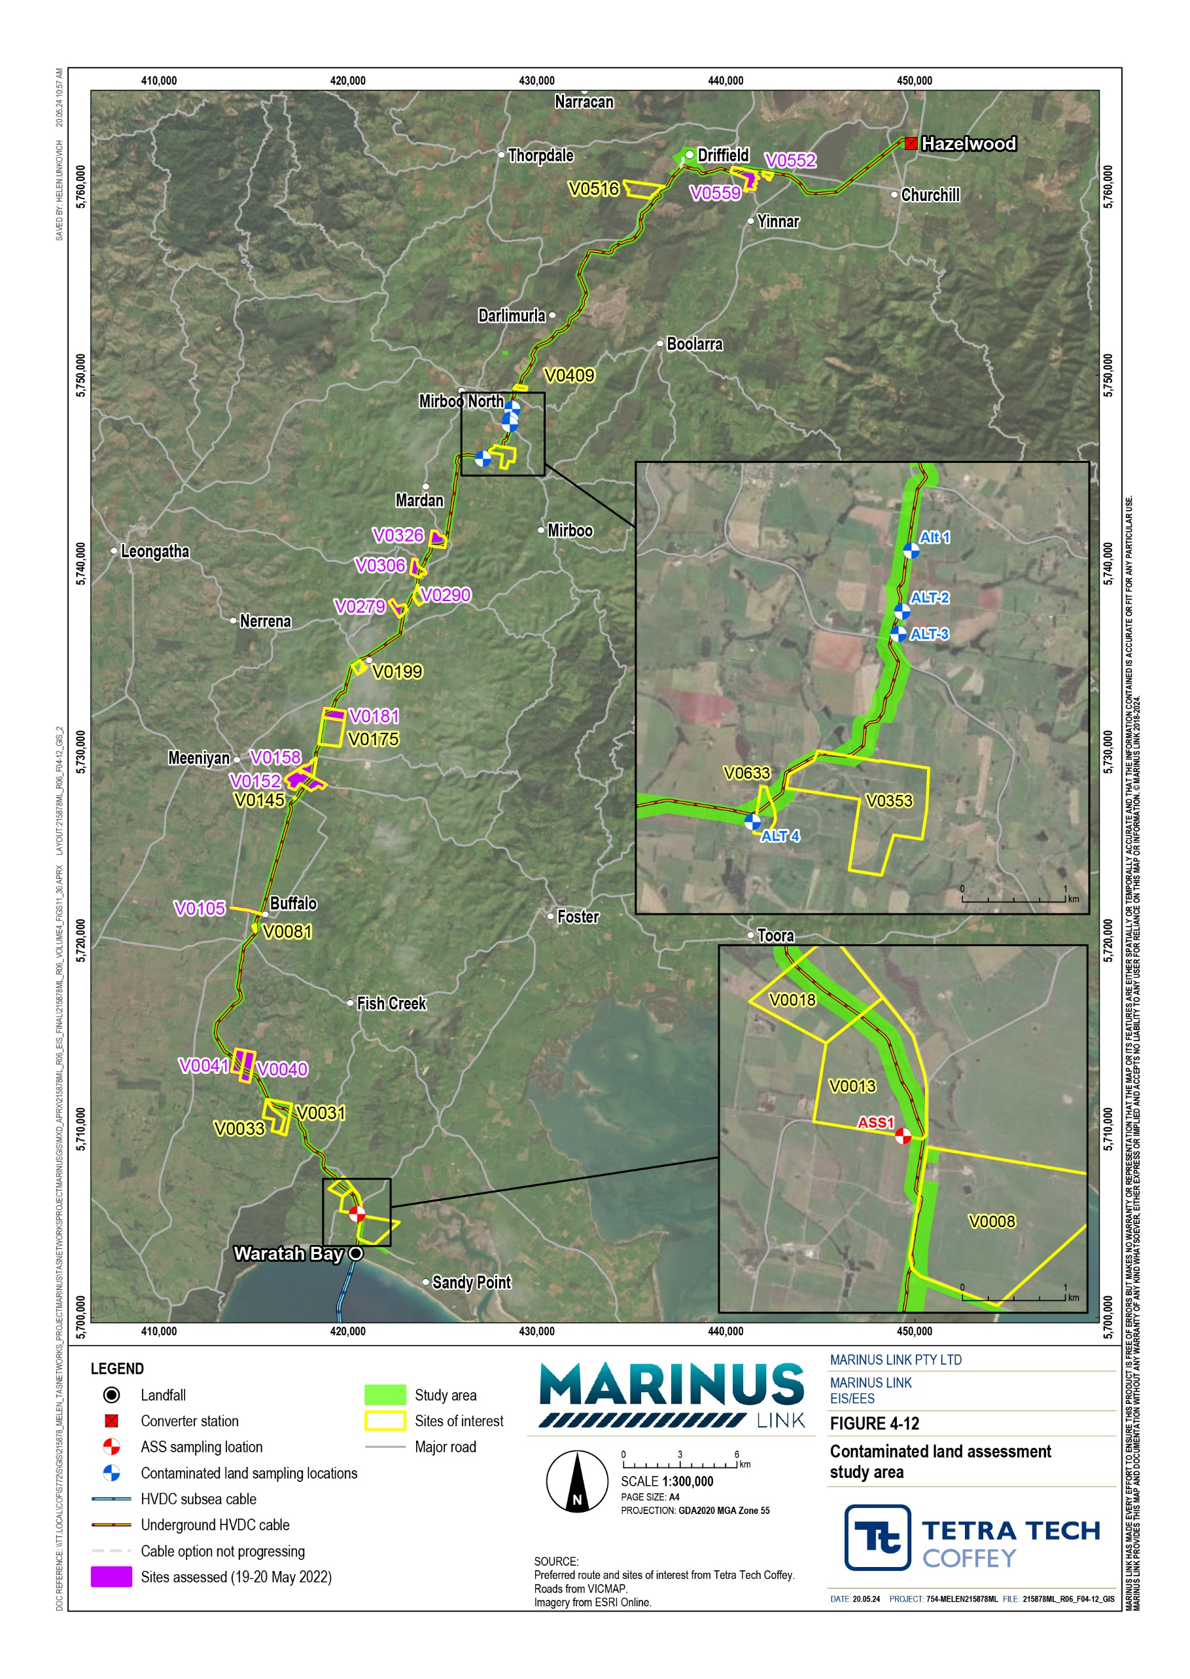

Study area
The study area was defined as 110 m either side (total width 220 m) of the 90 km alignment between Waratah Bay and the Hazelwood Converter Station (see study area in Figure 4-12). The defined study area was reviewed in the context of potential regional contaminated sites that were outside of the study area, but which could result in contamination to the study area. This review considered EPA priority sites, EPA audit sites, potentially perfluoroalkyl and polyfluoroalkyl substances (PFAS)-contaminated sites in the regional vicinity of the study area, as well as potential sources of contamination within 500 m of the study area boundary. All of the potentially contaminated sites reviewed (as a part of the study boundary review) were determined to be outside of the project’s area of influence and not considered further in the assessment.

Legislative context
The Environment Protection Act 2017 (Vic) (EP Act) is the key legislation that provides the framework for assessing the potential impacts of contaminated land. The supporting guidance for the EP Act that has informed this assessment are provided in Table 3-1.
Central to the EP Act is the General Environmental Duty (GED). The GED places a duty on all Victorians and Victorian businesses who engage in an activity that may give rise to risks of harm to human health or the environment from pollution or waste to minimise those risks, as far as reasonably practicable. Where it is not reasonably practicable to eliminate such risks, they are required to reduce them so far as reasonably practicable. This is a key guiding principal for the assessment of risk of harm to human health and the environment.

Title | Relevance to the assessment
Environment Protection Act 2017  (Vic) | This Act requires Victorians and businesses to minimise harm to the environment and human health from pollution or waste. It includes a GED, a duty to notify the EPA Victoria of prescribed notifiable contamination, and a Duty to Manage contamination.
Environment Reference Standard  (Vic) | The ERS is made under Section 93 of the EP Act, and outlines the environmental values, indicators and objectives for ambient air, ambient sound, land and water environments that are sought to be achieved or maintained in Victoria and standards to support those values. It plays a key role in environmental protection and guides the standards and management of surface water in Victoria.
National Environment Protection (Assessment of Site Contamination) Measure (Cwlth). | The NEPM (Assessment of Site Contamination) outlines the assessment approach for site contamination in Australia and was adopted for the assessment.
ANZG 2018. Australian and New Zealand Guidelines for Fresh and Marine Water Quality | This publication provides authoritative guidance and outlines the acceptable guideline levels relating to fresh and marine water quality. The projects EPRs were developed to achieve compliance with these guideline levels.
EPA Publication 655.1: Acid sulfate soil and rock | Provides guidance identifying, classifying and managing ASS and rock. Ultimately, waste ASS and rock must be managed in accordance with the requirements of the Victorian Best Practice Guidelines for Assessing and Managing Coastal Acid Sulfate Soils (DSE 2010)

Title | Relevance to the assessment
EPA publication 1940: Contaminated land: Understanding section 35 of the Environment Protection Act 2017 | This publication provides guidance on determining whether a site is potentially contaminated land. This was considered in the assessment and development of the EPRs.
EPA Publication 1977.1 – Guide to the duty to manage contaminated land | This publication provides reasonably practicable steps to comply with Section 39(2) of the EP Act, duty to manage contaminated land, and was considered in the assessment and development of the EPRs.
EPA Publication 2008.2 – Guide to the duty to notify of contaminated land | This publication provides guidance to comply with duty to notify requirements, set out in Section 40 of the EP Act, duty to notify EPA Victoria of notifiable contamination and was considered in the assessment and development of the EPRs.
EPA Publication 2010: Potentially contaminated land – A guide for business | This publication provides general guidance to businesses, regarding contamination identification, management and obligations under the EP Act.
EPA Publication 1968.1: Guide to Classifying Industrial Waste (August 2021) | This publication outlines the process for classifying industrial waste under the EP Act. The CEMP will need to adopt this classification process to comply with the EP Act.
EPA Publication 1828.2: Waste Disposal Categories – Characteristics and Thresholds (EPA 2021). | This publication outlines the assessment criteria that is used in classifying waste under the EP Act. Waste soil generated by the project must adopt these assessment criteria thresholds to classify the waste.
EPA Publication 1827.2: Waste classification assessment protocol | This publication outlines the protocol that establishes the waste classification assessment process, to comply with the Environment Protection Regulations. The project will need to follow this protocol to achieve compliance.

Assumptions and limitations
The following assumptions and limitations have informed the assessment:

It has been assumed that any potential source of contamination located within the study area could be disturbed by the project, regardless of proximity to project-related activities and the construction method employed. This provides a conservative approach and accommodates for changes in the alignment with the final design.
There were access constraints for a number of parcels along the alignment. Therefore, a conservative approach has been adopted in assuming that parcels that could not be accessed contain contaminated material. These parcels will warrant further assessment prior to construction to confirm the nature and extent of contamination in these parcels (if any). The findings of this assessment will inform the construction method and measures to be included in management plans to mitigate the identified risks.
Site access in the coastal area was also restricted and there is a high potential for ASS to occur in the area. Whilst a conservative approach has been taken to assume the presence of ASS, further assessment is recommended prior to construction to confirm the extent and nature of the ASS.

Mapping data bases used in the assessment, including Australian Soil Resource Information System (ASRIS) for acid sulfate soils and Department of Sustainability and Environment (DSE 2010) for coastal ASS (CASS), have degrees of uncertainty associated with boundary accuracy of the maps used and the characterised potential of ASS. Therefore, the uncertainty of the databases used has been assumed to have a 95% accuracy in determining the project’s potential to encounter potential ASS during construction. The overall uncertainty adopted was incorporated into the iterative risk-based approach to assessment of ASS for the study and included a level of conservatism regarding the extent of potential ASS that may be encountered within the study area.
Potential PFAS contamination identified near or around roadways, due to the use of PFAS-containing firefighting foams at the scene of vehicle incidents is not considered further as Country Fire Authority (CFA) do not maintain a record of all incidents or locations where firefighting foam was deployed.

Existing conditions
This section describes the existing conditions that may influence the behaviour of contamination, and the environmental values that may be affected by contamination, within the study area. This includes features of the environment that may influence the transportation of contamination, and historical and existing land uses, and naturally occurring processes that may cause contamination, if disturbed.

Potential contamination
Publicly available information was used to identify sources of naturally occurring material or substances, and existing or historical land uses or incidents that may have caused, or has the potential to cause contamination, or impact the projects works within the study area.
Following this, a conceptual site model was prepared showing how potential contamination could have impacted environmental values within the study area. A conceptual site model was developed to understand the potential sources, pathways and sensitive receptors of the contamination, to inform the targeted soil sampling program and gain further understanding of potential contamination within the study area.
Naturally occurring material or substances refers to contamination that may be generated by natural processes or exist prior to anthropogenic activities.
ASS containing metal sulfides may be present in areas characterised by highly mineralised geology. The metal sulfides may occur or become available through natural processes, such as hydrothermal alteration of rocks and soils containing metal sulfides, or microbial decomposition of organic matter in water-logged soils and sediments containing metal sulfides. If these metal sulfides are exposed to oxygen (e.g., through excavation or drilling and the management of excavated material or drill cuttings), they will react to form sulfuric acid. Sulfuric acid can significantly impact environmental sensitive receptors, including reducing soil and water quality, and increasing toxicity. Therefore, areas that are permanently water-logged or lack

exposure to oxygen are considered to have an increased potential of containing ASS. Disturbance and/or generation of ASS can also result in release of hydrogen sulfide, which produces a rotten egg like odour that may impact on air quality and amenity.
NOA is typically associated with ultra-mafic and hydrothermally altered basaltic rocks and serpentinites. The technical study identified and assessed the geological units that the project alignment crosses and found no potential sources of NOA based on the geological units. NOA is generally not encountered within Victorian geology, due to the geological units being predominantly sedimentary. Therefore, there is a very low likelihood of NOA being present or encountered in the study area.
There is a low to extremely low probability that ASS exists within most of the study area. The only exception is the Waratah Bay Beach area that has been assessed as having a high probability of containing ASS (see Figure 4-13). Permanently waterlogged soils, such as in streams, floodplains, rivers, wetlands, and shallow groundwater have an increased potential of containing ASS; however, they are not covered by Commonwealth Scientific and Industrial Research Organisation (CSIRO) published ASS maps. Due to their increased potential, the section of Eel Hole Creek that feeds into Hazelwood pondage area (see Figure 4- 14), and locations with shallow groundwater and stream crossings that are mapped in the groundwater and surface water technical appendices (see Technical Appendix P: Groundwater and Technical Appendix Q: Surface water) have been assessed as having a high probability of containing ASS.
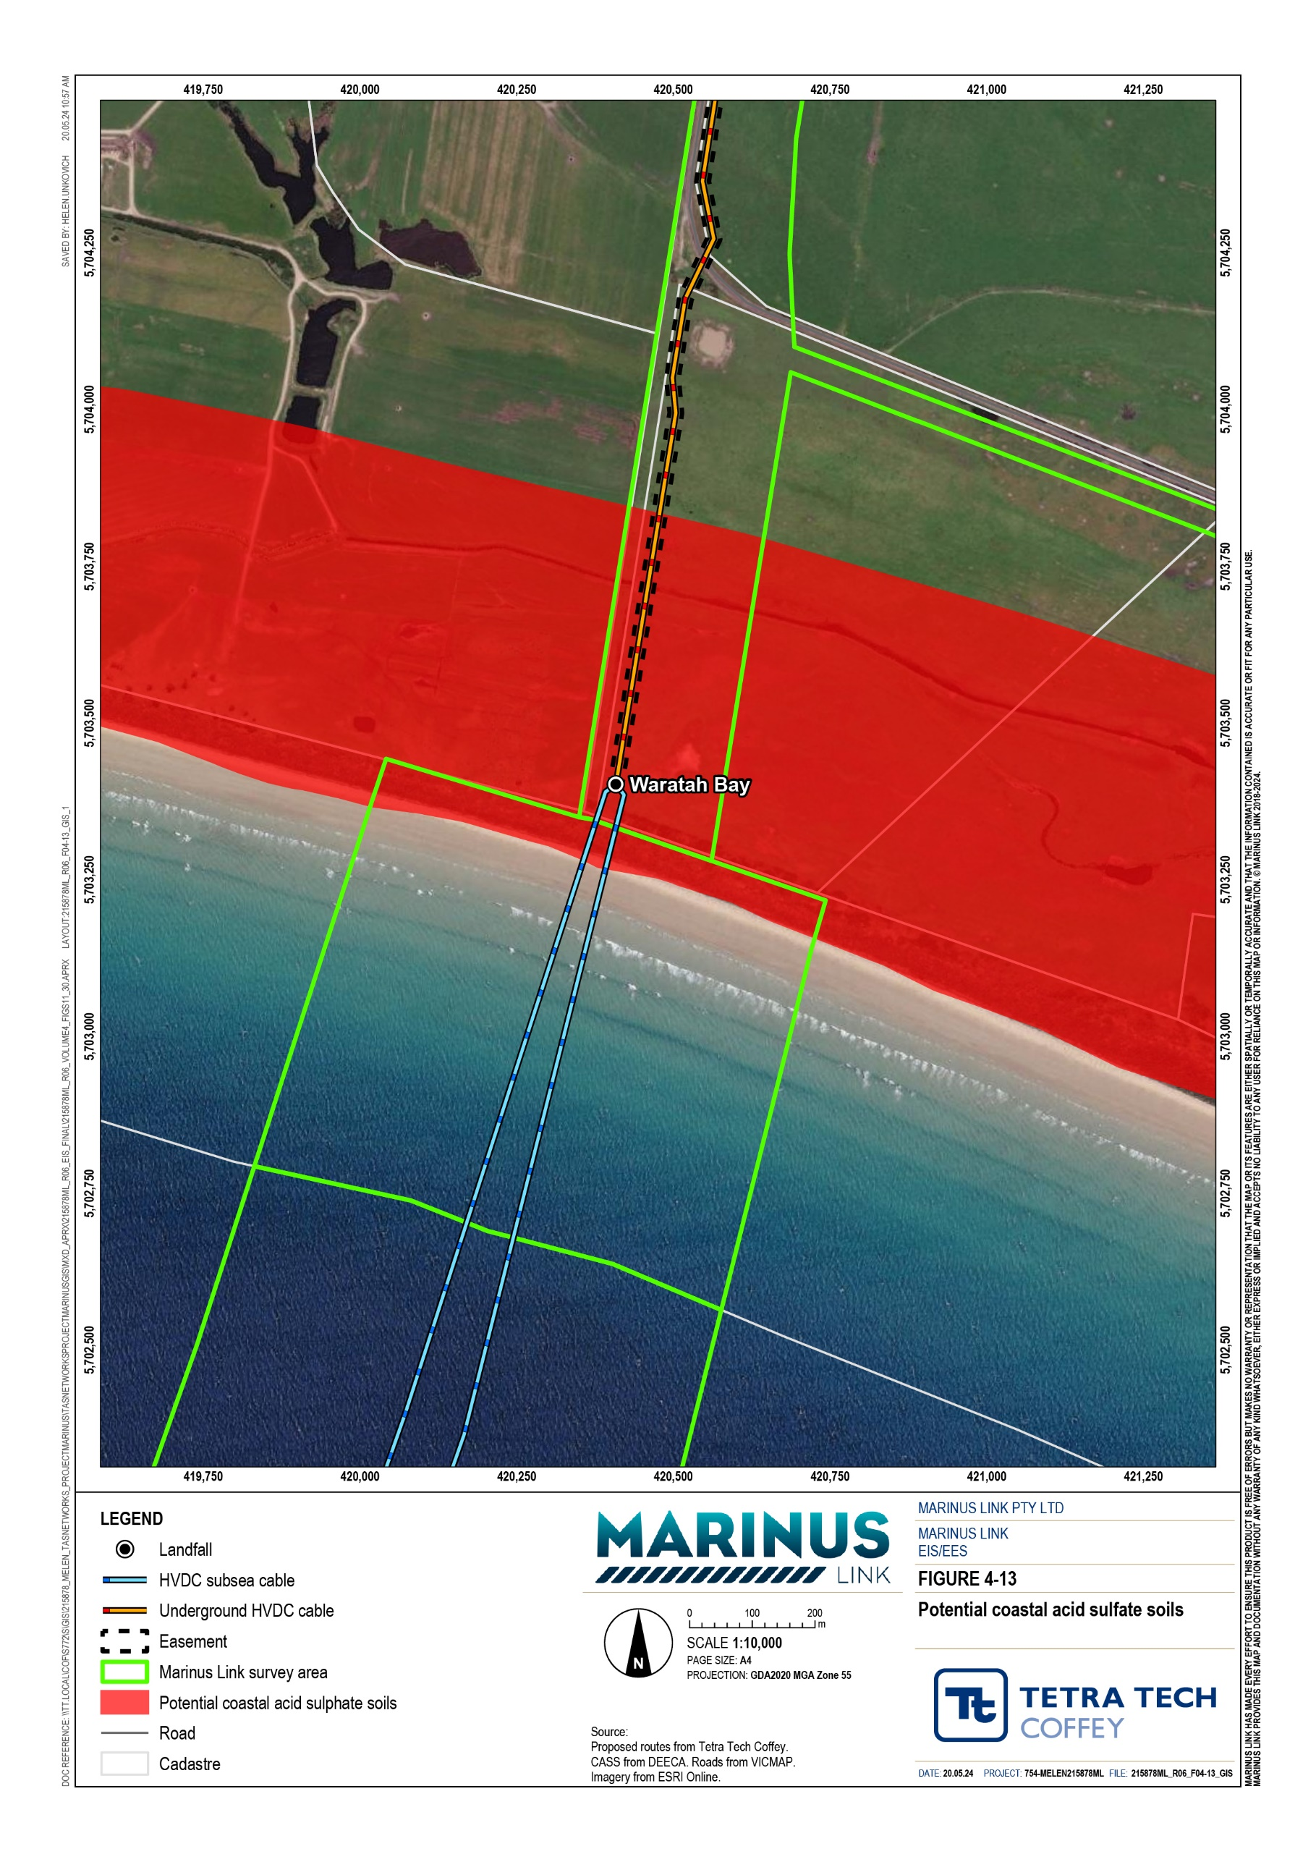

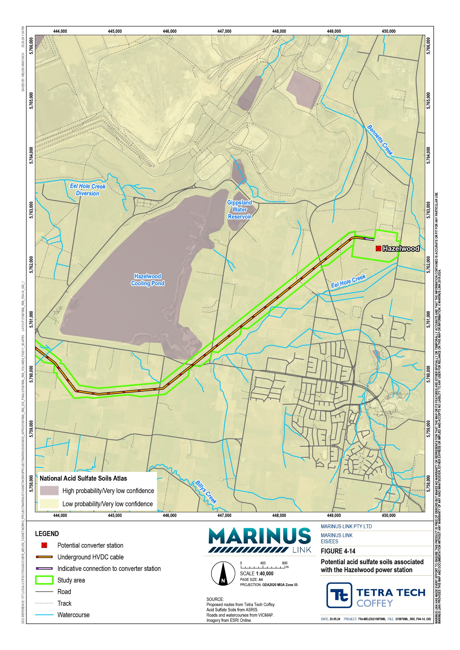

In addition to sources of naturally occurring material or substances that may cause contamination, the potentially contaminated sites that were identified include:
A former industrial site, listed on the EPA Priority Sites Register, is located 980 m east of the project area, in Hazelwood.
Potential PFAS containing sites reviewed through a search of Department of Defence and Air services PFAS programs or databases. The potential sources of PFAS identified within the study area include:
- The Dumbalk CFA fire station. The fire station is located approximately 500 m from the project alignment, and may be contaminated with PFAS, due to the potential historical use of PFAS- containing firefighting foams, such as for training or testing of equipment. However, it is considered unlikely that PFAS would have migrated far enough to be within the project’s AoD, and therefore, has not been considered further.
- Near or around roadways, due to the potential that PFAS-containing firefighting foams were used at the scene of vehicle incidents.
- The Hazelwood Landfill site is a potential source of PFAS to groundwater.
A petrol station in Dumbalk identified 440 m east of the alignment. Petrol stations have a high potential to cause contamination of soil or groundwater. However, it is considered unlikely that any potential contamination from this source would have migrated to the project’s AoD. This is due to the distance between the site and the project area, and the direction in which the ground water travels (to the south- east, and away from the alignment – based on the topography). Therefore, the impacts relating to the petrol station in Dumbalk have not been considered further.
The Delburn Wind Farm is located within 500 m of the project area and found to have a historical EPA audit report, which could imply potential contamination. The Delburn windfarm, whilst being noted as the subject of an environmental audit, was audited for a noise audit, and not for potential contamination. Consequently, whilst the site transects the boundary of the Delburn windfarm audit, there are not considered to be any potential sources of contamination within the study boundary related to the Delburn windfarm, and this area was not considered further.
The Hazelwood Power Station boundary is located within 500 m of the project area and found to have historical EPA audit report. The Hazelwood Power Station Environmental Audit was associated with the operation of parts of the power station infrastructure and mining areas. However, due to EPA requirements, the boundary of environmental audits are either based on a property title boundary, or an operating licence boundary. As a result, the Hazelwood Power Station Environmental Audit boundary encompassed large tracts of land that did not contain any potential sources of contamination. The review of the environmental audits at Hazelwood indicated that the areas of potential contamination within the audit boundary were greater than 1 km from the study area and considered unlikely to have resulted in contamination on the study area.

No other potential sources of contamination, such as drycleaners, motor garages, former licensed activities, EPA development licences, prescribed industrial waste permits, landfills, former gasworks, waste management facilities were identified within 500 m of the study area.
The 2014 Hazelwood mine fire is not considered a potential source of PFAS, as the fire occurred after the PFAS containing foams were withdrawn from use. Through the review of aerial photographs of the study area, the following features indicating potential sources of contamination were identified:
Land or soil disturbance, or increased soil movements

Intensive agricultural practices (e.g., potato farming)

Wastes or waste material

Dairy operations or shedding

Areas observing these features, as well as areas where the alignment passed close (<500 m) to buildings, shedding, stockyards etc., were considered for further review
Tree dieback.

A site visit was undertaken to verify the potential sources contamination identified in the literature and aerial photography review. A detailed historical aerial review, along with site walkover photographs are provided in the technical appendices (see Technical Appendix N: Contaminated land and acid sulfate soils). A conceptual site model informed by the desktop assessment and site walkover was prepared to further understand the potential risk from contamination in the study area.
Two other potential sources of contamination with a potential for broader impacts were identified and include the agricultural areas, particularly the potato growing region near Thorpdale, due to the use of pesticides and herbicides, and the Waratah Bay Beach area that has been assessed as having a high probability of containing ASS. The Thorpdale potato growing area was targeted for broad-area sampling to assess the potential presence of pesticide residues. The results of the pesticide sampling were all below the adopted screening criteria and below the laboratory reporting limits.
Soil sampling for ASS was undertaken near the Waratah Bay ‘high-probability-ASS’ mapped area (noting that access to the high-probability-ASS area was not available) to assess the potential northern extent of ASS in this area. The results of the ASS testing were below the applicable EPA Victoria Publication 655.1 Acid sulfate soil and rock. The ASS sampling results indicated a low likelihood of impact if disturbed and was used to confirm that the mapped ASS is likely to be limited to the mapped high-probability and does not extend inland. The results also confirmed the mapped broader 'low probability-ASS' zone of the project.
The assessment did not identify any potential sources of contamination within the coastal fringe of Waratah Bay (or within 2 km out from coast) that have the potential to result in contamination of seabed sediments during construction, operation or decommissioning of the cable. Therefore, no specific testing of seabed sediments was undertaken. Soil sample results have been tabulated against the adopted assessment criteria and presented in the technical appendices (see Technical Appendix N: Contaminated land and acid sulfate soils).

In summary the potential localised point sources of contamination identified during the technical study are listed in Table 3-2.

Potential contamination source | Associated contaminants of potential concern
Former railway alignment | Metals, petroleum hydrocarbons, asbestos
Agricultural use – heavy machinery | Hydrocarbons
Agricultural use – pasture and cropping | Herbicides and pesticides
Agricultural use – grazing | Herbicides and pesticides
Waste dumping | Metals, hydrocarbons, pesticides, herbicides, asbestos, inert wastes
Burn piles | Hydrocarbons, metals
Imported fill material | Metals, hydrocarbons, pesticides, herbicides, asbestos, inert wastes
Septic tanks | Nitrates, phosphorus, Escherichia coli, thermotolerant coliforms,
Aboveground and underground fuel tanks | Petroleum hydrocarbons
Fire fighting | PFAS
Landfills/buried waste | Metals, hydrocarbons, pesticides, herbicides, asbestos, inert wastes, nitrates, ammonia, bicarbonates, PFAS, methane
Potential acid sulfate soil | Acid generation (low pH), metals

Summary of environmental values
Technical Appendix N: Contaminated land and acid sulfate soils considered the elements of the environment, and their associated environmental values to be achieved or maintained in Victoria (ERS 2021) including:
Ambient air: comprises the external air environment, with the relevant environmental values: life, health and well-being of humans; and other forms of life; local amenity and aesthetic enjoyment; and visibility.
Land: comprises soil, fill, rock, weathered rock and sand, the vapour and liquids within these materials, the relevant environmental values of land dependent ecosystems and species, human health, buildings and structures, aesthetics and production of food, flora and fibre.
Water:

      - Surface water: comprises aquatic reserves and other surface waters including rivers and streams, wetlands, estuarine settings and marine settings with the relevant environmental values: water dependant ecosystems and species; human consumption, agriculture and irrigation, human consumption of aquatic food, industrial and commercial, water based recreation, and traditional owner cultural values.

      - Groundwater: comprises any water occurring in or from an aquifer, including includes any dissolved or suspended in any such water, with the relevant environmental values: water dependent ecosystems and species; potable water supply; potable mineral water supply; agriculture and irrigation (irrigation and stock watering); industrial and commercial use, water-based recreation, traditional owner cultural values, buildings and structures, and geothermal properties.
These environmental values were reviewed to identify the relevant receptors within the study area that may be impacted by disturbance of potential contamination or ASS through project construction and operation. Indicators and objectives were established to assess the potential risks to these receptors, and the pathways by which the receptors may be exposed to the potential sources of contamination.

Sensitive receptors and exposure pathways
Human and ecological sensitive receptors may be exposed to existing contamination that is disturbed or contamination occurring through spills or leaks, if standard management measures fail, and those sensitive receptors have exposure pathways to the contamination.
Specific sensitive receptors identified that may be impacted by potential contamination include:

Persons using the study area including farm workers, recreational users and visitors, that may come into contact with contaminated soil and/or groundwater or be exposed to airborne contamination, or vapours that emit into indoor or outdoor areas.
Construction and maintenance workers conducting works at the site, that may come into contact with contaminated soil and/or groundwater or are exposed to airborne contamination, or vapours that emit into indoor or outdoor areas.
Recreational users of impacted surface waterbodies.

Surface waterbodies and the aquatic ecosystem(s) therein receiving surface water runoff and/or groundwater discharge from contamination associated with the study area and their surrounds.
Ecological sensitive receptors (aquatic and terrestrial flora and fauna) that may be exposed to contamination in soils and that may uptake contamination from on-site or off-site water bodies or where contamination may migrate.
The potential pathways through which human and ecological sensitive receptors may be exposed to potential contamination include:
Human health exposure pathways.

Dermal contact with contaminated soil.

Incidental ingestion of soil.

Inhalation of soil/sediment derived dusts (including asbestos fibres), and/or soil vapour.

Volatilisation of contaminants leading to inhalation.

Incidental ingestion or dermal contact with contaminated surface water or groundwater.

Ecological exposure pathways.

Ingestion of soil by, or direct toxicity to, soil invertebrates.

Uptake and accumulation by, or direct toxicity to terrestrial plants.

Incidental ingestion of soil by fauna foraging.

Migration of contamination via surface run-off result in direct contact with contaminated water and/or sediment by aquatic organisms in receiving surface waters.
Leaching of contamination in soil to groundwater resulting in impacts to groundwater dependent ecosystems.
In summary, the key potential sources of contamination are from existing waste and effects of which are expected to be localised, and not expected to pose a risk to sensitive receptors, unless disturbed. This includes landfills, buried waste, imported fill material, burn piles, septic tanks, above and below ground fuel tanks, and other locations that are potential sources of contamination, such as a former railway alignment, and agricultural chemical storage. The primary mitigation approach is to avoid these sites via micro realignment (involving small-scale adjustments to the route to avoid localised features such as small areas of wastes or contamination) of the project and were therefore not included in the targeted sampling program.

Construction impacts
A risk assessment was completed to assess the potential environmental risks that construction activities pose to values.
The assessment identified the following construction hazards and impact pathways that pose a risk to human health and the environment if standard management measures fail or are inappropriately implemented:
Disturbance of existing waste (such as chemical containers, construction materials, buried waste etc) that impacts the environmental values of ambient air, land and water and potentially poses an unacceptable risk to human health and ecological sensitive receptors via dermal contact, incidental ingestion, inhalation, uptake, or migration via surface water or groundwater to surface water or groundwater dependent ecosystems.
Disturbance of unexpected areas of contamination or waste (such as hazardous materials or asbestos) that impacts the environmental values of ambient air, land and water and potentially poses an unacceptable risk to human health and ecological sensitive receptors via dermal contact, incidental ingestion, inhalation, uptake, or migration via surface water or groundwater to surface water or groundwater dependent ecosystems.
Erosion of excavations, temporarily stockpiled soils and completed works areas during and following construction impacts the environmental values of ambient air, land and water and potentially poses an unacceptable risk to human health and ecological sensitive receptors via inhalation, migration to surface water bodies resulting in sedimentation and uptake by aquatic ecological sensitive receptors.

Disturbance and oxidation of ASS leading to acid generation and/or metal leaching that impacts the environmental values of land or water, and potentially presents an unacceptable risk to ecological sensitive receptors via ingestion, uptake and accumulation, migration via surface water or groundwater to surface water or groundwater dependent ecosystems, or acid degradation of cultural heritage items. The oxidation of ASS may also lead to the generation of hydrogen sulfide gas, that may impact on air quality.
Leaks or spills of construction materials (such as oils, hydraulic fluids, drilling muds, cable joining compounds etc) that impacts the environmental values of ambient air, land and water and potentially poses an unacceptable risk to human health and ecological sensitive receptors via dermal contact, incidental ingestion, inhalation, uptake, or migration via surface water or groundwater to surface water or groundwater dependent ecosystems.
These impacts are discussed in the sections below.

Localised impacts of existing waste
Waste piles, including wood, plant material, tyres, building wastes, potentially asbestos-containing materials, agricultural chemical containers and general household or agricultural waste material were observed during site walkovers of the project area. Buried waste material presents an increased risk due to the potential for hazardous material, based on the items observed across some sites, including fire extinguishers, live and spent ammunition and chemical containers.
The desktop assessment identified several other potential areas of contamination, that were not able to be verified by a site visit, due to a lack of access.
Disturbance of these waste materials has been assessed to pose a low risk to environmental values. In particular construction workers, flora, and fauna that may come into contact with the material if there is a loss of containment incident due to the incorrect management of the material. For example, dermal exposure to construction workers, spread of contamination through surface water runoff and ground water, spreading to surrounding values. The low initial risk is derived from the unlikely likelihood, based on the expectation that standard controls will be implemented e.g., appropriately segregating and containing wastes, and waste management hierarchy principles - avoid, minimise, reuse, recycle and appropriately dispose, and minor consequence rating, based on the impacts expected to be localised. The management of localised impacts of existing waste is described in EPRs CL01, CL02 and CL04.

Excavated soil and surplus material
The assessment of the study area has not identified areas of contaminated soils or ASS that require specific management. Soils excavated from areas where contamination or ASS are identified and cannot be avoided will require separate management, as described in EPR CL02. These would be identified by site inspection, soil validation testing, and development of an ASS management plan, as described in EPR CL01 and EPR CL03.

The construction phase is expected to generate one cubic metre of surplus soil per linear metre of the alignment, due to the project components replacing soil space during trenching. This equates to approximately 90,000 m³ of surplus soil for the entire project. This surplus soil is not expected to be contaminated. Additionally, there is expected to be a surplus of crushed rock (used for access track construction) at the completion of the project.
Depending on the constraints of the land, area, and quality of surplus soil or rock, it may be repurposed in- situ or require off-site transportation for treatment, or disposal, in accordance with the EP Act. The handling, transport, storage and disposal of excavated soil and contaminated soil will be documented in a contaminated land management plan, as required by EPR CL02. The improper handling of the excavated soil and surplus material may result in impacts to air or water quality due to dust generation or spread of contamination and has been assessed to pose a moderate risk to environmental values. This is derived from the unlikely likelihood, based on the expectation that standard controls will be implemented e.g., erosion and runoff mitigation, and major consequence rating, based on the large total volume of soil that is to be managed during construction, which may cause significant sedimentation impacts.

Unexpected contamination
There is a potential to uncover unexpected contamination during ground disturbing activities. This is due to the length of the alignment and variety of land types in the project. These unexpected finds could potentially impact values, particularly construction workers and flora or fauna in the vicinity. The risk associated with unexpected contamination on values was assessed as moderate in the initial risk assessment. An initial risk of moderate is derived from the possible likelihood and consequence of unexpected contamination on values. The possible likelihood is based on the potential for the project to uncover waste and naturally occurring material or substances that may cause contamination, given it traverses a mixture of farmland, and developed or undeveloped land used for forestry plantations. Consequence is rated as moderate, based on the expectation that the contamination encountered is relatively isolated and of a smaller quantity, given the project area has initially been assessed for potential contamination. Potential impacts related to unexpected contamination can be managed through implementing EPR CL02.

Acid sulfate soils
The disturbance of ASS and consequential oxidation has the potential to create acid and/or hydrogen sulfide, which can cause degradation of environmental values. The majority of the project area has been categorised as having a low to extremely low probability of containing ASS. The exception of this is the Waratah Bay area and section of Eel Hole Creek feeding into the Hazelwood pondage area, which are categorised as having a high probability of containing ASS. These areas will require further site investigations to inform an ASS management plan, as described in EPR CL03.
EPR CL03 also requires further site investigations to characterise potential ASS that may be disturbed by the construction works, including areas mapped as having a high-probability of containing ASS and areas of waterlogged soils.

The risk of disturbed ASS impacting values is low. This is derived from the unlikely likelihood of encountering ASS, based on the low to extremely low probability of ASS occurring in the project area, and minor consequence, given the acid generation will cause minor and localised impacts, including scalding and grass death, or temporary impacts to air quality from hydrogen sulfide, if excavated.

General construction impacts
There are a broad range of potential impacts from routine construction activities that pose a risk to values. Examples include (but are not limited to) impacts associated with:
Contamination of near surface soils from spills or leaks from vehicles, storage tanks, underground infrastructure, and the use of small volumes of chemicals, fuels, and other materials.
Use of subsurface construction materials (sealants, grouts, adhesives etc.).

Infrastructure construction (roads, drainage areas, concreting, drilling etc.).

Contaminated drilling fluids.

These common risks have been assessed to have a low risk to values. These risks are typically addressed by standard operating procedures or industry guidelines for managing hazards associated with the handling chemicals, wastes, and undertaking underground excavations, and the minor consequence, as these impacts are expected to remain localised and isolated due to implementation of these standard measures, as described in EPR CL02.

Operation impacts
Localised impacts of existing waste and general operational activities have been assessed as applicable to the operational phase, with a risk of low, and both having the same characteristics as is described in Section 3.3.1, Localised impacts of existing waste, and Section 3.3.5, General construction impacts. This is due to the potential for contamination that was avoided in the construction phase to be then encountered in the operation phase, or for contamination or potential sources of contamination to be introduced after the construction phase. Potential operation impacts will be managed through implementation of EPR CL04.

Decommissioning impacts
The current operational lifespan of the project is a minimum 40 years. At this time, the project will either be decommissioned or upgraded to extend its operational lifespan.
Requirements at the time will determine the scope of decommissioning activities and impacts. The key objective of decommissioning will be to leave a safe, stable and non-polluting environment, and minimise impacts during the removal of infrastructure.
In the event that the project is decommissioned, all above- ground infrastructure will be removed, and associated land returned to the previous land use or as agreed with the landholder. All underground

infrastructure will be decommissioned in accordance with the requirements of the time. This may include removal of infrastructure or some components remaining underground where safe to do so.
Should removal of project infrastructure be required at the end of its operational life, the nature, extent and magnitude of impacts would be no greater than those associated with construction. A decommissioning management plan will be prepared to outline how activities would be undertaken and potential impacts of contaminated land and ASS managed.

Environmental performance requirements
EPRs set out the environmental outcomes that must be achieved during all phases of the project. In developing these EPRs, industry standards and guidelines, good practice and the latest approaches to managing impacts were considered. Project specific management measures, relevant legislation and policy requirements informed these EPRs.
The EPRs that will be implemented to manage potential impacts on contaminated land and ASS are listed in Table 3-3.

EPR ID | Environmental performance requirement
CL01 | Inspect sites to avoid or remove buried waste and waste piles to manage impacts to the environment  Prior to commencement of project works:  Inspect properties to be directly disturbed that have a medium or high risk of contamination as identified in the EIS/EES Technical Appendix N: Contaminated Land and Acid Sulfate Soils, and have not been previously accessed to identify risk of potential contamination. The purpose of inspections is to identify areas of potential contamination including buried waste and waste piles to be sampled and tested.  Where practicable, realign the cable route to avoid areas of identified wastes and/or potential contamination. Areas that cannot be avoided should be tested to confirm the presence of contamination as required by EPR CL02.
CL02 | Manage excavated soil, contaminated soils, removed wastes and potential risks to the environment due to contamination during construction  Prior to commencement of project works, prepare a contaminated land management plan in consultation with EPA to manage excavated soils that includes:  A procedure for completing a detailed site investigation (in accordance with the National Environment Protection (Assessment of Site Contamination) Measure (2013) (including as a minimum scheduled B1 and B2) prior to any excavation of medium to high risk of being contaminated areas (as identified in the EIS/EES Technical Appendix N) to identify the location, types and extent of contamination.  Measures for the management of all material generated from excavation or trenchless construction methods in accordance with the Environment Protection Act 2017 (Vic) (EP Act) and Environment Protection Regulations.  Validation testing of soils beneath removed wastes and contaminated soils, and implement measures to remediate or dispose of contaminated soils that present a potential risk to human health and the environment.  Handling, transport, storage and disposal of spoil, excavated or generated wastes in accordance with EM07 to protect human health and the environment.  Management of hazardous substances, excavated soils and asbestos contaminated soils to  minimise risks to human health and the environment.

EPR ID | Environmental performance requirement
An unexpected finds protocol for contaminated land, acid sulfate soils, asbestos and odour management of excavated soils.
Preventing contamination of soil, surface water and groundwater water during construction activities through:
- Chemicals, fuels and hazardous materials being stored and handled onsite in a manner that prevent contamination and in accordance Australian Standard AS1940 Storage and Handling of Flammable and Combustible Liquids and with reference to EPA Victoria Publication 1698: Liquid storage and handling guidelines.
- Contingency and emergency response procedures to handle fuel and chemical spills, including availability of on-site hydrocarbon spill kits.
Document the requirements for the use, handling, storage, transportation and disposal of all substances to minimise the risk of pollution or harm and in accordance with the relevant legislation and guidelines to demonstrate compliance with the General Environmental Duty.
The contaminated land management plan must be a sub plan to the CEMP and implemented during construction.
CL03 | Develop and implement an acid sulfate soils management plan  Prior to commencement of project works:  Undertake site investigations to characterise potential acid sulfate soils (ASS) prior to construction to confirm the location and extent of potential ASS that could be disturbed by the project (including areas mapped as having a high-probability of containing ASS and areas of waterlogged soils).  Develop an ASS management plan for locations where disturbance intersect potential ASS.  The ASS management plan must meet the requirements of Industrial Waste Management Policy (Waste Acid Sulfate Soils), EPA Publication 655.1: Acid Sulfate Soil and Rock and the Victorian Best Practice Guidelines for Assessing and Managing Coastal Acid Sulfate Soils (DSE 2010), and include:  The location of potential ASS identified.  Measures to prevent oxidation of ASS identified and acidification of groundwater wherever possible.  Management of potential ASS to limit or treat acid generation.  Identification of appropriate stockpile areas and management measures to prevent release of acid and odours to the environment including lining, covering and runoff collection.  Identification of suitable sites for management, re-use or disposal of any ASS spoil that may be generated in accordance with EPA Victoria requirements.  The ASS management plan must be informed by the sub plan developed for EPR GW07 and approved by EPA Victoria.  The ASS management plan must be a sub plan to the CEMP and implemented during construction.
CL04 | Develop and implement measures to manage potential contamination impacts in operation  As part of the OEMP, develop and implement measures to avoid causing contamination during the operation of the project. The measures should:  Comply with Australian Standard AS1940 Storage Handling of Flammable and Combustible Liquids.  Address requirements of EPA Victoria Publication 1834.1 Civil construction, building and demolition guide.  Address requirements of EPA Victoria Publication 1698 Liquid Storage and Handling Guidelines.

In addition to the contaminated land and ASS EPRs above, a range of other EPRs will reduce the potential for contaminated land and ASS impacts and associated risks caused by the project, including:
Groundwater (Volume 4, Chapter 4 – Groundwater) Surface water (Volume 4, Chapter 5 – Surface water)
The complete list of EPRs for the project is provided in Volume 5, Chapter 2 – Environmental Management Framework.

Residual impacts
Where micro-realignments of the project to avoid existing waste areas are not possible, waste may be removed, and the area validated post-removal, in accordance with EPRs CL01 and CL02, to reduce the associated risk from low to very low.
Measures to manage excavated soil and contaminated soils will be developed in consultation with EPA Victoria and documented in a contaminated land management plan (EPR CL02), reducing the potential risk from moderate to low.
The implementation of measures to comply with EPR CL03 will minimise the disturbance of ASS and prevent oxidation of ASS, wherever possible, reducing the residual risk from low to very low.
The development and implementation of an unexpected finds protocol for potential contamination (as per EPR CL02) reduces the associated risk from moderate to low. In addition to EPR CL02, an unexpected finds protocol should be included in the environmental management plans of future investigations to manage the risk of uncovering unexpected contamination during investigation and prior to construction activities.
Prior to construction, further investigation should be undertaken in areas with a high probability of containing ASS, and other locations with water-logged soil, in accordance with the ASS management plan (EPR CL03) to inform any design measures and reduce the associated risk of ASS from low to very low.
Development and implementation of measures to manage potential contamination impacts in operation (EPR CL04) will effectively manage risk associated with general operational impacts, reducing the risk from low to very low.
Residual impacts are summarised in Table 3-4.

Design, Construction, Operation
Relevant Residual
EPRs risk
Justification
Initial risk
Impact
Affected sensitive receptors

Human health, ecological receptors, aesthetics
Localised impacts from chemical containers, construction material and buried waste may present a risk to human health, ecological receptors or an aesthetic impairment, causing degradation of environment or hazards to health.
Low Implementation of EPRs CL01, CL02 and CL04 can reduce the potential risk to human health and ecological receptors from chemical containers, construction material and buried waste.
Standard management measures include segregating and manage waste in accordance with the waste management hierarchy (i.e., avoid, reduce, reuse, recycle, recover and landfill).
CL01, CL02, CL04
Very Low

Human health, ecological receptors
Excavated soils (including contaminated soils) may present a risk to human health or ecological receptors if not contained causing degradation of environment or hazards to health.
Moderate Implementation of EPR CL02 will reduce the potential risk to human health and ecological receptors from excavated soils (including contaminated soils).
Standard management measures, including wetting, stormwater controls, bunding and/or covering will limit erosion due to wind or surface water.
CL02
Low

Ecological receptors
Potential ASS may cause degradation to flora and/or fauna if disturbed.
Low Implementation of EPR CL03 will reduce the potential risk flora and fauna.
Prior to ground disturbance, confirm the location and extent of potential ASS. Risks will be managed through measures to prevent oxidation of ASS and acidification of groundwater wherever possible.
CL03 Very Low

Human health, ecological receptors
Unexpected areas of contamination/ wastes (natural or anthropogenic) uncovered during construction that result in exposure to human or ecological receptors and result in health effects or ecological damage.
Moderate Implementation of EPR CL02 will reduce the potential risk flora and fauna. The application of an unexpected finds protocol will require measures for managing unexpected contamination and asbestos uncovered during works.
CL02
Low

Human health, ecological receptors
Construction/ operational activities lead to generation of wastes, spills or leaks that may cause a risk to human health or ecological receptors if not contained causing degradation of environment or hazards to health.
Low Implementation of EPR CL02 and CL04 will reduce the potential risk to human health and ecological receptors from generation of wastes, spills or leaks.
Standard industry practice for managing hazards associated with handling chemicals, wastes, and undertaking underground excavations.
CL02, CL04
Very Low

Cumulative impacts
Cumulative impacts associated with contaminated land and ASS are not considered to be relevant to this assessment due to the temporary and localised nature of the contamination impacts of the project.

Conclusion
The assessment identified five potential hazards and impact pathways with a low to moderate risk of causing impacts to the environment without the application of additional controls including:
Localised impacts on flora, fauna and human health by contact (dermal contact, incidental ingestion, inhalation, uptake, or migration via surface water or groundwater to surface water or groundwater dependent ecosystems) with disturbed existing waste, such as chemical containers, construction materials and buried waste.
Impacts on human health and ecosystems, due to reduced water quality because of significant erosion of excavated soil and surplus material by wind or rain transporting and causing sedimentation of watercourses and waterbodies.
Impacts on flora, fauna and human health by contact (dermal contact, incidental ingestion, inhalation, uptake, or migration via surface water or groundwater to surface water or groundwater dependent ecosystems) with disturbed areas of unexpected contamination or waste, such as hazardous materials or asbestos.
Impacts on flora and fauna via oxidation of disturbed ASS and generation of acid, leaching of metals, generation of odours, and impacts on cultural heritage (via acid degradation).
Impacts on human health and ecosystems, due to contact (dermal contact, incidental ingestion, inhalation, uptake, or migration via surface water or groundwater to surface water or groundwater dependent ecosystems) with contamination from general construction spills and leaks (e.g., oils, hydraulic fluids, fuels, cable joining compounds, etc.).
The assessment did not identify any areas of contamination that potentially posed a risk to human health or the environment that could not be managed via the application of standard construction measures and additional EPRs.
The EPRs and standard management and mitigation measures that would be adopted for each of these potential hazards identified are considered appropriate for managing the potential risks to values and have resulted in a residual risk rating of low to very low.
Potential impacts from decommissioning activities are expected to be smaller or equal to the scale of construction related impacts. Requirements at the time will determine the scope of decommissioning activities and impacts and inform the preparation of a decommissioning management plan to achieve the objective of decommissioning to leave a safe, stable and non-polluting environment.

