Groundwater
This chapter provides an assessment of the potential groundwater impacts from the construction, operation and decommissioning of the project. The chapter is based on the information provided in Technical Appendix P: Groundwater.
Groundwater refers to the water present in underground saturated zones beneath the surface. It is an essential natural resource that sustains ecosystems, supports human activities, and contributes to social and economic development. The project is anticipated to intersect shallow groundwater along some sections of the project alignment. The construction, operation and decommissioning activities of the project could potentially impact aquifers, groundwater levels, flow, and quality, as well as groundwater-dependent ecosystems (GDEs) and groundwater users such as farmers, businesses, and communities.
The EIS guidelines set out the following requirements related to groundwater:

Section 4.2: Description of the existing environment

Section 5.1: General impacts

Section 5.5: Terrestrial impacts Section 5.11: Cumulative impacts
Section 6: Proposed avoidance and mitigation measures

Refer to Attachment 1: Guidelines for the Content of an Environmental Impact Statement for the EIS guidelines.
The EES scoping requirements set out the following evaluation objective relevant to groundwater:

Marine and catchment values – Avoid and, where avoidance is not possible, minimise adverse effects on land and water (including groundwater, surface water, waterway, wetland, and marine) quality, movement and availability.
Refer to Attachment 2: Scoping Requirements Marinus Link Environment Effects Statement for the EES scoping requirements.
The groundwater impact assessment considers the potential impacts of the project to groundwater. It also recommends measures to be implemented to comply with EPRs to mitigate impacts.
Other aspects covered in the above EES evaluation objective not related to groundwater are addressed in the following EIS/EES chapters:
Volume 3, Chapter 2 – Marine ecology

Volume 3, Chapter 3 – Marine resource use

Volume 4, Chapter 3 – Contaminated land and acid sulfate soils

Volume 4, Chapter 5 – Surface water

Method
Informed by the significance assessment methods described in Volume 1, Chapter 5 – EIS/EES assessment framework, the key steps taken in assessing the impacts to groundwater included:
Defining a study area for the groundwater impact assessment.

Conducting a desktop review and baseline data review to assess the existing groundwater conditions, including groundwater quality and levels, groundwater uses and management, and influences from factors such as climate, hydrology, existing land uses, contamination, and geological conditions. Several data sources were utilised, including published geological records, Victorian Water Measurement Information System database (WMIS), Bureau of Meteorology (BoM) climate data and Victorian Aquifer Framework document.
Identifying aquatic and terrestrial GDEs using the BoM GDE Atlas.

Conducting groundwater modelling, in accordance with the parameters adopted from the Gippsland groundwater model (cited in Technical Appendix P: Groundwater) to model groundwater levels and flows, and hydraulic properties of aquifers to characterise baseline and background groundwater conditions and assess magnitude of potential impacts due to groundwater dewatering and interactions with the groundwater through construction.
Identifying and assessing the potential groundwater impacts during construction and operation of the project using the significance assessment method.
Identifying potential cumulative impacts on groundwater within the study area.

Developing EPRs in response to the impact assessment to reduce the identified impacts where necessary.
Assessing residual impacts after implementation of mitigation measures to comply with the EPRs.

Study area
The study area for the groundwater impact assessment extends 500 m either side of the 90 km long project alignment from the shore crossing at Waratah Bay to the converter station at Hazelwood in Victoria.
The assessment also includes a nominal vertical study area of 10 m deep to address potential effects from:

Excavating the 1.5 m cable trench;

Excavating 3 m deep cable joint pits;

HDD crossings of waterways, native vegetation, major roads, and railways; and

HDD for the shore crossing, approximately 1 km offshore in 10 m of water.

The 1 km wide study area for the groundwater impact assessment is shown in Figure 4-15.

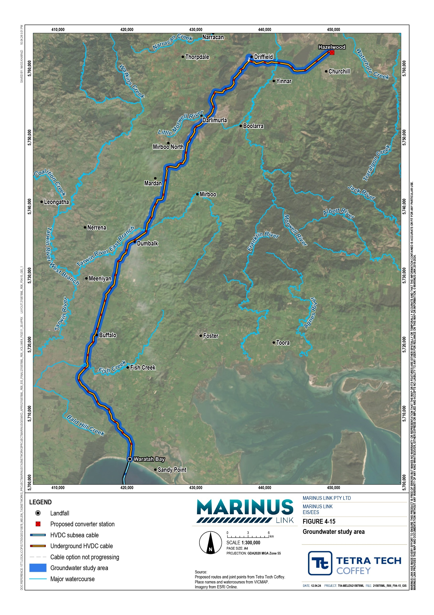

Legislative context
Table 4-1 outlines the key Victorian legislation and guidelines that informed the groundwater impact assessment.
Table 4-1 Key legislation and guidelines relevant to assessment

Title | Relevance to the assessment
Environment Protection Act 2017 (Vic) | This Act requires Victorians and businesses to minimise harm to the environment and human health from pollution or waste. It includes a General Environmental Duty (GED), a Duty to Notify the EPA of prescribed notifiable contamination, and a Duty to Manage contamination.
Environmental Reference Standard (Section 93) (Vic) | The ERS is made under Section 93 of the EP Act, and sets benchmarks to assess and report on environmental conditions, including groundwater, using indicators and objectives to determine whether environmental values are being maintained or threatened. The values considered by the groundwater assessment are based on the environmental values identified by ERS.  It is important to note that these environmental values encompass broader environmental considerations, such as ecosystems, and may not exclusively represent criteria for beneficial uses (see Section 4.2.12). While the groundwater assessment aligns with the ERS, it is crucial to recognise that the assessment focuses on preserving environmental values for groundwater rather than specific criteria for beneficial uses. This distinction is essential to avoid potential confusion, particularly in the context of the risk assessment, which may not comprehensively address risks related to future uses if solely based on beneficial use criteria.
Water Act 1989  (Vic) | This Act establishes a framework for the management and regulation of water resources in Victoria including groundwater. The Act legislated water entitlements issued and allocated in Victoria. If groundwater is extracted by the project for use or dewatering, or if works are undertaken on waterways, licencing may be required under the Act.

Assumptions and limitations
The groundwater impact assessment has been conducted based on the following assumptions and limitations:
A two-dimensional analytical groundwater model was used to assess dewatering requirements and potential drawdown impacts on groundwater during construction. The model was based on the parameters used in the regional Gippsland groundwater model by the Department of Economic Development, Jobs, Transport and Resources and the theoretical approach by J.H Edelman 1972 (cited in Technical Appendix P: Groundwater) which considers how water levels and flow change due to dewatering. This model simulated a range of predicted changes in groundwater quantity drawdown and aimed to understand its effects towards groundwater values.
Site inspections have not been undertaken to characterise hydrogeological features or attributes of the study area at a local scale. The desktop assessment has been informed by review of the extensive hydrogeological data, modelled groundwater levels and information about aquifer hydraulic properties that is available across the project. This available information provides a level of data considered by the technical study author to be sufficiently detailed to characterise baseline groundwater conditions and inform the groundwater impact assessment.

Ten GDEs were classified using the BOM GDE Atlas, whilst additional two GDEs were identified by the desktop assessment as being groundwater dependent. These findings have been carried through the impact assessment process to be conservative and are assumed to be GDEs until proven otherwise by further investigation.
Aquifer parameters (e.g., water levels, hydraulic conductivity (K), specific yield (Sy), specific storage (Ss) etc.) along the project alignment were based on extensive regional groundwater studies and groundwater modelling.
It was assumed groundwater levels are 1 m shallower than modelled and considered long-term drawdown values in areas where dewatering will take place. Groundwater drawdown estimates also assume steady-state conditions, with conservative assumptions made regarding duration and magnitude of drawdown.
There is limited information available on stygofauna communities in shallow aquifers across the project alignment. As the proposed construction activities are not expected to cause long-term changes to groundwater levels or quality, stygofauna communities (if present in the study area) are also not expected to be impacted. Information on their presence and nature is limited and is a common limitation across Victoria. As the project alignment is expected to not have a long-term impact to stygofauna communities, this has been considered to be of low importance to the groundwater impact assessment for the project.
The ERS does not set specific groundwater quality or quantity criteria for the protection of Traditional Owner and cultural values. To establish suitable criteria, direct consultation with local Traditional Owner groups is recommended. These criteria often relate to other environmental values, such as aquatic ecosystems and recreational water use. In the groundwater assessment, water quality criteria have been adopted for all relevant environmental values of groundwater with the assumption that these will also be protective of Traditional Owner and cultural values. However, it is crucial to acknowledge the need for ongoing consultation with traditional owner groups to ensure comprehensive understanding of specific criteria for the protection of their values.
No potential impacts to groundwater are considered for the decommissioning phase as the project has not identified the need for additional subsurface work. However, it is acknowledged that during the decommissioning phase, some underground infrastructure may be removed, which could result in minimal impacts on groundwater. A decommissioning management plan will include mitigation measures to avoid and minimise any potential impacts to groundwater, specific to the conditions present at the time of decommissioning (see Section 4.7.3).

Existing conditions
This section describes the existing conditions of the study area along the project alignment as it relates to groundwater values, features and aspects.

Land use
The land use setting within the project alignment mainly consists of agricultural land and plantation forestry, with agricultural land often exposed to uncontrolled livestock access, such as increased nitrate contamination due to livestock and fertilizers. Forestry areas undergo significant changes in groundwater and surface water conditions when timber is harvested after decades of growth. Small rural communities such as Buffalo, Dumbalk, Baromi, and Churchill are also scattered throughout the project area. Planning zones and the portion associated with the project alignment is summarised in Table 4-2.
Further details of land uses along the project alignment is provided in Volume 4, Chapter 15 – Land use and planning.
Table 4-2 Planning zones along the project alignment

Planning Zone | Description | Length along project alignment (km) | Portion of alignment (%)
Farming Zone | Includes farmland, dairy, grazing, sheep. | 60.8 | 69.1%
Farming Zone – Schedule 1 | Includes farmland around Hazelwood and some forestry plantations. | 12.0 | 13.7%
Public Conservation and Resource Zone | Includes public reserves, Strzelecki State Forest | 5.0 | 5.7%
Public Park and Recreation Zone | Includes bike trails, parks, playgrounds, Waratah Bay Shallow Inlet Reserve | 0.2 | 0.2%
Public Use Zone – Service and Utility | Includes Hazelwood Cooling Pond | 0.1 | 0.2%
Road Zone – Category 1 | Roads | 0.7 | 0.8%
Special Use Zone – Schedule 1 | Forestry plantations and farmland near Driffield and Hazelwood | 9.2 | 10.5%

Geology
The project is located within the Gippsland Basin, which is characterised by its structural complexity and diverse depositional history.
The project alignment encompasses three major surface geological formations, namely the Latrobe Valley Depression, the Strzelecki Group Balook Block, and the Tarwin Sub Basin. At the Waratah Bay shore crossing, the surface geology primarily consists of coastal, alluvial, and lacustrine deposits, including dune sand, swamp sediments, organic material, river terrace sands, silts, and clay.
The Latrobe Valley Group formations, including the Childers Formation, Morwell Formation, and Traralgon Formation, represent various sedimentary deposits such as alluvial fans, lignite swamps, and sandstones. Within the Latrobe Valley Depression, Quaternary alluvial sediments and Haunted Hill Formation overlay the

Latrobe Valley Group. The Haunted Hill Formation consists of poorly consolidated gravels, sands, clays, and other materials deposited by flooding streams, slope colluvium, and alluvial fans.
The basement rocks of the Gippsland Basin within the project area mainly consist of the Strzelecki Group, comprising non-marine Lower Cretaceous sedimentary rocks like sandstone, siltstone, conglomerate, and mudstone. These basement rocks also contain minor rock types, including siltstone, fine-grained sandstone, paleosols, coal seams, and lacustrine shale.
The Strzelecki Group basement lies deep within the Latrobe Valley Depression, hosting up to 900 m of Latrobe Valley Group sediments that become thicker toward the east but eventually pinches out along the north-east/south-west trending faults at the Driffield site. The Strzelecki Group is overlain in some areas by Thorpdale Volcanics, which comprise of basalt, tuff, and interbedded sandstone and silcrete, and is often covered by alluvial and colluvial sediments.
Between the Driffield and Hazelwood areas, surface geology is unconsolidated sediments (sand, organic material, silts, and clay) associated with the Morwell River floodplain and terraces, alluvial, river terraces and lacustrine deposits, and the Haunted Hills Formation. Moreover, extensive outcrops of the Strzelecki Group consist of the Wonthaggi Formation, which consists of mainly volcanic sandstone, siltstone, minor conglomerate and coal.
Within the Tarwin Sub Basin, the Childers Formation overlays the Strzelecki Group, followed by Thorpdale Volcanics, Haunted Hill Formation, and Quaternary alluvial units. These local aquifer units within the project area are further discussed in Section 4.2.4.
Table 4-3 provides a summary of the geological units along the project alignment. Further detail discussing the geological and geomorphological setting along the project alignment is provided in Volume 4,
Chapter 2 – Geomorphology and geology.

Table 4-3 Summary of geological units along the project alignment

Geological Unit | Symbol | Origin | Description | Distribution | Approximate length of intersection along project alignment (km)
Wonthaggi | Ksw | Fluvial | Early Cretaceous lithic volcaniclastic sandstone, arkose, | Located throughout most of the central site route | 25
Formation |  |  | siltstone, minor conglomerate and coal. | from 4 km south of Buffalo up to Dumbalk and
 |  |  |  | interspersed with Put and Qa1 up to Mirboo
 |  |  |  | North.

Thorpdale Volcanic Group
Put Volcanic Paleocene to Miocene tholeiitic and alkalic basalt; minor
nephelinite, basanite, nepheline hawaiite, hawaiite, mugearite, nepheline mugearite, tuff, interbedded sandstone and silcrete.
Haunted Hill Formation
Nlh
Fluvial
Pliocene to Pleistocene sand, silt, gravel: various shades of brown, yellow, red, white; variably sorted; variably rounded; crudely to well-bedded; commonly strongly oxidised with ironstone near the top and also within the formation.
Located throughout the southernmost and northernmost sections of the site between Waratah Bay and Buffalo and between Driffield and Hazelwood (interspersed with Pv, Qa2 and Qa1).
17
Interspersed with Ksw, Pv, and Qa1 between 20
Dumbalk and Driffield.

Latrobe Valley Group
Alluvial Terrace Deposits (generic)
Qa2
Alluvial floodplain
Pleistocene to Pleistocene gravel, sand, silt: variably sorted and rounded, generally unconsolidated; dissected to form terraces higher than Qa1.
Located within the southern and northern sections of the site, associated with river systems, and interspersed with Ksw, Nlh and Qa1.
9

Pv Marine to deltaic

Eocene to Miocene clastic sedimentary rocks: nonmarine to paralic clastics, marine clastics.

Located between Mirboo North and 2 km east of 11
Driffield, interspersed with Put and Nlh.

Alluvium (generic)

Qa1 Alluvial floodplain

Pleistocene to Holocene gravel, sand, silt: variably sorted and rounded; generally unconsolidated; includes deposits of low terraces.

Located within the southern and northern 8
sections of the site, associated with river systems, interspersed with Ksw, Nlh and Qa1. It can also be found around Dumbalk, interspersed with Ksw and -Put.

Coastal Lagoon Qg Deposits
(generic)
Deltaic
Holocene silt, clay: dark grey to black; variably consolidated.
Located immediately within the southern sections of the site, immediately north of the coastal dune deposits (Qdl1).
2

Geological Unit | Symbol | Origin | Description | Distribution | Approximate length of intersection along project alignment (km)
Colluvium (generic) | Qc1 | Base of slope, | Pliocene to Holocene diamictite, gravel, sand, silt, clay, rubble: sorting variable, usually poor; generally, poorly | Located within the southernmost section of the site interspersed with Qg, Qa2 and Nlh. | 1
 |  | foothills | rounded; clasts locally sourced; includes channel deposits with better rounding and sorting.
Coastal Dune Deposits (generic) | Qdl1 | Coastal dune and swamp | Holocene sand, silt, clay: well sorted, poorly consolidated; coastal dune and beach deposits, some swamp deposits | Located within the southernmost section of the site, along the beach and surrounding area at Waratah Bay | 0.5
Liptrap Formation | Dxl | Marine | Early Devonian thin-bedded quartz-rich sandstone and  siltstone with minor sandstone and gritstone, and rare diamictite which contains chert and limestone pebbles. | This unit could potentially be found for a short  stretch of the site just north of Waratah Bay, interspersed with Nlh. | 0.5

Hydrology
The project alignment intersects the back beach deposits of the Waratah Bay-Shallow Inlet Coastal Reserve and the low-lying pasture areas on the Gippsland Plain within the Victorian coast, which are prone to tidal inundation.
The project alignment continues as a north-westerly transect, passing through the southern part of the Strzelecki Range. It then deviates to the east-north-east, crossing agricultural land west of Meeniyan (crossing Stony Creek) and east of Dumbalk, subsequently traversing more rugged terrain (Strzelecki Range and the Tarwin River East Branch) while intersecting numerous minor drainages and passing east of Mirboo North. The project alignment also extends through forested terrain, including the Thorpdale Volcanics, crossing the Little Morwell River and the Morwell River, which is located south of the Hazelwood cooling pond.
There are no Ramsar wetlands (wetlands of international importance) in close proximity to the project alignment. The nearest Ramsar wetland, which is Corner Inlet, is located approximately 26 km southeast of Dumbalk. The project alignment has no credible potential for direct or indirect impacts to the Ramsar site.
The project is located within six major surface water catchments (from south to north): Fish Creek, Buffalo Creek, Stony Creek, Tarwin River East Branch, Little Morwell River, and Morwell River. These catchments are shown in Figure 4-16 and are listed in Table 4-4, along with associated waterway crossings within and/or in the vicinity of the project alignment.
These catchments and potential surface water impacts associated with the project are further discussed in Volume 4, Chapter 5 – Surface water.
Table 4-4 Surface water catchments and waterway crossings

Surface water catchment | Approximate catchment area (ha) | Major waterway crossing
Fish Creek | 170 | Fish Creek
Buffalo Creek | 38 | Buffalo Creek
Stony Creek | 72 | Stony Creek (south) Stony Creek (north)
Tarwin River – within Tarwin River (Meeniyan) water supply area | 1,500 | Tarwin River East Branch, Toomey Creek, and Berrys Creek.
Morwell River | 674 | Morwell River, Eel Hole Creek and Hazelwood cooling pond
Little Morwell River | 87 | Little Morwell River

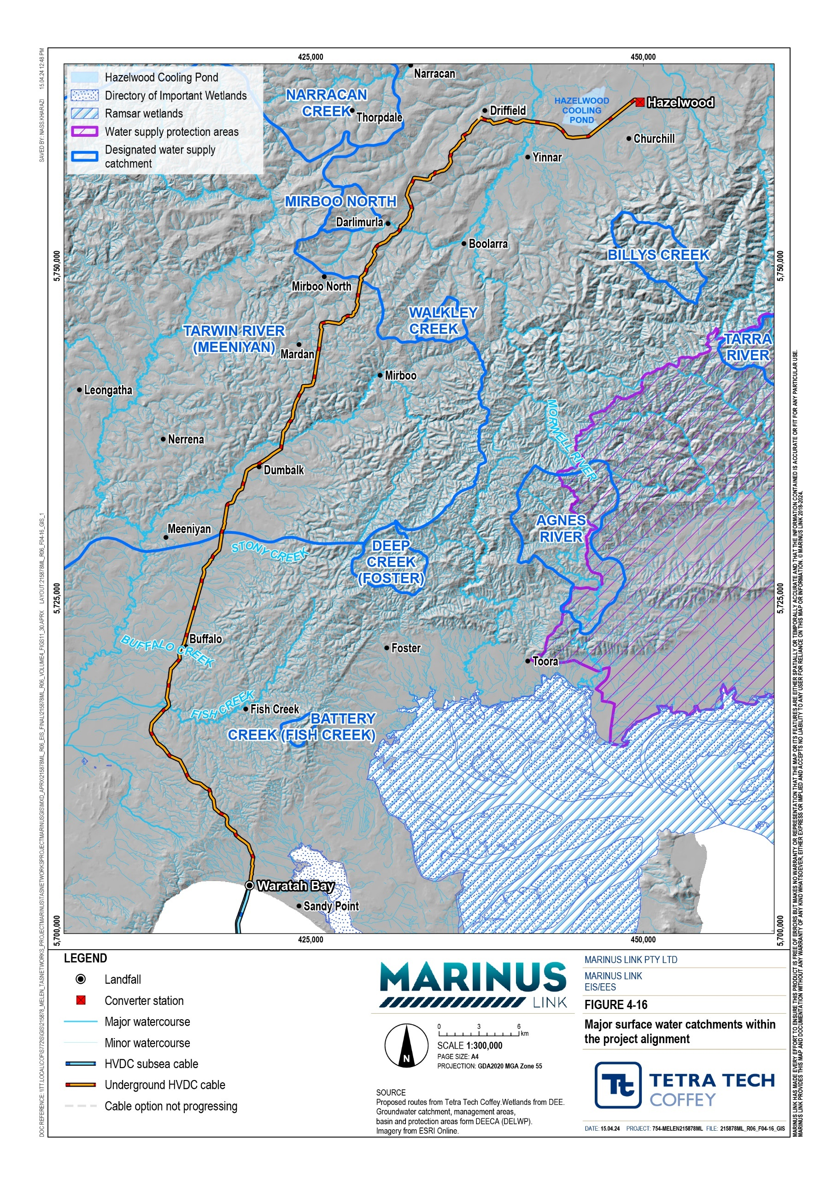

Hydrogeology
The project alignment spans the Gippsland Basin and the Highlands basin. Within these basins, the project alignment crosses the Tarwin and Central Gippsland groundwater catchments in Victoria, which are managed by the West Gippsland Catchment Management Authority (WGCMA). The Gippsland Basin's groundwater system is complex as a result of the dynamic depositional environment and tectonic movements experienced after deposition. Four main aquifer types were characterised within the region, namely:
Strzelecki Group, comprising of fractured Paleozoic and Cretaceous rocks

Lower Aquifer System, comprising of Eocene to Oligocene age rocks

Middle Aquifer System, comprising of the Oligocene to Miocene age rocks

Upper Aquifer System, comprising of Quaternary age rocks.

Major flow systems interact with the surface via key outcropping aquifers, which are aquifers exposed to the surface due to erosion, tectonic activity, or other geological processes. As the groundwater impact assessment considers groundwater impacts to depths within 10 m of ground surface, the study area identifies the following local aquifer units, as shown in Figure 4-17:
Upper Tertiary Quaternary aquifers, which comprised of the Haunted Hills Formation and the Quaternary alluvial units (present at most locations where dewatering is required).
Bedrock units, including:

- Thorpdale Volcanics of the Lower Tertiary Basalt

- Wonthaggi Formation (Strzelecki Group) of the Cretaceous Palaeozoic Bedrock.

The bedrock units, including the Wonthaggi Formation (Strzelecki Group) and Thorpdale Volcanics (Lower Tertiary Basalt) units form fractured rock aquifers with local flow paths, characterised by short, rapid groundwater flow paths that discharge to nearby streams with some recharge to the basement rocks. The Upper Tertiary Quaternary aquifers, including the Haunted Hills Formation and Quaternary alluvial units form intermediate and regional groundwater flow systems in the floodplain and coastal sections of the Gippsland Basin.

Volume 4 – Victorian terrestrial environment Page 4-12
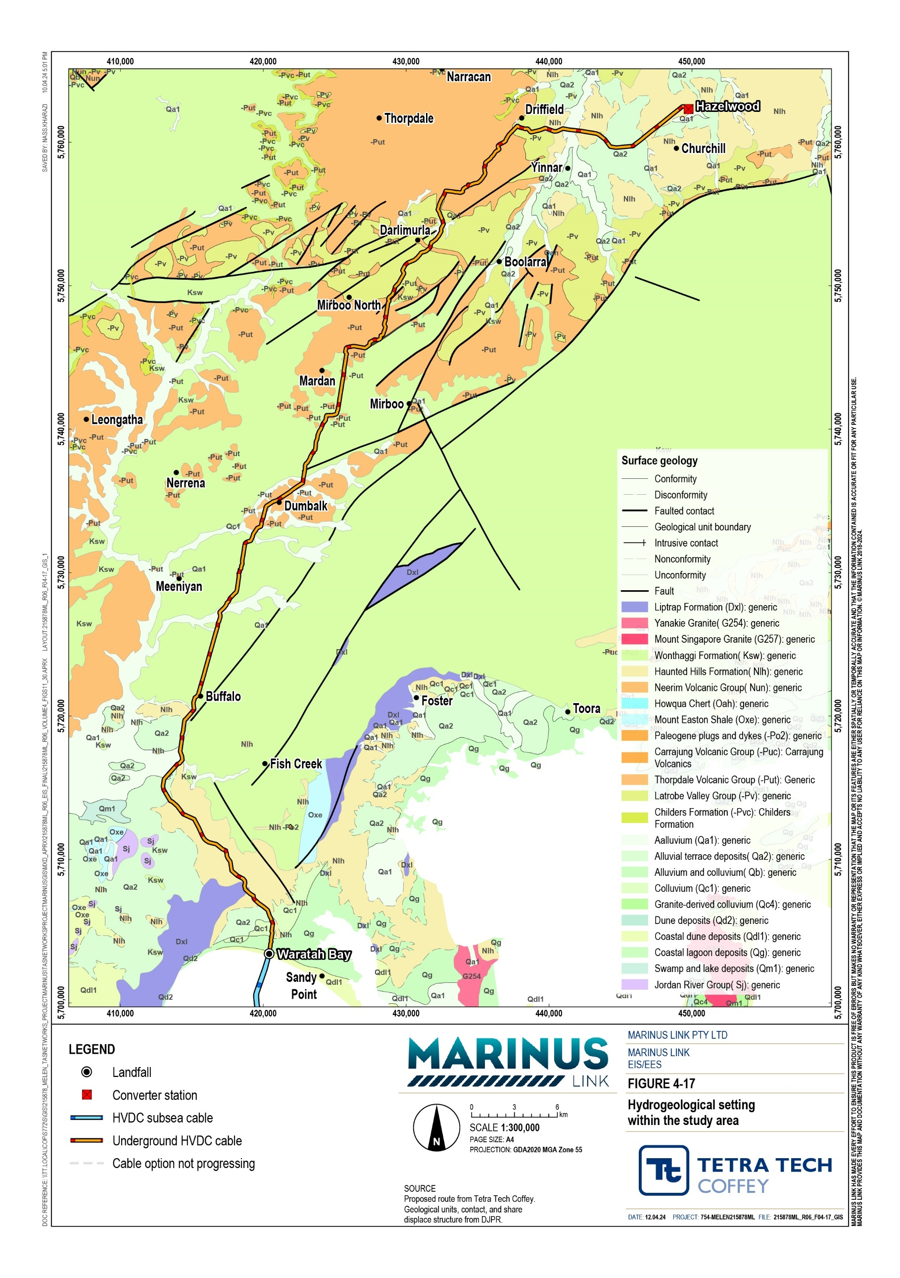

S

Groundwater management areas
The WGCMA manages groundwater resources in the Tarwin and Central Gippsland groundwater catchments within the Gippsland Basin and Highlands Basin, as shown in Figure 4-18. The study area has two groundwater management areas (GMAs), Rosedale GMA and Stratford GMA, both with restrictions on groundwater use, as these resources are close to, or at maximum sustainable allocation. The extent of the Rosedale GMA applies to groundwater resources from 50 m to 150 m below ground surface, while extent of the Stratford GMA encompasses groundwater from 150 m below ground surface.
Dewatering activities would be limited to less than 10 m below ground surface and would not impact the Rosedale and Stratford GMAs, which encompass groundwater resources below 50 m and 150 m, respectively. The project alignment is located more than 5 km from other GMAs, such as the Tarwin and Leongatha GMAs, and is not expected to impact on them.

Groundwater levels and flow directions
The interpretation of levels and flow direction in the Gippsland Basin are influenced by several factors, including the presence of multiple aquifers at different depths and the impact of activities, such as offshore oil extraction and onshore mining, particularly in the Hazelwood region.
The groundwater impact assessment for the project is limited to the near-surface environment (up to 10 m deep due to a maximum trench depth of 1.5 m and joint pits of 3 m), and the focus is on the continuous, unconfined water table across the study area.
Groundwater levels have been assessed by drawing on information published as part of the Secure Allocations Future Entitlements project.
Groundwater flow in the study area is expected to generally follow the ground surface topography, with rainfall infiltrating and recharging across the region. This groundwater recharge then migrates from high elevation to low elevation, eventually discharging to the network of groundwater dependent creeks and rivers.
The depth of groundwater in the project alignment was determined by comparing the groundwater level contours with the ground surface elevations, as shown in Figure 4-19 and Figure 4-20.

Volume 4 – Victorian terrestrial environment Page 4-14
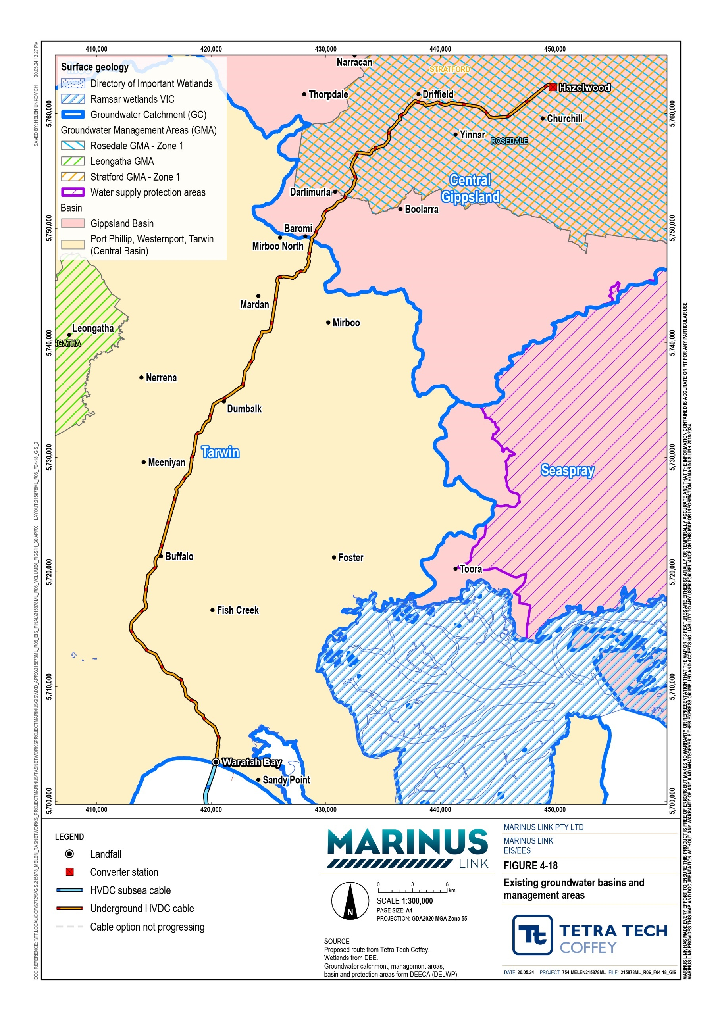

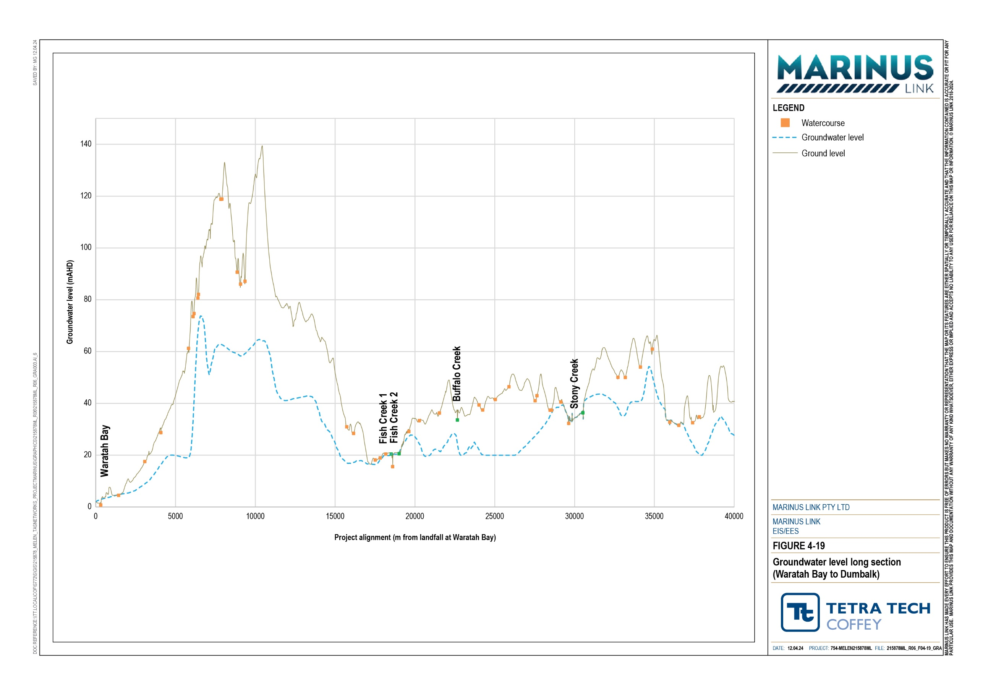

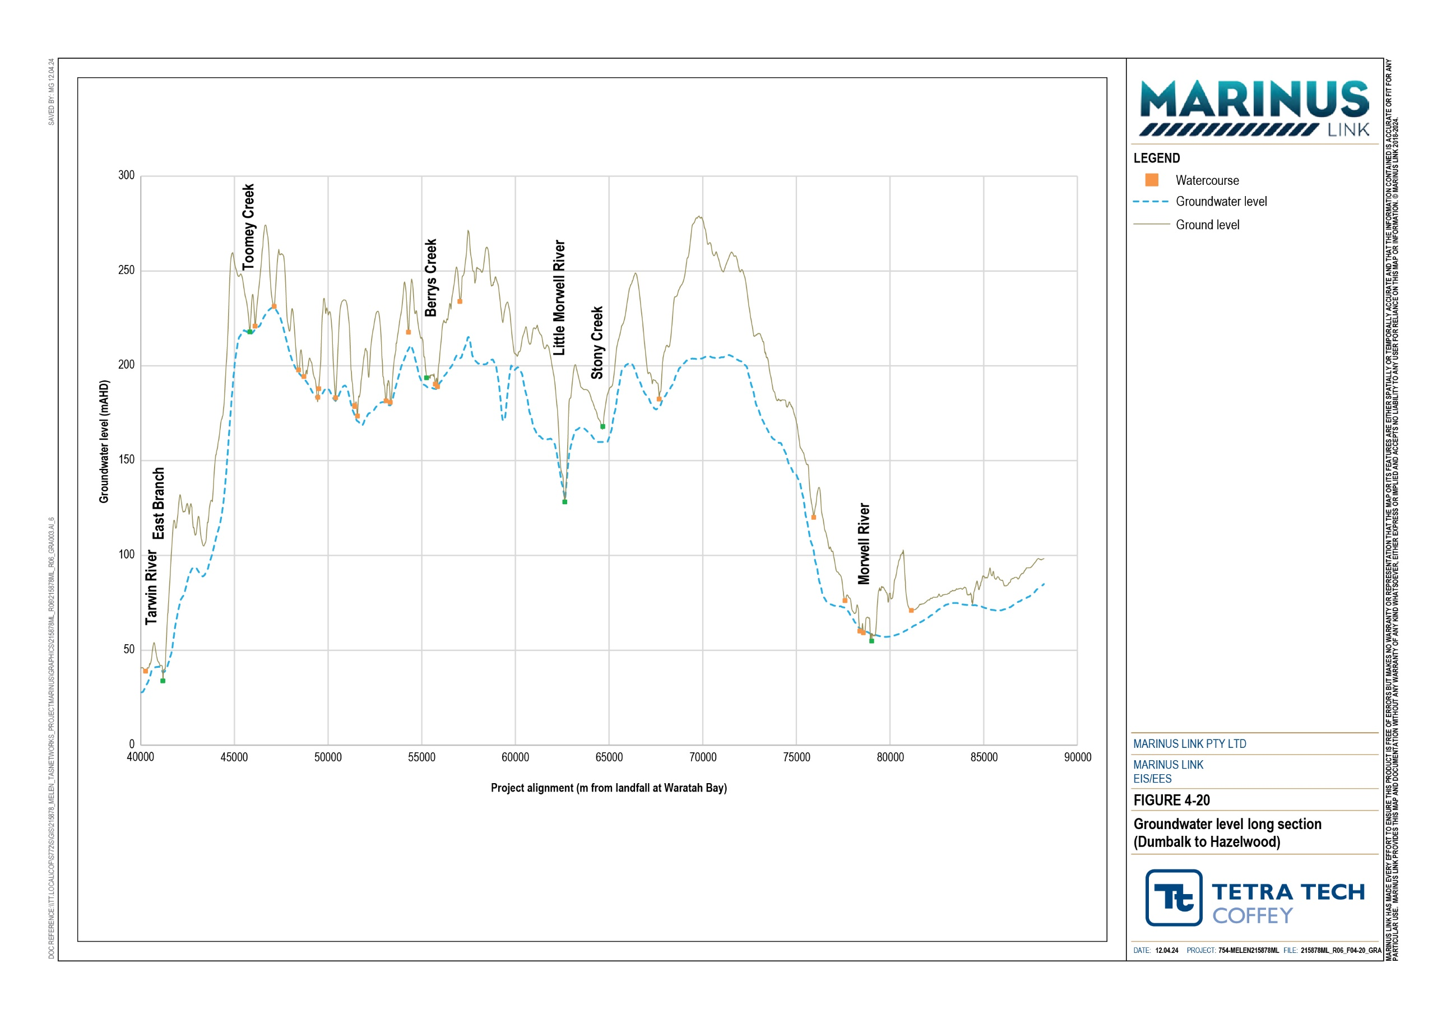

Groundwater and surface water interaction
Groundwater interacts with surface water in several ways, for example, shallow groundwater systems can discharge to waterways (rivers, streams, creeks, wetlands, and springs) or to the marine environment.
Conversely, water from waterways can recharge groundwater systems, particularly during high rainfall and flow periods.
Groundwater-surface water interactions in the study area follows a pattern of rainfall recharge to outcropping aquifers in the highland regions (losing streams) and groundwater discharge to connected surface water systems in the lowlands.
At a local scale, minor creeks and wetlands can have their own flow systems, with shallow perched aquifers directing local rainfall recharge towards them and other surface water features. One perched aquifer that may interact with waterways has been identified, approximately 800 m north of the Hazelwood converter station.
Interactions occur between groundwater and the marine environment where aquifers are connected in the coastal zone. During low tide, the water table in an adjacent groundwater system may exceed the level of coastal waters, leading to the discharge of groundwater into the marine environment. Conversely, during high tide, the marine water level might surpass the onshore groundwater level, causing a reversal of hydraulic gradients and the infiltration of saline water back into the groundwater system.
Tidal influences on groundwater are present within the Waratah Bay estuarine wetlands. The estuarine wetlands are intermittently identified with points of groundwater dependent terrestrial vegetation and rely on fresh groundwater input to some degree. Salinity within the estuarine wetlands varies from fresh to brackish, or saline, depending on river flows and marine tide events. Dewatering of aquifers within the coastal zone can lead to a decline in groundwater levels causing additional intrusion of saltwater into the aquifer, leading to increased salinity within the wetland zones.
A review of climate change projections indicated sea levels are predicted to rise in the long term (Volume 1, Chapter 9 – Sustainability, climate change and greenhouse gas emissions). The assessment found a predicted rise in sea levels, which will consequently modify the freshwater-seawater interface dynamics, promoting further inland encroachment and increasing groundwater salinity in the coastal zone.

Climate
Across the study area, the mean total rainfall peaks during the winter months and is at its lowest during summer. This seasonal rainfall is characteristic of the oceanic climate, with the absence of a dry season and the distribution of rainfall across the year. Climate change is projected to result in increased occurrence of hazardous storm surges, flood inundation, increased erosion and increased groundwater recharge seasonality, which will have direct impacts on groundwater including rising groundwater levels and saline intrusion.

In the study area, climate change is expected to result in an increase in the intensity of storm surges and heavy rainfall events, while the annual rainfall totals may reduce by 2.3%. Subsequently, groundwater may become more unpredictable, leading to a potential 11% to 35% reduction in groundwater recharge by 2040.
Climate change impacts to groundwater levels may be realised over the operation and decommissioning of the project, though long-term groundwater impacts from climate change would not alter the impacts of the project on groundwater as assessed in Technical Appendix P: Groundwater. Climate change is not considered relevant to impacts associated with drawdown during the construction period, as this period will occur under the existing climate conditions. As such, the effects of climate change are not considered further in the assessment. Potential climate change impacts on the project are discussed in Volume 1,
Chapter 9 – Sustainability, climate change and greenhouse gas emissions.

Groundwater use
Records of registered groundwater bores in the study area were obtained from the water measurement information system (WMIS). Most of the registered bores, owned by the former national electricity supplier known as State Electricity Commission (SEC), are located between Driffield and Hazelwood. These bores are expected to be used for groundwater observation purposes, forming part of a wider network of bores around as the former coal mine operations. These bores are not considered registered for extractive activities.
Table 4-5 provides summary of the 102 registered groundwater bores located within 500 m of the centreline of the project alignment. Out of the 102 registered groundwater bores, 99 bores are currently in use.
Additionally, there are eight active and registered bores, comprising five bores for stock and domestic use and three bores with unknown uses, which may be impacted by the project (Table 4-6). These bores are considered further in Section 4.3.1.
Table 4-5 Registered groundwater bores within 500 m of the project alignment

Registered use | Not in use | In use
Domestic | 0 | 2
Stock and domestic | 0 | 2
Geotechnical or environmental government investigation | 0 | 1
Non-groundwater | 0 | 4
Groundwater observation | 0 | 86
Stock | 0 | 1
Unknown | 3 | 3
Totals | 3 | 99

Table 4-6 Eight bores with registered extractive or unknown use within 500 m of the project alignment
Registered bore ID | Total bore depth (m) | Easting | Northing | Registered use | Distance from project alignment
84269 | 0 | 432452.3 | 5753830 | Unknown | 0.5
84270 | 0 | 432200.3 | 5755489 | Unknown | 67
N/A | 83 | 443867 | 5759994 | Domestic | 154
85575 | 30.48 | 418111.3 | 5729680 | Stock | 178
61664 | 46.94 | 421195.3 | 5734918 | Unknown | 218
77659 | 12.5 | 414963.3 | 5721234 | Stock and domestic | 230
61662 | 208.48 | 423061.3 | 5736531 | Stock and domestic | 260
120540 | 6 | 425653.3 | 5742104 | Domestic | 303

Groundwater dependent ecosystems
GDEs are receivers that wholly or partially depend on groundwater for their water needs. This section describes terrestrial, subterranean and aquatic GDEs present in the study area.
The locations of the terrestrial GDEs are shown in Appendix C of Technical Appendix P: Groundwater.

Terrestrial GDEs
Terrestrial GDEs are ecosystems that rely on groundwater to survive. This may occur where groundwater is shallow and near the surface or where vegetation has sufficient rooting depth to access deeper groundwater.
Most terrestrial GDEs along the project alignment are expected to be facultative GDEs, which rely on groundwater for some of their water needs and also draw on rainfall infiltration and bank storage in riparian zones at other times.
The project predominantly crosses cleared agricultural land with limited native vegetation between Waratah Bay and Mirboo North. Isolated occurrences of estuarine wetland vegetation have been observed in low-lying areas behind the Waratah Bay dune system, corresponding to areas of high likelihood of terrestrial GDEs.
The vegetation in this area is composed of grasses, sedges, rushes and salt tolerant herbs and is often fringed by a tall scrub layer of Melaleuca ericifolia (swamp paperbark). This vegetation class can draw water from both groundwater and the estuary system, is adaptable to both saline and freshwater conditions, and is expected to be groundwater dependent. However, the shallow root zone of these species is likely to make it more sensitive to long term changes in groundwater level if this occurred.

Further along the project alignment, the alignment passes through a combination of localised stands of native vegetation, extensive forestry plantations, and various land uses including cleared agricultural land and isolated estuarine wetlands. The native vegetation types found in this area include Swamp Scrub, Damp Heathy Woodland, Lowland Forest Mosaic, and Swampy Riparian Woodland. The Damp Heath Woodland and Lowland Forest Mosaic are considered vulnerable species while the Swamp Scrub and Damp Forests are endangered species. These vegetation types are known to access both groundwater and estuary water and are adaptable to both saline and freshwater conditions.
From Mirboo North through to the Morwell River, the project alignment further passes through extensive forestry plantations, of which very little is expected to rely on groundwater. Limited areas of native riparian vegetation along creeks (primarily Swampy Riparian Woodland and Lowland Forest) are likely to rely on groundwater during dry periods.
Terrestrial GDEs are discussed further in Volume 4, Chapter 11 – Terrestrial ecology.

Aquatic GDEs
Aquatic GDEs in the study area comprise of wetlands, swamps, springs, estuaries and baseflow fed watercourses that are groundwater dependent. The low-lying land behind the Waratah Bay dune system has areas of estuarine wetlands that are intermittently identified with points of groundwater dependent terrestrial vegetation. Although not identified by the BOM GDE Atlas, it is possible that this network of isolated swamps and wetlands, and connected streams is likely to have aquatic ecosystems that rely on fresh groundwater input to some degree.
Table 4-7 identifies the rivers, creeks and waterbodies with a moderate or high likelihood for groundwater dependence within the project alignment. Twelve aquatic GDE’s were identified by the assessment. Ten of 12 GDE’s were classified by the BoM GDE Atlas, whilst an additional two GDE’s were identified by the desktop assessment as being potentially groundwater dependant.

Most creeks and rivers within the study area rely on groundwater during dry periods, including Fish Creek, Buffalo Creek and Stony Creek. Located upstream of the study area, the Tarwin River East Branch and Morwell River have permanent or near-permanent flow, while Little Morwell River and Eel Hole Creek within the Morwell River catchment have limited flow, which may highly alter the habitat of aquatic GDEs present. Berrys Creek is suspected to have limited ecosystem value due to the agricultural land it crosses, and Toomey Creek is considered ephemeral (fleeing or random flows), subsequently aquatic GDEs are unlikely to be present.

Table 4-7 Rivers, creeks and waterbodies with moderate or high likelihood of being groundwater dependant within the project alignment
Named waterway | Likelihood of being groundwater dependant | Comment
Waratah Bay estuarine wetlands | N/A* | Shallow groundwater anticipated in an area of swamp, wetland and connected estuarine streams.
Fish Creek | High | Permanent or near permanent flow.
Buffalo Creek | High | -
Stony Creek (south) | High | -
Freshwater swamp (35,600 m from onshore at Waratah Bay) | N/A* | Palustrine, temporary freshwater swamp, approximately 80 m east of project alignment.
Tarwin River East Branch | High | Permanent or near permanent flow.
Toomey Creek | High | Toomey Creek appears ephemeral in area crossing the project alignment. There are unlikely to be aquatic ecosystems present. Not considered a GDE.
Berrys Creek | High | Highly altered stream condition through agricultural land crossed by the project alignment. Possibly of limited ecosystem value in this location.
Little Morwell River | Moderate | Limited stream flow apparent from aerial photographs. Potentially intermittent flow during dry months.
Stony Creek (north) | High | -
Morwell River | High | Permanent or near permanent
Eel Hole Creek | Moderate | May have limited flow, isolated pools crossing agricultural land. Likely highly altered aquatic ecosystem.
*Additional GDE’s identified by desktop review as being groundwater dependant but the BoM GDE Atlas has not assigned a likelihood of groundwater dependence to these GDEs.

Subterranean GDEs
Stygofauna are small, primarily aquatic invertebrate organisms that inhabit aquifers. They can be found in fresh to saline water, however, are predominantly known to occur in these aquifers under fresh to brackish groundwater (electrical conductivity (EC) of less than 5000 microsiemens per centimetre(µS/cm)) and are mostly abundant in shallow aquifers, where regular recharge, nutrients, and oxygen are available.
Stygofauna can be found in aquifers with predominantly larger (1 millimetre (mm) or greater) pore spaces, such as alluvial, karstic and some fractured rock aquifers (Hancock and Boulton 2008; Hose et al, 2015). Karstic aquifers are commonly associated with the development of soluble carbonate rocks (e.g., limestone), which provide increased potential for stygofauna species to be present.

A baseline survey of stygofauna was conducted in 2019 by the Geological Survey of Victoria’s Victorian Gas Program (cited in Technical Appendix P: Groundwater) in the West and East Gippsland Catchment Management Authority regions, covering most of the project alignment. The regional stygofauna survey found only one worm taxon in one of the 20 bores sampled. This suggests a low abundance and biodiversity of stygofauna in the unconfined aquifers of the Gippsland Basin and are therefore not further discussed in this chapter.

Groundwater quality
Regional groundwater salinity mapping has been used to provide an estimation of total dissolved solids (TDS) as there is limited shallow groundwater quality data available. TDS is a measure of salinity (milligrams per litre (mg/L)) that represents existing groundwater quality and TDS levels range along the project alignment from below 500 mg/L up to around 3,500 mg/L.
Lower TDS levels coincide with the Upper Tertiary/Quaternary aquifer near Waratah Bay and a joint pit (JP5A). An analysis conducted in 2010 at one Sandy Point state observation bore network (SOBN) (bore 100976) found that nearshore groundwater in the study area is relatively fresh, which has TDS concentration of 480 mg/L and pH of 6.6. It is recognised that this one sample from one bore for groundwater analysis reduces the robustness of the contemporary groundwater assessment for the project in terms of establishing uncertainty in the baseline understanding and making determinations regarding the impacts to groundwater quality. It is acknowledged that further groundwater quality assessment will be required as part of the groundwater management plan and program outlined in the EPRs (EPR GW09).
Moving north, the groundwater TDS is expected to be more saline ranging from 1,000 to 3,500 mg/L until reaching Mirboo North. Shallow groundwater beyond Mirboo North is projected to be relatively fresh with TDS concentrations of below 500 mg/L to around 1,000 mg/L.

Groundwater contamination
Potential pathways for contamination to groundwater in the study area include infiltration to aquifers and run- off to waterways connected to shallow groundwater.
The EPA Victoria holds records that identify potential sources of groundwater contamination in the area, including priority sites register, environmental audits, EPA licensed areas, groundwater restricted use zones (areas with historical groundwater pollution from past industrial activities), and landfill registers. No groundwater restricted use zones were identified within the study area.
On a regional scale, diffuse contamination sources from agriculture, forestry activities, a former railway line, and areas with potential acid sulfate soils were noted to be potential sources of groundwater contamination. Table 4-8 summarises the potential sources of contamination and contaminants of concern. Further detail discussing contamination sources along the project alignment is provided in Volume 4, Chapter 3 – Contaminated land and acid sulfate soils.

Table 4-8 Potential point sources of groundwater contamination

Groundwater contamination source | Location | Contaminants of potential concern
Hazelwood Cooling Pond | Hazelwood | Metals, hydrocarbons, nutrients, PAHs, TRHs, PFAS
Hazelwood Eastern Overburden ash dump and perched aquifer | Hazelwood | Metals, hydrocarbons, nutrients, PAHs, TRHs, PFAS
Agricultural use - Heavy machinery | Unknown* | Metals, degreasers, solvents, TRHs
Agricultural use – Sheep dip | Unknown* | Metals, OC/OP pesticides
Buried waste, informal dumps, burn piles, tyre stacks, building rubble | Unknown* | Metals, TRHs, PAHS, PFAS, nutrients, OC/OP pesticides
Above ground fuel tanks | Unknown* | TRHs
*‘Unknown’ locations relate to commonly occurring contamination sources in agricultural use zones. Locations have not been identified but may exist within the study area.

Summary of groundwater values
Potential impacts were determined based on the identified values associated with groundwater, which may be affected by project construction and operation activities.
The ERS categorises Victoria’s environmental values related to groundwater beneficial uses into ‘segments’ based on the background level of total dissolved solids (a measure of salinity, measured in mg/L). Table 4-9 summarises the levels of total dissolved solids required for groundwater to be classified as suitable for each type of environmental value in Victoria.
Table 4-9 Environmental values that apply to the Groundwater Segments in Victoria

Environmental value | Segments (TDS mg/L)
 | A1  (0-600) | A2 (601-  1,200) | B (1,201-  3,100) | C (3,101-  5,400) | D (5,401-  7,100) | E (7,101-  10,000) | F (>10,001)
Water dependent ecosystems and species |  |  |  |  |  |  | 
Potable water supply (desirable) | 
Potable water supply (acceptable) |  | 
Potable mineral water supply |  |  |  | 
Agriculture and irrigation (irrigation) |  |  | 

Environmental value | Segments (TDS mg/L)
 | A1  (0-600) | A2 (601-  1,200) | B (1,201-  3,100) | C (3,101-  5,400) | D (5,401-  7,100) | E (7,101-  10,000) | F (>10,001)
Agriculture and Irrigation (stock watering) |  |  |  |  |  | 
Industrial and commercial |  |  |  |  | 
Water-based recreation (primary contact recreation) |  |  |  |  |  |  | 
Traditional Owner cultural values |  |  |  |  |  |  | 
Buildings and structures |  |  |  |  |  |  | 
Geothermal properties |  |  |  |  |  |  | 
Notes: grey shading – EV does not apply to Segment
Source: ERS 2021

Most sections of the project alignment, including the shallow aquifer in the Upper Tertiary/Quaternary between Waratah Bay and joint pit JP5A is identified as within Segment A1 or A2, which are considered to have groundwater suitable for most potable water supply, agricultural and irrigation (stock watering), industrial and commercial, recreation, water dependent ecosystems and Traditional Owner cultural values. Within the central zone of the project alignment, groundwater generally appears as within Segment B due to higher salinity concentrations, compared to Segment A1 or A2 of the project alignment. Environmental values are generally the same for Segment B relative to Segment A1 or A2 of the project alignment, with the exception of potable water supply.
No designated mineral springs or geothermal recreational activities were mapped within the project alignment. As such, these environmental values are not considered further in the groundwater impact assessment for the project.
Collectively, the values associated with groundwater in the study area based on the environmental values identified by ERS , are:
Consumptive or productive uses:

- Registered groundwater use, including stock and domestic use.

- Potential for irrigation and potable water supply but it is unlikely to occur from shallow aquifer resources.
- Recreational use, including swimming in baseflow-fed rivers and creeks.

GDEs including:

- Baseflow-fed rivers and creeks exist throughout the study area.

- Groundwater dependent terrestrial vegetation particularly in riparian zones.

Cultural or spiritual values including aesthetic, historical, scientific, social, or other significance to the present generation or past or future generations. Cultural values of groundwater are likely to exist where they support the identified terrestrial and aquatic GDEs (Refer to Volume 4, Chapter 13 – Aboriginal cultural heritage and Chapter 14 – Non-Indigenous cultural heritage).
The sensitivity of the aquifers in the study area and their ability to continue to support these groundwater values described above and in Section 4.2.4 during construction and operation was assessed. The sensitivity levels assigned to water table aquifers present across the study area are summarised in Table
4-10, based on the sensitivity criteria presented in Volume 1, Chapter 5 – EIS/EES assessment framework. Each aquifer received an overall moderate sensitivity based on the rounded mean ranking: high risk =3, moderate sensitivity =2, and low sensitivity =1.

Table 4-10 Sensitivity of groundwater aquifers

Aquifer | Assessment | Environmental values | Uniqueness and rarity | Resilience to change | Recovery potential | Replacement potential | Overall sensitivity
Quaternary | Sensitivity | High (3) | Low (1) | Moderate (2) | Low (1) | Low (1) | Moderate
alluvial | assignment |  |  |  |  |  | (Mean 1.6)
 | Justification | The alluvial systems support | Alluvial aquifers and | Recharge rates and | Alluvial aquifers have | There are several local
 |  | aquatic ecosystems that are | their connected | groundwater-surface | relatively high | water features (surface
 |  | of high importance but may | features are common | water interaction likely | recharge rates and | water or groundwater)
 |  | be slightly modified. | throughout the study | allows moderate | short recovery periods. | that could provide
 |  | Intrinsic attributes support | area and on a | resilience and capacity to |  | alternative water
 |  | the use of the groundwater | regional and national | adjust to level or quality |  | sources to users.
 |  | for potable supply, | basis. | change.
 |  | agricultural use, and food
 |  | production.

Haunted Hill | Sensitivity assignment | High (3) | Low (1) | Moderate (2) | Low (1) | Low (1) | Moderate  (Mean 1.6)
Formation
 | Justification | Consistent with the | Consistent with the | Consistent with the | Consistent with the | Consistent with the
 |  | assessment of Quaternary | assessment of | assessment of Quaternary | assessment of | assessment of
 |  | alluvial. | Quaternary alluvial. | alluvial. | Quaternary alluvial. | Quaternary alluvial.
Bedrock | Sensitivity | Moderate (2) | Low (1) | Moderate (2) | Moderate (2) | Moderate (2) | Moderate
Units | assignment |  |  |  |  |  | (Mean 1.8)
 | Justification | Low yields and higher | Bedrock and Tertiary | Where they outcrop, the | Fractured rock aquifers | Their main occurrence
 |  | salinity support secondary | Basalts are regionally | basalt and bedrock | have lower recovery | in foothills and ranges,
 |  | domestic supply and some | extensive and do not | aquifers are susceptible to | potential particularly | and absence of other
 |  | agricultural uses. The | support groundwater | effects of surface | for quality changes. | aquifer alternatives
 |  | bedrock and Tertiary Basalt | system, or connected | activities. The low | Remediation is more | offers reduced water
 |  | are not preferred water | feature recognised on | hydraulic conductivity and | challenging and should | supply alternatives
 |  | resources but contribute | statutory registers | dominant fracture porosity | contamination occur. | (primarily surface
 |  | some baseflow to aquatic |  | will limit the radial extent |  | water).
 |  | GDEs. |  | of level or quality change.

Construction impacts
Construction activities will occur progressively along the project alignment. Potential impacts resulting from project construction activities, prior to the implementation of the EPRs were identified. Potential sources of impacts to groundwater quantity (flows and levels) and quality include:
Removal and replacement of registered groundwater bores during construction

Temporary dewatering and groundwater drawdown for the construction of the onshore cable trenches and cable joint pits affecting groundwater bores and GDEs.
HDD activities.

Construction of surface project infrastructure, including haul roads and laydown areas.

Temporary dewatering and groundwater drawdown, which can lead to groundwater acidification (due to enhancing presence of acid sulphate soils) or saline intrusion.
Mobilisation of existing groundwater contamination associated with existing land uses including former coal mine and agricultural land, or contamination of groundwater from storage, transport, handling, disposal, and unplanned releases of hazardous substances.
Materials used for backfilling of cable trenches has a higher or lower hydraulic conductivity than the existing conditions.
Project activities and related process that may cause impacts to groundwater quantity and quality during construction are discussed below.

Groundwater bores
Groundwater bores may be affected during construction by being located directly in the construction area or within the area of groundwater drawdown. A construction area approximately 36 m wide will be required along the project alignment, which may impact several registered groundwater bores. Within the construction area, there are seven registered bores. Five of these bores are registered as Victorian SEC bores and are likely to be associated with groundwater monitoring for the former coal mining operations and power stations in the Hazelwood area. The uses of the other two bores are unknown.
Licensed drillers will be required to decommission the bores to prevent potential contamination during construction, and that such decommissioning of groundwater bores will be completed in accordance with the minimum bore construction requirements (EPR GW08). This could have a moderate impact should these bores provide water for property operations and are not just observation bores.
There are a further six bores located within 50 m of the edge of the construction area, which have highest potential to be affected by temporary groundwater drawdown of 1 m or more during construction. Five of the six bores are registered to be SEC observation bores, while the one remaining bore (ID 84270) is registered for a potentially extractive (in this case unknown) use, however, is not located in an area where dewatering is likely to be required.

Further groundwater analysis was conducted for bores registered for extractive use, where located within 500 m of the onshore cable trench and therefore likely to be subject to dewatering during construction. Three registered bores were identified from this analysis, two of which are located more than 250 m away from the dewatering points and therefore will not be impacted. The groundwater modelling results indicate that the extent of drawdown caused by temporary construction activities is not predicted to significantly impact registered bore users.
To verify that project design aligns with groundwater impact assessment and minimises potential impacts on groundwater bores, geotechnical and hydrogeological investigations will be conducted. These investigations will be guided by experienced hydrogeologists and assess groundwater levels and site geology in areas that may require dewatering (EPR GW01). In cases where the construction area or dewatering affects the water supply for groundwater users, alternative water supplies would be provided or the need for replacement to new bores would be negotiated to all groundwater users within the project area (EPRG GW08).
Overall, the residual impact to ground water bores due to relocation or groundwater drawdown is low with implementation of measures to comply with EPRs.

Temporary dewatering and GDEs
Temporary dewatering of the aquifers will occur where the cable trenches, joint pits or HDD related excavations are deep enough to intersect the groundwater. Dewatering has the potential to cause groundwater drawdown, and this could continue until water levels recover after construction (i.e., when dewatering stops).

Terrestrial GDEs
Long term decline of groundwater levels can affect the health of terrestrial ecosystems that access groundwater for some or all of their water needs. Groundwater drawdown can impact these GDEs where it occurs rapidly, is beyond the natural range of groundwater level fluctuations (in the order of 1 to 2 m) and persists for an extended period of time.
Dewatering of trenches and joint pits for the project would occur for up to two months in each location within the project area. Groundwater levels are expected to recover once dewatering activities cease, unless additional sources of recharge are present, such as surface water or rainfall recharge. Therefore, the total period of level drawdown (of any magnitude) could be up to a likely maximum period of two to four months.
The high conductivity of the alluvial and coastal lagoon aquifers in the area allows water to flow more easily, and modelling indicates that drawdown of 1 m is not anticipated to extend beyond 200 m from the edge of the cable trenches or joint pits under long term, steady state conditions. This indicates that the aquifers allow water to flow more easily, which can facilitate faster recharge and shorter recovery period. However, it could potentially affect the habitat of GDEs in the affected area, particularly terrestrial GDEs. Those terrestrial ecosystems with a moderate and high potential of being groundwater-dependent that are located within
500 m of areas of expected dewatering are summarised in Table 4-11.

Furthermore, the impact on terrestrial GDEs due to groundwater drawdown is expected to be low. This is largely attributed to the rapid recharge of aquifers from surface water features, resulting in shorter recovery periods, as most terrestrial GDEs draw groundwater from alluvial and coastal lagoon aquifers connected to surface water features which will rapidly recharge the aquifer.
However, there remains some uncertainty in determining water sources for specific terrestrial GDEs, particularly those that rely on groundwater. This uncertainty is recognised as a data gap that warrants further hydrogeological assessment during detailed design, particularly in areas likely to require dewatering, with a focus on verifying groundwater conditions and updating drawdown estimates (EPR GW01). This could be achieved by installing groundwater monitoring wells, conducting aquifer hydraulic tests (such as rising and falling head tests), and providing updated drawdown estimates. In addition, EPR GW02 aims to minimise groundwater level drawdown affecting aquatic GDEs such as by minimising groundwater inflow into cable trenches and joint pits so that potential impacts on such environmental values are minimised.
Table 4-11 Terrestrial GDEs with estimated groundwater drawdown

Project chainage point | Distance from dewatering | Outcrop geology | Predicted drawdown level | Vegetation type | Likelihood of being groundwater dependant | Comment
 | 0 m | Coastal lagoon deposits | Up to 1.5 m | Estuarine wetland | High | Isolated areas of mapped wetland vegetation in agricultural land. Cable trench passes alongside and through the vegetation.
17,430 | 10 to 90 m | Alluvial terrace | 1 m to  1.5 m | Damp Heathy Woodland, Lowland Forest Mosaic | High | 0.8 ha of vegetation surrounding ephemeral drainage lines on agricultural land.
28,450 to  28,660 | 30 m | Bedrock units (Wonthaggi formation) | 1 m to  1.5 m | Swamp Scrub | Moderate | 260 m section of roadside native vegetation parallel to the project alignment.
29,000 to  29,880 | 10 to 80 m | Bedrock units (Wonthaggi formation) | 1 m to  1.5 m | Swamp Scrub | Moderate to high | 1.5 km zone of native vegetation along unpaved road.
30,475 to  30,590 | 0 m | Quaternary alluvium | Up to 1.5 m | Swampy Riparian Woodland | High | Stony Creek riparian vegetation.
35,700 to  36,000 | 0 to 60 m | Quaternary alluvium | Up to 1.5 m | Swampy Riparian Woodland | High | Tarwin River East Branch – unnamed tributary riparian vegetation.

Project chainage point | Distance from dewatering | Outcrop geology | Predicted drawdown level | Vegetation type | Likelihood of being groundwater dependant | Comment
41,100 to  41,310 | 0 to 60 m | Quaternary alluvium | Up to 1.5 m | Swampy Riparian Woodland | Moderate to High | Tarwin River East Branch, isolated stands of riparian vegetation.
62,580 | 20 m | Quaternary alluvium | Up to 1.5 m | Lowland Forest | High | Little Morwell River riparian vegetation.

Aquatic GDEs
The project alignment also crosses a number of surface water features that have been identified as having a moderate or high likelihood of being aquatic GDEs. These values are discussed further in Volume 4, Chapter 11 – Terrestrial ecology.
HDD will be adopted for major river crossings, and this will minimise the impacts of drawdown in the immediate vicinity of groundwater baseflow-fed rivers and creeks. Dewatering of trenches and HDD entry and exit excavations may cause groundwater drawdown to propagate away from the excavations towards the surface water features.
Impacts due to groundwater drawdown beneath aquatic GDEs may occur when surface water levels and/or flow rates are low. If these changes are large enough and occur for an extended period of time, they could alter surface water quality and affect the dynamics of aquatic ecosystems that rely on higher level of groundwater inflows. These effects would however be localised to the section of the waterway passing the area of groundwater drawdown.
At Little Morwell River, where waterways are proposed to be crossed by trenching, there would also be groundwater dewatering required. There would be temporary drawdown within the aquifer to approximately 25 m either side of the trench. The impacts of dewatering would however be secondary to the physical impact associated with trenching.
In the area behind the Waratah Bay dunes, dewatering of the open cable trenches will be required during construction, which includes a section crossing an estuarine stream. Similar to Little Morwell River, dewatering in this area is not expected to significantly impact surface water levels or flow, the estuarine water quality, or the aquatic ecosystems in any measurable effect.
Table 4-12 outlines the level of potential drawdown at the points closest to the identified aquatic GDEs along the project alignment based on estimates provided for joint pits which may conservatively represent radial flow to the HDD entry and exit excavations.
For waterway crossings where HDD is not proposed, such as Little Morwell River and the estuary behind Waratah Bay dunes, temporary dewatering may occur, resulting in minor groundwater impacts. A 1.5 m deep cable trench is assumed to be constructed through these surface water features using temporary flow diversion or damming/retainment of standing water during construction. However, these impacts are expected to be low significance and secondary to direct trenching effects.

In cases where HDD is proposed, such as in waterway crossings namely; Fish Creek, Stony Creek, and Tarwin River East Branch, minor groundwater drawdown is anticipated. However the minor drawdown is likely to have negligible effects on aquatic ecosystems or surface water features due to the short duration and limited loss of groundwater. Therefore, the impact is assessed as low for most surface water features.
Table 4-12 Aquatic GDEs within estimated groundwater drawdown

Named Water Course (aquatic GDEs) | Distance from dewatered trench (m) | Predicted groundwater level drawdown at GDE (m) | Comment
Waratah Bay estuarine wetlands | 0 m | Up to 1.5 m | Cable trench crosses estuarine stream 310 m from the shore landing point. Wetland exists 320 m west of cable joint pit JP1A. Boundary effects are likely to minimise the drawdown that is realised.
Fish Creek | 40 m | 1.0 to 1.2 m | -
Buffalo Creek | N/A | N/A | Dewatering not anticipated.
Stony Creek (south) | 40 m | 1.0 to 1.2 m | -
Freshwater swamp (KP 34,600) | 90 m | 0.1 to 0.5 m | Located on low-conductivity Wonthaggi Formation outcrop. Drawdown only expected to influence western edge of the swamp and would be unlikely to have measurable effect on water balance in the short term.
Tarwin River East Branch | 45 m | 1.0 to 1.2 m | Joint pit at the edge of the HDD launch point, 45 m from the river.
Berrys Creek | N/A | N/A | Dewatering not anticipated.
Little Morwell River | 0 m | 25 m zone either side of trench with 0.1 to 1.5 m groundwater drawdown | Limited flow anticipated in minor drainage line, which may increase magnitude of drawdown impact.  Potential for drawdown to affect passing flow. Trenching proposed through bed which will disrupt flow more considerably than dewatering.
Stony Creek (north) | N/A | N/A | Dewatering not required.
Morwell River | 260 m | < 0.1 m | HDD will avoid the need for dewatering in close proximity.
Eel Hole Creek | N/A | - | Dewatering not required. Located near the Hazelwood converter station.
Note: N/A – Not applicable

Hydrogeological assessments will be completed where dewatering is likely to be required for the final design and construction method for the cable trench, joint pits and HDDs (EPR GW01). This assessment will include installing groundwater monitoring wells and conducting groundwater testing to verify the local groundwater conditions (including groundwater levels, quality and aquifer hydraulic conditions) and confirm that any drawdown estimates and durations are generally consistent with those predicted by the groundwater impact assessment provided in Technical Appendix P: Groundwater. EPR GW02 also requires contractors to minimise the magnitude and duration of groundwater drawdown that may affect aquatic GDEs.

HDD
HDD will be used to cross waterways and the coastal dunes at Waratah Bay to avoid surface impacts. HDD will however interact with groundwater and potentially create new hydraulic pathways to and between aquifers. This could impact groundwater availability for GDEs and groundwater users, and impact on the complex perched groundwater systems that can occur in coast dune systems.

GDEs and groundwater users
HDD below waterways can create hydraulic pathways between perched or confined aquifers which could reduce groundwater availability and baseflows. Altered flow paths can be created by drilling allowing groundwater to migrate along the borehole annulus, which might allow interaction between different aquifers. This is generally not a concern when drilling within the same aquifer however can be problematic where drilling crosses confining groundwater layers and could allow interaction between isolated aquifers.
The sediments below waterways are often characterised by interbedded lower permeability clays and sands. If clay layers are present and they support perched groundwater system, they may be connected to surface water features. Drilling through these aquifers may alter the flow dynamics of the system.
Drilling may also provide a potential pathway for surface contaminants (such as runoff from agricultural areas, roads, or chemical spills) to enter groundwater more rapidly and affect its quality.
If such impact did occur, the spatial extent would be limited to the area surrounding the HDD boreholes and would have a relatively low ecosystem impact due to the characteristics of the alluvial sediments (e.g., low permeability) typically encountered during HDD, which are often interbedded with clays and sands.
Frac out during HDD is the release of drilling fluids to the ground surface. It typically occurs most commonly near the borehole entry and exit points which will have lower potential for impact due to shallow depth and localised disturbance by the main borehole. It also occurs when the pressure in the drilling hole is greater than the pressure in the surrounding ground and there is a pathway such as fissure that allows for seepage of drilling fluid from drilling hole to the surface.
HDD boreholes could have moderate impact magnitude to aquatic GDEs particularly where frac out occurs, which corresponds to an overall moderate un-mitigated impact. Terrestrial GDEs are less sensitive to altered hydraulic pathways and some groundwater users (registered bores) typically do not rely on perched systems for water supply. Therefore, the potential frac out during HDD would have a negligible impact on terrestrial GDEs and groundwater users. Mitigation measures would be implemented to seal the bore hole annulus and minimise the potential for groundwater movement and contamination during HDD (EPR GW03). Incident management, such as frac out will be covered in EIS/EES Volume 5, Chapter 2 – Environmental Management Framework. These mitigation measures would be informed by the hydrogeological assessment completed to inform the design and construction methods (EPR GW01). With the implementation of these mitigation measures there would be a negligible impact magnitude to terrestrial GDEs and other groundwater users, and a negligible impact magnitude to aquatic GDEs. Overall, the impact on GDEs and groundwater users from altered hydraulic pathways due to HDD construct would be low.

Waratah Bay dunes
The HDD beneath the Waratah Bay dune system will take around 12 months to construct the shore crossings. It will begin in the farmland behind the coastal reserve and dune system where the ground-surface elevation is approximately 2.5 m Australian Height Datum (AHD) and extend offshore to emerge at a point of about -10 m AHD and 10 m water depth. Figure 4-21 illustrates the HDD arrangement for the shore crossing at Waratah Bay (indicative shore crossing construction).
Whilst dune systems can have perched groundwater systems, there is no evidence that this occurs in the Waratah Bay coastal reserve. Terrestrial and aquatic GDEs were also not identified with the dunes and foreshore area.
It is unlikely that HDD activities at the shore crossing will impact on groundwater, as the baseline assessment (see Section 4.2.7 and Section 4.2.9) did not identify any perched aquifers and potential aquatic or terrestrial GDEs within the Waratah Bay dune system. Precautionary mitigation measures will however be implemented to minimise the potential for groundwater movement and contamination during the HDD crossing of the Waratah Bay dunes (EPR GW03). Further assessment will be undertaken to confirm the hydrogeological conditions for the shore crossing and inform construction methods (EPR GW01). Overall, the impacts to groundwater at the Waratah Bay shore crossing have been assessed as low.
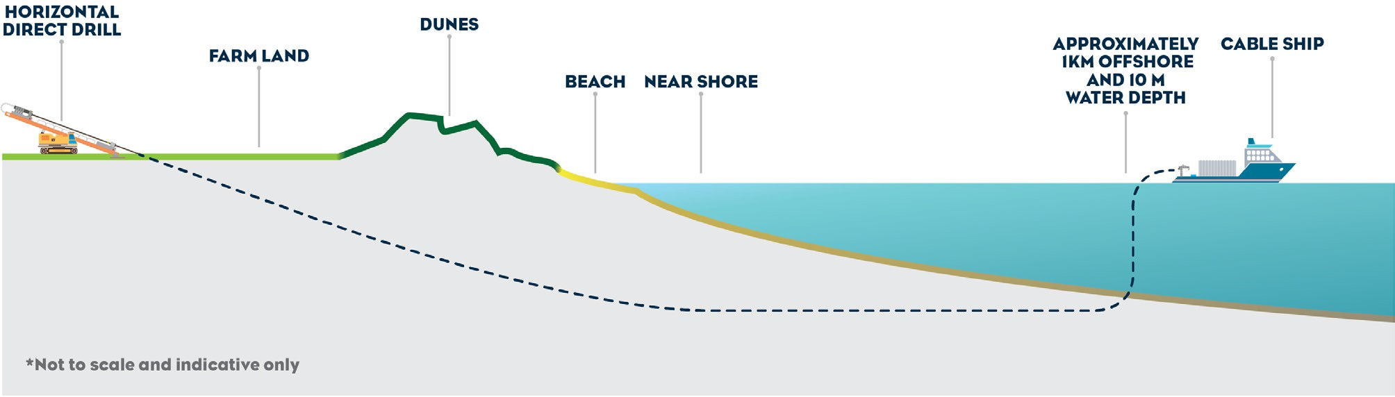

Figure 4-21 Indicative shore crossing construction

Construction of project infrastructure
Construction of project infrastructure, including haul roads, laydown areas, converter station and land cables has the potential to cause compaction of unconsolidated aquifer matrices in alluvial sediments. Compaction is less likely to occur in areas where bedrock units outcrop. Compaction causes changes to the physical properties of the aquifers through reducing pore space and altering hydraulic properties, which changes groundwater levels, flow direction and flow rates.
Generally, construction and operational activities do not result in the level of ground surface compaction or loading that will alter the hydraulic properties of aquifers. Localised compaction around haul roads, joint pits or other surface infrastructure would be negligible and would not affect groundwater flow directions at a regional aquifer scale. It is unlikely to cause aquifer compaction at levels lower than those experienced

across the region in highly trafficked roads outside the study area. Therefore, impacts from groundwater compaction have been assessed as low.

Groundwater acidification
Where ASS are present in the study area and it is allowed to oxidise, either in situ or in stockpiles, it may acidify groundwater. Acidification of groundwater can impact on ecology as well as lowering the pH of the groundwater which can increase concentrations of dissolved metals.
A zone of mapped potential coastal ASS material has been identified between the Waratah Bay landfall point and approximately the first 430 m of the project alignment towards cable joint pit JP1A (Figure 4-22). If shallow soil sulfides oxidise from exposure to oxygen following drawdown during dewatering, it may pose an impact associated with groundwater acidification. There is a low likelihood of ASS occurring in other locations along the study area.
The extent of groundwater acidification from oxidation of ASS (if it occurs) would be a function of the duration of dewatering and the time required for groundwater levels to recover. If acidic groundwater was generated it is expected to be limited in extent and would likely migrate towards the Waratah Bay coastline and the estuarine environment behind the dune system, then discharging to the marine environment. Areas of vegetation dieback and aquatic ecosystem impact could occur, and in turn, affect other groundwater values such as water-based recreation and traditional owner cultural values.
Permanently waterlogged soils, such as those found in streams, floodplains, rivers, wetlands, and shallow groundwater, have an increased potential of containing ASS. Due to the presence of these features in the section of Eel Hole Creek that feeds into Hazelwood cooling water pond and the Waratah Bay beach area, these areas have been considered as potential ASS site. However, there is a low to extremely low probability that ASS exists within most of the study area (Volume 4, Chapter 3 – Contamination and acid sulfate soils). Therefore, initial impacts to due to groundwater acidification were assessed as low for aquatic GDEs, and moderate for terrestrial GDEs and groundwater users.
Further assessment of the ASS in the coastal zone will be required prior to construction to confirm the extent of ASS and groundwater levels (EPR GW07). This would inform the development of mitigation measures, such as installing barriers to minimise groundwater drawdown in areas of ASS to the extent reasonably practicable to prevent the acidification of groundwater. Where the potential for groundwater acidification occurs, groundwater monitoring would be required to confirm mitigation measures are effective and EPRs are being met (EPR GW06).
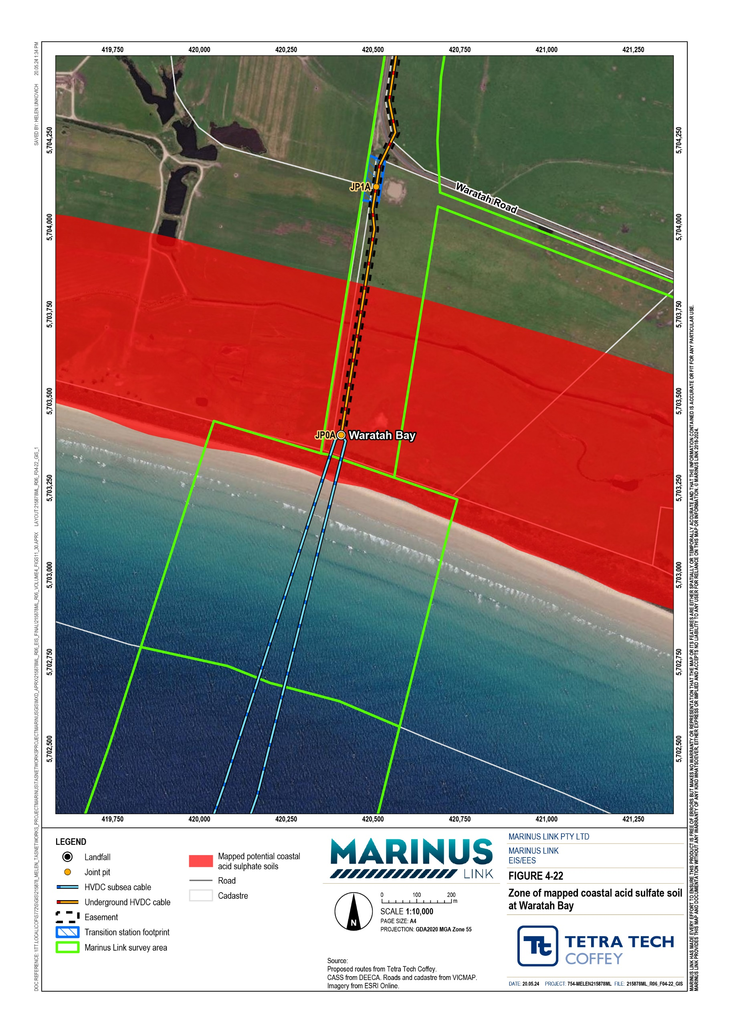

Saline intrusion
Trenching and dewatering activities between the shore crossing and joint pit JP1A in the low-lying coastal region of the study area has the potential to alter the fresh and saline water interface. The dewatering could cause landward movement of the saline water interface that may displace fresh, shallow groundwater in the estuary zone and increase groundwater salinity. The proposed dewatering activities in the coastal zone may result in a groundwater drawdown of up to 1.5 m, which is the maximum cable trench depth. Groundwater drawdown of 1 m is not predicted to extend beyond 200 m from the edge of the onshore trench under long term, steady state conditions.
Altered flow paths can also be created by HDD that can allow saline water to migrate along the borehole annulus to the estuarine zone behind the Waratah Bay dunes.
Variable groundwater inflows may be expected in the coastal zone due to the presence of both high conductivity coastal dune deposits and lower conductivity coastal lagoon deposits, which would have substantially less drawdown propagation during HDD.
Limited groundwater drawdown is expected to extend away from the cable trench during the short construction period, and with application of mitigation measures adopted to comply with EPR GW01. The aquatic and terrestrial ecosystems in the coastal zone are typically resilient to natural changes in salinity and are unlikely to be affected by localised saline groundwater intrusion. Furthermore, there are likely to be existing hydraulic boundaries in the estuarine zone such as the streams and swamps that will significantly limit the lateral extent of groundwater drawdown.
A hydrogeological assessment (EPR GW01) will be undertaken prior to construction to verify the aquifer hydraulic conditions and confirm drawdown estimates for final design and construction method adopted. Dewatering controls may be required in the coastal zone to limit groundwater drawdown where ASS is present and where the cable trench is proposed to cross estuarine streams (EPR GW07). Groundwater monitoring in the coastal zone will also be required to establish baseline conditions and monitor for compliance with EPRs (EPR GW06). Methods that seal the annulus of directionally drilled bores or otherwise prevent water movement along the borehole annulus will be adopted (EPR GW03). Where potential impacts to groundwater quality are predicted to occur (as identified in GW01), measures would be implemented to prevent saline water intrusion into freshwater aquifers (EPR GW07). Overall, the potential impact of increased saline groundwater intrusion on groundwater values due to temporary groundwater level drawdown was assessed as low.

Contamination
Construction activities and mobilisation of existing contamination sources have potential to cause groundwater contamination.
Construction activities may impact groundwater through the use of hazardous materials and products such as drilling fluids, chemicals (e.g., lubricants, sealants, chemical grouts) and fuels from machinery, vehicles or fuel tanks, directly entering the aquifers that these activities access/interact with. Hazardous materials will be

mostly used by equipment and vehicles during construction. The volume of fuels used and stored on site are expected to be relatively small as mobile re-fuelling would occur during construction.
The storage, handling, transport, disposal or accidental leaks and spills of these hazardous substances has the potential to contaminate groundwater. If leaks and spills are uncontrolled and inappropriately managed, they may infiltrate the soil and reach the shallow aquifer or be transported as runoff to waterways and passing through the soil into aquifers.
A CEMP will be developed and implemented by contractors. The CEMP will include a hazardous materials register, minimum requirements for handling and disposing of hazardous materials, spill response procedures and incident management plans. The CEMP will comply with the EP Act’s requirements for managing pollution and waste related impacts to comply with the GED.
Overall, the impact of groundwater contamination due to hazardous materials and chemicals used during project construction activities are assessed as low impact.
Drilling for construction e.g., HDD, could use alternative drilling fluid additives that could cause low concentrations of toxic chemical contamination. In Victoria drilling activities typically adopt water based, non- toxic and biodegradable additives. The large number of boreholes that will be drilled along the project alignment and the proximity of both drilling and HDD to sensitive groundwater receivers may result in moderate impact due to the use of drilling additives, to consumptive or productive uses of groundwater and aquatic GDEs. The use of non-toxic and/or biodegradable drilling additives such as bentonite clay and xanthan gum (EPR GW03) would however, reduce the potential impact to low.
The mobilisation of existing groundwater contamination has been assessed as having a low impact due to temporary groundwater drawdown. The draw down due to cable trench construction activities may affect groundwater quality if there is existing contamination in the area by mobilising that contamination source into groundwater. Limited information is available on groundwater quality along the project alignment, and unexpected contamination is possible. Where existing groundwater contamination occurs that may impact groundwater uses, receptors or cause degraded groundwater quality (as identified in EPR GW01), measures to prevent the mobilisation of known contamination would be implemented to comply with EPR GW07. The management of extracted groundwater will be necessary to minimise potential impacts to groundwater values.
A review of land and groundwater contamination has identified potential contaminated areas, but they do not overlap with the proposed dewatering areas except for the Hazelwood cooling water pond and Eel Hole Creek launch and recovery sites. Therefore, mobilisation of existing groundwater contamination due to temporary groundwater level drawdown has been assessed as a low impact.

Groundwater flows and recharge
The material used for backfilling of cable trenches has the potential to cause impacts to groundwater if it has a different hydraulic conductivity than the existing soil.

Material with a lower hydraulic conductivity used in trench backfilling can cause aquifer damming, which restricts groundwater flow. This can result in changes in groundwater levels upstream and downstream of the trench (known as mounding). If low permeable backfill is used in areas where the trench intersects with alluvial aquifers, it can further exacerbate this impact by creating a barrier effect on groundwater. This can have various consequences such as altering floodplain dynamics, damaging surface infrastructure, causing vegetation dieback, impacting streams, and limiting access to GDEs, resulting in a moderate impact.
If materials with a higher permeability or poorly compacted materials are used to backfill cable trenches, surface water can enter and recharge groundwater at a higher rate. This can lead to increased groundwater recharge and potentially affect groundwater values where the cable trench is located in flood prone areas and drainage lines where water may flow across the cable. The extent of these impacts can vary depending on factors like high rainfall and flow periods.
The cable trench was identified to be below the water table in locations where the alluvial aquifers are present around drainage lines. An example is shown in Figure 4-23 for a location in the Stony Creek flood plain where trenching is proposed to cross a zone of alluvial outcropping between JP 26 and JP 27. These conditions are also anticipated at:
Fish Creek

Unnamed tributary of Tarwin River East Branch

Tarwin River East Branch

Morwell River.

The alluvial aquifers in these locations may be relatively thin, and the backfilled trench might penetrate the full alluvial aquifer thickness so impacts of damming or increased recharge could occur.
Existing soils will be used to backfill trenches where they are suitable and meet the required thermal properties. This will enable the original subsoil and topsoil layers to be reinstated (EPR GW04). Where groundwater barrier effects could occur as identified by hydrological investigations undertaken to inform the final design (EPR GW01), groundwater levels will be monitored prior to and after construction (EPR GW06). The project will use low permeability thermal backfill below the water table but will be avoided in areas where the cable trench may penetrate and impact the full thickness of the aquifer (EPR GW04). Engineering solutions can also be adopted to prevent groundwater barrier effects such as under-drainage layers or other features that allow groundwater pressure to accommodate across the structure.
Overall, with the implementation of mitigation measures to comply with EPRs, the residual impact of backfilling from cable trenches is predicted to be low.

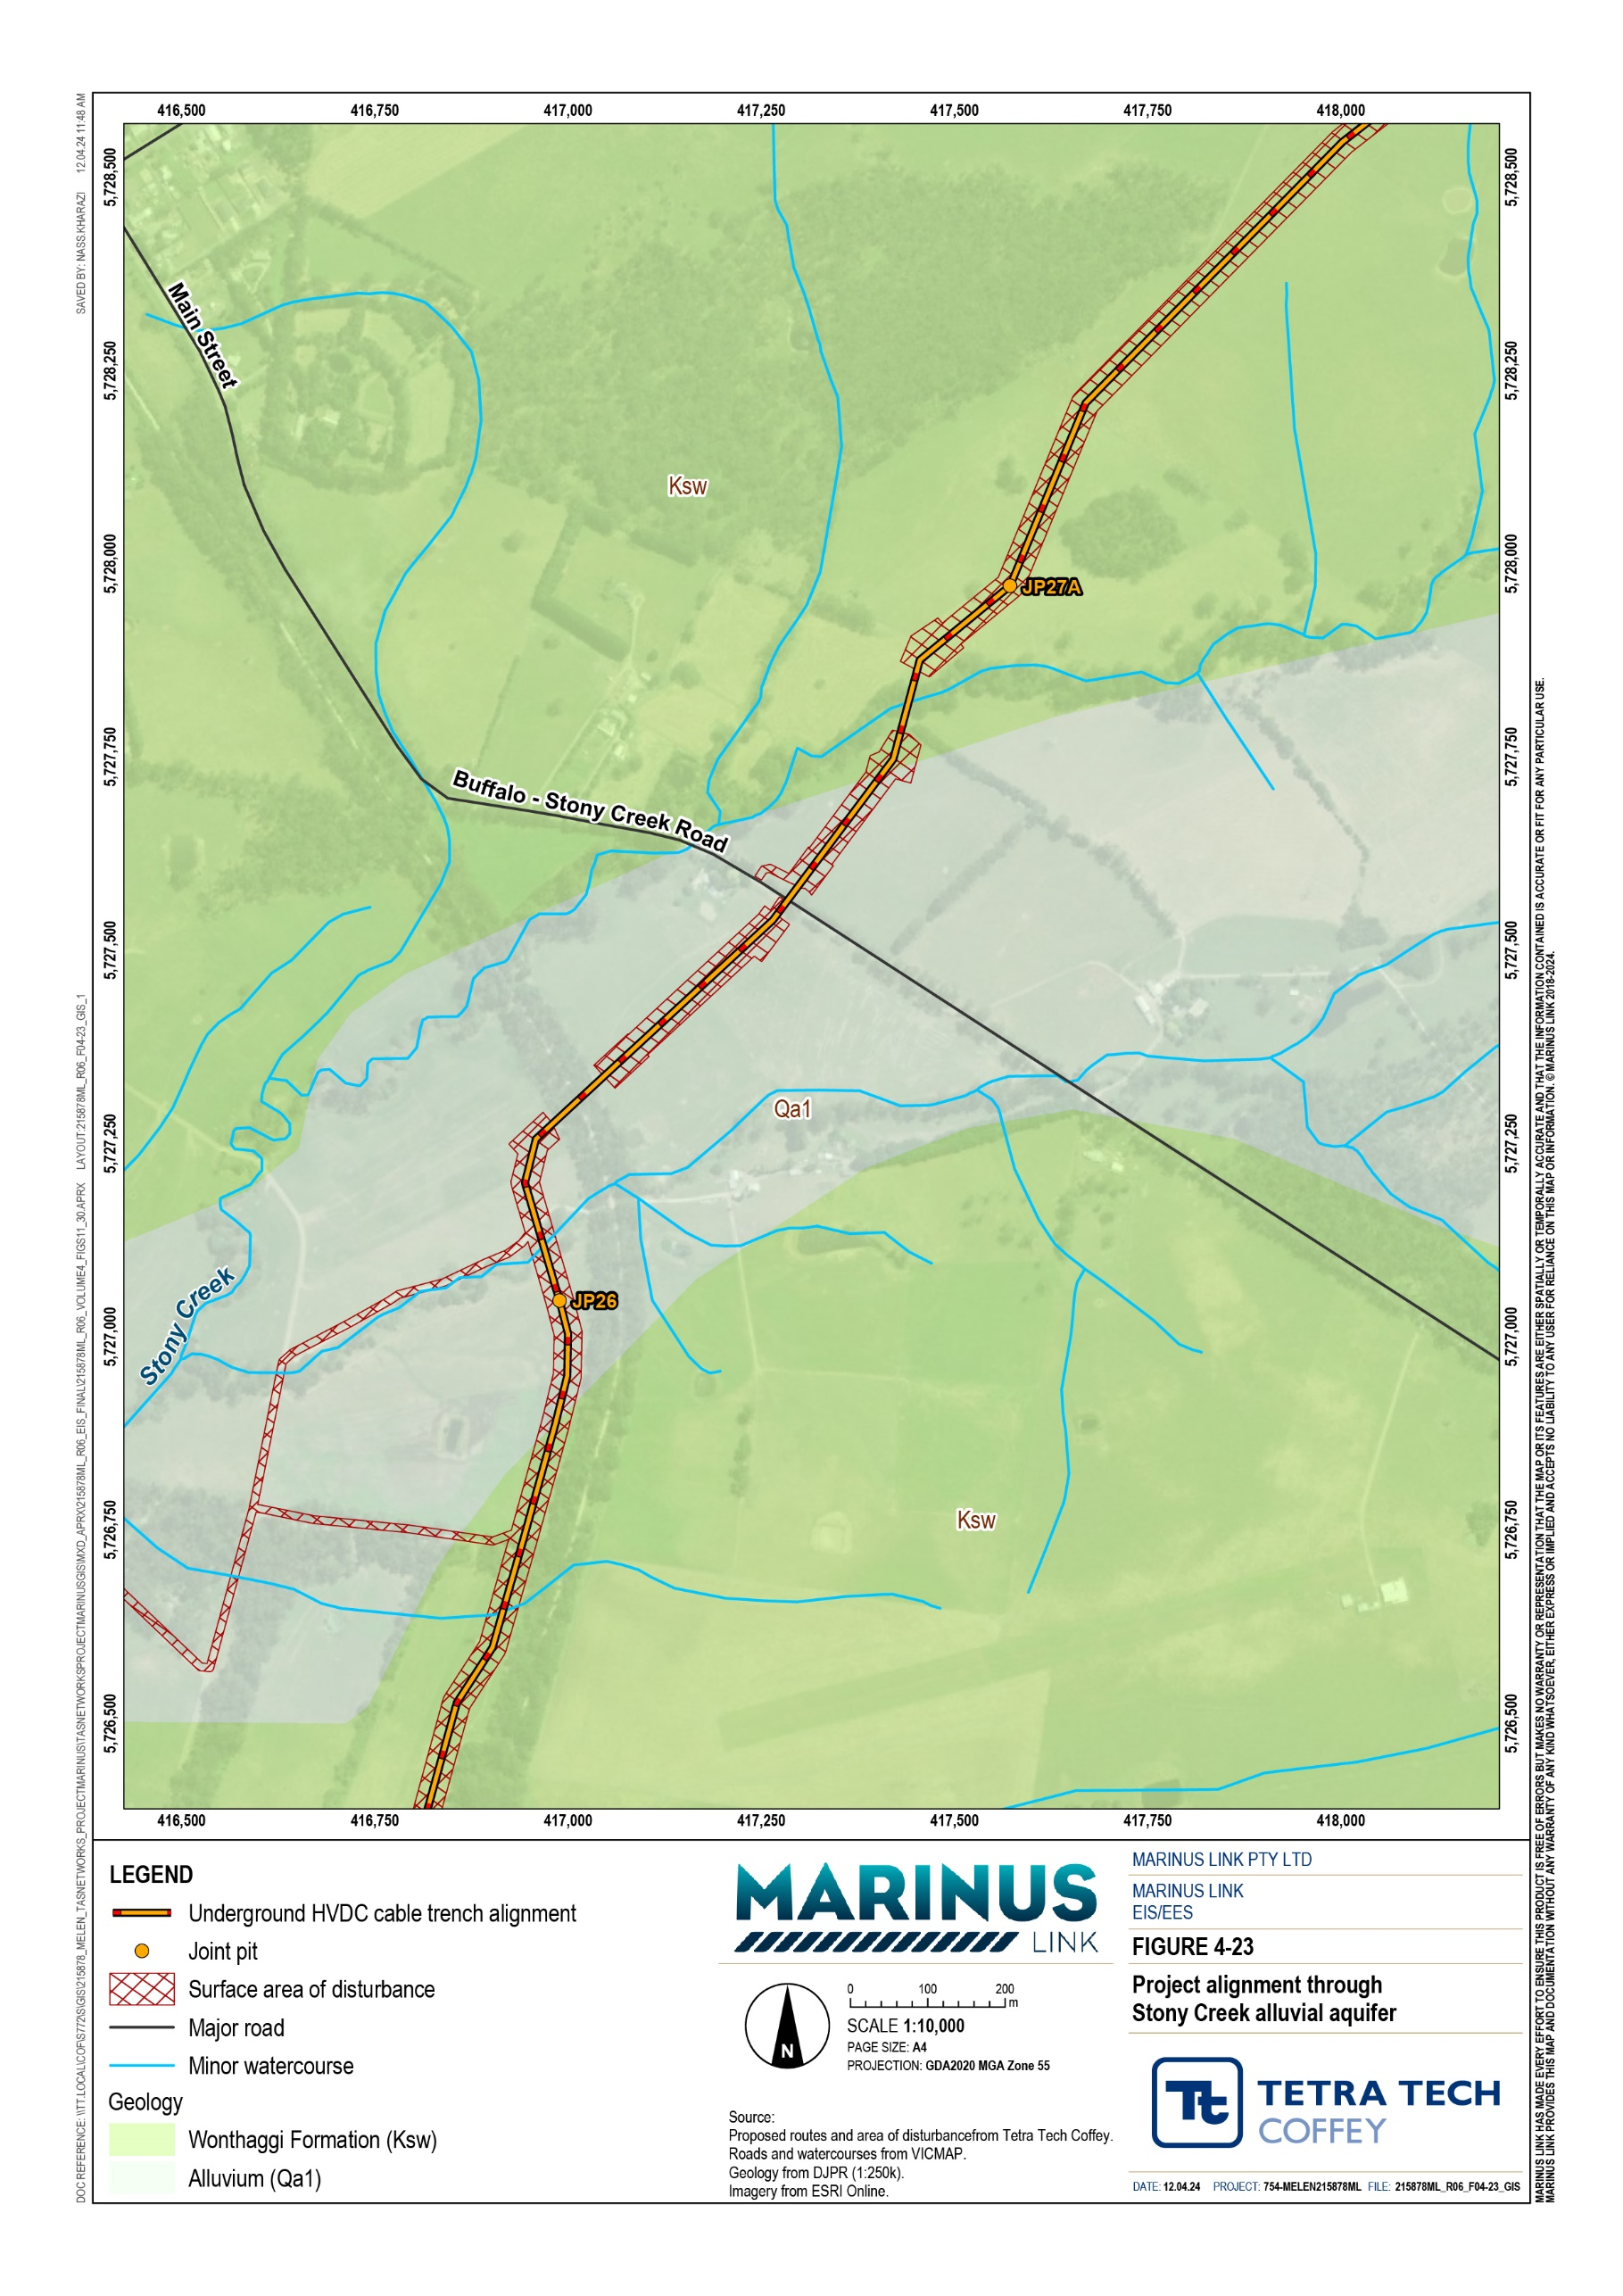

Operation impacts
Activities during project operation have the potential to cause groundwater contamination (quality) and alter groundwater regime (quantity). These activities are:
Storage, handling, transport, disposal and accidental spills and leaks of hazardous materials, including transformer oil, lead acid batteries, and diesel fuel stored in above ground tanks at the Hazelwood converter station.

Contamination
During the operation of the converter station at Hazelwood, there is limited potential for groundwater contamination. Impacts could occur if there are leaks or spills from the storing, handling, transporting or disposing of various hazardous substances such as diesel for generators or oil for transformers. There could also be contamination caused by incorrect usage of herbicides on site to manage weeds, or effluent discharges resulting from the project. Contaminants may migrate within groundwater towards connected features.
There are no extractive use bores registered in the vicinity of the proposed Hazelwood converter station site. The aquatic GDEs of Bennett’s Creek and Eel Hole Creek are located approximately 50 m and 350 m south of the Hazelwood converter station site, respectively, and unlikely to be impacted by spills or leaks from the sites.
Any hazardous chemicals stored or used during operation including herbicides will be in accordance with the relevant regulatory requirements and manufacturer’s guidance (EPR GW07). Accidental spills of contaminants and then migrating to groundwater is expected to be a minor magnitude of impact when applying standard controls such as bunding. The residual impact would be low with the application of mitigation measures to achieve EPRs.

Decommissioning impacts
The current operational lifespan of the project is a minimum 40 years. At this time, the project will either be decommissioned or upgraded to extend its operational lifespan.
Requirements at the time will determine the scope of decommissioning activities and impacts. The key objective of decommissioning will be to leave a safe, stable and non-polluting environment, and minimise impacts during the removal of infrastructure.
In the event that the project is decommissioned, all above ground infrastructure will be removed, and associated land returned to the previous land use or as agreed with the landholder. All underground infrastructure will be decommissioned in accordance with the requirements of the time. This may include removal of infrastructure or some components remaining underground where safe to do so.

A decommissioning management plan will be prepared to outline how activities will be undertaken and potential groundwater impacts managed. The decommissioning plans will outline how activities will be undertaken and potential impacts managed as outlined in EPRs EM04 and EM05 included in the Environmental Management Framework for the project (Volume 5, Chapter 2 – Environmental Management Framework).

Environmental performance requirements
Potential impacts identified during the groundwater impact assessment for the project have informed the formation of EPRs for the project. EPRs set out the environmental outcomes that must be achieved during all phases of the project, without defining how the outcome is to be achieved. In developing these EPRs, industry standards and guidelines, good practice and the latest approaches to managing impacts were considered.
The proposed groundwater related EPRs are summarised in Table 4-13.

Table 4-13 EPRs

EPR ID | EPR
GW01 | Complete a hydrogeological assessment and dewatering drawdown assessment to inform the design  Prior to commencement of project works, complete a hydrogeological assessment at locations identified along the final project alignment as likely to encounter groundwater during construction to refine the predicted groundwater drawdown levels identified and assessed in EIS/EES Technical Appendix P: Groundwater Assessment.  The assessment must:  Be completed by a suitably qualified hydrogeologist.  Consider the assumptions and approach outlined in the EIS/EES Technical Appendix P.  Be informed by hydrogeological investigations including groundwater level and quality monitoring, and aquifer hydraulic testing.  Be informed by geotechnical investigations where available.  Be informed by representative aquifer hydraulic conditions (such as from aquifer hydraulic tests completed on-site) in areas of shallow groundwater and use relevant, available monitoring data.  Include a groundwater drawdown assessment for areas where dewatering of construction trenches will be required based on the detailed design.  Incorporate groundwater quality analysis undertaken to assess for the presence of unexpected, existing groundwater contamination.  The assessment must be documented as part of the groundwater management plan as a sub plan to the CEMP and implemented during construction.

EPR ID | EPR
GW02 | Develop and implement methods to minimise groundwater inflow into trenches and groundwater level drawdown  Prior to commencement of project works, develop methods that identify and either avoid (where possible) or minimise groundwater inflow into cable trenches and joint pits. The construction method should:  Be informed by the hydrogeological assessment completed for EPR GW01.  Include measures to minimise groundwater drawdown where impacts may occur to groundwater quality, productive uses or the function of GDEs.  Consider scheduling construction works to minimise the total time that dewatering is required.  Adopt engineering controls during construction such as sheet pile walls or other temporary structures to avoid (where possible) or minimise groundwater ingress to construction trenches at locations where:  - High groundwater inflows are predicted to be encountered.  - The hydrogeological assessment (EPR GW01) identifies potential impacts to groundwater that may be more significant than assessed the EIS/EES Technical Appendix P.  These measures must be documented in a groundwater management plan as a sub plan to the CEMP and implemented during construction.
GW03 | Develop and implement methods for HDD and drilling to prevent groundwater movement and contamination  Prior to commencement of project works, develop methods to identify and avoid or minimise impacts to groundwater that:  Seal the annulus of directionally drilled bores or otherwise prevent water movement along the borehole annulus.  Adopt relevant guidance from Minimum construction requirements for water bores in Australia (2020) to minimise potential for impacts to groundwater.  Utilise non-toxic and/or biodegradable drilling additives, such as bentonite clay and xanthan gum, for HDD and other drilling activities during construction.  Are informed by investigations as required by EPR GW01.  Are informed by geotechnical investigations or advice prior to commencing HDD activities.  Include methods for HDD monitoring and mitigation measures to minimise potential for frac-outs to occur and limit the scale of impact in sensitive areas. These include minimum observations during drilling to detect frac-outs (such as loss of fluid circulation) and pressure relief methods. Emergency response measures for frac out during HDD are covered by EPR SW01.  These measures must be documented in a groundwater management plan as a sub plan to the CEMP and implemented during construction.
GW04 | Develop and implement measures to utilise cable backfill material to minimise impact on groundwater recharge and flow  Prior to commencement of project works, develop measures to backfill excavations with the same material that was excavated in approximately the same order so far as reasonably practicable, and having regard to EPR A03.  The backfill should reinstate the soil profile with adequate compaction to avoid (where possible) or minimise surface water ingress to the trench, flow along the trench, and preferential recharge to groundwater, and allow for existing groundwater movement.  Backfill below the water table should be informed by a hydrogeological assessment (EPR GW01).  Where the existing material is not suitable for backfill and thermal backfill is required, the placement of thermal backfill and the construction design should be informed by the hydrogeological assessment (EPR GW01) to prevent barrier effects and allow groundwater pressure to equilibrate across the structure. Engineered solutions might include the design of under-drainage layers or other features that allow groundwater pressure to equilibrate across the structure.  These measures must be documented in a groundwater management plan as a sub plan to the CEMP and implemented during construction.
GW05 | Design and implement measures to manage and dispose of extracted groundwater during construction to avoid (where possible) or minimise environmental impacts  Prior to commencement of project works, develop measures to manage, monitor, reuse where possible, treat where necessary, and dispose of groundwater inflows during construction dewatering that identify and avoid or minimise potential impacts to groundwater values and conditions.

EPR ID | EPR
The measures must be developed in consultation with relevant water authorities and EPA Victoria, and comply with relevant legislation and guidelines, including but not limited to:
EP Act and Environment Protection Regulations 2021. Environment Reference Standard.
Water Industry Regulations 2006.
Occupational Health and Safety Act 2004 (Vic) and Occupational Health and Safety Regulations 2017. The waste management hierarchy.
The measures must be documented in a plan that also outlines the approach to:
Avoiding or minimising wastewater production from dewatering groundwater, consistent with EPR GW02
Monitoring of groundwater levels and quality where dewatering may occur.
Management of extracted groundwater including collection methods, quality monitoring methods during disposal, discharge criteria and trigger levels developed in consultation with relevant regulators, proposed treatment methods, and disposal processes.
Groundwater disposal options and individual discharge locations including estimated discharge volumes and flow rates, discharge limits for water quality and flow rates, anticipated potential water treatment requirements and any required approvals, monitoring and reporting.
These measures must be documented in a groundwater management plan as a sub plan to the CEMP and implemented during construction.
GW06 | Undertake groundwater monitoring to establish baseline groundwater conditions prior to construction and monitor groundwater levels and quality in areas of higher potential impact during construction  Prior to commencement of project works, develop a groundwater monitoring program to establish background and baseline groundwater conditions to the extent reasonably practicable. The baseline and background level and quality data will be used to identify if there are any changes in groundwater during construction. The program must focus on areas where higher impacts to environmental values may occur and include, but not be limited to, the project alignment area adjacent to Hazelwood cooling pond, Waratah Bay, groundwater dependent ecosystems and areas of potential ASS.  The monitoring program must:  Be developed in consultation with EPA Victoria to confirm the extent and duration of monitoring required prior to, during and post construction.  Establish seasonal variability and other long-term trends of groundwater conditions.  Establish baseline groundwater levels and quality conditions in areas where shallow groundwater is expected to be encountered and is susceptible to groundwater quality, flow and drawdown impacts, as identified in EPR GW01.  Calibrate the groundwater drawdown assessment prior to commencement of project works and during construction activities to verify predictions.  Verify the adequacy of the proposed design and construction methods, and where required, identify and implement any additional measures required to mitigate impacts from changes in groundwater levels, flow and quality.  Be informed by the outcomes of the hydrogeological assessment (EPR GW01) and acid sulfate soil assessment (EPR GW07).  Outline the approach to review of monitoring results and define acceptability criteria for groundwater recovery at completion of construction for water quality, flows and level recovery as predicted by the groundwater drawdown assessment required in EPR GW01 and considering the impacted groundwater values. Where recovery may extend into operation, relevant groundwater monitoring activities should be incorporated into the OEMP (EPR GW09)  The monitoring program, where required, must be consistent with the obligations of the EP Act, EPA Victoria Publication 668 Hydrogeological assessment groundwater quality guidelines, EPA Victoria Publication 669 Groundwater Sampling Guidelines, EPA Victoria Publication 2033 Background levels methodology guidance and the Environment Reference Standard.  This program must be documented in a groundwater management plan as a sub plan to the CEMP and implemented during construction.

EPR ID | EPR
GW07 | Develop and implement measures to prevent groundwater acidification, saline intrusion and contaminant mobilisation in areas where they are predicted to occur  Prior to commencement of project works, develop measures to prevent groundwater acidification within the zone of groundwater drawdown and in the coastal area. The measures must:  Be informed by the ASS management plan (EPR CL03) that will identify locations where ASS could occur.  Be based on the findings of the hydrogeological assessment EPR GW01 and groundwater monitoring EPR GW06.  Adopt appropriate engineering controls, such as sheet pile walls or other barriers, to prevent groundwater level drawdown, so far as reasonably practicable or adopt other mitigations or management measures to prevent groundwater acidification impacts.  Develop and implement measures to:  Prevent saline water intrusion into freshwater aquifers where potential impacts to groundwater quality are predicted to occur as a result of dewatering in the coastal zone. Measures should be developed based on the outcome of the hydrogeological assessment (EPR GW01) and prior to the commencement of works.  Prevent the mobilisation of known, existing groundwater contamination, as identified in EPR GW01, that would increase the risk posed to groundwater receptors or cause degraded groundwater quality.  Groundwater monitoring must be carried out during construction to verify groundwater acidification, saline intrusion and mobilisation of contamination is not occurring and responses are implemented if quality impacts are detected.  The measures must be documented in a sub plan endorsed by a person(s) appointed by EPA Victoria as an environmental auditor.  These measures must be documented in a groundwater management plan as a sub plan to the CEMP and implemented during construction.
GW08 | Develop and implement measures to maintain water supply to registered groundwater users  Confirm the status and use of registered and unregistered bores within the immediate construction zone by making inquiries with affected landholders and estimate the drawdown area due to construction.  Where necessary, negotiate requirements to decommission existing bores where they may be destroyed during construction, and/or negotiate the need for replacement with new bores or the provision of an alternative water supply.  Where dewatering reduces access to groundwater for landholders, negotiate arrangements to provide alternative water supplies until groundwater levels return to enable supply of water.  Bore decommissioning must be completed in accordance with the Minimum Construction Requirements for Water Bores in Australia.  These measures must be documented in a groundwater management plan as a sub plan to the CEMP and implemented during construction.
GW09 | Develop and implement measures to manage potential impacts to groundwater in operation  As part of the OEMP, develop and implement measures to identify and avoid (where possible) or minimise potential impacts to groundwater during the operation of the project as identified by the EIS/EES Technical Appendix P or by assessment of impacts from the proposed operation and maintenance activities. The OEMP must also include measures to manage any residual impacts to groundwater from construction that need to be managed in operation.  The measures must address:  Ongoing monitoring requirements as determined through the monitoring program developed in accordance with EPR GW06, including monitoring to confirm recovery of groundwater levels and quality, where required.  Management of materials to prevent contamination of groundwater, as required by EPR CL04.  The groundwater management plan must be a sub plan to the OEMP and implemented during operation.

In addition to the groundwater EPRs above, other EPRs that would reduce the potential for groundwater impacts resulting from the project, including:
Marine ecology (Volume 3, Chapter 2 – Marine ecology)

Contaminated land and acid sulphate soils (Volume 4, Chapter 3 – Contaminated land and acid sulfate soils)
Surface water (Volume 4, Chapter 5 – Surface water).

Refer to Volume 5, Chapter 2 – Environmental Management Framework for a full list of all EPRs.

Residual impacts
Residual impacts are those remaining after the application of mitigation measures to comply with EPRs. The residual impacts to groundwater during construction and operation are low. A summary of residual impacts is provided in Table 4-14.

Construction
Project activities with the most impacts to groundwater are anticipated to occur during the construction phase where activities occur below the groundwater table or from the potential contamination through the use of potentially hazardous materials.

Groundwater bores
Construction activities may temporarily impact groundwater bores within the project area, resulting in an initial impact of moderate. While construction activities are expected to impact groundwater users in the short term (i.e., removal/replacement of bores and temporary dewatering impacts), implementation of proposed mitigation measures such as providing alternative water supply to affected users (EPR GW08) will control and minimise the residual impact on groundwater users, resulting in a low residual impact.

Groundwater-dependent ecosystems
The predicted extent of the temporary dewatering may affect both terrestrial and aquatic GDEs, however dewatering activities are expected to be localised within the project area and last for a maximum of two months. Groundwater levels are expected to recover once dewatering ceases. Therefore, initial impacts on both terrestrial and aquatic GDEs are assessed as low.
The implementation of potential mitigation measures to comply with EPRs GW01 and GW02 will further minimise the magnitude and duration of dewatering and the impact on GDEs. With the small-scale nature of dewatering associated with the project and the implementation of mitigation measures, the residual impact for terrestrial and aquatic GDEs is assessed as low.

HDD
The initial impacts on GDEs and groundwater users from HDD are expected to be low due to the characteristics of the alluvial aquifers encountered during drilling. The alluvial aquifer has interbedding clay and sands which generally restrict the spatial extent of groundwater flow and would minimise the impact on groundwater supply to users and GDEs.
Initial impacts to the Waratah Bay dune system due to HDD are also assessed as low due to the absence of prospective perched aquifers and GDEs.
The application of EPRs GW01 and GW03 will further support the initial low impact rating, and the residual impact will not change. These EPRs primarily focus on controls to restrict groundwater movement during the construction of HDD.

Groundwater acidification
The Waratah Bay landfall and cable joint pit JP1A locations are prone to the presence ASS. Initial impacts to due to groundwater acidification were assessed as low for aquatic GDEs, and moderate for terrestrial GDEs and groundwater users.
Control barriers could be installed to minimise drawdown at the coastal zone where ASS is anticipated to occur, and groundwater monitoring will be implemented to confirm the mitigation measures are effective (EPRs GW06, GW07). The EPRs will avoid ASS during dewatering and minimise potential groundwater acidification to the extent practicable. Based on the implementation of EPRs, the residual impact for terrestrial and aquatic GDEs and groundwater users was assessed as low.

Saline intrusion
Ecosystems that occur in the coastal zone are known to be highly resilient to salinity. Saline intrusion as a result of trenching and dewatering activities may occur. However, the extent and duration of such impact is predicted to be limited and measures would be implemented if it was found likely to occur (EPR GW07), therefore the initial impact rating is low.
Further specific mitigation is not required, and the residual impact will remain low.

Contamination
The impacts of groundwater contamination as a result of construction will be temporary and range from low to moderate initial impact ratings (see Table 4-14).
The application of standard mitigation measures to comply with EPRs GW03 and GW07 will manage potential contamination during construction. Standard mitigation measures could include requiring the use of non-toxic drilling additives during drilling activities, and requirements to manage chemicals and hazardous materials in line with relevant guidelines.
With the implementation of EPRs, the residual impact of groundwater contamination from construction activities is assessed as low.

Construction of project infrastructure
Based on the impact assessment, it is unlikely that construction of project infrastructure (including haul roads, laydown areas, converter station and land cables) will have an impact on the GDEs and groundwater users due to compaction. Therefore, no EPRs are proposed or required specifically for this potential impact and the residual impact has been considered as low.

Groundwater flows and recharge
The installation and backfilling of cable trenches has the potential to cause aquifer damming, which restricts groundwater flow and recharge. Initial impacts have been assessed as low for groundwater users and terrestrial GDEs, and moderate for aquatic GDEs.
Existing soils will be used to backfill trenches where they are suitable and meet the required thermal properties. This will enable the original subsoil and topsoil layers to be reinstated (EPR GW04). Where groundwater barrier effects could occur from construction and where engineering design mitigations have been adopted, as identified by hydrological investigations undertaken to inform the final design (EPR GW01), groundwater levels will be monitored prior to and after construction to verify the effectiveness of the mitigation measures (EPRs GW06 and GW07).
Contractors will be required to use low permeability thermal backfill where the cable is located in groundwater and impact the full thickness of the aquifer (EPR GW04). The use of low permeability thermal backfill would however, avoid the areas where cable trench may penetrate the full thickness of the aquifer. Where this is unavoidable, engineering solutions can also be adopted to prevent groundwater barrier effects.
Overall, with the implementation of mitigation measures to comply with EPRs, the impact would be low (Table 4-14).

Operation
This section provides an overview of the residual impacts to groundwater during the operation phase of the project.

Groundwater recharge and flow
During operation aquifer damming and increased groundwater recharges as a result of installation and backfilling of cable trenches is expected to be minimal and will not extend beyond the project area. With the implementation of mitigation measures to comply with the EPRs (EPR GW04), residual impacts on groundwater values are expected to be low.

Hazardous chemicals
Any hazardous chemicals stored or used during operation including herbicides will be in accordance with the relevant regulatory requirements and manufacturer’s guidance (EPR GW07). Accidental spills of contaminants and then migrating to groundwater is expected to be a minor magnitude of impact when applying standard controls such as bunding. Therefore, the residual impact of groundwater contamination during operation is expected to be low.

Contamination
Accidental spills of contaminants and the application of herbicides at the converter station sites have the potential to cause groundwater contamination during the operational phase of the project. With the implementation of mitigation measures to comply with the EPRs (GW09), including the application of standard controls such as bunding and environmental reporting of incidents, the residual impact of groundwater contamination during operation is expected to be low.

Decommissioning
Depending on the extent of decommissioning activities required after operation of the project, it can be expected that no potential impacts to groundwater are considered for the decommissioning phase as the project has not identified the need for subsurface work as the subsurface infrastructure will be left in place. Mitigation measures to avoid and minimise impacts to groundwater developed as part of the decommissioning management plan are expected to be similar to those adopted during construction. The mitigation measures will also be specific to groundwater conditions at the time of decommissioning.
If the project infrastructure is fully removed during decommissioning, it is expected that the impacts would be no greater than those associated with construction.

Summary of residual impacts
Construction, operation, and decommissioning activities of the project are expected to present a low overall impact on groundwater values if the appropriate EPRs are adopted.
Table 4-14 summarises the residual impacts on groundwater values, with significance ratings derived from relevant assessment of sensitivity and magnitude.

Table 4-14 Summary of residual impacts

Activity Value Initial impact Justification of residual rating Recommended Residual impact
EPRs
Sensitivity Magnitude Impact Magnitude Impact
rating rating
Construction
Temporary dewatering of onshore cable trenches, cable joint pits, and HDD pits during construction leading to groundwater level drawdown. | Aquatic GDEs (Little Morwell River and Waratah Bay) | Moderate | Minor | Low | Future hydrogeological assessments at points where dewatering is likely and the implementation of measures to manage, monitor, reuse where possible, treat where necessary, and dispose of groundwater inflows will minimise impacts on groundwater recharge, and inflow that may affect groundwater values. | GW01, GW02, GW03 | Minor | Low
 | Terrestrial GDEs Aquatic GDEs | Moderate | Negligible | Low |  | GW01, GW02, GW03 | Negligible | Low
 | Consumptive or productive uses. | Moderate | Negligible | Low | The implementation of measures to maintain water supply to registered groundwater users, will include negotiating requirements for decommissioning existing bores and replacing existing bores with new bores or providing an alternative water supply, if required. | GW08 | Negligible | Low
Construction activities destroying registered and unregistered groundwater bores. | Consumptive or productive uses | Moderate | Moderate | Moderate |  | GW08 | Moderate | Low

Activity Value Initial impact Justification of residual rating Recommended
EPRs
Sensitivity Magnitude Impact
rating
Residual impact

Magnitude Impact
rating

Mobilisation of existing groundwater contamination towards the project due to temporary groundwater level drawdown
Consumptive or productive uses
Terrestrial GDEs
Moderate Negligible Low Hydrological investigation in areas of
potential dewatering will provide further information on existing groundwater quality and allow contaminated groundwater to be avoided or managed appropriately.
Measures to minimise the potential of
GW01, GW02, GW03, GW05, GW06, GW07
Negligible Low

groundwater drawdown, including the

Release of contaminated groundwater generated during dewatering to the environment.
Aquatic GDEs Moderate Minor Low

All values Moderate Minor Low
installation of sheet pile walls or other barriers, will prevent the release of contaminated groundwater. The utilisation of non-toxic, and/or biodegradable drilling additives during HDD or other drilling activities will remove a potential source of contamination.
The implementation of measures to manage and dispose of extracted groundwater minimises potential impacts to groundwater values and conditions.
Groundwater monitoring will confirm the existing sources of groundwater contamination and verify the adequacy of the proposed design and construction methods.
GW01, GW02, GW03, GW05, GW06, GW07

GW01, GW02, GW03, GW05, GW06, GW07
Minor Low

Minor Low

Groundwater contamination from drilling fluids.
Consumptive or productive uses
Aquatic GDEs
Moderate Moderate Moderate The utilisation of non-toxic, and/or
biodegradable drilling additives during HDD or other drilling activities will remove
GW03 Minor Low

a potential source of contamination. Terrestrial GDEs Moderate Minor Low GW03 Minor Low

Activity Value Initial impact Justification of residual rating Recommended
EPRs
Sensitivity Magnitude Impact
rating
Residual impact

Magnitude Impact
rating

Groundwater contamination from construction chemicals and fuels
All values Moderate Minor Low Groundwater monitoring will confirm the
existing groundwater contamination and verify the adequacy of the proposed design and construction methods.
Management and disposal of extracted groundwater from dewatering activities will be required to minimise potential impacts to environmental values.
If identified in monitoring, measures will put in place to prevent the mobilisation of known, existing groundwater contamination.
GW01, GW05, GW06, GW07
Minor Low

Saline groundwater intrusion due to temporary groundwater level drawdown.
Terrestrial GDEs
Aquatic GDEs
Moderate Minor
Low
Groundwater monitoring will confirm the existing groundwater conditions and verify areas where saline intrusions are likely to occur. Monitoring will inform the implementation of measures to prevent saline water intrusion into freshwater aquifers where potential impacts to groundwater quality are predicted to occur as a result of dewatering.
Methods that seal the annulus of directionally drilled bores or otherwise prevent water movement along the borehole annulus should be adopted.
GW01, GW03, GW06, GW07
Minor
Low

Activity Value Initial impact Justification of residual rating Recommended
EPRs
Sensitivity Magnitude Impact
rating
Residual impact

Magnitude Impact
rating

Construction and operation

Potential for HDD beneath rivers and creeks to create new hydraulic pathways if perched aquifers exist, potentially reducing groundwater availability
Consumptive or productive uses
Terrestrial GDEs
Moderate Negligible Low HDD and drilling method will be informed
by monitoring and geotechnical information. The implementation of engineering controls during construction such as sheet pile walls or other temporary structures will minimise groundwater ingress to construction
GW03, GW09 Negligible Low

and baseflow discharge.
Aquatic GDEs Moderate Moderate Moderate
trenches.
Measures will be put in place during operation to manage potential impacts to groundwater.
GW03, GW09 Minor Low

Potential for directional drilling through and beneath Waratah Bay dune system may alter perched groundwater systems within the
Terrestrial GDEs Aquatic GDEs
Moderate Minor Low HDD and drilling method will be informed
by monitoring and geotechnical information. Proposed investigation and engineering design will minimise barrier effects and impacts on groundwater recharge and flow.
GW01, GW03, GW09
Minor Low

dunes. | Consumptive or productive uses | Moderate | Negligible | Low | The implementation of engineering controls during construction such as sheet pile walls or other temporary structures will minimise groundwater ingress to construction trenches. | GW01, GW03, GW09 | Negligible | Low
Backfilling cable trenches with material of higher hydraulic | Consumptive or productive uses  Terrestrial GDEs | Moderate | Negligible | Low | Measures will be put in place during operation to manage potential impacts to groundwater. | GW04, GW09 | Negligible | Low
conductivity causing Aquatic GDEs
localised groundwater
recharge and mounding.

Activity Value Initial impact Justification of residual rating Recommended
EPRs
Sensitivity Magnitude Impact
rating
Residual impact

Magnitude Impact
rating

Impermeable (or low permeability) subsurface infrastructure creating a
Consumptive or productive uses
Moderate Negligible Low Groundwater monitoring will confirm the
existing groundwater conditions and verify areas where saline intrusions are likely to occur.
GW01, GW04, GW06, GW09
Negligible Low

hydraulic barrier and causing damming affects to shallow
Terrestrial GDEs Moderate Minor Low
Proposed investigation and engineering design will minimise barrier effects and impacts on groundwater recharge and
GW01, GW04, GW06, GW09
Minor Low

groundwater flow.
Aquatic GDEs Moderate Moderate Moderate
 |  |  |  |  | operation to manage potential impacts to groundwater. | GW06, GW09
Groundwater acidification due to temporary groundwater level drawdown | Consumptive or productive uses Terrestrial GDEs | Moderate | Moderate | Moderate | Groundwater monitoring will confirm the existing groundwater conditions and verify areas where contamination is likely to occur. | GW01, GW02, GW06, GW07, GW09 | Minor | Low
 |  |  |  |  | Recommended controls will be
implemented during construction and
operation to avoid dewatering acid sulfate
 | Aquatic GDEs | Moderate | Minor | Low | soils and minimises potential for groundwater acidification to the extent practicable. | GW01, GW02, GW06, GW07, GW09 | Minor | Low
Enhanced recharge of stormwater runoff | Consumptive or productive uses | Moderate | Negligible | Low | Recommended controls will minimise movement of water along cable trench | GW01, GW04, GW06, GW09 | Negligible | Low

flow.
Measures will be put in place during

GW01, GW04,

Minor Low

(including flood waters)
Terrestrial GDEs
towards aquatic ecosystems.

to shallow groundwater via higher-conductivity

backfilled cable trench.
Aquatic GDEs Moderate Moderate Moderate GW01, GW04,
GW06, GW09
Low Low

Activity Value Initial impact Justification of residual rating Recommended
EPRs
Sensitivity Magnitude Impact
rating
Residual impact

Magnitude Impact
rating

Operation

Herbicide application at the converter station migrating to groundwater.
All Moderate Negligible Low During operation, the consideration of
minimum industry requirements for storage of fuels, such as bunding and environmental reporting of incidents, and
GW09 Negligible Low

would be readily remediated via
Accidental spills and leaks of transformer oil, lead acid batteries, and diesel fuel stored in above ground tanks at the Hazelwood converter station. | Consumptive or productive uses Aquatic GDEs | Moderate | Minor | Low | conventional remediation methods. | GW09 | Minor | Low
 | Terrestrial GDEs | Moderate | Negligible | Low |  | GW09 | Negligible | Low

Cumulative impacts
Two established projects have been assessed for their cumulative impacts due to their proximity to the project alignment and their potential to affect groundwater including:
Hazelwood mine rehabilitation project

Delburn windfarm project

Eel Hole creek is near the Hazelwood mine rehabilitation project as well as the Hazelwood converter station. If this waterway is impacted, it would be short term and not result in long term effects as drawdown from the project is temporary as well as localised. It is also understood the Hazelwood project could result in a long- term rise in groundwater levels rather than any drawdown.
The Delburn Windfarm project is located along side Marinus Link in the Driffield area. It involves excavations for turbine footings and cable trenches which may also require groundwater dewatering in locations. It is considered these impacts would be localised, short time and ground water levels would return following completion of construction.
When considered with these additional projects, the residual impact would remain low as the impacts would be temporary in nature and localised. As the cumulative effect of the project on the values of groundwater would be temporary, the potential cumulative effects in the region, are considered to be negligible. This would not increase the impact to levels greater than already assessed by assessment presented in Technical Appendix P: Groundwater.

Conclusion
The groundwater impact assessment identified potential impacts to the groundwater values due to project activities. These values include consumptive or productive uses, aquatic and terrestrial GDEs.
The assessment identified initial impacts ranging from low to moderate during construction and operation. The key impacts to groundwater will occur in construction due to direct impact to groundwater bores, dewatering of aquifers, saline intrusion of groundwater and potential acidification due to oxidation of acid sulfate soil. These impacts were assessed to be localised, short term and manageable with standard mitigation measures. A detailed hydrogeological assessment (EPR GW01) will be undertaken to inform the final design and construction mitigation measures to mitigate impacts (EPRs GW03, GW02, GW05, GW07, GW08). Overall, the residual impact to groundwater in construction would be low.
Impacts to groundwater could occur if the material used for backfilling the cable has lower or higher conductivity than the natural soil layers affecting groundwater flow or recharge. This could result in aquifer damming effects or increased recharge. Wherever possible the existing soil will be used to backfill trenches where they are suitable and meet the required thermal properties. This will enable the original subsoil and topsoil layers to be reinstated (EPR GW04). Where groundwater barrier effects could occur as identified by hydrological investigations undertaken to inform the final design (EPR GW01), groundwater levels will be monitored prior to and after construction (EPR GW06). Overall, the residual impact to groundwater flows in operation would be low.

Contamination due to the use potentially toxic substance in construction and operation could occur if they enter the groundwater. With the application of standard mitigation measures, requiring the use of non-toxic drilling additives during drilling activities, and requirements to manage chemicals and hazardous materials in line with relevant guidelines, to comply with EPR GW09 the residual impact have been assessed to be low.
EPRs were developed to address the identified impacts to groundwater levels and quality and the associated values of the groundwater. With the implementation of mitigation measures to comply with EPRs, the overall residual impacts to groundwater would be low during construction and operation.
Following the implementation of proposed EPRs, it is anticipated that the project will be able to meet the evaluation objective to ‘Avoid and, where avoidance is not possible, minimise adverse effects on water (including groundwater, surface water, waterway, wetland, and marine) quality, movement and availability’.

