- Surface water
This chapter provides an assessment of the potential surface water impacts associated with the construction, operation, and decommissioning of the project. This chapter is based on the assessment provided in Technical Appendix Q: Surface water.
Surface water includes natural water on the land’s surface including streams, lakes and wetlands. It provides aquatic and riparian habitat, as well as supporting recreational, domestic, agricultural and industrial uses and has Aboriginal cultural heritage values. Surface water impacts occur when the waterway health, including flow, connectivity, water quality or geomorphology are impacted.
This chapter addresses the following sections of the EIS guidelines:

Section 4.2: Description of the baseline

Section 5: Relevant impacts

Refer to Attachment 1: Guidelines for the Content of a Draft Environmental Impact Statement for the EIS guidelines.
The evaluation objective in the EES scoping requirements relevant to surface water is:

Marine and catchment values – Avoid and, where avoidance is not possible, minimise adverse effects on land and water (including groundwater, surface water, waterway crossings, wetland, and marine) quality, movement, and availability.
Refer to Attachment 2: Scoping Requirements Marinus Link Environment Effects Statement for the EES scoping requirements.
The surface water impact assessment considered the impacts and risks to waterways that could arise from the construction, operation, and decommissioning phases of the project. It also considers potential flooding impacts due to works on waterways and in floodplains. The assessment recommends EPRs to avoid, reduce or manage potential impacts.
Other aspects covered in the above EES evaluation objective are addressed in the following EIS/EES chapters:
Volume 3, Chapter 2 – Marine ecology

Volume 3, Chapter 3 – Marine resource use

Volume 4, Chapter 3 – Contaminated land and acid sulfate soils
Volume 4, Chapter 4 – Groundwater

Volume 4, Chapter 11 – Terrestrial ecology

Volume 4, Chapter 16 – Social.

Method
This assessment was informed by the risk assessment approach described in Volume 1, Chapter 5 – EIS/EES assessment framework. The key steps in assessing the surface water risks and impacts included:
Defining a study area for surface water.

Conducting a desktop and baseline data review to assess the existing surface water conditions, including flood behaviour, water quality and geomorphology. The following data sources and reference standards were reviewed:
- Aerial photography, topographic maps (including VicMap Hydro, VicMap Lite and Nearmap) and LiDAR to categorise defined and undefined waterways.
- ERS water quality objectives to assess available water quality monitoring data from WaterWatch Victoria portal and the Victorian Water Measurement Information System gauges.
- Index of Stream Condition (ISC) database to provide information on the geomorphic and habitat condition of waterways in the project area. The ISC was utilised to assess aspects such as instream barries, large wood and bank condition. However due to altering conditions of waterways over time, the ISC only presents a ‘snapshot’ indication of the existing waterway conditions and is not used for direct comparisons of waterway health with previous ISC assessments.
- Typical shear stress values based on the Stability Thresholds for Stream Restoration Materials by Fischenich, 2001 (cited by Technical Appendix Q: Surface water) to assess shear stress (the force tending to cause deformation in soils) of waterways which could lead to potential erosion.
Assessing and categorising of waterways using LiDAR data and/or aerial imagery to identify major waterway crossings to focus on for the assessment based on their topographic definition, categorisation and HIERACHY attributes in the VicMap Lite 1:250,000 to 1:5,000,00 waterways network layer.
A site-inspection was undertaken to validate the desktop review findings and gather information on the current state and potential changes of the waterway crossings. The visit involved identifying site-specific features and engaging with landholders to assess the existing conditions of the major waterway crossings.
Conducting flood modelling of the above ground infrastructure located at Hazelwood and Waratah Bay, and waterway crossings. A direct rain fall approach was adopted and Australian Rainfall and Runoff (ARR) guidelines were applied to assess the extent of flooding and potential impacts on flood behaviour for the 0.5% and 1% Annual Exceedance Probability (AEP) flood extents. The modelling included scenarios for the effects of climate change.
Identifying and assessing the potential flooding, water quality and geomorphology risks and impacts to surface water during construction, operation and decommissioning of the project using the risk assessment method.
Identifying potential cumulative impacts on surface water values within the study area.

Developing EPRs in response to the impact assessment to set the required environmental outcomes for the project. The assessment of residual impacts presented in this chapter assume implementation of measures to comply with the EPRs. Refer to Volume 5, Chapter 2 – Environmental Management Framework for the complete list of EPRs.
Further details of the method are provided in Technical Appendix Q: Surface water.

Study area
The study area for this assessment extended approximately 90 km from the shore crossing at Waratah Bay to the converter station at Hazelwood. The study area includes 82 waterways, however as many of these waterways are small and/or ephemeral, the assessment focused on eight major waterway crossings:
Morwell River, near Hazelwood

Little Morwell River, near Darlimurla

Tarwin River East Branch, near Dumbalk

Tributary of the Tarwin River East Branch, near Dumbalk (northern tributary)

Tributary of the Tarwin River East Branch, near Dumbalk (southern tributary)

Stony Creek, near the town of Stony Creek

Buffalo Creek, near the town of Buffalo

Fish Creek, south of the town of Buffalo.

The study area also included the proposed Hazelwood converter station and the Waratah Bay transition station sites. Figure 4-24 provides an overview of the study area for the surface water impact assessment.

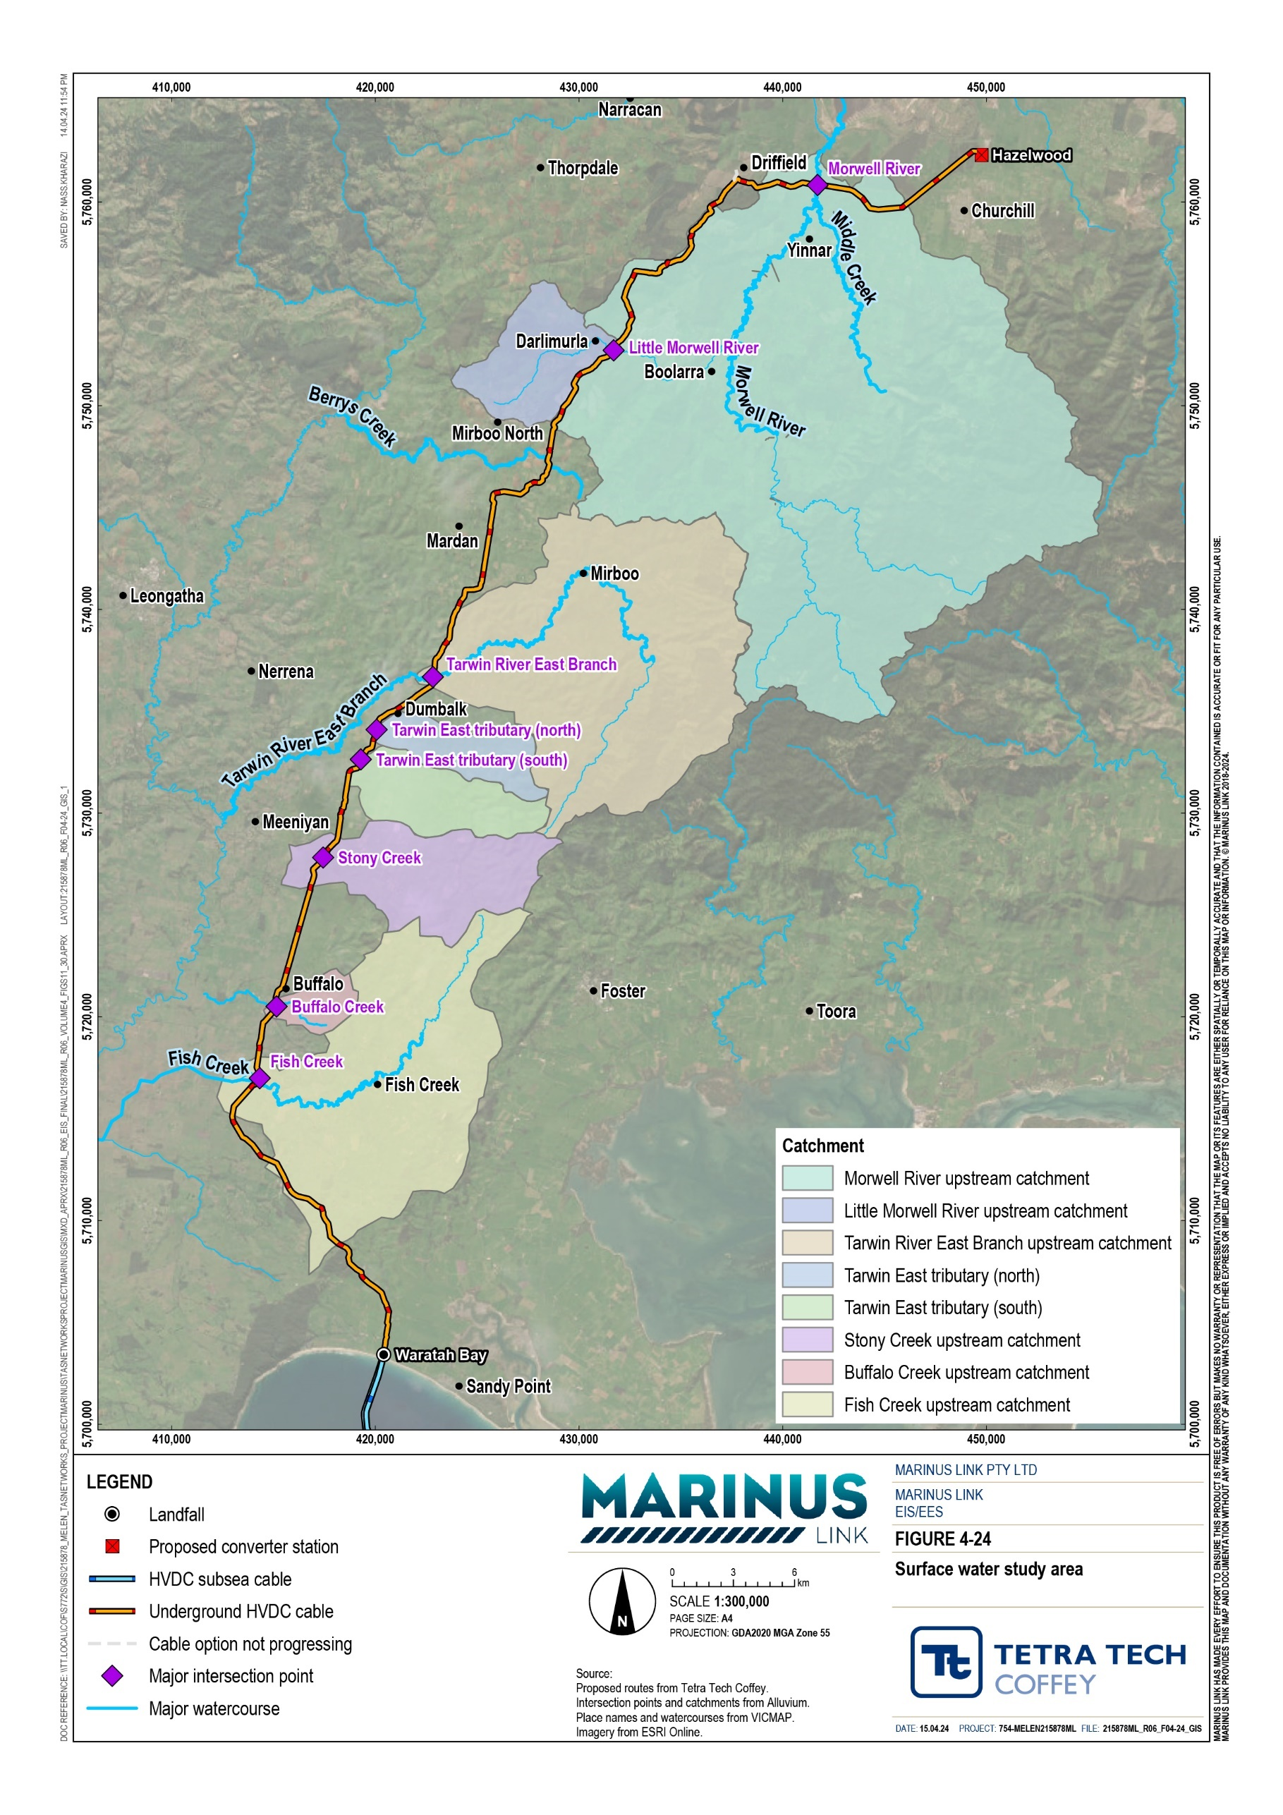

The key legislation, policies and guidelines that informed the assessment of surface water impacts is outlined in Table 5-1. Other legislation that informs the approvals required when a project interacts with various waterways in Victoria are described in Volume 1, Chapter 4 – Legislative framework.
Table 5-1 Key legislation relevant to surface water assessment

Title | Relevance to the assessment
Environment Protection Act 2017 (Vic) (EP Act) | This Act requires Victorians and businesses to minimise harm to the environment and human health from pollution or waste. It includes a GED, a duty to notify the EPA Victoria of prescribed notifiable contamination, and a duty to manage contamination. The ERS sets benchmarks to assess and report on environmental conditions, including surface water, using indicators and objectives to determine whether environmental values are being maintained or threatened.
Environment Reference Standard (Vic) | The ERS is made under Section 93 of the EP Act, and outlines the environmental values, indicators and objectives for ambient air, ambient sound, land and water environments that are sought to be achieved or maintained in Victoria and standards to support those values. It plays a key role in environmental protection and guides the standards and management of surface water in Victoria.
Water Act 1989 (Vic) | The Water Act establishes a framework for the management and regulation of water resources in Victoria including surface water. The Act legislated water entitlements issued and allocated in Victoria. Works undertaken by the project on waterways will require a permit under the Water Act.
West Gippsland Flood Guidelines for development in flood prone areas (WGCMA 2020) | These guidelines promote safe development in flood-prone areas by providing design responses and decision guidelines. They are based on the State-wide Guidelines for Development in Flood Affected Areas and verify responsible development that does not exacerbate surface water-related risks, making them relevant to this surface water assessment.
Victorian Waterway Management Strategy | The Victorian Waterway Management Strategy (VWMS) provides the policy for managing waterways in Victoria. It outlines an approach of identifying environmental, social, cultural, and economic values that are supported by waterways and its environmental condition.  Supporting this approach is the key objective of the strategy which is to maintain or improve the condition of the waterways to support these values.
South Gippsland Planning Scheme | The local planning scheme of the South Gippsland Shire Council establishes consistent planning controls for the environment in the South Gippsland region of Victoria. The proposed project alignment of the project lies within the “Declared Special Water Supply” of the Tarwin River catchment area. The South Gippsland Water (SGW) is considered the primary local water authority responsible for supplying and maintaining water services in most of the South Gippsland region, and across their surrounding catchment areas. Their role is to protect the quality and quantity of potable water available for human use in the declared catchment area. The planning scheme is administered by Council as the responsible authority, including through ensuring that planning permission is sought and  obtained for developments that could potentially impact the catchment and that SGW assesses applications for permission.

5.1.3 Assumptions and limitations
The key assumptions and limitations for the surface water assessment include:

The study assessed eight defined major waterway crossings. The remaining identified 74 waterways were not considered further in this assessment due to their lack of definition (i.e., small and ephemeral nature), smaller catchment scale, and classification as low or minor importance according to the HIERARCY attribute within the VicMap Hydro waterways network layer.
Water quality monitoring data is only available for five of the eight major waterway crossings assessed. The available data is incomplete, with one of the five having no data available for total phosphorus and nitrogen. Further water quality assessment will be required as part of the surface water monitoring plan and program outlined in the EPRs.
Major waterway crossings were identified and prioritised based on topographic definition, categorisation (within VicMap Lite), waterways network layer and HIERARCHY attribute (a type of spatial data category) within the VicMap Hydro waterways network layer.
The flood extents for major waterway crossings have been based on existing available information. Further hydrologic and/or hydraulic modelling has not been undertaken for the crossings. This was assumed to be sufficiently accurate for identifying potential impacts for the assessment.
The flood modelling has been based on available data including limited feature and topographic survey and incomplete spatial data provided, including onsite drainage pits and pipes. Where inconsistencies were encountered, nominal depths from LiDAR or gradients were calculated from surface profiles.

Existing conditions
This section describes the existing waterways, their conditions and determines the sensitivity of these values within the study area. This includes features such as flood behaviour, water quality and geomorphic conditions of the waterways in the project area and that could be impacted.

Waterways
Based on available LiDAR and aerial imagery, a total of 82 waterways were identified along the project alignment and are summarised in Table 5-2. Further detail is provided in Technical Appendix Q: Surface water.
Of the 82 waterways along the project alignment, eight defined major waterway crossings within a catchment area of more than 5 km² were considered for the surface water impact assessment, which are discussed in this chapter.

Regarding the proposed crossing methods, among the 82 waterways along the project alignment, 15 are initially proposed to be crossed with HDD, while the remaining 67 waterways will be crossed by open cut trench construction method. Open cut trench construction involves excavating a narrow, shallow, or deep trench in the ground for the installation, maintenance or inspection of conduits, cables, and other utilities. While the detailed impact assessment focused on eight major waterway crossings, the EPRs (Section 5.6) are to be adopted for all 82 waterway crossings identified and in the vicinity of any waterway that might be subject to potential impacts from the project.
This section provides an overview of the key features and attributes of the eight major waterways and the crossing locations of the project alignment (Refer to Figure 4-24 for the locations) and adjacent to the converter station within the study area.
Table 5-2 Waterway classification

Waterway classification | Description | Number of waterways
Defined major waterways | Waterways that:  Can be defined on aerial imagery and/or LiDAR  Are included in VicMap Lite 1:250,000 to 1:5,000,000 waterways network layer  Have a catchment area greater than 5 km²  These waterways have been investigated in detail and are discussed further in the chapter. | 8
Defined waterway | Waterways that:  Can be defined on aerial imagery and/or LiDAR  Are included in VicMap Lite 1:250,000 to 1:5,000,000 waterways network layer  Have a catchment area less than 5 km²  Have a HIERACHY classification of low or minor importance | 2
Small defined waterway | Waterways that:  Can be defined on aerial imagery and/or LiDAR  Are not included in VicMap Lite 1:250,000 to 1:5,000,000 waterways network layer  Have a HIERACHY classification of low or minor importance | 28
Undefined waterway | The waterway:  Cannot be defined on aerial imagery and/or LiDAR  Have a HIERACHY classification of low or minor importance | 44
Total |  | 82

Morwell River
The Morwell River flows for approximately 83 km, joining the Latrobe River near Yallourn. The proposed project alignment crosses the river 2.2 km downstream of Yinnar-Driffield Road. The total catchment is
674 km². The Morwell River has been impacted by historical land use and management activities. The upper catchment is forested however agricultural activities and mining have influenced the lower reaches.
Downstream, there are power generation facilities near Hazelwood and Yallourn, and the river has undergone multiple diversions due to mining activities.
The geology in the Morwell River catchment varies. The headwaters of the east and west branches are mainly composed of Wonthaggi formation sandstone. Moving towards the project alignment crossing, the geology consists of a combination of Latrobe Valley group sedimentary rock, Thorpdale basalt, and deposits of sand, gravel, and silt found in alluvial terraces, alluvium, and the Haunted Hills formation.
The intersection of this major waterway crossing has pasture and grasslands, mainly for dairy or meat cattle. It is an unconfined river with high curving/bending channel pattern (meandering and sinuosity). The channel is around 18-m-wide and 4-m-deep, with a floodplain width ranging from 300 to 600 m. The levee banks have an average height of around 1 m and are well-developed. As a result of the floodplain width, there is potential for an abandonment of stream alignment in favour of an alternate channel (avulsion) if a new flow pathway forms on the floodplain.

Little Morwell River
The Little Morwell River is a 21 km long waterway that flows northeast and meets the Morwell River downstream of Boolarra. It is small and largely a spring fed stream that transitions from dissected plains to lower relief areas and the broader floodplain. The geology consists of Latrobe Valley Group sedimentary rock and Thorpdale volcanic basalt. The catchment is around 87 km² and comprised of predominantly kandosols and ferrosols. Primary land use along the Little Morwell River includes residential areas, farm infrastructure and services near Mirboo North.
At the intersection with the proposed project alignment, the Little Morwell River is partially confined, meandering, and is approximately 6 m wide and 0.6 m deep. The surrounding floodplain is about 20 to 30 m wide. The stream channel has a sandy bed with basalt outcrops, potentially preventing the waterway from deepening and widening (incision). The stream alignment in this area has experienced minimal changes and there is increased vegetation cover.

Tarwin River East Branch
The Tarwin River East Branch is a 66 km river with a 269 km² catchment area. It originates in the Strzelecki ranges and flows northeast, northwest, and southwest towards the Tarwin River. It passes through areas of high relief sedimentary rock before entering lower relief riverine plains downstream of Mirboo. The geology consists mainly of sandstone, basalt and alluvium. The upper catchment includes plantation forests; grazing pastures; and pockets of residential, cropping and nature conservation areas.

At the intersection with the project alignment, the land cover surrounding the waterway is pasture and grasslands. The river has a partially confined, meandering channel that is approximately 15-m-wide and 3-m- deep. The floodplain varies in width between 500 and 600 m. The riverbed grade in the area is relatively stable. The channel alignment has shown little change over the past 10 years, with no significant bank erosion or bed scour observed. There are tributaries, drainage channels and unrestricted stock access, which may lead to bank slumping, trampling and erosion in certain areas.
The proposed development area is within the ‘Declared Special Water Supply Catchment Area – Tarwin River’. The purpose of the catchment is to protect the quality and quantity of potable water available for human use in the declared catchment area. SGW are the primary agency responsible for the protection and management of the Tarwin River catchment. Planning permit applications for developments that increase the potential for impacts on the catchment are referred by Council to SGW for assessment (see Section 5.1.2).

Tributaries of Tarwin River East Branch (north and south)
The Tarwin River East Branch has north and south tributaries from the Strzelecki Ranges that join upstream of Dumbalk. The northern tributary is 12.3 km long with a 24 km² catchment, and the southern tributary is
14.1 km long with a 36 km² catchment. The geology of the catchment area is dominated sandstone, basalt and alluvium. Land use is mainly grazing modified pastures with some residential, cropping and nature conservation areas. The project alignment intersects the waterway amongst pasture and grasslands. The tributaries have unconfined and meandering flows, and broad floodplains. The bed grade is stable with no evidence of steepening or incision.

Stony Creek
Stony Creek is a small waterway in Gippsland with a length of 29 km and a catchment area of 72 km². The creek flows from Foster North to the Tarwin River near Meeniyan. The geology of the catchment area is dominated by Wonthaggi formation sandstone and alluvial deposits. Land use along Stony Creek comprises grazing modified pastures, residential and farm infrastructure, and some cropping. The project alignment intersects a partially confined waterway with a 15-m-wide and 4-m-deep channel and a 500-m-wide floodplain. The bed grade is stable, with no major instabilities or incision. Site inspections show well- vegetated banks and the presence of large wood debris from recent storms.

Buffalo Creek
The project alignment crosses Buffalo Creek, flowing through hills and riverine plains to the Tarwin River floodplain. The geology consists of sandstone, sand, gravel, silt, and alluvial terrace deposits. Land use includes grazing modified pastures, residential and farm infrastructure, and nature conservation. The upstream soils are acidic are characterised by poor infiltration and erosion susceptibility. The crossing features a 17-m-wide and 4-m-deep channel with nearby levee banks and small farm dams. To protect the creek, a riparian buffer fenced from stock access has been established.
The creek's alignment has remained stable for 11 years without major instabilities or incision. The banks are well-vegetated, and site inspections show stable banks with no significant erosion. Retaining existing vegetation lowers the likelihood of incision or sustained bank erosion.

Fish Creek
Fish Creek is a 44 km long creek that starts in Tarra Bulga National Park and flows southwest through Fish Creek town before joining the Tarwin River. The geology of the upper catchment consists of sandstone and Haunted Hills formation, while at the intersection with the project alignment it features alluvium and alluvial terrace deposits. The soil in this area is dispersive white clays covered by a thin layer of topsoil, known for their high erosive potential. The catchment is primarily used for grazing modified pastures, with some residential and farm infrastructure, and mining operations.
The channel is approximately 15-m-wide and 2-m-deep, with the southern channel being deeper and serving as the main flow pathway. No major instabilities or incision are observed near the project alignment, and the banks are relatively stable, protected by a narrow buffer of native vegetation, fenced from stock access.

Bennetts Creek and Eel Hole Creek
Bennetts Creek is located to the east of the Hazelwood converter station site and Tramway Road. It flows north and splits into two flows upstream of the converter station site and Boldings Road, as shown in Figure 4-25. One flow path travels north adjacent to Tramway Road and continues as Bennetts Creek. The other flow path travels to the west through a series of irrigation channels and across Churchill-Traralgon Road where it becomes Eel Hole Creek that ultimately flows to the former Hazelwood mine cooling pond. These waterways are not crossed by the project alignment.

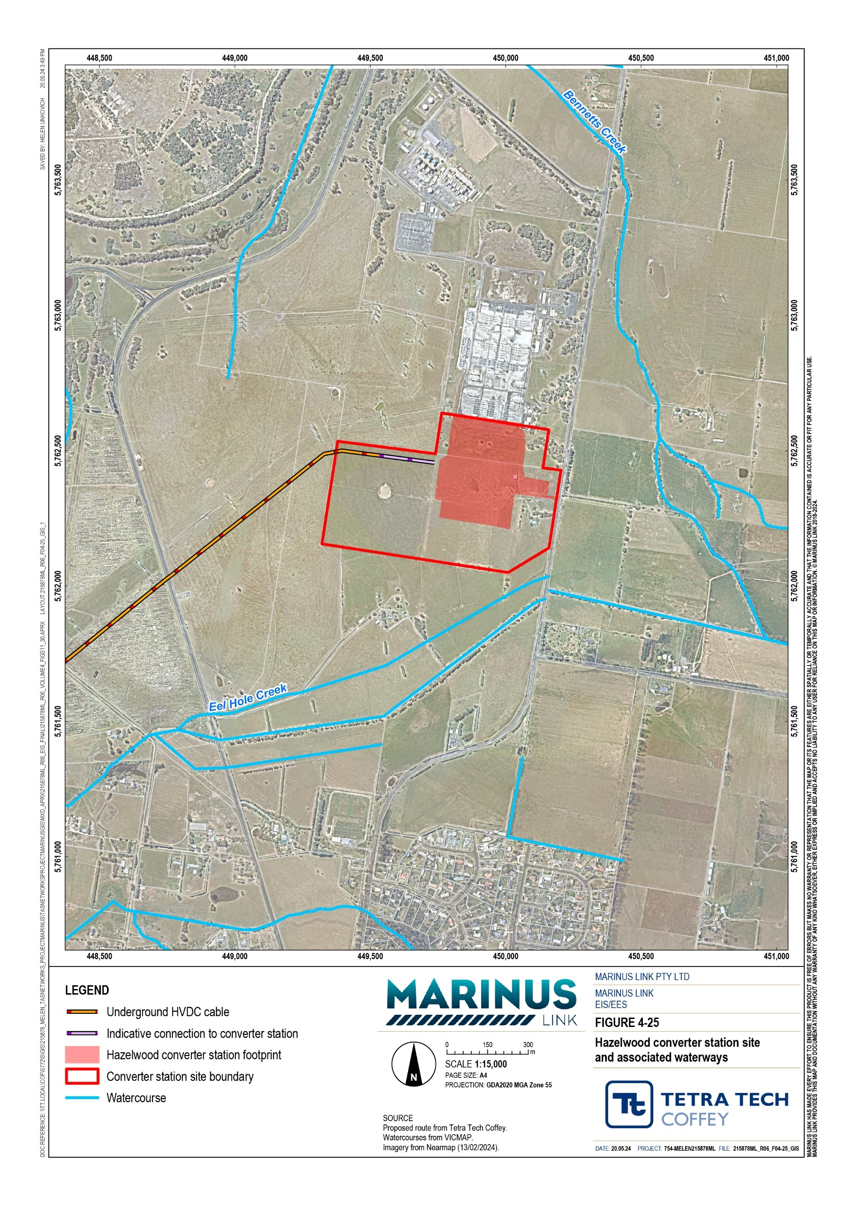

Flooding
Baseline flood extents were analysed using 1% AEP (which represents a one in a hundred chance of being exceeded in any year) for each major waterway crossing to assess existing flood conditions within the project area.
Floodplain areas with wide flood extents occur at the crossing locations of the Little Morwell River, Tarwin River East Branch and their tributaries, with flood extents reaching up to 850 m under 1% AEP. In the absence of a mapped 1% AEP flood extent for Buffalo Creek, an estimated flood extent of 418,902 m² was determined by interpreting the valley topography, slope and vegetation trends over multiple aerial images.
Downstream of Fish Creek, the 1% AEP flood extent widens significantly, accompanied by observed soil erosion during the 2022 flood event. Existing flood prone areas were identified at the Hazelwood converter station site, particularly in Eel Hole Creek along Monash Way. In addition, high flood risks are also associated with retaining dams and the natural drainage system on site. The Waratah Bay transition station experiences overland flows under 1% AEP flood events, with a maximum flood depth of 0.6 m. The site is situated outside the primary floodplain under 0.5% AEP flood (one-in-200-year flood) events.
The flood modelling results that informs the flood behaviour and extent of waterways within the study area are provided in Technical Appendix Q: Surface water. Impacts from project construction and operation activities predicted by the flood modelling are discussed further in Section 5.3.1.

Water quality
Water quality may be influenced by several factors including climate, landform, soil type, land use, vegetation and location within the stream system. Water quality plays a crucial role in safeguarding human health, supporting ecosystem vitality and ensuring the long-term sustainability of the environment.
To determine the existing water quality conditions in the study area, available monitoring data from surface water gauges as well as additional data provided by WaterWatch were assessed against the water quality objectives provided by the ERS (2021).
Waterways in Victoria are categorised into ‘segments’ based on their geographical areas, commonality in environmental condition and natural characteristics. The segments have existing environmental values whereby surface water supports ecosystems either directly or indirectly. Each segment has a particular level of protection to reflect the environmental values of surface water.
The ERS (2021) water quality objectives form the primary guide to determine existing water quality impacts and risk to surface water. These objectives are classified based on the waterway segments and their associated level of protection on environmental values, for example, if water quality conditions exceed these water quality objectives, it could be expected to lead to detrimental effects to relevant environmental values.

Water quality data were compared against the ERS (2021) water quality objective values. The water quality objectives used were based on the following segments relevant to the study area:
Central Foothills and Coastal Plains which covers the Morwell River, Little Morwell River, Stony Creek and Fish Creek, and are classified to have ‘slightly to moderately modified’ level of protection on environmental values.
Uplands A segment, which covers the Tarwin River East Branch and is considered to have a ‘largely modified’ level of protection on environmental values.
There is a relatively long but intermittent record of surface water quality data in the study area. This is due to the monitoring sites being inactive or only have a few measurements within the study area (1994 to 2022). For instance, there is no data for Buffalo Creek, the two tributaries of the Tarwin River East Branch, and no measurements for any dissolved oxygen for five of the eight major waterway crossings. There is also no water quality data for Bennetts Creek and Eel Hole Creek. The major waterway crossings with available monitoring data within the upstream and downstream areas of proposed construction areas of the project alignment include:
Morwell River

Little Morwell River

Stony Creek

Fish Creek

Tarwin River East Branch

The ERS water quality objectives are outlined in Table 5-3 and were compared against the available water quality data in
Table 5-4. The general parameters analysed include pH, electrical conductivity (EC), turbidity, total phosphorus and total nitrogen.

Table 5-3 ERS water quality objectives

Indicator | Parameter | Tarwin River East Branch | Morwell River, Little Morwell River, Stony Creek, Fish Creek
Segment | - | Uplands A | Central Foothills and Coastal Plains
Total phosphorus (µg/L) | 75th percentile | ≤35 | ≤55
Total nitrogen (µg/L) | 75th percentile | ≤900 | ≤1,100

Dissolved oxygen (% saturation)
25th percentile ≥80 ≥75
Maximum 130 130
Turbidity (NTU) 75th percentile ≤15 ≤25

Electrical conductivity (µS/cm at 25°C)
75th percentile ≤100 ≤250

pH (pH units) | 25th percentile | ≥6.4 | ≥6.7
 | 75th percentile | ≤7.6 | ≤7.7

Table 5-4 Summary of available water quality data

Indicator | Parameter | Morwell River |  | Little Morwell River | Tarwin River East Branch | Stony Creek |  | Fish Creek
Measurement site / source |  | Gauge (226407) | Water- watch (MOR040) | Water- watch (LMR050) | Water- watch (TWN001) | Gauge (227275) | Water- watch (STN002) | Water- watch (FSC002)
No. of visits/readings (dates of readings) |  | (1999-  2002) | 163  (2008-  2022) | 1  (2005) | 216  (1995-  2009) | 12-14  (2021-  2022) | 119  (1995-  2002) | 41  (1994-  1995)
Total P (µg/L) | 75th percentile | No data | No data | No data | No data | 340 | 0.2 | No data
Total N (µg/L) | 75th percentile | No data | No data | No data | No data | 2500 | No data | No data
Turbidity (NTU) | 75th percentile | 47.5 | 24 | 33* | No data | 41.4 | 25 | 41
EC  (µS/cm @25°C) | 75th percentile | No data | 320 | 270* | 580 | 679.5 | 777.5 | 492#
pH  (pH units) | 25th percentile | No data | 6.6 | 6.5* | 7.3 | 6.5 | 7.1 | 7.6#
 | 75th percentile | No data | 7.1 |  | 7.7 | 7.1 | 7.4
Note:
*Only one reading available in 2005 #Only one reading available in 2002 Data for dissolved oxygen not available
Red shading indicates result does not meet the ERS objectives in Table 5-3.

The key findings from the assessment of the available water quality data are:

Across all selected waterways, pH was circumneutral to slightly alkaline, ranging from 6.6 to 7.7, except for Stony Creek (pH 6.5) which does not meet the ERS (25th percentile) for pH (≥6.7).
EC ranged from 270 microsiemens per centimetre (µS/cm) to 777.5 µS/cm, which does not meet the ERS 75th percentile for EC (≤100 to 250 µS/cm). The exception was Fish Creek (1994 to 1995) which had one record of EC value of 492 µS/cm, which met the ERS 75th – percentile for EC. No EC data was recorded at the gauge in the Morwell River (1999 to 2002).
No pH and EC data were recorded at the gauge in the Morwell River, and no turbidity data in Tarwin River East Branch was available from WaterWatch.
Turbidity levels ranged from 25 micrograms per litre (µg/L) to 47.5 µg/L, which (exceeded the ERS 75th percentile for turbidity (≤15 to 25 µg/L). These results may be attributed to sediment emerging from the surroundings or disturbance of bottom sediments during the time data was collected.
Stony Creek recorded a total nitrogen concentration of 2,500 µg/L, exceeding the ERS 75th percentile for nitrogen (≤1,100 µg/L). This elevated concentration aligns with the elevated turbidity recorded at Stony Creek (41.4 µg/L), which is consistent with the land use present in this creek (Section 5.2.1). Rainfall prior to or during sampling could also contribute to the water quality results.
Trends in water quality data cannot be readily assessed given the limited data available so only qualitative assessments can be undertaken. The water quality data indicates that the waterways are influenced by runoff from the surrounding agricultural land use.

Contamination
Disturbance of land is a potential source of contamination to waterways and subsequent reduction in water quality. Existing potential contamination sources in the study area include:
agricultural, forestry and development activities

industrial activities associated with Hazelwood mine site and power station

former railway line

ASS

landfill

PFAS

petrol station.

Surface water contamination generally occurs when harmful materials and substances discharge into waterways, often leading to decreased water quality, which could be a potential risk to the environment and human health. Sources of potential contamination and ASS are discussed in Volume 4, Chapter 3 – Contaminated land and acid sulfate soils.

Geomorphology
Fluvial geomorphology (or physical form) describes the size, shape and diversity of the river channel and the processes by which these elements form and change through time. Fluvial geomorphology shapes river channels, sediment dynamics, floodplain development, bank erosion, riparian vegetation and instream features to create a variety of habitats. The variety of habitat types create distinct ecological niches, contributing to the ecological health and functioning of a fluvial system.

Waterways
To assess the physical form of the eight major waterway crossings, the study assigned a rating of very poor, poor, moderate, good or excellent through assessing the following factors:
channel description (cross section, sinuosity, confinement)

bed and bank stability (evidence of lateral or vertical erosion and/or deposition of floodplain

riparian and bank vegetation (overstorey, midstory and understorey vegetation cover)

in-channel habitat features (pools, riffles, benches, bars and large wood)

floodplain features (floodplain habitat features, wetlands, other drainage and flow pathways)

associated processes and bank stability (vertical and lateral bank stability).

A site visit was undertaken to confirm the results of the desktop assessment and review key geomorphic features, the findings are summarised below:

Morwell River
The lack of riparian vegetation and unrestricted stock access to the river increases the likelihood of bank erosion. Although largely stable, this reach of the Morwell River is considered to have moderate physical form.

Little Morwell River
The riparian zone in the reach in the vicinity of the proposed crossing has a narrow buffer of moderately dense vegetation. Aerial imagery indicates no evidence of bank erosion. The reach of the Little Morwell River is considered to have moderate physical form.

Tarwin River East Branch
Although riparian vegetation was sparse, there was no evidence of bank erosion, with established ground cover to the toe of the banks. On the right bank (looking downstream) vegetation was more established with some remnant trees and shrubs, while on the left bank, vegetation comprised of only phragmites and other ground cover species. The river is considered to have moderate physical form.

Tributaries of Tarwin River East Branch
As with the East Tarwin, its tributaries are considered to have moderate physical form.

Stony Creek
Stony Creek is well-vegetated with trees, shrubs, and ground cover. The stream was fenced at top of bank with little riparian buffer, but no apparent stock access. There are no signs of active floodplain scour or obvious breakout points, with dense vegetation cover, and it is unlikely that a large-scale change in the waterway will occur. Stony Creek is considered to have good physical form in the subject reach.

Buffalo Creek
There is a low likelihood of waterway incision or sustained bank erosion being triggered in this reach without major changes to the flow regime. Vegetation cover along banks is good, with narrow riparian vegetation, large wood and pools present. There was no evidence of major erosion. This reach of the Buffalo Creek is considered to have good physical form.

Fish Creek
The reach has a combination of a low confined bend (meandering) and unconfined straight formations. There is also evidence of major evidence of channel widening and deepening with ongoing bed and bank erosion. Narrow and irregular occurrences of vegetation cover is present. Overall, this reach is considered prone to phases of geomorphic changes, typically due to some existing land disturbance, resulting to a poor physical form.
Examples of the existing geomorphic condition for each waterway are shown in Plate 5-1 to Plate 5-4, with the exception of the Little Morwell River, Fish Creek and the tributaries of Tarwin River East Branch as these sites were not accessible due to lack of access during the site visit.
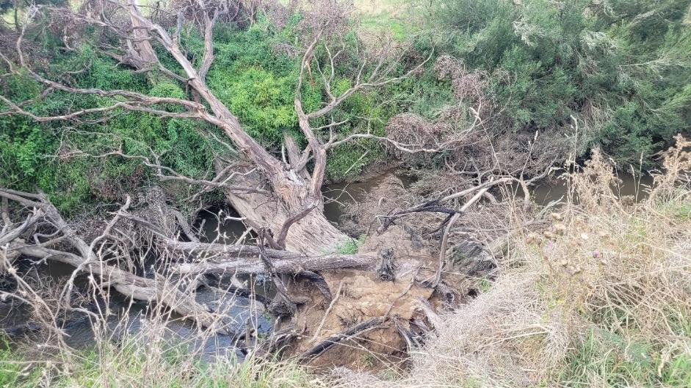
Plate 5-1 Geomorphic condition observed at the Morwell River

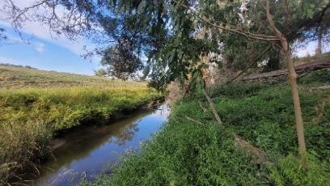
Plate 5-2 Geomorphic condition observed at the Tarwin River East Branch
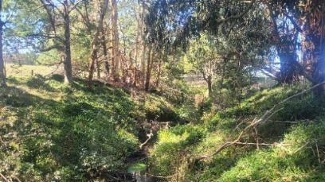
Plate 5-3 Geomorphic condition observed at Stony Creek
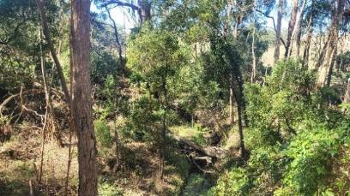
Plate 5-4 Geomorphic conditions observed at Buffalo Creek

Converter and transition station sites
The existing flooding conditions and overland flows of the converter and transition station sites has been assessed by developing a model of flood levels and shear stress of overland flows to compare the existing and operational conditions. The change of flood levels in development is referred to as afflux.
Erosion occurs when the force of moving water is stronger than the resistance of the ground and materials along the waterway. It is commonly recognised as an environmental concern resulting from land or soil disturbance, which can have adverse impacts on surface water regime and quality. In general, disturbance in the mobilisation of sediments can often result in waterway instability and erosion; and is typically assessed and represented through shear stress assessments, and modelling.
Shear stress modelling for the study area was conducted around the proposed Hazelwood converter station and the transition station at Waratah Bay. The modelling results were evaluated in relation to the shear stress threshold values based on several parameters outlined in Fischenich, 2001 (cited by Technical Appendix Q: Surface water). This analysis aimed to identify and predict potential erosion sites and waterway instability at these two sites (Table 5-5). Coarse sediments are easily mobilised at lower shear stress, which typically indicates minor erosion while cohesive soils, vegetation and other armour materials require higher shear stress values to be entrained, suggesting a potential erosion hazard.
The summary of shear stress modelling results for the converter and transition stations is provided in below.

Table 5-5 Shear stress threshold values

Parameter | Shear stress (N/m²)
Sand | 1.44
Gravel | 3.59
Grass | 4.55
Clay | 12.45
Cobble | 32.08
Wattle | 47.88
Long native grasses | 81.40
Gravels (D50 = 150 mm) | 95.76
Structurally diverse hardwood and understory planting | 150.00
Rock (D50 = 300 mm) | 244.19
Concrete | 598.50
Source: Fischenich (2001)

At the Waratah Bay transition station, existing shear stress conditions ranged between 10 to 20 N/m², suggesting a slow-moving flow on the surface. The predominant land use in the area is grazing or grasslands, which indicates that minor erosion may occur due to the presence of suitable ground cover. However, erosion from the area can be widespread due to the extent of flows in the waterways. Along a defined channel located west of the transition station, shear stress values are typically 80 to 100 N/m², however there were peaks over 200 N/m². This can be attributed to the native long grasses and wattles that are known to occur, which may contribute to increased sediment mobilisation and higher potential for erosion.
In Hazelwood, the intersection of Bennetts Creek and Eel Hole Creek showed higher shear stress values ranging from 40 to 100 N/m², indicating potential erosion hazard on site. These results are consistent with the existing land use of the area, which predominantly consists of concrete surface and other electrical infrastructure. Conversely, the grassland and grazing areas surrounding the site, have a lower shear stress value 4.55 N/m², corresponding to low sediment mobilisation and erosion on site.
The shear stress modelling results that inform the erosion extent of waterways within the study area are provided in Technical Appendix Q: Surface water.

Summary of values
Based on the assessment of existing surface water conditions, the environmental values associated with surface water are:
Flood storage and transport of floodwaters downstream (also known as flood conveyance behaviour) and associated functions (flooding).
Surface water quality that supports ecology and human uses.

Waterway stability and associated functions (geomorphology and erosion).

Sections 5.3, 5.4 and 5.5 present the assessment of the potential impacts and risks on surface water resulting from the project’s construction, operational and decommissioning activities.

Construction impacts
Most surface water risks and impacts are associated with construction activities of the project. Of the 82 waterways along the project alignment, HDD is initially proposed to be used to cross 15 waterways including seven of the eight major waterway crossings. Little Morwell River is the only major waterway that will not be crossed with HDD, with trenching proposed.
The assessment has considered the risks and impacts to surface water due to the project including flooding, water quality and the physical form of the waterway (geomorphology). It has also considered the risks to the project from existing waterway conditions and processes including flooding, erosion and natural waterway movement.

The impacts assessment discussed in this section considered three key aspects in relation to surface water:

Flooding: the potential for the project to affect flood water movement and flood levels.

Water quality: the potential for contaminated runoff or sediment to be transported into surface water.

Geomorphology (the study of landforms and their origin): the potential for the project to impact the stability of waterway beds and banks through erosion.

Flooding
Floodplains provide temporary storage of flood waters and allow the passage of waters to downstream areas. The amount of storage and ability for water to move through floodplains will influence the level and extent of a flood.
The construction activities that have the potential to increase flooding within the project area, include:

Construction of project infrastructure including temporary excavation, trenching, filling, stockpiling, presence of heavy vehicles and machinery constricting or altering surface flow pathways altering flood levels and flows.
Construction works including trenching within the floodplain, diverting flows to land not previously subject to flooding or increasing flows to waterways.
Reducing the storage area of floodplains due to project infrastructure.

Temporary activities such as stockpiling soil and materials, establishing laydown areas and constructing access roads can modify topography, take up floodplain storage area and alter flow pathways. This can alter existing flow paths, change floodplain function and extent, and potentially increase the risk of flooding.

Waterway crossings
Construction areas will be established adjacent to waterway crossings to support trenching and the HDD rigs for the major waterway crossings. These HDD drill pads and trenches associated with construction will avoid riparian vegetation along the edge of the waterways, but they may be located in floodplain areas adjacent to the waterway.
Impacts on flooding during construction of waterway crossings by HDD were assessed by considering proposed construction areas and the AoD that would be within the 1% AEP flood extent. The area of flood extent impacted, and the proposed construction activities are summarised in Table 5-6.
The flood extents for the eight major waterway crossing are shown in Figure 4-26, Figure 4-27 and Figure 4- 28.

Table 5-6 Construction areas and their associated AoD within 1% AEP flood extent

Waterway | Total area of disturbance within flood extent (m²) | Description of proposed construction area within the flood extent
Morwell River | 4,790 | Upgrading existing track and constructing temporary new track (i.e., McFarlane Road and Morwell River flood runner TCM AoD).
Little Morwell River* | 10,624 | TCM AoD steep slope and road crossing above the Little Morwell River and Grand Ridge Rail Trail Pleasant Valley Road.  Open trench construction.
Tarwin River East Branch | 8,461 | Upgrade of existing and new permanent/temporary track (i.e., Meeniyan- Mirboo North access track and Tarwin River Each Branch TCM AoD).
Northern and Southern tributaries of Tarwin River East Branch | Total: 68,613  North: 38,887  South: 29,726 | Upgrade of existing and new permanent/temporary track (i.e., Meeniyan- Mirboo North access track Meeniyan – Mirboo North Road, unnamed waterway and farm infrastructure, and shelter belt and farm infrastructure TCM AODs  Joint pits  Areas of open cut trench construction.
Tarwin River East Branch | 8,461 | Upgrade of existing and new permanent/temporary track (i.e., Meeniyan- Mirboo North access track and Tarwin River Each Branch TCM AoD).  Areas of open cut trench construction.  Join pits (i.e., joint pit around 20 m away from 1% AEP flood extent).
Stony Creek | 33,904 | Mix of existing track upgrade and new permanent/temporary tracks (i.e., Buffalo-Stony Creek road, O’Connor road access track and Great Southern Rail Trail).  Joint pits within 50 m of flood extent. Areas of open cut trench construction.
Buffalo Creek* | 2,5023 | Access track and TCM AoD within floodplain vicinity. Two drill pads for Buffalo Creek TCM.  Joint pit.  Areas of open cut trench construction within flood extent.
Fish Creek | 4,649 | New temporary track (e.g., Harding Lawson Rd access track and Fish Creek TCM AoD).  Small area of open cut trench construction within flood extent
*Note: The flood extents for Little Morwell River and Buffalo Creek are determined based on valley topography, slope, and vegetation types from multiple aerial images, due to no mapped 1% AEP flood extents provided by WGCMA.

Based on the results of the flood modelling, the pre-mitigated flooding impacts due to project construction activities were considered to have a moderate to high unmitigated risk rating.
Of the 82 waterways along the project alignment, HDD is proposed to be used to cross 15 waterways including seven of the eight of the major waterway crossings. Little Morwell River is the only major waterway that would not be crossed with HDD. The Little Morwell River is proposed to be trenched due to the limited space available for HDD drill pads and limited length for the bore under the river.
All permanent and temporary works will be constructed with consideration of mitigating potential impacts on flooding. Specific mitigation measures will be identified and documented in the erosion and surface water

management plan (EPR SW01). Modelling will be undertaken of the final design to assess the overall flood levels and risk profile to minimise potential flooding impacts to surrounding land and properties (EPR SW02 and SW03). A waterway monitoring program will also be undertaken to establish a baseline and monitor for potential impacts during construction (EPR SW04). The residual risk ratings due to construction in floodplain areas is low for all major waterways crossings with implementation of mitigation measures to achieve the EPRs.

Converter and transition station
Changes in flood levels at the Hazelwood converter station and Waratah Bay transition station were also predicted using flood modelling (Figure 4-29 and Figure 4-30). Minor increases in flood levels were observed west of the project alignment at Hazelwood. Results indicate a 0.02 to 0.05 m increase in flood levels west of the proposed Hazelwood converter station and downstream of Monash Way under the 1% AEP scenario.
The Waratah Bay transition station, if a transition station is required, will be located outside the floodplain however, given the significant flooding predicted in the model for the coastal area, the site would be impacted by overland flow. The site is predicted to experience a minimal increase in flood levels, with only a slight increase of up to 0.1 m during the 0.5% annual exceedance probability (AEP) event.
EPR SW02 will require permanent infrastructure to minimise flood risks. With the implementation of measures to comply with EPRs, the residual risk of flooding impacts from the converter station and transition station was assessed as low. Residual risk ratings are discussed further in Section 5.7.
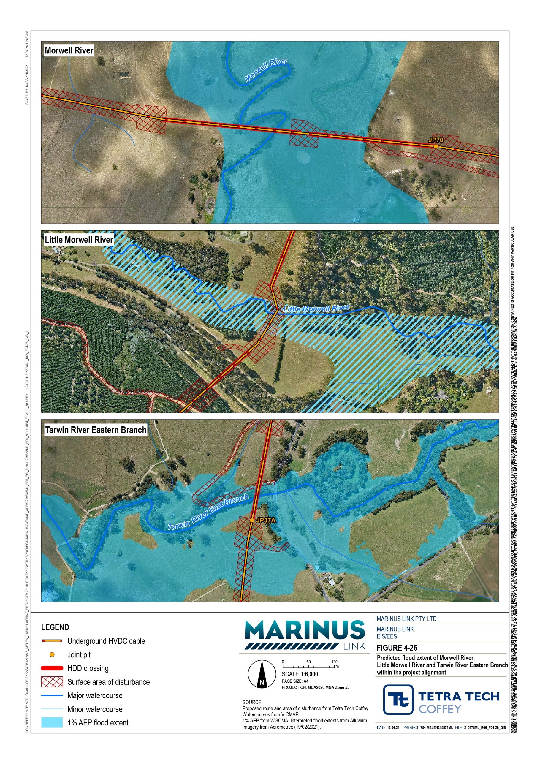

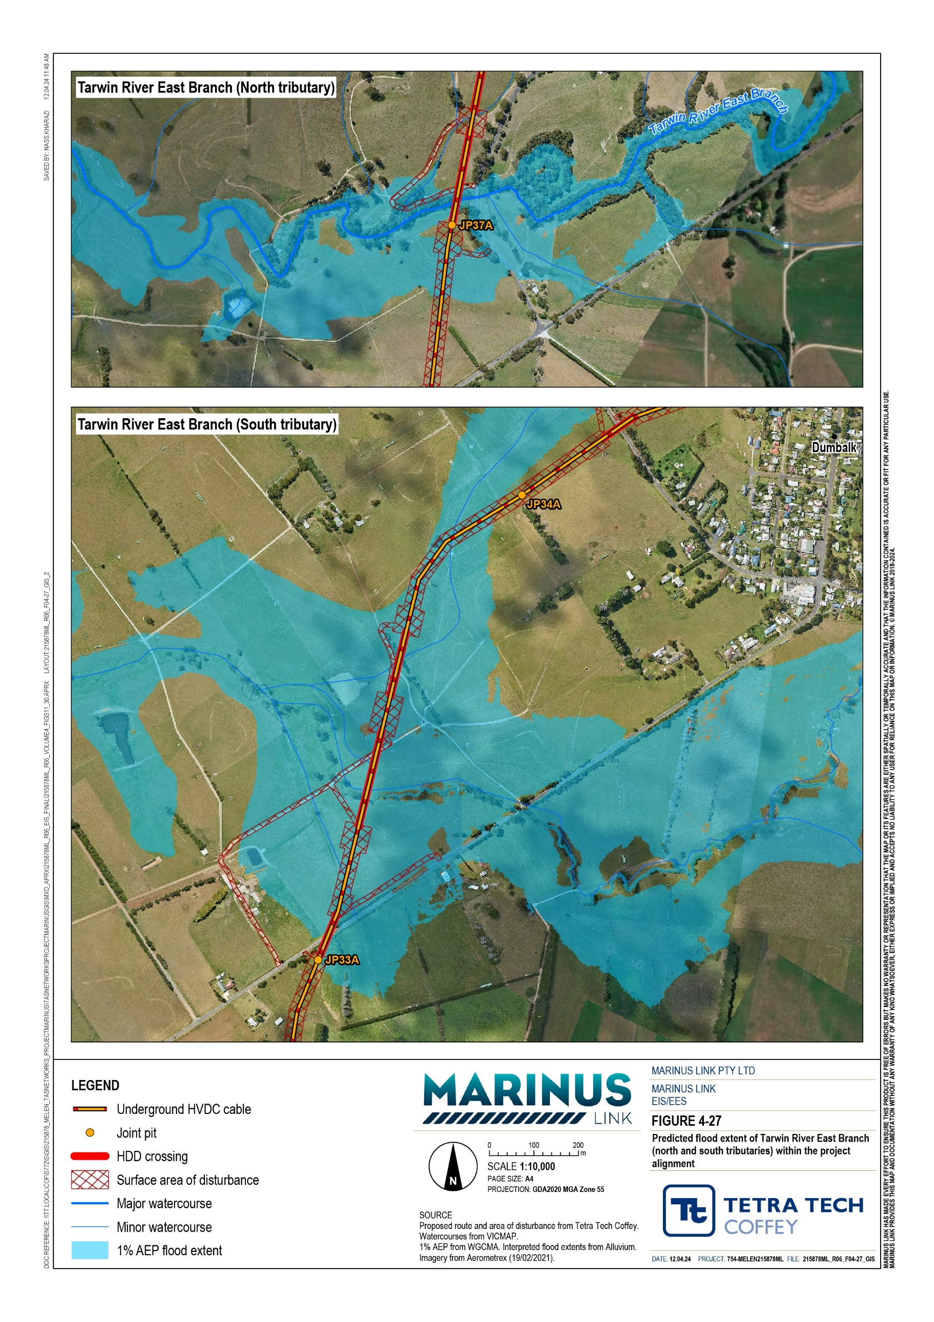

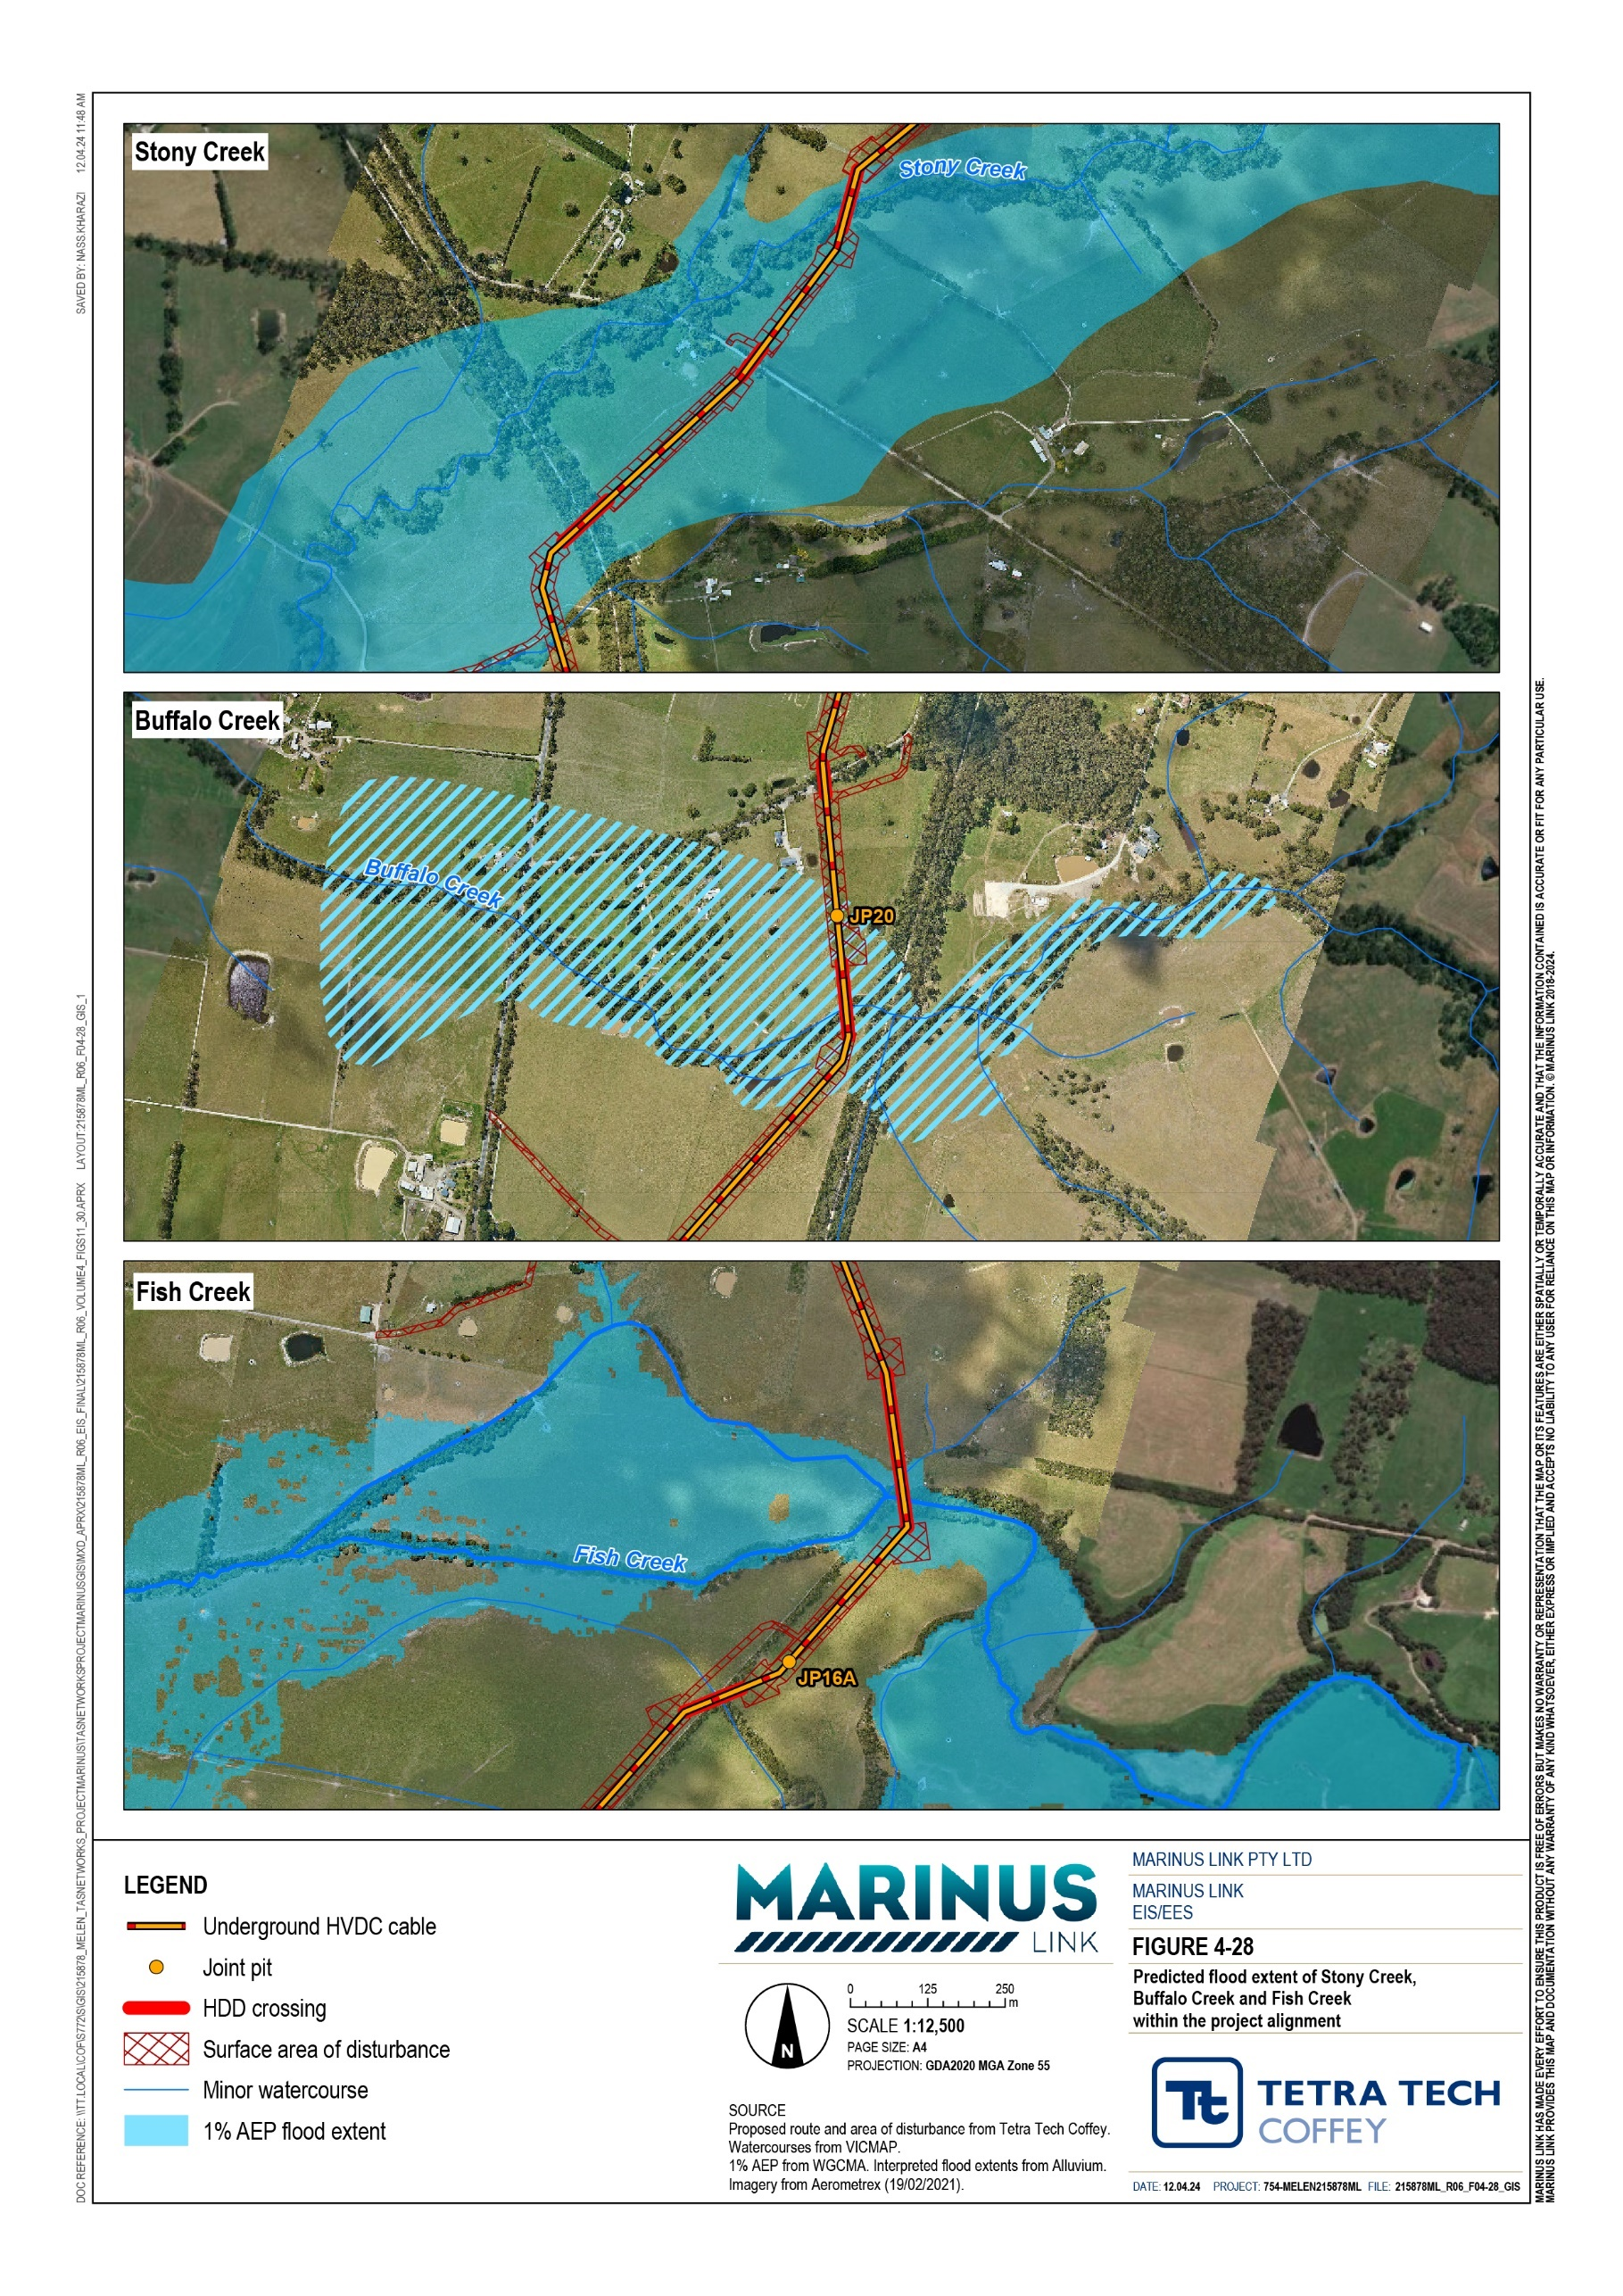

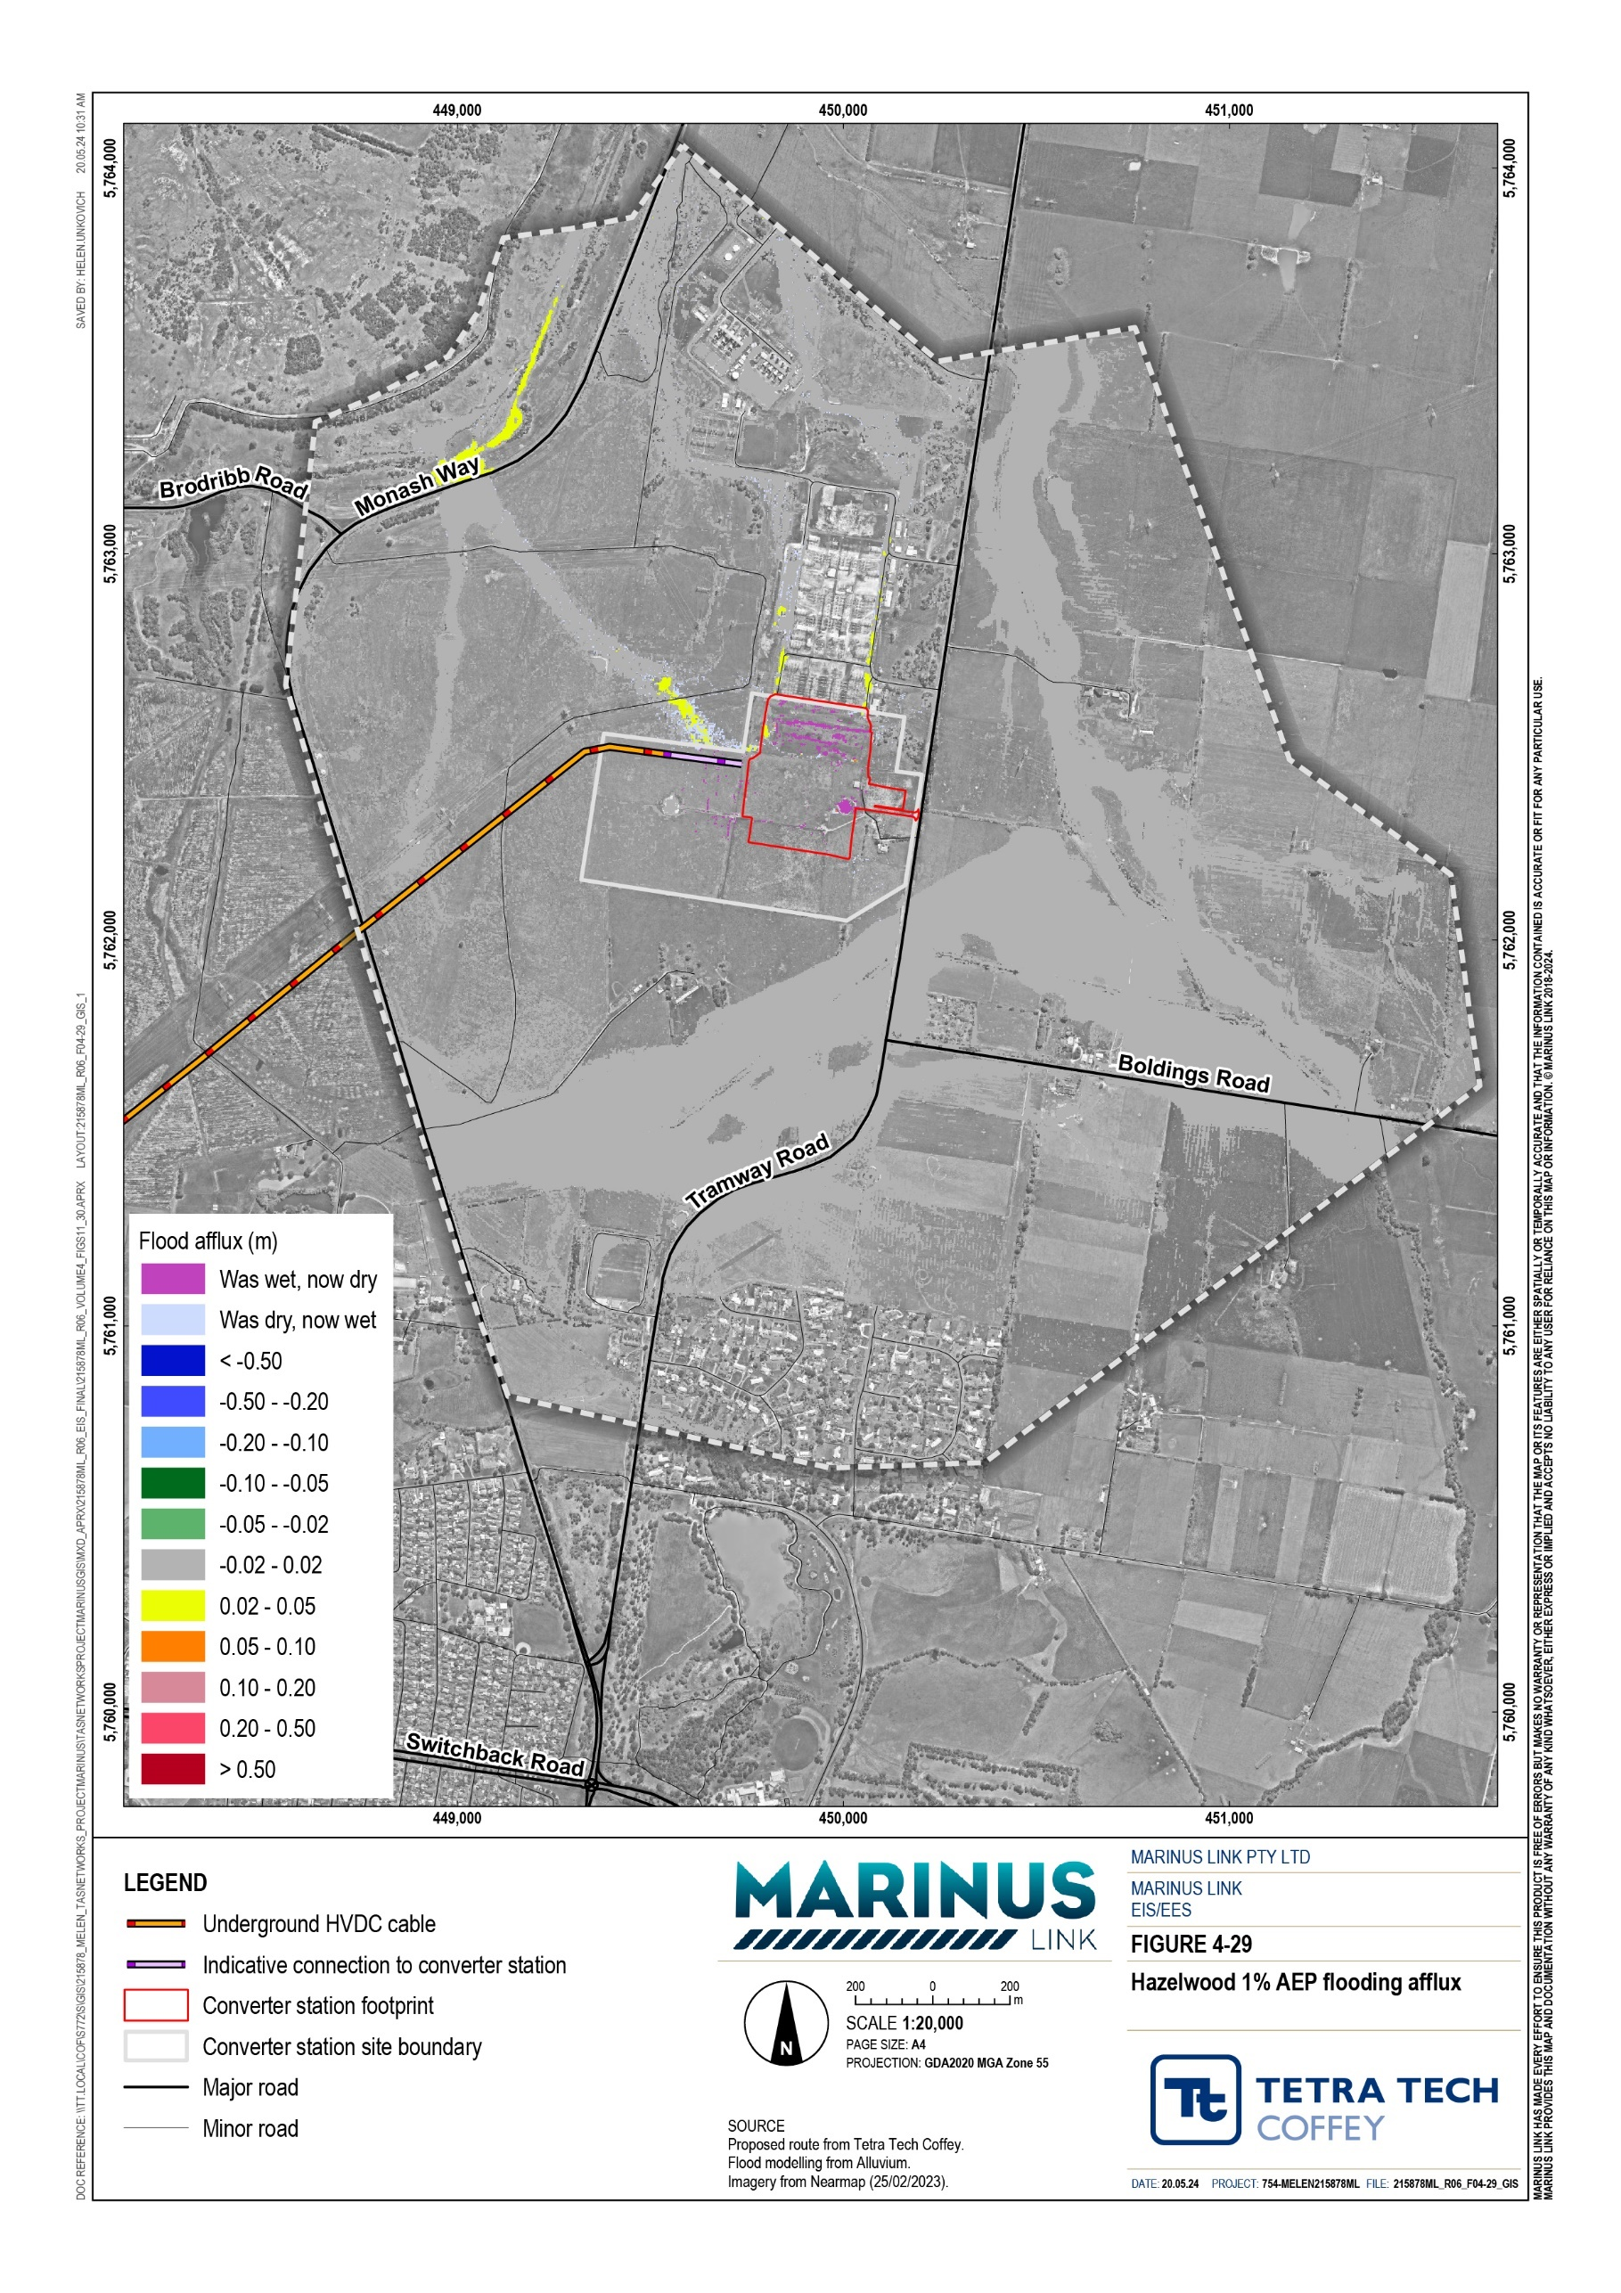

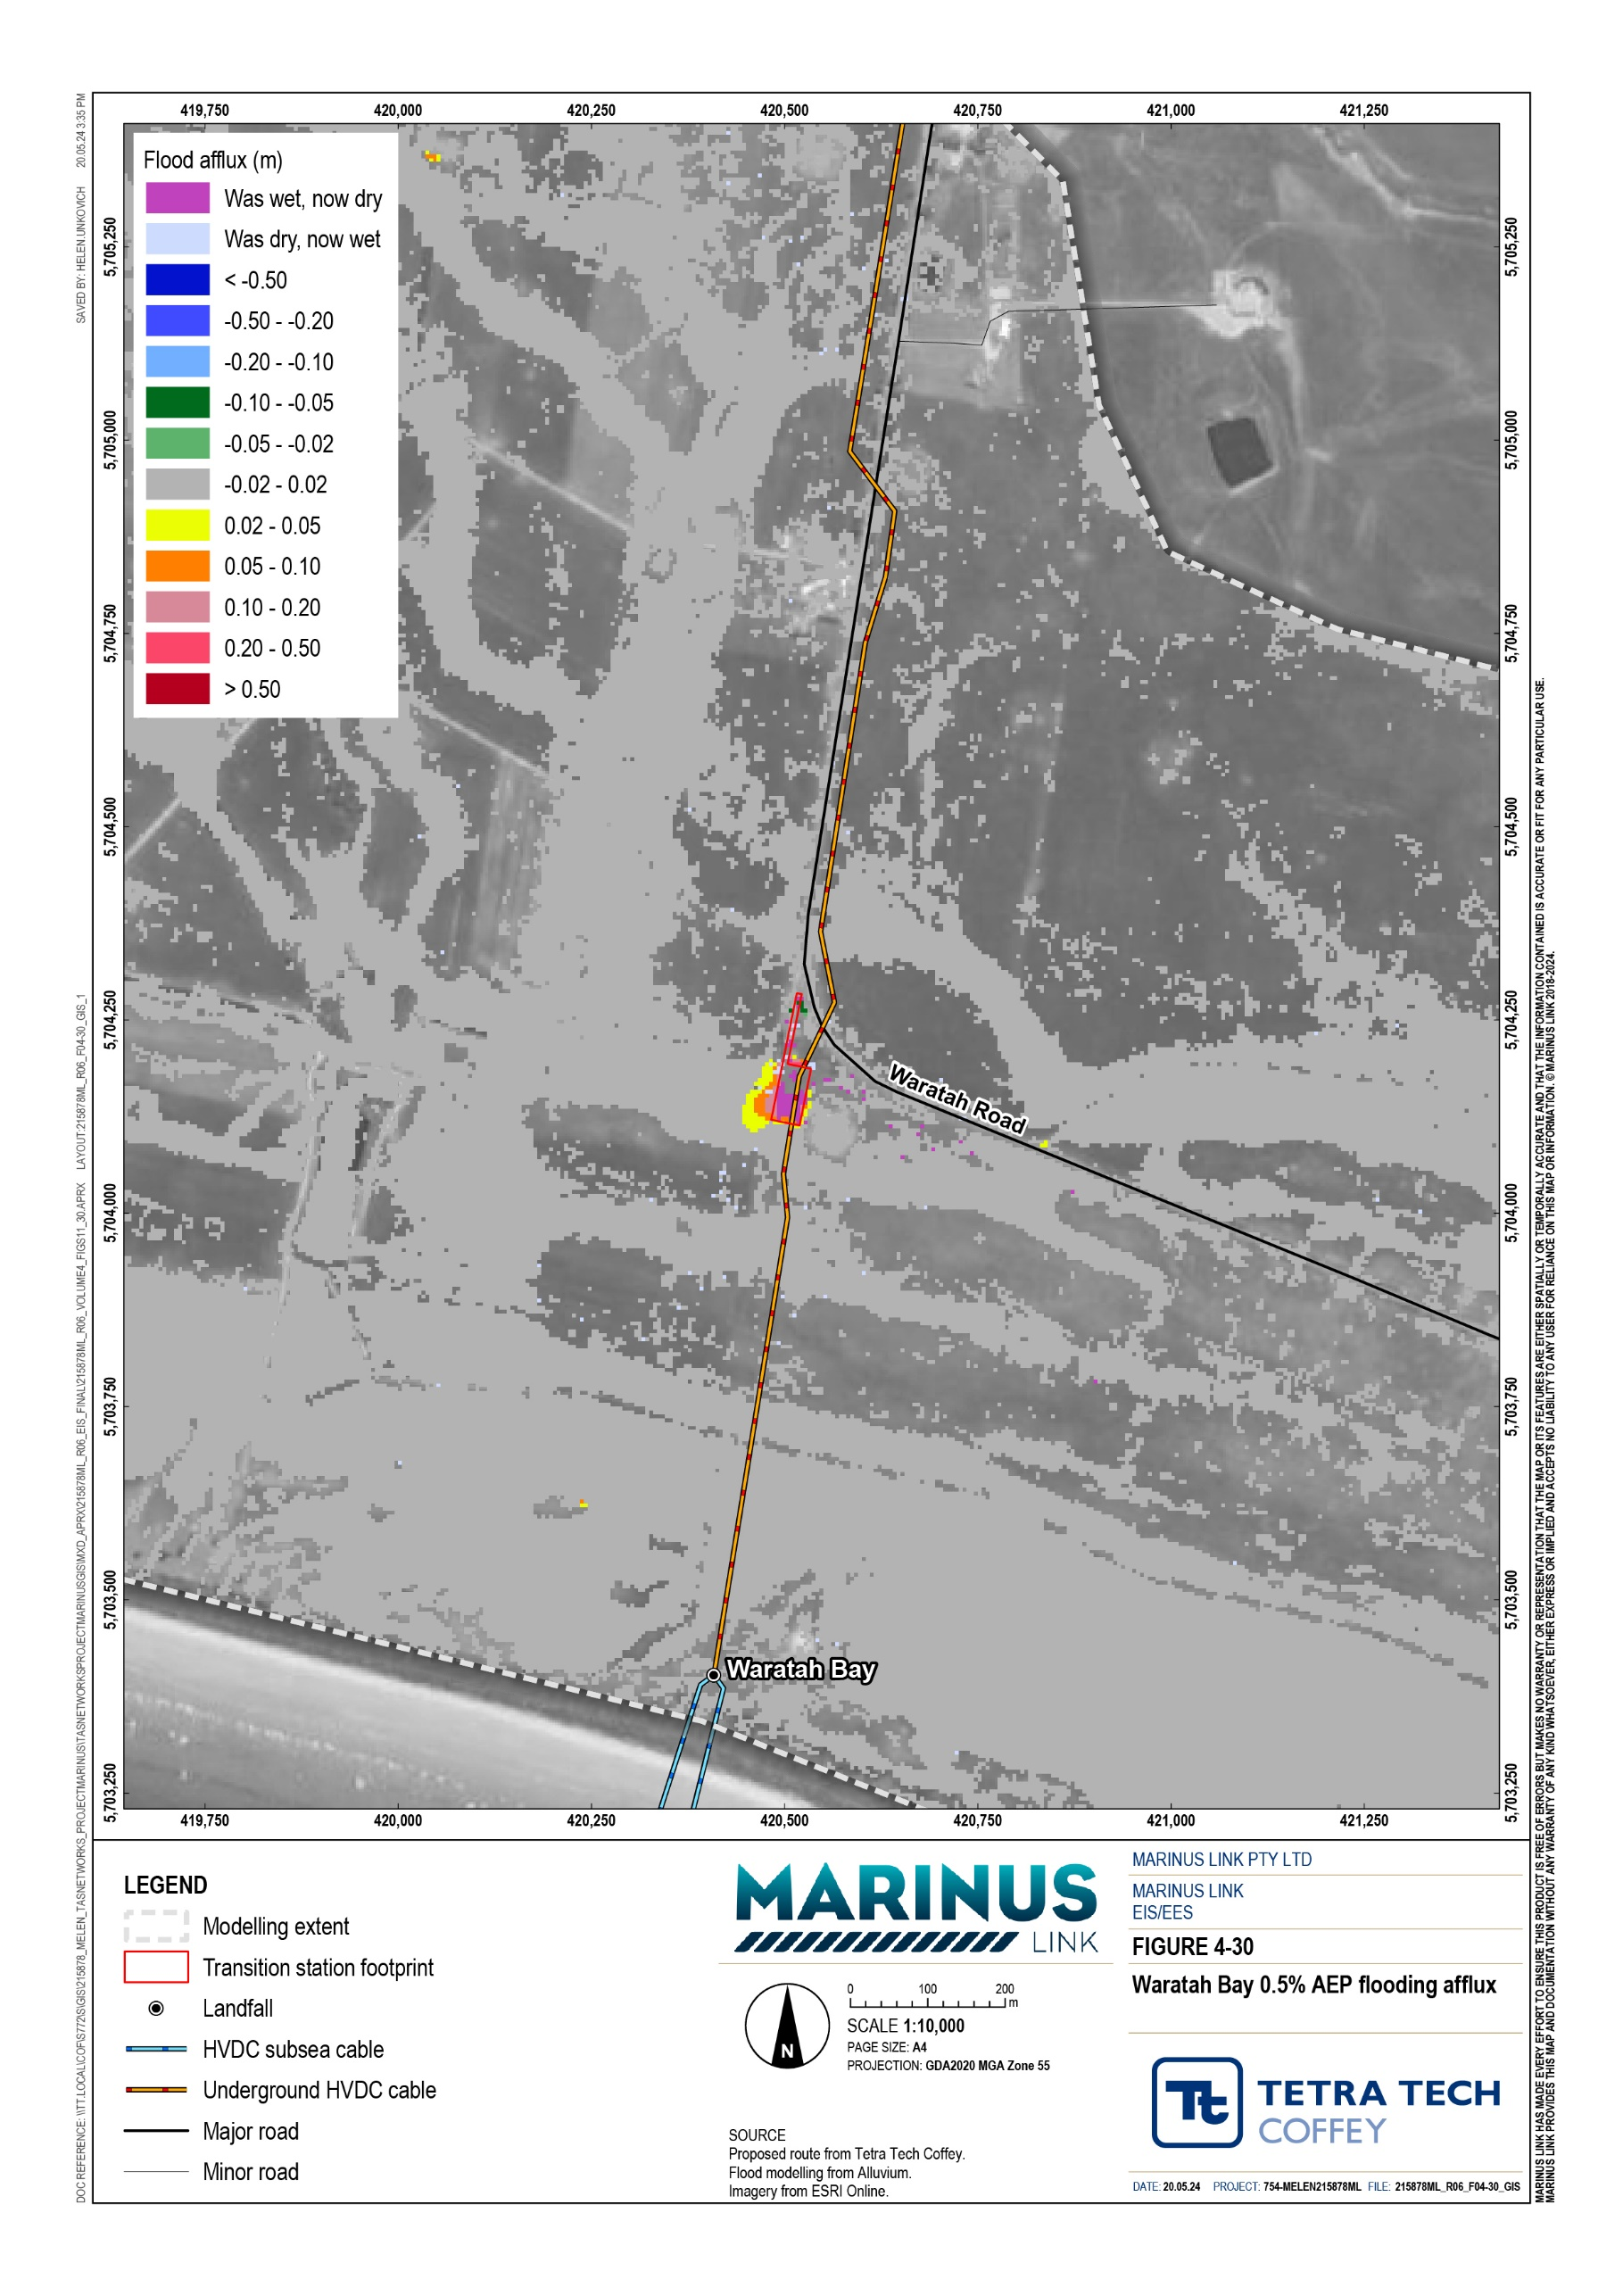

Water quality
The project has the potential to impact surface water quality in the area. The construction phase of the project will involve several activities with the potential to impact surface water quality, including:
Disturbed land and soil exposed to rainfall runoff or to surface water due to ground disturbance (such as trenching), leading to releases of sediments, particulates, and dissolved associated metals and nutrients.
Spill of hazardous or potential polluting chemicals or materials.

HDD frac out into waterways (e.g., where the clay used to line the tunnel wall leaches into the waterways).
Project construction activities such as trenching, excavation, soil stockpiling, and heavy vehicles and machinery on channel banks may lead to increased sedimentation from runoff of disturbed areas, which may then have impacts on water quality. Construction may also directly alter waterways, leading to flow disruption, erosion, and potential impacts on water quality, habitat and species diversity.
An assessment of the risks to water quality due to surface runoff was undertaken by considering the AoD of construction activities in the flood extent of the major waterway crossings, Hazelwood converter station and Waratah Bay transition station sites (Table 5-6). The flood extents are shown in Figure 4-26, Figure 4-27, Figure 4-28, Figure 4-29 and Figure 4-30. Exposed topsoil in these locations could be captured in a flood event or in runoff and lead to surface water quality impacts. The risks to water quality will however reduce as the construction area is progressively reinstated.
Although other surrounding waterways were not directly considered, the assessment of potential water quality impacts of the project on major waterway crossings and the relevant EPRs would apply to all waterways within the study area that could be impact during construction.
Equipment and vehicles involved in construction activities may handle or use hazardous materials. Uncontrolled releases due to equipment failure, incorrect operation, non-compliance with regulations, improper storage, or incorrect disposal can directly introduce hazardous materials into waterways, compromising surface water quality.
Disturbance of potential ASS sites, such as those at Waratah Bay and in some areas of Hazelwood Pondage, may also impact surface water quality. Impacts of potential contamination and ASS are discussed further in Volume 4, Chapter 3 – Contaminated land and acid sulfate soils.
Frac out during HDD is the release of drilling fluids to the ground surface. It typically occurs when the pressure in the drilling hole is greater than the pressure in the surrounding ground and there is a pathway such as a fissure that allows for seepage of drilling fluid from drilling hole to the surface. This risk will be managed through construction, and contractors are also required to use non-toxic drilling fluids (refer to groundwater EPRs in Volume 4, Chapter 4 – Groundwater).

Mitigation measures to comply with EPRs would be applied for all construction areas and relevant locations along the project alignment to avoid and manage impacts to waterways and surface water quality. The EPRs require the development of an erosion and surface water management plan (EPR SW01) that documents the requirements and methods for avoiding and otherwise managing impacts to waterways. This plan must also include measures for the containment of hazardous materials and release of spills from the project to the environment and emergency response procedures if frac out occurs during HDD of waterways (EPR SW01). A monitoring program of waterways would also be undertaken to establish a baseline and monitor for potential impacts during construction (EPR SW04).
Based on the assessment, the unmitigated risk rating for water quality from construction activities ranges from moderate to high within the study area. With the implementation of mitigation measures to comply with EPRs, the residual risk would be low. Residual risk ratings are summarised in Section 5.7.

Geomorphology
Waterway features such as pools, riffles and benches, which provide habitat that support ecological values are maintained by the geomorphic process that shape a waterway channel or floodplain.
Geomorphic processes and the physical form of waterways change overtime and are influenced by several factors. These factors include changes in the flow regime, characteristics of the stream bed and bank sediments, riparian and instream vegetation, valley controls (such as confinement and valley slope) and the sediment flow regime.
A ’stable’ waterway is in dynamic equilibrium and these factors may alter slightly and the channel naturally adjusts without altering the waterway overall.
During the construction phase of the project, potential impacts to waterway geomorphology could occur due to:
Flood waters, flow diversion and hydraulic behaviour changes causing increased erosion or incision of waterways.
Sediment supply changes causing a build-up of sediment (aggradation).

Direct modification of a waterway channel.

Flows from the floodplains adjacent to the waterway crossing would be impacted if a flood occurred during construction. Construction areas and equipment could reduce the floodplain area and alter water flow paths. Flows from construction areas have the potential to cause local erosion and sediment release without mitigation measures applied.
Potential geomorphological impacts during construction of the project include creation of unstable landforms, changing vegetation habitat, degraded soil structure, changed channel dynamics of waterways, locally altered groundwater dynamics (i.e., infiltration through changing land use), leading to increased sedimentation in runoff to surface water. Sedimentation due to runoff from construction areas could smother stream beds. Sediment could also build up, alter flows, and increase scour and channel movements. Altering the sediment balance could also change the rates of erosion of the waterways.

The stability of waterways was assessed for the eight major waterways crossings. All the waterways except for the Morwell River were identified to be laterally active, which means they are moving horizontally across the landscape. The Morwell River is undergoing long term change and gradual lengthening of meanders is expected. The eight major waterway crossings were all assessed to be vertically stable except for Fish Creek, so they are not expected to be eroding downwards toward the HDD crossings. Waterway bank erosion was evident in the Morwell River and Fish Creek, and minor bank erosion in Stony Creek. Any potential risk to the stability of Fish Creek during construction will be managed through the implementation of mitigation measures to comply with the EPRs (EPR SW01, SW03 and SW04).
Open cut trench construction of the Little Morwell River crossing will have a higher impact than the HDD crossing of all other major waterway crossings. Channel instability and erosion, due to trenching, could impact the geomorphology of the river without application of mitigation measures.
The erosion and surface water management plan would document requirements and methods for avoiding and otherwise managing flood waters, surface runoff and the impacts to waterway geomorphology (EPR SW01). This plan must also outline how works will be managed to not increase overall flooding risk considering the effects of climate change on flood levels (EPR SW02). The residual risk to geomorphology would be low with the implementation of mitigation measures to comply with EPRs. Residual risk ratings are summarised in Section 5.7.

Operation impacts
As the project is largely underground, it is only the surface components and operational activities that could interact with, or potentially impact, surface water during operation. There will be no permanent above ground structures located in floodplains.
This section provides a summary of potential flooding, water quality and geomorphology related impacts during the operation phase of the project.

Waterways
During operation, the project can impact waterways in the study area through:

Project assets requiring ongoing redirection of flow, initiation or acceleration of waterway bed or bank erosion and increased sediment supply to waterways.
Spill of hazardous or potentially polluting chemicals or materials used during operation are released into the waterway during rainfall events (runoff or resulting from a flood event).
At the locations where the project crosses waterways, drill pads, any trenches and all areas excavated during construction will be reinstated to match the existing surface conditions and levels post construction so there is no impact on the 1% AEP flood behaviour (flood extent, water levels and flood water storage area).

Changes to current land use from permanent project assets, such as access roads may alter overland flow behaviour and reduce floodplain storage areas. Any associated drainage lines or stormwater diversion systems could also increase flows to waterways potentially causing erosion and instability, or increased sediment loads. These risks will be managed through the design of project assets and stormwater systems to minimise risk from changes in flood levels (EPR SW01 and SW02).
Spills of hazardous materials pose a risk to water quality. The storage, handling, transport and disposal of hazardous materials can result in unplanned releases to the environment, affecting water quality. Water quality impacts are considered to have moderate to high risk at the waterways without mitigation. With the application of standard measures to manage spills and site runoff (EPR SW01) the residual risk is low.

Converter and transition stations
Shear stress results generated through flood modelling will indicate impacts to geomorphology and erosion of waterways due to changes in overland flows. The sheer stress results were assessed for construction of the converter and transition stations.
Figure 4-31 shows shear stress values of up to 5 N/m² in the drainage channels north of the Hazelwood converter station in both the current and climate change scenarios, reaching up to 10 N/m² west of the site. The existing Hazelwood Terminal Station is also expected to experience increased shear stress, indicating higher flows and potential for erosion. Erosion control works may be required in the grassed drainage channels to the north of the site.
In contrast, the Waratah Bay transition station is unlikely to be impacted by erosion from increased runoff from the project. Shear stress decreases near the site due to increased flood depths, and the associated increases in other areas are not expected to have consequential effects based on erosion thresholds and existing conditions (Figure 4-32).
The risks to geomorphology and erosion due to runoff will be managed through the design of project assets and stormwater systems (EPR SW01). The residual risk will be low with the implementation of mitigation measures to comply with EPRs. Residual risk ratings are summarised in Section 5.7.
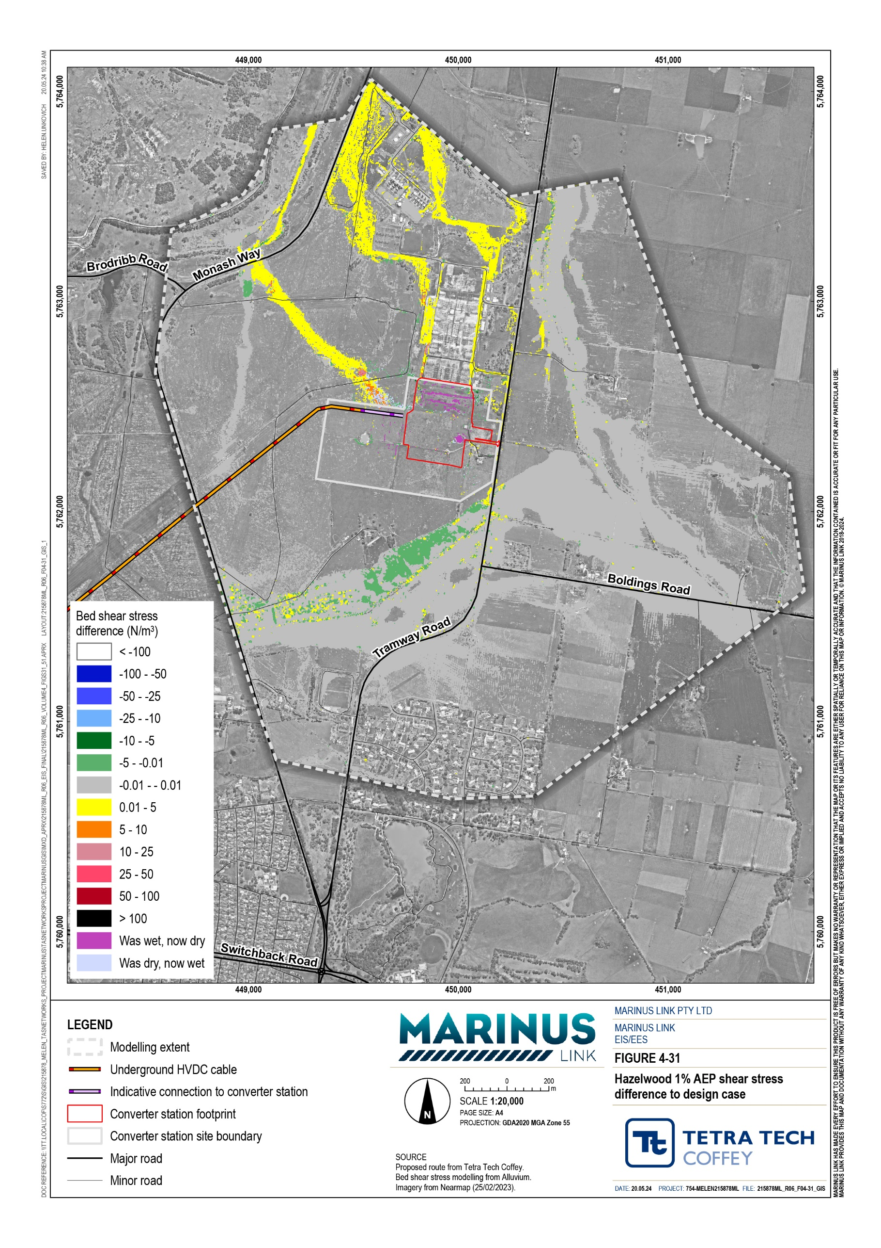
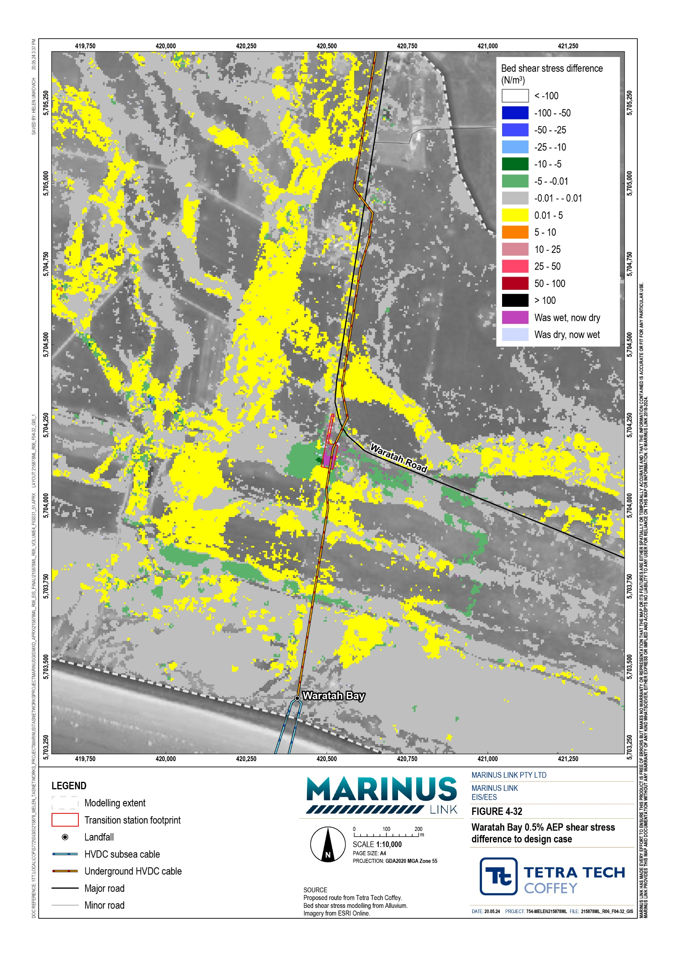

Decommissioning impacts
The current operational lifespan of the project is a minimum 40 years. At this time, the project will either be decommissioned or upgraded to extend its operational lifespan.
Requirements at the time will determine the scope of decommissioning activities and impacts. The key objective of decommissioning will be to leave a safe, stable and non-polluting environment, and minimise impacts during the removal of infrastructure.
In the event that the project is decommissioned, all above- ground infrastructure will be removed, and associated land returned to the previous land use or as agreed with the landholder. All underground infrastructure will be decommissioned in accordance with the requirements of the time. This may include removal of infrastructure or some components remaining underground where safe to do so.
Should removal of project infrastructure be required at the end of its operational life, the nature, extent and magnitude of surface water impacts would be no greater than those associated with construction. A decommissioning management plan will be prepared to outline how activities would be undertaken and potential surface water impacts managed.

Environmental performance requirements
EPRs set out the environmental outcomes that must be achieved during the design, construction, operation and decommissioning phases of the project without defining how the outcome is to be achieved. In developing these EPRs, industry standards and guidelines, good practice, and the latest approaches to managing impacts were considered. Project specific management measures, relevant legislation and policy requirements informed these EPRs.
The surface water EPRs provide flexibility in construction methods and contractor design, as long as they achieve the required environmental outcomes, manage impacts and undergo necessary reviews before any work commences to optimise design solutions.
Proposed EPRs to set the required environmental outcomes for the project in relation to surface water are summarised in Table 5-7.

Table 5-7 EPRs

EPR ID
EPR

SW01 Develop and implement an erosion and surface water management plan
Prior to commencement of project works, develop a plan to manage erosion and surface water. The plan must:
Be developed in consultation with West Gippsland Catchment Management Authority
Document the existing condition of all waterways and drainage lines potentially affected by construction (including their immediate surrounds) to establish baseline conditions and inform development of measures to manage potential impacts.
Describe sediment and erosion controls and monitoring requirements in accordance with EPA Victoria Publication 1834.1 Civil construction, building and demolition guide, and with reference to the IECA Best Practice Erosion and Sediment Control Guidelines 2008.
Identify controls to:
- Maintain the key hydrologic and hydraulic functionality and reliability of existing flow paths and drainage channels.
- Retain existing flow characteristics to maintain waterway stability downstream of construction.
- Minimise erosion and acceleration of stream processes to protect bank stability of waterways and drainage channels that could be affected by directly or indirectly affected by construction activities, in accordance with West Gippsland Catchment Management Authority requirements.
Details of measures for revegetation and reinstatement of the beds and banks of waterways and drainage lines in accordance with West Gippsland Catchment Management Authority requirements. The measures should be appropriate for the different categories of waterways and drainage channels considering if they are subject to shear stress that exceeds the boundary material resistance thresholds, and the extent of existing native vegetation in and around the stream that will be impacted.
Location for storage of contaminated material, hazardous substances or stockpiled soil outside an appropriate flood level and to the requirements of EPA Victoria and the relevant drainage authority.
Protocol for scheduling of works to minimise or avoid flood related risks (see EPR SW03).
Details of the stormwater drainage system and spills containment measures for construction areas to manage the risk of hazardous spills and runoff to waterways from paved or trafficable surfaces. This must include requirements for bunding of excavations including joint pits to avoid contamination of stormwater.
Measures for minimising, the handling, classifying, treating, disposing and otherwise managing wastewater. Wastewater from the site may be subject to approval by the relevant authority prior to discharges occurring and subject to classification under the Environment Reference Standard requirements in accordance with the EP Act.
Emergency response protocol for flooding events and frac out during HDD construction under waterways. Methods for HDD drilling to prevent frac out and the use of non-toxic drilling fluids are described in EPR GW03.
Review and update of the plan annually to address the outcomes of water quality monitoring as required by EPR SW03.

The plan must be a sub plan to the CEMP and implemented during construction.

SW02 Minimise flood risk due to permanent infrastructure

Prior to commencement of project works, develop a design for permanent infrastructure to address the requirements outlined in the Guidelines for Development in Flood Prone Areas (West Gippsland Catchment Management Authority 2020), that demonstrates how the project has been designed to mitigate the overall flood risk and incorporate flood protection measures where required.
The design must:
Be developed in consultation with West Gippsland Catchment Management Authority.
Be assessed and informed by a hydraulic flood model prepared for the design of permanent works to assess overall flood risk to the community and the project, predict changes to flow regimes, and to demonstrate the resultant flood levels and risk profile.
Include a flood modelling report prepared to document the modelling and how it has addressed current climate conditions and the potential effects of climate change considering pre and post work scenarios as predicted at the end of assets design life using RCP4.5 and RCP8.5 projections (Ball, et al. 2019). The repot must also outline how the hydraulic modelling has been scoped in consultation with West Gippsland Catchment Management Authority.
Document the measures to manage overland stormwater flows and provide protection of joint pits, the converter station, transition station and any other permanent works from flood waters.
Document the events and scenarios modelled to inform the overall flood risk to the community and the project, and assess potential flood damage to permanent works.
Document mitigation measures develop to address areas of predicted increase flood risk and the engagement undertaken with the relevant drainage authority or asset owner to seek acceptance of the measures.
SW03 Minimise impacts due to flooding during construction

Prior to commencement of project works, develop a flood risk management plan to address the requirements outlined in the Guidelines for Development in Flood Prone Areas (West Gippsland Catchment Management Authority 2020), that demonstrates how the project has been designed to mitigate the overall flood risk and incorporate flood protection measures where required.
The plan must:
Be developed in consultation with West Gippsland Catchment Management Authority.
Be assessed and informed by a hydraulic model prepared to assess overall flood risk and flow regime that could affect temporary work sites, and to demonstrate the resultant flood levels and risk profile during construction.
Include a flood modelling report that document the events and scenarios modelled to inform the overall flood risk to the community and the project and assess potential flood damage to construction works.
Document the measures and work scheduling requirements to minimise or avoid or minimise flood related risks for construction sites and temporary structures.
The flood risk management plan must be a subplan to the CEMP and implemented during construction.

SW04 Develop and implement a surface water monitoring program

Prior to commencement of project works, develop a surface water monitoring program to assess water quality and waterway conditions during construction. The monitoring program must:
Be developed in consultation with the EPA Victoria and West Gippsland Catchment Management Authority
Include monitoring locations at suitable distances both upstream and downstream of works to establish baseline conditions prior to construction. Include parameters, frequency, durations of water quality monitoring and waterway condition inspections.
Be implemented for up to 12 months after commencement of operation, or a lesser period agreed with EPA Victoria (EPR SW05)
Outline requirements for data to be reviewed to assess the discharges and runoff from the project against Environment Reference Standard requirements and confirm the effectiveness of environmental controls.
Monitor the condition of reinstated waterway crossings and riparian vegetation to confirm the re-establishment of vegetation (EPR SW01). Be developed with reference to applicable policies and guidelines, including:
- EP Act
- Environment Reference Standard
- Victorian Stormwater Committee’s Victoria Best Practice Environmental Management Guidelines for Urban Stormwater (as published by CSIRO in 1999 with assistance from EPA Victoria and others)
- EPA Victoria Publication 596 Point source discharges to streams: protocol for in-stream monitoring and assessment
- Industrial Waste Resource Guideline 701 Sampling and analysis of waters, wastewaters, soils and wastes
The surface water monitoring program must be implemented during construction with results used to inform the development, review and updating of the plan prepared to manage erosion and surface water (EPR SW01).
SW05 Develop and implement measures to manage potential impacts to surface water in operation

As part of the OEMP, develop and implement measures to avoid or minimise impacts to surface water during the operation, in accordance with West Gippsland Catchment Management Authority requirements. The measures must include:
Ongoing surface water quality monitoring requirements, as outlined in the surface water monitoring program (EPR SW03). Controls for management of sites and materials to prevent erosion, runoff of contamination and sediments entering waterways. Requirements for monitoring the establishment of revegetation at waterway crossings.

In addition to the surface water EPRs above, other EPRs that would reduce the potential for surface water impacts and associated risks caused by the project, including:
Contaminated land and acid sulfate soils (Volume 4, Chapter 3 – Contaminated land and acid sulfate soils)
Groundwater (Volume 4, Chapter 4 – Groundwater)

Terrestrial ecology (Volume 4, Chapter 11 – Terrestrial ecology)

The complete list of EPRs for the project is provided in Volume 5, Chapter 2 – Environmental Management Framework.

Residual impacts
Residual risks are those remaining after the application of measures to comply with EPRs. The residual risks to surface water during construction and operation have been assessed as low. A summary of residual risks is provided in Table 5-8.

Construction
Construction in floodplain areas will be short in duration and small in area compared to the larger floodplain around the major waterway crossings. Standard controls will be applied to minimise impacts from changing flow, alterations to waterways and any loss of floodplain storage. Flood modelling will also be undertaken to confirm flow paths and inform the mitigation measures developed through design and implemented in construction (EPRs SW01, SW02). The residual risks to flooding will be low and are summarised in Table
5-8.

The residual risks to water quality during construction have been assessed as low and are summarised in Table 5-8. Impacts will be short-term and localised. Standard measures will be implemented to reinstate any works on waterway banks, manage the risk of spills, and manage stormwater and site runoff to minimise erosion and sediment release (EPRs SW01, SW02, SW04, SW05). HDD of the major waterway crossings will avoid direct impacts to water quality and erosion in those locations (EPR SW01). A surface water monitoring program will also be implemented to monitor surface water quality before and after construction (EPR SW04).
Managing site runoff, erosion and change in flood water flows will also minimise impacts to geomorphology and waterway stability during construction (EPR SW01, SW02, SW03, SW04). HDD crossing of major waterway crossings also avoids direct impact to the stream channel and riparian vegetation. All waterways, except for the Morwell River, are laterally active, (moving horizontally across the landscape over time) however all are vertically stable except for Fish Creek. The residual risk to geomorphology of waterways have been assessed as low.

Operation
With the project being constructed to be primarily underground, there will be limited risks to surface water values during operation. Impacts could only arise from operation of the converter station, transition station (if it is required) and maintenance along the project alignment.
Surface levels will be reinstated for any excavation undertaken for the project to avoid and otherwise minimise impacts to surface flows and flood waters. Above ground infrastructure will not be located in floodplains and stormwater systems will be designed to minimise risks due to flooding. There would be minor increases in flood levels at the converter station and transition station, however it will be less than 50 mm and contained to the immediate area (EPR SW02). The residual risk to flooding in operation was assessed as low with implementation of mitigation measures to comply with EPRs.
There will be limited storage of hazardous materials at the converter station site and transition station if it is required. The sites will be designed to contain spills of any hazardous materials, such as diesel for generators, stored on site. Runoff and potential spills from operational activities will be managed in accordance with the operation environment management plan (OEMP) (EPR SW05).
Impacts to waterway geomorphology will be avoided following completion of construction and the reinstatement of construction areas together with the management of any site runoff to reduce the risk of erosion. The residual risk to geomorphology and waterway stability will be low with the implementation of mitigation measures to comply with EPRs (EPR SW02 and SW05).
Overall, residual risks associated with project operation are considered low and are summarised in Table 5-8.

Table 5-8 Residual surface water risks
Construction
risk
EPRs
Recommended Residual
Initial risk Justification of residual rating
Sites
Impact pathway/mechanism
Values impacted

Flood storage behaviour and associated functions (Flooding)
Temporary activities such as excavation, stockpiling and alteration of topography or change in impervious surfaces alters floodplain storage capacity to store/transport floodwaters and/or diverts flow.
All waterway crossings, converter station and transition station
Moderate Implementation of EPRs SW01 SW03 can reduce the likelihood of impacting flood storage behaviour over the duration of the project activity to unlikely, with short term impacts extending beyond the operational area that can be ameliorated.
Standard management controls may include: locating stockpiles outside floodplains, earthwork cut/fill balance to maintain floodplain storage.
SW01 SW03
Low

Flood conveyance behaviour and associated functions (Flooding) | Excavation, filling or other interference with existing overland/surface flow pathways leading to changes in flow conveyance behaviour, direction, velocity or other characteristics. | Open trench construction waterway crossings (i.e., Little Morwell River)  Trenchless construction waterway crossings, converter station and transition station | High  Moderate | Implementation of EPRs SW01 and SW03 can reduce the likelihood of impacting flood conveyance behaviour over the duration of the project activity to unlikely, with short term impacts extending beyond the operational area that can be ameliorated.  Standard management controls may include: earthwork design to maintain overland / surface flow pathway capacity and include erosion control armouring where required. | SW01 | Low
 |  |  |  |  | SW03
 |  |  |  |  | SW01 | Low
 |  |  |  |  | SW02
 |  |  |  |  | SW03

Flood conveyance behaviour, waterway stability and
Direct alteration of waterways that alters flow behaviour, initiates/increases erosion and/or disrupts physical waterway habitat (e.g., bank disturbance).
Open trench construction waterway crossings (i.e., Little Morwell River)
High Implementation of EPRs SW01 and SW03 can reduce the likelihood of impacting flood conveyance behaviour and waterway stability over the duration of the project activity to unlikely, with short term impacts
SW01 SW03
Low

associated functions (Flooding and geomorphology)
All other waterways, converter station and transition station
Moderate
extending beyond the operational area that can be ameliorated.
Standard management controls may include: earthwork design to maintain overland / surface flow pathway alignment and protect/reinstate physical waterway habitat where required.
SW01 SW02
Low

Values impacted | Impact pathway/mechanism | Sites | Initial risk | Justification of residual rating | Recommended EPRs | Residual risk
Water quality | Spill of hazardous or potentially polluting chemicals or materials used in construction are released into the waterway during rainfall event (runoff or resulting from a flood event). | All waterway crossings, converter station and transition station | High | Implementation of EPRs SW01 and SW04 can reduce the likelihood of spill of hazardous or potentially polluting chemicals over the duration of the project activity to rare (not anticipated), with widespread, long lasting and results in substantial change to surface water values requiring design responses. | SW01 SW04 | Low
 |  |  |  | Standard management controls include: use of spill kits, bunding, dewatering procedures, emergency response and monitoring.

Water quality, waterway stability, flood behaviour and associated
Direct or indirect activities that cause damage to the bed or bank of the waterway, such as bank slumping/collapse e.g., heavy machinery on channel banks, operations within the
Open trench construction waterway crossings (i.e., Little Morwell River)
High Implementation of EPRs SW01 and SW04 can reduce the likelihood of direct or indirect activities casing damage to the bed or bank of the waterway over the duration of the project activity to unlikely, with short
SW01 SW04
Low

functions (Flooding)
channel, including trenching. Sediment release impacts water quality and waterway stability through aggradation.
Trenchless construction waterway crossings’ converter station and transition stations.
High
term impacts extending beyond the operational area that can be ameliorated.
Standard management controls may include: limiting machinery movement to designated areas, sediment controls, erosion protection, monitoring.
Low

Water quality, waterway stability
Open excavation or exposed soil is inundated in a flood event or direct rainfall within construction period,
All waterway crossings, converter station and transition station
Moderate
Implementation of EPRs SW01, SW03 and SW01
Low
SW04 can reduce the likelihood of sediment liberation from open excavation/bare soils over the duration of the project activity to unlikely, with short term impacts extending beyond the operational area that can be ameliorated.
Standard management controls may include: sediment controls, limiting bare soil exposure, erosion protection, monitoring.
SW03 SW04
(Geomorphology) causing sediment to be liberated and
travel through surface water into waterways, impacting on water quality and waterway stability through aggradation.

Values impacted
Impact pathway/mechanism
Sites
Initial risk Justification of residual rating
Recommended Residual
EPRs
risk

Water quality, waterway stability (Geomorphology)
Direct rainfall or a flood event inundates soil stockpiled as part of construction activities, causing sediment to be liberated and travel through surface water into waterways, impacting on water quality and waterway stability through aggradation.
All waterway crossings, converter station and transition station
Moderate Implementation of EPRs SW01, SW03 and SW04 can reduce the likelihood of sediment liberation from stockpiles over the duration of the project activity to unlikely, with short term impacts extending beyond the operational area that can be ameliorated.
Standard management controls may include: sediment controls, limiting bare soil exposure, erosion protection, monitoring.
SW01 SW03 SW04
Low

Water quality | HDD results in frac out - where the clays used to line the tunnel walls leech into a waterway impacting on water quality. | All waterway crossings where HDD is utilised | High | Implementation of EPRs SW01 and SW04 can reduce the likelihood of frac out over the duration of the project activity to rare (not anticipated), with widespread, long lasting and results in substantial change to surface water values requiring design responses. | SW01 SW04 | Low
 |  |  |  | Standard management controls may include: emergency response procedures, monitoring.
Operation
Flood conveyance behaviour and associated functions (Flooding) and Water quality | Permanent project assets including bunds, access roads, drains and modification to surface levels leading to changes in flow conveyance behaviour, direction, velocity or other characteristics. | All waterway crossings, converter station and transition station | Moderate | Implementation of EPRs SW01, SW02, SW04 and SW05 can reduce the likelihood of impacting flood conveyance behaviour and water quality over the duration of the project activity to unlikely, with short term impacts extending beyond the operational area that can be ameliorated. | SW01 SW02 SW04 SW05 | Low
 |  |  |  | Standard management controls may include: access track/road design to maintain overland / surface flow pathway capacity and include erosion control armouring where required.

Values impacted
Impact pathway/mechanism
Sites
Initial risk Justification of residual rating
Recommended Residual
EPRs
risk

Flood behaviour and associated functions (Flooding), water quality, waterway stability (Geomorphology)
Changes to current land use from permanent project assets such as access tracks, joint pits, or other hardstand areas are created which reduce the ability for water to infiltrate into the ground, causing increase in surface runoff, changes to flow discharge, and/or bed and bank erosion, increasing sediment supply to waterways.
All other waterway crossings, converter station and transition station
Moderate Implementation of EPRs SW01 SW02, SW04 and SW05 can reduce the likelihood of impacting flood behaviour, waterway stability and water quality over the duration of the project activity to unlikely, with short term impacts extending beyond the operational area that can be ameliorated.
Standard management controls may include: access track/road, hard surface areas design to minimise change surface flow discharge rates and volumes.
SW01 SW02 SW04 SW05
Low

Flood behaviour Road/access track drainage is insufficient and associated to convey rainfall associated with functions increase rain intensities as a result of
All waterway crossings, converter station and transition station
Moderate
(Flooding), water climate change. Reduced drainage quality, waterway capacity may lead to diversion of stability water/flooding elsewhere, erosion of (Geomorphology) waterways and liberation of sediment
travelling in surface water to waterways.
Implementation of EPRs SW01, SW02, SW04 and SW05 can reduce the likelihood of impacting flood behaviour, waterway stability and water quality over the duration of the project activity to unlikely, with short term impacts extending beyond the operational area that can be ameliorated.
Standard management controls may include: road/access track drainage design to consider climate change scenarios.
SW01 SW02 SW04 SW05
Low

Flood storage behaviour and associated functions (Flooding)
Permanent project assets such as access tracks, bunds, joint pits, or other modified areas causes diversion of runoff routes or flow pathways which leads to a loss of floodplain storage capacity to
Open trench construction waterway crossings (i.e., Little Morwell River)
High Implementation of EPR SW01 and SW02 can reduce the likelihood of impacting flood storage behaviour and waterway stability over the duration of the project activity to unlikely, with short term impacts extending
SW01 SW02
Low

store/transport floodwaters and/or diverts flow.
All other waterway crossings, converter station and transition station
Moderate
beyond the operational area that can be ameliorated.
Standard management controls may include: road/access track drainage design and earthwork cut/fill balance to maintain floodplain storage.
SW01 SW02
Low

Flood behaviour and associated functions (Flooding), water quality, waterway stability (Geomorphology)
Diversion of stormwater, drainage alignment or flow pathways leading to bed or bank erosion causing instability of assets adjacent to the waterway and/or increased sediment loads.
Open trench High construction waterway crossings (i.e., Little
Morwell River)
Implementation of EPRs SW01, SW02 and SW04 can reduce the likelihood of impacting flood behaviour, waterway stability and water quality over the duration of the project activity to unlikely, with short term impacts extending beyond the operational area that can be ameliorated.
Standard management controls may include: access track/road, hard surface areas design to maintain flow pathways and consider outfall arrangements that minimise erosion potential.
SW01 SW02 SW04
Low
All other waterway crossings, converter station and transition station
Moderate
SW01 SW02 SW04 SW05
Low
risk
EPRs
Recommended Residual
Initial risk Justification of residual rating
Sites
Impact pathway/mechanism
Values impacted

Water quality Spill of hazardous or potentially polluting
chemicals or materials used during operation are released into the waterway during rainfall event (runoff or resulting from a flood event).
All waterway crossings, converter station and transition station
High Implementation of EPR SW01, SW04 and SW05 can reduce the likelihood of spill of hazardous or potentially polluting chemicals over the duration of the project activity to rare (not anticipated), with widespread, long lasting and results in substantial change to surface water values requiring design responses.
Standard management controls include: use of spill kits, bunding, dewatering procedures, emergency response and monitoring.
SW01 SW04 SW05
Low

Cumulative impacts
Four established projects have been assessed for cumulative impacts due to their proximity, expected commencement overlap with the project, and potential to affect the waterways. These projects are:
Hazelwood Mine Rehabilitation Project

Delburn Wind Farm Project

Star of the South Offshore Wind Farm

Wooreen Energy Storage System.

While these nearby projects could impact waterways adjacent to their construction areas, it is expected that those projects are expected to have standard management measures to mitigate impacts. The Delburn Wind Farm and the project are located in the same area around Driffield however there are no major waterway crossings in this location, and it is not within the catchment of the waterways assessed. It is not expected that these projects will generate impacts that will affect the waterways in the project area due to their location.
Overall, it is considered unlikely that there would be cumulative impacts to waterways within the study area from these projects.

Conclusion
The project alignment crosses eight major waterway crossings between Waratah Bay and Hazelwood, in Victoria. The study assessed the potential impacts on surface water at the eight waterway crossings, the Hazelwood converter station and Waratah Bay transition station.
Of the 82 waterways along the project alignment, HDD will be used to cross 15 waterways including seven of the eight of the major waterway crossings. Little Morwell River is the only major waterway that will not be crossed with HDD. Overall, the construction and operation residual risks of the project on surface water values will be low as they are localised, and risk will be minimised through the implementation of standard measures to comply with EPRs. Flood modelling will inform design and construction to avoid and otherwise mitigate impacts on flooding and erosion due to surface runoff. Spill containment and site runoff management will also be key measures to avoid water quality impacts.
Impacts to waterway geomorphology will also be minimised through the reinstatement of construction areas together with the management of any site runoff to reduce the risk of erosion. All waterways are laterally active except for the Morwell River, and all are vertically stable except for Fish Creek. Therefore, the waterways are all expected to move horizontally to some extent across the landscape over time but are not eroding downwards towards the HDD crossing, expect for Fish Creek.

The focus of the surface water EPRs are to minimise alteration of flood levels and flows, avoid impacts to water quality by implementing measures to manage site runoff, and to maintain waterways stability to all 82 waterway crossings identified and in the vicinity of any waterway with potential impacts from the project. A surface water monitoring program will also be implemented to monitor surface water quality before and after construction (EPR SW04).
Following the implementation of measures to comply with the EPRs, it is expected that the project will be able to meet the EES evaluation objective to ‘Avoid and, where avoidance is not possible, minimise adverse effects on water (including groundwater, surface water, waterway, wetland, and marine) quality, movement and availability’.

