Landscape and visual
This chapter provides an assessment of the landscape and visual impacts associated with the construction, operation, and decommissioning of the project. This chapter is based on the impact assessment provided in Technical Appendix R: Landscape and visual.
The assessment of landscape and visual impact considers the impacts to landscape character, significant or valued landscapes and sensitive viewing locations. The project is located within Victorian coastal areas and productive hinterland landscapes, which include grazing, dairy, horticultural and forestry areas which are valued for their productivity and ‘rural’ amenity.
The EIS guidelines do not address landscape and visual impacts.

The EES scoping requirements set out the following evaluation objective relevant to landscape and visual:

Landscape and visual – Avoid and, where avoidance is not possible, minimise the potential adverse effects on landscape and visual amenity.
Refer to Attachment 2: Scoping Requirements Marinus Link Environment Effects Statement for the EES scoping requirements.
The assessment characterises the landscape character units along the alignment and considers the impacts that could arise from the construction, operation, and decommissioning phases of the project. It considers potential landscape and visual impacts that may occur through vegetation clearing and construction of above ground project structures. The assessment recommends EPRs to avoid, reduce or manage potential impacts.
Other aspects covered in the above EES evaluation objective are addressed in the following EIS/EES chapters:
Volume 4, Chapter 5 – Surface water

Volume 4, Chapter 12 – Bushfire

Volume 4, Chapter 13 – Aboriginal cultural heritage

Volume 4, Chapter 15 – Land use and planning

Volume 4, Chapter 16 – Social

Method
This assessment was informed by the significance assessment approach described in Volume 1, Chapter 5 – EIS/EES assessment framework. The key tasks undertaken to assess the landscape and visual impact assessment (LVIA) included the following:
Definition of a study area.

Conducting a desktop assessment of existing visual and landscape values in the study area through review of:
- Victorian and local government publicly available mapping of geological units, topography, vegetation, waterways and waterbodies, land use, conservation parks and reserves, townships.
- Relevant international, interstate guidelines and practice notes.

- Local planning policies, zoning and overlays

- Technical Appendix S: Land use and planning

Identifying landscape characters units based on physical and natural attributes in the study area.

Consolidating landscape character units to define visual landscape patterns in the study area. Three broad regional scale landscape character areas were defined:
- coast and plains

- cleared flat farmland (south and north)

- rolling farmland and forests.

Selecting viewpoints in each landscape character unit that were publicly accessible and representative of a range of viewing angles, distances, and landscape character types. Also including views from well- known places within the community and where the community will be most likely to be able to view components of the project.
Assessing landscape and visual impacts for construction and operation at each viewpoint considering:

- visibility of project elements and scale of the effects of that view of project elements

- distance from visible project elements and the dominance of those elements in the landscape

- duration of time that the project elements are visible to the viewer, fixed in view, or short and transitory
- landscape character and sensitivity

- viewer numbers that can view the project at the viewpoint.

Determination of the viewer sensitivity in each landscape character unit.

Preparation of photomontages from selected public viewpoints to assist the assessment by illustrating the scale of the project at key viewpoints.

Assessing the overall visual impact at each viewpoint. Visual impacts to landscape character units from construction and operation of the project are discussed for each viewpoint from south to north along the project alignment. The scale of visual impacts has been assessed for each viewpoint and rated by considering the aspects below and assigning a rating from nil to high, as described in Table 7-1.
Matrices are not used in the assessment, as the assessment is based on an examination of qualitative aspects of each of the selected viewpoints based on the following criteria:
- Visibility: The visibility of the project elements can be affected by topography, vegetation, built form and infrastructure.
- Distance: Infrastructure visibility and dominance will decrease with distance. The zone of visual impact (ZVI) provides an indication of visual dominance and potential impact based on distance.
- Duration: The duration of a view is also relevant and must be considered when assessing the overall visual impact. For example, a project would be more noticeable from locations where views are static or stationary due to the increased duration in which a project would be visible. Conversely, project visibly would be shorter in duration from views that are in transit and therefore reduced. An example of a static view may include a private residence, reserve or recreation areas. Transitory views may include locations such as roadways, vegetated trails or public transport.
- Landscape character and sensitivity: The landscape character of an area is based upon visual features such as topography, vegetation and the use of the land, the naturalness of the area and planning provisions. Specific landscape studies and assessments within the study area may also influence sensitivity. Typically, a modified landscape prevalent within the study area or the region is less sensitive than one ostensibly natural.
- Viewer numbers: The overall visual impact level will decrease when fewer people can view the project. Conversely, the level of visual impact may also increase where the viewing location is a recognised key vantage point or tourist route where a greater number of people may view the change.
Identifying potential cumulative impacts on landscape and visual values within the study area.

Developing EPRs in response to the impact assessment to set the required environmental outcomes for the project.
Further details of the method are provided in Technical Appendix R: Landscape and visual.

Overall visual impact | Definition
Nil visual impact | An overall assessment of Nil will be arrived at where the project will be screened by topography, vegetation, buildings and other structures or project features are at such a distance that they will no longer be a readily discernible feature in views.
Negligible visual impact | An overall assessment of Negligible is a minute effect barely discernible over ordinary day-to-day views. A ‘negligible’ level of visual impact will typically occur where the Project will be at a distance that it will be a minute element in views, or will be filtered by vegetation or partially screened by features such as topography or buildings. An overall assessment of negligible may also be where the project is added to views that already include many similar features.
Low visual impact | An overall assessment of Low will be arrived at where the project is noticeable but will not cause significant adverse impacts. For example, a “low” level of visual impact will be assessed if the rating of several, but not all, assessment criteria (visibility, distance, viewer numbers and landscape sensitivity) is assessed as low.
Moderate visual impact | An overall assessment of Moderate may occur where several criteria are higher than “low” as listed above, or the visual effects will be mitigated/remedied from an initial rating of High.
High visual impact | An overall assessment of High will be arrived at where significant adverse effects cannot be avoided, remedied, or mitigated. For example, a highly sensitive landscape, viewed by many people, with the project in close proximity and largely visible, will lead to an assessment of a high level of visual impact.

Study area
The landscape and visual study area encompasses the area or distance from the project where the key project elements may be noticed within a viewpoint by human vision (zone of visual influence).
Distinct aspects of the project relevant to landscape and visual impacts include, the transition station/terminal station, cleared land cable sites, and the converter station adjacent to the existing Hazelwood Terminal Station, where the project connects to the existing Victorian transmission network.
The tallest component of the project is the converter station halls, which have an overall height of up to 30 m. Given the height of the halls, the extent of the study area for the proposed converter station will be a radius of up to 3.5 km.
The tallest component in the transition station will be the containerised communications hut at 3.5 m in height. Given the height of the transition station buildings and the land cables are installed underground, a nominal study area for the proposed transmission line and transition station will an area of up to 450 m on either side of the project alignment.
The study area encompasses key publicly accessible viewpoints of the project. Figure 4-35 provides an overview of the study area for the LVIA.

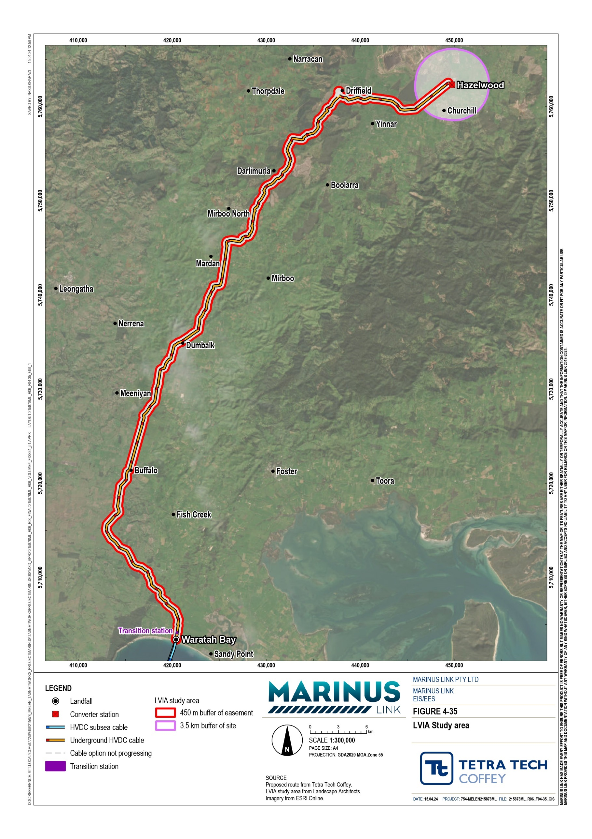

Policies and guidelines
No Commonwealth or Victorian government legislation is specifically relevant to LVIA. However, planning, environmental, and heritage policies identify areas of landscape sensitivity and important areas for managing views. Australian, New Zealand and British guidelines also provide LVIA methodology considerations for professionals. Table 7-2 outlines key policies that informed identification of landscape character units and sensitive views in the study area, and the LVIA method.

Title | Relevance to the assessment
Environmental impact assessment practice note EIA-NO4, Roads and Maritime Services, NSW, December 2018 | Established guideline for determining landscape character and visual impact assessment for road projects in NSW. This guideline assesses visual sensitivity, which is derived from the qualities of an area, and the magnitude of the change derived from the scale or prominence of the project in a matrix framework to assess the level of impact.
Guidance Note for Landscape and Visual Assessment, AILA Queensland, June 2018 | Recognises that the “Landscape and Visual Assessment (LVA) should be scoped to reflect the scale of the project”.
The Guidelines for Landscape and Visual Impact Assessment, Third Edition, Landscape Institute and Institute of Environmental Management and Assessment (2013) (UK Guidelines) | Provides a method to combine scale, duration, and reversibility to evaluate magnitude and viewer sensitivity and landscape character inform sensitivity to assess overall visual impact.  Defines cumulative visual impacts as the combined effect of changes by a proposed development in conjunction with other similar developments in an area which may result in changes to the perceptions of the local community or a visitor to the region. The guidelines provide that there is potential for cumulative visual impacts to occur is where there may be, sequential views to multiple similar projects along roads within the study area; and simultaneous views from publicly accessible viewpoints or private viewing locations may occur.  Matrices are not utilised in visual assessment in this guideline.
New Zealand Institute of Landscape Architects, NZ (2010) Best Practice Note: Landscape Assessment and Sustainable Management 10.1 | Provides that landscape characterisation is a process of interpreting how attributes such as geomorphology, natural ecosystems, vegetation cover and land-use history come together to distinguish landscapes.  Recognises that landscapes are dynamic and continually changing and that landscape assessment should reflect project scale. Guidelines seek to manage the direction and consequences of change and how to sustain landscape values and attributes over time instead of ‘freezing’ a landscape view in a particular state.
Siting and design guidelines for structures on the Victorian Coast, May 2020 | Seeks to protect Victoria's coastal landscapes' natural processes and amenity. It includes chapters covering views, local character and sense of place and materials and sustainability provide guidance to guide the form and finishes of above-ground elements associated with the above-ground transition station. With a view to minimise intrusion and obviousness of new development and built form in the coastal area. These guidelines help to identify landscape character areas.
Victorian Planning Provisions (VPPs) | The VPPs includes state and regional planning policies. State policy applies across the whole of Victoria to achieve a consistent approach to land use and development.  Regional policy provides local content to the areas within each local government area. The VPPs have helped to identify landscape character areas and the clauses of relevance to the landscape and visual assessment of the project include:  12.05-2S Landscapes  12.05-2L-01 Coastal and hinterland landscapes  12.05-2L-02 Significant Landscape Character Areas

Title | Relevance to the assessment
Planning Scheme Overlays | Overlays are applied to landscapes and features in the study area that protect landscape character, views, and amenity. The overlays help to identify landscape character areas in the study area. The overlays relevant to the project that have been considered include:  Design development overlays  - Design Development Overlay (Schedule 3 – Sandy Point Township) – South Gippsland Planning Scheme  - Design Development Overlay (Schedule 4 – Waratah Bay Township) – South Gippsland Planning Scheme  Environmental significance overlays  - Environmental Significance Overlay (Schedule 1 – Areas of Natural Significance) – South Gippsland Planning Scheme  - Environmental Significance Overlay (Schedule 1 – Urban Buffer) – Latrobe Planning Scheme  - Environmental Significance Overlay (Schedule 3 – Coastal Settlements – Non- Residential Zones) – South Gippsland Planning Scheme  Significant landscape overlays  - Significant Landscape Overlay (Schedule 3 – Corner Inlet Amphitheatre) – South Gippsland Planning Scheme
Planning Scheme Zones | Areas with the most significant protection include areas designated as Public Conservation and Resource Zone (PCRZ) in the local planning schemes. Examples of such locations include the dune system to the north of Waratah Bay Beach, Stony Creek Water Frontage, Tarwin River East Brach Water Frontage, and Morwell River.  Settlement and residential areas include land within the General Residential Zone (GRZ), Township Zones (TZ), and Rural Living Zones (RLZ).  Most of the land within the study area is within the Farming Zone. A purpose of the farming zone is to protect the ongoing use of the area for agriculture and prevent encroachment from incompatible uses such as dwellings and lifestyle properties with higher amenity expectations of surrounding areas. These zones help to identify  landscape character areas.

Assumptions and limitations
The landscape and visual assessment has been conducted based on the concept project design described in Volume 1, Chapter 6 – Project description, including the building heights for the converter station halls.

Existing conditions
Existing conditions relevant to landscape and visual assessment in the study area are described by regional landscape character and landscape character units.
The geological units, topography, vegetation, waterways, land use, extent of existing landscape modification, location of conservation parks and reserves and townships were reviewed to inform relevant landscape character units in the study area.
Landscape character units were also consolidated into regional scale landscape characters to define visual landscape patterns in the study area.

Landscape character units
The existing landscape for visual assessment has been described by the composition of landscape character units. Six landscape character units have been identified within the study area; these are:
Landscape Character 1 – Coastal dunes and beaches. Coastal areas valued for recreation and amenity benefits. This area is present at the Victorian shore crossing in Waratah Bay.
Landscape Character 2a – Townships. The visual landscape of townships includes residential dwellings clusters, main streets with shop fronts, and community buildings. With vegetation in road reserves, private gardens, and parks. Townships within the study area include Buffalo, Stony Creek, Dumbalk, and Mirboo North.
Landscape Character 2b – Rural residential. These areas are residential land uses outside of townships that are not intrinsically linked to agriculture or other rural industries. Many constructed elements are present, including dwellings, structures and sheds, transmission line towers, plantations, mining and quarrying activities, and power infrastructure in this landscape character unit.
Landscape Character 3a – Cleared flat farmland. Characterised by wide landscape views, comprising low level broad acre cropping and pasture for agricultural production, and tall vegetation along property boundaries and fence lines and watercourses. This landscape character unit also presents built visual landscape elements such as machinery, sheds, dwellings, irrigation plant and equipment and powerlines along local distribution networks.
Landscape Character 3b – Cleared hilly farmland. Cleared hilly farmland comprising rolling to steep- sided hills cleared for farming purposes. Like Landscape Character 3a taller vegetation includes trees along property boundaries, fence lines, road reserves and water courses, though scattered and retained paddock trees can be seen. Elevated locations on hill crests and hillsides provide expansive and varied views to lower elevations. Views are confined by topography and vegetation. Built visual landscape elements are also present as described in Landscape Character 3a above.
Landscape Character 4 – Plantations. Characterised by timber plantation forests. These forests comprise one species of timber, with plantings in rows, that limit views and can visually contrast against surrounding landscape when viewed from a distance.
Landscape Character 5 – Waterbodies and waterways. Natural waterways in the study area include Tarwin River East Branch, Little Morwell River, and Morwell River. Other waterways include but are not limited to Fish Creek, Stoney Creek and Berry’s Creek. The open waters of Bass Straight lie to the south of the transition station at Waratah Bay. Elevated viewpoints in the northern end of the project provide views of waterway tributaries which contribute to localised landscape and visual character.
Landscape Character 6 – National Parks, State Parks and State Forests. Categorised by vegetated and hilly landscapes that include often include dramatic topographical features. Landscape features remain primarily intact with little development or modifications other than access roads, trails, and telecommunications infrastructure. Viewpoints in these areas are limited to locations such as elevated lookouts or at bends in roads and at switchbacks on steep climbs and descents.

Regional landscape character
Three broad regional scale landscape character areas were determined for the alignment. Regional landscape units in the study area consist of cleared flat farmland (north and south), coasts and plains and rolling farmland and forests.
Cleared flat farmland in the south of the study area encompasses the southern cleared farmland from the north of Waratah Bay through to Dumbalk township and includes the areas of Buffalo and Meeniyan.
Cleared flat farmland in the north spans from Latrobe valley and includes the eastern edge of Driffield and the agricultural areas surrounding Yinnar and Hazelwood.
Characterised by highly modified landscape, with cleared farmland, planted windbreaks established along fence lines and property boundaries. Native vegetation is primarily in road reserves and along waterways.
The southern section of the study area includes the coast and plains regional landscape character, which includes the beach and small coastal townships of Waratah Bay and Sandy Point
Landforms in this regional landscape character area include long flat sandy beaches backed by sand dunes, flat low lying floodplain areas and steep land leading to a plateau to the north of Waratah Bay township, including thick vegetation.
This landscape is dominated by cleared rolling hills from the north of the township of Dumbalk, running through Mirboo North and through to the forested hills of Darlimurla and Delburn.
Characteristics and features include rolling hills intersected by waterways, planted hedgerows and shelter belts.
Native or remnant vegetation is confined to elevated hillsides, road reserves and water courses. Most vegetation in this landscape comprises exotic species within farming areas, hedgerows, shelterbelts and timber plantations.
The relationship of these character areas to the project are shown in Figure 4-36.
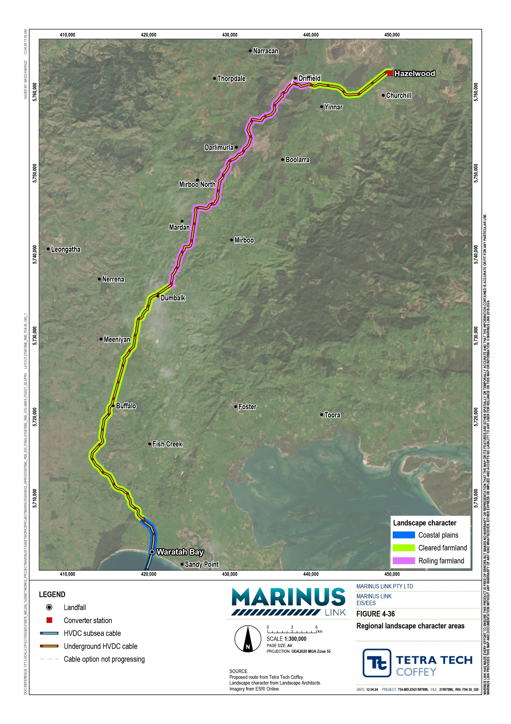

Summary of values
Landscape character units have also been identified as the values for the landscape and visual assessment. The assessment identified the existing sensitivity to visual change of each landscape character unit within the study area based on key features, attributes and associated environmental protections afforded by planning provisions. Table 7-3 outlines the visual values of each landscape character unit.

Landscape unit | Value descriptor and sensitivity
Landscape Character 1 – Coastal dunes and beaches | Coastal areas are valued for their recreation and amenity benefits. Some coastal areas have been modified by way of agriculture and urban areas, which lessens their sensitivity to visual change, however some coastal areas have been afforded protection under environmental planning instruments.  The visual sensitivity of coastal areas to change is moderate to high, dependant on the area and planning protection afforded to the specific coastal area.
Landscape Character 2a – Townships | Townships and views from individual dwellings with townships have a moderate sensitivity to change. This is due to the highly modified and built environment combined with the screening effects of existing buildings or vegetation from the surrounding landscape.
Landscape Character 2b – Rural residential | The sensitivity of views from individual residential dwellings in these areas is high due to residents of these areas, valuing the rural amenity and outlook. Although these areas are adjacent to farming areas, which are highly modified, the amenity of these areas are recognised through specific zoning that is distinct to townships and farming areas.  The landscape and viewer sensitivity of these areas is moderate.
Landscape Character 3a – Cleared flat farmland and Landscape | Most farmed landscape areas are highly modified, not visually rare to the viewer of the landscape. These areas are extensively modified through land clearing, fencing, subdivision viewed through the patterns of roads, fencing, vegetation changes, and supporting farm buildings and infrastructure.  The sensitivity of farmland landscape units to visual change are considered low due to these landscapes continual and seasonal visual change through activities associated with farming and new dwellings and structures in some areas.  Provisions within the planning scheme often provide greater protections for the use of these areas and the potential for offsite amenity impacts and impacts to these uses through encroachment from sensitive residential uses. It is recognised that these areas are often highly regarded in a local context.
Landscape Character 3b – Cleared hilly farmland | Most farmed areas present a very modified landscape to the viewer. Modifications include clearing the land and vegetation changes, subdivision patterns interpreted through roads and fences, and buildings and structures supporting farming activities.  The sensitivity of farmland landscape units to visual change are considered low due to these landscapes continual and seasonal visual change through activities associated with farming and new dwellings and structures in some areas.  Provisions within the planning scheme often provide greater protections for the use of these areas and the potential for offsite amenity impacts and impacts to these uses through encroachment from sensitive residential uses. It is recognised that these areas are often highly regarded in a local context.
Landscape Character 4 – Plantations | Commercial timber plantations are a dynamic landscape with trees being cleared as they mature, reducing their sensitivity to change. Due to the managed nature of the plantations, underlying land-use zones and absence of overlays protecting landscape  features, views or amenity, these areas are not considered to be not sensitive to visual change.

Landscape unit | Value descriptor and sensitivity
Landscape Character 5 – Waterbodies and waterways | Natural waterways are valued for their natural features, scenic qualities, and recreational uses. The landscape and viewer sensitivity of water bodies and waterways is high due to the high value of natural features and amenity and associated recreational use of these areas.
Landscape Character 6 – National Parks, State Parks and State Forests. | National Parks and State Forests landscapes are valued for their amenity, scenic qualities, and recreational values. The sensitivity to visual change in this landscape is high due to these landscapes appearing pristine or more natural than other landscape character units to the viewer.

Construction impacts
This section provides the visual impact assessment of the project during construction from viewpoint locations within the regional landscape character areas discussed in Section 7.2. The visual impact assessment for construction has utilised public viewpoints including lookouts, tourist attractions, representative roads, and key vantage points in or close to an area of interest or from where the project will be in view.
Construction of the project will result in largely temporary changes to visual amenity, through construction activities that disturb the existing view of the landscape. Activities such as clearing of vegetation, excavations, the addition of construction equipment and vehicles, installation of fencing and construction of buildings. Some of these will occur for the duration of project construction and operation (e.g., for
above-ground infrastructure at the converter station), while others will be short-lived for a specific location such as the construction area for land cable laying activities that will move along the project alignment.
The land cable laying activities could progress at multiple locations simultaneously across the project alignment. As these activities progress along the project alignment, each location is referred to as a construction work front. Further detail of the timing of construction phase components is provided in Volume 1, Chapter 6 – Project description.
There are limited measures that can be employed to mitigate the visual impacts of the land cable construction, as the construction work front will move through an area before a vegetation screen can be established to mitigate visual impacts. The CEMP will include measures relating to site presentation, hygiene and management which will inherently reduce visual impacts. Temporary construction hoardings could be installed however they may be more intrusive in the landscape than the construction activities themselves.
Figure 4-37 shows the locations of the viewpoints assessed in the study area. Photos from each viewpoint location are provided in Technical Appendix R: Landscape and visual.

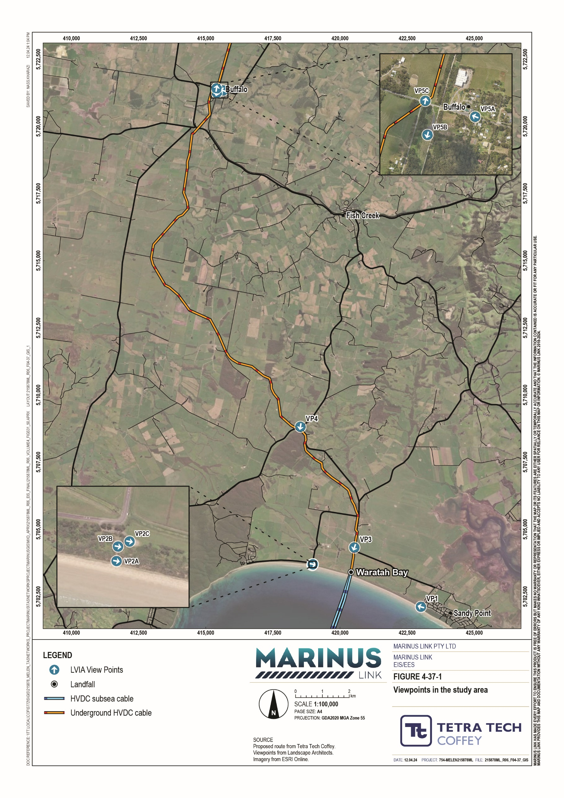

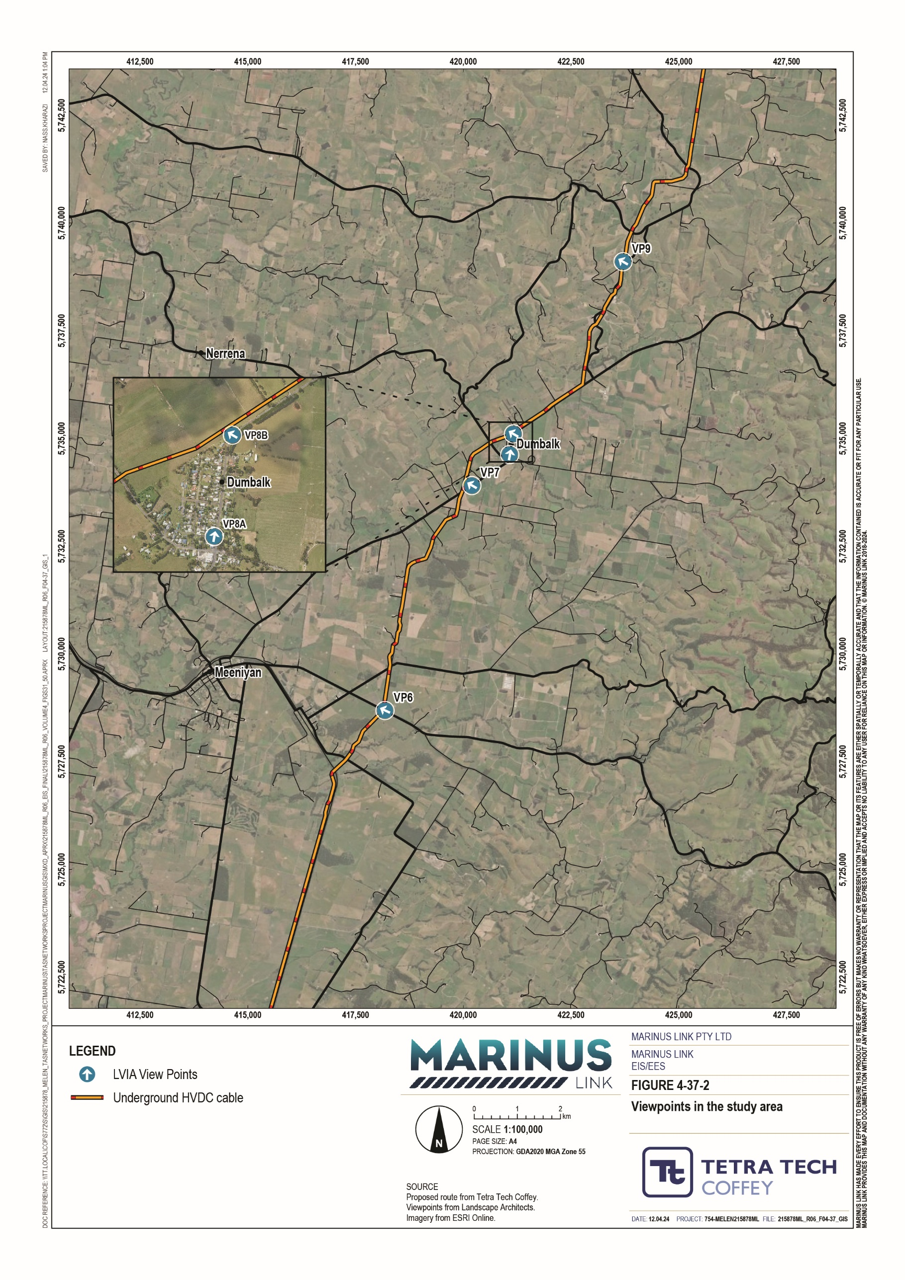

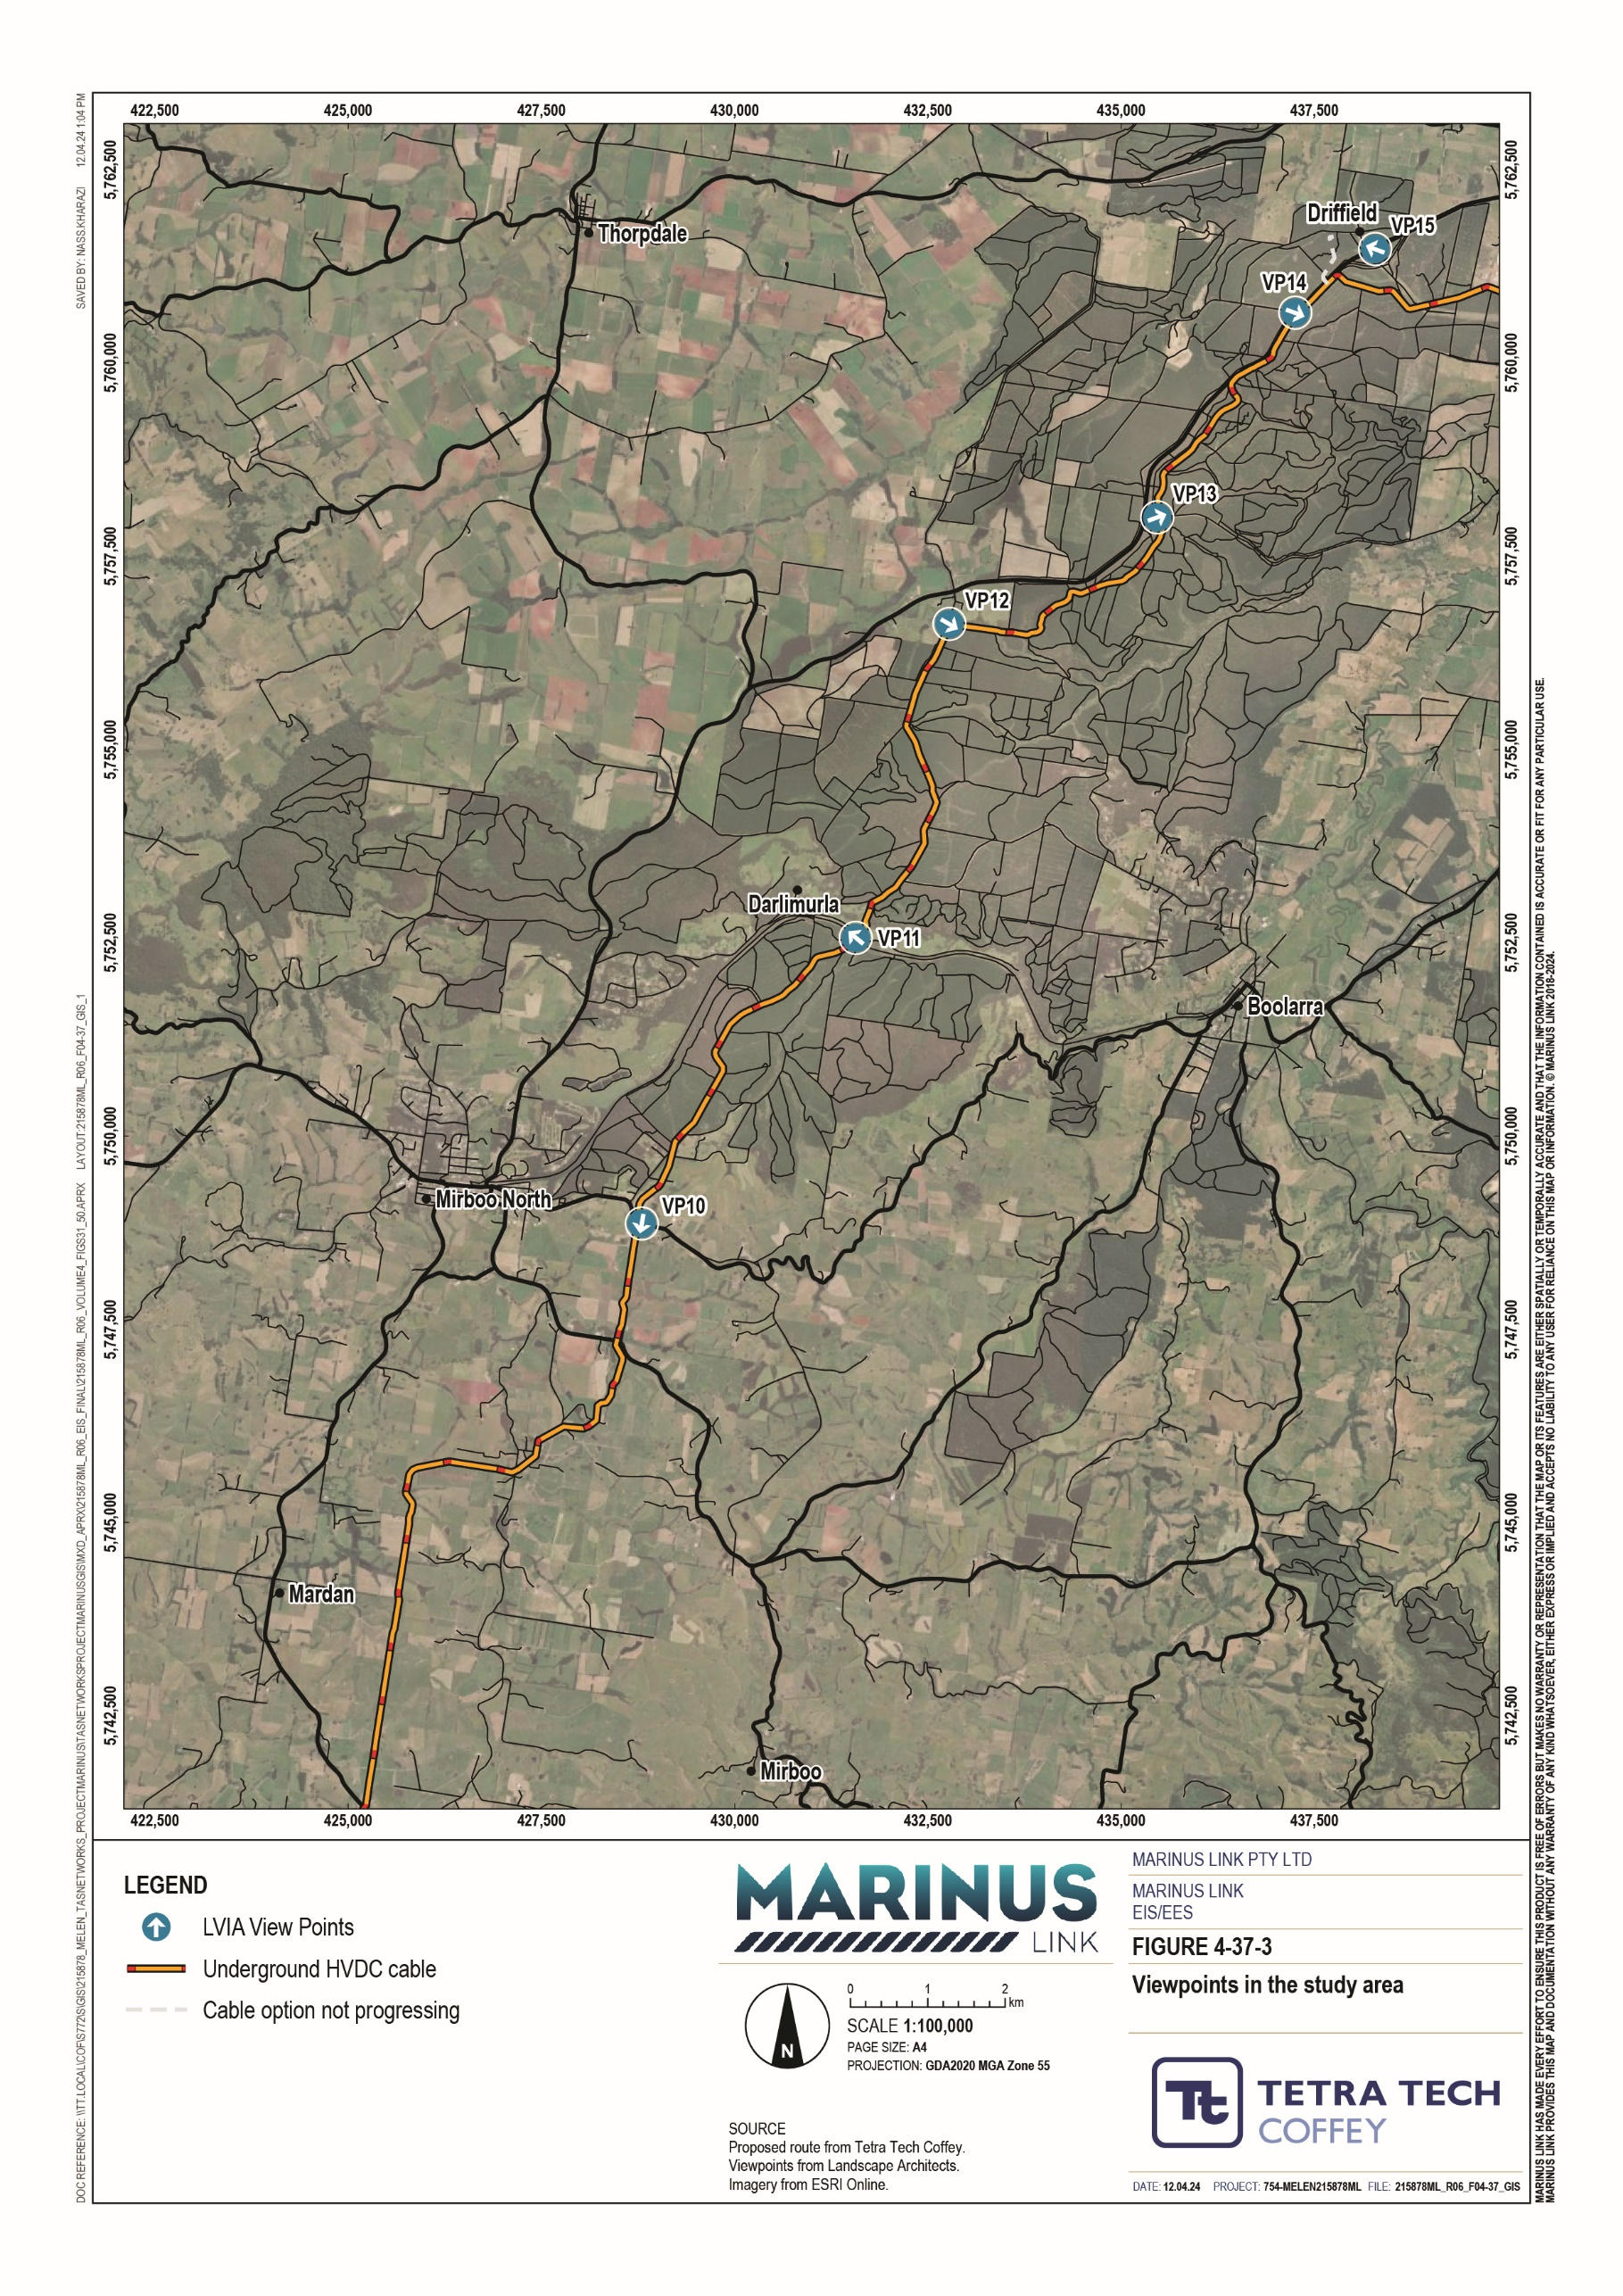

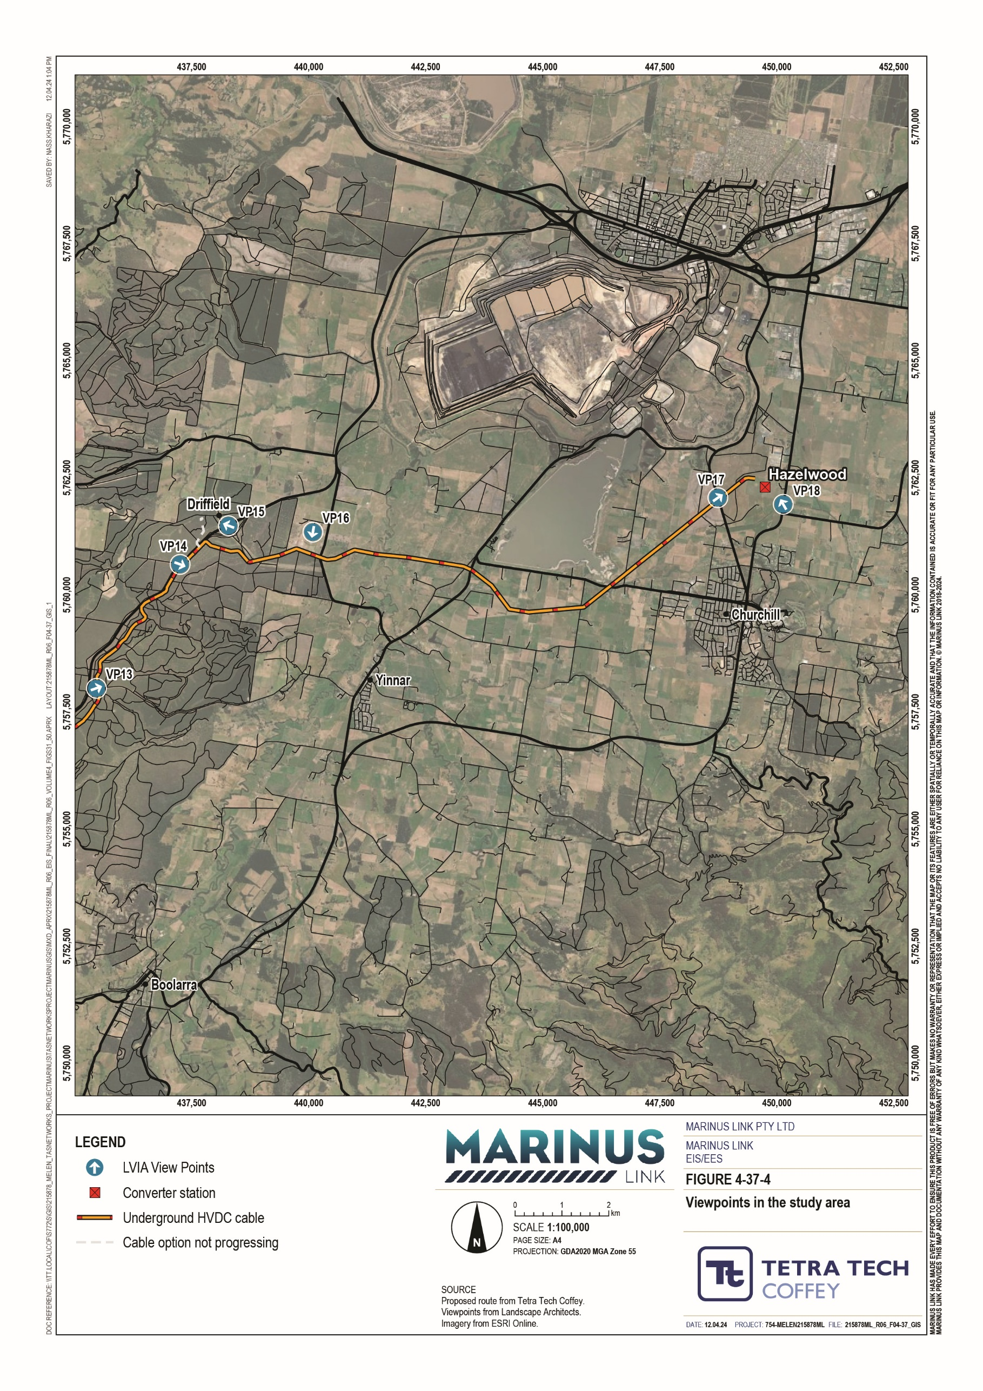

Coasts and plains
Four viewpoints have been selected from locations in the public domain within the Coast and Plains landscape character area. This section includes the area from Waratah Bay – Shallow Inlet Coastal Reserve to Fish Creek – Walkerville Road intersection. Photos from each viewpoint are provided in Technical Appendix R: Landscape and visual.
The viewpoint is in the Sandy Point township that is approximately 2.8 km east of the alignment. Landscape views include the coastline which has been assessed as having a moderate to high sensitivity to visual change. This viewpoint is within the coastal dunes and beaches landscape character unit.
Construction of the project in this location includes the offshore cable laying works and Victorian shore crossing. The transition station if required, will be located to the north of the dune system and not visible from the viewpoint. The shore crossing will avoid the dunes and beach through HDD construction, approximately 10 m below ground level, and extending approximately 900 m offshore to approximately 10 m water depth.
Offshore works include cable lay, burial, and guard vessels.

Construction activities may be noticeable from this viewpoint. However, the impacts on views and amenity of the nearby and surrounding areas are low due to distance from the project activities.
The coastal landscape has a moderate to high sensitivity to visual change due to the natural scenic values, and location within the coastal dunes and beaches landscape character unit.
Construction of the project from this location includes the offshore cable laying works and Victorian shore crossing. The transition station, if required, will be located to the north of the dune system and not visible. Construction of the transition station may be noticeable from the beach. However, the impacts on views and amenity of the nearby and surrounding areas will be low due to distance of the public viewpoint and the surrounding landscape being farmland.
Viewpoint 3 is located on Waratah Road, approximately 30 m west of the alignment and 130 m north of the transition station. This landscape is highly modified by farmland and roads, and consequently the sensitivity to visual change is low. Viewpoint 3 is in landscape character unit cleared flat farmland.
Visual changes during construction include establishment of site entries and gates, access roads and tracks to the construction corridor, stock-proof fencing, topsoil stripping and stockpiling.
The most noticeable visual changes associated with the transition station will be the entrance gates and perimeter fencing. All other features will be screened by vegetation and the low rise seen to the east of the site entrance.

Construction activity will be noticeable from Waratah Road due to the proximity of the works. The impact on views and amenities of the nearby and surrounding areas will be high though temporary, due to construction activities associated with the transition station. To mitigate visual impacts of the terminal station existing vegetation screening will be maintained (EPR LV03).
Viewpoint 4 is located at the intersection of Fish Creek-Walkerville Road and Waratah Road, approximately 115 m north-east of the alignment. The sensitivity to visual change in this area is low as the landscape has been highly modified. Viewpoint 4 is in landscape character unit cleared flat farmland.
Construction activity will be noticeable due to the proximity of the works. Views are limited to transitory views for road users, short in duration (viewed for a very short period in the road users landscape view) and extent. The impacts on views and amenity are low, and temporary. Retaining roadside vegetation partially screens or filters views toward the construction areas.

Cleared flat farmland (South)
Three viewpoints have been selected from locations in the public domain within the cleared farmland landscape character area. This section includes the area from Fish Creek – Walkerville Road intersection to the south to Dumbalk Township to the north. Photos from each viewpoint are provided in
Technical Appendix R: Landscape and visual.
Viewpoint 5 is located within the Buffalo township, approximately 230 m southeast of the project.

Viewpoint 5 is located within the township landscape character unit. The existing visual and landscape conditions are moderately sensitivity to visual change due to it being a highly modified landscape including built elements of the township.
Construction activities will be noticeable due to the proximity of the works to Buffalo. Views are limited to transitory views for road users and will be short in duration and extent. The impacts on views and amenity are moderate and temporary, with remediation returning the land cable area to seasonal pastures.
Viewpoint 6 is located at the intersection of South Gippsland Highway and McKittericks Road, approximately 55 m south-east of the alignment. The existing visual and landscape conditions have a low sensitivity to visual change due to the highly modified visual landscape.
Viewpoint 6 is located within cleared flat farmland landscape character unit. Views to the west include roadside vegetation. Views to the north are across cleared flat farmland and include existing elements such as hay sheds and other farm infrastructure.

Construction activity will be noticeable due to the proximity of the works. Project views are limited to transitory views for road users and will be short in duration and extent. The impacts on views and amenity are moderate, and temporary.
Viewpoint 7 is located on Meeniyan-Mirboo North Road, approximately 1 km southwest of Dumbalk township. The project is approximately 170 m northwest. Viewpoint 7 is located within cleared hilly farmland landscape character unit. Views to the north and over cleared flat farmland, to rolling hills in the distance.
The view includes scattered vegetation and wind break planting. This landscape has a low to moderate sensitivity to visual change due to the highly modified landscape.
Construction activity will be noticeable due to the proximity of the works. Views are limited to transitory views for road users, short in duration and extent. The impacts on views and amenity are temporary and moderate.

Rolling farmland and forests
Eight viewpoints have been selected from locations in the public domain within the rolling farmland and forests landscape character area. This section includes the area from Dumbalk Township to the south to Yinnar-Driffield Road to the north. Photos from each viewpoint are provided in Technical Appendix R: Landscape and visual.
Viewpoint 8 is located within the Dumbalk township, approximately 410 m southeast of the alignment. Viewpoint 8 is located within township landscape character unit and moderate sensitivity to change for views in the township landscape character unit and low to moderate sensitivity to change for views over the adjacent cleared hilly farmland landscape character unit from Dumbalk. Views to the north from within the Dumbalk township include a small strip of shops on the western side and residential dwellings. Vegetation is located within the roadside and within properties. Views to the project are filtered and screened from within the township. Views to the north-east and north from the northern edge of Dumbalk are across cleared rolling hills. Vegetation includes scattered trees, windbreak planting and vegetation along creek lines. Sensitivity to visual change in the township is moderate and low at the northern edge of Dumbalk looking north looking toward the project.
Construction activity will be noticeable at this viewpoint due to the proximity of the works. Views will be limited for road users passing by the site and be short in duration and extent. The impacts on views and amenity are temporary and moderate.

Viewpoint 9 is located on Meeniyan-Mirboo North Road, approximately 120 m north of H Wallers Road. The project is approximately 18 m west of this viewpoint. Viewpoint 9 is located within the cleared hilly farmland landscape character unit.
Views from this location have a low to moderate sensitivity to visual change based on the level of modification of the existing landscape. Construction activities will be seen from this location, but the view is limited to road users for a short duration and extent. Impact on views and amenity is moderate and temporary.
Viewpoint 10 is located on Boolarra-Mirboo North Road, approximately 40 m east of the intersection with Fullertons Road where the project will cross Boolarra-Mirboo North Road. The project will be approximately 20 m west of this viewpoint. Viewpoint 10 is located within the cleared hilly farmland landscape character unit. Views from this location have a low to moderate sensitivity to visual change based on the level of modification of the existing landscape.
The approved Delburn Wind Farm would be located 6 km northeast.

Views to the north and northeast are over cleared rolling farmland with vegetated hills. This view from a bend in the road is clear of roadside vegetation and allows for views of the project. This location has a low to moderate sensitivity to visual change.
The impacts on views and amenity during project construction are moderate and temporary, as the construction activity will be noticeable from this viewpoint.
Viewpoint 11 is located on the Grand Ridge Rail Trail approximately 150 m northwest of the Neil Trease Bridge. The project is approximately 20 m northwest. Viewpoint 11 is located within the plantation landscape character unit.
Views along this section of the Grand Ridge Trail are generally confined to the trail due to existing vegetation. User sensitivity to visual changes in the rail trail are high, however the overall landscape sensitivity to visual change is low.
It is assumed that construction under the rail trail will be undertaken using HDD. This minimises impact on the rail trail and users while retaining vegetation along the trail margins. Construction activity will be noticeable due to the close proximity of the works. Views will be limited in extent for trail users who could pass by the construction site for a short duration. The impacts on views and amenity are high due to viewer sensitivity, surrounding landscape character and disruptive nature of the works, though impacts will be temporary. Retaining trailside vegetation, partially screening or filtering views toward the construction areas will mitigate visual impact from view of rail trail users.

Viewpoint 12 is located on Ten Mile Creek Road, approximately 400 m south of the intersection with Strzelecki Highway. The project is located approximately 40 m southeast of this viewpoint. Viewpoint 12 is located within the plantation landscape character unit. Views from this location have a low sensitivity to visual change based on the level of modification of the existing landscape.
Views from Ten Mile Creek Road are filtered by the surrounding vegetation. The project is in the cleared landscape alongside the plantation access tracks so construction activity will be noticeable in this landscape view.
The impact will be minimal and short term so the impact to views and amenity is expected to be moderate. Turbines in the approved Delburn Wind Farm will be visible to the north.
Viewpoint 13 is located on Creamery Road approximately 170 m east of the intersection with Strzelecki Highway. Creamery Road is a local access road that runs through a section of the plantation. The project alignment crosses Creamery Road approximately 25 m east of the viewpoint. Viewpoint 13 is located within the plantation landscape character unit.
Views to the east are across the plantation through to the Plains in the east. Views from this location have a low sensitivity to visual change based on the level of modification of the existing landscape.
Turbines in the approved Delburn Wind Farm may also be visible.

The project construction activity will be noticeable but limited for road users passing by. The impacts to views and amenity will be short in duration and expected to be moderate.
Viewpoint 14 is located at the intersection of Strzelecki Highway and a local access track Smiths Road. Viewpoint 14 is located within the plantation landscape character unit. The project is approximately 40 m southeast. A construction laydown area is approximately 40 m northwest.
Views to the northwest and east are across the Strzelecki Highway to timber plantations. This viewpoint is located within the approved Delburn Wind Farm site boundary, a highly modified landscape. Views from this location have a low sensitivity to visual change based on the level of modification of the existing landscape. Turbines may be visible above plantation trees where breaks in roadside vegetation allow.
Construction activity will be highly noticeable at the intersection but temporary. The impacts on views and amenity of the nearby and surrounding areas are expected to be high.

Viewpoint 15 is located on Strzelecki Highway approximately 425 m southwest of the intersection with Fords Road. The Hazelwood converter station is approximately 500 m southwest. Viewpoint 15 is located within the plantation landscape character unit.
Current landscape sensitivity to visual change is low due to the highly modified landscape at this viewpoint.

This viewpoint is located adjacent to the approved Delburn Wind Farm. Views are expected to include turbines from the Delburn wind farm and existing 500 kV transmission lines. Although the turbines are not yet constructed, they will be visible from parts of the Strzelecki Highway. There is nil visual impact expected at this location during construction of the project because of the highly modified landscape containing existing infrastructure and the project won’t be visible.

Cleared flat farmland (North)
Three viewpoints have been selected from locations in the public domain within the Cleared Farmland landscape character area. This section includes the area from Yinnar-Driffield Road to the west to Tramway Road to the east.
Viewpoint 16 is located within a rural residential area on Yourongi Court, the project is located 460 m to the south. Viewpoint 16 is located within the rural residential landscape character unit. This viewpoint comprises cleared rolling hills within the rural residential area, and vegetated hills and plantation areas to the south.
Landscape sensitivity to visual change from this viewpoint is moderate for views of the landscape and high for viewpoints from individual dwellings.
Construction activities will be partially filtered or screened by topography and existing vegetation as the project is in the timber plantation areas approximately 460 m to the south.
Construction activity will be screened by existing topography and filtered by existing vegetation, consequently the impact of construction works will be negligible where visible.
Viewpoint 17 is located on Monash Way, approximately 1.1 km northwest of Silcocks Road. Hazelwood converter station will be approximately 1.0 km northeast. Viewpoint 17 is located within the cleared flat farmland landscape character unit.
Views are highly disturbed with existing overhead high-voltage transmission infrastructure, including the 500 kV Hazelwood to Melbourne Transmission line, Hazelwood Terminal Station visible from this viewpoint. The Wooreen Energy Storage System is also proposed in proximity to this viewpoint. Landscape sensitivity to visual change is low due to the highly modified landscape at this viewpoint.
Construction activity will be noticeable from Monash Way. The impacts on views and amenity of the nearby and surrounding areas will be low.

Viewpoint 18 is located on Tramway Road, approximately 210 m north of Boldings Road. The Hazelwood converter station will be approximately 400 m northwest. Viewpoint 18 is located within the cleared flat farmland landscape character unit. Landscape sensitivity to visual change is low due to the highly modified landscape at this viewpoint.
This view is north of an existing windbreak planting that runs perpendicular to Tramway Road which screens views from locations further to the south and the location of the proposed transition station.
Views to the west and northwest are over cleared farmland with Hazelwood Terminal Station and the 500 kV Hazelwood to Melbourne transmission line visible from this viewpoint.
Construction works at the Hazelwood converter station includes clearing of plantation timbers, and installation of perimeter fencing, fire trails and access tracks prior to installation of the switchyard and cut-in of existing 500 kV Hazelwood to Melbourne Transmission lines.
Construction activity will be noticeable from Tramway Road. The impacts on views and amenity of the nearby and surrounding areas will be high as the viewpoint is highly visible from Tramway Road. To mitigate visual impacts in construction vegetation screening will be maintained and planted within the site boundaries to screen the converter station construction (EPR LV02).

Operation impacts
Following the rehabilitation of the construction areas, most of the project will be underground and within grassed easements in farming land. This confines the landscape and visual impacts to the remaining above ground-built elements of the Waratah Bay transition station in the south and the Hazelwood converter station in the north of the study area. These above ground built elements present a nil to low visual impact to the respective landscape character unit viewpoints in the operation phase. This is due to minimal lighting required on the above ground built structures, establishment of vegetation screening and the design of above ground structures. The above ground structures also won’t be dominant features in the landscape.
The draft Planning Scheme Amendment and Incorporated Document for the project requires that a Development Plan is prepared for the final design of above ground components of the project and approved by the Minister for Planning. Development Plans will show the site layout plans and elevations for the converter station, communications building and potential transmission station. Further description of the draft Planning Scheme Amendment is provided in Volume 1, Chapter 4 – Legislative framework and Volume 5, Chapter 2 – Environmental Management Framework.

Decommissioning impacts
The operational lifespan of the project is 40 years. At this time the project will either be decommissioned or upgraded.
Decommissioning will be planned and carried out in accordance with regulatory and landholder requirements at the time. A decommissioning plan in accordance with approvals conditions will be prepared prior to planned end of service and decommissioning of the project.
Requirements at the time will determine the scope of decommissioning activities and impacts. The key objective of decommissioning will be to leave a safe, stable, and non-polluting environment, and minimise impacts during the removal of infrastructure.
In the event that the project is decommissioned, all above-ground infrastructure will be removed, and associated land returned to the previous land use or as agreed with the landholder.
Decommissioning activities required to meet the objective will include, as a minimum, removal of above ground buildings and structures. Remediation of any contamination and reinstatement and rehabilitation of the site will be undertaken to provide a self-supporting landform suitable for the end land use.
Should removal of project infrastructure be required at the end of its operational life, it is expected that the nature, extent, and magnitude of impacts will be no greater than those associated with construction and limited to the transition station at Waratah Bay and the Hazelwood converter station.
A decommissioning management plan will be prepared to outline how activities would be undertaken and potential impacts managed (Volume 5, Chapter 2 – Environmental Management Framework).

Environmental performance requirements
EPRs set out the environmental outcomes that must be achieved during all phases of the project. In developing these EPRs, industry standards and guidelines, good practice and the latest approaches to managing impacts were considered. Project specific management measures, relevant legislation and policy requirements informed these EPRs.
The EPRs that will be implemented to manage potential impacts on landscape and visual are listed in Table 7-4.

EPR ID | Environmental performance requirement
LV01 | Design converter station buildings to minimise visual impacts from public locations  During the design of the converter station buildings, incorporate design outcomes to reduce the visual prominence of the buildings in views from the public roads. Design of the building facades will be documented in a Development Plan(s) and may include, but not be limited to:  Tapering of leading edges of the building and roofline. Articulation of building facades.  Using colours such as dark greens, reflecting existing vegetation, or muted tones minimises contrast and prominence.
LV02 | Implement measures to establish and maintain a vegetative screen for public views of above ground components  During the design of the converter station and transition station, develop measures to ensure a vegetative screen is established to shield views from public roads.  Strategies to achieve this may include, but not be limited to: Ensuring sufficient setbacks along the road frontages. Layered landscaping using endemic species.
LV03 | Design transition station to minimise visual impacts from public locations  During the design of the transition station, develop measures to provide screening from Waratah Road that is similar to, or better than that which is provided by existing vegetation and landforms. Strategies to achieve this may include, but not be limited to:  Retaining existing vegetation within the site.  Including vegetation or landscaping within the site boundaries to screen or filter views of project features using endemic species.  Locating perimeter fencing behind landscape plantings or landforms.
LV04 | Develop and implement measures to manage potential visual impacts in operation  As part of the OEMP, develop and implement measures to minimise visual impacts during the operation. The measures should address:  Monitoring vegetation screening and landscaping with site boundaries for at least two years ensuring establishment and long term viability of landscaping.  Replacement of any failed vegetation screens or landscaping with endemic species.

The complete list of EPRs for the project is provided in Volume 5, Chapter 2 – Environmental Management Framework.

Residual impacts
The residual impacts on landscape and visual values have considered the effective implementation of the potential mitigation measures that will be implemented to comply with proposed EPRs outlined in
Section 7.6.

Construction
Residual impacts in construction are predominantly low to moderate. While project elements are visible from key publicly accessible viewpoints, the land cable construction areas will move along the project alignment and the impacts will therefore be short term.

High visual impacts of temporary duration (within the field of view experienced) will occur during construction at Waratah Road, the intersection of Strzelecki Highway and Smiths Road and Tramway Road where construction will occur for longer durations for the transition station, laydown areas and Hazelwood converter station. Works in the vicinity of Grand Ridge Rail Trail also have been assessed as high visual impact, in construction, albeit it temporary, due to proximity to the recreational rail trail.
Mitigation measures implemented to comply with EPRs to reduce the residual impacts in construction are limited to minimising visual disturbance in the landscape by maintaining vegetation screening at static construction fronts (EPRs LV02, LV03).

Operation
The following measures implemented to comply with EPRs will reduce the visual impact of the project during the operation phase:
Using exterior colours for converter station buildings that minimise contrast with vegetation in surrounding farming areas, roadsides, and vegetated hills in the distance (EPR LV01).
Reducing the prominence of converter station buildings in the landscape through designed elements that break up the exterior appearance of the building facades. This will allow the converter station buildings to blend into the highly modified and variable farmland landscape (EPR LV01).
Maintenance and promotion of landscape screening within the site boundary of the Waratah Bay transition station and Hazelwood converter station locations (EPRs LV02, LV03, LV04).
The residual impacts in the regional landscape character units after applying these measures is discussed below.
Residual visual and landscape impacts in the coasts and plains regional landscape character unit have been assessed as nil to low. The transition station will be noticeable but not a dominant feature in the landscape view at Waratah Road due to vegetation, topography and distance from Waratah Bay viewpoints. The low- rise and existing vegetation will be reinstated within the project boundaries, achieving similar or improved levels of screening and filtering of views. Screening vegetation will be monitored for at least two years to confirm that screening of the site is achieved (EPR LV04). A photomontage of the Waratah Bay viewpoint showing the entrance to the potential transition station site is shown in Figure 4-38.
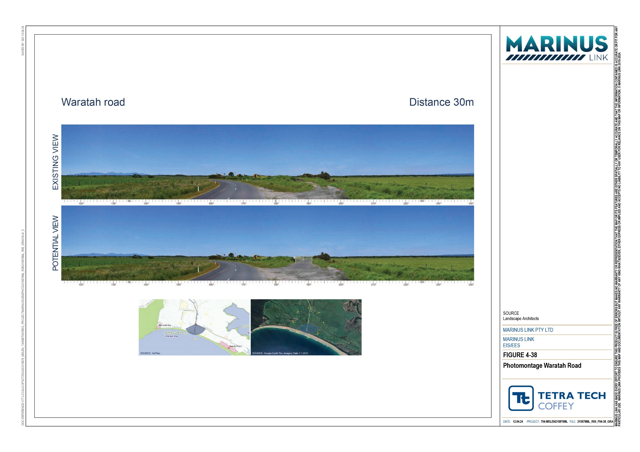

Residual visual and landscape impacts in the southern cleared flat farmland regional landscape character unit have been assessed as nil to negligible. Views within the Buffalo township will be filtered and screened by existing built elements of the township and vegetation. Views from the northern edge of Buffalo will include some noticeable elements of the project such as the cleared easement. While noticeable, the changes will not be visually dominant and will not contrast the existing visual setting and character of the areas at the viewpoints.
Residual visual and landscape impacts in the rolling farmland and forests regional landscape character unit have been assessed as nil to negligible.
Project infrastructure will only be visible intermittently and for a short duration (i.e., while passing by on adjacent roads). Therefore, impacts to views will be short in duration and over a landscape that has a low sensitivity to visual change. While noticeable, the visual changes from the project will not be visually dominant and will not contrast to the existing visual setting and character of the areas.
Residual impacts in cleared farmland in the north of the study area are nil to low.

At Viewpoint 17 – Monash Way the residual visual impact of the project is negligible due to the transition station being barely discernible.
At Viewpoint 18 – Tramway Road the Hazelwood converter station will be a noticeable element in the view; however, views are be confined to large sheds, similar in scale to other buildings in the surrounding farming land (Figure 4-39). Project infrastructure will only be visible intermittently and for a short duration (i.e., while passing by on adjacent roads). Therefore, views will be short in duration and over a landscape that has a low sensitivity to visual change. The residual visual impact will be low with implementation of landscape sensitive design elements for the converter station buildings and development of vegetation screening (EPRs LV01, LV02). Screening vegetation will be monitored for at least two years to confirm that screening of the site is achieved (EPR LV04).

Volume 4 – Victorian terrestrial environment Page 7-28

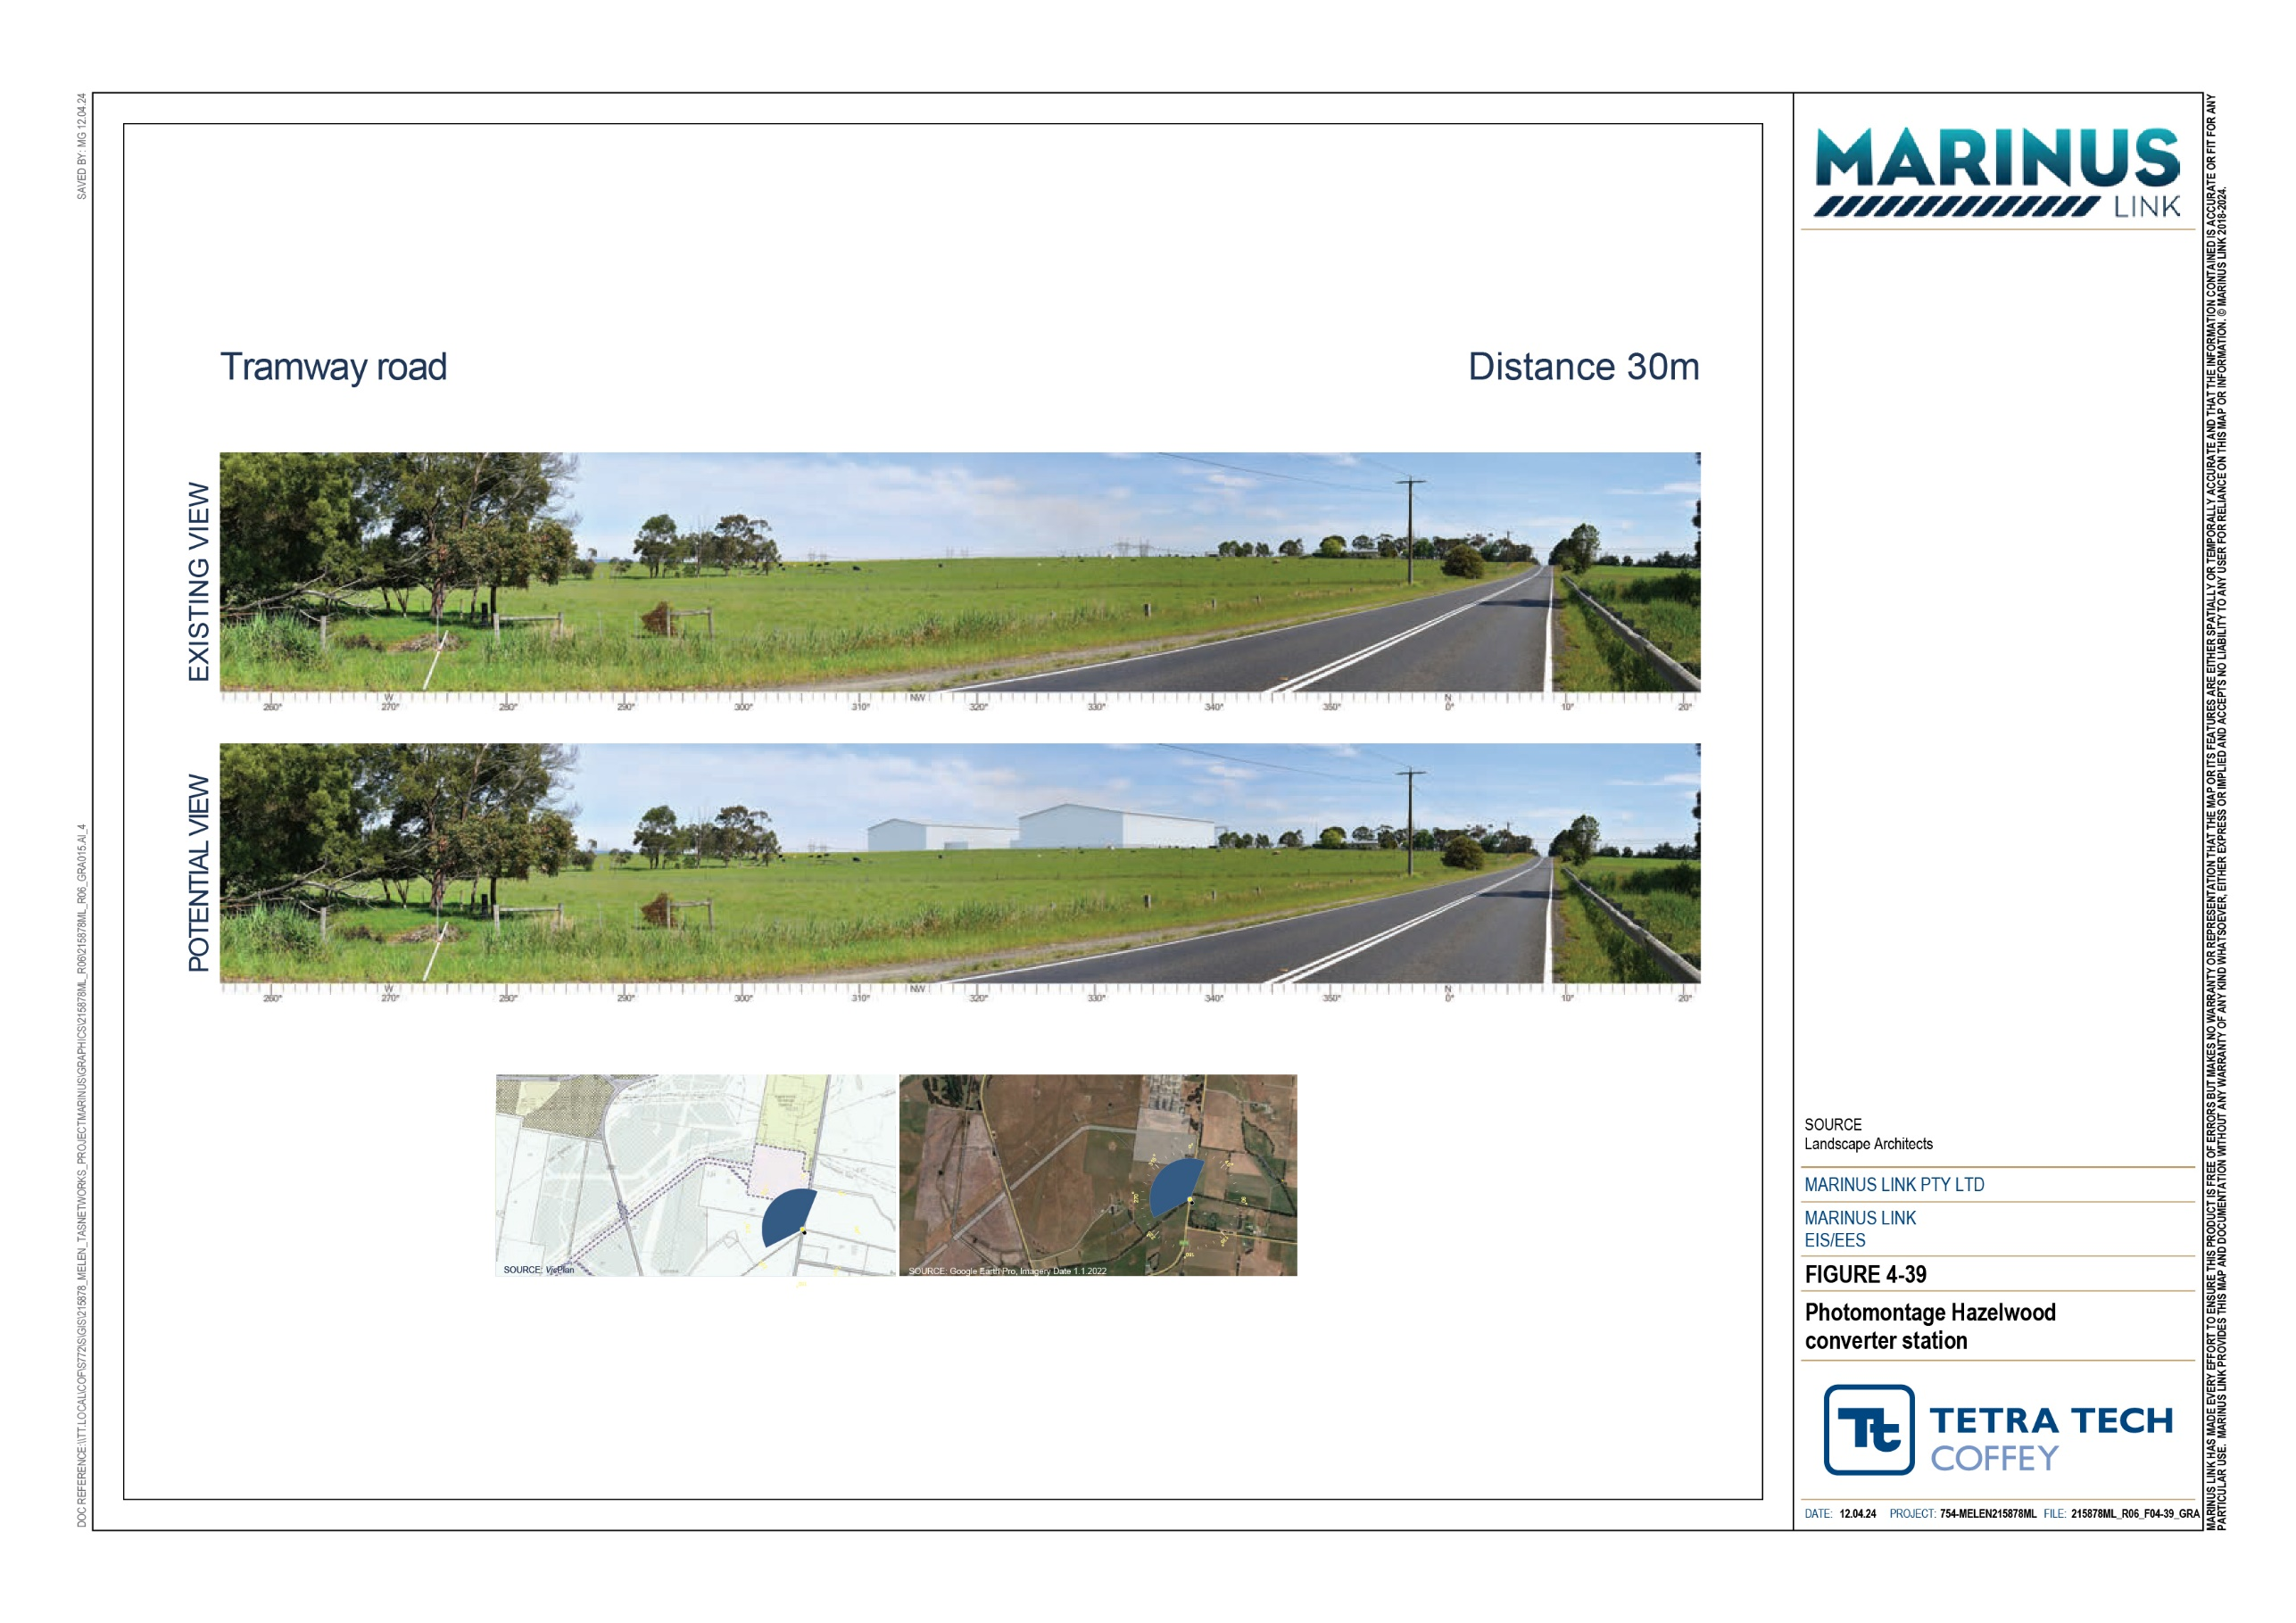

Residual impact summary
The initial landscape and visual impact assessment considers the effects of construction of the project along the project alignment. The residual impacts consider the final visual impacts of the project in operation once the construction areas have been rehabilitated and above ground structures are built and implementation of mitigation measures to achieve EPRs.
A summary of the residual impact assessment is provided in Table 7-5.

Regional Landscape Character Unit | Viewpoint | Initial impact | Justification for residual rating | Residual impact
Coasts and plains | Viewpoint 1-  Ned Neale’s Lookout | Low | Some construction activity may be noticeable from Neale’s lookout. In operation, there will be no visible features of the project. | Nil

change
Coasts and plains | Viewpoint 2- Waratah Bay Beach | Low | Construction activity may be noticeable but will be at quite a distance from the viewpoint. In operation the transition station will be noticeable but will not be a dominant feature in the landscape. | Negligible
Coasts and plains | Viewpoint 3- Waratah Road | High | Visual changes during construction will include site establishment of site entries and gates, access roads and tracks. Entrance gates and perimeter fencing for the transition station site will be noticeable in operation but will be screened by vegetation and an earthen rise. | Low
Coasts and plains | Viewpoint 4- Intersection Fish Creek – Walkerville Road and Waratah Road | Low | Construction activity will be noticeable due to the close proximity of the works to the road. Views will be limited to transitory views for road users, short in duration and extent. Roadside vegetation will screen construction areas.  In operation views will be short in duration and over a landscape that has a low sensitivity to visual | Negligible
Cleared farmland South | Viewpoint 5- Buffalo township / Great Southern Rail Trail | Moderate | Construction activity will be noticeable due to the close proximity of the works to the roads, Buffalo township and rail trail. Views will be limited to transitory views for road users, short in duration and extent.  Views within Buffalo township will be filtered or screened by existing vegetation and built form. Following remediation, views to the north from the edge of Buffalo will include a cleared easement with farm fencing to the west of the vegetation along the Great Southern Rail Trail. While noticeable, the changes will not be visually dominant. | Nil-Negligible
Cleared farmland South | Viewpoint 6- South Gippsland Highway | Moderate | Construction activity will be noticeable due to the close proximity of the works to the South Gippsland Highway. Views will be limited to transitory views for road users, short in duration and extent. | Negligible
 |  |  | In operation views will be short in duration and over a landscape that has a low sensitivity to visual
 |  |  | change.
Cleared farmland South | Viewpoint 7- Meeniyan – Mirboo North Road | Moderate | Construction activity will be noticeable for road users though transitory in view and short in extent. In operation views will also be short in duration in a landscape that has low sensitivity to visual | Negligible

change.

Regional Landscape Character Unit | Viewpoint | Initial impact | Justification for residual rating | Residual impact
Rolling farmland and forests | Viewpoint 8- Dumbalk Township | Moderate | Construction activity will be noticeable due to the close proximity of the works to the Dumbalk township. Views will be limited to transitory views for road users, short in duration and extent.  Views from within Dumbalk township will be filtered or screened by existing vegetation and built form.  Following remediation, views to the north from the northern edge of town will include a cleared easement with farm fencing on either side, while noticeable, the changes will not be visually dominant. | Nil within the township  Negligible from the northern edge of the township
Rolling farmland and forests | Viewpoint 9- Meeniyan – Mirboo North Road | Moderate | Construction activity will be noticeable though views will be limited to transitory views for road users, short in duration and extent.  In operation views will be short in duration and over a landscape that has a low sensitivity to visual change. | Negligible
Rolling farmland and forests | Viewpoint 10- Boolarra – Mirboo North Road | Moderate | Construction activity will be noticeable though views will be limited to transitory views for road users, short in duration and extent.  After remediation and in operations views will be in short duration over a landscape that has low sensitivity to change. | Negligible
Rolling farmland and forests | Viewpoint 11- Grand Ridge Trail | High | Construction activity will be noticeable due to the close proximity of the works. Views from Grand Ridge Trail will be limited to transitory views for road users, short in duration and extent. Vegetation buffers will also screen the works. | Negligible
Rolling farmland and forests | Viewpoint 12-  Ten Mile Creek Road | Moderate | Construction activity will be noticeable due to the close proximity of the works. Views from Mile Creek Road will be limited to transitory views for road users, short in duration and extent.  Following remediation, views will include a cleared easement alongside the plantation access tracks, similar to the existing setting. | Negligible
Rolling farmland and forests | Viewpoint 13- Creamery Road | Moderate | Construction activity will be noticeable due to the close proximity of the works. Views will be limited to transitory views for road users, short in duration and extent. | Negligible
 |  |  | Following remediation views will include a cleared easement within the plantation, which will not be dissimilar to the existing landscape.

use and filtered by vegetation.
Regional Landscape Character Unit | Viewpoint | Initial impact | Justification for residual rating | Residual impact
Rolling farmland and forests | Viewpoint 14- Intersection of Strzelecki Highway and Smiths Road | High | Construction works and laydown area will be noticeable but temporarily in view from Strzelecki Highway and Smiths Road.  Following removal of laydown area and completion of construction area will be returned to current | Negligible
Rolling farmland and forests | Viewpoint 15- Strzelecki Highway | Low | The impacts on views and amenity of the nearby and surrounding areas will be Low, because views are short in duration from the Strzelecki highway, and due to adjacent high voltage transmission lines with a backdrop of pine plantation which is also subject to rapid and highly noticeable change.  However, these views will be short in duration and over a landscape that has a low sensitivity to visual change. | Low
Cleared farmland North | Viewpoint 16- Yourongi Court | Negligible | Construction activities will be partially filtered or screened by topography and existing vegetation. There will be no discernible change in views from Yourongi Court at this location following the construction of the project. | Nil
Cleared farmland North | Viewpoint 17- Monash Way | Low | Construction activity will be noticeable. Views will be short in duration from Monash Way over a landscape with a low sensitivity to visual change and one that includes many other constructed and obvious features. | Negligible
Cleared farmland North | Viewpoint 18- Tramway Road | High | Construction of the Hazelwood converter station will be noticeable. It will be of similar form and scale as the adjacent Hazelwood terminal station. The scale of the converter station will be comparable to large farming sheds found elsewhere in the landscape, and the views to the converter station will be of short duration from Tramway Road and over a landscape with low sensitivity to visual change. | Low

Cumulative impacts
The landscape and visual assessment of cumulative impacts considers where multiple projects occur in the study area and can be viewed from publicly accessible or private viewpoints. Potential cumulative impacts occur in operation where there is a permanent change to a landscape character area. Cumulative impacts during construction only occur where multiple project construction areas are visible from the same viewpoint at the same time. Therefore, the landscape and visual cumulative impacts considered for the project are for the operation phase only.
Existing power generation and transmission infrastructure near the northern end of the project include open- cut coal mines, thermal power stations, terminal stations and high-voltage transmission lines. The project will be constructed in close proximity to the 500 kV Hazelwood to Cranbourne overhead transmission line between the Strzelecki Highway to the west and Tram Road to the East. The Jeerelang “A” Gas Fired Power Station, Jeerelang Terminal Station and Hazelwood terminal station are also adjacent to the proposed Hazelwood converter station.
The Delburn Wind Farm, Hazelwood Rehabilitation Project, and the Worreen Energy Storage System (WESS) have been reviewed for cumulative impacts in the LVIA (Appendix R: Landscape and visual).
The approved Delburn Wind Farm grid connection is approximately 11.5 km northwest of the Hazelwood converter station. Given the above ground elements of the project are a considerable distance from the Delburn Wind Farm, it is expected that there will be limited potential for simultaneous, sequential visual impacts.
The Hazelwood Rehabilitation Project involves decommissioning remaining buildings, roads and infrastructure, earthworks to reprofile steep slopes, reinstating some water courses to a more natural alignment, and the proposed creation of a mine lake over time.
The WESS is proposed in the land to the north of the existing Hazelwood Terminal Station and the Hazelwood converter station.
The landscape and visual assessment identified that there is not sufficient public information available to consider the potential cumulative impacts associated with the Hazelwood Rehabilitation Project or the WESS.
To reduce the potential for cumulative landscape and visual impacts, cumulative visual impacts have been managed through the design of the project, by:
Reducing visual clutter through structure placement and design where co-location of easements and infrastructure is to occur.
Locating converter station away from key viewing locations or dwellings and settled areas.

Conclusion
The project travels through six landscape character units that are within three regional landscape character areas. The project's visual impacts have been assessed from eighteen viewpoint locations within the public domain.
Most of the above-ground infrastructure is in farming areas, which has a low sensitivity to changes in landscape views. Impacts on sensitive coastal landscapes will be avoided by constructing the project below- ground.
The assessment identified construction impacts ranging from nil to high. The highest visual impact assessed in construction were at viewpoints that overlooked static construction locations, such as the Waratah Bay transition station, laydown area off Strzelecki Highway and the Hazelwood converter station viewed from Tramway Road. Construction of the land cable near the Grand Rail Trail was also assessed as high impact due to the viewer numbers in that area, and scenic values at that location.
Most viewpoints that overlook the moving front of construction related to the land cable installation have nil to moderate impact, due to the short term and temporary visual intrusion in the landscape or distance from viewpoints.
The LVIA determined there are limited to no measures that can be employed to mitigate the visual impacts of construction works in the study area, as the construction work front will move through before vegetation screening mitigation measures come into effect. However, all residual visual impacts during construction have been assessed as low or negligible.
Overall residual landscape and visual impacts in operation are low due to:

Most of the project being underground

Route selection to directly avoid townships and communities or areas of residentially zoned land.

Minimising distances where the project will run parallel to major roads, highways, and tourist routes.

Locating the project to minimise vegetation disturbance along property boundaries and fence lines; and

Locating the project alongside existing tracks and cleared easements in forested areas.

The focus of the landscape and visual EPRs are to minimise visual impact in the landscape of static above ground project elements including the transition station and Hazelwood converter station, through vegetation screening (EPRs LV02, LV03) and using sympathetic design elements that minimise contrast with the existing landscape view (EPR LV01).
Following the implementation of measures to comply with the EPRs, it is expected that the project will be able to meet the EES evaluation objective to “Avoid and, where avoidance is not possible, minimise the potential adverse effects on landscape and visual amenity”.

