Traffic and transport
This chapter provides an assessment of the traffic and transport impacts associated with the construction, operation, and decommissioning of the project. This chapter is based on the impact assessment provided in Technical Appendix W: Traffic and transport.
The project will utilise arterial roads, minor streets and bridges within the project area. Impacts to traffic and transport occur when a project generates increased volumes of traffic, leading to impacts on the condition, safety and performance and capacity of the road network.
This chapter addresses the following sections of the EIS guidelines:

Section 4: Description of the action

Section 5: Relevant impacts

Refer to Attachment 1: Guidelines for the Content of a Draft Environmental Impact Statement for the EIS guidelines.
The EES scoping requirements set out the following evaluation objective relevant to traffic and transport:

Amenity, health, safety and transport – Avoid and, where avoidance is not possible, minimise adverse effects on community amenity, health and safety, with regard to noise, vibration, air quality including dust, the transport network, greenhouse gas emissions, fire risk and electromagnetic fields.
Refer to Attachment 2: Scoping Requirements Marinus Link Environment Effects Statement for the EES scoping requirements.
The EIS guidelines relevant to marine traffic and transport are addressed in Volume 3, Chapter 2 – Marine ecology.
The traffic and transport assessment considers the potential effects of the project on traffic volumes, public transport, pedestrians, cyclists, and the wider road network. It also recommends EPRs to avoid, reduce and mitigate impacts.
Other aspects covered in the above EES evaluation objective are addressed in the following EES chapters:

Volume 1, Chapter 9 – Sustainability, climate change and greenhouse gas emissions

Volume 1, Chapter 10 – Electromagnetic fields

Volume 4, Chapter 9 – Air quality

Volume 4, Chapter 10 – Noise and vibration

Volume 4, Chapter 12 – Bushfire

Volume 4, Chapter 16 – Social

Method
The key steps taken in assessing the impacts to traffic and transport included:

Definition of a study area.

Conducting a desktop assessment and baseline data review to assess the existing traffic volumes and operation of the transport network within the immediate surrounds of the project. A review of traffic engineering literature and publicly available data (including Department of Transport and Planning’s (DTP) database and the VicRoads vehicle crash data) was undertaken.
Classifying roads in accordance with the Austroads Guide to Road Design: Part 3, Section 4.2.6 to determine their theoretical capacity.
Signalised & unsignalised Intersection Design and Research Aid (SIDRA) modelling to calculate the intersection performance - applying the Austroads Guide to Traffic Management: Part 6, Section 3.3.6 Warrants for BA, AU and CH Turn Treatments.
Swept path assessment to analyse whether intersections have the necessary geometry to accommodate the turning of heavy vehicles servicing the project.
Site inspection of the road network surrounding the project extents. The site inspection involved a visual condition assessment of the pavement along proposed transport routes that would be used by the project.
Automatic traffic count (ATC) tube counts to evaluate the traffic volumes along the project cable route, which are anticipated to be utilised by construction vehicles.
Assessment of road pavement conditions and capacity of the road network (including bridges and culverts) to accommodate heavy construction vehicles and transport of large project components such as transformers for the converter station.
Review of alternative modes of transport, including the public transport network, walking paths and cycling infrastructure.
Assessment of the traffic and transport impacts during construction, operation, and decommissioning of the project using the significance and compliance methods described in Volume 1, Chapter 5 – EIS/EES assessment framework.
Development of EPRs in response to the impact assessment to set the required environmental outcomes for the project. The assessment of residual impacts presented in this chapter assume implementation of measures to comply with the EPRs. .
Further details of the method are provided in Technical Appendix W: Traffic and transport.

Study area
The traffic and transport study area encompasses the road network immediately adjacent to the project alignment and those required for transport of materials to project area, including:
Major arterial roads that service the area’s towns.

Arterial roads within Gippsland that connect the major arterial roads.

Minor streets and access tracks that will be utilised to access the cable easement.

The study assessed the existing conditions of the road network and identified whether upgrades may be required to accommodate the access needs of the project, including access to the following locations:
HDD drill pad for the shore crossing at Waratah Bay and other HDD locations along the cable alignment.

Transition station site near Waratah Bay.

Cable route access tracks and laydown areas utilised to construct the cable.

Hazelwood converter station.

Figure 4-40 shows the approximate extent of the assessed study area and project-related travel routes.
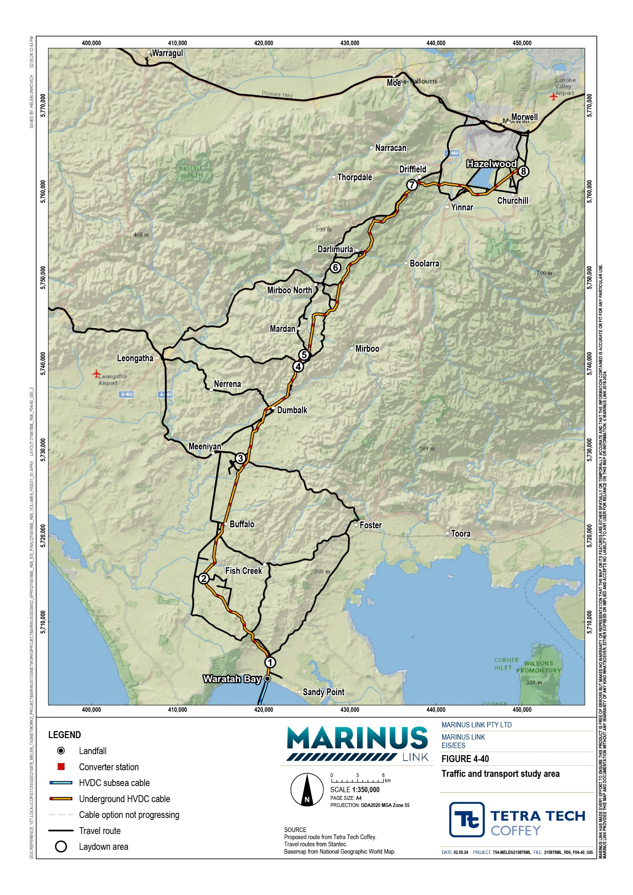

Legislative context
Table 8-1 outlines the key legislation used to inform the traffic and transport impact assessment.

Title | Relevance to the assessment
Transport Integration Act 2010 (Vic) | Establishes a framework for an integrated and sustainable transport system for Victoria and requires that all decisions affecting the transport system consider the principles and objectives set out in the Act.
Road Management Act 2004 (Vic) | Provides the statutory framework for VicRoads and local councils to manage the Victorian road network and the coordination of road reserves for roadways, pathways, infrastructure, and similar purposes.
Local Government Act 1989 (Vic) | Describes the objectives, roles and functions of local government in Victoria. The Act establishes a framework for the local to plan, develop, and maintain their local road networks, ensuring safe and efficient movement of people and vehicles. The Act grants local authorities the authority to implement traffic management measures, including speed limits, parking regulations, and road signage.
Road Safety Act 1986 (Vic) | Establishes regulations and provisions related to driver licensing, road rules, vehicle standards, and enforcement measures to reduce road accidents and protect the wellbeing of road users.
Heavy Vehicle National Law 2004 (Cwlth) (HVNL) | Regulates the vehicle standards, mass and dimension limits and operator accreditation of vehicles over 4.5 tonnes (t) in gross vehicle mass.

Assumptions and limitations
The key assumptions and limitations of the transport and traffic assessment are:

The baseline level of traffic assessed is representative of typical operating conditions. The assessment does not consider fluctuations experienced on the road network such as on travel routes to tourist destinations during holiday periods.
The travel routes of heavy construction vehicles to site are from Melbourne. This is a conservative assumption, as it assesses the higher impact scenario that all vehicles use the same portion of the road network.
The distribution of employees arriving to site was based on the population of the surrounding towns. The assessment considered towns with populations greater than 1000 due to the likelihood of employees residing in towns greater than 1000 in population.
The transformer transporter will travel from the Port of Melbourne to site and utilise the over-dimensional road network where possible.
Heavy construction vehicles will utilise the B-Double road network, where possible and are assumed to currently be of a standard to accommodate B-Double vehicles.
The DTP approved B-double road network can accommodate the physical requirements for a semi- trailer. Semi-trailer swept paths are therefore not required to be completed on these roads.

The higher level of pavement composition along DTP managed arterial roads can accommodate the project generated traffic and vehicle types.
School bus routes throughout the area are subject to change based on each years’ school children population and their differing addresses.
The cable drum vehicles assumed to weigh approximately 34 t and the transformer transport vehicle is 650 t.
150 vehicles per day (vpd) is the threshold for when to consider sealing an unsealed road (refer to Section 6.3.1.3 of Technical Appendix W: Traffic and transport).
An onsite inspection of culverts and bridges and review of local government bridges and culverts databases for capacity, location and integrity assessment was not undertaken as part of this assessment.
All construction equipment that needs to go to the cable route will go to the laydown area first.

Existing conditions
This section describes the existing traffic and transport conditions and values in the study area. The assessment considered the following features:
road network

road pavement

bridges and culverts

vehicle crashes

public transport

walking and cycling network.

Road network
The assessment investigated the 60 roads in the study area that are likely to be utilised for the project. These roads include freeways, highways and rural roads that vary in capacity (in vpd) from around 100 vpd, to over 3000 vpd and vary in type from single-lane unsealed roads to two-lane, two-way freeways with occasional overtaking lanes.
The assessment investigated 67 intersections in the study area likely to be utilised for the project. Most intersections will be used by all project traffic and the remainder used by one of, or a combination of, heavy vehicles, workers or the transformer transport vehicle. The available sight distance at these intersections is generally acceptable, except for four, where there is a potential issue.

Roads and associated intersections that were the focus of the assessment included:

Roads to and from laydown areas, due to the most project traffic being generated on these roads.

Roads that require treatment or intersection treatments.
The assessment averaged two-way traffic volumes on these key roads during peak times and the total daily volume during the survey. The results of the surveys show that Mardan Road was over capacity by 86 vpd. The busiest roads identified in the survey were Monash Way, the Strzelecki Highway and South Gippsland Highway. The results of the ATC surveys and their locations are presented below in Table 8-2. The locations of the ATC surveys in the study area are shown in Figure 4-41.
The table provides the following information:

Road classification – The VicRoads classification of the road section.

Road capacity – The theoretical capacities based upon Austroads guidelines.

Project traffic that uses this road:

- W – routes used by workers travelling to and from the laydown areas

- T – the routes used by the transformer vehicle delivering to the converter station

- HV – the routes used by heavy vehicles to the laydown areas

- AT – routes used by all construction traffic to and from the laydown areas and access tracks.

Vehicles per day – surveyed annual average daily traffic (AADT) values at each section of road.

Road Road classification Average two-way traffic volumes Road Project
 | B-Double, Over Dimensional (OD), Oversize & Overmass OSOM Council/Unclassified | AM peak hour | PM peak hour | Daily | VPD | W,T, W, HV, AT
Fish Creek – Walkerville Road (1) | B-Double | 26 | 25 | 279 | 1000-3000 | AT
Waratah Road (2) | B-Double | 43 | 53 | 586 | 1000-3000 | HV, W, AT
Evans Road (3) | Council/Unclassified | 4 | 4 | 37 | 100-150 | AT
Harding-Lawson Road (4) | Council/Unclassified | 2 | 2 | 15 | 100-150 | HV, W, AT
Meeniyan – Promontory Road (5) | B-Double | 177 | 199 | 2,006 | 1000-3000 | HV, W, AT
Buffalo-Waratah Road (6) | B-Double | 11 | 14 | 143 | 1000-3000 | HV, W, AT
Buffalo-Tarwin Lower Road (7) | B-Double | 77 | 79 | 835 | 1000-3000 | HV, W, AT
Meeniyan – Promontory Road (8) | B-Double | 115 | 128 | 1,400 | 1000-3000 | HV, W, AT
Jacks Road (9) | Council/Unclassified | 4 | 2 | 28 | 100-150 | AT
Stony Creek-Dollar Road (10) | B-Double | 10 | 10 | 88 | 500-1000 | HV, W, AT
Stony Creek – Dollar Road (11) | B-Double | 13 | 15 | 166 | 500-1000 | HV, W, AT
South Gippsland Highway (12) | OSOM/B-Double | 334 | 394 | 4,404 | >3000 | HV, W, AT
Meeniyan – Mirboo North Road (13) | B-Double | 74 | 81 | 748 | 1000-3000 | HV, W, AT
Dumbalk-Stony Creek Road (14) | Council/unclassified | 41 | 38 | 397 | 500-1000 | AT
Nerrena Road (15) | B-Double | 72 | 60 | 712 | 1000-3000 | HV, AT
Meeniyan – Mirboo North Road (16) | B-Double | 67 | 62 | 675 | 1000-3000 | HV, W, AT
Mardan Road (17) | Council/unclassified | 17 | 22 | 236 | 100-150 | W

Volume 4 – Victorian terrestrial environment Page 8-8

Road Road classification Average two-way traffic volumes Road Project
B-Double, Over Dimensional (OD), Oversize & Overmass AM peak PM peak Daily VPD W,T, W, HV, OSOM Council/Unclassified hour hour AT
Smallmans Road (18) | Council/unclassified | 0 | 0 | 2 | 100-150 | HV, W, AT

Nicholls Road (19) | Council/unclassified | 13 | 14 | 142 | 100-150 | AT
Old Nicholls Road (20) | Council/unclassified | 2 | 2 | 24 | 100-150 | AT
Boolarra South-Mirboo North Road (21) | B-Double | 67 | 56 | 600 | 100-3000 | AT
Fullertons Road (22) | Council/unclassified | 2 | 2 | 10 | 100-150 | AT
Old Darlimurla Road (23) | Council / Unclassified becomes B-double after Darlimurla Road / Pleasant Valley Road | 6 | 9 | 63 | 100-150 | HV, W, AT
Baromi Road (24) | B-Double | 49 | 56 | 541 | >3000 | HV, W, AT
Strzelecki Highway (25) | OD | 291 | 317 | 3,330 | >3000 | T, HV, W, AT
Ten Mile Creek Road (26) | Council/unclassified | 0 | 2 | 9 | 100-150 | AT
Strzelecki Highway (27) | OD | 317 | 339 | 3,516 | >3000 | T, HV, W, AT
Yinnar – Driffield Road (29) | B-Double | 139 | 150 | 1,482 | 1000-3000 | T, AT
McFarlane Road (30) | Council/unclassified | 4 | 4 | 27 | 100-150 | AT
Morrisons Road (31) | Council/unclassified | 4 | 3 | 30 | 100-150 | AT
Yinnar Road (32) | B-Double | 113 | 125 | 1,306 | 1000-3000 | T, AT
Switchback Road (33) | B-Double | 79 | 88 | 812 | 1000-3000 | AT
Monash Way (35) | OD | 697 | 729 | 7,737 | >3000 | T, HV, W, AT
Tramway Road (36) | B-Double | 306 | 342 | 3,134 | >3000 | T, AT
**Number in brackets represents identifier used in Figure 4-41

Volume 4 – Victorian terrestrial environment Page 8-9

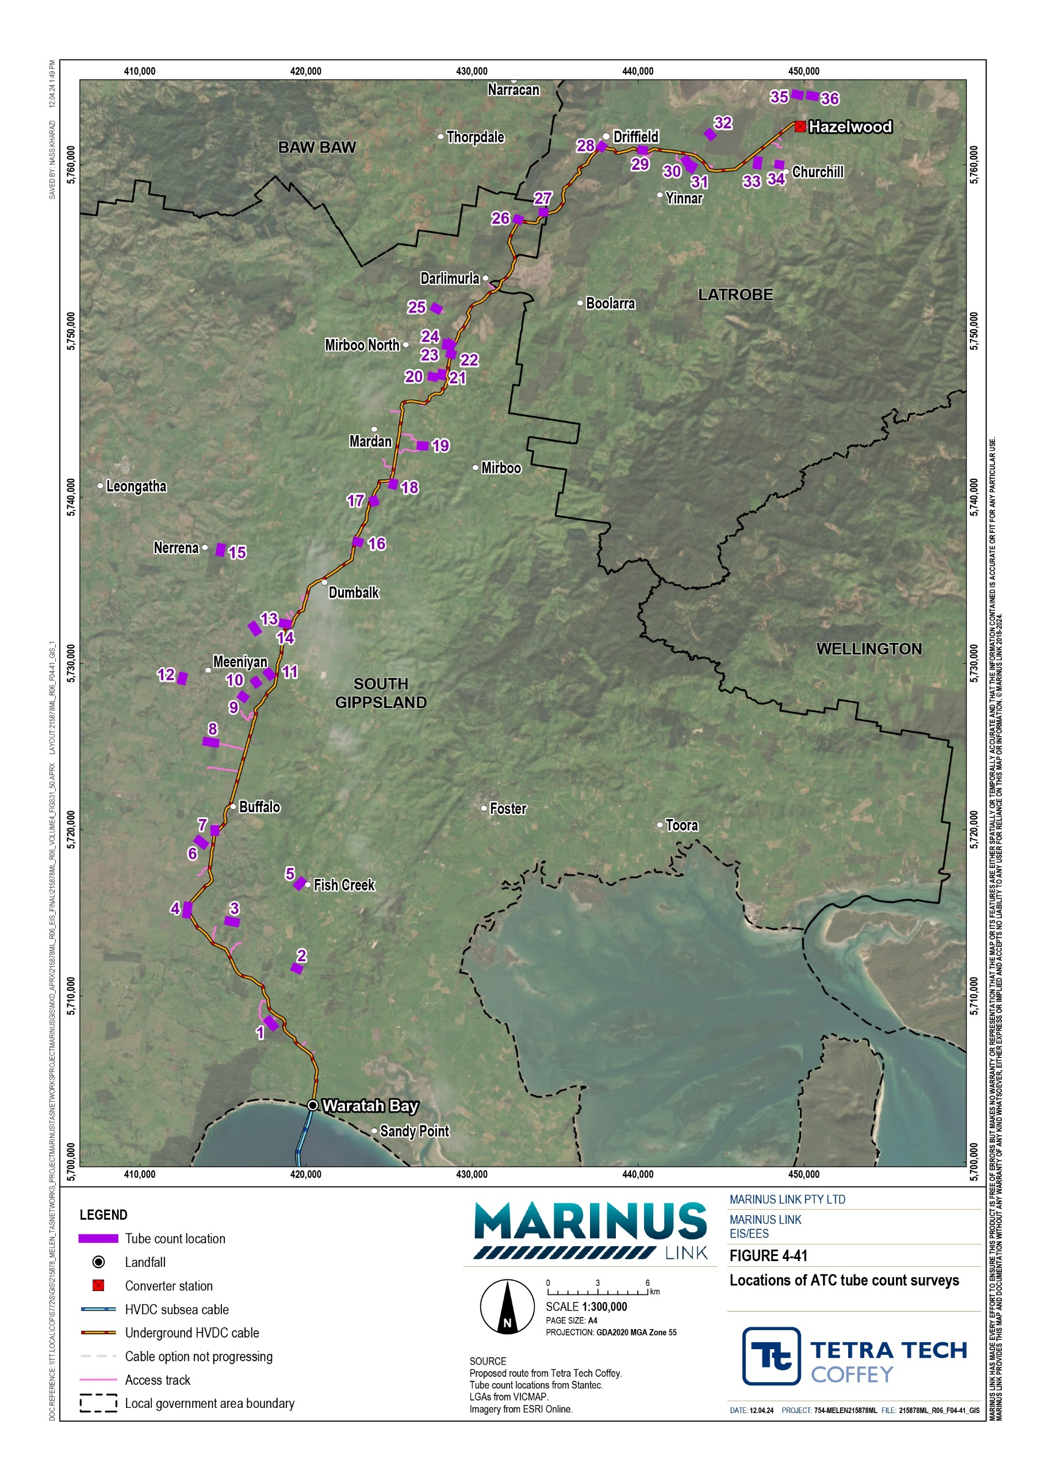

The assessment categorised roads within the study area in accordance with Austroads Guide to Road Design: Part 3, Section 4.2.6 to determine their theoretical capacity constraints. This process considered the size of traffic lanes, the size of the shoulder and the road’s total carriageway. These considerations determine the theoretical limit of vehicles per day that a road of a given size can service.
Table 8-3 outlines the best practice capacity constraints, in vehicles per day, of roads within the study area based on the road’s size.
In combination with the traffic volumes in Table 8-2, the dimensions listed in Table 8-3 can be used to predict whether project-related traffic increases will cause a given road’s daily theoretical capacity to be exceeded.

Element |  |  | Design AADT
 | 1-150 vpd | 150-500 vpd | 500-1,000 vpd | 1,000-3,000 vpd | >3,000 vpd
Traffic lanes | 3.7  (1 x 3.7 m) | 6.2  (2 x 3.1 m) | 6.2-7.0  (2 x 3.1 m/3.5 m) | 7.0  (2 x 3.5 m) | 7.0  (2 x 3.5 m)
Total shoulder | 2.5 m | 1.5 m | 1.5 m | 2.0 m | 2.5 m
Minimum shoulder seal | 0 m | 0.5 m | 0.5 m | 1.0 m | 1.5 m
Total carriageway | 8.7 m | 9.2 m | 9.2-10.0 m | 11.0 m | 12.0 m

It is likely that some of the older roads in the study area will not meet the dimension requirements in Table 8-3. In these instances, minor road upgrades or widening would be needed to meet the dimension
requirements in Table 8-3. Such improvements are often impractical, to avoid this, minimum road dimensions for these roads, as per Table 8-4, were used in the assessment.

Element |  | Design AADT
 | 150-500 vpd | 500-1,000 vpd | 1,000-3,000 vpd | >3,000 vpd
Traffic L\lanes | 6.2 (2 x 3.1 m) | 6.2-7.0 (2 x 3.1 m/3.5 m) | 7.0 (2 x 3.5 m) | 7.0 (2 x 3.5m)
Shoulders | 0.85m (1.0 m) | 0.85m (1.0 m) | 1.25 m (1.5 m) | 1.75m (2.0 m)
Total carriageway | 7.9m (8.2 m) | 7.9m (8.2 m)-8.7 m (9.0 m) | 9.5 m (10.0 m) | 10.5 m (11.0 m)

Multiple roads in the study area are unsealed dirt and gravel roads. The quality of the road surface impacts the daily capacities listed in Table 8-3 and Table 8-4. The study reviewed the Australian Road Research Board (ARRB) Unsealed Roads Best Practice Guide to determine an appropriate daily traffic threshold for when to seal an unsealed road. Sealing an unsealed road improves the road surface quality and makes a road less susceptible to damage from increased traffic. A description of the individual roads assessed is provided in Section 6.3.1.3 of Technical Appendix W: Traffic and transport.

The assessment reviewed the study area against the DTP heavy vehicle map, which displays roads that can accommodate heavy vehicle access. This includes the following heavy vehicle classifications:
B-Double network: The portion of the road network assumed to be accessible by B-Double vehicles.

OSOM : The portion of the road network with greater accessibility than the B-Double Network that can accommodate class 1 heavy vehicles.
OD road network: The portion of the road network with minimal height, width or mass restrictions that can best accommodate the transformer transporter vehicle.
The DTP heavy vehicle map shows whether the road network can accommodate the movement, to site, of the heavy vehicles used for the project.
The transformer transporter will be approximately 130 m long, approximately 6 m tall and approximately 650 t. It will travel from the Port of Melbourne to site and utilise the over-dimensional road network where
possible. The assumed route is shown in Figure 4-42 and Figure 4-43. The indicative transformer transporter arrangement is shown in Figure 4-44.

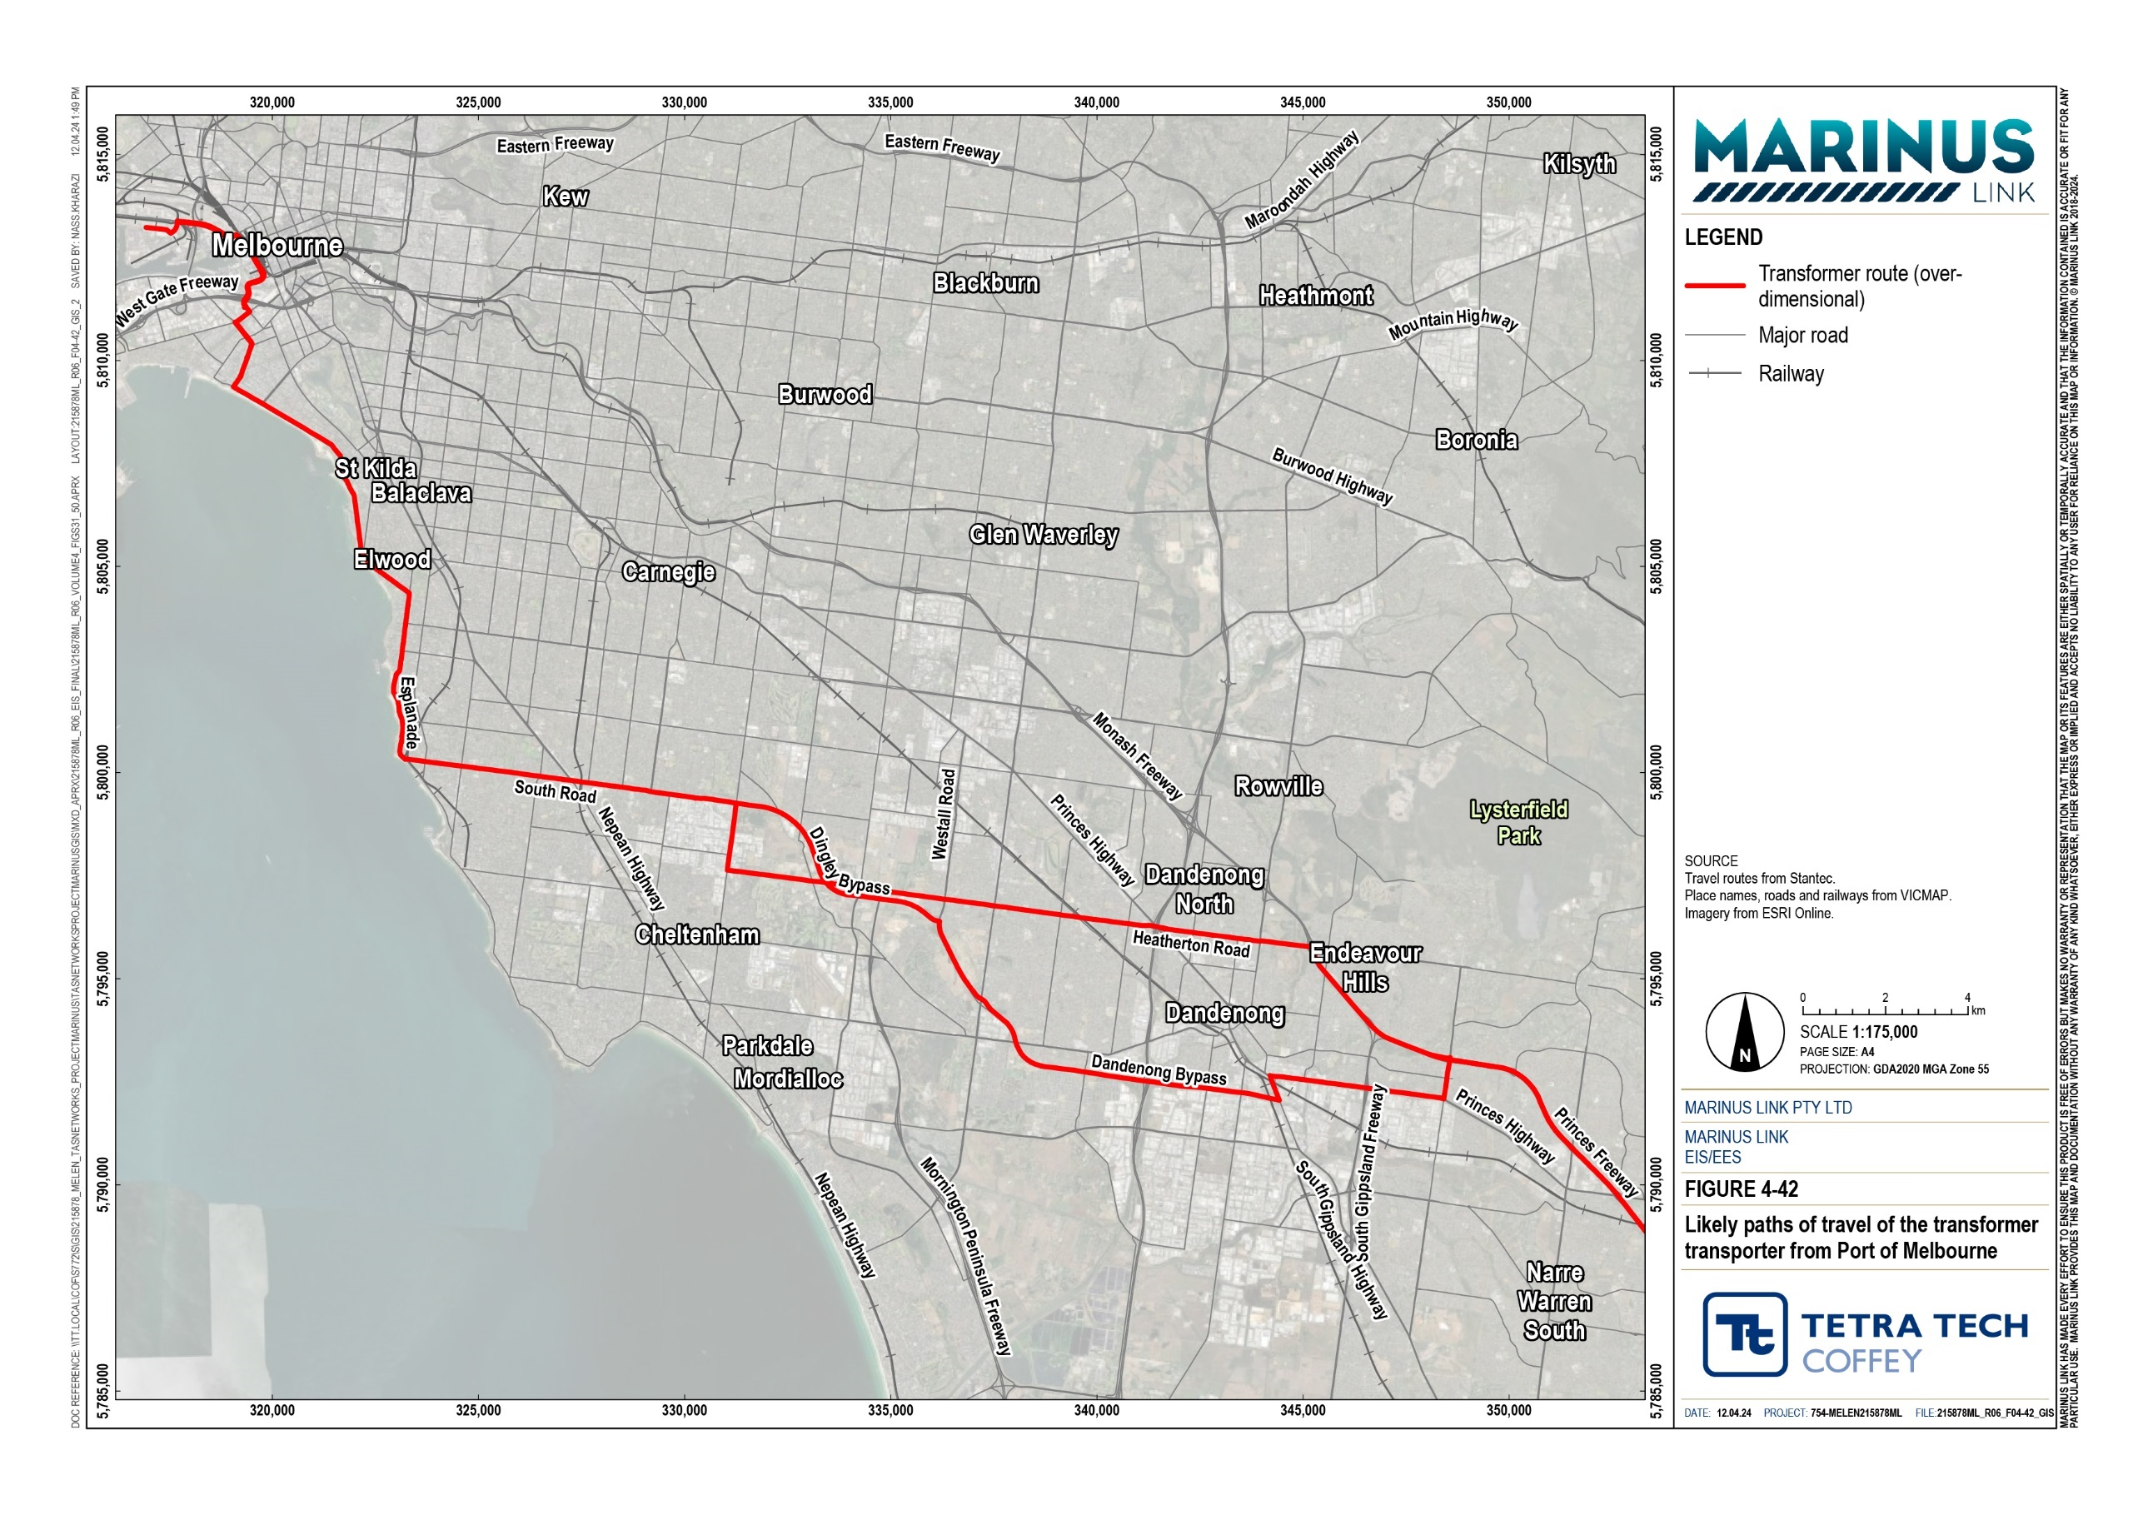
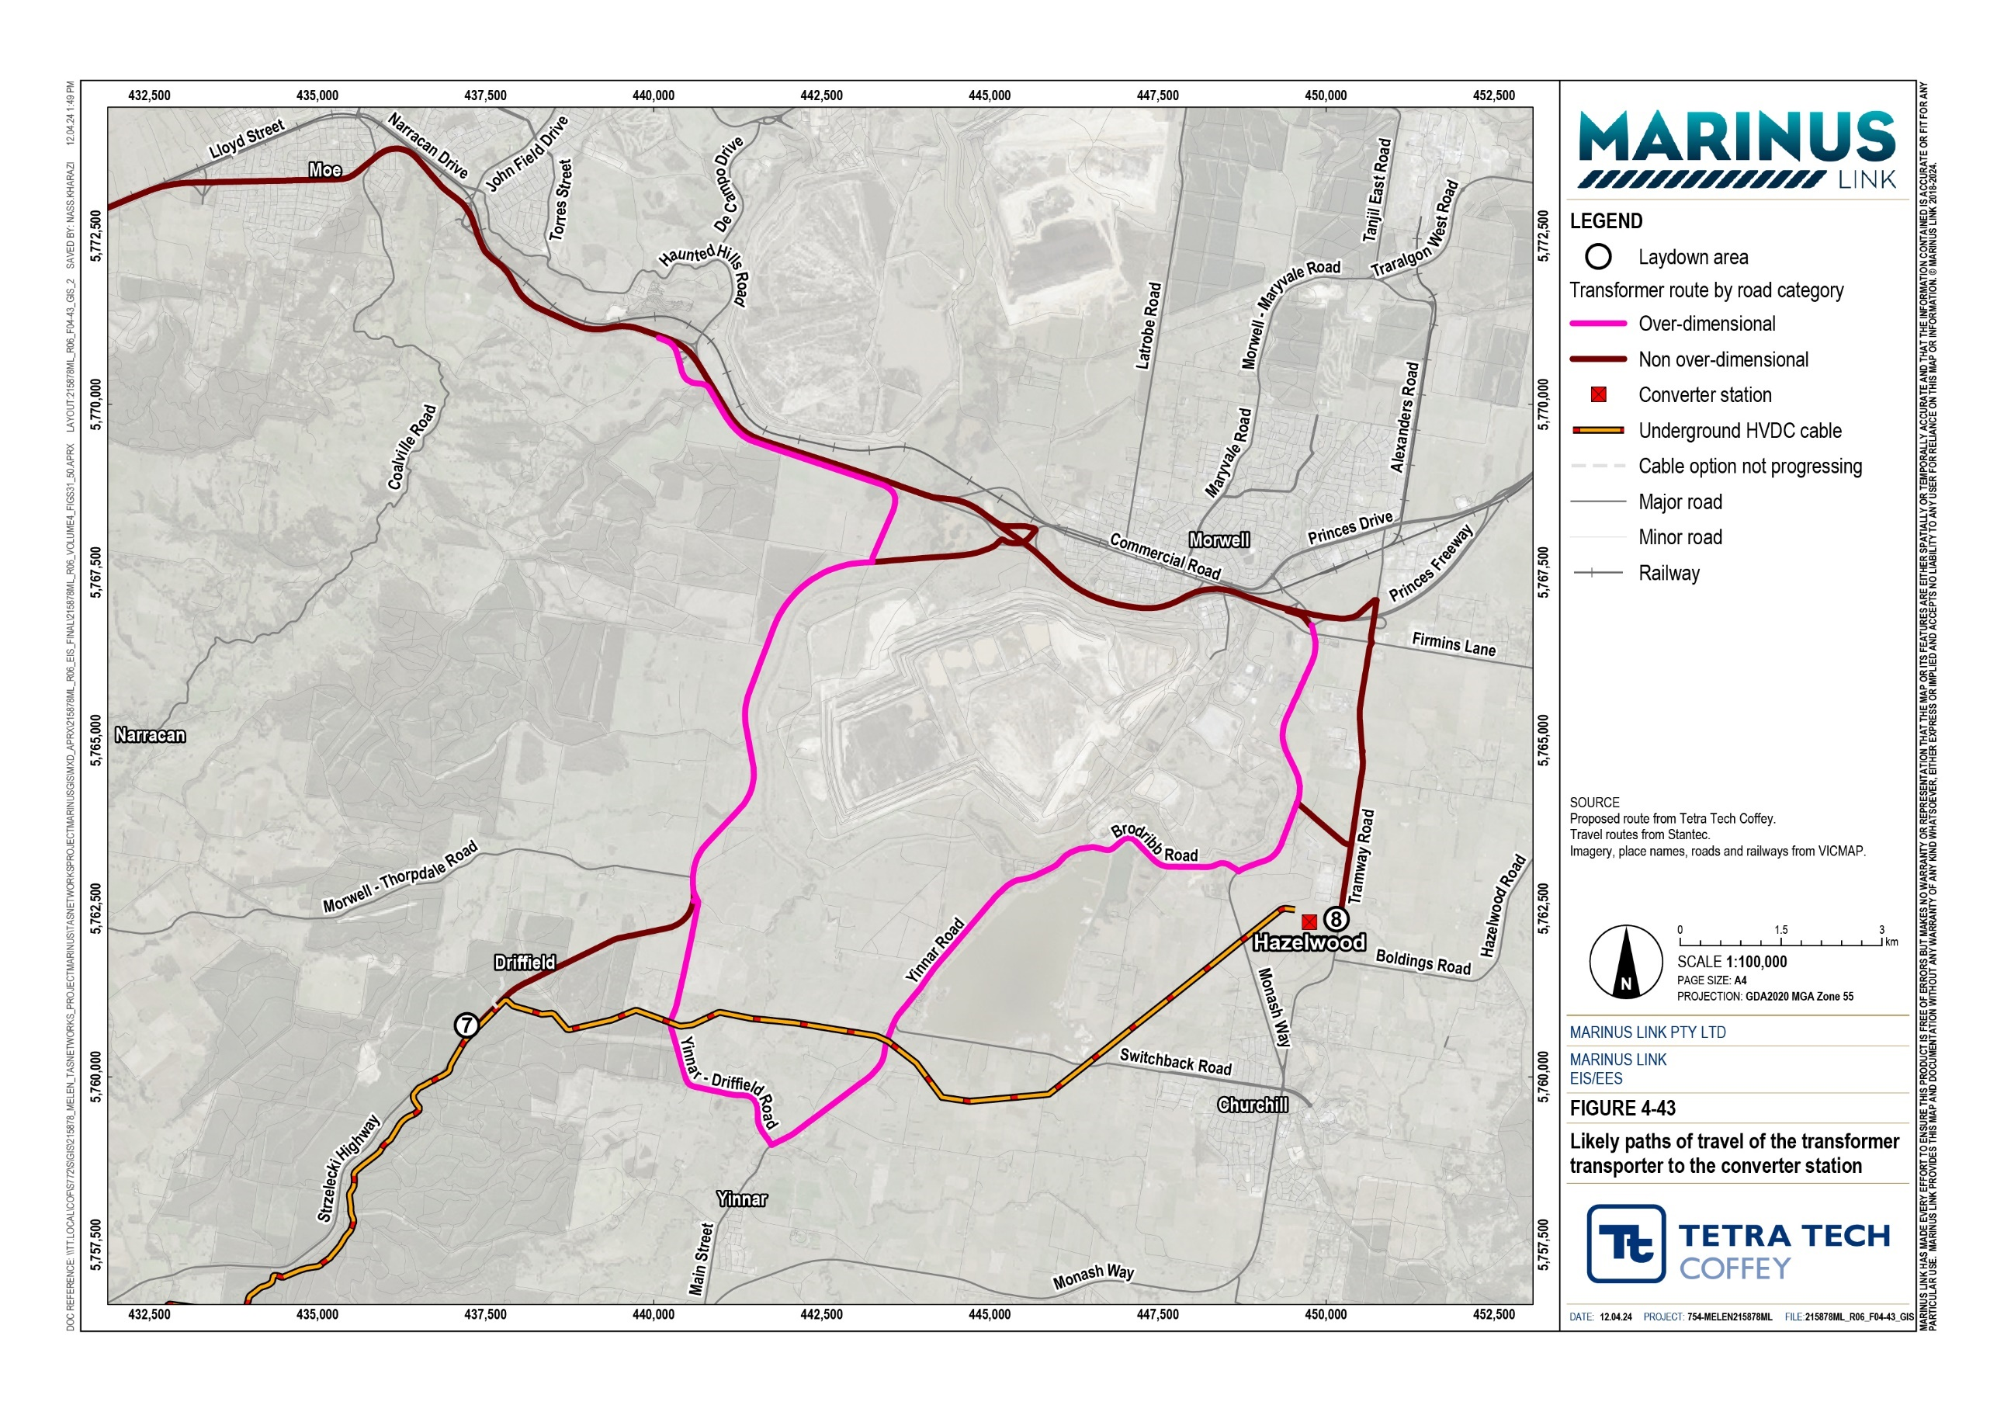

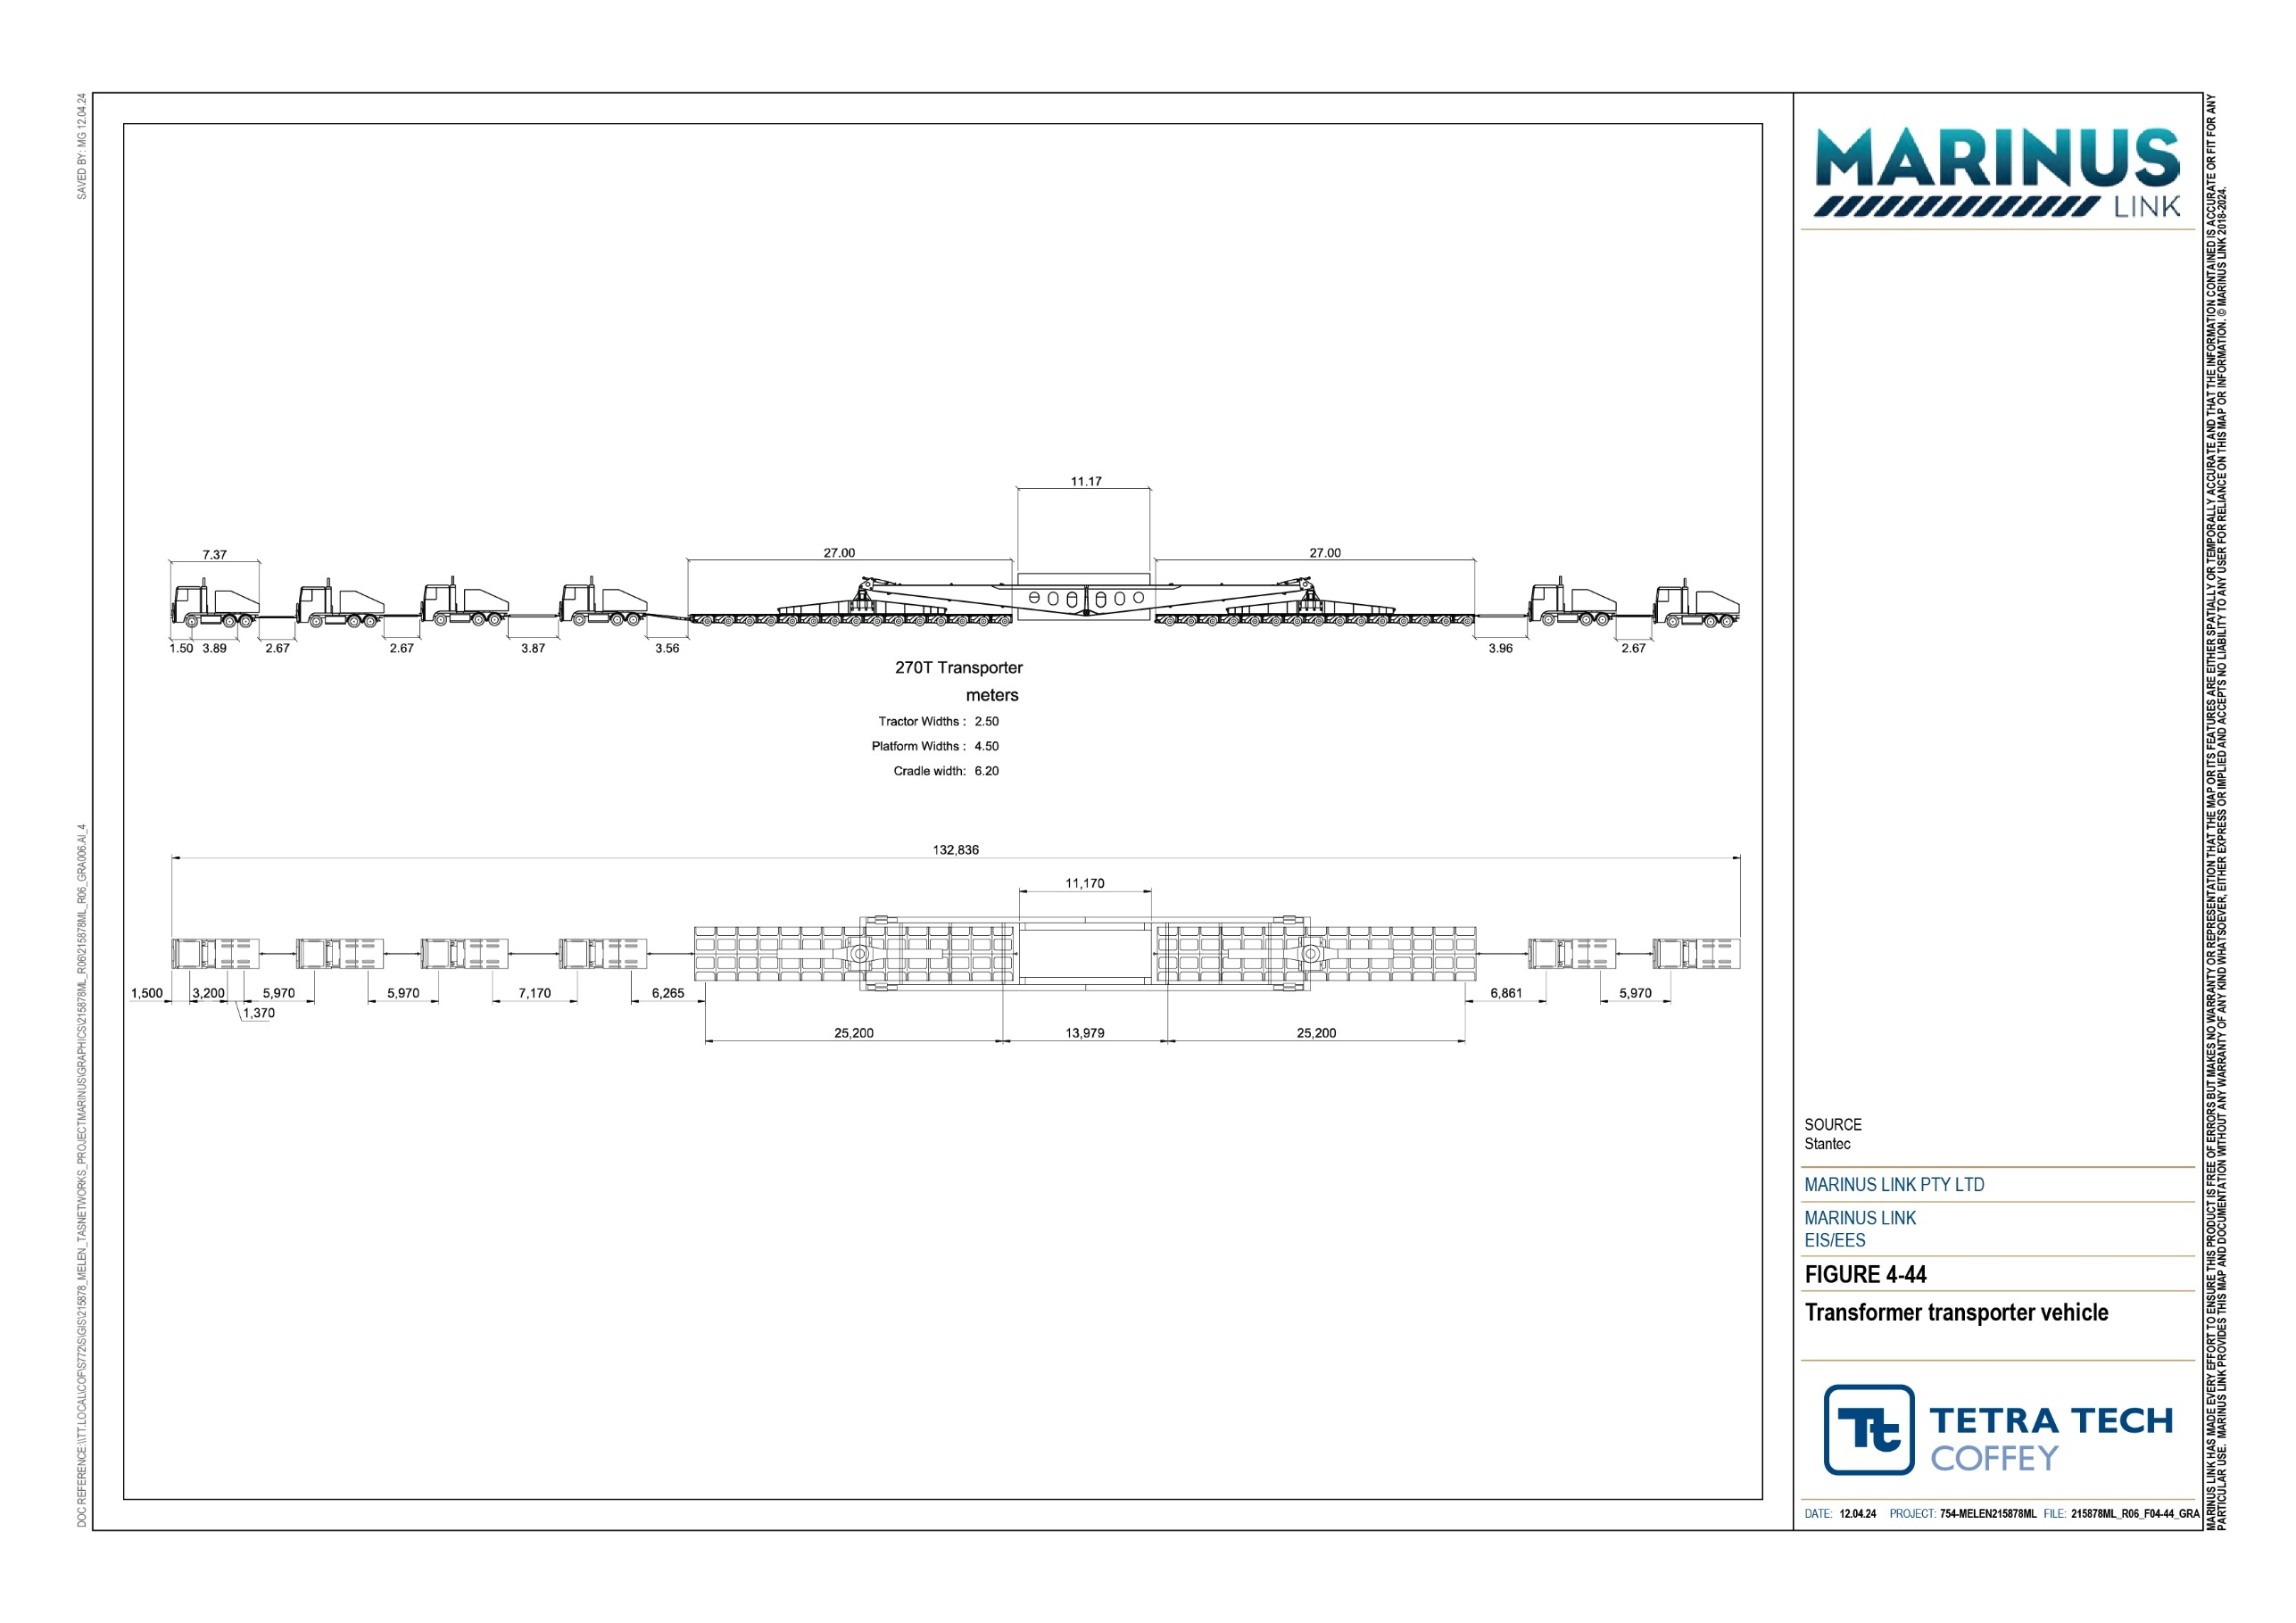

Road pavement
High-level assessment of the road pavement condition identified some general defects. The Austroads Guide to Pavement Technology Part 5: Pavement Evaluation and Treatment Design (AGPT-05) guided the identification of defects. Commonly highlighted minor defects include:
potholes

water ponding in low lying areas

edge breaks

loss of gravel wearing course

poor drainage

delamination of spray seal

damaged road shoulders

drainage and surface runoff issues.

The road pavement condition informs the extent of impact on road pavement quality of the increase in traffic levels from the project. The assessments discounted DTP roads as these are assumed to be regularly maintained and focussed on council roads.
Roads such as Jacks Roads, Ten Mile Creek Road and Silcocks Road have complete loss of wearing course and poor drainage. Severe potholes were observed at:
Darlimurla Road

Old Darlimurla Road

Moores Road

Harding Lawson Road

Buffalo-Waratah Road

Kerrs Road

Duncans Road.

Detailed pavement assessment is provided in Section 6.3.2 of Technical Appendix W: Traffic and transport.

Bridges and culverts
Many bridges and culverts are present along travel routes in the study area. Most of these are under council jurisdiction and the capacity is not publicly available. The exception is two bridges identified from the VicRoads website of publicly available data for mass limit restrictions that each have a restricted structure limit of 49.5 t. These are:
Nerrena Road: Bridge over Tarwin River West Branch

Mardan Road: Bridge over Tarwin River East

Vehicle crashes
The assessment of the latest available data spanning a five-year period (July 2015 to June 2020) listed 181 crashes in the study area. Of these, six were fatal, 60 caused serious injury and 115 caused other injuries. Annual crash numbers are generally consistent over the period reviewed but there are minor fluctuations.
Refer to Table 6.8 of Technical Appendix W: Traffic and transport for full details on crashes within the study area.
Figure 4-45 shows the locations of vehicle crashes along project-related travel routes within the study area as well as their severity.
Most crashes occurred in the middle of a stretch of road (129), with 31 occurring at T-intersections, 17 at cross-intersections, and three at multiple intersections (one crash had an unknown road geometry). Crashes mostly occurred during the day (122), with six occurring at dusk or dawn and 47 at night.
The most common crash type was a collision with another vehicle (84), followed by collision with a fixed object (60), struck pedestrian (13), and vehicle overturned (9). Passenger vehicles comprised 91% of the transport modes involved in crashes.

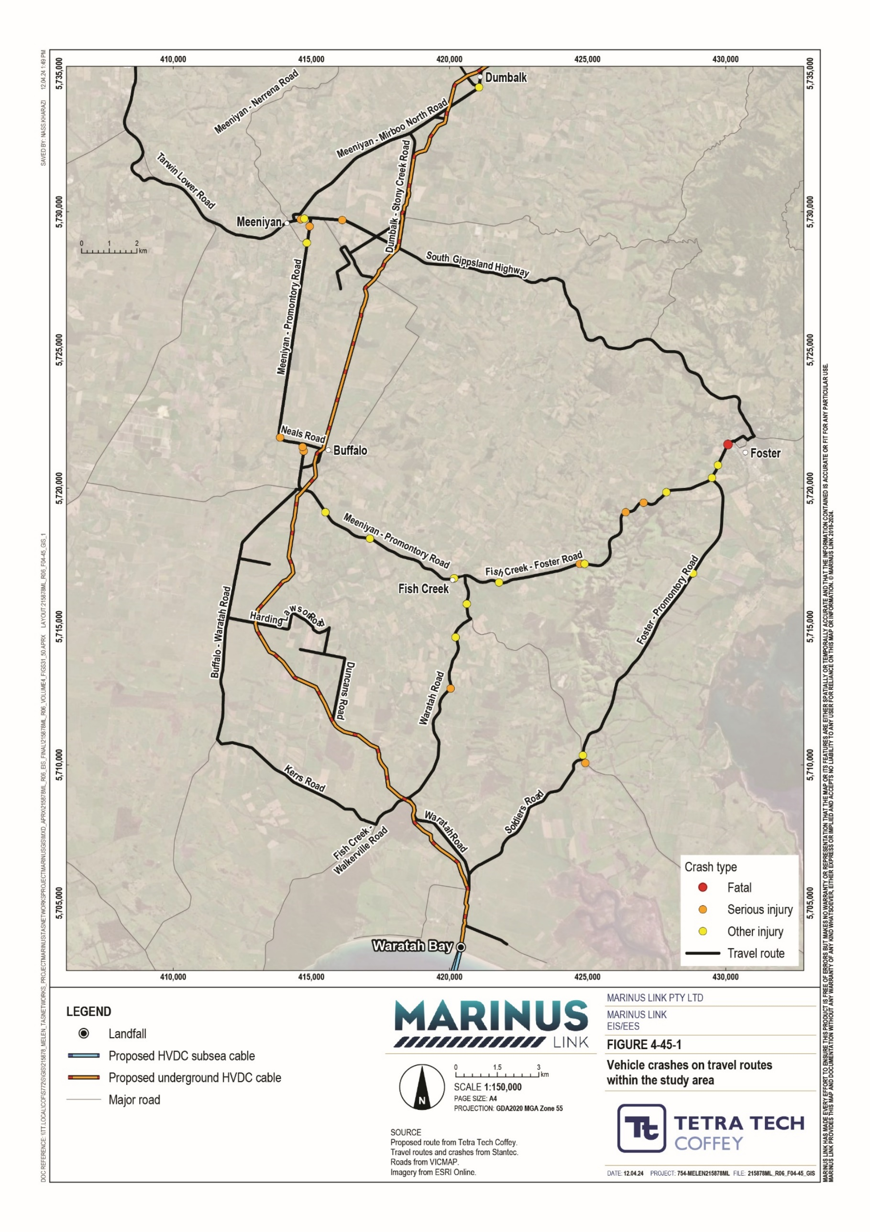

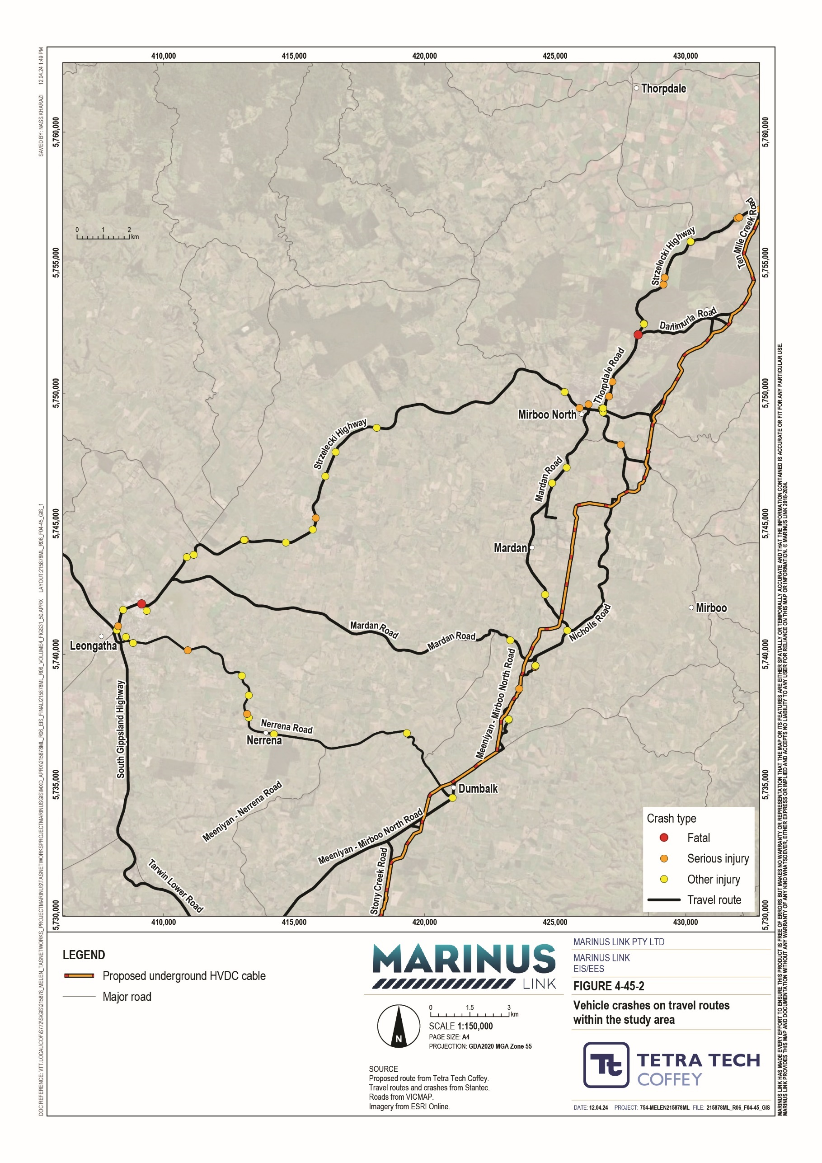

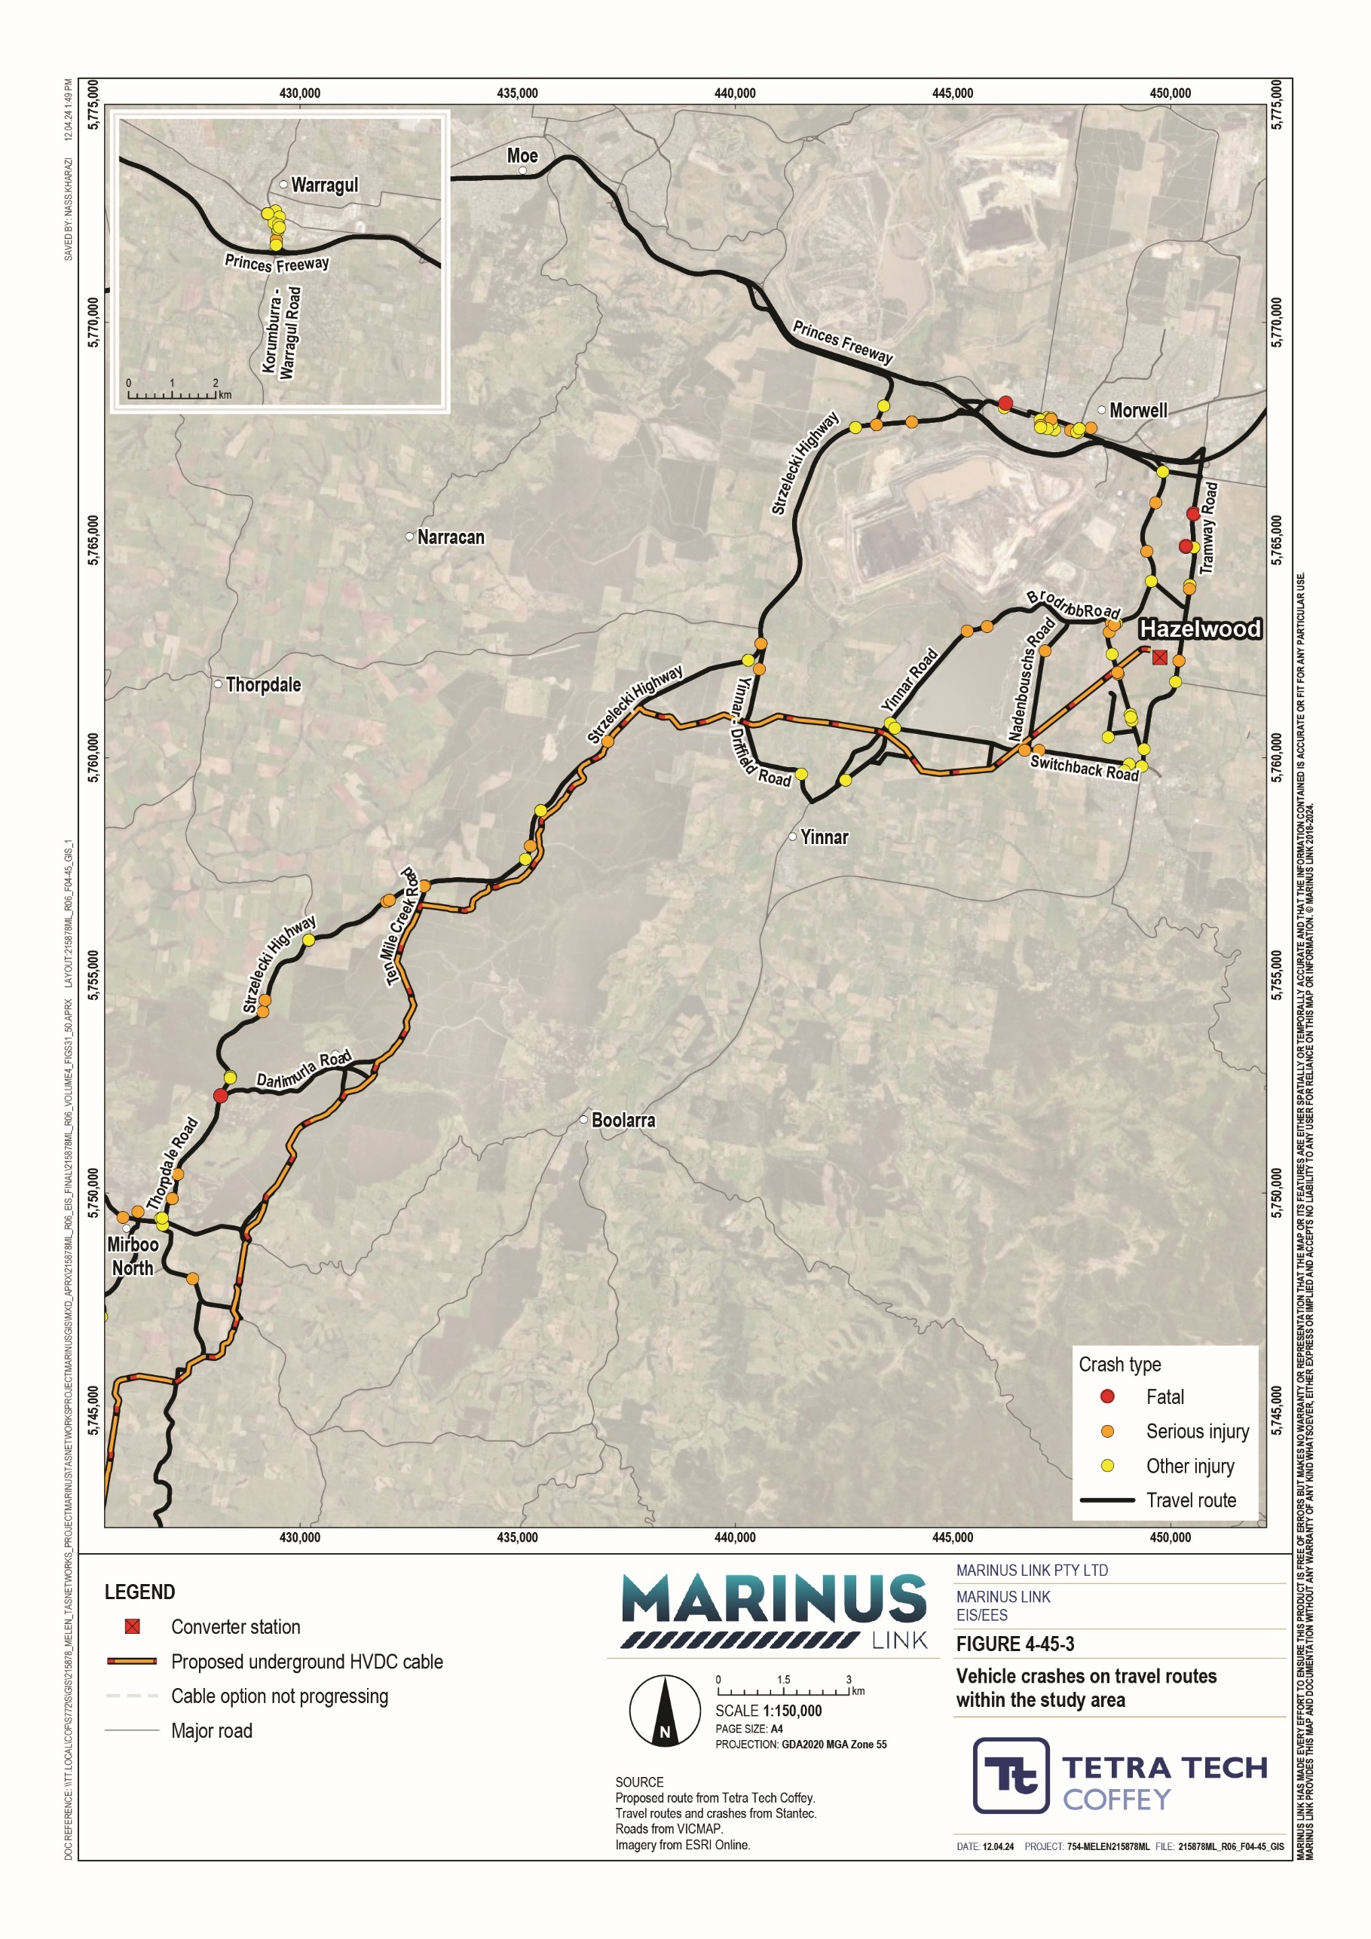

Public transport
V/Line trains provide a public transport link to Melbourne and services the regions surrounding the project including the towns of Moe, Morwell and Traralgon. The proposed cable route does not cross this train line.
Public buses serve the study area’s major towns and predominantly connect towns or provide access to town centres. Additionally, school bus services will operate throughout the towns. Future and ongoing consultation with councils will be necessary to determine these routes, noting that they are subject to change.
Over 90% of residents in South Gippsland Shire and Latrobe City Council commute to work in private vehicles. In part, this is because most towns in the study area are not served by public transport routes. As such, the region is classified as having low public transport services and accessibility.

Walking and cycling network
On-road cycling paths exist throughout the towns within the study area that vary in width, length, quality and connectivity. The Great Southern Rail Trail and the Grand Ridge Rail Trail are two major rail trails that traverse the study area. A section of the proposed cable route, between Buffalo and Stony Creek, runs alongside the Great Southern Rail Trail.
The largely rural nature of the study area means it is not well serviced by formalised footpaths. Primarily, footpaths are next to roads in town centres or residential streets.

Summary of values
Table 8-5 summarises the values considered in this assessment. For the full explanation of values and attributes, and their corresponding sensitivity levels, refer to Technical Appendix W: Traffic and transport.

Value | Attribute
Value 1 - Road Network Capacity  The operational performance of the road network with regard to its theoretical capacity and existing operation. This value recognizes how the road network is performing, whether a substantial change is to occur from its existing operational performance | Arterial road network capacity
 | Local road network capacity and net change
 | Intersection capacity
 | Road connectivity and provision of alternative routes
Value 2 - Safe Road Performance, Condition and Design  The design and operation of the road network, ensuring that it is provided in a safe manner that is compliant with relevant industry standards and  guidelines. | Road pavement condition assessment
 | Safe condition of bridges and culverts
 | Provision of adequate road geometry
 | Review of crash history
 | Intersection safe sight distance assessment
 | Height clearance requirements of the transformer transporter
 | Safe operation and management of construction activities

Value | Attribute
Value 3 - Public and Active Transport  The continued operation of the public transport network, as well as the active transport infrastructure in the surrounding area. This includes V/Line trains, local bus services, school buses, recreational rail trails and public footpaths. | Operation of public transport services and infrastructure
 | Operation of active transport infrastructure

Construction impacts
Construction of the project will result in changes to road conditions, traffic volumes and flows, and travel times. Some of these will occur for the duration of project construction while others will be more short-lived, being tied to a specific aspect of construction (e.g. the movement of the transformer transporter vehicle).
The project impacts to the traffic and transport network are consider the following values:

road network capacity

safe road performance, condition and design

public and active transport

Construction of the project will involve some modifications to the road network and its operation. Modifications that may temporarily impact on residents, landholders and road users in the vicinity of the project during construction include:
traffic distribution

traffic management, including speed limit reductions

turning lane treatments

upgrades to bridges and culverts

clearing of land and vegetation

raising the height of low-hanging power lines

provision of temporary construction lighting

avoiding movement of construction vehicles at higher-impact times

further assessment and inspections.

Impacts to vegetation are detailed in Volume 4, Chapter 11 – Terrestrial ecology.

Overview of construction-related traffic
Construction of the project is predicted to take place over six years. Specific aspects of construction will occur over varying time periods. Those that are relevant to traffic and transport are as follows:
Victorian shore crossing – 24 hour, 7 day per week construction over approximately 12 months.

Transition station – construction will occur from 7:00 am to 4:00 pm, six days per week for approximately 16 months.
Converter station – construction will occur from 7:00 am to 4:00 pm, six days per week for approximately 35 months.
Cable route – construction will occur from 7:00 am to 5:00 pm, 13 days per fortnight for approximately 36 months.
The traffic generated over the course of construction is likely to follow the travel routes depicted in Figure 4 -46 and Figure 4-47 and will include the following vehicles:
Light vehicles for the transport of workers to and from sites.

A variety of heavy vehicles supporting construction activities.

A 130 m long, 6 m tall, 650 tonne transformer transport vehicle (Figure 4-44).

The most significant impacts addressed relate to the transformer transporter vehicle. This is due to its size and the road network modifications required to accommodate its movement to site. The impact assessment has assumed a travel route for the transformer to the Hazelwood converter station, however the final travel route will be determined by the appointed contractor.

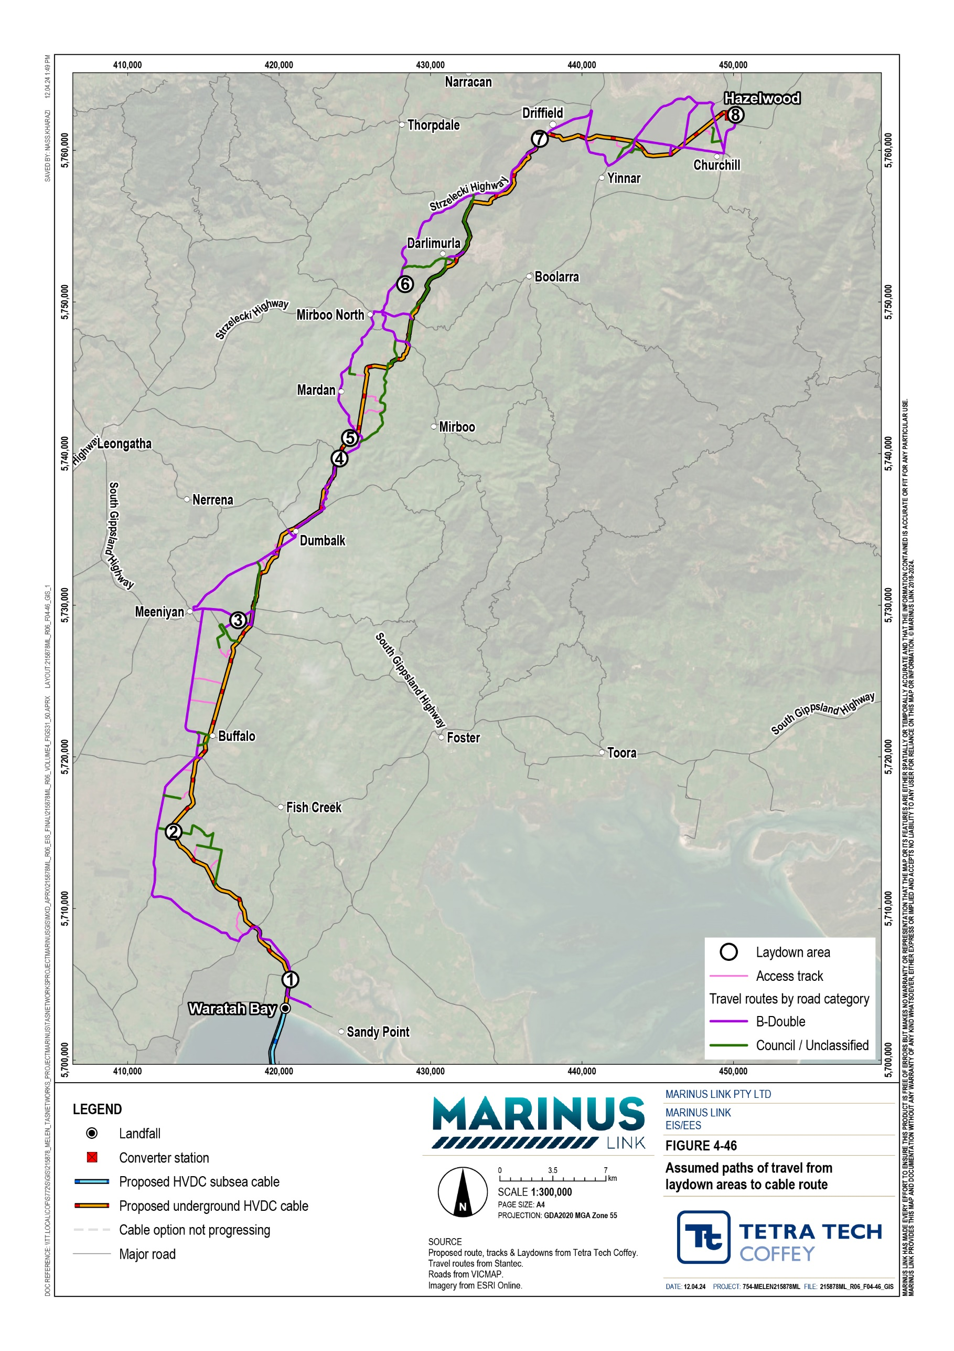

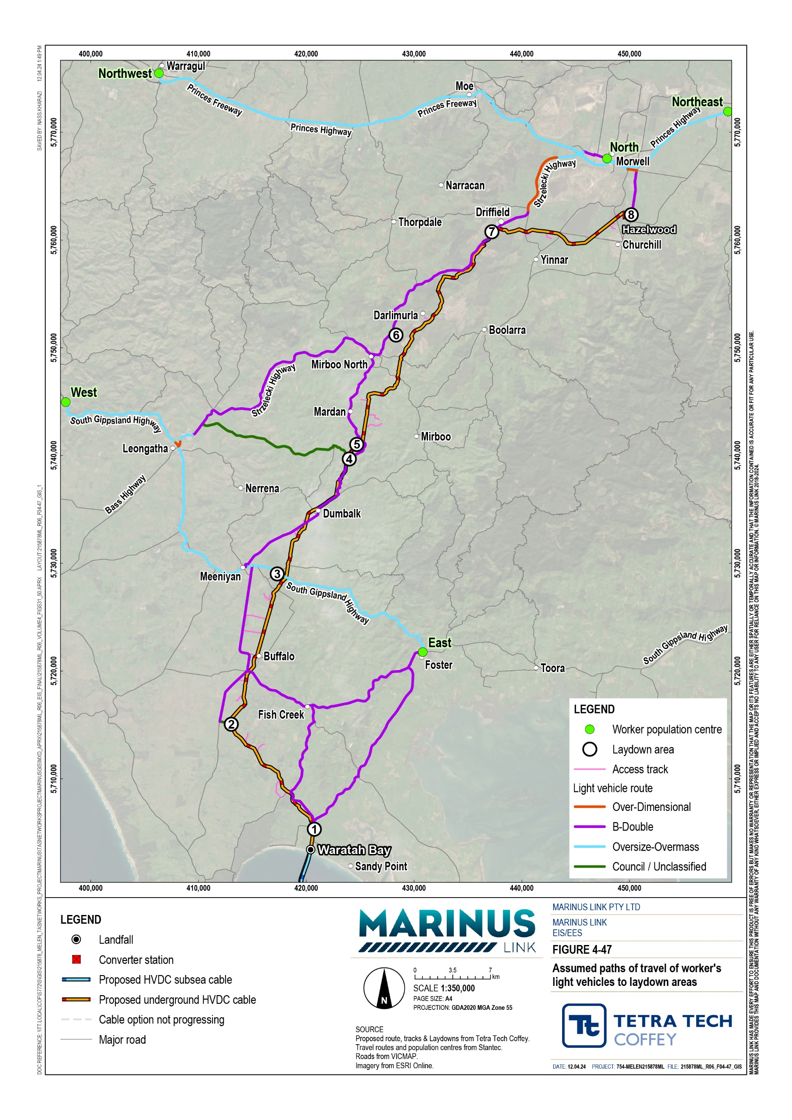

Road network capacity
The road network’s capacity is its theoretical design capacity for the type and number of vehicles it can carry per day. This assessment considered the existing conditions of the road network and assessed whether any significant changes are likely in its operational performance due to the construction traffic for the project. The assessment uses the Austroads Guide to Road Design: Part 3, Section 4.2.6, surveyed traffic volumes and projected project traffic generation, to assess road network impacts.
Project-related impacts to arterial road network capacity were assessed to be very low. This is due to the assessment showing that even at peak levels of traffic generated by the project, arterial roads used by construction traffic will still operate below capacity. Monash Way was the only arterial road for which project- related traffic will cause it to operate at over 50% of its theoretical capacity but under its design capacity. The arterial roads and their capacity are summarised in Table 8-2 while the likely travel routes of construction traffic are depicted in Figure 4-46 and Figure 4-47.
A review of the local road network determined whether local roads would operate underneath their theoretical capacity during construction of the project. Given local road networks in rural areas often operate with very low volumes, the net change in traffic was considered with the addition of the daily construction traffic volumes.
The construction of the project will result in increases in traffic on the local road network when accessing access tracks or the laydown area. The assessment surveyed the roads listed in Table 8-2 and found that the maximum increase in daily traffic on roads used to access a laydown area is 319 vehicle movements. The maximum increase in daily traffic on roads connecting to the access tracks is 103 vehicle movements.
Most roads will not exceed their theoretical operating capacity during construction phase. The theoretical operating capacity of roads servicing the project construction phase is assessed in Section 8.2.1, using the constraints depicted in Table 8-3 and Table 8-4. However, some gravel roads with a lower capacity of
150 vpd will exceed their capacity at peak traffic volumes. For the assessment, peak traffic volumes assume that all deliveries to a given site would happen on one day (i.e. the maximum feasible amount of traffic project construction could generate, as a worst case scenario). Pre-mitigation, the impacts are assessed as high due to the relative increase in traffic volumes on rarely used, low capacity roads, due to construction traffic.
This will be mitigated through distributing peak traffic events over multiple days where practicable. Further, some of the impacted roads are currently used by local residents and landholders to access their properties. The construction contractor will notify and consult with residents and landholders regarding peak works scheduling on the impacted roads (EPR T01).

To assess the operational capacity of the access points leading to laydown areas and access tracks, the assessment considered whether the existing infrastructure could facilitate safe and efficient turning movements of vehicles at particular intersections, also known as the level of turning treatment for an intersection. Existing conditions and peak construction traffic volume scenarios were used to assess the change in traffic performance because of the project. The assessment also considered carriageway traffic flow and the volume of turning movements.
The assessment found that the intersections for accessing the converter station will have sufficient capacity to accommodate construction traffic. Table 8-6 shows that the maximum delay projected for the arterial roads that lead to the access track is 12 s and the maximum degree of saturation is 0.23 during the PM peak hour. Degree of saturation is the commonly used measure of intersection performance, for which the ideal limit is 0.905. As the projected maximum degree of saturation is well below the ideal limit, no upgrades are required for intersections accessing the converter station.
The assessment found ten intersections, that would service the access tracks, may require upgrades to accommodate peak traffic levels. The assessed maximum total vehicles per hour at peak hour for each intersection was 50 vehicles. Three of these ten intersections access HDD sites, which are likely to generate a maximum 15 total vehicles per hour during peak hour. Consequently, the reduced traffic volume at the intersections accessing the HDD sites discounts these intersections from requiring upgrades.
The remaining seven intersections have an assessed impact of high as the arterial roads that service the access tracks are heavily trafficked and construction traffic may cause safety and road performance issues during peak traffic events. To mitigate this impact, a temporary reduction in speed limit, during peak traffic volumes, from 100 kilometres per hour (km/h) to 70 km/h on the arterial roads servicing the access track will be enforced (EPR T01). The speed limit reduction is sufficient to discount three additional intersections from needing further upgrades.
Four intersections may require intersection treatments to mitigate high impact including South Gippsland Highway access to HDDs, joint pit and laydown area access from Strzelecki Highway (EPR T01).
The four intersections that may require upgrades are on the following roads:

South Gippsland Highway

Strzelecki Highway

Smiths Road

Tramway Road

The impacts to the intersections that require treatment could be mitigated in two ways. Firstly, through a temporary speed limit reduction from 100 km/h to 70 km/h and secondly, through provision of a right turn lane treatment. Treated intersections will require inspections to verify they are performing as expected, as well as further assessments in the event of unexpected traffic volumes (EPR T01).

Peak hour | Intersection | Approach | Degree of saturation (DOS) | Average delay (seconds)
AM peak hour | Tramway Road / Hazelwood converter station access point | Tramway Rd (South) | 0.13 | 0 s
 |  | Tramway Rd (North) | 0.20 | 6 s
 |  | Site access (West) | 0.00 | 12 s
 |  | Intersection | 0.20 | 4 s
PM peak hour | Tramway Road / Hazelwood converter station access point | Tramway Rd (South) | 0.10 | 0 s
 |  | Tramway Rd (North) | 0.12 | 0 s
 |  | Site access (West) | 0.23 | 9 s
 |  | Intersection | 0.23 | 3 s

Safe road performance, condition and design
This assessment has considered the attributes that contribute to the safe performance of the existing road network and how the roads in the project area can safely accommodate construction traffic for the project.
Additional traffic volume and types of traffic due to construction activities will accelerate the degradation of roads already approaching or beyond their design life. Many of these local roads are gravel roads and dirt

tracks, which have little capacity to support heavy construction vehicles. Construction traffic will range from light duty trucks and excavators to heavy vehicles delivering the cable drums.
Impacts to road pavement condition would be moderate as most of the assessed unsealed roads are in poor condition. The additional construction traffic will likely reduce these roads’ serviceability and exacerbate the existing defects described in Section 8.2.2.
A qualified pavement engineer would be engaged to further assess these roads for existing defects. Defects caused by construction activities will be monitored on an ongoing basis and impacts to road surface conditions will be remediated (EPR T02).
Many bridges in the study area have an operational mass limit. The introduction of heavy vehicles for construction may exceed this operational mass limit on certain routes. Two bridges identified in the desktop assessment (Section 8.2.3), have operational mass limits of 49.5 t and service the cable route and laydown areas. This capacity is sufficient to support all construction traffic except the transformer transporter vehicle. As these bridges do not service the converter station, the transformer transporter vehicle will not travel on these bridges. Consequently, these two bridges do not need upgrading.
Pre-mitigation, the assessment projected a high impact, as bridges and culverts, not yet assessed, servicing construction activities may not be conditioned for the mass of the vehicles generated.
Once the travel routes of construction vehicles have been finalised, bridges and culverts on these routes will be inspected by a suitably qualified civil engineer. This will determine which need upgrading to accommodate heavy construction vehicles (including those on the transformer transporter vehicle’s travel route) and which already have sufficient capacity.
Impacts will be mitigated through identification and assessment by a suitably qualified civil engineer and upgrades to bridges and culverts servicing construction activities where required. These bridges require ongoing monitoring to verify continuous acceptable operating conditions (EPR T02).
Road geometry was assessed with a swept path analysis at critical locations to identify if the road can accommodate the size of vehicles proposed to be used for construction. Swept path analysis identifies if any works are required to accommodate construction vehicles based on their turning movements.
There are multiple locations where the existing road geometry was identified as not being suitable if used by large construction vehicles. These impacts could vary based on the location and the size of the construction vehicles causing the impact.
The assessment assumed that all roads classified on the B-Double network are accessible by a 19 m semi- trailer, which was the assumed vehicle required for cable drum delivery at the time of assessment. The swept path analysis focused on locations where a 19 m semi-trailer would be required to leave the B-Double network onto a lower order road to access the construction or laydown areas. Other areas identified by councils as having access constraints were also considered.

Pre-mitigation, the assessment identified one moderate and one high impact for the movement of semi- trailers up to 19 m. Swept path assessments found nine locations where access may be restricted by the road geometry. These locations may not accommodate turns made by vehicles of this size and may require a combination of local widening, which may include some land and vegetation clearing (addressed in Volume 4, Chapter 11 – Terrestrial ecology) and removal of traffic infrastructure to accommodate the movement of semi-trailers (EPRs T01, T02). The intersections requiring works, their corresponding impact and the nature of these works are summarised in Table 8-7.

Location | Impact | Required upgrades
Intersection of Yinnar Road / Mcfarlane Road | Moderate  The intersection will not adequately accommodate the semi-trailer movements without damaging the shoulders and road reserve. | Minor local widening will be required
Intersection of Strzelecki Highway / Ten Mile Creek Road | Moderate  The intersection will not adequately accommodate the semi-trailer movements and traffic without will damaging the shoulders and road reserve. | Minor local widening will be required
Intersection of Buffalo Waratah Road / Harding Lawson Road | No impact on traffic infrastructure | Possible clearing of low- hanging branches
Intersection of Boolarra South-Mirboo North Road / Old Nicholls Road | No impact on traffic infrastructure | Possible clearing of low- hanging branches
Intersection of Darlimurla Road / Old Darlimurla Road | High  Semi-trailers cannot conduct turning movements at this intersection without encroaching on land outside the road reserve. | Minor local widening will be required  Clearing of trees and low- hanging branches may be required
Intersection of Darlimurla Road / Pleasant Valley Road | High  Semi-trailers cannot conduct turning movements at this intersection without encroaching on land outside the road reserve. | Minor local widening will be required  Clearing of trees and low- hanging branches may be required
Intersection of Harding Lawson Road / Evans Road | High  Semi-trailers cannot conduct turning movements at this intersection without encroaching on land outside the road reserve. | Minor local widening will be required  Possible clearing of low- hanging branches
Intersection of Evans Road / Pilkington Road | High  Semi-trailers cannot conduct turning movements at this intersection without encroaching on land outside the road reserve. | Minor local widening will be required  Possible clearing of low- hanging branches
Intersection of Evans Road / Duncans Road | High  Semi-trailers cannot conduct turning movements at this intersection without encroaching on land outside the road reserve. | Minor local widening will be required  Possible clearing of low- hanging branches

The assessment identified three separate major impacts for the movement of the transformer transporter from the Princes Freeway to the Hazelwood converter station. The route from the Port of Melbourne to the Princes Freeway would require approval for transport of an oversized and over mass load. Ongoing consultation with DTP will be undertaken to inform transport arrangements and to seek secondary approvals where necessary.
The major impacts assessed for the movement of the transformer transporter vehicle are:

The transformer transporter will need to travel down the centre of the road at low speed (on any road that is one lane in each direction or narrower) during its transit, potentially causing significant traffic delays.
Upgrades, and removal of minor road furniture, vegetation and land at five locations to allow the transformer transporter’s access to site.
Works to private property at two locations to accommodate the transformer transporter vehicle’s access to site. Works may include temporary removal of fencing on private land to accommodate the turning path of the transformer transporter vehicle.
The intersections requiring works, their corresponding impact and the nature of these works are summarised in Table 8-8. In instances where potential removal of safety infrastructure is identified, these are to be reinstated or upgraded in line with the relevant road authority’s requirements.

Location | Impact | Required upgrades / management
Princes Freeway off-ramp to Marretts Road | Major  The nature of the road network will prevent the transformer transporter from safely completing turning movements here. | Grading of green space to accommodate vehicle turning arc.
Marretts Road westbound and on- ramp to Princes Freeway | Major  The nature of the road network will prevent the transformer transporter from safely completing turning movements here. | Removal of crash barriers may be required on on- ramp to freeway.
Intersection of Marretts Road and Strzelecki Highway | Major  The nature of the road network will prevent the transformer transporter from safely completing turning movements here. | Removal of concrete road separator may be required on Marretts Road approach.
Intersection of Strzelecki Highway and Yinnar-Driffield Road | Major  The transformer transporter vehicle would need to travel the wrong way on a slip lane to make the necessary turning movement here. This may cause delays for other road users. | Slip lane used for both turning movements. Travelling contraflow for right turn movement from Yinnar-Driffield Road on to Strzelecki Highway.  Traffic management will be required throughout this movement.  Clearing of low-hanging branches may be required. Further investigation recommended.

Location | Impact | Required upgrades / management
Intersection of Yinnar-Driffield Road and Yinnar Road | Major  The nature of the road network will prevent the transformer transporter from safely completing turning movements here. | Local road widening may be required at turn onto Yinnar Driffield Road, including trafficable surface of green space and removal of crash barriers.
Intersection of Monash Way and Bonds Lane | Major  The nature of the road network will prevent the transformer transporter from safely completing turning movements here.  Necessary geometry to complete turning movements may intrude on private properties. | Local road widening may be required at intersection to accommodate turning arc.  May require removal of fencing and vegetation. May require use of private property.
Intersection of Bonds Lane and Tramway Road | Major  The nature of the road network will prevent the transformer transporter from safely completing turning movements here.  Necessary geometry to complete turning movements may intrude on private properties. | Local road widening may be required at intersection to accommodate turning arc.  May require removal of fencing and vegetation. May require use of private property.
Increased traffic, due to the project construction, may present an increased crash risk at nine locations. The increased crash risk is due to the inherent increased risk associated with increased construction traffic from the project. The potentially impacted roads are:

Tramway Road (Churchill) Monash Way (Churchill)
Strzelecki Highway (Driffield)
Strzelecki Highway (Mirboo North)
Strzelecki Highway (Leongatha)
South Gippsland Highway (Meeniyan)
Meeniyan-Promontory Road (Buffalo)
Fish Creek-Foster Road (approach to Foster)
Fish Creek-Foster Road (Foster)

Moderate and minor impacts could occur due to the increase in traffic by construction activities causing an increased potential for crashes. However, the largest percentage increase in traffic generation was 12.76% at Tramway Road, which is considered a low-level increase. The low increase in traffic volumes will not cause a material increase in the likelihood of crashes during the construction phase.
These potential impacts will be addressed through the development of measures implemented with the TMP (EPRs T01, T02). No additional or site-specific measures will be required.
The majority of intersections assessed have the required site distances and the intersections without adequate sight distances have signage in place to warn road users of the approaching intersection. These intersections are described in Table 8-9. No further mitigation measures are required for these intersections.

Intersection | Description and existing measures
Meeniyan – Promontory Road / Waratah Road | There are curves in the road in both directions on the major carriageway which limit the sight distance.  The intersection currently has appropriate signage to identify the curves in the road and the location of the intersection.
Meeniyan – Promontory Road / Buffalo – Tarwin Lower Road | Curved alignment at all three approaches prevents achievable sight distances. Appropriate signage identifying the curves in the road currently exists on both major and minor carriageways.
Meeniyan Mirboo North Road / Mardan Road | Steep incline on the minor arm approach limits the available visibility and a curved carriageway on Mardan Road limits the visibility of the intersection. Appropriate signage is provided to alert drivers of the intersection in both approaches.
Baromi Road / Old Darlimurla Road | Curved carriageways in both directions on the major carriageway limits the  available sight distance. Appropriate curve in the road signage is in place on both approaches.
The transformer transporter vehicle is 6 m high and has the potential to damage low-hanging powerlines over Marretts Road, Strzelecki Highway, Yinnar-Driffield Road, Yinnar Road, Brodribb Road and Tramway Road. The height of these low-hanging powerlines o will need to be raised if this transformer transport route is adopted by the contractor to avoid impacts to the powerlines (EPRs T01, T02).
The additional traffic generated from construction activities has the potential to impact safe road operations with mitigation measures put in place. These impacts are summarised in Table 8-10.
The requirement for night works at the shore crossing and Morwell River HDDs will result in increased traffic at night in areas with poor road lighting. This could increase the crash risk in these areas without mitigation. A review of lighting conditions and requirements will be completed, with additional lighting provided at intersections providing access for night works to improve safety (EPR T01).
The transformer transporter vehicle, moving at low speed down the centre of the road, could potentially cause a safety hazard if not mitigated. The impacts would be reduced through mitigation measures implemented to comply with EPRs such as continuous traffic management personnel to supervise and manage traffic when the transporter is travelling down the centre of the carriageway or completing turns (EPRs T01, T02).
There is potential for construction traffic to increase safety risks around schools if they are located on the final travel routes selected for construction vehicles. Mitigation measures such as limiting the amount of heavy vehicles and haulage during peak traffic periods near schools will be required as part of the TMP (EPR T01). Construction routes will be documented in the TMP.

Impacts due to increased truck movements causing a safety risk to pedestrians in towns was assessed as being high without mitigation measures applied. The increased safety risk applies in towns where construction vehicle move off the arterial road network. This could occur in the following towns:
Buffalo Mirboo North

Stony Creek Baromi

Meeniyan Churchill

The TMP will include measures to limit heavy vehicles and haulage during public events such as local markets or festivals (EPR T01). Consideration will also be given to avoiding peak travel demand periods and documented in the TMP (EPR T01).
Transportation of hazardous goods will be required to comply with the road authority’s requirements for hazardous material transport (EPR T01).

Impact pathway | Initial impact | Potential mitigation measures and EPR | Residual impact
Increased crash risk due to poor road lighting for HDD at night | Major | The contractor to provide adequate temporary construction lighting at access intersections during HDD operations. A review of existing lighting conditions and requirements to be conducted (EPR T01). | Moderate
Transformer transport movement moving at low speed down the centre of the road and potentially causing a safety hazard | Major | Constant traffic management personnel to supervise, namely, to block traffic when the transporter is travelling down the centre of the carriageway or completing turns. Moving warnings that a large, slow-moving vehicle is on the approach will be provided (EPRs T01,T02). | Moderate
Increased truck movements causing a safety risk to pedestrians in towns | High | Avoid movement of construction vehicles during high pedestrian traffic periods including during local markets or festivals (EPR T01) | Low
Increased traffic potentially causing a safety risk around schools | Major | Prohibit travel of heavy vehicles past schools during hours of school pickup and drop-off (EPR T01) | Low
Transportation of hazardous goods | Severe | The transportation of any hazardous goods or materials to be conducted in adherence with any standard requirements relating to that specific material (EPR T01) | Moderate
Peak seasonal events increasing traffic levels and consequently risk of crashes and road capacity issues | High | Reduce construction operations during peak seasonal events including long weekends (EPR T01) | Low

Public and active transport
The services provided by the public and active transport networks and infrastructure in the vicinity of the project’s activities must be maintained or alternatives provided during construction.

Public transport services and infrastructure
The movement of the transformer transporter and access of construction vehicles to the cable route will pass through townships and utilise major roads where there will be interaction with public transport services. The assessment identified two potential impacts to public transport services due to:
Heavy vehicles potentially travelling on school bus routes. School bus routes change based on which children are enrolled and where they live. A review of heavy construction vehicle traffic routes against school bus routes will be conducted prior to construction.
The transformer transporter route potentially intersecting with the routes of public transport services including, buses, trams and train lines.
The impacts were assessed to be high and major, respectively, without mitigation measures applied to comply with EPRs.
To mitigate school bus-related impacts, heavy construction vehicle movements occurring on school bus routes will be restricted to occur outside typical school bus operating hours (EPR T01).
To mitigate transformer transporter-related impacts, transformer transporter movement will primarily avoid public transport service times (EPR T01).
The primary active transport infrastructure for walking and cycling in the project area includes the Great Southern Rail Trail and the Grand Ridge Rail Trail. As the area is largely rural, there are not many formalised footpaths that could be impacted.
Impacts to active transport will be low due to permanent or temporary closures of minor and informal trails, cycling paths and footpaths. No impacts will occur to trails, cycling paths and footpaths crossed with HDD. In these instances, consultation with relevant councils and impacted residents to determine appropriate mitigation measures will occur.

Operation impacts
The operational traffic requirements and subsequent impacts are described in this section. The vehicles to be used during operation will be mostly light vehicles.

Converter station
The converter station at Hazelwood will only be attended during normal working hours. Generally, vehicle traffic per day will consist of a maximum of five light vehicles for operational personnel. Planned outages of a maximum two weeks up to twice a year will involve 15 to 20 personnel and additional vehicle movements.
The traffic accessibility requirements described above are minor and are not likely to compromise the safety, function or operation of the surrounding road network.

Transition station
During regular operation, the transition station at Waratah Bay will be monitored remotely with one to two personnel regularly conducting maintenance and inspecting buildings. No impacts are predicted to traffic and transport values from operation of the transition station.

Land cables
The extents of the land cables are typically maintenance free. Testing of the joint pits occurs every five years, which requires two workers for a duration of one day at each joint pits. No impacts to traffic and transport values are expected from these activities.

Decommissioning impacts
The current operational lifespan of the project is at least 40 years. At this time, the project will either be decommissioned or upgraded to extend its operational period.
Requirements at the time will determine the scope of decommissioning activities and impacts. The key objective of decommissioning will be to leave a safe, stable and non-polluting environment, and minimise impacts during the removal of infrastructure.
In the event that the project is decommissioned, all above-ground infrastructure will be removed, and associated land returned to the previous land use or as agreed with the landholder. All underground infrastructure will be decommissioned in accordance with the requirements of the time. This may involve leaving some components underground where safe to do so.
Should removal of project infrastructure be required at the end of its operational life, the nature, extent and magnitude of traffic and transport impacts would be lesser than those associated with construction. A decommissioning management plan will be prepared to outline how activities would be undertaken and potential impacts managed.

Environmental performance requirements
EPRs set out the environmental outcomes that must be achieved during all phases of the project, without defining how outcomes is to be achieved. In developing these EPRs, industry standards and guidelines, good practice and the latest approaches to managing impacts were considered. Project specific management measures, relevant legislation and policy requirements informed these EPRs. Table 8-11 sets out the proposed EPRs to mitigate project-related impacts to traffic and transport.

EPR ID EPR

EPR T01 Develop a transport management plan
Prior to commencement of project works, develop a transport management plan/s to document how disruption to affected local land uses, traffic, car parking, public transport (rail and bus), pedestrian and cycle movements and existing public facilities will be managed during all stages of construction. The transport management plan/s may be split into locations / areas where appropriate or aligned with construction methodology.
The transport management plan/s must:
Be developed in consultation with relevant road authorities.
Include requirements for maintaining transport capacity and appropriate performance for all travel modes in the peak travel demand periods.
Identify where traffic management is required to lower the speed limit during construction, such as at the intersections to Strzelecki Highway if they are utilised to access the following locations: JP61, JP62, JP 65, JP66, HDD49a, JP67 (and any additional locations where it may be required).
Identify the requirements for the provision of intersection treatments at the following locations if they are used by construction vehicles: South Gippsland Highway access to HDD15b, JP27, HDD16a; Strzelecki Highway access to LA07, and any additional locations where it may be required.
Describe measures to manage any temporary or permanent full or partial traffic lane closures or impacts to property access.
Include requirements for limiting the amount of construction heavy vehicles and haulage during the peak traffic periods with specific regard for sensitive land uses such as schools, school bus routes and during any local public events.
Include requirements for the delivery or removal of oversize and over mass loads.
Include a construction parking management plan to provide for adequate parking at appropriate works locations, including containing all worker car parking demands within the construction sites and laydown areas where practicable.
Outline measures to manage impacts and coordinate activities where necessary with other relevant major projects occurring at the same time.
Confirm and document the proposed route of the transformer transporter, including any necessary measures and works required to accommodate the height, weight and geometric requirements, and manage any associated impacts, during the transport. This must be informed by consultation with the relevant road authorities.
Document construction vehicle routes including the transformer travel route and the transport of hazardous goods / materials, and prioritise the use of higher order roads, approaching the study area via the South Gippsland Highway and Princes Highway where possible.
Identify construction vehicle staging areas and/or construction methodologies to minimise potential impacts of truck movements on residents and businesses.
Describe methods investigated and adopted to reduce impact of project generated traffic i.e. shuttle bus for workers, stagger start / finish times.
Requirements for the provision of adequate temporary road lighting over night at required intersections to access the construction site during HDD operations.
Policies to ensure staff comply with relevant industry standards and guidelines with regards to safe practice, including managing driver fatigue. These policies should outline induction requirements for all workers, identifying site specific safe practice, such as identified locations on the road network with a known safety risk.
Outline measures to manage the project interface with rail trails and provide for the continuous operation / access of the rail trails.
Document how any road closures will be managed to ensure access is maintained, especially on roads that operate as a single point of access for private properties. These measures must be informed by engagement with affected properties, relevant road authorities and emergency services. The design and construction staging approach should aim to not close any public roads during construction, so far as reasonably practicable.
Outline induction requirements for all workers, identifying site specific safe practice, such as identified locations on the road network with a known safety risk.
Outline the inspections to be undertaken to assess the effectiveness of the transport management plans on all modes of transport. Where inspections identify adverse impacts, implement practicable and appropriate mitigation measures.

EPR ID | EPR
Outline the requirements for worksite construction traffic management that are activity and location specific to manage day-to-day activities and the requirements of the transport management plan. This includes the movement of the transformer transporter.
Include a consultation plan for the engagement with local authorities, impacted landholders and the broader community. This consultation will include, but not be limited to:
- Informing affected parties of the level of traffic generated by the project construction and any road closures.
- Engaging with local road authorities to coordinate construction vehicle movements to avoid school bus routes during their time of operation.
- Engaging with road authorities and emergency services about any partial or full road closures.
The transport management plan/s must be updated when there are significant changes in construction methodology, including changes in construction traffic volumes or roads closures that requires further analysis to confirm adequacy and appropriateness of management measures.
The transport management plan/s must be implemented throughout construction.
EPR T02 | Design transport infrastructure to maintain safety in operation  Design all roadworks, construction staging, and site access arrangements as stipulated in the transport management plan (EPR T01) to meet relevant design standards and provide for safe movement of operational vehicles. The project design must:  Be developed in consultation with the relevant road management authorities.  Meet all relevant road and transport authority requirements with respect to transport network user safety.  Be informed by appropriate transport analysis with the objective to maximise performance for all modes where necessary.  Address the reinstatement of vehicle and pedestrian access that is to be altered during construction, in accordance with relevant road design standards.  Consider any services relocations and the requirements of services authority approvals.  Be audited by an independent road safety auditor during the preparation of the design, at design stages to be agreed upon with the relevant road authority. In addition, the project is to agree upon authority requirements as it relates to road safety audits during construction and post construction.  Be informed by inspection and assessment of existing road and pavement conditions by suitably qualified engineers.  Provide for appropriate upgrades of pavement, bridges, intersections and other road infrastructure, in line with the recommendations of the road safety audit and condition inspections.

In addition to the traffic and transport EPRs, the other EPRs that would reduce the potential for traffic and transport impacts caused by the project for disciplines including:
Air Quality (Volume 4, Chapter 9 – Air Quality)

Social (Volume 4, Chapter 16 – Social)

The complete list of EPRs for the project is provided in Volume 5, Chapter 2 – Environmental Management Framework.

Residual impacts
Residual impacts on traffic and transport have been assessed by considering the effective implementation of the potential mitigation measures to comply with proposed EPRs outlined in Section 8.6. Overall, most of the traffic and transport residual impacts will be very low or low, with some remaining as moderate. A summary of moderate residual impacts, and potential mitigation measures that could be implemented to comply with EPRs is provided in Table 8-12.

Residual impact Initial impact Potential mitigation measures Recommended Residual impact EPRs
 | Sensitivity | Magnitude | Impact |  |  | Magnitude | Impact
Local roads over their operating capacity due to construction activities | High | Moderate | High | The impact will be mitigated by consulting with effected parties prior to relevant construction activities and distributing peak traffic events over multiple days. | T01 | Minor | Moderate
Loss of access to Sandy Point if | Very High | Negligible | Moderate | Waratah road is not proposed to be closed. | T01 | Negligible | Moderate
Waratah road is closed during construction. |  |  |  | However, if road closures are required due to unforeseen events, authorities will be consulted, and measures put in place to minimise disruption.
Traffic disruption due to five locations with inadequate road geometry for large construction vehicles to access the construction sites | Moderate | Major | High | Conducting local widening works at specific intersections and constructing access tracks where necessary will provide adequate geometry for the movement of construction vehicles and mitigate | T01, T02 | Moderate | Moderate
 |  |  |  | traffic disruption.
Traffic disruption due to five locations with inadequate road geometry for the transformer transporter vehicle to access the construction site | High | Major | Major | Conducting local widening works at specific intersections and constructing access tracks where necessary will provide adequate geometry for the movement of transformer transporter and mitigate traffic disruption. | T01, T02 | Minor | Moderate
Increased traffic, from construction | Very high | Negligible | Moderate | Measures under a transport management plan to | T01 | Negligible | Moderate
activities, on the road network increasing crash risk at locations 1, 4, 5 and 9 identified in the report |  |  |  | reduce the risk of driver fatigue and induct workers on locations with a safety risk will mitigate the increased crash risk.
Low-hanging power lines on the transformer transporter’s travel route obstructing its movement | High | Major | Major | Works to raise the height of power lines, where necessary, will mitigate the impact from the low- hanging power lines. | T01 | Minor | Moderate
General driver safety | Low | Major | Moderate | Measures to be documented in a transport | T01 | Major | Moderate
 |  |  |  | management plan including to reduce the risk of driver fatigue, induct workers on unfamiliar locations and survey drivers to improve driver safety.

Residual impact | Sensitivity | Initial impact  Magnitude | Impact | Potential mitigation measures | Recommended EPRs | Residual impact  Magnitude Impact
Increased crash risk due to poor lighting for HDD at night | High | Major | Major | Providing appropriate temporary construction lighting at required intersections will mitigate the impact of increased crash risk. | T01 | Minor | Moderate

Impacts of the transformer transporter’s movement on safety and traffic delays throughout its travel path | High | Major | Major | Constant traffic management throughout the travel of T01, T02 the transformer transporter will mitigate its impact on  the traffic network. | Minor | Moderate
Transportation of hazardous goods and materials | High | Major | High | Transportation of hazardous goods and materials will T01 be conducted in adherence with relevant road  authority requirements. | Minor | Moderate

Cumulative impacts
Cumulative impacts have been considered for other major project occurring in the vicinity of the project and that could be delivered at the same time. The following projects may be constructed concurrently with the project:
Delburn Wind farm

Hazelwood Rehabilitation Project

Star of the South Offshore Wind farm.

Based on the final construction timelines of each project, there is a possibility of a cumulative rise in traffic impacts during concurrent construction phases. While the traffic volumes and associated timelines of these projects are unknown, the road network’s capacity will be able to accommodate the concurrent construction of these projects, due to the temporary, sectional and localised nature of the project construction phase. The impacts of traffic generating events from concurrent projects will be mitigated by coordinating such events under the TMP (EPR T01).

Conclusion
Impacts to traffic and transport occur when a project generates increased volumes of traffic, leading to impacts on the condition, safety and performance and capacity of the road network. Much of the road network that will be used during construction and operation is supported by high volume arterial roads. Some minor local roads, bridges and culverts in the study area may not have sufficient capacity to support project vehicles.
The most significant impact associated with construction traffic will be the movement of large construction vehicles and the transformer transporter vehicle on roads not designed to accommodate these large vehicles. Impacts will be managed by upgrading pavement, bridges, intersections and other road infrastructure to accommodate large construction vehicles, in line with the recommendations of the road safety audit and condition inspections.
Construction will lead to a minor increase in traffic from project vehicles marginally increasing the inherent crash risk associated with driving. Distributing peak event traffic and implementing a transport management plan in accordance with DTP and local requirements, will mitigate these impacts and allow the continued effective and safe functioning of the road network. The TMP will also document the proposed route of the transformer transporter, including consideration for height and geometric requirements.
Other potential impacts include minor local roads operating over capacity and the minor increase in traffic from project vehicles marginally increasing the inherent crash risk associated with driving. Distributing peak event traffic and implementing a transport management plan, will mitigate these impacts and allow the continued effective and safe functioning of the road network.

Following the implementation of measures to comply with EPRs, residual impacts during construction are mostly low or very low. Some moderate residual impacts remain as there will be a change to the road network and its operation during the construction phase on the project. Some of these impacts will occur for the duration of project construction while others will be more short-lived, being tied to a specific aspect of construction (e.g. the movement of the transformer transporter vehicle).
Following the implementation of measures to comply with EPRs, it is expected that the project will meet the EES evaluation objective to ‘Avoid and, where avoidance is not possible, minimise adverse effects on community amenity, health and safety, with regard to noise, vibration, air quality including dust, the transport network, greenhouse gas emissions, fire risk and electromagnetic fields’.

