Air quality
This chapter provides an assessment of the potential air quality impacts associated with the construction, operation and decommissioning of the project. This chapter is based on the impact assessment provided in Technical Appendix L: Air quality.
Emissions from vehicles, construction activities and other sources have the potential to affect human health and public amenity. The assessment has considered air emissions, odour and dust when assessing the project’s potential impacts to air quality. The generation of dust from construction activities is expected to be the primary contributor to impacts on air quality and is the focus of the assessment.
The EIS guidelines set out the following requirements related to air quality:

Section 4.2: Description of the existing environment

Section 5: Relevant impacts

Section 5.1: General impacts

Section 5.11 Cumulative impacts

Section 6: Proposed avoidance and mitigation measures

Refer to Attachment 1: Guidelines for the Content of an Environmental Impact Statement for the EIS guidelines.
The EES scoping requirements set out the following EES objective relevant to air quality:

Amenity, health, safety and transport – Avoid and, where avoidance is not possible, minimise adverse effects on community amenity, health and safety, with regard to noise, vibration, air quality including dust, the transport network, greenhouse gas emissions, fire risk and electromagnetic fields.
Refer to Attachment 2: Scoping Requirements Marinus Link Environment Effects Statement for the EES scoping requirements.
The air quality impact assessment considers the potential impacts of the project on air quality. It also recommends EPRs to mitigate impacts.
Other aspects covered in the above EES evaluation objective are addressed in the following EIS/EES chapters:
Volume 1, Chapter 9 – Sustainability, climate change and greenhouse gas emissions

Volume 1, Chapter 10 – Electromagnetic fields
Volume 4, Chapter 3 – Contaminated land and acid sulfate soils

Volume 4, Chapter 8 – Traffic and transport

Volume 4, Chapter 10 – Noise and vibration

Volume 4, Chapter 12 – Bushfire.

Method
The potential impacts to air quality have been assessed using the Institute of Air Quality Management’s (IAQM) Guidance on the assessment of dust generated from demolition and construction (IAQM 2014).
The IAQM method adopts a risk assessment framework that assesses the level of risk based on the sensitivity of the area and the magnitude of change to air quality due to the project-related activities. The IAQM method considers the number, type and distance of sensitive receivers from the construction areas, rather than focusing on each individual receiver.
The sensitivity of an area is determined by considering:

The presence of sensitive receivers and uses, such as dwellings and ecological habitat.

Proximity and numbers of receivers.

Existing ambient air quality values and background concentrations of particulate matter 10 micrometres or less in diameter (PM10).
Site specific factors such as whether there are natural shelters (e.g., trees) to reduce the risk of windblown dust.
The magnitude of dust emissions is determined by the nature of the project-related works and size of construction area. As project-related activities vary in nature and effect, they also vary in associated risk of potentially impacting air quality. The IAQM method requires that project-related activities are categorised to reflect their potential impacts and to inform the assessment of magnitude of dust emissions. The activity categories include:
Demolition: any removal or decommissioning activities.

Earthworks: any earth disturbing activities, including soil stripping, excavation, trenching, ground- levelling and landscaping.
Construction: any activities related to the construction of new structures or modification of existing structures.
Trackout: the transport of dust and dirt from the construction site onto the public road network where it may be deposited and then re-suspended by vehicles using the road network.
The magnitude of change is defined by the degree in which the sensitive receivers will be affected, with respect to applicable air quality criteria. Magnitude of change has been assessed individually for the project and cumulatively with background and non-project emission contributors to air quality. The applicable air quality criteria are set out under the environment reference standard, made under Section 93 of the EP Act and based upon the National Environment Protection (Ambient Air Quality) Measure (Air NEPM) (2021).
The risk characterisation of each project-related activity is used to determine the level of mitigation that must be applied to achieve the outcome prescribed by the EPRs. The IAQM method also informs the design and implementation of appropriate dust management measures. Mitigation measures are outlined in the IAQM method based on the level of impact assessed.

Gaseous air emissions produced by project-related activities, such as carbon monoxide, nitrogen oxides, hydrocarbons, volatile organic compounds and sulfur dioxide, will be reduced by the adoption of best standard practices, outlined in a CDMP. After adoption of these practices, gaseous air emissions pose no risk of significantly impacting sensitive receivers and therefore, are not considered further in the air quality risk assessment.
The operation of the land cable and converter station is not expected to generate significant emissions to air due to the small-scale nature of operational works, including inspections of the cable alignment, and routine maintenance of access tracks, transition station and converter station equipment. Therefore, the assessment has focused on the potential risk of impacts from dust emissions during construction. The key issue relating to air quality will be emissions of dust due to construction activities, vehicles and machinery.
Odour may be produced during earth works if there is presence of contaminated material or naturally occurring sulfate or arsenic. The assessment of contaminated material and odour causing soil is addressed in Volume 4, Chapter 4 – Contaminated land and acid sulfate soils and has not been considered in the air quality risk assessment.
The IAQM method is further discussed in Technical Appendix L: Air quality.

Study area
The study area was defined in accordance with the screening boundaries used in the IAQM method. The IAQM method considers the potential for impacts to air quality within a screening boundary of 350 m of the project area, or within 50 m of roads used by construction vehicles within 500 m of the project area.

Legislative context
Table 9-1 outlines the key legislation and guidelines that informed the air quality assessment.

Title | Relevance to the assessment
Environment Protection Act 2017 (Vic) | The EP Act establishes the GED. The GED places a duty on all Victorians and Victorian businesses to reduce risks of harm to human health or the environment from pollution or waste. Where it is not reasonably practicable to eliminate such risks, the GED requires risks to be reduced so far as reasonably practicable. The EP Act is a key guiding principle for the assessment of risk of harm to human health and the environment.
Air NEPM (NEPM 2021)  (Cwlth) | The Air NEPM sets national health-based standards for key air pollutants to which most Australians are exposed. These include carbon monoxide, ozone, sulfur dioxide, nitrogen dioxide, lead and particulates (PM10 and PM2.5 (particulate matter 2.5 micrometres or less in diameter)) – particulates with a diameter of ≤10 micrometres or ≤2.5 micrometre, respectively). The health-based standards for  PM10, PM2.5 and combustion gases (carbon monoxide, nitrogen dioxide, sulfur dioxide) are relevant to the air quality assessment.

Title | Relevance to the assessment
Environmental Reference Standard (ERS) (Section 93) (Vic) | The ERS is made under Section 93 of the EP Act, and outlines the environmental values, indicators and objectives for ambient air, ambient sound, land and water environments that are sought to be achieved or maintained in Victoria and standards to support those values. The indicators and objectives for ambient air are largely based upon the Air NEPM, and the health-based standards relevant to the air quality assessment, including PM10, PM2.5 and combustion gases (carbon monoxide, nitrogen dioxide, sulfur dioxide).
EPA Victoria Publication 1961 – Guideline for Assessing and Minimising Air Pollution in Victoria (Vic) | This guideline provides a framework to assess and control risks associated with air pollution. The guideline provides an approach for level 1 assessments. A level 1 assessment has been applied in the assessment of the project.
EPA Victoria Publication 1943 – Guideline for assessing nuisance dust (Vic) | This guideline provides those with a role of managing air pollution a framework to assess nuisance dust risks. The guideline was published by the EPA Victoria and outlines best practices that inform development of the EPRs. This guideline has been used to inform the development of EPRs.
EPA Victoria Publication 1820 – Construction – guide to preventing harm to people and the environment (Vic) | This guideline outlines the legal obligations (under the EP Act), in relation to managing construction risks to people and the environment. The guideline was published by EPA Victoria and provides information on how to manage these construction risks and refers to measures from supporting guidelines. This guideline has been used to inform the development of EPRs.
EPA Victoria Publication 1834 – Civil construction, building and demolition guide (Vic) | This guideline provides information regarding good environmental practice, relating to managing environmental and human health risks as a result of construction, building and demolition activities. This guideline has been used to inform the development of EPRs.

Assumptions and limitations
The air quality assessment has been conducted based on the following assumptions:

The land cable construction crew will be working between 7 am to 5 pm, 13 days per fortnight. The exception is when HDD works take place at the shore crossing, when construction will be 24 hours at times.
No demolition works will be required.

Construction works will be moved to more suitable locations, in instances where site conditions are unsafe for work, e.g., wet weather.
The vehicles, equipment, and machinery that have been considered as representative for what could be used in construction and operation are described in Sections 9.3 and 9.4.

Existing conditions
This section describes the existing conditions relating to air quality, considering:

The topography, meteorological and climate characteristics of the region that influence the potential for dust generation and mobilisation.
Existing air quality data, to establish the baseline conditions of the region.

Location of the potential sensitive receivers and their distance from construction activities to establish their sensitivity.

Topography and landscape
Local topographic and landscape features may influence the way dust is transported or dispersed. For example, undulating, rough or coastal landforms can affect wind speed, direction and turbulence. Bodies of water may dampen wind turbulence and valleys may restrict lateral wind movement.
The elevation along the route of the HVDC cable approximately ranges between 0 m AHD at Sandy Point to 300 m AHD near Mirboo (Figure 4-48).
The terrain along the route of the HVDC cable includes the coastal region of Waratah Bay and the Strzelecki Ranges, which are expected to be the predominant influencers of wind direction and speed across the project area.

Land use
The Victorian Land Use Information System was used to determine the land use that the project intersects (see Figure 4-49). The predominant land use intersected by the project is primary production (agriculture and forestry). Approximately 80% of the land cable alignment passes through agricultural land (including dairy production, beef production and horticultural operations).
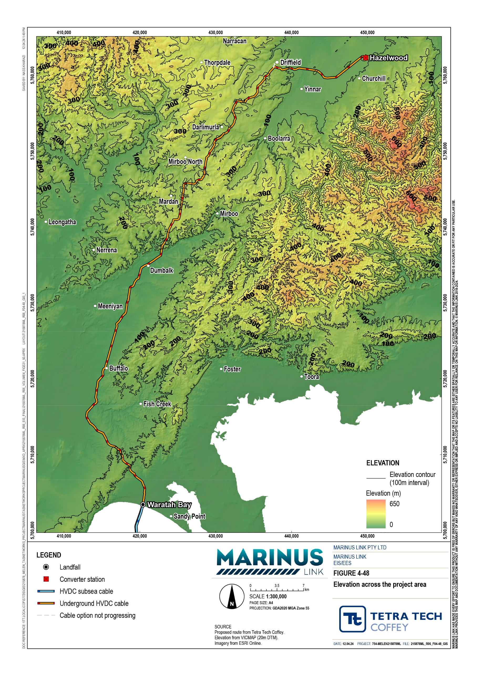

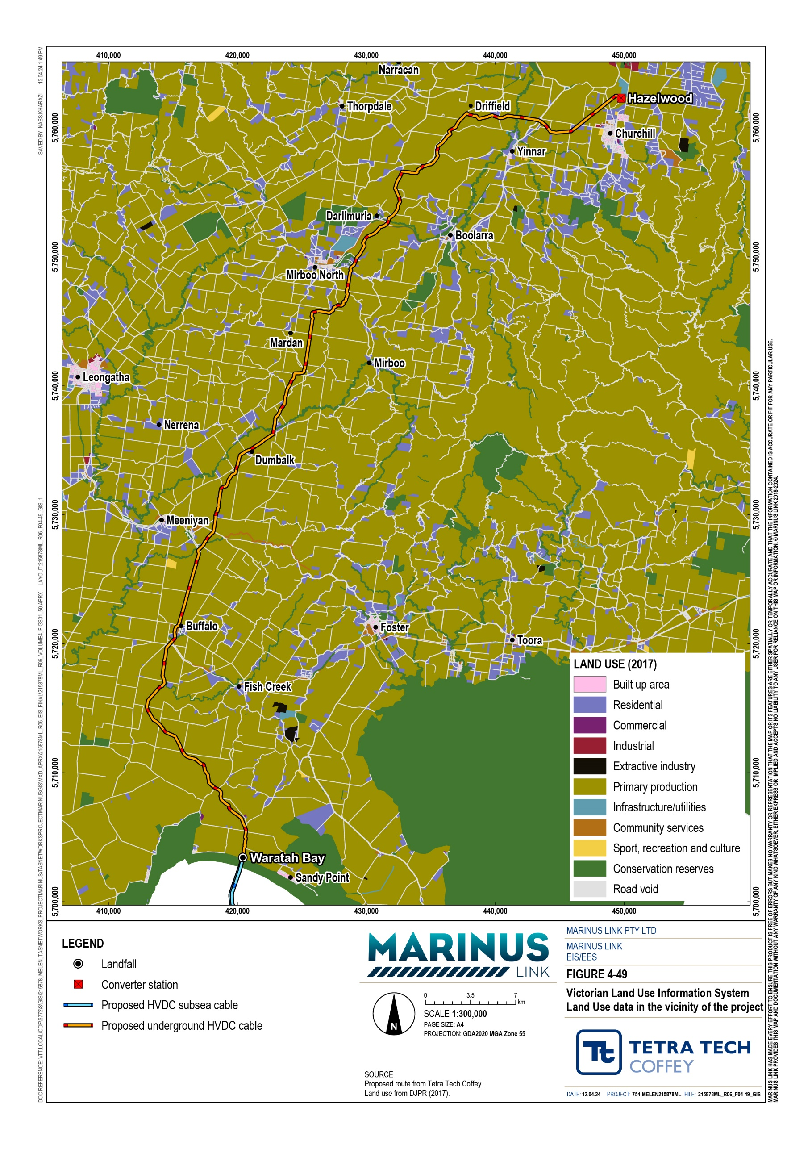

Meteorology and climate
Local meteorological and climate conditions, such as wind speed and direction, temperature, and rainfall are key characteristics that influence the potential for dust to be suspended and transported. For example, a hot and dry climate, with strong wind conditions has a higher potential for dust suspension and transportation, when compared to a cool and humid climate, with weak wind conditions. Higher temperature will change the physical characteristics of dust, allowing for easier suspension. Temperature may also influence the convective movement of air. Increased precipitation and humidity reduces the potential for dust to be suspended or transported.
The project area is located in the central southern region of Victoria. It is described as temperate, with no dry season, and mild summers under the Koeppen Classification.
The surface wind climate is driven by the large-scale circulation pattern of the atmosphere. The project is in the Southern Slopes region which is at the northern edge of the ‘Roaring Forties’ belt of westerly circulation, and therefore receives predominantly westerly winds.
A variation in wind speed was observed across the study area between seasons, and between day and night. Spring and summer recorded wind speeds higher than autumn and winter. With wind speeds gradually increasing throughout the day to their peak in the afternoon (midday to 6 pm) and gradually decrease over night (midnight to 6 am).
Rainfall reduces the emissions of dust from construction activities and exposed ground. The average annual rainfall at Morwell is 711 mm, with a maximum annual total of 947 mm, and a minimum annual total of
384 mm. The winter period accounts for 27% of the mean annual rainfall, while summer only accounts for 22%. Spring and autumn observe a greater contrast, accounting for 30% and 21% of the mean annual rainfall, respectively.
The average annual rainfall at Corner Inlet is 725 mm, with a maximum annual rainfall of 966 mm, and a minimum annual rainfall of 319 mm. The winter period accounts for 33% of the mean annual rainfall, while summer only accounts for 17%. Spring and autumn are equivalent, accounting for 26% and 24% of the mean annual rainfall, respectively.
The mean total rainfall peaks during the winter months and is at its lowest during summer. This seasonal rainfall is characteristic of the oceanic climate, with the absence of a dry season and the distribution of rainfall across the year.

Ambient air quality
Five EPA Victoria air monitoring stations were identified within 20 km from the project (Figure 4-50). The monitoring stations all capture data on PM2.5 and one station in Traralgon also monitors for PM10. The monitoring stations are situated within residential areas to the north of the project and were installed for the purpose of capturing data to help understand the potential risk of impacts from the existing industrial facilities in the region.

Air quality data captured at each of the monitoring sites between 2015 and 2021 was used to characterise the ambient air quality of the project area. Average annual PM2.5 and PM10 levels recorded at the five monitoring stations between 2015 and 2021 were mostly below their respective limits of 25 and 50 µg/m³. The exceedances were largely due to bushfires and some unknown sources.
An annual average background PM10 concentration of 15.4 µg/m³ has been adopted as the ambient levels in the vicinity of the project, based on the monitoring station at Traralgon. Data from years 2019 and 2020 have been omitted due to influence of bushfires in these years.

Sensitive receivers
Sensitive receivers are locations that may be affected by dust emissions during demolition and construction. The IAQM method considers these locations to be where people live and spend time. Sensitive receivers within 1 km of the land cable and Hazelwood converter station were identified with a focus on high sensitivity receivers in accordance with the IAQM method. This review identified 245 residential buildings within 1 km of the project, with the closest resident being 11 m from the construction corridor of the land cable. This dwelling has however been purchased by MLPL and is intended to be demolished prior to construction (demolition works are to be completed prior to the project and are not associated with the project).
Figure 4-51 shows the varying distribution of the residential sensitive receivers along the alignment, with key clusters around Churchill and Mirboo.
In accordance with the IAQM method, ecological habitats within 20 m of the project have also been considered in the assessment as sensitive receivers. For ecological habitats to be impacted by dust, large volumes of dust deposition are required to reduce rates of photosynthesis and respiration. This level of dust deposition is considered unlikely due to the high rainfall in the region. The assessment did not identify any dust sensitive habitats and, consequently, the ecological receivers identified in the terrestrial ecology assessment have been classified as low sensitivity receivers (Technical Appendix V: Terrestrial ecology).

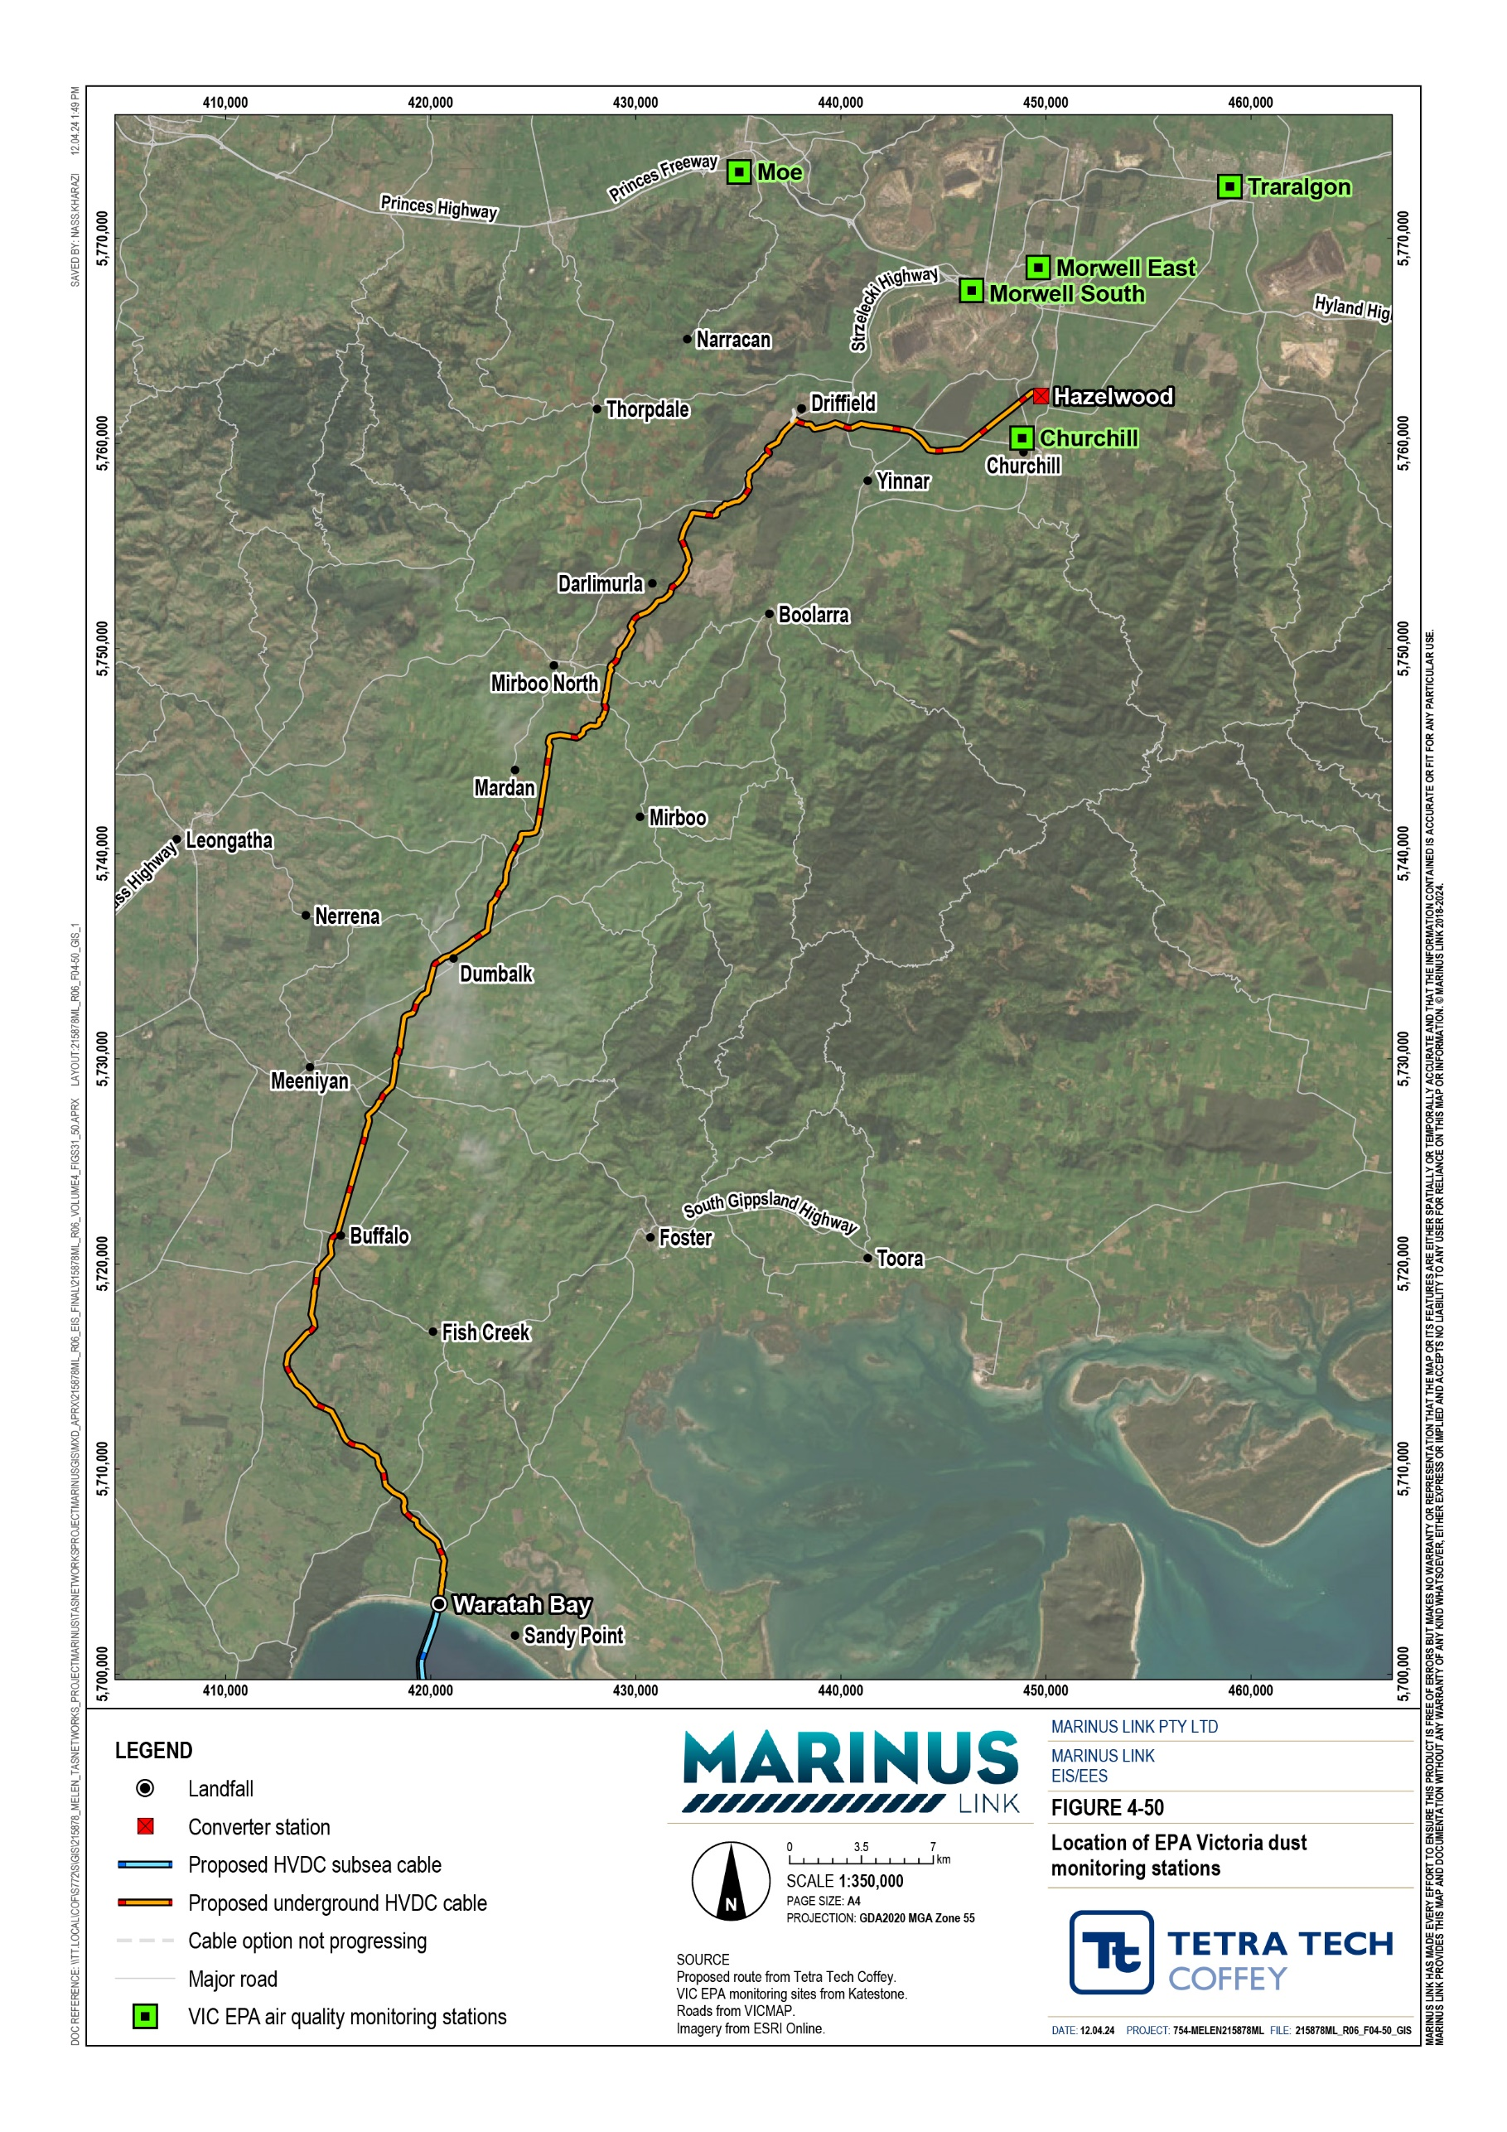
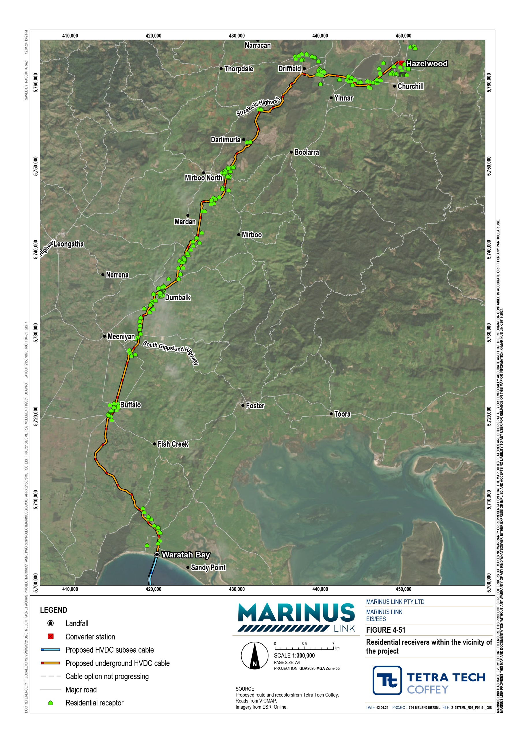

Construction impacts
Construction activities will occur progressively along the cable alignment. Construction will require the use of a variety of equipment and machinery such as 36 t excavators, bulldozers, graders, franna cranes, front end loaders, drilling rigs, medium and heavy rigid trucks, agitator trucks, light vehicles, wheeled and tracked excavators, piling rigs, elevated work platforms, spider cranes, and 1,500 kilo-volt-amperes (kVA) diesel generators.
The potential risk of dust-related impacts associated with construction of the project are:

Risk of reduced public amenity due to dust soiling: larger dust particles above 10 μm in diameter are more likely to be visible to the public and may reduce public amenity if it deposits on clothes (on clothes lines), vehicles, buildings and other surfaces.
Risk of health impacts due to elevated levels of dust: smaller dust particles such as PM10, can affect human health if inhaled, as they can become trapped in the nose, mouth, throat, or can be drawn into the lungs. Smaller dust particles such as PM2.5 are more likely to enter the lungs than PM10.
Potential risk of harm to ecological receivers from dust deposition may include reduced rates of photosynthesis and respiration.
The air quality impacts from the construction of the land cable and the Hazelwood converter station are expected to vary due to the differences in duration and intensity of construction activities. Construction of the land cable will move along the alignment and be shorter at each location compared to the longer construction time for the Hazelwood converter station. Therefore, construction activities for each of these components were assessed separately and are discussed below.

Land cable
The construction area for the land cable will be up to 36 m wide to accommodate construction of the two cable trenches, joint pits, haul road and construction support sites. Approximately 80% of the land cable alignment passes through agricultural land used for dairy production, beef production and horticulture.
Dust emissions have the potential to pose a risk of impact to agricultural values, particularly relating to amenity if dust deposits on agricultural properties adjacent to the construction area. If dust deposition is significant, it could pose a risk of impacting tank water quality, plant photosynthesis and animal health, resulting in reduced amenity, or reduced productivity or yields. The potential risk of impacts to agriculture properties will be managed using typical mitigation measures to manage and supress dust emissions.
Potential risk of dust impacts on agriculture are assessed further in Technical Appendix K: Agriculture and forestry.
In accordance with the IAQM method, the potential risk of dust-related impacts due to the land cable construction were assessed in the construction activity categories: earthworks, construction and vehicle trackout.

The magnitude of emissions associated with each construction activity category is outlined in Table 9-2. The magnitude rating for earthworks is characterised by the total area of earthworks for the land cable construction. The extent of earthworks is approximately 3,532,000 m², based on a 36 m wide corridor required to construct the cable trenches, cable joint pits, and associated infrastructure. Although the risk of impact in any single area will be relatively small in terms of area of earth works and duration of works, the magnitude rating is based on the total area of earthworks. This therefore results in a large magnitude of emissions rating.
The construction activity category primarily consists of laying cables. This has a lower potential to generate dust and therefore was assigned a magnitude of emissions rating of medium.
The vehicle trackout activity category was assigned a magnitude of emissions rating of large. This is due to the distance of access tracks being up to several km long and the expected amount of traffic of up to
13 trucks per day.

 | Earthworks | Construction | Vehicle trackout
Magnitude of emissions | Large | Medium | Large
There are 197 residential receivers within 350 m of the land cable. An additional 10 residential receivers are included when assessing access tracks. This number of receivers triggers the need for a detailed risk assessment under the IAQM method.
Table 9-3 presents the number of residential receivers and the presence of ecological receivers at increasing distances from the project construction areas. Given the transient nature of cable laying construction the sensitive receivers may only be in proximity to construction for a number of weeks.
The residential sensitive receivers along the project construction are also presented in Figure 4-52.

Receiver Summary |  |  | Distance to activity
 | <20 m | < 50 m | < 100 m | < 350 m | < 500 m
Number of residential receivers to the land cable | 3 | 12 | 37 | 197 | 240
Number of residential receivers to land cable and access roads (for earthworks & vehicle trackout) | 6 | 17 | 56 | 207 | 245
Ecological receivers located within proximity to the land cable and  access roads | Yes | Yes | - | - | -

Table 9-4 presents the sensitivity of the area to potential impacts during construction phases considered in the IAQM method. The sensitivity is based on the number of receivers and distance from construction activities considered against the matrices in the IAQM method. The area surrounding the project was assessed to have a medium sensitivity to dust during earthworks, construction and vehicle trackout. The area surrounding the project was assessed to have a medium sensitivity to human health impacts. This is due to the annual mean PM10 concentration being below 17.5 µg/m³ and there being between one to ten receivers within 20 m of the works.

Potential impact | Earthworks | Construction | Vehicle track out
Dust soiling effects | Medium | Medium | Medium
Human health impacts | Medium | Medium | Medium
Ecological impacts | Low | Low | Low

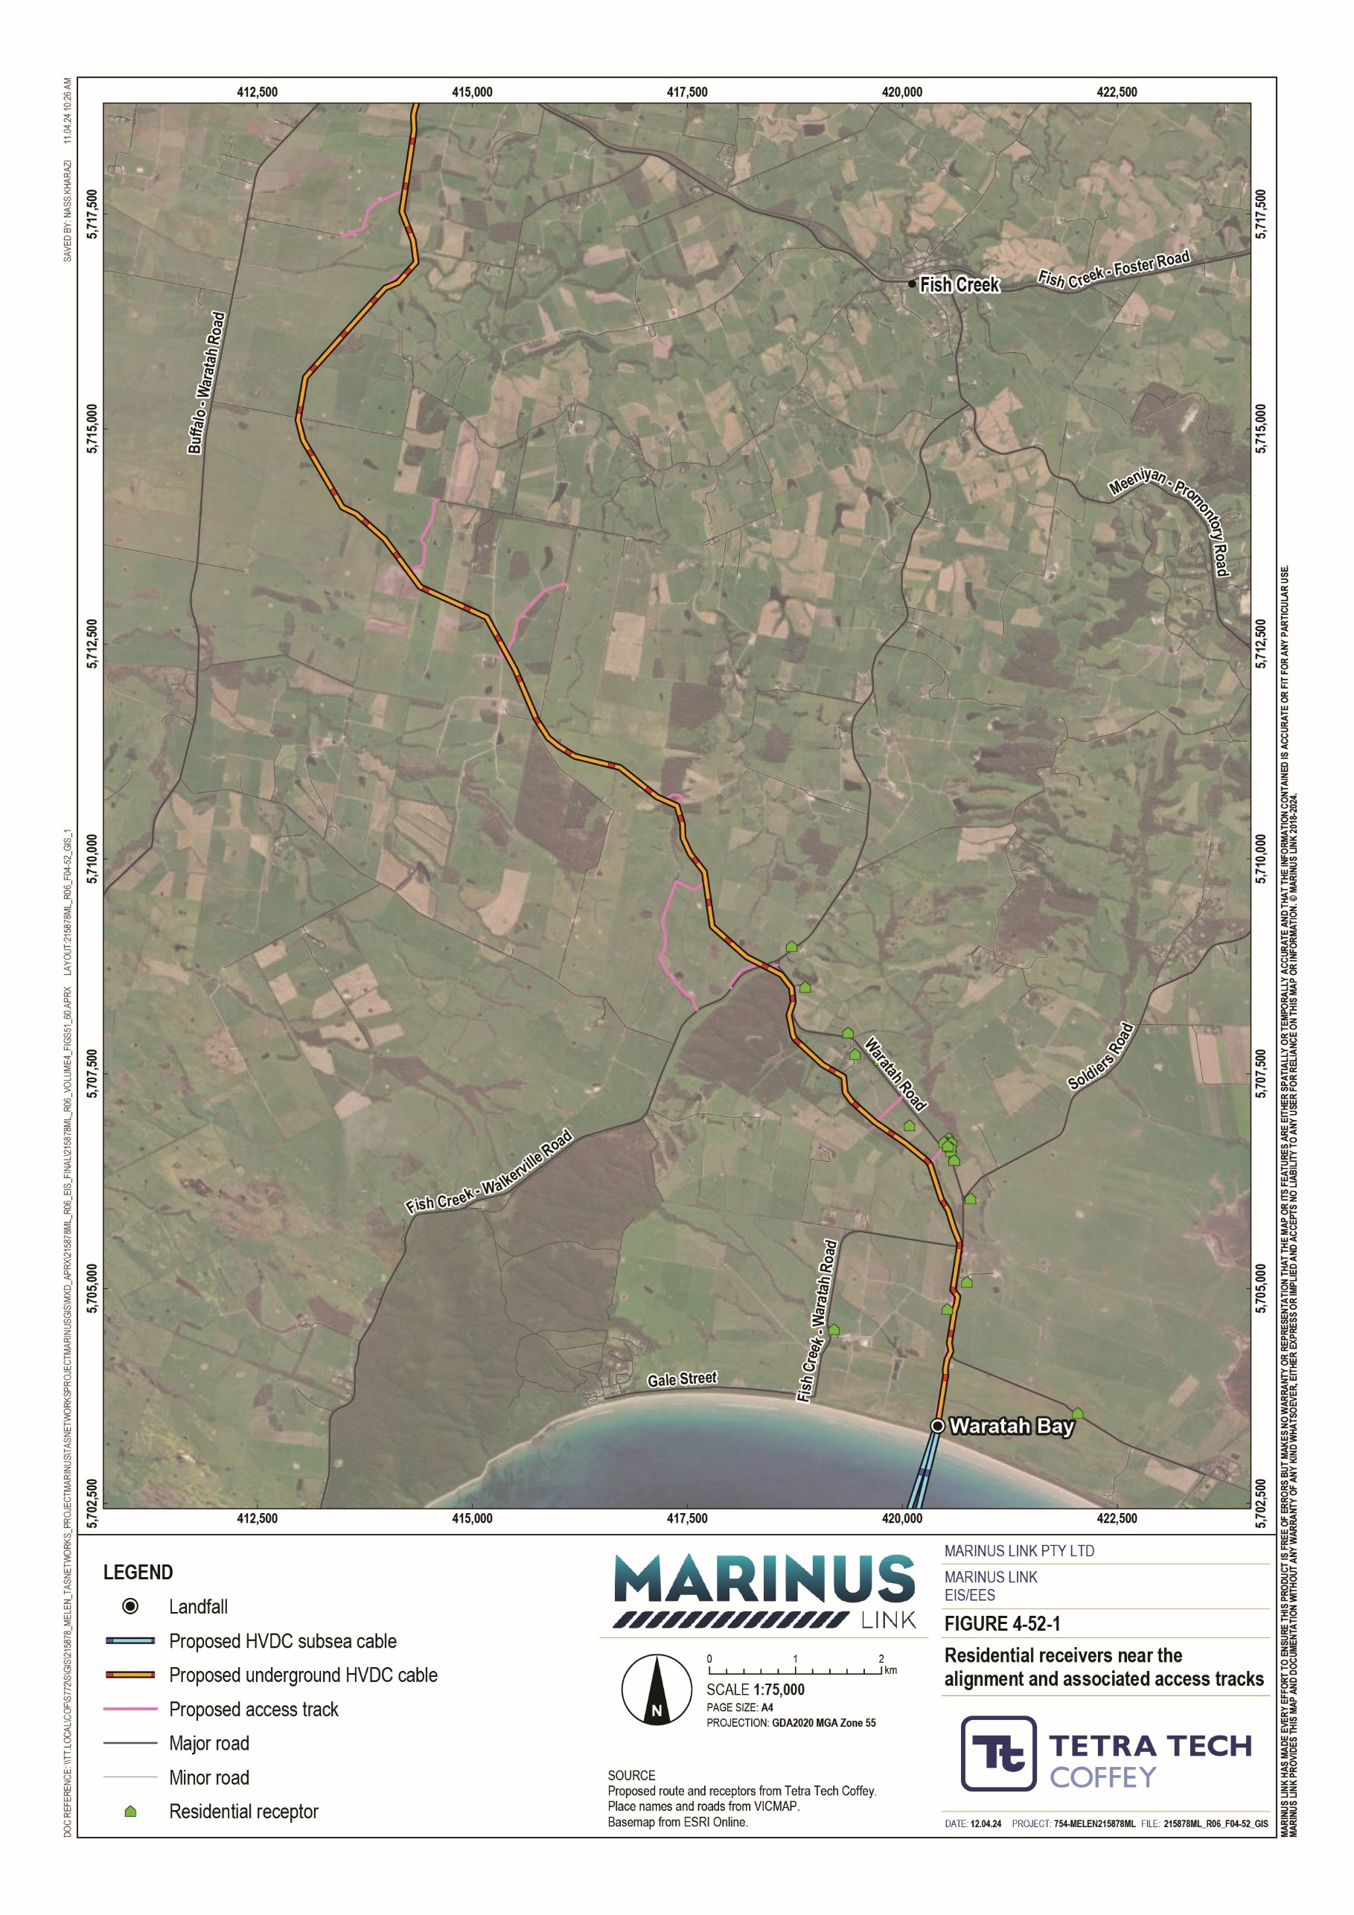
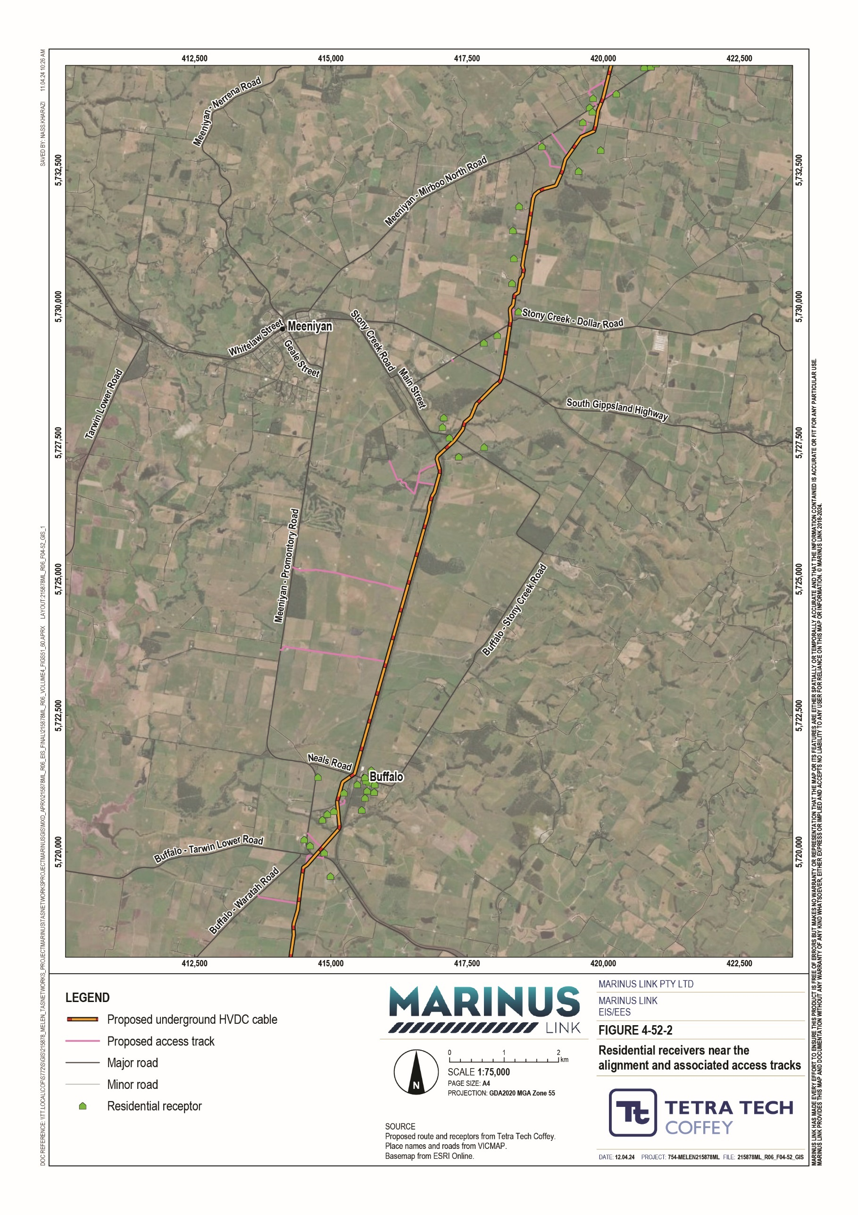
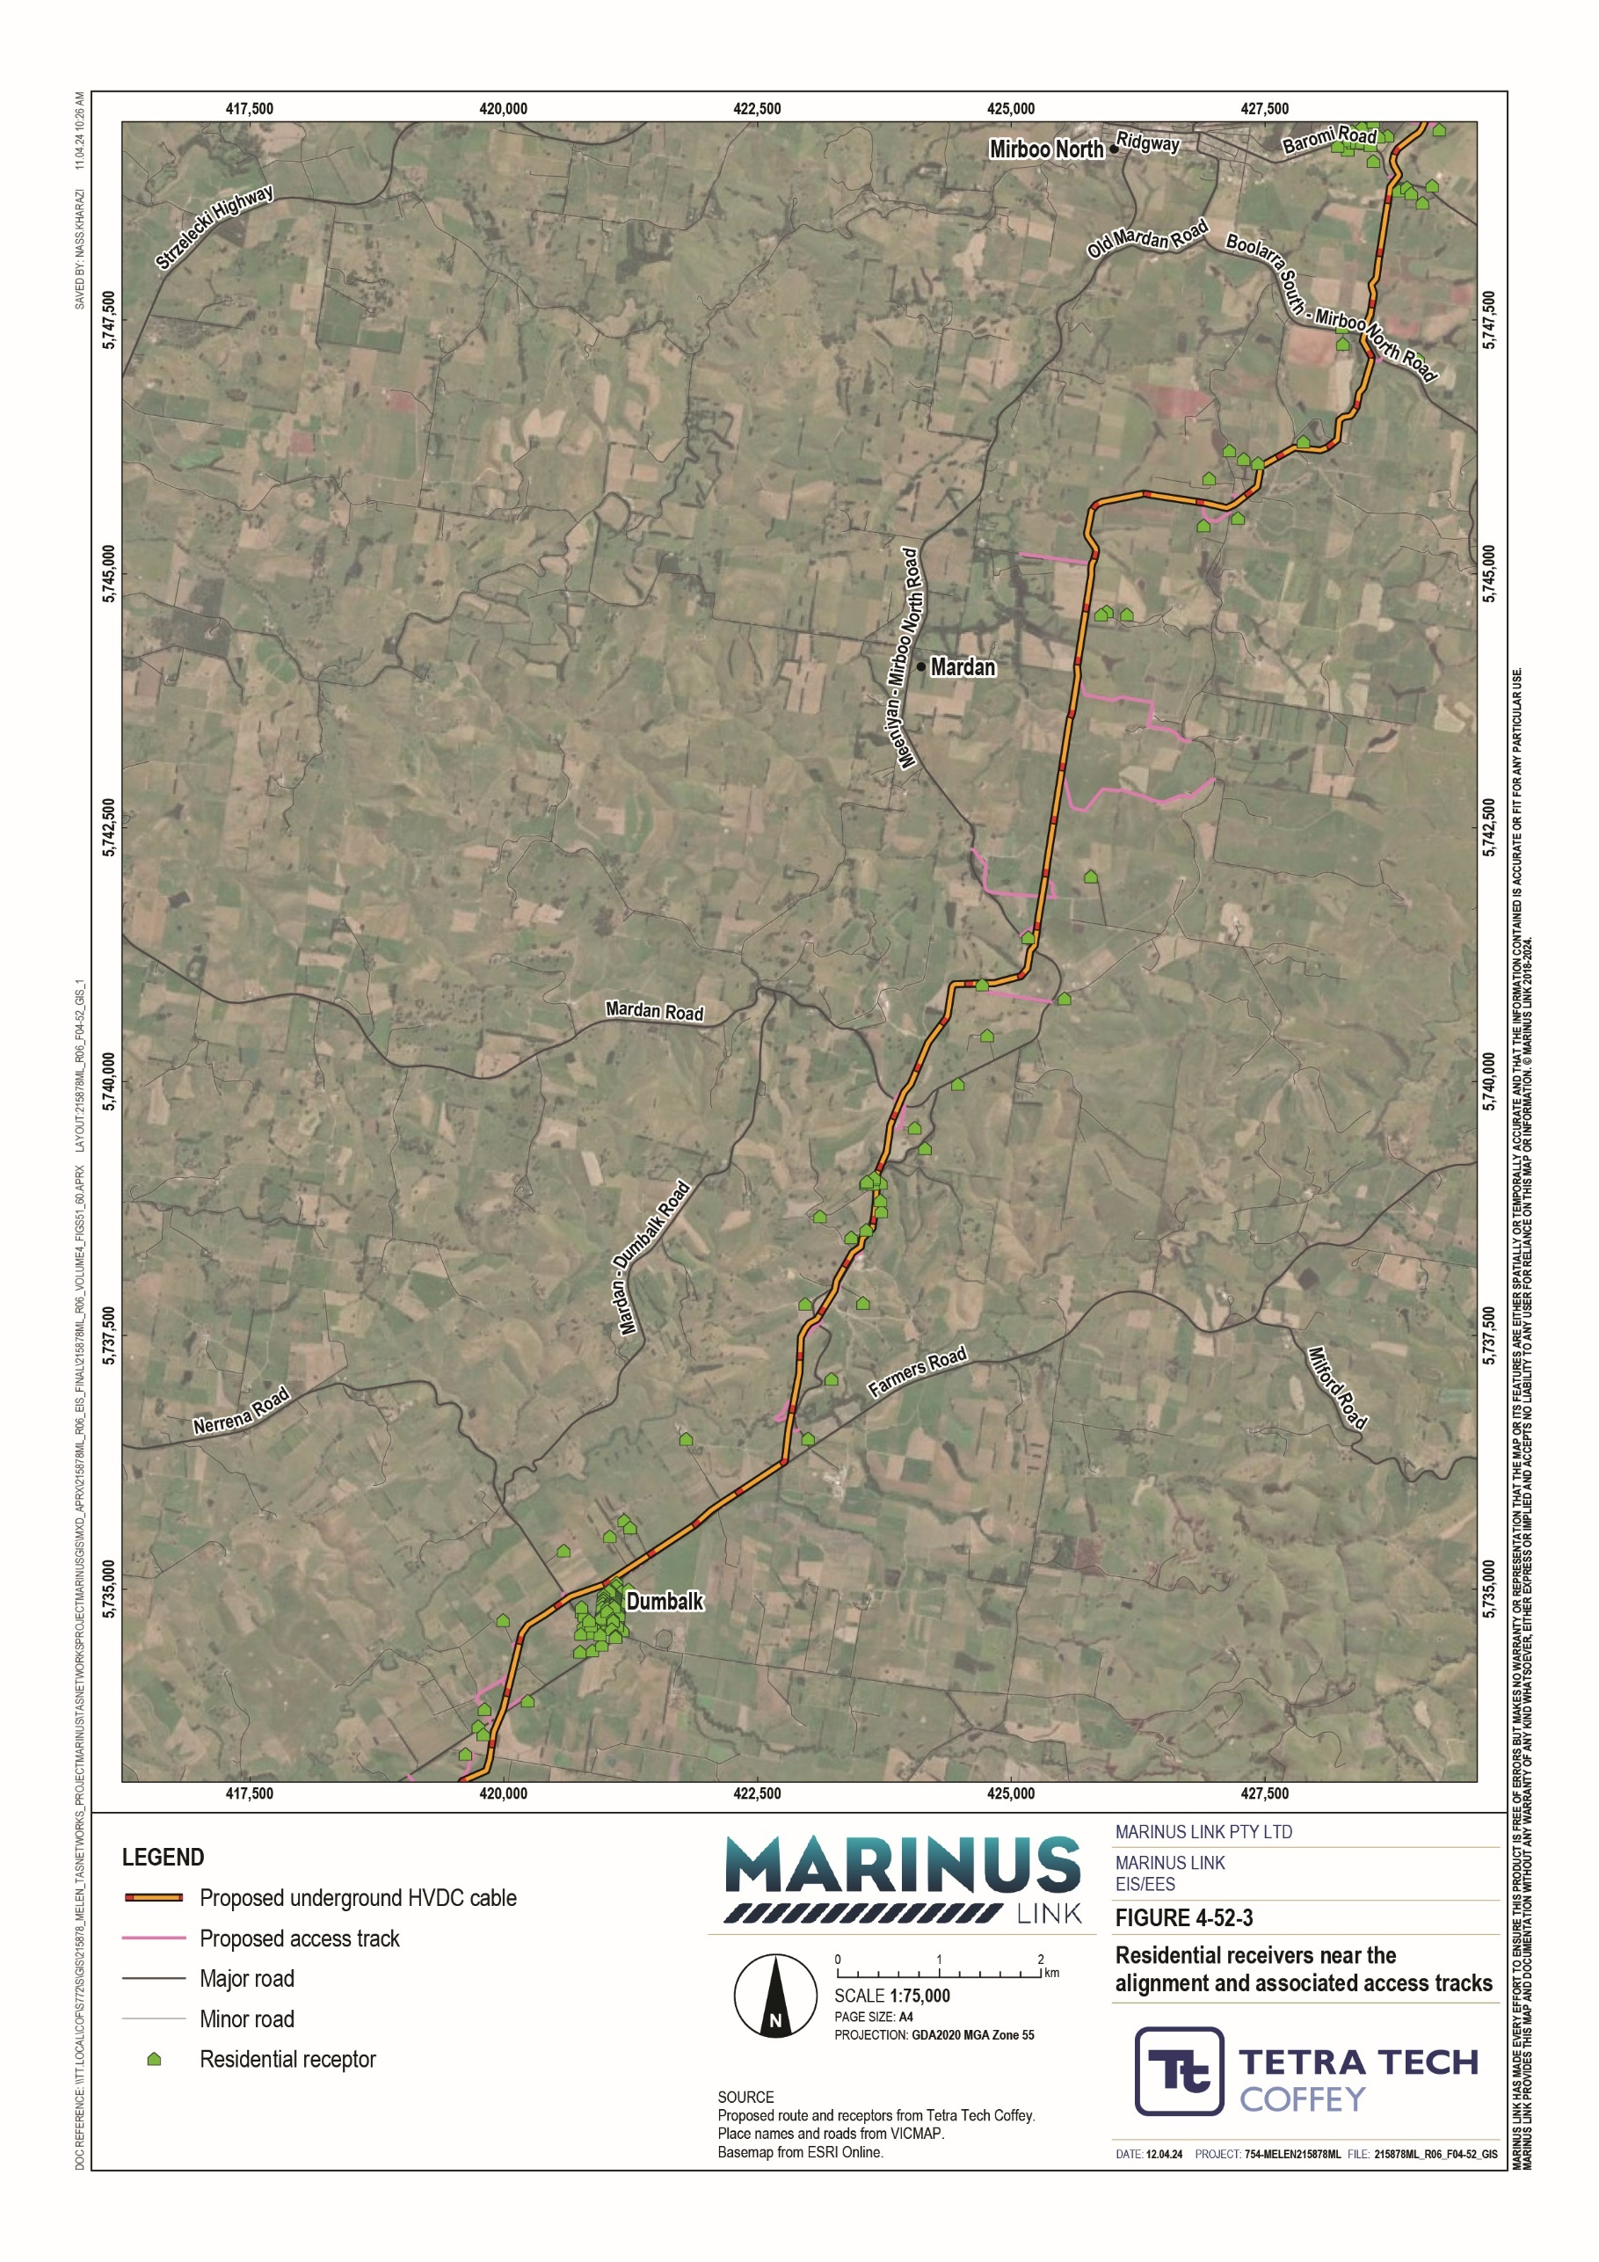

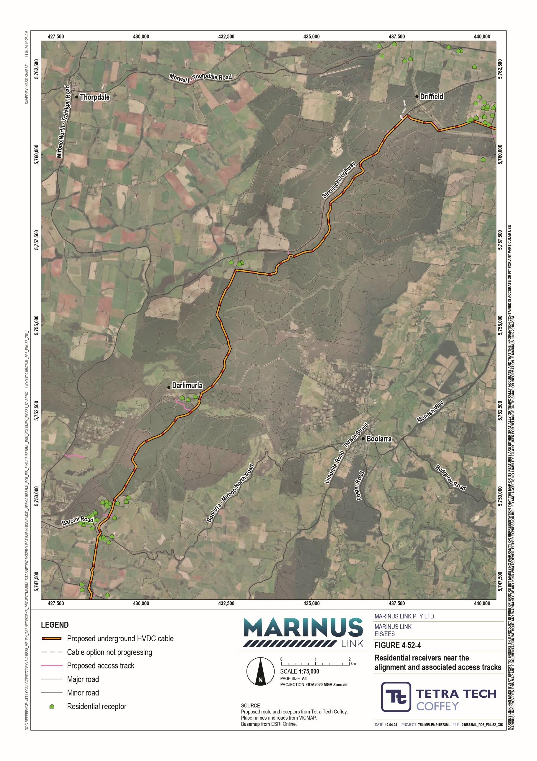
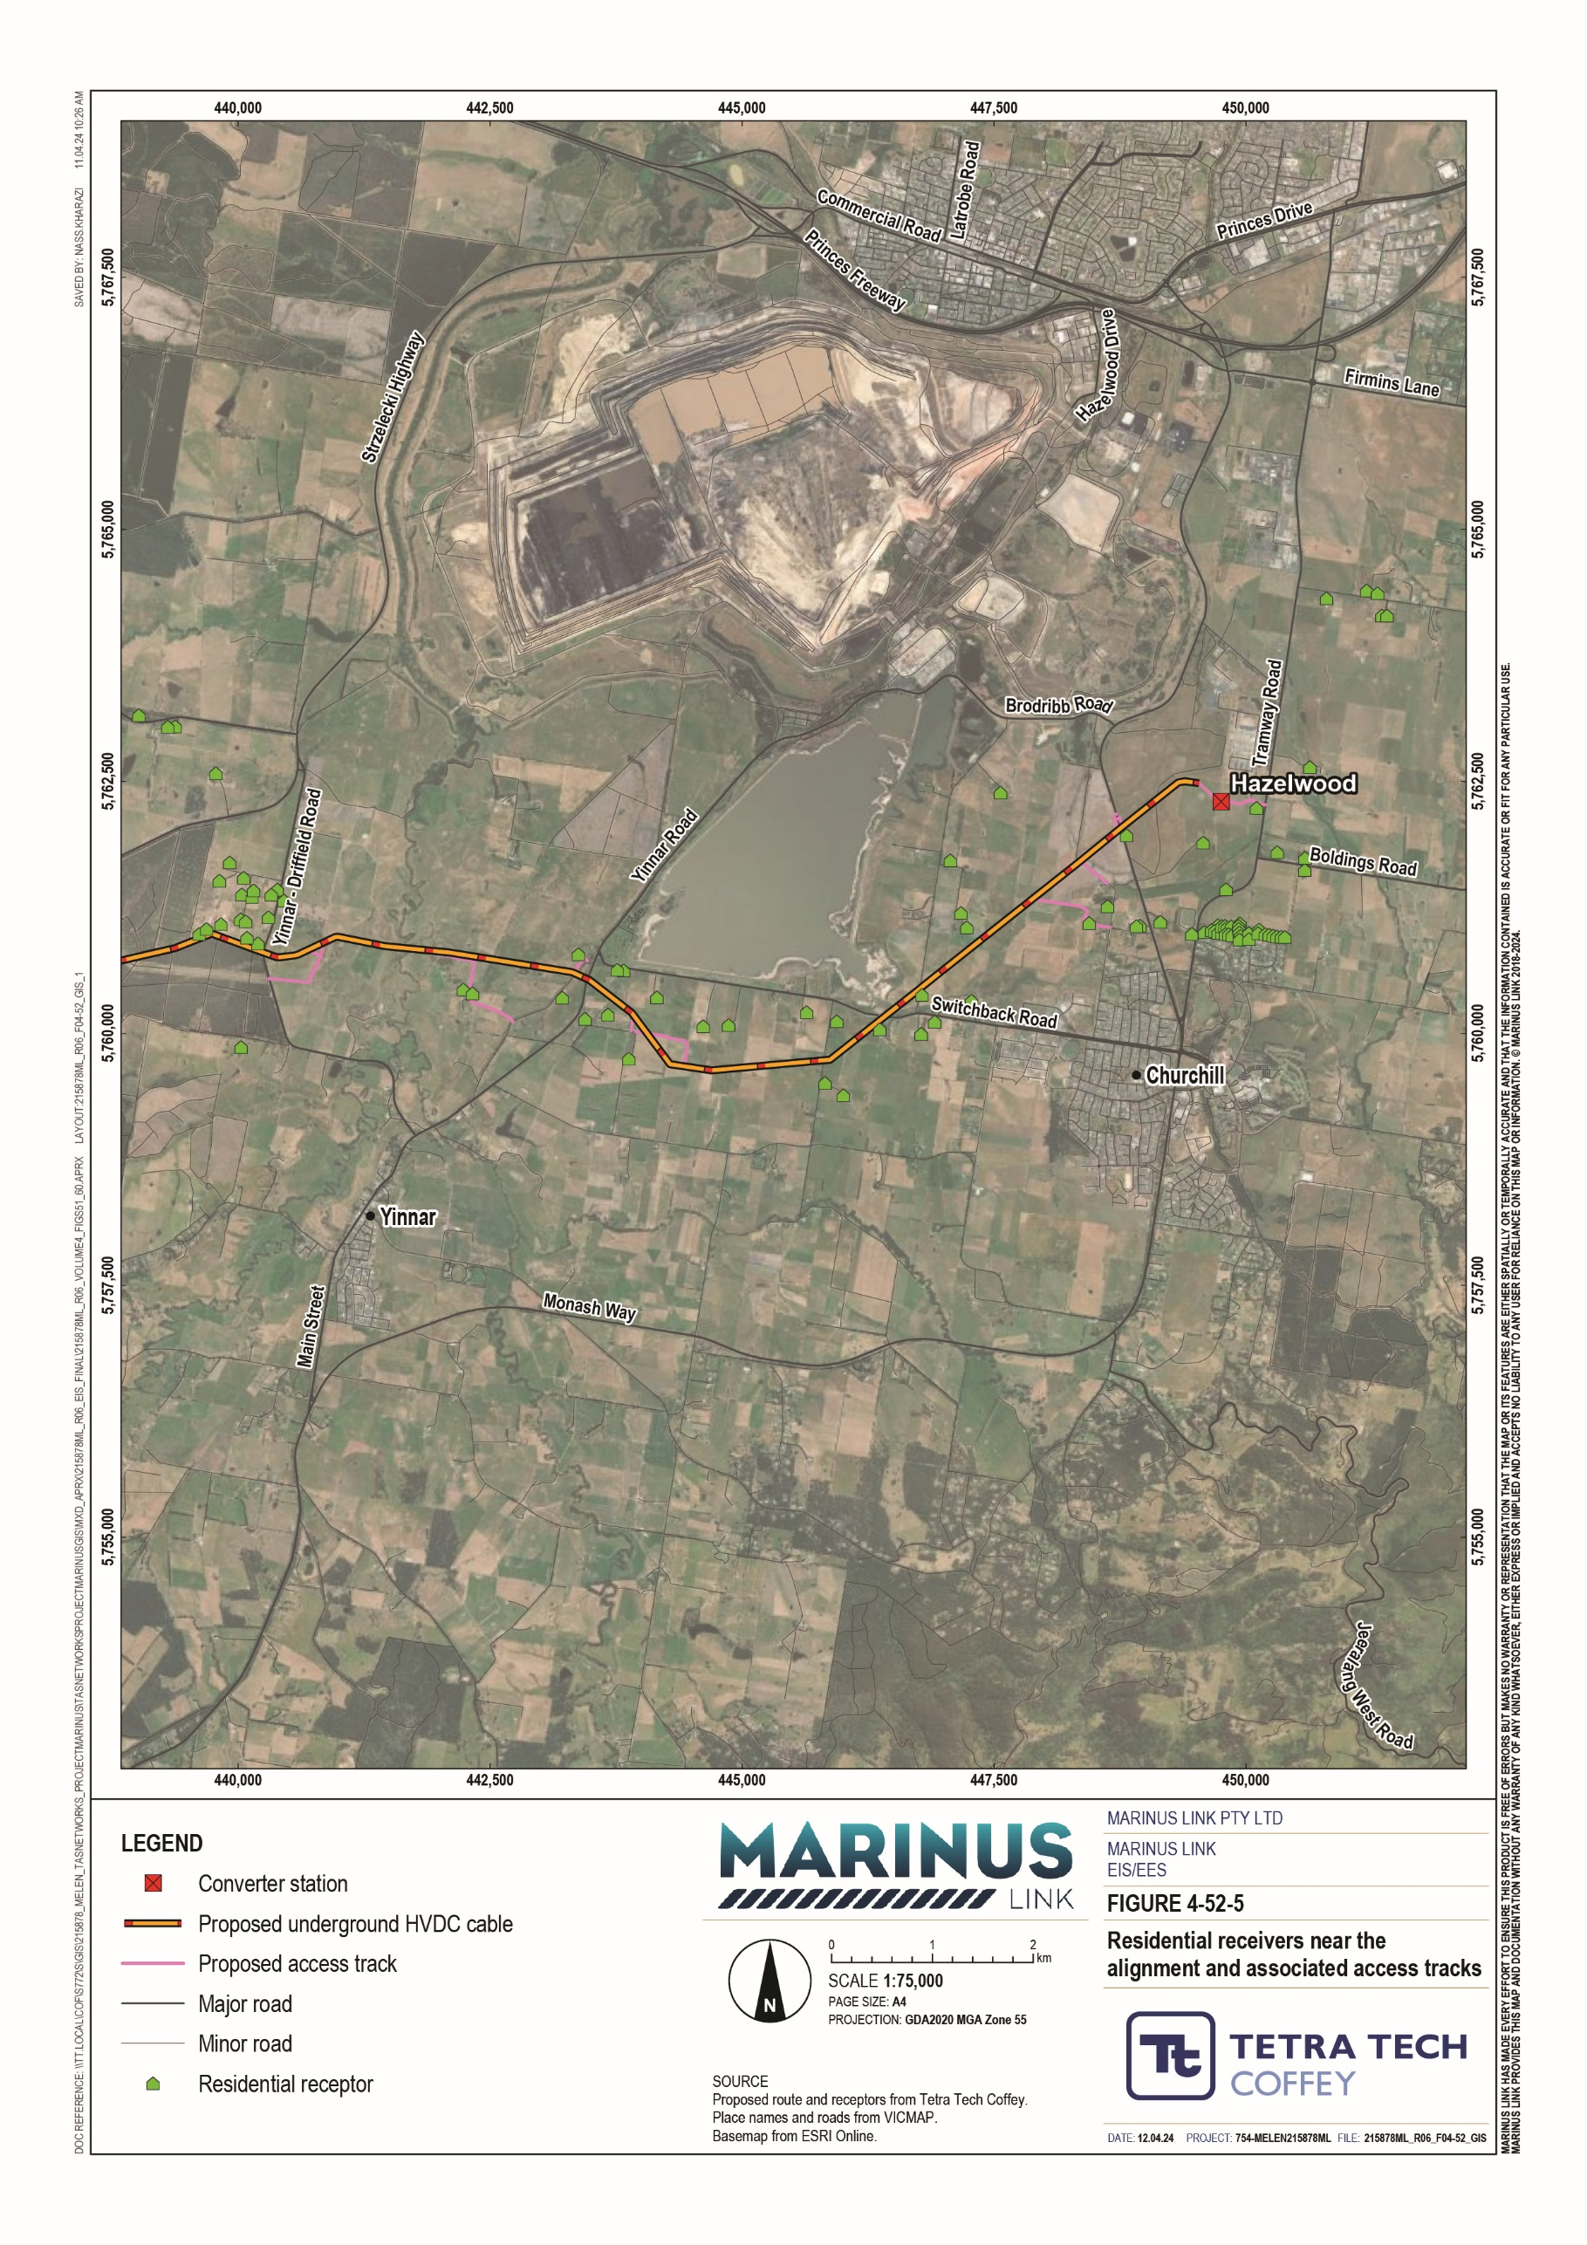

Table 9-5 presents the preliminary risk assessment rating for the project prior to implementation of any mitigation measures. There is a low to medium preliminary risk of impact from the construction of the land cable to sensitive receivers and low preliminary risk of impact to ecological receivers.
The duration of works in proximity to individual receivers will be brief, and a conservative approach was adopted for the assessment by rating the magnitude of emissions for these works as large.

Potential impact | Earthworks | Construction | Vehicle trackout
Dust soiling effects | Medium | Low | Medium
Human health impacts | Medium | Low | Medium
Ecological impacts | Low | Low | Low

These risks of impact are manageable through the implementation of dust suppression measures to comply with a robust CDMP. The requirements for the CDMP and its content are detailed in EPR AQ01. Possible dust suppression measures are outlined in the IAQM method and could include techniques such as the use of water spraying, storing materials to minimise dust, regular inspections for dust sources, speed limits on unsurfaced haul roads, and maintaining vehicles to emissions standards. Possible dust emission controls have been identified from the level 1 assessment in accordance with the IAQM method and have informed the development of the EPRs. These controls will address the requirements of the EPA Victoria’s Guideline for Assessing Nuisance dust (Publication 1943) and the EPA Victoria’s Construction – Guide to preventing harm to people and the environment (Publication 1820).

Hazelwood converter station
There are no residential properties within 350 m of the Hazelwood converter station construction area. The closest receiver is located 375 m away. The converter station and surrounding area is shown in Figure 4-52. Given the distance from residential properties, the construction of Hazelwood converter has been assessed as having a negligible to low risk of impact.
Although the need for a detailed risk assessment under the IAQM method is not triggered, mitigation measures documented in a CDMP for the site (EPR AQ01) will be implemented to comply with EPRs to manage dust emissions and will reduce the risk of impacts on the surrounding environment from the Hazelwood converter station construction.

Operation impacts
The operation phase activities have the potential to result in emissions to air from:

Operation of two 1,500 kVA backup diesel generators at the Hazelwood converter station.

Routine inspections of the land cable easement and converter station.

Use of light vehicles for maintenance of project infrastructure including access tracks retained following construction.
The backup diesel generators will be used occasionally for emergencies and routine testing or maintenance activities. The nearest sensitive receiver is 350 m away from the converter station. The occasional use of the generator will not result in significant risk of air quality impacts to sensitive receivers.
Quarterly inspections of the easement will involve the use of a small number of light vehicles accessing the converter station site and land cable easement. Exhaust emissions and dust generated from light vehicle movements will not result in significant risk of air quality impacts.
Occasional maintenance of access tracks may result in some dust emissions (depending on the degree of maintenance required). However, this will not result in significant risk of air quality impacts at nearby sensitive receivers, given the frequency and temporary nature of these works.
Overall, operational and maintenance activities will not result in significant risk of air quality or dust impacts at sensitive receivers. This is due to the small scale use of vehicles, equipment and machinery and the occasional frequency that they are used in conducting the works.

Decommissioning impacts
The operational lifespan of the project is a minimum 40 years. At this time the project will be either decommissioned or upgraded to extend its operational lifespan.
Decommissioning will be planned and carried out in accordance with regulatory requirements at the time. A decommissioning management plan in accordance with approvals conditions will be prepared prior to planned end of service and decommissioning of the project.
Requirements at the time will determine the scope of decommissioning activities and risk of impacts. The key objective of decommissioning is to leave a safe, stable and non-polluting environment, and minimise risk of impacts during the removal of infrastructure.
Decommissioning of project infrastructure will implement the waste management hierarchy principles of avoid, minimise, reuse, recycle and appropriately dispose. Waste management will be in accordance with applicable legislation at the time.
A decommissioning management plan will be prepared to outline how activities will be undertaken and potential risk of air quality impacts managed.

Environmental performance requirements
EPRs set out the environmental outcomes that must be achieved during all phases of the project. In developing these EPRs, industry standards and guidelines, good practice and the latest approaches to managing risk of impacts were considered. Project specific management measures, relevant legislation and policy requirements informed these EPRs.
The EPRs that will be implemented to manage potential risk of impacts on air quality are listed in Table 9-6.

EPR ID | EPRs
AQ01 | Develop and implement a construction dust management plan  Prior to commencement of project works, develop a construction dust management plan that documents measures to avoid, minimise and mitigate dust emissions. The construction dust management plan must:  Identify sources of dust and airborne pollutants, including diffuse sources and the location of sensitive receptors in accordance with EPA Victoria Publication 1943 – Guideline for assessing nuisance dust.  Describe dust management measures to be adopted in construction considering:  - Earthworks, exposed areas and stockpiles  - Access tracks and haul routes  - Construction vehicles and equipment  - Construction materials, transport, handling and storage  - Waste management transport, handling and storage  Describe measures to avoid and, where avoidance is not practicable, reduce the risk of harm from air emissions so far as reasonably practicable to minimise impacts on health, safety or amenity in accordance with EPA Victoria Publication 1820.1 – Guide to preventing harm to people and the environment.  Describe inspection requirements for construction areas to monitor implementation of controls. Define roles and responsibilities of the contractors, and how implementation of dust management measures will be communicated.  Outline a process to address complaints related to dust and dust events and identify opportunities for continual improvement of air quality impacts from construction.  Outline a process for review and improvement of dust and emission reduction and management measures.  Consider the mitigation measures presented in the Air Quality impact assessment prepared for the Marinus Link EIS/EES including mitigation for cumulative impacts.
AQ02 | Develop and implement measures to manage emissions to air during operations  As part of the OEMP, develop measures to avoid or minimise air quality impacts. These measures must include consideration of:  Converter station site maintenance and exposed soil areas Access roads  Vehicles and equipment Waste management

In addition to the air quality EPRs, the other EPRs that will reduce the potential risk of air quality impacts caused by the project are related to:
Sustainability, climate change and greenhouse gas (Volume 1, Chapter 9 – Sustainability, climate change and greenhouse gas emissions)
Contaminated land and acid sulfate soils (Volume 4, Chapter 3 – Contaminated land and acid sulfate soils)
Agriculture and forestry (Volume 4, Chapter 4 – Agriculture and forestry)

Traffic and transport (Volume 4, Chapter 8 – Traffic and transport)

The complete list of EPRs for the project is provided in Volume 5, Chapter 2 – Environmental Management Framework.

Residual risk of impact
With the effective implementation of dust mitigation measures to comply with EPRs, the residual risk of impacts are assessed as not significant for the construction of the land cable and Hazelwood converter station, as shown in Table 9-7.
The IAQM guidance acknowledges that even with the implementation of a rigorous CDMP it is not possible to guarantee that dust mitigation measures will always be sufficient at every location. For example, dryer conditions during summer months, or under unusual or adverse weather conditions, the likelihood of risk of dust impacts to air quality is higher. However, mitigation efforts will likely increase in dryer months to meet CDMP requirements, and unusual weather is typically short term, and is not expected to change the overall risk of impact rating. The CDMP will outline the process to manage dust and address any complaints received due to dust events (EPR AQ01).
Residents near the project are expected to experience minimal dust impacts. For example, they should not witness visible plumes of dust leaving construction sites and travelling towards their properties. The primary impact that may be observed by nearby residents, will be the increased rate of dust build-up on surfaces, due to deposition. These impacts will only be experienced for a short, temporary period while construction works are carried out in proximity to their property. In most cases, nearby residents will be unlikely to notice a significant difference to the normal rate of dust build-up.
The operation of the project will not generate significant risk of air quality impacts at nearby sensitive receivers. As part of the OEMP, measures will be developed to avoid or minimise air quality impacts to manage impacts associated with operation (AQ02).
Risk of ecological impacts from dust are negligible through all applicable activity categories.

Overall, residual risks associated with project are considered negligible or low and are summarised in Table 9-7.

Potential risk | Sensitivity | Magnitude | Risk rating | Justification of residual rating | Recommended EPRs | Residual risk rating
Earthworks
Dust soiling effects | Medium | Large | Medium | With the application of dust suppression measures, dust impacts are expected to be minimal. The gradual buildup of dust on surfaces due to deposition may be noticeable for residents near to the earthworks, however, impacts for residents are expected to short-term and temporary in nature. | AQ01 | Low

Human health | Medium | Large | Medium | With the applications of standard dust controls, PM10 concentration are no expected to pose a risk to human health. | AQ01 | Low
Ecological receivers | Low | Large | Low | Ecological receivers in the study area have been classified as low sensitivity receivers, therefore the applications of standard dust management controls are residual risk rating will be negligible. | AQ01 | Negligible
Construction activities
Dust soiling effects | Medium | Medium | Low | With the application of dust suppression measures, dust impacts are expected to be minimal. The gradual buildup of dust on surfaces due to deposition may be noticeable for residents near to the construction activities, however, impacts for residents are expected to short-term and temporary in nature. | AQ01 | Negligible
Human health | Medium | Medium | Low | With the applications of standard dust controls, PM10 concentration are no expected to pose a risk to human health. | AQ01 | Negligible
Ecological | Low | Medium | Low | Ecological receivers in the study area have been classified as low sensitivity | AQ01 | Negligible
receivers |  |  |  | receivers, therefore the applications of standard dust management controls are residual risk rating will be negligible

Trackout
Dust soiling | Medium | Large | Medium | Through the implementation of measures to maintain access tracks to suitable | AQ01 | Low
effects |  |  |  | standard, and application of dust suppression measures (i.e., application of water to
 |  |  |  | unsealed access tracks), the impacts associated with trackout are expected to be
 |  |  |  | low.

Human health | Medium | Large | Medium | With the applications of standard dust controls, PM10 concentration are no expected to pose a risk to human health. | AQ01 | Low
Ecological receivers | Low | Large | Low | Ecological receivers in the study area have been classified as low sensitivity receivers, therefore the applications of standard dust management controls are residual risk rating will be negligible | AQ01 | Negligible

Cumulative risk of impact
The Delburn Windfarm and Hazelwood Rehabilitation Project were considered in the cumulative impact assessment. It was considered highly unlikely that any significant cumulative risk of dust impacts will be experienced at sensitive receivers in proximity to these projects, given the frequency of dust-generating activities and the distance to these receivers.
The risk of cumulative impacts due to dust emissions from construction works associated with the Delburn Wind Farm are considered highly unlikely due to the large area over which the project turbines are located and the distance from sensitive receivers (1.3 km from the sensitive receivers considered in this assessment).
There is, however, a potential risk of cumulative impacts with the future use of the Hazelwood Rehabilitation Project area. The concept for the rehabilitation project includes areas to the south becoming an agricultural hub for intensive soil-based agriculture, high technology agriculture and plantations. This may generate additional sources of dust if this occurs at the same time as construction of the project. Therefore, the following mitigation measure is recommended by the IAQM guidance:
Hold regular liaison meetings with other high risk construction sites within 500 m of the site boundary, to ensure plans are co-ordinated and dust and particulate matter emissions are minimised. It is important to understand the interactions of the off-site transport/deliveries which might be using the same strategic road network routes.
If the above measure is implemented, dust emissions should be sufficiently managed such that no significant cumulative risk of dust impacts will be experienced at sensitive receivers.

Conclusion
The IAQM method adopted for this assessment has focused on the potential risk of dust impacts during construction. The assessment found that, without mitigation, the construction of the land cable poses a low to medium risk of impact to sensitive receivers, and the construction of the converter station poses a negligible risk. The assessment also found that without mitigation, the construction of the land cable poses a low risk to ecological receivers.
With the implementation of mitigation measures to comply with EPRs the construction of the land cable and converter station pose a negligible to low and negligible risk to sensitive receivers, respectively. The assessment also found that, with mitigation, the construction of the land cable posed a negligible risk to ecological receivers.
No significant cumulative risk of dust impacts will be experienced at sensitive receivers with the implementation of measures to manage dust emissions to comply with EPRs that require a CDMP be prepared (EPR AQ01).

EPR AQ02 will require the development and implementation of measures to manage emissions to air during operations. Once operational, the project is not expected to generate significant emissions to air.
The risk of potential impacts to air quality from decommissioning activities are expected to be no greater than construction related impacts and will be managed in accordance with a decommissioning management plan.
Overall, the risk to sensitive human and ecological receivers can be sufficiently managed with the implementation of mitigation measures to achieve compliance with EPRs.
The project will have a low risk of impact to human health and ecological receivers, and therefore, does not require a quantitative assessment using dispersion modelling to verify compliance for PM10, PM2.5 and combustion gases.
Following the implementation of measures to comply with the EPRs, it is expected that the project will meet the EES evaluation objective to ‘Avoid and, where avoidance is not possible, minimise the potential adverse effects community amenity, health and safety, with regard to noise, vibration, air quality including dust, the transport network, greenhouse gas emissions, fire risk and electromagnetic fields.’

