Noise and vibration
This chapter provides an assessment of the noise and vibration impacts associated with the construction, operation, and decommissioning of the project. This chapter is based on the impact assessment provided in Technical Appendix T: Noise and vibration.
The project will generate noise and vibration in the construction, operation and decommissioning phases of the project. Primary noise sources include plant and equipment used in construction and cable installation, construction of the Hazelwood converter station, and HDD of the shore crossing at Waratah Bay and at local feature crossings (e.g., waterways). Noise and vibration will also be associated with operation of the converter station.
The EIS guidelines set out the requirements related to noise and vibration that are focused on impacts in the marine environment. Underwater noise impacts are discussed in Volume 3, Chapter 2 – Marine ecology. The impact of noise and vibration on terrestrial ecology is discussed in Volume 4, Chapter 11 – Terrestrial ecology.
The EES scoping requirements set out the following evaluation objective relevant to noise and vibration:
Amenity, health, safety and transport – Avoid and, where avoidance is not possible, minimise the potential adverse effects community amenity, health and safety, with regard to noise, vibration, air quality including dust, the transport network, greenhouse gas emissions, fire risk and electromagnetic fields.
Refer to Attachment 2: Scoping Requirements Marinus Link Environment Effects Statement for the EES scoping requirements.
The construction and operation of the project has the potential to result in noise and vibration impacts at sensitive locations in the area around the project such as residential dwellings and other types of accommodation. This chapter assesses impacts that vary from irritation and minor disturbance of domestic and recreational activities, potentially resulting in behaviour changes to adapt to the noise, to disruption of domestic activities and health impacts, which may arise from potential sleep disturbance.
The assessment recommends EPRs to avoid, reduce or manage potential impacts.

Other aspects covered in the above EES evaluation objective are addressed in the following EIS/EES chapters:
Volume 1, Chapter 9 – Sustainability, climate change and greenhouse gas emissions

Volume 1, Chapter 10 – Electromagnetic fields

Volume 4, Chapter 8 – Traffic and transport

Volume 4, Chapter 9 – Air quality

Volume 4, Chapter 11 – Terrestrial ecology

Volume 4, Chapter 12 – Bushfire

Volume 4, Chapter 16 – Social.

Method
This assessment was informed by the risk assessment approach described in Volume 1, Chapter 5 – EIS/EES assessment framework. The key tasks undertaken to assess the noise and vibration impact assessment included the following:
Definition of a study area and identification of receivers (residential dwellings considered sensitive to noise or vibration).
Background noise characterisation, via on ground noise survey. The noise survey was undertaken at eleven selected locations along the cable route within a range of representative environments of the project. This included locations near main project components such as the converter station and feature crossings to provide an understanding of background (baseline) noise conditions for the project.
Measured background noise levels for each survey location were reviewed using procedures in Section
4.1 of the EPA Victoria Publication 1826.4: Noise limit and assessment protocol for the control of noise from commercial, industrial and trade premises and entertainment venue (Noise Protocol).
Review of construction methods to identify key noise management controls to reduce risk of harm in accordance with the GED.
Construction noise modelling to predict the highest noise level that may be experienced at receivers within 500 m of the project during construction, and the distances from construction activities where the predicted noise level may be within priority or high priority reference levels. Construction noise predictions were calculated using International Organisation for Standardisation (ISO) 9613-2:1996 Attenuation of sound during propagation outdoors – Part 2: General method of calculation (ISO 9613-2). ISO 9613-2 predicts noise levels for atmospheric conditions which increase receiver noise levels comprising either:
- a wind directed from the noise source to the receivers; or

- a moderate ground-based thermal inversion (a condition when temperatures increase with height above ground, as may occur on clear and still nights).
Mapping priority noise management areas to identify zones around each receiver where a construction activity results in predicted noise levels above the reference levels, and management measures for the control of noise must be prioritised (refer to Section 10.1.1 for more detail). Management zone maps are primarily for the day period to account for the wide range of locations where activity could occur.
Predictive modelling of the generation of offsite transportation noise based on vehicles travelling at 100 kilometres per hour (km/h) and a total of forty heavy vehicles distributed evenly across a 10-hour working day.

Completion of a high-level assessment of potential vibration associated with construction of the project is presented based on a comparison of the separating distances to each receiver with the minimum working distances set out in the guidance referenced from the Construction Noise and Vibration Guideline (NSW CNVG). Note that a baseline survey of vibration levels was not considered necessary due to the rural residential setting of the project and associated low levels of expected vibration from construction.
Assessing operation noise associated with the Hazelwood converter station by:

- Collating of noise emission data for converter station plant based on the manufacturer data and provided for comparable projects.
- Preparing of a three-dimensional (3D) digital model of the site.

- Predicting operational noise levels using methodology in ISO 9613-2: 1996 Attenuation of sound during propagation outdoors – Part 2: General method of calculation and the octave band calculation method described in ISO 9613-2. The octave band calculation method calculates predicted noise levels considering atmospheric conditions which increase receiver noise levels.
Applying a risk-based approach to impact assessment, considering the:

- type and nature of noise and vibration source

- environment and associated environmental influences where the noise or vibration is produced

- extent of noise and vibration (time, duration and regularity)

- type and number of sensitive locations potentially affected

- level of information available and type of assessment to evaluate risks

- the assessment framework which applies to each noise and vibration source

- the options available to manage the noise or vibration source.

Identifying potential cumulative impacts on noise and vibration values within the study area.

Developing EPRs in response to the impact assessment to set the required environmental outcomes for the project. The assessment of residual impacts presented in this chapter assume implementation of measures to comply with the EPRs. Refer to Volume 5, Chapter 2 - Environmental Management Framework for the full list of EPRs.
Technical specialist attendance at community engagement sessions in March and April 2023. Noise was not raised as a point of concern by community at these sessions.
Further details on the method are provided in Technical Appendix T: Noise and vibration.

Reference levels
Given the large scale of the project a set of noise reference levels were used to describe the distribution of noise across the project based on the ERS, EPA Victoria Publication 1834.1 Civil construction, building and demolition guide and supplementary guidance. These reference levels categorise the predicted noise level range of project construction works and identify locations that could result in the highest levels of construction noise. This allowed for the identification of priority management areas for noise control measures, for works both within and outside of normal working hours.
Reference levels for works within normal working hours were divided into three categories:

40 dB LAeq,16h (a-weighted equivalent noise level, in decibels, over a continuous 16-hour period) corresponding to a very low level of noise associated with temporary construction.
55 dB LAeq,16h corresponding to noise impact that may be an indicator of risk of people being highly annoyed from noise and indicates locations where noise control is an increasing priority.
75 dB LAeq,15min (a-weighted equivalent noise level, in decibels, over a continuous 15-minute period) corresponding to an indicator of sensitive locations likely to be highly affected by construction noise even if noise is experienced temporarily. This reference level is used to indicate locations where high priority noise management measures can be targeted.
The reference levels range from a value of 40 to 75 dB LAeq, with the lower value corresponding to the ERS benchmark for the day period, and the upper value corresponding to the reference level from the NSW Interim Construction Noise Guidelines guidance for highly affected locations.
Reference levels for works outside of normal working hours were also divided into three categories:

25 dB LAeq,8h (a-weighted equivalent noise level, in decibels, over a continuous 8-hour period) corresponding with low noise levels inside a residential dwelling and that would be difficult to hear.
35 dB LAeq,8h corresponding with a low level of temporary noise that will be audible outside a sensitive receiver house or audible inside with windows open that house. This reference level is below thresholds that ordinarily may disturb sleep.
42 dB LAeq,8h corresponding with locations where night works may increase sleep disturbance.

In all cases reference levels do not represent design targets or a noise criteria and they are not intended as an indication that noise below these levels would be acceptable.

Study area
The noise and vibration study area encompasses 500 m either side of the project for the full 90 km length of the project alignment. Within the study area a total of 312 residential receivers were identified.
It is acknowledged in the assessment that some level of noise from the construction activities are expected to extend further than the study area. The study area has been determined to capture the greatest number of receivers that will experience the highest construction and operational noise impacts due to proximity to the project. The study area also allows the identification of key construction noise generating activities and areas.
Outside of the nominated study area, the noise and vibration assessment also consider the high value natural recreational areas of Waratah Bay – Shallow Inlet Coastal Reserve, which is adjacent to the proposed Victorian shore crossing and the Cape Liptrap Coastal Park which is located approximately 4 km to the west of the shore crossing. Figure 4-53 provides an overview of the study area for the noise and vibration impact assessment.
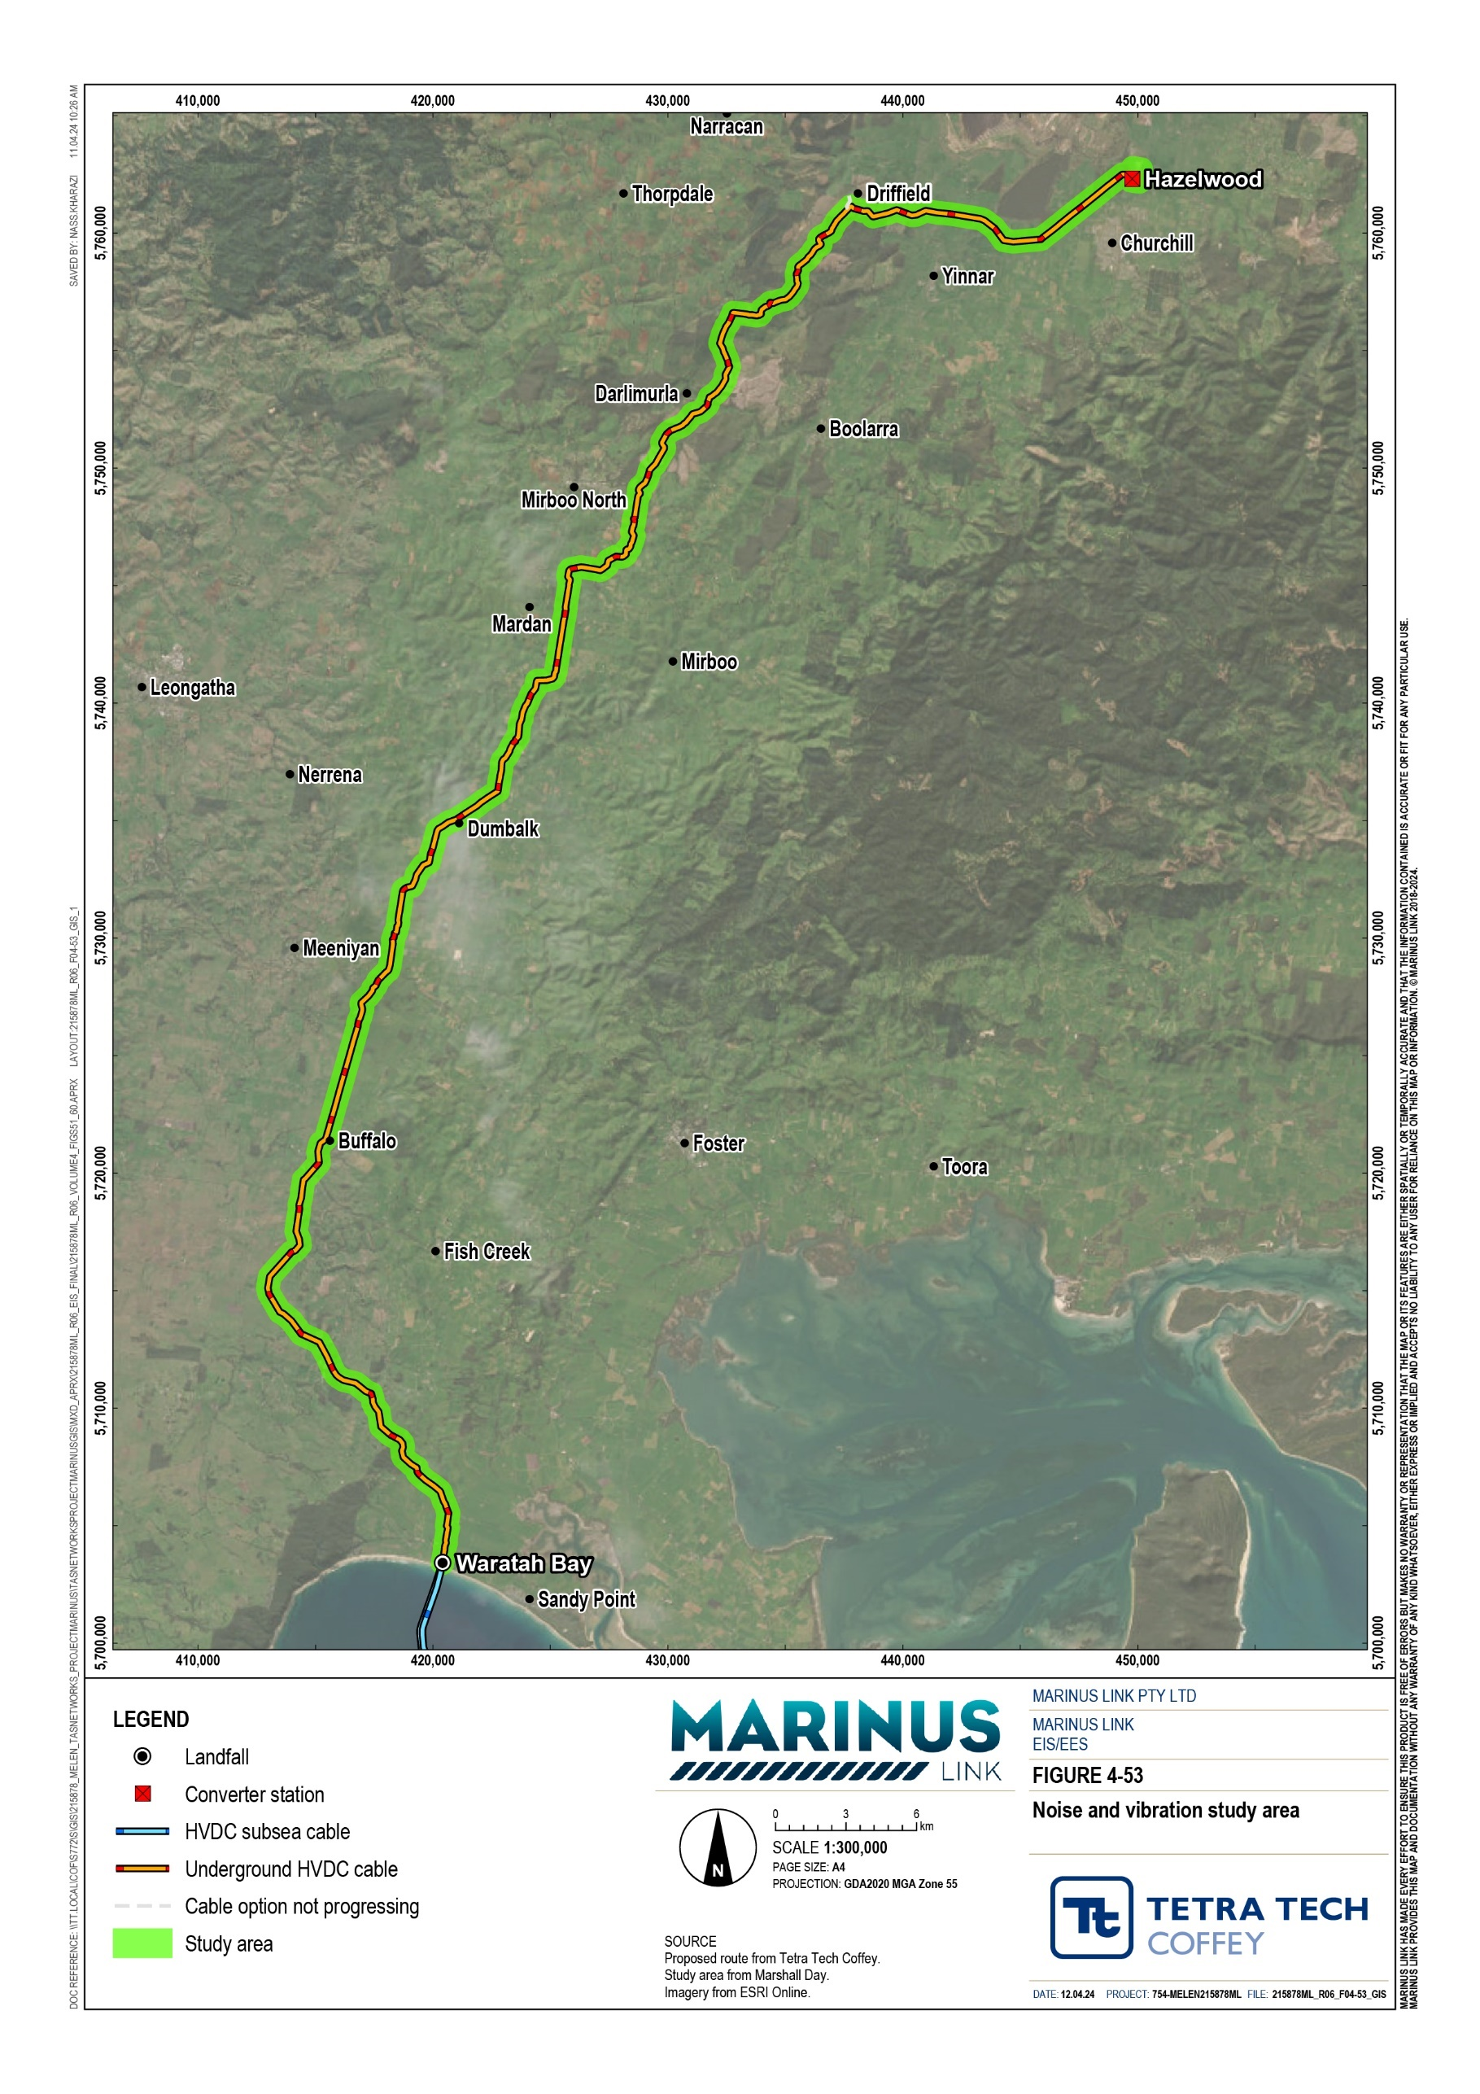

Legislative context
The key legislation and guidelines relevant to the assessment of noise and vibration impacts are provided in Table 10-1.
For the full extent of legislation relevant to the project refer to Volume 1, Chapter 4 – Legislative framework.

Title | Relevance to the assessment
Environment Protection Ac 2017 (Vic) (EP Act) | t The EP Act establishes mandatory requirements for the control of environmental noise.  Under the EP Act, operators of commercial, industrial or trade premises (industry premises) must:  fulfil the GED requirement to implement all reasonably practicable measures to minimise the risk of harm from noise, including health and amenity related impacts; and  not emit unreasonable noise.  An assessment of compliance with the EP Act must therefore demonstrate that:  all reasonably practicable measures would be implemented to reduce the risk of harm from noise;  the project could achieve noise levels below the threshold prescribed to be unreasonable; and  the project would not result in unreasonable noise according to the listed factors of the EP Act.  The definition of harm under the EP Act includes adverse effect on amenity.  The EP Act defines noise as both sound and vibration. The provisions of the EP Act with respect to the GED and unreasonable noise apply to both sound and vibration for the project.
Environment Protection Regulations 2021  (EP Regulations) | The noise requirements are defined according to the type of noise generating activity under consideration. The EP Regulations also define the types of noise sensitive areas where these requirements apply and the hours of different assessment time periods (i.e., day, evening and night).  The relevant elements of the EP Regulations are the requirements for the operational noise from commercial, industrial and trade premises (industry). The EP Regulations specify that the prediction, measurement, assessment or analysis of operational noise from industry within a noise sensitive area must be conducted in accordance with the Noise Protocol.  Noise from industry is prescribed by the EP Regulations to be unreasonable for the purposes of the EP Act if it exceeds the noise limit determined in accordance with the Noise Protocol.
Environment Reference Standard (Vic) | The environmental values of the ambient sound environment defined by the ERS relate to conditions that are conducive to domestic activities (conversation, recreation, and sleep), learning, and appreciation and enjoyment of tranquillity in natural areas. The primary function of the ERS is to provide an environmental assessment reporting reference which can be used as a reference point for decision makers to consider whether a proposal or activity is consistent with the environmental values identified in the ERS. The ERS is not a compliance standard.

Title | Relevance to the assessment
EPA Victoria Publication 1826.4 Noise limit and assessment protocol for the control of noise from commercial, industrial and trade premises and entertainment venues published May 2021 (Noise Protocol) | Noise Protocol defines a procedure for setting noise limits that apply to the operation of industry premises in Victoria. The noise limits are applicable to the operational stage of the project. Compliance with the noise limits is mandatory.  The Noise Protocol defines noise limits that are used to assess whether a noise is prescribed to be unreasonable in accordance with the EP Regulations and the EP Act.
EPA Victoria Publication 1834.1 Civil construction, building and demolition guide published September 2023  (EPA Publication 1834.1) | EPA Publication 1834.1 describes measures for managing noise and vibration from construction and decommissioning of a project. The guidance relates to:  working hours, works scheduling, consultation and managing noise.  EPA Publication 1834.1 states that noise and vibration is to be always minimised and works be undertaken in normal working hours. Where necessary, and subject to the approval of the relevant authority, construction activities outside normal working hours may occur in justifiable situations.
Construction Noise and Vibration Guideline published August 2016 (NSW CNVG) | Quantitative criteria for control of construction vibration are not provided in Victorian legislation or guidelines. The NSW CNVG has been adopted in lieu of Victorian quantitative criteria.  A high-level risk-based assessment of potential vibration associated with construction of the project is presented based on a comparison of the separating distances to each receiver with the minimum working distances set out in the guidance referenced from the NSW CNVG.
EPA Victoria Publication 1695.1 Assessing and controlling risk: A guide for business published March 2019 (EPA Publication  1695.1) | Guidance provided on risk management framework applied to prevent harm to human health and the environment. Guidance under this publication aligns with contemporary approaches to noise and vibration management under Victorian legislation. The consequence and likelihood definitions and risk matrix from this publication have been adopted for the noise and vibration impact assessment.

Assumptions and limitations
The noise and vibration assessment has been conducted with the following assumptions:

Construction plant noise emissions: Noise emission data from standards and previous measurements are utilised and assumed to represent the types of construction plant for the project. Mid to upper range noise available emission data was used to conservatively predict construction noise levels.
Construction activity: all plant associated with each of the construction activities are assumed to be operating simultaneously and producing their highest noise emissions for the full duration of working hours. This is considered a conservative approach and may lead to higher predicted noise emissions than is likely to occur in practice due to the likelihood that some plant and equipment will only be operating for part of the working hours.
Converter station plant noise emissions: representative noise emission data based on manufacturer data provided for similar projects, has been assumed for the assessment. The assumed emission data assumes noise attenuation systems and plant enclosures. The actual noise emissions of construction and operation plant items will need verification and equipment selected to achieve outcomes that are consistent with noise and vibration assessment.

Receiver data: noise receivers identified have been limited to an area extending approximately 500 m either side of the project, which are receivers that are expected to experience the highest construction noise levels. It is acknowledged in the noise assessment that this limitation may result in an underestimation of receivers within the lower predicted noise bands. This limitation to the study does not impact assessment outcome as risk controls are determined by predicted noise levels at nearest receivers.
Baseline characterisation: broad indications of background noise conditions were provided through the on-ground noise surveys. Baseline noise data is preliminary only, to inform the impact assessment.
Further background noise monitoring will be required prior to the commencement of construction works to confirm background noise conditions at the time works are progressing and to allow definitive design and compliance assessment criteria to be set.
Construction and operational noise risk controls: specific details of measures required to minimise noise risks as far as reasonably practicable will be determined when further information is available regarding planned works, equipment selection and design of converter station. EPRs to manage noise and vibration impacts are detailed in Section 10.6.
Conservative assumptions were adopted in applying ISO 9613-2 to predict noise levels from construction of the project. Through the assumption of continuous and simultaneous operation of construction equipment, modelling for noise and vibration propagation over flat ground, and using set atmospheric conditions (at a temperature of 10 °C and relative humidity 70%).

Existing conditions
The project is in a rural area with scattered houses and small suburban townships. Low background noise levels correspond with more sparsely populated rural areas, and ambient (average) noise in these settings is influenced by agricultural activities, livestock, and local traffic with natural noise contributions from wildlife, and vegetation movement in winds. Higher background noise levels are likely in proximity to public roads, intense farming activities or forestry operations, or near higher density population centres.

Survey
A noise survey was completed to understand the existing background noise levels in the study area. Survey locations and the survey location description is provided below in Table 10-2 and shown in Figure 4-54.
Survey locations were identified following a desktop review of the study area and are considered to be representative of different environments in proximity to the project.
At each location an unattended monitor was used to continuously sample noise levels during the day, evening, and night periods. Measurements were conducted at the locations over a period of approximately 10 days between Monday 11 July and Friday 22 July 2022.

At some survey locations local weather stations were deployed alongside noise monitoring equipment to identify periods of adverse weather (e.g., high wind and/or rain) that may influence survey results. At other survey where a weather station was not deployed, wind and rainfall were assessed based on a combination of data from the other weather stations and publicly available data for the BoM monitoring station at Pound Creek. Frequent rainfall and periods of wind speed greater than a gentle breeze were experienced during the survey period.
Table 10-2 provides a summary of the background noise levels measured during the noise survey.

Area | Description
Site 1 | Tramway Road, Hazelwood North  At the site of the Hazelwood converter station.  Existing dwelling in a rural environment characterised by noise from local roads.
Site 2 | Switchback Road, Hazelwood  Rural environment beyond the suburban areas of Churchill, subject to a mix of noise influences from local traffic as well as noise from power transmission infrastructure.
Site 3 | Yinnar-Driffield Road, Driffield  Rural environment characterised by noise from livestock and birds. Noise from a nearby local road may also affect the acoustic environment.
Site 4 | HVP (off Fords Road)  Located on land used by HVP for plantation timber.  Operational commercial/industrial site amid a rural environment characterised by noise from wildlife and distant highway traffic. While not noted during surveys, there is potential for noise due to commercial activities including truck movements within the plantation.
Site 5 | Smallmans Road, Mardan  Rural environment characterised by noise from livestock and birds, and distant traffic noise from a main road connecting rural areas.
Site 6 | Meeniyan-Mirboo North Road, Dumbalk (north of Dumbalk)  Rural environment characterised by noise from traffic on local roads, livestock and birds
Site 7 | Meeniyan-Mirboo North Road, Dumbalk (south of Dumbalk)  Rural environment characterised by noise from traffic on local roads, livestock and wind
Site 8 | Buffalo-Stony Creek Road, Stony Creek  Semi-rural environment characterised by noise from traffic on local roads, livestock and birds
Site 9 | Moores Road, Buffalo  Semi-rural environment characterised by noise from traffic on local roads, livestock and birds
Site 10 | Waratah Road, Sandy Point  Rural environment located approximately 1,600 m from the ocean, characterised by noise from traffic on local roads
Site 11 | Fish Creek-Waratah Road, Waratah Bay  Rural environment located approximately 860 m from the ocean, characterised by noise from the ocean, wildlife and livestock

Location | Day  (0700 – 1800 hrs Mon to Sat) |  | Evening  (1800 – 2200 hrs Mon to Sat) (0700 – 2200 hrs Sundays and public holidays) |  | Night  (2200 –to 0700 hrs)
 | Minimum | Median | Minimum | Median | Minimum | Median
Site 1 | 42 | 44 | 40 | 41 | 33 | 36
Site 2 | 35 | 37 | 39 | 60 | 35 | 43
Site 3 | 37 | 38 | 35 | 40 | 29 | 34
Site 4 | 31 | 34 | 32 | 37 | 28 | 32
Site 5 | 27 | 35 | 32 | 38 | 25 | 33
Site 6 | 30 | 33 | 30 | 33 | 27 | 28
Site 7 | 34 | 35 | 34 | 38 | 30 | 34
Site 8 | 32 | 35 | 33 | 40 | 29 | 33
Site 9 | 35 | 41 | 21 | 44 | 22 | 44
Site 10 | 33 | 39 | 36 | 39 | 31 | 38
Site 11 | 35 | 43 | 37 | 40 | 35 | 41

Most background noise levels recorded during the daytime period at surveyed receivers were within 40 to 50 dB LAeq,1h, while levels recorded outside of that range can be attributed to high winds and rain conditions during the survey period. As outlined in Technical Appendix T: Noise and vibration, these results are consistent with the land uses within the study area.
Background noise conditions indicate that construction noise from high noise emission construction activities and works requiring large plant will likely be audible at receivers at times when noise generated exceeds the noise level of the ambient noise environment.

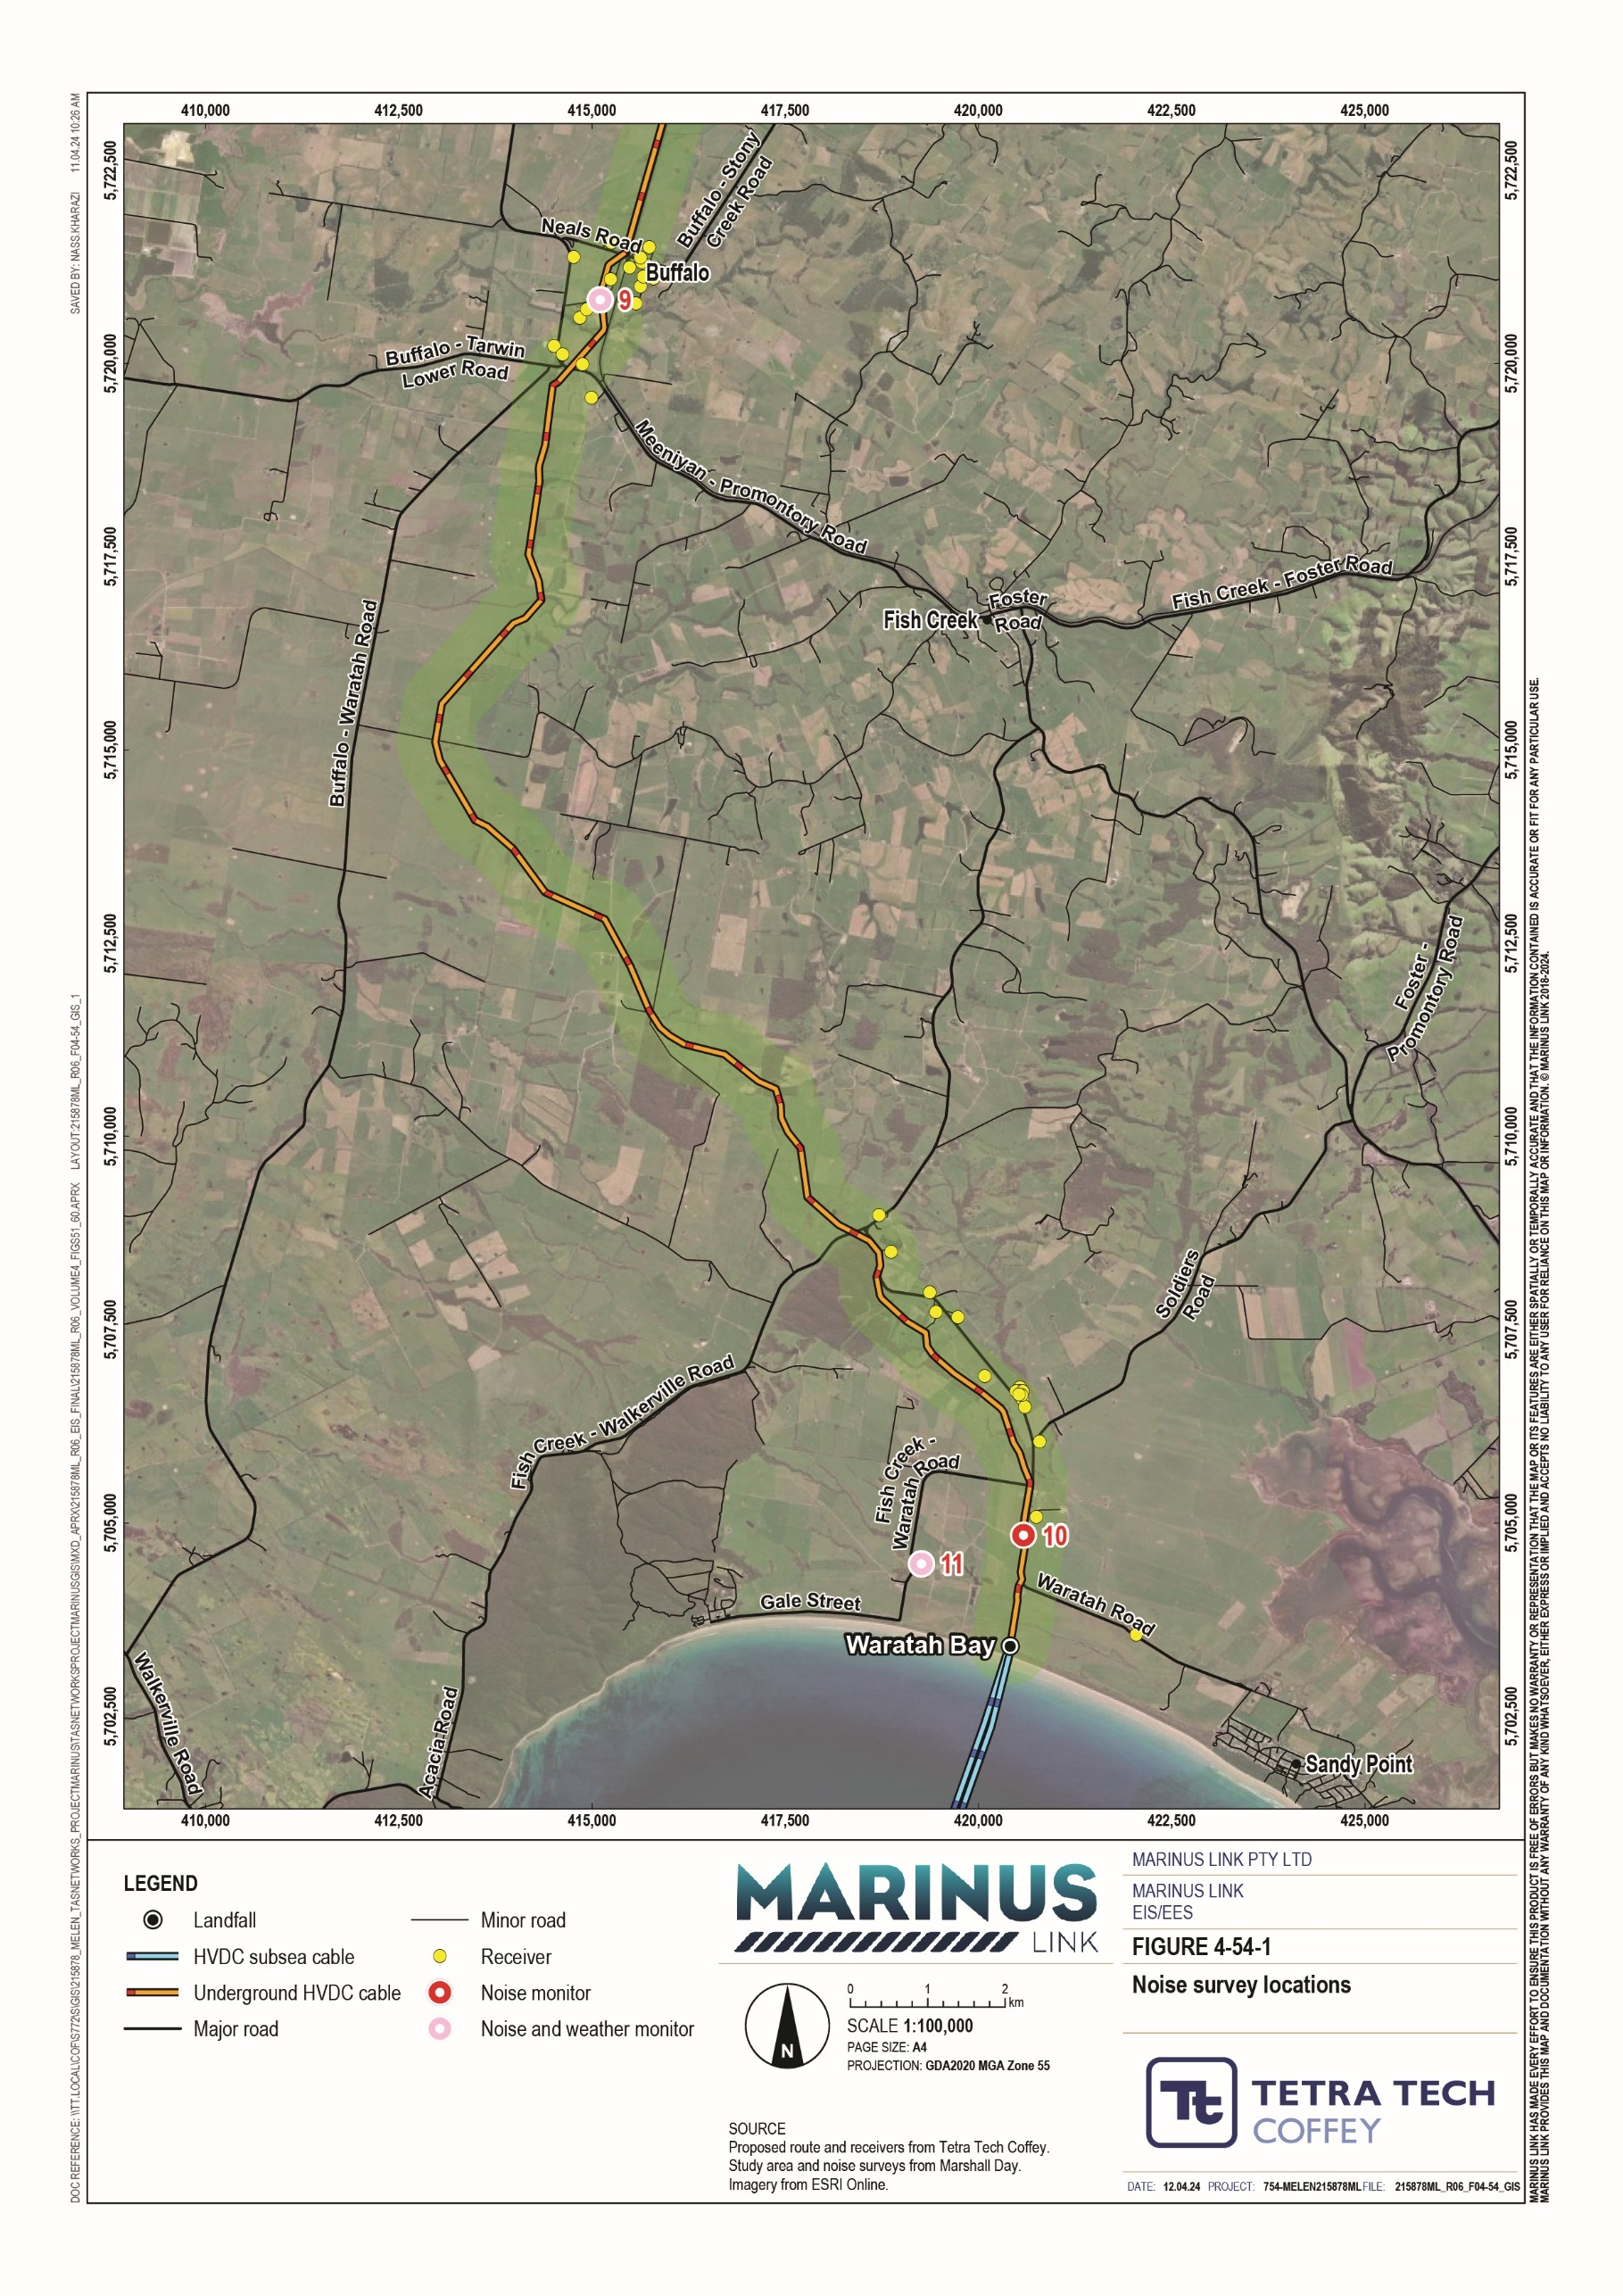

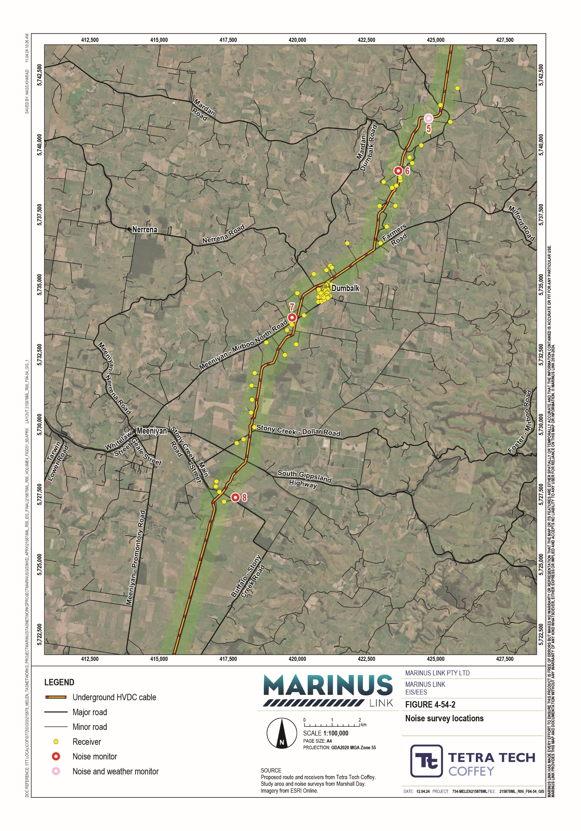

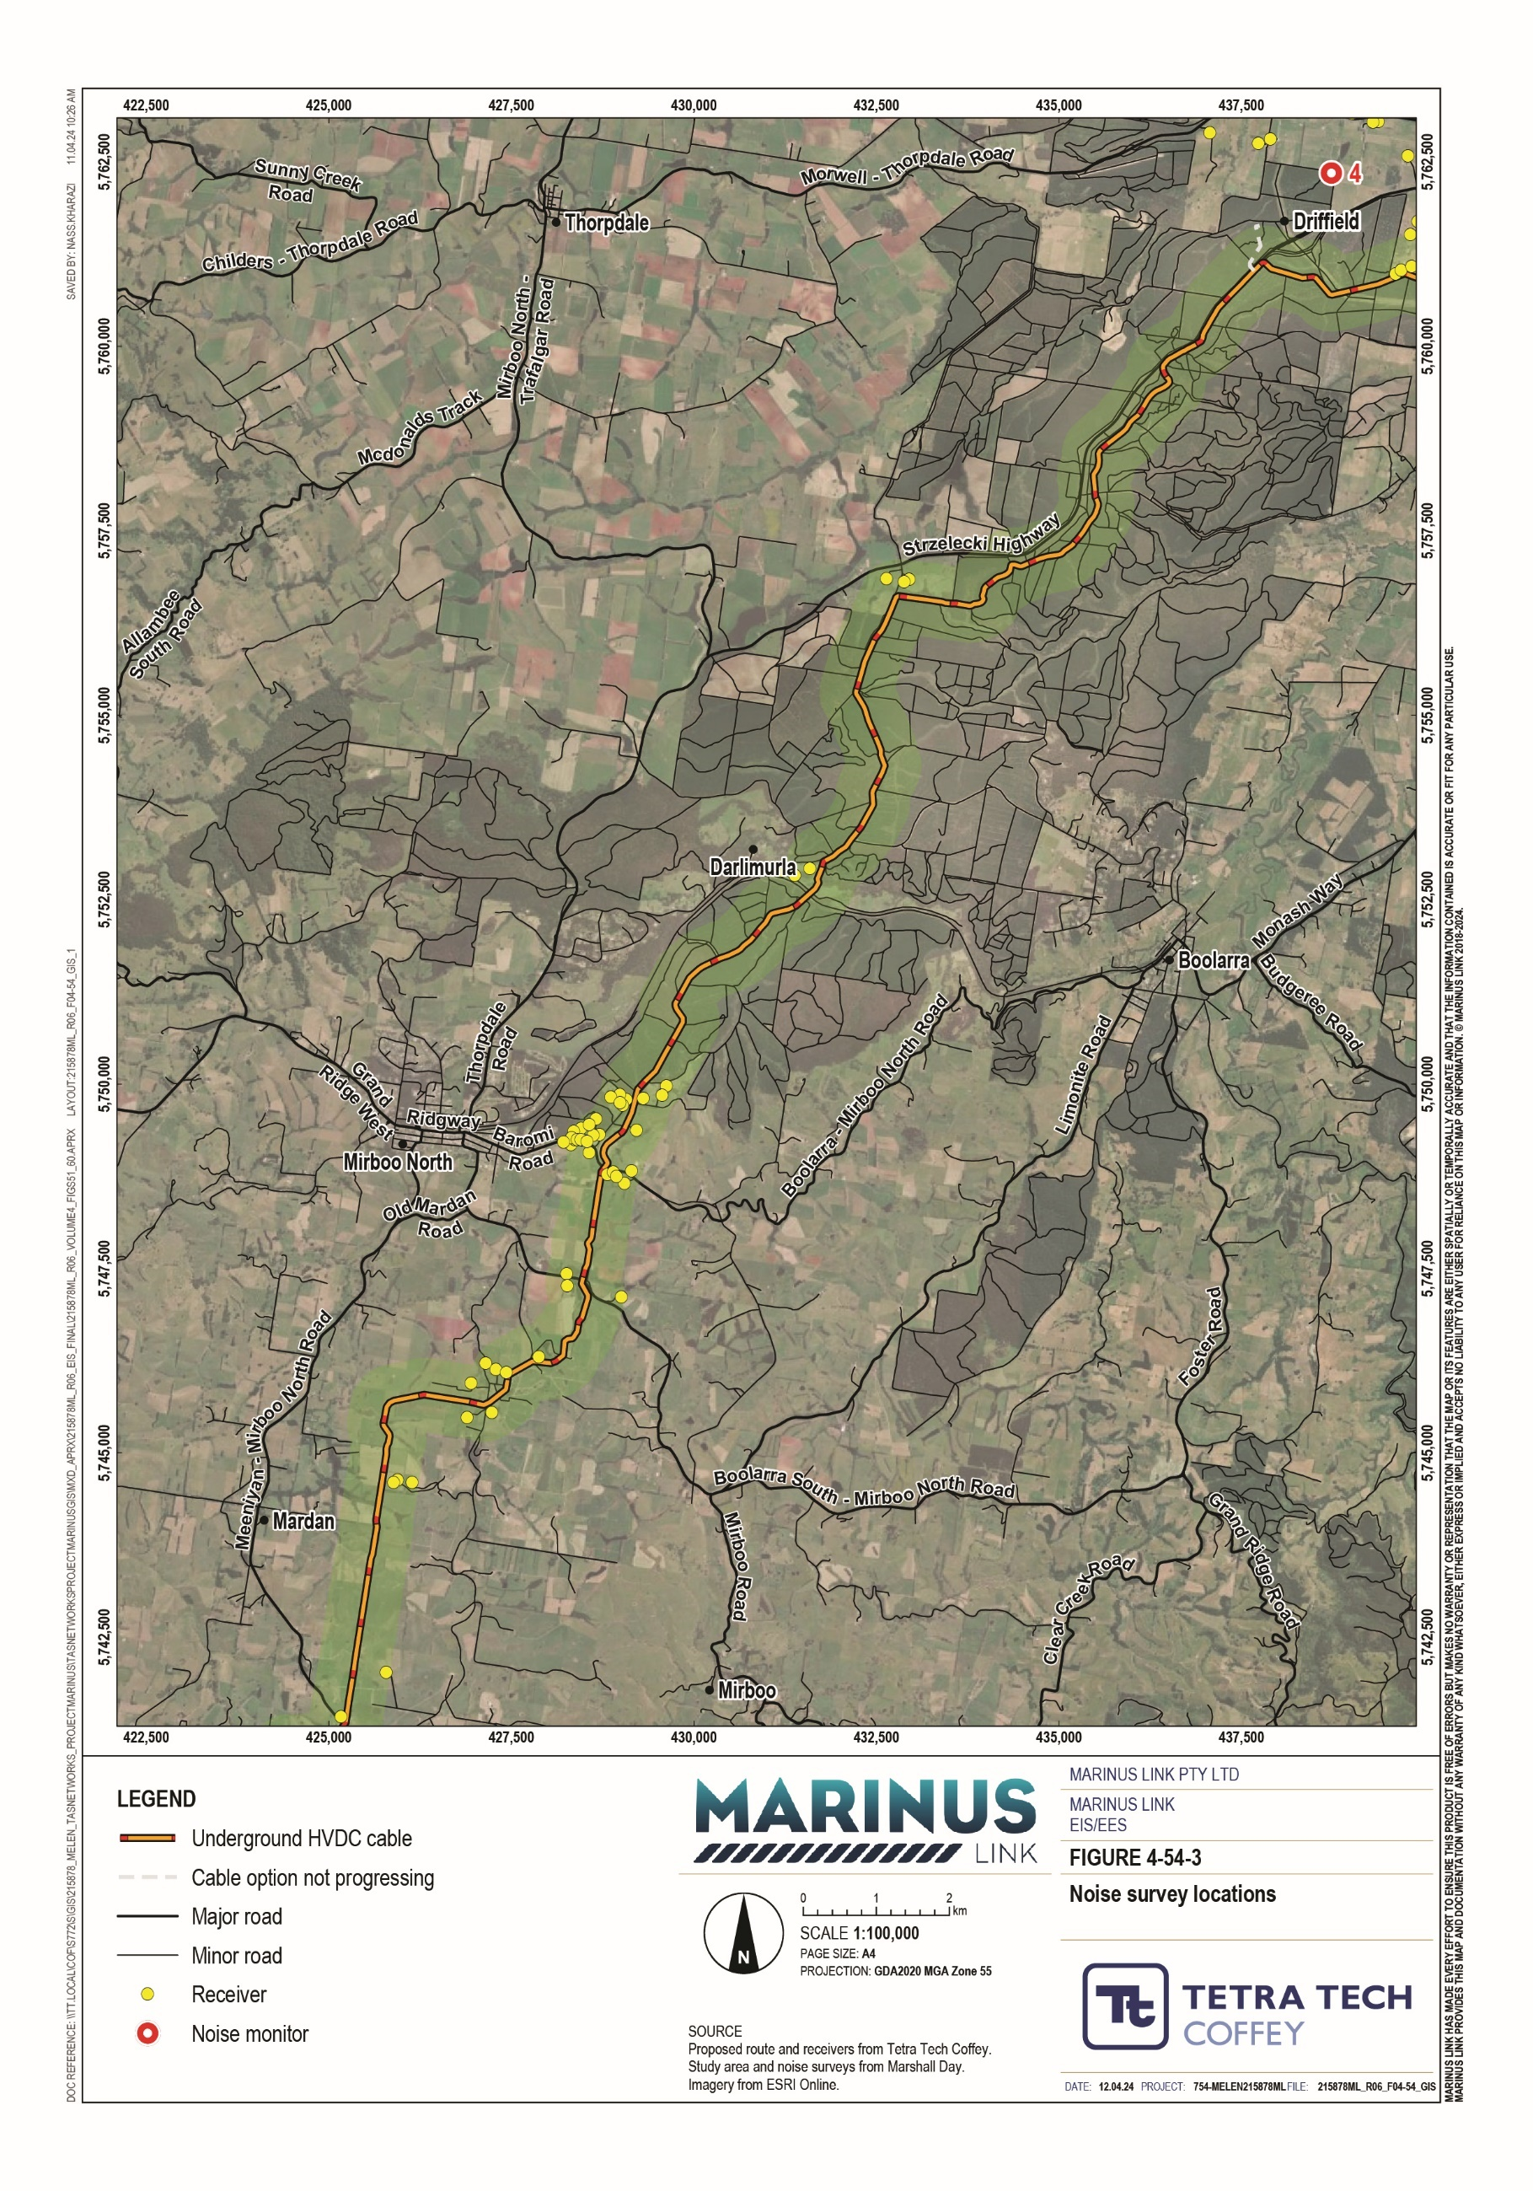

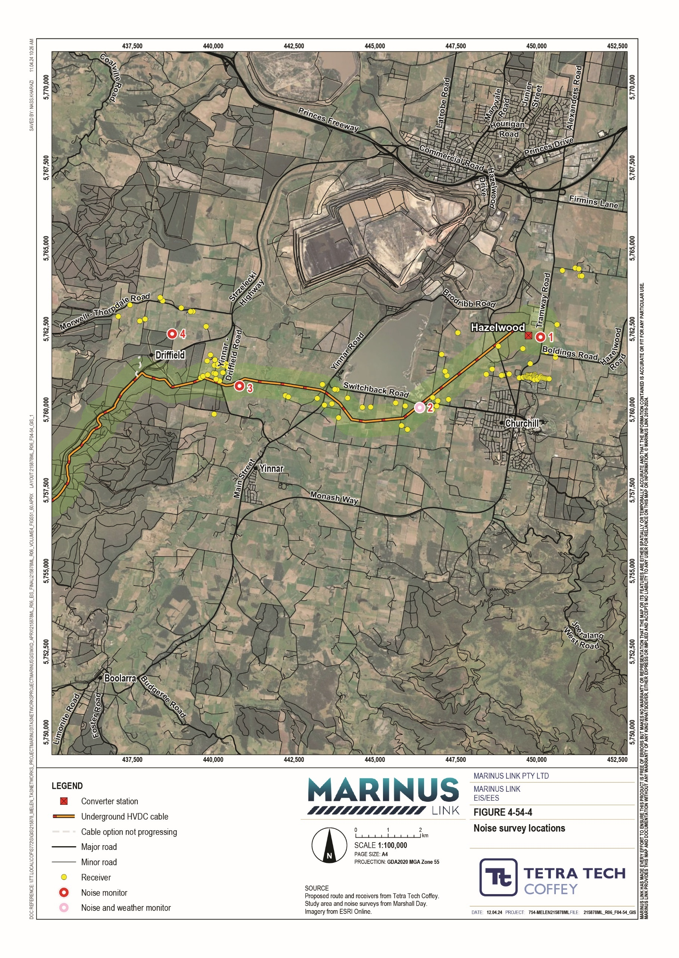

Summary of values
The key value considered by the noise and vibration assessment is the ambient noise environment for relaxation and recreation in a domestic residential environment. The ambient noise environment is defined in the ERS as the ‘external sound environment’ which includes vibration.
For the impact assessment, the key features of the ambient noise environment for relaxation and recreation in a domestic environment includes ambient sound environment that facilitates sleep at night, domestic and recreational activities, conversation, child learning and musical entertainment.

Construction impacts
Construction activities for the project are likely to impact on the ambient noise environment. The main noise generating project construction activities are:
Cable installation and converter station construction, including:

- Access track and haul road construction

- Construction and use of laydown areas

- Topsoil stripping and trenching

- Civil and structural works, including building and plant assembly

Shore crossing HDD

Local feature crossing HDD

Offsite transportation/vehicle movements.

The assessment acknowledges that construction will involve other activities such as pit construction and construction of the transition station. However, the assessment has modelled the noisiest activities (listed above) as this provides a representative model of the noises from construction.
For cable construction, noise will be temporary as the construction front moves through the landscape. Other construction activities such as the shore crossing, converter station and laydown areas, will have longer construction timeframes in the same location, resulting in different noise impacts.
Most activities will be undertaken in normal working hours, except the Waratah Bay shore crossing HDD and Morwell River crossing HDD. Normal working hours as per EPA Publication 1834.1 (Monday to Friday 0700 – 1800 hrs and Saturday 0700 – 1300 hrs, excluding public holidays) have been adopted for the majority of the noise and vibration assessment.
EPA Publication 1834.1 will also be applied where there is need for unavoidable works outside of normal working hours. MLPL must demonstrate planned unavoidable works cannot be reasonably moved to normal work hours. Undertaking unavoidable works will also require relevant authorities and neighbours to be consulted on the nature and duration of planned works.

EPA Publication 1834.1 requires construction noise generated on evenings (1800 – 2200 hrs) and weekends, not to exceed the background noise by:
10 dB or more for up to 18 months after project commencement

5 dB or more after 18 months.

Nights works (2200 – 0700 hrs) must be inaudible within a habitable room of any residential premises.

The noise level experienced at each receiver will change throughout the construction period depending on the stage of construction, equipment type and duration of use of each type of equipment.

Noise emission data
The noise and vibration assessment considered the sound power levels of equipment likely to be used in construction of the project (e.g., excavator, grader, hand tools, HDD rig, water truck, etc.). These power sources were then grouped to determine total sound power levels for key project construction activities as shown in Table 10-4.
The noise and vibration assessment has conservatively assessed the total sound power levels at each activity, as it is acknowledged it is not practical for all equipment to be operating at the same time. However, the total sound power levels presented in Table 10-4 for the main construction activities represent the worst case LAeq noise level that may be experienced at a receiver. Sound power levels for each activity are calculated based on the activity occurring at a single location at one time.

Construction activity | Plant/equipment | Approximate total sound power level, dB LWA
Access road construction | 2x excavators, 1x dozer, 2x wheeled loaders, 2x dump trucks, 1x grader, 1x roller, 1x water truck, 2x tippers, 5x light vehicles, 1x hand tools | 125
Strip and stockpile | 2x excavators, 1x dozer, 1x tipper, 2x wheeled loaders, 2x dump trucks | 120
Site offices and laydown areas | 2x excavators, 1x dozer, 2x wheeled loaders, 2x dump trucks, 1x grader, 1x roller, 1x water truck, 2x tippers, 5x light vehicles, 1x hand tools | 125
Trenching | 1x trencher (or excavator), 1x dozer, 1x dump truck | 120
Shore crossing | 2x HDD rigs (including ancillary pumping equipment), 1x excavator, 1x dump truck, 5x light vehicles, 1x mobile crane, 2x road trucks | 120
Local feature crossings | 1x HDD rig (including ancillary pumping equipment), 1x road truck, 1x light vehicle | 110
Converter station - earthworks/civil | 2x excavators, 1x dozer, 1x wheeled loader, 2x dump trucks, 1x roller, 2x tippers, 5x light vehicles, 1x concrete agitator, 1x concrete saw | 120
Converter station - Infrastructure | 5x light vehicles, 1x mobile crane, 4x hand tools, 3x non-slewing cranes | 125

Cable and converter station
Construction of the cable and converter station at Hazelwood will generate varying noise and vibration emissions depending on the time of day, noise level of works and duration of the noise generating activities. Construction of the cable and converter station will occur during normal working hours, avoiding impacts to receivers during evening and night hours which are key periods for relaxation and recreation.
Cable construction, access track construction, topsoil stripping and stockpiling, and trenching activities will generate noise at the highest predicted noise levels at the highest number of receivers. The noise impacts will be temporarily experienced by receivers because the work fronts will be fast moving as construction progresses along the route. It is expected that the highest noise levels above thresholds will last for less than one week near any one receiver. There is a medium risk (unmitigated) of construction noise affecting the ambient noise environment for relaxation and recreation in residential homes. This is due to high noise generating activities only affecting many receivers for a brief time as construction moves along the project alignment, and works being undertaken in normal working hours.
The converter station is a static project location, where construction activities will occur over a longer period and noise levels will be consistently less. Noise at these sites will be associated with site offices and laydown areas, mainly associated with construction vehicles and material handling. There is a medium risk (unmitigated) of construction noise affecting the ambient noise environment for relaxation and recreation in residential homes. Although noise at the converter station site will result in lower noise levels compared to cable construction works, they will occur over a longer period of time.
Risks will be managed through the implementation of a construction noise and vibration management plan (CNVMP) (EPR NV02). The CNVMP will require the implementation of practicable measures to minimise the risk of harm as a result of noise and vibration, including:
selection of major plant items with low noise emissions

vibration controls and monitoring requirements

communication protocols for notifying landholders of noise generating works.

To minimise the risk of impact on sensitive receivers, a detailed noise and vibration impact assessment will be completed for construction activities at specific sites. This assessment will model predicted noise levels for the activities, and identify noise and vibration controls to minimise the risk of harm from construction noise and vibration.
The noise and vibration assessment utilised two noise reference levels to identify priority locations, where dedicated and site-specific measures to minimise risk of harm will be implemented where reasonably practicable. These areas were categorised by construction locations that result in predicted noise levels higher than 55 dB LAeq and 75 dB LAeq at receivers.
Figure 4-55 to Figure 4-59 provide the priority noise management locations identified for the construction of the cable and Hazelwood converter station.
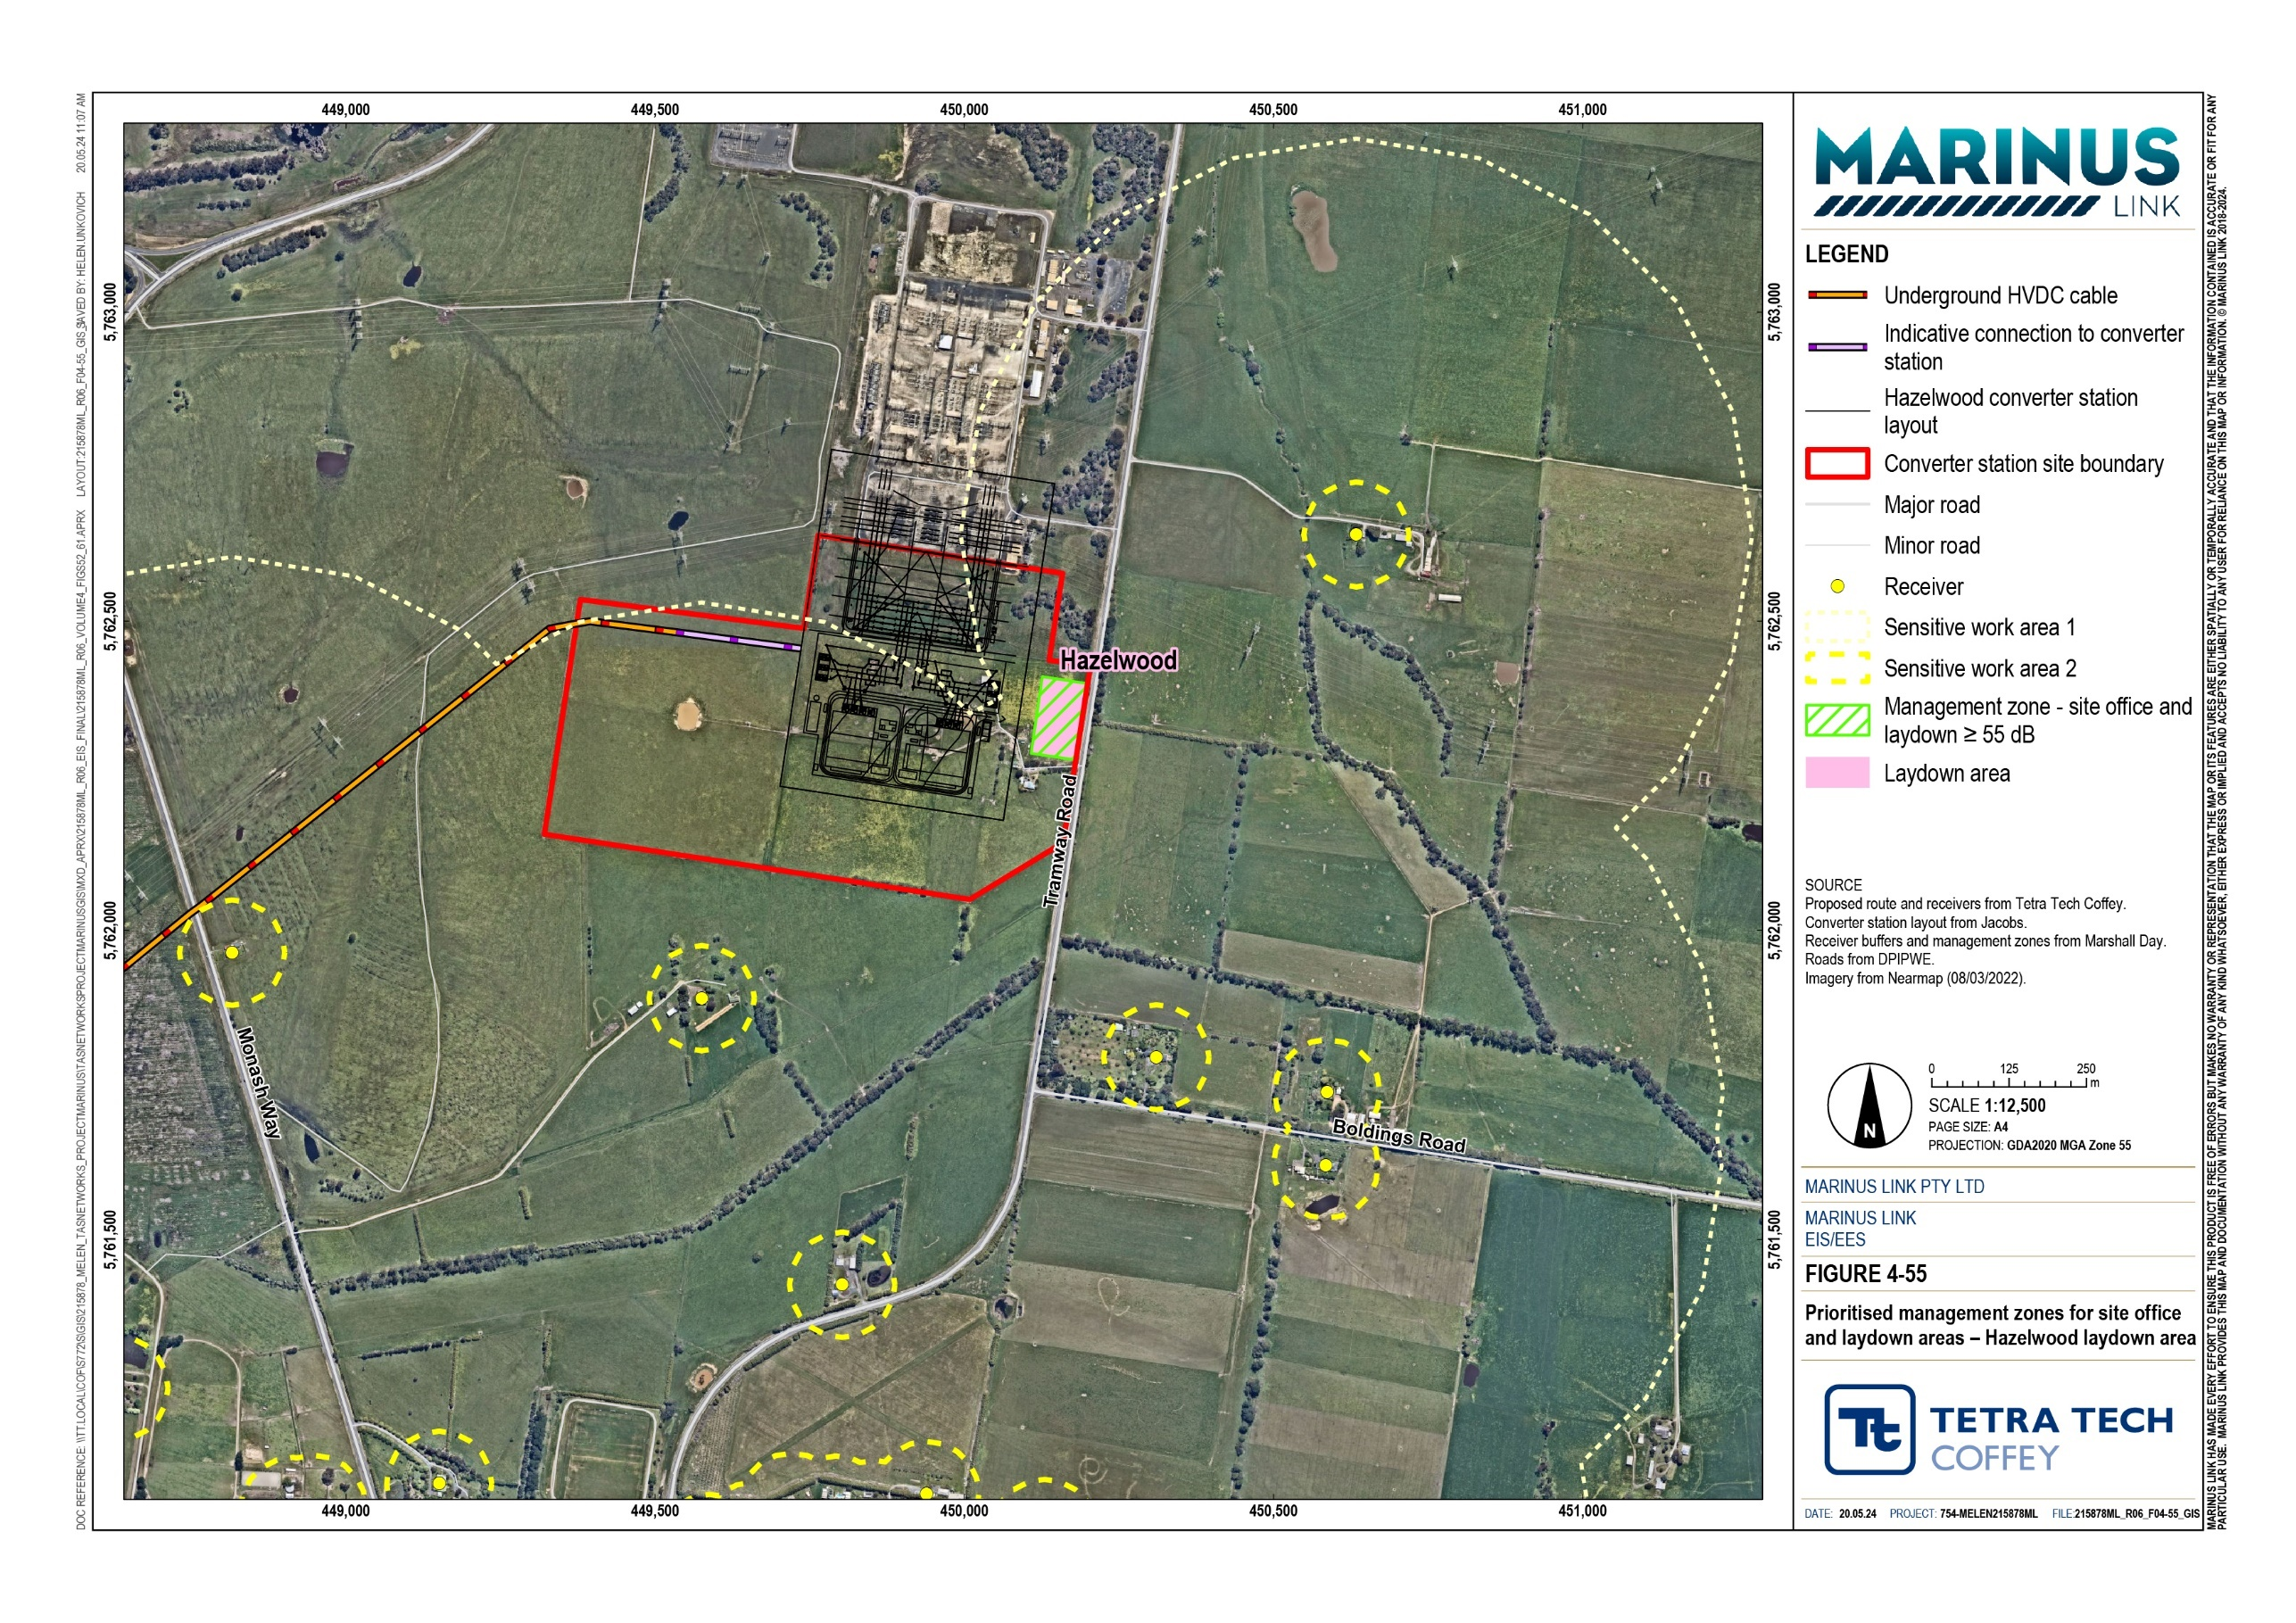
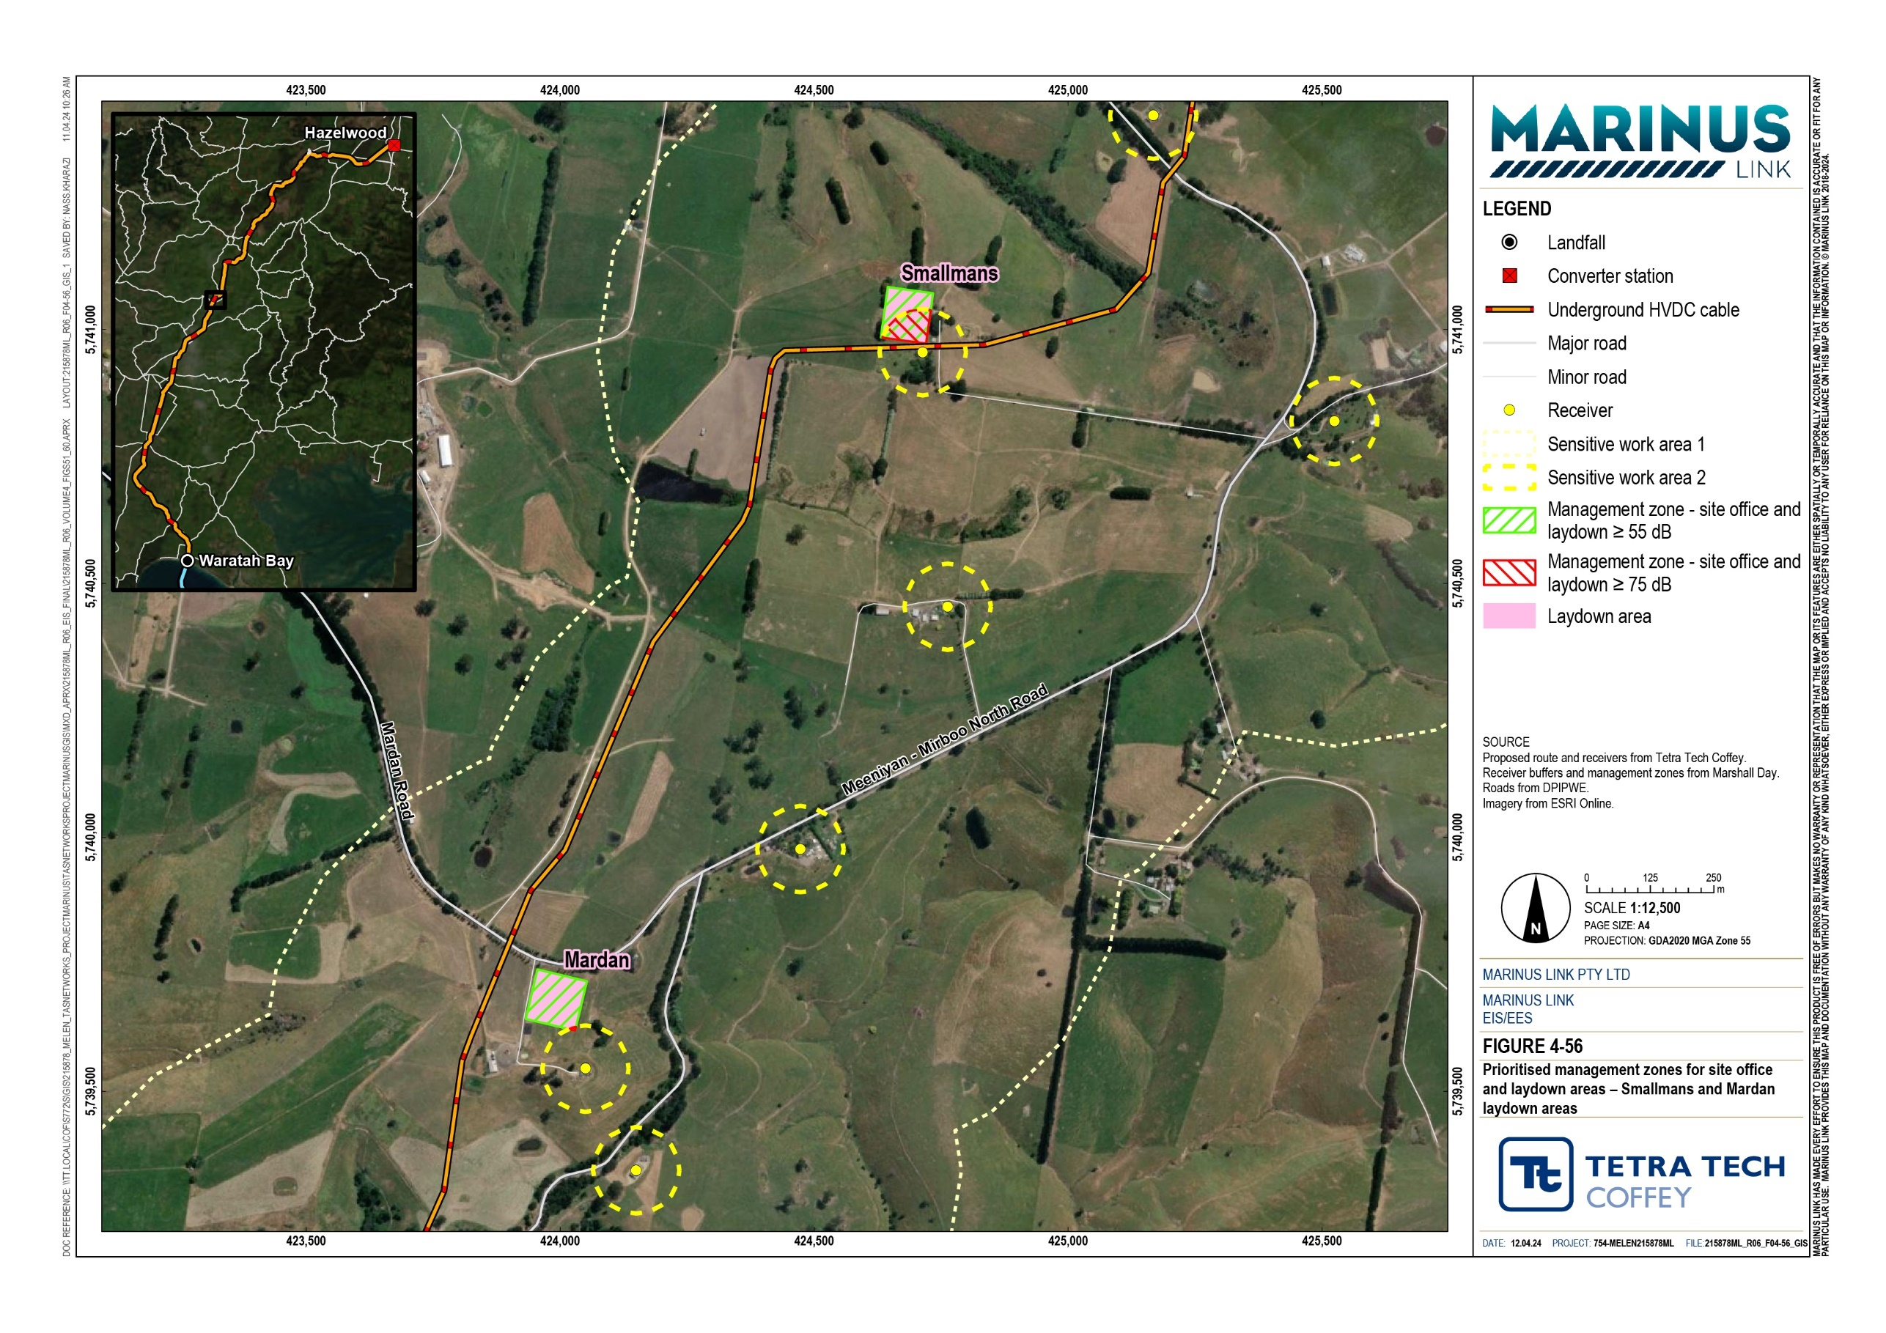

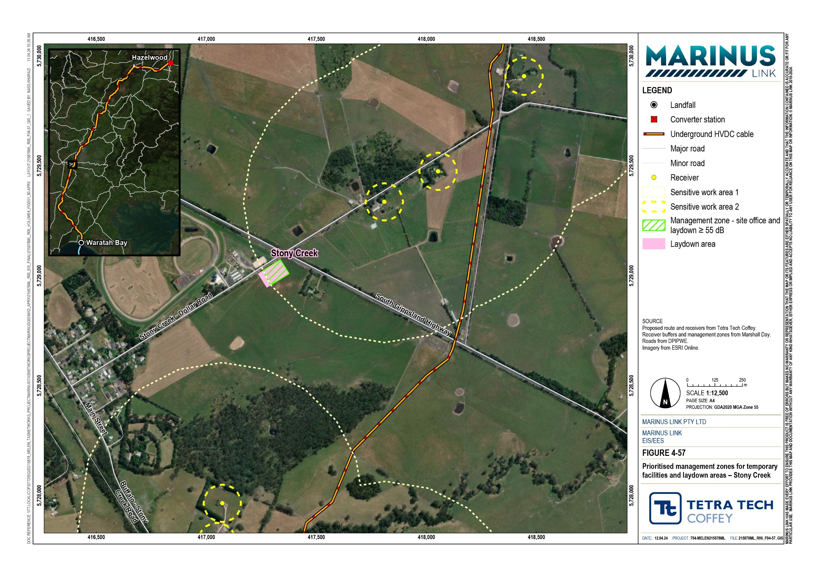
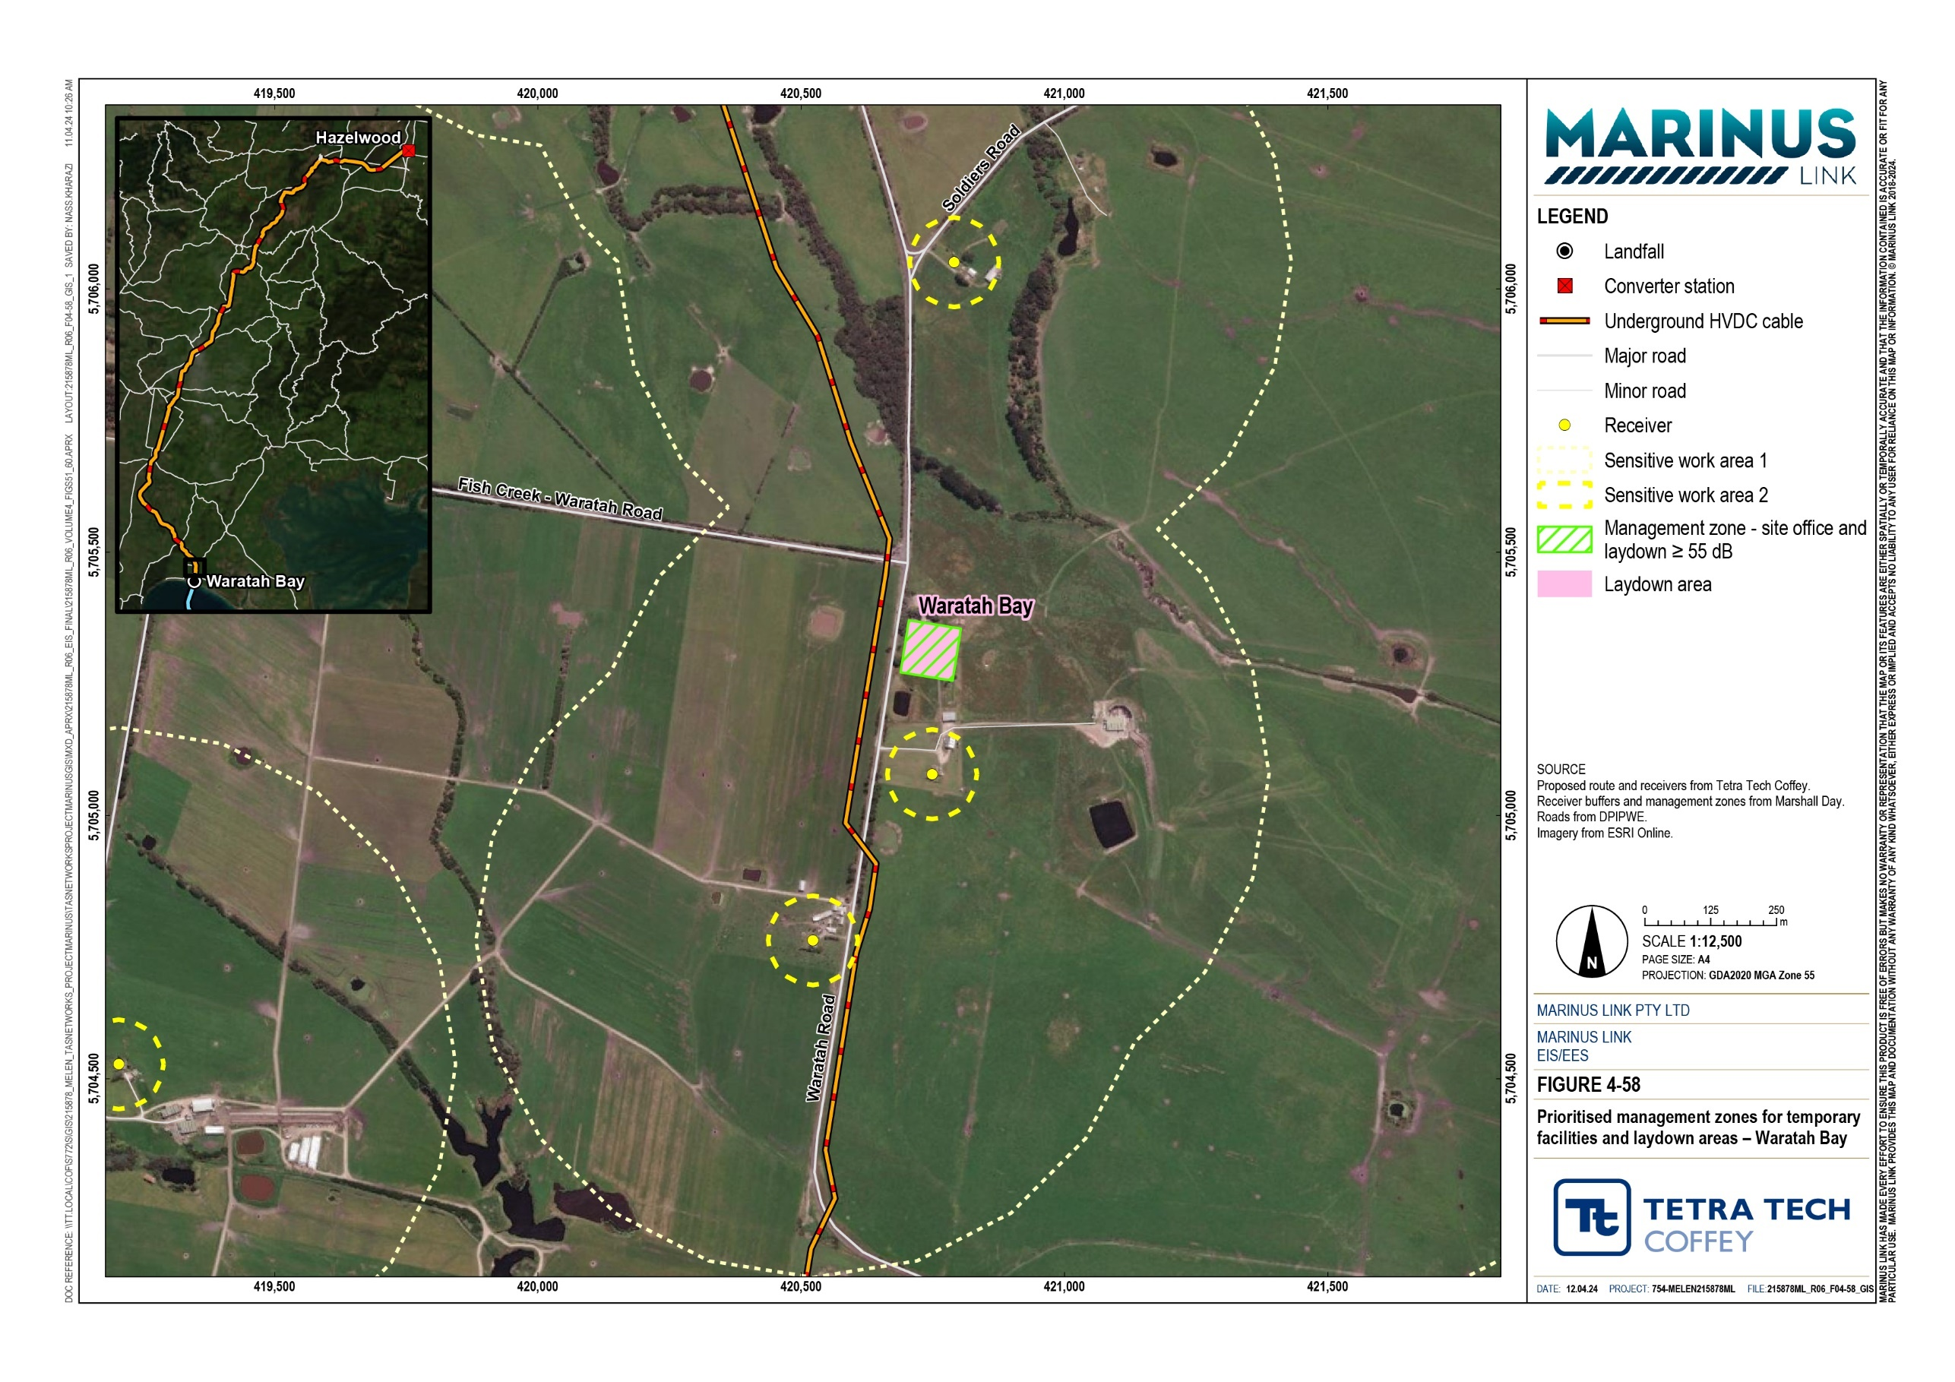

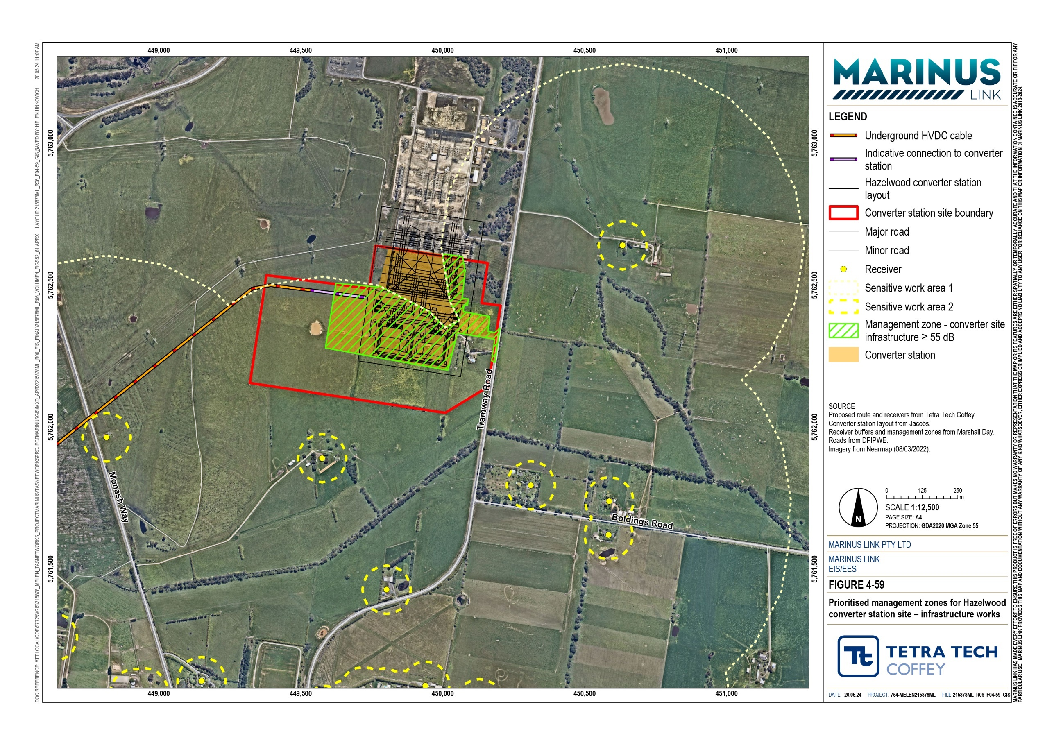

Shore crossing
Noise predictions for the shore crossing activities are based on aggregated sound power levels for the shore crossing as shown in Table 10-5. The receivers affected by the shore crossing works have then been identified based on those that will experience noise above reference levels detailed in Section 10.1.

Period | Reference noise level dB LAeq | Receivers with predicted noise levels above the reference noise level
Normal working hours | 40 | 1
 | 55 | 0
 | 75 | 0
Out of hours works | 25 | 14
 | 35 | 1
 | 42 | 0

Construction activities at the shore crossing are expected to occur intermittently over a period of approximately 12 months and involve periods of continuous HDD works during the day, evening and night periods. Continuous HDD activity is expected to be required to maintain bore hole stability. Background noise levels for the shore crossing location are elevated at 29 to 33 dB LA90,1h and considered to be influenced by the coastal environment. The elevated background noise may reduce the audibility of construction noise at receivers where predicted noise levels are 30 dB LAeq or less.
Shore crossing construction undertaken in normal working hours is predicted to result in low predicted noise levels at receivers. At night, there is potential for construction noise to be above the 25 dB LAeq reference level at fourteen receivers in proximity to the shore crossing. This means noise may be able to be heard inside houses at night. However, predicted noise levels are below the reference level of 42 dB LAeq,8h, which has potential to impact sleep disturbance.
The noise and vibration assessment also determined that there will be one receiver where the shore crossing noise may be above the 35 dB LAeq,8h reference level at night, which is above the ERS night-time reference level. Therefore, shore crossing construction activity has the potential to cause sleep disturbance at this receiver.
The noise and vibration assessment also considered the impact of shore crossing activities on Waratah Bay – Shallow Inlet Coastal Reserve, where works are likely to be audible for the duration of the HDD. Noise from construction may impact the amenity of visitors to this location.
Construction works may be heard at Cape Liptrap Coastal Park, but the change in noise due to construction is likely to be difficult to detect in most conditions due to the existing background noise levels. For these reasons the shore crossing works are not expected to impact visitors to the Cape Liptrap Coastal Park.

There is medium overall risk of noise impacts on the ambient noise amenity of receivers affected by shore crossing construction activities. This is due to the expected noise emissions from the HDD over an extended period. The levels are influenced by atmospheric conditions which increase noise levels and the conservative assumption of simultaneous operation of construction plant.
The noise and vibration assessment determined that HDD works at the shore crossing undertaken outside of normal working hours can be managed providing dedicated noise and vibration management measures are implemented in construction (EPRs NV01, NV02, NV03).
The priority noise management zones for local feature crossing works are shown in Figure 4-60.
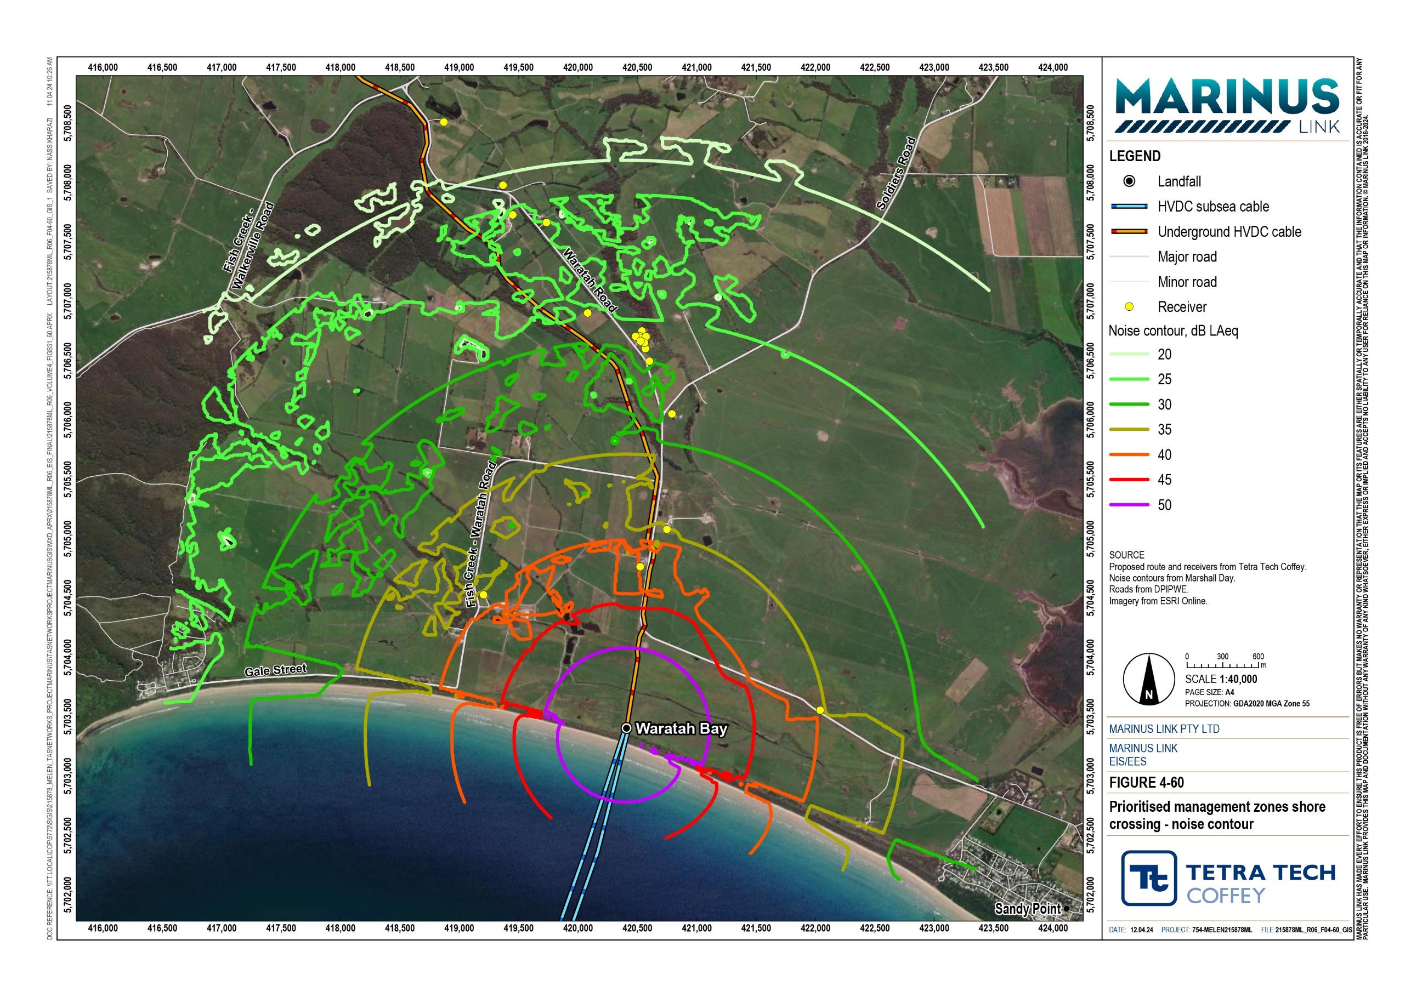

Local feature crossings
Predicted noise levels associated with local feature (waterways, road reserves) crossings were calculated for 58 crossings where HDD is proposed to be utilised during normal working hours. Noise levels were also calculated for the Morwell River crossing HDD work, which may need to continue 24-hours per day, 7 days per week. HDD works are expected to last for two weeks at each location.
Predicted noise levels for each feature crossing, nearest receiver, and number of receivers within specific reference levels for normal and out of hours works are detailed in Technical Appendix T: Noise and vibration. The priority noise management zones for local feature crossing works are shown in Figure 4-61.
Local feature crossing works, undertaken during normal working hours are likely to reach levels higher than the 40 dB LAeq reference level. At 13 feature crossings the predicted noise level at the nearest receiver will be above 55 dB LAeq. For each of these sites there are no more than four receivers where the noise level is predicted to be above 55 dB LAeq reference level.
Local feature crossings undertaken within working hours, were assessed as medium overall unmitigated risk of noise impacts.
Twenty-four-hour HDD works are proposed to ensure borehole stability at Morwell River feature crossing. Works at this location are predicted to generate noise levels above 25 dB LAeq for 16 receivers, above the 35 dB LAeq night reference level for one receiver (Figure 4-62).
The twenty-four-hour Morwell River feature crossing HDD has been assessed as medium overall unmitigated risk of noise impact.
Site specific noise mitigation, management, and communication measures will be developed for HDD works at the shore crossing and local feature crossings (EPR NV02). Associated night works for the Morwell River crossing will require dedicated measures to be established under the CNVMP, within detailed noise and vibration impact assessments prepared for the final construction method (DNVIAs) (EPR NV03).

Volume 4 – Victorian terrestrial environment Page 10-27

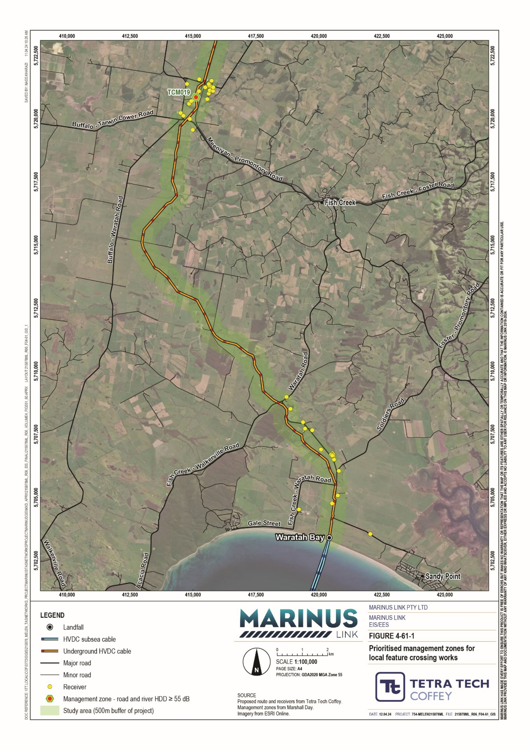

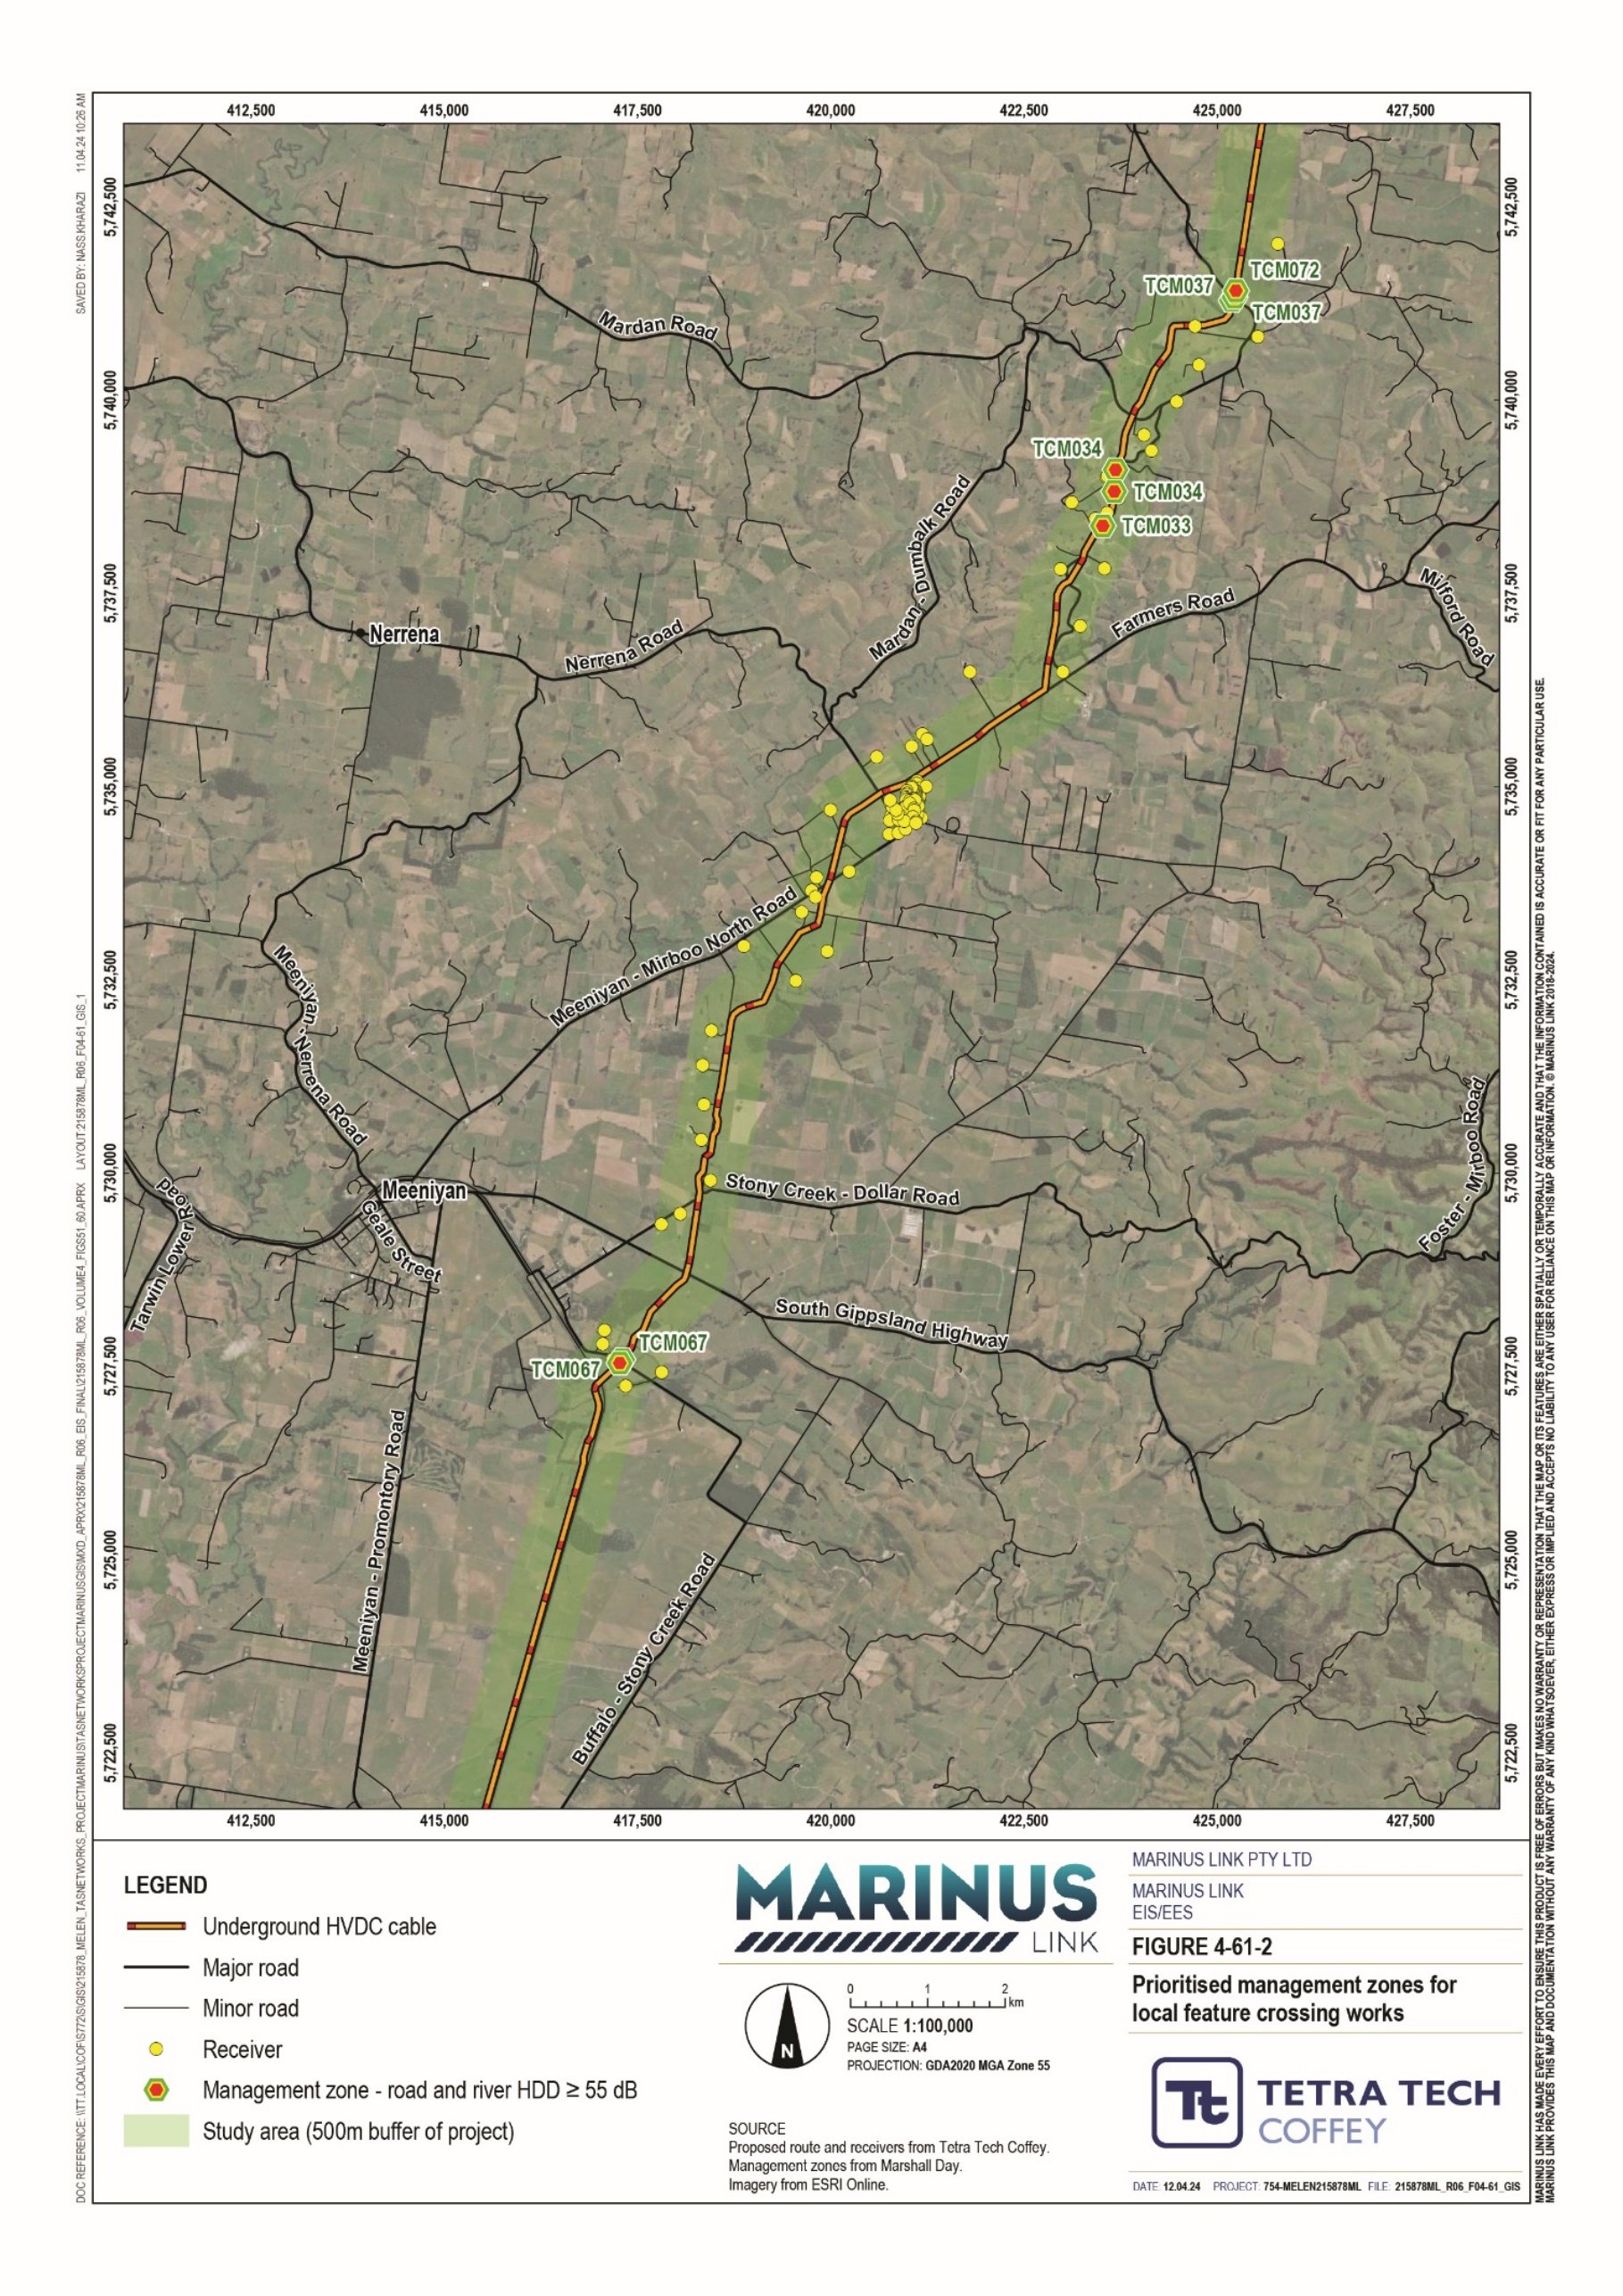

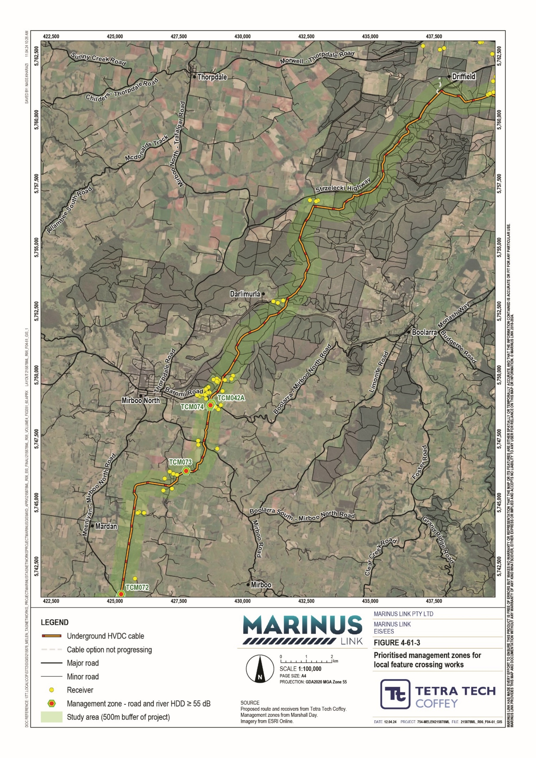

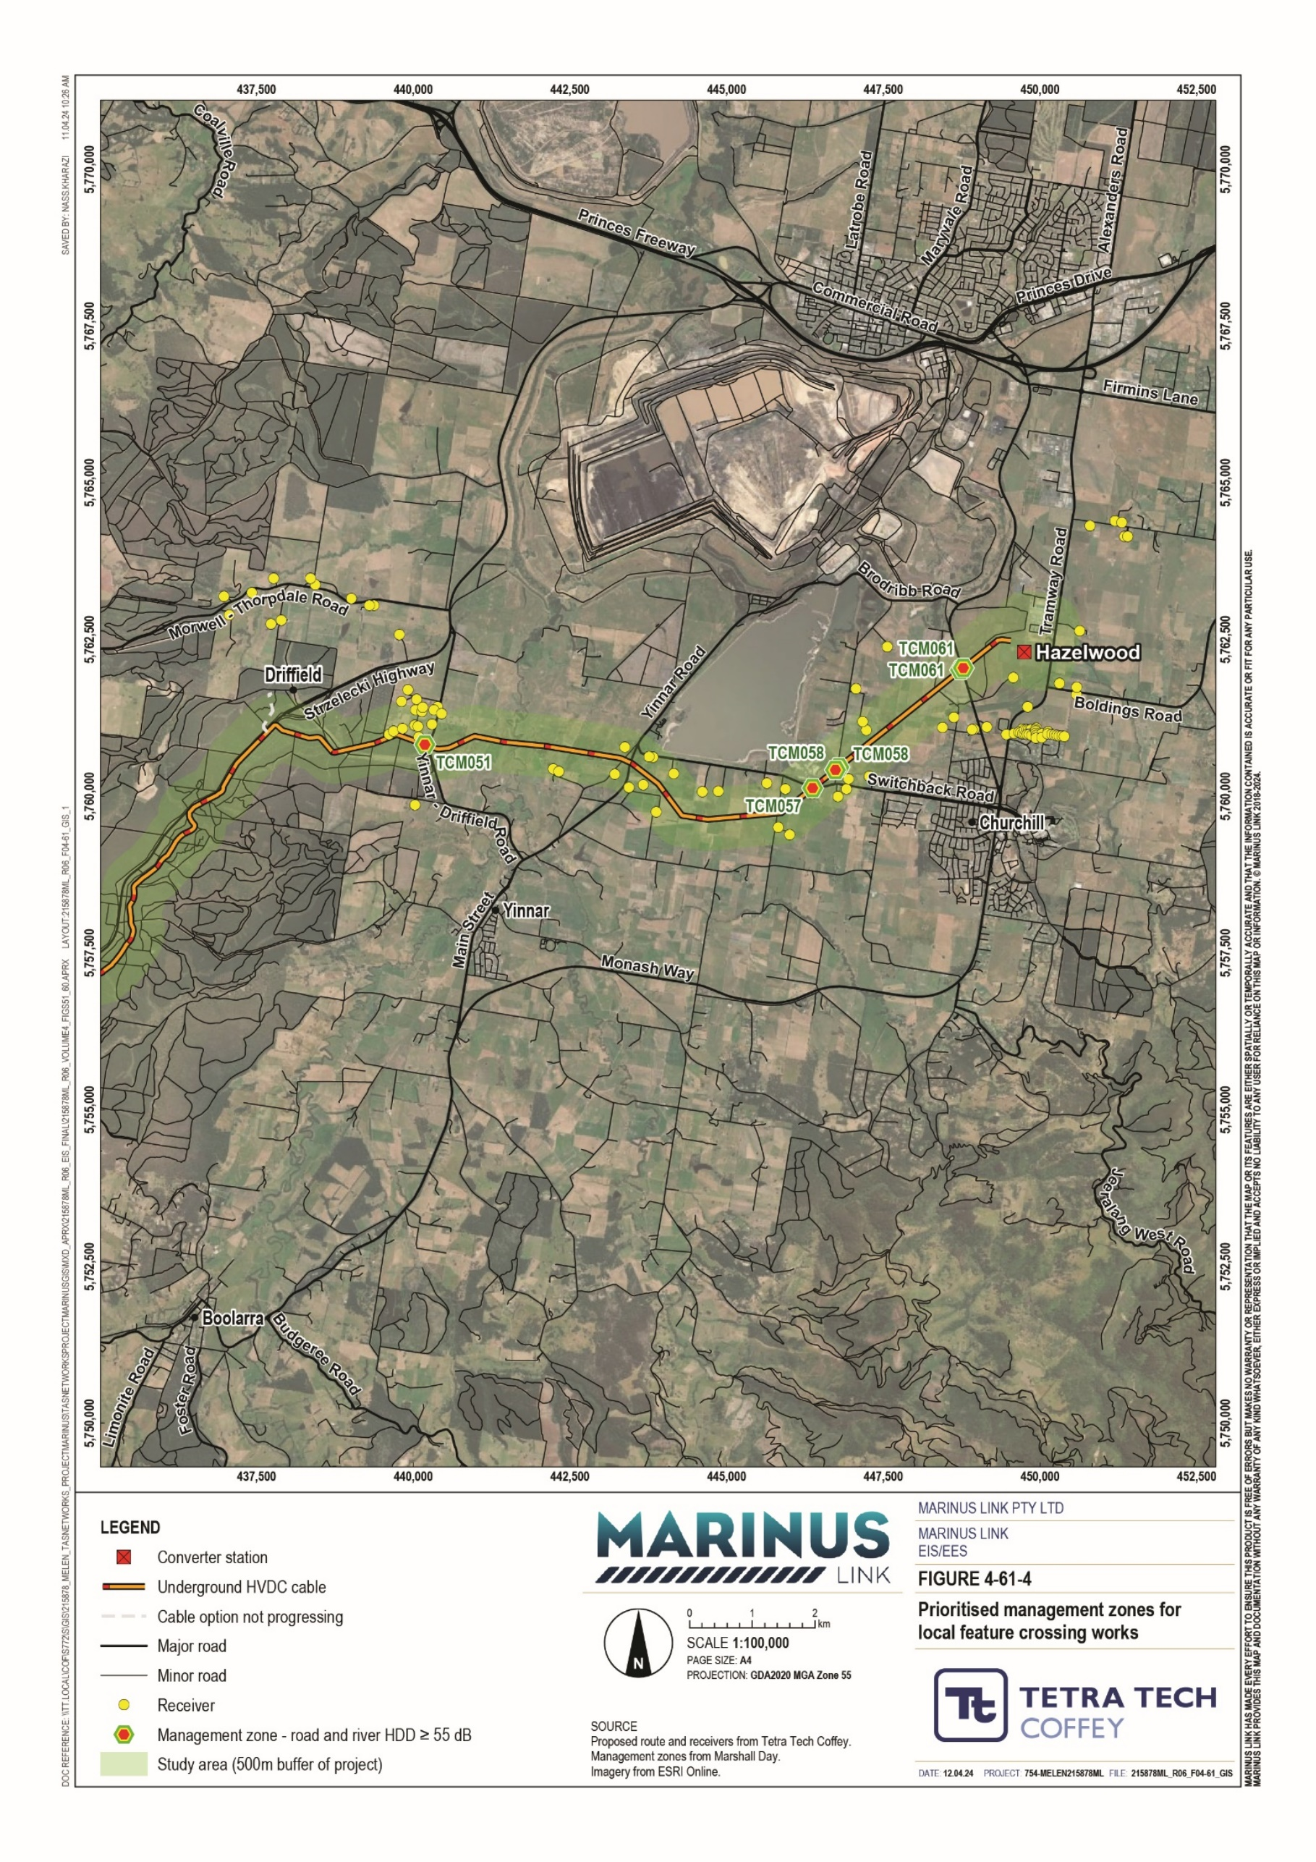

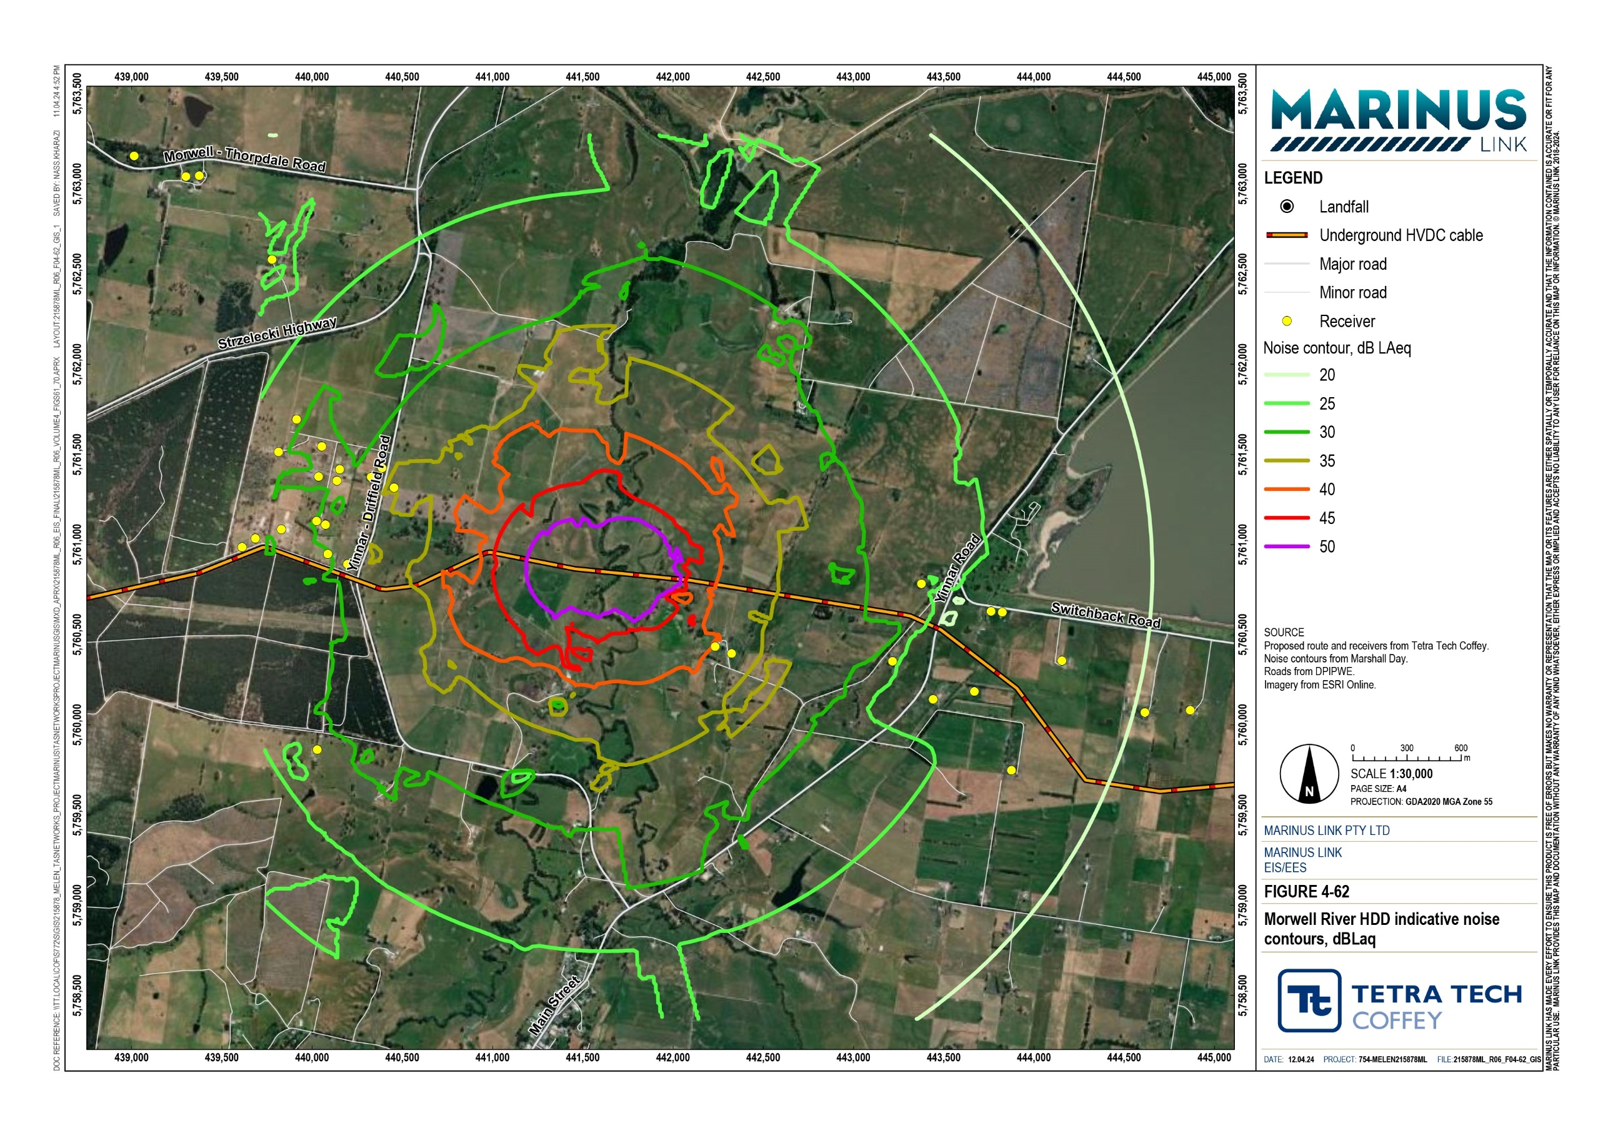

Offsite transportation noise
Project related traffic movements will generate noise through additional heavy vehicle and light vehicle movements. Construction materials and equipment will be transported from source locations to laydown areas and then redistributed to project work sites. Most vehicle movements associated with project construction will occur within normal working hours with travel through rural and lightly populated areas. Some receivers will be located within 15 m of the construction vehicle routes. More information on proposed project traffic movements is provided in Technical Appendix W: Traffic and transport.
An estimation of heavy vehicle generated noise was made at four setback distances (15 m, 25 m, 50 m, 100 m) from the edge of the road. At a 15 m setback from the road, noise levels are estimated to be marginally higher than the reference level of 55 dB LAeq,16h where it is expected that noise will be temporarily intrusive for receivers. At 25 m to 100 m setback ranges it is estimated that the noise level at receivers will be less than the 55 dB LAeq,16h reference level.
The overall risk of offsite noise impacts on the ambient noise environment due to construction heavy vehicles is low. This is due to low number of traffic movements and traffic movements being intermittent even at construction peak periods.
The CNVMP will incorporate measures for heavy vehicle movements to be undertaken primarily in normal working hours and for arterial roads be used to the greatest extent possible (EPR NV02).

Construction vibration
Construction vibration emissions were assessed against the minimum working distances from vibration intensive plant outlined in the NSW CNVG. The main project activities that may generate vibration are access road and haul road construction via use of high vibration equipment such as vibratory rollers. There is a small number of receivers that could experience very low levels of vibration due to proximity to haul road and access road construction. However, this risk can be managed through plant selection, consultation with receivers, and vibration monitoring if and where required (EPR NV02).
Construction vibration may be noticeable at greater distances than 100 m from the construction source, dependent upon geotechnical conditions, though the intermittent nature of vibration emitting activities is expected to decrease risk to the ambient domestic environment.
HDD works will be typically undertaken at greater distances from sensitive receivers than access road, haul road and converter station earthworks activities. HDD equipment also tends to emit less vibration than earthworks equipment.
One brick cistern heritage item was also considered in the construction vibration assessment. A combination of plant selection and vibration monitoring can be used to manage risk of vibration impact to the brick cistern.

The overall risk from construction vibration to the ambient environment will be low. This is based on the proximity of most receivers being beyond the distance where vibrations from construction will cause an impact. Where there are receivers close to construction activities, low vibration emitting plant can be used to reduce the impacts to those receivers (EPR NV02).

Operation impacts
Sources of operational noise expected to be generated by the project are the fixed noise emitting plant components of the converter station. All other noise-generating project activities are limited to the construction and decommissioning phases.
Noise emitting plant at the converter station include:

converter transformers

converter transformer coolers

auxiliary transformers

standby diesel generators

valve cooling banks comprising cooling units.

The highest noise generating plant are valve coolers and converter transformers. Standby generators will be used in emergency situations where mains power has been disrupted, though to make certain this equipment is emergency ready, the generators must be tested and maintained quarterly (during normal working hours).
Predicted operational noise from the converter station is expected to pose a medium risk, as noise levels generated are predicted to be well below background noise levels at receivers. Selection of low noise emitting converter station plant and use of site-specific noise attenuation measures (sound buffering enclosures), will reduce impacts to the ambient noise environment in a domestic environment during the operation phase of the project.
The findings of the noise and vibration assessment will be validated in the final design stages to confirm that operational noise is consistent with the assessed risk in the final design and commissioning phases of the project (EPR NV04).
Prior to converter station commissioning, an operational environmental management plan detailing noise compliance testing procedures, maintenance and monitoring measures and noise complaint procedures be developed in consultation with the EPA (EPR NV05).
During the operational phase of the project a post-construction noise compliance assessment will be undertaken to check noise control implementation compliance against the operation noise management plan (EPR NV06).
Figure 4-63 and Figure 4-64 show the typical operations (no standby generators) predicted noise contours.

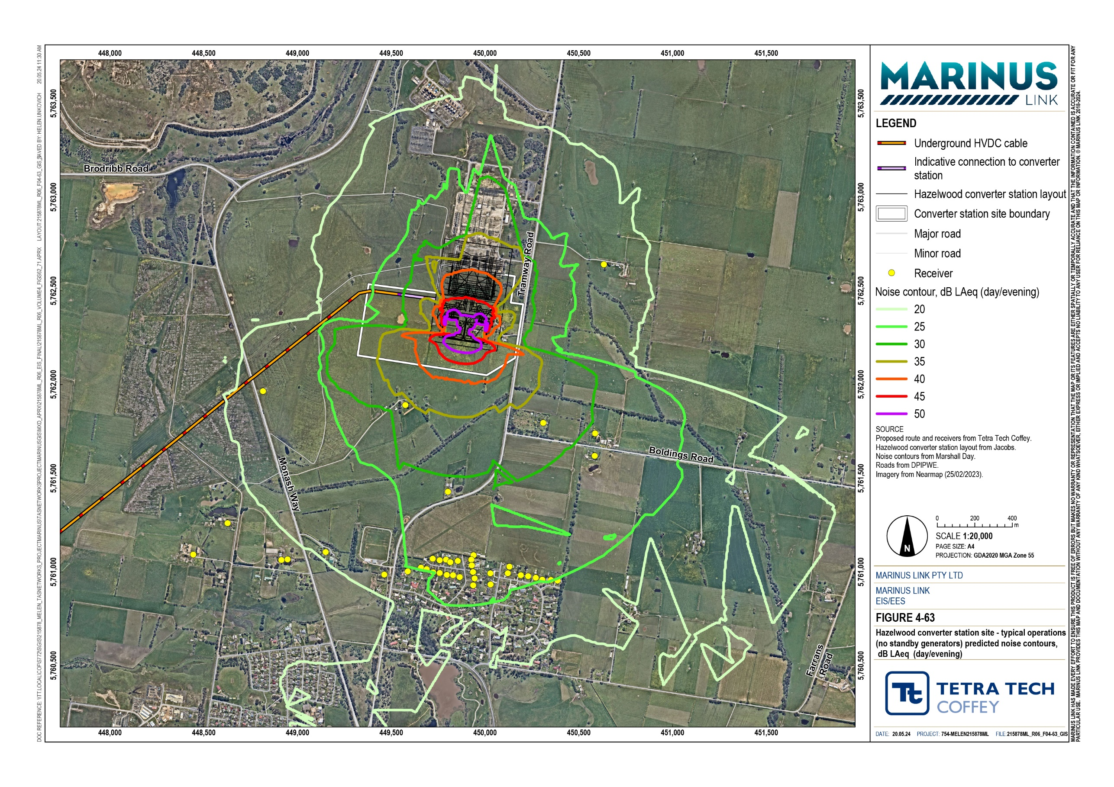

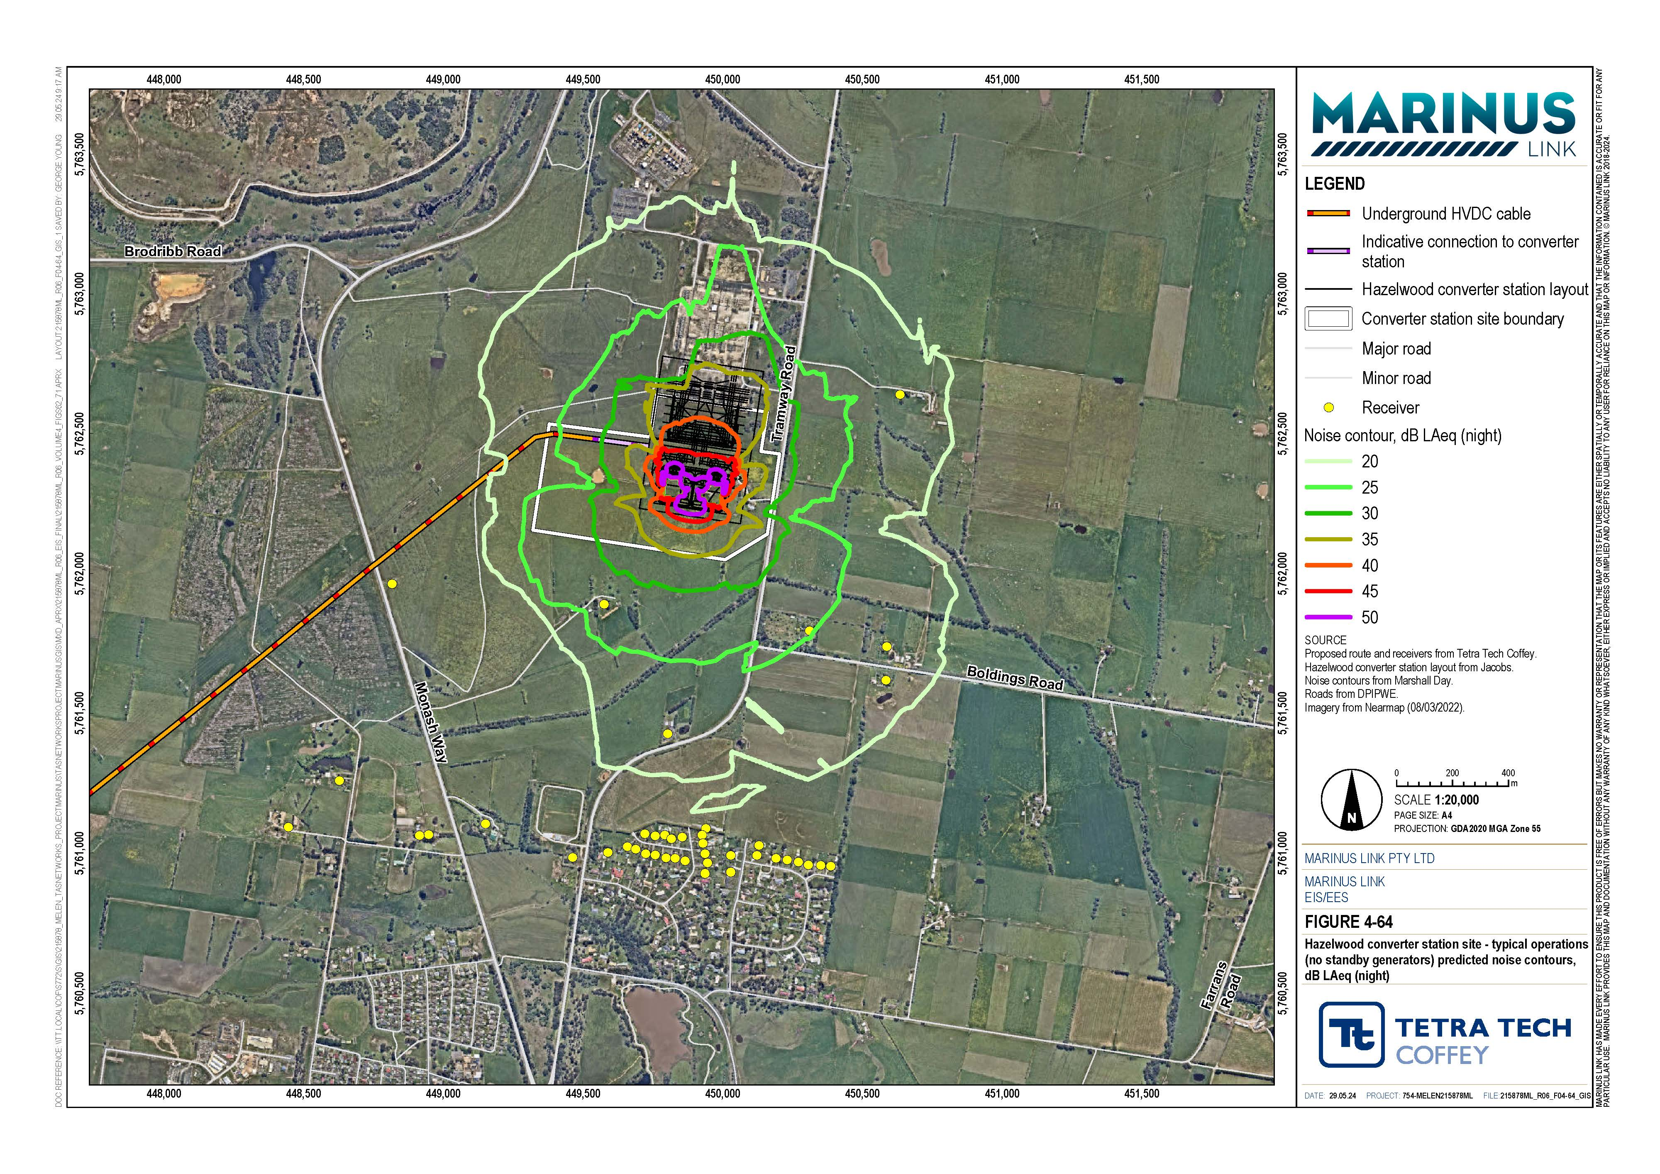

Decommissioning impacts
The operational lifespan of the project is 40 years. At that time the project will either be decommissioned or upgraded to extend its operational lifespan.
Decommissioning will be planned and carried out in accordance with regulatory and landholder requirements at the time. A decommissioning management plan in accordance with approvals conditions will be prepared prior to planned end of service and decommissioning of the project.
Requirements at the time will determine the scope of decommissioning activities and impacts. The key objective of decommissioning will be to leave a safe, stable and non-polluting environment, and minimise impacts during the removal of infrastructure.
In the event that the project is decommissioned, all above-ground infrastructure will be removed, and associated land returned to the previous land use or as agreed with the landholder.
Decommissioning activities required to meet the objective will include, as a minimum, removal of above ground buildings and structures. Remediation of any contamination and reinstatement and rehabilitation of the site will be undertaken to provide a self-supporting landform suitable for the end land use.
A decommissioning management plan will be prepared to outline how activities will be undertaken and potential noise and vibration impacts managed.
The noise and vibration impact assessment concludes that the types of equipment and processes associated with decommissioning will be like construction but considers works will be less intensive, resulting in lower noise and vibration emissions, than construction.

Environmental performance requirements
EPRs set out the environmental outcomes that must be achieved during all phases of the project. In developing these EPRs, industry standards and guidelines, good practice and the latest approaches to managing impacts were considered. Project specific management measures, relevant legislation and policy requirements informed these EPRs.

EPR ID | EPR
NV01 | Conduct additional background noise monitoring  Prior to commencement of project works, conduct additional background noise monitoring for onshore receivers in the vicinity of the following project components:  Shore crossing.  Construction locations where unavoidable works outside of normal working hours could occur for a period of five or more days.  Converter station.  Communications building and transition station (if required). The background noise monitoring data must:  Inform the assessment of construction noise (EPR NV02 and NV03) and operational noise (EPR NV04, NV05 and NV06).  Be conducted at a selection of locations which are representative of the receivers that could be impacted by construction of the project components listed above.  Be conducted at representative locations for the shore crossing in the townships of Sandy Point and Waratah Bay.  The background noise monitoring and results analysis must be conducted in accordance with procedural guidance detailed in:  EPA Victoria Publication 1826.4 Noise limit and assessment protocol for the control of noise from commercial, industrial and trade premises and entertainment venues (the EPA Noise Protocol).  EPA Victoria Publication 1834.1 Civil construction, building and demolition guide.  EPA Victoria Publication 1997 Technical guide: Measuring and analysing industry noise and music noise.  Australian Standard 1055:2018 Acoustics - Description and measurement of environmental noise  where relevant.  Data must be collected and analysed in formats which are suitable for the distinct assessment requirements of the EPA Noise Protocol and EPA Publication 1834.1.  The results must be documented in a background noise report and made available to EPA Victoria on request.
NV02 | Develop and implement a construction noise and vibration management plan  Prior to commencement of project works, develop a construction noise and vibration management plan in consultation with EPA Victoria for onshore construction including the shore crossing.  The construction noise and vibration management plan must describe the measures to be implemented during the onshore project works in Victoria to minimise the risk of harm from construction noise and vibration, so far as reasonably practicable, in accordance with the general environmental duty under the Environmental Protection Act 2017 (Vic).  The plan must document:  A description of all noise generating construction activities and their locations. This must include a schedule of equipment types and numbers for each activity and location.  A description of the proposed construction program including timing and duration of construction activities. This must include confirmation that the works will adhere to normal working hours specified in EPA Victoria Publication 1834.1 Civil construction, building and demolition guide, other than unavoidable works, low-noise works, or managed-impact works, that must occur outside normal working hours.  The results of additional background noise monitoring conducted under EPR NV01.  Details of the location, duration and type of unavoidable works, which may need to occur outside of normal working hours and the protocols that will apply for the management of unavoidable works outside normal working hours. These protocols must include a process for the justification and approval of any unavoidable works, managed-impact works, or low noise impact works that may be planned to occur outside the normal working hours.  The locations of the most sensitive working areas along the project alignment, including the extent of areas around unavoidable works where noise and vibration sensitive areas (receivers) need to be identified where risk controls for noise and vibration are most important, based on the predicted  construction noise levels.

EPR ID | EPR
A systematic evaluation of noise control options to minimise the risk of harm from operation noise so far as reasonably practicable.
A framework for the selection and implementation of risk controls that are proportionate to the risk of harm from noise, informed by factors including the noise level, noise character, work timing, and work duration. The existing noise environment and the number of affected receivers may also be relevant factors at some sites.
Details of all reasonable and practicable measures that are proposed to minimise the risk of harm as a result of noise and vibration associated with both on-site and off-site sources of construction activities (including heavy vehicle movements on local roads), including:
- Requirement for the selection of major plant items with low noise emissions, characterised by sound power levels that are equivalent to, or lower than, the values/ranges indicated in AS 2436, Guide to Noise and Vibration Control on Construction, Demolition and Maintenance Sites (Reconfirmed 2016), unless it can be demonstrated that adhering to these values would not be reasonably practicable.
- Measures for the control of potentially annoying characteristics such as tonality, impulsive and low frequency noise (accounting for frequency spectrum as a prescribed characteristic where applicable).
- A requirement to for each HDD rig associated with the shore crossing (including ancillary plant) to achieve a total sound power level of 110 dB LWA or lower, unless it can be demonstrated that adhering to this value would not be reasonably practicable or would increase the duration of exposure.
- Scheduling protocols for minimising the potential disruption caused by high noise levels as a result of transient construction activities which occur near to receivers for brief periods.
- Details of any locations where temporary screens or enclosures are identified as a reasonably practicable control measure, informed by updated construction noise modelling.
Details of any low-noise or managed-impact works which may need to occur outside of normal working hours and the protocols that will apply to the management of these works outside of normal working hours.
Requirements for monitoring noise and vibration of construction works, including unavoidable works.
The protocol for preparing detailed noise and vibration impact assessments (EPR NV03) including when they are required, format, timing and process for review. The protocol must address all project works and specifically:
- The shore crossing.
- Locations where there is prolonged unavoidable works, managed-impact works, or low noise impact works outside of normal working hours.
- The converter station.
Vibration controls and monitoring requirements, including details of the locations and circumstances in which vibration noise monitoring would be conducted, for heritage structures including the cistern structure identified in Moores Road, Buffalo.
Communication protocols for notifying landholders in advance of the works occurring.
Noise complaint handling and response protocols, in accordance with the broader process for managing and responding to complaints received during construction (prepared under EPR S03)
Protocols for continual improvement of the construction noise and vibration mitigation measures, informed by data sources including but not limited to audit findings, the community and stakeholder engagement framework (prepared under EPR S03), complaint reviews, noise modelling (e.g. as part of preparing detailed noise and vibration impact assessments under EPR NV03), and monitoring.
The construction noise and vibration management plan must address the requirements and guidance of: The general environmental duty under the EP Act.
EPA Victoria Publication 1834.1. AS 2436 - 2010.
EPA Victoria Publication 1996 Noise guideline – assessing low frequency noise.
Both the construction noise and vibration management plan and the IEA review report of the plan must be made available to EPA Victoria on request.
The construction noise and vibration management plan must be a sub plan to the CEMP and implemented during construction.

EPR ID | EPR
NV03 | Develop a detailed noise and vibration impact assessment for construction activities at specific sites  Prior to commencement of noise generating work that could impact onshore sensitive receivers, a detailed noise and vibration impact assessment must be completed for construction in accordance with the protocol contained in the construction noise and vibration management plan (EPR NV02):  Each assessment must:  Identify all relevant sensitive locations (receivers).  Determine the sound power level for all noise generating plant and equipment planned to be used for the activities being assessed.  Include information to demonstrate the selection, or the processes for selection, of low noise equipment, including consideration of any potentially annoying characteristics of the noise such as tones, impulses or prominent low frequencies.  Model predicted noise levels for the activities and plant being assessed.  Assess noise and vibration impacts on sensitive receivers. This must include an objective assessment of the risk of low frequency noise, informed by indicative estimations of low frequency noise levels.  Include a systematic evaluation of noise control options to minimise the risk of harm from construction noise and vibration so far as reasonably practicable. For unavoidable works outside of normal working hours, the noise control options evaluated should account for any feedback from consultations with the nearest affected receivers.  Include details of all noise and vibration controls and management measures to be implemented to minimise the risk of harm from construction noise and vibration so far as reasonably practicable.  Describe construction noise and vibration monitoring requirements, including verification noise testing (if warranted) to assess the effectiveness of the noise controls before commencing continuous unavoidable works outside of normal working hours.  Include protocols for providing respite in circumstances where residents are affected by prolonged exposure to elevated noise levels as a result of unavoidable works out of hours.  Comply with the controls and protocols documented in the construction noise and vibration management plan.  The detailed noise and vibration impact assessments must address the requirements and guidance of: The general environmental duty under the Environmental Protection Act 2017 (Vic).  EPA Victoria Publication 1834.1 Civil construction, building and demolition guide.  Australian Standard AS 2436-2010 Guide to Noise and Vibration Control on Construction, Demolition and Maintenance Sites (Reconfirmed 2016).  EPA Victoria Publication 1996 Noise guideline – assessing low frequency noise.  Each detailed noise and vibration impact assessment must be reviewed by the independent environmental auditor (IEA), prior to commencement of the noise generating work under assessment. The detailed noise and vibration impact assessments and the IEA review reports must be made available to EPA Victoria on request.  All of the recommended noise and vibration risk controls (including mitigation, management, monitoring and respite measures) established in the detailed noise and vibration impact assessment must be implemented during construction.
NV04 | Design the converter station to minimise the risk of harm from noise so far as reasonably practicable  In accordance with the general environmental duty under the EP Act, the design process for the converter station must include a systematic evaluation of noise control options to minimise the risk of harm from operation noise so far as reasonably practicable. The evaluation must:  Consider site layout, equipment selection, and built form to control noise.  Address both the level and character of the noise, accounting for the assessable characteristics defined in the EPA Noise Protocol and prescribed characteristics under the EP Act.  Address normal operation and routine equipment testing.  Prior to installing the converter station plant and any enclosing structures, prepare a design noise assessment report for the final converter station design. The report must:  Document the systematic evaluation of noise control options.  Describe the measures to be implemented to control environmental noise levels, demonstrating that all reasonable and practicable measures will be implemented to minimise the risk of harm as a result of noise, as required by the general environmental duty under the EP Act.

EPR ID | EPR
Confirm the applicable noise limits (normal operation and routine equipment testing) determined in accordance with the EPA Victoria Publication 1826.4 Noise limit and assessment protocol for the control of noise from commercial, industrial and trade premises and entertainment venues (EPA Noise Protocol), accounting for the background monitoring data obtained for EPR NV01 and cumulative noise considerations.
Provide details of the noise frequency characteristics of key items of plant such as the transformers and valve coolers, and assessment of whether character adjustments are warranted.
Present predicted noise levels at noise sensitive locations (receivers) from operation of the converter station.
Demonstrate that operational noise levels for the final design and equipment selections are predicted to comply with noise limits determined in accordance with the EPA Noise Protocol.
Present an assessment of the potential for prescribed characteristics under the EP Act.
The design noise assessment report must be reviewed by the independent environmental auditor. Both the design noise assessment report and the IEAs review report must be made available to EPA Victoria on request.
NV05 | Develop an operation noise management plan for the converter station and transition station sites  As part of the OEMP, develop an operation noise management plan for the converter station and transition station (if required) sites in consultation with EPA Victoria. The operation noise management plan must document:  The noise mitigation and management measures developed in design (EPR NV04) that apply to the operation and maintenance of the converter station.  The confirmed applicable noise limits determined in accordance with the EPA Noise Protocol, including for routine testing of plant that is used solely for emergencies (i.e. standby generators for the converter station and the transition station), determined under EPR NV04.  Procedures for, and timing of, noise monitoring to be carried out to assess compliance with the applicable noise limits when the converter station and transition station commences operation.  Details and timing of a noise compliance reporting to be submitted to EPA Victoria.  Details of any maintenance and monitoring measures that are required to maintain ongoing compliance with the EP Act including the general environmental duty.  Procedures for routine testing of plant that is used solely for emergencies (e.g. regularity, days, and times of testing).  Procedures to investigate noise complaints or suspected noise compliance issues.  Protocols for continual improvement of the operation noise management plan, informed by data sources including but not limited to audit findings, complaint reviews and monitoring.  The operation noise management plan must be made available to EPA Victoria on request.  The operation noise management plan must be a sub plan to the OEMP and implemented during operation.
NV06 | Prepare an operation noise compliance assessment report  Prepare an operation noise compliance assessment report based on:  An inspection of the converter station and transition station to confirm that the noise mitigation and management measures documented in the operational noise management plan (EPR NV05) have been fully implemented.  The results of noise monitoring conducted in accordance with the operation noise management plan (EPR NV05), to assess compliance with the applicable noise limits.  The report must be submitted to EPA Victoria within six months of each stage of the converter station  becoming fully operational.

The complete list of EPRs for the project is provided in Volume 5, Chapter 2 – Environmental Management Framework.

Residual impacts
The residual risk of noise and vibration impacts have considered the effective implementation of the mitigation measures that will be implemented to comply with EPRs outlined in Section 10.6.
Residual risk of noise and vibration impacts in the construction phase is low for construction of communications building and potential transition station, converter station and land cable installation. The primary noise and vibration impacts during construction are associated with access track construction, topsoil stripping and stockpiling and trenching activities. However, these type of construction activities are expected to be relatively fast moving and temporary as cable lay works progress along the project alignment. Consequently, the residual risk of noise and vibration impacts on sensitive receivers is expected to be short in duration and managed through works scheduling, selection of low noise and vibration emitting plant and equipment, and consultation with receivers.
Construction activities at the Hazelwood convertor station and laydown areas will be during normal working hours. While construction will occur over a longer period and noise levels will be lower than other construction activities such as HDD.
The HDD works associated with the shore crossing and Morwell River crossing constructed in both normal working hours and out of normal working hour time periods. Predicted noise levels indicate there may be a small number of receivers that experience noise levels which may cause sleep disturbance. Dedicated HDD noise management measures will reduce the residual risk of impact to sensitive receivers to medium for the shore crossing and low for the Morwell River crossing (EPRs, NV01, NV02 NV03).
Residual risk of noise and vibration impacts will be low in operation. This low residual risk is based on the effective implementation of EPRs NV04, NV05 and NV06. The primary source of operational noise is the converter station in Hazelwood. As discussed in Section 10.4 noise levels generated by fixed plant at the converter station are expected to be well below background noise levels at receivers. Selection of low noise emitting converter station plant and use of site-specific noise attenuation measures (sound buffering enclosures), is key to mitigating the risk to the ambient noise environment for relaxation and recreation in a domestic environment during the operation phase of the project.
A summary of initial and residual noise and vibration risks is provided in Table 10-7.

Affected value | Potential risk of harm | Project phase | Initial risk | EPRs | Justification of residual rating | Residual risk
Ambient | Airborne noise generated | Construction | Medium | NV01 | Risk reduction based on | Low
noise | by construction activities |  |  | NV02 | additional noise
environment | associated with the land |  |  | NV03 | monitoring
 | cable installation and |  |  |  | preconstruction and
 | converter station during |  |  |  | development and
 | normal working hours |  |  |  | implementation of
 | impacting noise sensitive |  |  |  | CNVMP and DNVIA.
 | areas

Ambient noise environment | Airborne noise generated by construction of the shore crossing involving 24-hour work over an extended period, affecting noise sensitive areas (including disturbance of sleep) and natural areas valued for their soundscapes. | Construction | Medium | NV01 NV02 NV03 | Risk reduction based on additional noise monitoring preconstruction and development and implementation of CNVMP and DNVIA. | Medium
Ambient noise environment | Airborne noise generated by construction of local feature crossings (other than Morwell River – see below) during normal | Construction | Medium | NV01 NV02 NV03 | Risk reduction based on additional noise monitoring preconstruction and development and | Low
 | working hours impacting noise sensitive areas. |  |  |  | implementation of CNVMP and DNVIA.
Ambient noise environment | Airborne noise generated by construction of the Morwell River crossing involving 24-hour work over a period of up to 2- weeks, affecting noise sensitive areas (including disturbance of sleep) | Construction | Medium | NV01 NV02 NV03 | Risk reduction based on additional noise monitoring preconstruction and development and implementation of CNVMP and DNVIA. | Low
Ambient | Airborne noise generated | Construction | Low | NV02 | Risk reduction of through | Low
noise environment | by heavy construction vehicles using the public road network during normal working hours affecting noise sensitive areas. |  |  |  | developing and implementing CNVMP
Ambient noise environment | Ground borne vibration generated by construction activities resulting in perceptible vibration in sensitive (habited) areas | Construction | Low | NV02 | Risk reduction through developing and implementing CNVMP | Low
 | or building damage.
Ambient noise environment | Airborne noise generated by operation of the converter station affecting | Operation | Medium | NV01 NV04  NV05 | Risk reduction through preconstruction noise monitoring, design | Low
noise sensitive areas NV06 considerations to
minimise noise at
converter and transition stations and compliance assessment in operation.

Cumulative impacts
The noise and vibration assessment of cumulative impacts considers the construction and operation of other projects occurring at the same time and within relevant proximity to each other within the study area. There are three projects that have the potential to contribute to cumulative impacts for noise and vibration:
Delburn Wind Farm

Hazelwood Power Station rehabilitation

WESS.

Construction
There is potential for cumulative noise and vibration impacts during construction of the project and construction of Delburn Wind Farm and the Hazelwood Power Station rehabilitation. The risk of cumulative impacts from construction noise and vibration of these projects has been assessed as low due to the distances between the projects and the moving construction work fronts.

Operation
The WESS is proposed to be located northeast of the existing Jeeralang power station, approximately
1.2 km north of the converter station site. There is a receiver located approximately 900 m northeast of the converter station site where noise levels from operation of the converter station are predicted to be more than 10 dB below the applicable industry noise limit. The predicted noise levels at other receivers, closer to the WESS, are significantly lower. On this basis, the likelihood of cumulative noise and vibration impacts at receivers in between the two projects, is low.
A design verification report will be produced based on the updated modelling of final converter station design, equipment selections, and to address addresses cumulative noise considerations in accordance with the Noise Protocol (EPR NV06).

Conclusion
The key value considered by the noise and vibration assessment is the ambient noise environment for relaxation and recreation in a domestic residential environment. The key features of this value are ambient noise conditions that are conducive to sleep during the night, domestic and recreational activities, normal conversation, child learning, and development and musical entertainment.
Most of the noise and vibration emissions generated during construction will be from activities that move along the project alignment. Offsite heavy vehicle movements along public roads have been considered as low risk, as they will be infrequent and there will be little change from current traffic noise. The noise and vibration risks during construction have been assessed as low to medium for works undertaken in normal working hours, and medium for HDD works at the feature crossings and shore crossing.

The construction vibration risk is low, due to the separating distances of construction works to receivers. To maintain a low risk low vibration emitting plant and equipment will be used when within 25 m of a receiver.
Following implementation of EPRs, construction noise and vibration residual impacts will be low for all construction activities, apart from night works associated with the continuous HDD at the shore crossing which is expected to generate a medium risk noise and vibration impacts.
The converter station is the only source of operational noise for the project and will comprise of both indoor and outdoor noise generating plants, including transformers and cooling systems. The unmitigated risk of the project in operation is assessed as medium. The predicted operational noise levels for the converter station are below the background noise levels, based on selection of low noise emission plant, and site-specific noise mitigation. The residual risk of operational noise is low with implementation of EPRs.
The focus of the noise and vibration EPRs are to avoid and minimise the risk of noise and vibration impacts generated by the project during construction and operation activities through development of detailed measures during detailed design and construction management planning. These measures include:
Conducting additional background noise monitoring (EPR NV01).

Development and implementation of a CNVMP (EPR NV02) preparation of DNVIAs for construction activity at specific sites (EPR NV03).
Preparing a design verification noise assessment report for the final converter station design (EPR NV04).
Preparing an operational noise management plan (EPR NV05).

Preparing of operation noise compliance assessment report (EPR NV06).

Following the implementation of measures to comply with the EPRs, it is expected that the project will meet the EES evaluation objective to ‘Avoid and, where avoidance is not possible, minimise the potential adverse effects community amenity, health and safety, with regard to noise, vibration, air quality including dust, the transport network, greenhouse gas emissions, fire risk and electromagnetic fields.’

