Bushfire
This chapter provides an assessment of the bushfire impacts associated with the construction, operation, and decommissioning of the project. This chapter is based on the impact assessment provided in Technical Appendix M: Bushfire.
Bushfires are a natural part of the Australian landscape, and many ecosystems have evolved to be fire dependent. The project alignment crosses bushfire prone areas and sites of historical fires in rural Gippsland. Assessment of bushfire impacts is important in bushfire prone rural settings and where there are bushfire management overlays, to identify risks to people, property and the environment.
The EIS guidelines set out the following requirements related to bushfire.

Section 5.1: General Impacts

Refer to Attachment 1: Guidelines for the Content of an Environmental Impact Statement for the EIS guidelines.
The EES scoping requirements set out the following evaluation objective relevant to bushfire:

Amenity, health, safety and transport – Avoid and, where avoidance is not possible, minimise adverse effects on community amenity, health and safety, with regard to noise, vibration, air quality including dust, the transport network, greenhouse gas emissions, fire risk and electromagnetic fields.
Refer to Attachment 2: Scoping Requirements Marinus Link Environment Effects Statement for the EES scoping requirements.
The bushfire assessment considers the potential risks and impacts of bushfire to the project, and the potential bushfire impacts as a result of the project. It also recommended EPRs to mitigate impacts.
Other aspects covered in the above EES evaluation objective are addressed in the following EIS/EES chapters:
Volume 1, Chapter 9 – Sustainability, climate change and greenhouse gas emissions

Volume 1, Chapter 10 – Electromagnetic fields

Volume 4, Chapter 8 – Traffic and transport

Volume 4, Chapter 9 – Air quality

Volume 4, Chapter 10 – Noise and vibration

Volume 4, Chapter 15 – Land use and planning

Volume 4, Chapter 16 – Social.

Method
The risk assessment method was used to assess the potential bushfire impacts associated with the project activities. This method is detailed further in Volume 1, Chapter 5 – EIS/EES assessment framework. The key steps of this assessment method included:
Defining a study area for the bushfire assessment.

Conducting a desktop assessment and baseline data review to assess the existing bushfire risk and management practices across the study area. This also involved a review of available spatial data and fire history to characterise the landscape (slope, elevation, vegetation and land use) and understand potential fire spread. The assessment also reviewed the Technical Appendix C: Climate change to identify climate issues that have the potential to influence the bushfire risk context for the project.
Identifying values within the project area that may be impacted by bushfires, including life (human populations) and property (human settlement, infrastructure, pine plantation, and agricultural lands).
Identifying potential ignition points related to the project, potential bushfire hazards, and the factors that contribute to affecting the overall risk exposure.
Defining vulnerability criteria for the life and property in the project areas.

Applying a risk assessment method to assess potential impacts and considering the vulnerability criteria, which involved identifying bushfire hazards, considering the consequence of a bushfire event, and the likelihood of an impact occurring to the identified values (life and property). Risk assessment was conducted in accordance with AS/NZS IS0 3100:2018, Risk management) as described in Volume 1, Chapter 5 – EIS/EES assessment framework.
Developing EPRs in response to the impact assessment to set the required environmental outcomes for the project.
Considering the residual impacts of and to the project from bushfire. The assessment of residual impacts presented in this chapter assumes implementation of measures to comply with the EPRs. Refer to Volume 5, Chapter 2 – Environmental Management Framework for a full list of EPRs.
The method is detailed in Technical Appendix M: Bushfire. The project alignment for the underground cable in Technical Appendix M: Bushfire has been assessed under a worst-case hazard scenario of forest.

Study area
The bushfire assessment study area considers the total area needed to sufficiently characterise and assess potential bushfire impacts to and from the project.
The study area for this assessment covers three separate project sites: the Hazelwood converter station, the Waratah Bay transition station, and the 90 km of underground cable from the shore crossing at Waratah Bay to the converter station at Hazelwood.

The assessment of the underground project alignment between Hazelwood and Waratah Bay considered the construction area as a temporary and mobile study area, as works that pose a potential bushfire risk are limited to the construction phase of the project.
The study areas for the Hazelwood converter station and Waratah Bay transition station project sites involved the following analysis:
Bushfire Hazard Assessment – assessment of bushfire fuels (vegetation) and topography at a local scale within a 500-m buffer of each of the project sites; and
Bushfire Risk Assessment – assessment of the bushfire hazard in combination with fire history, fire weather, fire behaviour potential, fire paths, and assets at risk at a semi-landscape level within a 5 km buffer of each of the project sites.
The study areas for this assessment are shown in Figure 4-70.

Legislative context
Table 12-1 outlines the key legislation and guidelines that informed the bushfire impact assessment.

Title | Relevance to the assessment
Planning and Environment Act 1987 (Vic) (P&E  Act) | The P&E Act provides a framework for urban planning and the use and development of land. The act addresses all requirements that are needed for planning approval to be issued by the Minister for Planning for renewable energy zone facilities.  Any related bushfire conditions identified within the planning approval for the proposed development on bushfire prone land must be addressed to mitigate bushfire risk from the site.
Planning Schemes Clause 13.02 | The primary planning pathways to assess bushfire risk is through Clause 13.02-1S of the  Planning Policy Framework and the P&E Act.  Clause 13.02-1S of the Planning Policy Frameworks for Victoria sets out the specific compliance strategies for the protection of human life, which is the overall objective of this Victorian state bushfire policy. The four key strategies that are required to be addressed for facilities located within Bushfire Management Overlay (BMO) and Bushfire Prone Areas  (BPA) include:
- Consideration of bushfire impacts where there is a bushfire hazard;
- Direct proposals to be situated low risk locations;
- Assess and apply bushfire protection measures; and
- No increased risk and risk reduction where applicable.

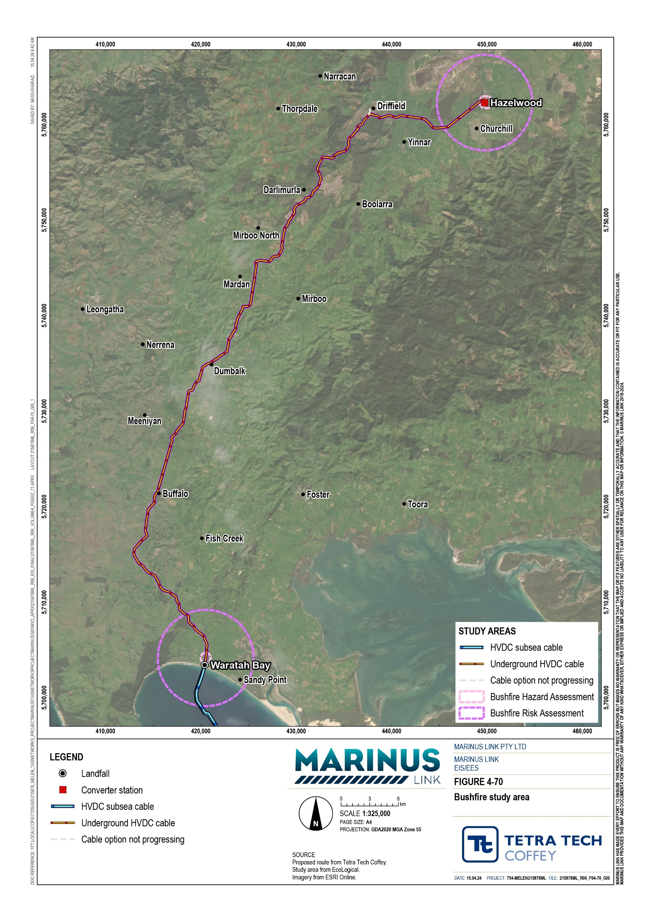

Assumptions and limitations
The bushfire assessment has been conducted based on the following assumptions and limitations:

A desktop assessment was completed that was informed by review of existing information including BoM weather and climate data and publicly available data regarding fire history. A desktop assessment is considered sufficient for assessing the risk of bushfire in the region where the project is proposed, considering the fire history and fuel hazards associated with land use in the region, and the predominantly underground nature of the project.

Bushfire risk factors
This section describes the existing conditions that affect the project’s level of risk of exposure to bushfires. The assessment considered the following factors:
Fire history

Fire weather and danger ratings

Climate

Topography

Fuel hazard

Fire suppression resources

Fire ignition risks.

Fire history
A review was completed of historic bushfire events recorded within the study area. While there have been no recorded bushfires within the Waratah Bay or Hazelwood project sites, several have been recorded within and beyond the study area. The most recent fire was an event at the Hazelwood Mine in 2014 (DELWP 2022a) that is located to the west of the Hazelwood converter station site. The Hazelwood Mine fire originated from a grassfire spreading onto the mine site, leading to ignition of coal reserves and burnt for 45 days.
While the compiled bushfire history mapping would not contain all bushfire occurrences (i.e., small scales fires may not be recorded), the bushfire history generally indicates a very low number of large bushfire events in the landscape for all sites.
Figure 4-71 and Figure 4-72 show the fire history within the study area.

Volume 4 – Victorian terrestrial environment Page 12-5

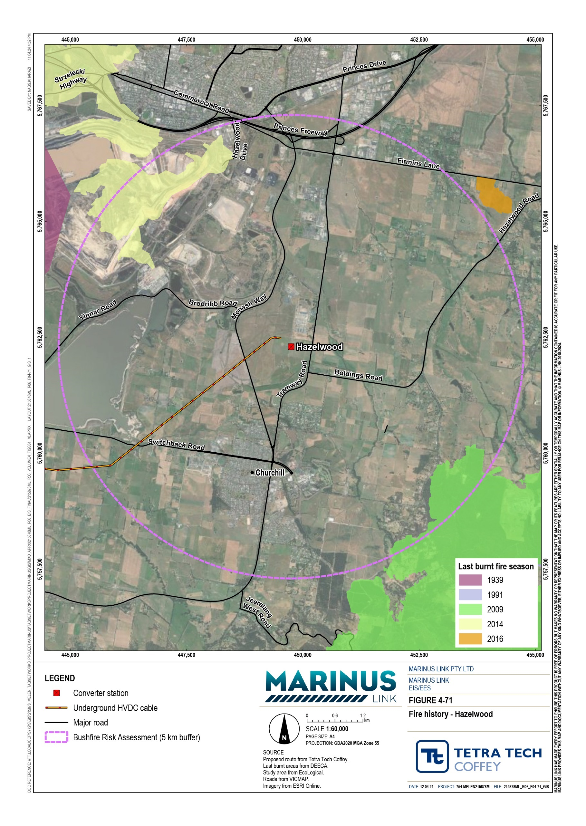
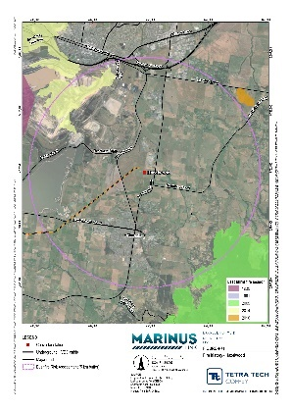
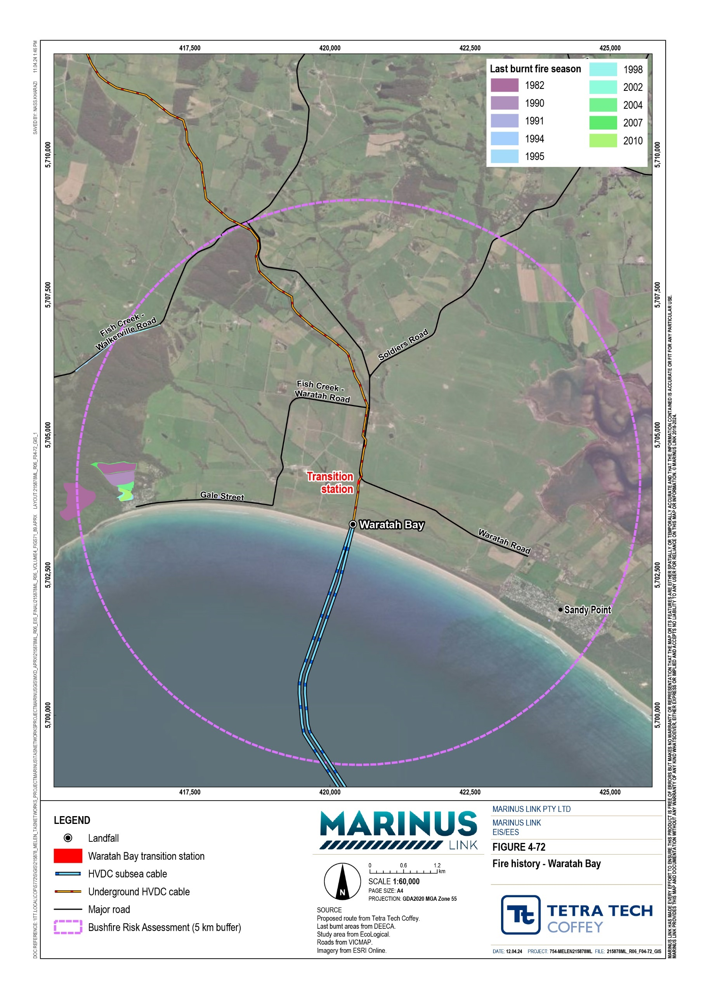

Fire weather and danger ratings
Fire weather strongly influences the likelihood of a bushfire starting, and how likely a fire will become uncontrollable.
Fire weather is reported as a Fire Danger Rating (FDR). In September 2022, Australia adopted the new Australian FDR System which calculates, forecasts and reports fire danger using up-to-date fuel state data, spatial and satellite data and weather data to calculate the Fire Behaviour Index (FBI) (AFAC 2022). The FBI is used to identify potential fire behaviour in finer detail and assist in better decision making within the four FDRs. This information is also used to declare the bushfire season, which generally commences on
1 October and concludes on 31 March the following year; however, these dates can be modified depending on the season and conditions.

Climate
The study area experiences mild to warm summers with an average temperature of 21 to 25°C, and mild to cool winters with an average temperature of 12 to 15°C. Rainfall across the study area is variable, with the southwestern and eastern parts of region receiving rainfall amounts of 1,000 mm to over 1,600 mm, while the central parts of the region receive less than 600 mm of rainfall on average. The average windspeed is
3.74 metres per second (m/s) at Morwell and 4.63 m/s at Yanakie. There are some diurnal and seasonal variation in both wind direction and wind speed throughout the year.
The greatest potential for bushfire events in the project area is associated with the bushfire season, which coincides with strong north to north-west and south-west winds, together with low rainfall and drought conditions.

Topography
Topography influences bushfire behaviour by affecting wind patterns, how vegetation and fuel loads form and accumulate, the direction and speed that fire spreads through the landscape, and the presence of natural firebreaks or barriers.
The landscape along the underground project alignment is generally undulating, with elevations ranging from 0 m AHD at Waratah Bay (i.e., sea level) to a peak of approximately 300 m AHD around Mirboo. At the Hazelwood and Waratah Bay project sites the landscape is generally flat.
The slope of the landscape within the survey area at the Waratah Bay and Hazelwood project sites is shown in Figure 4-73 and Figure 4-74.

Volume 4 – Victorian terrestrial environment Page 12-8

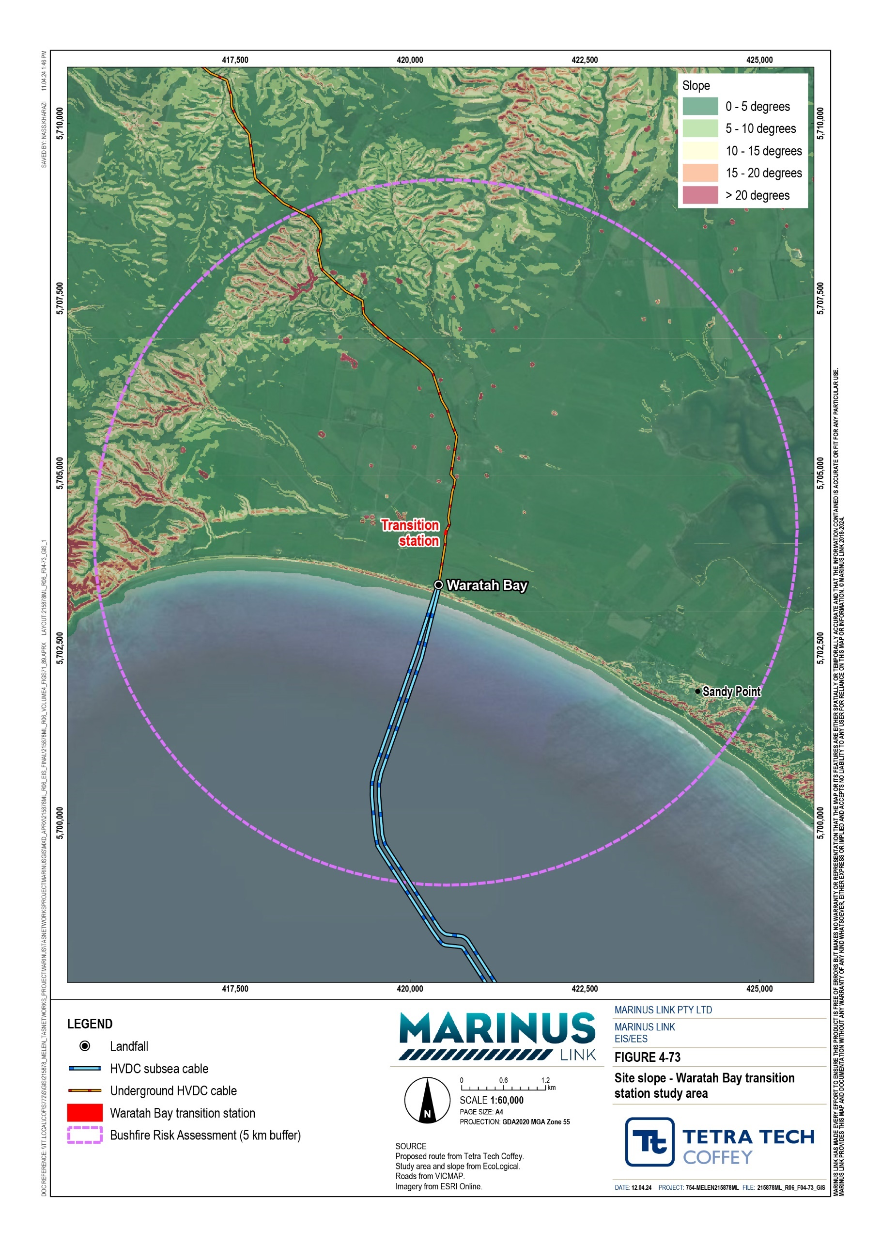

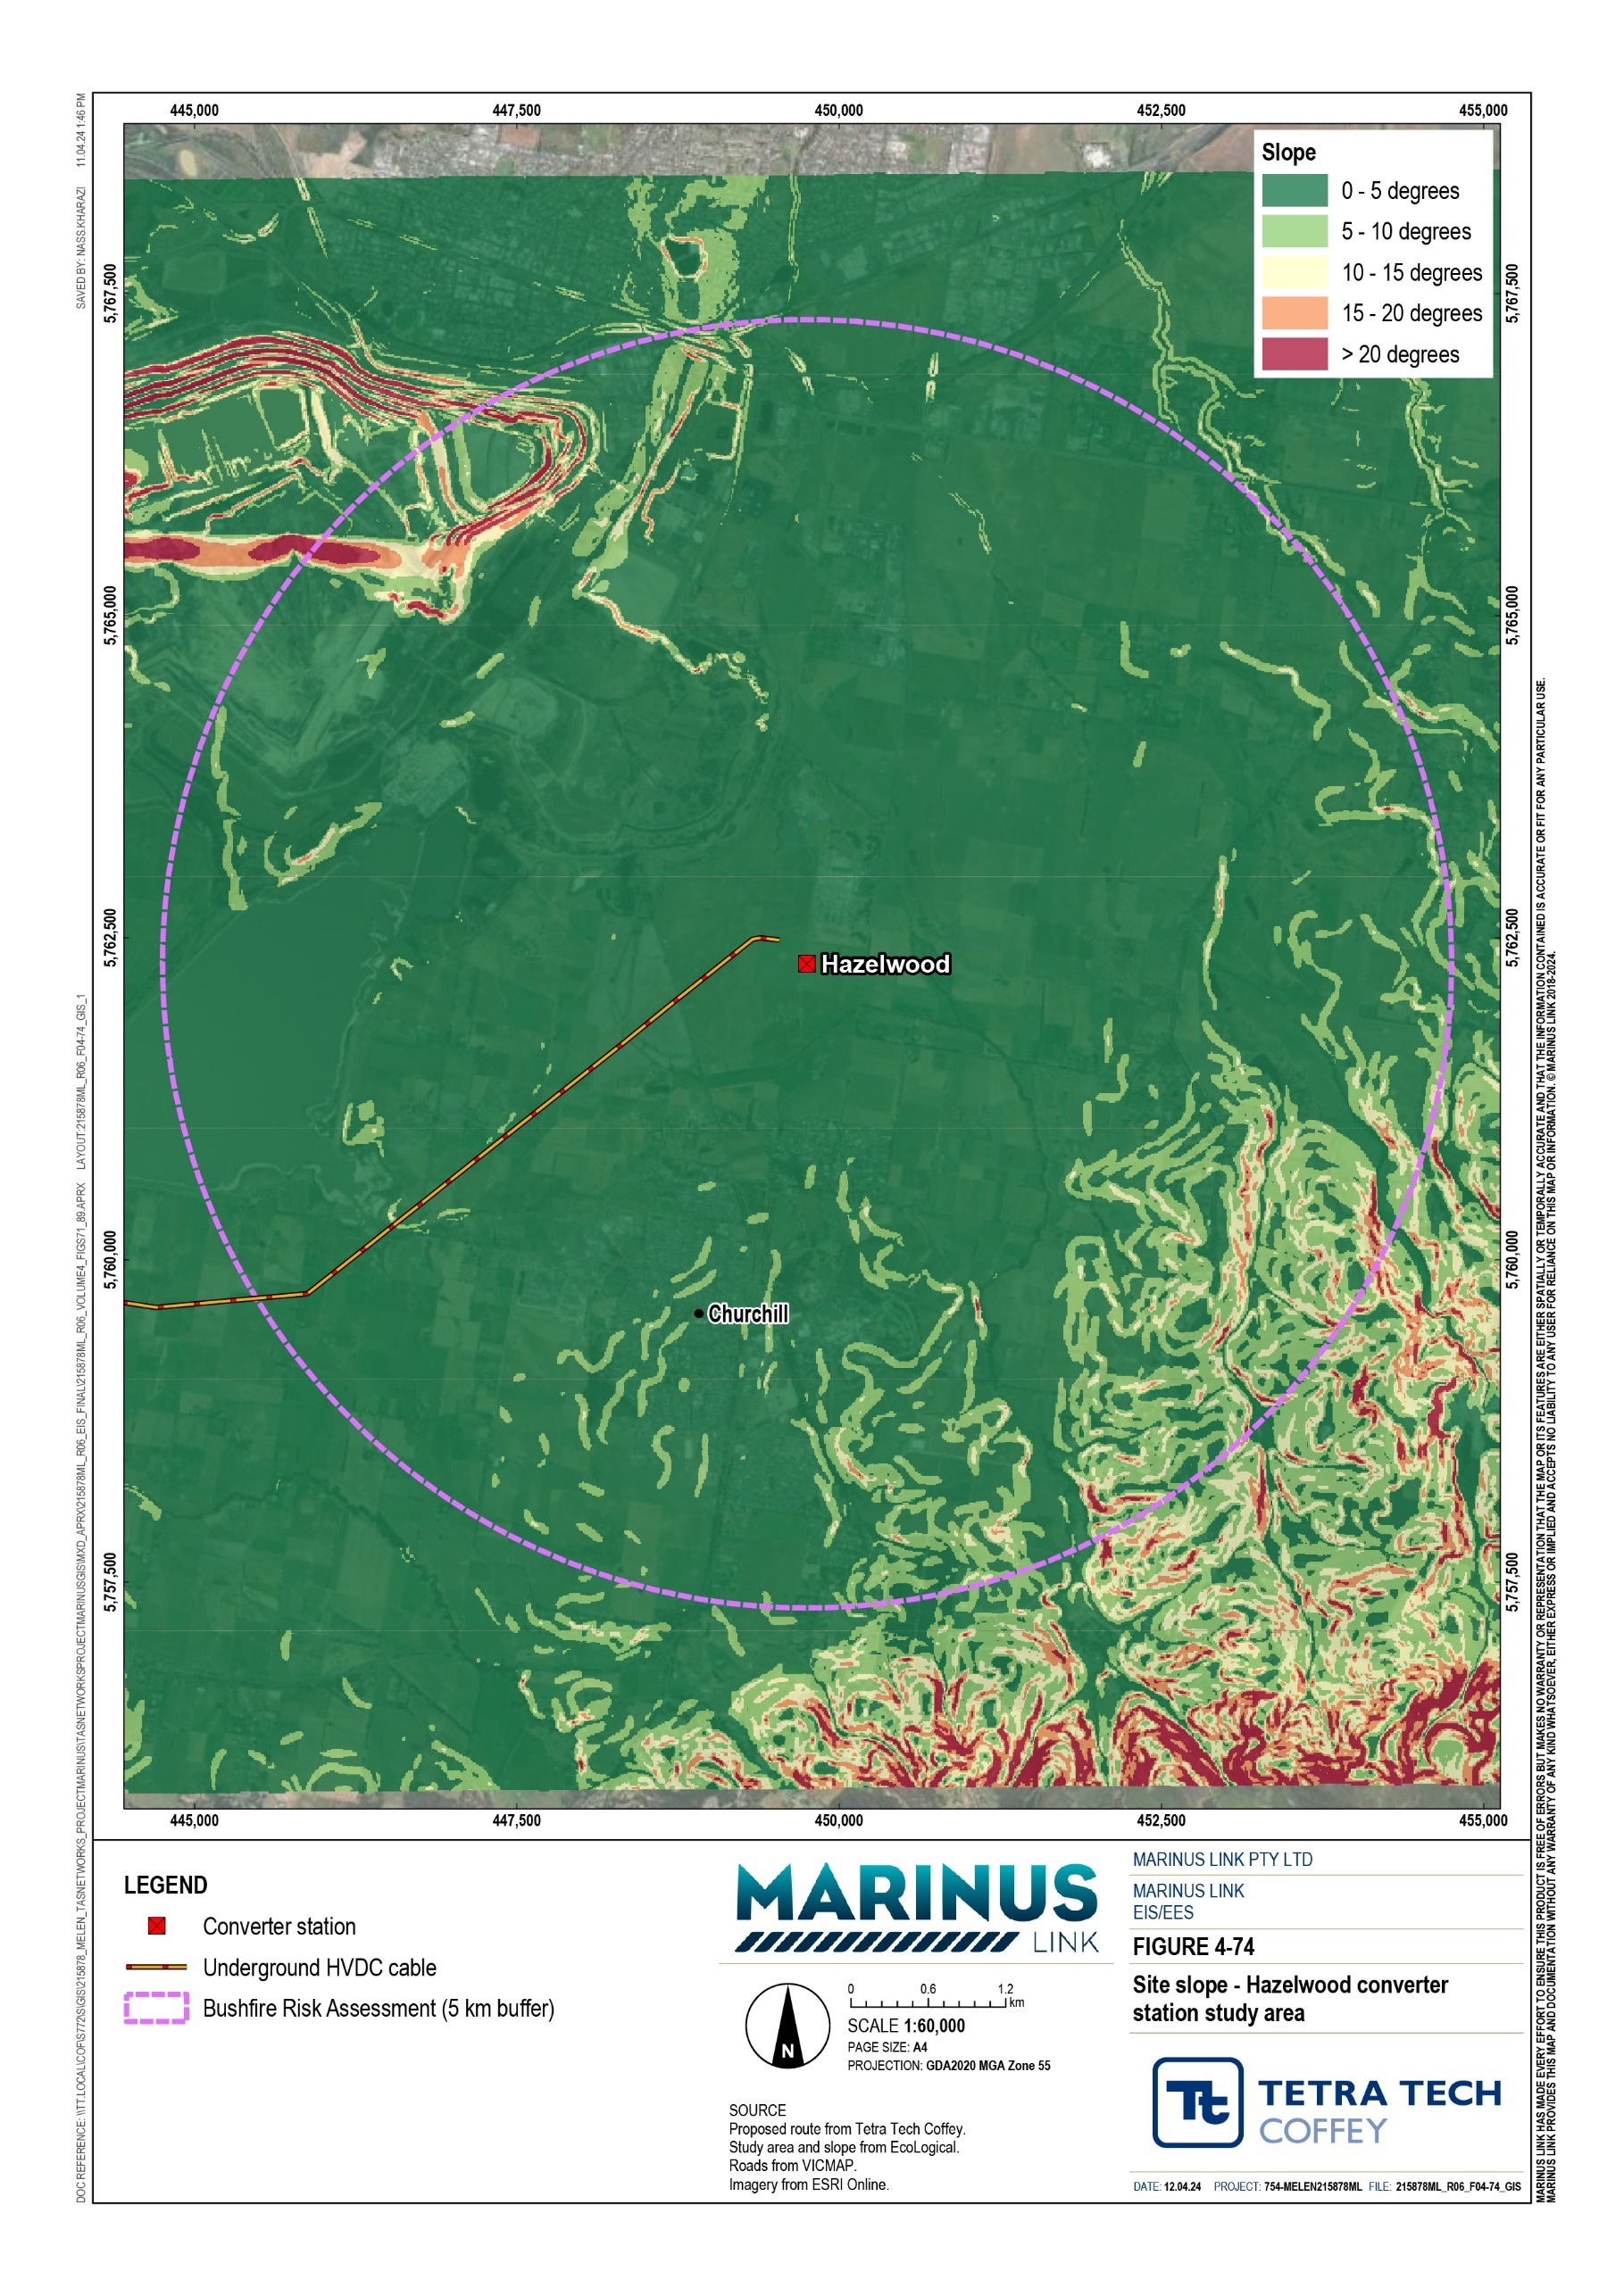

Land use and fuel hazard
Fuel hazard refers to the type of potentially combustible vegetation or materials that could contribute to the spread and intensity of a bushfire, influencing the fire's behaviour and impact. The land use of an area will therefore influence the fuel hazard present.
The areas within and surrounding the Waratah Bay and Hazelwood project sites are predominantly used for agricultural practices, and the fuel hazard is grassland. Cropping and grazing activities keep the grasslands in a state in which the amount and density of potential fuel for a fire is minimised, also referred to as a fuel reduced state.
The northern section of the project alignment falls within areas of pine plantations, with a fuel hazard of forest. While forest fuels present a higher fuel load and therefore a higher bushfire hazard type than grassland, the plantations are subject to regimes of thinning and harvesting operations which creates a modified fuel level over time.
Figure 4-75 and Figure 4-76 show the land use and vegetation at the Waratah Bay project site. Figure 4-77 and Figure 4-78 show the land use and vegetation at the Hazelwood project site.

Fire ignition sources
Fire ignition refers to the beginning of a fire when an ignition source (i.e., material or equipment) such as a spark, flame, or heat, comes into contact with fuel and begins the combustion process. The assessment has categorised ignition risks into onsite (within project sites) and offsite (outside project sites) ignition sources.
The primary sources of ignition offsite include agricultural activities (harvesting, farm equipment), controlled burning operations and other anthropogenic sources (e.g., arson, motor vehicle, power tools, illegal burning).
The primary source of ignition onsite includes construction and maintenance activities at each of the sites and operational use of the onsite infrastructure. Decommissioning activities could also present potential sources of ignition from each of the sites. The potential fire ignition sources include:
Electrical or mechanical faults;

The use of or inappropriate storage of flammable fuels;

Utilisation of machinery and equipment;

Land management activities (e.g., fire break maintenance, vegetation management);

Construction or maintenance activities (e.g., welding, grinding and other ignition generating works); and

Other anthropogenic sources (e.g., from discarded cigarette butts, cooking fires, fire starts from vehicles or accidents, arson etc.).

Volume 4 – Victorian terrestrial environment Page 12-11

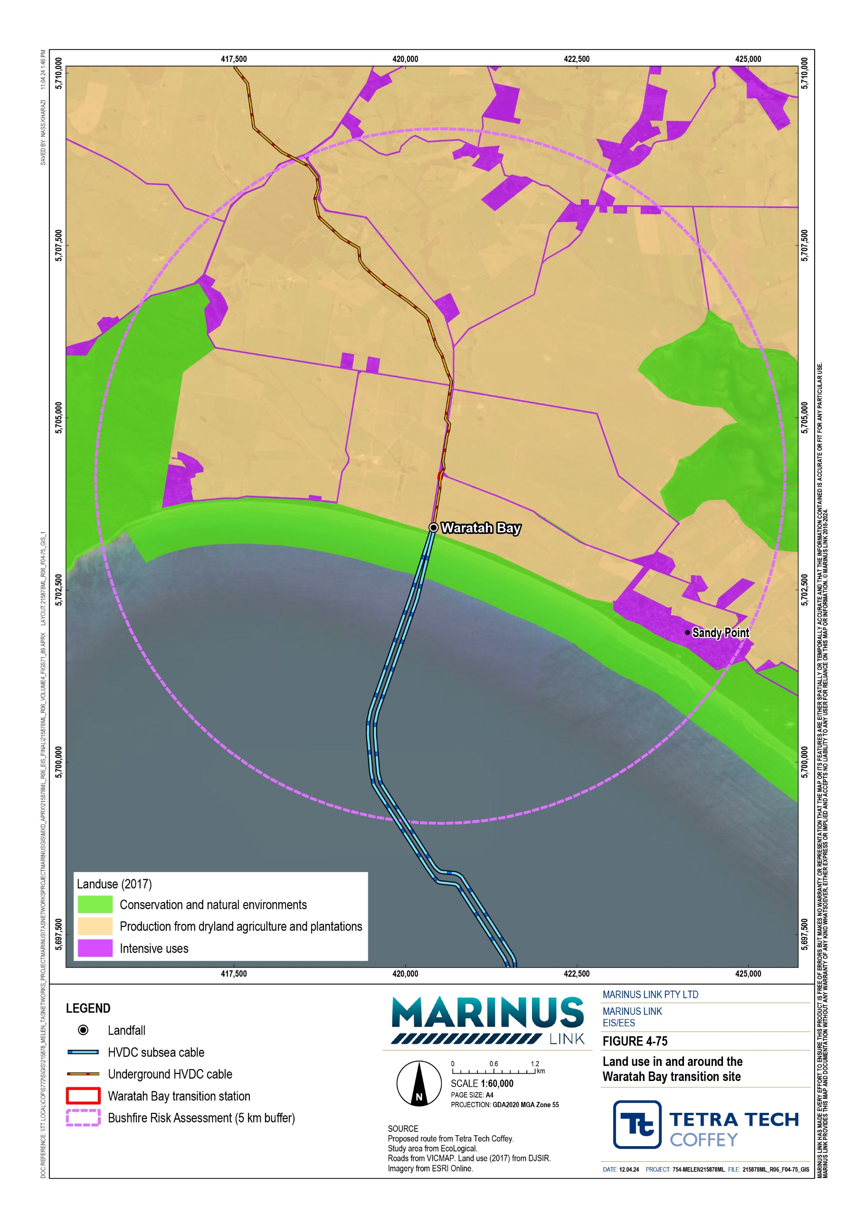

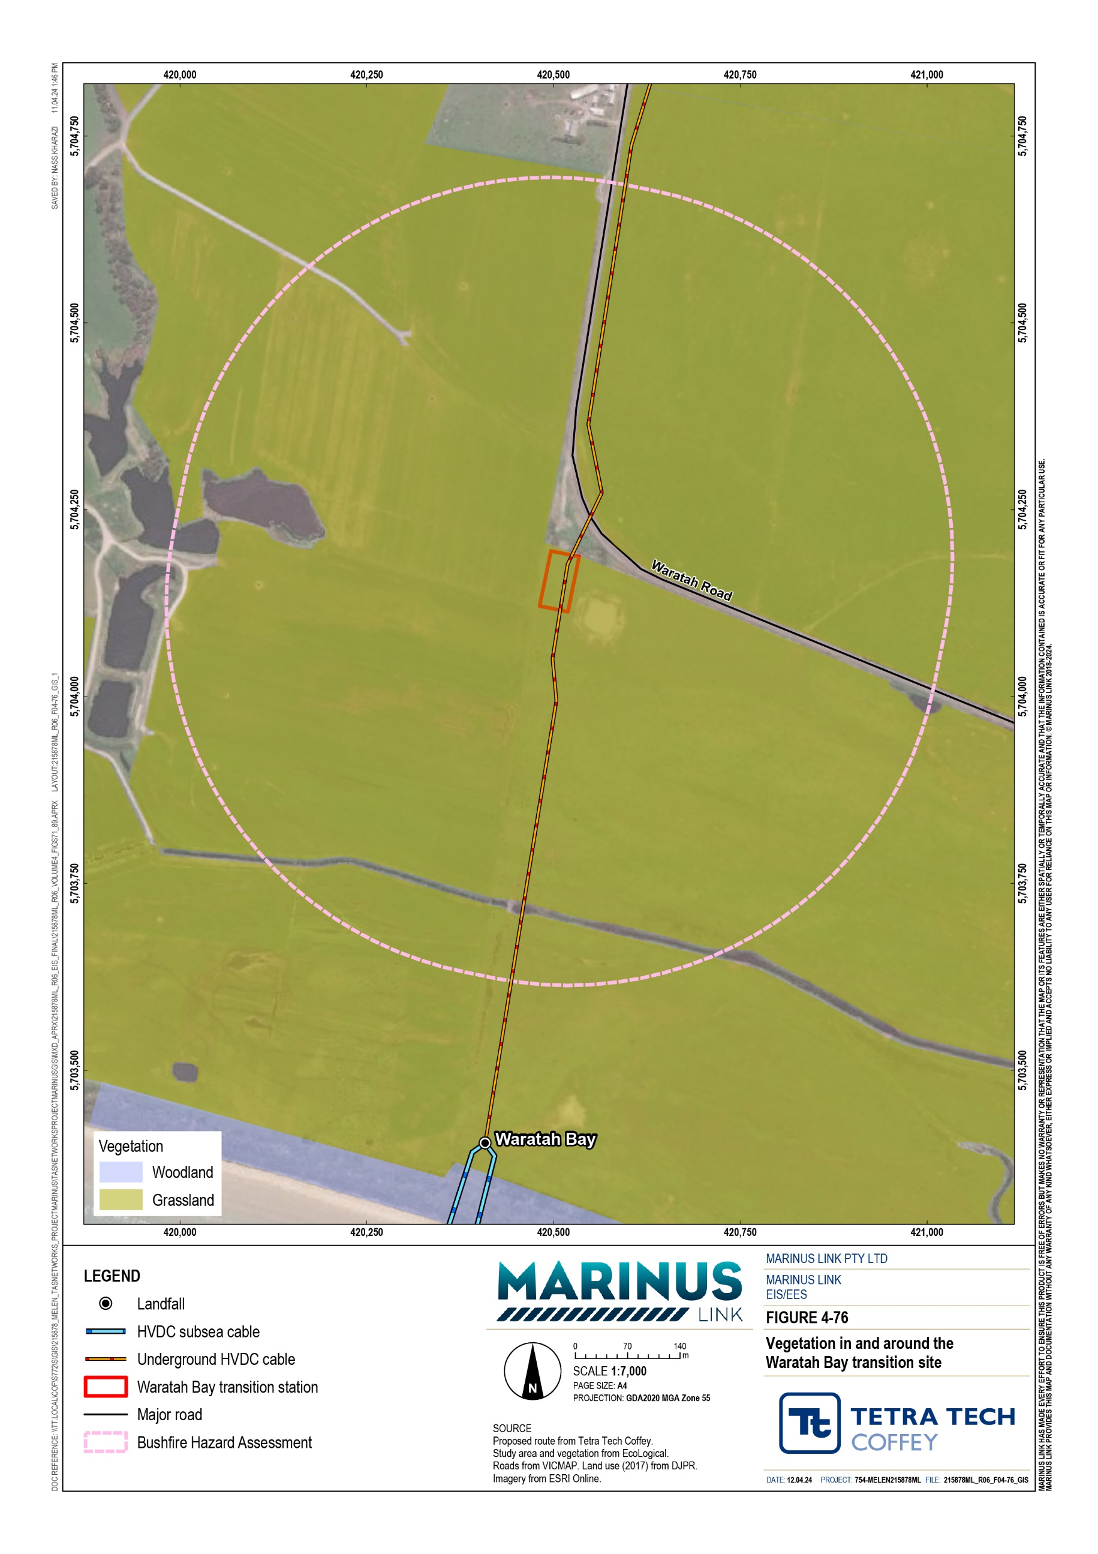

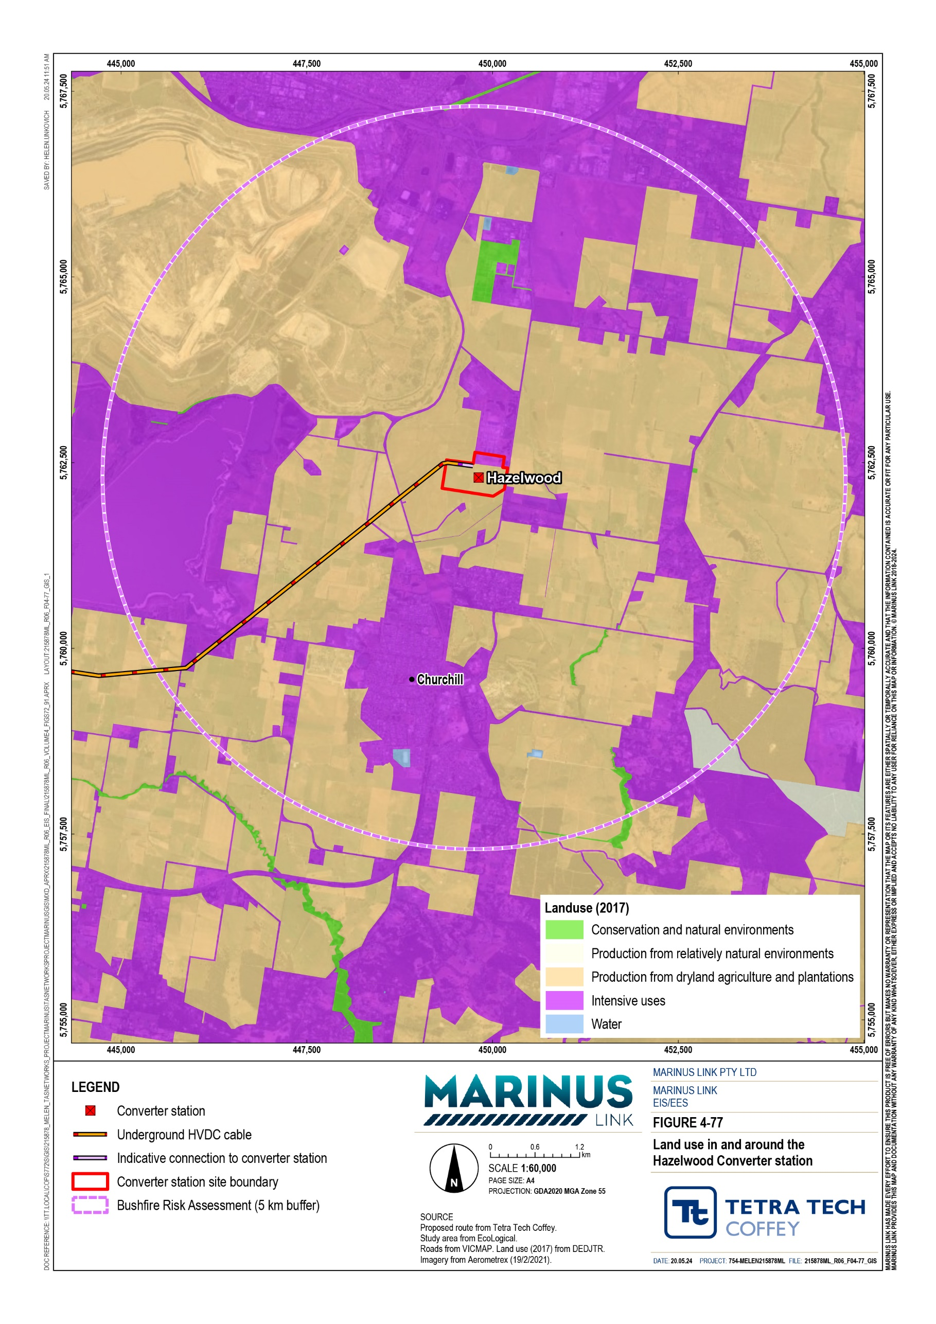
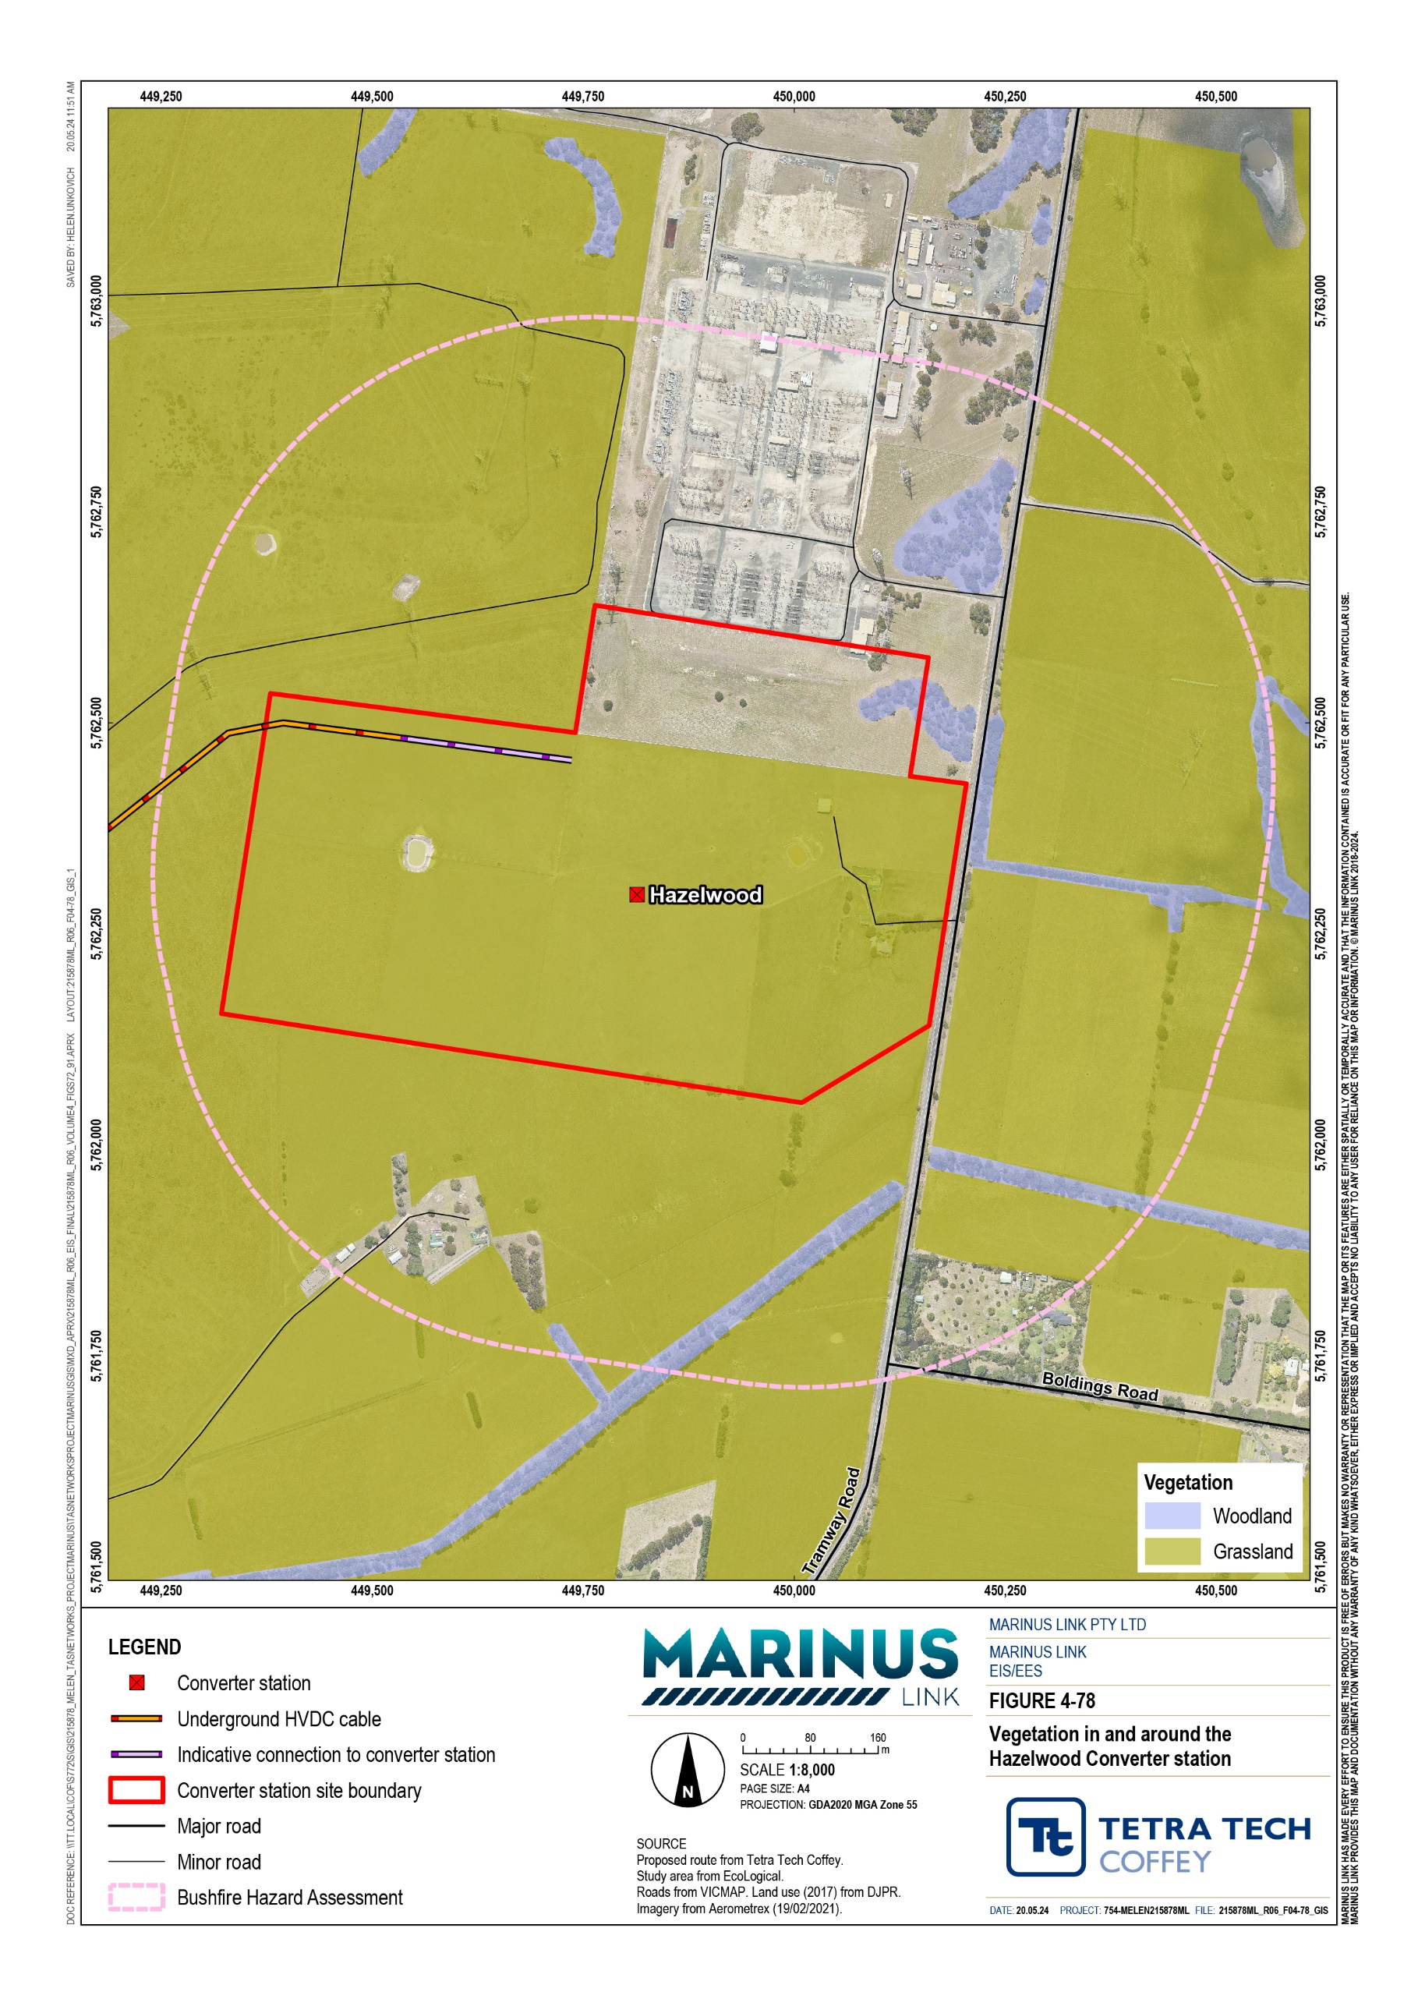

Values at risk
The key values requiring protection from bushfire are:

Life (human populations); and

Property assets (human settlement, infrastructure, pine plantation, and agricultural lands).

These are discussed below.

Life
Life refers to human populations living and working in and around the study area. This includes temporary populations (e.g., construction workforce for the project) in the area. The study area is generally characterised by a relatively low and dispersed population due to the primary land use being agriculture and forestry.
The Waratah Bay and Hazelwood project sites are located in areas serviced by the following CFA branches:

Walkerville CFA station

Sandy Point CFA station

Churchill CFA station

Hazelwood North station

Morwell station.

The wider project area, including the underground cabling route are serviced by the following CFA branches:

Thorpdale CFA station

Yarragon CFA station

Morwell CFA station.

The risks to fire-fighter safety associated with a fire burning at the Hazelwood converter station and Waratah Bay transition station sites include:
Electrocution from physical contact with energised electrical infrastructure or from conduction through air, water or materials in contact with the infrastructure; and
Inhalation of potentially toxic fumes and smoke from any plastic or rubber components such as cables, or other building or infrastructure components on site involved in a fire.

Property assets
Property assets refers to human settlement, infrastructure, pine plantations, and agricultural lands in proximity to the study areas.
For the purpose of this assessment, the following assets could be at risk from a bushfire that may start and spread either from within each of the three project sites or from an external fire threat:
Project property and infrastructure includes:

      - Waratah Bay transition station site, including the transition station, security fencing and gates, laydown or hardstand areas.
      - Hazelwood converter station site, including the converter station and switching station, security fencing, laydown or hardstand areas, support buildings and rooms, and transmission lines.
Non-project property assets in the study area include:

      - Modified grazing pastures

      - Stock (sheep and cattle)

      - Boundary fences

      - Scattered rural residences, sheds and other farming infrastructure

      - Jeeralong A and B Power Station

      - Hazelwood Terminal Station

      - Townships of Driffield, Hazelwood, and Yinnar

      - Townships of Waratah Bay, Sandy Point and Walkerville

      - Larger settlements of Churchill and Hazelwood (North and South)

      - Waratah Beach Camp

      - HVP Plantations

      - Jeeralang Traralgon Plantations

      - Martin Walker Reserve

      - Morwell Open Cut Mine.

Impact assessment
A risk assessment approach was adopted to assess the potential impacts the project will have on bushfire management within and in proximity to the study area. The assessment also assessed the risks posed to the project from bushfire with consideration of landscape factors (i.e., fuel type, topography, fire history, land use, and opportunities for fire detection and suppression).
This assessment has considered several worst-case bushfire scenarios for the purpose of understanding the level of bushfire risk exposure for the project.
For the Hazelwood converter station and Waratah Bay transition station sites, the following scenarios have been considered:
A large landscape grassfire starts outside of the project sites to the northwest with winds from the northwest, within un-grazed paddocks surrounding the project sites. The fire progresses further southeast and impacts the project infrastructure.
An electrical fault in electrical infrastructure (existing infrastructure for construction impacts, and project infrastructure for operational impacts) ignites unmanaged grass (greater than 100 mm in height) within the project sites on a day with a westerly wind, and at a time when grassland fuels within and adjacent to the project sites are fully cured or dried. The fire spreads to the east of each site, impacting on established rural residential properties, crops, stock, and fences.
To account for the large and varying nature of the underground project alignment in the study area, two worst-case bushfire scenarios have been considered for a nominal location of high bushfire hazard in the northern portion of the study area. Fuel loads along the majority of the project alignment are much lower than those within the Driffield area which supports extensive pine plantations and remnant native vegetation; therefore, this assessment represents a conservative worst-case for that project site.
The risk scenarios considered for the underground cable are:
A large landscape forest fire starts outside of the study area to the northwest, with winds from the northwest, within pine plantations with low fuel moisture content and no previous plantation thinning. The fire progresses further south-east, and the head fire impacts on the study area.
An electrical fault ignites unmanaged plantation forest fuels directly adjoining the study area with a westly wind direction and at a time when pine plantation forest fuels within the development site having low moisture contents. The fire spreads to the east impacting on established pine plantations, rural residential dwellings, crops, stock and fences.
The study area for the underground cable is considered temporary and mobile, as the construction areas and workforce move along the alignment. Further detail on the project staging for construction and operation is provided in Volume 1, Chapter 6 – Project description.
Permanent cable infrastructure will be underground during project operation. Therefore, the risk of fire ignition from this temporary study area is limited to the construction phase of the project, when works with ignition potential (e.g., hot works) are being completed.

Construction impacts
The following sections discuss the outcomes of the impact assessment for works during the construction phase of the project based on the scenarios described in the previous section.
During construction activities, the likelihood of the fire scenarios described above occurring is low. This is because of the low incidence of bushfire history, the generally modified or reduced grassland fuels from agricultural practices in surrounding land uses, and subsequent interruptions in fuel hazard continuity.
Section 12.5.6 describes construction activities, which are temporary in nature, that act as possible ignition sources.
The risk of impact to life has been assessed as insignificant to minor, given the relatively low and dispersed human populations across agricultural landholdings, which are largely managed in a low hazard grassland state. While the consequence of impacts to life from a bushfire can be catastrophic, the likelihood of a fire spreading across this landscape and having an impact on life is reduced.
Table 12-2 shows the assessed bushfire impact to life for the Waratah Bay and Hazelwood sites.

Potential impact from bushfire (vulnerability criteria) | Initial risk rating
Populated area where the combination of threat and vulnerability expose a community to a significant likelihood of fatalities and major injuries. | Minor
Less likely to be fatalities or major injuries due to the presence of attributes which afford some protection. | Insignificant
Loss of life or major injury highly unlikely. Medical/hospital treatment may be required. | Minor
Minor injuries only - first aid treatment. No major injuries or fatalities likely. | Minor
No injuries or fatalities likely. | Insignificant

The impact to property assets (including agricultural land) has been assessed as insignificant to minor because of the temporary nature of construction works, and the relatively low and dispersed human population and built assets in the area. Fuel hazard loads within agricultural landholdings in the area are also largely maintained to a low level through the land use. Risks of impact to project assets are assessed as minor to insignificant because the background bushfire hazard context, landscape profile and project siting all reduce the potential risk of a bushfire occurring.
Table 12-3 shows the assessed impacts to project and non-project property assets for the Waratah Bay and Hazelwood sites.

Potential impact from bushfire (vulnerability criteria) | Initial risk rating
Extensive and widespread loss of property. Major impact across a large part of the community and region. Long term external assistance required to recover. | Minor
Localised damage to property. Short-term external assistance required to recover. | Minor
Short-term damage to individual assets. No external assistance required to recover. | Minor
Inconsequential or no damage to property. Little or no disruptions to the community. | Insignificant
The Driffield area has the highest occurrence of bushfires historically across the project area. The likelihood of the fire scenarios described above occurring during construction would be higher for construction of the cable through the Driffield area given the history of bushfires and the forestry plantation fuels loads. Across the rest of the alignment, the potential risk of bushfires would be lower.
The impact to life has been assessed as insignificant to minor because of the relatively low and dispersed human populations located in proximity to the plantations or forested areas. Occupied landholdings are generally used for agricultural purposes and are maintained to a generally low fuel level. The established road network in the area also offers increased opportunities to contain a bushfire moving through the landscape. As such the likelihood of a bushfire spreading and the subsequent consequence of impacts to life is reduced.
Table 12-4 shows the assessed bushfire impact to life for the underground cable study area.

Potential impact from bushfire (vulnerability criteria) | Initial risk rating
Populated area where the combination of threat and vulnerability expose a community to a significant likelihood of fatalities and major injuries. | Minor
Less likely to be fatalities or major injuries due to the presence of attributes which afford some protection. | Insignificant
Loss of life or major injury highly unlikely. Medical or hospital treatment may be required. | Minor
Minor injuries only - first aid treatment. No major injuries or fatalities likely. | Minor
No injuries or fatalities likely. | Insignificant

The impact to property assets (including pine plantations and agricultural land) has been assessed as insignificant to minor due to the temporary nature of construction works, and the relatively low and dispersed human population and built assets in the area. Fuel hazard loads within agricultural landholdings in the area are also largely maintained to a low level through the land use. The road network would also assist to contain fire outbreaks and reduce impacts.

Table 12-5 shows the assessed impacts to project and non-project property assets for the underground cable study area.

Potential impact from bushfire (vulnerability criteria) | Initial risk rating
Extensive and widespread loss of property. Major impact across a large part of the community and region. Long term external assistance required to recover. | Minor
Localised damage to property. Short-term external assistance required to recover. | Minor
Short-term damage to individual assets. No external assistance required to recover. | Minor
Inconsequential or no damage to property. Little or no disruptions to the community. | Insignificant

Operation impacts
Operation impacts from the project are limited to the areas of above-ground infrastructure at Waratah Bay and Hazelwood, as the undergrounding of the project alignment provides a level of bushfire protection both as a source and an asset at risk.
The impact to life for the Waratah Bay and Hazelwood project sites during operation has been assessed as insignificant to minor as there is a relatively low and dispersed human population, particularly across agricultural landholdings which are largely managed in a low hazard grassland state. As such the likelihood of a fire spreading across the landscape and the consequence of significant impact to life is insignificant to minor.
Table 12-6 shows the assessed impacts to life at the Waratah Bay and Hazelwood project sites.

Potential impact from bushfire (vulnerability criteria) | Initial risk rating
Populated area where the combination of threat and vulnerability expose a community to a significant likelihood of fatalities and major injuries. | Minor
Less likely to be fatalities or major injuries due to the presence of attributes which afford some protection. | Insignificant
Loss of life or major injury highly unlikely. Medical or hospital treatment may be required. | Insignificant
Minor injuries only - first aid treatment. No major injuries or fatalities likely. | Insignificant
No injuries or fatalities likely. | Insignificant

The risk of impact to property assets, including agricultural lands, at the Waratah Bay and Hazelwood sites has been assessed as insignificant to minor. This assessment is based on the large separation of built assets (such as dwellings, major sheds, and other infrastructure) and the location of these within agricultural landholdings which are generally maintained to a low fuel hazard level.
Table 12-7 shows the assessed impacts to property assets for the Waratah Bay and Hazelwood project sites.

Potential impact from bushfire (vulnerability criteria) | Initial risk rating
Extensive and widespread loss of property. Major impact across a large part of the community and region. Long term external assistance required to recover. | Minor
Localised damage to property. Short-term external assistance required to recover. | Minor
Short-term damage to individual assets. No external assistance required to recover. | Insignificant
Inconsequential or no damage to property. Little or no disruptions to the community. | Insignificant

Decommissioning impacts
The operational lifespan of the project is a minimum 40 years. At this time the project will be either decommissioned or upgraded to extend its operational lifespan.
In the event that the project is decommissioned, all above-ground infrastructure will be removed, and associated land returned to the previous land use or as agreed with the landholders. All underground infrastructure will be decommissioned in accordance with the requirements of the time. This may include removal of infrastructure or some components remaining underground where it is safe to do so.
Requirements at the time will determine the scope of decommissioning activities and impacts. The key objective of decommissioning is to leave a safe, stable and non-polluting environment, and minimise impacts during removal of infrastructure.
Decommissioning activities required to meet the objective will include, as a minimum, removal of above ground buildings and structures. Remediation of any contamination and rehabilitation of the site will be undertaken to provide a self-supporting landform suitable for the end land use.
Decommissioning of project infrastructure will implement the waste management hierarchy principles being avoid, minimise, reuse, recycle and appropriately dispose. Waste management will accord with applicable legislation at the time.
The nature, extent and magnitude of bushfire impacts will be no greater than those associated with construction. A decommissioning management plan will be prepared to outline how activities will be undertaken and potential bushfire impacts managed.

Environmental performance requirements
EPRs set out the environmental outcomes that must be achieved during the construction and operation phases of the project. In developing these EPRs, industry standards and guidelines, good practice, and the latest approaches to managing impacts were considered.
Proposed EPRs to set the required environmental outcomes for the project in relation to bushfire are summarised in Table 12-8.

EPR ID | EPR
BF01 | Develop and implement measures to avoid and manage ignition of fires during construction  Prior to commencement of project works, develop a bushfire protocol as part of the CEMP to: Avoid and minimise high risk activities on Total Fire Ban Days.  Maintain fuels to low levels within the sites prior to and during the bushfire danger periods.  Maintain vehicles, plant and machinery in accordance with specifications to prevent fire ignition from their operation.  Mitigate ignition risks from electrical faults.  Establish and maintain vehicle access to the site and surrounds for fire suppression activities by fire fighting authorities.
BF02 | Provide onsite firefighting water capacity in high fire risk areas  Prior to commencement of project works, develop a protocol for the provision of dedicated onsite water supply tanks or alternative water sources for firefighting in high fire risk areas. The protocol must include:  Provision of mobile water carts along the cable route to supplement emergency water supply for onsite personnel and emergency services.  For the fixed sites, use tank(s) that are non-combustible and incorporate appropriate fire fighting fittings, for emergency services to access the water supply.  Maintaining clear access to tanks or water sources for fire fighting vehicles. Providing sufficient water capacity to undertake adequate fire suppression. Provision of trained personnel and equipment.  High fire risk areas are areas in the natural landscape that are located in both a Bushfire Prone Area and/or the Bushfire Management Overlay.  This protocol should be referenced in the Emergency Response Plan.
BF03 | Prepare and implement a bushfire emergency management plan (BEMP)  As a subplan to the project’s Emergency Response Plan, prepare and implement a BEMP that includes, but is not limited to:  Description of the site facility  Provide details of all emergency procedures Emergency preparedness arrangements  Details of all shelter in place and offsite evacuation procedures

EPR ID | EPR
BF04 | Develop and implement measures to avoid and manage ignition risks during operation  Develop and implement a protocol for:  Avoiding high risk activities on Total Fire Ban Days. Maintenance of converter station infrastructure.  Maintenance of fire fighting systems and water tank capacity at the converter stations.  Maintaining vehicle access to the site and surrounds for fire suppression activities by fire fighting authorities.  Operation of electrical infrastructure to minimise ignition risk and maintain monitoring and management systems (emergencies, fault management, system monitoring, fire detection and suppression).  Provision of trained personnel and equipment.  This protocol should be referenced in the Emergency Response Plan.

In addition to the bushfire EPRs above, a range of other EPRs will reduce the potential for bushfire impacts and associated risks caused by the project, including:
Climate Change (Volume 1, Chapter 9 – Sustainability, climate change and greenhouse gas emissions)

Surface water (Volume 4, Chapter 5 – Surface water)

Agriculture and forestry (Volume 4, Chapter 6 – Agriculture and forestry)

Air quality (Volume 4, Chapter 9 – Air quality)

Terrestrial ecology (Volume 4, Chapter 11 – Terrestrial ecology)

Social (Volume 4, Chapter 16 – Social).

The complete list of EPRs for the project is provided in Volume 5, Chapter 2 – Environmental Management Framework.

Residual impacts
Residual impacts are those remaining after the application of measures to comply with EPRs. The residual bushfire impacts to life and property assets during construction and operation have been assessed as insignificant.
Table 12-9 shows a summary of the initial and residual bushfire impacts assessed for life and property assets. The potential risk, initial impact, and residual impact ratings have been assigned based on the highest derived rating identified in Technical Appendix M: Bushfire.

Construction
Initial impact ratings for risks to life and property assets during construction were assessed as insignificant to minor. The application of the EPRs identified in Section 12.8 will lower those initial impacts rated as minor to insignificant.

Measures will be developed and documented in the construction environmental management plan to be implemented in construction to avoid the ignition of fires (EPR BF01), manage onsite water supplies for firefighting purposes in high fire risk areas (EPR BF02) and include a BEMP (EPR BF03).

Operation
Initial impact ratings for risks to life and property assets during operations were assessed as insignificant to minor. The application of the EPRs identified in Section 12.8 will lower those initial impacts rated as minor to insignificant.
The operation environmental management plan will include measures to avoid fire ignition (BF03) and manage onsite water supply for firefighting purposes (EPR BF02). These measures should be referenced in the project’s Emergency Response Plan.

Decommissioning
Decommissioning activities to remove above-ground infrastructure, and underground cable if required at the time, will be similar to those undertaken in construction. Measures to avoid and minimise impacts from bushfire developed as part of the decommissioning management plan are therefore expected to be similar to those adopted during construction and will be specific to the bushfire risk and fuel hazard conditions at the time of decommissioning.

Affected value |  | Potential risks | Initial risk rating | EPRs | Residual risk rating
Construction
Waratah Bay and Hazelwood project sites | Life | Minor | Minor | BF01, BF02, BF03 | Insignificant
 | Property assets | Minor | Minor | BF01, BF02, BF03 | Insignificant

Underground project alignment | Life | Minor | Minor | BF01, BF02, BF03 | Insignificant
 | Property assets | Minor | Minor | BF01, BF02, BF03 | Insignificant

Operation
Waratah Bay and Hazelwood project sites | Life | Minor | Minor | BF02, BF04 | Insignificant
 | Property assets | Minor | Minor | BF02, BF04 | Insignificant

Underground project alignment | Life | Minor | Minor | BF02, BF04 | Insignificant
 | Property assets | Minor | Minor | BF02, BF04 | Insignificant

Cumulative impacts
Cumulative impacts associated with bushfire were considered as part of this assessment in line with the method outlined in Volume 1, Chapter 5 – EIS/EES Assessment framework.
The initial risk of bushfire impacts for the project (before the implementation of measures to comply with EPRs) ranges from insignificant to minor risk to life and property during the construction, operation and decommissioning phases. With the introduction of measures to comply with EPRs, the residual risk is reduced overall to insignificant.
In addition, local CFA brigades will provide response to fire outbreaks across the region, including from stations in the localities of Morwell, Moe South, Thorpdale, Boolarra, and Mirboo North.
There is therefore an extremely low risk of simultaneous fire propagation within the landscape, and as such the cumulative impacts are considered to be insignificant and warrant no further assessment.

Conclusion
The project intersects mapped bushfire prone areas and sites of historical fires. The study assessed the potential impacts of bushfire on the project and surrounding values, including life and property assets.
Overall, the construction and operational residual impacts of the project on life and property assets are rated as insignificant due to the background bushfire hazard context and landscape profile of the study area.
Bushfire impacts will be further minimised through the implementation of measures to comply with EPRs.

The focus of bushfire EPRs is to implement measures to avoid ignition of fires during construction and operation, verify onsite firefighting water capacity at high-risk areas and develop an emergency response procedure with the aim of preventing injuries or fatalities in the event of a bushfire.
Following the implementation of measures to comply with the EPRs, it is expected that the project will be able to meet the EES evaluation objective of ‘Avoid and, where avoidance is not possible, minimise adverse effects on community amenity, health and safety, with regard to noise, vibration, air quality including dust, the transport network, greenhouse gas emissions, fire risk and electromagnetic fields’.

