Aboriginal cultural heritage
This chapter provides an assessment of the potential Aboriginal cultural heritage impacts associated with the construction, operation and decommissioning of the project. This chapter is based on the impact assessment provided in Technical Appendix J: Aboriginal and historical cultural heritage.
Project activities will disturb the surface and subsurface within the project area. Impacts to Aboriginal cultural heritage may occur when these disturbances intersect with examples or representations of tangible or intangible cultural heritage. Tangible cultural heritage includes physical objects, sites (places) and structures, while intangible cultural heritage includes knowledge, beliefs, cultural practices and language. This chapter discusses impacts to tangible cultural heritage only, as addressed in Technical Appendix J: Aboriginal and historical cultural heritage. Intangible cultural heritage is being considered through separate CVAs that will inform the CHMPs for the project. As these programs are ongoing, this chapter does not incorporate the outcomes of the CVAs.
The EIS guidelines set out the following requirements related to Aboriginal cultural heritage: Section 4.2: Description of the baseline.
Section 5.5: Terrestrial impacts.

Section 10.1: Indigenous engagement.

The EIS requirements regarding Aboriginal engagement are further addressed in Volume 1, Chapter 8 – Community and stakeholder engagement.
Refer to Attachment 1: Guidelines for the Content of a Draft Environmental Impact Statement for the EIS guidelines.
The EES scoping requirements set out the following evaluation objective relevant to Aboriginal cultural heritage:
Historical heritage values, and tangible and intangible Aboriginal cultural heritage values – Protect, avoid and, where avoidance is not possible, minimise adverse effects on historic heritage values, and tangible and intangible Aboriginal cultural heritage, including Traditional Owners.
Refer to Attachment 2: Scoping Requirements Marinus Link Environment Effects Statement for the EES scoping requirements.
The Aboriginal cultural heritage impact assessment considers the potential impacts of the project to Aboriginal cultural heritage. It also recommends EPRs to mitigate impacts.
Other aspects covered in the above EES evaluation objective not related to Aboriginal cultural heritage are addressed in the following EIS/EES chapters:
Volume 3, Chapter 4 – Underwater cultural heritage

Volume 4, Chapter 14 – Non-Indigenous cultural heritage.

Method
Informed by the significance and compliance assessment methods described in Volume 1, Chapter 5 – EIS/EES assessment framework, the key steps taken in assessing the impacts to Aboriginal cultural heritage values include:
Defining a study area and a survey area.

Conducting a desktop assessment and baseline data review of online information from the Victorian government to assess the Aboriginal cultural heritage potential of the study area, including:
- Searching relevant databases and online resources for information relating to the study area (including the Victorian Aboriginal Heritage Register (VAHR), VicPlan, Naturekit, GeoVic and LANDATA).
- Assessing the land use, landform, geomorphology, geology and vegetation.

Generating a digital predictive model of potential Aboriginal archaeological sites to assess the likelihood of presence throughout the study area.
Consulting relevant First Peoples groups including the GLaWAC, BLCAC and BLSC as well as regulators including First Peoples-State Relations (FPSR). This engagement is further detailed in Volume 1, Chapter 8 – Community and stakeholder engagement and Technical Appendix J: Aboriginal and historical cultural heritage, and was related to:
- project design and construction

- desktop and field survey information and methods

- results of the fieldwork program

- the CVA program.

Conducting fieldwork programs designed to satisfy the requirements of the Aboriginal Heritage Regulations 2018. Fieldwork included archaeological ground surveys and a subsurface testing program along the construction corridor and full width of the study area at water crossings, areas of cultural heritage sensitivity and key project components, including access tracks and the converter station footprint. Representatives of Registered Aboriginal Parties (RAP) were present for the portions of fieldwork conducted in designated RAP areas for the program to support the CHMP process.
Representatives of First Peoples groups were present for the portions of fieldwork in non-RAP areas.

Conducting a ground penetrating radar survey in the Waratah Bay beach landform as part of the geotechnical survey method. The survey employed electromagnetic waves to identify subsurface Aboriginal cultural heritage features such as middens, earth mounds and burials.
Assessing the impacts to Aboriginal cultural heritage values identified in the desktop assessment and fieldwork, during construction, operation and decommissioning of the project. The impact assessment used the significance and compliance methods described in Volume 1, Chapter 5 – EIS/EES assessment framework.

Developing EPRs in response to the impact assessment to set the required environmental outcomes for the project and mitigate the identified impacts. The assessment of residual impacts presented in this chapter assume implementation of measures to comply with the EPRs. Refer to Volume 5, Chapter 2 – Environmental Management Framework for a full list of EPRs.
The assessment sought to understand the tangible and intangible cultural values relevant to First Peoples in the study area and that could be impacted by the project. Tangible values were identified and assessed through on-country surveys and archaeological investigations with First Peoples. CVAs are being developed in partnership with each First Peoples group to understand the intangible values and connection to country. Complete of a CVA with GLaWAC is consistent with the aspirations and objectives of the Gunaikurnai Whole-of-Country Plan.

Study area
The study area for the Aboriginal cultural heritage assessment comprises the area required to characterise Aboriginal cultural heritage values and provide context for the assessment of impacts. The study area includes a survey area and AoD. These areas are defined as follows:
Study area – An area extending 2.5 km to 5 km either side of the 220 m wide survey area as shown in Figure 4-79 (referred to as the geographic region in Technical Appendix J: Aboriginal and historical cultural heritage).
Survey area – A 220 m wide corridor with some areas slightly wider or narrower based on property boundaries.
AoD – the area that will be disturbed to facilitate construction works that may result in impacts to Aboriginal cultural heritage values (referred to as project footprint in Technical Appendix J: Aboriginal and historical cultural heritage). The AoD consists of a 20 m to 36 m construction corridor for the project alignment and minor laydown areas, 10 m-wide corridors for access tracks and areas up to 1 ha for major laydown areas.

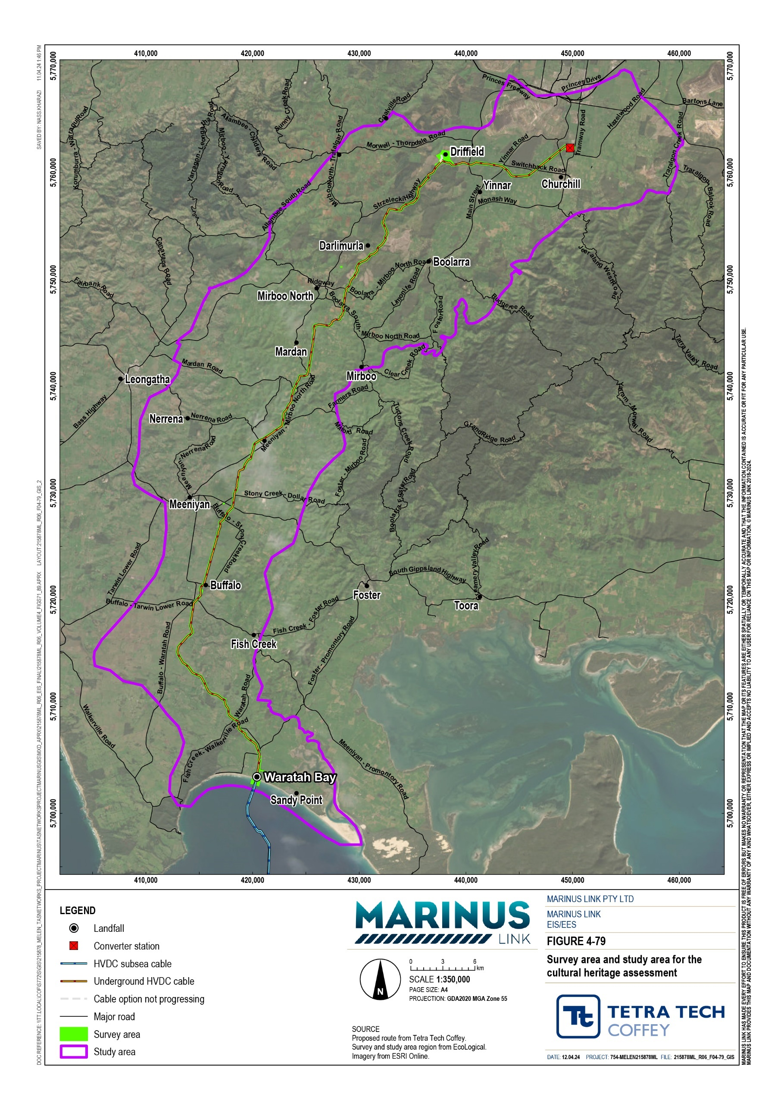

Legislative context
Table 13-1 outlines the key legislation and guidelines relevant to the assessment of Aboriginal cultural heritage.

Title | Relevance to the assessment
Environment Protection and Biodiversity Conservation Act 1999 (EPBC Act) (Cwlth) | The EPBC Act establishes the National Heritage List and the Commonwealth Heritage List which in turn afford cultural heritage values the same protective measures and penalties as for environmentally sensitive sites. DCCEEW’s Interim Engaging with First Nations People and Communities on Assessment and Approvals under the EPBC Act 1999 outlines the applicable statutory obligations and their expectations of proponents with regard to engaging First Peoples and communities under the EPBC Act. The EIS guidelines require assessment of heritage matters under the EPBC Act.
Aboriginal and Torres Strait Islander Heritage Protection Act 1987 (ATSIHP Act)  (Cwlth) | The ATSIHP Act can be invoked by an Aboriginal or Torres Strait Islander person or organisation to protect Aboriginal cultural heritage places or objects. This may result in a stop order if it is deemed that Victorian legislation does not sufficiently protect these cultural heritage values.
National Heritage List and Commonwealth Heritage List (Cwlth) | Any historic or Aboriginal heritage places in the study area that are included in either list will be protected under the EPBC Act. Any action that could have a significant impact on a listed place must seek approval under the EPBC Act.
Aboriginal Heritage Act 2006  (Vic) | Requires a CHMP to be prepared for the project. Two are being prepared, one for the RAP area and one for the non-RAP area.
Aboriginal Heritage Regulations 2018 (Vic) | Sets the circumstances for when a CHMP must be prepared and sets standards for the preparation of a CHMP.
Gunaikurnai Whole of Country Plan | Outlines the Gunaikurnai’s goals for their Country and people, including objectives ‘to  protect and practice our culture’. The plan also includes principles for the management of national parks and reserves on Gunaikurnai Country.

Assumptions and limitations
The Aboriginal cultural heritage assessment has been conducted based on the following assumptions and limitations:
Not all land could be accessed for the archaeological ground surveys and subsurface testing program due to unfavourable conditions or not being granted permission by the landholder. Potential Aboriginal cultural heritage values that may exist in areas where access was not obtained will be further investigated and managed through the CHMP process and implementation measures to comply with the EPRs.
The extent of site access is considered adequate to inform the assessment and consider the nature and significance of Aboriginal cultural heritage values with the study area. Considering the areas of potential sensitivity identified with the predictive model, approximately two-thirds of all properties intersecting the ‘highly likely” and ‘likely’ zoned have been surveyed, and one-third subject to sub surface testing.
The assessment assumed that the inaccessible Aboriginal cultural heritage places are still intact and assessed them on this basis.
The cultural heritage databases used to complete the desktop assessment of the study area are not exhaustive and only contain information on registered or listed Aboriginal cultural heritage places. A location isn’t necessarily free of cultural heritage if it is not present on these databases.
Newly recorded Aboriginal cultural heritage values identified during the fieldwork program are preliminary, as they have not been fully validated with FPSR or the First Peoples groups and are not registered with the VAHR or the Victorian Heritage Inventory. New values will be registered once the nature, location and extent of the cultural heritage places have been determined, as required by the relevant regulations and guidelines.
This assessment only considers tangible Aboriginal cultural heritage values as the CVAs are not yet sufficiently advanced to provide meaningful information regarding intangible Aboriginal cultural heritage values. Completing the CVAs is a requirement of the EPRs. The outcomes of the CVAs will also be considered when addressing matters raised under Section 61 of the Aboriginal Heritage Act 2006 (Vic) in the two CHMPs currently being prepared for the project. Section 61 requires consideration of whether an activity will be conducted in way that avoids harm to Aboriginal cultural heritage, or if avoidance is not possible, in a way that minimises harm. The CHMPs will include management conditions that will reduce the project’s impact on both intangible and tangible Aboriginal cultural heritage values.

Existing conditions
This section describes the Aboriginal cultural heritage existing conditions and values in the study area. The desktop assessment, digital predictive model and field surveys gathered information to characterise the existing conditions and values. The assessment considered the following values or site types:
ancestral remains quarries

art sites scarred trees

artefact scatters and low-density artefact distributions (LDADs)
shell middens

stone features and arrangements

Natural environment
The natural environment can be used to predict the occurrence of Aboriginal cultural heritage values. Historical human behaviour patterns are linked to natural environmental features or conditions and allow connections to be made between natural environmental features or conditions and archaeological site types. This assessment used the following features and conditions to help predict the likelihood of various types of Aboriginal cultural heritage values:
landform vegetation

geology slope

geomorphology elevation

climate distance from fresh water
The assessment used a digital predictive model to predict the likelihood that Aboriginal cultural heritage values are present at any given location in the study area and informed the prioritisation of survey locations in fieldwork programs. The model was informed by natural environmental features and conditions listed in Section 13.2.1. The results of the digital predictive model showing the likelihood of presence of Aboriginal cultural heritage values at any given point in the study area are presented in Figure 4-80.
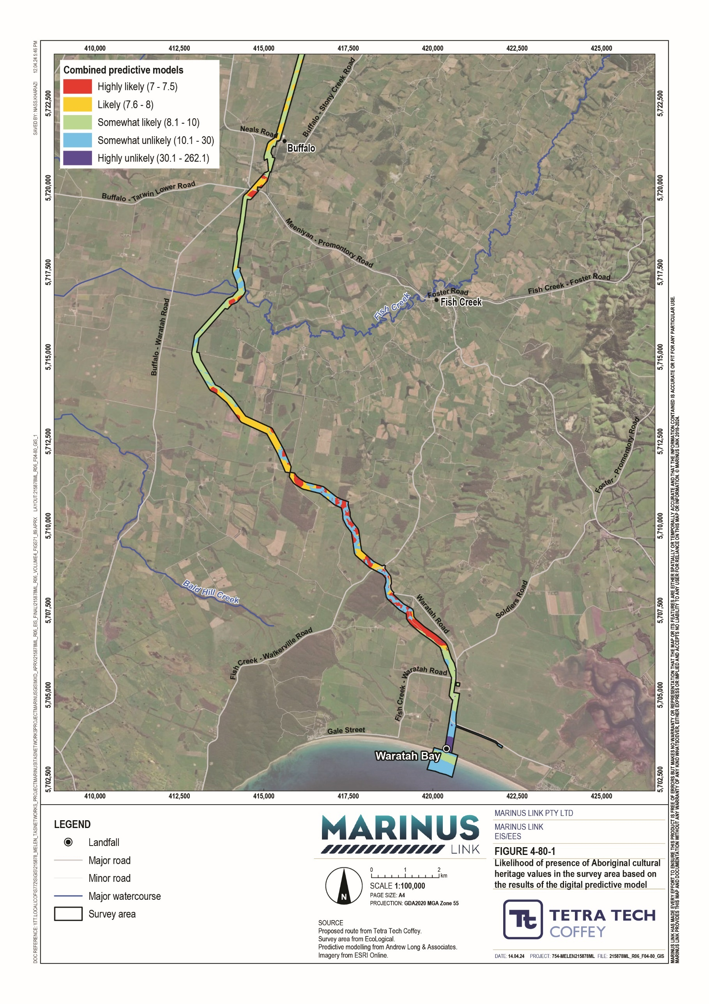

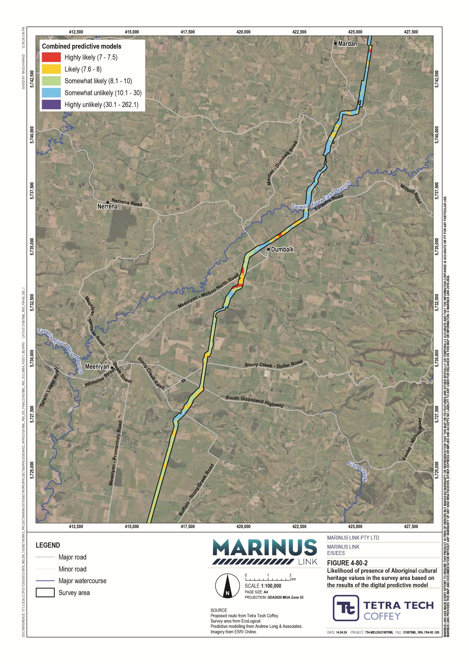
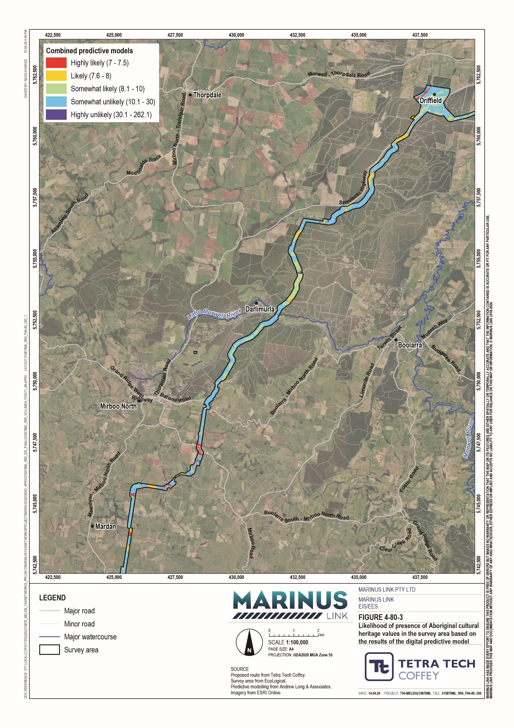
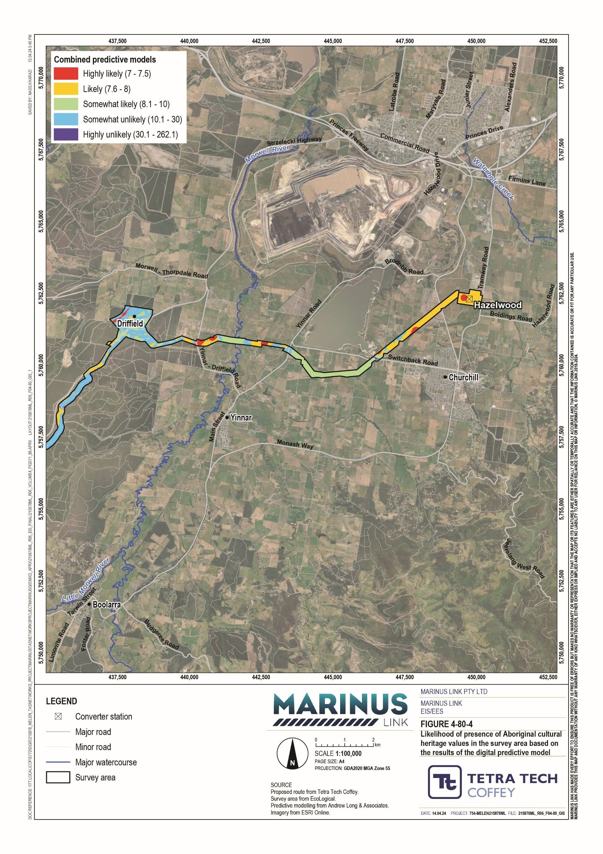

Historical and ethno-historical accounts of Aboriginal occupation in the region
Historical and ethnographical accounts of Aboriginal occupation can inform Aboriginal occupation patterns. While there are limitations to the accuracy of nineteenth century records, they help interpret and further predict the locations of Aboriginal cultural heritage values in the study area.
The ethnographic search indicates that two Aboriginal language groups, the Gunaikurnai and the Boonwurrung, likely resided in the study area at the time of European arrival. Two of the six clans within the Gunaikurnai language group likely occupied a large extent of the study area:
the Brayakaulung clan, who occupied the Latrobe Valley down to the Strzelecki Ranges

the Brataualung clan, who occupied the area south of the Strzelecki Ranges down to Cape Liptrap.

Gunaikurnai population estimates for the initial post contact period in the 1830s range from around 700 to nearly 5,000 people. By 1857, the Brayakaulung, considered the largest of the Gunaikurnai clans at the time, had only 50 people remaining, exhibiting the effects of European settlement in Victoria and the interclan conflict that followed.
Most references to the behaviours of the Gunaikurnai people relate to the language group in general, rather than specifically to the Brayakaulung or Brataualung clans. Consequently, behaviour patterns and subsistence strategies of these historical occupants of the study area are not well understood. Accounts refer to the Gunaikurnai as regularly moving between different resource zones based on the season. During the warmer months, the Gunaikurnai occupied coastal and lake environments where they hunted birds, fished and foraged for seasonal fruit and vegetables. In the cooler months, they moved inland, focusing on hunting mammals, collecting root vegetables and venturing into the mountains to collect Bogong moths.
The Boonwurrung language group occupied the coastal areas southwest of the Gunaikurnai and comprised six clans. Of the six clans, the lands of the Yowengarra, who occupied the Tarwin River area, are most likely to have overlapped with the study area. As with the Gunaikurnai, accounts of Boonwurrung activities are generalised and refer to the seasonality of their subsistence strategies. Accounts of seasonal behaviours are contradictory, implying that different Boonwurrung clans would respond differently to climatic changes due to the difference in resources available in their lands.
Conflicts following European arrival involved both Aboriginal language groups and consisted of intra-group violence, violence between language groups and violence between Aboriginal people and European settlers. Much of this conflict is believed to be incited by the pressures brought about by European occupation of Aboriginal lands, whether from the spread of disease, dispossession of land, or reprisals following murders or massacres.

Registered Aboriginal cultural heritage
The desktop assessment included a search of the VAHR which records locations and descriptions of all registered Aboriginal cultural heritage places and objects in Victoria. At the time of assessment, the register included 96 Aboriginal cultural heritage places in the study area. These are summarised in Table 13-2.
A detailed description of the registered Aboriginal cultural heritage places and more detailed maps of their locations is available in Technical Appendix J: Aboriginal and historical cultural heritage.

Place type | Number of sites
Artefact scatter | 62
LDAD | 13
Shell midden | 11
Artefact scatter; object collection | 1
Artefact scatter; earth feature | 1
Artefact scatter/quarry | 1
Earth feature | 1
Quarry | 2
Scarred tree | 4
Total | 96

Of the 96 VAHR-registered places in the study area, 13 are in the survey area (VAHR 8121-0399 is a multicomponent site). The place name and place type of the 13 places within the survey area are listed in Table 13-3 and are depicted in Figure 4-81.

VAHR no. | Place name | Place type
VAHR 8120-0212 | Heywood 1 | Artefact scatter
VAHR 8120-0213 | Heywood 2 | Artefact scatter
VAHR 8120-0214 | Heywood 3 | Artefact scatter
VAHR 8121-0052 | Smiths Road 1 | Artefact scatter
VAHR 8121-0060 | Mountain Hut Road 1 | Artefact scatter
VAHR 8121-0061 | Mountain Hut Road 2 | Artefact scatter
VAHR 8121-0062-1 | Kings Road Extension 1 | LDAD
VAHR 8121-0063 | Kings Road Track 1 | LDAD
VAHR 8121-0068 | Kings Rd Extension 2 | LDAD
VAHR 8121-0069 | Mountain Hut Rd 3 | LDAD
VAHR 8121-0354 | Strzelecki Highway 1 | LDAD
VAHR 8121-0398-1 | Eel Hole Creek 3 | Artefact scatter
VAHR 8121-0399-1/ VAHR 8121-0399 | Eel Hole Creek 4 | Artefact scatter/ Quarry

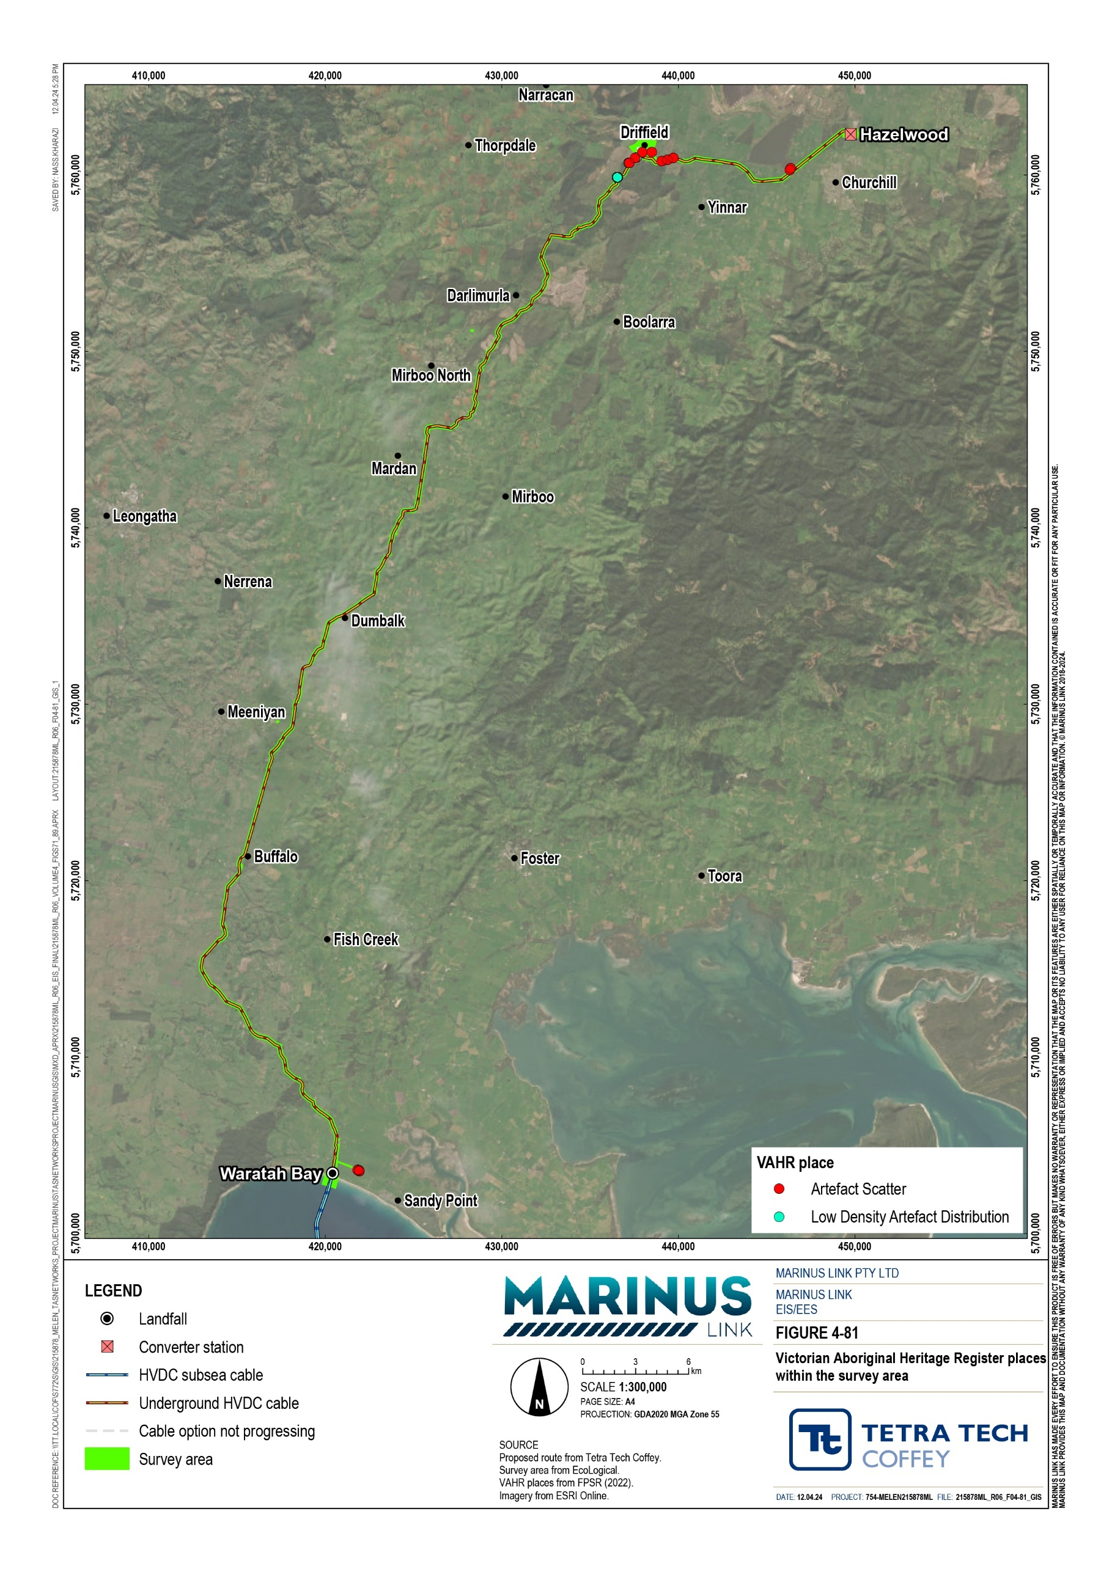

The desktop assessment found 22 previous studies relevant to the study area, including four relevant to the survey area. The studies relevant to the survey area are summarised in Table 13-4.

Year | Reference | Survey type | Summary
1992 | M. Harding, An Archaeological Survey of Waratah Bay | Ground survey | Completed for a proposed underground cable within Waratah Bay in the southern section of the study area.  Eleven sites identified including nine shell middens, two isolated artefacts and a private object collection.  Two distinct landforms identified (coastal lowlands and rocky headlands).
2014 | Orr and Butler, Overtaking Lane, Strzelecki Highway, Smiths Road Junction, CHMP 13061 | CHMP standard and complex assessment ground survey and subsurface testing program | CHMP prepared for VicRoads for a 1.3 km stretch of Strzelecki Highway, south of Morwell.  Desktop assessment identified one previously registered artefact scatter.  Complex assessment identified 25 artefacts across two places consisting of flakes, tools and cores. Both places were slightly elevated above the surrounding landscape.
2017 | J Hill, Installation of NBN Co  Infrastructure at Sandy Point | CHMP standard assessment ground survey | CHMP prepared for NBN Co infrastructure at Sandy Point.  Desktop assessment identified 24 previously recorded Aboriginal cultural heritage features along coastlines and sandy ridge landforms. Three of the artefact scatters are within 200 m of the project study area.  Aboriginal cultural heritage features consisted of shell middens and earth features along coastlines as well as artefact scatters on sandy rises.  Ground survey did not identify any Aboriginal cultural heritage features.
2021 | T Rymer, Delburn Wind Farm, Delburn, CHMP 16429 | CHMP standard and complex assessment ground survey and subsurface testing program | CHMP prepared for Delburn Wind farm.  Desktop assessment identified landforms including hills, rises, ridgelines, creek banks, terraces and elevated land within 200 m of waterways as having highest potential for stone artefacts. Twenty-four artefacts making up an LDAD identified along the ridgeline that abuts Strzelecki Highway approximately  3.2 km southwest of Driffield.  Ground survey identified 96 stone artefacts.  Complex assessment identified a further 69 artefacts.

Aboriginal places predictive model
The desktop assessment incorporated analysis of the natural environment, ethnohistorical accounts, the digital predictive model and the results of previous studies. The desktop assessment informed the following statements regarding Aboriginal cultural heritage sites, the landforms in which they are most likely to be found and whether they are likely to be in the study area:
Ancestral remains are generally rare in Victoria but are associated with almost every landform, tending towards geographic high points and water features. Four examples of ancestral remains have been found in dune swales 15 km to 20 km from the study area. Consequently, there is moderate potential that ancestral remains are present in the coastal dunes of the study area.
Art sites are unlikely to occur as they are associated with caves and shelters which are not common in the study area. No examples of art sites or rock shelters have been identified in the study area.
Artefact scatters and LDADs are very likely to occur, particularly throughout the foothills in the central section of the study area. Numerous examples of artefact scatters and LDADs have been identified throughout the study area. Flakes, tools and cores are examples of artefacts that can make up artefact scatters and LDADs.
Quarries are likely to occur in the study area on slopes and ridges above creeks and rivers, particularly between Waratah Road and Tarwin River where such landforms are most likely.
Scarred trees are somewhat likely to occur in the study area, particularly alongside watercourses with mature vegetation. Only four scarred trees have been identified in the study area.
Shell middens are likely to occur in the sandy beach landforms of the study area. Examples of shell middens have been identified along the Waratah Bay coastline, in landforms similar to sandy beaches.
Stone features or arrangements are somewhat unlikely to occur in the study area. Limited suitable landforms are present in the study area and no stone features or arrangements have been identified in the study area.

Fieldwork program
The assessment included a fieldwork program consisting of ground surveys and complex testing (excavation) which considered the findings of the desktop assessment in its design.
The fieldwork program involved an archaeological ground survey conducted over 15 days between January and September 2022. The archaeological ground survey sought to assess the overall Aboriginal cultural heritage potential of the study area.
The ground survey segmented the study area into eight different investigation areas (IAs), based on the presence of eight distinct natural environmental features. The eight IAs are summarised in Table 13-5.

IA name | Description | Archaeological sensitivity rating
IA-1  Waratah Bay beach | The southern boundary of the study area in Waratah Bay, comprising a sandy, flat beach. | Low – due to the landform’s natural environmental features
IA-2  Waratah Bay beach dunes | Beach dunes up to 15 m in height, immediately north of IA-1. | High – as the area is between water sources and historically was likely used extensively
IA-3  Floodplains and river/creek corridors | Includes nine floodplains and river/creek corridors: Tarwin River East Branch  Buffalo Creek  Stony Creek – Tarwin River tributary Toomey Creek  Morwell River  Little Morwell River Berrys Creek  Stony Creek – Morwell River tributary Eel Hole Creek | Low – due to the landform’s natural environmental features
IA-4  Terraces | Elevated terraces overlooking features including: Tarwin River East Branch  Toomey Creek  Eel Hole Creek Morwell River  Little Morwell River Berrys Creek. | Moderate or high – as the landform overlooks a floodplain and is nearby a waterway. Where a level crest is part of the landform, the sensitivity is high.
IA-5  Plain | Landforms with a flat to gentle incline towards the north/north east. | Low to moderate – due to slight elevation above the adjacent floodplain
IA-6  Low rolling hills | Two locations where streams have shallowly cut into sedimentary plains:  Waratah North  Mirboo North and Hazelwood. | Low to moderate – due to the landform’s natural environmental features
IA-7  Rounded hills and rises | Rounded hills and rises separated by steep valleys, deeply cut into by streams, at:  Hazelwood Mardan Farm  Smallmans Road, Mardan | Moderate or moderate to high – due to the landform being a rise overlooking Toomey Creek. The moderate to high sensitivity landform also overlooks terraces.
IA-8  Ridges | A long ridge approximately 3 km north east of Mirboo North. | Moderate to high – due to the landform’s natural environmental features

The ground surveys identified flaked stone artefacts at two locations on a terrace overlooking Morwell River (IA-4). The first site was an artefact scatter consisting of 69 surface artefacts, 43 of which were flakes,
23 were fragments and 3 were cores. Thirty-three were made of quartz, 29 of silcrete and the remainder of quartzite, crystal quartz and rose quartz. The second site was an LDAD consisting of a single quartz flake. The locations of the artefacts from both sites are displayed in Figure 4-82. The archaeological ground survey identified no other examples of Aboriginal cultural heritage.

Page/s have been redacted for public release.

The fieldwork program involved subsurface testing conducted between September 2022 and February 2023. Subsurface testing sought to complement the desktop assessment by determining the nature, extent and significance of Aboriginal cultural heritage places.
The following considerations directed the program sampling strategy:

Targeting areas of disturbance during construction e.g., trenches.

Targeting areas rated as slightly likely, likely or highly likely to contain Aboriginal cultural heritage by the predictive model.
Advice from consulted First Peoples groups regarding excavation locations.

The subsurface testing program included six of the eight IAs introduced in Section 13.2.5 and summarised in Table 13-5. While the testing program included parts of IA-3, some parts were inaccessible at the time of surveys. The untested IAs were:
IA-1 as it is eroding, and a ground penetrating radar survey (incorporated in the subsurface testing program) did not identify any cultural deposits (as detailed in Technical Appendix J: Aboriginal and historical cultural heritage)
IA-2 as it will be crossed using HDD.

The program included 194 excavations consisting of:

143 0.5 m x 0.5 m test pits uncovering 130 artefacts

16 1 m x 1 m test pits uncovering 129 artefacts

35 3 m x 1 m mechanical test pits uncovering 19 artefacts.

The investigation areas where testing uncovered the highest number of artefacts were IA-4 Morwell River terrace (126 artefacts), IA-6 Mirboo North and Hazelwood low rolling hills (68 artefacts), and IA-7 Hazelwood rounded hills and rises (30 artefacts). These IAs, with the highest number of artefacts, are shown with their predictive model likelihood ratings in Figure 4-83. These results indicate that raised river terraces and low- rise landforms in the north of the study area are the most culturally sensitive, in a subsurface context.
The investigation areas where testing uncovered some of the lowest numbers of artefacts were IA-3 Tarwin River East Branch, 3 Buffalo Creek, 3 Stony Creek and 3 Toomey creek floodplain (21 artefacts collectively) and IA-5 Plain (four artefacts). These results indicate that floodplain and plain landforms are generally some of the least culturally sensitive landforms, in a subsurface context.

Volume 4 – Victorian terrestrial environment Page 13-20

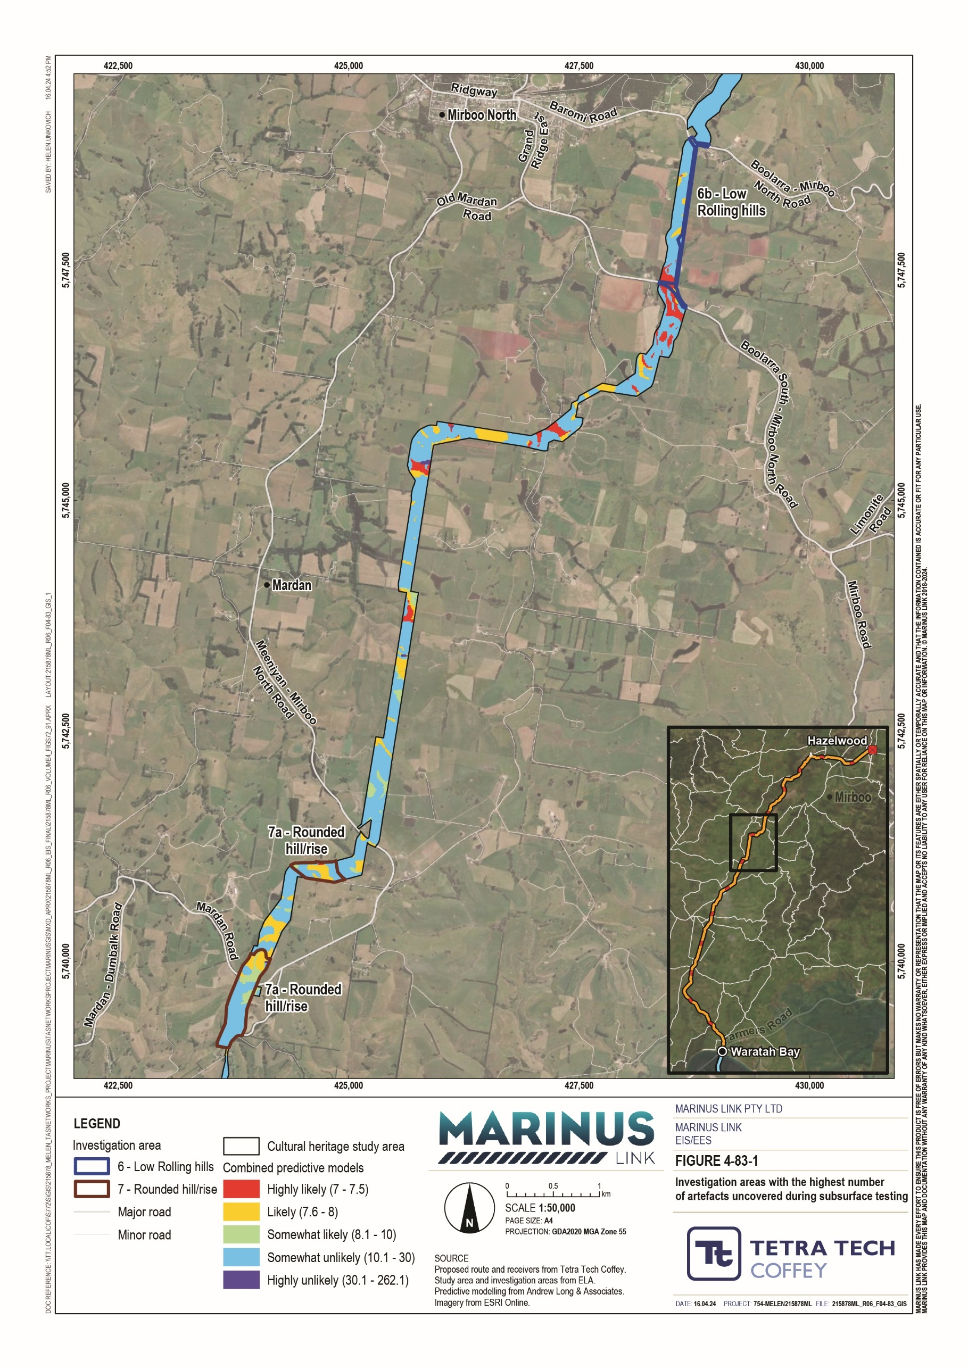

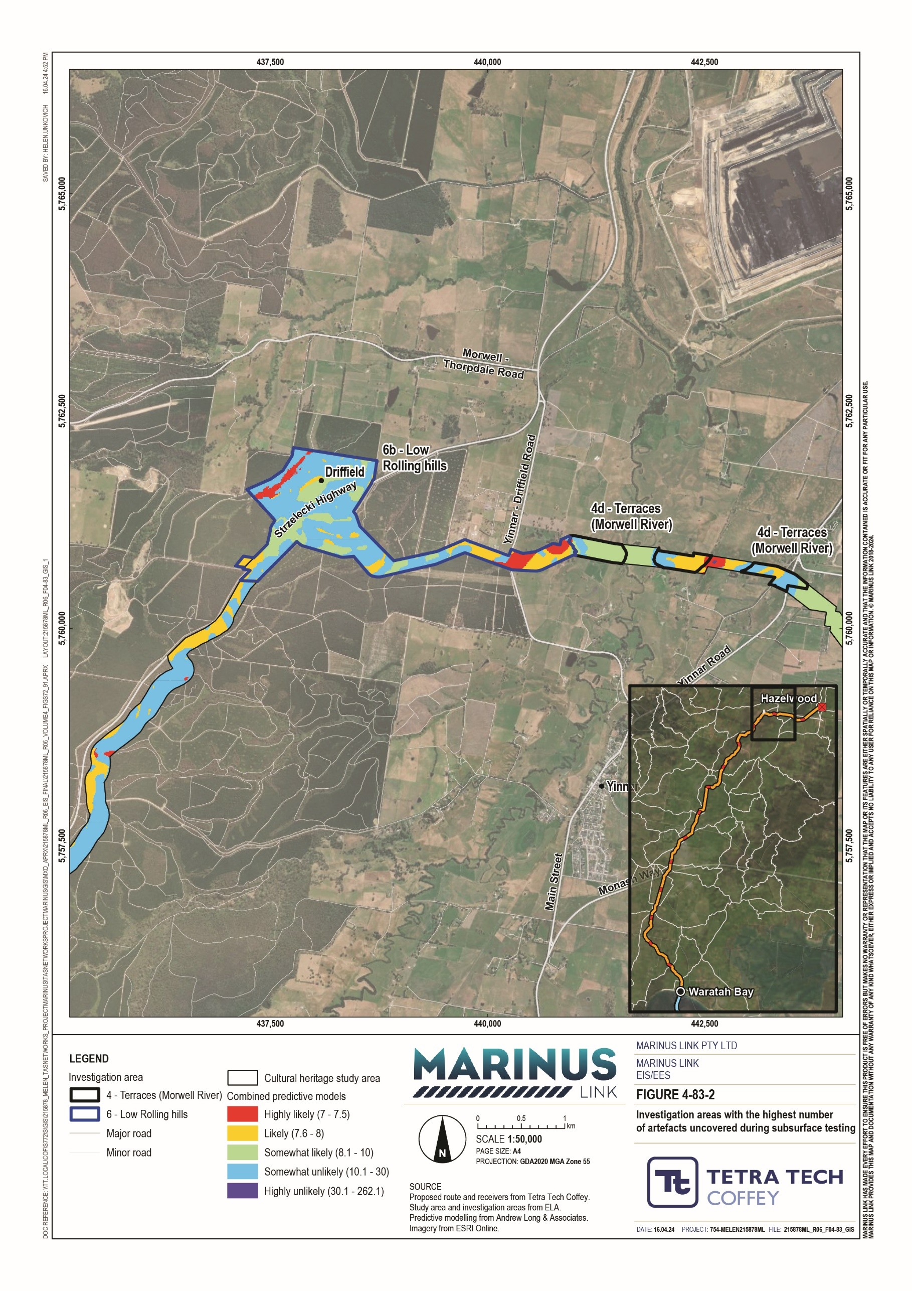

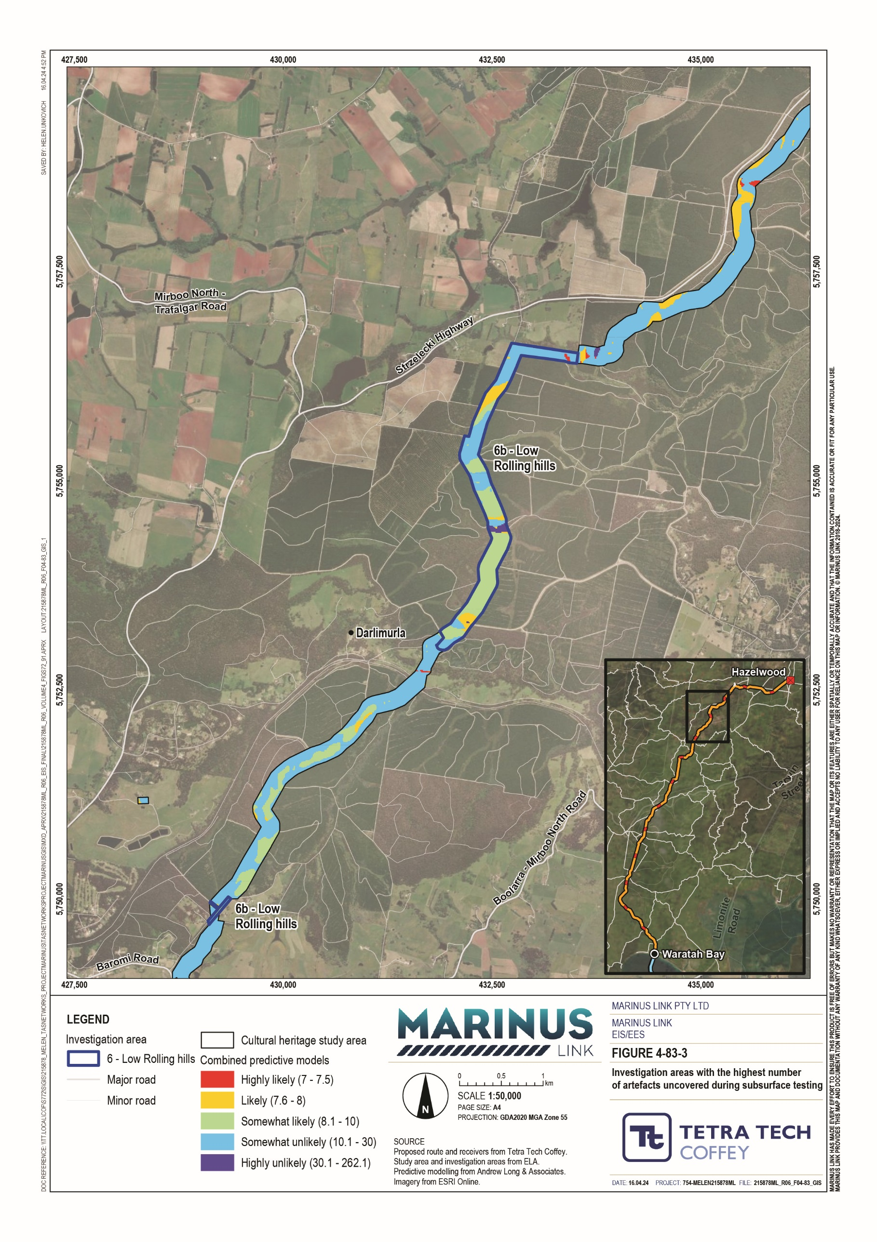

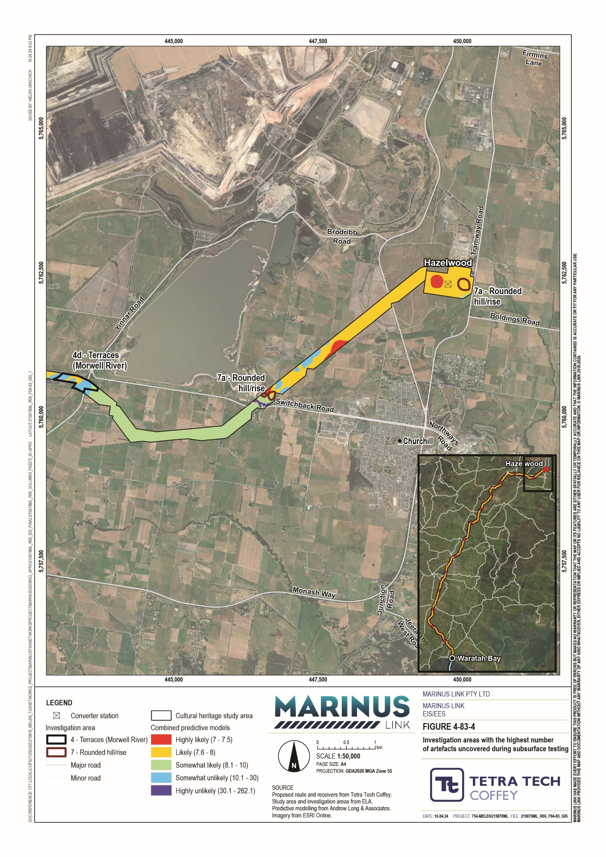

The archaeological ground survey and subsurface testing program identified 15 new Aboriginal cultural heritage places, including three artefact scatters and 12 LDADs. These are located on a range of elevated landforms including:
River and creek terraces near Eel Hole Creek, Morwell River and Tarwin River East Branch.

Rounded hills and rises.

Low rolling hills.

Table 13-6 summarises the results of the archaeological ground survey and subsurface testing program.

Place name | Site type | Artefacts | IA | Description
Eel Hole Creek LDAD-01 | LDAD | 15 | IA-4 | Excavated on an elevated terrace landform adjacent to Eel Hole Creek. The place is within an area rated as likely by the digital predictive model and includes 15 subsurface artefacts recovered from six test pits.
Eel Hole Creek AS-01 | Artefact scatter | 20 | IA-7 | Excavated on a rounded hill and rise landform adjacent to Eel Hole Creek. The place is within an area rated as likely by the digital predictive model and includes 20 subsurface artefacts recovered from one test pit.
Eel Hole Creek LDAD-02 | LDAD | 10 | IA-7 | Excavated on a rounded hill and rise landform adjacent to Eel Hole Creek. The place is within an area rated as somewhat likely by the digital predictive model and includes 10 subsurface artefacts recovered from five test pits.
Eel Hole Creek LDAD-04 | LDAD | 11 | IA-6 | Excavated on a low rolling hill landform adjacent to Eel Hole Creek. The place is within an area rated as somewhat likely by the digital predictive model and includes 11 subsurface artefacts recovered from three test pits.
Morwell River  LDAD-01 | LDAD | 41 | IA-4  and IA-5 | Excavated on elevated terrace and plain landforms adjacent to the Morwell River. The place is within areas rated as highly likely, likely and somewhat unlikely by the digital predictive model and includes 18 subsurface artefacts recovered from three test pits, as well as 23 surface artefacts.
Morwell River AS-01 | Artefact scatter | 181 | IA-4 | Excavated on an elevated terrace landform adjacent to the Morwell River. The place is within an area rated as likely by the digital predictive model and includes 112 subsurface artefacts recovered from one test pit, as well as 69 surface artefacts.
Morwell River AS-02 | Artefact scatter | 16 | IA-4 | Situated on an elevated terrace landform adjacent to the Morwell River. The place is within an area rated as likely by the digital predictive model and included 16 surface artefacts.

Place name | Site type | Artefacts | IA | Description
Morwell River  LDAD-02 | LDAD | 54 | IA-6 | Excavated on a low rolling hill landform adjacent to the Morwell River. The place is within areas rated as highly likely, likely, somewhat likely and somewhat unlikely by the digital predictive model. Surveys identified 53 subsurface artefacts recovered from seven test pits, as well as one surface artefact.
Darlimurla LDAD-01 | LDAD | 5 | IA-6 | Excavated on a low rolling hill landform near Darlimurla. The place is within an area rated as somewhat likely by the digital predictive model and includes four subsurface artefacts recovered from one test pit, as well as one surface artefact.
Berrys Creek LDAD-01 | LDAD | 1 | IA-4 | Situated near Berrys Creek. The place is within an area rated as highly likely by the digital predictive model and includes one surface artefact.
Kings Road LDAD-01 | LDAD | 1 | IA-6 | Situated near Kings Road. The place is within an area rated as likely by the digital predictive model and includes one surface artefact.
Toomey Creek LDAD-01 | LDAD | 1 | IA-3 | Excavated on a floodplain landform adjacent to Toomey Creek. The place is within an area rated as somewhat likely by the digital predictive model and includes one subsurface artefact recovered from one test pit.
Tarwin River East Branch LDAD-01 | LDAD | 1 | IA-8 | Excavated on a ridge landform near the Tarwin River East Branch. The place is within an area rated as likely by the digital predictive model and includes one subsurface artefact recovered from one test pit.
Tarwin River East Branch LDAD-02 | LDAD | 20 | IA-3  and IA-4 | Excavated on elevated terrace and floodplain landforms adjacent to the Tarwin River East Branch. The places are within areas rated as somewhat likely and somewhat unlikely by the digital predictive model. Surveys identified 20 subsurface artefacts recovered from seven test pits.
Buffalo LDAD-01 | LDAD | 10 | IA-3 | Excavated on a floodplain landform adjacent to Buffalo. The place is within an area rated as somewhat likely by the digital predictive model and includes 10 subsurface artefacts recovered from one test pit.

Aboriginal cultural values assessment
To satisfy the EIS guidelines and EES scoping requirements, the project must understand and assess the extent of tangible and intangible Aboriginal cultural heritage values in the study area. This can only be achieved by engaging with First Peoples to understand cultural values and potential impacts. Engagement is ongoing with GLaWAC, BLCAC and BLSC.
The commitment to completing the CVAs is stated in EPR CH03, including that the outcomes be incorporated into the two CHMPs being developed for the project: 18201 Mirboo North to Hazelwood and 18244 Waratah Bay to Hazelwood. The desktop assessment, supporting this impact assessment, will help inform the development of the CVAs. Three CVAs will be developed for the project, one for each First Peoples group:
GLaWAC covering the areas defined for CHMPs 18201 and 18244.

BLCAC covering the area defined for CHMP 18244.

BLSC covering the area defined for CHMP 18244.

Development of the CVAs has commenced with inception meetings held with each of the First Peoples groups to brief them on the approach. As part of this process, each First Peoples group was asked how they would want their CVA to be managed and delivered. The preference for each group is as follows:
GLaWAC – project heritage advisors will meet with one GLaWAC representative during a single site inspection, the results of which will be used to draft a CVA report.
BLCAC – elected to develop their own CVA.

BLSC – elected to work closely with project heritage advisors and the project team to manage the CVA. The project heritage advisors will prepare a draft CVA report.
Preparation of the CVAs will be supported by ongoing engagement with the project’s engagement FPAG. The scope of the CVAs will cover both terrestrial landscapes and marine submerged landscapes.

Summary of Aboriginal cultural heritage values
The assessment identified 28 Aboriginal cultural heritage places. Thirteen of these were previously registered and the remaining fifteen places were identified during the fieldwork program.
The thirteen previously registered places consisted of seven artefact scatters, five LDADs, and one multicomponent artefact scatter and ochre quarry site. Five of these thirteen places were inaccessible during the archaeological ground survey, and it is assumed that the registered artefacts are present and intact for the purposes of this study. The survey team investigated the other eight places and did not identify the recorded Aboriginal cultural heritage. Regardless, these eight places are assessed in this impact assessment as they remain Aboriginal cultural heritage places under the Aboriginal Heritage Act 2006 (Vic).
The places identified during the fieldwork program consisted of three artefact scatters and 12 LDADs.

The 28 Aboriginal cultural heritage places each have a level of significance based on their historical, scientific, social and spiritual significance as determined during the fieldwork program. To determine the significance of the five inaccessible places, the assessment used the information from the Aboriginal Cultural Heritage Research and Information System (ACHRIS) and relevant previous studies.
While First Peoples group representatives were present during fieldwork activities and inspection of the preferred route options, the assessment has not obtained formal advice from First Peoples groups regarding the traditional (social) significance of the Aboriginal cultural heritage places. However, CVAs are currently underway. This program will obtain advice from First Peoples regarding the tangible and intangible cultural heritage values that they associate with the region. The information obtained during the CVAs will then be incorporated into the two CHMPs currently being prepared for the project. As the CVAs will not be completed in time to inform this assessment, the identified Aboriginal cultural heritage places have been rated as highly significant, in line with the view of First Peoples that all Aboriginal cultural heritage is highly significant.
The assessment determined the level of cultural heritage significance for the other three criteria (historical, scientific and spiritual) through the fieldwork conducted for the project. Where previously registered sites could not be accessed, the assessment determined the cultural heritage significance of these sites based on the information in relevant site cards accessed via ACHRIS, and/or reports summarised in Section 13.2.3.
As all 28 cultural heritage places were artefact scatters or LDADs, the assessment graded their spiritual and historical significance levels uniformly, as low. The scientific criterion distinguished between the various places’ overall significance, as this is a product of content, condition and representativeness.
A summary of the cultural heritage significance assessment is in Table 13-7 and a detailed breakdown is provided in Technical Appendix J: Aboriginal and historical cultural heritage.
The impact assessment considered the following known cultural heritage places as well as unknown cultural heritage:
one artefact scatter/ochre quarry

ten artefact scatters

seventeen LDADs

Field surveys did not access all areas considered by the predictive model as highly likely to contain Aboriginal cultural heritage. Despite this, field survey results are considered sufficient to comment on the nature and significance of tangible Aboriginal cultural heritage values likely to be present within the study area.
The impact assessment considered 28 Aboriginal cultural heritage places. For the purpose of this impact assessment, these Aboriginal cultural heritage places are referred to as ‘values’, as outlined in Section 13.1, which aligns with the defined ‘values’ considered as part of the CVAs. Aboriginal cultural heritage values in the study area are summarised in Table 13-7 and shown in Figure 4-84.

Value number (for impact assessment) | Value name | Value type | Intersects AoD | Cultural heritage significance
1 | Heywood 1 | Artefact scatter | Yes | Low – one artefact identified during field surveys that was rated as deteriorated and common
2 | Heywood 2 | Artefact scatter | Yes | Low – one artefact identified during field surveys that was rated as deteriorated and common
3 | Heywood 3 | Artefact scatter | Yes | Low – one artefact identified during field surveys that was rated as deteriorated and common
4 | Smiths Road 1 | Artefact scatter | No | Low – twelve artefacts removed during a previous study that were rated as deteriorated and occasional
5 | Mountain Hut Road 1 | Artefact scatter | No | Low – one artefact removed during a previous study that was rated as deteriorated and common
6 | Mountain Hut Road 2 | Artefact scatter | No | Low – one artefact removed during a previous study that was rated as deteriorated and common
7 | Kings Road Extension 1 | LDAD | No | Low – three artefacts removed during a previous study that were rated as deteriorated and common
8 | Kings Road Track 1 | LDAD | Yes | Low – fourteen artefacts removed during a previous study that were rated as deteriorated and occasional
9 | Kings Rd Extension 2 | LDAD | No | Low – eight artefacts removed during a previous study that were rated as deteriorated and common
10 | Mountain Hut Rd 3 | LDAD | No | Low – four artefacts removed during a previous study that were rated as deteriorated and common
11 | Strzelecki Highway 1 | LDAD | Yes | Low – 51 artefacts removed during a previous study that were rated as deteriorated and occasional
12 | Eel Hole Creek 3 | Artefact scatter | Yes | Moderate – 101 artefacts identified during field surveys rated as deteriorated and occasional
13 | Eel Hole Creek 4 | Artefact scatter/ ochre quarry | Yes | Moderate – 60 artefacts identified during field surveys rated as deteriorated and occasional
14 | Eel Hole Creek LDAD- 01 | LDAD | Yes | Moderate – 15 artefacts identified during field surveys rated as fair to good and occasional
15 | Eel Hole Creek AS-01 | Artefact scatter | Yes | Moderate – 20 artefacts identified during field surveys rated as fair to good and occasional

Value number (for impact assessment) | Value name | Value type | Intersects AoD | Cultural heritage significance
16 | Eel Hole Creek LDAD- 02 | LDAD | Yes | Moderate – 10 artefacts identified during field surveys rated as fair to good and common
17 | Eel Hole Creek LDAD- 04 | LDAD | Yes | Moderate – 11 artefacts identified during field surveys rated as fair to good and common
18 | Morwell River LDAD-01 | LDAD | Yes | Moderate – 41 artefacts identified during field surveys rated as fair to good and occasional
19 | Morwell River AS-01 | Artefact scatter | Yes | Moderate – 181 artefacts identified during field surveys rated as fair to good and rare
20 | Morwell River AS-02 | Artefact scatter | Yes | Moderate – 16 artefacts identified during field surveys rated as deteriorated and occasional
21 | Morwell River LDAD-02 | LDAD | Yes | Moderate – 54 artefacts identified during field surveys rated as fair to good and occasional
22 | Darlimurla LDAD-01 | LDAD | Yes | Moderate – 5 artefacts identified during field surveys rated as fair to good and common
23 | Berrys Creek LDAD-01 | LDAD | Yes | Low – 1 artefact identified during field surveys rated as deteriorated and common
24 | Kings Road LDAD-01 | LDAD | Yes | Low – 1 artefact identified during field surveys rated as deteriorated and common
25 | Toomey Creek LDAD- 01 | LDAD | Yes | Moderate – 1 artefact identified during field surveys rated as fair to good and common
26 | Tarwin River East Branch LDAD-01 | LDAD | Yes | Moderate – 1 artefact identified during field surveys rated as fair to good and common
27 | Tarwin River East Branch LDAD-02 | LDAD | Yes | Moderate – 20 artefacts identified during field surveys rated as fair to good and occasional
28 | Buffalo LDAD-01 | LDAD | Yes | Moderate – 10 artefacts identified during field surveys rated as fair to good and common

Page/s have been redacted for public release.

Construction impacts
Construction of the project may impact on Aboriginal cultural heritage through activities that result in vegetation removal and disturbance of surface or subsurface deposits. The assessed potential impacts in this section are direct impacts.
Indirect impacts to Aboriginal cultural heritage can be difficult to quantify. The CHMPs (EPR CH02) will outline management measures to minimise indirect impacts to Aboriginal heritage values. Further understanding of the potential for indirect impacts to intangible and tangible Aboriginal cultural heritage will be achieved through the CVAs. The outcomes of the CVAs will be incorporated into the management conditions of the two CHMPs being developed for the project and reduce the impact of the project on Aboriginal cultural heritage.
The impact assessment considered the existing conditions outlined in Section 13.2 as well as the project construction activities with the potential to impact on Aboriginal cultural heritage values (as summarised in Section 13.2.6 and Table 13-7). Project activities that could potentially impact Aboriginal cultural heritage values are outlined in Table 13-8.

Activity | Actions potentially impacting cultural heritage values
Shore crossing | excavation of HDD entry and exit pits
Transition and converter stations | vegetation removal  ground surface levelling and benching hardstand and laydown preparation  foundation construction  civil works and underground utility installations
Land cables | vegetation removal  topsoil stripping and stockpiling site establishment  haul road construction  cable trench excavation, duct installation, backfilling excavation of HDD entry and exit pits
Access roads and tracks | vegetation removal  topsoil stripping and stockpiling

Potential impacts on the 28 known Aboriginal cultural heritage values were assessed. In the context of the impact assessment, the distinction between these values is the content, condition and representativeness of the Aboriginal cultural heritage places. These factors determine the places’ scientific significance and consequently informed their cultural heritage significance. Of the 28 known values, the assessment found the impact level prior to implementing mitigation measures, to be high for 15 values, moderate for 11 values and low for 2 values. This is summarised in Table 13-9.

Value numbers | Cultural heritage significance | Impact magnitude | Impact level
12, 13, 14, 15, 16, 17, 18, 19, 20, 21,  22, 25, 26, 27, 28 | Moderate | Major | High
1, 2, 3, 4, 5, 7, 8, 9, 11, 23, 24 | Low | Major | Moderate
6, 10 | Low | Moderate | Low

The high impact rating for 15 values indicates that construction activities may cause damage to these artefacts and reduce their contribution to the understanding of the cultural significance of the broader region. The impact level of high is attributed to the sites being of greater scientific significance, relative to the other 13 sites. The nature of the artefacts at these sites results in a cultural heritage significance rating of moderate. The other contributing factor to the high impact level is the assessed impact magnitude of major. This impact rating combines the severity, extent and duration of potential impacts to values by the project.
The moderate impact rating for 11 values indicates that construction activities may cause damage to these artefacts and reduce their contribution to the understanding of the cultural significance of the broader region, but less than for the high impacts. These places are less scientifically significant than the previously mentioned 15, based on containing less artefacts, containing artefacts in worse condition or containing artefacts that are relatively common. The nature of the artefacts at these sites results in a cultural heritage significance rating of low. The impact magnitude for these 11 sites is major.
The low impact rating for two values indicates that construction activities will have little effect on the ability to derive understandings about people, places, processes or practices. The assessed low impact level is attributed to an impact magnitude of moderate and cultural heritage significance of low. The lower impact magnitude compared with the high and moderate ratings is due to the potential impacts damaging less than a third of the extent of the sites. The low cultural heritage significance rating is due to these two sites containing less scientifically significant artefacts than the 15 sites with a cultural heritage significance of moderate.

Potential mitigation measures include having a qualified archaeologist inspect these places and collecting all visible surface artefacts (EPR CH02). All mitigation measures will adhere to the methods prescribed by the relevant CHMP.
The extent to which mitigation measures could reduce the level of impact on values considered each value’s cultural heritage significance and physical location relative to the AoD.

Operation impacts
Operation of the project may impact on Aboriginal cultural heritage through activities associated with weed control and vehicle track maintenance in locations previously disturbed during construction. The assessed potential impacts in operation are direct impacts. Indirect impacts will be minimised by implementing management conditions in accordance with the approved CHMPs (EPR CH02). Further understanding of the potential for indirect impacts to intangible and tangible cultural heritage will be achieved through the ongoing work to complete the CVAs.
While the mitigation measures for the construction impacts involve excavation and collection of artefacts, these are not expected to recover all Aboriginal cultural heritage at these cultural heritage places. Further, if all Aboriginal cultural heritage is recovered, an Aboriginal cultural heritage place is still protected under the Aboriginal Heritage Act 2006 (Vic) and remains on the VAHR if it has been registered. Consequently, following successful implementation of construction phase mitigation measures to comply with EPRs, Aboriginal cultural heritage values may still be impacted during the project’s operation phase. The activities that may impact on Aboriginal cultural heritage during the project’s operation phase are:
maintenance of access roads servicing the transition and converter stations

weed control along the land cable easement.

The assessment of these activities’ impacts on Aboriginal cultural heritage values is summarised in Table 13-10 and outlined below.
Pre-mitigation, the assessment found the impact to 19 values to be moderate. Of these, 15 have a cultural heritage significance of moderate and an impact magnitude of moderate, indicating that the artefacts at these sites would be more scientifically significant than those at the other sites, and potential impacts to these sites will be high duration, low extent and low severity. The magnitude ratings for content and extent are based on the assumption that these sites were impacted during construction, as they are within the project’s AoD. The other four values with a moderate impact have a cultural heritage significance of low and an impact magnitude of major, indicating that potential impacts to these sites will be high duration, medium extent and medium severity. As these sites are outside the AoD they would not be impacted by construction activities.
The assessment found the impact to nine values to be low, due to a cultural heritage significance of low and an impact magnitude of moderate. The low cultural significance is due to a lower scientific significance of the artefacts at these sites. The magnitude is lower as the impact severity, extent and duration are lesser, relative to the values with an impact magnitude of major. As these sites are outside the AoD they would not be impacted by construction activities.
Potential mitigation measures include having a qualified archaeologist inspect these places and collecting all visible surface artefacts (EPR CH02). All mitigation measures will adhere to the methods prescribed by the relevant CHMP.

Value numbers | Cultural heritage significance | Impact magnitude | Impact level
12, 13, 14, 15, 16, 17, 18, 19, 20,  21, 22, 25, 26, 27, 28 | Moderate | Moderate | Moderate
4, 5, 7, 9 | Low | Major | Moderate
1, 2, 3, 6, 8, 10, 11, 23, 24 | Low | Moderate | Low

Decommissioning impacts
The operational lifespan of the project is a minimum 40 years. At this time the project will either be decommissioned or upgraded to extend its operational lifespan.
Decommissioning will be planned and carried out in accordance with regulatory and landholder requirements at the time. A decommissioning plan in accordance with approvals conditions will be prepared prior to planned end of service and decommissioning of the project.
Requirements at the time will determine the scope of decommissioning activities and impacts. The key objective of decommissioning is to leave a safe, stable and non-polluting environment, and minimise impacts during the removal of infrastructure.
In the event that the project is decommissioned, all above-ground infrastructure will be removed, and associated land returned to the previous land use or as agreed with the landholder.
Decommissioning of the project may impact on Aboriginal cultural heritage through activities associated with disturbance of surface or subsurface deposits. This includes both direct and indirect impacts on Aboriginal cultural heritage. The assessment below considers direct impacts, as indirect impacts are difficult to quantify. Indirect decommissioning impacts will be managed by implementing appropriate management conditions and responses in line with the approved CHMPs (EPR CH02). The approved CHMPs will be informed by the ongoing CVAs, which will increase understanding of potential impacts to tangible and intangible Aboriginal cultural heritage. The understanding achieved through the CVAs will be incorporated into the management conditions of the two CHMPs, being developed for the project, and reduce the impact of the project on Aboriginal cultural heritage.
The activities that may impact on Aboriginal cultural heritage during the project’s decommissioning phase are:
Excavation on or within previously impacted ground surfaces during removal of aboveground and underground infrastructure (including access roads and tracks).
Land restoration activities stripping the topsoil of areas not impacted during construction or operation.

While the mitigation measures for the construction impacts will have been implemented, this process may have missed some artefacts and the Aboriginal cultural heritage places remain protected even after artefacts are removed. Consequently, Aboriginal cultural heritage values may be impacted during the project’s decommissioning phase.
The impact pathways for decommissioning are similar to those during construction however, the impact level will be lower. This is because decommissioning activities are expected to mostly be confined to locations that were previously disturbed during construction activities and where mitigation measures were previously implemented.
The impact of decommissioning activities on Aboriginal cultural heritage values is considered to be the same as those in operation and summarised in Table 13-10.

Environmental performance requirements
EPRs set out the environmental outcomes that must be achieved during all phases of the project. In developing these EPRs, industry standards and guidelines, good practice and the latest approaches to managing impacts were considered. Project specific management measures, relevant legislation and policy requirements informed these EPRs.
The EPRs that will be implemented to manage potential impacts on Aboriginal cultural heritage are listed in Table 13-11.

EPR ID | EPR
CH02 | Comply with the Cultural Heritage Management Plans (CHMPs) 18201 and 18244.  Implement and comply with CHMPs 18201 and 18244, prepared by qualified Heritage Advisors recognised under s 189 of the Aboriginal Heritage Act 2006 (Vic), and approved in accordance with Division 5 (ss. 61-66A) of the Aboriginal Heritage Act 2006 (Vic).  The CHMPs must be implemented and complied with during construction and operation.
CH03 | Develop a cultural values assessment for land and sea country with First Peoples  As part of the strategy developed for EPR EM08, continue working with First Peoples in Victoria and Tasmania about intangible heritage values and develop an understanding of terrestrial and submerged intangible values. Work with First Peoples to prepare cultural values assessments for each group, and incorporate the results relevant to the Victoria jurisdiction into the two CHMPs referenced in EPR CH02.
EM08 | Develop and implement a strategy for ongoing engagement with First Peoples  MLPL will develop and implement a strategy for ongoing engagement with First Peoples in Victoria and Tasmania during construction and operation of the project.

The complete list of EPRs for the project is provided in Volume 5, Chapter 2 – Environmental Management Framework.

Residual impacts
The evaluation of residual impacts on Aboriginal cultural heritage has considered the implementation of potential mitigation measures to comply with the proposed EPRs outlined in Section 13.6. Across all phases of the project, the assessment found that mitigation measures will reduce the impact magnitude for most values, and consequently reduce the impact level by at least one rating. This results in:
fifteen values with a moderate residual impact level

seven values with a low residual impact level

six values with a nil residual impact level.

This is achieved by implementing EPR CH02, including the following associated potential mitigation measures that will occur prior to construction and throughout the project:
inspection of the locations by a qualified archaeologist

collection of all visible surface artefacts within the place

salvage excavation consistent with the methods prescribed under relevant CHMP conditions.

comply with relevant CHMP site-specific management conditions.

The potential for residual indirect impacts (residual impacts to unknown Aboriginal cultural heritage values) from the project, including intangible values, remains after implementation of mitigation measures to comply with EPRs. Highly culturally significant Aboriginal cultural heritage values, including Aboriginal Ancestral Remains, are unlikely to occur on the project alignment and the surveys did not identify any such values.
Further, landforms typically associated with these values are rarely intersected by the project alignment and often bypassed by HDD.
Impacts to tangible or intangible Aboriginal cultural heritage values identified following the assessment will be mitigated by adhering to measures under the CHMPs that will be approved by GLaWAC and FPSR
(EPR CH02), and appropriate management and contingency responses.

Residual construction impacts
The implementation of measures to comply with EPRs on construction impacts will reduce the impact to each value. This is primarily due to reducing the impact severity and impact extent parameters (two of the three parameters that underpin impact magnitude). For the 15 values with a cultural heritage significance of moderate, reducing the residual impact severity and extent will reduce the residual impact magnitude from major to moderate and consequently the residual impact level from high to moderate. Similarly, for seven of the values with low cultural heritage significance, reducing the residual impact severity and extent will reduce the residual impact magnitude from major to moderate and consequently the residual impact level from moderate to low. The remaining six values are outside the AoD, in which case the residual impact magnitude and consequently residual impact level is nil. Table 13-12 shows the changes in impact assessment gradings for the construction phase by implementing EPR CH02.

Value numbers | Cultural heritage significance | Impact magnitude | Impact level | Residual impact magnitude | Residual impact level
12, 13, 14, 15, 16, 17, 18, 19,  20, 21, 22, 25, 26, 27, 28 | Moderate | Major | High | Moderate | Moderate
1, 2, 3, 8, 11, 23, 24 | Low | Major | Moderate | Moderate | Low
4, 5, 6, 7, 9, 10 | Low | Moderate | Low | Nil | Nil

Residual operation impacts
Implementing the EPRs for operation impacts will reduce the impact to 13 values. The impact to the
15 values with a moderate cultural heritage significance will not change. This is largely a product of the significance assessment matrix, where the probability of impact is not considered. The residual impact levels for the values within the AoD represent the scenario that impacts do occur. However, as construction activities will have affected the sites of many of these values and there are fewer impact pathways during operation, the likelihood that operation activities impact on values is much less.
For the 13 values where the level of impact will be reduced by the EPRs, the residual impact level is low (7) or nil (6). All 13 have a cultural heritage significance of low, but the distinction is the proximity of the site to the AoD. It is assumed that the six sites outside the AoD will not be impacted, resulting in a residual impact magnitude, and consequently residual impact level, of nil.
Table 13-13 summarises the residual impacts on Aboriginal cultural heritage values following the implementation of measures to comply with EPR CH02 during operation.

Value numbers | Cultural heritage significance | Impact magnitude | Impact level | Residual impact magnitude | Residual impact level
12, 13, 14, 15, 16, 17, 18, | Moderate | Moderate | Moderate | Moderate | Moderate
19, 20, 21, 22, 25, 26, 27,
28
1, 2, 3, 8, 11, 23, 24 | Low | Moderate | Low | Moderate | Low
4, 5, 7, 9 |  | Major | Moderate
 | Low |  |  | Nil | Nil
6, 10 |  | Moderate | Low

Residual decommissioning impacts
The residual decommissioning impact assessment is the same as for the residual operation impacts. The impact to seven of the values will be reduced from moderate to low, and for a further six values, from low to nil, by implementing the EPRs. Further, the impact level for the remaining 15 values will remain at moderate, though the likelihood of these impacts occurring is significantly less than during construction.
Table 13-13 summarises the residual impacts on Aboriginal cultural heritage values following the implementation of measures to comply with EPR CH02 during decommissioning.

Cumulative impacts
The Aboriginal cultural heritage cumulative impact assessment considered projects that are currently under construction, approved, or have officially begun the approval process and have the potential for their impacts to accumulate with those of Marinus Link. The projects considered in the Aboriginal cultural heritage cumulative assessment and level of impact for projects individually are:
Delburn Wind Farm: low to moderate

SoTS: low to moderate

Hazelwood Rehabilitation Project: very low

Wooreen Energy Storage System: very low

Onshore wind farms, such as Delburn Wind Farm, typically have small impact footprints limited to access tracks and turbine locations. Delburn Wind Farm is located within a plantation so is unlikely to cause significant impacts to Aboriginal cultural heritage. Implementation of this project’s approved CHMP will further limit its impact on Aboriginal cultural heritage. Intangible Aboriginal cultural heritage may be impacted by the wind farm’s visual impact and physical presence.
SoTS may impact on Aboriginal cultural heritage given its location in Gippsland and its construction method. SoTS is expected to follow the existing Bass Link cable alignment which was investigated for its potential impact on cultural heritage when the project was developed. This should reduce its impact on Aboriginal cultural heritage.
Impacts of the Hazelwood Rehabilitation Project are expected to be confined to areas of previous disturbance which reduces the potential for future impact to Aboriginal cultural heritage.
Wooreen Energy Storage System will be constructed within the existing Jeeralang plant. This confines its impacts to areas of previous disturbance and reduces the potential for future impact to Aboriginal cultural heritage.
The assessment calculated a weighted statistical median of the potential residual impacts of Marinus Link together with the other projects in the region on Aboriginal cultural heritage. Considering the assessment of each of the individual projects, the overall cumulative impact level was assessed to be low which indicates

that the condition of Aboriginal cultural heritage places will be largely undisturbed. Consequently, the project is considered to have a relatively negligible cumulative impact on Aboriginal cultural heritage in the region.

Conclusion
The desktop assessment and field surveys identified 28 cultural heritage places within the study area including:
one artefact scatter/ochre quarry

ten artefact scatters

seventeen LDADs.

These could be impacted where project activities, that result in vegetation removal and ground disturbance, coincide with these values. Impacts will be mitigated by preparing and implementing two CHMPs
(EPR CH02) and by implementing potential mitigation measures such as inspecting sites for artefacts and collecting those identified, prior to construction commencing.
There is potential for unknown Aboriginal cultural heritage values to be present. Impacts to these will be mitigated by implementing appropriate mitigation measures under the relevant CHMP (EPR CH02).
Construction activities have the greatest potential to impact Aboriginal cultural heritage due to ground disturbance activities such as digging trenches and site establishment. The assessment found that following implementation of measures to comply with EPRs the residual impacts to Aboriginal cultural heritage will be reduced, in most cases, by at least one level. The exception is the 15 values with moderate cultural heritage sensitivity during the operation and decommissioning phases. This outcome is largely due to the parameters of the significance assessment method, in that it does not consider probability. These 15 values’ sites will have been assessed and disturbed during construction, reducing the probability of further impacts to cultural heritage.
Moderate residual impacts may occur to 15 Aboriginal cultural heritage values during the construction, operation and decommissioning of the project. These values and applicable EPRs are:
one artefact scatter/ochre quarry (EPR CH02)

four artefact scatters (EPR CH02)

ten LDADs (EPR CH02).

Following the implementation of measures to comply with EPRs, it is anticipated that the project will meet the EIS guidelines and the EES evaluation objective relating to Aboriginal cultural heritage to ‘Protect, avoid and, where avoidance is not possible, minimise adverse effects on historical heritage values, and tangible and intangible Aboriginal cultural heritage values, in partnership with Traditional Owners’.

