Non-Indigenous cultural heritage
This chapter provides an assessment of the potential impacts to non-Indigenous cultural heritage values, from activities associated with the construction, operation, and decommissioning of the project. This chapter is based on the impact assessment provided in Technical Appendix J: Aboriginal and historical cultural heritage.
Culture is values, practices, and symbols that define a group of people, and which can give people connection to social values, beliefs, religions and customs. Cultural heritage values are often categorised as tangible or intangible and vary between cultures. Tangible heritage refers to physical values that are associated with cultural heritage, forms of which include structures, sites, property, objects, and natural features or landscapes that carry cultural significance (e.g., bodies of water, and geological features).
Intangible cultural heritage refers to tradition and living cultural expression, and includes knowledge, practices, and beliefs that have been passed down through generations.
The significance of cultural heritage to Australians is made evident by the Commonwealth and state legislation that is in effect for its protection and management.
The EIS guidelines set out the following requirements related to non-Indigenous cultural heritage:

Section 4.2: Description of the existing environment.

Section 5.5: Terrestrial impacts.

Refer to Attachment 1: Guidelines for the Content of a Draft Environmental Impact Statement for the EIS guidelines.
The EES scoping requirements set out the following evaluation objective relevant to non-Indigenous cultural heritage:
Historical heritage values, and tangible and intangible Aboriginal cultural heritage values – Protect, avoid and, where avoidance is not possible, minimise adverse effects on historical heritage values, and tangible and intangible Aboriginal cultural heritage values, in partnership with Traditional Owners.
The other aspect covered in the above EES evaluation objective is Aboriginal cultural heritage, is addressed in EIS/EES Volume 4, Chapter 13 – Aboriginal cultural heritage.
Refer to Attachment 2: Scoping Requirements Marinus Link Environment Effects Statement for the EES scoping requirements.

Method
The key steps undertaken to assess non-Indigenous cultural heritage values present in the study area and the potential impacts are summarised below.

Conducting a desktop assessment to establish the level of previous investigation and evidence of historical places in the study area by:
- Defining a study area.
- Searching previous archaeological reports relevant to the study area.
- Identifying documented non-Indigenous cultural heritage within the study area, by using relevant online information systems, including:
  - World Heritage List

  - National Heritage List

  - Commonwealth Heritage List

  - Victorian Heritage Inventory (VHI)

  - Victorian Heritage Register (VHR)

  - Local Government Area (LGA) planning scheme heritage overlays (including Latrobe Shire and South Gippsland Shire heritage overlays).
Conducting an archaeological ground survey of the construction corridor and full width of the study area at water crossings, areas of cultural heritage sensitivity, and key project components such as access tracks and the converter station footprint. The archaeological ground survey involved a series of pedestrian surveys transecting the study area, where land access was available.
Subsurface testing for non-Indigenous cultural heritage artefacts.

Conducting cultural values significance assessment, by adopting the assessment criteria set out in the Australia ICOMOS Charter for Places of Cultural Significance 2013 (The Burra Charter): ‘Aesthetic, historic, scientific, social or spiritual value for past, present or future generations’.
Assessing project-related impacts to non-Indigenous heritage values based on the findings of the desktop assessment, archaeological ground survey results, and the project design as described in Volume 1, Chapter 6 – Project description.
Identifying potential cumulative impacts.

Developing EPRs in response to the impact assessment to set the required environmental outcomes for the project. The assessment of residual impacts presented in this chapter assume implementation of measures to comply with the EPRs. Refer to Volume 5, Chapter 2 – Environmental Management Framework for the complete list of EPRs.

Study area
The study area for the non-Indigenous cultural heritage assessment comprises of the area required to characterise non-Indigenous cultural heritage values and provide context for the assessment of impacts (see Figure 4-85). The study area (referred to as the ‘geographic region’ in Technical Appendix J: Aboriginal and

historical cultural heritage) includes a survey area and AoD (referred to as ‘project footprint’ in Technical Appendix J: Aboriginal and historical cultural heritage). The study area extends 2.5 km to 5 km either side of the 220 m wide survey area (as shown in Figure 4-85) and encompasses:
Survey area – A 220 m wide corridor with some areas slightly wider or narrower based on property boundaries.
AoD – the area that will be disturbed to facilitate construction works that may result in impacts to cultural heritage values. The AoD consists of a 20 m to 36 m construction corridor for the cable route and minor laydown areas, 10 m wide corridors for access tracks and areas up to 1 ha for major laydown areas.

Legislative context
The key legislation and guidelines relevant to the assessment of non-Indigenous cultural heritage are provided in Table 14-1.

Name | Relevance to the assessment
Environment Protection and Biodiversity Conservation Act 1999 (Cwlth) (EPBC Act) | The EPBC Act establishes the Commonwealth Heritage List and National Heritage List, which includes registered historical heritage places, and is consulted in the desktop assessment phase of the assessment.
Heritage Act 2017 (Vic) | The Heritage Act 2017 (Vic) provides protection and conservation to Victorian cultural heritage values that are recorded in the VHI and VHR, and historical archaeology older than 75 years, that have been identified within the study area.  The Act requires permits for works to places on the register and reporting of archaeological sites discovered during works. Where works uncover an archaeological site, works must cease until the site is added to the register and a consent obtained.
VHI | The VHI was consulted to determine whether any known historical archaeological sites exist within the study area.
VHR | The VHR was consulted to determine whether any known historical cultural heritage places of state significance are situated within the study area.
Australia ICOMOS Charter for Places of Cultural Significance- (Burra Charter) | The Burra Charter outlines a process for establishing cultural significance using a set of clearly defined criteria. The assessment incorporated the criteria into the heritage impact assessment methodology.

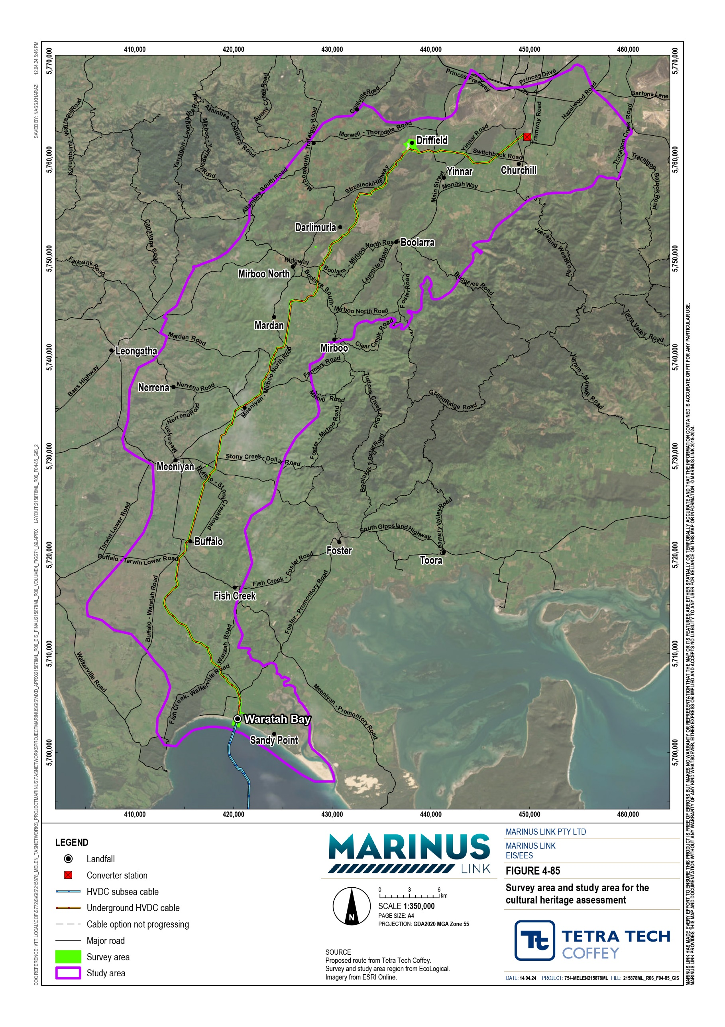

Assumptions and limitations
The non-Indigenous cultural heritage assessment has been conducted based on the following assumptions and limitations:
Not all land could be accessed for the site walk overs or archaeological ground surveys, due to unfavourable conditions or land access restrictions. Potential non-Indigenous cultural heritage values that may exist in areas land access restrictions were in place will be managed through the implementation of measures to comply with EPRs. The findings of the non-Indigenous heritage assessment are informed by access to approximately 44% of the survey area.
The cultural heritage value identified during the archaeological ground survey has not been validated with Heritage Victoria, and has not been registered with VHR or VHI. Registration is not yet possible, as the assessment of the value does not yet meet relevant legislative requirements. Therefore, the discussion around the cultural heritage value is only preliminary.

Existing conditions
This section describes the existing conditions relating to non-Indigenous cultural heritage. The existing conditions have been characterised by information gathered through a desktop assessment and field surveys, comprises of archaeological ground surveys and subsurface testing. Subsurface testing program did not identify any non-Indigenous cultural heritage values; therefore, these values are not discussed further.

Local history
The Gippsland region became an area of interest for wealthy landholders in New South Wales (NSW) in the late 1830s, with interest increasing through the 1840s, once access was improved with the construction of Port Albert. Prior to this, the settlement of the region was slow. Early settlement began in the late 1840s with squatters arriving from Port Albert and Port Phillip, and from Omeo, establishing stations on large pastoral runs. Pastoral land use at this time was mainly cattle and sheep grazing.
Through the 1850s the region’s economy was stimulated by the gold rush in Walhalla and Omeo. Miners retrained as farmers, once gold mining in the region became less profitable in the 1860s. Changes to legislation in Victoria led to smaller freehold farming allotments taking the place of the larger pastoral runs through the 1870s and 1880s. The region had remained relatively isolated until the 1860s when access routes to and from Melbourne to the west were established and communication between Melbourne and the region became easier. Agriculture, including the breeding of sheep, beef and dairy cattle, became the major land use in the area.

Non-Indigenous heritage records
The desktop review of the international, Commonwealth, state and local government online information systems did not identify any pre-recorded non-Indigenous cultural heritage values in the study area.
However, a lack of documented cultural heritage does not mean there is no non-Indigenous heritage present in the study area.

Archaeological ground survey
The archaeological pedestrian ground survey were completed by heritage advisors and archaeologists throughout 2022 and early 2023. The surveys involved a general assessment of the overall historical archaeological potential of the study area and covered eight landform sections:
Waratah Bay beach Plain

Waratah Bay beach dunes Low rolling hills

Floodplains and river/creek corridors Rounded hills and rises

Terraces Ridges.

The current ground disturbance was assessed to range between low to moderate across all of these landform sections. Ground disturbance was attributed to a variety of impacts associated with plantations and farming practices, including land clearing and livestock grazing, and infrastructure or residential development, including development of roads, dams, buildings, and implementation of erosion controls.
A single non-Indigenous cultural heritage site, a brick cistern, was identified on the plain surveyed, located near the Buffalo township (see Plate 4-05, and Plate 4-06). A cistern is a buried tank, commonly made of brick or metal. Brick cisterns were used for water storage and have been recorded as early as the 1870s in Australia. Up until the early 20th century these cisterns were prevalent where connections to town water supplies were established.
The brick cistern was found in Buffalo (Figure 4-86) and features an above-ground dome with a circular opening at the top. The historical use for the land where it is located was likely livestock grazing. The brick cistern is understood to have been constructed in association with a homestead on the site that has since been dismantled and relocated to near Waratah Bay. The above-ground portion of the cistern has been eroded from exposure to the elements, with remnants of concrete or plaster material. Sections of the cistern are damaged, exposing the partially hollow interior below-ground.

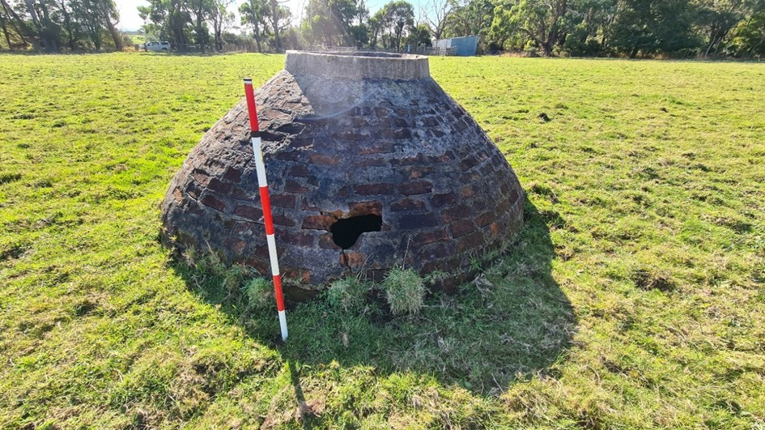

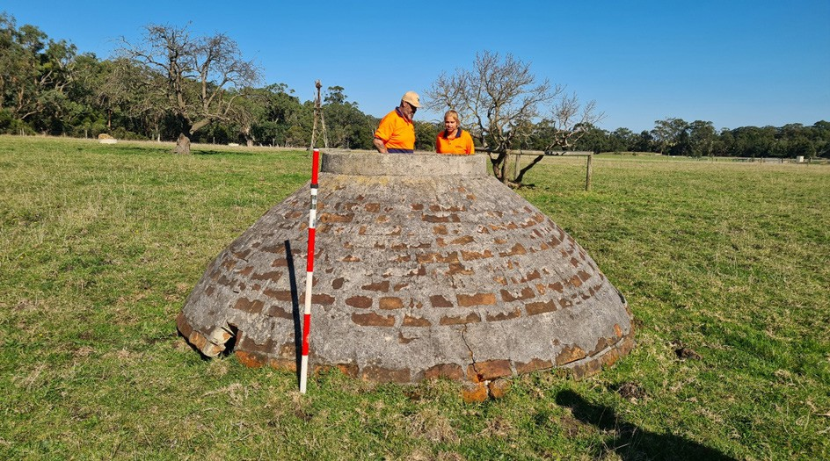

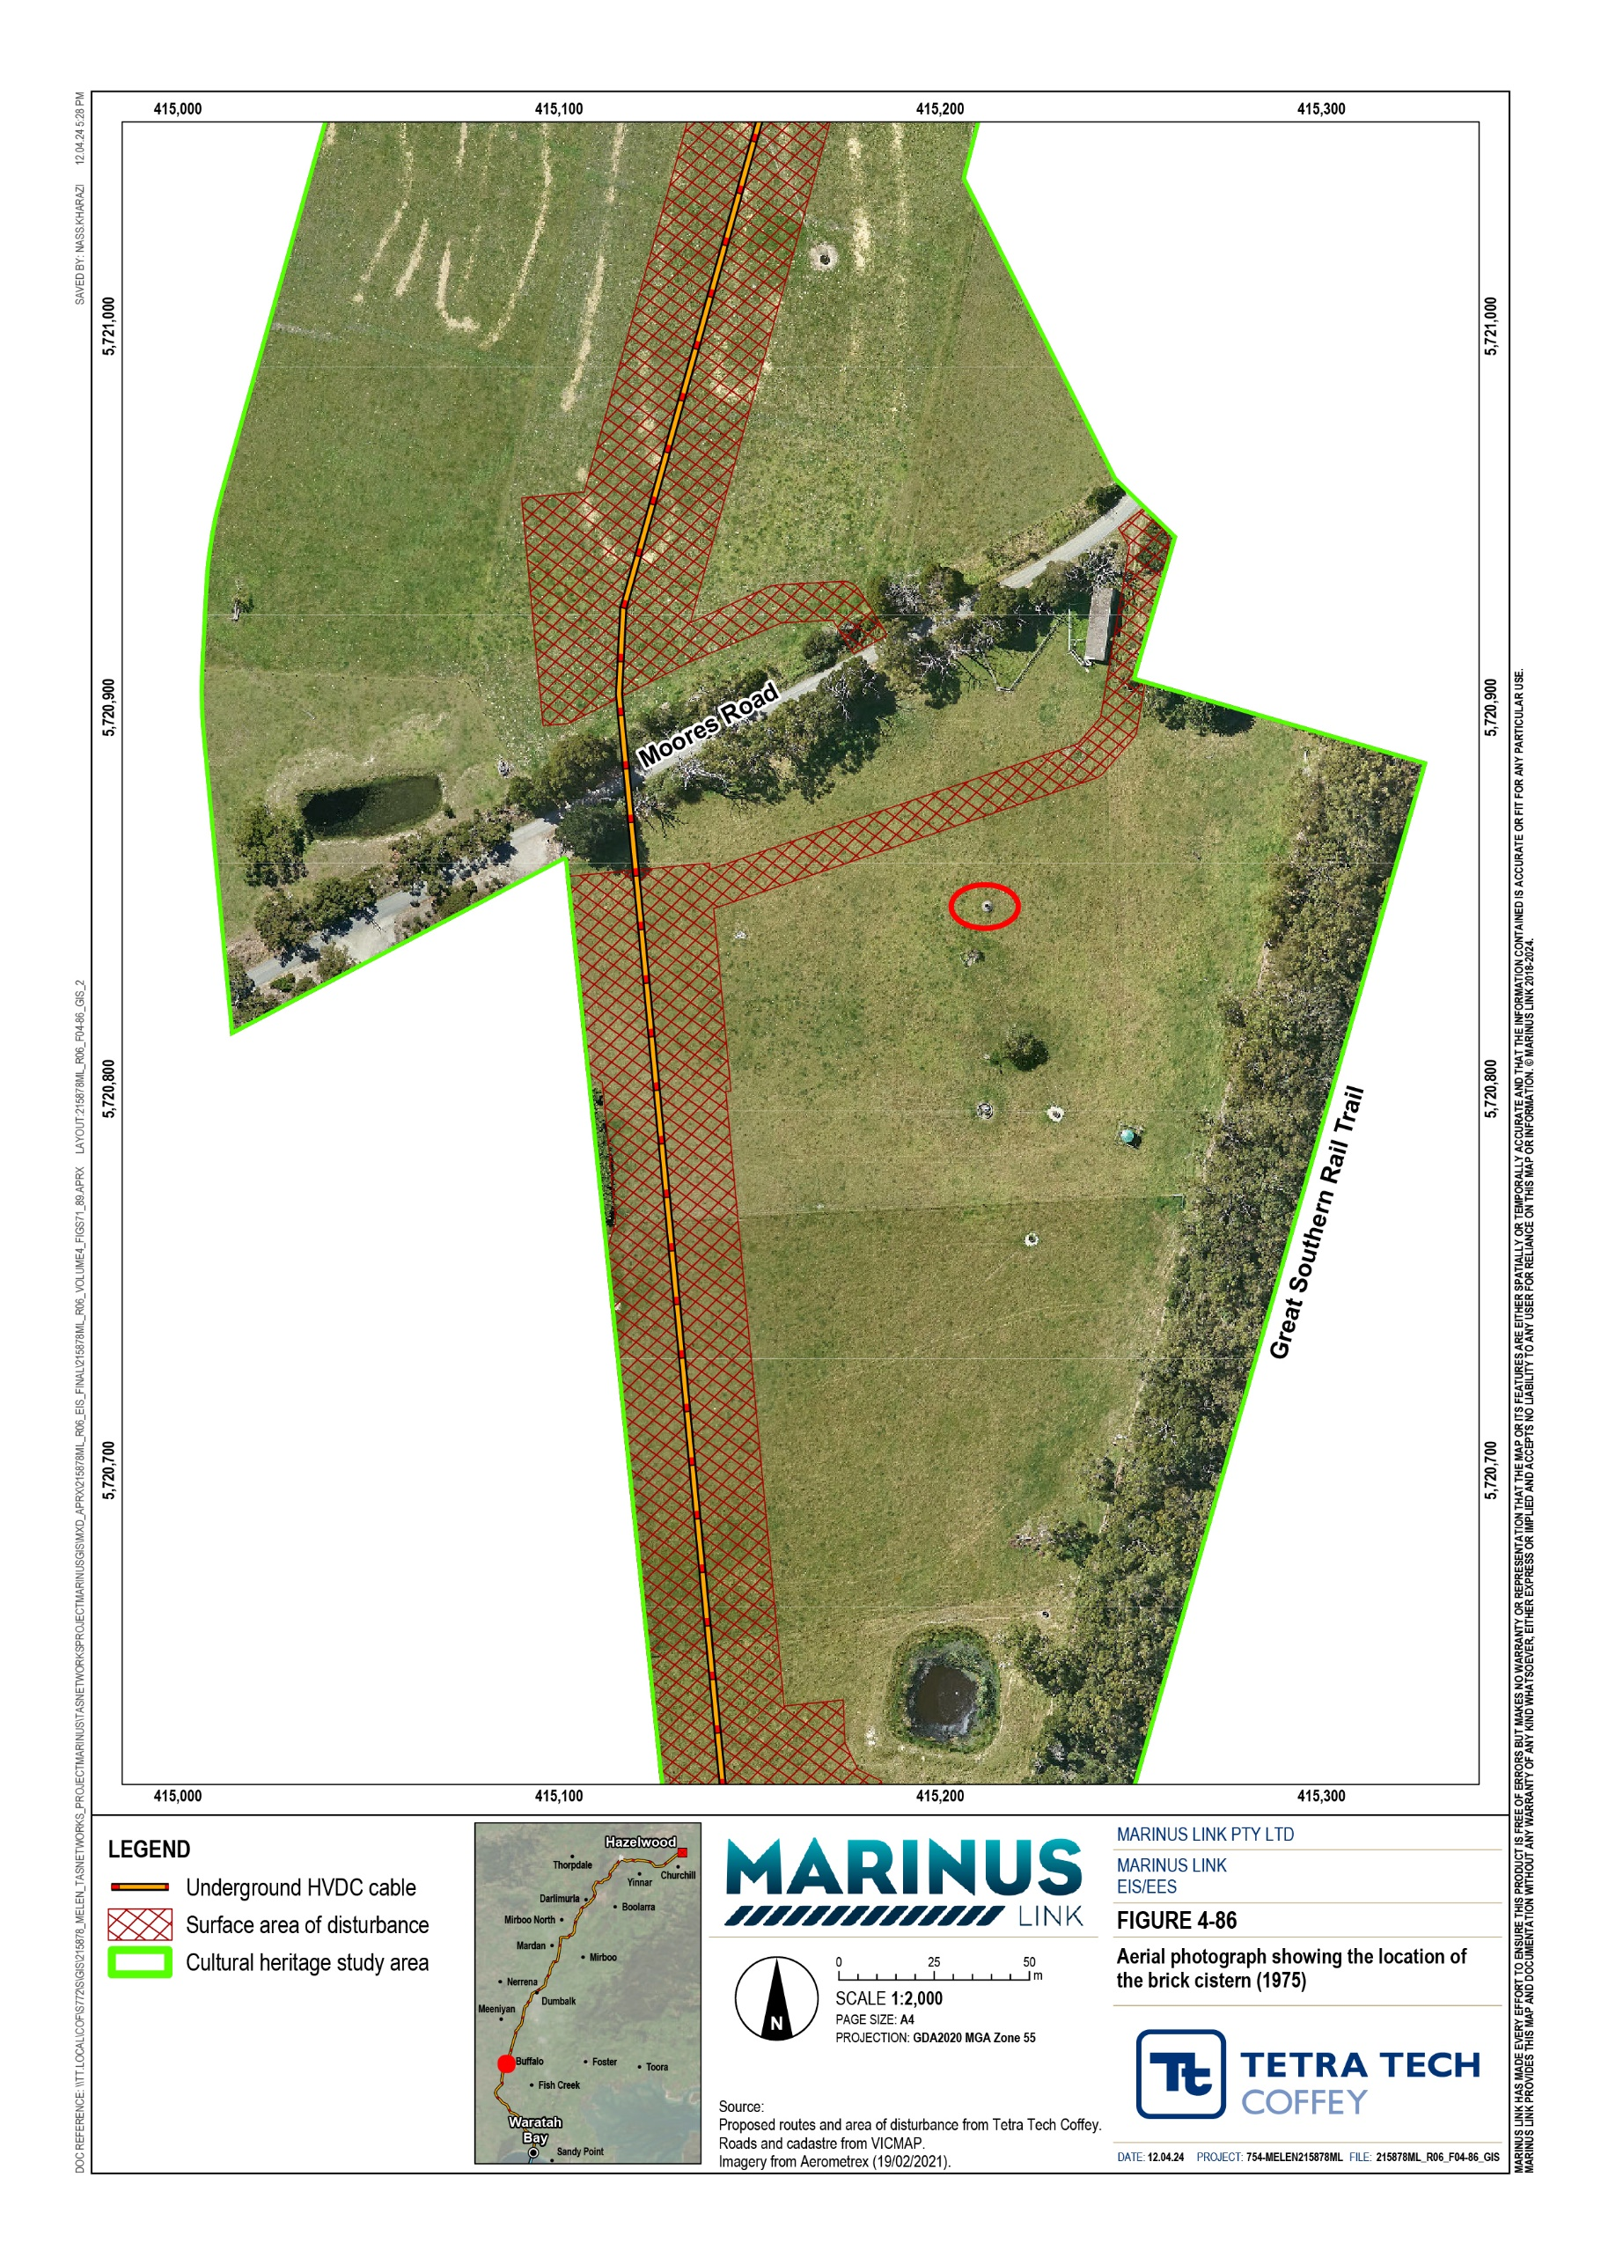

Summary of non-Indigenous heritage cultural values
The brick cistern was the only non-Indigenous cultural heritage value identified within the study area. The cultural significance rating of the brick cistern was determined by assessing its historical, scientific, social, and spiritual value, which were based on information collected during field work, and community interviews.
The cistern was determined to have a moderate cultural heritage significance. This was based on the following:
Low historical value, given it is not associated with any historical event, person or theme.

High scientific value, given it is one individual site with limited diversity, in relatively excellent condition, and is assessed to have a rare representativeness.
Low social and spiritual value, given it does not appear to have any clear social or spiritual connection at a local, state, or national level.

Construction impacts
While the brick cistern is not located within the AoD, it is within 50 m of the edge of the construction area and access road (Figure 4-7), and HDD under Moores Road. There is potential for impacts during project construction phase, in particular from vibrations generated by construction activities (trench excavations, HDD works, and vehicle or heavy machinery movements) within the AoD. Both the above and below-ground components of the brick cistern may be vulnerable to vibrations that can cause damage to the structure.
There is also potential for vehicles using the access track or construction workers in the vicinity to cause damage to the cistern.
Prior to the implementation of measures to comply with EPRs, construction activities may result in an impact rating of high for the brick cistern. This is based on the brick cistern’s moderate cultural heritage sensitivity and an impact magnitude rating of major.
Impacts to the cistern can be successfully mitigated through the implementation of measures to comply with EPR CH01, including setting up a barrier to protect the cistern site from direct impacts (with a suitable buffer), and monitoring for potential vibration impacts during construction activities to protect against indirect impacts. Contractors and employees will also undertake cultural awareness training and daily toolbox meetings that would reference the protection strategy for the cistern when working in the vicinity of the site. These measures will be documented in the historical heritage management plan (HHMP) prepared to comply with EPR CH01.
The HHMP will also include a protocol for managing unexpected finds, including archaeological features associated with the brick cistern. This will manage any potential impacts to newly identified non-Indigenous heritage along the project alignment (EPR CH01).

Operation impacts
Project operations could impact known and unknown non-Indigenous cultural heritage primarily through maintenance activities such as weed control, access track maintenance or excavation at joint pits for cable repairs.
Similar to impacts during the construction phase, both the above and below-ground components of the cistern will be vulnerable to vibrations generated by vehicle or heavy machinery movements or excavations (for cable repairs) in proximity to the cistern. Vibrations can damage both the structure of the cistern and the materials it is made from.
Prior to the implementation of measures to comply with EPRs, impacts on the brick cistern are assessed as having a high significance due to the value’s moderate cultural heritage significance and major impact magnitude.
Measures to protect the brick cistern (and any newly identified heritage values) during operation of the project will be documented in the HHMP (EPR CH01) and will be implemented when operation works occur in proximity to the identified values. The key mitigation for the brick cistern will be for a suitable barrier to be erected and in place for the duration of any works occurring in proximity to the cistern, and for contractors and employees to complete cultural awareness training prior to completing any works (EPR CH01).

Decommissioning impacts
The operational lifespan of the project is a minimum 40 years. At this time the project will be either decommissioned or upgraded to extend its operational lifespan.
Decommissioning will be planned and carried out in accordance with regulatory requirements at the time. A decommissioning management plan in accordance with approvals conditions will be prepared prior to planned end of service and decommissioning of the project.
Requirements at the time will determine the scope of decommissioning activities and impacts. The key objective of decommissioning is to leave a safe, stable and non-polluting environment, and minimise impacts during the removal of infrastructure.
Decommissioning of project infrastructure will implement the waste management hierarchy principles of avoid, minimise, reuse, recycle and appropriately dispose. Waste management will be in accordance with applicable legislation at the time.
Decommissioning activities may include recovery of subsea cables and removal of rock armouring or mattresses. Alternatively, the subsea cables may be left in situ. The conduits and shore crossing ducts would be left in-situ as removal may cause significant environmental impact.
Decommissioning activities are expected to impact the same areas as during construction. Therefore, the areas that may be impacted during decommissioning will likely have been previously disturbed and assessed during construction. Decommissioning activities also have less associated impact pathways than during construction.

If an impact on the brick cistern does occur it would be high, based on the brick cistern’s moderate cultural heritage significance and the major impact magnitude. Regarding unidentified non-Indigenous cultural heritage, assessments during construction are not expected to unearth all artefacts present Therefore, impacts to further non-Indigenous cultural heritage, while unlikely, are possible. Potential mitigation measures developed and documented in the HHMP for construction will also apply to the decommissioning phase, including implementation of unexpected finds protocols (EPR CH01).
A decommissioning management plan will be prepared to outline how decommissioning activities will be undertaken and potential impacts managed. The full EPR is provided in Volume 5, Chapter 2 – Environmental Management Framework chapter of the EIS/EES.

Environmental performance requirements
EPRs set out the environmental outcomes that must be achieved during all phases of the project. In developing these EPRs, industry standards and guidelines, good practice and the latest approaches to managing impacts were considered. Project specific management measures, relevant legislation and policy requirements informed these EPRs.
The EPRs that will be implemented to manage potential impacts on non-indigenous heritage are listed in Table 14-2.

EPR ID | Environmental performance requirement
CH01 | Develop and implement a historical heritage management plan to avoid and minimise impacts to historical cultural heritage values  Prior to commencement of project works prepare a historic heritage management plan. The plan must be prepared by a suitably qualified archaeologist in consultation with Heritage Victoria. The plan must include:  An unexpected finds protocol. Artefact and site recognition guide. Artefact and site recording standards.  Artefact management and retention protocol.  Measures to avoid impacts to the brick cistern located at Moores Rd, Buffalo, including:  - Confirmation of the cistern site’s boundary by a suitably qualified archaeologist.  - Installation of a barrier around the site when construction activities are in proximity to the site.  - Training to prevent access to the site by project employees and contractors.  - Reference to the site and protection measures in daily toolbox meetings when construction activities are in proximity to the site.  - Periodic inspections to confirm the barrier around the site remains in place.  - Monitoring during construction for vibration related impacts if required under the noise and vibration construction management plan prepared under EPR NV02.  Cultural awareness training.  Procedure for historical cultural heritage inductions to be delivered to all project staff and contractors managing or directly undertaking ground disturbing activities.  The plan must be implemented during construction.  As part of the OEMP, include measures to ensure protection of the brick cistern during operation.

In addition to the Non-Indigenous cultural heritage EPR, the other EPRs that would reduce the potential for traffic and transport impacts caused by the project for disciplines including:
Underwater cultural heritage (Volume 3, Chapter 4 – Underwater cultural heritage)

Noise and vibration (Volume 4, Chapter 10 – Noise and vibration)

Terrestrial ecology (Volume 4, Chapter 11 – Terrestrial ecology).

The complete list of EPRs for the project is provided in Volume 5, Chapter 2 – Environmental Management Framework for a full list of EPRs.

Residual impacts
Following successful implementation of measures to comply with EPRs, no residual impacts to the brick cistern will occur. This is based on the brick cistern being outside the AoD and implementation of measures to comply with EPRs resulting in impacts to the brick cistern during construction, operation and decommissioning being avoided (EPR CH01).
There is potential for residual impacts to unidentified non-Indigenous cultural heritage values. While the brick cistern is the only example of non-Indigenous cultural heritage identified during this assessment, there may be other features associated with the brick cistern in the vicinity. Impacts to features associated with the brick cistern, or any newly identified non-Indigenous cultural heritage features, will be avoided or mitigated by applying measures in line with the approved HHMP (EPR CH01). Table 14-3 shows a summary of the potential residual impact to the brick cistern.

Value | Initial impact assessment | EPR | Justification | Residual impact assessment
MR 1  Moores Road 1 Brick Cistern | High | CH1 | Confirmation of the site’s boundary and erection of site barrier will be done by an archaeologist.  Cultural training, daily toolbox meetings and compliance with a site specific HHMP. | Nil

Cumulative impacts
The following projects have been assessed for their cumulative impacts to non-Indigenous values due to their proximity to the project alignment and their potential to overlap with the project temporarily. The project and their level of impact individually are:
Delburn Wind Farm: very low SoTS: low
Hazelwood Rehabilitation Project: low to moderate WESS: very low.

Onshore wind farms, such as Delburn Wind Farm, typically have small impact footprints limited to access tracks and turbine locations. Delburn Wind Farm is located within a plantation so is unlikely to cause significant impacts to non-Indigenous cultural heritage.
SoTS may impact on non-Indigenous cultural heritage given its location in Gippsland and its construction method. However, the terrestrial aspect of SoTS intends to follow the previously assessed Bass Link cable alignment which reduces the potential impacts to non-Indigenous cultural heritage.
The Hazelwood Rehabilitation Project is assessed to have a low to moderate potential impact to non- Indigenous cultural heritage due to the Morwell Power Station and Briquette Factories, which are VHR listed buildings located within the Hazelwood Project Rehabilitation area. No VHR listed sites were identified associated with the other project areas based on review of public information.
WESS will be constructed within the existing Jeeralang plant. This confines its impacts to areas of previous disturbance and reduces the potential for future impact to non-Indigenous cultural heritage.
Considering the assessment of each individual project, the overall potential for cumulative impacts to non- Indigenous heritage is very low as the AoD does not interact and there are no identified VHR sites predicted to be impacted.

Conclusion
The desktop assessment and archaeological ground survey identified a single non-Indigenous cultural heritage site within the survey area. The surveys identified a brick cistern and assessed it to have moderate cultural heritage significance based on its low historical, social and spiritual value, and high scientific value.
The brick cistern could be directly impacted if activities such as vegetation removal, earth works, infrastructure construction and installation and the movement in the project’s workforce are not managed to avoid impacts. The pre-mitigated impacts to the brick cistern would be high for the construction, operation and decommissioning phases.
With the successful implementation of measures to align with EPR CH01, and given the brick cistern is outside the AoD, the residual impact of construction, operation and decommissioning phases of the project on this value is assessed as nil.
There is potential for unidentified non-Indigenous cultural heritage values to be present and impacted by the project. Impacts to newly identified values will be avoided or mitigated by applying measures in line with an approved HHMP (EPR CH01).
With the implementation of EPRs, the project will meet the EES evaluation objective to “Protect, avoid and, where avoidance is not possible, minimise adverse effects on historical heritage values, and tangible and intangible Aboriginal cultural heritage values, in partnership with Traditional Owners’.

