Land use and planning
This chapter provides an assessment of the land use and planning impacts associated with the construction, operation, and decommissioning of the project. This chapter is based on the impact assessment provided in Technical Appendix R: Land use and planning impact assessment.
The project will be located on freehold and Crown land that is used for a range of uses including residential, agricultural, forestry, commercial/rural industry, open space, tourism and community facilities. Land use impacts occur when a project has an effect on the form, ongoing function, amenity, or appearance of the existing environment and/or the character of a place or location.
There are no requirements in the EIS guidelines directly relevant to land use and planning. Refer to Attachment 1: Checklist - Guidelines for the Content of a Draft Environmental Impact Statement for the EIS guidelines.
The EES scoping requirements set out the following evaluation objective relevant to land use and planning:

Agriculture, land use and socio economic – Avoid and, where avoidance is not possible, minimise adverse effects on agriculture, forestry and other land uses, social fabric of communities, and local infrastructure, businesses and tourism.
Refer to Attachment 2: Checklist - Scoping Requirements Marinus Link Environment Effects Statement for the EES scoping requirements.
The land use and planning assessment considered the potential effects of the project on existing land uses and the consistency of the project with planning and land use policy. It also recommends EPRs to mitigate impacts.
Other aspects covered in the above evaluation objective are related to agriculture and social. These are addressed in the following EIS/EES chapters:
Volume 4, Chapter 6 – Agriculture and forestry

Volume 4, Chapter 16 – Social

Method
The land use and planning assessment has focused specifically on the impact of the project on land uses, namely the ability for land use to continue, consistency of the land use outcome with land use planning policies, and impacts on utility infrastructure.

Informed by the compliance and significance risk assessment methods described in Volume 1, Chapter 5 – EIS/EES assessment framework, the key steps taken in assessing the impacts to land use included:
Definition of a study area.

Desktop assessment and baseline data review, including review of relevant existing planning controls, planning schemes (including the Planning Policy Framework which comprises state, regional and local policy), relevant strategic planning documentation, relevant planning scheme amendments and planning permit applications.
A site inspection and review of publicly available aerial imagery.

Consultation with City of Latrobe and South Gippsland Shire councils.

Assessment of the potential land use and planning impacts during construction, operation, and decommissioning of the project using the significance and compliance methods described in Volume 1, Chapter 5 – EIS/EES assessment framework.
Development of EPRs in response to the impact assessment to set the required environmental outcomes for the project.
The assessment of residual impacts presented in this chapter assume implementation of measures to comply with the EPRs. Refer to Volume 5, Chapter 2 – Environmental Management Framework for a full list of EPRs.

Study area
The study area for this assessment extended approximately 90 km from the shore crossing at Waratah Bay to the converter station at Hazelwood. The study area consisted of land generally within and adjacent to the 220m project survey area which incorporated the:
cable construction corridor and laydown areas

converter station site at Hazelwood

HDD drill pad for the shore crossing at Waratah Bay and other HDD locations along the project alignment
proposed transition station site near Waratah Bay

10 m wide access tracks where required.

These areas form the extent of physical disturbance of ground, vegetation and watercourses required for the project, being the proposed area of disturbance.
Broader consideration was also given to significant land uses, known substantial developments and proposed planning scheme amendments outside the study area which have the potential to influence or be influenced by the project. Figure 4-87 provides an overview of the study area for the land use and planning impact assessment.

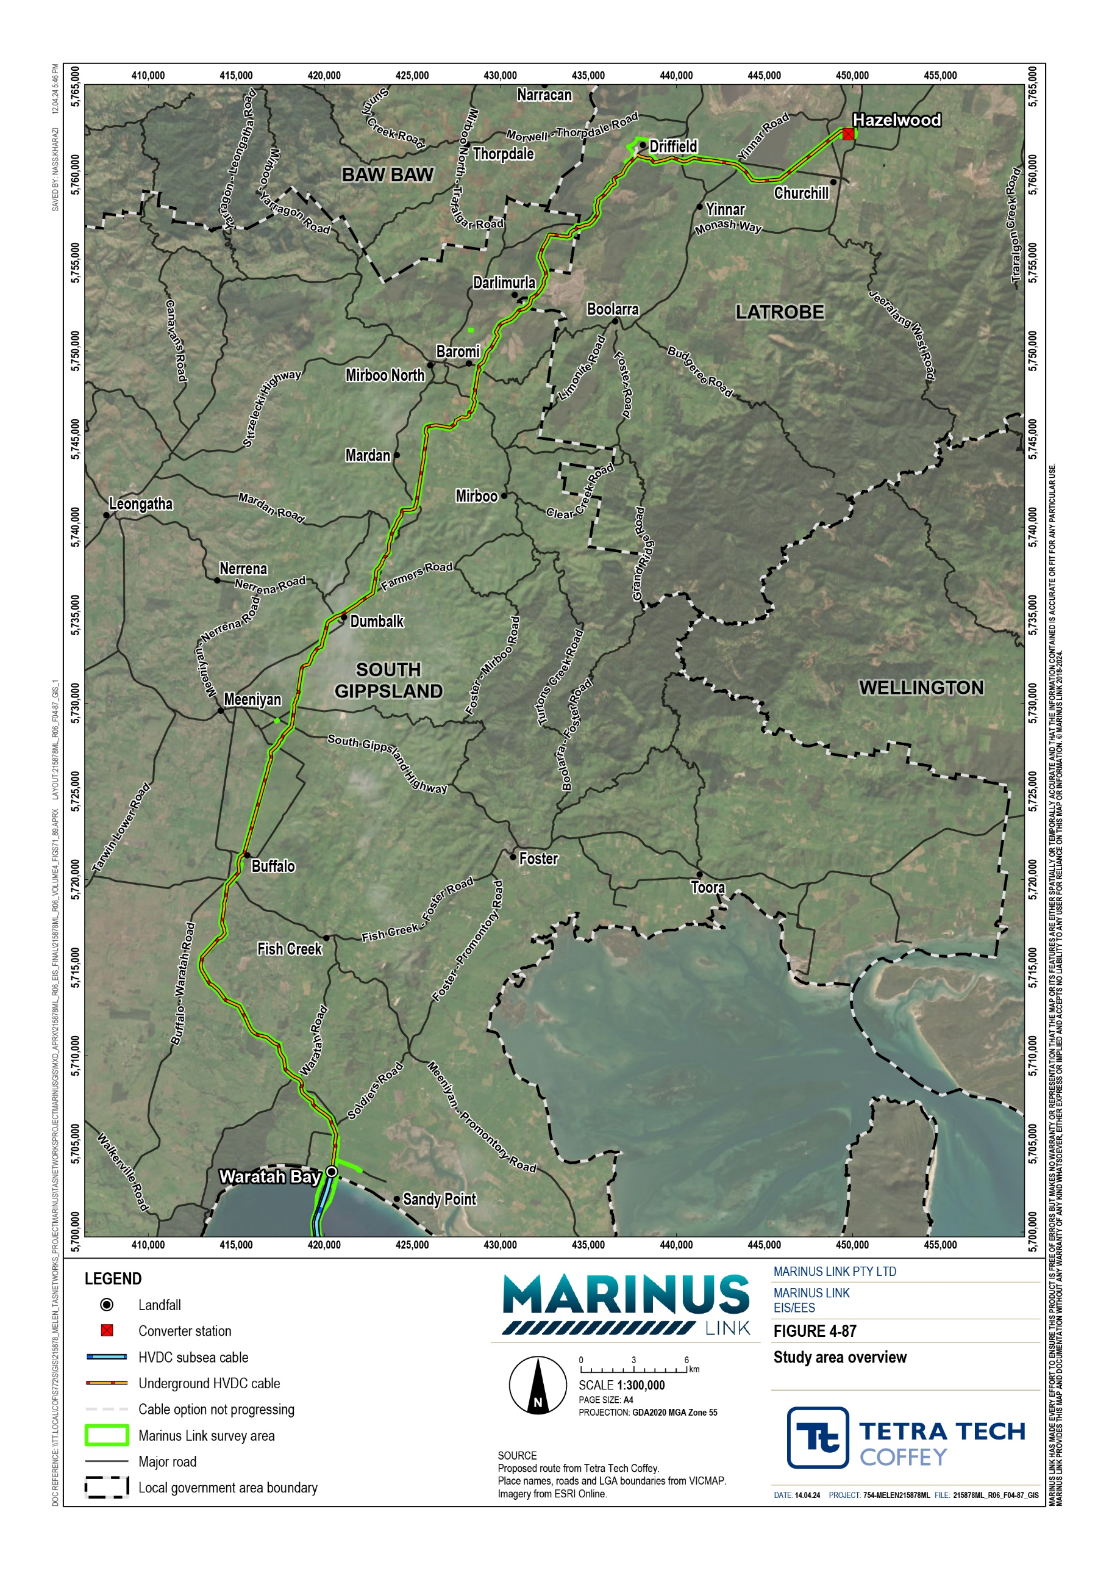

Legislative context
Table 15-1 outlines the key Victorian legislation that informed the land use and planning impact assessment.

Title | Relevance to the assessment
Planning and Environment Act 1987 (Vic) | Provides the framework for planning and managing the use, development, and protection of land in Victoria. Planning schemes under the provision of the act governs the process for approval pathways, including the preparation, approval, and adoption of planning schemes and planning scheme amendments by planning authorities.
Marine and Coastal Act 2018 (Vic) | As components of the project will be located offshore within Victorian waters and use sections of Crown land within 200 m of the high-water mark during construction, consent is required under the MAC Act from the Minister for Environment, Energy and Climate Action for any development and use on marine and coastal Crown land.  Following the Minister’s assessment of the EES, the appropriate consents and licenses will be sought, where required.

Assumptions and limitations
The land use and planning assessment has considered available planning scheme amendments and planning permit applications data exhibited/on notice from 12 December 2021, the date the project was announced. It has also considered relevant strategic land use policies published at the time of preparing the assessment in January 2023.
Planning is a specialist field which draws upon the outcomes of other technical studies such as those completed for this EIS/EES. The environmental, social, and economic issues that are addressed by planning policies contained with the relevant Planning Schemes have been considered within the other chapters of this EIS/EES.

Existing conditions
This section describes the existing conditions of the study area along the project alignment as it relates to land use.
The project is located across the municipal areas of the South Gippsland Shire and City of Latrobe and extends approximately 90 km from the shore crossing at Waratah Bay to the converter station at Hazelwood. The project from the high-water line at Waratah Bay to the Delburn area is within the South Gippsland Shire, and from Delburn to Hazelwood is within the City of Latrobe.
From the shore crossing the project extends northward within proximity of the localities of Buffalo, Stony Creek, Dumbalk, Mardan, Mirboo North-Baromi, Darlimurla and Delburn, Churchill and Hazelwood. The project route travels under coastal Crown land and is then primarily located in agricultural, rural living and forestry plantation land while bypassing key townships.

The project area is subject to the provisions of the South Gippsland and Latrobe Planning Schemes and the relevant land use policy is described in this section. The map book appended to Technical Appendix R: Land use and planning impact assessment, show the planning zones from the South Gippsland and Latrobe Planning Schemes.

Land use policy context
State planning policies and strategies providing guidance on land use within Victoria are summarised below.
The P&E Act provides the framework for land use and development in Victoria, where planning schemes are prepared for each municipality. The Victorian land component of the project will be located in the City of Latrobe and South Gippsland Shire and is therefore subject to the Latrobe and South Gippsland Planning Schemes. The provisions of each municipal planning scheme govern the use, development, protection, and conservation of land in that municipality. The assessment of land use impacts has considered both use and development with respect to land use impacts.
The Municipal Planning Strategy (MPS) within the South Gippsland Planning Scheme highlights that South Gippsland is a large rural municipality with a decentralised population, and the main agricultural land use is dairy farming and associated activities. Agriculture is expected to become increasingly important for the South Gippsland region where primary economic drivers include primary industries combined with associated activities and food processing. Areas in closer proximity to the coast have a greater focus on tourism, food and wine. Relevant to land use impacts, the MPS notes that Council seeks to:
Build on the region’s natural advantages and to provide the community with services and infrastructure that enhance liveability and environmental sustainability for current and future generations.
Maintain a viable and sustainable agricultural industry by protecting high quality agricultural land for primary production.
Encourage tourism use and development in association with the Great Southern Rail Trail and the Grand Ridge Rail Trail.
Although Latrobe Valley has one of the world’s largest reserves of brown coal, the MPS as set out in the Latrobe Planning Scheme states that Latrobe is experiencing a period of economic restructuring associated with the change in traditional employment sectors that support Victoria’s power production from coal.
Industry diversification and employment generation are major priorities for Latrobe and the Gippsland region, drawing on the extensive natural resource base, built infrastructure and local workforce. Most rural areas in Latrobe contain high quality agricultural land that supports dairy farming, broadacre farming and forestry.
Other industries in the area include food processing, engineering, health, and post-secondary education. Relevant to land use impacts, the MPS notes that Council seeks to:
Reduce bushfire risk through various bushfire protection measures; and decrease the level of risk to life, property, the environment and biodiversity from bushfire.

Acknowledge that the coal resource in the Latrobe Valley is of national and state importance and significantly contributes to the economy of Latrobe.
The Planning Policy Framework (PPF) as set out in the planning schemes comprises the state, regional and local planning policies relating to settlement, environmental values and risks, natural resource management, built environment and heritage, housing, economic development, transport and infrastructure. The PFF operates together with the remainder of the planning scheme to deliver integrated decision making. Each municipal planning scheme includes land use planning and environmental policies that are relevant to land use impact assessment of the project. The relevant aspects of the PPF and supporting strategic documents guide land use and infrastructure decisions. The other EIS/EES chapters provide detail on polices relevant to other considerations of the project.
The PPF clauses that are most relevant to the consideration of land use impact assessment for the project are:
Clause 11 Victoria includes key strategies of relevance at Clause 11.01-1S Settlement, which relate to provision of access to jobs, services, infrastructure and community facilities to promote investment and growth. Clause 11.02-1S Supply of urban land seeks to ensure that a sufficient supply of land is available for various uses as required, specifically identifying the need to ‘maintain access to productive natural resources and an adequate supply of well-located land for energy generation, infrastructure and industry.’ Clause 11.03-5S Distinctive areas and landscapes seeks to protect and enhance the valued attributes of identified distinctive areas and landscapes, and relevant strategies that support this objective include (as relevant) protecting ‘identified key values of and activities of these areas’, avoiding ‘use and development that could undermine the long-term natural or non-urban use of land in these areas’ and protecting ‘areas that are important for food production.’ These matters are assessed in Volume 4, Chapter 7 – Landscape and visual and Volume 4, Chapter 6 – Agriculture and forestry. Local policies for Churchill, Mirboo North, Buffalo, and Dumbalk are included in the respective planning schemes at Clause 11.01-1L.
Clause 12 Environmental and Landscape Values acknowledges ecological systems, biodiversity and conservation areas and includes policy to protect sites and features of nature conservation, biodiversity, geological or landscape value, as well as coastal environments, cultural values. Local policies in this Clause further highlight local environmental values including biolinks and roadside vegetation and habitats in Latrobe, and landscape values in South Gippsland. These matters are considered in the other relevant EIS/EES chapters including Volume 4, Chapter 11 – Terrestrial ecology, Volume 4, Chapter 2 – Geomorphology and geology, Volume 4, Chapter 7 – Landscape and visual, Volume 4, Chapter 13 – Aboriginal cultural heritage, and Volume 4, Chapter 14 – Non-indigenous cultural heritage.
Clause 13 Environmental Risk and Amenity provides overarching objectives which seek to strengthen the resilience and safety of communities by adopting a best practice environmental management and risk management approach. It includes policy relating to climate change, natural hazards and bushfire, erosion, floodplain, soil degradation, noise, and air quality. These matters are assessed in Volume 4, Chapter 3 – Contaminated land and acid sulphate soils, Volume 4, Chapter 4 – Groundwater, Volume 4, Chapter 5 – Surface water, Volume 4, Chapter 9 – Air quality, Volume 4, Chapter 10 – Noise and

vibration, and Volume 4, Chapter 12 – Bushfire. Some of the relevant policies include Clause 13.02-1S Bushfire Planning, Clause 13.07-1S Land use compatibility and Latrobe Clause 13.02-1L Bushfire Prone Areas. These policies emphasise the importance of ensuring that proposed land use and development is compatible with nearby and adjoining land uses and appropriately respond to bushfire risk.
Clause 14 Natural Resource Management seeks to assist in the conservation and wise use of natural resources including energy, water, land, stone and minerals to support both environmental quality and sustainable development. It includes policies for catchment management, which is assessed in Chapter 5 – Surface water. Also, to ensure that agricultural land is managed sustainably, while acknowledging the economic importance of agricultural production, which is assessed in Volume 4, Chapter 6 – Agriculture and forestry. This clause contains policy regarding the protection of coal resources which is relevant to parts of the study area. Some of the relevant policies include Clause 14.03-1S Resource exploration and extraction, Clause 14.03-1R Resource exploration and extraction - Gippsland Coal Resource, and Clause 14.01 Agriculture. Clause 14.01-1S Protection of agricultural land and Latrobe Clause 14.01-1L Protection of agricultural land are particularly relevant to land use considerations for the project, whereby they seek to avoid permanent removal of productive agricultural land from without consideration of the economic importance of the land for the agricultural production and processing sectors, and to protect productive agricultural land from impacts on noise, odour, sight lines and infrastructure and livestock movements. Latrobe Clause 14.01-3L Forestry and timber production includes the policies to avoid non-agricultural uses from locating or developing in a manner that will inhibit the expansion or operation of forestry uses.
Clause 15 Built Environment and Heritage recognises the role of energy and resource efficiency in delivering liveable and sustainable cities, towns and neighbourhoods. It also highlights that development should appropriately respond to its surrounding landscape, character and cultural context. Relevant policy includes Clause 15.01-6S Design for Rural areas, Clause 15.03-2S Aboriginal cultural heritage, South Gippsland Clause 15.01-1L-01 Urban design, where these matters are addressed in the Volume 4, Chapter 13 – Aboriginal cultural heritage and Volume 4, Chapter 7 – Landscape and visual.
Clause 19 Infrastructure states that planning should minimise the impact of development on the operation of major infrastructure of national, state and regional significance such as communication networks and energy generation and distribution systems. Planning for physical infrastructure should ‘enable it to be provided in a way that is efficient, equitable, accessible and timely’. Strategies in place to achieve these objectives include:
- Clause 19.01 Energy, and particularly Clause 19.01-1S Energy supply which seeks to facilitate appropriate development of energy supply infrastructure, by: Support the development of energy generation, storage, transmission, and distribution infrastructure to transition to a low-carbon economy; Develop appropriate infrastructure to meet community demand for energy services; Ensure energy generation, storage, transmission and distribution infrastructure and projects are resilient to the impacts of climate change; Support energy infrastructure projects in locations that minimise land use conflicts and that take advantage of existing resources and infrastructure

networks; Facilitate energy infrastructure projects that help diversify local economies and improve sustainability and social outcomes.
- Latrobe Clause 19.01-3L Pipeline infrastructure seeks to minimise risks associated with land use and subdivision within the measurement length of high pressure gas transmission pipelines.
- South Gippsland Clause 19.01-2L discourages structures associated with alternative energy production that detrimentally affect the character of the area and discourages tall structures on ridgelines or in view corridors.
Applicable zones and overlays within the study areas are show in the map book appended to Technical Appendix R: Land use and planning impact assessment. A review of the zone and overlays was completed to identify the current baseline land use patterns and potential development outcomes to understand the potential land use-related impacts of the project. Due to the significant length of the project alignment, it is subject to a wide range of zone and overlay controls and approval requirements. An overview of planning permit triggers associated with the project is provided in Technical Appendix R: Land use and planning impact assessment. These triggers are also included as part of the draft Planning Scheme Amendment.
Particular and General Provisions relevant to the project are further discussed in the Planning Scheme Amendment Strategic Assessment (refer to Attachment 3: Planning Scheme Amendment).
Clause 50 Particular Provisions apply to a range of matters in addition to zone and overlay requirements.
Their purpose is to provide an additional level of guidance to land use and development outcomes. Particular Provisions considered relevant to the project include:
Clause 52.02 Easements, Restrictions and Reserves

Clause 52.06 Car Parking

Clause 52.17 Native Vegetation

Clause 52.29 Land Adjacent to the Principal Road Network

Technical Appendix R: Land use and planning impact assessment and the draft Planning Scheme Amendment (Attachment 3) expand upon these provisions.
Clause 60 General Provisions relate to the administration of planning schemes, existing uses, decision guidelines and the referral requirements for planning applications amongst other matters. General Provisions relevant to the project include:
Clause 62.01 Uses Not Requiring a Permit
Clause 62.02-1 Buildings and works not requiring a permit and Clause 62.02-2 Building and works not requiring a permit unless specifically required by the planning scheme
Clause 66 Referral and Notice Provisions

Technical Appendix R: Land use and planning impact assessment and the draft Planning Scheme Amendment documentation expands upon those provisions.

While Latrobe Council and South Gippsland Council are responsible for administering the respective Planning Schemes, Clause 72.01-1 notes that the Minister for Planning is the responsible authority for matters under Divisions 1, 1A, 2 and 3 of Part 4 of the P&E Act (and matters required by a permit or the scheme to be endorsed, approved or done to the satisfaction of the responsible authority), in relation to the use and development of land for a utility installation used to transmit or distribute electricity or for a utility installation used to store electricity if the installed capacity is 1 MW or greater. This will apply to the project and has been reflected in the draft Planning Scheme Amendment.
A number of State and regional policies are also relevant to the project and the Study Area. These include:

Coastal Spaces Landscape Assessment Study 2006

Marine and Coastal Policy 2020

Siting and Design Guidelines for Structures on the Victorian Coast 2020

Marine and Coastal Strategy 2022

Victoria’s Climate Change Strategy 2021

Water for Victoria 2016

South Gippsland Rural Land Use Strategy 2011

Strong, Innovative, Sustainable: A new strategy for agriculture in Victoria 2020Victoria’s Regional Statement 2015
Guidelines for the removal, destruction or lopping of native vegetation 2017

Gippsland Regional Plan 2020-2025

Victoria’s Infrastructure Strategy 2021-2051

Land use
The study area has been described in three segments which are relatively distinct in terms of land use. These segments are Waratah Bay to Baromi, Baromi to Driffield and Driffield to Hazelwood, and are illustrated on Figure 4-88.
For the first two segments from the shore crossing at Waratah Bay to Driffield the land use is agricultural, forestry plantations and conservation. For the third segment between Driffield and Hazelwood the land use is agriculture and rural living. Tourism is a land use that also occurs across the whole study area in the form of accommodation, rail trails and the attraction to coastal and conservation areas. Technical Appendix R: Land use and planning impact assessment includes mapping of key land uses and their locations within the study area.

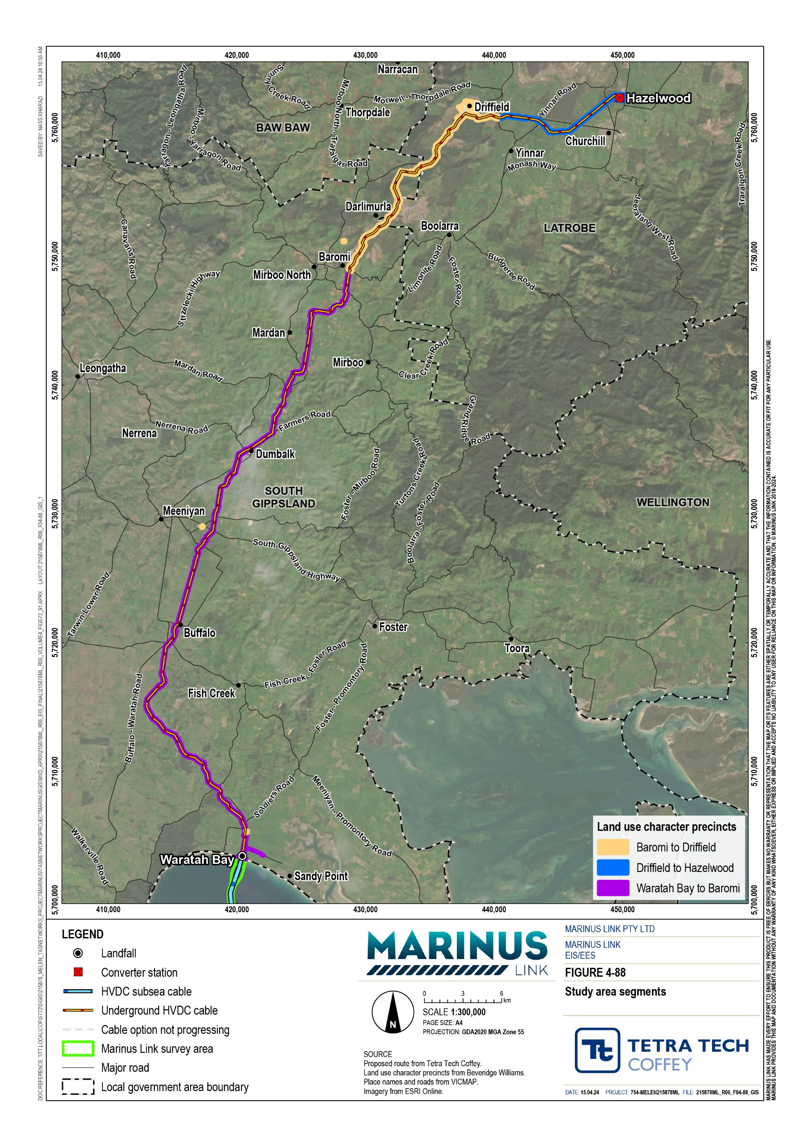

This segment extends from the high-water mark at Waratah Bay to approximately 55 km north to the eastern side of the townships of Mirboo North and Baromi. This segment is entirely within the South Gippsland Shire and includes the townships of Buffalo, Meeniyan, Stony Creek, Dumbalk, Mirboo North and Baromi.
This segment is primarily characterised by agricultural land uses including dry land cropping, horticulture, grazing and dairying, with associated infrastructure including dams, stock yards, water tanks, agricultural sheds and access tracks. Several dairies are located proximate to the survey area including along Waratah Road, Duncans Road, and Meeniyan-Mirboo North Road north of Dumbalk. An existing dairy adjacent to the incline of Meeniyan-Mirboo North Road is currently undergoing a significant redevelopment / expansion.
Dwellings located outside but proximate to the survey area are sparsely located through this segment and are mostly associated with agricultural activities. The project alignment will pass nearby the townships of Buffalo and Dumbalk. Some dwellings will be proximate to, although outside the proposed area of disturbance and operational easement.
The project has been designed to align with key features of the built and natural landscape where possible, including topographical features, fence lines and key roads. Within this segment, the alignment crosses several waterways including Little Morwell River, Fish Creek, Berrys Creek, Buffalo Creek, and Tarwin River East. It also crosses arterial roads including Waratah Road, Meeniyan-Promontory Road, Meeniyan-Mirboo North Road, Nerrena Road, and Boolara South-Mirboo North Road, and the South Gippsland Highway.
Several local roads are also intersected, and several proposed access tracks will utilise private roads / driveways.
From the shore crossing at Waratah Bay the project extends through the Waratah Bay-Shallow Inlet Coastal Reserve to the communications building (and potential transition station) location within adjoining freehold agricultural land. The beach is publicly accessible from Waratah Bay and Sandy Point with the nearest beach access being approximately 1.5 km west of the alignment. Cape Liptrap Coastal Park is also located to the west and Wilsons Promontory to the east of the study area.
Visitor accommodation in this segment is outside of the survey area and includes the Prom Coast Holiday Lodge (hotel accommodation) on Waratah Road near Soldiers Road, Benwerrin House on Eastaways Road near Fish Creek, and Maple Ridge Cottages accommodation are located on Meeniyan-Mirboo North Road north of Dumbalk.
The project is near the Great Southern Rail Trail at Buffalo, where it follows the alignment of the Rail Trail between Buffalo and Stony Creek. The project also crosses an off-road bike path at Stony Creek-Dollar Road.

The Baromi to Driffield segment of the study area is located in both South Gippsland and Latrobe municipalities. It is characterised by large tracts of Strzelecki State Forest and timber plantation on both sides of the Strzelecki Highway and Darlimurla Road. The project alignment generally follows the Strzelecki Highway in a north-easterly direction towards Driffield.
Timber production is generally carried out by Hancock Victoria Plantations Holdings Pty Ltd (HVP) which operates on a few freehold land holdings and under a license on several Crown allotments.
To the east of Darlimurla, the alignment crosses the Grand Ridge Rail Trail and the Little Morwell River. Several rural residential properties are proximate to the survey area in this location, and there is also a wildlife sanctuary to the north of the river crossing.
The survey area also includes proposed infrastructure for the Delburn Windfarm. The windfarm includes a visitor information centre with associated car park and an operations and management facility which is partly within the survey area, and the survey area is adjacent to proposed turbine T16.
A coal mining licence and several basalt quarries affect land outside and to the north of the survey area at Driffield.
This segment includes the converter station site at Hazelwood and is located entirely within the City of Latrobe.
This segment includes the HVP plantations and land predominantly used for smaller allotment-based agriculture, including hobby farming, rural residential living, grazing and cropping. Some properties in this area are used for equestrian activities, including the Hazelwood Lodge riding school (outside but proximate to the survey area) and a horse racing/training business on Silcocks Road. The alignment crosses the Morwell River west of Yinnar Road and Eel Hole Creek to the east of the Hazelwood Pond. The Hazelwood Pondage (part of the decommissioned Hazelwood Power Station cooling pond) and former Caravan Park site are located north of Switchback Road outside the survey area.
There is existing transmission infrastructure including the Hazelwood terminal station that are part of the Victorian electricity network located in this segment. The Hazelwood converter station location forms the northernmost extent of the project survey area and is located immediately to the south of the Hazelwood terminal station.
The Hazelwood converter station is located within an area zoned in the Latrobe Planning Scheme as Special Use Zone – Schedule 1 (Brown Coal) (SUZ1), and which applies to a large region west and south of Morwell. This zone contains provisions which facilitate land uses associated with brown coal mining, electricity generation and supporting non-urban use and development.

Land tenure
The study area contains primarily freehold land with 159 privately owned freehold land parcels that will be affected by the proposed project easement. Many of the landholders hold multiple adjoining allotments within the survey area and several parcels often make up a property.
Of the freehold land within the survey area, several allotments are held by private interests such as HVP Plantations and its subsidiaries, as well as MLPL. One is owned by government namely Central Gippsland Region Water Corporation. The balance of freehold land within the survey area is owned by approximately 74 individuals and 15 business entities. Of these, 74 individuals and 13 business entities will be affected by the easement.
Many of the freehold titles are already affected by easements associated with power generation and transmission, drainage, water supply and gas transmission. Several roads, carriageway and right of way easements also affect land within the study area and are generally in favour of properties nearby or adjacent to those on which they are registered.
Delburn Wind Farm Pty Ltd have a caveat over 17 land parcels associated with proposed works for the Delburn Wind Farm project, 10 of which will also be affected by the project easement. Three additional caveators are affected by the survey area with three of these to be affected by the easement. Ten land parcels within the survey area are subject to a S173 agreement, 9 of which are affected by the proposed easement and where generally these agreements restrict the further subdivision of land.
The project also intersects several Crown land parcels, mostly being Government roads (both made and unmade), as well as both reserved and unreserved Crown land parcels. Figure 4-89 illustrates the location of Crown land in the study area. The largest areas of Crown land in the study area are between Baromi and Driffield, within the south-eastern parts of the Strzelecki State Forest and where the land is used for timber production under license by HPV. Between Buffalo and Stony Creek, the project follows a Crown land reserve incorporating part of the Great Southern Rail Trail, and east of Darlimurla, the alignment crosses Crown land comprising part of the Grand Ridge Rail Trail.
Parts of the project alignment will pass through Crown land that is subject to the Gunaikurnai Settlement Indigenous Land Use Agreement (ILUA) covering approximately 13,390 km² over parcels where native title has been affirmed. Any activities that may affect native title rights and interested are ‘future acts’ under the Native Title Act 1993 (Cwlth) and will need to adhere to specified procedures under the ILUA.
In 2010, acknowledging the difficult nature of having native title determined under the Native Title Act, the Victorian Government developed an alternate system for recognising the rights of Victorian traditional owners. The Victorian Traditional Owner Settlement Act 2010 allows the government and traditional owner groups to make agreements that recognise traditional owners' relationship to land and provide them with certain rights on Crown land. A Recognition and Settlement Agreement has been made between the State and the Gunaikurnai people, which outlines:
Orders by the Federal Court recognising that the Gunaikurnai people hold native title in the settlement area.

An agreement for some national parks and reserves to be granted as Aboriginal title to the Gunaikurnai to be jointly managed with the State.
Rights for Gunaikurnai people to access and use Crown land for traditional purposes, including hunting, fishing, camping and gathering in accordance with existing laws.
Funding for the Gunaikurnai to manage their affairs, including responding to their obligations under the settlement.
A Traditional Owner Land Management Agreement, which establishes the Gunaikurnai Traditional Owner Land Management Board to jointly manage ten national parks and reserves in the agreement area.
The Recognition and Settlement Agreement area covers the same area as the ILUA. Both the Agreement and the Native Title determination only affect Crown land within this area.
As of 20 December 2022 (time of writing the Planning and land use assessment) there are no Land Use Activity Agreements (LUAA) applying to the study area listed on the Register of Land Use Activity Agreements under the Traditional Owner Settlement Act 2010.

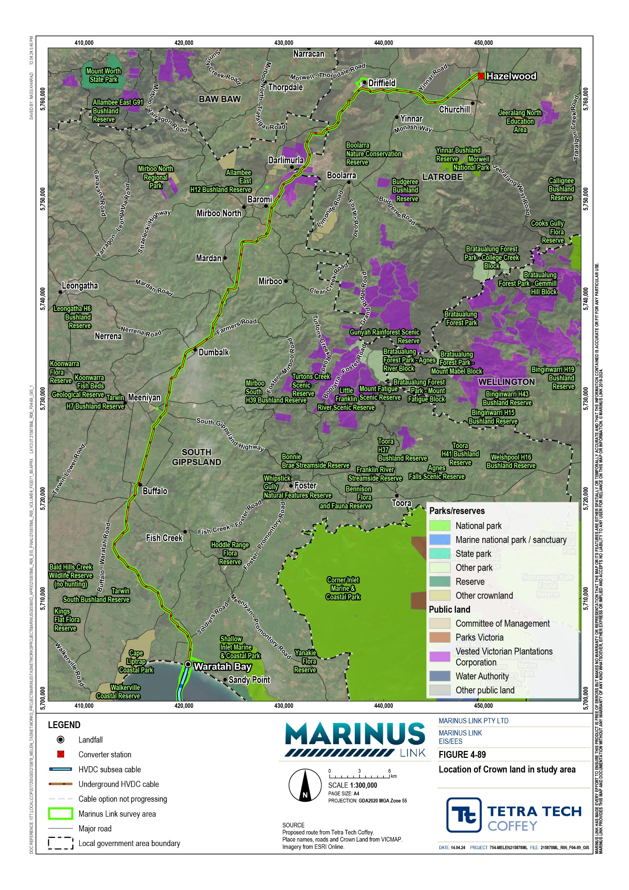

Infrastructure
Several significant infrastructure assets are located within and nearby to the study area. The South Gippsland and Latrobe regions support energy generation and related activities due to the region’s natural features and the planning policy which supports the economic benefits derived from these uses.
High voltage overhead electricity transmission lines are located through the northern segment of the study area between Driffield and Hazelwood. The existing overhead high voltage powerline corridor crosses the Strzelecki Highway and the project alignment to the east of Strzelecki Highway and again at Frasers Road. The Hazelwood terminal station and Jeeralang power station are located to the north of the Hazelwood converter station site. Major overhead powerlines also cross the project south of Baromi and southwest of Dumbalk, while minor powerlines can be observed throughout the study area.
Local power supply and telecommunications infrastructure is notably more visible and concentrated in the Driffield to Hazelwood segment of the study area, reflecting a greater concentration of the use of land for residences.
Approximately 1.6 km to the east of the shore crossing is a Telstra optic fibre and transmission cable which stretches across Bass Strait and provides communications capacity to Tasmania. The project alignment crosses the Telstra cable twice along Waratah Road. Several low impact mobile telecommunications facilities are located adjacent to arterial roads within the study area in the Waratah Bay hinterland.
Underground telecommunications infrastructure was observed in multiple locations in the study area, generally along fence lines and road corridors, and the alignment crosses this infrastructure at a number of road crossings.
High pressure gas mains are located to the south of Hazelwood Cooling Pond where the survey area is in proximity to the pipeline near Yinnar Road. The project crosses the gas pipeline south of Switchback Road near Frasers Road, and again north of Switchback Road to the east of the Cooling Pond.
A detailed utility services search will need to be undertaken prior to construction as part of detailed design of the project, to identify any additional minor or localised infrastructure that may be impacted by the project.
This will be included in the Construction Environmental Management Plan prepared for the project.

Figure 4-90 illustrates the major infrastructure located within the study area. A detailed description of road and rail and other transport infrastructure is provided in Volume 4, Chapter 8 – Traffic and transport.
Community infrastructure is considered within Volume 4, Chapter 16 – Social.

Volume 4 – Victorian terrestrial environment Page 15-16

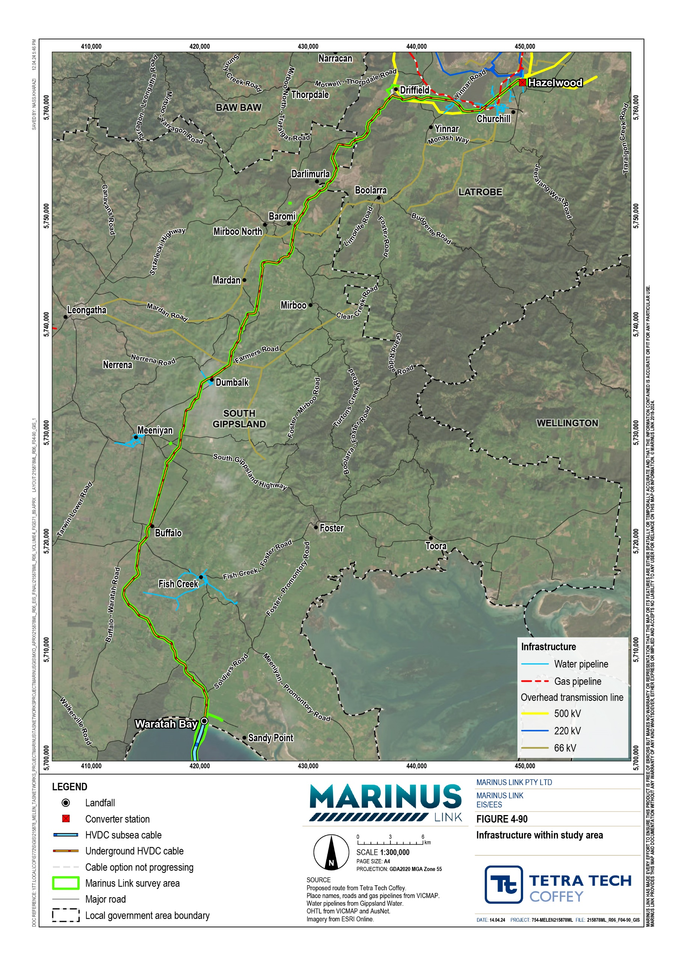

Planning policy
The provisions of each municipal planning scheme govern the use, development, protection, and conservation of land in that municipality. The planning schemes and policy for both South Gippsland Shire and Latrobe City considers the development and delivery of energy supply infrastructure.

Planning approval approach
Under the provisions of the planning schemes of the South Gippsland Shire and Latrobe City Council, a planning permit would be required for various aspects of the project. Permits would be required for use (ongoing use of land for a utility installation), and development (buildings and works including construction of infrastructure, earthworks, access, subdivision / creation of easements, removal of vegetation).
The proposed planning approval pathway for the project is by a Planning Scheme Amendment (Attachment 3: Planning Scheme Amendment) rather than by obtaining separate planning permits within
each council area in response to the planning scheme triggers. Through the Planning Scheme Amendment, a Specific Controls Overlay (SCO) will be applied to the project area and apply specific controls for the project that are specified in an Incorporated Document. This approach enables a project specific and integrated planning approval to consistently apply across the whole project in both council areas to facilitate use and development for the purposes of the project. The Planning Scheme Amendment will provide a single planning approval for the project. The Minister for Planning has agreed to the preparation of a draft Planning Scheme Amendment for the Victorian components of the project, and for it to be exhibited with the EIS/EES (Refer to Volume 1, Chapter 4 – Legislative framework).
The SCO applies to a wider area than is required for the easement, to allow for variations to the alignment through detailed design, ongoing landholder consultation and to ensure that ancillary works are captured in the approval facilitated by the Incorporated Document. Volume 5, Chapter 2 – Environmental Management Framework outlines the different areas within the SCO and how alignment changes within the SCO are approved. The SCO does not prohibit or restrict the use or development of land beyond the controls that are proposed to facilitate the project.

Consistency with planning policy
The development of energy supply infrastructure in the Gippsland region is supported by state and local planning policy in the South Gippsland and Latrobe Planning Schemes.
Victorian Government planning policy as set out in the Victoria Planning Provisions (DTP 2022) is to “minimise the impact of use and development on the operation of major infrastructure of national, state and regional significance, including… energy generation and distribution systems” (Clause 19). Further, planning for physical infrastructure should ‘enable it to be provided in a way that is efficient, equitable, accessible and timely’ (Clause 19). In particular, the state policy as set out in the Victoria Planning Provisions (DTP 2022) seeks to facilitate appropriate development of energy supply infrastructure, through the implementation of the following strategies:
Support the development of energy generation, storage, transmission, and distribution infrastructure to transition to a low-carbon economy.
Develop appropriate infrastructure to meet community demand for energy services.
Ensure energy generation, storage, transmission and distribution infrastructure and projects are resilient to the impacts of climate change.
Support energy infrastructure projects in locations that minimise land use conflicts and that take advantage of existing resources and infrastructure networks.
Facilitate energy infrastructure projects that help diversify local economies and improve sustainability and social outcomes.
The project supports Victoria’s Climate Change Strategy 2021 whereby the State’s vision is to achieve net- zero emissions by increasing energy efficiency and productivity, moving to a clean electricity supply, electrifying the Victorian economy, switching to clean fuels, reducing non-energy emissions and increasing carbon storage. The project also supports Victoria’s Infrastructure Strategy 2021-2051, whereby Marinus Link is specifically identified as a key project in providing access to, and supporting, renewable energy development in Victoria and assisting in meeting the net zero emissions goal.
The project is consistent with the policies of the South Gippsland Shire Planning Scheme as:
The project builds upon on the region’s natural advantages with regards to access to renewable energy and energy transmission infrastructure, and locational advantages on Bass Strait close to Tasmania, to provide the broader community with services and infrastructure that enhance liveability and environmental sustainability for current and future generations.
The project design has considered locally significant views and vistas that contribute to the character of the coast and coastal hinterland region, noting that the project will be primarily underground.
The project minimises disruption to the agricultural industry through project staging and access agreements with landholders, and by placing the infrastructure underground, maintaining high quality agricultural land for primary production.
The project minimises impacts to tourism values including the coastline, rural landscapes, accommodation, the Great Southern and Grand Ridge rail trails.

The project is consistent with the policies of the Latrobe City Council Planning Scheme as:

The project has sought to reduce bushfire risk through design measures.

The project has sought to minimise impacts on high quality agricultural land that supports dairy farming, broadacre farming, forestry, rural residential living, tourism, niche rural industry and small-scale farming operations.
The project will not prejudice the use of brown coal reserves and supports the transition to cleaner energy production.
Consistent with planning policy, the sensitive environmental, social, cultural, and economic values of the region have been avoided and impacts reduced in the design of the project. This has been achieved through careful route selection and refinement to avoid sensitive areas and assets, detailed assessment of potential impacts, community and landholder engagement, and agency and stakeholder consultation. Further implementation of the Environmental Management Framework and the EPRs will enable impacts to sensitive environmental, social, cultural, and economic values to be managed consistent with planning policy.

Construction impacts
Construction of the project will result in temporary changes to land use. The key impacts to land use and land use character during construction occur due to:
temporary occupation of land

amenity impacts caused by construction activities, and

changes to access.

A 20 to 36 m wide construction corridor is required for the project alignment, haul road, minor laydown areas and temporary facilities to support construction. There will also be approximately seven larger laydown areas adjacent to the construction corridor. The project alignment and area of disturbance has been located to avoid dwellings, commercial buildings, and rural industry infrastructure. To minimise disturbance to sensitive environments the width of the construction area has been reduced to 20 m in some locations. Further refinement of the alignment is likely during the detailed design stage that may reduce the area of disturbance and extent of land temporarily occupied for the construction.
Short-term impacts on existing land use (e.g., through visual amenity impacts, noise, dust, vibration, traffic) and the natural environment (e.g., land clearance/disturbance) during construction will result in temporary changes to existing land uses. These short-term impacts are considered in the context of their impact on an existing or proposed land use remaining viable.

Agriculture and rural industry
The occupation of land for construction purposes will be temporary and limited to a small portion of the overall landholdings. The construction corridor typically follows property boundaries, existing access tracks or other infrastructure, however there are instances throughout the study area where the alignment bisects properties. Laydown areas are proposed to be located on the edge of large agricultural properties, where the temporary occupation during construction will not impact the ongoing use of the balance of the land for agriculture. EPRs require that the project be designed to further minimise the construction footprint and impact on existing land use.
The construction of the project will result in localised changes to the way that individual land holders utilise their land, however existing agricultural land uses will be able to continue during the construction phase albeit in a modified way. Construction will be managed to minimise disruption to existing land use. While the construction area will be fenced, the project will provide for crossings of the alignment by stock and machinery where required by and in negotiation with the landholder. Affected landholders will be compensated for the occupation of their land for construction. With the implementation of the Environment Management Framework and EPRs, the residual impact to agricultural land use because of construction is low.
The transition station (if it is required) will be located on agricultural land which will be permanently removed from agricultural production. The area is small in the context of the wider landholding, and the proposed works are located along the property boundaries. It is expected that the size of the balance of the site will remain viable for the existing and permitted agricultural land use (refer Volume 4, Chapter 6 – Agriculture and forestry).
Where possible, existing roads and access tracks will be utilised by the project during the construction phase, however most of the proposed project alignment is not directly accessible via existing roads. The utilisation of private land for access tracks will remove some land from agricultural use during construction. Where access roads for the project are required to be upgraded or created these will be removed from private property at the completion of construction to the extent required, unless otherwise determined in consultation with the landholder. In this way, the land use change caused by the use of land for access, will be a temporary short-term impact, unless deemed to be of ongoing benefit by the landholder (refer
Volume 4, Chapter 6 – Agriculture and forestry).

Forestry plantations
The project will remove some productive forestry plantation area from use during construction of the cable. The project alignment has followed existing roads and access tracks where possible through the plantation to minimise impacts. While the project may result in the loss of approximately 41 ha of plantation land during construction, it is a small part of a significantly larger forestry area of approximately 81,000 ha in Gippsland. The project alignment has also been located along existing access tracks and site boundaries where possible to minimise impacts. EPRs require that the project be designed to further minimise the construction footprint and impact on existing land use. The loss of this area of the plantation will not affect the viability of the forestry operations and operations are expected to be able to be maintained on surrounding land throughout construction with the implementation of measures to comply with EPRs (refer Volume 4, Chapter 6 – Agriculture and forestry).

Brown coal resources
The project is not expected to have any impact on brown coal resources or extraction activities during construction. While part of the study area is zoned for brown coal extraction and is of State significance, the project impacts a limited part of the overall brown coal resource area. Approximately 264 ha of the SUZ1 for brown coal is located within the project survey area and 54 ha of this is located within the project area of disturbance. The project is not located within, adjacent or proximate to any existing mine, and does not affect any existing or licence or work authority.

Township and rural residential
In locations closer to townships, such as Baromi, Buffalo, Dumbalk, and for some agricultural properties, amenity impacts from construction may be experienced at residential dwellings. Amenity impacts associated with noise, vibration, air quality, access and visual impacts are considered in other chapters. These impacts will be localised and temporary for the duration of construction and will not result in any change to land use.
The changes, particularly those to the noise environment and visual amenity, will be noticeable to residents during the construction phase of the project. Mitigation measures for amenity impacts will be implemented to comply with EPRs (refer Volume 4, Chapter 11 – Noise and vibration and Volume 4, Chapter 8 – Landscape and visual) however the magnitude of changes may be perceived by some residents to be negative and intrusive (refer Volume 4, Chapter 17 – Social).
Construction will be managed to minimise disruption to the use of land that the project is located on. Landholders will be compensated through leases or access agreements for the temporary occupation and use of their land for construction including construction laydown areas.

Tourism and recreation
The project alignment comes ashore at Waratah Bay where the is a crown land reserve used for recreational purposes. The shore crossing is located approximately 1.5 km from the nearest public access point, and some distance from the Sandy Point and Waratah Bay townships. The beach at Waratah Bay will remain accessible to the public during construction of the shore crossing. There may be some temporary and localised amenity impacts experienced on the beach due to HDD for the shore crossing under the dunes and beach (refer Volume 4, Chapter 11 – Noise and vibration and Volume 4, Chapter 8 – Landscape and visual) however this will not prevent the use of the land for recreation throughout construction.
The project will follow an alignment adjacent to the Great Southern Rail Trail or the Grand Ridge Rail Trail for a number of kilometres and has been designed to not physically disrupt the trails. The rail trails will remain accessible for tourism and recreational use during construction. There may however be some temporarily diminished amenity experienced by users for a short segment of the trails during construction (refer Volume 4, Chapter 11 – Noise and vibration and Volume 4, Chapter 8 – Landscape and visual). There will also be a need to manage the interaction of cyclists with project construction traffic (refer Volume 4, Chapter 9 – Traffic and transport).
Accommodation including bed and breakfast accommodation are likely to experience amenity impacts as described in Section 15.4.4. Changes to the noise environment and visual amenity will be noticeable to visitors during the construction phase of the project. Accordingly, despite the implementation of measures to comply with EPRs, the project may temporarily impact tourist accommodation where the attractiveness of these locations is diminished during construction in the immediate area. In addition, limited availability of affordable rental accommodation is likely in the regional area during construction such that the project workforce will compete for the limited accommodation that is available (refer Volume 4, Chapter 17 – Social).

Infrastructure
Infrastructure services in the study area will be avoided where reasonably possible however some are likely to be impacted during construction and will be relocated. The extent of service relocation will be confirmed during the detailed design phase of the project in consultation with the utility service providers. The implementation of measures to comply with EPRs will minimise disruption and provide for continue provision of services.
Impacts to major regional and State infrastructure during construction such as high voltage powerlines and gas transmission lines will be avoided. Construction near or across these assets will be done in accordance with the requirements of the asset owner.

Operation impacts
Key impacts to land use during operation of the project are broadly related to:

The ongoing use of land due to easement conditions and access to maintain the project structures above and below ground.
The potential for future redevelopment.

Any works within the easement will require the prior approval of MLPL, who will limit works to protect the integrity of the cable. Cropping, grazing, irrigation, recreational activities, minor structures, gardening, parking of vehicles, and driving vehicles over the easement are permitted activities. Intrusive works such as excavations and earthworks, cropping below 0.5 m, structures and buildings, electric fences and utility installations will be conditional. Cropping (ploughing/tilling greater than depth of 0.7 m), planting deep rooted trees, building a dam, reducing or increasing ground level, substantial buildings and structures, storing or using explosives, fixed plant and equipment, storage of hay, garbage or timber, lighting of fires and storage of flammable materials are prohibited. These restrictions for the easement area are documented in the Victorian Land Access and Easement Acquisition Process (MLPL 2021a).
There are locations at either end of the project that will require the permanent acquisition and exclusive use of land, however the majority of the alignment will be below ground and require acquisition of an easement. In most cases former uses can resume after construction and land reinstatement and rehabilitation is complete.

Agriculture and rural industry
The ongoing implications for agricultural land use during the operational phase are limited to the easement area. The 20 m wide easement will be reflected on property titles and will require the approval from the easement holder prior to any works within the easement. This will have the effect of restricting some activities to protect the integrity of the cable infrastructure. Arrangements will be made with landholders to facilitate access for monitoring and maintenance of the project alignment once in operation. While the use of some properties may be impacted by restrictions within the easement area, primary land uses along the corridor such as cropping and grazing will be permitted across the easement (refer Volume 4, Chapter 6 – Agriculture and forestry). Potential impacts arising from access for maintenance such as the introduction of pests or weeds will be managed through the implementation of measures to comply with EPRs.
The acquisition of land for the potential transition station at Waratah Bay, is a small area in the context of the wider agricultural landholding, and the proposed works are located along the property boundaries. The agricultural activities on the balance of the land will however be able to continue.
The converter station in Hazelwood will be located on a property that has already been acquired by MLPL. This land will be removed from agricultural production whereby the cropping activities on this land will cease with the commencement of the project.

Forestry plantations
Forestry plantations will not be able to resume over the easement as the root systems could impact on the project infrastructure. Forestry vehicles and machinery however will be able to continue to traverse the easement following construction of the project.
The loss of productive land for forestry activities due to the easement that will cover approximately 35 ha comprises a small part of a significantly larger forestry area covering approximately 81,000 ha in Gippsland, and will not affect the viability of the forestry operations. Forestry operations are expected to be able to be maintained on surrounding land throughout operation with the implementation of measures to comply with EPRs, noting that forestry vehicles and machinery will be able to traverse the easement following construction of the project during operation (refer Volume 4, Chapter 6 – Agriculture and forestry).

Brown coal resources
Similar to construction, the project will not impact on nearby existing or proposed brown coal mining and as it will not significantly reduce the area available for future or sequential development of brown coal resources in the area. The project is not located within any existing mine or licence area.

Township and rural residential
Operational impacts to townships and rural residential land uses will be limited as the infrastructure is located underground and inspections requirements are for maintenance inspections will be infrequent and short in duration. Access for monitoring and maintenance of the cable during the operation will be managed in consultation with landholders to minimise impacts on daily operations.
The converter station at Hazelwood will not be manned 24 hours a day and only attended during normal working hours by a small number of personnel. The facility may generate some noise emissions during operation and through maintenance activities. Measures to address noise generation in operation and maintenance will be implemented to measures to comply with EPRs (Volume 5, Chapter 10 – Noise and vibration).

Tourism and recreation
Once the project is operational, there will be few project maintenance activities or amenity impacts that will have the potential to affect the amenity of or restrict the use of tourism and recreational facilities (including accommodation, rail trails and beaches). Any maintenance and monitoring will be temporary, short term, and infrequent. The implementation of measures to comply with EPRs will negate the visual impacts of the project on the users of the regional reserves, rail trails and beaches.

Infrastructure
The project will be located in a dedicated easement or on property purchased by MLPL for the project. Operation of the cable and the converter station are not expected to interact with the operation or maintenance of other infrastructure. The project is therefore not expected to have any impact on infrastructure during operation.

Decommissioning impacts
The operational lifespan of the project is a minimum 40 years. At this time the project will be either decommissioned or upgraded to extend its operational lifespan.
In the event that the project is decommissioned, all above-ground infrastructure will be removed, and associated land returned to the previous land use or as agreed with the landholders. All underground infrastructure will be decommissioned in accordance with the requirements of the time. This may include removal of infrastructure or some components remaining underground where it is safe to do so.
Requirements at the time will determine the scope of decommissioning activities and impacts. The key objective of decommissioning is to leave a safe, stable and non-polluting environment, and minimise impacts during removal of infrastructure.
Decommissioning activities required to meet the objective will include, as a minimum, removal of above ground buildings and structures. Remediation of any contamination and rehabilitation of the site will be undertaken to provide a self-supporting landform suitable for the end land use.
Decommissioning of project infrastructure will implement the waste management hierarchy principles being avoid, minimise, reuse, recycle and appropriately dispose. Waste management will accord with applicable legislation at the time.
While the scope of decommissioning activities is not yet known, land uses are not expected to be impacted by the retention of redundant infrastructure underground whereby the conduit will remain in situ where necessary to avoid impact, given the largely agricultural nature of current land uses in the study area. All land uses are expected to benefit from the lifting of easement restrictions and access for maintenance no longer being required. Forestry will particularly benefit where plantations could return over the easement area. Redundant easements will be removed from titles by the easement holder.
A decommissioning management plan will be prepared to outline how activities will be undertaken and potential impacts managed.

Environmental performance requirements
EPRs set out the environmental outcomes that must be achieved during all phases of the project. In developing these EPRs, industry standards and guidelines, good practice and the latest approaches to managing impacts were considered. Project specific management measures, relevant legislation and policy requirements informed these EPRs.
The EPRs that will be implemented to manage potential impacts on land use and planning are listed in Table 15-2.

EPR ID | EPR
LUP01 | Minimise land use impacts through design  Design the project to minimise the footprint and avoid, so far as reasonably practicable, impacts on the following land uses:  Agricultural, rural industry, and forestry properties Townships and rural residential properties  Native vegetation, state parks and nature reserves Significant landscapes  Other sensitive land uses such as tourism facilities and community recreational areas Crossing of other major services and utilities where possible.  Prior to submission of Alignment Plans, identify any material changes to relevant strategic land use plans and planning policies that provide for current and future land use in the project area and that have occurred after planning approval for the project, and consider whether the Alignment Plans can respond to any such change.
LUP02 | Minimise disruption due to property and easement acquisition  Design the project to minimise property and easement acquisition where reasonably practicable and to provide for safe asset operation and maintenance.  Engage with affected landholders to, where reasonably practicable, negotiate property and easement acquisition, and the terms of ongoing access arrangements to minimise impact on existing land uses, access, and amenity.
LUP03 | Minimise land use impacts during and post construction  Prior to commencement of project works, develop a plan to:  Minimise the construction footprint and any temporary land use impacts due to construction activities where reasonably practicable.  Undertake construction to minimise disturbance to ongoing use of land for existing purposes.  Reinstate land and access following construction to pre-construction conditions to enable existing land uses to resume, unless otherwise agreed with landholders (EPR A04).
LUP04 | Avoid and minimise impact on services and utilities  Prior to commencement of project works by each principal contractor, consult with asset owners and managers with the objective to:  Agree requirements when construction is proximate to other services, particularly high voltage powerlines and high-pressure gas lines.  Design requirements for crossing of other assets and services.  Minimise disruption to localised services and reinstate interrupted services as required. Where services are planned to be disrupted, advance notification must be provided to service users.

In addition to the land use and planning EPRs, a range of other EPRs will reduce the potential for land use impacts associated with altered access, land capability, amenity, and environment caused by the project for disciplines including:
Agriculture and Forestry (Volume 4, Chapter 6 – Agriculture and forestry)

Landscape and visual (Volume 4, Chapter 7 – Landscape and visual)

Traffic and transport (Volume 4, Chapter 8 – Traffic and transport)

Air quality (Volume 4, Chapter 9 – Air quality)

Noise and vibration (Volume 4, Chapter 10 – Noise and vibration)

Terrestrial ecology (Volume 4, Chapter 11 – Terrestrial ecology)

Social (Volume 4, Chapter 16 – Social)

The complete list of EPRs for the project is provided in Volume 5, Chapter 2 – Environmental Management Framework.

Residual impacts
The planning policy in Gippsland supports the use of energy resources and associated infrastructure. The project is broadly consistent with planning and land use policy, and therefore the residual impacts of the project on land use as prescribed by strategic planning policy are low.
With the implementation of measures to comply with EPRs to mitigate impacts on amenity, the residual amenity impacts during construction are not expected to impact on the viability of land uses and as such are very low.
The final design and construction area for project must also be located within the area of the SCO. The final alignment and infrastructure within the SCO will be developed to meet the EPRs and design specification, and be documented in Alignment Plans and Development Plans that will be approved by the Minister for Planning in accordance with the Incorporated Document, as described in Volume 5, Chapter 2 – Environmental Management Framework.
The impacts to other infrastructure are largely associated with the construction phase. Potential impacts can be managed through appropriate design and construction methodologies in accordance with the requirements of the infrastructure owner to allow for the ongoing safe and efficient operation and maintenance of services. The area impacted within plantation land is small (approximately 41 ha) in the context of the broader plantation landholding (approximately 81,000 ha in Gippsland). Overall, residual land use impacts to infrastructure associated with construction are considered to be very low.
The operation of the project will result in impacts to existing land uses due to some change to the existing use at locations where above ground infrastructure is proposed, and in plantation areas. Other than pre- arranged periodic access for maintenance, the ongoing operation and maintenance of the project is generally not expected to have any considerable long-term impact on the way land is used. The cable

easement will be registered on land titles whereby approval will be required from the easement holder prior to any works within the easement, and will effectively preclude the erection of any structures, excavations and the planting of trees in that location, however the majority of affected land will be able to return to its original use once construction activities have concluded and rehabilitation has occurred. The use of land for the operation of the cable is expected to be consistent with the established land use prior to construction, therefore land use residual impacts are considered negligible.
The use of land for the operation of the potential transition station and Hazelwood converter station will be altered but will not impact the ongoing operation of surrounding land uses, with land use impacts isolated to the affected landholdings. The area impacted within plantation land is small (approximately 35 ha) in the context of the broader plantation landholding (approximately 81,000 ha in Gippsland) and the residual impact is considered low. Overall, residual land use impacts associated with the operation of the project are very low.
Depending on the extent of decommissioning and rehabilitation works required at the termination of the project, it can be expected that residual impacts will be similar to those associated with construction.

Cumulative impacts
Cumulative impacts have been considered for other major projects occurring in the vicinity of the project and that could be delivered at the same time.
The cumulative impact of the Delburn Windfarm project has been considered due to its direct interaction with the project survey area. The Delburn Windfarm timing for construction may contribute to cumulative impacts to land use during construction. This impact could arise due to the physical area of disruption during construction, increased traffic and reduced amenity (specifically noise and vibration, and air quality). Ongoing consultation will be required with the Delburn Windfarm project together with HVP to confirm construction timing and to manage the impacts of both projects on forestry operations. The project and Delburn Windfarm will also cumulatively have a greater impact on the use of land for forestry plantations, though collectively still represent a small area of the overall plantation land.
Other potential future projects including the Gippsland Renewable Energy Zone and Star of the South, may also impact on land use around the Hazelwood converter station site, as all three projects are proposing significant transmission line infrastructure in the Gippsland region that connect to or near Hazelwood.
Cumulative construction impacts from all three projects are not expected to result in any changes to land use in this area, though it is acknowledged that there may be some cumulative amenity and other temporary impacts on land use during construction depending on project timing.
No cumulative land use impacts are expected as a result of the Hazelwood Rehabilitation project, given that land use of the Hazelwood site within and proximate to the project is expected to transition to agricultural land use.
There are not expected to be any cumulative impacts on land use during operation of the project, Delburn Wind Farm, or the other identified projects considered in the region. Existing infrastructure in this region has

developed over time and the planning policy has evolved to support the economic benefits derived from these uses and these types of projects. While there are other energy and power infrastructure and associated facilities in this study area, the cumulative impact of these infrastructure assets is not significant with regards to land use.

Conclusion
The project alignment will pass through areas used for agriculture, forestry, conservation, rural residential land use, and is proximate to tourism, open space, and rural industry land uses. The alignment affects both Crown land and freehold land. The project will also be located proximate to and intersect existing service infrastructure, including gas, electricity and telecommunications.
The project is broadly consistent with existing land use planning policy which supports the timely provision of energy distribution infrastructure to meet community demand for energy services. With the implementation of measures to comply with EPRs to manage potential impacts to environmental, social and economic values, the project will not contradict any existing or proposed land use planning policy.
Some short-term amenity impacts during the project construction phase are likely to be experienced by sensitive land uses including residential dwellings, tourism, and recreational land uses. Amenity impacts to sensitive uses have been avoided wherever possible through route selection and alignment refinement and will be minimised through the application of appropriate measures to comply with EPRs. Other impacts during construction include potential disruptions to utilities and services, and measures will be implemented to manage impacts in accordance with service provider requirements.
The occupation of agricultural land for construction purposes will be temporary and limited to a small portion of each affected landholding. Measures will be put in place to avoid impacts and minimise disruption to the balance of the land for agriculture. While localised changes are likely to be required to the way that agricultural businesses utilise their land during construction, existing land uses are expected to be able to continue during the construction phase.
The alignment of the project through areas of plantation used for forestry purposes will remove some productive plantation during construction. The loss of this part of the plantation will not affect the viability of the forestry operations and forestry operations are expected to be able to be maintained on surrounding land throughout construction with the implementation of EPRs.
During the operational phase, the project will not change any land use designation within the study area. Land use impacts are generally limited to property specific matters due the easement conditions or access for operation and maintenance of the cable. This easement will affect some of the ways that land is used and developed. Cropping and grazing could continue over the easement, but development of structures and planting of deep-rooted vegetation will be restricted. The easement is generally located in larger agricultural allotments where this impact will be minor.
The impact to forestry is low in the context of the wider plantation extent, however the localised site changes will remove some land from timber production. Forestry vehicles and machinery will be able to traverse the

easement following construction of the project. Forestry operations are expected to be able to be maintained on surrounding land throughout operation with the implementation of measures to comply with EPRs which minimise impacts to the forestry plantation.
All landholders will be compensated for the occupation of their land during construction, and for acquisition of an easement. With the implementation of measures to comply EPRs the impacts of construction to agricultural land uses will be minimised.
Overall, impacts to land use arising from construction activities such as trenching are generally short term and localised and can be minimised through the implementation of measures to comply with EPRs. There will be no long-term changes to land use as a result of the project, although there will be some restrictions on those land uses as a result of the easements for the protection of the project infrastructure.
Following the implementation of measures to comply with EPRs, it is expected that the project will meet the EES evaluation objective to ‘Avoid and, where avoidance is not possible, minimise adverse effects on agriculture, forestry and other land uses, social fabric of communities, and local infrastructure, businesses and tourism’.

