- Terrestrial ecology
This chapter provides an assessment of the terrestrial ecology impacts associated with the construction, operation, and decommissioning of the project. This chapter is based on the assessment provided in Technical Appendix V: Terrestrial ecology.
Terrestrial ecology (including aquatic) values include native vegetation and associated habitats, threatened species, migratory species and threatened ecological communities (TECs) recognised under Commonwealth and/or state legislation. Impacts to these values could occur during construction from activities such as the clearing of vegetation, and movement of people and machinery spreading weeds or other pest species.
This chapter addresses the following sections of the EIS guidelines:

Section 4.2: Description of the existing environment

Section 4.3: Description of the protected matters

Section 5: Relevant impacts

Section 5.5: Terrestrial impacts

Section 5.10: Consequential and facilitated impacts

Section 5.11: Cumulative impacts

Section 6: Proposed avoidance and mitigation measures

Section 7: Offsets

Refer to Attachment 1: Guidelines for the Content of a Draft Environmental Impact Statement for the EIS guidelines.
The EES scoping requirements set out the following evaluation objective relevant to terrestrial ecology:

Biodiversity and ecological values – Avoid, and where avoidance is not possible, minimise adverse effects on terrestrial, aquatic and marine biodiversity and ecology, including native vegetation, listed threatened species and ecological communities, other protected species and habitat for these species, and to address offset requirements consistent with state policies.
Refer to Attachment 2: Scoping Requirements Marinus Link Environment Effects Statement for the EES scoping requirements.
The terrestrial ecology assessment considered the potential effects of the project on terrestrial (including aquatic) ecological values, including relevant MNES, and recommended EPRs to mitigate impacts. MNES include migratory species, which are considered as part of this assessment and further detailed in Volume 3, Chapter 2 – Marine ecology.

Other aspects described in the above EES evaluation objective are addressed in the following EES chapters:

Volume 3, Chapter 2 – Marine ecology

Volume 4, Chapter 4 – Groundwater

Volume 4, Chapter 5 – Surface water.

Method
This assessment was informed by the significance assessment approach described in Volume 1, Chapter 5 – EIS/EES assessment framework. The key steps in assessing the terrestrial ecology values and impacts included:
Defining a study area and landscape regions. Four landscape regions were defined within the study area based on similar landforms.
Completing a desktop assessment to identify the ecological values that may occur in the study area including review of:
- biological databases, spatial datasets and aerial imagery

- publicly available reports, guidelines, standards and scientific literature.

Field surveys involving vegetation quality and habitat condition assessments, and targeted surveys for threatened flora and fauna species. Where land access was not available, the assessment mapped populations of native vegetation using remote imagery and field observations in neighbouring land parcels (where possible), otherwise relying on the results of desktop assessment and inferred presence of values.
Identifying and assessing the potential terrestrial ecology impacts during construction, operation and decommissioning of the project using the significance assessment method (see Volume 1, Chapter 5 – EIS/EES Assessment framework).
Identifying potential cumulative impacts on terrestrial ecology values within the study area.

Developing EPRs in response to the impact assessment to reduce the identified impacts where necessary.
Assessing residual impacts after implementing measures to comply with the EPRs.

Consideration of the need for offsets as required by Commonwealth and Victorian legislation, based on a worst case scenario impact to native vegetation.
A detailed method (including field survey methods) is provided in Technical Appendix V: Terrestrial ecology.

Study area
The study area comprises the area required to characterise ecological values and provide context for the assessment of impacts. For terrestrial ecology, the study area includes a survey area and AoD, defined as:
Survey area – A 220 m wide corridor with some areas slightly wider or narrower based on property boundaries.
Study area – approximately 10 km search radius either side of the survey area depending on the nature of the landscape and values (shown in Figure 4-65).
AoD – the area that will be disturbed to facilitate construction works that may result in impacts to ecological values. The AoD consists of a 20 m to 36 m wide corridor for the project alignment, including minor laydown areas, 10 m-wide corridors for access tracks, and areas up to 1 ha in size for major laydown areas.

Landscape regions
Landscape regions have been defined to assist with determining the likely presence and distribution of values and to present the outcomes of assessment for the study. The assessment distinguished the landscape regions:
Waratah Bay – Waratah Bay coastline to Fish Creek-Walkerville Road.

Tarwin Valley – Fish Creek-Walkerville Road to Mirboo North.

Strzelecki Ranges – Mirboo North to Yinnar-Driffield Road.

Latrobe Valley – Yinnar-Driffield Road to AusNet Terminal station on Tramway Road.

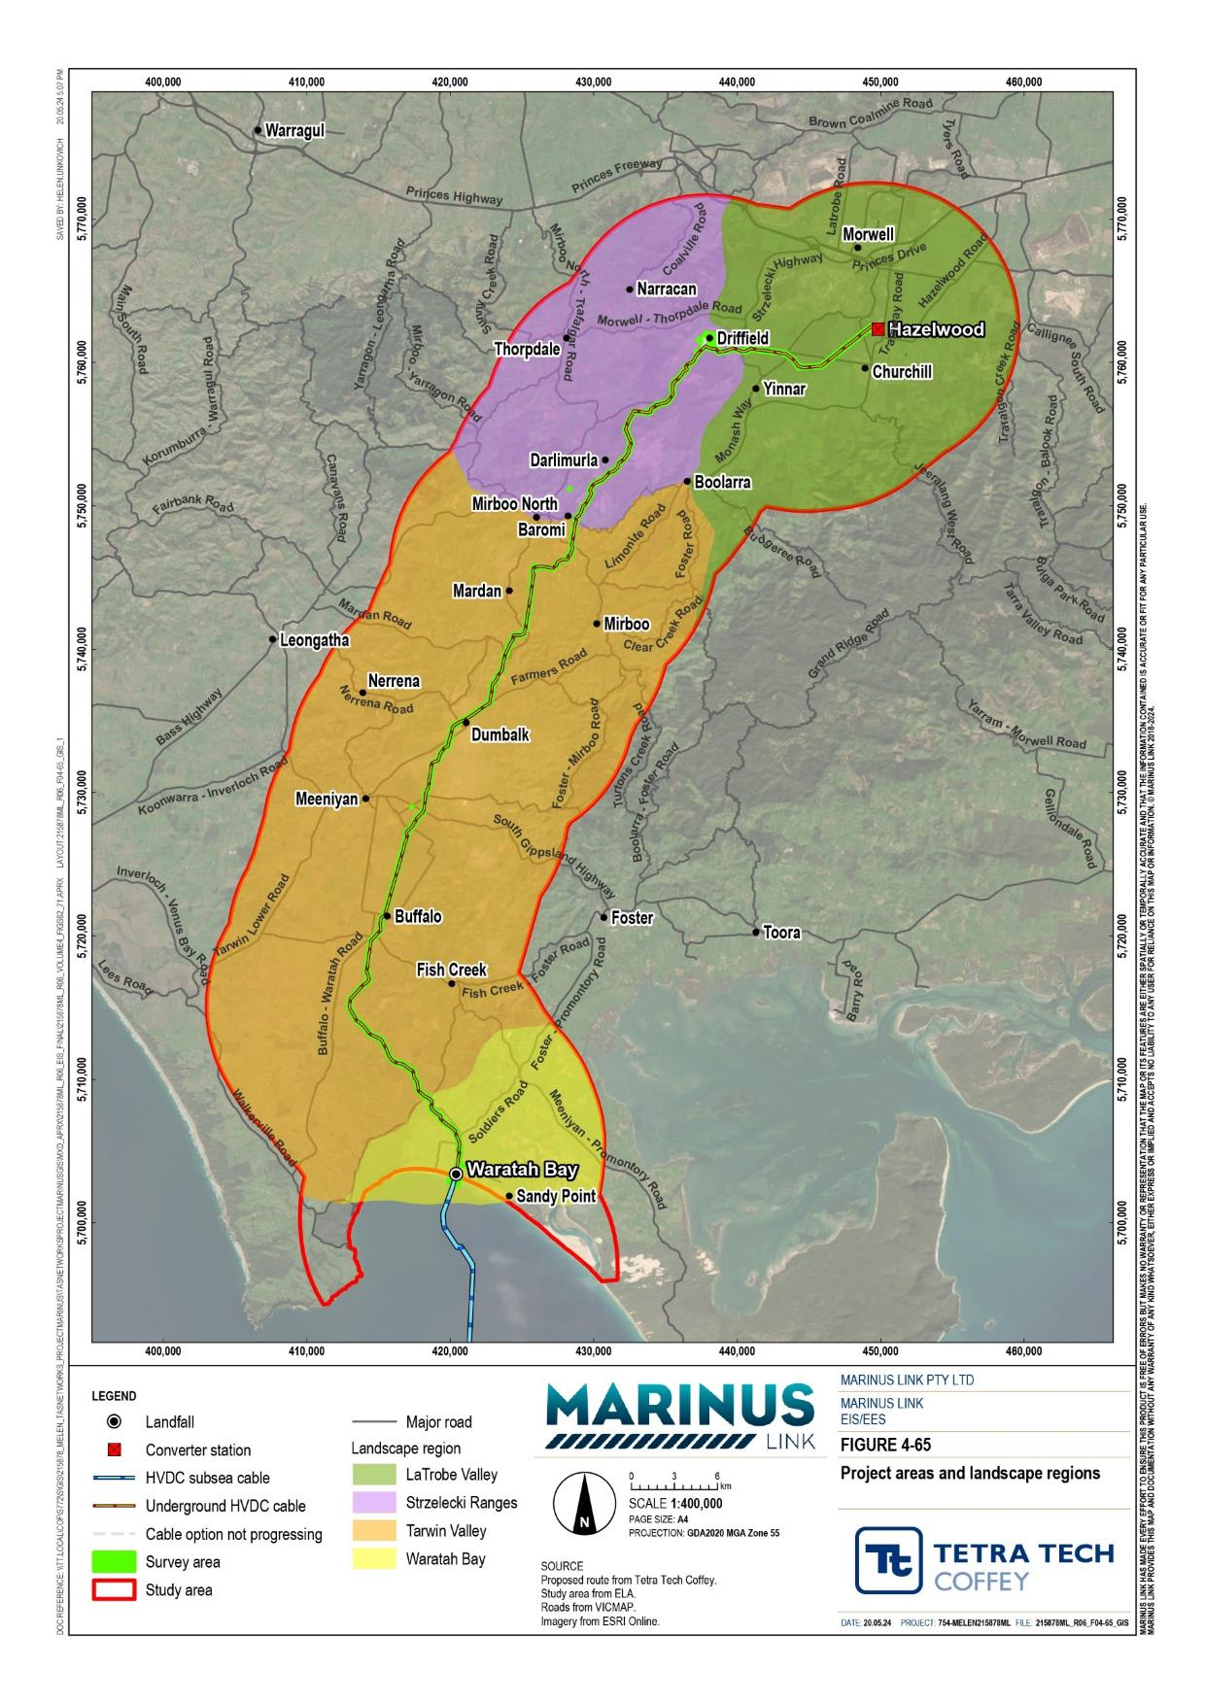
he landscape regions are shown in Figure 4-65 and consist of

Legislative context
Table 11-1 outlines the key legislation and guidelines that informed the terrestrial ecology assessment.

Title | Relevance to the assessment
Environment Protection and Biodiversity Conservation Act 1999 (EPBC Act) (Cwlth) | The EPBC Act is Commonwealth’s key environmental law. The EPBC Act identifies nine MNES including listed nationally and internationally important flora, fauna and ecological communities. The project requires assessment and approval under the EPBC Act for threatened species and communities, migratory species and Commonwealth marine areas.
Significant Impact Guidelines 1.1 (Cwlth) | EPBC Act policy statement that provides guidance for determining whether the project is likely to have a significant impact on a protect matter.
Recovery plans (Cwlth) | Sets the research and management actions required to stop the decline of, and support the recovery of, listed species and threatened ecological communities. Recovery plans have been considered for relevant species where they have been prepared. Under the EPBC Act, in deciding whether or not to approve the project, the Minister for the Environment and Water must not act inconsistently with a recovery plan
Conservation advice (Cwlth) | Enforced under the EPBC Act, conservation advice inform the Commonwealth Government in decision-making for listed species and ecological communities. Conservation advice can be developed in tandem with recovery plans to identify actions required to support conservation and recovery of listed species and ecological communities. Under the EPBC Act, in deciding whether or not to approve the project, the Minister for the Environment and Water must have regard to any approved conservation advice for relevant species or ecological communities.
Threat abatement plans (Cwlth) | The Commonwealth Minister for the Environment and Water may enforce a threat abatement plan to provide for the research, management and other actions necessary to mitigate the impact of a process that threatens native species and ecological communities. Under the EPBC Act, in deciding whether or not to approve the project, the Minister for the Environment and Water must not act inconsistently with a threat abatement plan.
Flora and Fauna Guarantee Act 1988 (Vic) (FFG Act) | The FFG Act regulates the protection and management of biodiversity including the conservation of threatened species and communities and the management of potentially threatening processes in Victoria. Permits are required to take, remove, or disturb listed or protected flora species, listed communities and fish on public land.  Under s4B(2) of the FFG Act public authorities must consider the objectives of the FFG Act and the impact on biodiversity. This includes consideration of Biodiversity 2037 targets (DELWP 2017b), action statements, critical habitat determinations and management plans made under the FFG Act.
Marine and Coastal Act 2018 (Vic) (MACA) | The project will require consent under MACA for any proposed use, development or works that are on marine and coastal Crown land.  Marine and Coastal Policy 2020 was prepared under MACA and provides direction to decision makers including local councils and land managers on a range of issues relating to the planning, management and sustainable use of coastal and marine environments; including the impacts of climate change, population growth and ageing coastal structures.  The policy applies to the planning and management of all private and public land and waters between the outer limits of the Victorian coastal waters (3 NM from the high water mark) and five km inland of the high water mark, including 200 m below the surface of that land.

Title | Relevance to the assessment
Planning and Environment Act 1987 (Vic) (P&E Act) | The P&E Act governs the use, development, and protection of land in Victoria including planning schemes to manage native vegetation. Planning permits and precinct plans are the legal instruments of this governance.  The Guidelines for the removal, destruction or lopping of native vegetation (DELWP 2017; the ‘Guidelines’) describes Victoria’s state-wide policies in relation to assessing and compensating for the removal of native vegetation. This includes the assessment of impacts from removing native vegetation, and how offsets are calculated to compensate for the loss of biodiversity values. The Guidelines are incorporated into the Victorian Planning Provisions and all planning schemes in Victoria including local council planning schemes.
Wildlife Act 1975 (Vic) | Provides procedures for the protection and conservation of wildlife (fauna), including the requirement for a licence to take or destroy wildlife, including for translocation.
Catchment and Land Protection Act 1994 (Vic) (CALP Act) | The objective of the CALP Act is to manage and protect catchments and set up a system of controls for noxious weeds and pests. Under the act, landholders (including the Crown) have responsibilities and requirements set out for pest animals  and different categories of weeds in a ‘declared list of noxious weeds’.

Assumptions and limitations
The key assumptions and limitations for the terrestrial ecology assessment include:

Land access: not all land parcels in the survey area were accessible during field surveys, which prevented field teams from validating and assessing vegetation, threatened species and habitats (including aquatic species and habitats) that may be impacted in these areas, or conducting targeted species surveys. In response, the assessment undertook the following steps:
- Unassessed native vegetation: where land access was not available, vegetation was mapped based on desktop assessments, aerial imagery and field observations (observations from a distance and results of surveys in adjoining land). Modelled condition scores were used to attribute a relative value to the vegetation for use in the impact analysis. Some of this vegetation is likely exotic or a planted native species, however a conservative approach was taken which assumed, for the purpose of this impact assessment, that all non-validated vegetation impacted by the project is native.
- Unassessed habitat for threatened species: where land access was not available, threatened species habitat (including aquatic habitat) and occurrence was determined based on desktop assessments, aerial imagery and field observations (observations from a distance and results of surveys in adjoining land). Where this information could not conclusively rule out the presence of threatened species, the assessment considered this species as present.
- Threatened ecological communities: while sections of the survey area were not able to be accessed for surveys, these do not coincide with areas considered likely to support TECs. The survey effort completed to inform this impact assessment is considered sufficient to determine the extent and presence of TECs, and therefore no further investigation is required.

- Impacts within unsurveyed land: where there is considered to be a reasonable likelihood that a value will occur within land that was not accessed for surveys, this impact assessment assumed presence and assessed the impacts based on the likely extent of habitat and the construction methods proposed.

Existing conditions
The study area is dominated by productive agricultural landscapes, with higher elevation sections in the Strzelecki Ranges supporting dense pine plantations. There are also numerous invasive pests, weeds and diseases already within the study area. As a result, the majority of native vegetation (scrubs, woodlands and forests) and associated habitat that would have once covered South Gippsland has been historically cleared, leaving small, fragmented patches remaining along road reserves, property boundaries and waterways, and scattered trees in paddocks. In some areas, such as the hills around Waratah Bay, the Great Southern Rail Reserve and the Strzelecki Ranges, larger patches of native vegetation remain on private and public land.
These areas represent important areas of habitat for flora and fauna species.

This section describes the existing conditions and values of terrestrial ecology in the study area. The assessment considered the following features:
Native vegetation and habitat

Threatened flora and threatened fauna

Threatened ecological communities

Groundwater dependent ecosystems.

Native vegetation and habitat
Potential native vegetation and habitat values within the study area were identified and assessed using a combination of high-resolution aerial imagery, ecological vegetation class (EVC) model data, and detailed site assessments and surveys.
Native vegetation and habitat along the project alignment varies in nature and extent. Along the southern extent, in areas dominated by pastoral properties, only fragments of vegetation and scattered trees remain. In the ranges north of Mirboo North, dense plantations of native and introduced species are more prominent. Further north, land use returns to pastures with fragmented woodlands amongst the plains of Latrobe Valley. Throughout the alignment, there is ecologically valuable native vegetation alongside roads and rail lines.

Inspection of the DEECA pre-1750 EVC model dataset indicates that the survey area and its surrounds may have once supported at least 13 EVCs. This dataset represents the estimated extent of EVCs present pre- 1750 (prior to European influence) which when considered against more current extent mapping informs the conservation status of the EVCs. The 13 EVCs are listed with their bioregional conservation status in Table 11-2.

Bioregional conservation status | Ecological vegetation classes
Endangered | damp forest (EVC 29)  herb-rich foothill forest (EVC 23) swamp scrub (EVC 53)  swampy riparian woodland (EVC 83) plains grassy woodland (EVC 55)  plains grassy forest (EVC 151, Strzelecki Ranges bioregion) shrubby foothill forest (EVC 45)
Vulnerable | damp heathy woodland/lowland forest mosaic (EVC 1106) lowland forest (EVC 16)  plains grassy forest (EVC 151, Gippsland Plain bioregion)
Depleted | wet forest (EVC 30)  coastal dune scrub/coastal dune grassland mosaic (EVC 1)
Least concern | estuarine wetland (EVC 10)
The landscape region of Waratah Bay extends from the foreshore area, into the surrounding farmland and then for 6.4 km into the hills surrounding the coastal plains. The region includes the following native vegetation groups:
Coastal dune vegetation – characterised by dense shrub species and no canopy species along the foreshore of Waratah Bay. This vegetation represents coastal dune scrub (EVC 160).
Swamp scrubs and woodland – characterised by a low canopy, in some areas dominated by swamp gum and in other areas dominated by swamp paperbark. This vegetation is in scattered patches and contiguous remnants throughout the coastal pastoral land and represents Swamp Scrub (EVC 53).
Heathy lowland forest and heathy woodland – characterised by an open structure with clear distinctions between storeys. Surveys identified exotic groundcover species more frequently than native groundcover species. This vegetation is in the hills surrounding the coastal plains and represents lowland forest
(EVC 16).

Key habitat values within this region include:

Coastal dune vegetation in the foreshore of Waratah Bay – which provides habitat for threatened shorebirds and migratory species.
Five farm dams – which provides habitat for threatened aquatic fauna.

Large patches of interconnected woodland adjacent to Fish Creek-Walkerville Road and Waratah Road that – likely acts as an important wildlife corridor and is mapped as both Swamp Scrub (EVC 53) and Damp Heathy Woodland or Lowland Forest Mosaic (EVC 1106).

The landscape region of Tarwin Valley extends from south of Tarwin River East Branch up towards Mirboo North. The land is largely cleared, with small patches of regrowth and planted native vegetation within farmland. The region has following native vegetation:
South of the Tarwin River – characterised by swampy, riparian forests and heathy, lowland forests with a eucalypt canopy and a species-diverse mid-storey. The understorey was diverse with a substantial proportion of exotic species and several native species These vegetation assemblages represent swamp scrub (EVC 53), swampy riparian woodland (EVC 83), damp heathy woodland (EVC 793), lowland forest (EVC 16), riparian forest (EVC 18) and floodplain riparian woodland (EVC 56).
North of the Tarwin River – characterised by wet or damp forests, generally in small highly-modified patches with exotic understoreys (often pasture). The mid-storey was often absent while canopy species were limited to stringybark and grey-gum.
Key habitat values within this region include:

A large heathy woodland or lowland forest and a surveyed section of high-quality scrub and woodland remnants along the Great Southern Rail Trail provide foraging habitat for fauna, as well as refuge and wildlife corridors for flora and fauna. Mapped as damp forest (EVC 29) and damp heathy woodland or lowland forest mosaic (EVC 1106).
Vegetated waterways that provide habitat for fauna species occur throughout the project alignment, providing a corridor network for fauna movement and maintaining water quality.
Scattered old, large trees provide roosting and connectivity for fauna.
The landscape region of Strzelecki Ranges extends from Mirboo North to the upper river terraces of the Latrobe Valley. The region holds several pine plantations with scattered patches of woodland and tall forests. These are mostly adjacent to the Strzelecki Highway or intersecting the project alignment at creek lines. The region encapsulates the following native vegetation:
Lowland forests between Mirboo North and Stony Creek (EVC 16).

Tall, damp or wet forest characterised by a eucalypt canopy, acacia-dominant mid-storey and groundcover with a variety of native species. These vegetation assemblages were either herb-rich foothill forest (EVC 23), damp forest (EVC 29) or wet forest (EVC 30).
Tall, dry forests on the ridgelines where the project alignment reaches Latrobe Valley which best represents herb-rich foothill forest (EVC 23) and shrubby foothill forest (EVC 45).

The Strzelecki Ranges landscape region has large areas of interconnecting remnant vegetation. This makes it particularly important habitat for threatened flora and fauna species. Key habitat values within this region include:
Two large patches of vegetation providing linkages to the surrounding landscape, as well as foraging and habitat for fauna.
Little Morwell River, Stony Creek and unnamed drainage lines that provide important habitat for fauna. Riparian vegetation along watercourses contains suitable habitat for fauna including burrowing crayfish.
Tall forests along Ten Mile Creek Road, the Strzelecki Highway and Kings Road. The vegetation contains large, hollow-bearing trees, diverse flora and provides foraging and breeding habitat for native fauna species.
The landscape region of Latrobe Valley extends from Yinnar-Driffield Rd to Hazelwood. The land is largely cleared agricultural land with scattered, highly modified grassy forests, woodlands and floodplain woodlands along Morwell River. The region encapsulates the following native vegetation:
Grassy woodlands – characterised by canopies of gum trees, a mostly absent mid-storey and grassy groundcover. The vegetation assemblage represents riparian forest (EVC 18), plains grassy woodland (EVC 55), floodplain riparian woodland (EVC 56), plains grassy forest (EVC 151) and grassy woodland (EVC 175).
The Latrobe Valley landscape region is largely cleared, limiting its environmental values. However, several key habitat values persist including:
Small woodland patches of scattered trees including riparian vegetation along Morwell River containing large, old trees with a variety of hollows. This vegetation is poorly connected and likely only utilised by mobile species tolerant of disturbed landscapes.
Small wetlands in the terraces adjacent to Morwell River may provide habitat for aquatic flora and fauna.

Hazelwood Cooling Pond – potential foraging habitat for waterfowl, crustaceans, fish and amphibian species.

Threatened ecological communities
The assessment of TECs involved a desktop assessment and field surveys. The desktop assessment identified TECs with a natural distribution (historically recorded during field surveys) or a modelled distribution (thought to occur based on suitable conditions). The assessment identified the following TECs in the survey area:
Natural Damp Grassland of the Victorian Coastal Plain (EPBC Act critically endangered)

Gippsland Red Gum Grassy Woodland and Associated Native Grassland (EPBC Act critically endangered) and related FFG Act listed threatened community Forest Red Gum Grassy Woodland Community or Central Gippsland Plains Grassland, within the Latrobe Valley.
Subtropical and Temperate Coastal Saltmarsh (EPBC Act vulnerable).

FFG Act listed Warm Temperate Rainforest (East Gippsland Alluvial Terraces) Community within the Strzelecki Ranges.
Field surveys identified the critically endangered Gippsland Red Gum Grassy Woodland and Associated Native Grassland community and related FFG Act listed threatened community Forest Red Gum Grassy Woodland Community in the McFarlanes Lane road reserve in the southern portion of the Latrobe Valley. Field surveys did not identify any other TECs.

Groundwater dependent ecosystems
GDEs are ecosystems that rely partially or entirely on groundwater for their water needs. The groundwater assessment (Technical Appendix P: Groundwater) modelled the project alignment for known and potential GDEs. Known GDEs were identified during previous desktop or field studies and potential GDEs were identified through analysis of spatial data sets. GDEs are also categorised as terrestrial, aquatic or subterranean. Only terrestrial and aquatic GDEs are discussed in this chapter. For further detail on GDEs, refer to Volume 4, Chapter 4 – Groundwater and Technical Appendix P: Groundwater.
Areas of native vegetation that represent potential terrestrial or aquatic GDEs along the project alignment are shown in Figure 4-66, and summarised in Table 11-3.

Landscape region | EVC | GDE status | Figure reference
Waratah Bay | Swamp Scrub (EVC 53) | Potential | Figure 4-66-1
Tarwin Valley | Swampy Riparian Woodland (EVC 83) | Potential | Figure 4-66-2
Tarwin Valley | Floodplain Riparian Woodland (EVC 56) Swampy Riparian Woodland (EVC 83) Damp Heathy Woodland (EVC 793) | Likely | Figure 4-66-3 to Figure 4-66-5
Tarwin Valley | Riparian Forest (EVC 18)  Swampy Riparian Woodland (EVC 83) Swamp Scrub (EVC 53) | Likely | Figure 4-66-6
Tarwin Valley | Floodplain Riparian Woodland (EVC 56) Swampy Riparian Woodland (EVC 83) | Potential | Figure 4-66-7

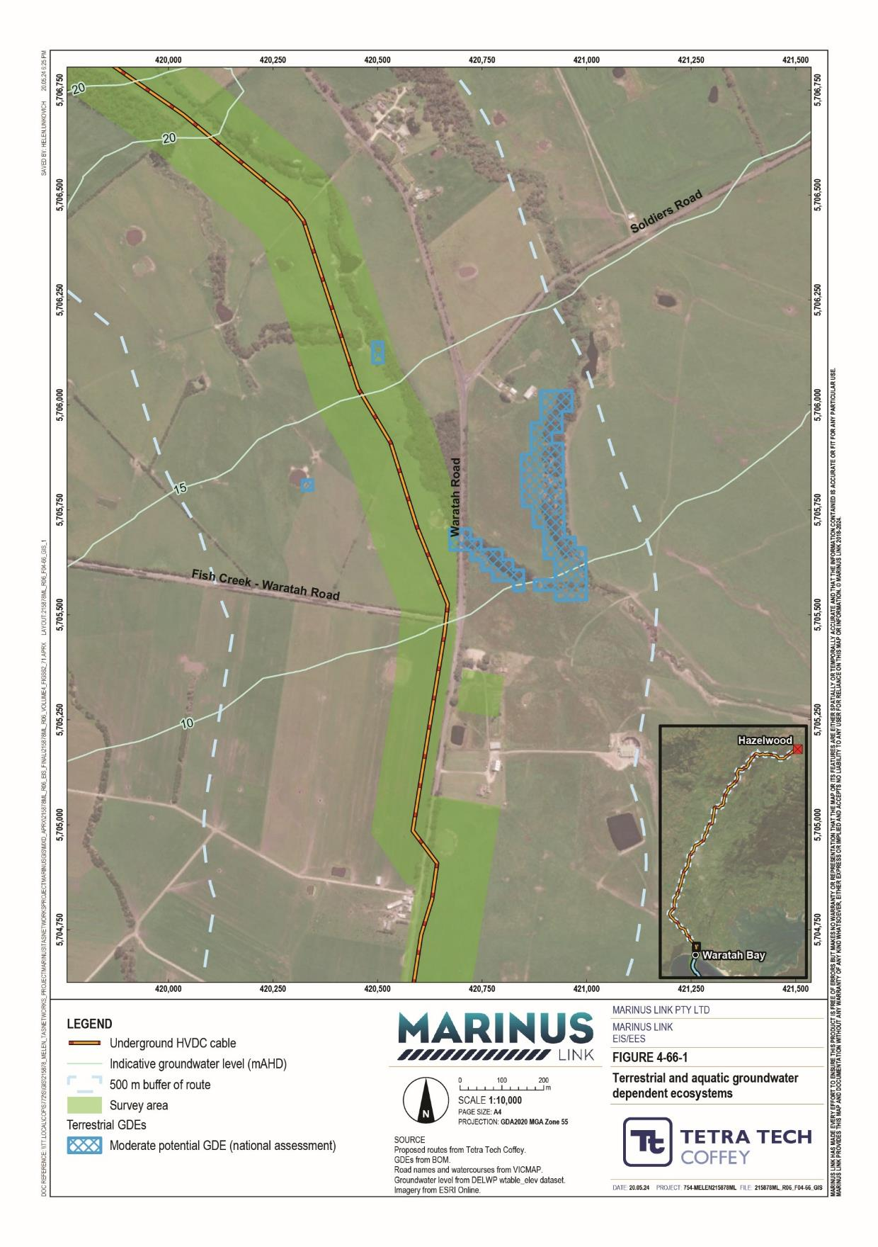
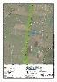

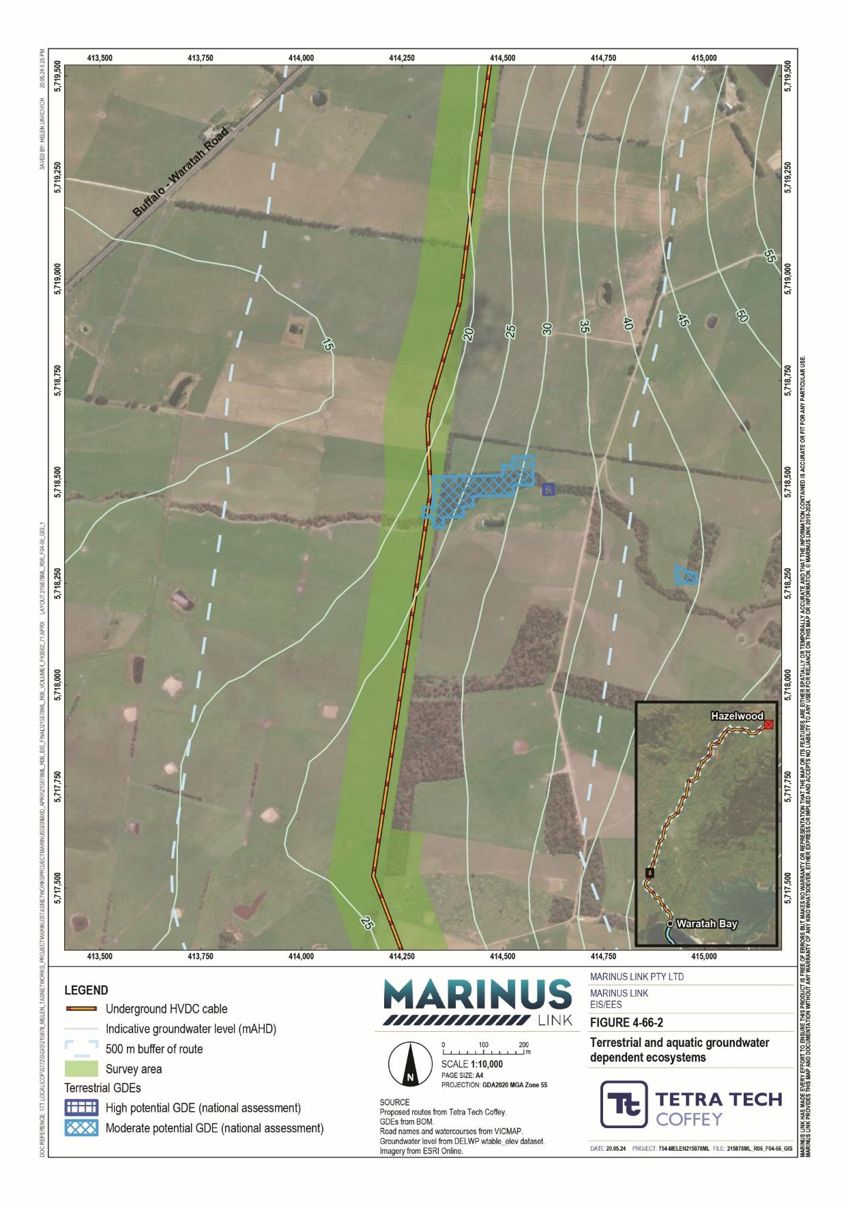

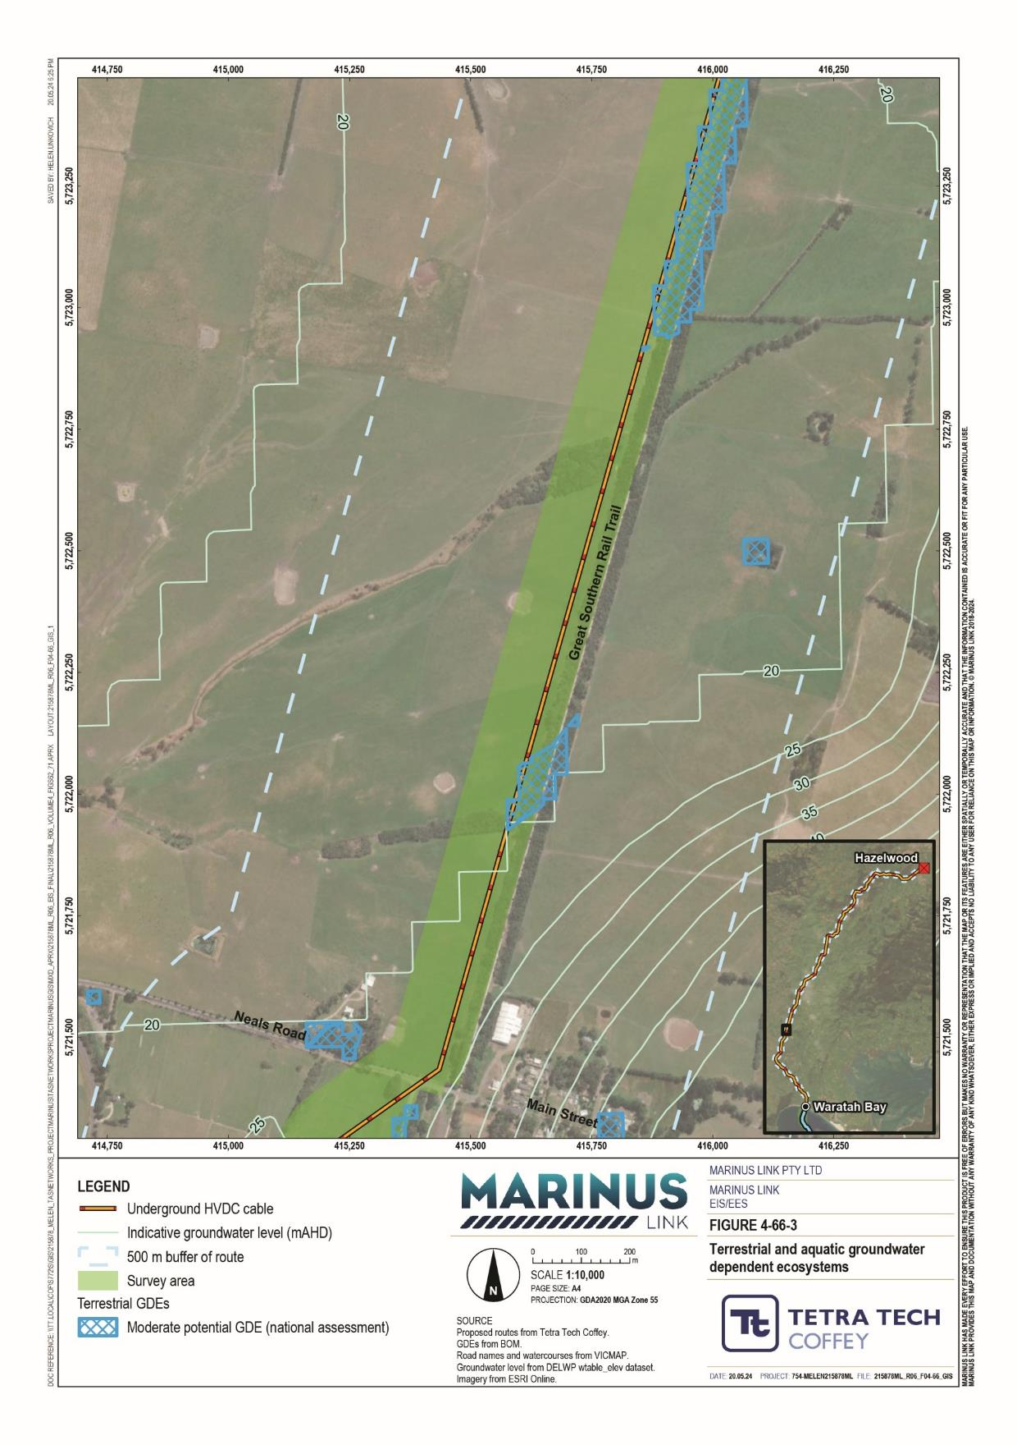

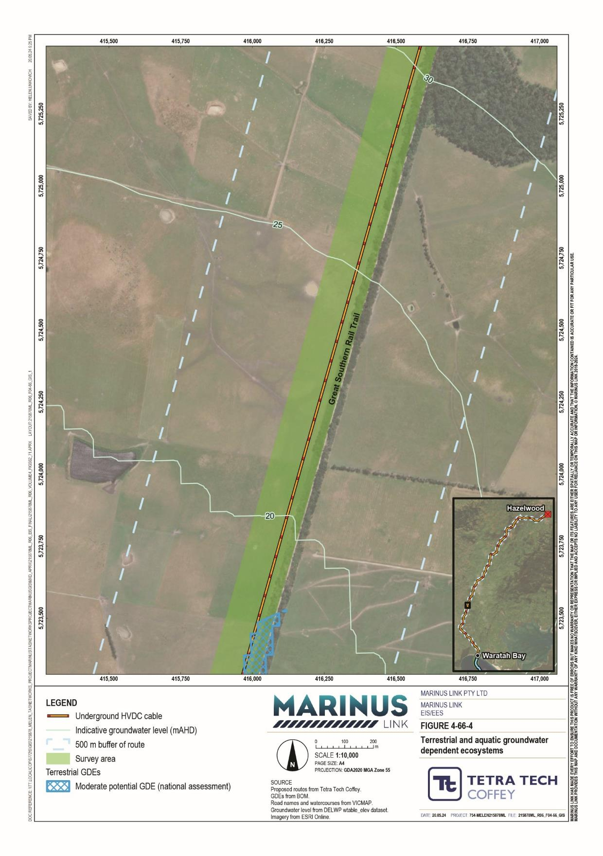

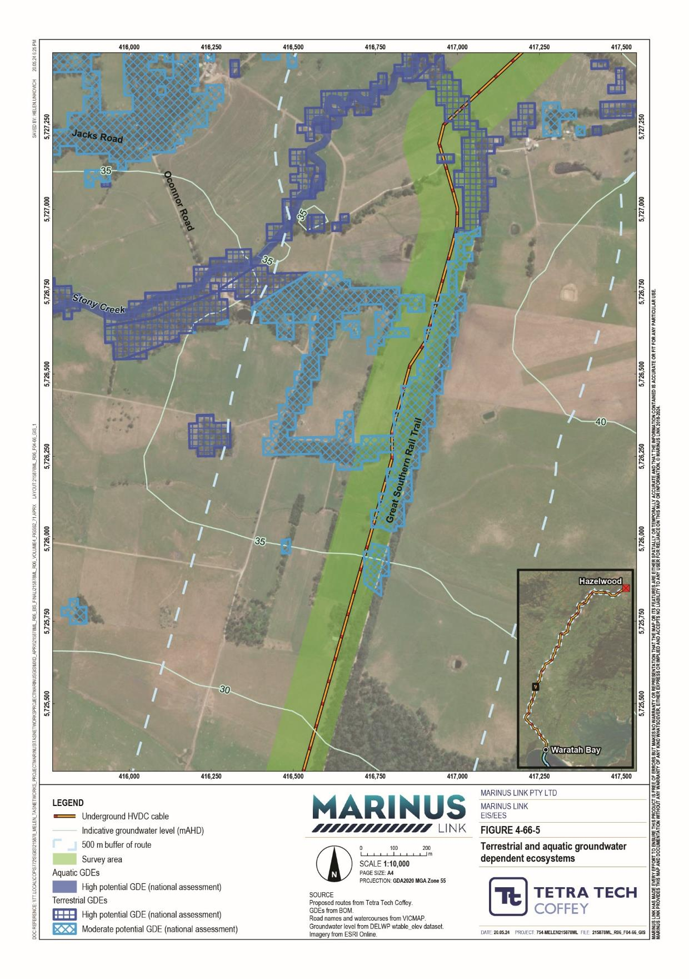

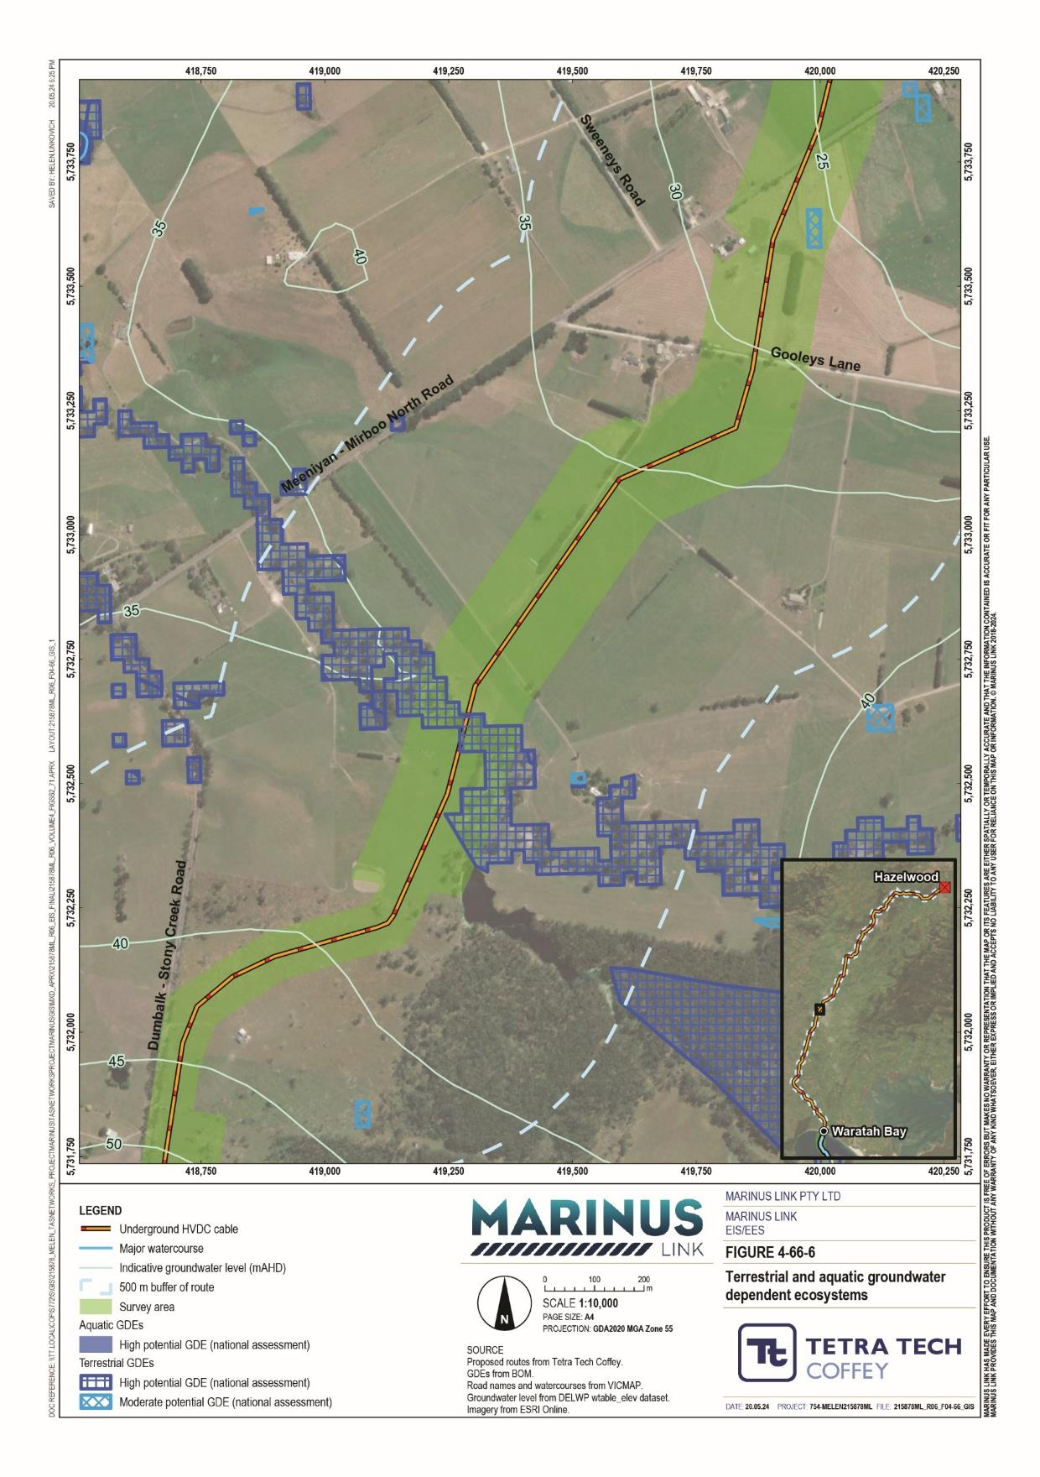

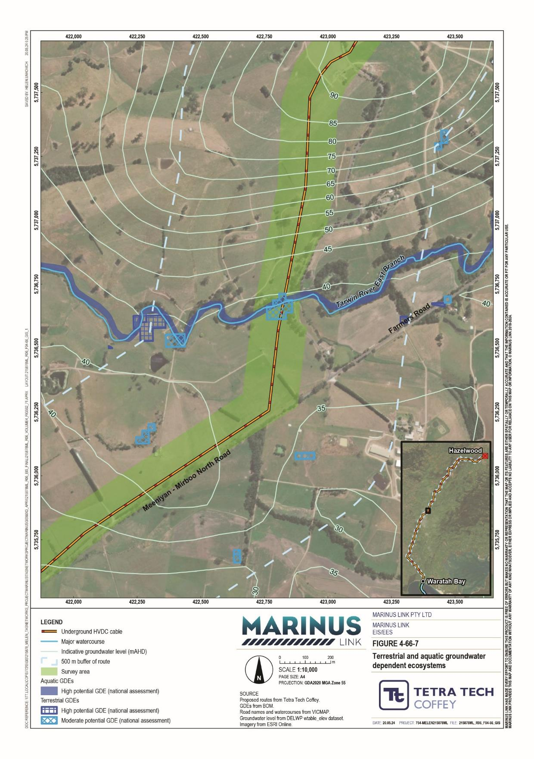

Threatened species
A desktop assessment was completed to identify potential threatened species within the area. Field surveys were then completed to determine the condition of vegetation and quality of habitat in the survey area.
The results of both the desktop assessment and baseline field surveys informed an assessment of which species are either not present, are unlikely to occur, are likely to occur or are known to be present within the study area.
The desktop assessment identified 79 significant flora species as occurring within the study area. This includes 54 EPBC Act listed species and 75 FFG Act listed species.
The assessment compared the habitat requirements of the 79 identified flora species against information about the survey area and surrounding landscape, including nearby records and level of disturbance. From this, the assessment determined that 37 of these species as present or likely to occur within the survey area. These 37 species are shown in Figure 4-67.
The assessment involved targeted surveys for species with a moderate or high likelihood of occurring in the survey area and that are likely to be impacted by the project.

Volume 4 – Victorian terrestrial environment Page 11-19
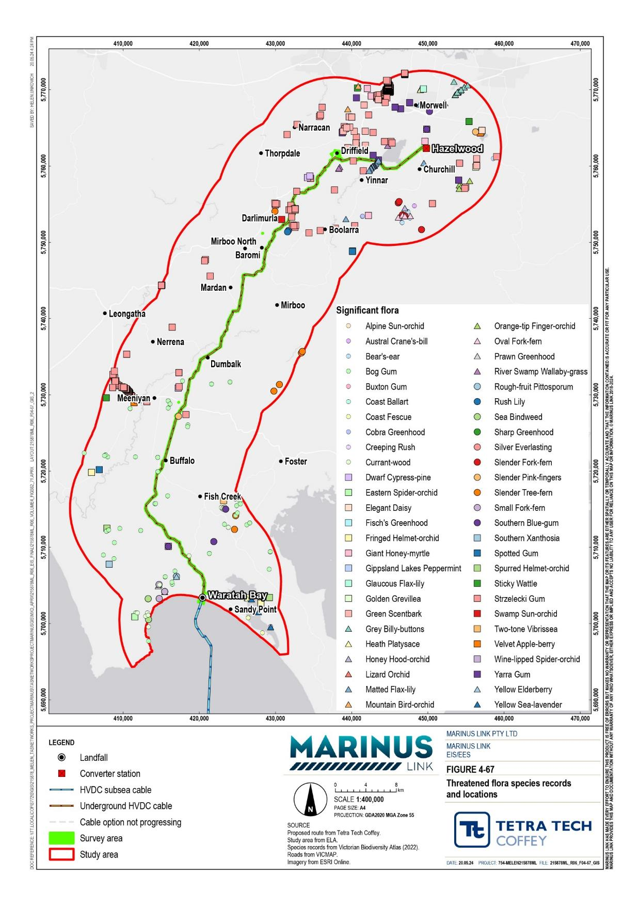

The desktop assessment identified potential habitat for five threatened flora species within the coastal dune system in the Waratah Bay landscape region of the survey area including:
tussock-grass coast colobanth (FFG Act endangered)

coast wirilda (FFG Act endangered) dune wood-sorrel (FFG Act endangered).

coast bitter-bush (FFG Act endangered)

As the project design will avoid the dune system via HDD, the assessment did not include targeted surveys for these species. The assessment assumed these species to be present, however direct impacts from cable-laying will be avoided.
The desktop assessment identified potential habitat within the survey area for 16 threatened flora species including:

eastern spider orchid (EPBC Act and FFG Act endangered)
currant-wood (FFG Act endangered)
rush lily (FFG Act vulnerable)

slender fork-fern (FFG Act critically endangered)

silver everlasting (FFG Act endangered) small fork-fern (FFG Act endangered)

lizard orchid (FFG Act endangered)

orange-tip finger orchid (FFG Act endangered)
thick-lipped spider orchid (EPBC Act vulnerable)
dense leek-orchid (EPBC Act vulnerable)

slender pink-fingers (FFG Act vulnerable)

spurred helmet-orchid (FFG Act endangered) fringed helmet-orchid (FFG Act endangered)
green-striped greenhood (EPBC Act vulnerable)
leafy greenhood (EPBC Act vulnerable)

cobra greenhood (FFG Act endangered)

There is suitable habitat for these species in lowland forest and heathy woodland remnants in the Waratah Bay landscape region, particularly in roadsides north and south of Fish Creek-Waratah Bay Road (Figure 4- 69-3 and Figure 4-69-4).
Historical surveys in the Waratah Bay landscape region are limited, so records of these species are sporadic. The exception is the currant-wood, which is recorded frequently. There is extensive suitable coastal woodland and lowland forest habitat in Cape Liptrap Coastal Park less than 2 km to the southeast of the survey area where numerous threatened species have been recorded. Cape Liptrap Coastal Park is connected to a large patch of woodland and forest within and adjacent to the survey area in the Waratah Bay landscape region and the southern portion of the Tarwin Valley landscape region. The assessment did not survey this area as it is on private land for which access was not obtained. While this large patch is considered highly likely to support threatened flora species, this is most likely in areas outside the AoD.

Within the survey area, habitat within this patch is of lesser quality due to weed encroachment from pastures and cattle access and may not support any threatened species (currant-wood is likely an exception). As these species absence was not confirmed, the assessment considered woodland flora to be present.
Targeted flora surveys in Fish Creek-Waratah Bay Road and Waratah Bay Road did not identify any threatened species from this group.
There is suitable habitat in most of the survey area for river swamp wallaby-grass (EPBC Act vulnerable) along minor drainage lines and associated wetlands.
River swamp wallaby-grass can be unobtrusive and historical surveys in the study area are limited, so the species is likely more widespread than the sporadic historical records suggest. There is suitable habitat in discrete areas throughout the survey area, but presence is considered highly likely in waterways intersecting the survey area in the Latrobe Valley and Strzelecki Ranges, as well as small dams and lakes in the Tarwin Valley.
The survey identified 10 locations with a high likelihood of presence and targeted surveys inspected four of these as the other six weren’t accessible. Targeted surveys identified a large population of over 100 individuals in a small wetland adjacent to the Morwell River in the Latrobe Valley landscape region. Surveys did not identify river swamp wallaby-grass in any other surveyed location. In the areas the assessment determined River swamp wallaby-grass to have a high likelihood of occurring, the species is considered present.
The desktop assessment identified potential habitat in the survey area within drier forest habitats in the Strzelecki Ranges for three threatened flora species including:
cobra greenhood (FFG Act endangered)

bear’s ear (FFG Act endangered)

austral crane’s-bill (FFG Act endangered).

Historical records identified cobra greenhood and bear’s ear in numerous locations in the study area in drier forest habitat in the north and south of the survey area.
There is one historical recording of austral crane’s-bill within the study area in Morwell National Park. This may not be a good representation of the species’ distribution as it can be unobtrusive and often mistaken for common species within the genus.
While targeted surveys did not identify these species in the survey area, their presence cannot be ruled out. However, given the survey results and the sub-optimal nature of the suitable habitat, it is considered unlikely the survey area supports these species.

The desktop assessment identified potential habitat in the survey area within damp or wet forests in the Strzelecki Ranges for six threatened FFG Act listed flora species and one threatened FFG Act listed fungus species including:
mountain bird orchid (FFG Act vulnerable)

slender tree-fern (FFG Act critically endangered)

alpine sun-orchid (FFG Act critically endangered)

slender fork-fern (FFG Act critically endangered)

oval fork-fern (FFG Act endangered)

netted brake (FFG Act endangered)

two-tone vibrissae (fungus) (FFG Act endangered)

Historical records of these species are limited, likely due to their being under-surveyed. Consequently, they may persist in small pockets of remnant forest within relatively undisturbed waterways, gullies or shaded roadsides.
While targeted surveys did not identify these species in the survey area, their presence cannot be ruled out. The presence of unsurveyed potential habitat for alpine sun-orchid, slender fork-fern and oval fork-fern means these species are assumed to be present. Given the survey results and the sub-optimal nature of the suitable habitat, the remaining species are unlikely to occur.
The desktop assessment identified suitable habitat in the survey area for the matted flax-lily (EPBC Act endangered and FFG Act critically endangered) in roadsides and remnant woodland patches within the Latrobe Valley and northern foothills of the Strzelecki Ranges.
Matted flax-lily occurs throughout much of Victoria, particularly in native grasslands and woodlands of the Victorian Volcanic Plains and Gippsland Plains.
There is suitable habitat within grassy woodland or grassland remnants in roadsides in the Strzelecki Ranges landscape region and the Latrobe Valley landscape region. Of these, McFarlanes Road in the Latrobe Valley was considered particularly likely to support the matted flax-lily, as historical records (shown in Figure 4-69- 37) indicate it supports an important population. Targeted surveys were completed at the section of McFarlanes Road within the survey area as well as all other areas of suitable habitat within the survey area and no occurrence of the matted flax-lily was found. Consequently, this species is considered unlikely to occur.

The desktop assessment found five threatened eucalyptus species may potentially occur in the survey area including:
Strzelecki gum (EPBC Act vulnerable and FFG Act critically endangered)

green scentbark (FFG Act endangered)

southern blue-gum (FFG Act endangered)

bog gum (FFG Act critically endangered)

Yarra gum (FFG Act critically endangered).

These species may occur in remnant patches of forest or as scattered trees in cleared settings (such as paddocks).
Strzelecki gum may occur on ridges, slopes and stream banks throughout the survey area from Buffalo in the Tarwin Valley landscape region into the Latrobe Valley landscape region. Vegetation and habitat surveys identified 104 individual trees in the survey area including major populations at Stony Creek, an unnamed creekline and Tarwin River East Branch in the Tarwin Valley landscape region, as well as Morwell River in the southern Latrobe Valley landscape region.
Green scentbark and Yarra gum may occur on the plains and lower slopes of the Latrobe Valley. Vegetation and habitat surveys identified 18 individual Yarra gum trees in an unused rail reserve in the Latrobe Valley landscape region. Vegetation and habitat surveys did not identify green scentbark in the survey area.
Historical records indicate southern blue-gum occurs infrequently in the study area from the hills around the Waratah Bay landscape region to the Latrobe Valley landscape region. The northern populations may represent a transition from southern blue-gum to eurabbie, a similar eucalypt species. Vegetation and habitat assessments did not identify southern blue-gum in the survey area.
Bog gum occurs in low-lying areas prone to waterlogging or infrequent inundation. Historical records indicate it occurs frequently within the survey area from Waratah Bay to the Tarwin River East Branch. Vegetation and habitat surveys identified 500 individual trees in the survey area within the Tarwin Valley landscape region, including major populations in the Great Southern Rail Trail reserve and the Dumbalk-Stony Creek Road reserve. Southern blue-gum and green scentbark are considered unlikely to occur within the survey area as they are conspicuous, and surveys recorded trees extensively.

The desktop assessment identified 133 significant fauna species as occurring within in the study area. This includes 104 EPBC Act listed species, of which 64 are threatened and 56 are migratory, and 90 FFG Act listed species.
The assessment compared the habitat requirements of the 133 identified threatened fauna species against information about the survey area and surrounding landscape, including nearby records and level of disturbance. From this, the assessment determined 54 threatened fauna species as present or likely to occur within the survey area. These recorded locations of these 54 species are shown in Figure 4-68 and are described in further detail below.

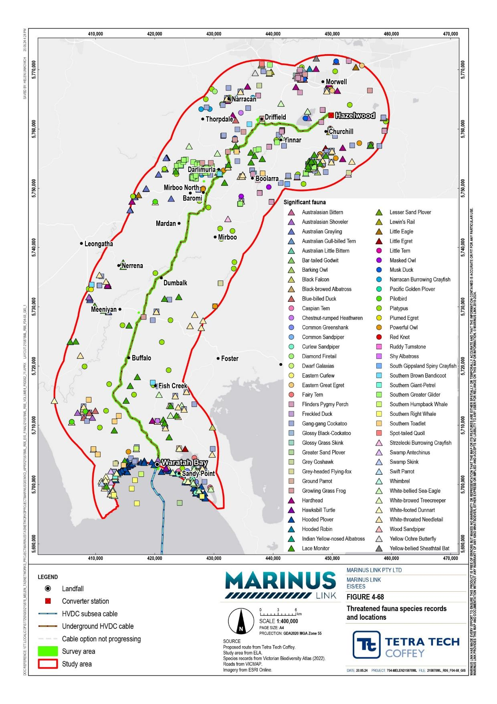

The desktop assessment identified suitable habitat in the survey area for two threatened fish species and one threatened semi aquatic mammal species. These were the dwarf galaxias (EPBC Act vulnerable, FFG Act endangered), Flinders pygmy perch (FFG Act vulnerable) and platypus (FFG Act vulnerable).
Dwarf galaxias is endemic to south-eastern Australia from Central Gippsland to near the Coorong in South Australia. Habitat includes well vegetated, slow flowing, still, shallow temporary or permanent freshwater habitats including swamps, drains, and backwaters of streams and creeks. Populations are fragmented and the species has suffered declines due to habitat loss and modification.
Flinders pygmy perch occurs from eastern Victoria to as far west as the Latrobe River. It occurs in waters with abundant aquatic vegetation, including lakes, ponds, and slow-flowing rivers and creeks, as well as pools in moderately flowing streams.
Both fish species have the potential to occur in waterways south of Buffalo to Morwell, including Morwell River, Eel Hole Creek, Stony Creek, Little Morwell River, Berrys Creek, Tarwin River East Branch, and Fish Creek. There are recordings of these species at several locations along the Tarwin River East Branch, although not where Tarwin River East Branch intersects the survey area.
Platypus are widespread in Victoria, occurring in a range of freshwater bodies where the banks are suitable for building burrows and the water is shallow enough for them to dive and feed on bottom-dwelling creatures. This species prefers well-vegetated freshwater creeks, slow-moving rivers, lakes joined by rivers and built water storages such as farm dams. Such conditions occur in creeks and rivers throughout the project alignment. Platypus have recently been recorded in:
Fish Creek – 1.7 km west of the survey area (Fish Creek intersects the survey area in Tarwin Valley)

Amber Creek (a branch of Fish Creek) – approximately 6 km east of the survey area

Stony Creek – 2 km west of the survey area (Stony Creek intersects the survey area in Tarwin Valley)

Tarwin River East Branch – 700 m west of the survey area (Tarwin River East Branch intersects the survey area at in Tarwin Valley)
Berrys Creek – approximately 850 m east and approximately 500 m west of the survey area (Berrys Creek intersects the survey area in Tarwin Valley)
Morwell River – approximately 2.5 km south of the survey area (Morwell River intersects the survey area in Latrobe Valley).
The assessment did not include targeted surveys of these species. The desktop assessment identified priority habitat for these species within the survey area, where their presence is assumed.
The desktop assessment identified suitable habitat in the survey area for two threatened freshwater crayfish species. These were the South Gippsland spiny crayfish (FFG Act endangered) and the Narracan burrowing crayfish (FFG Act endangered).

South Gippsland spiny crayfish occurs in streams in sclerophyll forest where the streamside vegetation is dominated by mountain ash, tree ferns, and lilly pilly throughout Wilsons Promontory and the Strzelecki Ranges. It is more common in streams with pools and little to no aquatic vegetation cover.
Narracan burrowing crayfish spends most of its life underground. Its burrows are typically found in fern gullies in wet sclerophyll forest. Surveys did not capture any Narracan burrowing crayfish, but historical records indicate presence within 10 km of the survey area.
Surveys identified potential habitat for these species within the riparian corridor of Stony Creek and tributaries that intersect the survey area near Mirboo North, where their presence is assumed.
The desktop assessment found the growling grass frog (EPBC Act and FFG Act vulnerable) has the potential to occur in the survey area. It occurs in permanent or seasonally inundated waterbodies including swamps, lakes, ponds, farm dams and irrigation channels. It is mostly associated with waterbodies that support dense emergent vegetation at its fringes.
Areas of suitable habitat within the survey area include Fish Creek, Stony Creek, Tarwin River East Branch, Berrys Creek, Little Morwell River, Morwell River and Eel Hole Creek, dams near Buffalo, Dumbalk-Stony Creek Road, South Gippsland Highway and Waratah Road and within wetlands along Clarkes Road in Luxford Pond.
Twenty-nine records of growling grass frogs exist within 10 km of the survey area. Targeted surveys completed in areas of suitable habitat did not identify presence of growling grass frogs. However, survey results also indicate that many of the areas surveyed represented poor quality habitat often inhabited by mosquito fish, which feed on frog tadpoles. Consequently, these areas are considered unlikely to support the growling grass frog.
Surveys for the Delburn Wind Farm (a project in the vicinity of the project) identified a population of 20-30 individuals in a wetland in the Strzelecki Ranges that provides good quality habitat and is connected to other areas of suitable habitat. While targeted surveys for the project in this area did not record growling grass frog at this wetland, given the good quality habitat in this location and the recent records of occurrence (surveyed for the Delburn Wind Farm in 2020), for the purpose of this impact assessment, the growling grass frog are assumed to be present in this location (discussed further in Section 11.3.3).

The desktop assessment identified suitable habitat in the survey area for three threatened mammal species. These were the listed greater glider (EPBC Act endangered, FFG Act vulnerable), grey-headed flying-fox (EPBC Act and FFG Act vulnerable), swamp antechinus (EPBC Act and FFG Act vulnerable), and white- footed dunnart (FFG Act vulnerable).
Greater glider occurs in eucalypt forests and woodland in eastern Australia, particularly tall montane wet forests where large old trees and hollows are plentiful. There are known greater glider populations approximately 1 km west of the project alignment in Mirboo North Regional Park, in adjacent forest and woodland, and further east between Stony Creek and Morwell River. There is suitable habitat in tall, moist eucalypt forests within the survey area between Mirboo North and Hazelwood. Segments of this habitat are connected with the areas supporting known greater glider populations, however the species has relatively poor dispersal ability and therefore may not utilise the connection between habitat areas. Targeted surveys within the survey area covered five areas of suitable habitat within the Strzelecki Ranges and recorded no greater gliders. The surveys identified several other small arboreal mammals, which suggests that the greater glider would have been identified if it was present. This is consistent with targeted surveys conducted for the Delburn Wind Farm. Survey results indicate a low likelihood of this species occurring within the survey area.
Grey-headed flying fox occurs in the coastal regions of central Queensland to Melbourne, particularly in rainforests, open forests, closed woodlands and open woodlands. There is suitable habitat within the survey area in tall sclerophyll forests in the Strzelecki Ranges. Targeted surveys identified two individuals in this landscape region, which indicates this section of the study area is used for foraging.
Swamp antechinus occurs mainly in damp areas including dense wet heathlands, tussock grasslands, sedgelands, damp gullies, swamps and some shrubby woodlands in coastal Victoria. There is suitable habitat in unsurveyed areas within swamp scrub and damp heathy woodland within the Waratah Bay landscape region and southern Tarwin Valley, therefore this species is assumed present.
White-footed dunnart occurs in a range of sclerophyll and coastal habitats in Victoria, including forest, woodland, heathland and coastal shrublands. There is suitable habitat in unsurveyed areas within swamp scrub and damp heathy woodland within the Waratah Bay landscape region and southern Tarwin Valley and in swampy riparian woodland along the Great Southern Rail Trail in the Tarwin Valley landscape region.
Though the habitat along the Great Southern Rail Trail is considered low to moderate quality. Targeted surveys did not record any white-footed dunnart, but there is suitable habitat in areas not surveyed. The results indicate a low likelihood of presence in the surveyed areas. Presence is assumed in areas of potential habitat that were not surveyed.

The desktop assessment identified potential habitat in the survey area for three threatened raptors and two threatened owl species. These were the:
grey goshawk (FFG Act endangered) barking owl (FFG Act critically endangered)

black falcon (FFG Act critically endangered) powerful owl (FFG Act vulnerable).

white-bellied sea eagle (FFG Act endangered, EPBC Act marine)
Grey goshawk occurs in woodlands and forests in the Strzelecki Ranges, Gippsland Plains, Glenelg Plain and Otway plains, and most commonly in wet forests in the Otway Ranges. There is potentially suitable habitat in woodlands, dry forests and farmlands along the Morwell River. Surveys recorded one individual in the Strzelecki Ranges landscape region.
Black falcon occurs in woodland associated with streams or wetlands. There is potentially suitable habitat throughout most of the survey area.
White-bellied sea eagle occurs in the coastal regions of mainland Australia and Tasmania, and extends inland along some larger waterways in eastern Australia. It occurs near freshwater swamps, rivers, lakes, reservoirs, billabongs, saltmarsh, sewage ponds and coastal waters, with habitats including coastal dunes, tidal flats, grassland, heathland, woodland, forest and urban areas. There is potentially suitable habitat along Morwell River and Waratah Bay.
Barking owl occurs in woodland and open forest, including fragmented remnants and partly cleared farmland, wetland and riverine forest throughout Victoria. There is suitable habitat within eucalypt-dominated woodland and open forests along the project alignment.
Powerful owl occurs mainly on the eastern side of the Great Dividing Range, inhabiting forests and woodlands, as well as sheltered gullies in wet forests with dense understoreys, especially along watercourses and areas with old growth trees for nesting. There is suitable habitat within old growth forest and open woodlands along watercourses in the Strzelecki Ranges. Targeted surveys recorded the powerful owl multiple times at a location in the Tarwin Valley landscape region. Targeted surveys did not identify the powerful owl in the Strzelecki ranges, but they are considered moderately to highly likely to utilise native vegetation within the survey area.
Targeted surveys did not identify the black falcon, white-bellied sea eagle or barking owl. This is consistent with targeted surveys for the Delburn Wind Farm. However, the desktop assessment and field surveys identified priority habitat for black falcon, white-bellied sea eagle and barking owl in the survey area where these three species’ presence is assumed.

The desktop assessment identified three threatened reptile species as likely to occur within the survey area. The three reptiles are swamp skink (EPBC Act and FFG Act endangered), glossy grass skink (FFG Act endangered) and lace monitor (FFG Act endangered).
Swamp skink and glossy grass skink occur in swampy and damp heath, including dense vegetation along the margins of swamps and watercourses, wet heathlands and salt marshes. There is suitable habitat within the survey area in swamp scrub and damp heathy woodland in the south of the project alignment and within swampy riparian woodland along the Great Southern Rail Trail, in the Strzelecki Ranges landscape region. Targeted surveys within the Great Southern Rail Trail did not identify any swamp skink or glossy grass skink. This result and the highly modified nature of the adjacent farmland habitat suggest a low likelihood of presence in the areas surveyed for these species. However, the desktop assessment and habitat assessments identified priority habitat for these species within the survey area, where their presence is assumed.
Lace monitor occurs in wooded habitats across Victoria and south-eastern Australia. There is suitable habitat within the survey area in larger patches of woodland and forest in the Waratah Bay, southern parts of Tarwin Valley, Strzelecki Ranges and Latrobe Valley landscape regions. Targeted surveys recorded a lace monitor in the survey area within the Great Southern Rail Trail. Given this result, historical records and the species’ mobility, lace monitor is considered likely to occur in all areas of suitable habitat within the survey area.
The desktop assessment identified suitable habitat in the survey area for 14 threatened shorebird species within the foreshore and dunes in the Waratah Bay landscape region including:

common sandpiper (EPBC Act marine and migratory, and FFG Act vulnerable)
little tern (EPBC Act marine and migratory, and FFG Act listed critically endangered)

red knot (EPBC Act endangered, marine and migratory, and FFG Act endangered)
fairy tern (EPBC Act vulnerable and marine, and FFG Act listed critically endangered)

greater sand plover (EPBC Act vulnerable, marine and migratory and FFG Act endangered)
lesser sand plover (EPBC Act endangered, marine and migratory, and FFG Act endangered)
Caspian tern (EPBC Act marine and migratory, and FFG Act vulnerable)
eastern curlew (EPBC Act critically endangered, marine and migratory, and FFG Act critically endangered)
hooded plover (EPBC Act listed vulnerable and marine, and FFG Act vulnerable)
sanderling (EPBC Act marine and migratory)

red-necked stint (EPBC Act marine and migratory)
double-banded plover (EPBC Act marine and migratory)
red-capped plover (EPBC Act marine)

crested tern (EPBC Act marine and migratory)

Numerous records of hooded plover exist along Waratah Bay, most of which are either approximately 3 km east or west of the survey area. One historical record of hooded plover exists in the survey area at Sandy Point Beach, Waratah Bay. There is suitable hooded plover habitat for foraging and nesting in the survey area, but human activities, and limited seaweed, flotsam and dune sites reduce its significance.
Targeted surveys at Sandy Point Beach in Waratah Bay identified three crested terns and a flock of approximately 200 sanderlings. Surveys did not identify any other species, but the survey area at Waratah Bay likely provides a movement corridor as well as foraging and nesting opportunities for threatened shorebird species.
The findings of the desktop assessment and field surveys indicate priority habitat for shorebirds in the Waratah Bay landscape region on the foreshore and in the dunes. Consequently, shorebirds are assumed to be present in this priority habitat.
The desktop assessment identified suitable habitat in the survey area for 14 threatened inland waterbird species within the watercourses, well-vegetated wetlands and wet grasslands along the project alignment. These included the following species:

eastern great egret (EPBC Act marine and FFG Act vulnerable)
musk duck (EPBC Act marine and FFG Act vulnerable)
little egret (EPBC Act marine and FFG Act endangered)
Caspian tern (EPBC Act marine and migratory, and FFG Act vulnerable)
cattle egret (EPBC Act marine)
sharp-tailed sandpiper (EPBC Act marine and migratory)
Latham’s snipe (EPBC Act marine and migratory)
Hardhead (FFG Act vulnerable)
Australasian bittern (EPBC Act endangered and FFG Act critically endangered)
Australian little bittern (FFG Act endangered) Lewin’s rail (FFG Act vulnerable)
blue-billed duck (FFG Act vulnerable)
Australasian shoveler (FFG Act vulnerable) freckled duck (FFG Act endangered)

There is suitable habitat within and adjacent to the survey area, including waterbodies with dense reed beds, farm dams and lakes within the Tarwin Valley and Strzelecki Ranges landscape regions, as well as Hazelwood Cooling Pond and Eel Hole Creek in the Latrobe Valley landscape region.
Surveys identified cattle egret in a wetland in the Tarwin Valley landscape region and Latham’s snipe in a waterbody in the Latrobe Valley landscape region. Day time bird surveys in the Tarwin Valley landscape region identified hardhead in a farm dam. These four locations support priority habitat for waterbirds and given survey results, historical records and waterbirds’ mobility, these species are considered highly likely to occur in other areas of suitable habitat within the survey area.

The desktop assessment identified suitable habitat in woodland patches within the survey area for four threatened woodland and forest bird species including:

gang-gang cockatoo (EPBC Act endangered)

blue-winged parrot (EPBC Act vulnerable and marine)
satin flycatcher (EPBC Act marine and migratory)
rufous fantail (EPBC Act marine and migratory).

Gang-gang cockatoo are endemic to south-eastern Australia. In Victoria they occur throughout the north-east and southern areas, having been recorded in east Melbourne, Mornington Peninsula and south-western Gippsland. They primarily occur within the temperate eucalypt forests and woodlands of mainland south-east Australia, inhabiting mature, wet sclerophyll forests during summer months and woodland assemblages at lower, drier altitudes during winter months. There is suitable habitat within wet sclerophyll forests in the Strzelecki Ranges.
The blue-winged parrot occurs within a range of habitats in southern Victoria, and sub-coastal and inland areas, favouring grasslands and grassy woodlands. There is suitable habitat within grassy paddocks throughout the survey area.
The satin flycatcher inhabits eucalypt-dominated forests, especially near wetlands, watercourses and heavily vegetated gullies throughout the south and east of Victoria. There is suitable habitat within tall forests in the survey area.
The rufous fantail occurs in sclerophyll forests and woodlands with a shrubby or heathy understorey. There is suitable habitat in sclerophyll forests within the Strzelecki Ranges and woodland patches in the Tarwin Valley. Targeted surveys identified one rufous fantail Strzelecki Highway Road reserve within the Strzelecki Ranges landscape region.
Of this group, targeted surveys only identified the rufous fantail. However, due to the results of the desktop review, habitat assessments and the mobility of the species, the assessment assumed presence of these species in areas of suitable habitat.
In Victoria, the koala is not a listed threatened species but is considered regionally significant and culturally, environmentally and economically important due to their specific dietary niche of Eucalyptus foliage and their aesthetic appeal. The Strzelecki koala is considered to have particular significance as they are considered representative of the original Victorian population, largely unaffected by inbreeding as a result of re- population programs in other parts of the state.
The Gippsland region supports approximately 80% of Victoria’s koala population in native vegetation, with 99% of these inhabiting eucalyptus plantations.
The surveys recorded numerous koalas along the Great Southern Rail Trail in the Tarwin Valley landscape region and in the Strzelecki Ranges landscape region.

Summary of terrestrial ecology values
Based on the assessment of existing terrestrial ecology conditions through desktop review and field surveys, the ecological values in the following subsections are relevant for the impact assessment. The sensitivity of each value is determined by its listing under the EPBC Act or FFG Act.
The terrestrial ecology values associated with native vegetation and habitat within the survey area include:

Patches of listed EVCs – 201.9 ha

- Endangered – 102.85 ha

- Vulnerable – 85.66 ha

- Depleted – 13.39 ha

Large trees – 1084 individuals

These values are scattered along the project alignment at the following locations:

Coastal scrub vegetation on the foreshore and coastal dunes of Waratah Bay.

Swamp scrubs and Riparian Woodlands, heathy woodlands and lowland forests between Waratah Road and Fish-Creek Walkerville Road.
Heathy woodlands and lowland forests north of Fish-Creek Walkerville Road.

Swamp scrubs, swampy woodlands and lowland forest in Great Southern Rail Trail and intersecting waterways, including stony creek and adjoining private land.
Lowland forests between Mirboo North and Stony Creek.

Tall forests along Ten Mile Creek Road and Strzelecki Highway.

Floodplain woodlands and grassy woodlands associated with Morwell River and nearby terraces.

GDEs (listed in Table 11-3) are considered as part of the assessment of impacts on native vegetation and habitat.
The only TEC present within the study area that may be impacted is the Gippsland Red Gum Grassy Woodland and Associated Native Grassland (EPBC Act critically endangered) including the related FFG Act listed threatened community Forest Red Gum Grassy Woodland Community identified within the McFarlanes Lane road reserve. This TEC has a very high sensitivity as it is listed as critically endangered under the EPBC Act.

Surveys determined that much of the survey area habitat lacks characteristics required to sustain threatened species. Consequently, this section filtered the species identified during the desktop assessment
(Section 11.2.4) to only include those considered present or likely to occur within the survey area, based on field survey findings.
The assessment organised species into subgroups that use the same habitat (functional groups). Assessing impacts by habitat captures all the species that use this habitat. The assessment was conservative, as it uses the most threatened species’ listing to determine the subgroups’ sensitivity.
The subgroups of threatened species considered present or likely to occur within the survey area are listed in Table 11-4.

Species subgroup | Species |  | Sensitivity
Threatened fauna species
Owls, raptors and other large mobile fauna | powerful owl  white-bellied sea- eagle (marine)  grey goshawk | grey-headed flying fox lace monitor | High – Includes species listed as critically endangered under the FFG Act
Ground dwelling fauna | swamp skink  glossy grass skink swamp antechinus | white-footed dunnart southern toadlet | High – Includes species listed as endangered under the EPBC Act
Aquatic fauna | dwarf galaxias  flinders pygmy perch growling grass frog | Narracan burrowing crayfish  South Gippsland spiny crayfish  platypus | Moderate – Listed as vulnerable under the EPBC Act and endangered under the FFG Act
Shorebirds | eastern curlew (marine, migratory)  lesser sand plover (marine, migratory)  greater sand plover (marine, migratory)  fairy tern (marine) hooded plover  (marine)  sanderling (marine, migratory) | red-necked stint (marine, migratory)  double-banded plover (marine, migratory)  red-capped plover (marine) Caspian tern (marine, migratory)  little tern (marine, migratory) crested tern (marine, migratory) | Very high – Listed as critically endangered under the EPBC Act
Waterbirds and waders | Australasian bittern cattle egret (marine)  Latham’s snipe (marine, migratory) | Hardhead Australasian shoveler | High – Listed as critically endangered under the FFG Act
Woodland birds | gang-gang cockatoo blue-winged parrot  (marine) | satin flycatcher (marine, migratory)  rufous fantail (marine, migratory) | High – Includes species listed as endangered under the EPBC Act

Species subgroup | Species |  | Sensitivity
Threatened flora species
Coastal flora | coast wirilda  coast bitter-bush coast colobanth | dune wood-sorrel coast fescue | Moderate – Includes species listed as endangered under the FFG Act
Waratah Bay woodland flora | eastern spider orchid  thick-lipped spider- orchid  dense leek-orchid green-striped  greenhood  leafy greenhood silver everlasting lizard orchid | orange-tip finger-orchid slender pink-fingers spurred helmet-orchid fringed helmet-orchid currant-wood  cobra greenhood rush lily  small fork-fern | High – Includes species listed as endangered under the EBPC Act
Strzelecki Ranges damp forest flora species | alpine sun-orchid slender fork-fern | oval fork-fern | High – Listed as critically endangered under the FFG Act
Threatened Eucalyptus species | Strzelecki gum Yarra gum  bog gum |  | High – Critically endangered under the FFG Act
River swamp wallaby grass | River swamp wallaby grass |  | Moderate – Listed as vulnerable under the EPBC Act

Construction impacts
Potential impacts to terrestrial ecology values can be split into direct and indirect impacts. Direct impacts are those where the impact pathway immediately effects a value, such as clearing of native vegetation. Indirect impacts are those where the impact pathway affects something that a value relies on (e.g., habitat), rather than the value itself, such as the release of sediment into a waterway and the subsequent impacts to habitat downstream. Indirect impacts to a value may not manifest for an extended period of time. In some cases, an indirect impact to one value may pose a direct impact to another, where a value is particularly sensitive to impacts via that pathway, e.g., the release of pollutants into water or as dust may pose an indirect impact to a threatened bird species but poses a direct impact to an aquatic fauna species.
The key project activity that is likely to have direct impacts on terrestrial ecological values is the clearing of vegetation within the AoD. The AoD provides the space needed for the construction of all project infrastructure. Direct impacts to ecological values (threatened flora and fauna species, threatened communities and GDEs) are associated with the impacts to their habitat (e.g., removal of habitat). Within the AoD, direct impacts to native vegetation/habitat will be limited to those areas that intersect with trees or patches of vegetation. Where feasible, minor realignments or reducing the width of the AoD may be required to avoid or otherwise minimise impacts on native vegetation and priority habitat.

The route and site selection process detailed in Volume 1, Chapter 3 – Route selection and project alternatives outlines how the project has avoided key ecological values where possible through design. Direct impacts will occur from the direct removal or degradation of vegetation from clearing, trimming or crushing (from machinery). It is assumed that for all areas within the AoD that vegetation will be cleared to ground level. Because deep-rooted vegetation will not be able to regenerate within the project easement (20 m permanent easement, as outlined in Volume 1, Chapter 6 – Project description) the clearing of vegetation within the AoD is considered to be a permanent or long-term impact.
Consequential loss of vegetation is also considered as an indirect impact, where soil excavation or compaction during construction activities impacts on the roots of adjacent trees or shrubs causing death or decline over medium to long term. Consequential loss of vegetation as an indirect impact is considered to have a lower magnitude of impact compared to clearing, as the vegetation and associated resource as habitat is likely to persist for some time, continuing to provide habitat value.
Other potential direct and indirect impacts to ecological values during construction are likely to occur from vehicle collision, noise, vibration, light, dust, and the introduction of weeds or pest species. The majority of these impacts will have a low magnitude due to the temporary or short-term nature as the construction workforce moves along the project alignment. The release of dust or other pollutants, or the introduction of pests or weed species poses a longer-term impact to ecological values, as this can lead to a decline in health or mortality if not managed appropriately.
Potential impacts to terrestrial ecological values are discussed further below. The assessment considers the pre-mitigated impacts based on the project design, which has inherent avoidance measures incorporated into the design (e.g., HDD in targeted locations), followed by the residual impacts following the application of measures to comply with EPRs. The EPRs are outcomes-based criteria designed to further avoid or minimise impacts to ecological values.

Native vegetation and habitat
Project construction impacts to native vegetation and habitat involve direct impact pathways and indirect impact pathways. Direct impact pathways to native vegetation and habitat may include the physical removal of all or parts of native vegetation to allow for construction activities.
Indirect impact pathways to native vegetation and habitat may include:

Soil excavation or compaction damaging roots of native vegetation.

Loss or removal of non-native trees or vegetation providing habitat, foraging and landscape connectivity.

Release of pollutants into water or as dust, causing a long-term decline in health or mortality.

Introduction or promotion of noxious weeds, pest species or diseases, causing a long-term decline in health or mortality.
The assessment determined the native vegetation and habitat that will be impacted by overlaying the defined AoD (Section 11.1.1) with the assessed native vegetation (Section 11.2.1). The assessment determined the significance of impact by considering the sensitivity of the value to impacts, and the magnitude of the impact.

The sensitivity and magnitude criteria used are detailed further in Technical Appendix V: Terrestrial ecology and relate to the EVCs and the bioregional status of native vegetation, established during the desktop assessment and field surveys, in each landscape region.
Prior to the application of measures to comply with EPRs, 10.56 ha of native vegetation (including 49 large trees) will be lost due to direct impacts and a further 10.69 ha of native vegetation (including 135 large trees) could be lost due to indirect impacts, during the construction phase. This is a total of 21.25 ha of native vegetation (including 184 large trees). This constitutes a magnitude rating of moderate.
A breakdown of the area of native vegetation and habitat related to direct and indirect impacts is provided in Table 11-5. The sensitivity level of native vegetation and habitat is moderate as it includes vegetation listed as endangered under the FFG Act. The direct and indirect impacts constitute an impact level of moderate.

Landscape region | Total native vegetation in survey area (ha) | Native vegetation impacted pre- mitigation (ha) | Native vegetation impacted post- mitigation (ha) | % of survey area impacted
Direct impacts
Waratah Bay | 34.35 (45 large trees) | 1.33 (3 large trees) | 0.37 (2 large trees) | 1.1% (4.4% of large trees)
Tarwin Valley | 74.91 (443 large trees) | 6.13 (24 large trees) | 3.5 (15 large trees) | 4.7% (5.4% of large trees)
Strzelecki Ranges | 85.78 (526 large trees) | 2.53 (14 large trees) | 1.87 (14 large trees) | 2.2% (2.7% of large trees)
Latrobe Valley | 6.86 (70 large trees) | 0.57 (8 large trees) | 0.46 (8 large trees) | 6.7% (11.4% of large trees)
Total (direct impacts) | 201.98 (1084 large trees) | 10.56 (49 large trees) | 6.2 (39 large trees) | 3.1% (3.6% of large trees)
Indirect impacts
Waratah Bay | 34.35 (45 large trees) | 0.47 (3 large trees) | 0.15 (3 large trees) | 0.4% (6.7% of large trees)
Tarwin Valley | 74.91 (443 large trees) | 1.04 (11 large trees) | 0 (0 large trees) | 0.0% (0% of large trees)
Strzelecki Ranges | 85.78 (526 large trees) | 9.14 (121 large trees) | 0.41 (9 large trees) | 0.5% (1.7% of large trees)
Latrobe Valley | 6.86 (70 large trees) | 0.04 (0 large trees) | 0 (0 large trees) | 0.0% (0% of large trees)
Total (indirect impacts) | 201.98 (1084 large trees) | 10.69 (135 large trees) | 0.55 (12 large trees) | 0.27% (1.1% of  large trees)
Grand Total |  | 21.25 (184 large trees) | 6.75 (51 large trees)

Areas of native vegetation that will be impacted prior to the implementation of measures to comply with EPRs are shown in map series Figure 4-69.
Direct impacts to ecological values (threatened flora and fauna species, threatened communities and GDEs) are generally associated with the impacts to their habitat. Therefore, the total areas of vegetation impacted by the project outlined above relate to the impacts to threatened species and communities discussed in the following sections.

Threatened ecological communities
Project construction impacts to TECs involve direct impact pathways and indirect impact pathways. Direct impact pathways to native vegetation and habitat include:
Physical removal of all or parts of native vegetation to allow for construction activities.

Crushing of native vegetation from the movement of heavy machinery and heavy vehicles.

Indirect impact pathways to native vegetation and habitat include:

Soil excavation or compaction damaging roots of native vegetation.

Loss or removal of non-native trees or vegetation providing habitat.

Release of pollutants into water or as dust.

Introduction or promotion of noxious weeds, pest species or diseases.

These pathways may impact, through direct removal, 0.11 ha of the EPBC Act listed Gippsland Red Gum (Eucalyptus tereticornis subsp. mediana) Grassy Woodland and Associated Native Grassland TEC (see Figure 4-69-37) including the related FFG Act listed threatened community. Vegetation clearance and fragmentation, weed and pest invasion, and infrastructure and maintenance works each relate to potential impacts from the project. The relevant impacts include those that involve clearing, damaging or degrading native vegetation, or introducing weeds and pests. The threat abatement plan for disease in natural ecosystems caused by Phytophthora cinnamomic (DoEE 2018) is relevant to this TEC.
This TEC is critically endangered under the EPBC Act, resulting in a very high sensitivity. The assessed magnitude is severe as the direct removal of 0.11 ha of this TEC constitutes a long-term significant impact that is likely irreversible. The outcome is a pre-mitigation impact level of major.
Through the application of measures to comply with EPRs (in particular EPR EC01), direct impacts to this TEC will be avoided. This TEC is identified as priority habitat (as shown in Figure 6 of Technical Appendix V: Terrestrial ecology) for the purpose of avoidance and minimisation measures under EPR EC01, which requires the implementation of measures to avoid impacts to this TEC such as HDD.
With the implementation of measures to comply with EPRs (in particular EPR EC01), the assessed magnitude of impact for this TEC is reduced to negligible, resulting in a post-mitigation impact rating for this species of moderate.

Threatened species
Impacts to threatened species involve direct impacts such as the physical removal of vegetation/habitat or fauna mortalities, as well as indirect impacts such as the introduction of pests, weeds and diseases.
The assessment determined the threatened species that could be impacted by overlaying the locations of habitat, individuals and populations with the AoD. Where land access restrictions prevented field surveys from determining presence of threatened species in areas mapped as containing appropriate habitat, these species are considered present.
Areas of threatened species habitat that will be impacted prior to the implementation of measures to comply with EPRs are shown in map series Figure 4-69.
The 27 flora species considered present or likely to occur within the survey area are assessed by functional group in the following subsections. When determining the sensitivity of each subgroup of species, a conservative approach has been applied and sensitivity was assigned based on the species with the highest level of EPBC Act or FFG Act listing.
This subgroup consists of coast wirilda, coast bitter-bush, coast colobanth, dune wood-sorrel and coast fescue. These species are considered likely to occur in low scrub and tussock grasslands within the coastal dunes of Waratah Bay. Approximately 8.8 ha of suitable habitat occurs within the survey area, however both direct and indirect impacts to coastal flora are avoided as HDD will under-bore any suitable habitat and species present. The impact of releasing pollutants or sediment is limited by the landscape topography as the elevated dunes shelter the suitable habitat.
The species in this subgroup are listed as endangered under the FFG Act, resulting in a sensitivity of moderate. The assessed magnitude is negligible as impacts are avoided through adopting HDD for the shore crossing or due to the landscape topography, and are unlikely to materially affect these species. Therefore, the impact prior to mitigation is low, and no specific mitigation measures would be required.
This subgroup consists of:

eastern spider orchid
lizard orchid
cobra greenhood

thick-lipped spider-orchid
orange-tip finger-orchid
rush lily

dense leek-orchid
slender pink-fingers
small fork-fern.

green-striped greenhood spurred helmet-orchid

leafy greenhood fringed helmet-orchid

silver everlasting currant-wood

These species are considered likely to occur in the woodlands around Waratah Bay, and 54.7 ha of suitable habitat occurs across the survey area. However, due to the patchy nature of habitat along the project alignment, it is less likely that these species will be present in the AoD. Consequently, removal of vegetation is mostly to degraded edges, fragmented patches and scattered trees. Construction impacts may include removing these degraded patches and scattered trees, as well as releasing pollutants or sediment into adjoining habitat in steeper sections south of Waratah Bay-Fish Creek Road, dust impacts and introducing weed species.
Without the implementation of measures to comply with terrestrial ecology EPRs the project will lead to the removal of 1.27 ha of suitable growth and reproduction habitat for these species. With the successful implementation of measures to comply with the EPRs however, the area of habitat impacted by the project may be reduced to less than 0.3 ha.
This subgroup includes species listed under the EPBC Act and FFG Act. The highest listing is endangered under the EPBC Act, resulting in a high sensitivity. The assessed magnitude is major as potential impacts to priority habitat in unassessed areas may be significant and irreversible. Therefore, the impact prior to mitigation is major.
Impacts can be reduced by implementing measures to comply with the EPRs for terrestrial ecology. Potential mitigation measures that could be implemented include:
Minimising loss of habitat resources through the measures (EPR EC01).

Identifying and protecting native vegetation and priority habitat to be retained (EPR EC02).

Maintaining landform stability in work areas to avoid erosion and sedimentation, and employ appropriate sediment controls around priority habitats (EPR EC02).
Implementing biosecurity controls to avoid introducing and spreading weeds and diseases (EPR EC02).

With the implementation of measures to comply with EPRs, the assessed magnitude of impact is reduced to minor, resulting in a post-mitigation impact rating for this subgroup of moderate.
This subgroup consists of alpine sun-orchid, slender fork-fern and oval fork-fern. These species are considered likely to occur in forest habitats within the Strzelecki Ranges, with 100.62 ha of suitable habitat occurring within the survey area. Indirect construction activities may include removing habitat at the fringes of forests where these species are less likely to occur, as well as releasing dust, pollutants or sediment, and introducing weed species.
Without the implementation of measures to comply with terrestrial ecology EPRs the project will lead to the removal of 1.24 ha of suitable growth and reproduction habitat for these species. With the successful implementation of measures to comply with the EPRs however, the area of habitat impacted by the project may be reduced to less than 0.7 ha.

This subgroup includes species listed under the FFG Act. The highest listing is critically endangered under the FFG Act, resulting in a high sensitivity. The assessed magnitude is moderate as potential impacts may be significant but reversible in the medium term (5 to10 years to recover). Therefore, the impact prior to mitigation is high.
Impacts can be reduced by implementing measures to comply with the EPRs for terrestrial ecology. Potential mitigation measures that could be implemented include:
Minimising loss of habitat resources (EPR EC01).

Identifying and protecting native vegetation and priority habitat to be retained (EPR EC02).

Maintaining landform stability in work areas to avoid erosion and sedimentation, and employ appropriate sediment controls around priority habitats (EPR EC02).
Implementing biosecurity controls to avoid introducing and spreading weeds and diseases (EPR EC02).

With the implementation of measures to comply with EPRs, the assessed magnitude of impact is reduced to negligible, resulting in a post-mitigation impact rating for this subgroup of low.
This subgroup consists of Strzelecki gum, Yarra gum and bog gum, which are present within the survey area. Yarra gum occurs in one patch within the Latrobe Valley, bog gum occurs in numerous patches in the southern area of the Tarwin Valley landscape region as well as Waratah Bay, and Strzelecki gum occurs as patches and scattered trees throughout the project alignment. Direct construction impacts will likely include the direct removal of individual trees or patches. Indirect construction impacts may include works within tree protection zones (TPZs), trimming of branches introducing pest species or diseases, and release of pollutants or dust.
Without the implementation of measures to comply with terrestrial ecology EPRs the project will lead to impacts ranging from less than 0.05 ha to 2.21 ha of habitat for the species within this subgroup. The nature and extent of habitat impacted for each species is shown in Table 11-6. With the successful implementation of measures to comply with the EPRs, impacts to habitat for these species can be avoided (Table 11-6).
Following mitigation, impacts range from 0.00 ha to 0.28 ha of habitat for the species within this subgroup.

Species | Habitat type | Extent of habitat in survey area (ha) | Area impacted pre- mitigation (ha) | Area impacted post- mitigation (ha)
Strzelecki gum | Growth and reproduction | 9.07 | 0.44 (one tree) | 0.00 (zero trees)
Bog gum | Growth and reproduction | 71.85 | 2.21* | 0.28*
Yarra gum | Growth and reproduction | 0.98 | 0.04 (three trees) | 0.00 (zero trees)
*Numbers of trees not available due to uncertainty in extent of the species habitat / number of trees in areas not yet surveyed.

Strzelecki gum is critically endangered under the FFG Act (as well as vulnerable under the EPBC Act), resulting in a high sensitivity. The assessed magnitude is minor, as a single tree may be impacted during construction. The outcome is a pre-mitigation impact level of moderate.
Yarra gum is critically endangered under the FFG Act, resulting in a high sensitivity. The assessed magnitude is moderate as there may be direct impacts to three trees within a small, important population within the AoD. These impacts are not expected to be significant and are likely reversible within five years. The outcome is a pre-mitigation impact level of moderate.
Bog gum is critically endangered under the FFG Act, resulting in a high sensitivity. The assessed magnitude, prior to implementation of any mitigation measures, is major as there may be direct impacts to multiple large populations within the AoD, a direct impact to a single tree during access track upgrades and direct impacts to significant populations in unsurveyed areas. These impacts are potentially irreversible (>10 years to recover). Therefore, the impact prior to mitigation is major.
Impacts can be reduced by implementing measures to comply with the EPRs for terrestrial ecology. Potential mitigation measures that could be implemented include:
Minimising loss of habitat resources through the measures (EPR EC01).

Identifying and protecting native vegetation and priority habitat to be retained (EPR EC02).

Using sedimentation and pollution controls to prevent release into adjacent vegetation (EPR EC02).

With the implementation of measures to comply with EPRs, the assessed magnitude of impact for the Strzelecki gum and Yarra gum is reduced to negligible, resulting in a post-mitigation impact rating for these species of low.
With the implementation of measures to comply with EPRs, the assessed magnitude of impact for the Bog gum is reduced to moderate, resulting in a post-mitigation impact rating for this species of high.
River swamp wallaby grass occurs in the survey area in a small wetland adjacent to the Morwell River and may occur within minor drainage lines in unsurveyed areas south of Mirboo North. Approximately 5.7 ha of suitable habitat occurs within the survey area. Impacts include removal of habitat, degradation of habitat by releasing pollutants or sediments, introducing or spreading weeds and diseases, and changing surface water flows in wetland habitats.
Without the implementation of measures to comply with terrestrial ecology EPRs the project will lead to the removal of 0.82 ha of suitable growth and reproduction habitat for this species. With the successful implementation of measures to comply with the EPRs however, the area of habitat impacted by the project may be reduced to less than 0.4 ha.
This species is listed as vulnerable under the EPBC Act, resulting in a moderate sensitivity. The assessed magnitude is major as there may be significant irreversible impacts (>10 years to recover) to unsurveyed potential habitat. Therefore, the impact prior to mitigation is high.

Impacts can be reduced by implementing measures to comply with the EPRs for terrestrial ecology. Potential mitigation measures that could be implemented include:
Identifying and protecting native vegetation and priority habitat to be retained (EPR EC02).

Using sedimentation and pollution controls to prevent release into adjacent vegetation (EPR EC02).

Employing measures such as HDD (EPR EC03).

Maintaining landform stability in work areas to avoid erosion and sedimentation, and employ appropriate sediment controls around priority habitat (EPR EC03).
Implementing appropriate measures to reduce the risk of introducing or spreading weeds and diseases (EPR EC03).
With the implementation of measures to comply with EPRs, the assessed magnitude of impact for river swamp wallaby grass is reduced to moderate, resulting in a post-mitigation impact rating for this species of moderate.
The 39 fauna species considered present or likely to occur within the survey area are assessed by functional group in the following subsections. When determining the sensitivity of each subgroup of species, a conservative approach has been applied and sensitivity was assigned based on the species with the highest level of EPBC Act or FFG Act listing.
This subgroup consists of powerful owl, white-bellied sea-eagle, grey goshawk, grey-headed flying fox and lace monitor. Habitat for these species consist of large old trees with hollows for roosting and breeding, areas with open understorey vegetation next to cleared farmland, and flowering tree species such as Eucalyptus and Banksia. Suitable habitat occurs within high-quality woodland throughout the survey area, and therefore these species are likely to occur. Direct construction impacts may include the removal of habitat, disturbance from noise and light pollution, and, for the lace monitor, vehicle strikes.
Without the implementation of measures to comply with terrestrial ecology EPRs (in particular EPR EC01) the project will lead to the removal of up to 5 ha of habitat for the species within this subgroup. The nature and extent of habitat impacted for each species is shown in Table 11-7.

Species | Habitat type | Extent of habitat in survey area (ha) | Area impacted  pre-mitigation (ha) | Area impacted post- mitigation (ha)
Grey-headed Flying-fox | Foraging | 218.42 | 4.17 | 1.08
White-bellied Sea- Eagle | Foraging | 65.74 | 1.27 | 0.28
Grey Goshawk | Foraging | 155.32 | 2.51 | 0.94
Lace Monitor | Breeding and foraging | 218.42 | 4.17 | 1.08
Powerful Owl | Breeding and foraging | 233.96 | 4.58 | 1.08

This subgroup includes species listed under the EPBC Act and FFG Act, with the highest-level listing of critically endangered under the FFG Act, therefore a collective sensitivity rating of high is applied to the subgroup. The assessed magnitude is moderate as potential impacts are significant but reversible in the medium term (5 to10 years for recovery). The outcome is therefore a pre-mitigation impact level of high.
With the successful implementation of measures to comply with the EPRs (in particular EPR EC01), the area of habitat impacted by the project may be reduced to 1.08 ha or less (Table 11-7). Considering how mobile these species are, the extent of habitat proposed for removal, and with the implementation of measures to comply with EPRs, these species are unlikely to be significantly impacted by the project due to their extensive range and the availability of similar foraging habitat throughout the region.
Impacts can be reduced by implementing measures to comply with the EPRs for terrestrial ecology. Potential mitigation measures that could be implemented include:
Minimising loss of habitat resources (EPR EC01).

Identifying and protecting native vegetation and priority habitat to be retained (EPR EC02).

Work restrictions and controls for works within 100 m of priority habitat (particularly relating to noise and vibration) (EPR EC02).
Completing fauna utilisation surveys of all impacted large hollow-bearing trees within areas of priority habitat to identify nesting sites and minimise removal of hollow bearing trees (EPR EC02).
Ensuring speed limits within works areas are restricted to appropriate levels, and enforced, to minimise the risk of faunal strikes) (EPR EC02).
With the application of EPRs the post-mitigation magnitude rating is reduced from moderate to negligible, and potential disturbance from noise or light, if mitigated accordingly, will be minimal and of a short duration. This results in a post-mitigation impact rating of low.

This subgroup consists of swamp skink, glossy grass skink, swamp antechinus, white-footed dunnart and southern toadlet. Key habitat resources for these species include dense understorey vegetation, particularly in damp areas which provide refuge from predators and high-quality foraging habitat. These species are likely to occur in scrub and woodland habitats around Waratah Bay.
The majority of the AoD for the project is located on the edge of potential habitat for these species, with approximately 54-64 ha of suitable habitat occurring within the survey area. In addition to the removal of vegetation, direct construction impacts are largely limited to disturbance from noise and light pollution. Disturbance from noise, light or vibrations may alter species behaviour, however some of these species, including swamp antechinus and white-footed dunnart, are largely inactive during daylight hours when the majority of the work activity would take place. Indirect construction impacts include increasing the prevalence of pest species, and edge effects from the removal of habitat.
This subgroup includes species listed under the EPBC Act and FFG Act. The highest listing in this case is endangered under the EPBC Act, resulting in a sensitivity level of high. The assessed magnitude is moderate as potential impacts are significant but reversible in the medium term (5 to10 years for recovery). The outcome is therefore a pre-mitigation impact level of high.
Without the implementation of measures to comply with terrestrial ecology EPRs the project will lead to the removal of 1.27 ha of suitable foraging and breeding habitat for these species. With the successful implementation of measures to comply with the EPRs however, the area of habitat impacted by the project may be reduced to 0.27 ha.
Impacts can be reduced by implementing measures to comply with the EPRs for terrestrial ecology. Potential mitigation measures that could be implemented include:
Minimising loss of habitat resources through the measures (EPR EC01).

Work restrictions and controls for works within 100 m of priority habitat (particularly relating to noise and vibration) (EPR EC02).
Implementing appropriate measures to manage the risk of introducing and spreading, diseases and pests (EPR EC02).
Inspecting trenches and pits daily for trapped animals (EPR EC02).

Preventing movement of wildlife into high-risk areas (including access tracks) with temporary barriers near priority habitat (EPR EC02).
With the implementation of measures to comply with EPRs, the assessed magnitude of impact is reduced to minor, resulting in a post-mitigation impact rating for this subgroup of moderate.

This subgroup consists of dwarf galaxias, flinders pygmy perch, growling grass frog, Narracan burrowing crayfish, South Gippsland spiny crayfish and platypus. These species are known to occur or are considered likely to occur in ephemeral wetlands, dams and other aquatic habitats throughout the survey area.
Direct construction impacts will largely be avoided as suitable habitats, where these species are present or likely to be present, are in watercourses where HDD will be employed. Several low-quality, ephemeral streams may be impacted, but these do not represent suitable habitat for aquatic fauna. Indirect construction impacts may include releasing pollution or sediment into watercourses, introducing diseases or weeds into waterways and altering behaviour patterns with light pollution.
Without the implementation of measures to comply with terrestrial ecology EPRs the project will lead to the impacts to less than 0.05 ha of habitat for the species within this subgroup. The nature and extent of habitat impacted for each species is shown in Table 11-8. With the successful implementation of measures to comply with the EPRs, impacts to habitat for these species can be avoided (Table 11-8).

Species | Habitat type | Extent of habitat in survey area (ha) | Area impacted pre- mitigation (ha) | Area impacted post- mitigation (ha)
Dwarf galaxias | Breeding and foraging | 2.03 | 0.03 | 0.00
Growling grass frog | Breeding and foraging | 0.43 | 0.00 | 0.00
Narracan burrowing crayfish | Breeding and foraging | 5.60 | 0.03 | 0.00
South Gippsland spiny crayfish | Breeding and foraging | 5.60 | 0.03 | 0.00
Flinders pygmy perch | Breeding and foraging | 2.55 | 0.03 | 0.00
Platypus | Breeding and foraging | 2.03 | 0.03 | 0.00

This subgroup includes species listed under the EPBC Act and the FFG Act. The highest listing is vulnerable under the EPBC Act, resulting in sensitivity level for the subgroup of moderate. The assessed magnitude is major in the case that HDD is not employed to avoid impacts to watercourses, and due to potential impacts to priority habitat that may be irreversible (>10 years for recovery). Therefore, the impact prior to mitigation is major.

Impacts can be reduced by implementing measures to comply with the EPRs for terrestrial ecology. Potential mitigation measures that could be implemented include:
Preventing movement of wildlife into high-risk areas (including access tracks) with temporary barriers near priority habitat (EPR EC02).
Reducing erosion and damage to crayfish burrows by leaving root systems intact while clearing vegetation (EPR EC02).
Employing HDD (EPR EC03).

Prior to construction, conducting aquatic surveys, and salvaging and translocating aquatic fauna in flowing waterways that may be impacted (EPR EC03).
Maintaining landform stability in work areas to avoid erosion and sedimentation, and employ appropriate sediment controls around priority habitats (EPR EC03).
Implementing waste (chemicals, fuels) management controls and biosecurity controls, and reducing the use of chemicals (particularly pesticides and herbicides) around watercourses (EPR EC03).
Avoiding storing excess soil or fill material uphill or adjacent to watercourses (EPR EC03).

Implementing appropriate measures to reduce the risk of introducing or spreading weeds and diseases (EPR EC03).
With the implementation of measures to comply with EPRs, the assessed magnitude of impact is reduced to minor, resulting in a post-mitigation impact rating for this subgroup of low.
This subgroup consists of:

eastern curlew
hooded plover
red-capped plover

lesser sand plover
sanderling
Caspian tern

greater sand plover
red-necked stint
little tern

fairy tern
double-banded plover
crested tern.

The coastal habitat of Waratah Bay is high-quality habitat and may be used for nesting, refuge and foraging. Approximately 18 ha of suitable habitat occurs within the survey area. Direct construction impacts may be solely noise and light pollution as HDD will avoid degrading this habitat. This is in line with Volume 1, Chapter 6 – Project description. The impact of noise and light pollution is limited by the landscape topography as the elevated dunes shelter a portion of the high-quality habitat.
Without the implementation of measures to comply with terrestrial ecology EPRs the project will already avoid the removal of habitat for these species. Potential impacts from noise and light pollution can be suitably reduced or managed through the implementation of measures to comply with EPR EC02, such as restrictions on construction activities in proximity to priority habitat areas during sensitive life stages (e.g. breeding or nesting season/s).

This subgroup includes species listed under the EPBC Act and FFG Act. The highest listing is critically endangered under the EPBC Act, resulting in a very high sensitivity. The assessed magnitude is minor as any impacts are non-significant and likely to be reversible in the short term (5 years to recover). Therefore, the impact prior to mitigation is rated as moderate.
Impacts can be reduced by implementing measures to comply with the EPRs for terrestrial ecology. Potential mitigation measures that could be implemented include:
Identifying and protecting native vegetation and priority habitat to be retained (EPR EC02).

Implementing work restrictions and controls within 100 m of priority habitat to avoid disturbance (particularly regarding noise and light) during sensitive life stages (including nesting from August to March) (EPR EC02).
With the application of EPRs the assessed magnitude of impact is reduced to negligible, however as the sensitivity of the species to impacts remains rated very high, the ultimate post-mitigation impact rating remains moderate.
This subgroup consists of Australasian bittern, cattle egret, Latham’s snipe and hardhead. These species are known to occur or are considered likely to occur in ephemeral wetlands or dams within the survey area.
Direct construction impacts will largely be avoided, as suitable habitats where these species are present or likely to be present, are in watercourses where HDD will be employed. Several low-quality, ephemeral streams may be impacted, but these do not represent suitable habitat for waterbirds and waders. Indirect construction impacts may include releasing pollution or sediment into watercourses, and altering behaviour patterns and changing faunal assemblages with noise and light pollution.
Without the implementation of measures to comply with terrestrial ecology EPRs the project will lead to the impacts to less than 2 ha of habitat for the species within this subgroup. The nature and extent of habitat impacted for each species is shown in Table 11-9. With the successful implementation of measures to comply with the EPRs, impacts to habitat for these species can be avoided (Table 11-9).

Species | Habitat type | Extent of habitat in survey area (ha) | Area impacted pre- mitigation (ha) | Area impacted  post-mitigation (ha)
Australasian bittern | Foraging | 0.00 | 0.00 | 0.00
Cattle egret | Foraging | 1.37 | 0.13 | 0.00
Latham’s snipe | Foraging | 0.00 | 0.00 | 0.00
Hardhead | Foraging | 1.89 | 0.13 | 0.00

This subgroup includes species listed under the EPBC Act and the FFG Act. The highest listing is critically endangered under the FFG Act, resulting in a sensitivity level of high. The assessed magnitude is moderate

as impacts may be significant but reversible in the medium term (5 to10 years to recover). Therefore, the impact prior to mitigation is high.
Impacts can be reduced by implementing measures to comply with the EPRs for terrestrial ecology. Potential mitigation measures that could be implemented include:
Minimising loss of habitat resources through the measures (EPR EC01).

Identifying and protecting native vegetation and priority habitat to be retained (EPR EC02).

Implementing sediment and pollution controls to prevent uncontrolled releases into aquatic habitat (EPR EC02).
Implementing work restrictions and controls within 100 m of priority habitat to avoid disturbance (particularly regarding noise and light) during sensitive life stages (including nesting from August to March) (EPR EC02).
Avoid or minimise impacts by employing HDD or changing the project alignment (EPR EC03).

With the implementation of measures to comply with EPRs, the assessed magnitude of impact is reduced to negligible, resulting in a post-mitigation impact rating for this subgroup of low.
This subgroup consists of gang-gang cockatoo, blue-winged parrot, satin flycatcher and rufous fantail. These species are considered likely to occur in woodland and forest within the survey area (approximately 155 ha of suitable habitat). Direct construction impacts may include disturbance from noise and light pollution.
Indirect construction impacts may include increasing the prevalence of pest species, the removal of key habitat resources such as open understorey vegetation, grassy habitat adjacent to woodlands and high tree cover, and reducing habitat connectivity.
Without the implementation of measures to comply with terrestrial ecology EPRs the project will lead to the removal of 2.51 ha of suitable foraging and breeding habitat for these species. With the successful implementation of measures to comply with the EPRs however, the area of habitat impacted by the project may be reduced to 0.94 ha.
This subgroup includes species listed under the EPBC Act. The highest listing is endangered under the EPBC Act, resulting in a high sensitivity. The assessed magnitude is moderate as impacts may be significant but reversible in the medium term (5 to10 years to recover). Therefore, the impact prior to mitigation is high.
Impacts can be reduced by implementing measures to comply with the EPRs for terrestrial ecology. Potential mitigation measures that could be implemented include:
minimising loss of habitat resources through the measures (EPR EC01).

survey all potentially impacted hollow-bearing trees for fauna utilisation within areas of priority habitat (EPR EC01).
implementing work restrictions and controls within 100 m of priority habitat to avoid disturbance during sensitive life stages (EPR EC02).

With the implementation of measures to comply with EPRs, the assessed magnitude of impact is reduced to negligible, resulting in a post-mitigation impact rating for this subgroup of low.

Matters of national environmental significance
A significant impact assessment has been completed for MNES protected under the EPBC Act. The assessments have been completed against criteria from the Significant Impact Guidelines 1.1 (Department of the Environment 2013) for each of the potentially impacted listed threatened species and communities, including critically endangered and endangered threatened ecological communities, critically endangered and endangered species, and vulnerable species.
Overall, the project will not impact on the recovery of threatened species or communities, and will not have a significant impact on MNES. The significant impact assessments are detailed in the following sections.
Gippsland Red Gum (Eucalyptus tereticornis subsp. mediana) Grassy Woodland and Associated Native Grassland is a critically endangered TEC listed under the EPBC Act and has approved conservation advice and an adopted threat abatement in place. The approved conservation advice for this TEC (DEWHA 2008c) identifies the species’ key threats including:
Vegetation clearance and fragmentation.

Management regimes (fire, grazing, mowing).

Weed and pest invasion.

Infrastructure and maintenance works.

Rural tree dieback.

Detailed analysis against the EPBC Act significant impact guidelines is provided in Technical Appendix V: Terrestrial ecology. The primary conclusions are that:
The AoD currently intersects 0.11 ha of this TEC. Direct and indirect impacts will be avoided through the use of measures such as HDD to comply with EPR EC01. Therefore, the project will not reduce the extent of this ecological community.
The TEC currently occurs in a fragmented state along a road reserve. The project is unlikely to fragment or increase fragmentation of this TEC. Direct and indirect impacts will be avoided through the implementation of measures to comply with terrestrial ecology EPRs.
The project is unlikely to adversely affect habitat critical to the survival of this TEC. No habitats within the survey area are identified on the Register of Critical Habitat. Direct and indirect impacts to the TEC will be avoided through the use of measures to comply with terrestrial ecology EPRs.
With the implementation of measures to comply with terrestrial ecology EPRs, the project is unlikely to modify or destroy abiotic factors necessary for this TECs survival.

With the implementation of measures to comply with terrestrial ecology EPRs, the project is unlikely to cause a substantial change in the species composition of an occurrence of this TEC.
With the implementation of measures to comply with terrestrial ecology EPRs, the project is unlikely to cause a substantial reduction in the quality or integrity of an occurrence of this TEC.
Direct and indirect impacts will be avoided through the implementation of measures to comply with EPR EC01. Therefore, the project is unlikely to interfere with the recovery of this TEC, and is unlikely to have a significant impact on this TEC.
The following sections summarise the significant impact assessment for threatened flora species listed under the EPBC Act.
Eastern spider orchid is endangered under the EPBC Act and has approved conservation advice and a national recovery plan (Todd 2000). The approved conservation advice (TSSC 2016) identifies the species’ key threats including:
Habitat loss, disturbance and modification.

Fire timing and frequency.

Weed invasion.

The threats referring to habitat loss and weed invasion are related to the potential impacts from the project which involve removing vegetation, releasing pollutants and sediment or introducing weed species.
The national recovery plan for eastern spider orchid (Todd 2000) includes recovery objectives to increase the probability of the species becoming self-sustaining. These objectives include:
Ensuring all existing populations are adequately protected.

Increasing the number of plants and populations in the wild.

Establishing a genetically representative collection of taxa in cultivation.

Raising public awareness and involvement.

The objectives referring to protecting and increasing plants and populations relate to the potential impacts from the project, as well as the recommended EPRs. Eastern spider orchid has no adopted threat abatement plan under the Act.
Thick-lipped spider-orchid is vulnerable under the EPBC Act and has approved conservation advice, a national recovery plan (DSE 2010) and an adopted threat abatement plan under the EPBC Act. The conservation advice (DCCEEW 2023c) identifies the species’ key threats including:
Habitat loss, disturbance and fragmentation.

Invasive species.

Grazing by macropods and lack of pollinators.

Climate change.

The threats referring to habitat loss and invasive species are related to the potential impacts from the project that involve vegetation removal, releasing pollutants and sediment or introducing weed species. The national recovery plan for thick-lipped spider-orchid (Duncan 2010) includes recovery objectives to increase the probability of the species becoming self-sustaining. These objectives include:
determining taxonomy, distribution, abundance, population structure, habitat requirements, growth rates and viability of populations.
identifying key biological functions.

ensuring all populations and habitats are protected and managed appropriately, including threats.

establishing a population in cultivation.

building community support for conservation.

The objective to ‘ensure all populations are managed appropriately’ is related to the potential impacts from the project, as well as the recommended EPRs. The threat abatement plan for competition and land degradation by rabbits (DEE 2016b) and threat abatement plan for predation, habitat degradation, competition and disease transmission by feral pigs (DEE 2017) are relevant to thick-lipped spider-orchid.
Dense leek-orchid is vulnerable under the EBPC Act and has a national recovery plan (Duncan 2010a) and an adopted threat abatement plan (DEE 2016b) under the EPBC Act. The national recovery plan for dense leek-orchid (Duncan 2010) includes recovery objectives to increase the probability of the species becoming self-sustaining. These objectives include:
Determining distribution, abundance, population structure, habitat requirements, life history and viability of populations.
Ensuring all populations and habitats are protected and managed, including threats.

Identifying key biological functions.

Establishing a population in cultivation.

Building community support for conservation.

The objective to ‘ensure all populations are managed appropriately’ is related to the potential impacts from the project, as well as the recommended EPRs. The threat abatement plan for competition and land degradation by rabbits (DEE 2016b) is relevant to dense leek-orchid. Dense leek orchid has no approved conservation advice under the Act.
Green-striped greenhood is vulnerable under the EPBC Act and has a national recovery plan and an adopted threat abatement plan (DEE 2016b) under the EPBC Act. The national recovery plan for green- striped greenhood (Duncan, Pritchard and Coates 2009) includes recovery objectives to increase the probability of the species becoming self-sustaining. These objectives include:

Determining distribution, abundance, population structure, habitat requirements, growth rates and viability of populations.
Ensuring all populations and habitats are protected and managed, including threats.

Identifying key biological functions.

Establishing a population in cultivation.

Building community support for conservation.

The objective to ‘ensure all populations are managed appropriately’ is related to the potential impacts from the project, as well as measures to comply with recommended EPRs. The threat abatement plan for competition and land degradation by rabbits (DEE 2016b) is relevant to green-striped greenhood. Green- striped greenhood has no approved conservation advice under the Act.
Leafy greenhood is vulnerable under the EPBC Act and has approved conservation advice, a national recovery plan (DSE 2010a) and three adopted threat abatement plans under the EPBC Act. The conservation advice (TSSC 2016) identifies the species’ key threats including:
Habitat loss, disturbance and modification.

Invasive species and domestic species.

Fire frequency.

The threats referring to habitat loss and invasive species are related to the potential impacts from the project, as well as measures to comply with recommended EPRs. The national recovery plan for leafy greenhood (Duncan 2010) includes recovery objectives to increase the probability of the species becoming self- sustaining. These objectives include:
Monitoring distribution, abundance, growth rates and viability of populations.

Protecting vulnerable populations and their habitats, including from threats.

Determining habitat requirements.

Building community support for conservation.

Revising conservation status.

The objective to protect vulnerable populations is related to potential impacts from the project, as well as measures to comply with recommended EPRs. The threat abatement plan for competition and land degradation by rabbits (DEE 2016b), the threat abatement plan for predation, habitat degradation, competition and disease transmission by feral pigs (DEE 2017) and threat abatement plan for competition and land degradation by unmanaged goats (DEWHA 2008d) are relevant to leafy greenhood.
Detailed analysis against the EPBC Act significant impact guidelines is provided in Technical Appendix V: Terrestrial ecology. The primary conclusions for the eastern spider orchid, thick-lipped spider orchid, dense leek-orchid, green-striped greenhood and leafy greenhood are that:

The project is unlikely to lead to a long-term decrease in the size of a population of these species. There are no known populations within the survey area, however available habitat has the potential to be located within woodland around Waratah Bay which has not been accessed for field surveys. Direct impacts are largely limited to degraded edges or fragmented patches of habitat along property boundaries.
It is possible that the area of occupancy of these species may be reduced through clearance of habitat that potentially supports the species, this habitat is considered highly likely to be already degraded or fragmented. The AoD is located degraded edges or fragmented patches along boundaries, with higher quality habitat likely to be present outside the AoD.
The project is unlikely to fragment an existing important population of these species into two or more populations. Any direct removal of habitat will be largely limited to degraded edges or fragmented patches.
The project is unlikely to adversely affect habitat critical to the survival of these species.

The project is unlikely to disrupt the breeding cycle of a population of these species.

The project is unlikely to modify, destroy, remove or isolate or decrease the availability or quality of habitat to the extent that the species are likely to decline. The potential habitat located within the AoD is limited to degraded edges or fragmented patches along property boundaries. Direct and indirect impacts can be managed through the implementation of measures to comply with terrestrial ecology EPRs.
The project is unlikely to result in invasive species that are harmful to these species becoming established within potential habitat. Measures to comply with EPRs (e.g., wash down procedures of machinery) will be implemented to prevent the spread of weeds into areas of habitat.
The project is unlikely to introduce disease that may cause these species to decline. Measures to comply with EPRs (e.g., wash down procedures of machinery) will be implemented to prevent the spread of disease into areas of habitat.
Overall, direct and indirect impacts can be reduced or managed through the implementation of measures to comply with EPRs. Therefore, the project is unlikely to interfere substantially with the recovery of the eastern spider orchid, thick-lipped spider orchid, dense leek-orchid, green-striped greenhood and leafy greenhood, and is unlikely to have a significant impact on these species.
Strzelecki gum is vulnerable under the EPBC Act and has a national recovery plan (DSE 2006) and approved conservation advice under the EPBC Act. The national recovery plan for the Strzelecki gum (Carter 2006) includes specific objectives to ensure its long-term survival. These objectives include:

acquiring accurate information for conservation status assessments
identifying critical, common and potential habitat, and ensuring these habitats and populations are legally protected

managing threats to populations, and determining their growth rates and viability
identifying key biological functions

building community support for conservation.

The objectives referring to threats to populations and legal protection of habitats relate to the potential impacts from the project, as well as recommended EPRs.
The approved conservation advice for Strzelecki gum (TSSC 2016) identifies the species’ key threats including:
impacts of domestic species

weed invasion

habitat loss

fire frequency

loss of genetic diversity.

These threats are related to the potential direct and indirect impacts from the project. The threats of weed invasion and domestic species relate to the potential impacts that involve introducing pest species and habitat loss relates to the potential impact of removing trees.
A threat abatement plan, under the EPBC Act, has not been adopted for Strzelecki Gum.

Detailed analysis against the EPBC Act significant impact guidelines is provided in Technical Appendix V: Terrestrial ecology. The primary conclusions are that:
The project is unlikely to lead to a long-term decrease in the size of an important population of Strzelecki gum. There are no identified important populations of this species intersecting with the AoD, and only one individual directly intersects with the AoD. Impacts may be avoided through the implementation of measures to comply with EPRs.
The project is unlikely to reduce the area of occupancy of an important population of Strzelecki gum. Direct and indirect impacts to this species can be avoided through the implementation of measures to comply with EPRs.
The project is unlikely to fragment an existing important population of this species into two or more populations. Only one individual tree is directly impacted.
The project is unlikely to adversely affect habitat critical to the survival of this species.

The project is unlikely to disrupt the breeding cycle of a population of this species. There are no identified important populations of this species intersecting with the AoD, and only one individual directly intersects with the AoD. Impacts may be avoided through the implementation of measures to comply with EPRs.
The project is unlikely to modify, destroy, remove or isolate or decrease the availability or quality of habitat to the extent that the species is likely to decline.

within potential habitat. Measures to comply with EPRs (e.g., wash down procedures of machinery) will be implemented to prevent the spread of weeds into areas of habitat.
The project is unlikely to introduce disease that may cause this species to decline.

Overall, the project is unlikely to interfere with the recovery of this species. The project will directly impact on one individual only, and direct and indirect impacts can be reduced or managed through the implementation of measures to comply with EPRs. The project is unlikely to have a significant impact on this species.
River swamp wallaby-grass is vulnerable under the EPBC Act and has approved conservation advice under the Act. The approved conservation advice for river swamp wallaby-grass (DEWHA 2008b) identifies the species’ key threats including:
Grazing and trampling by livestock.

Hydrological changes.

Invasion by exotic grasses and weeds.

Hydrological changes and invasion of exotic species relate to the potential impacts from the project that involve releasing pollutants or sediments, weeds and diseases and changing surface water flows.
Detailed analysis against the EPBC Act significant impact guidelines is provided in Technical Appendix V: Terrestrial ecology. The primary conclusions are that:
Important populations of river swamp wallaby grass have not been identified; however, a large population was recorded within the survey area in a small wetland adjacent to the Morwell River. Direct and indirect impacts will be managed through the implementation of measures to comply with EPRs.
This species also has the potential to occur within areas which have not yet been surveyed due to access constraints. Should a population be identified within this area, measures to comply with EPRs will be utilised to avoid any populations where feasible. The project is unlikely to lead to a long-term decrease in the size of an important population of these species.
The project is unlikely to reduce the area of occupancy of an important population of river swamp wallaby grass. Direct and indirect impacts to this species can be avoided through the implementation of measures to comply with EPRs.
The project is unlikely to fragment an existing important population into two or more populations. The known population adjacent to the Morwell River will not be fragmented as a result of the project. Should further populations be identified in areas which have not yet been surveyed, impacts can be managed through compliance with EPRs.
The project is unlikely to adversely affect habitat critical to the survival of these species.

requires periodic flooding of habitat to maintain wet conditions and allow for flowering and fruiting. The project is unlikely to disrupt this periodic flooding of habitat.
The project is unlikely to modify, destroy, remove or isolate or decrease the availability or quality of habitat to the extent that the species are likely to decline.
The project is unlikely to result in invasive species that are harmful to this species becoming established within potential habitat. Measures to comply with EPRs (e.g., wash down procedures of machinery) will be implemented to prevent the spread of weeds into areas of habitat.
The project is unlikely to introduce disease that may cause this species to decline.

Direct and indirect impacts can be reduced or managed through the implementation of measures to comply with EPRs. Therefore, the project is unlikely to interfere substantially with the recovery of river swamp wallaby grass, and is unlikely to have a significant impact on this species.
The following sections summarise the significant impact assessment for threatened fauna species listed under the EPBC Act.
The white-bellied sea-eagle is a listed marine species under the EPBC Act. The threat abatement plan for predation by the European red fox (DEWHA 2008a) is relevant to the white-bellied sea-eagle. There is no approved conservation advice or national recovery plan for the white bellied sea-eagle under the EPBC Act.
Grey-headed flying fox is listed as vulnerable under the EPBC Act and has a recovery plan (DAWE 2021) which includes objectives to avoid or reduce impacts or disturbance to a species. There is no approved conservation advice or adopted threat abatement plan for the species under the EPBC Act.
Detailed analysis against the EPBC Act significant impact guidelines is provided in Technical Appendix V: Terrestrial ecology, the primary conclusions are that:
The project is unlikely to lead to a long-term decrease in the size of an important population of the grey- headed flying fox. All grey-headed flying-fox individuals are considered part of single, mobile population. There are no known breeding camps located within the survey area, with the survey area providing foraging habitat only.
While the project will result in the removal of foraging habitat for this species (4.17 ha with no mitigation, or 1.08 ha with the implementation of measures to comply with EPRs), the amount of habitat removed represents a small proportion of available habitat within the locality (over 218 ha in the survey area). The linear nature of the project means that the overall area of occupancy of this species will not be reduced.
Suitable habitat will remain undisturbed outside of the AoD. This species is highly mobile, and therefore populations will not become fragmented as a result of vegetation removal for this linear project.

While foraging habitat will be impacted by the project, overall, the amount of habitat that will be removed (pre-mitigation) represents a small proportion of the available habitat within the region. Therefore, the project is not likely to adversely affect habitat critical to the survival of the species, and no habitats within the survey area are identified on the Register of Critical Habitat.
There are no known breeding camps for the species located within the survey area, and the project is not likely to disrupt the breeding cycle of the species.
The project is unlikely to modify, destroy, remove, isolate or decrease the availability or quality of habitat to the extent that the species is likely to decline.
The project is unlikely to result in invasive species that are harmful to this species becoming established within potential habitat.
The project is unlikely to introduce disease that may cause these species to decline.

Overall, the amount of habitat to be removed for the project represents a small proportion of available habitat within the local area, therefore the project is unlikely to interfere with the recovery of the species or have a significant impact on the species.
Swamp skink is listed as endangered under the EPBC Act and has approved conservation advice (DCCEEW 2023a). The approved conservation advice for swamp skink identifies the species’ key threats including:
habitat loss, fragmentation and degradation disease

invasive species impacts from domestic animals.

climate change

The key threats referring to habitat and invasive species relate to the potential indirect impacts from the project that involve introducing pest species and removing key habitat resources. Swamp skink has no national recovery plan or threat abatement plan adopted under the EPBC Act.
Swamp antechinus is vulnerable under the EPBC Act and has approved conservation advice under the EPBC Act. The approved conservation advice for swamp antechinus (TSSC 2016) identifies the species’ key threats including:
too frequent burning

habitat loss and fragmentation, and small remnant habitat size

predation by foxes and feral cats

habitat degradation due to grazing and over-grazing by livestock and feral herbivores, and native herbivores
disease

climate change.

The threats referring to burning, habitat and predation relate to the potential indirect impacts from the project that involve introducing pest species and removing key habitat resources. Swamp antechinus has no national recovery plan or threat abatement plan adopted under the EPBC Act.
Detailed analysis against the EPBC Act significant impact guidelines is provided in Technical Appendix V: Terrestrial ecology, the primary conclusions are that:
The project is unlikely to lead to a long-term decrease in the size of a population of swamp skink or swamp antechinus. The majority of the proposed AoD is located on the edge of potential habitat for these species, and it is expected that potential populations would utilise the extensive areas of available habitat adjacent to the project. The removal of potential suitable habitat from within a large contiguous patch is unlikely to lead to a direct decline in the size of a population.
While the project will result in the removal of potential habitat for these species (1.27 ha with no mitigation, or 0.28 ha with the implementation of measures to comply with EPRs), the amount of habitat removed represents a small proportion of available habitat within the locality (over 54 ha for the swamp skink and over 63 ha for the swamp antechinus within the survey area). Where there is potential habitat for this species, measures for the avoidance and minimisation of impacts to vegetation, including utilising HDD where feasible to further reduce impacts to native vegetation, are proposed. While permanent removal of potentially suitable habitat would reduce the area of available habitat within the survey area, habitat surrounding may still be utilised by swamp skink, should they be present. As such, the overall area of occupancy would remain unchanged post construction.
There are no known existing populations of swamp skink within the survey area, however potential habitat represents areas where targeted surveys for this species have not been undertaken. The majority of the proposed AoD is located on the edge of potential habitat for this species, and it is expected that potential populations would utilise the extensive areas of available habitat adjacent to the survey area. It is unlikely that the project will fragment an existing population into two or more populations.
For the swamp antechinus, habitat in the survey area would not be fragmented by the project as any resultant disturbance would be on the edge of potential habitat, leaving the larger contiguous patch intact. Therefore, an existing important population would not be fragmented.
The project is not likely to adversely affect habitat critical to the survival of these species, and no habitat within the survey area are identified on the Register of Critical Habitat.
The project will remove some potentially suitable habitat for these species which could be utilised as breeding and foraging habitat. This potential habitat is within a larger patch of vegetation, and it is likely that if the species utilises the survey area for foraging, breeding and sheltering, then the local populations would use the entire patch of habitat. As such, it is unlikely that the breeding cycle of populations or important populations will be disrupted as a result of the project.
The project is unlikely to modify, destroy, remove, isolate or decrease the availability or quality of habitat to the extent that these species are likely to decline, given the extent and quality of adjacent habitats.

The project is unlikely to result in the further introduction of invasive species that are harmful to these species within potential habitat.
The project is unlikely to introduce disease that may cause these species to decline.

Overall, the removal of potential suitable habitat is counter to the recovery for the swamp skink, however, the extent and nature of vegetation removal in the context of available suitable habitat within the broader locality is unlikely to interfere with the recovery of or significantly impact this species.
Key threats to the swamp antechinus relevant to the project include habitat loss and fragmentation, and small remnant habitat size. The project will result in the removal of a small amount of potential habitat, located on the edge of a larger contiguous patch of vegetation. Due to the small scale of the clearing, and the amount of potential habitat which will remain untouched, the project is not considered to interfere substantially with the recovery of the swamp antechinus, or have a significant impact on this species.
Dwarf galaxias is vulnerable under the EPBC Act and has a national recovery plan (Saddlier et al. 2010) under the EPBC Act. The national recovery plan for dwarf galaxias includes recovery objectives to ensure its long-term survival. These objectives include:
Determining the distribution and abundance, as well as genetic and taxonomic status of populations.

Determining habitat characteristics and requirements.

Identifying and managing potentially threatening processes impacting dwarf galaxias conservation.

Determining population trends at key sites and protecting key populations.

Investigating key aspects of biology and ecology.

Establishing a captive breeding population and undertaking translocations to establish new populations.

Undertaking community education and communication to increase awareness and involvement.

The objectives referring to threatening processes relate to the potential impacts from the project. Dwarf galaxias has no approved conservation advice or adopted threat abatement plan under the EPBC Act.
Detailed analysis against the EPBC Act Significant Impact Guidelines 1.1 is provided in Technical Appendix V: Terrestrial ecology, the primary conclusions are that:
There are no known important populations of dwarf galaxias within the survey area. The project is unlikely to lead to a long-term decrease in the size of an important population of this species. There will be no direct disturbance to habitat for this species. Indirect impacts include the potential release of pollution and/or sediment into waterways and potential light pollution, which can be avoided or reduced through the implementation of measures to achieve EPRs.

The project is unlikely to reduce the area of occupancy of dwarf galaxias. There will be no direct disturbance to habitat for this species. Indirect impacts include the potential release of pollution and/or sediment into waterways and potential light pollution. Trenchless technologies such as HDD will be utilised, including ensuring appropriate setbacks from aquatic habitat to minimise the release of sediments or pollutants into the water.
The project is unlikely to fragment an existing important population of dwarf galaxias into two or more populations. There will be no direct disturbance to habitat for this species, and therefore no fragmentation of habitat will occur.
Habitat critical to the survival of this species includes slow flowing and still, shallow, permanent and temporary, freshwater habitats, which also includes wetlands and ephemeral wetlands. The project is unlikely to adversely affect habitat critical to the survival of this species. There will be no direct impact to habitat. Indirect impacts can be suitably managed through the implementation of measures to comply with EPRs.
The project is unlikely to disrupt the breeding cycle of an important population of dwarf galaxias. There will be no direct loss of breeding habitat. Mitigation measures to minimise the release of sediments or pollutants into the water will be utilised to reduce indirect impacts to dwarf galaxias habitats.
The project is unlikely to modify, destroy, remove or isolate or decrease the availability or quality of habitat to the extent that the species is likely to decline.
The project is unlikely to result in invasive species that are harmful to this species becoming established within potential habitat. Measures to comply with EPRs (e.g., wash down procedures of machinery) will be implemented to prevent the spread of weeds into areas of habitat.
The project is unlikely to introduce disease that may cause these species to decline.

Overall, there will be no direct impacts to habitat for this species, and indirect impacts can be suitably avoided or managed through the implementation of measures to comply with EPRs. Therefore, the project is unlikely to interfere substantially with the recovery of dwarf galaxias, and is unlikely to have a significant impact on the species.
The growling grass frog is vulnerable under the EPBC Act and has an adopted recovery plan and an adopted threat abatement plan under the Act. The national recovery plan for growling grass frog (Clemann and Gillespie 2012) includes recovery objectives to progress towards recovery. These objectives include:
securing existing populations and improving their viability

determining distribution and ecology and identifying causes of decline

addressing known or predicted threatening processes

increasing community support and awareness of growling grass frog conservation.

The objectives referring to securing populations and threatening processes are relevant to the potential impacts from the project.

The threat abatement plan for infection of amphibians with chytrid fungus (DEE 2016a) resulting in chytridiomycosis is relevant to growling grass frog. There is no approved conservation advice for growling grass frog under the EPBC Act.
Detailed analysis against the EPBC Act significant impact guidelines is provided in Technical Appendix V: Terrestrial ecology, the primary conclusions are that:
Any viable population of growling grass frog is considered to be an important population. The project is unlikely to lead to a long-term decrease in the size of a population of this species, as there will be no direct disturbance to habitat for this species. Indirect impacts include the potential release of pollution and/or sediment into waterways and potential light pollution, which can be avoided or reduced through the implementation of measures to achieve EPRs. Trenchless technologies such as HDD will be utilised, including ensuring appropriate setbacks from aquatic habitat to minimise the release of sediments or pollutants into the water. Temporary protective fencing has also been recommended to prevent unnecessary access to areas of critical habitat for this species. Potential light pollution will be short term, and will only occur during the construction phase, and therefore will unlikely lead to a long-term decrease in the size of the population.
The project is unlikely to reduce the area of occupancy of an important population of growling grass frog. There will be no direct loss of growling grass frog habitat, and mitigation measures (such as maintaining appropriate setbacks for construction areas from aquatic habitat to minimise the release of sediments or pollutants into the water) will be implemented to reduce indirect impacts.
The project is unlikely to fragment an existing important population of growling grass frog into two or more populations. Trenchless technologies such as HDD will be utilised, to ensure no direct loss of aquatic habitat.
The project is unlikely to adversely affect habitat critical to the survival of this species. There will be no direct impact to habitat. Indirect impacts can be suitably managed through the implementation of measures to comply with EPRs.
The project is unlikely to disrupt the breeding cycle of an important population of growling grass frog.

The project is unlikely to modify, destroy, remove or isolate or decrease the availability or quality of habitat to the extent that the species is likely to decline.
The project is unlikely to result in the further introduction of invasive species that are harmful to this species within potential habitat.
The project is unlikely to introduce disease that may cause these species to decline. In particular, Chytrid fungus is known to infect the growling grass frog, which can be managed with the implementation of measures to comply with the terrestrial ecology EPRs.
Overall, there will be no direct impacts to habitat for this species, and indirect impacts can be reduced through the implementation of measures to comply with EPRs. Therefore, the project is unlikely to interfere substantially with the recovery of the growling grass frog, and is unlikely to have a significant impact on the species.

Impacts to migratory shorebirds have been considered in line with EPBC Act Policy Statement 3.21 Industry guidelines for avoiding, assessing and mitigating impacts on EPBC Act listed migratory shorebird species.
Eastern curlew is critically endangered, marine and migratory under the EPBC Act and has approved conservation advice under the EPBC Act. Lesser sand plover is endangered, marine and migratory under the EPBC Act and has approved conservation advice and an adopted threat abatement plan under the EPBC Act. Greater sand plover is vulnerable, marine and migratory under the EPBC Act and has approved conservation advice (DEE, 2016) under the EPBC Act.
The approved conservation advice for eastern (Department of the Environment 2015), the lesser sand plover (TSSC 2016) and the greater sand plover (TSSC 2016) each identifies the species’ key threats including:
ongoing human disturbance changes to water regime

habitat loss and degradation from pollution invasive plants

The threat of ongoing human disturbance relates to the potential noise and light impacts from the project, while other threats are not relevant or avoided in design. Eastern curlew has no national recovery plan or threat abatement plan adopted under the EPBC Act. The Department of the Environment (2008a) threat abatement plan for predation by the European red fox is relevant to the lesser sand plover. Lesser sand plover has no national recovery plan under the EPBC Act. Greater sand plover has no national recovery plan or threat abatement plan under the EPBC Act.
Fairy tern is vulnerable and marine under the EPBC Act and has approved conservation advice (DSEWPC 2011a), a national recovery plan (DAWE 2020) and two adopted threat abatement plans (DE 2015) under the EPBC Act. The approved conservation advice (DSEWPC 2011a) identifies the species’ key threats including:

predation by introduced mammals and native birds
irregular water management and increasing salinity in waters adjacent to colonies

disturbance by humans, dogs and vehicles weed encroachment

oil spills

These threats are mostly not relevant to the project or are avoided through design. The national recovery plan for fairy tern (Commonwealth of Australia 2020) includes recovery objectives to sustain a positive population trend. These objectives include:
Managing and protecting know breeding populations.

Developing and applying techniques to measure changes in population trends.

Reducing or eliminating threats at breeding, non-breeding and foraging sites.

Undertaking research and monitoring to improve understanding of breeding, non-breeding and foraging attributes to better target management actions and habitat restoration.

Engaging community stakeholders in conservation.

Coordinating, reviewing and reporting on recovery progress.

The objectives referring to breeding populations and reducing threats relate to the potential noise and light impacts from the project, as well as recommended EPRs. The threat abatement plan for predation by the European red fox (DEWHA 2008a) and the threat abatement plan for predation by feral cats (Commonwealth of Australia 2015) are relevant to the Australasian bittern.
Hooded plover is vulnerable and marine under the EPBC Act, and has approved conservation advice (DE 2014) and an adopted threat abatement plan (DEWHA 2008) under the EPBC Act. The approved conservation advice for hooded plover identifies the species’ key threats including:

disturbance of eggs, chicks and nesting birds by human activities
oil spills, and entanglement and ingestion of marine debris

predation by foxes, ravens, magpies, currawongs and silver gulls
indirect impacts of vehicles on prey availability
invasive weeds

climate change, including changing climatic conditions and human adaptation responses

The threats of disturbance by human activities, predation and impacts on prey availability are related to the potential noise and light impacts from the project, while other threats are either not relevant to the project or avoided in design. The threat abatement plan for predation by the European red fox (DEWHA 2008a) is relevant to the hooded plover. Hooded plover has no national recovery plan under the EPBC Act.
Sanderling is marine and migratory under the EPBC Act and has no approved conservation advice, national recovery plan or adopted threat abatement plan under the EPBC Act.
Red-necked stint is marine and migratory under the EPBC Act and has no approved conservation advice, national recovery plan or adopted threat abatement plan under the EPBC Act.
Double-banded plover is marine and migratory under the EPBC Act and has no approved conservation advice, national recovery plan or adopted threat abatement plan under the EPBC Act.
Red-capped plover is marine under the EPBC Act and has no approved conservation advice or national recovery plan. The threat abatement plan for predation by the European red fox (DEWHA 2008a) is relevant to the red-capped plover.
Caspian tern is marine and migratory under the EPBC Act and has no approved conservation advice, national recovery plan or adopted threat abatement plan under the EPBC Act.
Little tern is marine and migratory under the EPBC Act and has no approved conservation advice or national recovery plan under the act. The threat abatement plan for predation by the European red fox (DEWHA 2008a) and the threat abatement plan for predation by feral cats (Commonwealth of Australia 2015) are relevant to the little tern.

Crested tern is marine and migratory under the EPBC Act and has no approved conservation advice, national recovery plan or adopted threat abatement plan under the EPBC Act.
Detailed analysis for the eastern curlew and hooded plover as listed threatened species against the EPBC Act significant impact guidelines is provided in Technical Appendix V: Terrestrial ecology, the primary conclusions are outlined in Table 11-10.

Significant impact criteria
Assessment of impacts

Eastern curlew
Hooded plover

Lead to a long-term decrease in the size of a population
The project is unlikely to lead to a long-term decrease in the size of a population of the critically endangered eastern curlew. This species does not breed in Australia therefore no breeding populations will be impacted by the project. HDD is proposed to avoid the beach and dune system in Waratah Bay, which is the primary habitat for these species.
The project is unlikely to lead to a long-term decrease in the size of an important population of the vulnerable hooded plover. While there are no important populations identified within the survey area, Waratah Bay has the potential to host an unrecorded important population of hooded plover due to the presence of suitable habitat. The use of HDD will avoid direct impacts to the beach and dune system in Waratah Bay, which is the primary habitat for this species.
There is the potential for indirect impacts including noise and light to breeding populations of hooded plover, however these impacts will be for the duration of the construction phase only (approximately 12 months at the shore crossing).

Reduce the area of occupancy of the species
The project will not reduce the area of occupancy for this species. There will be no direct impacts to habitat for this species, and indirect impacts can be managed through the implementation of measures to comply with EPRs.
The project will not reduce the area of occupancy for this species. There will be no direct impacts to habitat for this species, and indirect impacts can be managed through the implementation of measures to comply with EPRs.

Fragment an existing population into two or more populations
The project will not fragment an existing population of eastern curlew into two or more populations. There will be no direct disturbance to habitat for this species, with HDD methods proposed to avoid the beach and dune system in Waratah Bay, which is the primary habitat for these species in the survey area.
The project will not fragment an existing population of hooded plover into two or more populations. There will be no direct disturbance to habitat for this species, with HDD methods proposed to avoid the beach and dune system in Waratah Bay, which is the primary habitat for these species in the survey area.

Adversely affect habitat critical to the survival of a species
The project is not likely to adversely affect habitat critical to the survival of this species, and no habitats within the survey area are identified on the Register of Critical Habitat.
The project is not likely to adversely affect habitat critical to the survival of this species, and no habitats within the survey area are identified on the Register of Critical Habitat.

Disrupt the breeding cycle of a population or important population
Eastern curlew are non-breeding visitors to Australia therefore the project will not disrupt the breeding cycle of a population.
There will be no direct impacts to breeding habitat for the hooded plover as a result of the project. Indirect impacts, including noise and light impacts, have the potential to disrupt the breeding cycle a population of the species. These impacts will only be for the duration of the construction phase, which will be approximately 12 months at the shore crossing, potentially disrupting one breeding season.

Significant impact criteria | Assessment of impacts  Eastern curlew | Hooded plover
Modify, destroy, remove, isolate or decrease the availability or quality of habitat to the extent that the species is likely to decline | The project is unlikely to modify, destroy, remove, isolate or decrease the availability or quality of habitat to the extent that the eastern curlew is likely to decline. This species does not breed within Australia, and there will be no direct disturbance to habitat for this species. | The project is unlikely to modify, destroy, remove, isolate or decrease the availability or quality of habitat to the extent that the hooded plover is likely to decline. There will be no direct disturbance to habitat for this species.

Result in invasive species that are harmful to a critically endangered or endangered species becoming established in the endangered or critically endangered species’ habitat
The project is unlikely to result in invasive species that are harmful to this species becoming established within potential habitat.
The project is unlikely to result in invasive species that are harmful to this species becoming established within potential habitat.

Introduce disease that may cause the species to decline, or
The project is unlikely to introduce disease that may cause this The project is unlikely to introduce disease that may cause this species species to decline. to decline.

Interfere with the recovery of the species.
The project is not expected to interfere with the recovery of these species. Eastern curlew does not breed within Australia, and therefore the survey area does not represent breeding habitat for this species. There will be no direct impacts to habitat for this species.
Key threats to these species include disturbance by humans and domestic dogs, walkers and horse riders, nest and egg destruction by off-road vehicles, feral predators; and destruction of nest sites through flood or storm damage. There will be no direct impacts to breeding habitat as a result of the project. Indirect impacts, including noise and light impacts, have the potential to disrupt one breeding cycle a population of hooded plover, should a population utilise suitable habitat within the survey area during the construction period (no known populations currently occur within survey area). Overall, due to the short-term nature of these indirect impacts, the project is considered unlikely to interfere substantially with the recovery of this species.

Conclusion
The project is unlikely to have a significant impact on the eastern curlew.
The project is unlikely to have a significant impact on the hooded plover.

For the migratory shorebird species outlined above (sanderling, red-necked stint, double-banded plover, Caspian tern, eastern curlew, crested tern), the primary conclusions of the analysis of significant impact are outlined in Table 11-11.

Significant impact criteria | Assessment of impacts
Substantially modify (including by fragmenting, altering fire regimes, altering nutrient cycles or altering hydrological cycles), destroy or isolate an area of important habitat for a migratory species | There is no known area of important habitat for these species intersecting the survey area, although Shallow Inlet, which is located approximately 3.5 kms east of the survey area, is considered to be a site of importance for the red-necked stint and double-banded plover. The majority of these species do not breed in Australia (or the project area is not considered to contain a significant regular breeding colony as is the case for the Caspian tern), with crested tern the only species with the potential to utilise the survey area for breeding. HDD is proposed to avoid the beach and dune system in Waratah Bay, which is the primary habitat for these species. As such, the project is unlikely to substantially modify, destroy or isolate an area of important habitat for these migratory species.
Result in an invasive species that is harmful to the migratory species becoming established in an area of important habitat for the migratory species, or | No invasive species that are harmful to these migratory species are expected to become established within the survey area as a result of the project.
Seriously disrupt the lifecycle (breeding, feeding, migration or resting behaviour) of an ecologically significant proportion of the population of a migratory species. | The majority of these species, including sanderling, red-necked stint, double-banded plover and eastern curlew, do not breed in Australia, and therefore breeding will not be disturbed for these species. For the Caspian tern, no significant breeding colonies will be impacted, as only three significant regular breeding colonies have been identified in Victoria, which are located at Corner Inlet, Mud Island and Mallacoota. For crested tern, which have the potential to utilise the survey area for breeding, there will be no disturbance to this habitat, due to the use of HDD methods to avoid the beach and dune system in Waratah Bay.  Indirect impacts, including noise and light impacts, have the potential to disrupt the breeding cycle of a population of crested tern, if they were to utilise the survey area. In particular, noise associated with the drilling for the Victorian shore crossing at Waratah Bay, which will involve HDD works, will occur 24 hours per day, 7 days per week, for a period of approximately 12 months to ensure the stability of the bore hole.  Indirect impacts will be managed through the implementation of measures to comply with EPRs. Therefore, the project is considered unlikely to seriously disrupt the lifecycle of an ecologically significant proportion of the population of these migratory species.
Conclusion | The project is unlikely to have a significant impact on migratory shorebirds including the sanderling, red-necked stint, double-banded plover, Caspian tern, eastern curlew and crested tern.

Cattle egret is marine under the EPBC Act and has no approved conservation advice, national recovery plan or adopted threat abatement plan under the Act.
Latham’s snipe is marine and migratory under the EPBC Act and has no approved conservation advice or national recovery plan under the Act. The threat abatement plan for predation by the European red fox (DEWHA 2008a) is relevant to Latham’s snipe.
Australasian bittern is endangered under the EPBC Act and has approved conservation advice (TSSC 2019), a national recovery plan (DCCEEW 2022a) and two adopted threat abatement plans under the EPBC Act.
The approved conservation advice (TSSC 2019) identifies the species’ key threats including:

habitat loss or degradation

climate change

infrastructure development

introduced animals.

The threats referring to habitat are largely avoided in design, while threats referring to infrastructure and introduced animals are related to the potential indirect impacts from the project that involve releasing pollution or sediment into water courses, and noise and light pollution. The national recovery plan for Australasian bittern includes recovery objectives to increase the number of mature individuals. These objectives include:
implementing management actions to mitigate or reduce threats to Australasian bittern and their habitat.

enhancing the quality, extent and protection of suitable habitat.

undertaking research and monitoring to improve knowledge of the species’ biology, ecology and population trends.
increasing stakeholder participation in species conservation and management.

coordinating, reviewing and reporting on recovery progress.

The objectives referring to threat reduction and enhancing suitable habitat are related to the potential impacts from the project, as well as recommended EPRs. The threat abatement plan for predation by the European red fox and the threat abatement plan for predation by feral cats (Commonwealth of Australia 2015) are relevant to the Australasian bittern.

Detailed analysis against the EPBC Act significant impact guidelines is provided in Technical Appendix V: Terrestrial ecology, however the primary conclusions are that:
The project is unlikely to lead to a long-term decrease in the size of a population of Australasian bittern.
There will be no direct disturbance to habitat for this species. Indirect impacts include the potential release of pollution and/or sediment into waterways and potential light pollution, which can be avoided or reduced through the implementation of measures to achieve EPRs.
The project is unlikely to reduce the area of occupancy of this species. There will be no direct disturbance to habitat for this species.
The project will not fragment an existing population into two or more populations. There will be no direct disturbance to habitat for this species.
The project is unlikely to adversely affect habitat critical to the survival of the Australasian Bittern. No habitats within the survey area are identified on the Register of Critical Habitat. Habitat critical to the survival of this species includes wetland habitats. There will be no direct disturbance to habitat for this species. Indirect impacts include the potential release of pollution and/or sediment into waterways and potential light pollution, which can be avoided or reduced through the implementation of measures to achieve EPRs.
There will be no direct impacts to breeding habitat for this species as a result of the project. Indirect impacts, including light pollution, have the potential to disrupt the breeding cycle of a population. Where feasible, works within the section of the alignment which contains critical habitat for this species will be undertaken outside of the breeding period (October to February) to reduce this indirect impact.
The project is unlikely to modify, destroy, remove or isolate or decrease the availability or quality of habitat to the extent that the species is likely to decline.
The project is unlikely to result in invasive species that are harmful to this species becoming established within potential habitat. Measures to comply with EPRs (e.g., wash down procedures of machinery) will be implemented to prevent the spread of weeds into areas of habitat.
The project is unlikely to introduce disease that may cause these species to decline.

The National Recovery Plan for the Australasian Bittern (DCCEEW 2022a) identifies principal threats as including the loss and degradation of wetland habitats through altered water regimes, clearing for urban and agricultural development and climate change Overall, given there will be no direct impacts to aquatic habitat for this species, and indirect impacts such as sedimentation can be suitably managed through the application of EPRs, the project is not likely to substantially interfere with the recovery of the species. The project is not likely to have a significant impact on this species.

Gang-gang cockatoo is endangered under the EPBC Act and has approved conservation advice (DAWE 2022b) under the EPBC Act. The approved conservation advice identifies the species’ key threats including:
inappropriate fire management

climate change

predation, competition for habitat and disease

habitat loss and degradation.

The threats referring to habitat relate to the potential indirect impacts from the project that could remove key habitat resources. Gang-gang cockatoo has no national recovery plan or adopted threat abatement plan under the EPBC Act.
Blue-winged parrot is vulnerable and marine under the EPBC Act and has approved conservation advice under the EPBC Act. The approved conservation advice identifies the species’ key threats including:
habitat loss, degradation and land clearing

inappropriate fire regimes

climate change

predation by introduced and feral species

competition for tree hollows

introduced diseases.

The threats referring to habitat loss and competition for tree hollows relate to the potential indirect impacts from the project that could remove key habitat resources. Blue-winged parrot has no national recovery plan or adopted threat abatement plan under the EPBC Act.
Satin flycatcher is marine and migratory under the EPBC Act and has no approved conservation advice, national recovery plan or adopted threat abatement plan under the Act.
Rufous fantail is marine and migratory under the EPBC Act and has no approved conservation advice, national recovery plan or adopted threat abatement plan under the EPBC Act.
Detailed analysis for the eastern curlew and hooded plover as listed threatened species against the EPBC Act significant impact guidelines is provided in Technical Appendix V: Terrestrial ecology, however the primary conclusions are outlined in Table 11-12.

Significant impact criteria
Assessment of impacts

Gang-gang cockatoo
Blue-winged parrot

Lead to a long-term decrease in the size of a population
The project is unlikely to lead to a long-term decrease in the size of a population of gang-gang cockatoo. The survey area contains potential foraging and breeding habitat for this species. Measures to comply with EPRs may further reduce the removal and disturbance of native vegetation, which provides habitat for this species. Overall, the amount of habitat to be removed represents a small proportion of available habitat within the locality.
Therefore, there is unlikely to be a long-term decrease in the size of a population of this highly mobile species.
The project is unlikely to lead to a long-term decrease in the size of an important population of the blue-winged parrot. Measures to reduce the removal and disturbance of native vegetation, which provides habitat for this species, includes HDD methods or realignment of the AoD where feasible to further reduce impacts to native vegetation. The survey area represents a small proportion of potential habitat for this species within the wider locality.

Reduce the area of occupancy of the While the project will result in the removal of foraging habitat for While the project will result in the removal of foraging habitat for
species this species (2.51 ha with no mitigation, or 0.94 ha with the this species (2.51 ha with no mitigation, or 0.94 ha with the implementation of measures to comply with EPRs), the amount of implementation of measures to comply with EPRs), the amount of habitat removed represents a small proportion of available habitat habitat removed represents a small proportion of available habitat within the locality (over 155 ha in the survey area). The linear within the locality (over 155 ha in the survey area). The linear nature of the project means that the overall area of occupancy of nature of the project means that the overall area of occupancy of this species will not be reduced. this species will not be reduced.

Fragment an existing population into two or more populations
Suitable habitat will remain undisturbed outside of the AoD. This species is highly mobile, and therefore populations will not become fragmented as a result of vegetation removal for this linear project.
Suitable habitat will remain undisturbed outside of the AoD. This species is highly mobile, and therefore populations will not become fragmented as a result of vegetation removal for this linear project.

Adversely affect habitat critical to the survival of a species
While foraging habitat will be impacted by the project, overall, the amount of habitat that will be removed (pre-mitigation) represents a small proportion of the available habitat within the region.
Therefore, the project is not likely to adversely affect habitat critical to the survival of the species, and no habitats within the survey area are identified on the Register of Critical Habitat.
The project is unlikely to adversely affect habitat critical to the survival of the blue-winged parrot. No habitats within the survey area are identified on the Register of Critical Habitat.

Significant impact criteria
Assessment of impacts

Gang-gang cockatoo
Blue-winged parrot

Disrupt the breeding cycle of a population or important population
Breeding habitat for this species includes hollow-bearing trees with hollows around 20 cm diameter. Measures to comply with EPRs may further reduce the removal and disturbance of native vegetation, which provides habitat for this species. Further measures including undertaking works within critical habitat containing potential hollows for this species outside of the breeding period (October to January) where feasible to reduce potential light disturbance. These measures will reduce the potential of disruption to the breeding cycle of a population of gang-gang cockatoo.
The blue-winged parrot breeds in southern Victoria in spring and summer. Measures to comply with EPRs may further reduce the removal and disturbance of native vegetation, which provides habitat for this species. Further measures including undertaking works within critical habitat containing potential hollows for this species outside of the breeding period (spring and summer) where feasible to reduce potential light or noise disturbance. These measures will reduce the potential of disruption to the breeding cycle of a population of blue-winged parrot.

Modify, destroy, remove, isolate or
The project is unlikely to modify, destroy, remove or isolate or
decrease the availability or quality of decrease the availability or quality of habitat to the extent that the
habitat to the extent that the species is species is likely to decline.
likely to decline
The project is unlikely to modify, destroy, remove or isolate or decrease the availability or quality of habitat to the extent that the species is likely to decline.

Result in invasive species that are harmful to a critically endangered or endangered species becoming established in the endangered or critically endangered species’ habitat
The project is unlikely to result in invasive species that are harmful to this species becoming established within potential habitat.
The project is unlikely to result in invasive species that are harmful to this species becoming established within potential habitat.

Introduce disease that may cause the The project is unlikely to introduce disease that may cause this
species to decline, or species to decline.
The project is unlikely to introduce disease that may cause this species to decline.

Interfere with the recovery of the species.
The amount of habitat to be removed represents a small proportion of available habitat within the locality. Therefore, it is unlikely that the project will interfere with the recovery of the species.
The amount of habitat to be removed represents a small proportion of available habitat within the locality. Therefore, it is unlikely that the project will interfere with the recovery of the species.

Conclusion
The project is unlikely to have a significant impact on the gang- gang cockatoo.
The project is unlikely to have a significant impact on the blue- winged parrot.

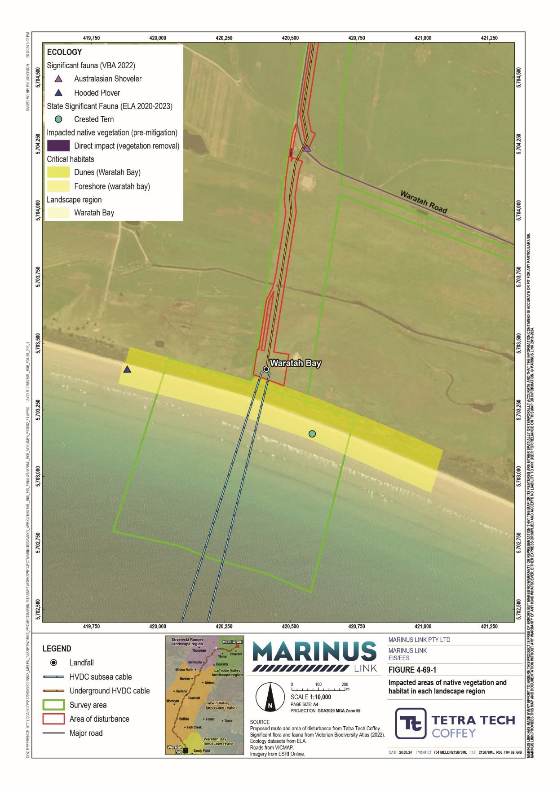

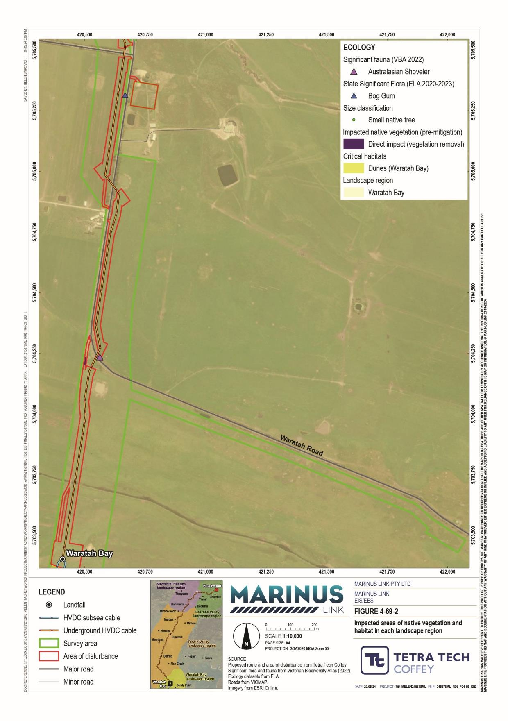

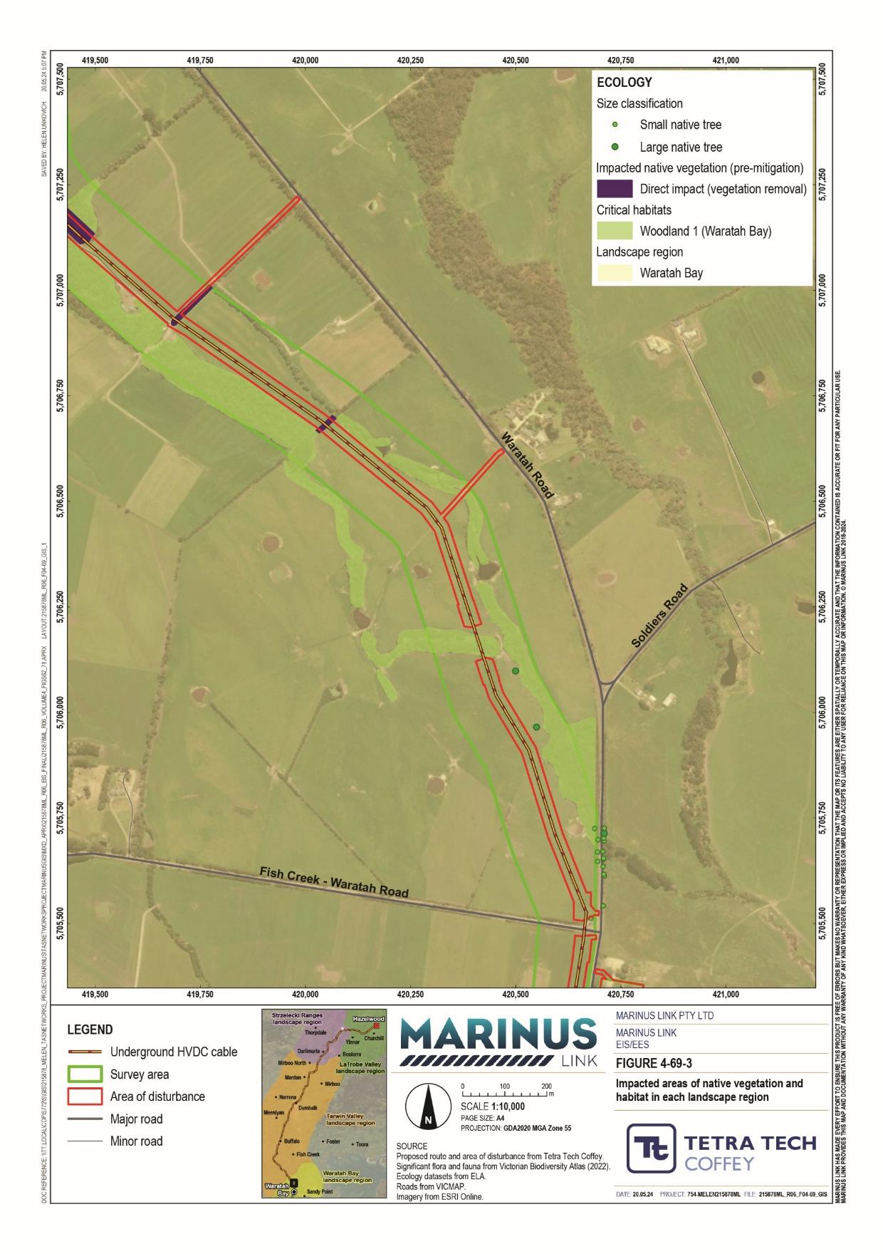

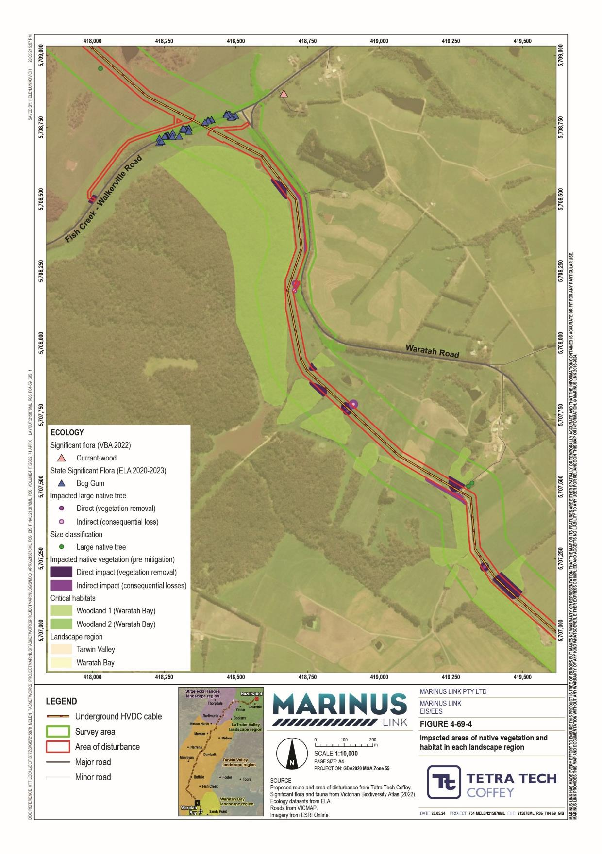

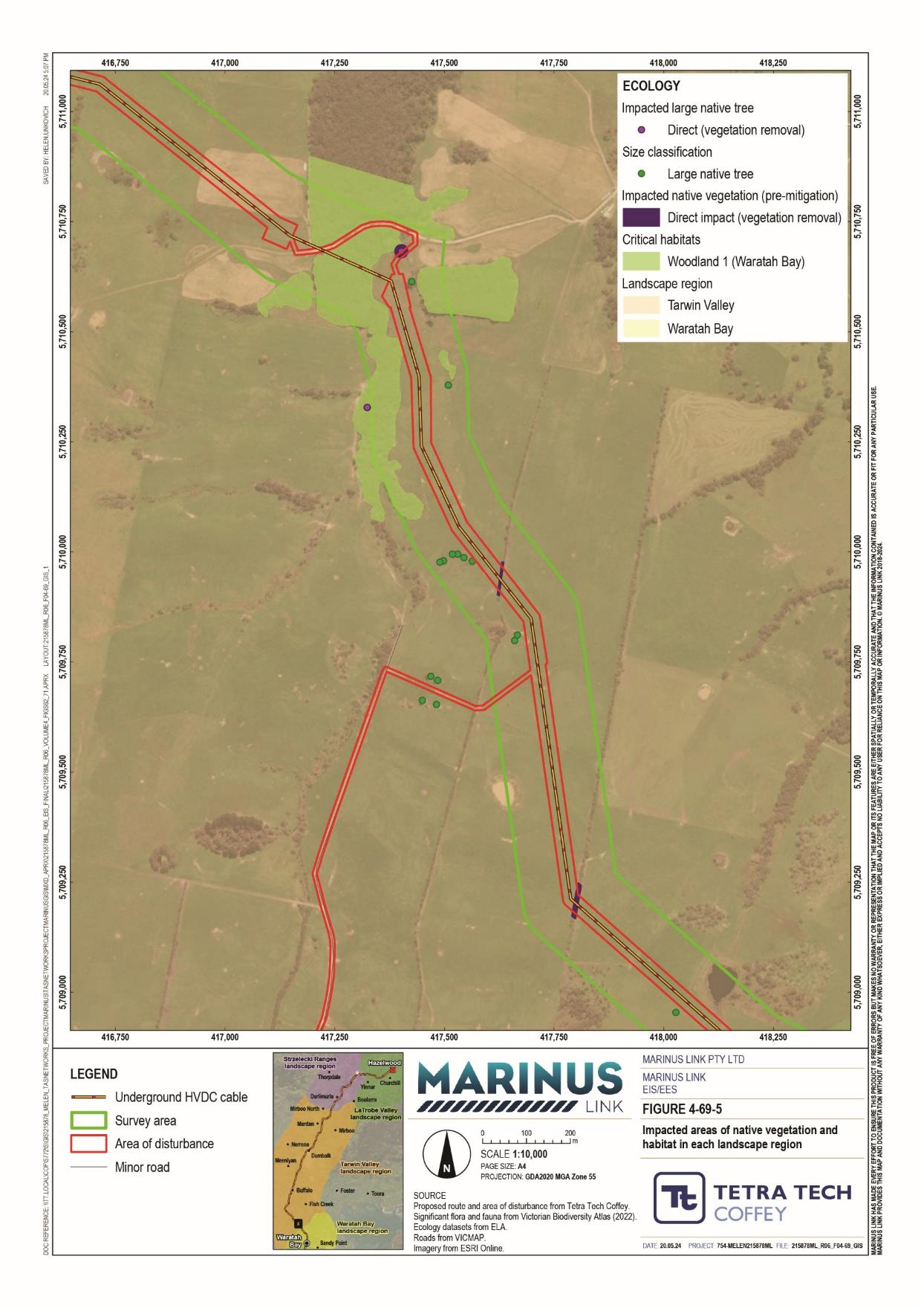

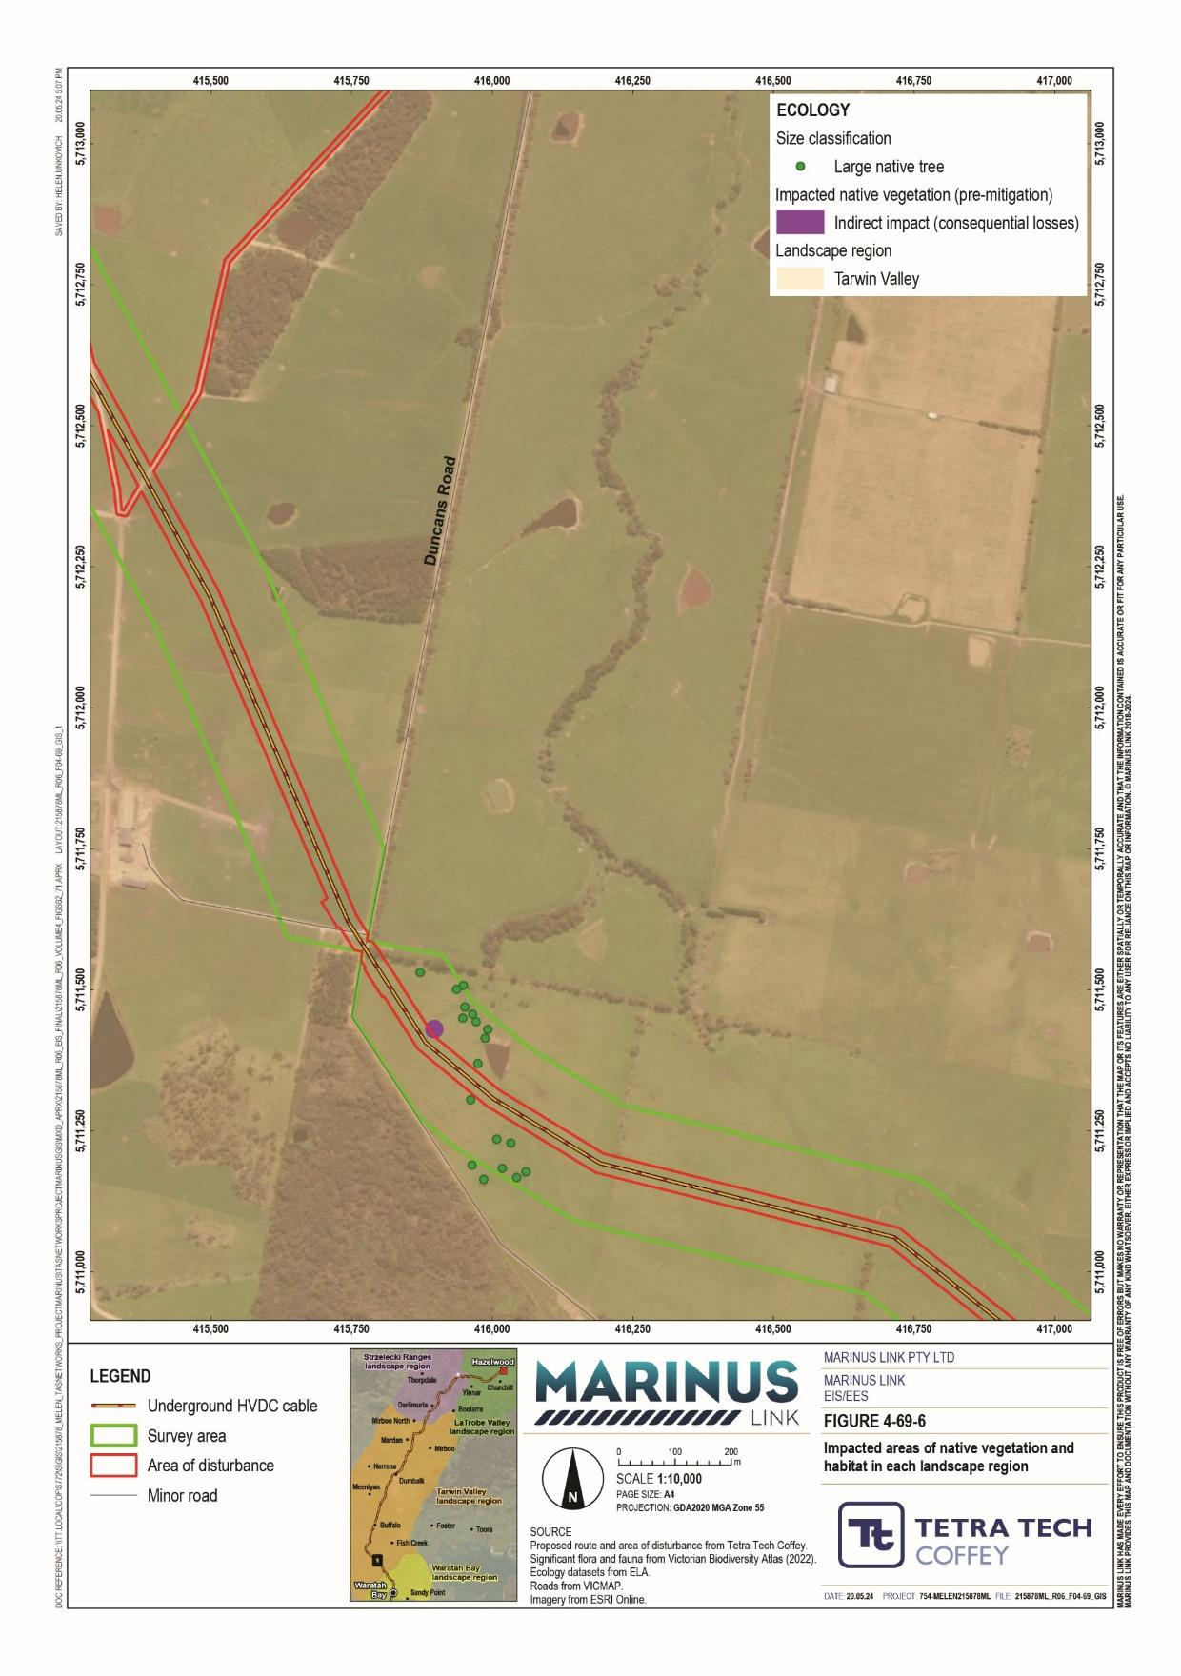

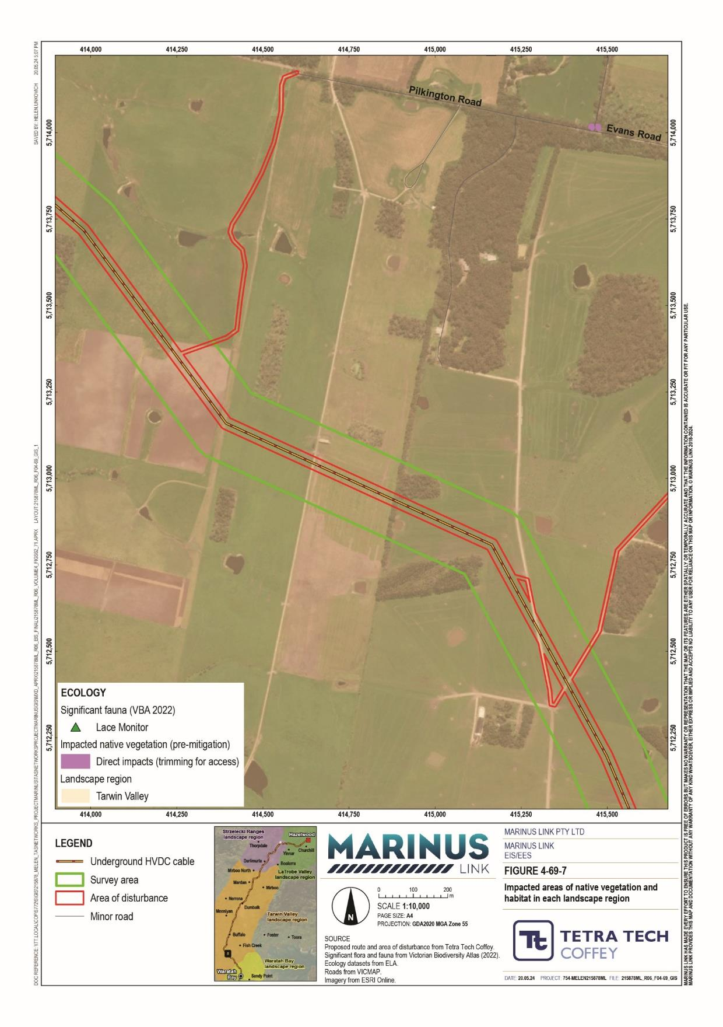

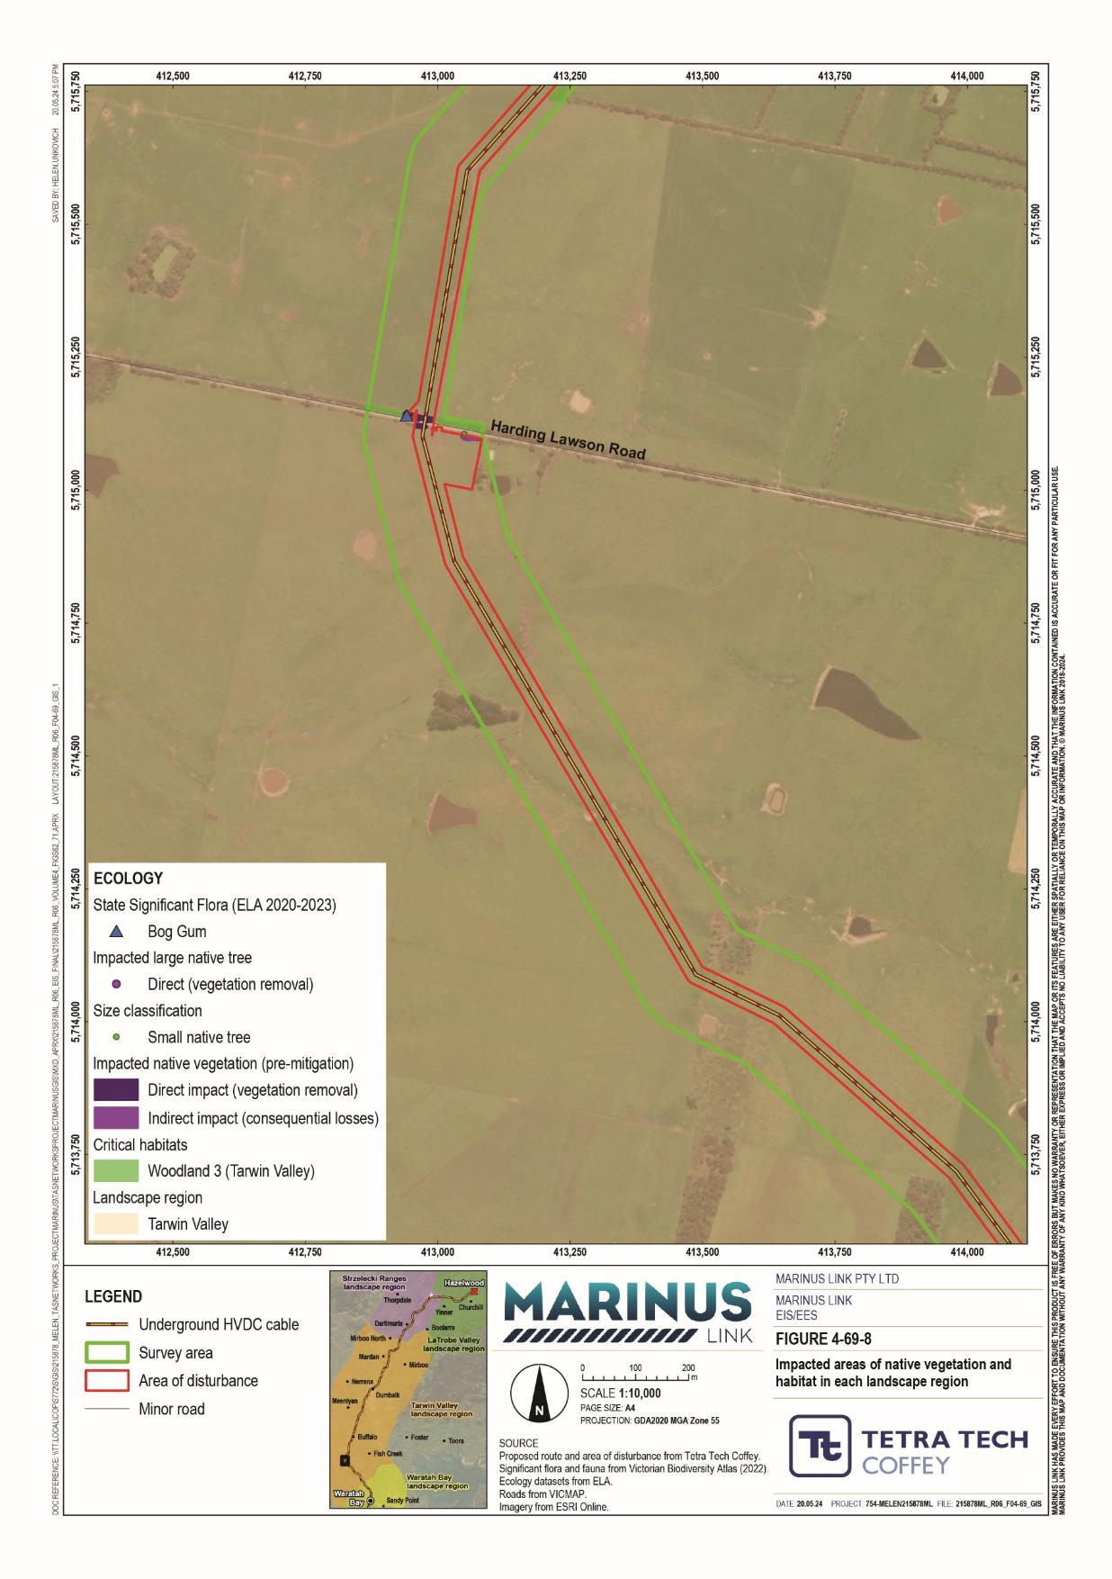

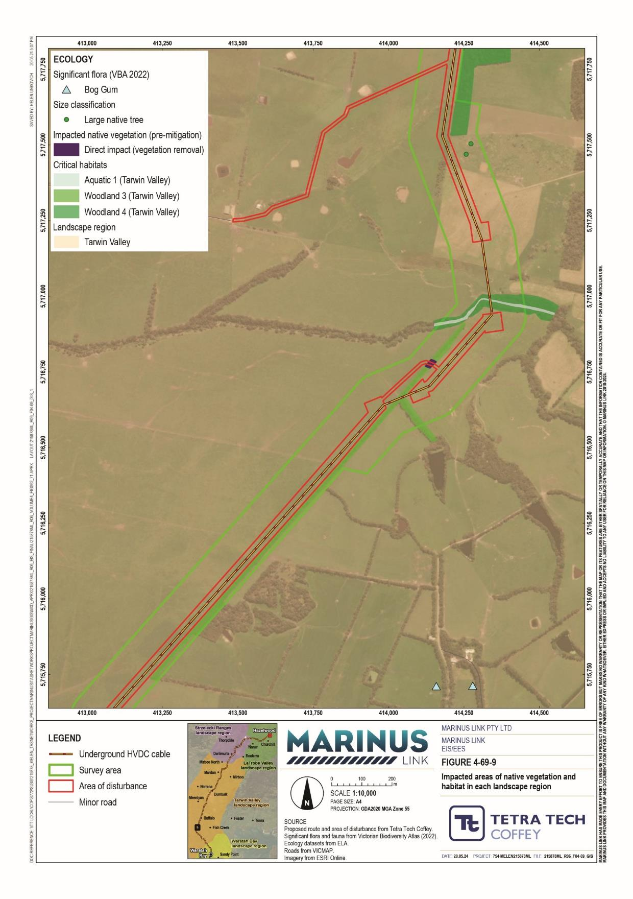

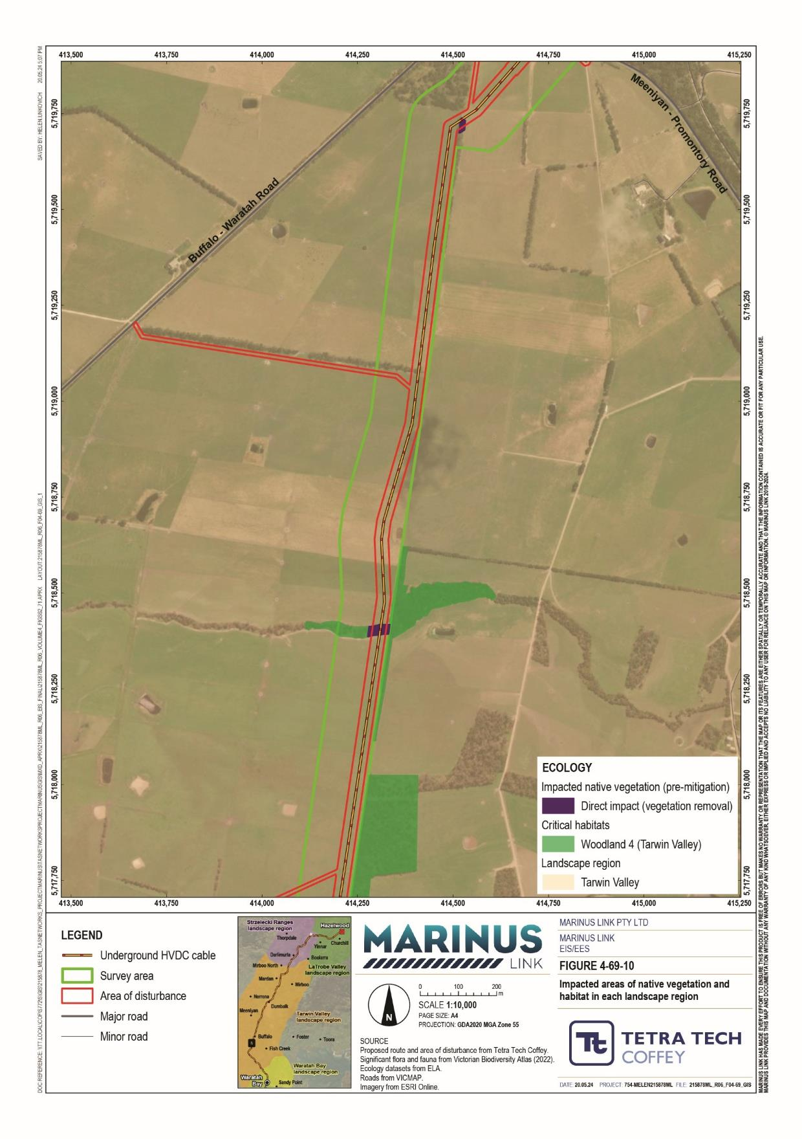

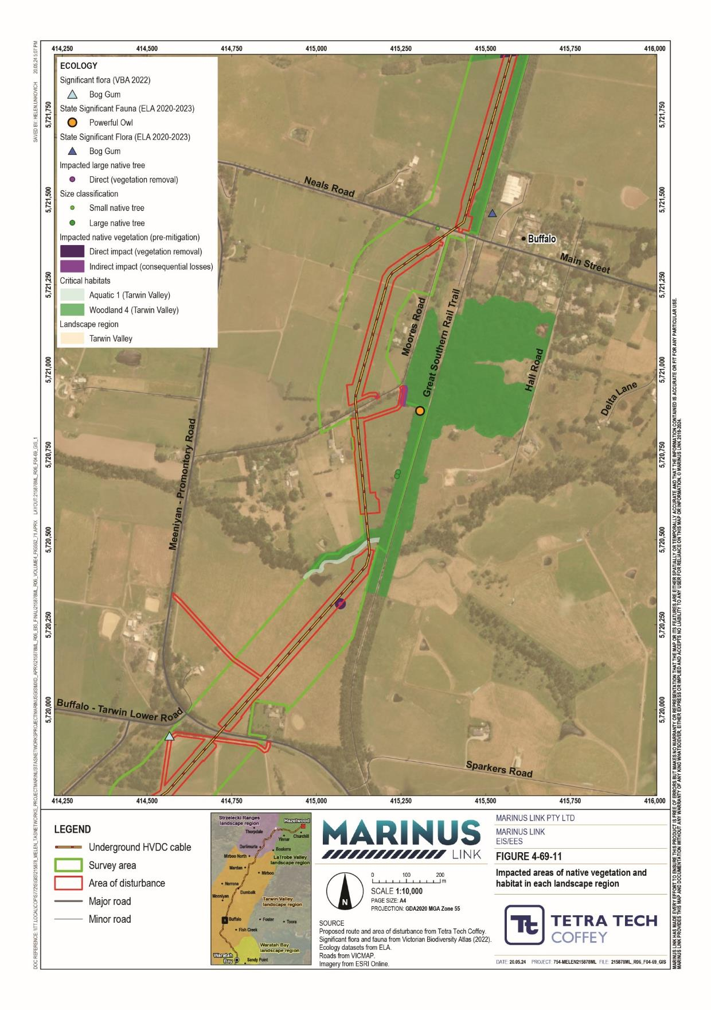

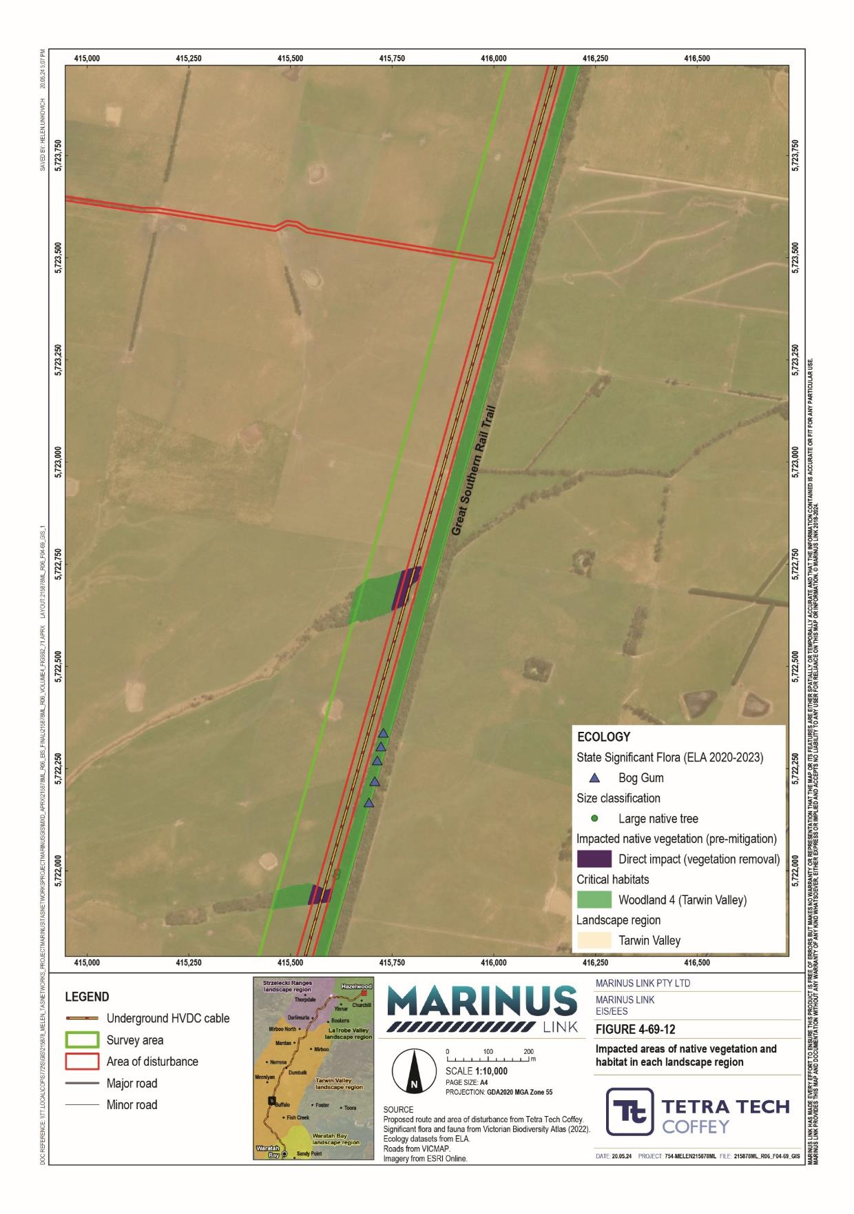

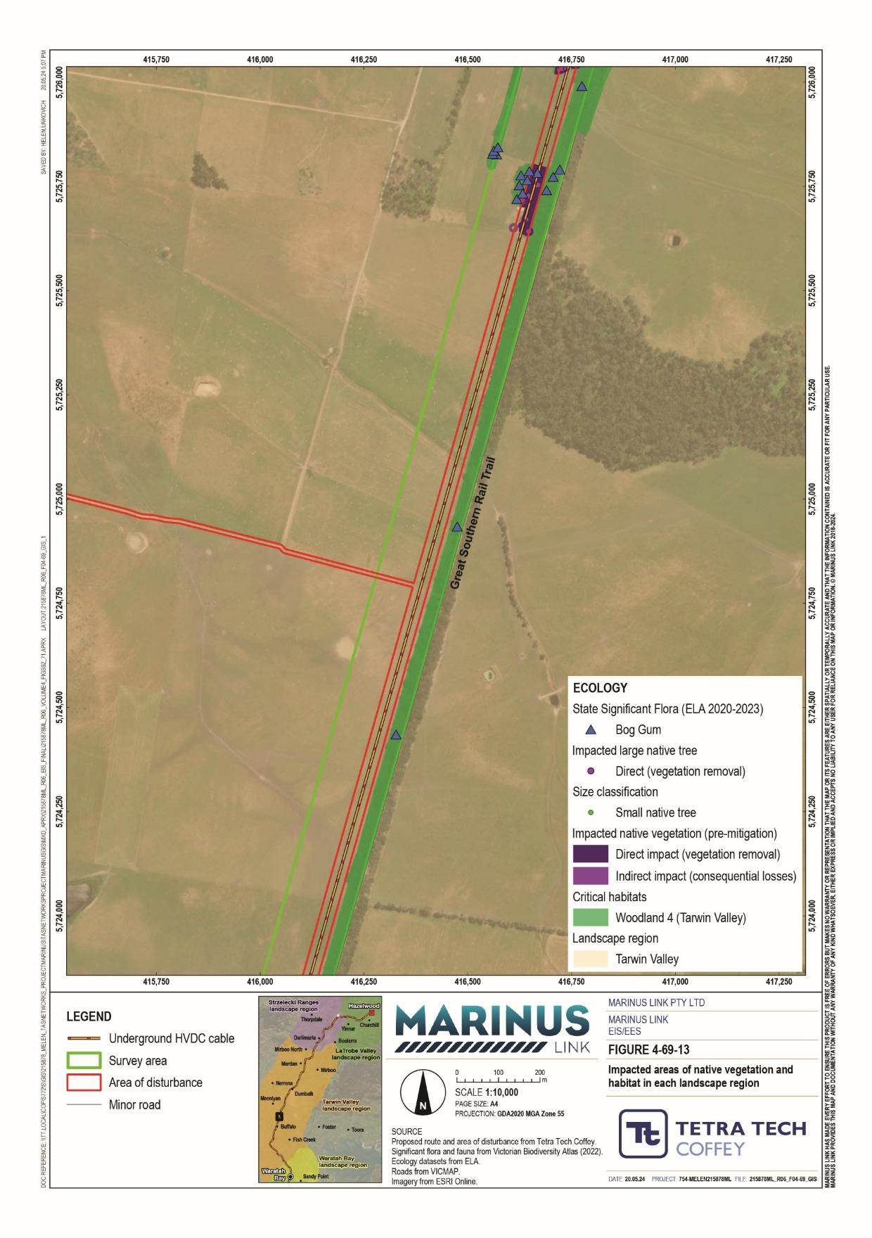

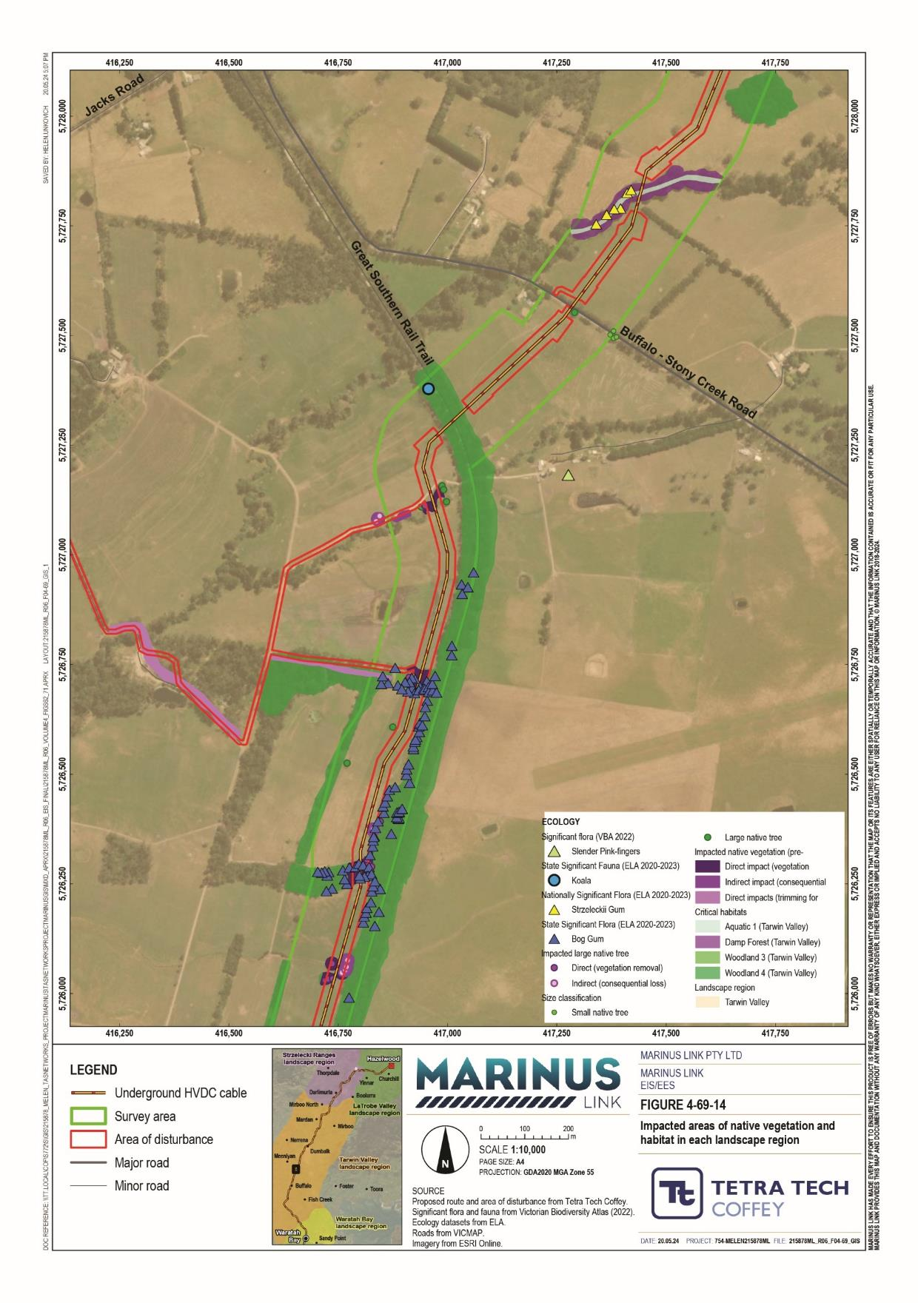

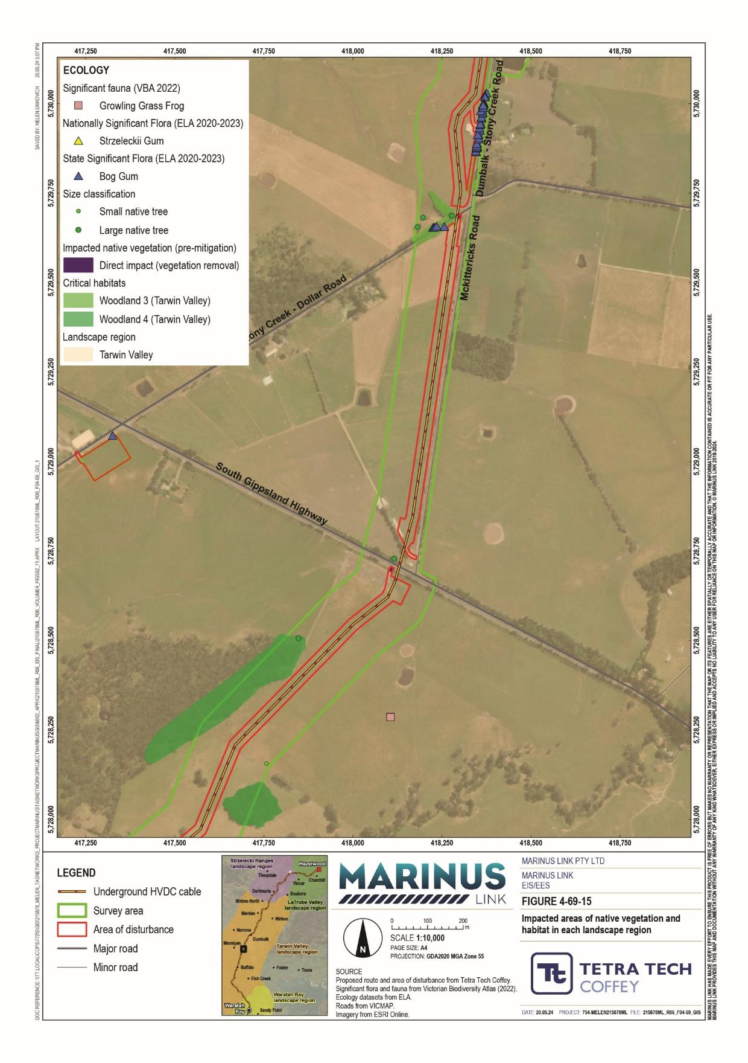

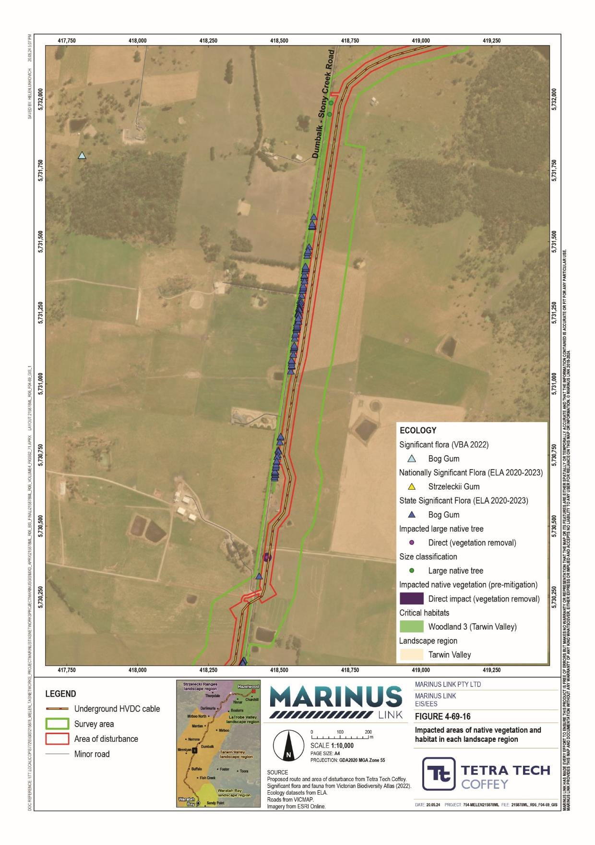

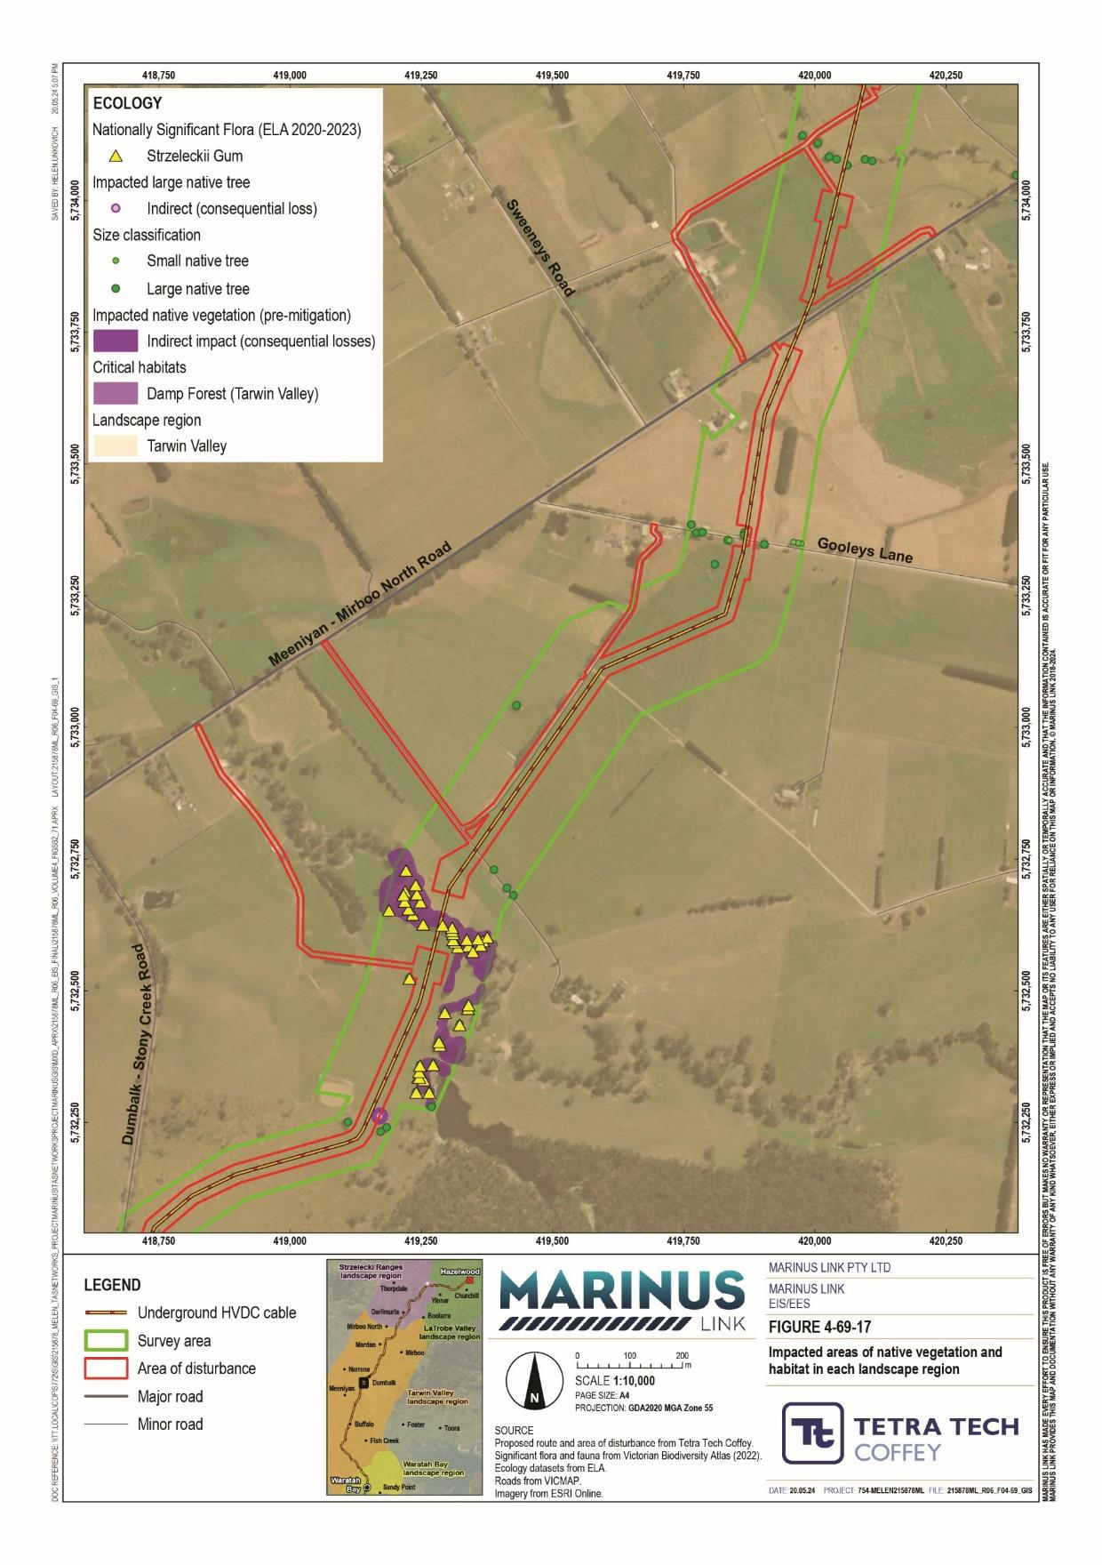

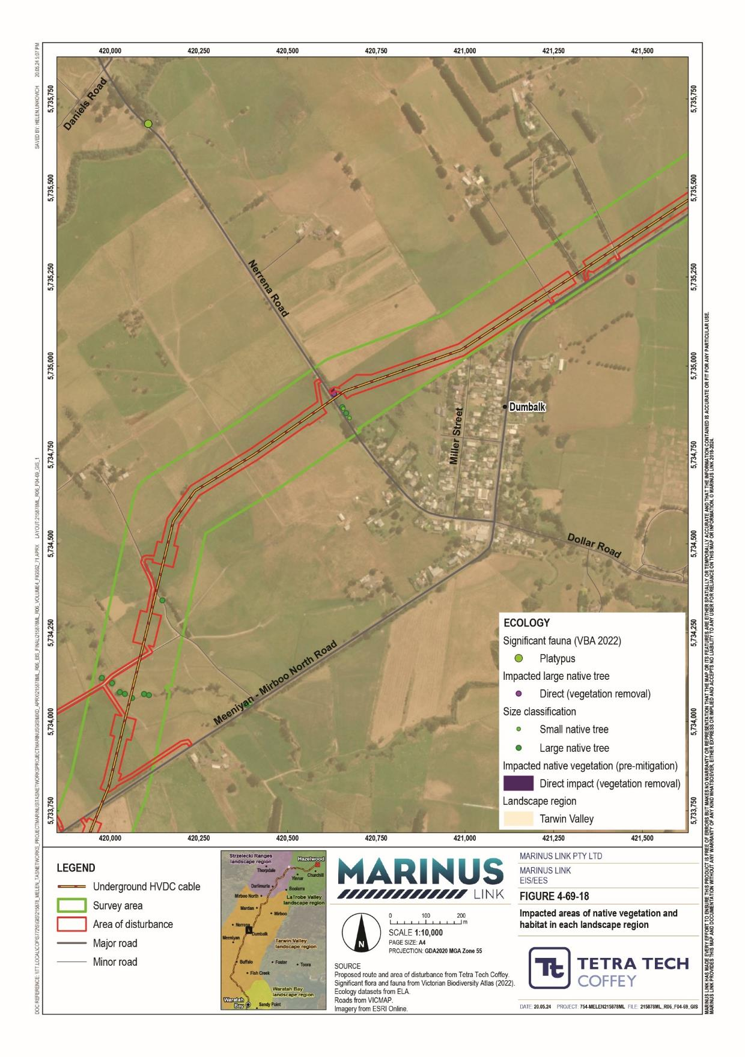

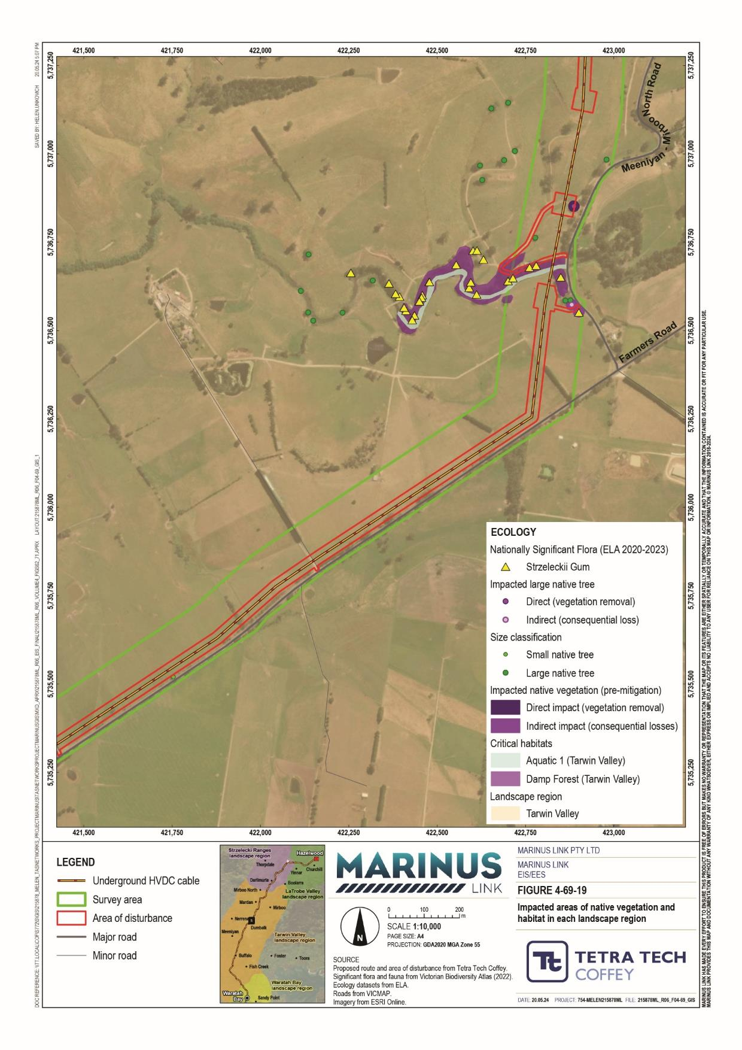

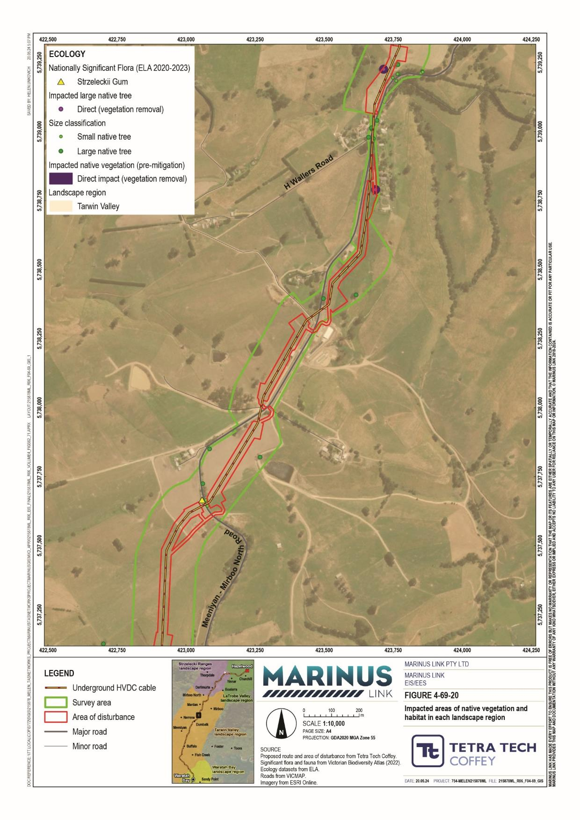

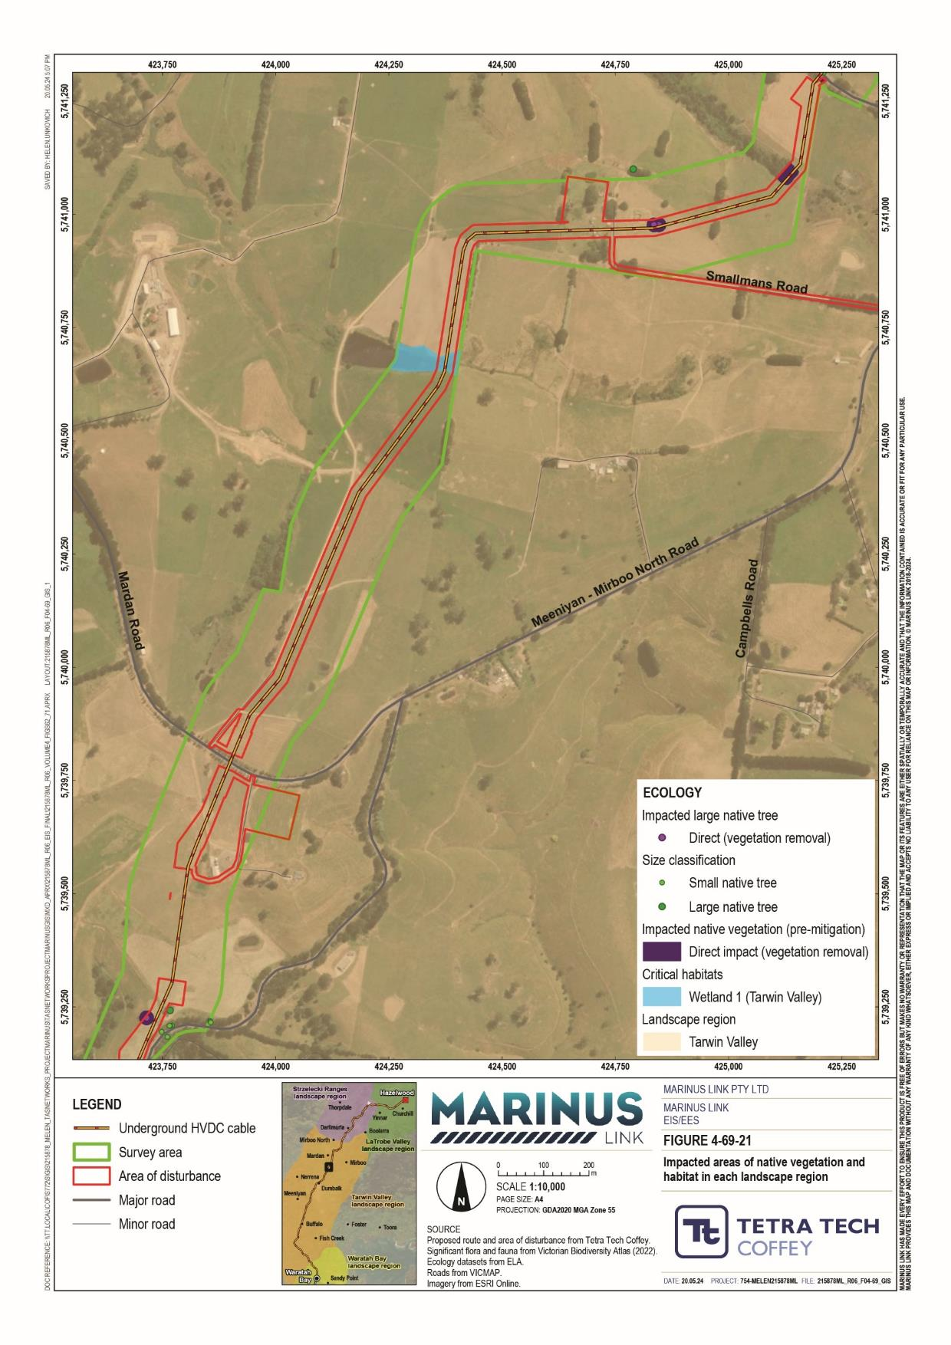

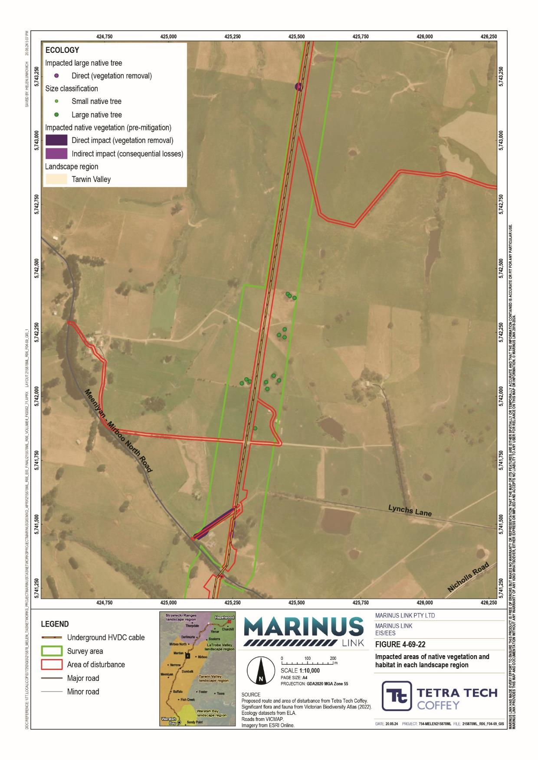

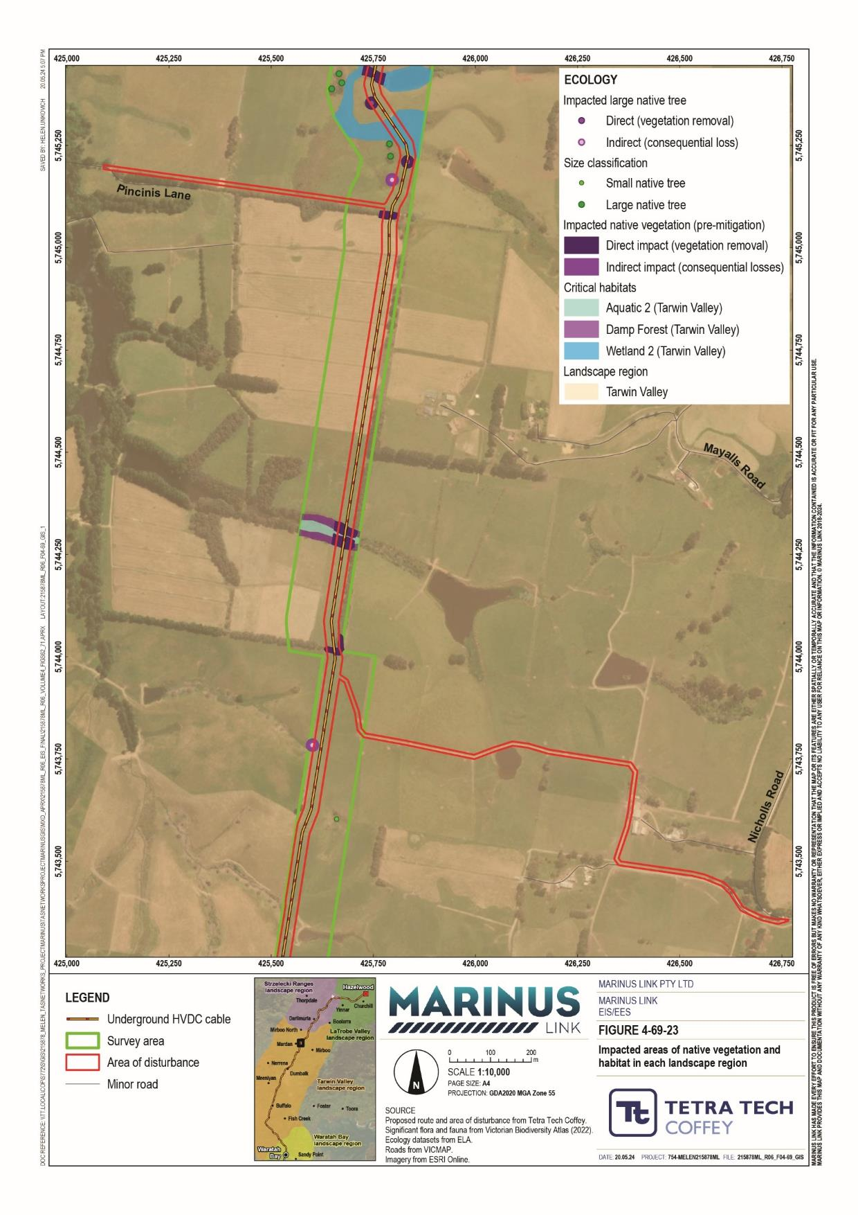

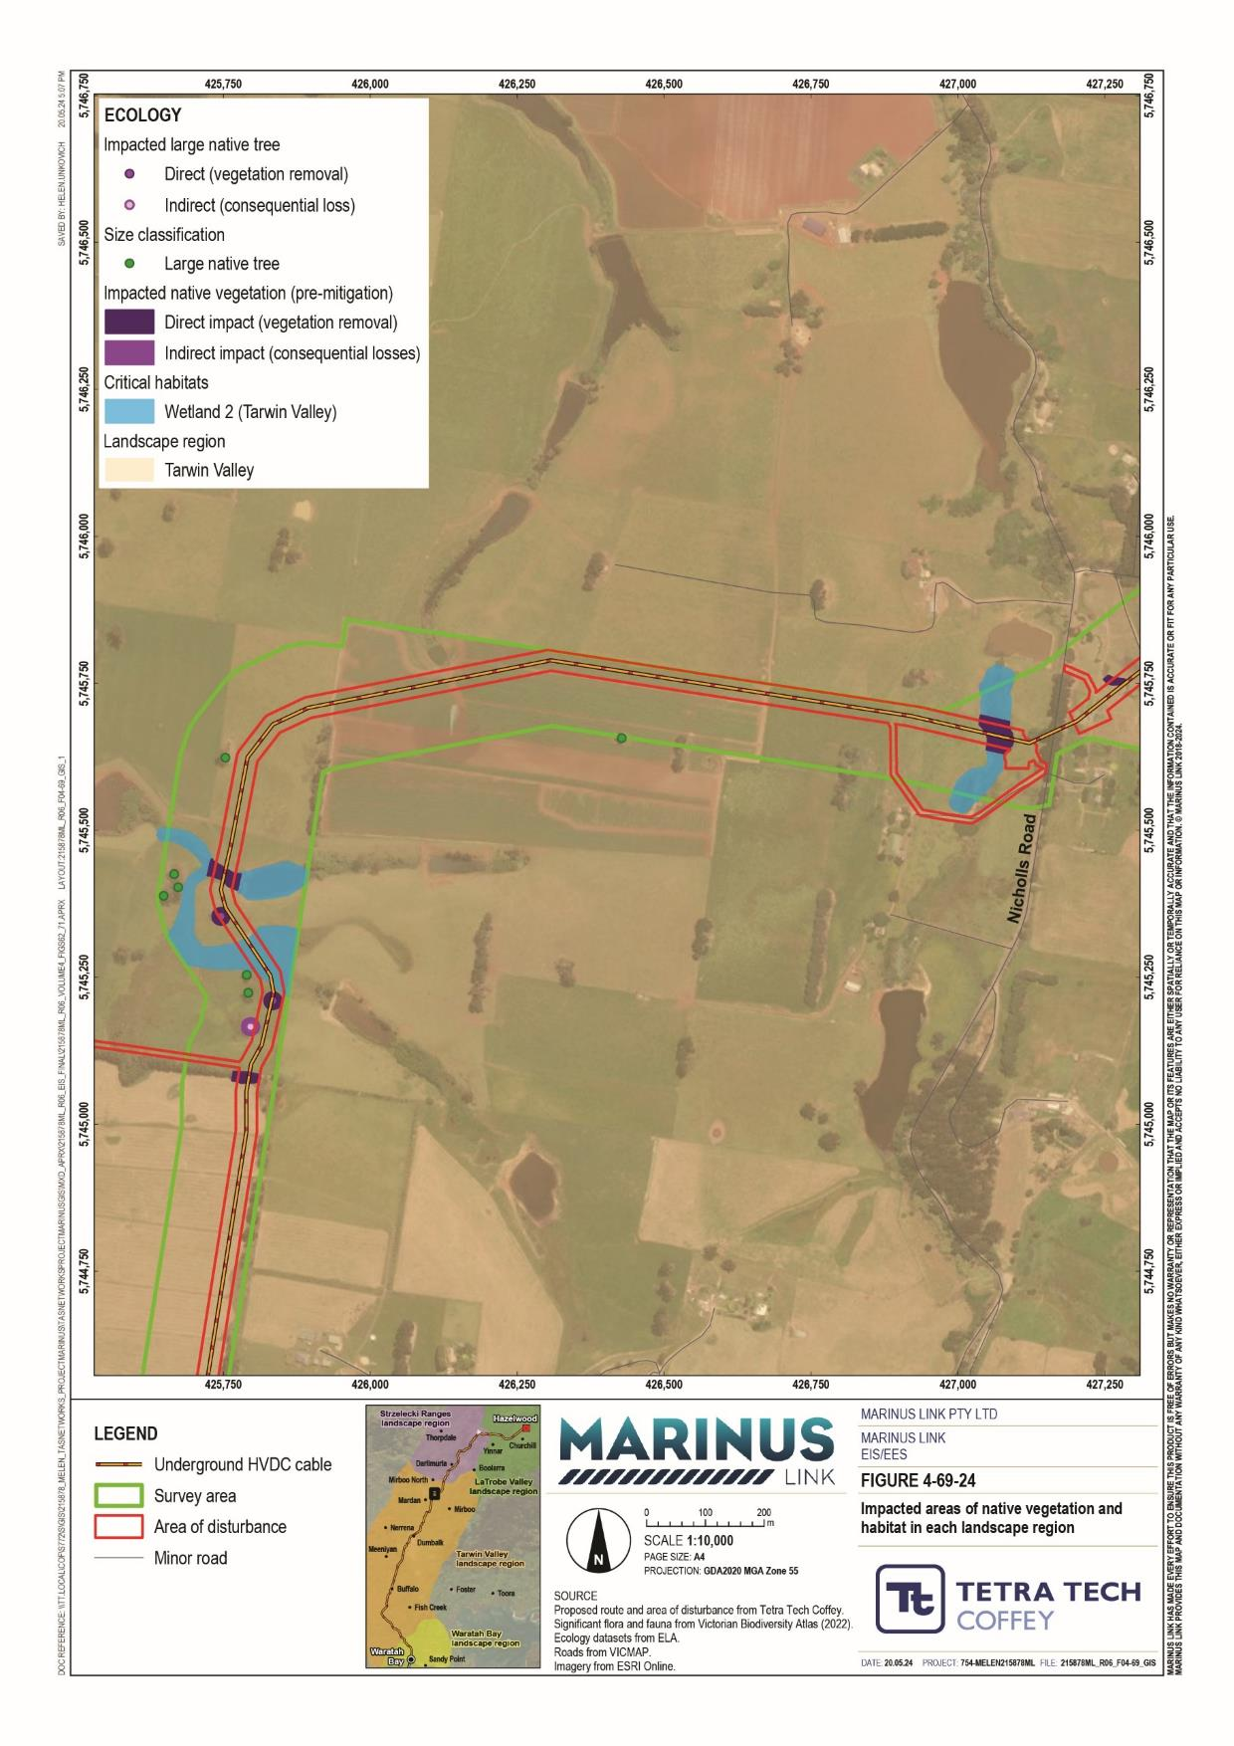

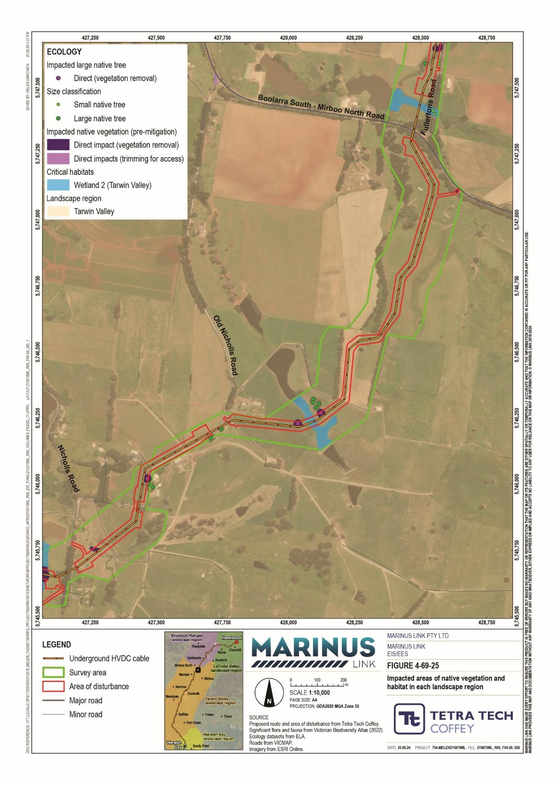

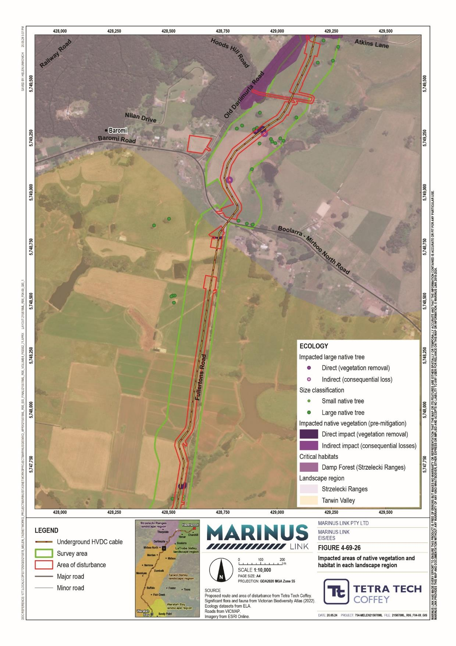
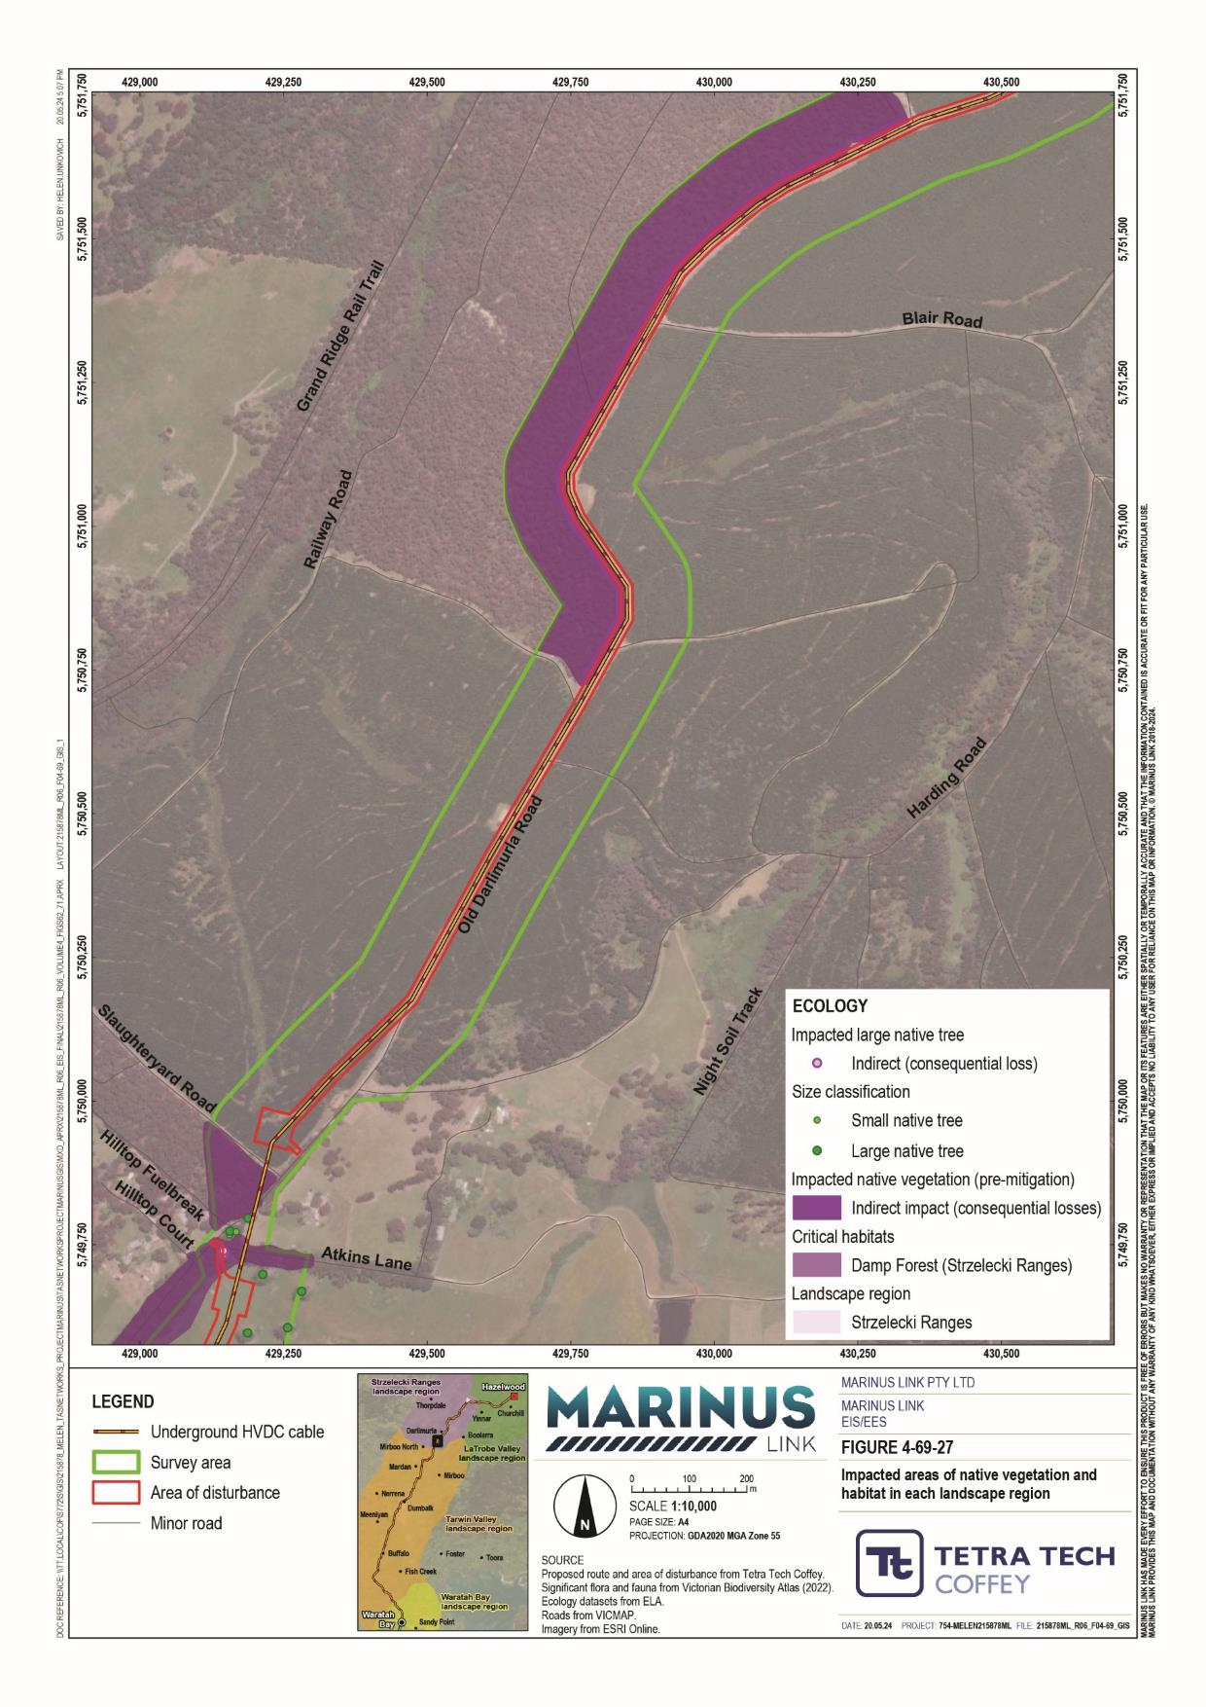
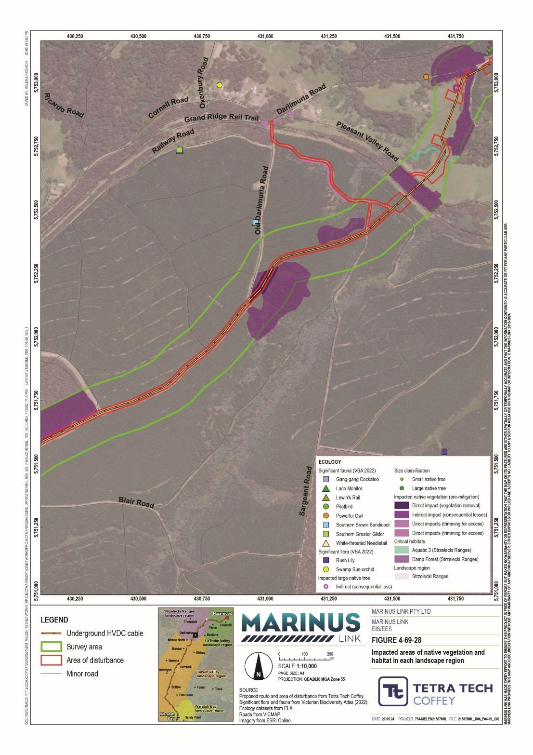
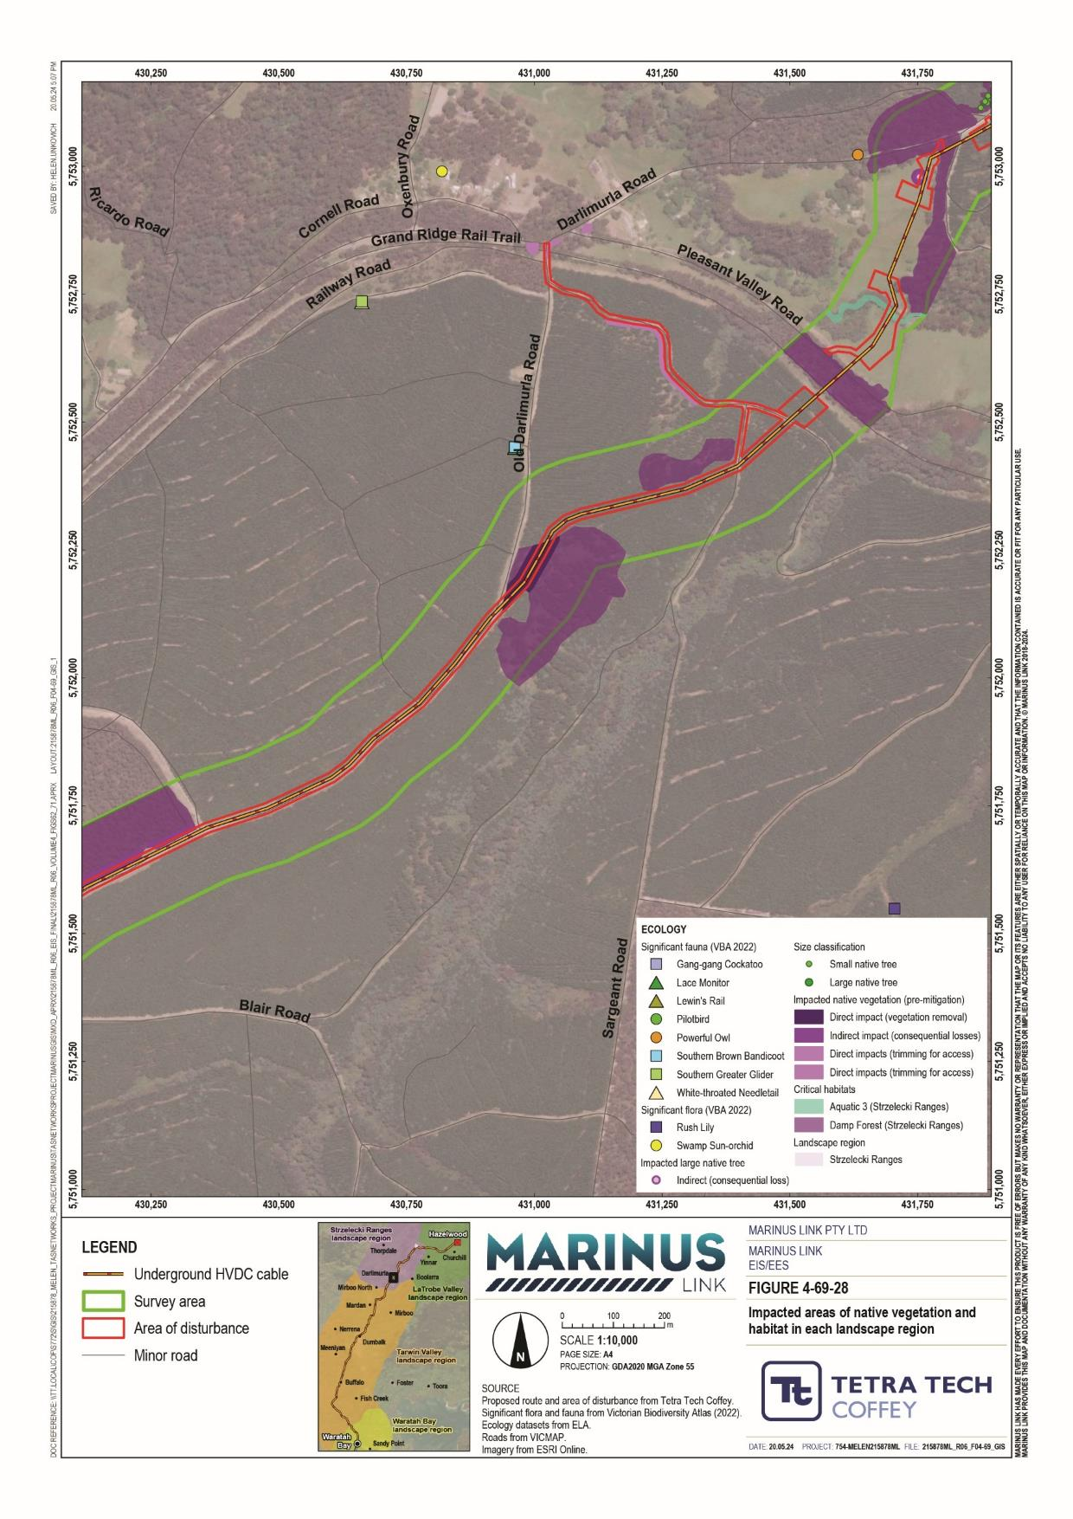

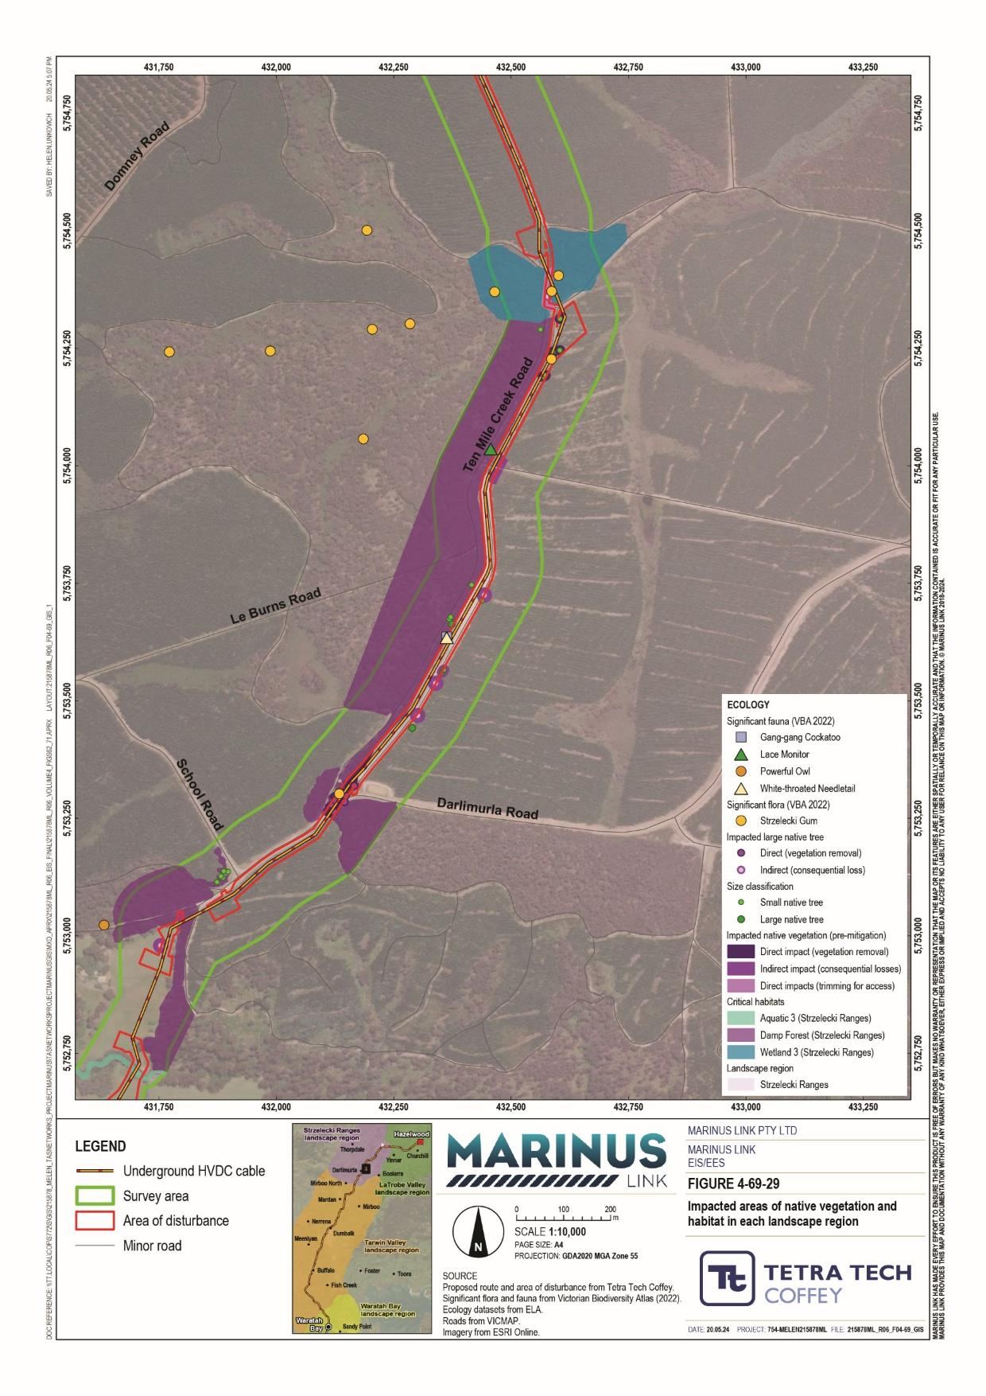

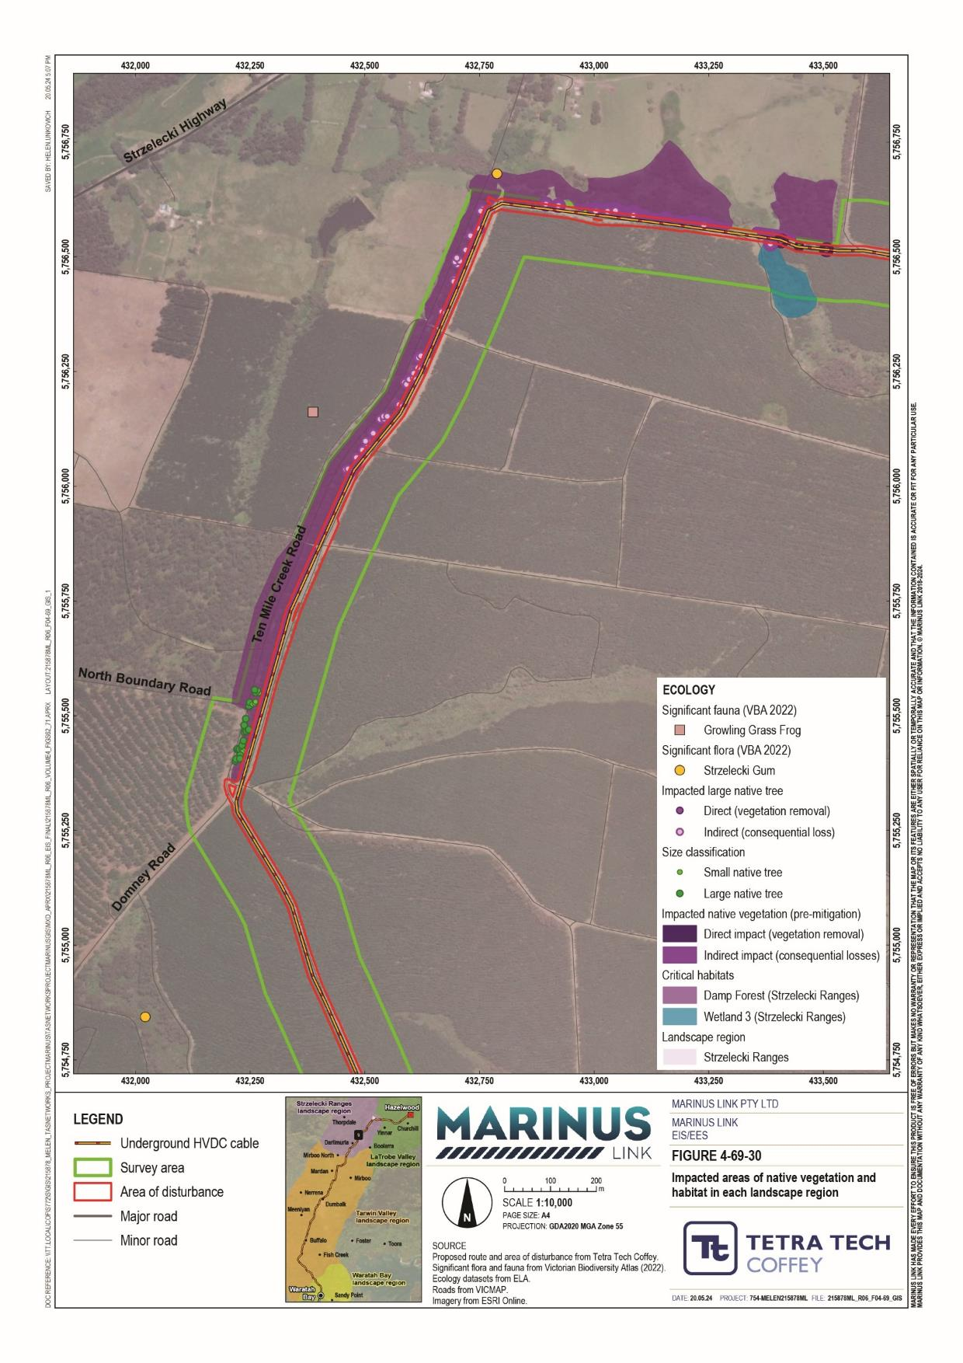

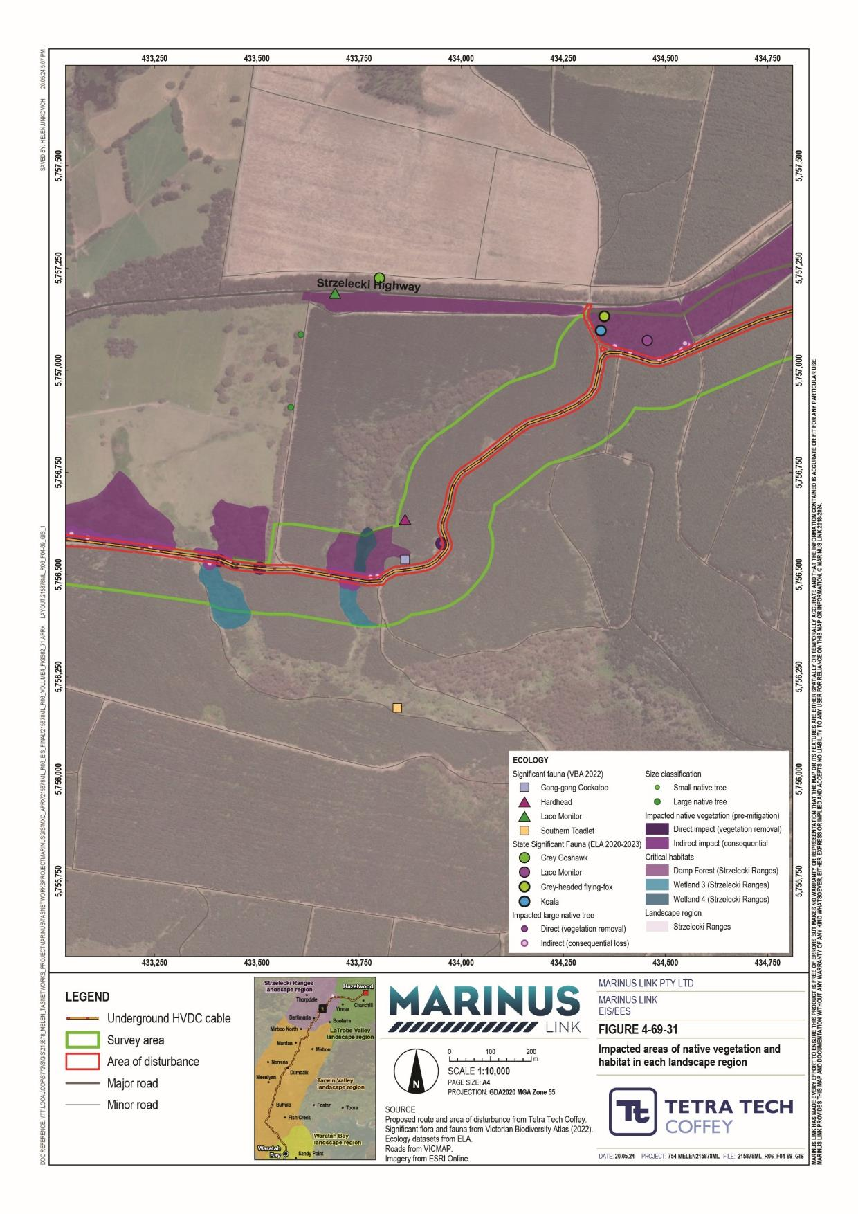

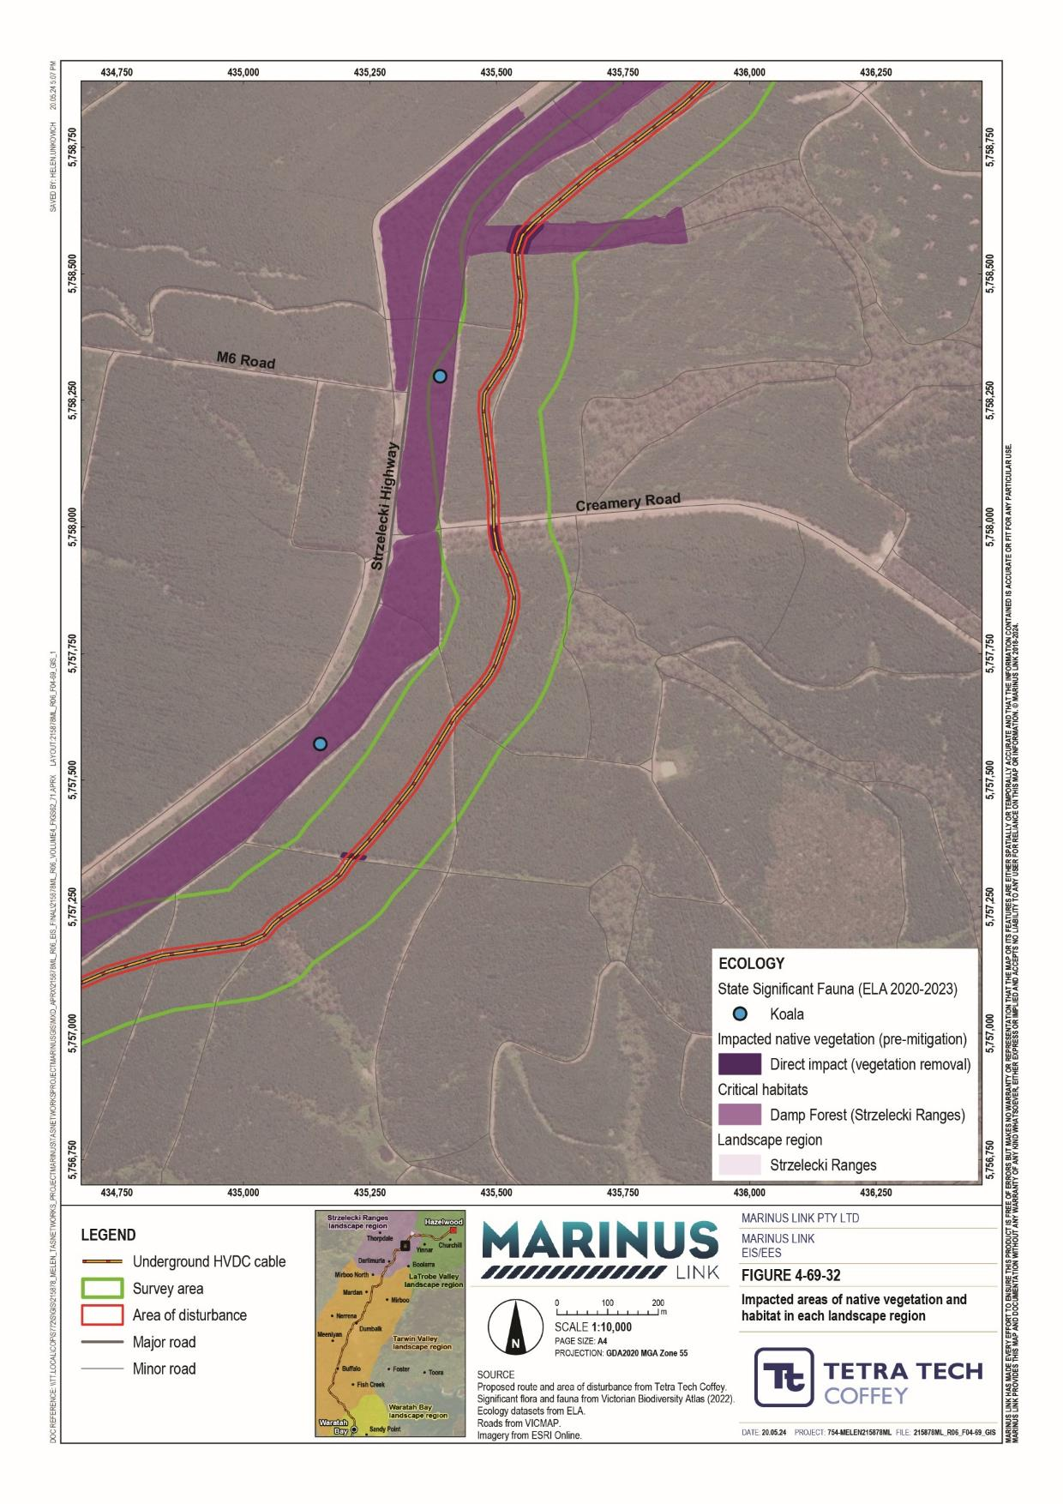

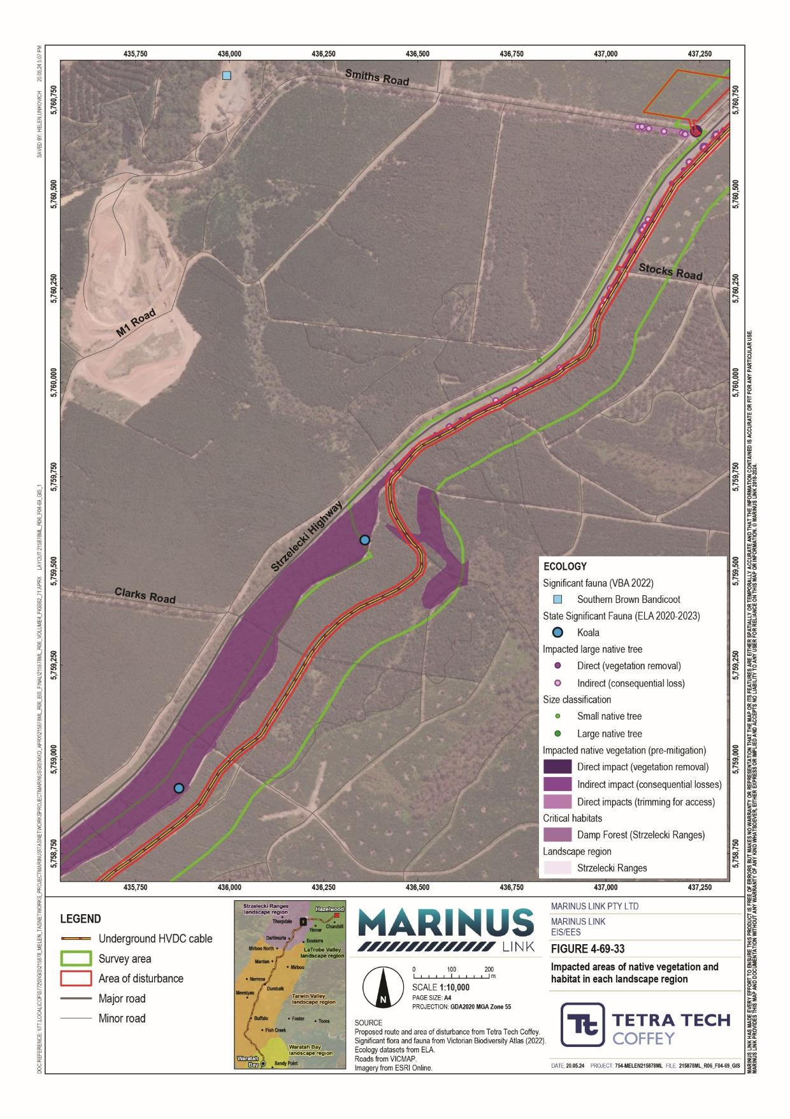
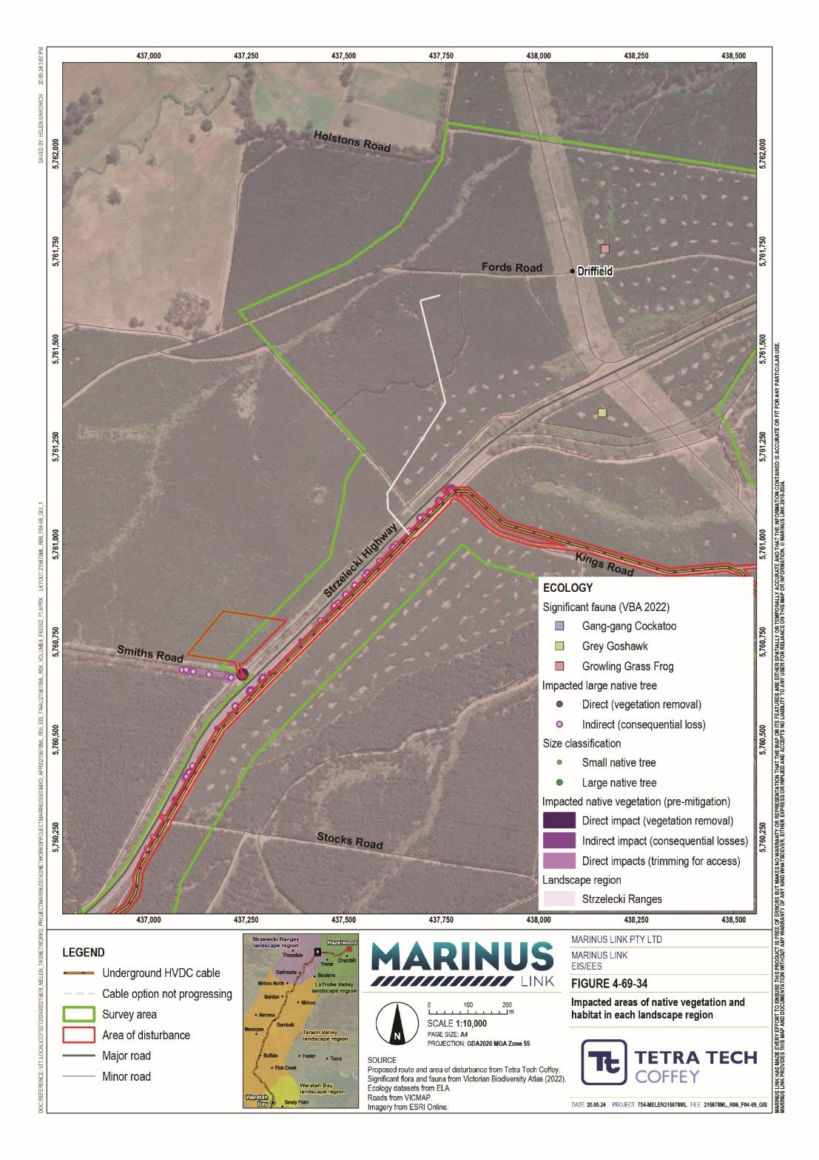
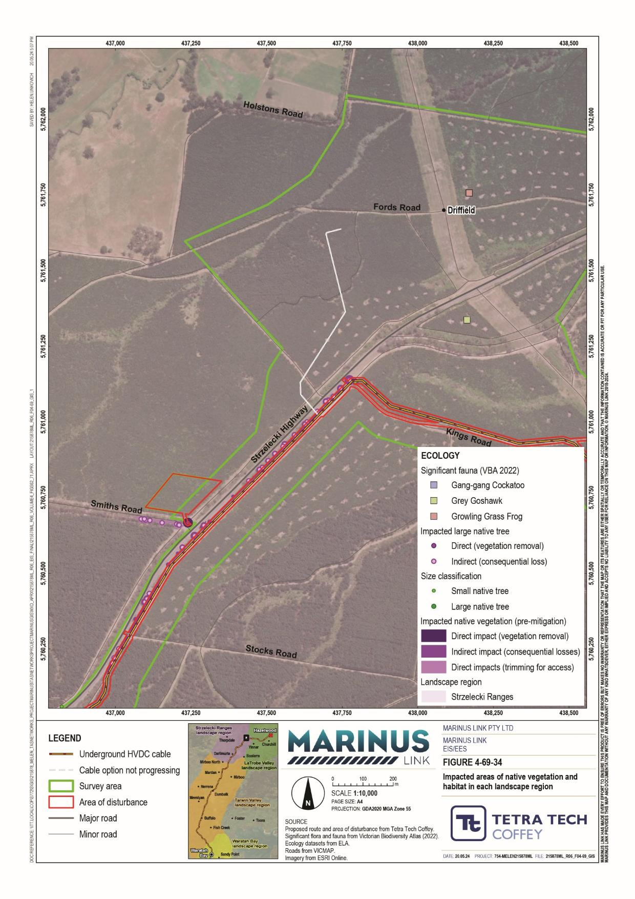

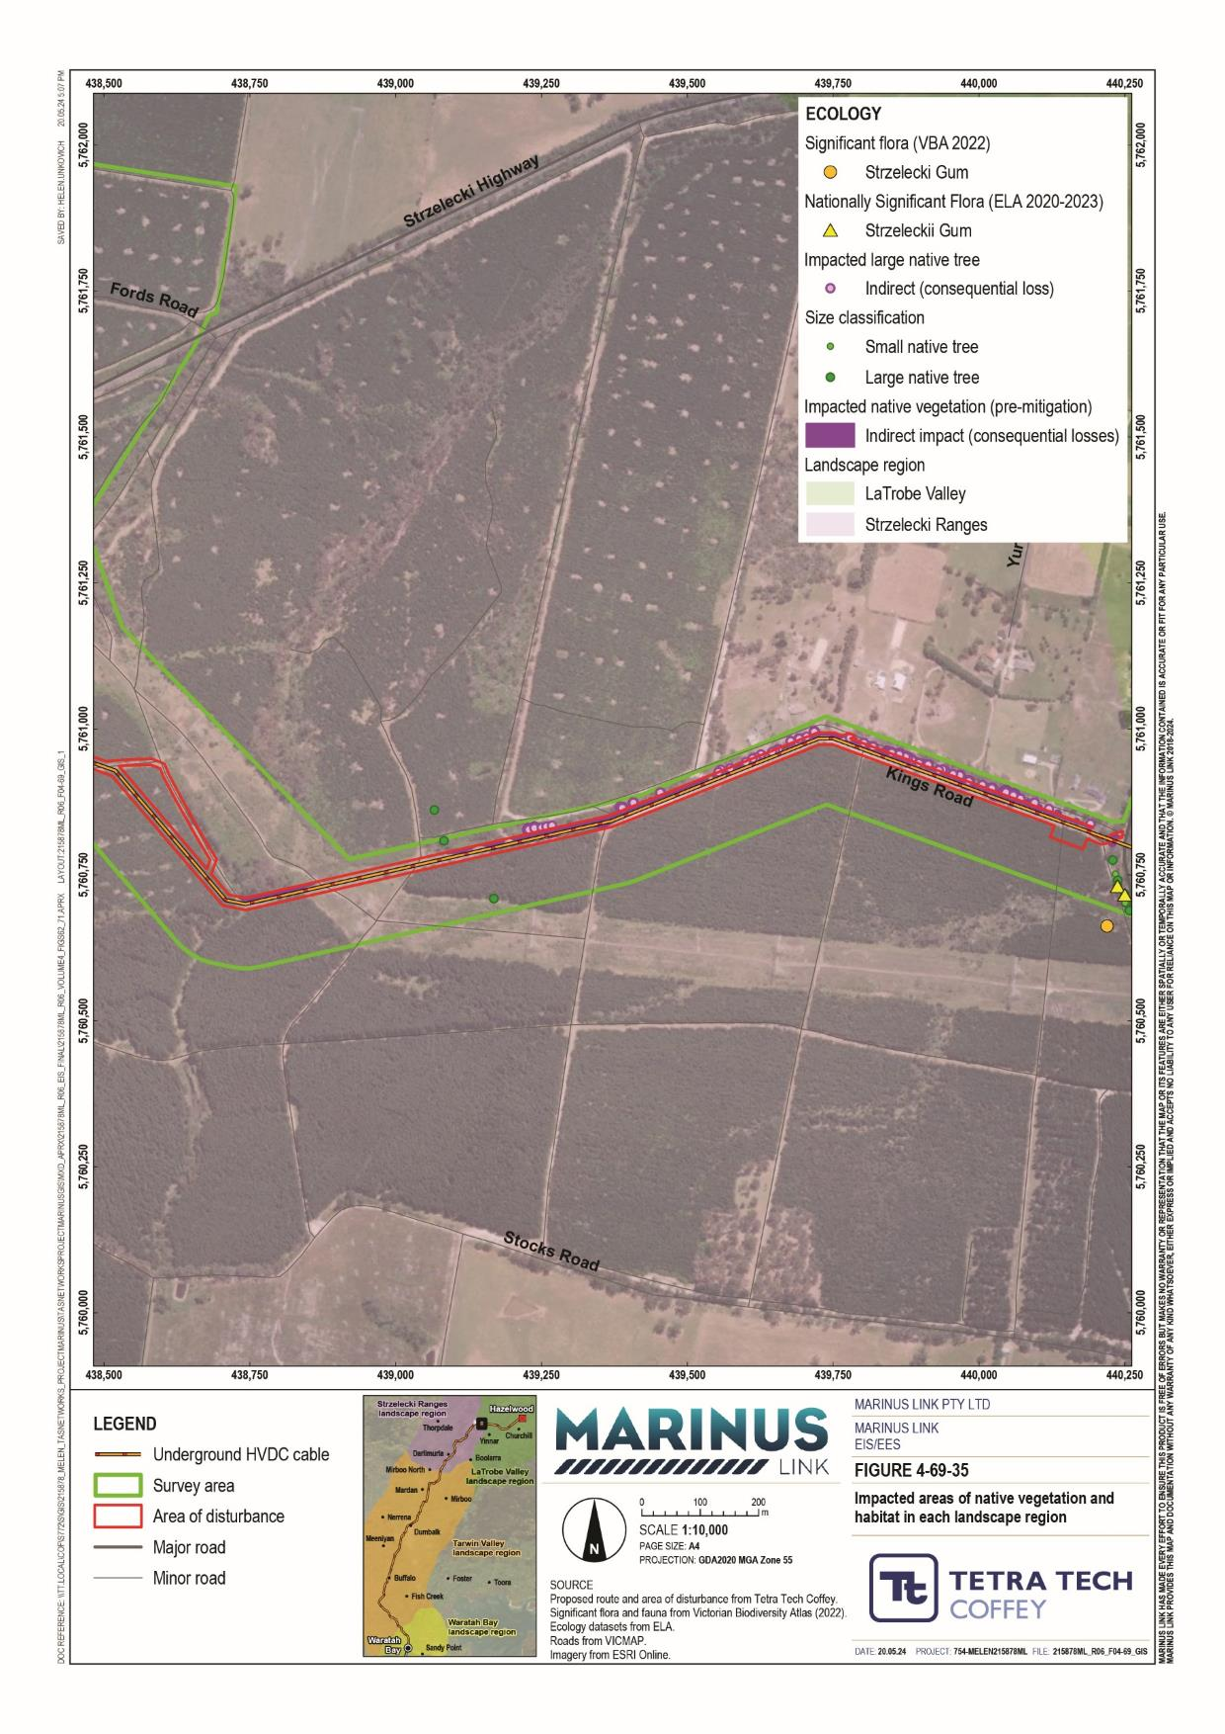

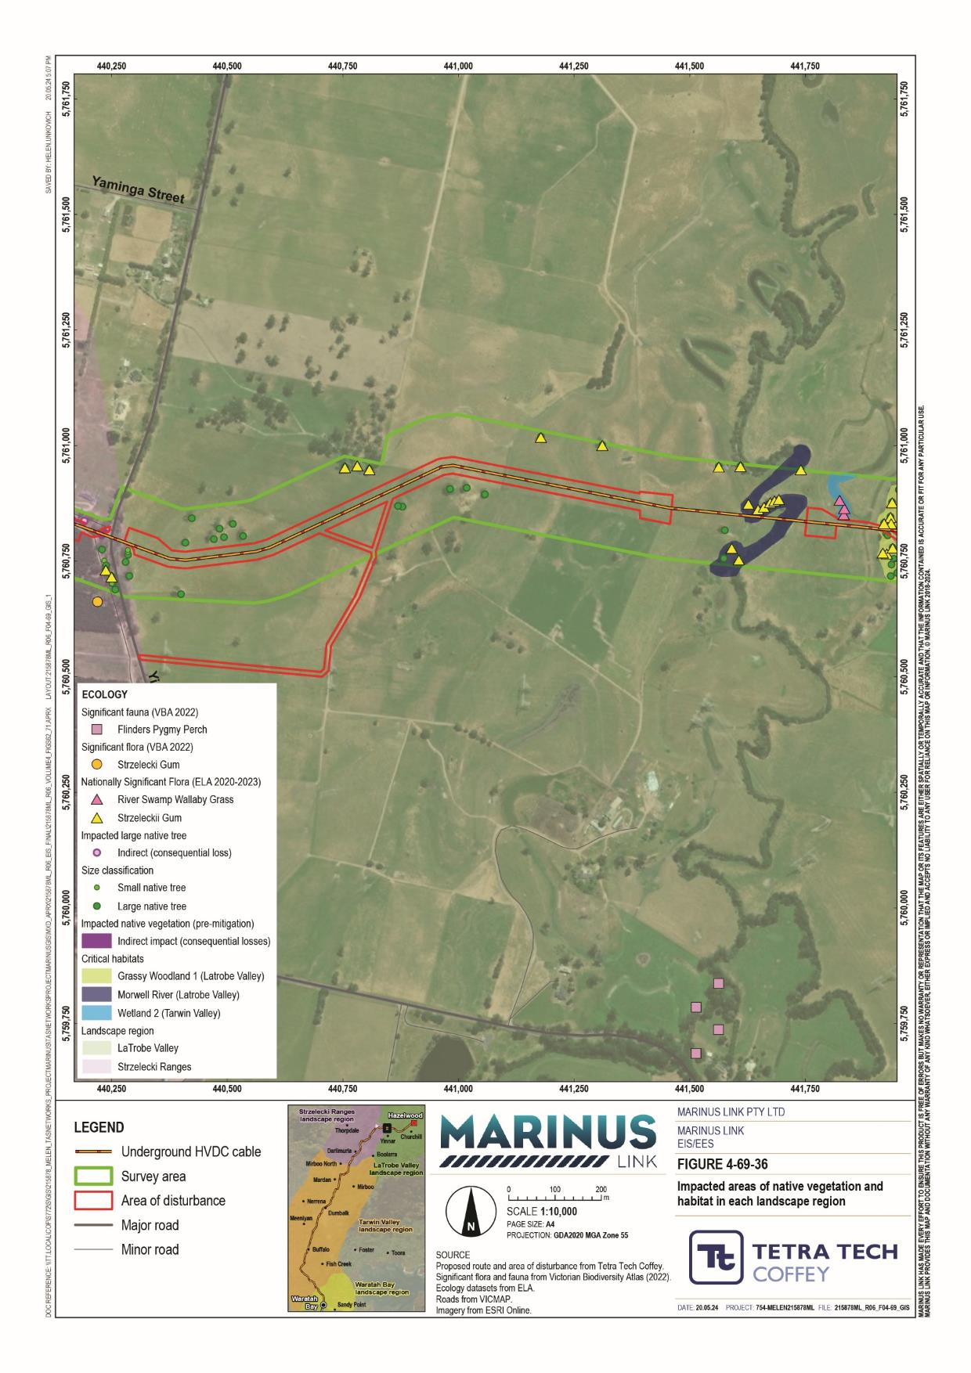

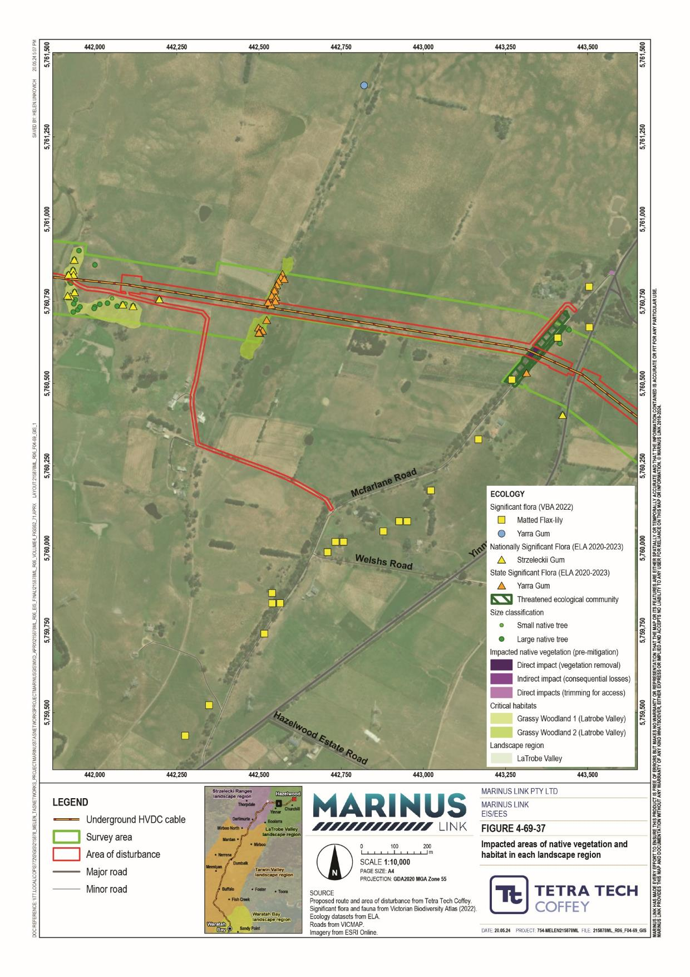

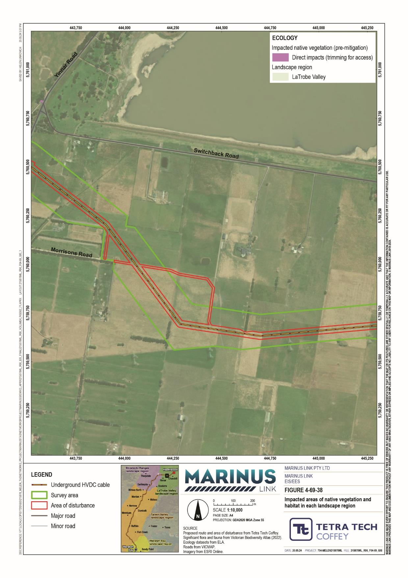

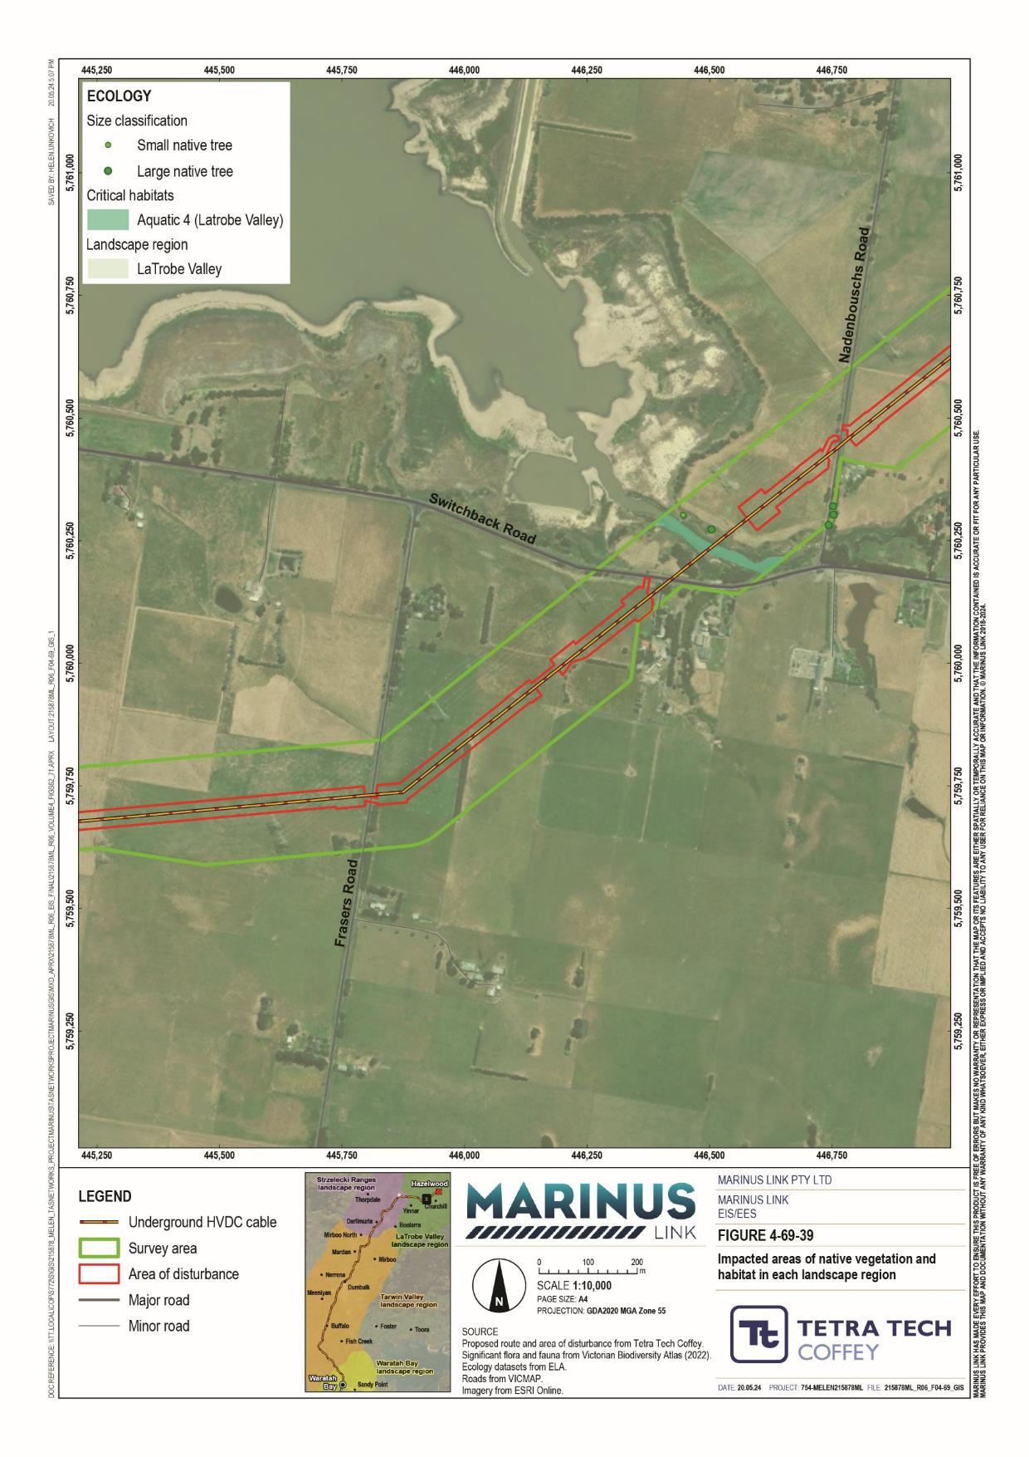
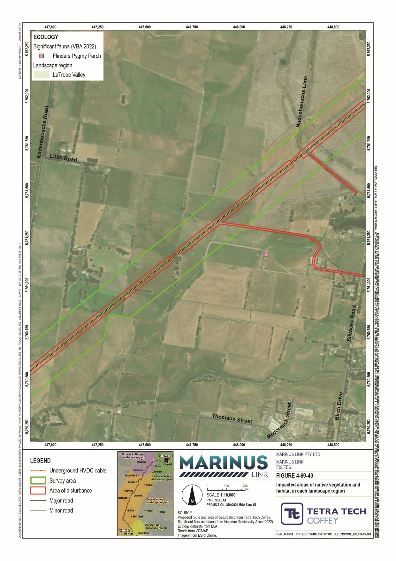

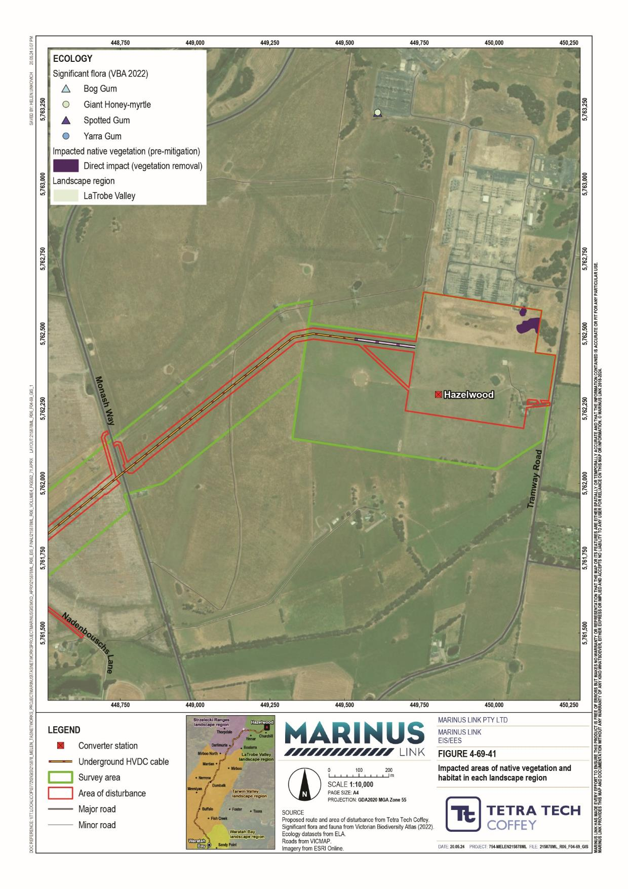

Operation impacts
Potential project impacts to terrestrial ecology values during operation are expected to be low or negligible. This is largely due to the greatest impacts (removal or degradation of native vegetation and habitat), only occurring during project construction. Other potential operation impacts include:
Project vehicles colliding with fauna.

Light, and noise and vibration pollution from project vehicles and transmission stations.

Spreading of weeds and diseases by project vehicles.

These impacts will be lesser than during the construction phase as there will be less project traffic during operation. Further, the impacts of light, and noise and vibration are expected to be lesser, when considering the assessments in Volume 1, Chapter 6: Project description and Technical Appendix T: Noise and vibration. Given this, and the highly modified nature of the landscape surrounding the project alignment, the project operation will not have a material impact on ecological values.

Decommissioning impacts
The operational lifespan of the project is a minimum 40 years. At this time the project will be either decommissioned or upgraded to extend its operational lifespan.
Decommissioning will be planned and carried out in accordance with regulatory requirements at the time. A decommissioning management plan in accordance with approvals conditions will be prepared prior to planned end of service and decommissioning of the project.
Requirements at the time will determine the scope of decommissioning activities and risk of impacts. The key objective of decommissioning is to leave a safe, stable and non-polluting environment, and minimise risk of impacts during the removal of infrastructure.
Decommissioning of project infrastructure will implement the waste management hierarchy principles of avoid, minimise, reuse, recycle and appropriately dispose. Waste management will be in accordance with applicable legislation at the time.
A decommissioning management plan will be prepared to outline how activities will be undertaken and potential ecology impacts managed.

Environmental performance requirements
EPRs set out the environmental outcomes that must be achieved during all phases of the project. In developing these EPRs, industry standards and guidelines, good practice and the latest approaches to managing impacts were considered. Project specific management measures, relevant legislation and policy requirements informed these EPRs.
The EPRs that will be implemented to manage potential impacts on terrestrial ecology are listed in Table 11-13.

EPR ID | EPR
EC01 | Avoid or minimise native vegetation and habitat loss and degradation
Prior to commencement of project works and to inform the design:
Complete vegetation quality assessments at locations that could be impacted by the areas of disturbance of the final design and require further assessment to confirm vegetation type and extent. Areas to be surveyed, if impacted, include those shown in Figure 6 of Technical Appendix V: Terrestrial Ecology Assessment.
Complete habitat assessments and targeted surveys at locations that could be impacted by the areas of disturbance of the final design and required further assessment to determine habitat suitability and/or presence/absence of threatened species. Areas to be surveyed, if impacted, include those shown in Figure 5 of EIS/EES Technical Appendix V.
Complete fauna utilisation surveys of all impacted hollow-bearing trees within areas of priority habitats shown in Figure 5 of EIS/EES Technical Appendix V, to identify nesting sites and minimise removal of hollow bearing trees.
Develop and implement measures to avoid or otherwise minimise impacts on native vegetation and priority habitats, so far as reasonably practicable, through detailed design and appropriate construction methods, at locations shown in Figure 7 of EIS/EES Technical Appendix V. Where feasible, measures will include:
- Minor realignment of the Area of Disturbance.
- Reducing the width of the Area of Disturbance.
- Use of trenchless technologies such as HDD.
Develop and implement construction methods that avoid impacts to the Gippsland Red Gum (Eucalyptus tereticornis subsp. mediana) Grassy Woodland and Associated Native Grassland Threatened Ecological Community including the related FFG Act listed Threatened Ecological Community located along McFarlane Road, Hazelwood as shown in Figure 5.42 of EIS/EES Technical Appendix V.
Prior to construction and to inform detailed design, complete an arboriculture assessment of trees impacted due to consequential losses and encroachment of tree protection zones, as shown in Figure 6 of EIS/EES Technical Appendix V. Inspections by qualified arborists must be undertaken to inform measures which may minimise the likelihood of trees being lost.
Obtain native vegetation offsets in accordance with the Guidelines for removal, destruction or lopping of native vegetation (DELWP 2017) for the native vegetation to be removed based on the detailed design.

EPR ID | EPR
EC02 | Develop and implement a biodiversity management plan  Prior to commencement of project works develop a biodiversity management plan to avoid or otherwise minimise impacts to flora and fauna values.  The vegetation and habitat management measures must cover, but not be limited to:  Identification and protection of native vegetation and priority habitats to be retained as shown in Figures 5 and 6 of EIS/EES Technical Appendix V. This must include pre-construction assessment to flag vegetation to be removed and retained and establishment of no-go zones to a standard suitable to prevent access during construction.  Implementation of appropriate measures to manage the risk of the introduction and spread of environmental weeds and diseases during construction in areas supporting native vegetation, priority habitats and threatened ecological communities, as shown in Figures 5 and 6 of EIS/EES Technical Appendix V including relevant approved EPBC Act threat abatement plans.  Manage all work areas to maintain landform stability and avoid or minimise erosion and sedimentation, and avoid storage of excess soil or fill material upslope or adjacent to native vegetation and priority habitats (to the extent not already addressed under EPR GM02, GM03, GM06, GM07, GM08).  Use of sedimentation and pollution controls to prevent uncontrolled releases into retained native vegetation and priority habitats, as shown in Figures 5 and 6 of EIS/EES Technical Appendix V (to the extent not already addressed under EPR GM08 and SW01).  Use of locally indigenous species in revegetation or plantings, particularly in areas where habitat is removed that is suited to the landscape context and associated native species requirements.  Where possible, avoid removal or disturbance of root systems associated with native vegetation in areas of priority habitat, to prevent impacts to ground-dwelling fauna (e.g. crayfish).  Incident management protocols for addressing accidental clearing of vegetation or habitat through assisted regeneration or additional offsets.  The flora and fauna species management measures must cover, but not be limited to:  Undertaking pre-clearing inspections by a suitably qualified ecologist to confirm the on-site location of fauna immediately prior to habitat removal.  Salvage and re-location of fauna, if required prior to construction, in accordance with the Wildlife Act 1975 (Vic) and EPBC Act (Cwlth) where required.  Daily inspections of open trenches or pits for trapped animals, such as reptiles and small-ground dwelling mammals.  Utilising night lighting to a minimum amount required to safely operate the site and to reduce light pollution and adverse effects to nocturnal species in accordance with Night Light Pollution Guidelines for Wildlife (DCCEEW 2023). This must include using:  - light shields to direct light and reduce light spill.  - low beam vehicle lights except where safety is compromised.  Work restrictions during sensitive life-stages (e.g. breeding, nesting, etc.) within 100m of priority habitats, as shown in Figure 5 of EIS/EES Technical Appendix V, to avoid and minimise disturbance to native fauna (with a particular focus on noise and light pollution). This may include restrictions on work activities during a season (e.g., spring), species life stage (e.g., breeding or nesting) or time of day (e.g., night-time), based on the ecology of the species and proximity to habitats. Where work restrictions are not feasible, develop and implement alternative control measures (e.g. light shields).  Installation of temporary wildlife barriers near priority habitats to prevent the movements of ground- dwelling fauna into high-risk areas, such as access tracks.  Ensuring speed limits within works areas are restricted to appropriate levels, and enforced, to minimise the risk of faunal strikes.  Managing native fauna that may be displaced due to habitat removal, in compliance with the Wildlife Act 1975 (Vic).  Procedures if unexpected threatened species are identified during construction.  The biodiversity management plan must be a sub plan of the CEMP and must be implemented during construction.

EPR ID | EPR
EC03 | Implement aquatic habitat protection measures  Avoid and minimise impacts to aquatic habitat, so far as reasonably practicable, through adopting trenchless construction methods (such as HDD) or project alignment changes at the following waterway crossing locations: Morwell River, Tarwin River East Branch, tributaries of the Tarwin River East Branch, Stony Creek, Buffalo Creek and Fish Creek, as shown in Figure 6 of EIS/EES Technical Appendix V.  If any flowing or ephemeral waterways that are deemed to be potential habitat for threatened species are proposed to be open-cut or directly impacted, conduct aquatic surveys prior to commencement of project works to inform design and construction methods.  Where direct impacts to waterways are likely to occur, prepare a site environmental management plan with reference to the plan prepared to manage erosion and surface water in accordance with EPR SW01 and in consultation with the West Gippsland Catchment Management Authority covering:  Details for retention and protection of riparian and instream vegetation, dead and alive standing trees and fallen timber and other habitat values.  Requirements for salvage and translocation of aquatic fauna prior to construction, in accordance with the Wildlife Act 1975 (Vic).  Approach for the implementation of appropriate measures to manage the risk of the introduction and spread of environmental weeds and diseases during construction in aquatic habitats.  Document the locations of where measures must be applied.  The plan must be a sup plan of the CEMP and be implemented in construction.

In addition to the terrestrial ecology EPRs above, other EPRs that would reduce the potential for terrestrial ecology impacts and associated risks caused by the project, including:
Geomorphology (Volume 4, Chapter 2 - Geomorphology)

Surface water (Volume 4, Chapter 5 – Surface water)

The complete list of EPRs for the project is provided in Volume 5, Chapter 2 – Environmental Management Framework.
Any further survey data collected prior to the commencement of construction works will be published on the project website.

Residual impacts
Residual impacts are those remaining after the application of measures to comply with EPRs. This section provides summary of residual impacts is provided. Table 11-14 summarises the residual impact assessment for terrestrial ecology values.

Native vegetation and habitat
Construction activities may impact native vegetation and habitat through the pathways discussed in
Section 11.3. Prior to mitigation, 10.56 ha of native vegetation and habitat (including 49 large trees) could be impacted by direct removal and 10.69 ha of native vegetation and habitat (including 135 large trees) could be indirectly impacted (consequential losses), resulting in an impact level of moderate.

Following the successful implementation of EPR EC01 and EPR EC02, direct construction impacts may be reduced to 6.2 ha of native vegetation removed (including 39 large trees) and 0.55 ha of consequential losses (including 12 trees). This constitutes an impact magnitude of minor resulting in a post-mitigation impact level of low.

Threatened ecological communities
Following successful implementation of EPR EC01, direct and indirect impacts will be avoided with the implementation of appropriate setbacks and the use of HDD. This reduces the impact magnitude from severe to negligible, as impacts are unlikely to be material. Therefore, the impact following mitigation is moderate.

Threatened species
Residual impacts to threatened species may remain following the successful implementation of the EPRs listed in Section 11.6. The following subsections discuss these residual impacts. Table 11-14 summarises the residual impact assessment.
Construction activities may impact flora species through the pathways discussed in Section 11.3. These impacts will be reduced by the successful implementation of the recommended EPRs.
Without the implementation of measures to comply with terrestrial ecology EPRs the project will lead to the removal of 1.27 ha of suitable growth and reproduction habitat for these species. This impact is rated major due to the sensitivity of one or more species within the subgroup (as a listed endangered species under the EPBC Act) and the magnitude of likely impacts.
This impact is conservative, as the modified nature of the potential habitat in the AoD means that these species are less likely to occur in areas impacted by the project. Considering this, and with the successful implementation of measures to comply with EPR EC01 and EPR EC02, the area of habitat impacted by the project may be reduced to less than 0.3 ha, reducing the impact magnitude to minor (reversible <5 years) as any species present in the AoD are unlikely to be significantly impacted. Therefore, the impact following mitigation is moderate.
Without the implementation of measures to comply with terrestrial ecology EPRs the project will lead to the removal of 1.24 ha of suitable growth and reproduction habitat for these species. This impact is rated as high due to the sensitivity of one or more species within the subgroup (as a critically endangered species listed under the FFG Act) and the magnitude of likely impacts.
This impact is conservative, as the removal of habitat will occur in areas where these species are less likely to occur. Considering this, and with the successful implementation of measures to comply with EPR EC01

and EPR EC02, the area of habitat impacted by the project may be reduced to less than 0.7 ha, reducing the impact magnitude to negligible, as any impacts to species (if present) are unlikely to have a material effect. Therefore, the impact following mitigation is low.
Without the implementation of measures to comply with terrestrial ecology EPRs the project will lead to the removal of 0.44 ha to 2.21 ha of reproduction habitat for these species. This impact is moderate and major due to the sensitivity of the species within the subgroup (as critically endangered listed under the FFG Act) and the magnitude of likely impacts. The impacts to Strzelecki gum and Yarra gum are to one and two trees respectively so impacts will be avoided through successful implementation of EPR EC01 and EPR EC02, reducing the impact magnitude to negligible, as impacts to species can be avoided through design refinement and implementation of appropriate construction controls. Therefore, the impact is low.
The impacts to bog gum are to several large populations, including some unsurveyed populations. While it is possible that impacts could be avoided to populations that were not accessed for surveys (through the implementation of measures to comply with EPRs), this assessment takes a conservative approach and assumes impacts are unavoidable where populations have not been surveyed. With the implementation of measures to comply with EPRs, impacts to some populations of bog gum can be suitably avoided, therefore while the residual impact magnitude can be reduced, it can be to a moderate level only. The subsequent the impact rating following mitigation is high.
Without the implementation of measures to comply with terrestrial ecology EPRs the project will lead to the removal of 0.82 ha of suitable growth and reproduction habitat for these species. This impact is high due to the sensitivity of the species within the subgroup (as a listed vulnerable species under the EPBC Act) and the magnitude of likely impacts.
There is uncertainty surrounding the extent of impacts to river swamp wallaby grass as its presence in priority habitat has not been established and an important population is proximal to the AoD. Considering this, and with the successful measures to implementation of EPR EC02 and EPR EC03, the area of habitat impacted by the project may be reduced to less than 0.4 ha, reducing the impact magnitude to moderate. Following the successful implementation of measures, this species is likely able to recover from any impacts more readily. Therefore, the impact following mitigation is moderate.

Construction activities may impact fauna species through the pathways discussed in Section 11.3. These impacts will be reduced by the successful implementation of measures to comply with the recommended EPRs.
The pre-mitigation impact to this subgroup is high due to the sensitivity of some species within the subgroup (as a critically endangered species listed under the FFG Act) and the magnitude of likely impacts. These

species are highly mobile and suitable habitat is available throughout the region. Considering this, and the successful implementation of EPR EC01 and EPR EC02, the impact magnitude will be reduced to negligible as impacts to priority habitat will be reduced or avoided, and disturbance from noise and light will be minimal. The outcome is a residual impact of low.
The pre-mitigation impact to this subgroup is high due to the sensitivity of one or more species within the subgroup (as a listed endangered species under the EPBC Act) and the magnitude of likely impacts. These species are unlikely to be materially impacted by the project as there is extensive suitable habitat and connectivity beyond the survey area. Further, the existing land use (pasture), in the vicinity of priority habitats, reduce the likelihood that construction activities will increase the prevalence of pest species.
Considering this, and the successful implementation of EPR EC01 and EPR EC02, the impact magnitude will be reduced to minor by avoiding impacts to priority habitats. The outcome is a residual impact level of moderate.
The pre-mitigation impact to this subgroup is high due to the sensitivity of one or more species within the subgroup (as a listed vulnerable species under the EPBC Act) and the magnitude of likely impacts.
The priority habitats for these species are in major watercourses where cable installation will be via HDD. Combined with proven construction controls to mitigate indirect impacts including weed and sediment dispersal (EPR EC02 and EPR EC03), the residual magnitude is reduced to minor as impacts to aquatic fauna will be non-significant. The outcome is a residual impact level of low.
The pre-mitigation impact to this subgroup is moderate due to the sensitivity of one or more species within the subgroup (as a critically endangered species listed under the EPBC Act) and the magnitude of likely impacts.
Impacts to these species’ habitat will be largely avoided, in design, by use of HDD at the Waratah Bay shore crossing and due to sheltering by the dunes. Following successful implementation of EPR EC02, impacts to shorebirds will be further mitigated by managing works during sensitive life stages. This reduces the residual magnitude to negligible. The residual impact level remains at moderate.
The pre-mitigation impact to this subgroup is moderate due to the sensitivity of one or more species within the subgroup (as a critically endangered species listed under the FFG Act) and the magnitude of likely impacts. These species are highly mobile and suitable habitat is available throughout the region and priority habitats for these species are in major watercourses where cable installation will be via HDD. Considering this, and the successful implementation of EPR EC01, EPR EC02 and EPR EC03, the impact magnitude will be reduced to negligible, as impacts to priority habitat will be reduced or avoided, and disturbance from noise and light will be minimal. The outcome is a residual impact of low.

The pre-mitigation impact to this subgroup is high due to the sensitivity of one or more species within the subgroup (as a listed endangered species under the EPBC Act) and the magnitude of likely impacts.
These species are highly mobile and suitable habitat is available throughout the region. Considering this, and the successful implementation of EPR EC01 and EPR EC02, the impact magnitude will be reduced to negligible as impacts to priority habitat will be reduced or avoided, and disturbance from noise and light will be minimal. The outcome is a residual impact of low.

Summary of residual impacts
Table 11-14 summarises the residual impact assessment for terrestrial ecology values.

Value | Initial impact  Sensitivity | Magnitude | Impact rating | Justification of residual rating | EPRs | Residual impact  Magnitude Impact rating
Native vegetation and habitat | Moderate | Moderate | Moderate | Direct construction impacts may be reduced to  4.13 ha of native vegetation removed (including 29 large trees) and 2.45 ha of consequential losses (including 14 trees). | EC01 EC02 | Minor | Low

Threatened ecological communities | Very high | Severe | Major | Direct and indirect impacts will be avoided through the application of appropriate setbacks and the use of HDD. | EC01 | Negligible | Moderate
Waratah Bay woodland flora | High | Major | Major | The area of habitat impacted by the project may be reduced to less than 0.3 ha, reducing the impact magnitude to minor as any species present in the AoD are unlikely to be significantly | EC01 EC02 | Minor | Moderate
 |  |  |  | impacted.
Strzelecki Ranges damp forest flora species | High | Moderate | High | The area of habitat impacted by the project may be reduced to less than 0.7 ha, reducing the impact magnitude to negligible, as any impacts to species (if present) are unlikely to have a material effect | EC01 EC02 | Negligible | Low
Threatened Eucalyptus species – Strzelecki gum and Yarra gum | High | Minor | Moderate | The impacts to Strzelecki gum and Yarra gum are to one and two trees respectively so impacts will be avoided through successful implementation of EPRs, reducing the impact magnitude to negligible, as impacts to species can be avoided through design refinement and implementation of appropriate construction controls. | EC01 EC02 | Negligible | Low

Value | Initial impact |  |  | Justification of residual rating | EPRs | Residual impact
 | Sensitivity | Magnitude | Impact rating |  |  | Magnitude Impact rating
Threatened Eucalyptus species – Bog gum | High | Major | Major | With the implementation of measures to comply with EPRs, impacts to some populations of bog gum can be suitably avoided. Assessment assumes impacts are unavoidable where populations have not been surveyed, therefore magnitude cannot be reduced below moderate. | EC01 EC02 | Moderate High
River swamp wallaby- | Moderate | Major | High | The area of habitat impacted by the project may | EC02 | Moderate Moderate
grass |  |  |  | be reduced to less than 0.4 ha, reducing the impact magnitude to moderate. Following the successful implementation of measures, this species to recover from any impacts more readily. | EC03
Owls, raptors and other fauna with large ranges | High | Moderate | High | Highly mobile species, with suitable habitat available throughout the region. With the implementation of measures to comply with | EC01 EC02 | Negligible Low
 |  |  |  | EPRs, the impact magnitude will be reduced to negligible as impacts to priority habitat will be reduced or avoided, and disturbance from noise and light will be minimal.
Ground-dwelling fauna | High | Moderate | High | Extensive suitable habitat and connectivity beyond the survey area. By avoiding priority habitats, the impact magnitude will be reduced to minor. | EC01 EC02 | Minor Moderate
Aquatic Fauna | Moderate | Major | High | Priority habitats avoided through use of HDD at major watercourse crossings. With construction controls to mitigate weed and sediment dispersal, the residual magnitude is reduced to minor. | EC02 EC03 | Minor Low

Value | Initial impact  Sensitivity | Magnitude | Impact rating | Justification of residual rating | EPRs | Residual impact  Magnitude Impact rating
Shorebirds | Very high | Minor | Moderate | Impacts to habitat largely avoided through use of HDD at shore crossing. Impacts will be further mitigated by managing works during sensitive life stages. | EC02 | Negligible | Moderate

Waterbirds and waders High Moderate High Highly mobile species, with suitable habitat
available throughout the region. Priority habitats avoided through use of HDD at major watercourse crossings. The impact magnitude will be reduced to negligible, as impacts to priority habitat will be reduced or avoided, and disturbance from noise and light will be minimal.
EC01 EC02 EC03
Negligible Low

Woodland birds | High | Moderate | High | Highly mobile species, with suitable habitat available throughout the region. The impact magnitude will be reduced to negligible as impacts to priority habitat will be reduced or | EC01 EC02 | Negligible | Low
 |  |  |  | avoided, and disturbance from noise and light will be minimal.

Cumulative impacts
The terrestrial ecology assessment of cumulative impacts considers the construction and operation of other projects occurring at the same time and within relevant proximity within the study area, in line with the method outlined in Volume 1, Chapter 5 – EIS/EES Assessment framework. The Delburn Wind Farm project was identified as the one project that has the potential to contribute to cumulative impacts for terrestrial ecology and that had detailed information publicly available on the extent of impacts to ecological values, as outlined in Technical Appendix V: Terrestrial ecology.
The potential impacts associated with the Delburn Wind Farm were used to determine a total combined area of native vegetation removal posed by both projects occurring at the same time and within relevant proximity to each other. An accurate picture of the true cumulative impacts of the two projects is difficult to gauge due to some areas where the projects share an alignment through the Strzelecki Ranges.
The combined residual vegetation losses from the project and Delburn Windfarm are:

19.09 ha of native vegetation

100 large trees

This is considered a conservative estimate, with actual losses likely to be less.

Offsets
In response to the outcomes of the terrestrial ecology impact assessment, an offset strategy has been prepared for native vegetation removal associated with the project in Victoria. The offset strategy is attached to the EIS/EES as Attachment 5. The objective of the offset strategy is to confirm that viable biodiversity offset options exist to achieve a ‘no net loss’ outcome for the project, specifically in relation to impacts to native vegetation under Victorian and Commonwealth legislation.
While the residual impact assessment (Section 11.7) assumes a fully mitigated scenario, MLPL is seeking approval and offsets for a worst case scenario of terrestrial ecology impacts, which assumes:
The successful implementation of measures to comply with EPR EC01, which requires the avoidance of impacts to the EPBC Act listed Gippsland Red Gum (Eucalyptus tereticornis subsp. mediana) Grassy Woodland and Associated Native Grassland TEC including the related FFG Act listed threatened community.
All other impacts as per the pre-mitigated impact assessment.

Based on the above, the worst case scenario for impacts to native vegetation is 21.14 ha (the pre-mitigated total impact of 21.25 ha minus the 0.11 ha area of TEC avoided through EPR EC01).
MLPL is seeking approval and offsets for this worst case scenario to reach a conservative position on the impacts of the project on native vegetation. Where impacts are further avoided through the implementation of

measures to comply with terrestrial ecology EPRs, the ultimate areas of native vegetation impacted by the project may reduce, and the offset requirements may change.
Based on the successful implementation of measures to comply with EPR EC01, national biodiversity offsets for MNES listed under the EPBC Act are not required, as the project is not anticipated to have a significant impact on MNES.
State biodiversity offsets for native vegetation have been calculated in accordance with the Guidelines for the removal, destruction or lopping of native vegetation (DELWP 2017) with general habitat and species offsets triggered based on the assessment of the worst case scenario. Based on the worst case scenario, state offset requirements have been determined to be:
0.984 general habitat units

3.833 species units of habitat for Eastern Spider-orchid

14.740 species units of habitat for Strzelecki Gum

184 large trees

A review of the credit market and potential trade options for the above requirements indicates all offsets for the project are readily available.

Conclusion
The terrestrial ecology impact assessment identified and assessed potential impacts to terrestrial ecology values from project activities. The values identified include native vegetation and habitat, threatened flora and threatened fauna species, and TECs. A significance method of impact assessment was completed, which is based on an impact occurring, considers the sensitivity of a value to impacts, and the magnitude of the impact that occurs.
The assessment identified initial impacts ranging from low to major significance resulting from construction activities. The most significant of these relate to species that are highly sensitive (significant at a state or national level) and construction activities that may remove or degrade flora species or important habitat.
Other significant impacts relate to species with sensitive life stages that may overlap with construction activities.
The EPRs will require measures to avoid or minimise native vegetation and habitat loss and degradation, which may include minor realignments or reducing the width of the AoD. A biodiversity management plan will document measures to avoid or otherwise minimise impacts to flora and fauna values, including pre- construction assessment to flag vegetation to be removed and retained and establishment of no-go zones. If any flowing or ephemeral waterways are deemed to be potential habitat for threatened species are proposed to be open-cut or directly impacted, aquatic surveys will be required to inform design and construction methods. Overall, the majority of impacts from the project on terrestrial ecology values in Victoria can be reduced to low or moderate significance (or avoided) with successful implementation of EPR EC01,
EPR EC02 and EPR EC03.

The exception is the potential high impact on Bog gum (FFG Act listed species) due to uncertainty surrounding an unsurveyed area of potential habitat. Further habitat assessments, prior to construction, as part of EPR EC01 can determine the feasibility of measures, including minor realignment and HDD.
MLPL is seeking approval for the removal and offset of up to 21.14 ha of native vegetation, based on a worst case scenario of impacts.
Following the implementation of measures to comply with EPRs, it is expected that the project will meet the EES evaluation objective to ‘Avoid, and where avoidance is not possible, minimise adverse effects on terrestrial, aquatic and marine biodiversity and ecology, including native vegetation, listed threatened species and ecological communities, other protected species and habitat for these species, and to address offset requirements consistent with state policies’.

